Digital Technology Hub January 2020

Regional Development Australia Kimberley submission on behalf of the Kimberley region.

1 Sources of information that should be incorporated into the design of the Digital Tech hub are

* Identify gaps in area - refer to Attachments A, B and C – Telstra coverage High Speed Broadband.

2 Other existing networks that could be used to promote the Digital Tech hub are

* Regional Development Commissions, Chambers of Commerce, Office of Northern Australia, Local Government community pages, Facebook Local community pages.

3 The social media presence that is most relevant to regional consumers – in the Kimberley region

* Facebook number 1, twitter.

4 If implementing a limited hours phone service the best 3 to 4 hour window would be

* 7PM – 10PM

5 The In-kind support that the RDAK could provide for the Digital Tech hub to retail service providers is

* distribution of information, facilitating workshops.

6 The most appropriate information that would be useful to SMEs to maximise the benefits of digital connectivity

* access to a strong highly reliable network offering maximum data speeds which is economically equitable across Australia.

7 The most appropriate information that would be useful to assist communities in undertaking local digital planning

8 The most appropriate information that would be useful to assist communities in preparing for, and best use digital connectivity during disaster and emergency situations

* Facebook, sms messages via mobile

9 Options that could be used to fund the operation of the Digital Tech hub beyond the 2 year funding period are –

* possible fee structure for advice – most people want and expect a free service.

From a regional perspective the Kimberley is the remotest region in Australia – distance from Capital City of Perth to the closest West Kimberley town of Broome is approximately 2200 kms, extending another 1000 kms to the furthest East Kimberley town of Kununurra.

In the East Kimberley, there are 94 remote Aboriginal communities with a total population of approximately 3,200 residents. The region spans some 263,908 square kilometres, with communities spread from the northern coastal community of Kalumburu to the most southern community of Yarramurral in the Great Sandy Desert.

The West Kimberley spans 159,609 square kilometres and includes 127 remote Aboriginal communities. The total estimated population of the 127 communities is 4,200 people, making the West Kimberley the region with the highest number of communities and largest total population.

There is significant economic disadvantage due to high cost of living, high fuel costs, and high unemployment. There are substantial social issues throughout the region. The region is constantly trying to prevent people leaving the region for the larger towns where the services that are provided are far better.

Telecommunications infrastructure carries voice and data between users across Australia and across the world. Effective data transfer, including internet access across the north is challenging outside of major urban centres. Reticulated access to high speed broadband for homes and businesses is limited to the towns of Carnarvon, Karratha, Roebourne, Port Hedland, Newman, Broome , Derby and Kununurra. Locations such as Halls Creek and Fitzroy Crossing in the Kimberley have the NBN in proximity but it has not been reticulated and there are no public plans to do so.

Mobile phone reception is also highly constrained and is limited to urban centres and along the Great Northern Highway, noting there are significant black spots where there is no reception.

Concern is also expressed about the vulnerability of the broadband network to accidental or intentional damage as occurred in August 2019. The 20 hour blackout was caused through third party damage to the fibre optic cable, interrupting 3G and 4G mobile networks along with landline and broadband services. This led to chaos in shops, delayed fights and slower response times for Police.

In an increasingly digital world, the lack of accessible communications infrastructure makes managing weather, fire or other emergencies significantly more challenging and may need to be upgraded in some locations to meet the needs of the region amidst growing geopolitical uncertainty.

Ongoing issues being experienced across the region are loss of connectivity on occasions which are detrimental to day to day to business. Very few people carry cash in the region and rely heavily on eftpos machines to carry out financial transactions.

A problem being faced in the remote community of Kalumburu is that they cannot use multiple phones at the same time so are limited to single phones.

Issue – If the Commonwealth government is committed to increasing population in the north of Australia then communications in the north must be equitable to that across Australia.

Attachments A, B and C are from Telstra and show the coverage of High Speed Broadband, 4G and 3G coverage in Australia – as can be seen the Kimberley coverage is very minimal to say the least – mostly following the Great Northern Highway.

Telstra has a monopoly on the Kimberley, there is very limited coverage by Optus and Vodaphone.

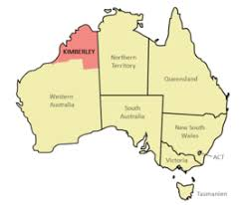

Kimberley region – highlighted

Attachment A

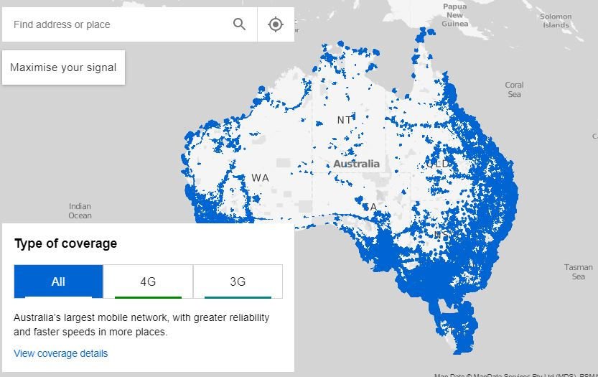

Attachment B

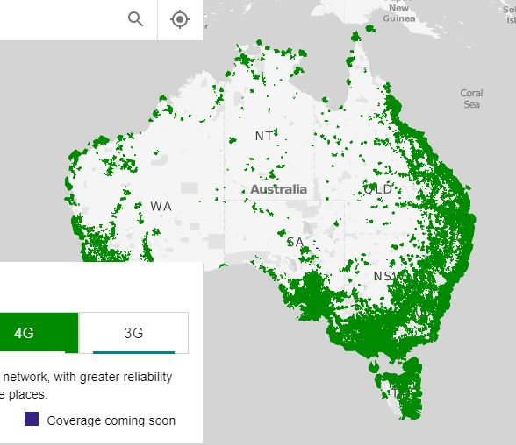

Attachment C

