**I have extracted this from the DOCA VAST “Issues Paper” and herewith provide some feedback on most of the points.**

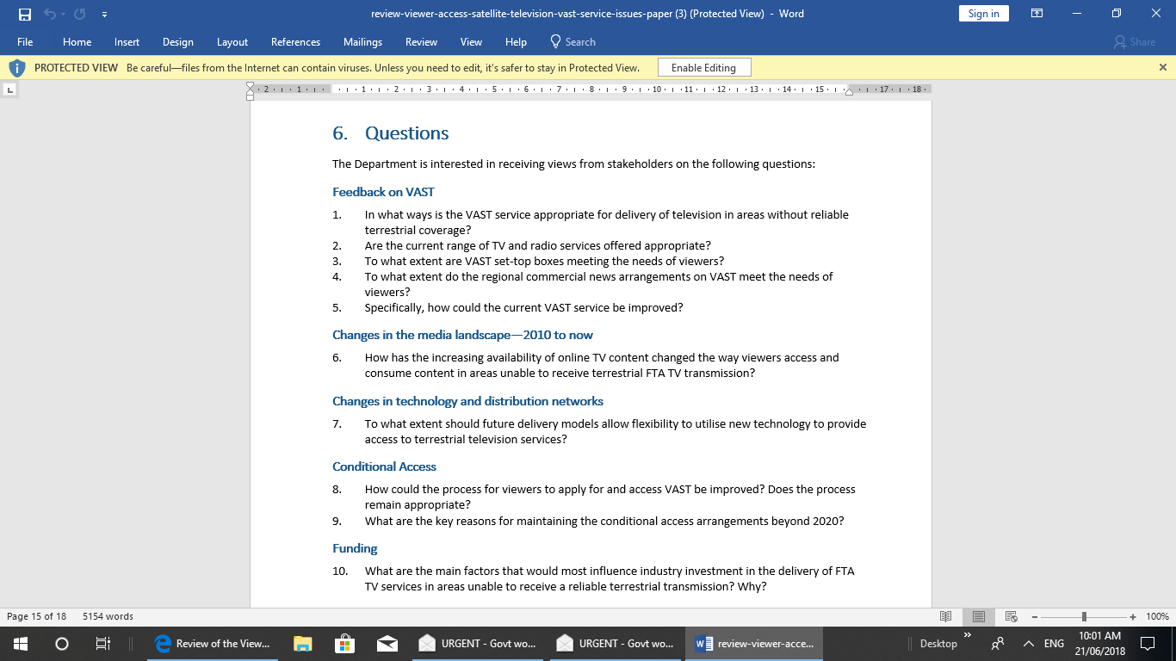

**Firstly some background on myself.**

I am now a retired TV Engineer who worked for a TV receiver manufacturer (HMV/EMI), a TV Broadcaster (ATN-7) and a Satellite Communications Company (Optus) during my 45 year working life and thus have a good knowledge of television and how it can be distributed. This knowledge includes the VAST system as I was one of the Engineers who developed and implemented the Optus Aurora platform on which it operates. I should also point out that I was one of the Engineers who, through Standards Australia and other groups, compiled the TV technical standards that both the terrestrial and satellite free to air digital TV systems operate in Australia.

Also my wife and I have a holiday property at North Arm Cove which is in an area north of Newcastle which had very poor terrestrial TV coverage at the time that the original Aurora service was implemented and consequently have been a viewer of FTA TV via the original Aurora and subsequently the VAST system for about 25 years. Thus I believe I have a good “first hand” knowledge of how well VAST works.

Regarding the questions in the “issues Paper”/

**Q1** I believe that the VAST satellite system is still the most appropriate way of delivering FTA TV to the many areas of Australia that still don’t have reliable terrestrial coverage. It is considerably better than the B-MAC and the original Aurora satellite systems tat pre-ceded it mainly because of the much greater number of TV channels available and the picture quality available. It should be pointed out that with the introduction of digital TV the aspect ratio of the pictures increased from 4:3 to 16:9 and since 2010 the screen size of most domestic TV’s has increased by a factor of probably at least 2:1. Additionally much higher resolution pictures (“HD”, “2K” and “4K”) displays and picture sources have become available. These wider and larger screens and “sharper” pictures require considerably higher resolution picture sources and transmission methods than those used prior to the introduction of VAST. Higher resolution pictures normally require greater bandwidths (ie higher MB/s data rates) but fortunately much of this requirement has been met by advances in digital picture compression techniques that fitted within the MPEG-2/4 technology that Australia’s DVB-T and DVB-S services use. There have been also been some advances in the data rates that can be fitted within the bandwidth constraints that the satellite system operates by implementing some of the parts of DVB-S2 in VAST without requiring changes to the significant population of VAST decoders.

**Q2** I believe the range of TV and radio services carried by VAST is good and appropriate

**Q3** I have used a UEC brand VAST decoder since its inception and am reasonably happy with it. However it has failed twice in that time (which I was able to fix myself being a electronic Engineer). There are some issues with the performance of my UEC decoder but unfortunately because of the cost of all VAST decoders and the fact that my authorised VAST smartcard is “locked” to my current decoder It makes it quite difficult to change to (or acquire and additional) decoders. See my answer to Q8 below.

**Q4** I have not used the Regional News arrangement (ie Chs 401 to 420) enough to comment, this is partly because I and my wife get most of our News via the excellent VAST SBS and ABC services.

**Q5.** We believe thecurrent ABC and SBS FTA TV coverage via VAST is very good (and could only be improved by improving the quality of many of the ABC and SBS programs by allocating additional money to the public broadcasters). In regard to the Commercial TV channels that we watch on VAST the most annoying thing we find is the most un-related to us advertisements (ie businesses in Alice Springs) and the constant repetition of the same “Ads” during a program and every night.

As a TV Engineer one minor improvement to the VAST service that should be easily possible would be to change the tuning picture and sound on Ch801 to a much better test pattern than just “colour bars with tone”. This might have been adequate in the days of low resolution analogue pictures but is of not much use in checking the capabilities of modern widescreen TV displays. Nor can it be used for checking the “lip synch” function of TV receivers or broadcasts which is often a problem with digital broadcasts. I recommend that what used to be called the “16:9 Philips TV Test Pattern” or similar be used instead. This pattern can be used for checking the resolution and lip synch of a TV.

**Q6** At our place in North Arm Cove the “media landscape” has not changed very much since 2010 largely because mobile phone and internet “connection” is still very poor. Possibly it may improve significantly when the NBN reaches that area but even when and if that happens it will probably not provide a viable alternative to VAST because it will (almost certainly) not be a free service. As a Communications Engineer I am very well aware of the fact that the most efficient method of carrying large bandwidth signals simultaneously to hundreds of thousands of people is via satellite or terrestrial broadcasting, not via a “Internet Clouds” etc. The news today that the Optus pay coverage of the Soccer in Moscow via this “Internet Cloud” has suffered significant problems whereas the SBS Broadcast Coverage works well, reinforces that fact.

**Q7**  Althoughit would seem to be ideal to allow emerging new technologies to quickly provide more or better ways of distributing and/or access experience indicates that this may not be a good idea. Since I have been involved with TV starting in 1958 I have seen it evolve through its “analog” phases ie from B&W, to Colour, to TV with Stereo Sound, to TV with Closed Captions. All of these changes/additions allowed the viewers to continue to use their old receivers for FTA TV or they could choose to purchase a new “TV set” to get the new feature if and when they chose. This was largely achieved because of the capabilities of the original TV systems that were chosen by Australia and the engineering work that went into each of the additions to make sure that they were compatible. Over that time there were many other “advances” in TV that were thought at the time to be “state of the art” but over time most of these “fell away” because they had significant problems and/or proved to be just “quick money making” schemes by various firms. Prior to the changeover to digital TV in Australia the many and quite different methods that might be used were studied extensively by many Australian TV Engineers over a period of about ten years to ensure that when that happened it would work well in the rather unique Australian requirements. Thus when Australia did change to digital TV (firstly with the Aurora Satellite System in the late 1990/s) and then with the change of Terrestrial services in the early 2000’s) it worked well and the simulcast period when both the old PAL analog transmissions continued for many years alongside the new DVB-T digital transmissions allowed people to smoothly changeover to the new digital TV’s.

I believe the message here is to not rush into “new technology” for such things as FTA TV where millions or at least hundreds of thousands of privately owned receivers are involved. Such new technology things as DVB-T2 which is currently being tried in Sydney may eventually lead to improvements in the efficiency of FTA terrestrial transmissions but such changes should be dome in a “slow and deliberate” way after extensive testing.

**Q8** The Conditional Access system used for the original Aurora system and continued with VAST was at the time the same system used for the Pay TV services used by Austar and Foxtel. This fact resulted in the fact that “hackers” were motivated to devise methods of “bypassing” the need to continue to outlay significant amounts of money each month to watch Pay TV. They did find ways of making “smartcards” that could allow free “pirate viewing” of such services, and thus similar smartcards could also be used for receiving Aurora services. The number of such “pirate Aurora” viewers was (I believe) never very large but to “solve the problem” when VAST was introduced the smartcards were locked to the particular receiver in which they were initially authorised and this is still the case today. I believe this “smartcard locking” requirement was a Optus and not a DOCA requirement. However since then the Austar/Foxtel service has changed to a completely different conditional access system and thus it would seem likely there would not be much motivation for “hackers” to develop and produce “pirate smartcards” for use in VAST decoders if they were unlocked. This smartcard locking means that it is much more expensive or difficult than it would otherwise be to change to viewing in a different room or to replace a decoder if it fails. It also tends to restrict the makers of VAST decoders to the current 3 or so which also means that they are very expensive compared to other similar electronic devices.

**Thus I recommend the “locking requirement” of VAST smartcards to decoders be removed.**

Indeed the “media landscape” has indeed changed considerably since the satellite based Remote Area TV systems were first introduced In Australia (via the B-MAC then Aurora then VAST systems) and the whole question of the need to restrict viewing of the FTA services by a Conditional Access System should be examined in the current environment. This requirement for Conditional Access makes it very difficult to build into normal mass produced digital TV receivers and consequently all viewers of VAST still require both a Set Top Box decoder and a TV. If the CA requirement was removed it seems likely (noting that the DVB-S technical standards used for VAST are widely used international standards) that some TV’s with both satellite and terrestrial inputs would become available at considerably less cost (and with better features) than the present arrangement.

Noting that the original reason for the CA system was to restrict Commercial TV viewers to a “Licence Area” and that the advent of high speed Internet Connections in the cities particularly with its capability to carry Commercial TV programs into other areas this CA requirement becomes very questionable.

**Thus I recommend that the Conditional Access requirement of VAST services be eliminated if reasonably possible.**

**Q10** As I have been retired now for more than 10 years I don’t think I can provide any informed input to this “funding” question

D. A. Drake

21/6/18