# TECHNOLOGIES FOR DIGITAL RADIO SERVICES IN REGIONAL AUSTRALIA

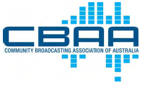

PO Box 564 Alexandria NSW 1435  
T - 02 9310 2999 F - 02 9319 4545 E - [office@cbaa.org.au](mailto:office@cbaa.org.au)  
ACN 003 108 030 ABN 92 003 108 030  
[www.cbaa.org.au](http://www.cbaa.org.au)

24 December 2010

Ms Kathryn Ries  
Manager, Regional Digital Radio Review  
Radio Broadcasting Section  
Department of Broadband, Communications and the Digital Economy  
GPO Box 2154   
CANBERRA ACT 2601

[*regionaldigitalradio@dbcde.gov.au*](mailto:regionaldigitalradio@dbcde.gov.au)

Dear Ms Ries

**TECHNOLOGIES FOR DIGITAL RADIO SERVICES IN REGIONAL AUSTRALIA**

I write in regard to the discussion paper on the above matter released 17 November 2010.

I understand that Section 215A of the Broadcasting Services Act requires the Minister to cause to be conducted a review relating to the relative merits of various technologies for digital radio services in regional areas, and that this review must occur by 1 January 2011.

I therefore write in concise terms to outline the position and views of the CBAA.

The CBAA is the peak industry body representing over 350 community broadcasting licensees in Australia. The CBAA supports and has been a vital part of the development of digital radio.

The first stage of digital radio has seen the introduction of services using DAB+ technology operating in VHF Band III spectrum. The existing digital radio framework and legislation sets out a timetable for commencement of services in the five mainland state capitals; Adelaide, Brisbane, Melbourne, Sydney and Perth. National, commercial and community broadcasting services are now on-air in each of those five cities.

The initial take up of digital radio has been encouraging and, especially taking account of the emergence of a large number of community sector services (37) as from late 2010, further growth in digital radio receiver take-up and listening is expected.

At this point DAB+ receivers in the Australian market are primarily either portable or tabletop devices. Their pricing and features are developing well.

It is important that the next steps of digital radio service provision in Australia provide an environment that encourages further pricing and feature development in receivers and, importantly, to mainstream the provision of digital radio receivers into vehicles.

Consolidation of DAB+ as being mainstream digital radio technology in the metropolitan and major regional areas is therefore an important current consideration.

**Digital radio is DAB+**

The CBAA supports the immediate focus being on consolidation and development of DAB+ as the core digital radio technology.

It is acknowledged that remote area and large coverage AM broadcast services will be difficult to replicate using DAB+ and for those situations other technology options should not be discounted.

But at this stage those technologies - and particularly receivers for those technologies - are not sufficiently mature. It is a case for further trials and future examination.

Right now, it is clear that regional (as well as metropolitan and remote town based) services ought to be planned under a presumption of DAB+ technology and operating in VHF Band III.

**Existing framework is DAB+**

To a large extent the existing digital radio framework and legislative model have been determined by the nature of DAB+ technology.

The framework and legislation presumes broadcast services share a common transmission technology. Capacity entitlements for broadcasters are then described in terms of parts of the whole (typically ninths) which are multiplexed together to feed the common transmission system.

This technology and legislative model has structural, commercial and access regime implications that are reasonably well understood and have occupied the minds all parties, including the community sector and the ACCC. There may be imperfections[1] in the model but at least they are understood and can be addressed.

It follows from a common transmission model that each service on a multiplex has the same effective reception and coverage footprint as any other service on that multiplex.

That is key to why the first stage of the digital radio framework provides digital capacity in respect of analog licensees whose existing services were licensed for broadly equivalent licence areas.

The first stage provides a digital pathway for services with licence areas (or, in the case of national services, coverage) that is equivalent to the applicable commercial radio license area (RA1) or else deemed to be providing a service or relevant to that license area.

Accordingly, ABC, SBS, commercial and community services intended for audiences within the area that defines the social and economic influence of each city have been included in the first stage.

**Moving beyond the first stage of digital radio**

Moving beyond the first stage of digital radio services in the state capitals means planning technology and spectrum solutions for:

* Regional areas adjacent to metropolitan areas or that are in some way affected by the onset of metropolitan services in a more immediate manner;
* The remaining regional areas; and
* Remote areas, including wide area coverage as well as town based services.

In addition there is the need within the existing first stage metropolitan areas to address:

* The current capacity limitations affecting metropolitan wide community broadcasting services in capital cities. This is most acute in Adelaide and Perth where the current capacity available results in services operating with technical characteristics well below other broadcasters.
* Legitimate community broadcasting services that serve substantial size licence areas and audiences but are nevertheless sub-sets of the metropolitan wide services and that have been excluded to date.

The CBAA supports and advocates use of DAB+ at VHF Band III as the mainstream digital radio technology solution. In one stroke that will ensure listeners are able to use their existing digital radios to receive services that they would reasonably expect - metropolitan, regional and sub-metropolitan.

The use of other digital radio technologies is not a listener proposition unless multi-technology receivers are standard fare and that is clearly not the current or even medium term situation.

**Service composition on each multiplex**

Accordingly, a key planning precept is to map out the key areas that are to receive digital radio services and with what composition of services.

The current digital radio legislation intends to match digital coverage with existing licence area boundaries. These have been developed historically with regard to socio-economic factors but also in the context of analog AM and FM coverage characteristics.

As a starting point for planning the existing licence area definitions are a useful tool. However, the practical requirement for a common transmission infrastructure will occasion some case by case analysis to ensure an efficient disposition of multiplexes and appropriate composition of services on each multiplex.

The national broadcasters have a suite of truly national services that, ideally, would be available on digital radio receivers in all regional areas. The national broadcasters also have services that will be specific to a particular regional multiplex.

There may be some regional commercial broadcasters where it would be logical and appropriate to share a common multiplex but which currently have slightly misaligned licence area definitions.

Equally, there are a variety of regional community broadcasting services that serve substantial size licence areas historically intended to match an area, or at least the core area, of socio-economic influence that is in common with relevant commercial or national services.

It is this mix that would make up the composition of services on multiplexes designed to bring digital radio to regional areas.

It seem likely that, in the detailed planning stages, toensure best service outcomes in regional areas some degree of licence area alignment may need to be considered on a case by case basis.

**Spectrum planning for digital radio**

The preferred spectrum for DAB+ is in VHF Band III. Much of this spectrum is currently used for analog and digital television services.

The government has announced its intention to recover a digital dividend of 126 MHz within UHF spectrum. To realise this dividend a re-stack of television services is currently under detailed planning consideration by industry and the ACMA. The re-stack will affect the allocation of television channels and therefore digital radio channel availability in VHF.

The CBAA position is that the channel re-stack must properly consider the service outcomes for digital radio - in metropolitan, regional and remote areas - as part of its deliberations.

The CBAA is pleased to be actively engaged with the current industry consultative process on this matter - the Re-stack Planning Advisory Group (RPAG) convened by the ACMA as from November.

The timeline for the RPAG work is very ambitious but the CBAA will continue to advocate a strong position in regard to the planning considerations that include and require a proper analysis of digital radio as well as digital television service outcomes.

This planning and the work of RPAG is guided by a Ministerial direction issued in July 2010 to reserve 14 MHz of VHF Band III spectrum in each metropolitan licence area to allow for digital radio. Whilst a reserved amount of spectrum is useful, it is a stringent limitation. CBAA submissions in early 2010 indicated that slightly more than this amount may be required to ensure adequate capacity in adjacent regional areas. More analysis on the effect of this limitation in terms of digital radio service composition is required as part of RPAG considerations. The CBAA intends to submit information to assist in this early in 2011.

**Coverage and same frequency infill**

DAB+ digital radio technology is able to provide coverage in a variety of models. The current model in stage one is a single high power main transmitter. That model is largely effective for blanket coverage, although areas of poor coverage are inevitable.

In fact, it has already been found helpful to augment the main coverage with initial supplementary infill transmission in Melbourne, and other similar infill services are to follow. Due to the use of COFDM inherent in DAB+ technology, these infill services are able to be engineered to operate on the same frequency as the main service. In this way, the coverage of a DAB+ service can be finessed and augmented without further serious spectrum allocation implications.

As well as the high power central transmitter model other transmission topologies are possible. A distributed emission topology with a group of medium or low power transmission multiplexes operating as a network on the same frequency can deliver good coverage outcomes and in a manner intended to align with conurbations. Extra infill and coverage extension can thus be managed on a case by case basis taking into account cost and service considerations.

A mix of these approaches is the likely practice in order to best meet specific coverage and service requirements.

DAB+ uses COFDM and a relatively wideband carriage to achieve good immunity to interference and propagation imperfections. The DAB+ bandwidth of over 1.5MHz is intrinsic to its immunity from phase hits caused by reflections from natural topography and in built up environments. The extent of these phase hits is typically only a small proportion of the total bandwidth of a DAB+ signal compared to other digital radio systems, even those that do use COFDM. In this respect DAB+ is clearly superior.

**Other technologies**

It is acknowledged that remote area and large coverage AM broadcast services will be difficult to replicate using DAB+ and for those situations other technology options should not be discounted for further consideration in the longer term.

Chief among these contenders is DRM30. It may well provide an overlay wide coverage solution for remote area (wide) indigenous broadcasting. The CBAA would be pleased to support trials for a future solution. However, alongside a DRM30 wide area solution that there would still be a need for DAB+ town based services even in remote Australia.

Another option for wide area remote services is satellite to a portable device: Worldspace, Sirius and XM Radio are examples. Under any analysis these do not seem to be viable options for Australia or able to be implemented without terrestrial augmentation. Note that delivery of radio like services using digital DTH satellite to a fixed STB is an important adjunct platform to digital radio, especially in remote Australia.

It has been noted that DRM+ on VHF may be used to provide digital radio coverage in regional areas and for limited coverage of population centres. Whilst this may be true, it does not recognise the significant receiver availability issues or that the rest of the population are relying on the use of DAB+ receivers. At this time it seems there are no hybrid receivers.

**Summary**

The CBAA supports and advocates use of DAB+ at VHF Band III as the mainstream digital radio technology solution. In one stroke that will ensure listeners are able to use their existing digital radios to receive services that they would reasonably expect - metropolitan, regional and sub-metropolitan.

The use of other technologies is not a listener proposition unless multi-technology receivers are standard fare and that is clearly not the current or even medium term situation.

Regional (as well as metropolitan and remote town based) services ought to be planned out under a presumption of DAB+ technology and operating in VHF Band III.

Moving beyond the first stage of digital radio services in the state capitals means planning technology and spectrum solutions for:

* Regional areas adjacent to metropolitan areas or that are in some way affected by the onset of metropolitan services in a more immediate manner;
* The remaining regional areas; and
* Remote areas, including wide area coverage as well as town based services.

In addition there is the need within the existing first stage metropolitan areas to address:

* The current capacity limitations affecting metropolitan wide community broadcasting services in capital cities. This is most acute in Adelaide and Perth where the current capacity available results in services operating with technical characteristics well below other broadcasters.
* Legitimate community broadcasting services that serve substantial size licence areas and audiences but are nevertheless sub-sets of the metropolitan wide services and that have been excluded to date.

The CBAA is pleased to be actively engaged with the current industry consultative process regarding re-stacking of digital television services and digital radio. More analysis on the effect of this spectrum planning process on digital radio service composition is required. The CBAA intends to submit information to assist in this early in 2011.

As a starting point for planning further digital radio services the existing licence area definitions are a useful tool. However, the practical requirement for a common transmission infrastructure will occasion some case by case analysis to ensure and efficient disposition of multiplexes and appropriate composition of services on each multiplex.

Yours sincerely



Kath Letch   
GENERAL MANAGER

Existing digital radio legislation provides a standard access entitlement for each commercial broadcaster to use one-ninth of the transmission capacity of a Category 1 digital radio multiplex. Each entitlement equates to a net bit rate for usable data of approximately 128 kbps. By contrast, all eligible community broadcasters in each licence area are to share two-ninths of multiplex capacity. This structural inequity limits the ability of community broadcasters to provide an equivalent digital radio service. Spectrum for extra multiplex capacity is required to address this inequity.

**Sydney**

The number of commercial broadcasters is 11.

There are two Category 1 multiplexes.

The number of eligible community broadcasters is 8.

Using the same bit rate as accorded to commercial broadcasters only 4 community broadcasters can be accommodated;

4 would have to stand aside.

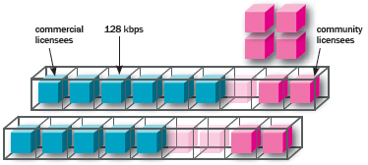

**Melbourne**

The number of commercial broadcasters is 11.

There are two Category 1 multiplexes.

The number of eligible community broadcasters is 9.

Using the same bit rate as accorded to commercial broadcasters only 4 community broadcasters can be accommodated;

5 would have to stand aside.

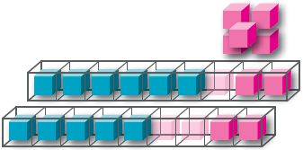

**Brisbane**

The number of commercial broadcasters is 8.

There are two Category 1 multiplexes.

The number of eligible community broadcasters is 7.

Using the same bit rate as accorded to commercial broadcasters only 4 community broadcasters can be accommodated;

3 would have to stand aside.

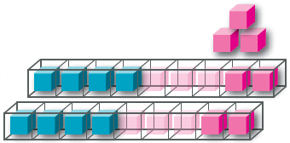

**Adelaide**

The number of commercial broadcasters is 6, and the number of eligible community broadcasters is also 6. Using the same bit rate as accorded to commercial broadcasters only 2 community broadcasters can be accommodated;

4 would have to stand aside.

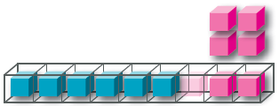

**Perth**

The number of commercial broadcasters is 6, and the number of eligible community broadcasters is 7. Using the same bit rate as accorded to commercial broadcasters only 2 community broadcasters can be accommodated;

5 would have to stand aside.

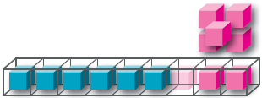

If all the eligible community broadcasters equally divide the two-ninths of multiplex capacity then only a low bit rate would be available to each. In some cases so low that it may not be possible to provide an adequate quality audio service.

**Sydney**

Dividing the two sets of two-ninths capacity by eight community broadcasters means an equal division is possible across two multiplexes. One multiplex would carry four community broadcasters, and each would have a nominal bit rate of 64 kbps. The second multiplex would also carry four community broadcasters, and each would have a nominal bit rate of 64 kbps.

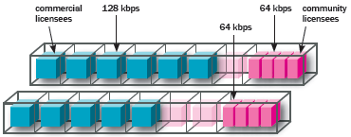

**Melbourne**

Dividing the two sets of two-ninths capacity by nine community broadcasters means an equal division is not possible. One multiplex would carry four community broadcasters, and each would have a nominal bit rate of 64 kbps. The second multiplex would carry five community broadcasters, and each would have a nominal bit rate of 51 kbps.

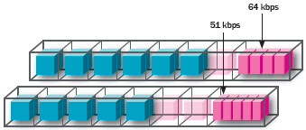

**Brisbane**

Dividing the two sets of two-ninths capacity by seven community broadcasters means an equal division is not possible. One multiplex would carry four community broadcasters, and each would have a nominal bit rate of 64 kbps. The second multiplex would carry three community broadcasters, and each would have a nominal bit rate of 95 kbps.

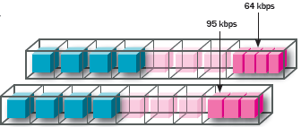

**Adelaide**

Dividing the two-ninths capacity by six community broadcasters means that each would have a nominal bit rate of 42 kbps.

In effect, this limits the audio bit rate to 32 kbps.

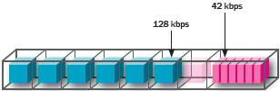

**Perth**

Dividing the two-ninths capacity by seven community broadcasters means that each would have a nominal bit rate of 36 kbps. In effect, this limits the audio bit rate to 32 kbps.

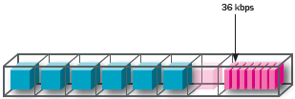



Electronic Program Guide (allocation not determined)



Excess Capacity



Commercial Licensees



Community Licensees



Category 1 Multiplex

1. The legislation does not specifically provide for capacity for an EPG, nor does it sufficiently recognise the capacity requirement for carriage of community sector services on an equivalent basis as other services (Att 1). The CBAA has conducted extensive correspondence with industry, the Minister, the ACMA and the ACCC in relation to these matters. Further information can be provided.