SUBMISSION BY SHOALHAVEN CITY COUNCIL

TO

INQUIRY INTO FREIGHT AND SUPPLY CHAIN PRIORITIES

Prepared by Economic Development Office

Shoalhaven City Council, Nowra NSW



Contents

Road transport corridors – the haulier’s workplace ................................................3

Rail Freight pathways – the preferred alternative? ................................................6

Freight generation – the manufacturing effort ........................................................6

Regional Growth in the Manufacturing sector ........................................................7

Manufacturing as a Regional economic generator.................................................8

Access to Seaports ................................................................................................8

Summing up...........................................................................................................9

Sample List of Road Freight Tasks required for Shoalhaven Based Industry ......10

Background and context



Road transport corridors – the haulier’s workplace

Shoalhaven City is on the eastern seaboard of NSW with the major administrative centre and manufacturing node at Nowra which is 160km south of Sydney.

Nowra is primarily serviced by the Princes Highway. This State Highway is currently undergoing a major upgrade by the NSW government and will in the near term be a 4 lane corridor from the industrial precincts at Nowra/Bomaderry into Sydney and Wollongong.

The road network is based on the Princes Highway (north-south) running to the east of the Illawarra escarpment. Freight between Nowra and the main southern corridor out of Sydney, the Hume Highway, requires crossing of the escarpment from the coastal plain to the southern tablelands, a vertical distance of 800m. To cross this escarpment and move freight between Nowra and say, Yass, the following options are available to hauliers:

|  |  |  |  |
| --- | --- | --- | --- |
| **Corridors across**  **Escarpment** | **Distance (time)** | **Max Truck type** | **Vertical climb/descent** |
| Mt Ousley/Picton Rd | 308km (3hr 16m) | B-doubles | 800m |
| Kangaroo Valley | 207km (2hr 27m) | Semi-trailer | 600m+600m  +800m |
| Nerriga/Tarago | 234km (2hr 40m) | <15 tonne | 800m |
| Nerriga/Braidwood | 264km (3hr 22m) | Semi-trailer | 800m |
| Batemans  Bay/Braidwood | 333km (4hr 20m) | Semi-trailer | 800m |

The preferred route is a link from Nowra to Nerriga, onwards to Tarago and Gunning via Collector. This route requires a progressive upgrade to meed B-double standard. The route is 217km in length and in an improved state would take approximately 2hr 30m to travel.

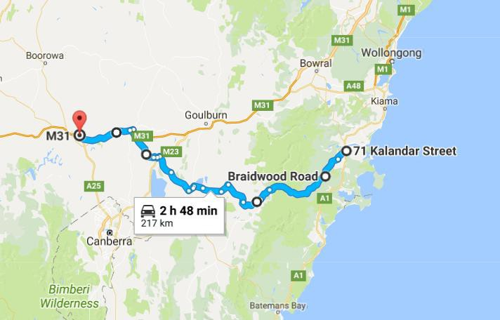

The next graphic shows dramatically the disadvantage of the route through Kangaroo Valley as opposed to the preferred option via Nerriga and Tarago.

**800 METRES**

**Sassafras**

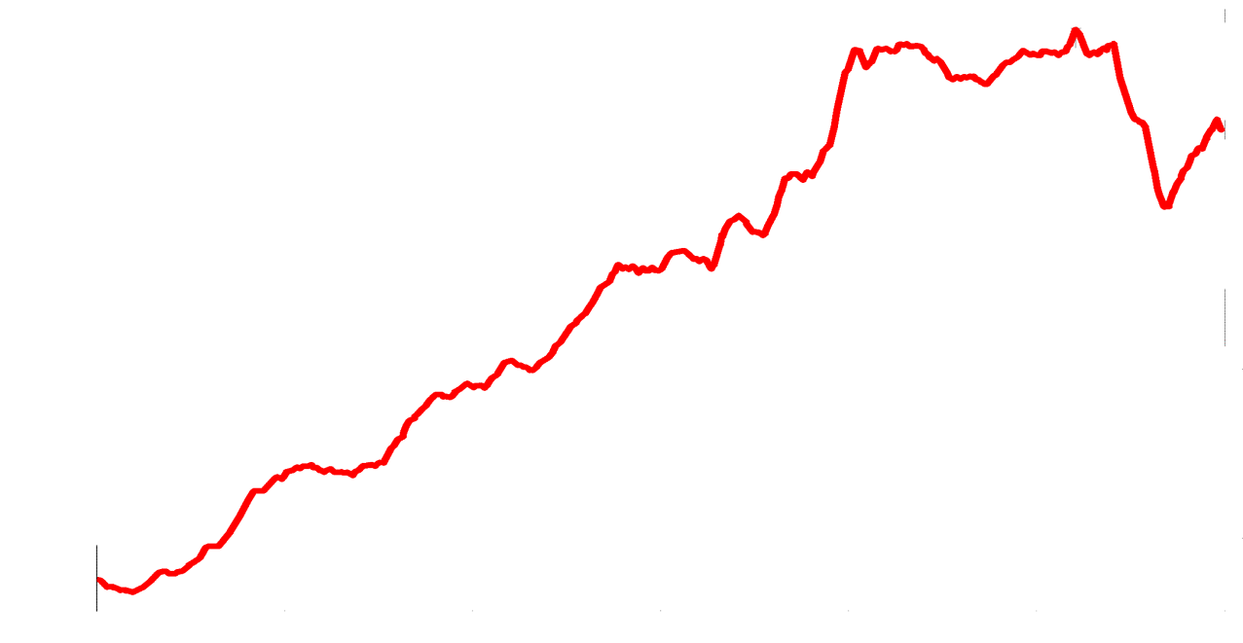

**Nerriga**

**600 A L T**

**I T**

**400 U**

**D**

**Enderick**

**River**

Nowra to Canberra via Tarago

Altitude in metres

**200**

**0**

**Tomerong turnoff**

**10 20**

**KILOMETRES**

**30**

**40 50 60**

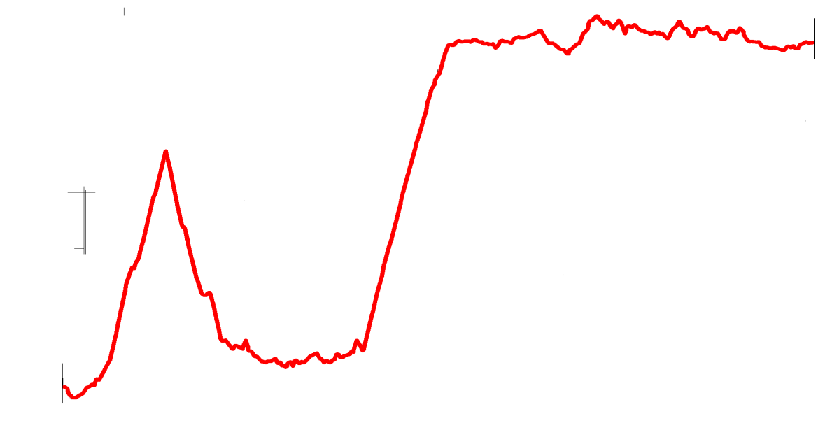

**Moss Vale**

**800 METRES**

**600 A L T**

**I T**

**400 U D**

**Cambewarra**

**Lookout Road**

**Kangaroo**

**Valley**

**Canberra**

Nowra to Canberra via Moss Vale

Altitude in metres

**200**

**0 10**



**KILOMETRES**

**20 30**



**40 50 60**



Rail transport is also important to the Nowra manufacturing hub with almost 50% of freight being hauled by that medium. Council and the local industries are aware that access to a road/rail intermodal around Goulburn/Gunning/Yass would allow freight to move across the escarpment by road and then to the southern states by rail.

Therefore efficient access to the Hume corridor in the southern tablelands is important to Shoalhaven businesses.

Rail Freight pathways – the preferred alternative?

The understanding of the rail freight are not as great by local government as the operations of this network do not involve Councils except for physical interfaces with the assets – bridges, under/over-passes, level crossings, stations etc.

Shoalhaven Council is aware of some of the issues with industry operating a rail receival and distribution network within a suburban passenger rail network which exists on the NSW South Coast line where Bomaderry, on the northern (Sydney side) of the Shoalhaven River.

Issues such as freight slots outside of the Sydney commuter peaks, the increasing peak commuter curfew windows, possessions for maintenance, different track owners are just some of these but it is anticipated that there are a lot more that exist on freight trains jointly utilising the same commuter network.

The operations within the seaports also has a range of issues as a single train may have a need for multiple Container deliveries to different stevedores.

To have rail as a viable freight alternative to roadhaul, the system needs to be readily useable and from all parts of the network.

Freight generation – the manufacturing effort

The northern portion of the Shoalhaven based around Nowra has a broad industrial base, more metropolitan in nature than regional. The Shoalhaven has a Gross Regional Product (GRP) of $4.895billion. The economic output of the Manufacturing sector is $1.989billion and represents 21.7% of the output of the Shoalhaven LGA.

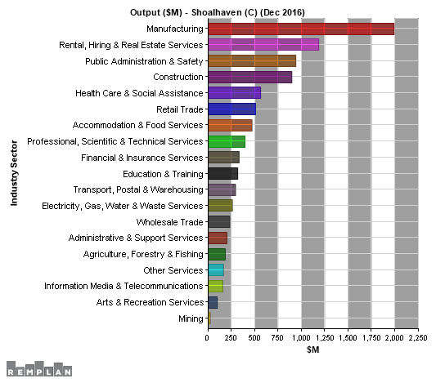

Manufacturing produce is concentrated around foodstuffs, chemicals and building components, each sector requiring bulk raw materials inwards and semi or finished product outwards.

The freight task is quite large and is externally focused in its origin and destination. Any improvement in efficiencies in the supply chain will reflect in the companies viability and ability to supply the Australian and export market at a competitive landed price.

Regional Growth in the Manufacturing sector

Much has been written and speculated about the erosion of the manufacturing effort in Australia. The experience here in Shoalhaven and in many other regional centres is, that manufacturing whilst it is not growing dramatically, is also not declining but rather has been quite stable and may have in fact increased in correlation with the lower value of the Australian dollar against the USD.

In Shoalhaven, whilst there have been a few closures of older manufacturing businesses that did not modernise, those companies that have sustained their competitiveness through investment are growing. A new group of industries that have introduced modern practices or new product lines are appearing to do well not only on the domestic market but also in the traditional markets of USA and Europe.

The above fact is important to understand and when combined with the fact that raw materials or ingredients mainly come from other regional centres and the outputs similarly go to regional centres or ports, the core point of Shoalhaven City Council’s point to this inquiry is based. Freight routes between regional centres is all important to the “manufacturing effort” of this nation.

The use of the National and State highway networks are key to the logistics framework. The first and last mile, usually the domain of the local government road network are also critical.

HOWEVER with the improvement in heavy vehicle technologies certain preferred haulage routes are not being upgraded to allow these productivity gains to be attained. The requirement to add 15% in time and distance to an interstate link to allow the efficiencies of a b-double over a traditional semi-trailer needs to be reviewed.

The next criteria is then to examine the tonnages involved. A route that could divert 10,000t/wk of national freight may warrant consideration of an upgrade, but may not be required if it is only for the school bus and the occasional livestock task.

Manufacturing as a Regional economic generator

The manufacturing/processing industries deliver far more relative economic activity within a regional context than a metropolitan one. To sustain a regionally based supply chain can lead to many primary jobs being sustained as well as having a greater impact on the flow on effects in a regional economy.

Many regional and rural economies are based on a single product eg timber, fish, grain livestock … However there are concentrations of manufacturing activities that do feed off each other and then offer support industries like transport and warehousing to gain a greater number of operators and competitiveness.

Access to Seaports

Australian seaports are predominantly located in or adjacent to metropolitan centres. As the metropolitan areas grow and congest, the slowing of the supply chain for the “last domestic mile” of the export journey is quite often the most inefficient.

Government realisation that this last leg of this journey is best attracted to rail freight and consolidating containers in the outer suburbs or at inland ports to allow rail passage is to be commended.

From Nowra/Bomaderry there is the ability to rail straight into the Ports of both Botany and Kembla. The ability of this to continue is requested and support for a greater

effort in this regard is sought. There is a likelihood of establishing at the hailhead at Bomaderry a road/rail intermodal for general use and this is supported by Council but could be countered by a requirement to assemble all containers to Moorebank.

Summing up

Shoalhaven City Council is aware that it has a role in the “first and last mile” of the supply chain. With the assistance of the Federal Government through the Heavy Vehicle Safety and Productivity Program and the NSW Government’s Fixing Country Roads and Fixing Country Rail programs, Council has implemented several projects over the years specifically to address the needs of industry and the haulage contractors.

As a regional centre, Nowra has a quite diverse economy and Council, and industry, see the need to adopt HML technologies and configurations to maintain competitiveness in the global economy. This change requires that existing freight routes need to be reviewed and upgraded and where warranted, new linkages need to be developed. Two major rail projects have done just that in the Adelaide to Darwin line and the proposed inland rail line between Melbourne and Brisbane. Access to non-metropolitan ports such as Newcastle, Kembla and Eden needs to be also kept to the fore.

Economic growth in regional areas can relieve the pressures on overcrowded and sprawling metropolitan centres. It does however take a proactive approach by governments and others to achieve such growth and entice manufacturing and processing industries to consider a regional context rather than one of our near Asian countries.

Shoalhaven Council does provide advocacy on these supply chain and other regional issues. The sustainment of our industry base and the provision of employment opportunities for our community is paramount.

Greg Pullen



Economic Development Manager

Shoalhaven City Council

Bridge Rd, Nowra

Ph +61 2 44293388

E [business@shoalhaven.nsw.gov.au](mailto:business@shoalhaven.nsw.gov.au)

Sample List of Road Freight Tasks required for Shoalhaven

Based Industry

|  |  |  |  |  |
| --- | --- | --- | --- | --- |
| **Product** | **Type/tonne** | **From** | **To** | **Carrier** |
| Calf feed | 25 pallets | Bomaderry | Traralgon | Willaton/Morwall |
| Liquid Alum | Bulk – 25t | Nowra | Canberra | ChemTrans/Unand  erra |
| Grouting resins | 50 pallets | Nowra | Mackay | Dunns/Nowra |
| Packaged cheese | 10 Pallets | Sth Nowra | Eastern Creek | Unicorn/Nowra |
| Sandy loam | 40t bulk | Bungendore | Nowra | Turfco |
| Chemicals | 40 bulk bags | Nowra | Wetherill Pk | NowChem/Nowra |
| Flour | 1500t bulk | Gunnedah | Bomaderry | National Rail |
| Carbon dioxide | 45t bulk | Bomaderry | Wetherill Pk | IOC |
| Liquid sucrose | 25t bulk | Bomaderry | Shepparton | Hitchcocks/Bomad  erry |
| Liquid | 25t bulk | Bomaderry | Morwell | McColls/Altona |
| Milk | 48t bulk | Nowra | Wetherall Pk | McColls/Altona |
| Calf supplement | 40x40’  containers | Bomaderry | Europe | National rail |
| Whitegoods | 20t | Ulladulla | Wagga W | Storey/Ulladulla |
| Ethanol | 45t bulk | Bomaderry | Botany | McColls/Altona |
| Silage | 25t bulk | Meroo | Goulburn | Warren/Terara |
| Livestock | 25t | Wagga | Milton | Various |
| Groceries | 25t | Wetherall Pk | Ulladulla | Bonnacord/ Bairnsdale |
| Roof trusses | 20t | Sth Nowra | Campbelltown | Various |
| Concrete Blocks | 45t | Sth Nowra | Albury, Grafton | Kerdons/Nowra |
| Mining Equip | 200t | Nowra | Mt Isa | Dunns/Nowra |
| Meat | 25t | Milton | Campbelltown | Various |
| Aggregate | 25t bulk | Yalwal | Moss Vale | Boral |
| Kitchen furniture | 45t Pallets | Gosford | Sth Nowra | Borg/C Coast |
| Saw logs | 45t | Braidwood | Sth Nowra/  Ulladulla | Various |
| Timber | 45t | Sth Nowra/  Ulladulla | Various | Various |
| Custom Yachts | 20t | Sth Nowra | New Zealand | Specialist carriers |
| Brewers syrup | 45t | Bomaderry | Syd/Melb | McColls/Altona |
| Keg/Package beer | 25t | Nowra | Wollongong to  Bega | Sthn Transport  Nowra |
| Greenwaste | 30t | Wollongong | Nowra | Soilco |