4th August 2017

Freight and Supply Chain Inquiry

Department of Infrastructure and Regional Development

GPO Box 594

CANBERRA CITY ACT 2601

Email: [freightstrategy@infrastructure.gov.au](mailto:freightstrategy@infrastructure.gov.au)

PO Box 1877

Mackay, QLD 4740 [ceo@rdamiw.org.au](mailto:ceo@rdamiw.org.au) [www.rdamiw.org.au](http://www.rdamiw.org.au/)

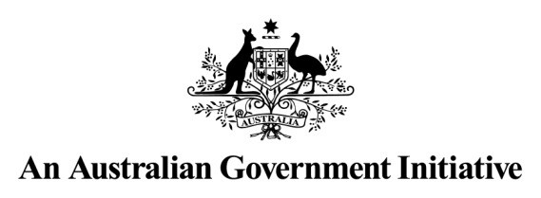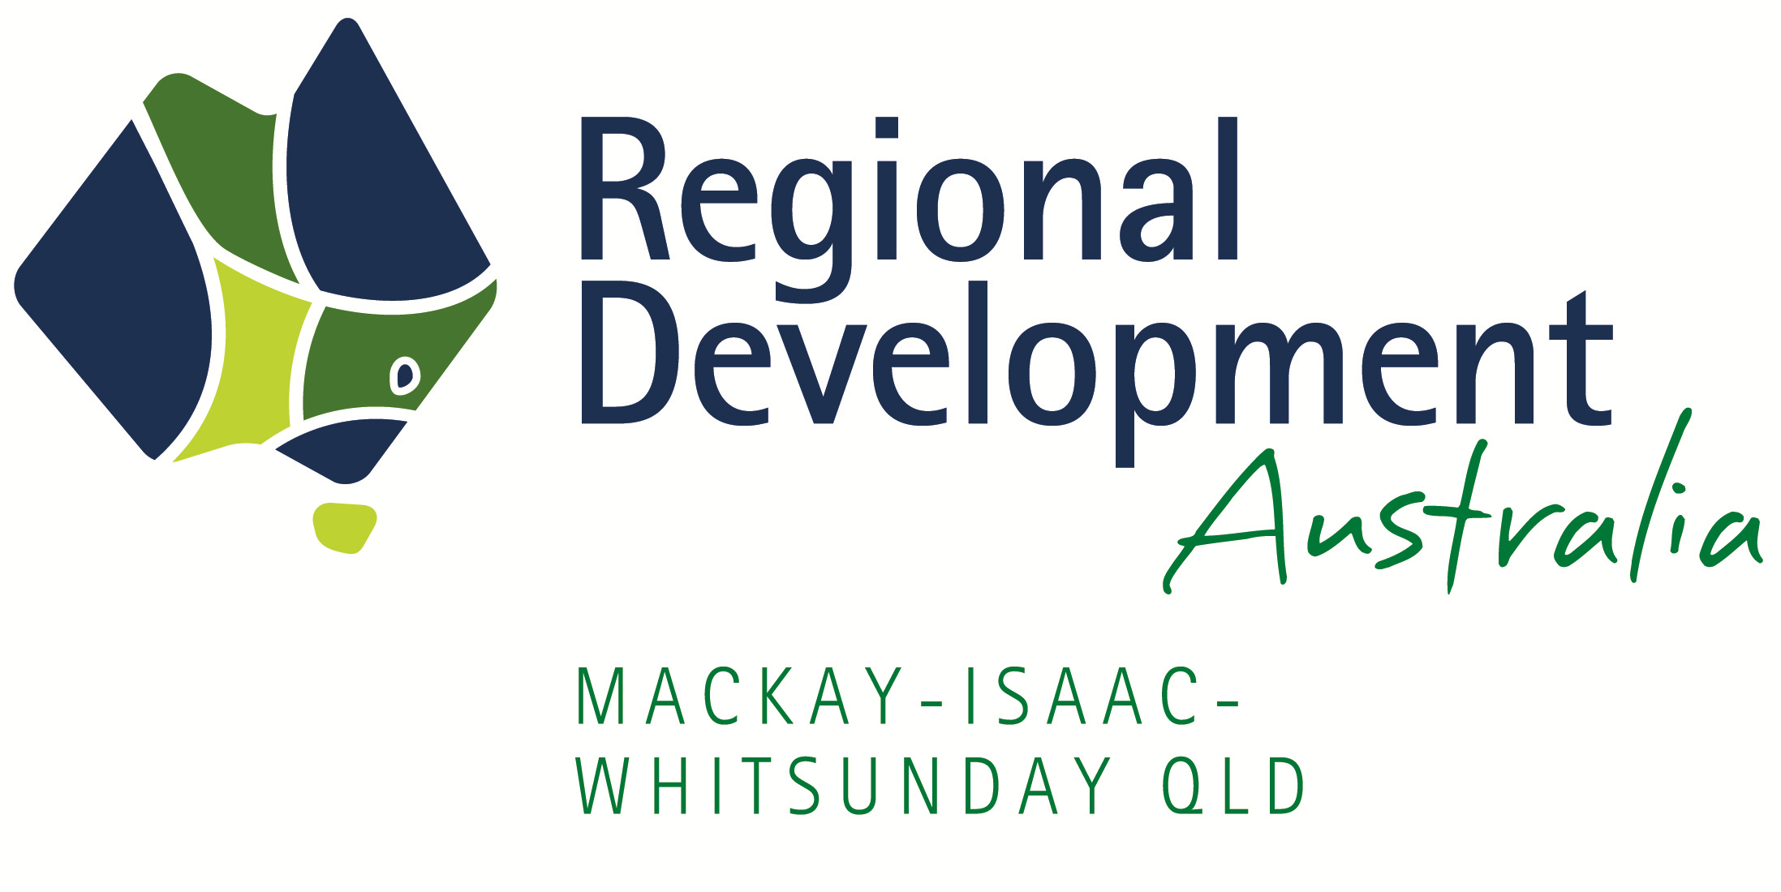

Dear Sir,

Re: Inquiry into National Freight and Supply Chain Priorities

Regional Development Australia Mackay-Isaac-Whitsunday Inc. (RDA MIW) is one of 55 Regional Development Australia bodies nationally. RDA MIW is a regional leadership entity that identifies priorities and advocates to all levels of Government for the region’s vision: lifestyle, opportunity and prosperity. The vision and our priorities have been developed with extensive engagement and collaboration with our community, peak bodies and three tiers of Government to map out a pathway forward for the region.

RDA Mackay-Isaac-Whitsunday supports the three regional council areas of Mackay, Isaac and Whitsunday and is an initiative of the Australian Government. It aims to bring together all levels of government to enhance the growth and development of regional Australia.

Key points about RDA MIW:

- Independent, apolitical, not for profit organisation.

- Funded by the Australian Government to deliver regional economic development activities and outcomes.

- Facilitate regional activities across local government boundaries.

- Committee members and staff have been appointed on the basis of their extensive networks across government, industry and communities.

- Regularly contribute to regional planning in partnership with key stakeholders and advocate for

outcomes in the MIW region.

A key part of our role in the region is to look at key infrastructure constraints and opportunities and as such we have a broad understanding of the freight task across a variety of key industries.

Mackay-Isaac-Whitsunday (MIW) is a resource-rich region, with iconic natural resources such as the Great Barrier Reef and Whitsunday Islands, significant coal mining deposits in the Bowen and Galilee basins and a rich agricultural history and significant current agricultural production. With our proximity to the Bowen basin MIW is also the principal services support centre for the mining resources sector in Central Queensland. The region punches well above its weight in relation to economic output with almost $15B Gross Regional Product (GRP) equating to $89.5K GRP per capita which is 16.3% above the Australia wide per capita GRPi.

With RDA MIW being located in Northern Australia we believe understanding our region and broader Northern Australia is critical to the development of a National Freight and Supply Chain strategy. As highlighted in the Inquiry’s Discussion Paper, “The Strategy is being undertaken in the context of a growing Australia ……… This growth is being driven by Australia’s growing populations and from increasing demand for Australian resources and produce, especially in Asian markets. ” With MIW’s proximity to Asia, strong export resources reserves and

current and potential agricultural growth, a National Freight and Supply Chain Strategy will clearly need to address freight and supply chain issues across the MIW region.

Our regional contribution and comments are made with regards to a number of the consolidated questions including:

2.1 What is moving, where, why and how?

3.2 Port Corridor Pressures – Protecting Land, Sea and Air Connections

3.4 The Air Freight Market

Mining

In 2015-2016 MIW was home to 32 operating coal mines producing 137 million tonnes of coal (net output) or

60% of Queensland’s total coal production. Coking coal represented 82% of total regional coal productionii. The bulk of this coal is transported via rail and then exported via the ports of Hay Point and Abbot Point. The

exported tonnes through these ports represent more than 50% of Queensland’s total sea exportsiii. An industry of this size does not generate this quantum of output without significant inputs and the bulk of the inputs for the

MIW region (including equipment and fuel) are transported to the various mine sites via road after being imported via a variety of ports.

The Port of Mackay plays a critical role in the fuel supply chain with ~1.4 million tonnes of petroleum products imported through the port in 2016/2017iv. The bulk of this fuel is transported by road with the Peak Downs Highway the key transport route in this supply chain.

North Queensland Bulk Ports Corporation Limited (NQBP) is the Government Owned Corporation that is the port authority for the ports of Abbot Point, Hay Point and Mackay, as well as Weipa, which is outside the MIW region. They have been working with local mining companies and original equipment manufacturers (OEMs) to establish the Port of Mackay as a key intermodal node for mining related break-bulk cargo and the bulk of this freight is also transported to the mines via road, predominantly the Peak Downs Highway.

The MIW region is also home to a number of proposed Galilee Basin mines, including the Adani Carmichael Mine, and the development of the Galilee Basin will increase the east-west freight task within the region, resulting in key east-west road connectors such as the Peak Downs Highway, the yet to be constructed Mackay to Bowen Basin Service Link, Bowen Developmental Road and Clermont-Alpha Road increasing in importance. Whilst RDA MIW acknowledges important recent funding announcements relating to all these roads, further investment will be required to ensure that the efficiency of supply chains is maximised in the future. This will be especially critical when low coal prices are in place, as low-cost efficient supply chains can make the difference between mines remaining open or slipping into care and maintenance mode.

Agriculture

RDA MIW has recently completed an overview of agriculture in the MIW region. It revealed that the region conservatively produced agricultural product with a gross value of $1.119B across 6.4M Ha. This represented

9.4% of Queensland’s gross agricultural value across 4.8% of Queensland’s land holdingv. MIW is a region of diverse agricultural production with cattle and grain production in the west and sugar cane, horticulture and

aquaculture in the coastal regions.

The freight task is equally diverse with cattle transported primarily via road to processing facilities including the meatworks in Mackay, grain via road and rail to use within the production system or to export facilities such as the Port of Mackay, sugar cane via rail to the mills and then via roads or rail to export facilities such as the Port of Mackay and horticulture primarily via road to markets in the south of the state.

Key transport infrastructure facilities that play a role in the MIW agricultural supply chain include (but are not limited to):

- East-West connectors - Peak Downs Highway, Clermont-Alpha Road, and Bowen Developmental Road –

cattle and/or grain transport.

- Port of Mackay – sugar and grain export and agricultural inputs imported.

- Bruce Highway – sugar, grain, horticultural and aquaculture transport.

- North-South Rail – North Coast line system for sugar and grain transport.

- East-West Rail – Aurizon/Graincorp’s Mt McLaren to Mackay rail system for grain.

Given the large quantity of high value horticulture and aquaculture production in the region, potential exists for international air freight, which could work in conjunction with cargo space from inbound tourism flights. In relation to the potential for an international air freight task, the MIW region is ideally located, being close to the mid-point between Queensland’s current international air hubs in south-east Queensland and Cairns.

Opportunities for MIW Region

Port of Abbot Point

As ship sizes increase in response to increased maritime cargo movements, the ports across Australia will need to be able to accommodate these larger vessels. A number of ports across Australia are constrained when it comes to larger Cape size vessels, and investigation into the potential for the port of Abbot Point to become a multi- commodity port is required. The port of Abbot Point is one of Australia’s most significant emerging bulk ports and is undergoing a major transformation into a port precinct of global importance. Abbot Point is located 25 kilometres north of Bowen, at the northern end of the Galilee and Bowen coal basins.

Abbot Point is placed between the existing industrial centres of Townsville to its north, and Mackay to its south. It is also adjacent to the Abbot Point State Development Areas, a 16,320 Ha site for dedicated industrial development. The Port of Abbot Point is Australia’s only Northern Australian natural deep water port, it has no reverse amenity, access via Palm Passage and is close to Asian and Pacific Rim growth and markets.

Given the lack of economic infrastructure and population in the region surrounding the port of Abbot Point, it is perfectly positioned for longer term planning for infrastructure corridors. Infrastructure Australia have found that this longer term planning for infrastructure corridors can help to avoid cost overruns, delays and community disruption when delivering new infrastructure and as such we believe that investigation into the potential for the port of Abbot Point to become a multi-commodity facility should be expedited. We understand that NQBP has already completed an infrastructure and land use plan for the future expansion of the port to cater for both coal and non-coal trade. Further investigation into the potential for the port of Abbot Point to become a future multi- commodity facility for Northern Australia should be expedited with the full support of State and Federal Government.

Port of Mackay

The Port of Mackay currently operates under slack water ship movement rules because of the configuration of the port entrance and prevailing wind and current conditions. This mostly impacts arrival times and the size and type of ships able to visit the port. Removing this constraint would transform the regional sea freight and regional supply chain capabilities of the MIW region and we support NQBP’s current investigations to find a solution to this issue.

The major roads connecting into the Port of Mackay are currently restricted to 25 metre HML B-doubles with a 44 tonne payload. Improvement to the road network to carry PBS, Type 1 and Type 2 Road Train vehicles would significantly improve the competitiveness of the Port of Mackay and provide efficiency movements to sugar, grains and mining inputs, as well as the opportunity for other crops and commodities to be advanced in the region.

Another key supply chain impediment in relation to ports are current dredging restrictions in the GBRMPA and it is imperative that any future regulation put in place to protect the Marine Park, takes into account the needs of ports, as they act as key gateways in our freight supply chains.

East-West Road Connectivity

Key east-west transport routes include:

- Yet to be constructed Mackay to Bowen Basin Service Link

- Peak Downs Highway

- Bowen Developmental Road

- Clermont-Alpha Road

- Yet to be funded Mackay Ring Road Stages 2 and 3 – Key Port Access Route

Whilst RDA MIW is cognisant of the current large scale investment in our regional road network, we believe that further work is required to ensure that connectivity from the Ports and service centres to the mines and agricultural regions remains a focus of key infrastructure providers.

Investigation into constraints surrounding bridge and road conditions and funding to remove these constraints on the Peak Downs Highway should be continued until this route has at least Type 1 Road Train access from Mackay to Clermont. The Bowen Developmental Road and Clermont-Alpha Road will also become increasingly important as the increased traffic demand on these roads results from new mining developments in the Galilee and Bowen basins. It is recommended that corridor studies are undertaken on these routes to ensure that they are of suitable standard to handle this extra traffic and freight demand.

Work should also expedite the development of the business case for the Mackay Ring Road Stage 2 and 3 as this road infrastructure (along with Stage 1 and the Mackay to Bowen Basin Service Link) will allow significant productivity gains for the freight task from and to the Port of Mackay.

North-South Road Connectivity

With the Mackay Ring Road Stage 1 to begin construction in 2018, the congestion related freight task issues on the Bruce Highway through Mackay will be reduced. The program of works around flood immunity on the Bruce Highway at Sandy Gully north of Bowen is also a significant positive for the region and broader supply chains throughout Queensland, however the Goorganga Plains situated on the Bruce Highway south of Proserpine still presents a significant supply chain risk as flooding is quite common and blocks the Bruce Highway in both directions. We recommend that a business case for flood immunity options for the Goorganga Plains should be developed by Department of Transport and Main Roads and that the works required to provide flood resilience should become a State and National priority.

Air Freight Network

As previously mentioned, with the large quantity of high value horticulture and aquaculture production in the region, potential exists for international air freight, in conjunction with cargo space from inbound tourism flights. In relation to the potential for an international air freight task, the MIW region is ideally located being close to the mid-point between Queensland’s current international air hubs in south-east Queensland and Cairns. We acknowledge that both Mackay Airport and Whitsunday Coast Airport have been looking at international flight options and with this will come the potential for reverse air freight movements. The Whitsunday Regional Council have developed a Whitsunday Trade Coast strategy which is based upon capturing the air freight opportunity and takes into account the airport’s proximity to other key road (Bruce Highway) and rail freight (North Coast line system) networks as well as the airport’s proximity to the Whitsunday Islands and the Bowen-Gumlu horticultural precinct.

As a regional development agency based in regional Australia we have also included a broader regional contribution in relation to the consolidated question about changing technology with particular reference to its impact on road funding moving forward.

Changing Technology

As technologies change, our road sector will face funding shortages due to the comparatively weak links between usage and charging. With the use of alternatively fuelled vehicles projected to increase, the fuel excise (which currently represents up to 46% of our average annual road bill per vehiclevi) will fall, exacerbating our road funding shortage issue. As road infrastructure providers (government) seek to remedy this funding shortage moving forward, any reform in road user charging will need to take into account regional and remote industry and communities to ensure that they are not unfairly disadvantaged.

This is especially important as we as a nation, seek to maximise the benefits of regionalisation and minimise the cost of congestion in our major cities. As detailed by the Regional Australia Institute (RAI)vii “as we confront the challenge of a 40 million population, for every 100,000 Australians who choose to live in growing small cities rather than our big five cities, the RAI estimates that an additional $50 billion will be released into the economy in reduced congestion costs and increased consumption”. This decongestion benefit will only be unlocked if the competitiveness of regional and remote industry and communities are maintained.

In relation to changing technology we also acknowledge that driverless vehicles are expected in the future, however they are not currently part of our regional supply chain.

In closing, we welcome the Inquiry into National Freight and Supply Chain Strategies and believe that understanding the current and potential freight task across the MIW region and broader Northern Australia will be critical to the formulation of the National Supply Freight and Supply Chain Strategy that maximises the economic potential of Australian industry. If you have any questions in relation to this submission, please do not hesitate to contact our CEO, Ben Wearmouth on 07 4957 6160.

Yours faithfully

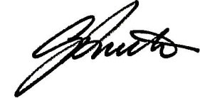

Graham Smith

Chair – RDA Mackay-Isaac-Whitsunday

i Mackay Regional Council 2017, Economy Profile - Gross Regional Profile, viewed 31st July 2017,

<http://www.economyprofile.com.au/mackay/industries/gross-regional-product>

ii Department of Natural Resources and Mines 2016, Coal industry review statistical tables – production by individual mines

2015-2016, viewed 31st July 2017, https://data.qld.gov.au/dataset/coal-industry-review-statistical-tables/resource/9c3c1aaf-

0afa-4e58-b67c-75c0d3574abd

iii Department of Transport and Main Roads 2016, Trade Statistics for Queensland Ports – 30 June 2015, viewed 31st July 2017,

https://[www.tmr.qld.gov.au/Business-industry/Transport-sectors/Ports/Trade-statistics-for-Queensland-ports.aspx](http://www.tmr.qld.gov.au/Business-industry/Transport-sectors/Ports/Trade-statistics-for-Queensland-ports.aspx)

iv North Queensland Bulk Ports trade statistics, viewed 31st July 2017.

v RDA MIW 2016, MIW Agricultural Overview, viewed 31st July 2017, <http://www.rdamiw.org.au/Agri%20Overview/MIW_Agri%20Overview_Final_A_17.8.16_Low%20Res.pdf>vi Infrastructure Australia 2016, Australian Infrastructure Plan, viewed 31st July 2017,

<http://infrastructureaustralia.gov.au/policy-publications/publications/files/Australian_Infrastructure_Plan.pdf>

vii Regional Australia Institute 2016, Deal or No Deal? Bringing Small Cities into the National Cities Agenda, viewed 31st July

2017, <http://www.regionalaustralia.org.au/home/wp-content/uploads/2016/04/Deal-or-No-Deal-Bringing-Small-Cities-into-the->National-Cities-Agenda_April-2016_FINAL.pdf

Supported by:

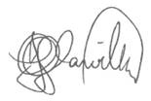

John Glanville – Chairman

Greater Whitsunday Alliance Ltd.

“Regional Opportunity – Strong for Generations”

