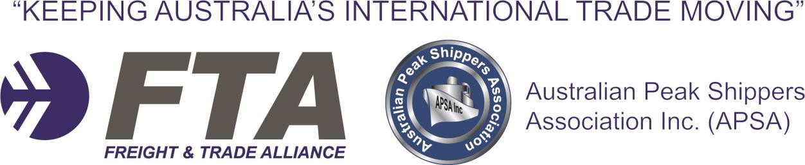

**Federal Inquiry into Freight & Supply Chain**

**Priorities**

Submission by the Australian Peak Shippers Association

Freight & Trade Alliance

And Associated Industry Bodies

1. About the peak bodies and extent of representation

The Australian Peak Shipper Association (APSA) is the peak body for Australia’s containerised exporters. APSA currently represents more than 500,000 standard containers on export annually, making it Australia’s largest representative group of outbound containerised cargo. APSA is a not- for-profit Association led by a Board of Directors representing the top containerised exporters by volume, representing dairy, cotton, paper and grain interests.

**Board of Directors/Office Holders**

Chairman: Mr. Paul Blake (Managing Director, Cloud Global Logistics) Treasurer: Mr. Dominic Dillon (Trade Execution Manager, Cargill)

Director: Mr. Sean Richards (Executive General Manager- Logistics, Visy Industries) Director: Mr. Michael Lamperd (Group Transport Manager, Bega/Tatura)

Director: Ms. Olga Harriton (Global Logistics Manager, Manildra Group)

Director: Ms. Caylene Wright (National Distribution Manager, Barrett Burston Malting)

Director: Ms. Eimear McDonagh (GM- Export Marketing & Logistics, Namoi Cotton/Director of the

Australian Cotton Shippers Association)

Director: Mr. Andrew Wilson (GM, King and Wilson Worldwide Moving/Director of the Australian

International Movers Association)

**Associations in support of the submission**

APSA provides advocacy support to the Australian Horticultural Exporters Association (AHEA), the Australian Cotton Shippers Association (ACSA) and the Australian International Movers Association (AIMA). ACSA has provided a submission (Appendix 1) in support of the APSA submission, of which relevant sections have been included in this document. AHEA has provided a letter of support for the Department’s consideration (Appendix 2).

**Freight & Trade Alliance**

Freight & Trade Alliance (FTA) is an industry body representing 275 international trade entities, including high-volume importers and freight forwarders. FTA is represented on the National Committee for Trade Facilitation (NCTF), the Department of Agriculture Cargo Consultative Committee (DCCC) and the Office of Transport Security Cargo Executive Committee. In October

2016, Freight & Trade Alliance was appointed to run the APSA Secretariat for a period of five years.

2. Executive Summary

This combined submission to the Federal Inquiry into Freight & Supply Chain Priorities, completed by the Australian Peak Shippers Association (APSA) and the Freight & Trade Alliance (FTA), encapsulates the following twelve (12) recommendations:

**Recommendation 1:**

That the National Freight Strategy engages relevant State Governments to strengthen stevedore rent and other price controls for all future port privatisations, with particular reference to the potential privatisation of the Port of Fremantle.

**Recommendation 2:**

An expansion of the regulatory powers of the Australian Competition and Consumer Commission (ACCC) to ensure that stevedore charges are fair, appropriately applied, not excessive and not prohibitive to Australia’s economic growth. This may require amendments to the *Competition and Consumer Act 2010* to better reflect the unique environment of our international container terminals where competition is restricted and where cargo owners cannot exercise their market power.

**Recommendation 3:**

That the Inquiry seeks clarification from the stevedores on their agreements with shipping lines (their commercial clients), to ensure that service prices with their shipping lines have not been reduced at the same time mandatory access fees on port users have increased by more than 900%.

**Recommendation 4:**

That the Inquiry reviews the outcomes achieved by the NSW Government via the PBLIS reforms, and examines the opportunity of working with the Victorian and Queensland Governments in introducing similar mandatory standards for carriers and stevedores.

**Recommendation 5:**

That transparency in vehicle booking system slot availability be provided to third parties such as approved freight forwarders and importers

**Recommendation 6:**

That Container Examination Facility (CEF) targeted containers have storage arrangements prescribed in Melbourne, Brisbane and Fremantle ports to meet the benchmark established in Sydney under the Port Botany Landside Improvement Strategy (PBLIS) Mandatory Standards.

**Recommendation 7:**

That extended container detention periods be provided by shipping lines whereby cargo has been reported in terms of statutory requirements with evidence that delayed release from the stevedore is due to CEF intervention.

**Recommendation 8:**

That cargo owners, and their peak bodies, as the end-users, are engaged directly and specifically in the approval of all future toll regimes and planned increases.

**Recommendation 9:**

That the Inquiry recommends a deferral on the repeal of Part X, currently being considered by

Cabinet, until such time that Minimum Levels of Service (MLS) can be assured from independent shipping lines and consortia, or until equal protections are achieved for Australian cargo owners.

**Recommendation 10:**

That funding is allocated to the development of a forecasting tool for our agri-exporters to provide full transparency of container availability.

**Recommendation 11:**

That the Inquiry examines international carrier surcharges in their review of international supply chain costs.

**Recommendation 12:**

That Australia follows the lead of other countries in introducing protections from inflated shipping line surcharges, via legislation, or through the expansion of Part X to include terminal handling and sundry charges. This could include mandatory “sunsets” on shipping line surcharges.

3. Comments regarding the Terms of Reference

APSA acknowledges the stated goal of this Inquiry as its appears in the Terms of Reference:

“The Australian Government is seeking to improve freight and supply chain efficiency and capacity and to reduce the costs of transporting goods through our major national container ports, airports and intermodal terminals.”

When reflecting on the current environment faced by cargo owners, the importance of this Inquiry is clear. In the last five years, we have seen the privatisation of our major container ports. In the last twelve months, we have seen an unprecedented increase in terminal access fees, with no commensurate increase in terminal productivity and accountability. As it stands today, only one major port in Australia has an independent regime regulating stevedore productivity and landside performance, the Port Botany Landside Improvement Strategy (PBLIS) at Port Botany. It is in this environment, of increasing costs and limited regulatory power, that we provide our submission to the Department of Infrastructure and Regional Development.

The APSA submission therefore seeks to:

1. identify the areas of increasing costs faced by freight and supply chain owners, particularly relating to our ports;

2. identify areas of inefficiency in the Australian container logistics chain, particularly relating to the operation of our terminals;

3. highlight the changing market conditions faced by our cargo owners that were not represented in the Discussion Paper;

4. present recommendations that will serve to reduce supply chain costs faced by Australian cargo owners; and

5. present recommendations that will ensure that private port owners and terminal operators are held to account for the productivity and performance of their leased assets.

4. Summary of Evidence

APSA’s submission will focus on the following evidence:

1. Port privatisation and price controls for future privatisation events (p.6)

2. Terminal Access Fees & the Vehicle Booking System (p.7)

3. Regulation and operation of our ports and terminals (p.10)

4. Cargo subject to border intervention (p.12)

5. Impact of toll increases on export competitiveness (p.14)

6. Shipping line consolidation and competition concerns (p.15)

7. Container inventory (p.17)

8. Ocean freight costs and unregulated surcharges (p.19)

5. Port Privatisation and price controls for future privatisation events

In September 2016, the Port of Melbourne lease was sold to the Lonsdale Consortium for $9.7BN, overshadowing the $4.3BN lease price for NSW Ports in 2013.

Historically, APSA and FTA identified the potential benefits that industry may see from port privatisation, including the increased competition between ports, as outlined in our Australian Financial Review editorial, *Private Ownership in a Safe Port* (Australian Financial Review, June 25,

2014). This has certainly been the case with APSA members such as Visy and Casella, located in the

contestable trade region of the Riverina, reporting an increase in incentives and services offered by the port leaseholders to attract their business.

However, concerns were raised at the time, particularly in the case of the Port of Melbourne lease transaction, that high lease values would foreshadow future price increases for port users. In

2014/2015 the Port of Melbourne made EBIT of only $121M. An investment return on a $9.7BN investment would require substantial increases in revenue, either through increased container throughput (largely not in their control and driven by economic factors), an increase in return on the land (through increasing stevedore rents) or an increase in fees and charges.

To this end, in 2015, while preparing for the lease sale, the Port of Melbourne attempted to increase the rent on DP World’s Swanson Dock facility by a factor of 767%. This move drew attention from the Prime Minister at the time, commenting in Parliament that “the Victorian Labour government is penalising the exporters of Tasmania by ever increasing the fees and charges in the Port of

Melbourne.” APSA and FTA were part of a coalition of peak bodies at the time that led the opposition

to the increased rent.

In NSW this issue has largely been addressed via “performance-based leases” where rent incentives can be granted to stevedores for productivity improvements. In Melbourne, prices for prescribed services are regulated by the Essential Services Commission (ESC) and are capped to CPI for 15 years, but stevedore rents are not regulated by the ESC.

In July 2016, the Chairman of the Australian Competition and Consumer Commission (ACCC), Mr Rod Sims, concluded that “ports privatisation was the best example of the approach that had turned him off privatisation as a policy” and that “it is increasing prices - let's just call it out."

While Australia’s two major container ports have already entered into long-term lease agreements, the

National Freight Strategy still has a role to play in guiding future port privatisation events.

**APSA Recommendation 1:**

That the National Freight Strategy engages relevant State Governments to strengthen stevedore rent and other price controls for all future port privatisations, with particular reference to the potential privatisation of the Port of Fremantle.

6. Terminal Access Fees

In early 2017 Australia’s two largest container terminal operators, Patricks (now owned by Qube) and DP World Australia, dramatically increased “Terminal Access Fees” for all laden import and export containers. In the case of the DPWA Swanson Dock Terminal, this represented a 980% fee increase per container. This fee was imposed on all landside port users for access to the terminals and was executed without consultation, without negotiation and with no opportunity to exercise market power, as cargo owners have no direct commercial relationship with stevedores. This announcement effected the largest three container ports in Australia- Sydney, Melbourne and Brisbane.

Both the terminal operators blamed “increased tenancy costs” in their respective notices, a nod to privatisation. This is despite the fact that:

• at the time of the notice, Patricks had not yet finalised their new lease agreement with the Port of Melbourne;

• according to a NSW Ports Media Release (21/07), “Patrick’s total rent per square metre of occupied land area has dropped slightly between FY2017 and FY2013 (pre-privatisation);

• Patrick’s quoted a backdated rent increase, which the Port of Melbourne has since denied; and

• DP World Australia, with the support of APSA and other bodies, successfully fought and reduced their 767% rent increase with the Port of Melbourne.

The suggestion that cargo owners can simply change shipping lines to change stevedores is not valid. Together DPWA and Patricks hold more than 70% market share and many shipping lines have entered mid-term agreements with those stevedores.

APSA and FTA hold the firm position that operating costs should be recovered by the stevedores through their commercial clients, the shipping lines, where normal market forces would have applied.

On Friday 24 March 2017, FTA and APSA participated in an industry roundtable with the ACCC in respect to the surcharges. The ACCC specifically looked at whether the terminals had:

• misused their market power;

• been unconscionable in its conduct; and/or

• engaged in unfair contract terms.

The ACCC expressed to FTA and APSA that while the behaviour was clearly “unfair”, it was not illegal and they could not pursue the stevedores within the limitations of the *Competition and Consumer Act 2010.*

Ironically, increased competition in the stevedoring/container terminal market (as heavily promoted by the ACCC) has resulted in DPWA/Patrick/HPA/VICTL conceding more to shipping line clients to win/retain business, and hence their focus on revenue supplements from powerless landside users.

**Concerns regarding these fees**

APSA has expressed a clear concern to the Inquiry: with no intervention, we are likely see regular and ongoing increases in terminal access fees, with no commensurate increases in productivity or efficiency.

While private port leaseholders are subject to price controls under legislation, the price regulation of terminal operators is clearly not adequate.

**Additional Costs of Collection**

In addition to the stevedore fees, FTA & APSA have received reports of “Admin Fees” charged by transport operators to cover the cost of collecting the “Terminal Access Fees”, sometimes cushioned with in-built margins. In short, a $25 charge can become more than $35 per container, with no additional productivity benefit.

**Impact of the terminal access fees**

APSA and FTA have received several statements from our members demonstrating the impact of this behaviour.

Members responsible for grain exports have reported that exorbitant increases in “Terminal Access Fees” have increased the price of containerised grain out of Australia by more than $1 a tonne, making our exports less competitive.

The following comment was received by one of Australia’s largest exporters by volume in relation to

the charges:

“In a global market, exporters simply do not have the ability to pass-on increases borne out of inefficiencies - the realistic scenario is either margin depletion or exiting from a particular trade. Either way, in an enduring unregulated environment, exporters will most likely be negatively impacted by reduced trade volumes and reduced capital spend.”

Another member, one of Australia’s largest containerised importers by volume, estimates the impact on their bottom line to be over $1m a year, a cost that may need to be passed onto consumers, increasing the cost of consumer goods.

**As the largest new and unregulated cost facing Australia’s import/export supply chain, this behaviour must be within scope of the Inquiry, particularly considering the Terms of Reference.**

**APSA Recommendation 2:**

An expansion of the regulatory powers of the ACCC to ensure that stevedore charges are fair, appropriately applied, not excessive and not prohibitive to Australia’s economic growth. This may require amendments to the *Competition and Consumer Act 2010* to better reflect the unique environment of our international container terminals where competition is restricted and where cargo owners cannot exercise their market power.

**APSA Recommendation 3:**

That the Inquiry seeks clarification from the stevedores on their agreements with shipping lines (their commercial clients), to ensure that service prices have not been reduced at the same time mandatory fees on landside port users have increased by more than 900%.

7. Regulation and operations of our ports and terminals

While Port of Botany has the Cargo Movement Coordination Centre and the benefits of the Port Botany Landside Improvement Strategy (PBLIS), other Australian ports do not have such independent controls.

As a result, we have an inconsistent regulatory regime between our major international container

ports. With no PBLIS-type regime, poor terminal operator performance in Melbourne and Brisbane is not met with commercial penalties, despite the surge in access fees.

In 2010, PBLIS was created after the Independent Pricing and Regulatory Tribunal (IPART) found that:

• bottlenecks at the port caused congestion on the wider Sydney road network;

• waiting times for trucks were often unreasonably long;

• stevedores were unable to service trucks within the timeslot booked due to a lack of clear rules around terminal delays;

• ineffective working relationships between stevedores and truck drivers were hurting supply

chain operations; and

• there was no performance data available about landside operations.

PBLIS certainly has its critics and it was born out of significant operational delays that we do not currently see in Brisbane and Melbourne. However, what PBLIS provides, above all, is a transparent and accountable operational environment.

On a day-to-day basis PBLIS has legislated structures to achieve reduced truck turnaround times, higher truck utilisation (containers per truck), less peak hour movements and increased rail mode share targets.

From a cargo owner’s perspective, Port Botany sets a national benchmark in efficiency as a “waiting time detention free port” giving freight forwarders and importers predictability in delivery times and cost. This has been achieved via the PBLIS regulation which prescribes that compensation is payable to or from stevedores and transport operators for failure in meeting the Mandatory Standards. In the event that delays occur at the stevedore in excess of prescribed Truck Turnaround Times (TTT), the stevedore must financially compensate the transport operator. In contrast, at other Australian ports, costs caused by extensive TTT are either absorbed by the transport operator or passed on to their client freight forwarder or importer.

In an environment of increasing costs with no commensurate increase in productivity or efficiency, APSA recommends that mandatory standards be introduced to Brisbane, Fremantle and Melbourne, in line with the PBLIS standards, to ensure minimum and consistent levels of terminal performance and landside productivity across the country.

**Recommendation 4:**

That the Inquiry reviews the outcomes achieved by the NSW Government via the PBLIS reforms, and examines the opportunity of working with the Victorian and Queensland Governments in introducing similar mandatory standards for carriers and stevedores.

**Staged container movements**

While PBLIS has generated clear benefits, the down side is that stevedores have understandably become risk averse and tend to commit only to supplying the minimum prescribed number of slots per hourly zone to ensure that they can meet TTT. As a result, there has been an increasing trend for import containers to be “staged” with less road deliveries direct from the stevedore to the importer during regular business hours. Staging occurs via rail to intermodal terminals or via road transport to an operator’s holding yard with a secondary delivery to the importer. Double handling of container movements generates increased logistics costs and has become a common practice in both Port

Botany and Melbourne operations.

From a cargo owner’s perspective, more transparency is required in the slot booking process. Currently the 1-Stop Vehicle Booking System (VBS) has restricted access to those only that have a Carrier Access Agreement with the stevedores. As a part of PBLIS, we understand that Transport for NSW is currently developing a mobile device application that will provide freight forwarders and importers visibility to slot availability. We wait with interest to see this functionality and the potential to replicate a similar service at other container ports.

While stevedores service levels are generally improving, extensive TTT continue to be reported at particular LCL deconsolidation depots and at empty container parks (ECPs). While ECPSs have deployed booking systems (two suppliers being Containerchain and 1-Stop), we understand that poor compliance by transport operators in meeting allocated slot times for empty container returns has adversely affected ECP efficiency. We anticipate that ECPs will progressively implement “disciplines” to ensure compliance with slot bookings with perhaps the need for PBLIS style regulation to ensure that both ECPs and transport operators meet prescribed service levels.

**Recommendation 5:**

That transparency in vehicle booking system slot availability be provided to third parties such as approved freight forwarders and importers.

8. Cargo subject to border intervention

The Container Examination Facility (CEF) utilises modern technology to enable the Australian Border Force (ABF) to fulfil its border protection role. The ABF has stated approximately 90% of containers selected for examination are x-rayed, released within 30 minutes and immediately returned to the stevedore. The remaining 10% may incur some form of delay as they are selected for more detailed physical examination.

To minimise associated costs incurred for delayed release of cargo, it is essential that importers supply timely and accurate import data, permits and documentation to customs brokers in order to meet statutory requirements. In the event that a container is subject to further ABF CEF assessment, storage fees are administered by stevedores despite the fact the container may not be physically available for collection. To be eligible for the extended storage arrangements, the cargo report has to be provided to the ABF in line with statutory provisions and the Import Declaration has to be lodged at least 24 hours prior to the vessel arrival at the port of discharge.

Below is a summary of operational responses by stevedores on a port by port basis:

• **Adelaide, Darwin, Launceston (Bell Bay), Townsville and Newcastle -** Assuming the

above reporting and declaration requirements have been satisfied, containers selected for CEF intervention will receive existing storage arrangements (a minimum of three days) from when they are returned from the CEF.

• **Melbourne, Brisbane and Fremantle -** Assuming the above reporting / declaration requirements have been satisfied, containers selected for CEF intervention will receive 24 hours free storage from when they are returned from the CEF.

• **Sydney -** Clause 72 of the Port Botany Landside Improvement Strategy (PBLIS) Mandatory Standards states that stevedores must provide free storage for the day the container is returned from the CEF and for the next two days after that. Again, these extended storage

arrangements are contingent on the above reporting / declaration requirements being satisfied.

**Recommendation 6:**

That CEF targeted containers have storage arrangements prescribed in Melbourne, Brisbane and

Fremantle ports to meet the benchmark established in Sydney under the PBLIS Mandatory Standards.

**Detention fees for late container de-hire**

While the ABF has in place procedures with stevedores, to date there are no similar arrangements in place with shipping lines. Whether or not reporting has been completed within prescribed timelines, shipping lines commonly charge a fee if containers are not de-hired (returned) to an empty container park within agreed terms. FTA has approached the ABF to assist our advocacy with individual shipping lines to challenge the rationale of starting the container detention clock from discharge instead of availability after CEF processing.

**Recommendation 7:**

That extended container detention periods be provided by shipping lines whereby cargo has been reported in terms of statutory requirements with evidence that delayed release from the stevedore is due to CEF intervention.

9. Impact of toll increases on export competitiveness

APSA members have expressed concerns to State and Federal Governments that substantial increases in road freight tolls can no longer be absorbed by transport operators and are now being passed on, in full, to Australian exporters, adding to supply chain costs and impacting the international competitiveness of our goods. While APSA members appreciate the necessity of public-private partnerships, we believe that greater consideration needs to be given to cargo owners, the end-users,

in the decision-making process through better and more focused industry engagement.

The most recent example of this is the Citylink operator Transurban who recently increased daily rates for road usage to $26.70 from April 1, up from $11.85. This increase was designed to recover costs from the Citylink/Tulla widening project. Because of this increase, one APSA member has directed their transport operator to use a less efficient alternative arterial road, to maintain their cost position.

In the case of the Transurban increase, Victorian Roads Minister Luke Donnellan has clarified that the toll increases were announced in 2014 before the commencement of the project. We believe that insufficient industry engagement took place with freight owners in these processes, despite cargo owners being liable for the full cost impact of those increases. The poor industry engagement was reflected in the industry outcry that occurred after the announcement and the subsequent media coverage.

**Recommendation 8:**

That cargo owners, and their peak bodies, as the end-users, are engaged directly and specifically in the approval of all future toll regimes and planned increases.

10. Shipping line consolidation and competition concerns

Australia’s international supply chain is wholly dependent on foreign shipping line services. Traditionally foreign shipping lines have used exemptions from Part X of the *Competition and Consumer Act 2010* to form consortia. Part X requires oversight from the Registrar of Shipping and peak shipper bodies, giving shippers some level of protection by ensuring that Minimum Levels of Service (MLS) are not reduced.

However, the market has entered a period of hyperactive consolidation, reducing choice for Australia’s cargo owners and making it more difficult to push back on increasing rates and surcharges. With 99% of Australia’s trade by volume carried by sea transport (ref: Department of Infrastructure and Regional Development website), this requires the attention of the Inquiry and deserves to be addressed in the National Freight & Supply Chain Strategy.

Major recent events included:

• the acquisition of Hamburg Sud by Maersk;

• the acquisition of OOCL by Cosco;

• the exit of NYK from Australian Services;

• the mooted acquisition/takeover of Yang Ming Line (YML); and

• the collapse of Hanjin.

Through this period of consolidation, cargo owners have reported a sharp increase in shipping lines recovering revenue from Australian shippers via spurious surcharges.The power to push back on these charges is limited with shipping lines forming global strategic alliances, where members of an alliance cannot compete with each other on important dimensions of competition on a particular route –

namely capacity, sailing frequency, ports of call, transit times and service quality. Most of the world’s trade is now covered under three main global strategic Alliances (please see overleaf). This substantial market power will allow the shipping lines to manipulate capacity as they see fit.

While Shipping Australia Limited (SAL) and other groups have stated that the Alliances are not active on Australian routes (north-south), they admit that they dominate the East-West trade, which Australian cargo regularly joins in our trading relationship with Europe & Asia.

It is important to note that these alliances often sit outside of the regulatory power of Part X, as they are not mirrored by the structure of Vessel Sharing Agreements and other agreements registered under Part X.

APSA is concerned that the creation of global strategic alliances and the exiting of shipping lines from Australian services is placing significant pressure on Australian cargo owners and shifting the market power away from them.

While the Harper Review recommended the repeal of Part X, it is important to note that it is currently the only device which guarantees Minimum Levels of Service (MLS) for Australian cargo owners. Removing these protections, the only protections that currently exist, at a time of considerable change and consolidation in global shipping, represents a real risk to Australia’s international supply chain.

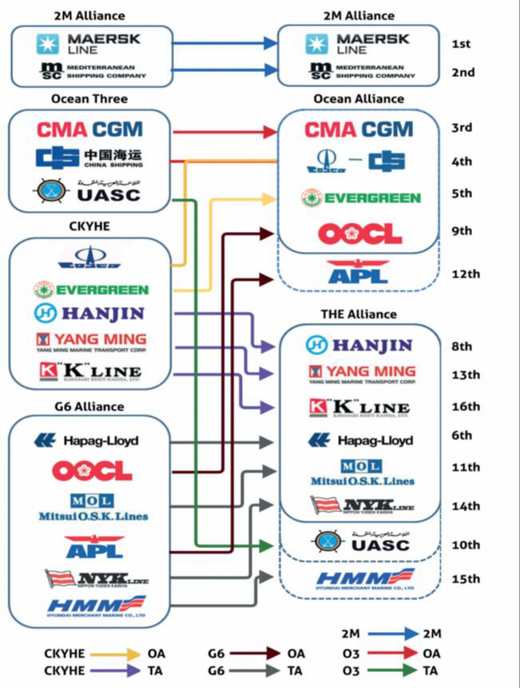

*2016: Strategic Alliance (Ref: Global Shippers Forum, Mega Ships and Alliances Report)*

**Recommendation 9:**

That the Inquiry recommends a deferral on the repeal of Part X, currently being considered by Cabinet, until such time that Minimum Levels of Service (MLS) can be assured from independent shipping lines and consortia, or until equal protections can be achieved for Australian cargo owners.

11. Container inventory

In January 2017 APSA and FTA received urgent feedback from our agri-exporter members regarding a major shortage of equipment, specifically the availability of food quality 20ft empty containers for export. The shortage affected major shipping lines including Maersk and ANL.

In this environment, many shipping lines introduced extra fees on shippers, including, in some instances, a 100% increase in cancellation fees and what some members regard as an excessive “repositioning fee” for access to containers, reported to be over $200 per container. APSA received reports that some shippers were forced to change shipping lines or roll shipments as they were unable to get the required equipment.

Deeply concerning were the accusations that shipping lines were manipulating inventory, sending vessels to Australia to collect empty 20-foot containers and repatriating them to other parts of the world. The lines concede that vessels had visited Australia during that period to collect empty containers but only collected 40-foot containers, where there was an oversupply. The lines maintain that the shortage of food grade 20-foot containers was a result of high demand, not reduced supply.

FTA and APSA concede the challenges of supply and demand. The 2016-17 Australian grain harvest was an unprecedented 58.9 million tonnes, *49% higher* than the previous year. The vast majority of this is shipped in bulk but huge tonnages have been moved in boxes. It is easy to see how such an event could create a “capacity shortage”.

However, there is no gain in Australia signing Free Trade Agreements and yielding record grain crop

outputs, if we don’t have the availability of shipping line services and equipment to get our products

to international markets. Australia should have a freight advantage that is not subject to an operational environment that makes us uncompetitive.

If the shortage is the result of a sudden freight surge, as the lines suggest, then shippers and shipping lines need to have a close look at their equipment planning processes, particularly in how they work with seasonal agri-exporters.

While Australia imports merchandise largely using 40’ containers, we are still reliant on 20’

containers for our exports due to weight restriction requirements at destination ports.

Australian cargo owners need better transparency on the availability of these containers, particularly as we become more reliant on agri-exports for our balance of trade.

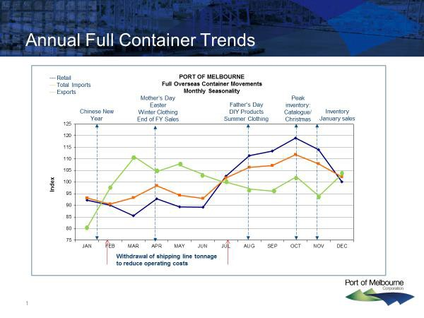

*Ref: Port of Melbourne. As you can see, import and export peaks are inversely related*

More advanced technology needs to be developed and utilised in matching container supply with container demand, particularly with our reliance on foreign-owned shipping lines in providing this equipment when needed.

Data61, an arm of the CSIRO, has met with the APSA Board of Directors and have confirmed that they have the capability to develop such a tool, with appropriate funding**.**

**Recommendation 10:**

That funding is allocated to the development of a forecasting tool for our agri-exporters that can be used in peak season container planning.

12. Ocean freight costs and unregulated surcharges

Shipping line consolidation has created a new market dynamic, where Australian shippers are subject to more and more unfair and spurious charges. This is not an Australian phenomenon with the United States, Vietnam, Sri Lanka, and other countries, introducing legislation to stop the practice.

Sri Lanka led the way with legislation introduced in early 2014, effectively banning surcharges, requiring an “all in rate”, and championing the philosophy that the contracted fee should be the fee. Shipping lines are required to quote one rate and shippers/forwarders can choose their preferred shipping line on that basis. If the cost environment changes, then the lines can absorb the cost or pass it on in their next quote. The International Chamber of Shipping has opposed this model outright, while the Global Shippers Forum, of which APSA is Australia’s representative, has applauded the move.

In Vietnam, a requirement now exists that forces all lines to publicise all charges, including surcharges, to ensure absolute transparency. The move was driven by the Vietnam Textile and Garments Association, which accounted for 90% of boxes in imported and exported from that country.

**Export capacity concerns during peak season**

After years of overcapacity, APSA members are now reporting a reduction to the capacity on the berth for Australian containerised exports.

Shippers have also reported an increasing number of cancelled bookings, cargo rollovers and blank sailings.

While these capacity issues may have arisen from the record grain output, the issue still comes down to inaccurate planning and forecasting between shipping lines and shippers.

The concern exists that many of these surcharges (Peak Season surcharges, for example) are due to these capacity and planning issues.

Australian supply chain owners need cost security and cost transparency, particularly at a time when supply chain costs are increasing.

**Recommendation 11:**

That the Inquiry examines international carrier surcharges in their review of international supply chain costs.

**Recommendation 12:**

That Australia looks to introduce similar protections from inflated rates and surcharges, via legislation, or through the expansion of Part X to include terminal handling and sundry charges. This could include mandatory “sunsets” on shipping line surcharges.

**Contacts for comment or clarification**

Australian Peak Shippers Association

Travis Brooks-Garrett Secretariat [secretariat@auspsa.com](mailto:secretariat@auspsa.com)

Freight & Trade Alliance

Paul Zalai Executive Director [pzalai@ftalliance.com.au](mailto:pzalai@ftalliance.com.au)