Logo: .auda .au Domain Administration Ltd.

Level 17, 1 Collins Street, Melbourne, Victoria, Australia, 3000
Ph: +613 8341 4111 Fax: +613 8341 4122 Email: info@auda.org.au Web: www.auda.org.au
.au Domain Administration Ltd ABN: 38 079 009 340


decorative; auDA colours

Ms Vicki Middleton  
First Assistant Secretary  
Department of Communications and the Arts  
Australian Government  
2 Phillip Law Street Canberra ACT 2601

19 August 2019

Dear Vicki,

# Further Consultation on the new .au Licensing Rules

In response to your letter of 5 August 2019, auDA thanks the Department for your comments on the proposed new Licensing Rules following your cross­ agency consultation. The auDA Board considered the Department's letter at its Board meeting on Monday, 19 August 2019.

auDA notes that the new Licensing Rules are a result of consolidating and updating 33 existing policies to reduce regulatory burden on registrants and registrars, and to improve the utility of the .au domain. The new rules have also taken into account the recommendations from the 2017 Policy Review Panel, which conducted extensive public consultation on the implementation of registration at the second level of .au (forexample.au), as well as other changes to the Licencing Rules. The new rules incorporate the majority of processes under the existing auDA Published Policies, with only some key areas being updated to reflect best practice.

## Public Interest Test

auDA appreciates the Department's offer to facilitate a workshop between representatives from auDA and officials from relevant government agencies to work through issues of concern with the proposed policy, and revise relevant sections of the rules, ahead of further public consultation. auDA will prepare a briefing note for the Department on the public interest test as background material for that meeting.

auDA notes that under the existing mandatory terms and conditions applying to domain name licences in .au (<https://www.auda.org.au/policies/index-of-­published-policies/2008/2008-07/)>, auDA may, at its discretion, cancel the registration of a .au domain name, or revoke a licence to use a .au domain name in order to comply with a request of a law enforcement agency, or an order of a court, or under any applicable law, government rule or requirements, or under any dispute resolution process. The proposed Public Interest Test was intended to provide more rigour to current provisions.

auDA notes that it is established as an Australian Public Company, Limited by Guarantee, and as such must comply with Australian legislation such as the Privacy Act 1988 with respect to the disclosure of personal information.

## Removal of allocation rules for com.au and net.au registrations

auDA notes the Department's concerns that the removal of the allocation rules for the com.au and net.au name spaces is a significant departure from the longstanding registration policy.

In response auDA will reinstate the close and substantial connection categories in the com.au and net.au name spaces, whilst undertaking further public consultation on the possible alternatives including: the current close and substantial connection rule, and the refinements suggested by the Policy Review Panel.

## Public and Government Consultation

auDA notes the Department's feedback that there needs to be a comprehensive dialogue with key stakeholders based on a mutual understanding of the potential impact of the proposed changes.

It is auDA's intention to develop a comprehensive stakeholder consultation program for an additional intensive 12-week period. To assist with this consultation, auDA will publish an explanatory statement for the Licencing Rules that will identify where the existing 33 policies have been retained, and where changes have been made. If a change has been made, auDA will establish a case for why the change was needed, identify all feasible policy options that were considered, and identify the impact on stakeholders and the broader Australian community.

Where auDA makes changes to the consolidated Licencing Rules that were approved by the auDA Board in June 2019 (subject to receiving feedback from the Department), auDA will provide a redline version of the changes to the rules, and will provide a statement setting out why the changes have been made.

The public consultation will consist of:

* outreach to Internet users in the form of advertising in trade media, providing targeted digital and social media information, and providing updates on the auDA website
* public forums for Internet users at venues in Sydney, Melbourne, and Canberra, as well as an online forum
* targeted communications to interest groups, clearly explaining how the licencing rules may affect them, including:
  + Government agencies such as the Department of Employment, Skills, Small and Family Business, the Australian Small Business and Family Enterprise Ombudsman, and IP Australia
  + Consumer groups, including the Australian Communications Consumer Action Network (ACCAN) and Internet Australia
  + Intellectual property community
  + Business Interests
  + Not-for-profit organisations and unincorporated associations
* the forms of engagement will be adapted to the needs of each group but will include a mix of written correspondence, face-to-face meetings, and group presentations

In addition, auDA would welcome the Department's assistance to facilitate a forum for affected Government agencies in Canberra, and also list auDA's public consultation on the Government's list of public consultations.

auDA appreciates and thanks the Department for your support for the implementation of the new Licencing Rules, following the additional comprehensive community consultation to achieve general consensus on the changes.

Yours sincerely,

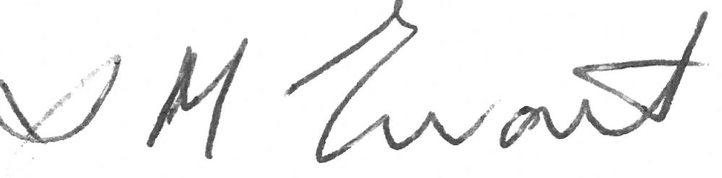

Ms Suzanne Ewart

Chair