

Frequently Asked Questions

Withdrawal of National Relay Service support for CapTel handsets
Concentrix Services Pty Ltd has been selected as the new provider to deliver the National Relay Service (NRS) for the next 3 years bringing new features and enhancements.
For most users, all existing relay call options through the NRS will remain available with some enhancements and no action is needed. Users of the CapTel handset will need to switch to an alternative device to continue using the NRS.

What is happening with the CapTel handset?
Access to a captioned relay service through the CapTel handset will not be supported under the new NRS arrangements. Alternative captioned services will be provided through the NRS. Captions through the CapTel handset are expected to be available until 31 January 2020.

Why is support for the CapTel handset being withdrawn?
The proprietor of CapTel has not, to date, agreed to work with the new NRS provider, Concentrix.

What are the communications options available through the NRS that are most like using the CapTel handset?
There are 2 options available through the NRS which allow you to speak your side of the conversation and receive captions of the other person’s words:
- NRS Captions (currently called Web Browser Captioned Relay), and
- Speak and Read TTY.
In addition to providing captions, both of these services will also provide the option to listen to the other person’s words.

How do you make a call using NRS Captions?
• You will be able to make a call through NRS Captions on almost any device with an internet connection. You will also need a phone connection. You can use a number of different combinations of equipment:
- home computer and landline or mobile phone
- home computer with headset
- tablet (e.g. iPad)
- tablet and landline or mobile phone
- a smartphone (iPhone or Android phone).
- With NRS Captions, you will be able to speak on your smartphone or telephone handset and read the other person’s words which will appear as captions on your device.
- The captions are generated by the relay officer re-speaking the words of the other party. Voice recognition software converts this into text which is transmitted to your device as captions.
- You will also be able to listen to the other person’s voice if you want to. The volume can be turned up, down or off according to your preferences.
- Just as with the CapTel handset, there will be a short delay as the hearing person’s words are captioned.
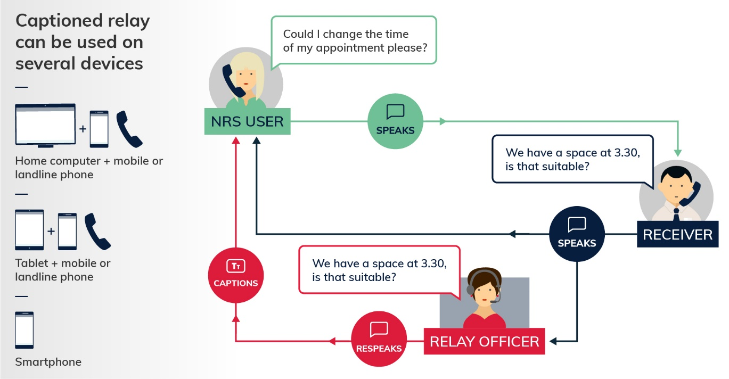

Are there any advantages to using a smartphone for NRS Captions?
- If you are using a smartphone you will only need one piece of equipment. If you have the phone on speaker or use a headset/headphones with a microphone you can use the smartphone phone to speak and listen and read the captions on the screen at the same time.
- You can save phone numbers you use to your contacts on your smartphone.
- As smartphones are mobile you will be able to use them to make an NRS Captions call anywhere at home or work or when you are out.

I have been using a CapTel handset. I don’t think I have internet access. What should I do?
CapTel captions are currently delivered over the internet so if you have a CapTel handset, then you have internet access.

I am a CapTel user and have access to a desktop computer, a tablet or mobile phone but don’t really know how to use them. What help is available?
There are step-by-step information resources available on Accesshub to show you how to make calls through the current NRS Web Browser Captioned Relay option. These step-by-step instructions will be updated closer to the release of the new NRS Captions service to reflect any changed steps.
If you would like one-on-one help to get familiar with using these devices, either get in touch with the NRS Helpdesk or fill in this questionnaire available at communications.gov.au/accesshub. The information you provide will help us workout how we can best help you. After we have received your completed questionnaire, we will get in touch to provide you with further assistance.

How do you make a call through the NRS using the Speak and Read TTY option?
- Using the handset of a Teletypewriter (TTY), you can speak your side of the conversation and read the captions of the other person’s words on the TTY screen.
- Unlike the CapTel phone, where the other person’s words appear in blocks of text, with a TTY, the captions will appear letter by letter shortly after the other person speaks. This can make it easier for you to quickly recognise words spoken by the other person.
- The captions which appear on the TTY screen are generated by the relay officer typing the words of the other person.
- The Uniphone handset also features volume control.
- The new Speak and Read TTY option will include the option of also listening to the other person’s words. The volume can be turned up, down or off according to your preferences.

But I don’t have a TTY. What can I do?
Some Uniphone TTYs will be made available for rent with no rental costs. Please let the NRS Helpdesk know if this is the option you would like to use.

What support is available to learn how to use these NRS options?
- The NRS Helpdesk is available to assist with any further information you need.
- There are step-by-step instructions available on Accesshub to show you how to make calls through the current Speak and Read TTY and Web Browser Captioned Relay services through the NRS. These instructions will be updated closer to the release of the new services.
- One-on-one sessions at the location of your choice will also be available. These sessions will focus on:
- Getting you familiar with smartphones, tablets or desktop computers.
- Step-by-step use of the NRS Captions service using the device of your choice.
- Step-by-step use of the NRS Speak and Read service on a Uniphone TTY.

But with the CapTel phone I don’t have to use the NRS. Do I?
The captions delivered on CapTel phones are currently generated by NRS Relay Officers.

How can I contact emergency services using these options?
Calls to emergency services made through these NRS options are prioritised ahead of other calls in the NRS call answer system.
For NRS Captions, just request 000 as the number you want to connect to.
For Speak and Read TTY, dial 106 and answer the questions from the relay officer and the Emergency Services Officer.
Hints to help emergency calls run smoothly are available on the Emergency Calls page of Accesshub.

Can I make a call using these captioned options through the NRS at any time?
Yes. Like most NRS services, these options are available 24 hours a day, 7 days a week.

Can people contact me using these new NRS Captioned options?
Yes. People can contact you through these options.
Updated step-by-step instructions for receiving calls through the new captioned services through the NRS will be available later this year.

What will these other options cost?
Calls through NRS Captions will be able to be made without any additional cost to the user. However, broadband data costs will apply. Text based messaging uses very small amounts of data so the NRS Captioned Relay service is likely to be cheap to use, depending on your data plan.
Calls made though a TTY are charged through your phone account. Some Uniphone TTYs will be made available with no rental costs. Please let the NRS Helpdesk know if this is the option you are interested in.

How reliable are these options?
Like the captioned service provided on the CapTel handset, NRS Captions will use the internet and can be affected by connection issues.
The Speak and Read TTY uses your normal phone line.

I have a hearing impairment and prefer to speak my side of the conversation. What alternatives do I have without using the NRS?
Mainstream communications services that use automated captioning technology are becoming more common internationally and in Australia. For example, the latest version of Skype offers an automated captioning service. These options may be suitable for some users of captioned services.

Who do I contact if I need help?
The NRS Helpdesk is here to support CapTel users to transition to other suitable devices. You can contact the NRS Helpdesk to find an alternative solution that meets your needs.
There are a number of ways to make contact with the NRS Helpdesk:
- Phone: 1800 555 660
- TTY: 1800 555 630
- Fax: 1800 555 690
- SMS: 0416 001 350
- Email: helpdesk@relayservice.com.au
- Post: PO Box 823, Strawberry Hills, NSW 2012/
For more information about the range of communication options available visit Accesshub.

