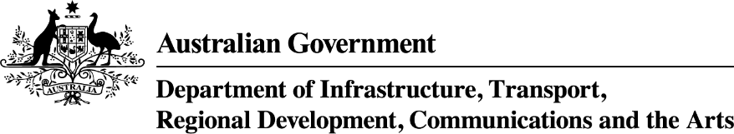

urban Precincts and Partnerships Program—Announced Projects
January 2025
uPPP Program stream | Applicant Organisation | Project Title | Project Description | Project Location | State | Commonwealth Funding Approved | Date Announced
One | Hume City Council | Broadmeadows Precinct Roadmap Strengthening Place, Community & Connection | The project will develop an integrated roadmap which aims to break down barriers that exist in revitalising Broadmeadows, address gaps and identify future opportunities through a place-based approach to precinct planning and delivery. | Broadmeadows | VIC | $3,332,500 | 23 January 2025
One | Brimbank City Council | Sunshine Energy Park Feasibility Study and Business Case | The project will develop a comprehensive business case and delivery strategy to identify how to transform a closed former landfill site into a new 74-hectare “central park”. | Sunshine | VIC | $500,000 | 23 January 2025
One | Maribyrnong City Council | Creative West: Transforming Footscray into a thriving cultural hub | This project supports the revitalisation of Footscray’s Metropolitan Activity Centre by establishing a cultural precinct in Melbourne’s inner west. | Footscray | VIC | $5,000,000 | 23 January 2025
One | Ipswich City Council | Ipswich Central Hearts: Arts, Commerce and Urban Greening | The project will deliver the planning and detailed design for key activities in Ipswich Central, including expanding Ipswich Art Gallery, redeveloping the Ipswich Civic Centre, developing the Cultural Heart, streetscape refresh of Brisbane Street, connection to the cycle network, urban greening initiatives and the addition of a new Black Box Theatre. | Ipswich | QLD | $3,837,000 | 30 January 2025
Two | Adelaide Central School of Art | The Erindale Transformation: A Multi-use arts zone in the Glenside Precinct | The project delivers the transformation of a historic building in the Erindale Precinct into a multi-use arts facility with artist studios, a First Nations artist residential studio, galleries, mental health arts program, education spaces, a Kaurna native edible garden, and a social enterprise café. | Erindale | SA | $6,954,000 | 30 January 2025
Two | Women’s & Children’s Hospital Foundation | Family Health and Wellbeing Hub in Elizabeth Vale, South Australia | This project supports the Women’s & Children’s Hospital Foundation to establish a Family Health and Wellbeing Hub, a four-storey building equipped to provide co-located, integrated wellbeing services in the Precinct. | Elizabeth Vale | SA | $26,050,046 | 30 January 2025

