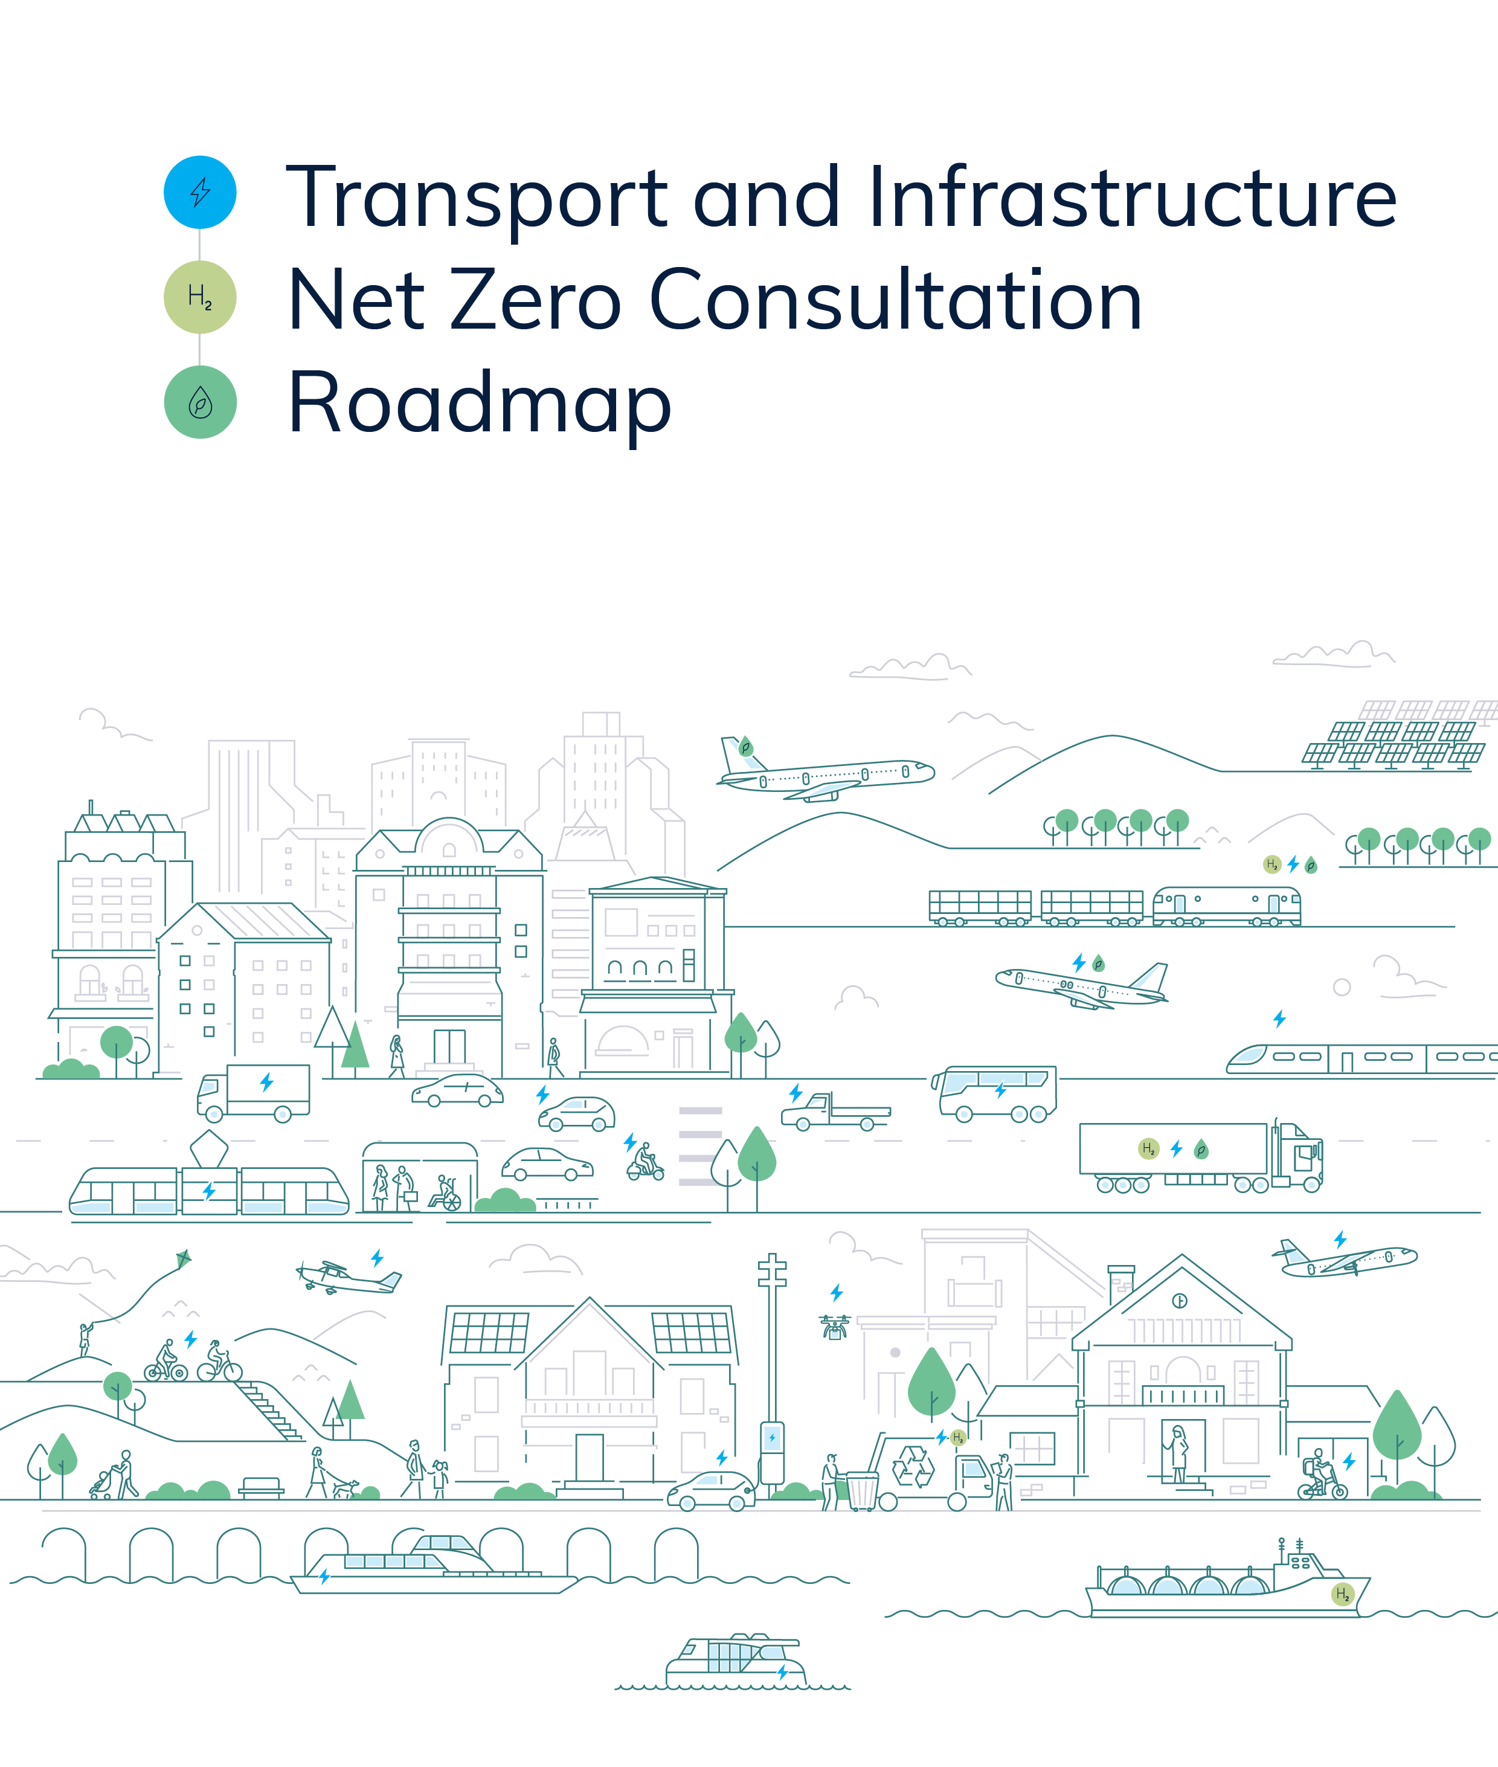Australian Government
Department of Infrastructure, Transport, Regional Development, Communications and the Arts

# Executive summary

*This Consultation Roadmap seeks feedback on potential pathways for transport and transport infrastructure to support economy-wide net zero as well as the actions or policies the Australian Government will need to take to support these potential pathways.*

*The Consultation Roadmap sets out the challenge in chapter 1 and considers opportunities to decarbonise the movement of people and goods in chapter 2, before analysing each transport mode in chapter 3. The enabling systems, including transport infrastructure and transport’s energy needs, are outlined in chapter 4. The final chapter describes how the Australian Government will work collaboratively to reduce transport and transport infrastructure emissions.*

*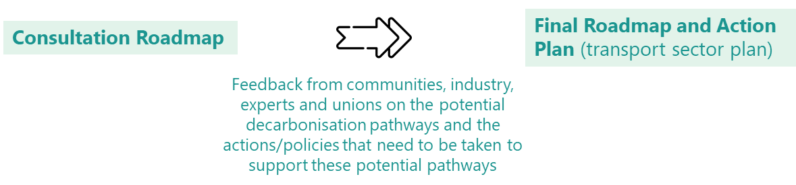The responses to the questions asked throughout the Consultation Roadmap will inform the pathways, actions and policies that the Australian Government will commit to in the final Transport and Infrastructure Net Zero Roadmap and Action Plan that will be released later this year.*

##### Chapter 1 – Introduction

The Consultation Roadmap begins by bringing together evidence to illustrate the challenge to reduce transport emissions. The Australian Government has an ambitious climate agenda, legislating to reduce national emissions by 43% on 2005 levels by 2030 and net zero by 2050 in line with the global goal to keep warming to well below 2°C and pursue efforts to keep it to 1.5°C. In addition, the government is developing a Net Zero Plan to help Australia maximise the benefits of the global transition to net zero. It will provide certainty through long-term policy and help drive investments in low emissions and renewable technologies. To support the Net Zero Plan, the government is developing six sectoral plans.

The Transport and Infrastructure Net Zero Roadmap and Action Plan will be the net zero sectoral plan for the transport and transport infrastructure sectors. It is being developed in two stages. The first stage is this Consultation Roadmap, which seeks your views on potential pathways to net zero for transport and transport infrastructure as well as the actions or policies taken by governments to support these potential pathways. What we hear from you will inform the pathways, actions and policies that the government will commit to in the second stage of development, the final Transport and Infrastructure Net Zero Roadmap and Action Plan.

Transport connects Australians to each other and to the rest of the world. It is essential for our economy and wellbeing. Transport is also the third-largest source of greenhouse gas emissions in Australia, amounting to 21% of Australia’s greenhouse gas emissions in 2023. Since 2005, transport emissions have increased by 19%. Without further action, transport will be the largest source of emissions in Australia by 2030. We have an opportunity to decarbonise transport and support Australia’s goal of reaching net zero by 2050.

Transport activity’s total contribution to the economy in 2020-21 was $164.4 billion or 7.9% of GDP. Transport was the second largest sector of the economy, behind the mining sector.

Total employment across all transport activity was 1.25 million people in 2020-21. A further 85,400 people were employed in the delivery of public roads, highways and subdivisions, bridges, railways and harbours.

Transport activity’s total contribution to the economy in 2020-21 was $164.4 billion or 7.9% of GPD. Transport was the second largest sector of the economy, behind the Mining sector.

Total employment across all transport activity was 1.25 million people in 2020-21. A further 85,400 people were employed in the delivery of public roads highways and subdivisions, and bridges, railways and harbours.

Transport activity’s total contribution to the economy in 2020-21 was $164.4 billion or 7.9% of GPD. Transport was the second largest sector of the economy, behind the Mining sector.

Total employment across all transport activity was 1.25 million people in 2020-21. A further 85,400 people were employed in the delivery of public roads highways and subdivisions, and bridges, railways and harbours.

Transport activity’s total contribution to the economy in 2020-21 was $164.4 billion or 7.9% of GPD. Transport was the second largest sector of the economy, behind the Mining sector.

Total employment across all transport activity was 1.25 million people in 2020-21. A further 85,400 people were employed in the delivery of public roads highways and subdivisions, and bridges, railways and harbours.

Transport activity’s total contribution to the economy in 2020-21 was $164.4 billion or 7.9% of GPD. Transport was the second largest sector of the economy, behind the Mining sector.

Total employment across all transport activity was 1.25 million people in 2020-21. A further 85,400 people were employed in the delivery of public roads highways and subdivisions, and bridges, railways and harbours.

Road transport is the main source of transport emissions (at around 83%), with emissions from light vehicles alone (passenger cars, motorcycles and light commercial vehicles) responsible for almost 60% of the sector’s emissions. Heavy vehicle emissions account for 23% of all transport emissions. After light vehicles, heavy vehicles present the largest abatement opportunity for the transport sector. Emissions from domestic aviation are 9% of transport emissions, rail roughly 4% and domestic maritime roughly 2%. It is estimated that the embodied emissions in transport infrastructure accounts for approximately 3% of Australia’s total emissions.

**Road vehicles are responsible for the majority of transport emissions**

Emission trends from the transport sector projected to 2035

Source: DCCEEW, Australia’s emissions projections 2023, Australian Government, 2023.

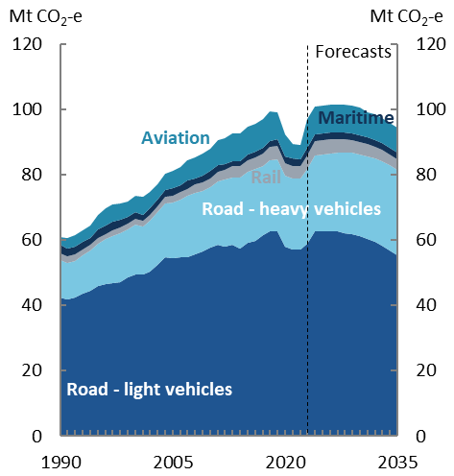Transport activity is also expected to continue to increase to 2050 in line with population and economic growth. The challenge is that, at the same time transport activity is projected to increase, we need to be reducing transport emissions. The projected emissions associated with our growing transport task are outlined in detail in chapter 1.2 of this Consultation Roadmap.

The government has a range of policy roles that can steer Australia to net zero: *leadership*, *investment* and *regulation*. Several key principles will guide how the government exercises these roles in developing the final Action Plan. We will seek to *maximise emissions reduction* and *economic opportunities* by providing *value for money* in an *inclusive and equitable* way that is *evidence-based*.

We will also *build on existing effort and knowledge*, acknowledging a range of actions have already been taken by governments, industry and communities to address climate change. As action on climate change is a shared responsibility, we will continue to *work in partnership* to reach net zero, especially with state and territory governments, industry, communities and international organisations. It is also necessary to work across *multiple timeframes*, considering actions that can be achieved in the short (2024-2030), medium (2030-2040) and long term (2040-2050). We will also look to embed resilience to current and future climate change in developing the final Action Plan.

Across these multiple timeframes it is necessary to consider abatement opportunities throughout our transport systems (chapter 2 looks at how people and goods move around our vast country), all four transport modes (chapter 3 breaks down the opportunities for road, rail, maritime and aviation) and the enabling inputs and policies (chapter 4 considers transport infrastructure and transport’s energy use).

##### Chapter 2 – Rethinking our transport networks and systems

Chapter 2 outlines how our transport networks and systems can support decarbonisation. There are opportunities to reduce emissions by promoting better planning and increased use of digital communication technologies. Transport systems and networks can also be designed to encourage a shift to sustainable, low emissions ways of moving people and goods, such as active and public transport for moving people. Chapter 2.1 considers the movement of people and chapter 2.2 looks at the movement of goods.

Active and public transport can ease congestion, reduce harmful pollution, reduce heat and noise, decrease household transport costs and provide health benefits from increased physical activity levels. Achieving higher rates of active and public travel will require investment in electrified public transport and improvements in the safety, connectivity and convenience of walking and cycling infrastructure. All levels of government, especially state and local governments, will need to continue to work together on the planning, design and delivery of this transport and infrastructure investment. The Australian Government’s $100 million investment in a new Active Transport Fund open to states and territories will ensure people who want to walk and cycle in their local community can do so.

A *shift* to sustainable, low emissions ways of moving goods also necessitates an end-to-end consideration of our freight and supply chains. *Improving* efficiency by adopting low or zero emission technologies across the freight sector must consider the cost impacts on commercial operators and consumers. Increasing access to intermodal facilities, and the share of goods moved on rail, as well as rolling out the required energy and transport infrastructure to enable low and zero emission freight transport modes will be essential to the transition.

The Australian Government is investing in nationally significant transport infrastructure consistent with the *Infrastructure Policy Statement*, which sets out three strategic themes to guide investment decisions. One of those themes is Sustainability, which is focused on reducing transport and infrastructure emissions through decarbonising transport operations, reducing emissions in the design, construction and operation of transport infrastructure, and investing in projects that encourage and enable more integrated and sustainable approaches to land use planning.

##### Chapter 3 – Net zero pathways for each transport mode

The pathway to net zero will be different for each transport mode. The approach for each transport mode will require a mix of technologies, policies and planning, based on evidence, market readiness and science. Chapter 3 outlines each transport mode and opportunities to *improve* the technology or efficiency of that mode.

***Road – light vehicles*** (chapter 3.1): Road transport presents the largest emissions reduction opportunity. The decarbonisation pathway for light vehicles is fuel efficiency and electrification. That is why the government is taking action through an *Australian New Vehicle Efficiency Standard* and the *National Electric Vehicle Strategy*.

The introduction of an Australian New Vehicle Efficiency Standard will increase the availability of new cleaner, cheaper-to-run vehicles and contribute to a cleaner, greener and more sustainable transport sector over time. It will also encourage supply of hybrid vehicles and zero-emissions vehicles, such as electric vehicles (EVs), to the Australian market. The National Electric Vehicle Strategy is implementing a number of policy initiatives to accelerate the uptake of EVs. Through this Consultation Roadmap, the government welcomes ideas to reduce emissions in the existing light vehicle fleet.

***Road – heavy vehicles***(chapter 3.2): The pathway for heavy vehicles is not as clear as it is for light vehicles. Battery electric trucks may be limited to shorter distances with lighter payloads until battery technology and charging infrastructure improves. Hydrogen or low carbon liquid fuels may be required for larger payloads and distances.

The government is currently working with the states and territories to remove regulatory barriers (width and mass limits) to support Euro VI standards. Introducing Euro VI will mean manufacturers must add the advanced safety and fuel-saving technologies to Australian models that other countries already have. This will help improve safety outcomes and contribute to our emissions reduction targets. However, the reforms to mass limits to support Euro VI will not, by themselves, be enough to overcome the productivity penalty that zero emission trucks face as a result of their heavy batteries. Australia’s steer axle mass limit, currently at 6.5 tonnes, will continue to limit the deployment of larger battery electric truck models. Although battery technology may become lighter over time, further reforms to mass limits will be necessary to remove this productivity penalty and increase the range of zero emission trucks available in Australia.

The high upfront cost of switching to low and zero emission heavy vehicles, together with the potential impact heavier vehicles would have on our road pavements, will remain challenging, even after regulatory barriers have been removed. Through this Consultation Roadmap, the government welcomes ideas to support the supply, uptake and operation of low and zero emission heavy vehicles.

***Rail*** (chapter 3.3): Rail is a low-emissions mode of transport when compared to other modes. An efficient and integrated rail system that supports Australia’s passenger and freight tasks is also crucial to our wellbeing and economic outcomes. Where feasible, increasing the share of freight moved on rail will also contribute to reducing overall freight emissions.

The decarbonisation of our rail sector will require the roll-out of infrastructure to support hydrogen and battery-electric trains, and consideration of policy settings to shift demand away from diesel locomotives. Low carbon liquid fuels could be required for larger payloads and distances until the supporting infrastructure for electrification is in place. Through this Consultation Roadmap, the government welcomes ideas to support rail decarbonisation.

***Maritime***(chapter 3.4): Maritime is a hard-to-electrify sector; it is unable to be completely electrified in the foreseeable future. Low carbon liquid fuels, hydrogen-derived fuels (such as green hydrogen, green ammonia and e-methanol), electrification and energy efficiency and optimisation improvements will all likely be needed to decarbonise maritime transport.

The *Maritime Emissions Reduction National Action Plan (MERNAP)* will set the strategic direction and recommend actions to decarbonise our domestic maritime transport sector, as well as our contribution to international shipping emissions. Australia’s reliance on international vessels for coastal shipping services means international decisions will have great influence on decarbonising maritime transport. Australia will need to accommodate multiple energy sources and technologies, especially for international bunkering.

***Aviation*** (chapter 3.5): As a hard-to-electrify sector, sustainable aviation fuel (SAF) will be the primary technology to reduce aviation emissions in the short-to-medium term. SAF is available as a drop-in fuel now. There are opportunities to encourage the development and deployment of SAF and other low carbon liquid fuels (LCLFs). Reducing the carbon intensity of liquid fuels with certification that verifies emissions abatement would ensure genuine emissions reduction in the aviation sector. Other technologies such as battery electric and hydrogen-powered aircraft are promising and will be trialled in Australia by regional domestic airlines.

The government is working with industry stakeholders, including through the *Australian Jet Zero Council*, to maximise aviation’s contribution to achieving net zero through SAF and emerging technologies. The *Aviation White Paper* will set the long-term policies to guide the next generation of growth and innovation in the aviation sector, including how to maximise the aviation sector's contribution to achieving net zero carbon emissions.

Building on consultation undertaken through the *Aviation White Paper*, the government will be undertaking targeted consultation to identify options for production incentives to support the establishment of a made in Australia LCLF industry, including through the release of a LCLF consultation paper.

Australia also supports initiatives from the International Maritime Organization (IMO) and the International Civil Aviation Organization (ICAO) to reduce maritime and aviation emissions.

##### Chapter 4 – Supporting transport’s net zero pathways

Chapter 4 looks at the enabling systems. There are several key inputs and enabling policies that are essential to transport achieving net zero, including appropriate and decarbonised transport infrastructure and the availability of low emissions energy (electricity and low carbon liquid fuels).

***Transport infrastructure*** (chapter 4.1): Decisions around where and what infrastructure we build influences the greenhouse gases emitted by the transport sector; for example, the building of roads could increase the emissions from light and heavy vehicles by enabling this transport mode. The Sustainability theme in the *Infrastructure Policy Statement* ensures that infrastructure’s role in enabling low and zero emission transport modes is considered in transport network planning and project selection frameworks.

However, the building, operation and decommissioning of transport infrastructure (roads, railways, ports and airports) also produces emissions. These emissions mostly come from the production of construction materials, such as cement, aluminium and steel. To decarbonise transport infrastructure, the main emissions reduction pathways will be through materials (low-carbon input materials such as green steel, concrete/cement, asphalt, aluminium and low-carbon recycled materials) and design (circular economy principles such as no-build situations, better maintenance, refurbishment or using more efficient planning, design and building techniques). Through this Consultation Roadmap, the government welcomes ideas on how to support transport infrastructure decarbonisation through materials and design, as well as the role of infrastructure in enabling low and zero emission transport modes.

***Energy – electricity and low carbon liquid fuels*** (chapter 4.2): All of the varied decarbonisation opportunities across Australia’s transport sector will require a shift away from fossil fuels. Transport currently makes up 75% of Australia’s liquid fuel demand. The primary method for reducing transport emissions will be through electrification, which is dependent on the decarbonisation of the electricity grid.

As part of the Future Made in Australia plan, the government will fast-track support for a LCLF industry, with an initial focus on sustainable aviation fuel and renewable diesel to support emissions reduction in the aviation, heavy vehicle, rail and maritime sectors. This will require local settings to develop the supply and use of LCLFs in Australia, as well as a regulatory system based on those used internationally to certify and accurately measure the lifecycle emissions of LCLFs. This is necessary so that government and industry are confident that the emissions benefits associated with displacing fossil fuel use are not being undermined by increasing carbon emissions elsewhere. Domestic production of LCLFs could provide opportunities for regional development and new jobs as well as liquid fuel security benefits.

The government will be undertaking targeted consultation to identify options for production incentives to support the establishment of a made in Australia LCLF industry, including through the release of a LCLF consultation paper.

##### Chapter 5 – Achieving net zero together

Collective action is needed for transport and transport infrastructure to reach net zero. That is why chapter 5 discusses how the government will continue to work collaboratively with states and territories, industry, unions, experts and local communities, as well as internationally, to develop the final Roadmap and Action Plan. What we hear from you on this Consultation Roadmap and the potential pathways to net zero will guide the development of the actions and policies the government will commit to in the final Transport and Infrastructure Net Zero Roadmap and Action Plan. These potential pathways are summarised on the next page.

This graphic shows the possible timeline of transport decarbonisation pathways for all transport modes, plus transport infrastructure and the enabling systems. 
For light vehicles it lists from now to 2030: battery electric passenger vehicles mass market adoption; and hydrogen fuel cell electric vehicles demonstration. Between 2030-2040 it lists: expansion of next-generation passenger and advancements for light commercial vehicles; hydrogen fuel cell electric adoption. Between 2040-2050 it lists battery electric available for all light vehicle tasks; hydrogen fuel cell electric vehicles where electrification is not feasible.
For heavy vehicles it lists: battery electric and hydrogen fuel cell demonstration; low carbon liquid fuels (LCLFs) blended in existing fleet use from now to 2030, with synthetic LCLF R&D starting now and extending to 2040. Between 2030-2040 it lists: battery electric and hydrogen fuel cell adoption accelerates; LCLFs support long distance, hard to electrify cases to transition. Between 2040-2050 it lists: battery electric and hydrogen fuel cell vehicles mass market adoption and efficiency improvements; LCLFs where battery electric and hydrogen fuel cell vehicles are still advancing/not feasible. 
For rail it lists: passenger rail electrification between now and 2050; hybrid and battery electric freight rail deployed; hydrogen fuel cell demonstration and LCLFs blended in existing fleet use between now and 2030, with synthetic LCLF R&D starting now and extending to 2040. From 2030-2050 it lists: hybrid, battery electric and hydrogen fuel cell mass market adoption and efficiency improvements. From 2030-2040 it lists: LCLFs support long distance, hard to electrify cases to transition. Between 2040-2050 it lists LCLFs where battery electric and hydrogen fuel cell are still advancing/not feasible. 
For maritime it lists: battery electric and hybrid propulsion and deployment for short range vessels; LCLFs blended in existing fleet use; and synthetic LCLF R&D between now and 2030. Between 2030-2040 it lists: short range battery electric vessels deployed; LCLFs deployed for long range vessels; continued synthetic LCLF investment. Between 2040-2050 it lists: short range battery electric vessels adoption and efficiency improvements; and LCLFs used for majority of long range vessels.
For aviation it lists: battery electric and hydrogen fuel cell development; LCLFs blended in existing fleet use; and synthetic LCLF R&D between now and 2030. Between 2030-2040 it lists battery electric and hydrogen fuel cell for short range flight demonstration; LCLFs for short, medium and long haul flights deployed in the market; and continued synthetic LCLF investment. Between 2040-2050 it lists: battery electric and hydrogen fuel cell deployment for short range flights; and LCLFs used for majority of medium and long haul flights. 
For transport infrastructure it lists: domestic low and zero carbon cement, alumina and steel industries emerging – used in transport infrastructure between now and 2030. Between 2030-2040 it lists domestic low and zero carbon cement and steel industries developing. Between 2040-2050 it lists: low and zero carbon concrete and steel is available for infrastructure projects.
For the enabling systems it lists: LCLF optionality in existing fleets; LCLF certification stimulates further demand; optimisation of intermodal infrastructure developing; and continued investment in active and public transport infrastructure between now and 2030. Between 2030-2050 it lists: LCLF used by transport modes that have limited electrification opportunities (aviation, heavy vehicles and maritime); increased low and zero carbon options to transport goods; and sustained investment and increasing use of public transport. 
