Australian Government
Department of Infrastructure, Transport, Regional Development, Communications and the Arts

Towards a long-term shipping solution for Norfolk Island

Summary of community feedback from the *Have Your Say* and community forum consultation process

February 2023

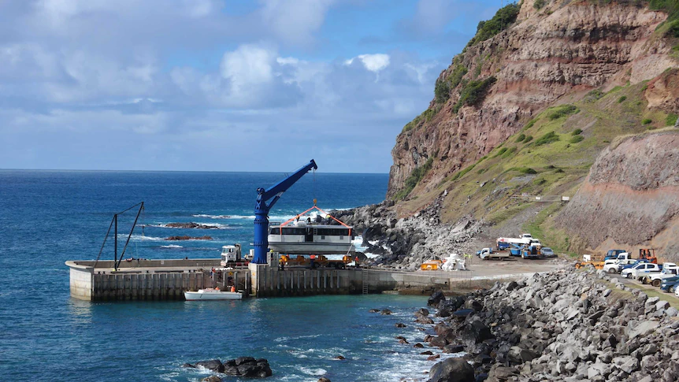

### Minister’s Foreword

In my visits to Norfolk Island, I have been struck by its natural beauty, its rich history, and the spirit and character of its residents.

I have also seen first-hand how the challenges of its remote location have conspired to reduce the flow of sea cargo to levels well below what is needed to sustain the community.

Supporting the Island and its community to sustainably continue and prosper is a priority for the Australian Government, with the most critical focus right now on shipping services which are maintained reliably, sufficiently and cost-effectively into the future.

I wanted to hear directly from the community on how the Government can best support the commercial market and local stakeholders in developing a long-term solution.

I asked the Department of Infrastructure, Transport, Regional Development, Communications and the Arts to consult with the community through a written *Have Your Say* process in October and November this year. This informed the community forum which I held on island on 14 November 2022.

Through these processes, I gained a strong appreciation of the key areas of interest, concern, and impacts of shipping on the community – along with how you see the Government’s role in development of port infrastructure.

I am pleased to present this report, providing a summary of the issues identified. I will bring back plans to the Norfolk Island community for future port infrastructure that reflect these issues, to support reliable and sustainable long-term shipping for Norfolk Island.

The Hon Kristy McBain MP

Minister for Regional Development, Local Government and Territories

## The consultation process

The Department sought written submissions through its website in October and November 2022. A total of 26 written submissions were received by the Department during this period.

On 14 November 2022, the Minister for Regional Development, Local Government and Territories, the Hon Kristy McBain MP, led a community forum at Rawson Hall on Norfolk Island. This event was attended by approximately 200 community members and local business owners.

The main issues raised in the written responses and at the community forum were:

Permanent port location 4

Port infrastructure 5

Cost of freight 5

Shipping containers 6

Schedule integrity 7

Frequency of delivery 7

Cargo capacity 8

## Next steps

The Australian Government is considering the views expressed in the written submissions and at the community forum to inform investments in port infrastructure to support reliable and affordable shipping arrangements for Norfolk Island. These plans will be shared with the Norfolk Island community in 2023.

## Permanent port location

### You said…

#### A permanent port location was the most frequently raised issue in written submissions – 14 submissions included this. This issue was also discussed at the community forum. There was most support for permanent facilities to be located at Cascade Bay, building on the existing infrastructure, or at a new location on the western side of Norfolk Island, including Jacobs Rock, Headstone and Puppy’s Point.

#### There was less support for permanent port development at Kingston Bay – several submissions noted the incompatibility of freight handling with tourism and heritage obligations at this location.

#### A few submissions were opposed to further development at Ball Bay due to difficulty in accommodating larger vessels, and the more difficult sea conditions at this location.

#### Some submissions suggested the need to maintain multiple harbours to retain flexibility for loading or unloading freight where poor sea conditions might affect one site but not others.

### We heard…

There is no single port location on Norfolk Island that can easily serve all needs.

Each potential location faces challenges, including weather exposure or lack of existing infrastructure. Each location is used by the community for different purposes, including commercial fishing and tourism operation.

It is important that a permanent port location is decided before planning begins, to create certainty for the community and to ensure that investment in infrastructure delivers the best possible outcomes for the community. It will be important that we work together to minimise negative impacts on existing users of that location.

**Cascade Bay**

Cascade Bay is already used for cargo handling and offers reasonable road access and landside space for further development, but it is exposed to difficult sea conditions at times and has some obstacles such as bommies. It is also commonly used for recreation and other purposes.

**Ball Bay**

Ball Bay is used for fuel ships and previously had a temporary groyne. There is limited road access, and it has significant exposure to easterly winds. Development at Ball Bay would have minimal impacts on recreational or other use.

**Kingston**

Kingston is sometimes used for lighterage but is part of the heritage precinct and more significant development for cargo handling is likely to be incompatible with its historical importance and tourism.

**Western locations (Jacobs Rock, Puppy’s Point, or Headstone)**

Bays on the western side of Norfolk Island generally benefit from some protection from prevailing sea conditions and are deeper with fewer obstructions. There is also less demand for competing recreational and other uses, but none of these locations have existing infrastructure and would require significant works to create road access.

## Port infrastructure

### You said…

Twelve written submissions addressed issues around the development of **port or berthing facilities** for sea freight, improvements needed to the seabed or removal of obstacles such as bommies.

Several submissions provided considerable detail on the nature of works that might be needed at one or more locations to support freight handling, with suggestions ranging from development of container handling facilities, development of a naval base to defray costs, development of an enclosed harbour and suspended access road at Jacob’s Rock, development of a marina for both freight and passenger transfer, to development of multiple locations simultaneously.

### We heard…

Australian Government investment in port infrastructure development at Norfolk Island is vital to the future of a reliable and affordable shipping service. The extent of infrastructure investment will be guided by the need to support more reliable and efficient shipping operations, along with protecting community and recreational use of the locations where possible.

## Cost of freight

### You said…

Rising **Sea freight tariffs** were an issue of considerable concern to a number of Norfolk Island community members and businesses who provided feedback through the consultation process, with this issue being raised in 11 written submissions and extensively canvassed at the community forum.

One business owner noted the high cost of sea freight was having flow-on effects to the cost of living, which was affecting their ability to attract staff to come to Norfolk Island to work.

### We heard…

The Norfolk Island community acknowledges that living on a remote island means freight is more expensive than the Australian mainland, and that shipping tariffs are determined by expenses incurred by private sector operators to deliver those freight services.

The Australian Government has a role in developing infrastructure that can help with cargo handling efficiency, such as improving vessel berthing facilities and supporting the use of containers. Such improvements will help to reduce overhead costs, such as the cost of delays caused by weather, and higher insurance premiums incurred by shipping freight by breakbulk.

## Shipping containers

### You said…

The issue of **adopting containers** for future sea freight cargo handling was another commonly raised issue, discussed in 11 submissions. Of these, nine submissions were in favour of moving to the use of containers for better security of goods, more efficient cargo handling and alignment with global practices.

Only one submission suggested that breakbulk and lighterage should be retained, while one other submission suggested that breakbulk and lighterage might still present a pragmatic solution to the various challenges for Norfolk Island cargo shipping.

One submission noted that more emphasis would be needed on biosecurity measures if containers were adopted, as they would create additional layers of necessary inspection.

### We heard…

While Norfolk Island’s use of lighter craft presents a traditional and long-respected method of transferring cargo from ship to shore, Norfolk Island’s shipping solution needs to consider worldwide sea freight practices to provide any improvements for the Norfolk Island community and economy. The use of containers for cargo shipping is virtually universal across the sea freight industry and modern vessels are progressively less capable of handling breakbulk goods.

The development of full container handling facilities may take some time, but there may be earlier opportunities for smaller scale use of containers. Development of port infrastructure will need to consider the need for biosecurity and other measures for the safe and secure handling of containers.

## Schedule integrity

### You said…

Nine written submissions raised the **reliability of shipping services** as a priority. Several submissions pointed to the lack of goods in the supermarket, or difficulty as a business owner in importing or exporting goods in a timely way. One submission noted that poor reliability severely affected import or export of perishable goods.

Four written submissions raised the importance of a sea freight vessel that is **dedicated to Norfolk Island** as being a priority. These submissions indicated that Norfolk Island has suffered in the past when vessels have been diverted to other uses or for different voyages, reducing capacity or frequency as a result.

### We heard…

Timeliness and reliability of shipping services should not be in question for shipping services to Norfolk Island. However, there are challenges in maintaining scheduling integrity for shipping services to Norfolk Island in the current environment, including the difficulty of accessing a port during inclement weather conditions.

Improvements to port infrastructure should enable safe vessel berthing and direct loading and unloading on shore, along with reducing delays that affect service reliability.

## Frequency of delivery

### You said…

How **frequently** the cargo ship brings sea freight to Norfolk Island was raised in four written submissions; all pointed to recent infrequent vessel calls as unsatisfactory, highlighting stock shortages in the supermarket and instances of long waits for postal items and other goods.

### We heard…

As with service reliability, frequency of services is very important to the Norfolk Island community, especially for time-critical and perishable goods and for the businesses on Island to maintain stock levels to support peak tourism seasons.

Service frequency is closely linked to the cost of sea freight. A balance is needed between more frequent servicing and less costly shipping tariffs.

## Cargo capacity

### You said…

Four submissions raised the issue of **insufficient capacity** in recent times, resulting in a cargo backlog. One submission indicated their business had suffered due to goods being left behind.

This issue was also raised at the community forum. Community members at the forum were particularly concerned with delays in postal services due to insufficient capacity and one business owner stated that recent ship cargo allocations were insufficient.

### We heard…

Having sufficient supply of food, stock feed, building and repair supplies, postal articles, and other essential items are all vital for the Norfolk Island community and economy to remain healthy and sustainable into the future. Improving overall capacity, like shipping frequency and cost, is a key area that needs to be accounted for in future improvements.