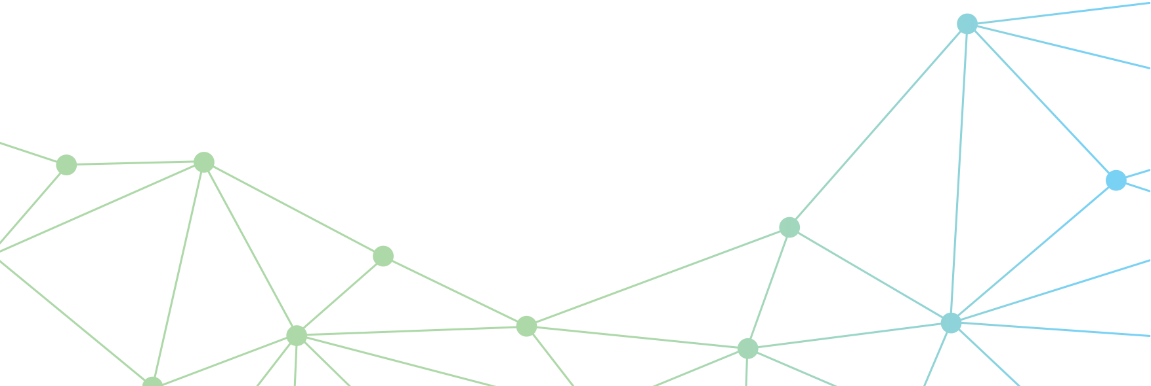 

Telecommunications affordability and access for First Nations households: Learnings from the HILDA survey

Working paper

June 2024

The Department of Infrastructure, Transport, Regional Development, Communications and the Arts acknowledges the Traditional Custodians of Country throughout Australia and their continuing connection to land, sea and community. We pay respects to them, their cultures and to their Elders, past, present and emerging.

© Commonwealth of Australia June 2024

ISBN: 978-1-922879-31-8

Ownership of intellectual property rights in this publication

Unless otherwise noted, copyright (and any other intellectual property rights, if any) in this publication is owned by the Commonwealth of Australia (referred to below as the Commonwealth).

Disclaimer

The material contained in this publication is made available on the understanding that the Commonwealth is not providing professional advice, and that users exercise their own skill and care with respect to its use, and seek independent advice if necessary.

The Commonwealth makes no representations or warranties as to the contents or accuracy of the information contained in this publication. To the extent permitted by law, the Commonwealth disclaims liability to any person or organisation in respect of anything done, or omitted to be done, in reliance upon information contained in this publication.

Creative Commons licence



With the exception of (a) the Coat of Arms; (b) the Department of Infrastructure, Transport, Regional Development, Communications and the Arts photos and graphics; (c) content supplied by third parties; (d) content otherwise labelled; copyright in this publication is licensed under a Creative Commons BY Attribution 4.0 International Licence.

Use of the Coat of Arms

The Department of the Prime Minister and Cabinet sets the terms under which the Coat of Arms is used. Please refer to the Commonwealth Coat of Arms - Information and Guidelines publication available at [http://www.pmc.gov.au](http://www.pmc.gov.au/).

Contact us

This publication is available in PDF format and Word format. All other rights are reserved, including in relation to any departmental logos or trademarks which may exist. For enquiries regarding the licence and any use of this publication, please contact:

Director – Bureau of Communications, Arts and Regional Research

Email: [BCARR@infrastructure.gov.au](mailto:BCARR@infrastructure.gov.au)

Website: <https://www.infrastructure.gov.au/research-data/bureau-communications-arts-and-regional-research>

Table of Contents

Key findings 4

About 5

Where does this analysis fit within the literature? 5

Background 6

Data definitions 6

Data limitations 7

Descriptive data: Telecommunications spending and internet access 8

Households where ‘all’ members are First Nations tend to spend a greater share of household income on telecommunications 8

First Nations household income has been growing, but is lower than average 10

Telecommunications expenditure has been steady 11

Spending on necessities varies across households 12

HILDA data indicates that access to internet at home is improving 13

The HILDA data appears to overestimate access 13

Remote households are not included in the HILDA sample 14

Regression findings: Household expenditure patterns and low-income groups 16

When controlling for other factors, First Nations households spend less on telecommunications 16

More people in First Nations households is correlated with lower shares of telecommunications expenditure 17

Likelihood to be in a low-income group 18

First Nations households are more likely to be low income, high spending (LIHS), although that changes as household size increases 18

The low-income, low spending (LILS) cohort is too small to draw relevant conclusions from 19

Conclusion 20

Attachment A – In-scope data from the HILDA survey 21

Attachment B – Some characteristics of First Nations households from Census 2021 23

Attachment C – Regression techniques 25

Attachment D – Regression outputs 26

OLS outputs for telecommunications expenditure share 26

Logistic regression for low income groups 27

References 28

|  |
| --- |
| Key findings  * **The analysis finds** **improvements in telecommunications affordability and access for First Nations households**. Access to the internet at home has increased while the share of disposable income spent on telecommunications has been decreasing. * Between 2006 and 2021, **households where ‘all’ members were First Nations spent 1.4 percentage points more of their disposable income on telecommunications services** than those that were not (4.9% compared to 3.5%). * **The share of income spent on telecommunications has been decreasing for First Nations households.** Between 2006 and 2021, telecommunications expenditure has been relatively steady, while household income has been increasing (in nominal terms). * **When looking at raw telecommunications expenditure (in nominal terms), households with ‘all’ First Nations members spend less than average**. Between 2006 and 2021, these households spent less on telecommunications and had lower household income compared to the national average**.** * **Access to the internet at home has been improving** for First Nations households between 2011 and 2021. The HILDA survey overestimates internet access for First Nation households as its sample excludes very remote and sparsely-populated areas (where internet access is more limited). * In the regression model, where household characteristics are held constant (such as income and size), **First Nations households spent a lower share of disposable income on telecommunications than non-First Nations households.** * In the logistic regression model, households with ‘some’ First Nations members were **more likely to be in the ‘low income, high spending’ group**. This can indicate a greater risk of having unsustainable spending arrangements. |
|  |

# About

This paper draws out the analysis on First Nations households from the Bureau of Communications, Arts and Regional Research’s (BCARR) [Australian households and the affordability of telecommunications paper](https://www.infrastructure.gov.au/department/media/publications/australian-households-and-affordability-telecommunications) (hereafter, ‘affordability paper’). This paper is intended to focus on trends for First Nations households and assist in interpreting the regression outputs from the affordability paper. This paper includes data on internet access and telecommunications expenditure using data from the Household Income, Labour Dynamics in Australia (HILDA) survey.

This report has been developed to contribute to the evidence base informing:

* [Closing the Gap Target 17](https://www.closingthegap.gov.au/national-agreement/national-agreement-closing-the-gap/7-difference/b-targets/b17): By 2026, Aboriginal and Torres Strait Islander people have equal levels of digital inclusion.
* The [First Nations Digital Inclusion Advisory Group](https://www.digitalinclusion.gov.au/) (FNDIAG) who are working with community to hear their views on digital inclusion, understand local needs and support Target 17.

The findings in this report derived from the HILDA survey are not considered representative of the population as the survey does not sample very remote locations (where 9.4% of First Nations people live)[1].

This paper has been written by non-First Nations data analysts. While every effort has been made to interpret the data within First Nations contexts, there may be instances in which a greater understanding of First Nations cultures would aid interpretation.

## Where does this analysis fit within the literature?

There is growing evidence around digital inclusion in Australia, including research specific to First Nations peoples. The main sources that have been released since 2020 are: the [Australian Digital Inclusion Index (ADII](https://www.digitalinclusionindex.org.au/first-nations/)) and the [Mapping the Digital Gap report](https://www.admscentre.org.au/mapping-the-digital-gap/). When considering this research, it is important to understand location-based differences between samples collected for each piece of research. No one source is nationally representative, but together they can be used to provide complementary insights.

Table The location-based differences of First Nations samples in recent research

|  |  |
| --- | --- |
| Report | Sample geography |
| Mapping the Digital Gap | 11 remote and very remote First Nations communities. |
| ADII | National sample, however “*No special First Nations collection was undertaken for urban and regional areas this year and results obtained based on national sampling methods of First Nations people should be treated with caution due to very small sample sizes.”* (Thomas, 2023) |
| This report | HILDA survey waves 6 to 22. The survey *is “restricted to households living in private dwellings, excluding very remote parts of Australia.”* (Watson, 2012)with weights applied to enable population inferences to be made. |

## Background

The affordability of telecommunications services varies by household (BCARR, 2020; BCARR, 2017). In the 2023 ADII report, the affordability index for First Nations people was 6.1 percentage points lower than the Australian average, 89.0 compared to 95.1 (Thomas, 2023).

While telecommunications affordability has improved for Australians overall, the benefits have not been shared evenly. The ADII shows that the digital inclusion gap between First Nations households and the Australian average is smallest in urban areas, and largest in remote and very remote areas (Thomas, 2023). The Australian Government’s focus on reducing this gap and improving data collection is supported by the establishment of the First Nations Digital Inclusion Advisory Group (FNDIAG) and recommendations in their initial report (FNDIAG, 2023).

## Data definitions

***How are First Nations households recognised?***

This analysis uses the HILDA survey to create two measures of First Nations households, where:

* all members of the household are First Nations (‘all’), and
* at least one member of the household is First Nations (‘some’).

***How is telecommunications expenditure calculated?***

The HILDA survey asks how much households spend on *‘telephone rent and calls, and internet charges (Include rent and charges on mobile phones)*’.

***What affordability measures are reported on?***

Consistent with previous research, this analysis looks at three measures to identify affordability trends:[2]

* Share of disposable income spent on telecommunications
* Proportion of households that are classed as ‘low income, high spending’ (LIHS)
* Proportion of households that are classed as ‘low income, low spending’ (LILS)

The low-income measures identify households with disposable income under half the median and telecommunications expenditure as a share of disposable income that is over three times the median (LIHS), or under half the median (LILS).

These measures are selected to examine the changing nature of telecommunications expenditure and identify households that potentially have unsustainable spending or are being priced out of the market.

***What internet access measures are reported on?***

The HILDA survey asks each respondent *‘Do you have access to the Internet at home, whether through a computer, mobile phone or other device?’* The responses to this variable have been aggregated by BCARR to create a household-level variable where all members of a household reported access to the internet at home. Census data is used for comparison where available.

The question does not reflect the quality and speed of household internet access e.g. mobile pre-paid plans or home broadband, but provides a high-level overview on access overall.

## Data limitations

The HILDA survey is designed to be nationally representative and includes participants from various demographic groups, including First Nations peoples. However, dwellings in remote and sparsely‑populated areas were not included in the survey (Woden and Watson, 2007).[3] As a consequence, the HILDA First Nations sample refers mostly to First Nations households living in regional and urban areas.

Despite omitting remote households, the HILDA sample slightly overrepresents First Nations households, relative to their share of the Australian population. In wave 21 of the HILDA survey, the ‘all’ group represented 2 per cent of in-scope households (179 households), while the ‘some’ group represented 4.4 per cent of the sample (399 households). Details on the First Nations sample in HILDA are included in Attachment A –.

Where possible, comparisons with Australian Census data are included to better understand the representativeness of the HILDA sample. This comparison shows that the HILDA First Nations sample have higher income and higher internet access rates than the First Nations population.

**Quality factors about connectivity are not captured in the data**

The HILDA data on internet access can be used to show improvements in connectivity at home. However, the limited scope of the question ‘*Do you have access to the internet at home?*’ means insights cannot be derived on connection type, device availability, reliability or speeds. This is particularly important in remote areas, where pre-paid mobile plans are the primary connection method (Featherstone D et al., 2023). In the Mapping the Digital Gap Annual Report 2022, only about 5% of homes reported fixed-line connections in most of the remote communities surveyed. The remaining 95% were mainly mobile only.

# Descriptive data: Telecommunications spending and internet access

## Households where ‘all’ members are First Nations tend to spend a greater share of household income on telecommunications

When looking at trends over time, expenditure on telecommunications as a share of household disposable income declined for all groups over the 15 years from 2006 to 2021 (Figure 1). The proportion of spending is higher where ‘all’ members of the household are First Nations across all years of data. There is greater variation in the ‘all’ group however, which reflects the smaller sample size.

Figure : Average telecommunications expenditure as a share of household disposable income; ‘all’ First Nations, ‘some’ First Nations households and overall average, by wave

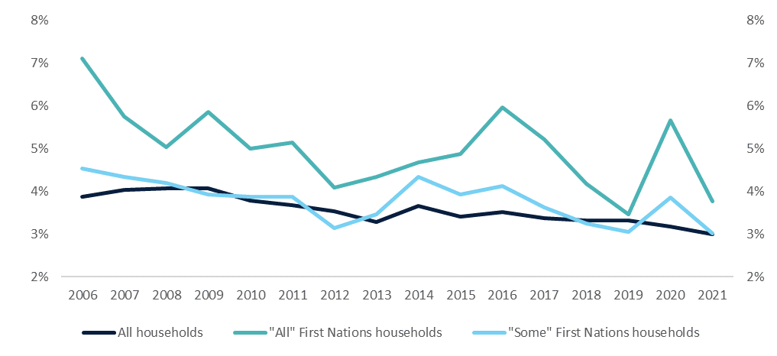

Source: The HILDA Survey, Release 21; BCARR calculations

The average share of disposable income spent on telecommunications in ‘all’ First Nations households across the 2006-2021 period was 4.9 per cent which is around 1.4 percentage points higher than the average Australian household spending share (3.5 per cent) over the same period (Figure 2). This difference is statistically significant at the 1 per cent level. For households where ‘some’ members are First Nations, the expenditure share was 3.7 per cent, which was not significantly different from households with no First Nations members.

Figure : Share of disposable income spent on telecommunications for households where...

Overall

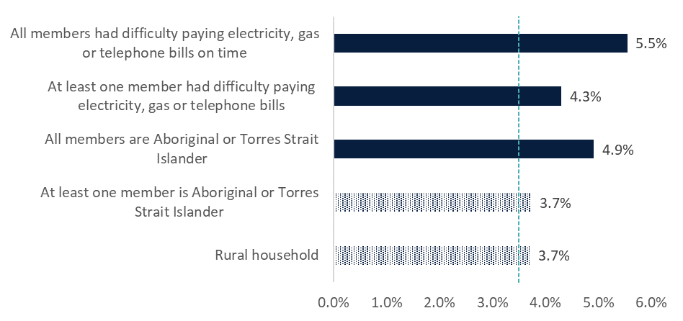

Source: The HILDA Survey, Release 21; BCARR calculations

Notes: The averages are derived across all 16 waves of available data (from 2006 to 2021). Difference of means calculated using T-test. The patterned bars are not statistically significant at the 10% level. Data on households located in rural areas and that have had difficulty paying electricity, gas or telephone bills on time (financial stress) are included in the chart for comparison. For more detail, refer to Attachment B of the affordability paper.

*Interpret this as:*

Between 2006 and 2021, households where ‘all’ members were First Nations spent approximately 1.4 percentage points more of their disposable income on telecommunications than the average household.

### First Nations household income has been growing, but is lower than average

Lower disposable income levels are driving the higher share of telecommunications expenditure for First Nations households. As illustrated in Figure 3, over the 2006-2021 period, the median disposable income of ‘all’ and ‘some’ First Nations households was generally below that of all households. In 2021, median household income was around $30,000 per annum lower for households where ‘all’ members were First Nations and around $8,000 per annum less for households where ‘some’ members were First Nations.

Figure : Median annual household disposable income by household type, wave 6 to 21

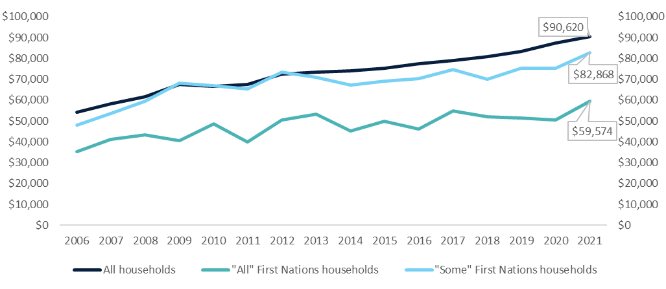

Source: The HILDA Survey, Release 21; BCARR calculations  
Note: Nominal values shown.

When comparing the 2021 HILDA data to the 2021 Census, the median First Nations household income in the HILDA sample is approximately $5,000 more per annum than reflected in Census data This is one indication that the HILDA responding cohort are relatively more advantaged and thus not fully representative of the entire First Nations population. For the average Australian household, the HILDA median annual income figure of $90,620 was almost the same as the Census figure ($90,792 per annum in 2021, see Attachment B).

### Telecommunications expenditure has been steady

When looking at nominal expenditure on telecommunication services, households that were ‘all’ First Nations spent less per annum than the average household (Figure 4). The difference in expenditure is less pronounced than income (Figure 3). Households that have ‘some’ First Nations members tended to spend around the overall average. As connectivity has become a necessity, households are likely to pay for connectivity regardless of income or demographic characteristics. Without affordable services, people may be shut out from accessing telecommunications services and the subsequent social and economic benefits.

While demand has increased for telecommunications services, consumers have benefitted from lower prices (in real terms) which has offset their increased consumption. The consumer price index (CPI), used to track inflation, shows that communications group[4] prices were around 20 percent lower in 2022 than the 2011-12 benchmark.[5]

Figure : Median annual household telecommunications expenditure by household type, wave 6 to 21

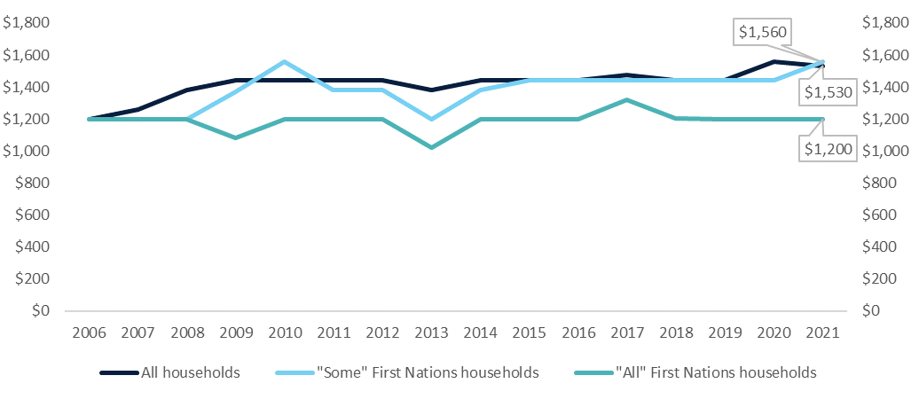

Source: The HILDA Survey, Release 21; BCARR calculations.  
Note: Nominal values.

### Spending on necessities varies across households

To compare expenditure patterns on telecommunications with other essential goods, Figure 5 shows that expenditure patterns are broadly similar between households. When looking at the ‘all’ First Nations households, it could be expected that they have higher expenditure shares on most necessity goods due to their lower disposable incomes. However, First Nations households spent proportionally less on rent, education and health‑related expenses. Telecommunications services along with transport and groceries were the necessity goods and services that First Nations households spent more on proportionally.

Figure : Comparison of expenditure share on a range of goods and services, by household type, 2021

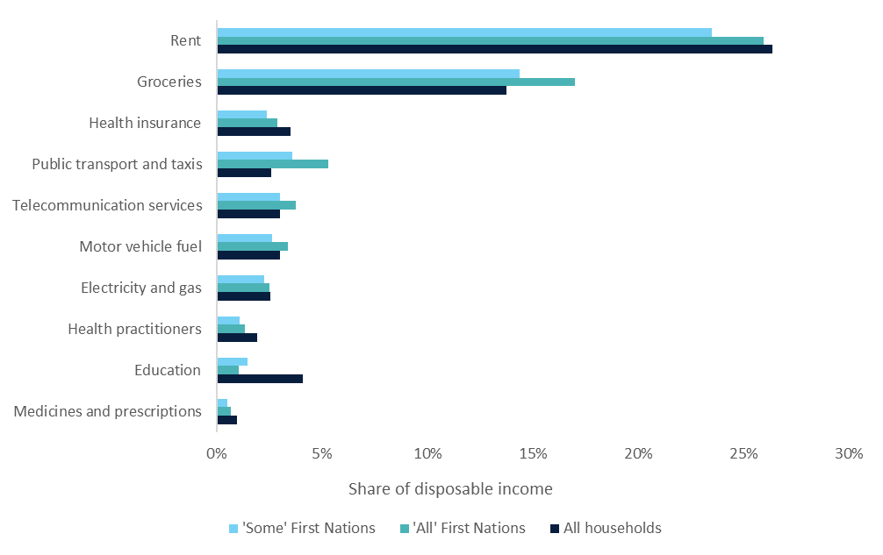

Source: The HILDA Survey, Release 21; BCARR calculations. Data from wave 21 only.

*Interpret this as:*

Households where ‘all’ members were First Nations spend less on telecommunications and have lower incomes. The low-income base is what drives their higher expenditure shares for certain goods and services, such as telecommunications.

## HILDA data indicates that access to internet at home is improving

Telecommunications expenditure can indicate access to telecommunications; however, it doesn’t provide insight on what types of services are used. The HILDA survey includes a question on access to the internet at home, which allows for an analysis on how internet access may differ for First Nations households. Between 2011 and 2021, households with ‘all’ First Nations members saw the largest percentage point increase in access to internet due to their lower base. The household internet access rate between First Nations households and the overall figure had converged to around 93 per cent in 2021 (Figure 6). Due to underlying data limitations discussed in the next sections, this is believed to be an overestimate of actual internet access.

Figure : All members of the household reported access to the internet

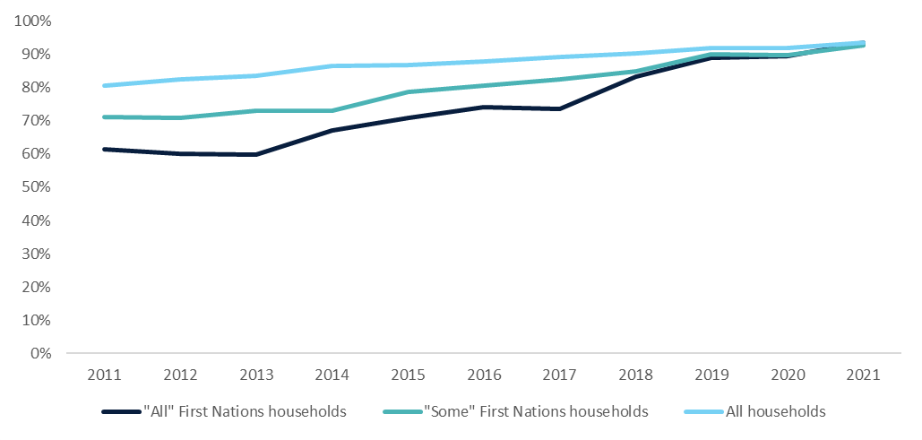

Source: The HILDA Survey, Release 21; waves 11 to 21, BCARR calculations.   
Note: Weighted responses to *_lsinthm ‘Do you have access to the Internet at home?’.* Data from wave 11 onwards due to lower response rates in earlier waves. Internet access counted where all members of the household reported access.

### The HILDA data appears to overestimate access

When comparing HILDA estimates to the 2011 and 2016 Census,[6] the HILDA internet access estimates appear to overestimate connectivity for all households. For First Nations households, HILDA appears to overestimate access by a greater margin than the average household.

In 2011, the Census reported around 63 per cent of First Nations households[7] had access to the internet, and around 77 per cent for Australian households overall. These are approximately 8 and 4 percentage points lower than the HILDA estimates, respectively. In 2016, the gaps between the data sources remained around this level. This overestimate in HILDA is likely due to the sample being slightly more urbanised than the Australian population. While weights are used to offset this, they are unable to produce representative data for all cohorts.

Further, the Australian Communications and Media Authority (ACMA, 2022) reported 91 per cent of households have access to the internet in June 2021 (and up to 93 per cent in 2022), while HILDA finds 94 per cent of Australian households had access in 2021.

Figure : Comparison of HILDA and Census internet access data, 2011 and 2016

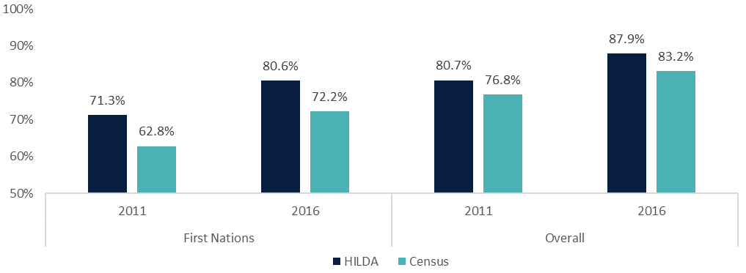Source: The HILDA Survey, Release 21, Census 2011 and Census 2016; BCARR calculations. Census data extracted from ABS TableBuilder.

Note: Axis starts at 50% access. The Census defines First Nations households as those where *at least one person is Aboriginal or Torres Strait Islander*, aligned with our definition for ‘some’ First Nations households.

### Remote households are not included in the HILDA sample

HILDA data is not representative for rural areas (Watson & Fry, 2002). To get an indication of the gap in internet access between rural areas and the overall population, Census data from 2011 and 2016 can be used. It shows that internet access is lower in remote areas for First Nations households and overall.

For rural First Nations households, Census data shows an internet access gap of 11 percentage points when compared to the average for all First Nations households in 2011. This gap reduced to around 8 percentage points in 2016. Non-First Nations households had higher levels of internet access in 2011 and 2016 as well as a smaller gap between rural areas and the average (Figure 8).[8]

Figure : Household internet access for rural areas, 2011 and 2016 Census

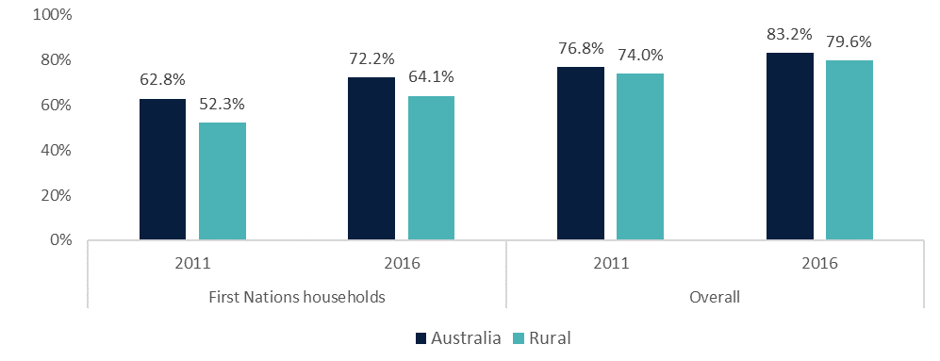Source: Census 2011 and Census 2016; BCARR calculations. Extracted from ABS TableBuilder.   
Note: Rural households counted by ‘section of state’ variable with bounded locality and rural balance included as rural.

*Interpret this as:*

Household access to the internet has been improving. HILDA data indicates the access gap between First Nations households and the average has been closing, however, there are some limitations with the data. The sample does not include remote households and subsequently overestimates households’ internet access compared to Census data.

# Regression findings: Household expenditure patterns and low-income groups

## When controlling for other factors, First Nations households spend less on telecommunications

The average spending data reported above doesn’t factor in other characteristics which may impact the share of income spent on telecommunications. First Nations households have observable differences to other households. For example, First Nations households are more likely to be located outside of major cities, have more people living at home and have lower incomes than those with no First Nations members (See Census data comparisons in Attachment B).

To control for these differences between households, regression modelling techniques are used to isolate and estimate the differences of individual characteristics. To test whether belonging to a First Nations household leads to different telecommunications expenditure, an ordinary least squares (OLS) regression was run using pooled HILDA data across waves 6 to 21.

When controlling for the other household characteristics (such as income and household size), OLS estimates show households with ‘some’ First Nations members spent on average 4.2 per cent less than households without any First Nations members. Households with ‘all’ First Nations members spent on average 11.4 per cent less than households that were not ‘all’ First Nations members (Figure 9).

Figure : Change in the share of income spent on telecommunications when some or all household members exhibit a characteristic

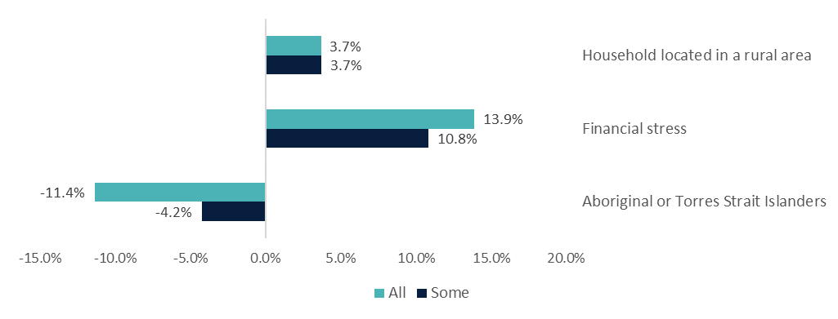

Source: The HILDA Survey, Release 21; BCARR calculations.

Notes: [1] For these household characteristics, which are binary in their nature, the marginal effects refer to the percentage change in the response variable if a given control changes from 0 to 1 while holding all the other control variables constant. [2] Marginal effects estimates for households located in rural areas and that have had difficulty paying electricity, gas or telephone bills on time (financial stress) are included in the chart for relevance and comparison. In the affordability paper, the marginal effects for all of household characteristics are shown in Figure 6 and detailed in Attachment F.

*Interpret this as:*

If two households exist with identical characteristics except for their First Nations members status, it would be expected the First Nations household spends a lower proportion of their disposable income on telecommunications.

### More people in First Nations households is correlated with lower shares of telecommunications expenditure

Regression analysis can also be used to test whether propensity to spend on telecommunications changes if households exhibit more than one characteristic at the same time. The model found that ‘all’ and ‘some’ First Nations households spent a lower share of income on telecommunications if their household size was larger.

This finding is consistent with the Mapping the Digital Gap 2022 outcomes report which found that remote First Nations households with more people have lower digital inclusion (Featherstone D *et al*., 2023). They found that in remote areas:

…larger households correlate with lower levels of digital inclusion. This points to issues of overcrowded housing, shared devices, and a lack of computers or computer services.   
(pp 37, Mapping the Digital Gap 2022 outcomes report)

The regression analysis found that the share of telecommunication spending is negatively correlated with income. As income increases, the share of income spent on telecommunications falls. However, for ‘some’ First Nation households, who spent a smaller share of income on telecommunications than non-First Nations households, the share of their expenditure on telecommunications increases as their income grows (See Attachment D –Regression outputs).

*Interpret this as:*

When controlling for other factors, including income, First Nations households with more people living in them tend to spend a lower share of disposable income on telecommunications.

## Likelihood to be in a low-income group

Logistic regression modelling was used to assess if ‘some’ or ‘all’ First Nations households were more or less likely to meet the criteria to be in two low-income groups at risk of digital exclusion. The two groups identified for their different levels of spending on telecommunication services are:

* **Low income, high spending (LIHS)** – where household disposable income is less than half the median and telecommunication expenditures as a share of disposable income is over three times the median.
  + This measure identifies low‑income households spending disproportionately high amounts on telecommunications, at risk of financial stress.
* **Low income, low spending (LILS)** – where household disposable income is less than half the median and telecommunications expenditures as a share of disposable income is below half of the median.
  + This measure identifies low income households that consume disproportionately fewer telecommunications services and are at potential risk of digital exclusion.[9]

*Interpret this as:*

To try identify which low income households are more at risk of being in financial stress (LIHS) or digitally excluded (LILS), a logistic regression model is used to calculate households’ likelihood of being in these groups. This model is used because the variable identifying in-scope households is binary, yes or no. See Attachment C for details.

### First Nations households are more likely to be low income, high spending (LIHS), although that changes as household size increases

When considering the LIHS group, households with ‘some’ First Nations members were more likely to be in this group than those without. This means these households are at a higher risk of financial stress (and potential digital exclusion) through unsustainable spending on telecommunications than non-First Nations households. Table 4 in Attachment D also shows that as household size increases, ‘some’ First Nations households were less likely to be LIHS, in line with earlier findings that spending reduces as household size increases.

For the ‘all’ First Nations households, the sample size is too small to draw statistically significant conclusions. For other demographic variables of interest, households with more people, in rural areas and under financial stress were also more likely to be LIHS (Figure 10).

Figure : Change in predicted probability of being LIHS, selected characteristics

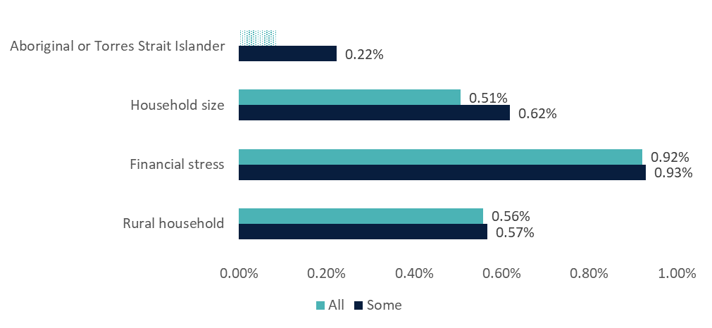

Source: HILDA waves 11 to 21; BCARR calculations.

Notes: [1] ‘Some’ refers to logistic regression estimates using control variables set to 1 if some members of the household displayed a given characteristic. ‘All’, refers to the regression estimates using control variables set to 1 if all members of the household displayed the particular characteristic. [2] Dotted bars indicate marginal effects that were not statistically significant (p-values were above the 10 per cent). [3] Marginal effect refers to the percentage change in the probability of belonging to the LIHS if a given variable is changed by one unit of measure, holding all the other control variables constant. [4] Marginal effects estimates for household size, households located in rural areas and that have had difficulty paying electricity, gas or telephone bills on time (financial stress) are included in the chart for relevance and comparison. In the affordability paper, the marginal effects for all of household characteristics are shown in Figure 9 and detailed in Attachment F – Logistic Regression Estimates.

### The low-income, low spending (LILS) cohort is too small to draw relevant conclusions from

For the LILS group, the findings are not statistically significant for First Nations households, so no conclusions can be drawn about the likelihood to be in this group. This is due to the very small sample of households which are in-scope. Even if the findings were statistically significant, the magnitude of these changes in reality are small as they may only refer to less than 0.5% of the population.

*Interpret this as:*

Households where ‘some’ members, but not ‘all’ members, are First Nations are more likely to be in the LIHS group. Similarly, households with lots of people are more likely to be LIHS. However, the ‘some’ First Nations households with more members are less likely to be in the LIHS group.

# Conclusion

Households where ‘all’ members of the household are First Nations tend to spend a higher proportion of their income on telecommunications than the average household. When controlling for income and other characteristics, First Nations households tend to spend less on telecommunications than non-First Nations households. HILDA data shows that internet access rates for First Nations households had grown to around the Australian average in 2021. These findings provide valuable insights into First Nations digital inclusion, but are limited by the geographic spread of the sample and lack of information on the type of connectivity experienced. To maximise the utility of these findings, they should be considered alongside the existing evidence base, including the ADII and Mapping the Digital Gap reports.

1. In-scope data from the HILDA survey

The affordability of telecommunications services for First Nations households was analysed using the HILDA survey from wave 6 onwards when the survey started to collect the information on households’ expenditure on telecommunications.

The key variable of interest is a derived variable _*hxytlii* capturing household annual expenditure on telecommunications services. This variable was constructed using responses to the Self-Completion Questionnaire’s question on monthly ‘telephone rent and calls, and internet charges’. It has been imputed if respondents provided no answer. Using *_hxytlii,* a measure of households’ affordability of telecommunications services is constructed by dividing it by household disposable income.[10]

Observations were excluded where household disposable income was negative or when the values of our constructed measure of affordability were below or equal zero and greater than or equal one.[11] The obtained total sample of all households varies by wave but remained around 6,000-9,000 households.

To analyse First Nations households within the HILDA data, two binary variables were created:

* the first where ‘all’ members of the household are First Nations people, and
* the second where at least one (‘some’) member of the household is First Nations.

Using these variables, the subset of ‘all’ and ‘some’ First Nations households can be identified within the HILDA dataset. As shown in Table 2, ‘all’ First Nations households account for between 86 to 187 households in a given wave which is equivalent to 1.3 to up to 2 per cent of all households. ‘Some’ First Nations households comprise between 203 and 436 households in a given wave which is around 3 to 4.7 per cent of all households.

The HILDA sample appears to overrepresent First Nations households. In 2021, the First Nations household sample was 4.4 per cent in HILDA, compared to 3.9 per cent in the 2021 Census (Table 2). This is a robust sample to make estimations from, especially when data is pooled across years. However, the sample is not nationally representative due to the lack of households in remote and sparsely‑populated areas (Woden & Watson, 2007), whom are known to be less digitally included.

The small sample size and lack of geographic representativeness are the main limitations of this study. These caveats need to be considered when drawing conclusions from these estimates. To overcome this limitation, where possible, comparisons to Census data and tests of statistical significance are conducted.

Table : HILDA sample size; all, ‘all’ First Nations, and ‘some’ First Nations households, by wave

|  |  |  |  |  |  |  |  |  |
| --- | --- | --- | --- | --- | --- | --- | --- | --- |
| Wave | Year | Households | ‘All’ First Nations | | ‘Some’ First Nations | | | Census comparison (%) |
| **No.** | **%** | | **No.** | **%** |
| 6 | 2006 | 6,850 | 86 | 1.3 | | 203 | 3.0 | 2.4 |
| 7 | 2007 | 6,768 | 97 | 1.4 | | 207 | 3.1 |  |
| 8 | 2008 | 6,770 | 95 | 1.4 | | 212 | 3.1 |  |
| 9 | 2009 | 6,948 | 104 | 1.5 | | 239 | 3.4 |  |
| 10 | 2010 | 7,024 | 98 | 1.4 | | 244 | 3.5 |  |
| 11 | 2011 | 9,214 | 141 | 1.5 | | 327 | 3.5 | 2.7 |
| 12 | 2012 | 9,229 | 150 | 1.6 | | 338 | 3.7 |  |
| 13 | 2013 | 9,214 | 158 | 1.7 | | 352 | 3.8 |  |
| 14 | 2014 | 9,263 | 164 | 1.8 | | 365 | 3.9 |  |
| 15 | 2015 | 9,279 | 163 | 1.8 | | 377 | 4.1 |  |
| 16 | 2016 | 9,383 | 163 | 1.7 | | 378 | 4.0 | 3.2 |
| 17 | 2017 | 9,389 | 174 | 1.9 | | 387 | 4.1 |  |
| 18 | 2018 | 9,288 | 174 | 1.9 | | 414 | 4.5 |  |
| 19 | 2019 | 9,327 | 181 | 1.9 | | 436 | 4.7 |  |
| 20 | 2020 | 9,165 | 187 | 2.0 | | 414 | 4.5 |  |
| 21 | 2021 | 8,982 | 179 | 2.0 | | 399 | 4.4 | 3.9 |

Source: HILDA Wave 21 Release; BCARR calculations and AIFS, 2023  
Note: Census groups First Nations households as those where at least one person is Aboriginal or Torres Strait Islander, aligned with our definition for ‘some’ households.

1. Some characteristics of First Nations households from Census 2021

Table : Household characteristics from Census 2021

|  |  |  |  |  |
| --- | --- | --- | --- | --- |
| Variable group | Category | With Aboriginal or Torres Strait Islander Person | Other households | Percentage point difference? |
| Household size | Average number of people | 3.1 | 2.5 | 0.6 |
| Household Composition (HHCD) | One family | 74% | 68% | 6% |
| Multiple family | 5% | 2% | 3% |
| Lone person | 16% | 26% | -10% |
| Group | 5% | 4% | 2% |
| Tenure type (TEND) | Owned outright | 14% | 32% | -18% |
| Owned with mortgage | 27% | 35% | -8% |
| Rented | 55% | 30% | 25% |
| Other | 2% | 2% | 0% |
| Dwelling structure | Separate house | 80% | 72% | 8% |
| Semi-detached | 11% | 13% | -2% |
| Apartment | 8% | 14% | -7% |
| Other | 1% | 1% | 0% |
| Remoteness indicator | Major Cities | 46% | 73% | -26% |
| Regional | 44% | 26% | 18% |
| Remote | 9% | 1% | 8% |
| Household income | Gross median annual | $78,364 | $90,792[12] | -$12,428 |

Source: Census 2021 -retrieved from ABS Census TableBuilder and Census QuickStats  
Note: [1] Percentage point difference used for percentage variables. [2] Some data points may not add up to 100% due to rounding or exclusion of ‘Not stated’ responses. [3] Gross median annual income is calculated by multiplying the weekly figures by 52 ($1,507 and $1,746 respectively).

Definition:

*In the Census, an Aboriginal and/or Torres Strait Islander household is a dwelling where at least one person identified as Aboriginal and/or Torres Strait Islander. On Census Night the person needs to have been present and a usual resident at the dwelling.*

Other sources:

* [Australia: Aboriginal and Torres Strait Islander population summary | ABS](https://www.abs.gov.au/articles/australia-aboriginal-and-torres-strait-islander-population-summary)
* [Housing Statistics for Aboriginal and Torres Strait Islander Peoples, 2021 | ABS](https://www.abs.gov.au/statistics/people/aboriginal-and-torres-strait-islander-peoples/housing-statistics-aboriginal-and-torres-strait-islander-peoples/2021#household-income)

1. Regression techniques

***Ordinary least squares (OLS) regression***

BCARR has used OLS regression to determine the independent effect of a household characteristic on the share of disposable income spent on telecommunications. These models hold other household characteristics constant, such as income and household size, to measure the strength of the association between the share of income spent on telecommunications (the response variable) and a one unit change in another specified variable.

OLS estimates show that once income, household size and other socioeconomic characteristics are controlled for, ‘all’ and ‘some’ First Nations households spend 4.2 and 11.4 per cent less of their income share on telecommunications than other households respectively. This suggests a lower propensity of First Nations households to spend their income on telecommunication and potentially a higher likelihood to be digitally excluded.

***Logistic regression***

Logistic regression models are used to model data where an outcome is binary; the result can either be “yes” (=1) or “no” (=0). This is true for the LILS and LIHS models, as a household can only be classified as LILS/LIHS (=1) or not (=0).

The estimates of the logistic regression are reported in the form of odds ratios, which is ratio of two probabilities. For example, for the LIHS group, the odds ratio refers to the probability of being in the LIHS group when exhibiting a characteristic, over the probability of being LIHS group when not exhibiting the same characteristic. An odd ratio greater than one means the household exhibiting the given characteristic is more likely to be in the LIHS group. An odd ratio less than one means the household exhibiting the given characteristic is less likely to be in the LIHS group.

***Model selection with interaction terms***

In both the LILS and LIHS models, the models which included interaction terms with household size were selected as the best.[13] When looking at First Nations households, this means two relevant variables calculating the likelihood of being in the low-income group are included:

* being a First Nations household
* the combined effects of being a First Nations household AND household size.

1. Regression outputs

## OLS outputs for telecommunications expenditure share

This section presents excerpts from the statistical outputs in the Affordability paper that are used here to highlight the findings for First Nations households. In the Affordability paper, these are found in *Attachment C – OLS regression estimates* and *Attachment G – Logistic regression estimates*. The tables below do not show all of the other independent variables included in the regression modelling.

Table : Excerpt of Table 4: OLS regression results, ‘some’ and ‘all’ models with interaction terms

|  |  |  |  |  |  |
| --- | --- | --- | --- | --- | --- |
| Dependent variable: ln (telecommunications expenditure share) |  | Some | | All | |
|  | | **Coef.** | **Std. error** | **Coef.** | **Std. error** |
| Aboriginal or Torres Strait Islander | | -1.047*** | 0.1993 | 0.047* | 0.0270 |
| ln(household income) | | -0.871*** | 0.0086 | -0.846*** | 0.0072 |
| ln(household size) | | 0.123*** | 0.0125 | 0.205*** | 0.0140 |
| Financial stress | | -0.487*** | 0.1177 | -0.468*** | 0.1351 |
| Rural household | | 0.019 | 0.0115 | 0.018 | 0.0115 |
| Aboriginal or Torres Strait Islander * household income | | 0.108*** | 0.0190 | n.a. | n.a. |
| Aboriginal or Torres Strait Islander * household size | | -0.258*** | 0.0260 | -0.218*** | 0.0320 |
| Household located in a rural area * household size | | 0.035*** | 0.0113 | 0.036*** | 0.0113 |
| Constant | | 5.571*** | 0.0958 | 5.283*** | 0.0787 |
| Sample size | | 136,063 | | 136,063 | |
| R-squared | | 36 % | | 35.9% | |

n.a – not included in the model as not statistically significant.

*Significant at 10% level; **Significant at 5% level; ***Significant at 1% level

Source: The HILDA Survey, Release 21; BCARR calculations

## Logistic regression for low income groups

Table : Excerpt of Table 7: Logistic regression estimates, LIHS group, ‘all’ and ‘some’ models with interaction terms

|  |  |  |  |  |
| --- | --- | --- | --- | --- |
| LIHS | Some | | All | |
|  | **Odds Ratio** | **Std Error** | **Odds Ratio** | **Std. Error** |
| Aboriginal or Torres Strait Islander | 1.542*** | 0.2453 | 1.025 | 0.0875 |
| Household size | 1.148* | 0.0824 | 1.192*** | 0.06 |
| Financial stress | 1.609*** | 0.1403 | 1.783*** | 0.1737 |
| Rural household | 1.207*** | 0.0582 | 1.204*** | 0.0579 |
| Aboriginal or Torres Strait Islander * Household size | 0.76*** | 0.0616 | n.a. | n.a. |
| _cons | 3.633*** | 1.0454 | 14.459*** | 2.7129 |
| No. observations | 136063 | | 136063 | |
| Log pseudolikelihood | **-15410.9** | | **-15414.3** | |
| Pseudo R2 | **51.9%** | | **51.8%** | |

Source: The HILDA Survey, Release 21; BCARR calculations

Note: For these household characteristics, which are binary in their nature, the marginal effects refer percentage change in the response variable if a given control changes from 0 to 1 while holding all the other control variables constant.

# References

ACMA. (2022, December). *Communications and media in Australia series: How we use the internet.* . Retrieved from https://www.acma.gov.au/sites/default/files/2023-03/HOWWEU~1.PDF

AIFS. (2023, July). *Population, households and families*. Retrieved from https://aifs.gov.au/research/facts-and-figures/population-households-and-families#references:~:text=Increase%20in%20First%20Nations%20households

BCARR. (2017). *Trends and drivers in the affordability of communications services for Australian households.* Retrieved from https://www.infrastructure.gov.au/department/media/publications/trends-and-drivers-affordability-communications-services-australian-households

BCARR. (2020). *Affordability of communciations services for low income households .* Retrieved from https://www.infrastructure.gov.au/department/media/publications/affordability-communications-services-low-income-households

Featherstone D, O.-P. L.-J. (2023, September 26). *Mapping the Digital Gap 2023 outcomes report.* doi:10.25916/a01g-fp91

FNDIAG. (2023, October). *First Nations Digital Inclusion Advisory Group: Initial report*. Retrieved from https://www.digitalinclusion.gov.au/sites/default/files/documents/first-nations-digital-inclusion-advisory-group-initial-report.pdf

Thomas, J. M.-J.-P. (2023). *Measuring Australia’s Digital Divide: Australian Digital Inclusion Index: 2023.* Melbourne: ARC Centre of Excellence for Automated Decision-Making and Society, RMIT University, Swinburne University of Technology, and Telstra.

Watson, N. (2012, December). *HILDA project technical paper series No. 2/12: Longitudinal and Cross-sectional Weighting.* Retrieved from https://melbourneinstitute.unimelb.edu.au/assets/documents/hilda-bibliography/hilda-technical-papers/htec212.pdf

Watson, N., & Fry, T. R. (2002, September). *The Household, Income and Labour Dynamics in Australia (HILDA) Survey: Wave 1 Weighting.* Retrieved from HILDA project technical paper series: https://melbourneinstitute.unimelb.edu.au/assets/documents/hilda-bibliography/hilda-technical-papers/htec302.pdf

Woden, M., & Watson, N. (2007). The HILDA Survey and its contribution to economic and social research (so far). *The Economic Record*, 208-231.

1. See Attachment B for more household characteristics from the Australian Census of Population and Housing (Census) 2021.
2. Breunig and McCarthy (2018) and BCARR (2017)
3. The HILDA sample excluded remote and sparsely -populated areas in wave 1 and in the wave 11 top-up. First Nations people were over-represented in this group.
4. The communications group covers all expenditure related to telecommunication services and postal services
5. [Consumer Price Index, Australia, June Quarter 2023 | Australian Bureau of Statistics (abs.gov.au)](https://www.abs.gov.au/statistics/economy/price-indexes-and-inflation/consumer-price-index-australia/jun-quarter-2023)
6. The question regarding Internet access was not included in the 2021 Census questionnaire.
7. Census defines First Nations households as those where at least one person is Aboriginal or Torres Strait Islander, aligned with our definition for ‘some’ households.
8. For more detailed information on First Nations rural digital inclusion, see [Mapping the digital gap: 2023 outcomes report (apo.org.au)](https://apo.org.au/node/324397)
9. There is an underlying assumption that the low income is what creates the lower consumption of telecommunications. This may be true for some, while others may consume less due to personal preferences.
10. Household disposable income is derived by subtracting the negative financial year disposable income (*_hifditn*) from positive financial year disposable income (*_hifditn*). This variable has not been adjusted for inflation.
11. 392 observations (0.3 per cent) were removed as they had negative disposable income. 4,597 observations (3.4 per cent) were dropped as their share of expenditure on telecommunications services in the disposable income was equal zero or was greater than one.
12. The “Other households” figure reported for income is the national median for Australian households. This is used for comparison purposes with Figure 3.
13. After adding the interaction terms the pseudo r-squared and log pseudolikelihood values improve, implying the model has greater explanatory power.