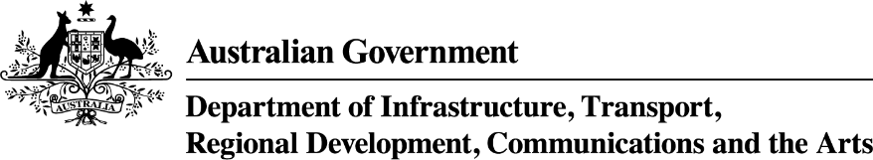

Tasmania—Thriving Suburbs Program projects—as at 4 December 2024
Applicant Organisation | Project Title | Project Description | Project Location | Project State | Commonwealth Funding Approved
Clarence City Council | Clarendon Vale Oval Pavilion Reconstruction and Sports Lighting | The project will deliver a state-of-the art sports pavilion and advanced lighting, to replace the 2019 demolished storm damaged structure, with inclusive amenities, unisex changerooms, catering kitchen, accessible public toilets and tiered seating to meet the increasing population demand and foster greater liveability, community participation and social cohesion. | Clarendon Vale | TAS | $2,200,000

