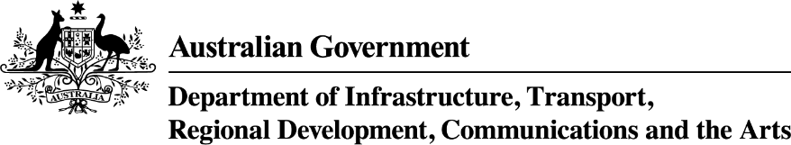

Tasmania: Growing Regions Program – Round 2 projects
Applicant Organisation | Project Title | Project Description | Project Location | Project State/territory | Commonwealth Funding Approved
Launceston City Council | Princess Theatre and Earl Street Theatre Project | The project will upgrade the Princess Theatre by constructing new facilities including toilets, staff areas, meeting rooms, kitchen areas, change rooms, bar and ticketing facilities, and refurbish the lobby, as well as improving disability access with the installation of a lift. The existing Earl Arts Centre will be demolished and a new contemporary youth-based Earl Street Theatre built to replace it. | Launceston | TAS | $12,761,600
Flinders Council | Flinders Island Airport Revitalisation | This project will deliver a comprehensive upgrade of the airport’s infrastructure, improve safety and enhance operational capacity by constructing a new operations office, upgrading the airport’s electrical system including LED runway and apron lighting, installing Precision Approach Path Indicators and installation of a standby generator and switchboard. | Whitemark | TAS | $2,682,119
Rural Health Tasmania Inc | The Circular Head Community Health and Wellbeing Hub | The project will renovate an existing building and deliver a community drop-in space and meeting spaces, including administration office space, toilets, a youth room, commercial kitchen, staff rooms, consultation rooms and reception area. | Smithton | TAS | $619,241

