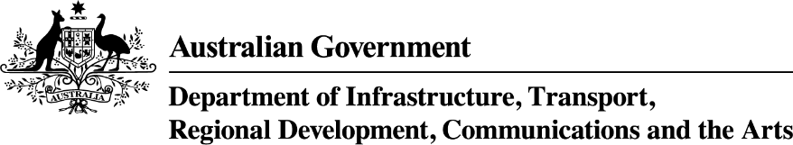

South Australia—Thriving Suburbs Program projects—as at 26 November 2024
Applicant Organisation | Project Title | Project Description | Project Location | Project State | Commonwealth Funding Approved
Coromandel Valley Ramblers Cricket Club | Hawthorndene Oval Multi-Use Changerooms and Public Toilets | The project will construct a contemporary, environmentally sensitive multi-use facility, incorporating multi use changerooms, showers, umpire’s room, store room, kitchenette and all access public toilets, which will provide a multi-use facility for organised sport in a rapidly growing community. | Hawthorndene | SA | $822,764
City of Burnside | Regal Theatre Precinct Redevelopment | The project will rejuvenate the heritage-listed theatre and surrounding precinct, increasing accessible outdoor open spaces, tree plantings and landscapes, to accommodate a greater range of performances, patron experiences and retail, café and outdoor dining opportunities. | Kensington Park | SA | $2,434,000
Town of Gawler | Gawler and District Tennis Association Court Redevelopment | The project will provide a high-quality regional tennis facility by reconstructing existing and constructing new tournament quality courts, to increase all aspects of participation and to attract additional and higher-level competitions. | Gawler | SA | $1,153,000
City of Onkaparinga | Noarlunga Aquatic Centre Upgrades | The project will revitalise the existing aquatic centre, by relining the pool shell, upgrading water treatment systems, addressing structural issues, and installing solar panels that will enhance safety, sustainability, efficiency and improve community health and social cohesion. | Noarlunga Centre | SA | $5,400,000
City of West Torrens | Redevelopment of Community Facilities at Karkungka Reserve, Keswick SA | The project will develop a new community hub facility alongside renovating an existing Child and Family Health Service building by providing new and updated kitchens, bathrooms, storage and function areas and redeveloped outdoor space to meet growing community need and strengthen social cohesion. | Keswick | SA | $3,683,472
Corporation of the City of Unley | Unley Cultural Hub | The project involves adaptive reuse of three existing cottages to create a high quality multipurpose Cultural Hub to accommodate cultural events, art exhibitions, studio and workshop spaces to enrich and celebrate the community's cultural identity, social landscape and community cohesion. | Unley | SA | $2,660,843
The Corporation of the City of Adelaide | Hutt Street Revitalisation Project - City of Adelaide (CoA) | The project will revitalise and activate the City’s Hutt Street precinct, with upgraded path ways, protected cycle paths and tree plantings to create a village-like atmosphere and enhance amenity, social cohesion and liveability. | Adelaide | SA | $7,324,193
City of West Torrens | Construction of a new community and recreation facility at Cowandilla SA | The project involves reconstructing a new community and recreation central hub to replace the ageing Western Youth Centre, featuring inclusive changerooms and versatile meeting spaces, to support community engagement, recreation, diverse sport clubs and groups of all ages. | Cowandilla | SA | $7, 528,000
Adelaide Football Club Limited | Next Generation Community Sports Hub | The project will deliver a multi-purpose community and Australian Football League (AFL) facility, including unisex change rooms and an administration hub, to provide culturally appropriate amenities, and foster social and health benefits to children and youth in the culturally diverse growing community. | Torrensville | SA | $2,708,512

