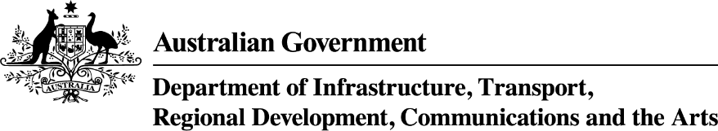

South Australia: Growing Regions Program—Round 2 projects
Applicant Organisation | Project Title | Project Description | Project Location | Project State/territory | Commonwealth Funding Approved
Kingston District Council | Investing for the future - no child left behind in Kingston | The project will deliver a new childcare centre, including a nature-based outdoor play space, indoor learning environments, consultation offices for child allied health service professionals, and a designated space for children’s playgroups and family members. | Kingston SE | SA | $3,500,000
Corporation of the City of Whyalla | Whyalla Beach Splash & Play Plaza | The project will deliver a destination playground which will include an adventure playbox, outdoor adventure play area, flying fox, swings, net crossings, climbing wall, monkey bars, water features, wave lawn and scooter track, basketball court, landscaping, seating, shelter, lighting and picnic areas. | Whyalla | SA | $3,141,443
APY Art Centre Collective Aboriginal Corporation | First Nations Men's Multidisciplinary Art Spaces and Keeping Places | The project will deliver men’s art spaces and keeping places at four established Indigenous Art Centres (Mimili Maku Arts, Kaltjiti Arts, Tjala Arts and Umooma Community Arts) to support the growth in men’s engagement in art and artefact making, and where culture is celebrated and instructed daily through art and cultural practice. | Mimili, Fregon, Amata and Umoona Communities (Coober Pedy) | SA | $2,509,470
Penola Football Club Incorporated | Penola Football Club and Community Sports Hub Redevelopment Project | The project will redevelop the existing facility by improving access through a covered stairwell and lift, incorporating more environmentally sustainable design features including LED lighting, installation of rainwater catchment and water efficient fixtures and fittings, installation of double-glazed windows, and installation of energy-efficient appliances. More flexible multi-use spaces, improvements to the ergonomics of the kitchen and bar areas, and external BBQ area, improved viewing spaces, and incorporation of improved information and communication technology will also be incorporated. | Penola | SA | $1,437,250
District Council of Orroroo Carrieton | Orroroo Main Street Upgrade | The project will revitalise the town's central  business area and improve amenity and accessibility through pedestrian safety and accessibility improvements, traffic calming measures, stormwater management, environmental enhancements, and cultural and heritage integration. This includes upgrading pedestrian crossings, widening footpaths, provide new disability-compliant parking spaces, with improved access to key services such as the post office, public toilets, and supermarket, as well as landscaping with native plant gardens and tree planting, and incorporating artwork. | Orroroo | SA | $900,000

