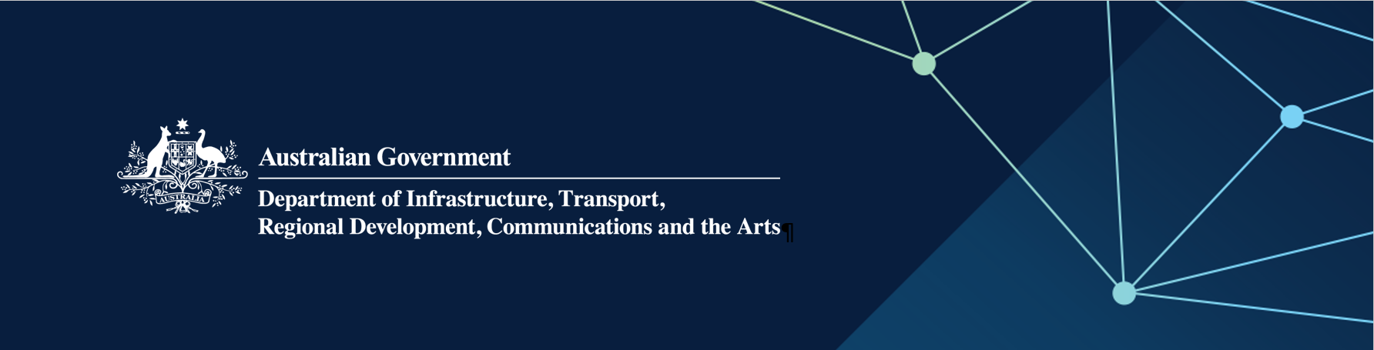

# Regional Airports Program (RAP) Round 4 WA approved projects

**February 2025**

| **Applicant** | **State/ Territory** | **Aerodrome** | **Project** | **Australian Government Funding (GST exc)** |
| --- | --- | --- | --- | --- |
| Shire of Northam | WA | Northam Airfield | Construct asphalt apron and line marking | $357,553 |
| Shire of Katanning | WA | Katanning Aerodrome | Restoration and resealing of runway | $236,817 |
| Shire of Cunderdin | WA | Cunderdin Airport | Upgrade drainage, repair runway seal, line marking and navigational aids | $153,000 |
| Shire of Boyup Brook | WA | Boyup Brook's Airstrip | Resurface runway | $26,662 |