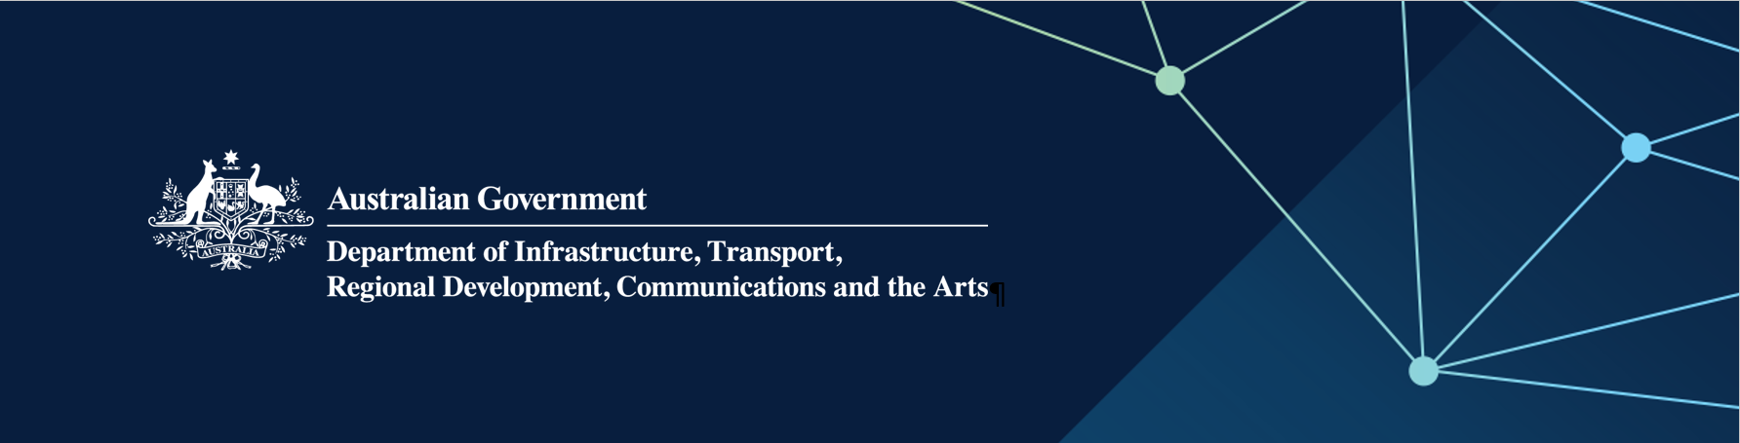

# Regional Airports Program (RAP) Round 4 VIC approved projects

**February 2025**

| **Applicant** | **State/ Territory** | **Aerodrome** | **Project** | **Australian Government Funding (GST exc)** |
| --- | --- | --- | --- | --- |
| Mildura Airport Pty Ltd | VIC | Mildura Airport | Rejuvenation and repair of the main runway and other pavement areas | $1,955,316 |
| Ballarat City Council | VIC | Ballarat Airport | Patient transfer and emergency services facility | $1,107,845 |
| Kyneton Aero Club Inc. | VIC | Kyneton Airfield | Extend and reseal runway, seal taxiways and install a helipad | $413,500 |
| Central Goldfields Shire Council | VIC | Maryborough Aerodrome | Upgrade Pilot Activated Lighting (PAL), upgrade tie-downs and renewal of main runway, taxiways and helipad surface | $210,000 |
| Warrnambool City Council | VIC | Warrnambool Airport | Upgrade and expansion of the main apron | $185,955 |
| Department of Energy Environment and Climate Action | VIC | Mansfield Airbase | Access improvement works, upgrade drainage, lighting and line marking of helipads | $181,500 |
| Greater Bendigo City Council | VIC | Bendigo Airport | Resurface part of runway 05/23, aprons and taxiways | $143,000 |
| Moira Shire Council | VIC | Yarrawonga Aerodrome | Reseal of runway 01/19 | $138,463 |
| Geelong/Surfcoast Airpark Pty Ltd | VIC | Barwon Heads | Reseal areas of runway and seal adjacent runup bays, shape and resurface taxiway and replace security fencing | $104,695 |