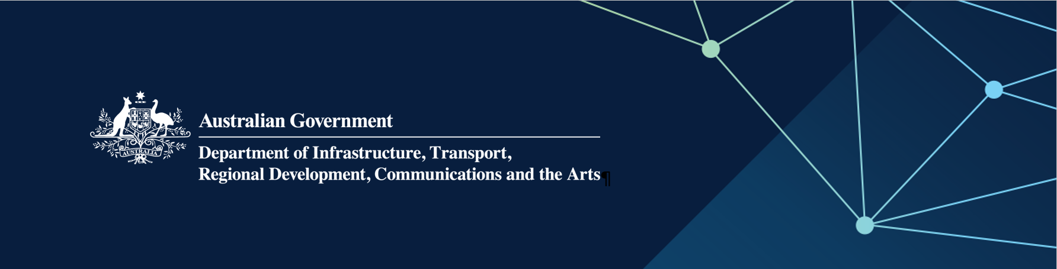

# Regional Airports Program (RAP) Round 4 Tasmania approved projects

**March 2025**

| **Applicant** | **State/ Territory** | **Aerodrome** | **Project** | **Australian Government Funding (GST exc)** |
| --- | --- | --- | --- | --- |
| Burnie Airport Corporation Pty Ltd | TAS | Burnie Airport | Application of Surface Enrichment Spray Treatment to main runway | $330,294 |