Australian Government
Department of Infrastructure, Transport, Regional Development, Communications and the Arts

**Prominence framework for connected TV devices**

Proposals Paper

**December 2022**

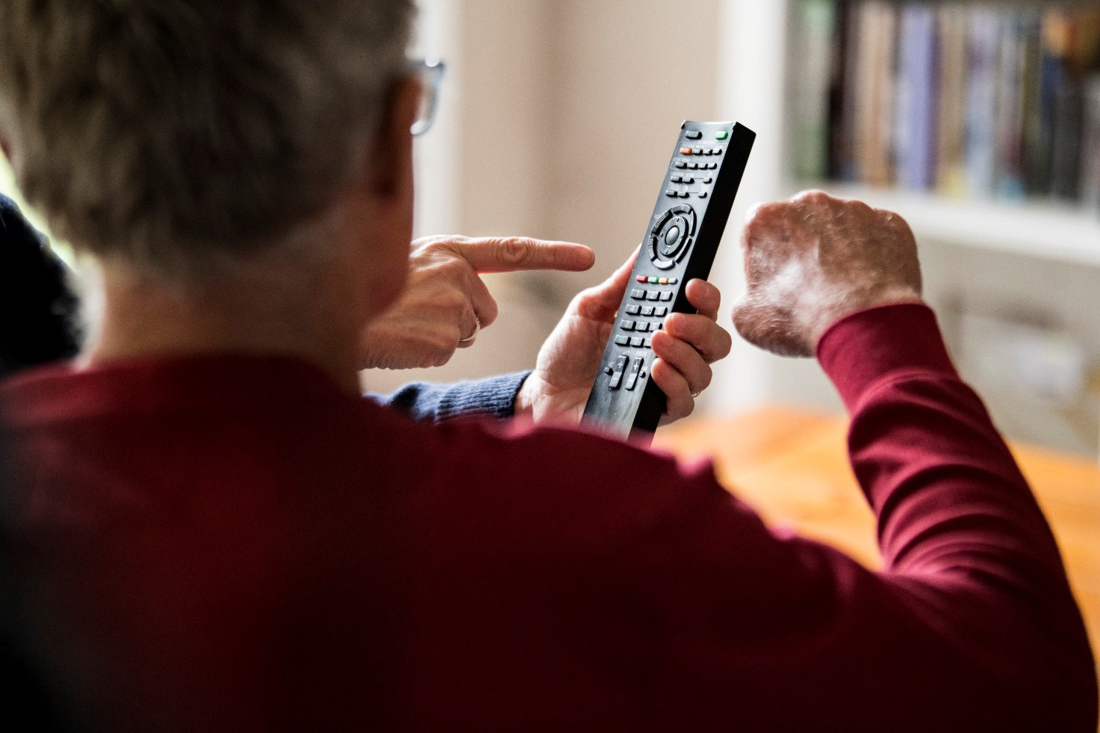

© Commonwealth of Australia 2022

**Ownership of intellectual property rights in this publication**

Unless otherwise noted, copyright (and any other intellectual property rights, if any) in this publication is owned by the Commonwealth of Australia (referred to below as the Commonwealth).

**Disclaimer**

The material contained in this publication is made available on the understanding that the Commonwealth is not providing professional advice, and that users exercise their own skill and care with respect to its use, and seek independent advice if necessary.

The Commonwealth makes no representations or warranties as to the contents or accuracy of the information contained in this publication. To the extent permitted by law, the Commonwealth disclaims liability to any person or organisation in respect of anything done, or omitted to be done, in reliance upon information contained in this publication.

**Creative Commons licence**

With the exception of: (a) the Coat of Arms; and (b) the Department of Infrastructure, Transport, Regional Development, Communications and the Arts photos and graphics, copyright in this publication is licensed under a Creative Commons Attribution 4.0 Australia Licence.

Creative Commons Attribution 4.0 Australia Licence is a standard form licence agreement that allows you to copy, communicate and adapt this publication provided that you attribute the work to the Commonwealth and abide by the other licence terms.

Further information on the licence terms is available from <https://creativecommons.org/licenses/by/4.0/>.  
This publication should be attributed in the following way: © Commonwealth of Australia 2022.

**Use of the Coat of Arms**

The Department of the Prime Minister and Cabinet sets the terms under which the Coat of Arms is used. Please refer to the Commonwealth Coat of Arms — Information and Guidelines publication available at [www.pmc.gov.au](http://www.pmc.gov.au).

**Contact us**

This publication is available in hard copy or PDF format. All other rights are reserved, including in relation to any departmental logos or trademarks which may exist. For enquiries regarding the licence and any use of this publication, please contact:

Director—Publishing and Communications  
Communication Branch  
Department of Infrastructure, Transport, Regional Development, Communications and the Arts  
GPO Box 594  
Canberra ACT 2601  
Australia

Email: [publishing@communications.gov.au](mailto:publishing@communications.gov.au)

Websites: [www.infrastructure.gov.au](http://www.infrastructure.gov.au) | [www.communications.gov.au](http://www.communications.gov.au) | [www.arts.gov.au](http://www.arts.gov.au).

Table of Contents

**Executive Summary 5**

**Make your views known 7**

**PART 1: prominence and the changing broadcast environment 10**

**Chapter 1: what is prominence? 10**

**Chapter 2: the role of FTA services 13**

**Chapter 3: the changing media environment 20**

**Chapter 4: international approaches to prominence 24**

**PART 2: framework proposals 27**

**Chapter 5: framework scope – local TV services 28**

Proposal 5.1: linear FTA broadcasts 28

Proposal 5.2: linear FTA broadcasts and BVOD applications 29

Proposal 5.3: content services providing Australian programming 30

**Chapter 6: framework scope – regulated TV devices 31**

Proposal 6.1: all TV devices 31

Proposal 6.2: a primary use approach 32

**Chapter 7: framework scope – responsible parties 34**

Proposal 7.1: obligations on device manufacturers 34

Proposal 7.2: multi-party obligations 35

**Chapter 8: framework models 36**

Proposal 8.1: a reporting framework 36

Proposal 8.2: a fair bargaining framework 36

Proposal 8.3: a must-carry (access) framework 37

Proposal 8.4: a must-promote framework 39

**Chapter 9: framework implementation 42**

Proposal 9.1: industry code under the Competition and Consumer Act 2010 42

Proposal 9.2: amendments to the Broadcasting Services Act 1992 43

Proposal 9.3: an industry code coupled with supporting legislation 44

List of Figures and Tables

Figure 1: Terminology for accessing television services 11

Table 1: Access pathways and associated prominence issues 11

Figure 2: Combined ‘main’ and ‘essential’ reason for watching FTA television 13

Table 2: Content quota requirements on metropolitan commercial television broadcasters 17

Table 3: Minimum requirements on regional commercial television broadcasters 18

Figure 4: Increase in viewing options for Australians – number of providers, 1992–2022 20

Figure 5: Percentage of Australians who used non-linear TV services in the last four weeks 21

Figure 6: Number of TVs connected to the internet in 2022 22

Figure 7: Percentage of Australians who viewed FTA television over a seven day period 23

Table 4: Proportion of plug-in device users who say they can access FTA TV on their device: 39

# **Executive Summary**

The Australian Government has committed to legislating a prominence framework to ensure local TV services are easy for Australian audiences to find on connected TV devices.

The Australian media landscape has changed dramatically over the last two decades. Audiences can now access a range of local and international TV services through internet-connected devices. While offering significant benefits for Australian audiences, these technology-driven changes are creating a more challenging environment for local TV services to deliver content to these viewers.

A legislated prominence framework would shape the way TV applications and/or content are presented to Australians. It would seek to ensure local TV services can be easily found on TV devices, so that they can continue to contribute to Australia’s public and cultural life.

The development and implementation of this framework will be complex and the Australian Government is undertaking this work in a progressive and consultative manner. An initial phase of stakeholder engagement was undertaken between August and November 2022 through which the preliminary views of stakeholders were gathered. These views (and the proposals advanced by some parties) have informed the development of this paper.

Views of interested parties are now sought in relation to the proposals outlined in this paper. The Government will consider these inputs and expects to make a decision regarding the model and mechanism of the framework in the first half of 2023.

## **Prominence forms part of a broader media reform agenda**

The design and implementation of a legislated prominence framework will not be undertaken in isolation. This forms part of a broader program of systemic regulatory reform and modernisation.

The objectives of media policy are enshrined in the *Broadcasting Services Act 1992* (BSA) and include (among others):

* the provision of Australian content;
* the availability of a diverse range of services;
* the provision of news and local content; and
* protecting minors from harms and upholding community standards.

These explicit objectives are underpinned by an implicit aim of ensuring all Australians have access to media services and content.

These objectives remain fit-for-purpose in a contemporary media environment, but the mechanisms used to support and achieve them are increasingly dated and ineffective. The Government is committed to modernising media regulations to fulfil the legitimate expectations of consumers and industry for consistency, transparency and equity in our regulatory environment.

Broadcasting services are, and will remain, important in achieving media policy objectives. The Government’s approach to media reform will look to foster a sustainable broadcast industry that:

* provides trusted news and emergency broadcasting, high quality entertainment and information that reflects national identity and cultural diversity;
* utilises terrestrial broadcasting arrangements and radiofrequency spectrum to deliver services that are accessible, free, stable and ubiquitous, regardless of income or location; and
* harnesses new technologies to deliver TV services, including via connected TV devices, in line with the objectives of the BSA.

## **Views are sought on the design of the prominence framework**

This paper is seeking views on specific proposals for elements of the prominence framework. It is organised into two parts.

**Part 1** describes the broadcasting environment in Australia and the emergence of prominence issues in Australia and overseas.

* Chapter 1 defines prominence, while Chapter 2 outlines the role of free-to-air (FTA) services in relation to the achievement of public policy objectives.
* Chapters 3 and 4 examine, respectively, recent changes in the broadcasting environment and technology, and the approaches to prominence taken in a number of international jurisdictions.

**Part 2** of the paper sets out a series of proposals for key elements of a legislated prominence framework. This is grouped into three sections.

* Chapters 5, 6 and 7 consider framework scope. These are the threshold issues that will need to be considered in the design of a prominence framework: regulated TV devices; local TV services; and the point of regulatory responsibility for the obligations contained in a framework.
* Chapter 8 puts forward a series of potential framework designs for a prominence framework, ranging from a reporting regime through to a full ‘must promote’ obligation.
* Chapter 9 deals with framework implementation, and includes a number of proposals for enacting and administering a prominence framework in terms of the legislative mechanism and regulator.

# **Make your views known**

The Department of Infrastructure, Transport, Regional Development, Communications and the Arts (the department) is seeking feedback from interested parties on the design of a prominence framework, with the submissions period closing on **Friday, 24 February**. Submissions received by the department as part of this consultation process will be used to inform the final design of the proposed framework.

## **Making a submission**

The department is welcoming written comments and submissions on the matters outlined in this paper. Comments and submissions should be received by **5:00 PM Australian Eastern Daylight Time on Friday,** **24 February 2023**.

Comments and submissions can be lodged by:

Website: <https://www.infrastructure.gov.au/have-your-say/>

Post: Online Safety, Media and Platforms Division  
Department of Infrastructure, Transport, Regional Development, Communications and the Arts GPO Box 594   
CANBERRA ACT 2601

Comments and submissions should include the respondent’s name, organisation (if applicable) and contact details.

Questions about the submission process can be directed to [media.reform@communications.gov.au](mailto:media.reform@communications.gov.au).

## **Publication of submissions and confidentiality**

All submissions will be made publicly available by the department unless a respondent specifically requests that a submission, or a part of a submission, be kept confidential. Comments will not be published.

The department reserves the right not to publish any submission, or part of a submission, which in its view contains potentially offensive or defamatory material, or for confidentiality reasons.

The department is subject to the *Freedom of Information Act 1982* and comments and submissions may be required to be disclosed by the department in response to requests made under that Act.

# **The process to date**

The Government is progressing its election commitment to legislate a prominence framework in a number of phases. The first phase involved a process of preliminary consultation with members of the Future of Television Working Group and (in parallel) a range of other stakeholders.

The Working Group was established in early 2022 to provide a forum for industry and Government to work through issues relating to the evolution of broadcasting technologies and other television market reforms. It is comprised of FTA broadcasters, consumer bodies, transmission infrastructure providers and television manufacturers. The organisations comprising the members of the Group are:

|  |  |
| --- | --- |
| * Australian Broadcasting Corporation (ABC) * Australian Communications Consumer Action Network (ACCAN) * Australian Industry Group (Ai Group) * BAI Communications * Consumer Electronics Suppliers Association (CESA) * Free TV Australia * Hisense Group * Imparja Television * Nine Entertainment | * Paramount Australia & New Zealand (Network Ten) * Samsung Electronics * Seven West Media * Sony Group Corporation * Southern Cross Austereo * Special Broadcasting Service (SBS) * TCL Electronics * TX Australia * WIN Corporation |

A parallel process of engagement was also undertaken with a number of additional stakeholders. These were:

|  |  |
| --- | --- |
| * Apple * Amazon * Commercial Radio and Audio (CRA) * Community Broadcasting Association of Australia (CBAA) * Disney * Fetch TV * Foxtel | * Google * Interactive Games and Entertainment Association (IGEA) * Netflix * Optus * Stan * Telstra |

Stakeholders were provided with a background paper prepared by the department.[1] The paper outlined a number of threshold issues to be considered as part of the framework design process.

Comments and inputs were received over the period from August through November 2022 and this has informed the development of this paper.

# **Acronyms and Glossary**

Acronyms

|  |  |  |  |  |
| --- | --- | --- | --- | --- |
| Term | Meaning |  | Term | Meaning |
| ACCC | Australian Competition and Consumer Commission |  | **EPG** | Electronic Program Guide |
| ACMA | Australian Communications and Media Authority |  | **FTA** | Free-to-Air television |
| AVOD | Advertising Video-on-Demand |  | **LCN** | Logical Channel Number |
| BSA | *Broadcasting Services Act 1992* |  | **OS** | Operating System |
| BVOD | Broadcast Video-on-Demand |  | **PSB** | Public Service Broadcaster |
| CCA | *Competition and Consumer Act 2010* |  | **SVOD** | Subscription Video-on-Demand |
|  |  |  | **TVOD** | Transactional Video-on-Demand |

Glossary

|  |  |
| --- | --- |
| Term | Meaning |
| Linear TV broadcasts | Television broadcasting services that are transmitted using radiofrequency spectrum and provided under the authority of a licence allocated under the *Broadcasting Services Act 1992* or another relevant Act. |
| Primary user interface | The built-in interactive home / landing page of a connected TV device, and the gateway for user access to applications and content. The functionality and features of the primary user interface will vary across devices. |
| RF tuner | Radiofrequency tuner, the means by which a TV device receives terrestrial broadcast signals broadcast via radiofrequency spectrum. |
| TV devices | Inclusive of:   * devices capable of receiving and displaying linear TV broadcasts transmitted via radiofrequency spectrum (i.e. television sets, whether or not they are internet-capable); * devices capable of receiving and distributing television broadcast content transmitted via radiofrequency spectrum (i.e. set-top-boxes, subscription television boxes); and * devices that are connected to the internet and capable of displaying broadcast television content, or facilitating the display of television content (i.e. gaming consoles, sticks, pucks, dongles, laptops, tablets, mobile phones) transmitted via the internet. |

# **PART 1: prominence and the changing broadcast environment**

Part 1 of this paper outlines a range of matters relevant to the design of a prominence framework.

|  |  |  |
| --- | --- | --- |
| *Issue* | *Outline* | *Chapter reference* |
| What is prominence? | A summary of what prominence is and how it operates in the broadcast context. | Chapter 1 |
| The role of FTA services | An assessment of the public policy role of FTA broadcasting. | Chapter 2 |
| The changing media environment | An outline of recent changes in the broadcast media environment. | Chapter 3 |
| International approaches | A summary of international approaches to prominence regulation. | Chapter 4 |

# **Chapter 1: what is prominence?**

In the context of this paper, prominence refers to the ability of users of TV devices to access local TV services. This can be further broken down into three types of prominence.

* The most basic form of prominence is whether an application (or, in some cases, a type of TV content) is present on a TV device, known as **‘availability’**.
* The relative visibility of apps to users on TV devices can be described as **‘positioning’**.
* Beyond app positioning, the ability of users to find particular content or programs can be referred to as **‘discoverability’** (which can occur within apps, or by selecting content through device menus that aggregate content or programming options).

The relationship between these terms is depicted in Figure 1.

Figure 1: Terminology for accessing television services

Selecting content via device menu

On devices such as smart TVs, users access services and content in several ways. For a given application on a device, issues of prominence arise for each of these access pathways, as set out in Table 1.

Table 1: Access pathways and associated prominence issues

|  |  |
| --- | --- |
| Access pathway | Prominence issues |
| Accessing linear FTA broadcasts | Availability and positioning of linear broadcasts on a TV device. |
| Opening an app from the device’s home screen | Are apps pre-installed? Is the service or app clearly visible? Is app positioning fixed by the device, or can users customise their placement? |
| Selecting content via device menus | Discoverability of content in device-level menus accessed at the discretion of the user. |
| Selecting content from the device’s ‘recommender’ systems | Discoverability of content ‘pushed’ to users by personalised and categorised systems. |
| Searching for the content | Is the content searchable? Do recommendations favour specific services or content over others? |
| App libraries or stores | Availability of a service’s app for downloading. Are some apps easier to download due to the device’s operating system? |
| Opening an app directly via the remote control | Availability and positioning of buttons on the remote control. |

The emergence of prominence as a public policy issue reflects the evolution of TV technology and markets since the 1990s. The initial phase of this evolution was the change from analogue, linear TV services used in the second half of the twentieth century to digital, linear services that were made available in Australia from 2001. While this was a significant development for TV broadcasting, the audience viewing experience remained fundamentally the same. Picture quality and channel choice increased, but the TV experience remained one where audiences passively received linear TV broadcasts.

Over the last decade a far more fundamental transition has occurred: the change from digital, linear TV broadcasting to the provision of TV services via connected TV devices. This has seen linear TV broadcasting services augmented with on-demand services, where audiences select specific apps that deliver TV content to them.[2] These apps include those used to deliver live linear TV broadcasts, as well as a range of video-on-demand (VOD) apps that are owned by Australian broadcasters and their competitors.

Under these conditions, prominence is vital for content service providers competing to deliver TV services to Australian audiences. The availability and relative positioning of applications, as well as the discoverability of content, can influence the content that audiences are able to access and, in turn, the sustainability of particular services.

A legislated prominence framework would guide the way applications and/or content are presented to audiences through some or all of the pathways described in Table 1. It would seek to ensure that local TV services can easily be found on connected TV devices, so that they can continue to contribute to Australia’s public and cultural life.

However, it is not proposed that the prominence framework would regulate every aspect of the availability of TV apps and content. In this context, it is proposed that a prominence framework would not:

* set obligations for particular types of content provided on connected TV devices;
* regulate the acquisition of content rights by television broadcasters; or
* regulate app or content prominence on non-television devices.

Australia does not currently have a prominence framework in place for media services. However, the consideration and development of prominence regulation is not unique in a global context. Since 2004, the United Kingdom has had a prominence regime in place to regulate electronic programme guides (EPG) on televisions.[3] A range of other jurisdictions either have introduced, or are in the processing of introducing, prominence frameworks for connected TV devices. These international approaches are outlined in more detail in Chapter 4.

# **Chapter 2: the role of FTA services**

FTA broadcasting remains an important mechanism for many Australians to access information and content essential to their entertainment and safety, as well as supporting our national identity, cultural diversity and social cohesion.

One of the key advantages of FTA broadcasting is its equity of access. As there are no ongoing costs for audiences to access these services, they are available to virtually all Australians who have the equipment to receive them, regardless of their financial means or location.

FTA services also carry content that is not necessarily available on streaming and other online services, such as local news and emergency information.

These points are reflected in the findings of the 2022 Television Consumer Survey (TVCS), commissioned by the department. The most commonly cited ‘essential’ reasons for watching FTA television were: no ongoing subscription costs (32 per cent); ease of access (27 per cent); and national or international news content (26 per cent).[4] The main and essential reasons for watching FTA television are reported in Figure 2.

Figure 2: Combined ‘main’ and ‘essential’ reason for watching FTA television

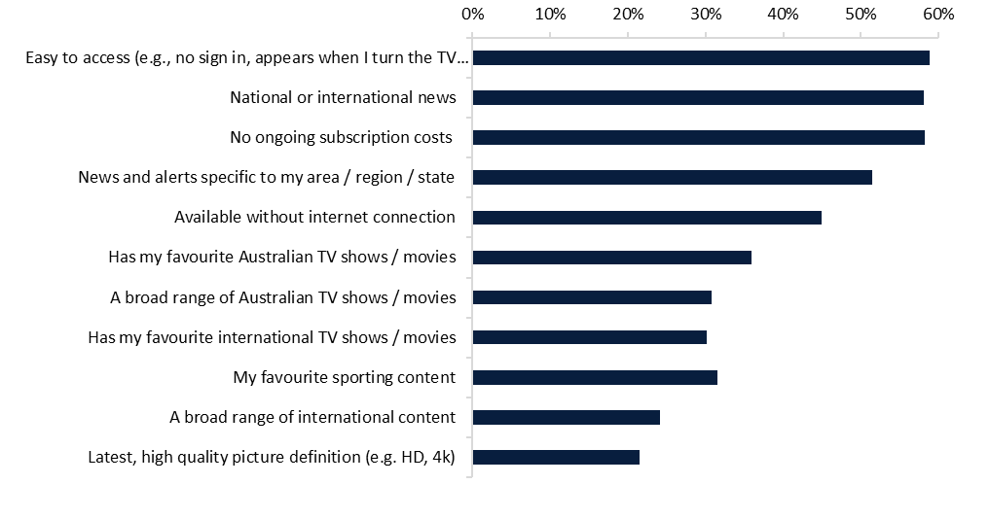

Source: 2022 Television Consumer Survey commissioned by the department.

## **Public policy functions of FTA broadcasting**

The existing legislative framework for media services in Australia relies heavily on broadcasting services to meet policy objectives.

Many of these policy goals focus on the role of broadcast services to meet the needs of Australian audiences, and are reflected in the objects of the *Broadcasting Services Act 1992* (BSA). Relevant objects include:

(a) to promote the availability of a diverse range of radio and television services offering entertainment, education and information;

(b) to provide a regulatory environment that will facilitate the development of a broadcasting industry in Australia that is efficient, competitive and responsive to audience needs;

(e) to promote the role of broadcasting services in developing and reflecting a sense of Australian identity, character and cultural diversity;

(ea) to promote the availability to audiences throughout Australia of television and radio programs about matters of local significance;

(f) to promote the provision of high quality and innovative programming by providers of broadcasting services; and

(g) to encourage providers of commercial and community broadcasting services to be responsive to the need for a fair and accurate coverage of matters of public interest and for an appropriate coverage of matters of local significance.

These objectives remain relevant in the new media environment. Even with the broadcast industry operating multi-platform businesses, terrestrial broadcast services will remain important to serve the vast majority of Australians as app-based services continue to grow.

The Australian Broadcasting Corporation (ABC) and the Special Broadcasting Service (SBS) also support specific public policy outcomes, consistent with requirements of sections 6 of the *Australian Broadcasting Corporation Act 1983* and the *Special Broadcasting Service Act 1991*, respectively.

* The ABC is required, among other matters, to provide (within Australia), innovative and comprehensive broadcasting services of a high standard as part of the Australian broadcasting system, including programs that contribute to a sense of national identity, inform, entertain and reflect the cultural diversity of the Australian community, and are of an educational nature.
* The SBS is required, among other matters, to provide multilingual and multicultural broadcasting and digital media services that inform, educate and entertain all Australians, and reflect Australia’s multicultural society.

Australians are supportive of the public policy roles played by the ABC and SBS, with 78 per cent of Australians believing that the ABC performs a valuable role in the Australian community,[5] and 90 per cent of the SBS audience believing the organisation helps Australia to be a more successful multicultural nation.[6]

## **Informing Australians**

FTA broadcasting provides close to universal access to news and information. Despite the growth of online news outlets, TV remains an important medium for the provision and consumption of news. In 2022, Deloitte Access Economics reported that 65 per cent of Australians found commercial TV to be a trusted source of local news that was essential to democracy.[7]

In the 2022 Media Content Consumption Survey (MCCS), the availability of news and current affairs was found to be an important factor driving viewing of FTA TV. The majority of respondents who watched linear FTA accessed news and current affairs on commercial (76 per cent), or publicly owned (79 per cent) FTA TV.[8]

The University of Canberra’s *Digital News Report: Australia 2022* found that terrestrial TV remains the most popular way to access news (60 per cent), and noted that 23 per cent of Australians use smart TVs to watch news content.[9] This report also found that, in 2022:

* Australians are most interested in local[10] (67 per cent), international (56 per cent), and COVID-19 (51 per cent) news (the global average for interest in local news was 60%);
* a ‘duty to stay informed’ (45 per cent) and ‘curiosity’ (44 per cent) are the top reasons for consuming news for Australians; and
* more than a quarter of Australians watch TV (27 per cent) or look at their smartphone (26 per cent) to get news first thing in the morning.

The national broadcasters play a particularly important role in this regard. Seventy per cent of Australians consider the ABC does a ‘good job’ covering regional issues, compared with 59 per cent for commercial media. Seventy-seven per cent of Australian adults aged between 18 and 75 trust the information that the ABC provides, which is significantly higher than trust of other platforms.[11]

## **Access to emergency information**

The ability to access local emergency information quickly and reliably is critical to the safety of many Australians, particularly those living in areas prone to emergency events.

As noted in recent work by the Australian Communications and Media Authority (ACMA), Australian audiences expect to have access to both general and localised information on unfolding emergencies, including from emergency services, to protect the life, health and safety of individuals and communities in times of crisis.[12] This is affirmed by the 2022 TVCS, which found that 51 per cent of Australian adults considered ‘news and alerts specific to my area / region / state’ as an essential or main reason for watching FTA TV.[13]

Radio and television broadcasting are very effective methods of communicating important information to large groups of people before, during and after emergency situations.

*Networks can fail due to physical damage or can fail due to congestion. Broadcasting services (one to many) are not subject to failure due to congestion, and can continue to operate during power outages, where there is otherwise no physical damage.*

*New and emerging technologies are not as robust as the traditional media technologies. The base stations for mobile phones, for example, generally only have short power backups, so reliance on mobile phone networks for the communication of emergency information may be severely compromised. Services including online (and VOIP), the NBN, and landline telephones cannot be guaranteed to operate during a power outage.*

SBS submission to the 2011 Inquiry into the capacity of communications

networks and emergency warning systems to deal with emergencies and natural disasters

The role played by broadcasters in emergency situations is likely to become of increasing importance in coming years. Work undertaken by the Commonwealth Science and Industrial Research Organisation and the Department of Home Affair’s National Disaster Risk Reduction Framework both conclude that the prevalence of natural disasters and crisis events is expected to increase over the coming decades.[14] Similarly, the Royal Commission into Natural Disaster Arrangements found that there is a greater need for, and reliance upon, emergency information that is reliable and reaches affected communities.[15] For this reason, the continued viability and accessibility of broadcasting services remains an important policy outcome, in case they are required in an emergency context.

## **Supporting Australian stories and voices**

Australian content is valuable to Australians, and important for cultural reasons. Screen content that has a strong focus on Australian stories, voices and perspectives helps to reflect Australia both to itself and to the rest of the world. It supports:

* children’s development and wellbeing;
* social cohesion and community;
* wider awareness of, and engagement with, Australian social issues;
* Australia’s international reputation and character; and
* Australia’s creative sector telling Australian stories.

Numerous studies and consultation processes have confirmed that Australian content is highly valued by Australians. A 2020 survey found that85 per cent of Australians ‘agreed’ or ‘strongly agreed’ that Australian film and television stories are important for contributing to our sense of Australian identity. ‘Made in Australia’ was considered by most Australian adults as one aspect that makes media content ‘Australian’.[16]

The BSA establishes obligations for overall levels of Australian content for commercial FTA broadcasters, while specific program genre requirements are included in the *Broadcasting Services (Australian Content and Children’s Television) Standards 2020* (ACCTS). The relevant requirements are set out in Table 2.

Table 2: Content quota requirements on metropolitan commercial television broadcasters

|  |  |  |
| --- | --- | --- |
| Type of content | Minimum requirements | Range for reported results for 2021[17] |
| Australian programming | **55 per cent** of all programming broadcast between 6 am and midnight on primary channels each calendar year (s 121G BSA) | **68 to 78 per cent** |
| Australian programming | **1,460 hours** between 6 am and midnight on multi‑channels each calendar year (s 121G BSA) | **1,719 to 5,512 hours** |
| Australian genre programs | **250 points\*** between 6 am and midnight of first release Australian programs, including drama, documentary and children’s programs, each calendar year (s 13 the ACCTS)* | **270 to 374 points** |

*Schedule 1 of the ACCTS sets out how points are allocated, between 1 and 6 points can be accumulated per hour of broadcast.

In 2020-21, commercial FTA television broadcasters spent $1.785 billion on television programming, $1.525 billion of which was on Australian programs. Figure 3 sets out program expenditure on Australian content by commercial FTA broadcasters on drama, news and sport from 2009-10 to 2020-21.[18]

**Figure 3: Program expenditure on Australian content by commercial FTA broadcasters**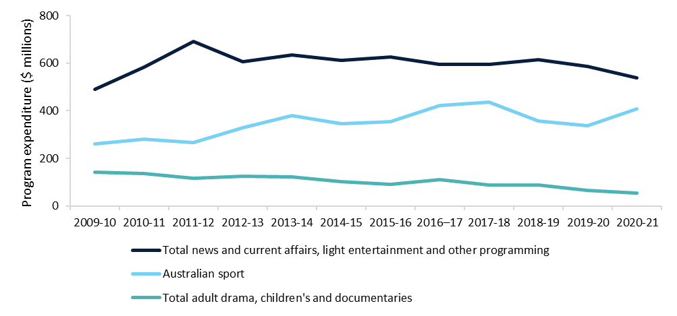  
Source: ACMA Program Expenditure data

Notes: indexed to 2021-22 figures; 2019-20 figures reflect the impacts of COVID-19 on advertising revenue, availability of live sport, and forbearance decisions by the regulator.

The national broadcasters also play a key role in ensuring the availability of Australian content.

* In 2021-22, the ABC commissioned $177 million of Australian screen content – up from $86 million in 2020-21 – with an estimated total Australian production value of $321 million.[19] During the same period, Australian content accounted for 79 per cent of total programming hours on the ABC’s main channel, 30 per cent on ABC TV Plus and ABC Kids, 30 per cent on ABC ME and 44 per cent on its broadcast video-on-demand (BVOD) application, iView.[20]
* In 2021-22, the SBS commissioned over $31 million in programs, focused on drama, children’s content, and factual and documentary. Australian content accounted for 26 per cent of total programming hours on the main SBS channel in 2021-22, 8 per cent on SBS Viceland, 63 per cent on National Indigenous Television (NITV), 34 per cent on SBS Food and 23 per cent on SBS On Demand.[21]

## **Local content**

Broadcasters also support access to local content for local communities. Local content includes material that is produced in a particular area, or that relates to events or people who live in that region or local area. This includes local news, weather, sport and community events. ACMA’s *Local content in regional Australia—2017 report* found that television was one of the principal ways that regional Australians accessed local content and local news, and that despite declines in viewership, commercial FTA television was the most preferred and trusted source of local news.[22]

Part 5 of the BSA sets out the local content obligations for regional commercial television broadcasters. These operate as a points-based system, with obligations varying depending on the type of licence area and increases where a ‘trigger event’ occurs.[23] Table 3 provides further details.

Table 3: Minimum requirements on regional commercial television broadcasters[24]

|  |  |  |
| --- | --- | --- |
| Licence type | No trigger event | Trigger event |
| Regional aggregated commercial television broadcasters[25] | 720 points per six-week period  90 points per week | 900 points per six-week period  120 points per week |
| Regional non-aggregated commercial television broadcasters[26] | No obligation | 600 points per six-week period  100 points per week |

The national broadcasters are not subject to specific local content requirements, but play a significant role in producing local content. The ABC has a long-standing commitment to local content, investing a third of its budget into rural and regional audiences.[27] This is reflected through shows such as Landline, which broadcasts stories with a strong local identity, and *Back Roads*, which features strong local regional characters.[28] The ABC has recently undertaken a series of initiatives to expand its presence outside metropolitan areas:

* Since 2021, the ABC has established a series of “pop up” newsrooms in outer metropolitan and regional locations as part of its commitment to establish new outposts.[29]
* In 2022, the ABC appointed 60 new positions across 19 locations, with the aim of delivering more content to regional audiences.[30]
* By 2025, the ABC plans to have 75 per cent of its content makers located outside its Ultimo headquarters in Sydney, and to grow its presence in outer suburban and regional areas.[31]

SBS also features regional and remote programming. For example, its genealogy documentary series *Who Do You Think You Are?* often takes individuals across Australia, showing the diverse history of immigration and Indigenous Australia. SBS’s NITV is the home of indigenous storytelling, delivering Australia’s only national Aboriginal and Torres Strait Islander television news service. It includes local content through programs such as Living Black, a half hour weekly current affairs program that is presented from various locations around Australia.[32]

## **Protecting audiences**

Licensed broadcasters are subject to regulations that aim to ensure they adhere to community standards, and that implement safeguards designed to protect vulnerable audiences, including children.

These protections, which are derived both from the BSA itself and co-regulatory industry codes of practice, broadly include:

* limits on advertising (frequency, content, classification), particularly during children’s programming;[33]
* restrictions on the broadcast of election matter and election advertisements during election periods, including an obligation to give reasonable broadcast opportunities to all political parties contesting an election;
* requirements for news and current affairs programs, including accuracy, fairness, limits on distressing material, impartiality and privacy;
* classification of programs, including time-specific classification zones to limit the potential for children to be exposed to harmful material; and
* complaints and investigation mechanisms – for offences or breaches of licence conditions; and complaints under codes of practice.

Broadly similar arrangements apply to the ABC and the SBS under their respective Acts, although there are differences in terms of regulatory oversight.

# **Chapter 3: the changing media environment**

The media landscape in Australia has changed significantly in recent years. Developments in markets, technology, and consumer behaviour challenge the objectives of media policy, and the traditional business and operating models of FTA broadcasting. Despite these challenges, FTA broadcasting remains important to Australia and Australians.

## **The TV market is evolving rapidly**

When the BSA was first introduced in 1992, television consisted of limited channels on analogue systems operated by FTA broadcasters. Since this time there has been a significant expansion in the range of television and television-like services (Figure 4).

Figure 4: Increase in viewing options for Australians – number of providers, 1992–2022[34]

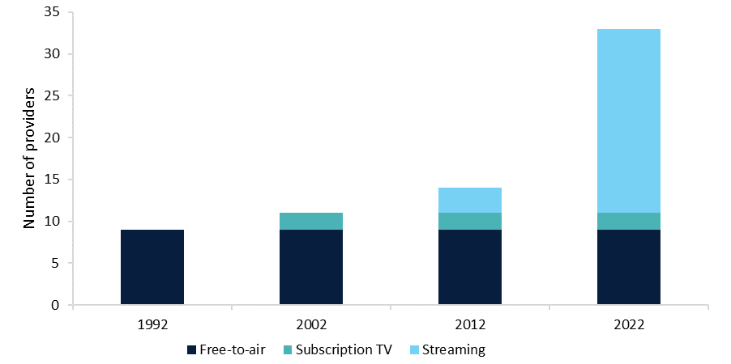

Source: Departmental assessment of service availability.

In response to the increased number of services, audiences have gradually been shifting away from the linear consumption of FTA broadcasts in favour of online and on-demand platforms.[35] Figure 5 shows the uptake of subscription video-on-demand (SVOD) and BVOD services over the last five years.

Figure 5: Percentage of Australians who used non-linear TV services in the last four weeks

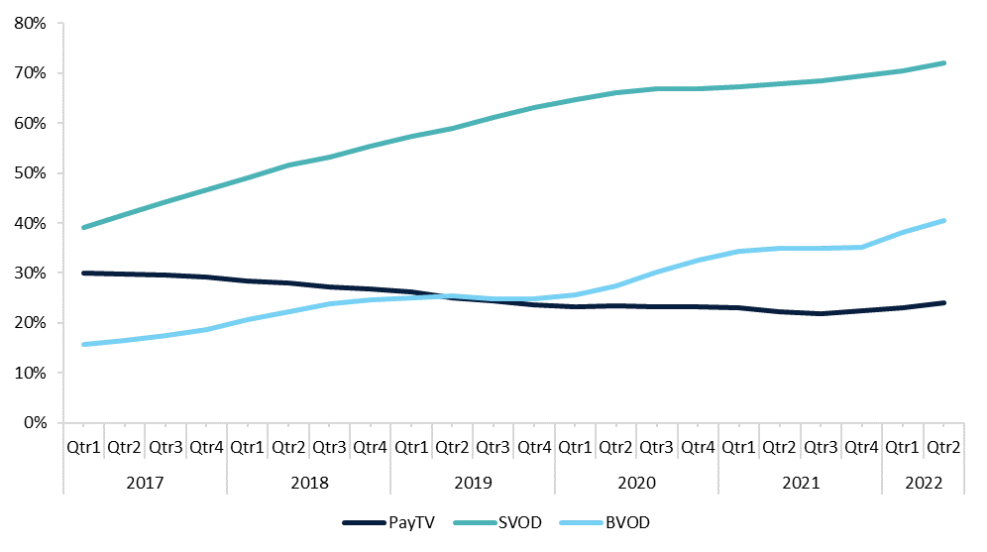

Source: Roy Morgan Single Source, Australians aged 14+, April 2016 – June 2022 (Rolling Years by Quarters). Based on usage last 4 weeks.

## **New technologies are fundamental to changing TV consumption**

As noted in Chapter 1, changes in consumption are occurring in tandem with changes in the services and devices used to access audio-visual content. Prior to the 2010s, television sets generally provided access to two types of content:

* broadcast content received via an RF tuner; and
* on-demand or interactive content through home entertainment devices, like DVD players or gaming consoles.

Today, TVs commonly allow audiences to access television or television-like services through a connection to the internet, in addition to traditional broadcast connections. Common mechanisms for connectivity include:

* smart TVs, where the set itself is connected to the internet and provides a user interface for accessing audio-visual content, as well as containing an RF tuner;
* set-top-boxes and plug-in devices, where an external device is connected to a television to provide connectivity and a user interface for accessing audio-visual content, and may also include an RF tuner; and
* gaming consoles, which commonly include set-top-box capabilities as a secondary function.

These devices effectively operate as digital content distribution platforms, through which device manufacturers and operating system providers work with content service providers to present a range of applications for use by end users.

As highlighted in Figure 6, over 80 per cent of Australian adults with at least one TV in their home had a TV connected to the internet in 2022. Over a third of these Australians had 2 or more internet-connected TVs, with the average number of internet-connected TVs being 1.4.

Figure 6: Number of TVs connected to the internet in 2022

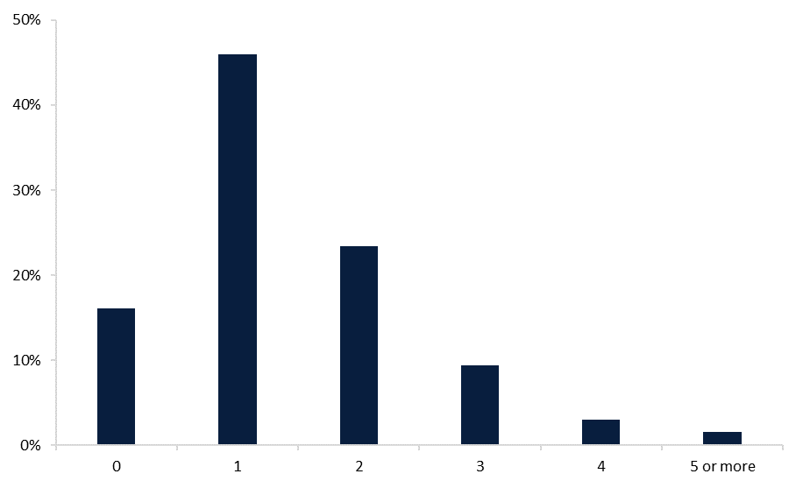

Source: 2022 Television Consumer Survey commissioned by the department.

Note: This includes connectivity through smart TV accessories such as Google Chromecast.

Research undertaken by the ACMA has yielded similar findings. As at June 2021, 70 per cent of Australian adults had a smart TV connected to the internet, up from 64 per cent in 2020.[36] Smart TVs are fast becoming the key way in which audiences access audio-visual content at home. They are providing a ubiquitous entry point for audio-visual content, allowing viewers to shift between traditional TV and a variety of live, catch-up, pay-per-view and subscription streaming services in a relatively seamless manner.[37]

## **This is challenging the operating model of FTA broadcasting**

These changes in technology and consumption present significant challenges for the operating models of FTA broadcasters. As they face more competition for consumers’ viewing time from new technologies which connect TVs and TV-like services to the internet, it is more difficult for FTA broadcasters to fulfil their public policy functions and operate sustainably.

The increasing popularity of SVODs is gradually eroding the audience of traditional broadcasters, impacting their ability to commission and produce content that supports public policy outcomes. Over the seven years to 2022, the audience for FTA broadcast television declined substantially, as highlighted in Figure 7. While FTA BVODs have increased their audiences in recent years, it is not yet clear whether they will offset lower linear broadcast viewership in the long run.

Figure 7: Percentage of Australians who viewed FTA television over a seven day period

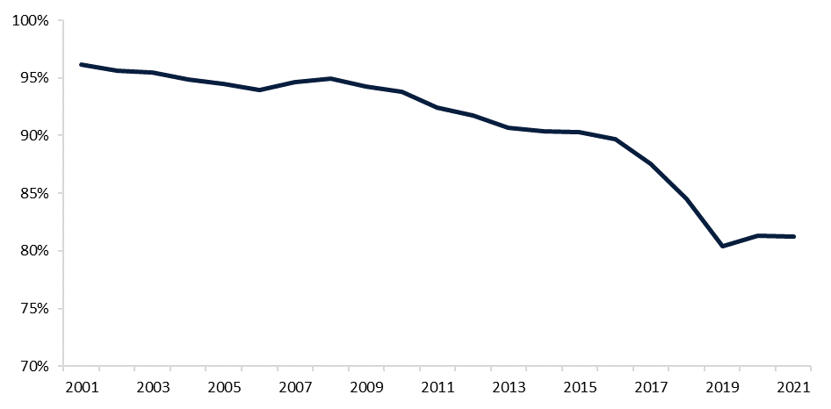

Source: Roy Morgan Single Source, Australians aged 14+, 2001 – 2022 (Calendar Years). Based on viewing last 7 days.

Alongside changes in content consumption, the supply of advertising services on which FTA broadcasters rely for revenue has also changed significantly.

In 2019, the Australian Competition and Consumer Commission’s (ACCC) Digital Platforms Inquiry found that online advertising had progressively eroded broadcast TV revenues. The final report found that expenditure on online advertising in Australia had increased from less than $1 billion in 2004 to $8.8 billion in 2019, accounting for 53 per cent of total advertising expenditure in that year.[38] This has come at the expense of advertising in other media. While the ACCC found that print media has seen the sharpest decreases in advertising revenue, expenditure on television has fallen steadily since 2014.

In response to these changing consumption patterns and increasing competition, FTA broadcasters have invested in new BVOD services, which have allowed them to offer on-demand content options as well as their traditional broadcasts. However, the advertising revenue gained from BVOD applications does not yet make up for declining advertising revenues from broadcast services. According to industry group ThinkTV,[39] BVOD revenue increased 53 per cent in the twelve months to June 2022, to $426 million.[40] However, this revenue only accounted for around 10 per cent of total advertising revenue for broadcasters in that year.[41]

# **Chapter 4: international approaches to prominence**

Australia is not alone in grappling with the challenge of safeguarding access to local TV content in an increasingly globalised marketplace.

A number of international jurisdictions have enacted, or are also considering, prominence rules to address the challenge. However, these have generally been targeted at prominence for local programming within SVOD services, such as Netflix and Amazon Prime, rather than the connected TV devices that host VOD applications. The exceptions are the UK and Germany, where both have built upon pre-existing regulatory arrangements for local broadcaster prominence on EPGs to include connected TV devices.

## **United Kingdom**

The UK is implementing a principles-based bargaining framework that supports prominence for Public Service Broadcasters’ on-demand services (PSB) on ‘Designated TV Platforms’ (smart TVs, pay TV operators and global TV platform providers). The proposed framework will require PSB providers to offer their on-demand services to Designated TV Platforms, which in turn must carry those services.[42]

**Public Service Broadcasters**

In the United Kingdom, ‘public service broadcasting’ refers to the BBC, ITV/STV, Channel 4, S4C and Channel 5, whose broadcasts are intended for public benefit rather than solely the pursuit of commercial interests. The communications regulator, Ofcom, requires that PSBs in television and radio fulfil certain requirements as part of their licence to broadcast, and includes content that is broadcast digitally. Commercial and pay-TV channels such as BT, Sky and Paramount are not considered PSBs and will not be covered by the proposed prominence regulation.

The proposed regulation is to be enforced through a bargaining framework, operating on the basis that PSBs and platforms should always seek to pursue mutually beneficial commercial arrangements in the first instance. However, if for whatever reason that is not possible, Ofcom would be empowered to resolve disputes and intervene in support of effective negotiations based on statutory objectives, which include:

* ensuring that PSB on-demand services are available to view by as many members of their intended audiences as practicable;
* ensuring that PSB on-demand services are given appropriate prominence on relevant TV platforms; and
* ensuring that PSB on-demand services are made available on terms that are consistent with the sustainable delivery of PSB obligations, but which also do not place disproportionate restrictions on consumer choice or TV platforms’ ability to innovate.

This paper considers a similar ‘fair bargaining’ model in Chapter 8.

## **European Union**

In November 2018, the European Commission adopted new rules for the EU Audiovisual Media Services Directive (AVMSD) which seek to enhance the promotion of European content in on-demand media services. These include obligations for on-demand services to reserve a minimum 30 per cent share of European works in their catalogue and that this content be given adequate prominence.

The revised AVMSD includes the following recommendations for media services:

* indicating the country where a film or series comes from;
* providing a dedicated section for European works that is accessible from the service homepage;
* providing possibilities for searching for European works by means of a search tool made available as part of the service;
* placing information and materials promoting European works, including in the home/front page or when promoting trailers or visuals;
* using European works in promotional campaigns for the service; and
* promoting a minimum percentage of European works in the service's catalogue e.g. by means of banners or similar tools.[43]

The EU maintains a relatively broad definition for prominence of “findability and accessibility of general interest content on significant audiovisual services,” though emphasising that it is of fundamental importance for a democratic society.[44] Further, as the Directive contains recommendations only, ensuring on-demand media services comply with these rules is matter for individual EU Member States. This has resulted in a heterogenous implementation across different member states.

## **Germany**

Germany’s Interstate Media Treaty (the Treaty) adopts, and builds upon, the requirements set out in the AVMSD, providing authorities with enforcement and arbitration powers.[45] Since being enacted in November 2020, the Treaty introduces findability and prominence rules for digital media platforms. The rules go beyond the ASMVD in mandating algorithmic transparency from those platforms regarding how content is aggregated, accessed, found and presented. Should unjustified discrimination of information occur, the provider of content is empowered to file a claim with the relevant broadcasting authority.

The regulation applies to both public and some private broadcasters that deliver content of public interest, such as news coverage of current affairs or regional information, German or European productions, and content that appeals to young target groups. Section V of the Treaty provides that such content is entitled to prominent positions within the operating system of the platform and that media platforms should ensure that:

* all content offerings must be searchable without discrimination using a search function;
* similar content must not be treated differently in relation to sorting, arrangement or presentation;
* content must be directly accessible and easy to find on the first selection level (e.g. through a dedicated button or a single action); and
* any programs that make a particular contribution to the diversity of opinions must be easy to find.

## **Canada**

In 2020, the independent Canadian Broadcasting and Telecommunication Legislative Review Panel recommended the following measures:

* discoverability obligations to positively discriminate in favour of Canadian content on all audio and audiovisual entertainment media services, through for instance exhibition requirements, prominence obligations, must-offer and algorithmic transparency;
* funding quotas for both producers and distributors to ensure sustained investment in Canadian content that reflects the diversity of languages, ethnicities and cultures of the Canadian population;
* revising intermediaries’ responsibilities and liabilities in view of their changing role in curating and aggregating content online; and
* updating ownership rules to redefine the current media and telecommunication ecosystem.[46]

A bill currently before the Senate, Bill C-11, adopts those recommendations as part of a broader modernisation of the Canadian *Broadcasting Act* to bring online undertakings within its scope. It seeks to amend broadcasting and regulatory policies to ensure that the programming provided is accessible and that the entire Canadian population is represented. This includes the requirement that “online undertakings shall clearly promote and recommend Canadian programming, in both official languages as well as in Indigenous languages, and ensure that any means of control of the programming generates results allowing its discovery”.[47] This covers aspects of both prominence and discoverability.

## **Colombia**

In May 2019, Colombia’s Congress approved the National Development Plan (NDP) for 2018-2022. Article 154 of the NDP included a prominence requirement that online SVOD providers must make a section for audio-visual works of national origin easily accessible to Colombian users. This obligation did not include any quotas for local content.

In March 2020, the Colombian ICT Minister presented a draft decree to implement Article 154 of the NDP. The draft decree clarified that providers must have a prominent and exclusive section for local content available in their catalogues. This draft was publicly consulted on in April 2020 and was finalised in by the ICT Minister in May 2020. The final decree maintains the prominence requirement, requiring online SVOD providers to ensure users in Colombia ‘have an easily accessible and clearly identified section’ for audio-visual works of national origin.[48]

# **PART 2: framework proposals**

Part 2 of this paper sets out a number of proposals for the key elements of a legislated prominence framework. These proposals are grouped into 3 sections.

|  |  |  |
| --- | --- | --- |
| *Section* | *Outline* | *Chapter reference* |
| 1. **Framework scope** | Threshold issues that will need to be considered in the design of a prominence framework, regardless of its ultimate form. | Chapters 5 - 7 |
| 1. **Framework models** | A series of potential designs for a prominence framework, ranging from a reporting regime through to a full ‘must-promote’ obligation. | Chapter 8 |
| 1. **Framework implementation** | The mechanisms for implementing and administering a prominence framework – legislative instrument and regulator. | Chapter 9 |

These proposals have been informed by the views of stakeholders elicited through the preliminary consultation process outlined in the Process to Date section. However, this initial consultation process was only the first phase in the process of developing and implementing a prominence framework. The Government is now seeking views from all interested parties on the potential design of the framework, guided by the proposals articulated in this paper. This second phase of work will inform a Government decision on the framework, expected in the first half of 2023.

The proposals canvassed in this paper are not mutually exclusive and there are various interdependencies.

* The definitions of local TV service and regulated TV device adopted in a framework (described in chapters 5 and 6 respectively) will influence the ultimate choice of framework model (Chapter 8).
* In turn, the choice of framework model will influence the legislative mechanism and choice of regulator (Chapter 9).

Comments are invited on the issues and proposals detailed in this paper. Submitters may wish to consider, and provide feedback on, whether the proposals:

* support the achievement of the broad policy objectives outlined in Chapter 2;
* are feasible to implement;
* present technical challenges for service providers, device manufacturers or any other party;
* impose costs on any particular individual or group (including the nature of those costs); and
* have the potential to distort competition in any market (and the nature of that distortion or impact).

Where possible, submitters are invited to support their views and claims with quantitative data and information.

Comments are not limited to these options, and views are welcome on a broader scope of issues associated with prominence.

# **Chapter 5: framework scope – local TV services**

The Government’s commitment to legislate for prominence is framed in terms of supporting the availability of ‘local TV services’. The definition of local TV services will require a decision on whether this is to include broadcasting services, provided under the authority of the BSA or other relevant statute, and/or non‑broadcasting services provided via the internet.

There are a number of categories of broadcasting licence issued under the BSA of relevance to the development of a prominence framework for local TV services, these include:

* Commercial television broadcasting licences: authorise the provision of services that are usually funded by advertising, operated for profit, and provide programming that appeals to the general public and is able to be received on commonly available equipment for free (e.g. Seven, Nine and Ten).
* Subscription television broadcasting licences: authorise the provision of services that are available to the public only on payment of subscription fees, and provide programming that appeals to the general public (e.g. Foxtel).
* Community television broadcasting licences: authorise the provision of services that are for community purposes, not operated for profit, and provide programming able to be received on commonly available equipment, for free, to the general public (e.g. C31 TV Melbourne).

Broadcasting services are also provided by the ABC and the SBS, although these are authorised under the respective Acts for the two entities, rather than the BSA.

Non-broadcasting services that are relevant to the consideration of the definition of local TV services for the purposes of a prominence framework include:

* Broadcast video-on-demand services: streamed and on-demand content provided by licensed commercial TV broadcasters or national broadcasters (e.g. ABC iView, 7plus, 9Now, 10 play, SBS On Demand).
* Subscription video-on-demand services: streaming and on-demand services provided by a range of entities and for which users generally pay a periodic fee (e.g. Netflix, Stan, Binge).
* Advertising video-on-demand services: streaming and on-demand services that are provided by a range of entities (often the same entities that provide SVOD services), but for which there is a discounted user fee. (e.g. Netflix’s ad-supported service option).
* Transactional video-on-demand services: streaming and on-demand services that provide access to particular programs or coverage of events based on a fee (e.g. iTunes, Palace Home Cinema).

Three proposals for defining local TV services are canvassed in this chapter.

## **Proposal 5.1: linear FTA broadcasts**

Under this proposal, the prominence framework would apply to the linear TV broadcasts of national, commercial and community television broadcasters on regulated TV devices. Specifically, this would require:

1. regulated TV devices with an RF tuner to provide access to the linear TV broadcasts of FTA broadcasters on the primary user interface of the device;
2. regulated TV devices with an RF tuner to default to the linear TV broadcasts of FTA broadcasters when no other input is selected on the device; and
3. remote controls for regulated TV devices with an RF tuner to include the physical inputs necessary to easily navigate to, and between, FTA linear TV broadcasts (among other matters, this could include numerical channel inputs and channel up/channel down inputs).

In Australia, television sets capable of receiving and displaying linear TV broadcasts have generally included the features noted at a) and c) above. This has been a market-driven outcome that is not reliant on regulations. Under this proposal, the prominence framework would ‘lock-in’ and (in some cases) extend those features, and apply a requirement for regulated TV devices to provide access to FTA broadcasts where the device includes an RF tuner capable of receiving linear TV broadcasts.

**Discussion**

Proposal 5.1 would seek to ensure the availability of linear FTA broadcasts, noting that these services are (with some exceptions) universally available and provide access to a range of programming – including news and emergency information – to a large number of Australians. This would maintain the functionality of devices that are able to receive TV broadcasts and (in some cases) enhance those features.

However, this option may require changes to regulated TV devices imported into Australia, particularly with respect to the elements of the proposal that would make linear broadcasting the default input and to include remote-control inputs, if these features are not part of the functionality of current or future models. Changes of this nature may be costly for manufacturers. This could result in reduced choice and higher costs for Australian consumers if compliance costs are passed on to consumers in the form of higher prices, or if some manufacturers chose not to supply particular models for the Australian market.

Any hardware requirements would also need to be considered in the context of Australia’s obligations under relevant free trade agreements.

## **Proposal 5.2: linear FTA broadcasts and BVOD applications**

Under this proposal, the framework would apply prominence requirements in relation to the linear TV broadcasts of FTA broadcasters (as per proposal 5.1) and the BVOD applications of FTA broadcasters.

These BVOD applications are an increasingly popular way for Australian users to access the content and programming provided by FTA broadcasters. As noted in Chapter 3:

* over 30 per cent of Australian adults who watched FTA TV in 2022 used on-demand applications as their primary means of doing so; and
* some 63 per cent of Australian adults who regularly used a connected TV device in 2022 used FTA on‑demand applications at least once a week to watch FTA content.

**Discussion**

This proposal would support the prominence of all FTA broadcasting services on regulated TV devices: linear TV and streamed and on-demand content provided via their BVOD applications. This would provide a prominence outcome that reflects contemporary use and consumption patterns for all FTA services, not just linear, terrestrial broadcasting services. Where BVOD applications include Australian programming, news, local content and emergency information (among others), their inclusion in a prominence framework would help to support the public policy benefits associated with this type of service.

However, as with proposal 5.1, this approach would potentially impose costs on manufacturers, with the consequent risk of retail price increases and reductions in choice for Australian consumers. The extension of the scope of the framework to BVOD services may also amplify these costs and risks. This risk may be mitigated to an extent if manufacturers are able to relatively easily update and modify their software.

## **Proposal 5.3: content services providing Australian programming**

Unlike proposals 5.1 and 5.2, this approach would not limit the scope of local TV services to those provided by FTA broadcasters. It would cover a broad range of service providers – including FTA broadcasters – that provide, and invest significantly in, Australian content.

The threshold for inclusion in the scope of the framework under this proposal would be whether the entities are subject to regulated requirements for Australian content. At present, this would include commercial television broadcasting licensees and subscription television broadcasting licensees.

Although the ABC and the SBS are not required to meet regulatory requirements in relation to Australian programming, they commission, produce and make available significant amounts of Australian content.

* In 2021-22, the ABC’s total investment in commissioned Australian content was $177 million, which included $26 million towards children’s content.[49]
* In 2021-22, the SBS invested $8 million in Australian drama content across its television and VOD offerings, including NITV.[50]

Under this proposal, the framework would deem the national broadcasters as being within scope of ‘local TV services’, along with community television broadcasting licensees.

The Government is also considering ways in which to boost the provision of Australian programming on streaming services as part of the development of the National Cultural Policy. Streaming services are increasingly commissioning Australian content.

* The ACMA has reported that Amazon Prime, Disney, Netflix, Paramount+ and Stan spent $335.1 million on Australian programs in the 2021-22 financial year.[51]
* This was an increase of $156.2 million from the previous year.[52]

**Discussion**

Adopting a definition of local TV services based on a qualifying threshold of whether they invest significantly in Australian content would alter the scope and outcomes of the prominence framework. It would prioritize the provision of Australian content and downplay the production and distribution of other genres of content that support important policy outcomes: news and emergency information are key examples.

This may be reasonable given the public policy benefits generally attributed to the provision of Australian stories and content. However, it would potentially broaden the range of entities that would receive benefits under the framework.

# **Chapter 6: framework scope – regulated TV devices**

The scope and impact of the prominence framework will heavily depend on the devices to which it applies.

Australians can watch TV content on a range of devices as well as within specific on-demand services and video-sharing platforms. A number of device features are relevant to this consideration, including:

* whether the device is able to receive and / or display linear TV services transmitted via radiofrequency spectrum (i.e. terrestrial transmission);
* whether the device is internet-capable (i.e. able to connect to the internet); and
* whether the device is primarily oriented to consuming audio-visual content (television sets, set-top-boxes and plug-in devices that are designed to support television streaming), or whether this is a possible but ancillary function of the device (as is generally the case with mobile phones, laptops and tablets).

The prominence framework will need to be clear on which categories of device are regulated, while ensuring that regulation is sufficiently flexible to account for changes in services through innovation and changing market dynamics. The fact that Australia is a relatively small market in terms of the global supply of connected devices will also have a bearing on this consideration.

Two proposals for defining regulated TV devices are canvassed in this chapter.

## **Proposal 6.1: all TV devices**

Under this approach, the prominence framework would apply to all ‘TV devices’. This would include:

1. devices capable of receiving and displaying television broadcast content transmitted via radiofrequency spectrum (i.e. television sets, whether or not they are internet-capable);
2. devices capable of receiving and distributing television broadcast content transmitted via radiofrequency spectrum (i.e. set-top-boxes, subscription television boxes); and
3. connected devices that are capable of displaying television content, or facilitating the display of television content (i.e. gaming consoles, pucks, dongles, laptops, tablets, mobile phones);

excluding:

1. devices that are capable of displaying audio-visual content but that are neither internet-enabled, nor able to receive and display TV broadcasts (i.e. computer monitors).

**Discussion**

Proposal 6.1 would provide for the greatest degree of prominence for local TV services, given its wide application to any device capable of displaying television content, or enabling the display of television content.

The latter element of this proposal – internet-connected devices – would significantly extend the scope of the scheme. A wide range of devices are internet-enabled and could (in theory) be used to facilitate the display of television content. For example, an internet-enabled washing machine could include an HDMI output that, in turn, could be connected to a monitor to display streaming services.

As such, the broad construction of Proposal 6.1 is likely to have a significant impact on the manufacturers of such devices, and may unreasonably extend the reach of the framework.

## **Proposal 6.2:** **a primary use approach**

Under this proposal, the prominence framework would apply to ‘TV devices’ (as defined in proposal 6.1), but would overlay this with a ‘primary use’ criterion: the primary use of the device must be to facilitate television viewing by Australian audiences.

The overlay would be intended to avoid capturing within the framework devices where television viewing is not a primary feature of the way the device is used by Australian consumers (internet-enabled washing machines, cars, home security systems, among others), or is ancillary or secondary to the use of the device (this could, for example, include personal computers, smartphones and tablets).

The proposal would require a greater degree of oversight and involvement by the regulator compared with proposal 6.1, as the primary use criterion injects a degree of subjectivity to the assessment of which services are regulated under the framework.

As such, proposal 6.2 would include a role for the regulator to issue guidance on contemporary device usage of various classes or categories of TV device in Australia, and to update that advice over time.

The framework would also provide a power for the regulator to make binding determinations on whether a particular device, or class of devices, falls within the remit of the prominence framework. The latter would operate as a ‘circuit breaker’ in instances where the inclusion of a device under the framework is contested.

**Discussion**

Proposal 6.2 would seek to provide prominence for local TV services on devices that would, in the eyes of an ordinary consumer, be considered a TV or TV-enabling device. The key advantages of this proposal, compared with 6.1, are that it would:

* limit the potential for unintended or unreasonable regulatory imposts by focusing on devices that are actually being used by Australians for accessing TV services;
* operate on a technology-agnostic basis and avoid distinguishing between devices that do or do not contain a traditional TV tuner, with all ‘primary use devices’ being regulated; and
* provide the regulator with flexibility and discretion regarding the definition and application of the ‘primary use’ concept.

In practice, the primary use approach would mean that smart TVs, third party set-top-boxes and certain plug‑in devices, such as Google Chromecast, Amazon Fire TV Stick and Apple TV, would be expected to be regulated by a prominence framework.

The 2022 TVCS found that although the majority of Australian adults that had watched FTA television in the seven days prior to the survey had done so through linear broadcast signals on their TVs, significant proportions of viewers also used BVOD applications through TVs and other devices.[53]

* 59 per cent used a linear broadcast signal
* 32 per cent used a BVOD application through their smart TV
* 23 per cent used a BVOD application through an internet-connected device plugged into a TV
* 19 per cent used a BVOD application through a device other than a TV (e.g. smartphone, laptop)

However, the subjectivity as to what constitutes ‘primary use’ would inject a degree of uncertainty to the framework. This uncertainty would initially manifest with devices that might be described as ‘edge cases’. These might, for example, include gaming consoles. Research published by the ACMA found that only 8 per cent of Australians used gaming consoles to view online video content at home in 2020-21.[54]

It would be important under this proposal for the regulator to develop and make guidelines well in advance of the commencement of the framework, to mitigate any potential uncertainty regarding the application of the framework to these types of devices.

# **Chapter 7: framework scope – responsible parties**

The prominence framework will need to identify the party or parties responsible for compliance with the framework. This is related to, but distinct from, the question of regulated TV devices (Chapter 6). The latter concerns the type of device that would be within scope of the regulation; the former concerns the entity, or entities, that would need to adhere to its requirements.

The supply of TV devices is highly complex and typically involves a significant number of entities. One device may have numerous parties contributing to its design, manufacture, distribution, sale and operation; each of which may have differing degrees of influence over the audience experience. For example, the offerings of a single smart TV or plug-in device could feature any combination of: the underlying software provider; the consumer-facing software provider; one or more device and/or component manufacturers; and content providers.

It will be important that the framework provides clarity on the party or parties responsible for ensuring that local TV services are prominent for Australian consumers. Two such proposals are canvassed in this chapter.

## **Proposal 7.1: obligations on device manufacturers**

Under this proposal, the framework would require device manufacturers to ensure compliance with any prominence obligations on regulated TV devices. These devices bring together all parts of the supply chain to create the access point for audiences to local TV services.

Although a single TV device may feature different partnerships of hardware and software providers, device manufacturers typically have a degree of control over the way the device operates. This can include the pre‑installation of consumer applications and the positioning of apps and content.

However, the capacity for device manufacturers to provide prominence for local TV services will depend on content providers developing and making available applications that meet the ‘reasonable technical requirements’ of the relevant device (and its operating system). This proposal would afford manufacturers an exception from liability for prominence in the circumstances where the relevant local TV service had failed to supply an application that meets the reasonable technical requirements of the relevant device. This would ultimately need to be assessed on a case-by-case basis. However, the regulator would have a power to provide guidance on what constitutes reasonable technical requirements, and the capacity to assess and determine whether those requirements have been met in specific circumstances.

**Discussion**

The key benefit of proposal 7.1 is that it would establish a clear point of regulatory obligation: a single intervention to capture all relevant parts of the supply chain and prominence dynamics. Device manufacturers are the final entity in the supply chain, and the party most often responsible to retailers and consumers for the operation of the relevant device. Targeting manufacturers may be an efficient way of implementing the prominence framework while minimising disruption of the supply chain.

Risks with this proposal would arise in circumstances where the device manufacturer does not control – either fully or partially – the operation of the device from a consumer perspective. The imposition of regulatory responsibility in this case would require device manufacturers to reconfigure their manufacturing processes or contractual arrangements to avoid being in a position of liability for a failure on the part of another entity to meet the requirements of the framework. This may give rise to additional costs for manufacturers to ensure compliance and mitigate any risks.

## **Proposal 7.2: multi-party obligations**

In contrast to proposal 7.1, this approach would impose obligations under the framework on all entities that have responsibility for the way in which local TV services are made available to Australian users on regulated TV devices, rather than just device manufacturers.

This proposal would seek to reflect to multiplicity of entities that have a role in making local TV content prominent. At a minimum, this is likely to include the suppliers of software and operating systems that shape the consumer experience of regulated TV devices.

This proposal would include an exception from liability for prominence outcomes under the framework in the same way as proposal 7.1.

**Discussion**

This option would seek to spread the regulatory burden of the prominence framework, and draw in those parties that contribute to the way in which TV services are made available to Australian users.

While this approach would avoid device manufacturers taking sole responsibility for prominence outcomes, it would be complex to oversight and administer given the various providers involved in developing the final product.

Given the complexity of the products involved, it may be difficult or impossible for the regulator to apportion responsibility for any failure to meet a prominence obligation. It would also inject uncertainty for those entities supplying a hardware component (i.e. an RF tuner), or software (i.e. an operating system), for a given product.

# **Chapter 8: framework models**

There are multiple ways in which the prominence framework could be designed and applied. This chapter canvasses four such proposals, although this is not an exhaustive list. These proposals represent differing levels of regulatory intervention and are, for simplicity, presented in ascending order of expected regulatory burden.

## **Proposal 8.1: a reporting framework**

This would be the ‘lightest touch’ design option for the prominence framework of those canvassed in this paper. Operating as a reporting scheme, proposal 8.1 would require regulated parties to report on the systems and processes they have in place to ensure the prominence of local TV services. Information could be sought about availability, positioning or discoverability. This information would be disclosed to the regulator, who would then prepare and publish aggregated reports on the degree to which regulated TV devices are providing prominence to local TV services. The framework would provide the regulator with powers to gather information or compel its provision, as necessary, if existing powers didn’t provide sufficient capacity for the regulator to do so.

**­Discussion**

A prominence framework constructed as a reporting scheme would represent a modest regulatory intervention with relatively low compliance costs for industry (particularly when compared with the other design proposals canvassed in this chapter). If cast relatively broadly in terms of the entities required to report to the regulator, an obligation of this nature may help inform future Government considerations of whether additional action is required to support prominence outcomes.

The key downside of this proposal is that it would do little to enhance the prominence of local TV services available to Australians. While a reporting scheme could be an important component of a prominence framework, it is unlikely to give effect to the Government’s election commitment to ensure local TV services can easily be found on connected TV devices.

## **Proposal 8.2: a fair bargaining framework**

Under this proposal, the framework would require the technical and commercial terms of access to regulated TV devices to be ‘fair and reasonable’, and stipulate that all local TV services and the parties responsible for regulated TV devices to engage in ‘good faith’ negotiations.

The regulator would have scope to issue guidance on what is likely to constitute fair and reasonable terms, and this could take the form of ‘model’ terms and conditions.

Parties would be required to enter into a process of mediation in the event that disputes arose over access. This would be a mandatory first step in instances where access was unable to be agreed.

Should mediation fail to produce an outcome acceptable to either party, the matter would be able to proceed to arbitration. The framework would provide for the establishment of an arbitration panel to resolve disputes between parties and, where necessary, stipulate fair and reasonable terms. Any such decisions of the panel would be binding on the parties.

The regulator would have a role in overseeing the operation of the framework, and issuing guidance on various matters that require clarification (as noted with other proposals in this paper).

**Discussion**

A fair bargaining approach would seek to ensure a level playing field for the provision of local TV services, without seeking to provide preferential regulatory treatment to either local TV services, or the parties responsible for regulated TV devices. It could be designed to promote the availability of local TV services, or both availability and positioning.

In contrast to proposals 8.3 and 8.4, a fair bargaining approach would not prevent the suppliers of local TV services from seeking payment, fees, remuneration or any other form of monetary or non-monetary consideration for the prominence (including advertising) of local TV services, provided they don’t breach the requirements for fairness and reasonableness. This represents a point of difference with proposals 8.3 and 8.4 which, to differing degrees, limit the ability of the entities responsible for regulated TV devices to seek payment for access to, or position on, these devices.

Although constructed differently, a fair bargaining model is also being pursued in the United Kingdom. As outlined in Chapter 4, the UK proposal would operate on the basis that TV services and platforms should always seek to pursue mutually beneficial commercial arrangements in the first instance. The regulator would be given powers to intervene if agreements are not reached.

A fair bargaining framework would not guarantee an outcome in which local TV services gain prominence on these devices. It could be the case that, as a result of fair, reasonable and open negotiations, local TV services are not able to secure access to regulated TV devices, or for their applications and content to be promoted or discoverable.

A fair bargaining framework may be potentially complicated to enforce and take longer to implement, depending on the complexity of negotiations and breadth of prominence to be provided.

## **Proposal 8.3: a must-carry (access) framework**

Under this proposal, regulated TV devices would be required to carry (make available) local TV services, with no fees, payments or other consideration payable by the provider of the local TV service to the entity responsible for the device for this basic level of access.

The framework could stipulate that the access provided by the regulated TV device must meet certain ‘minimum access requirements’. A set of possible requirements is stipulated below.

1. Local TV service applications must be located on, and available from, the primary user interface of the device, and visible from the start-up of the device, unless that placement is altered by the user.
2. Access to local TV service applications would be via a single ‘local TV service’ tile, or multiple tiles, provided that the access point was located on the device’s primary user interface and remained visible from device start-up.
3. Local TV service applications must be available from any relevant app store or library that is available on the regulated TV device.
4. For devices with an RF tuner (i.e. a device capable of receiving and decoding live TV broadcasts):
   1. linear TV functionality (including channel selection and any electronic program guide) must be accessible from the primary user interface and from the remote control for the device (or any other mechanism that may be used navigate or control the device); and
   2. any EPG must include all linear TV broadcast offerings from local TV services and present those offerings using the logical channel number sequence (with the exception of cable and satellite set-top-boxes).

Given the significant divergence between devices in the way that user interfaces present audiences with applications and content, the regulator would need a degree of discretion in determining whether devices had met relevant access obligations. It is therefore proposed that the minimum access requirements would be established at a high level in primary legislation, with the framework providing the regulator with the capacity to provide guidance and (as necessary) make determinations on whether a particular device or class of devices had met these requirements.

The must-carry proposal would not prevent the owners of regulated TV devices from seeking payment, fees, remuneration or any other form of monetary or non-monetary consideration for the promotion (including advertising) of particular applications or content over and above the minimum requirement of availability. As such, the provider of a regulated TV device could seek to negotiate for the positioning or discoverability of applications or content (or advertising thereof) without restriction under the framework, provided that this did not result in the availability of the applications of local TV services failing short of the minimum access requirements.

This must-carry proposal would also not alter or affect the operation of search functions on the regulated TV device. Search functions or other device features that operate in response to user input or requests would continue to surface applications and content without restriction under the framework.

However, where search results or the editorial placement of applications or content were the product of commercial arrangements (involving the payment of fees, remuneration or any other form of monetary or non-monetary consideration), this proposal would require the application or content to include a disclosure to that effect. This would have parallels to the disclosure of paid advertising on general search engines, and provide clarity for users in the circumstances where content is surfaced or recommended to them as a result of a commercial relationship between a device provider and a content provider.

**Discussion**

This must-carry proposal would operate to guarantee the availability of local TV services on all regulated TV devices. All users of regulated TV devices would have easy access to those services, unless they actively chose to remove or demote those services on the device’s configurable interfaces.

This framework would effectively ‘lock in’ the access arrangement for linear TV broadcast offerings that have historically been the norm for TVs and set-top-boxes.

This may be especially suitable given FTA services are not always available on the devices that Australians are using to access TV services. Data from the TVCS indicates:

* 25 per cent of Australian adults who used a TV in 2022 indicated they could not access any FTA BVOD applications on their device.[55]
* Likewise, for plug-in connected TV accessories, such as the Google Chromecast and Amazon Fire TV, the proportion of users who say they have no access to FTA services through that device ranged from 7 to 30 per cent, depending on the device.[56]

Table 4 provides further detail of the reported access to FTA services via plug-in connected devices.

Table 4: Proportion of plug-in device users who say they can access FTA TV on their device:

|  |  |  |  |
| --- | --- | --- | --- |
| Plug-in Device | FTA on-demand applications | Other FTA access | No access to FTA |
| Google Chromecast | 60.0% | 7.6% | 29.9% |
| Amazon Fire TV | 63.8% | 7.7% | 23.8% |
| A connected set-top box | 57.3% | 28.8% | 12.4% |
| Apple TV box | 67.1% | 1.7% | 28.3% |
| Telstra TV | 76.9% | 11.9% | 7.4% |
| Fetch | 69.4% | 23.0% | 7.2% |
| Foxtel set-top box | 51.7% | 36.3% | 9.6% |

Source: 2022 Television Consumer Survey commissioned by the department.

There are likely to be a range of factors that contribute to whether Australian audiences can access FTA content on their connected TV devices. However, this data highlights that, from a consumer perspective, the ability to access these services varies between devices.

In contrast with proposal 8.4, a must carry framework wouldn’t require the TV functions or applications of local TV services to be positioned or promoted ahead of other applications or content. It also wouldn’t prevent the provider of the regulated TV device from generating revenue from premium positioning or promotion of applications or content, provided the minimum access requirements for local TV services were fulfilled.

This must carry framework would have an adverse impact on the parties responsible for regulated TV devices. By preventing them from charging or imposing fees for minimum access, their capacity to generate revenue from their products would be affected. It would also distort the market for content services by favouring the applications of local TV services compared with other services (providing a ‘competitive boost’ to local TV service providers, who wouldn’t be required to pay for access to the devices). There would also be costs to device manufacturers in ensuring that their devices complied with the minimum access requirements.

Finally, a must-carry arrangement as envisaged under this proposal would not – by design – deliver discoverability outcomes. If the interfaces of regulated TV devices were to move away from an application‑based hierarchy, to favour programming and content discovery, then this model may fail to keep pace.

## **Proposal 8.4: a must-promote framework**

The final proposal canvassed in this chapter is a must-promote arrangement, under which regulated TV devices would be required to carry and promote those services at various points of interaction with users.

As with proposal 8.3, the foundation of a must-promote framework would be a must carry obligation: all parties responsible for regulated TV devices must ensure that local TV services are available on those devices.

However, in contrast to proposal 8.3, a must-promote framework would contain additional obligations in relation to positioning and discoverability.

Positioning

1. Local TV service applications must be prominently positioned on the primary user interface of the device: displayed within the first sequence of tiles on the primary user interface, requiring no further navigation or scrolling by the user, and only altered by a deliberate and conscious decision by the user.
2. For devices with an RF tuner (i.e. a device capable of receiving and decoding live TV):
   1. linear TV functionality (including channel selection and any electronic program guide) must be accessible from the primary user interface and from the remote control for the device (or any other mechanism that may be used to navigate or control the device);
   2. any EPG must include all live TV offerings from local TV services and present those offerings in the LCN sequence (with the exception of cable and satellite set-top-boxes); and
   3. linear TV function to be the default input for the regulated TV device when no other external source or application is selected by the user.

Discoverability

1. The content and programming of local TV services must receive ‘positive discrimination’ in the recommendation and search functions of regulated TV devices (placed first and ahead of content from other content providers).
2. The capacity of the regulated TV device to make available local TV services would be required to be prominently displayed as part of point-of-sale packaging for such devices.

In contrast with proposal 8.3 (a must-carry framework), this proposal would also place additional restrictions on the suppliers of regulated TV devices in terms of remuneration and service modification.

* Regulated TV devices would be required to provide the positioning and discoverability of local TV services (as outlined above) at no cost to local TV service providers. In other words, there would be no fees, payments or other consideration (monetary or non-monetary) able to be charged by the entities responsible for regulated TV devices on local TV services.
* The alteration of the local TV service applications, live TV offerings, programming content or EPGs would be prohibited, including (but not limited to) with respect to advertising.

Consistent with the must-carry proposal, this must-promote framework would require the disclosure of search results where the placement of applications or content was the product of commercial arrangements (involving the payment of fees, remuneration or any other form of monetary or non-monetary consideration).

**Discussion**

A must-promote framework would represent the most significant regulatory intervention of the framework model proposals canvassed in this chapter. It would not only require local TV services to be available and accessible on regulated TV devices, but it would push those services ahead of other similar services in terms of their visibility to users.

This would apply in terms of passive engagement by users (the positioning of tiles on primary user interfaces, ‘recommended for you’ functions, and default inputs for devices), and active engagement (search results).

Coupled with a prohibition on fees and a requirement that local TV services not be altered, this proposal would provide a significant competitive boost to the providers of local TV services.

However, this framework is likely to have a significant impact on the suppliers of regulated TV devices. The entities responsible for regulated TV devices would face additional costs to ensure that devices and systems complied with positioning and discoverability requirements, particularly if this necessitated the development of bespoke product solutions for the Australian market.

They would also face a reduction in overall revenue as a result of having to provide free positioning and discoverability for local television services, and in not being able to monetise the premium positions on their user interfaces.

It is reasonable to expect that some or all of these costs would be passed through to, and borne by, Australian consumers.

Other content suppliers would also be adversely affected as this proposal would affect their ability to compete with local TV services. This may ultimately subdue demand for their services.

# **Chapter 9: framework implementation**

There are a range of ways in which the prominence framework could be implemented and administered.

These could include primary and secondary legislation, or a combination of the two, with a role for either or both the ACCC and ACMA. This chapter presents three proposals:

* a code made by regulations under the *Competition and Consumer Act 2010* (CCA);
* amendments to the BSA to give effect to the framework; and
* a hybrid model, involving a code made under the CCA plus a range of supporting legislative amendments.

These implementation proposals are not exhaustive or mutually exclusive. It is also important to note that the choice of framework model (Chapter 8) will strongly influence the optimal implementation and oversight arrangements for that framework. The questions of framework scope canvassed in Chapters 5 through to 7 will also guide this implementation decision. This chapter provides an assessment of the alignment between implementation proposals and framework models.

Each of these implementation proposals would also include periodic review to ensure the framework remained fit‑for-purpose.

**Relevant elements of existing legislation**

Part 9A of the BSA provides powers for the ACMA to make technical standards for a range of matters, including domestic digital television reception equipment. However, these standards may only relate to equipment capable of receiving a range of broadcasting services licenced under the BSA. Under the current definition of ‘broadcasting service’, streaming and other online services (including BVOD services) are not broadcasting services, and therefore any standards made under these provisions could not apply to streaming or other online services.

Part IVB of the CCA enables industry codes of conduct to be prescribed by regulations under the BSA. The potential scope of these codes is quite broad, with the CCA requiring that they provide a set of rules or minimum standards for an industry, covering relationships between industry participants, or between participants and their customers. Industry codes are typically used to address imbalances in bargaining power between participants within an industry. Codes can be either mandatory of voluntary, and may include civil penalty provisions with pecuniary penalties. Codes are enforceable by the ACCC if they are prescribed in regulations under the CCA.

## **Proposal 9.1: industry code under the *Competition and Consumer Act 2010***

Under this proposal, a mandatory industry code would be made via regulations under the existing provision of Part IVB of the CCA. Part IVB industry codes are generally used to address problematic behaviour between industry participants that often stems from an imbalance of bargaining power. With respect to the framework design models outlined in Chapter 8, a code of this nature is likely to be most suitable for a fair bargaining prominence framework (Proposal 8.2).

Taking this example, a code could set out the requirements for the commercial arrangements governing access to regulated TV devices, and potentially include ‘model terms’ to guide what would be fair and reasonable. This could detail the attributes characterising ‘reasonableness’, such as certainty, balance, and timeliness. It would require relevant parties to engage in good faith and include mediation and arbitration pathways.

**Discussion**

The implementation of a prominence framework via a mandatory CCA code could offer a number of potential benefits:

* it could be implemented relatively quickly, requiring no changes to primary legislation;
* it would be relatively flexible in terms of the matters that could be included in the code; and
* it would be flexible over time, with regulations able to be remade as needed to accommodate technology, market or other development, without the need to amend primary legislation.

However, as noted above, a CCA code (overseen by the ACCC) may not suit every framework design. In general, industry codes have been used to provide a set of rules and minimum standards regarding what to include in contracts, encouraging good faith negotiations and providing avenues for dispute resolution. They also tend to be oriented to supporting the efficient and competitive operation of markets, rather than being used as a means of achieving particular policy outcomes, such as promoting the availability of certain media services.

As such, a stand-alone CCA code may be ill suited to a reporting-based prominence framework (proposal 8.1), as this design option may be more appropriately implemented via amendments to the BSA.

While a CCA code may be able to accommodate the must carry and must promote framework designs (proposals 8.3 and 8.4 respectively), both of these models would involve (to differing degrees) technical assessments of broadcasting and online technology. The ACMA, as communications regulator, may be better placed to oversee these technical framework elements. Depending on these and other design choices, a prominence framework implemented through an industry code could be an unusual and novel use of Part IVB.

Moreover, implementing prominence through an industry code would place primary regulatory responsibility for the prominence framework with the ACCC. However, the ACCC is not the sector regulator for communications and media services, and it may be more appropriate for the ACMA to take a role in the administration and oversight of the framework.

## **Proposal 9.2: amendments to the *Broadcasting Services Act 1992***

Amendments to the BSA would be required if the prominence framework were to be implemented through this statute, and overseen by the ACMA.

As noted, the ACMA’s existing capacity to make technical standards – while relevant to the issues being considered in this paper – would not extend to the regulation of BVODs or other online content services. Amendments would be required to provide the ACMA with a broader range of powers to give effect to any prominence framework, including those in relation to standards.

With respect to the framework design models outlined in Chapter 8, amendments to the BSA would appear better suited to a reporting-based prominence framework (proposal 8.1). Taking this example, the amending legislation could require the parties responsible for regulated TV devices to report on the systems and processes they have in place to ensure the prominence of local TV services. The amendments would enable ACMA to issue guidance on this reporting process, and enable the regulator to publish aggregated information on the availability of local TV services on regulated TV devices.

To support these activities, the framework would provide the regulator with powers to gather information or compel its provision, as necessary, if existing powers didn’t provide sufficient capacity for the regulator to do so.

A stand-alone BSA implementation proposal may also be suitable for the must carry and must promote framework designs (proposals 8.3 and 8.4, respectively). These design models would look to specify the technical conditions of access to local TV services on regulated TV devices (proposal 8.3), and the promotion and discoverability of local TV services on regulated TV devices (proposal 8.4). These aspects of a prominence framework would appear to be reasonably well aligned to the functions and role of the ACMA, as communications regulator.

However, the implementation of either of these framework designs through the BSA is likely to necessitate a significant degree of delegated legislation. As noted in Chapter 6, regulated TV devices are not homogenous, and their functions, systems and software differ markedly. This market is also changing rapidly as technologies evolve and develop, and as service providers innovate and seek to differentiate their products.

Amendments to the BSA would therefore establish the main components of the prominence framework – objectives, obligations on parties, enforcement provisions – and enable the regulator to set out much of the detail of the framework through delegated legislation, such as standards, determinations and other forms of disallowable instrument. The framework would also provide the regulator with the capacity to issue guidance to relevant parties.

In broad terms, this implementation model has parallels with the approach proposed for prominence regulation in the United Kingdom (outlined in Chapter 4). Under this proposal, the UK’s communications regulator (Ofcom) would oversee and administer a new prominence regime for on-demand public service broadcaster services, with powers to resolve disputes and intervene in support of effective negotiations. The UK’s proposal is similar to the fair bargaining framework model (proposal 8.2), rather than a must carry or must promote arrangement (proposals 8.3 and 8.4 respectively).

**Discussion**

The implementation of prominence framework via amendment to the BSA would have a number of advantages.

* It would establish the prominence framework within the existing regulatory architecture for media services, and would empower the communications regulator to oversee and administer this framework.
* Through the use of delegated legislation, it would provide a significant degree of flexibility in terms of establishing the detail of the framework, and in enabling these elements to be updated over time with the making of new instruments.

However, by requiring the development and passage of enabling legislation, this implementation option is unlikely to be implemented quickly.

This proposal is also unlikely to be suited to a fair bargaining design model for the prominence framework (proposal 8.2). Matters regarding the reasonableness or otherwise of commercial terms and conditions, and a requirement for parties to engage with each other in good faith, may be better dealt with under the auspices of the CCA, overseen by the ACCC, rather than through media legislation overseen by the ACMA.

## **Proposal 9.3: an industry code coupled with supporting legislation**

Under this proposal, the prominence framework would be implemented through a combination of a mandatory code made under the CCA, with a range of supporting provisions implemented through the BSA and other legislation.

The mandatory code would be developed and implemented in the manner envisaged in proposal 9.1. As noted in this section, a code is likely to be best suited to a fair bargaining model (proposal 8.2), although it could also be utilised to implement a must carry or must promote framework (proposals 8.3 and 8.4, respectively).

In addition to the code, this implementation proposal would include amendments to the BSA to require the ACMA to make technical standards in relation to regulated TV devices. A standard or standards of this nature would specify the technical requirements for regulated TV devices. The code could therefore require the entities responsible for regulated TV devices to adhere to any such standard or standards made by ACMA, without having to deal with such matters explicitly in the code itself.

The importation and supply of non-compliant regulated TV devices, in contravention of a standard, would be subject to penalty provisions under the BSA. Consideration could also be given to amendments to the *Customs (Prohibited Imports) Regulations 1956* (Customs Regulations) to prohibit the import of such devices should the enforcement arrangements via the BSA prove inadequate.

**Discussion**

The approach of implementing a prominence framework via a CCA code would offer a number of potential benefits:

* the code itself could be implemented relatively quickly;
* it would be relatively flexible in terms of the matters that could be included in the code; and
* it would be flexible over time, with regulations able to be remade as needed to accommodate technology, market or other developments without the need to amend primary legislation.

The use of the BSA to establish the technical standards for regulated TV devices would draw on the expertise of ACMA in establishing these baseline device requirements, and may be an appropriate delineation between the two regulators in terms of functions under the overall prominence framework.

However, the need for amendments to the BSA may delay the implementation of the framework compared with proposal 9.1, particularly if the code were to rely on a technical standard or standards being made by ACMA before it could commence.

As with proposal 9.1, the implementation of a prominence framework through an industry code would be an unusual and relatively novel use of Part IVB of the CCA, particularly if it were to implement a must carry or must-promote framework (proposals 8.3 and 8.4, respectively). A stand-alone CCA code is also likely to be ill suited to a reporting-based prominence framework (proposal 8.1), as this design option may be more appropriately implemented via amendments to the BSA.

1. A copy of the background paper can be provided to interested parties upon request.
2. A more detailed discussion of recent market changes can be found in Chapter 3.
3. See: Ofcom, (2010), [Code of practice on electronic programme guides](https://www.ofcom.org.uk/__data/assets/pdf_file/0031/19399/epgcode.pdf).
4. Social Research Centre (2022), Television Consumer Survey, reported to the Australian Government Department of Infrastructure, Regional Development, Communications and the Arts, p. 40. Unpublished.
5. ABC (2022), [Annual Report 2021-2022](https://about.abc.net.au/wp-content/uploads/2022/10/2021-22-ABC-Annual-Report.pdf), p 52 and 53.
6. SBS (2022), [Annual Report 2022](https://www.sbs.com.au/aboutus/sites/sbs.com.au.aboutus/files/sbs_annual_report_2021-2022.pdf), p 49 and 57.
7. Deloitte Access Economics (2022), [Everybody Gets It](https://www.freetv.com.au/wp-content/uploads/2022/09/Everybody-gets-it-2022.pdf), commissioned by Free TV, p 35.
8. Social Research Centre (2022), Media Content Consumption Survey, reported to the Australian Government Department of Infrastructure, Regional Development, Communications and the Arts. Unpublished.
9. Park, S., McGuinness, K., Fisher, C., Lee, J. Y., McCallum, K. & Nolan, D. (2022). *[Digital News Report: Australia 2022](https://www.canberra.edu.au/research/faculty-research-centres/nmrc/digital-news-report-australia-2022)*. Canberra: News & Media Research Centre, University of Canberra, p 23.
10. Defined as news about a region, city or town.
11. ABC (2022), Annual Report 2022, p 52.
12. ACMA (2022), [What audiences want - Audience expectations for content safeguards](https://www.acma.gov.au/sites/default/files/2022-06/What%20audiences%20want%20-%20Audience%20expectations%20for%20content%20safeguards.pdf), p 17.
13. Social Research Centre (2022), Television Consumer Survey, reported to the Australian Government Department of Infrastructure, Regional Development, Communications and the Arts, p. 40. Unpublished.
14. See, for discussion: CSIRO (2018), [State of the Climate 2018 report](https://www.csiro.au/-/media/OnA/Files/State-of-the-Climate-2018-CSIRO-BOM-Dec2018.pdf), December, and Department of Home Affairs (2018), [National Disaster Risk Reduction Framework](https://www.homeaffairs.gov.au/emergency/files/national-disaster-risk-reduction-framework.pdf).
15. Royal Commission into National Natural Disaster Arrangements (2020), [Report of the Royal Commission into National Natural Disaster Arrangements Report](https://naturaldisaster.royalcommission.gov.au/system/files/2020-11/Royal%20Commission%20into%20National%20Natural%20Disaster%20Arrangements%20-%20Report%20%20%5Baccessible%5D.pdf).
16. Department of Infrastructure, Transport, Regional Development and Communications (2020), [Media content consumption survey](https://www.communications.gov.au/documents/media-content-consumption-survey).
17. ACMA (2022), [2021 compliance with Australian and children’s content compliance (TV content standards),](https://www.acma.gov.au/publications/2022-08/report/2021-compliance-australian-and-childrens-content-compliance-tv-content-standards) p 5, p 13 and p 14. These results are limited to metropolitan networks, see s 121H BSA which deals with compliance by regional/remote commercial television broadcasters.
18. ACMA, August 2022, Program expenditure information, 2020–21, Aggregated data for commercial television [2020-21FY program expenditure report for commercial TV networks.pdf (acma.gov.au)](https://www.acma.gov.au/sites/default/files/2022-08/2020-21FY%20program%20expenditure%20report%20for%20commercial%20TV%20networks.pdf).
19. ABC (2022), [Annual Report 2022](https://about.abc.net.au/wp-content/uploads/2022/10/2021-22-ABC-Annual-Report.pdf), p 221.
20. ABC (2022), [Annual Report 2022](https://about.abc.net.au/wp-content/uploads/2022/10/2021-22-ABC-Annual-Report.pdf), p 217-220.
21. Department analysis of figures reported in: SBS (2022), [Annual Report 2022](https://www.sbs.com.au/aboutus/sites/sbs.com.au.aboutus/files/sbs_annual_report_2021-2022.pdf), p 136-142.
22. [ACMA (2017),](https://www.acma.gov.au/sites/default/files/2019-08/Local%20content%20in%20regional%20Australia%202017.docx) [Local content in regional Australia, 2017 report](https://www.acma.gov.au/sites/default/files/2019-08/Local%20content%20in%20regional%20Australia%202017.pdf), p 9.
23. Under section 61CV of the BSA, a ‘trigger event’ is where a person in a position to control a commercial television broadcasting licence becomes in a position to control two or more commercial television broadcasting licences (including at least one regional) with a combined licence area exceeding 75 per cent of the Australian population.
24. Note: Licences granted under ss 38A and 38B of the BSA are exempt from the local programming requirements for regional non‑aggregated commercial television broadcasters (s 61CX of the BSA).
25. Northern New South Wales TV1; Southern New South Wales TV1; Regional Victoria TV1; Eastern Victoria TV1; Western Victoria TV1; Regional Queensland TV1; and Tasmania TV1 (s 61CU of the BSA).
26. Broken Hill TV1; Darwin TV1; Geraldton TV1; Griffith and MIA TV1; Kalgoorlie TV1; Mildura/Sunraysia TV1; Mount Gambier/South East TV1; Mt Isa TV1; Remote and Regional WA TV1; Riverland TV1; South West and Great Southern TV1; and Spencer Gulf TV1 (s 61CU of the BSA).
27. ABC (2015), [Submission to Senate Inquiry on ABC Rural and Regional Advocacy Bill 2015](https://parlinfo.aph.gov.au/parlInfo/download/publications/tabledpapers/c3839719-0189-49e1-9de0-700e4d2a9379/upload_pdf/environment%20and%20communications%20-%20ABC%20amendment%20(rural%20and%20regional%20advocacy)%20report.pdf;fileType=application%2Fpdf" \l "search=%22publications/tabledpapers/c3839719-0189-49e1-9de0-700e4d2a9379%22), p 12.
28. ABC (2019), [Annual Report 2019](https://www.transparency.gov.au/annual-reports/australian-broadcasting-corporation/reporting-year/2018-2019-14), p 38-39.
29. ABC (2022), [Annual Report 2022](https://about.abc.net.au/wp-content/uploads/2022/10/2021-22-ABC-Annual-Report.pdf), p 23.
30. ABC (2022), [Corporate Plan 2022–23](https://about.abc.net.au/wp-content/uploads/2022/08/ABC_CorporatePlan2022_23.pdf), p 18.
31. ABC (2022), [Corporate Plan 2022–23](https://about.abc.net.au/wp-content/uploads/2022/08/ABC_CorporatePlan2022_23.pdf), p 14.
32. SBS (2016), [Submission to the Inquiry into broadcasting, online content and live production to rural and regional Australia, Standing Committee on Communications and the Arts](https://www.aph.gov.au/DocumentStore.ashx?id=bb153270-fee2-4768-a239-811d9608f180&subId=408755), p 8-9.
33. Applicable generally only to commercial television broadcasting licensees.
34. For the purposes of this chart, a single company that provides multiple services is considered one ‘provider’. ‘Streaming’ is broadly defined and includes a range of online video services, not just SVOD. BVOD services owned by free-to-air broadcasters have not been included in streaming.
35. Deloitte (2021) *[Media Consumer Survey 2021](https://www2.deloitte.com/au/en/pages/technology-media-and-telecommunications/articles/media-consumer-survey.html).*
36. ACMA (2022), [What audiences want - Audience expectations for content safeguards](https://www.acma.gov.au/sites/default/files/2022-06/What%20audiences%20want%20-%20Audience%20expectations%20for%20content%20safeguards.pdf), p 1.
37. ACMA (2022), [What audiences want - Audience expectations for content safeguards](https://www.acma.gov.au/sites/default/files/2022-06/What%20audiences%20want%20-%20Audience%20expectations%20for%20content%20safeguards.pdf), p 1.
38. ACCC (2019), [Digital Platform Inquiry Final Report](https://www.accc.gov.au/system/files/Digital%20platforms%20inquiry%20-%20final%20report.pdf), p 121.
39. Note: ThinkTV data includes Kayo, Foxtel Go and Foxtel Now as BVODs, but not iView and SBS On Demand. In general, this paper excludes the Foxtel applications and includes the national broadcaster applications when referring to FTA BVODs.
40. ThinkTV (2022), *[Total TV market records $4.3 billion for 12 months to June 2022](https://thinktv.com.au/news/total-tv-advertising-market-records-4-3-billion-for-12-months-to-june-2022/" \l ":~:text=Total%20TV%20advertising%20market%20records%20%244.3%20billion%20for%2012%20months%20to%20June%202022,-Posted%20on%208th&text=Total%20TV%20revenue%20increases%2011,months%20to%2030%20June%202022.)*.
41. Departmental analysis of ThinkTV data.
42. UK Department for Digital, Culture, Media & Sport (2022), [Up Next: The Government’s vision for the broadcasting sector](https://assets.publishing.service.gov.uk/government/uploads/system/uploads/attachment_data/file/1071939/E02740713_CP_671_Broadcasting_White_Paper_Accessible__1_.pdf), p 24.
43. European Commission (2018), *[Digital Single Market: updated audiovisual rules](https://ec.europa.eu/commission/presscorner/detail/en/MEMO_18_4093)*.
44. European Broadcasting Union (2020), *[AVMSD: EBU Calls on Member States to Ensure Prominence of General Interest Content](https://www.ebu.ch/news/2020/06/avmsd-ebu-calls-on-member-states-to-ensure-prominence-of-general-interest-content)*.
45. European Union (2020), [State Treaty on the Modernisation of media legislation in Germany](https://ec.europa.eu/growth/tools-databases/tris/en/search/?trisaction=search.detail&year=2020&num=26).
46. ISED Canada (2020), [Canada’s Communication Future: Time to Act](https://ised-isde.canada.ca/site/broadcasting-telecommunications-legislative-review/en/canadas-communications-future-time-act)*.* Final Report.
47. See: Parliament of Canada: [C-11 (44-1) - LEGISinfo - Parliament of Canada](https://www.parl.ca/legisinfo/en/bill/44-1/c-11), last accessed December 2022.
48. [TMG (2021),](https://www.tmgtelecom.com/wp-content/uploads/2021/06/TMG-Trends-and-issues-in-online-video-regulation-in-the-Americas-June-2021.pdf) [*Trends and issues in online video regulation in the Americas*](https://www.tmgtelecom.com/wp-content/uploads/2021/06/TMG-Trends-and-issues-in-online-video-regulation-in-the-Americas-June-2021.pdf)*.*
49. ABC (2022), [Annual Report 2021-2022](https://about.abc.net.au/wp-content/uploads/2022/10/2021-22-ABC-Annual-Report.pdf), p 221.
50. Screen Australia (2022), [Screen Australia Drama Report: Production of feature films, TV and VOD drama in Australia in 2021/22](https://www.screenaustralia.gov.au/getmedia/3a8f3011-211c-4f93-bd41-3b4767585dec/SA-DramaReport.pdf?ext=.pdf), p 34.
51. ACMA (2022), [Spending by subscription video on demand providers](https://www.acma.gov.au/spending-subscription-video-demand-providers-2021-22-financial-year), 2021-22 financial year.
52. This was due to a combination of an additional reporting entity (Paramount+), and greater investment in the production of Australian content.
53. Social Research Centre (2022), Television Consumer Survey, reported to the Australian Government Department of Infrastructure, Regional Development, Communications and the Arts, p. 28. Unpublished.
54. ACMA (2022), [Communications and media in Australia: Trends and developments in viewing and listening](https://www.acma.gov.au/sites/default/files/2022-07/Trends%20and%20developments%20in%20viewing%20and%20listening%202020-21.pdf), p. 11.
55. Social Research Centre (2022), Television Consumer Survey, reported to the Australian Government Department of Infrastructure, Regional Development, Communications and the Arts, p. 33. Unpublished.
56. Social Research Centre (2022), Television Consumer Survey, reported to the Australian Government Department of Infrastructure, Regional Development, Communications and the Arts, p. 33. Unpublished.