

Northern Australia Action Plan 2024-2029

Nautilus Washed Up by Paula Savage.
All types of shells wash up on our Moa Island beaches, including the Nautilus shell.
© Paula Savage/Copyright Agency, 2024

© Commonwealth of Australia 2024
ISBN 978-1-922879-40-0 (Print)
ISBN 978-1-922879-43-1 (Digital)
Ownership of intellectual property rights in this publication
Unless otherwise noted, copyright (and any other intellectual property rights, if any) in this publication is owned by the Commonwealth of Australia (referred to below as the Commonwealth).
Disclaimer
The material contained in this publication is made available on the understanding that the Commonwealth is not providing professional advice, and that users exercise their own skill and care with respect to its use, and seek independent advice if necessary.
The Commonwealth makes no representations or warranties as to the contents or accuracy of the information contained in this publication. To the extent permitted by law, the Commonwealth disclaims liability to any person or organisation in respect of anything done, or omitted to be done, in reliance upon information contained in this publication.
Creative Commons licence

With the exception of (a) the Coat of Arms; (b) the Department of Infrastructure, Transport, Regional Development, Communications and the Arts photos and graphics; (c) content supplied by third parties; and (d) content otherwise labelled; copyright in this publication is licensed under a Creative Commons BY Attribution 4.0 International Licence.
Creative Commons Attribution 4.0 International Licence is a standard form licence agreement that allows you to copy, communicate and adapt this publication provided that you attribute the work to the Commonwealth and abide by the other licence terms.
Further information on the licence terms is available from https://creativecommons.org/licenses/by/4.0/
This publication should be attributed in the following way: © Commonwealth of Australia 2024
Use of the Coat of Arms
The Department of the Prime Minister and Cabinet sets the terms under which the Coat of Arms is used. Please refer to the Commonwealth Coat of Arms − Information and Guidelines publication available at http://www.pmc.gov.au.
Contact us
This publication is available in hard copy, PDF format and Word format. All other rights are reserved, including in relation to any departmental logos or trademarks which may exist. For enquiries regarding the licence and any use of this publication, please contact:
Department of Infrastructure, Transport, Regional Development, Communications and the Arts
Email: northernaustralia@infrastructure.gov.au
Website: www.northernaustralia.gov.au
Accessibility
The department is committed to ensuring that our digital documents and content are accessible to everyone, including individuals with disability and the use of assistive technologies. However, we acknowledge that some of our digital documents and content may not fully comply with Web Content Accessibility Guidelines (WCAG) 2.2 Level AA standards and other relevant accessibility standards.
Work is currently underway to rectify the accessibility barriers, we thank you for your understanding and patience while we work towards making our digital documents and content more accessible to everyone.
Should you require assistance or would like an accessible version, please contact the Office of Northern Australia at northernaustralia@infrastructure.gov.au

Table of contents
List of figures and tables 5
Image credits 5
Acknowledgement of Country 6
Message from the Minister 7
Policy statement for northern Australia 8
Areas for continued focus 11
Delivering the Action Plan 12
Review and reporting 12
A refreshed agenda for northern Australia 13
A large, diverse region 14
Facing unique and complex challenges 15
Northern Australia policy agenda — 2015 to now 15
A refreshed agenda is needed 16
We listened to our stakeholders 16
The new 5-year Action Plan 17
Our policy priority areas 17
Development partners 20
Policy priority area 1: Activating the northern economy 23
A Future Made in Australia 23
Net zero 27
Northern Australia Infrastructure Facility 28
Agriculture 31
First Nations economic opportunities 34
First Nations businesses 34
Unlocking the Indigenous Estate 34
Visitor economy 36
Cost of doing business 37
Policy priority area 2: Infrastructure to unlock growth 40
Housing 40
Roads 43
Aviation 46
Ports 48
Common user infrastructure 48
Digital connectivity 49
Water 51
Policy priority area 3: A safe and secure north 54
National Defence Strategy 54
Defence investments in the north 55
Biosecurity 55
Policy priority area 4: Growing the northern Australia workforce 58
Workforce skills 58
Employment 60
Education 62
Population and migration 63
Policy priority area 5: Liveable, healthy and resilient communities 66
Amenity 66
Climate adaptation and disaster resilience 67
Communities undergoing economic transition 70
Healthy communities 70
First Nations justice outcomes 72
Policy priority area 6: Protecting the north’s environment and cultural heritage 74
Biodiversity 74
Natural and cultural heritage 75
Delivering the northern agenda 78
Working in partnership with First Nations people 78
Adopting a place-based approach 79
Resilience 80
Working collaboratively with northern jurisdictions 81
Data and evidence 81
Conclusion 84
Building a prosperous north for all 84
Artwork 85

List of figures and tables
Figure 1 Map of northern Australia 13
Figure 2 Northern Australia economic and population statistics 14
Figure 3 Survey respondent rankings of the 14 priorities for sustainable and resilient development 17
Figure 4 Our policy priority areas 18
Figure 5 Development partners matrix 20
Figure 6 Current NAIF project locations (mid-2024) 30
Figure 7 Value of agricultural commodities produced – Northern Australia vs Australia (2020–21) 31
Figure 8 Key freight routes across Australia map 38
Figure 9 Insurance premiums in northern Australia and the rest of Australia, 2023 39
Figure 10 Major road investments 44
Figure 11 Annual population change, Northern Australia 64
Figure 12 Components of population change, northern Australia, June 2021 to June 2023 64

Table 1 Breakdown of NAIF loans by sector 29
Table 2 Key figures for commodity values 32
Table 3 Major road investments 45
Table 4 Participation and rates of unemployment in northern Australia (May 2024) 61

Image credits
Cover/headings – left: Cable Beach, WA. Credit: Jess Wright, Office of Northern Australia
Cover – centre top: ‘Nautilus Washed Up’, © Paula Savage/Copyright Agency, 2024
Cover – centre bottom: Alice Springs, NT. Credit: Rob Blake, Office of Northern Australia
Cover/headings – top right: Whitsundays, Qld. Credit: Monika Bolton, Office of Northern Australia
Cover – bottom right: ‘Wangkartu’,
© Helicopter Tjungurrayi/Copyright Agency, 2024
Page 6 – background: Alice Springs, NT. Credit: Rob Blake, Office of Northern Australia

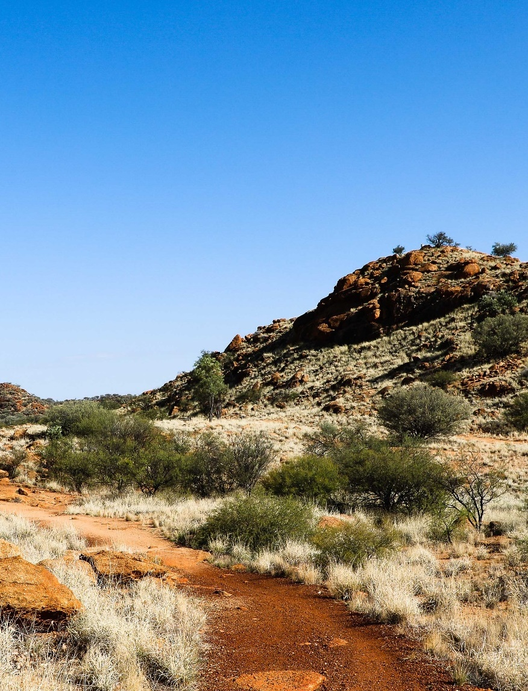
Acknowledgement of Country
In delivering the Northern Australia Action Plan, we pay our respects to Aboriginal and Torres Strait Islander peoples and Elders who have enduring connections to lands, waters and communities.
Aboriginal and Torres Strait Islander peoples have the oldest continuing cultures in the world. It is fitting to reflect on the thousands of generations of traditional knowledges that Aboriginal and Torres Strait Islander peoples hold and generously share.
We acknowledge the diversity of Aboriginal and Torres Strait Islander cultures, languages and practices and the resilience of Aboriginal and Torres Strait Islander peoples in keeping these alive. In supporting a strong and sustainable northern Australia, we recognise the importance of listening to the voices and perspectives of local Aboriginal and Torres Strait Islander peoples and responding to the uniqueness of each place.
We are committed to working in genuine and long-term partnership with Aboriginal and Torres Strait Islander peoples — in achieving current and future opportunities and addressing challenges and empowering First Nations economic self-determination, including through smart and responsible investment in northern Australia.
We thank Aboriginal and Torres Strait Islander peoples for their continuing custodianship of, and care for, the Country that we live and work on today.

Message from the Minister
The Australian Government is committed to unlocking the immense potential of northern Australia, working in partnership to build a sustainable, thriving and vibrant region.
As the Minister for Northern Australia, I am privileged to see the remarkable opportunities and endeavours unfolding across the region and experience first-hand the resilience and ingenuity of northern Australians.
I am proud to unveil the Northern Australia Action Plan 2024–2029 — a comprehensive plan that seeks to maximise new and emerging opportunities for northern Australians and tackle persistent challenges by prioritising sustainable and resilient development. The Action Plan marks a new chapter in the story of northern Australia — a story being written in partnership with northern Australians. I extend my gratitude to all those who have contributed to this Action Plan − in particular, key stakeholders across Queensland (Qld), Western Australia (WA) and the Northern Territory (NT), who provided invaluable insights. Since
re-establishing the Northern Australia Ministerial Forum in 2022, we are strengthening collaboration across state and territory partners to deliver our shared vision for the north.
A strong north means a strong Australia. The 2015 Our North, Our Future: White Paper on Developing Northern Australia remains the cornerstone document in the developing northern Australia agenda. This Action Plan reaffirms the Australian Government’s commitment to the north and builds upon the White Paper’s foundational principles to reflect the evolving needs and priorities of northern Australians.
The Northern Australia Infrastructure Facility (NAIF) is the centrepiece of the northern Australia agenda. In 2023, our government delivered on our commitment to provide the NAIF an additional $2 billion, bringing the NAIF’s total capacity to $7 billion. Amendments to the Northern Australia Infrastructure Facility Act 2016 (Cth) also broadened the definition of ‘northern Australia’ to include the Indian Ocean Territories, enabling the NAIF to invest in eligible projects that support the development of Christmas Island and the Cocos (Keeling) Islands. Since its establishment, NAIF has committed more than $4.4 billion to support 32 projects that are expected to generate around 18,400 northern Australia jobs and $33.8 billion in public benefit.
Our government is focusing on positioning regional Australia, including the north, to power our future prosperity and economic security. The $22.7 billion Future Made in Australia agenda addresses the structural and strategic challenges facing the Australian economy. It is about harnessing Australia’s advantages, like abundant natural assets and resource endowments, to encourage investment in sectors that will contribute to decarbonisation and Australia’s economic resilience. Northern Australia is ideally placed to benefit from this significant investment and will play a pivotal role in achieving our government’s commitment to reduce emissions to 43% below 2005 levels by 2030 and reach net zero by 2050.
Central to the north maximising its full potential is its people, including First Nations people. The Northern Australia Indigenous Reference Group provides valued insight on what is needed to support the aspirations of First Nations people. I thank all members for their contributions in shaping our ambitious agenda.
I look forward to continuing to work together with my colleagues including Mr Luke Gosling OAM, MP, Special Envoy for Defence, Veterans’ Affairs and Northern Australia to support thriving northern communities.

The Hon Madeleine King MP
Minister for Northern Australia

Policy statement for northern Australia
To enhance the prosperity and wellbeing of northern communities, the Australian Government is working to support development in Australia’s north.
The 2015 Our North, Our Future: White Paper on Developing Northern Australia set out a 20-year vision for northern Australia. The White Paper articulated a vision to unlock the vast potential of the north by addressing impediments to development, capitalising on its unique strengths and facilitating the right business environment to enable growth, in partnership with traditional owners. Significant investment and progress in this long-term agenda have been achieved through implementing the White Paper’s recommendations and through subsequent Australian Government budgets.
Northern Australia encompasses 53% of Australia’s landmass but is home to only 5.1% of Australia’s population. Almost 1.4 million people live in the north, of which 17.4% are First Nations people. Its economy supported over 100,000 businesses and employed over 629,000 people.
A refreshed agenda is needed.
This Action Plan sets out a refreshed policy agenda for Australia’s north. The vision has largely stayed the same but the importance of achieving this vision for Australia’s broader prosperity has become so much clearer.
Australia’s success relies on the north being successful.
A strong and prosperous north is key to the successful delivery of the Australian Government’s national policy agendas: supporting the nation’s transition to a net zero economy; encouraging investment in priority sectors to support Australia’s national interest through the Government’s Future Made in Australia agenda; the national target to protect and conserve 30% of Australia’s landmass and 30% of Australia’s marine areas by 2030; implementation of the Government’s National Defence Strategy 2024; and the National Agreement on Closing the Gap. Given the importance of economic development in northern Australia to achieving these national priorities, Australia cannot be successful without the north also being successful.
While challenges and impediments remain, much has changed since 2015 and new policy priorities are needed.
The policy priorities identified in the 2015 White Paper, including those focused on infrastructure and workforce development, remain important today. The north is experiencing certain challenges, such as the cost of living crisis, housing availability and affordability, skilled workforce shortages and the increasing impacts of climate change. These challenges are exacerbated by a small, sparse and transient population, long distances, harsh climatic conditions and historical underinvestment in infrastructure and services.
Thin markets, absence of scale, and underdeveloped and vulnerable supply chains all contribute to a higher cost of living and a riskier business environment.
But the world has changed markedly since 2015, when the White Paper was released. New issues and priorities have emerged. Therefore, a refreshed northern agenda is needed − one that reflects the full range of the Australian Government’s policy priorities. The new agenda must support the economic and development opportunities for the north, including for First Nations people, and take account of contemporary issues and the views of northern stakeholders.
The global impacts of the COVID-19 pandemic and an increase in the occurrence and severity of natural hazards have significantly impacted the northern economy. The net zero transition and geostrategic competition are transforming the global economy. The National Defence Strategy 2024 identified a new strategic reality for Australia, with Australia’s north pivotal to Australia’s defence objectives.
The National Agreement on Closing the Gap is a key priority for the Government, and this commitment is particularly important in Australia’s north. For decades, governments have strived to close the health, education and employment gaps between First Nations and non-First Nations people but have made only modest gains. Systemic barriers and the impacts of historical policy decisions have continued to stifle First Nations economic engagement such as employment, business ownership, access to business finance, access to Country for commercial opportunities and a broader lack of remote infrastructure and services. The National Agreement on Closing the Gap commitments, including embedding all 4 priority reforms, are reflected throughout this Action Plan.
In light of these changes, our specific policy priorities to achieve the vision also need to be updated. We need to ensure our northern communities are more resilient and better able to benefit from development opportunities. Some of the larger regional cities of the north have transformed over the last 10 years into vibrant economies and communities, but many northern regional and remote communities continue to struggle with significant barriers to prosperity.
The refreshed agenda demonstrates the Government’s ongoing commitment to northern Australia.
The Northern Australia Action Plan reaffirms the Australian Government’s commitment to the north and sets the strategic direction for the next stage of investment and growth in the region. The Action Plan recognises the potential of northern Australia to build on its position as an energy powerhouse and to become an attractive environment for investment, growth and liveability. The Action Plan focuses on 6 policy priority areas designed to enhance the prosperity and wellbeing of northern communities.
Central to all 6 policy priority areas is the commitment to advance First Nations outcomes, which is vital to the success of the northern Australia agenda. Specific action to achieve this goal is embedded across each of the following 6 policy priority areas.
- Activating the northern economy
Vital to the Government’s agenda is a strong northern economy. The Government is supporting growth in the north’s existing industries and developing new opportunities through its Future Made in Australia agenda, sustainable development of critical minerals, strategic materials and renewable energy, and the transition to a net zero economy. Critical to activating the northern economy is ensuring economic opportunities for First Nations people and addressing the high costs of doing business in the north.
- Infrastructure to unlock growth
While improving in some areas, poor and unreliable infrastructure impacts the north’s ability to conduct business and access essential education, health and emergency response services. The Government understands the need for reliable and affordable transport, communications links and community infrastructure to improve liveability and unlock economic opportunities in the north. The Government is investing in transport infrastructure, improved digital connectivity and water infrastructure to support business and economic growth in the north and improve the sustainability and liveability of communities.
- A safe and secure north
The National Defence Strategy 2024 highlights the strategic importance of the north to national security and the need for a re-posturing of Defence personnel and equipment across northern Australia. Defence investments, infrastructure and workforce in the north can deliver significant benefits to the local economies. Equally, a whole of government approach is needed to meet the strategic challenges Australia faces.
By working together, government and stakeholders can maximise local benefits, support the sustainable growth and integration of the defence community and industry in the north, and contribute to national resilience and national security. The Government’s continued investment in the management of biosecurity threats is also essential to protecting industries and the environment.
- Growing the northern Australia workforce
Across the north, there is a high demand for skilled labour, with intense competition across multiple industries and high turnover rates. Businesses face higher costs of labour and a shortage of skilled and semi-skilled personnel. The Government is working to develop a sustainable northern workforce by building the capability of the existing workforce and local communities, attracting and retaining skilled workers, accommodating the needs of fly-in−fly-out workforces, reviewing migration policy settings and lifting the participation of First Nations people in the northern economy.
- Liveable, healthy and resilient communities
The Government is working to improve the liveability of northern communities by investing in community infrastructure and services to build healthy and resilient communities and to encourage more people to live and work in the north. This includes work with industry, community representatives, state and territory governments and local governments to assist communities that are experiencing significant economic transition.
Northern Australia also faces particular challenges with more frequent and intense natural hazards. The Government is working with communities to help them understand, prepare for and respond to the impact of climate change, extreme weather events and disasters.
- Protecting the north’s environment and cultural heritage
The north’s natural and cultural wonders are recognised across the world. The Government is focused on working with stakeholders to protect, conserve and promote the north’s unique land and waterscapes, biodiversity and significant cultural heritage.
These policy priority areas are explored throughout this Action Plan and will be progressed through government action over the next 5 years.

Areas for continued focus
In addition to highlighting the existing government actions and investments relevant to the 6 policy priority areas, the Northern Australia Action Plan identifies 17 areas for continued focus for short to medium term action. The areas have been drawn from priorities identified by stakeholders and known policy gaps. They recognise that, despite the significant levels of investment and new initiatives for the north, there remain significant opportunities and challenges that require attention.
- Support northern Australia to capitalise on opportunities presented under the Future Made in Australia agenda and other major government investment opportunities.
- Build on northern Australia’s comparative advantages to harness the opportunities created by global commitments to transition to a net zero economy.
- Scope a First Nations Economic Partnership to improve economic outcomes for First Nations people, including northern perspectives.
- Enhance self-determined, sustainable opportunities for First Nations people and business, including Prescribed Bodies Corporates, to leverage and protect their land, water, traditional knowledge, expertise, ingenuity and cultural heritage and other assets, including a focus on access to capital, capacity building and benefit sharing.
- Enhance participation of Aboriginal and Torres Strait Islander community-controlled organisations and First Nations business in delivering services in the north.
- Investigate opportunities to address higher costs of doing business in the north.
- Raise awareness of the specific circumstances and needs of northern Australia in policy initiatives and investments in housing.
- Continue to work with state and territory governments to understand and address current and future infrastructure needs and priorities in northern Australia.
- Continue efforts to improve the affordability, accessibility and reliability of air services in the north.
- Continue to work with jurisdictions and regions to ensure there is adequate water planning and infrastructure to support a quadruple bottom line of industry, community, First Nations people and environmental sustainability objectives.
- Work with local communities, businesses, governments and other stakeholders to maximise local benefits from Defence investments in the north.
- Continue work to reduce northern Australia’s vulnerability to the impacts of biosecurity threats.
- Work with industry and state and territory governments to support northern Australia accessing the skilled workforce required for economic growth.
- Work to overcome challenges that northern Australians may face in equitably accessing Australian Government investment.
- Continue efforts to ensure government funding and policy decisions consider northern Australia’s unique climate adaptation needs.
- Work with industry, community representatives, First Nations people, state and territory governments and local governments to collectively assist communities undergoing significant economic transition.
- Partner with research organisations to develop research priorities for the north.

Delivering the Action Plan
To deliver this Action Plan, a new way of working is required − one in which governments recognise the importance of:
- working in partnership with First Nations people
- working in place, and the transformative impact this can deliver
- a focus on resilience
- a focus on decision making supported by evidence and data.
Additionally, while the Action Plan represents the Australian Government’s priorities, the Australian Government will work collaboratively with northern states and territories, through the Northern Australia Ministerial Forum, to develop a shared work program to foster northern development.

Review and reporting
Monitoring and reporting on the Australian Government’s northern Australia development agenda is an important way to track progress of government initiatives and areas for continued focus, share outcomes with stakeholders and implement improvements over time.
To maintain focus on the implementation of the Action Plan, the Minister for Northern Australia will provide an annual statement to Parliament on northern Australia, and the Government will publish an annual progress report on the implementation of the Action Plan.
The annual progress report will:
- provide an update on Australian Government actions in northern Australia
- outline work done by partner agencies to progress the 6 policy priority areas, and 17 areas for continued focus
- provide an update on new Australian Government initiatives supporting the north
- be produced alongside the annual statement to Parliament.
The Office of Northern Australia will work with Australian Government agencies to develop a work plan to progress the 17 areas for continued Focus, prepare an annual progress report to provide an update on progress against the areas for continued focus and the policy priority areas, and support the delivery of the annual statement to Parliament.



A refreshed agenda for northern Australia
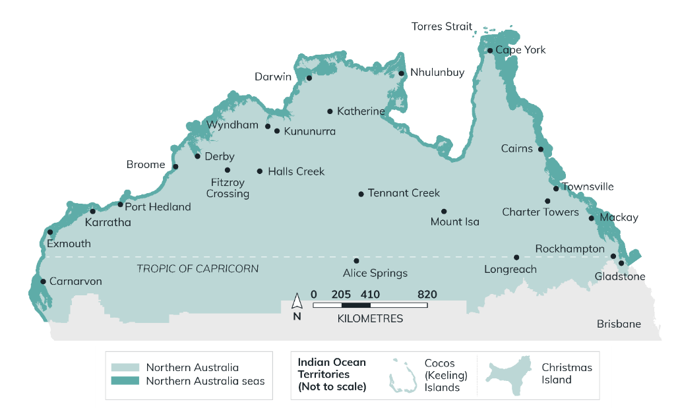
The Northern Australia Infrastructure Facility Act 2016 (Cth) (NAIF Act), s 5, defines ‘northern Australia’ as all of the NT and those parts of Qld and WA that intersect with the Tropic of Capricorn, Christmas Island and the Cocos (Keeling) Islands (collectively referred to as the Indian Ocean Territories). See NAIF Act, s 5, for further information.
Figure 1 Map of northern Australia

A large, diverse region
Northern Australia is a large, diverse and vibrant region. It incorporates the cultural and economic powerhouse of the Pilbara, the magnificent striped domes of the Bungle Bungles, the famous Mindil Beach sunset markets in Darwin, the rugged beauty of Kakadu, the iconic Great Barrier Reef and Gladstone at the forefront of the clean energy transition.
It has a young, multicultural population and it is home to some of the world’s most precious environments and rich and ongoing First Nations cultures.
Figure 2 Northern Australia economic and population statistics
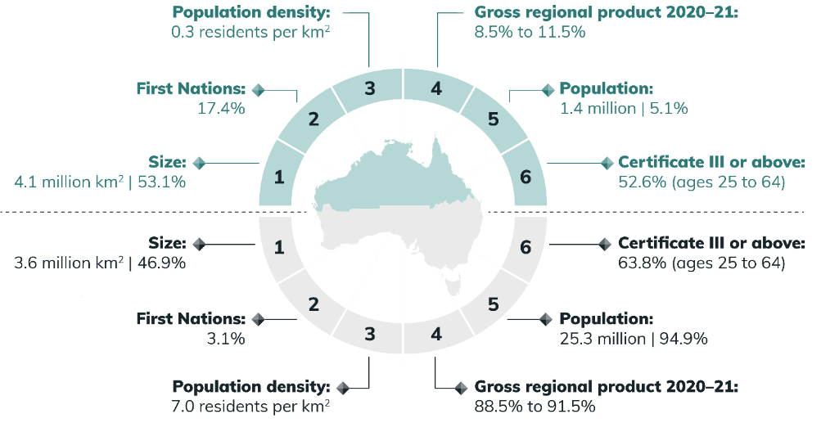
Source: Analysis of Australian Bureau of Statistics data
1/3/5 - LGA, 2023 data, 2/6 - SA2, 2021 data, 4 - SA4 2020-2021, DITRDCA (BCARR) Analysis. Range reflects inclusion of figures for SA4s which fall wholly within the northern Australia boundary through to inclusion of figures for all SA4 areas which also fall partially in northern Australia.
A strong, prosperous and resilient northern Australia is key to the prosperity and security of our nation. Iron ore and metallurgical coal have made a substantial contribution of prosperity to the north and will likely continue to do so for some time, alongside renewable energy. The north also has significant reserves of critical minerals and strategic materials, which are crucial components of low-emissions technologies such as batteries, electric vehicles and solar panels. Those resources are playing a critical role in supporting the nation’s transition to net zero and present significant opportunities for northern Australia to position itself as a renewable energy superpower.
Northern Australia’s geo-strategic location makes it a gateway for our defence and security cooperation in the Indo-Pacific region. It is also the frontline of Australia’s biosecurity. The National Defence Strategy 2024 highlights the strategic importance of the north to national security and the need for a re-posturing of Defence personnel and equipment across northern Australia.
The north provides Australia’s closest connection with our key trading markets, with South-East Asia within 2 to 5 hours of flight time from Darwin. Invested: Australia’s Southeast Asia Economic Strategy to 2040 recognises that Australia’s prosperity and security are intimately linked with South-East Asia. Rising incomes in Asia are increasing demand for a broad range of goods and services, including high-quality food products, tourism services and energy. Northern Australia’s proximity to South-East Asia presents a very real opportunity if appropriate infrastructure is developed and maintained.

Facing unique and complex challenges
The north is experiencing national challenges such as the cost of living crisis, housing availability and affordability, skilled workforce shortages and the increasing impacts of climate change. These challenges are exacerbated by a small, sparse and transient population, long distances, difficult climatic conditions and underinvestment in infrastructure and services. Thin markets, absence of scale and underdeveloped supply chains all contribute to a higher cost of living and a riskier business environment.
The north’s low population density means it is difficult to capture the economies of scale that would normally underpin the case for community and infrastructure investment.
Digital connectivity, including access to reliable internet and mobile services across northern Australia, is still challenging. Reliable access to telecommunications is important because it assists Australians in accessing essential services such as telehealth and education, and supports businesses to operate effectively.
Northern Australia’s proximity to its near neighbours also presents certain biosecurity challenges. For example, there is a risk that pests and diseases can enter the country through regulated and unregulated pathways, such as through airports and seaports. To maintain existing trade and gain access to new markets, biosecurity must be prioritised and resourced. Front-line and at-border services present associated employment opportunities.

Northern Australia policy agenda — 2015 to now
A 20-year vision for northern Australia was set out in the 2015 Our North, Our Future: White Paper on developing Northern Australia. The vision was to unlock the north’s full potential by addressing impediments to development, investing in critical enabling infrastructure and establishing the right business environment to facilitate growth. The White Paper recognised the need for a specific policy agenda for northern Australia to address its unique opportunities and challenges. It set out 51 measures across 6 pillars:
- Simpler land arrangements to support investment
- Developing the north’s water resources
- Business, trade and investment gateway
- Infrastructure to support growth
- A northern workforce for growth
- Good governance for northern Australia.
Much has been achieved through the measures already delivered under the White Paper. Most of the 51 measures have been completed. Complex, cross-jurisdiction, long-term initiatives, such as Native Title decisions, land tenure and cross-jurisdiction regulatory arrangements, continue to be progressed.
Key achievements under the White Paper have included:
- establishing the Office of Northern Australia (ONA), which is headquartered in the north
- establishing the Northern Australia Infrastructure Facility (NAIF). NAIF drives private sector investment in infrastructure by providing concessional loans to infrastructure projects that would not otherwise have been gone ahead
- establishing a $75 million Cooperative Research Centre for Developing Northern Australia (CRCNA), which is located in the north
- establishing the Northern Australia Indigenous Reference Group (IRG)
- investing $15 million for 3 CSIRO-led Northern Australia Water Resource Assessments.

A refreshed agenda is needed
The 2015 White Paper’s focus was on growing the north by establishing the right environment for businesses to invest through infrastructure investment and reducing red tape. While the White Paper fostered private investment, this refresh is an opportunity to expand the scope of the northern Australia agenda to include broader economic, social and environmental opportunities, such as supporting the nation’s transition to a net zero economy and the National Agreement on Closing the Gap.
The Government’s investment in actioning White Paper priorities has started the reform that is needed, and the Government’s focus has fostered private investment. However, northern Australia still faces a myriad of opportunities for growth and challenges to development. It is important the agenda is refreshed to ensure opportunities for developing Australia’s north are harnessed and impediments addressed.
Australia’s circumstances and the world we live in have changed since 2015, and our stakeholders have called for a refreshed set of priorities for northern Australia. The global impacts of the COVID-19 pandemic and an increase in the occurrence and severity of natural hazards had significant impacts on the northern economy. The net zero transition and geostrategic competition are transforming the global economy, and the 2023 Defence Strategic Review has identified a new strategic reality for Australia, with Australia’s north pivotal to Australia’s national security objectives.
Our focus needs to shift to ensure northern Australia is at the forefront of a stronger and more resilient Australian economy. This Action Plan takes a holistic approach, acknowledging the need to foster economic development as well as deliver a broad range of Australian Government priorities to support the north’s success. This includes pursuing government action on advancing First Nations outcomes in the north, undertaking transformational investment in partnership with communities, the north’s role in the transition to net zero, the Government’s Future Made in Australia agenda and delivering Australia’s national security, and the ongoing need for investment in resilient infrastructure and to protect the north’s unique environment and cultural heritage.

We listened to our stakeholders
From September 2023 to February 2024, the ONA engaged with stakeholders to gain a contemporary understanding of their views on priorities, opportunities and challenges for northern Australia. The Office conducted its engagement using 4 engagement pillars:
- one-on-one sessions with key stakeholders
- virtual sessions − 9 sessions were held with over 200 participants
- on-ground sessions − 39 sessions were held with key local organisations to understand place-based variances
- an online survey with over 500 respondents.
Through its 4 pillars, it engaged with key partners, First Nations organisations, businesses, industry representatives and peak organisations, academia, community organisations and all levels of government.
As part of the online survey, participants were asked to rank the priorities most important to them. Housing availability and engagement with First Nations people were ranked as the 2 most important priorities. Workforce skills and training development, justice reinvestment, diversification that responds to climate change, and transformational and complex projects were also ranked in the top 6.

Figure 3 Survey respondent rankings of the 14 priorities for sustainable and resilient development
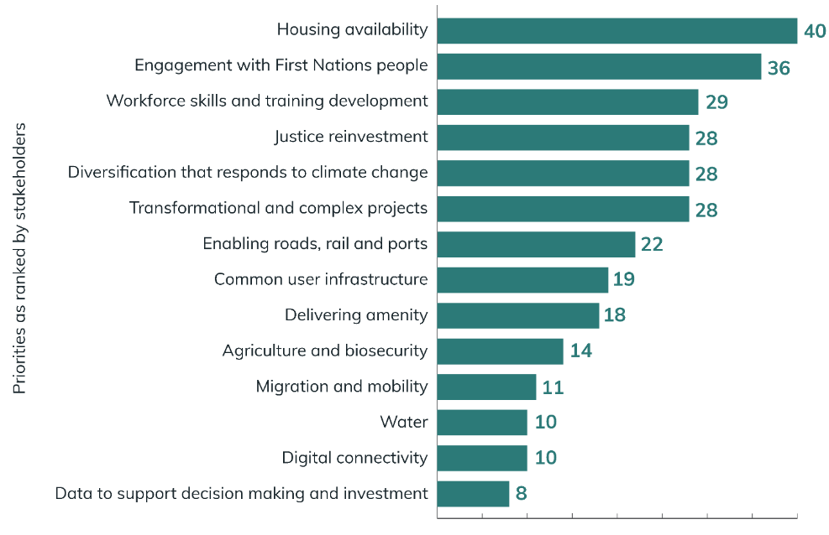
Other key inputs utilised in the development of the Action Plan included:
- the outcomes of the 2 recent parliamentary inquiries into the development of northern Australia: the Senate Select Committee inquiry into the effectiveness of the Australian Government’s Northern Australia agenda; and the Joint Select Committee inquiry into northern Australia workforce development
- advice and input from the Northern Australia IRG and the outcomes of the review of the Northern Australia Indigenous Development Accord
- the priorities and policies being progressed by the Australian Government
- the priorities identified by the Northern Australia Ministerial Forum (NAMF) in 2022
- regional information and data.

The new 5-year Action Plan
This Action Plan updates the Australian Government’s northern Australia agenda, responding to contemporary economic, social and environmental opportunities and challenges. It lays out the 6 policy priorities which will guide the development of policies and programs over the next 5 years and 17 areas for continued focus and that the government will progress in the short to medium term.

Our policy priority areas
The Northern Australia Action Plan reaffirms the Australian Government’s commitment to the north and sets the strategic direction for the next stage of investment and growth in the region. The Action Plan recognises the potential of northern Australia to build on its position as an energy powerhouse and to become an attractive environment for investment, growth and liveability. The Action Plan focuses on 6 policy priority areas designed to enhance the prosperity and wellbeing of northern communities (Figure 4).
Figure 4 Our policy priority areas
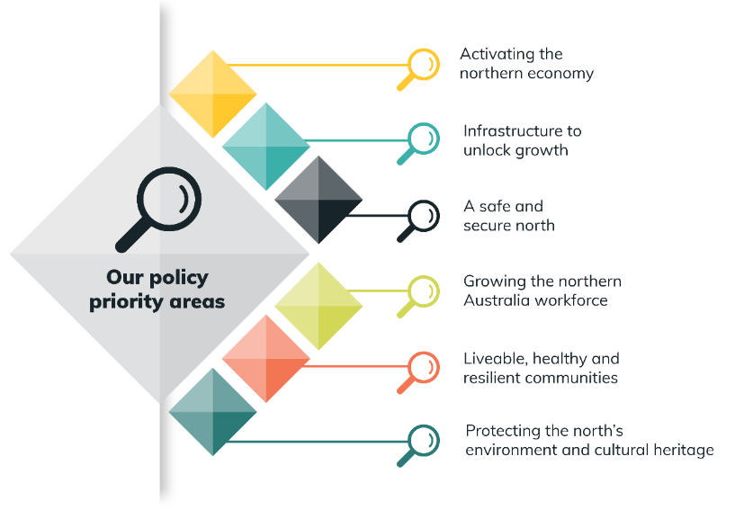
- Activating the northern economy
Central to the Government’s agenda is a strong northern economy that is reaching its full potential. The Government is supporting growth in the north’s existing industries and new opportunities through its Future Made in Australia agenda, development of critical minerals, strategic materials and renewable energy projects, and the transition to a net zero economy. Critical to activating the northern economy is ensuring economic opportunities for First Nations people and addressing the high costs of doing business in the north.
- Infrastructure to unlock growth
Poor and unreliable infrastructure impacts the north’s ability to conduct business and access essential education, health and emergency response services. The Government understands the need for reliable and affordable transport and communications links and community infrastructure to improve liveability and unlock economic opportunities in the north. Therefore, it is investing in transport infrastructure, improved digital connectivity and water infrastructure to support business and economic growth in the north and improve the sustainability and liveability of communities.
- A safe and secure north
The National Defence Strategy 2024 highlights the strategic importance of the north to national security and the need for a re-posturing of Defence personnel and equipment across northern Australia. Defence investments, infrastructure and workforce in the north can deliver significant benefits to the local economies. Equally, a whole of government approach is needed to meet the strategic challenges Australia faces.
By working together, government and stakeholders can maximise local benefits, support the sustainable growth and integration of the defence community and industry in the north, and contribute to national resilience and national security. The Government’s continued investment in the management of biosecurity threats is also essential to protecting industries and the environment.
- Growing the northern Australia workforce
Across the north, there is a high demand for skilled labour, with intense competition across multiple industries and high turnover rates. Businesses face higher costs of labour and a shortage of skilled and semi-skilled personnel. The Government is working to develop a sustainable northern workforce by building the capability of the existing workforce and local communities, attracting and retaining skilled workers, accommodating the needs of fly-in−fly-out workforces, reviewing migration policy settings and lifting the participation of First Nations people in the northern economy.
- Liveable, healthy and resilient communities
The Government is working to improve the liveability of northern communities by investing in community infrastructure and services to build healthy and resilient communities and encouraging more people to live and work in the north. This includes assisting communities experiencing significant economic transition.
Northern Australia also faces particular challenges, with climate change driving more frequent and intense extreme weather events. The Government is working with communities to help them understand, prepare for and respond to the projected impact of climate change, extreme weather events and disasters.
- Protecting the north’s environment and cultural heritage
The north’s natural and cultural wonders are recognised across the world. The government is focused on working with stakeholders to protect, conserve and promote the north’s unique land and waterscapes, biodiversity and significant cultural heritage.
These policy priority areas are explored throughout this Action Plan and are being progressed through government action over the next 5 years.
Advancing First Nations outcomes is vital to the success of the northern Australia agenda, with specific action to achieve this goal embedded across each policy priority area.
Common to all these focus areas is the need to ensure our actions are climate and disaster risk informed. Northern Australia faces particular challenges with more frequent and intense natural hazards. We must be anticipating and addressing these challenges in the decisions we make so we can build a vibrant, resilient northern Australia and deliver on our priority focus areas.

Development partners
The Australian Government recognises that delivery of the northern Australia agenda can only be achieved through collaboration between the public and private sectors and the community. The Government works with northern Australia development partners (see Figure 5) to ensure the needs of the north are addressed through government action.
Figure 5 Development partners matrix
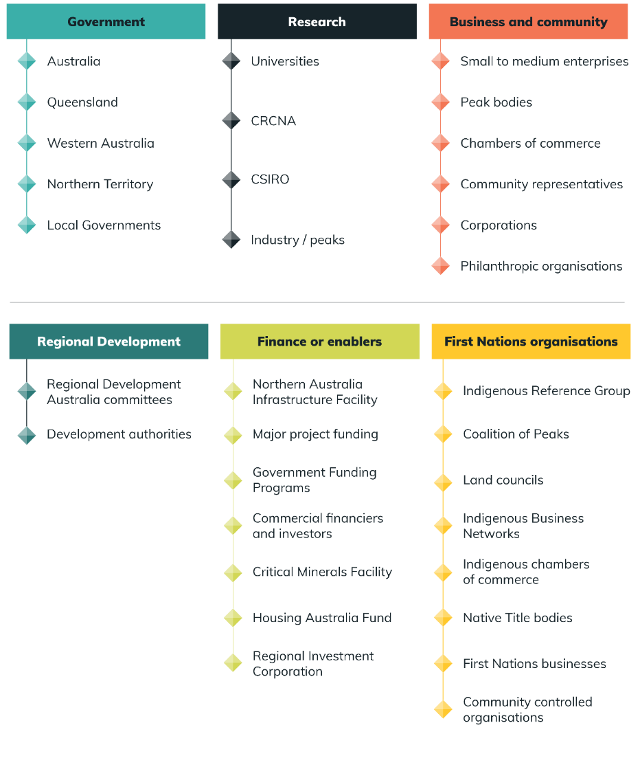

Office of Northern Australia
The ONA supports the delivery of the Australian Government’s northern Australia agenda. ONA’s primary roles are to:
- oversee the northern Australia policy agenda to support resilient and sustainable economic growth to secure a strong and sustainable future for northern Australia
- lead coordination and reporting on the Northern Australia Action Plan
- advocate for the development of northern Australia across the Australian Government, including resolution of challenges and maximisation of opportunities
- support the NAMF and the northern Australia IRG.
The ONA supports the Minister for Northern Australia, the Hon Madeleine King MP, and is located within the Department of Infrastructure, Transport, Regional Development, Communications and the Arts.

Northern Australia Indigenous Reference Group
The Northern Australia IRG advises the Australian Government on northern development, maximising benefits and implementation outcomes for Indigenous Australians. The IRG engages directly with, and provides policy advice to, the Minister for Northern Australia and the Minister for Indigenous Australians on practical actions to enhance the economic prosperity of Indigenous Australians in accordance with the aspirations of First Nations people.
IRG members draw on their business acumen and grassroots experience in economic development in the north to provide insights and advice to better understand the needs and opportunities of the northern Indigenous business sector.

Northern Australia Infrastructure Facility
The NAIF was established in 2016 to facilitate economic growth in northern Australia by financing infrastructure projects. The NAIF is a $7 billion government Specialist Investment Vehicle tailored to the unique needs of the north. It has specialist expertise in investing in the north and the sectors that will drive the north’s economic prosperity.
Since its establishment, the NAIF has committed more than $4.4 billion towards 32 projects across northern Australia to unlock the region’s potential. It has invested in regional airports, university student accommodation, energy and renewables, agriculture and water, transport and logistics, critical minerals, fertilisers and other resources. NAIF’s investment in these projects, on behalf of the government, is forecast to generate $33.8 billion in public benefit for the north and support the creation of more than 18,400 jobs.
NAIF’s operations are enabled and managed through its legislative framework, including the Northern Australia Infrastructure Facility Act 2016 (Cth) and the Northern Australia Infrastructure Facility Investment Mandate Direction 2023 (Investment Mandate), which outlines the Government’s expectations in terms of board governance, reporting and alignment with broader objectives and policy priorities. NAIF investment decisions are made by an independent skills-based Board, informed by the project’s alignment with the NAIF legislative framework and NAIF’s own investment requirements. NAIF requires each project to have an Indigenous Engagement Strategy that outlines how each financed project will create economic opportunity for First Nations people in the north.
In 2023, the Australian Government amended the NAIF’s investment framework to ensure its investments benefit local communities and lead to the creation of new jobs across the north. In particular, the Government increased the NAIF’s appropriation by $2 billion to $7 billion and expanded the definition of ‘northern Australia’ to include the Indian Ocean Territories. Issuing the NAIF with a new Investment Mandate, the Australian Government also directed the NAIF to align its investments with 5 priorities:
- Sustainable and resilient economic development and the alleviation of economic or social disadvantage in northern Australia
- Cooperation with jurisdictions in northern Australia to deliver key infrastructure projects, including electricity, water and transport infrastructure
- Supporting sustainability, climate change and circular economy principles and solutions in northern Australia
- Realising the Critical Minerals Strategy 2023–2030
- Materially improving the lives of Indigenous people and communities.
*NAIF is also directed to notionally set aside $500 million of its appropriation to support projects which align with the Critical Minerals Strategy 2023-2030.

Cooperative Research Centre for Developing Northern Australia
The CRCNA is investing $75 million in Australian Government funding to support science-based research and development in the north over 10 years: 2017 to 2027. Investments are developing new technologies, products and services that address industry issues unique to northern Australia. Key focus areas for research are:
- First Nations led business development
- agriculture (including horticulture and forestry)
- water security
- aquaculture
- health service delivery
- education.

Northern Australia Ministerial Forum
The Australian Government works together with the Qld, WA, and NT Governments through the NAMF to diversify and strengthen the north’s economy. The NAMF provides a forum for cross-government collaboration on key issues and priorities affecting northern Australia. The Australian Government is represented on the NAMF by the Minister for Northern Australia, the Hon. Madeleine King MP (chair) and the Minister for Indigenous Australians, Senator the Hon. Malarndirri McCarthy. Australian Government ministers are joined on the NAMF by state and territory representatives:
- the Qld Minister for Regional Development and Manufacturing and Minister for Water
- the WA Minister for Regional Development
- the NT Chief Minister.
In 2022, the NAMF agreed to 14 priorities under 3 high-level themes, which informed the development of the Action Plan. While the Action Plan represents the Australian Government’s priorities, the Australian Government will work collaboratively with states and territories, through the NAMF, to develop a shared work program to foster northern development.

Policy priority area 1:
Activating the northern economy
Activation of the northern economy by increasing
opportunities for investment, trade and innovation is vital
for a prosperous Australia.
While progress has been made, there are further opportunities to position northern Australia to expand its existing industries of mining, agriculture, tourism, education and the service sectors, while supporting innovative approaches to take advantage of global decarbonisation progress. However, higher costs for business in the north, the effects of long distances, and the impacts of climate change and severe weather events are impediments to growth.

A Future Made in Australia
In a changing global environment, with many nations investing in their manufacturing capability and economic security, the Government is investing $22.7 billion over the next decade to build a Future Made in Australia. The Future Made in Australia agenda will leverage the competitive advantages of Australia − like abundant renewable energy resources, natural assets and resource endowments − to maximise the economic and industrial benefits of the move to net zero and secure Australia’s place in a changing global economic landscape.
The Government has introduced the Future Made in Australia Bill to establish a National Interest Framework to support better alignment of economic incentives with our national interests. The Future Made in Australia Innovation Fund − $1.7 billion over 10 years from 2024–25 − will be established to support innovation and pre-commercial activities in Future Made in Australia priority industries, many of which are based in regional Australia. These investments will help create new industries in Australia, including creating opportunities in the north, supporting secure local jobs in clean energy industries and promoting sustained economic development.
In the 2024−25 Budget, the Government identified 5 sectors that are aligned with the National Interest Framework: renewable hydrogen, clean energy manufacturing (including battery and solar panel supply chains), critical minerals processing, green metals and low carbon liquid fuels.

Renewable hydrogen
Renewable hydrogen is the flagship of the net zero transformation stream of the Future Made in Australia agenda. It opens the door to green metals, such as iron, steel, alumina and aluminium, and other applications critical to industrial decarbonisation. Northern Australia is positioned to benefit from the Government’s $8 billion investment in the renewable hydrogen sector. Northern Australia’s world-class renewable energy resources make Australia well placed to produce green hydrogen at internationally competitive prices.
The establishment of green iron, steel, alumina and aluminium industries in Australia would also have a particularly transformative impact on northern Australia. These industries are estimated to be worth up to $122 billion per year to Australia’s economy by 2040, with global demand expected to grow. Northern Australia has an abundance of renewable energy resources that can support the production of green hydrogen and green metals at scale. Additionally, northern Australia is close to key markets, and our major trading partners have expressed a significant appetite for importing renewable hydrogen. This could unlock a whole new industry in northern Australia, creating long-term job and economic opportunities.
Australian Government backs first of a kind green hydrogen project with equity stake for traditional owners
The Australian Government has committed $1.67 million towards a $3.33 million Stage 1 feasibility study for one of Australia’s first large-scale green hydrogen projects in the Kimberley. The $3 billion East Kimberley Clean Energy Project could become Australia’s biggest green hydrogen producer and will involve the construction of a giant 900-megawatt solar farm at Lake Argyle near Kununurra, WA. The Australian Renewable Energy Agency (ARENA) will support research into the viability of an ambitious plan to use the Kimberley’s hot weather and fresh water to create electricity, which is then turned into green hydrogen and piped north to Wyndham, where the gas will be turned into ammonia and exported.
The East Kimberley region is well situated to help meet the global demand for hydrogen given its abundant sunshine, fresh water, excellent transport links and infrastructure.
The project is one of a number around the world attempting to contribute 306 million tonnes of green hydrogen each year by 2050 to achieve a net zero world. If successful, this project would be one of the world’s largest renewable hydrogen and ammonia production facilities, creating around 250,000 tonnes per annum.
Depending on its feasibility study, the East Kimberly Clean Energy Project could pave the way for First Nations led renewable energy developments. East Kimberley traditional owners, the Balanggarra people and the Miriuwung Gajerrong people, are working with the Kimberley Land Council to have a majority stake in the project. Having traditional owners onboard from the start will significantly enhance the project’s appeal for potential investors.
Source: Australian Renewable Energy Agency (ARENA), East Kimberley Clean Energy Project - Stage 1, Feasibility Study - Australian Renewable Energy Agency (ARENA) ARENA website, accessed 24 July 2024

Critical minerals and strategic materials
The global energy transition requires an extraordinary supply of critical minerals and strategic materials. Critical minerals and strategic materials are metallic or non-metallic elements that are essential to modern technologies, economies and national security. Critical minerals are also susceptible to supply chain disruption. The International Energy Agency predicts that demand for nickel and cobalt is estimated to increase by sevenfold by the mid-2040s, whereas demand for lithium could rise by more than 1,500% between now and 2050. Northern Australia has significant deposits of these minerals that are crucial components of low-emissions technologies, such as batteries, electric vehicles and solar panels. Support for development of these minerals can help ensure that the opportunities for northern Australia in a net zero future are maximised.
‘Well-designed support can de-risk investment, crowd in private sector funding, attract foreign investment and mature the sector. In a competitive global market, it is important that Australia’s efforts are targeted and proportionate for the greatest strategic and economic impact.’
Source: Department of Industry, Science and Resources (DISR), Critical Minerals Strategy 2023−2030, DISR website, 2023, p 23.
Central Australia rare earth projects attract $840 million investment
The Australian Government will provide up to $840 million, including $200 million from the Northern Australia Infrastructure Facility and $495 million from the Critical Minerals Facility, to help deliver Australia’s first combined rare earths mine and refinery in the NT.
The refinery, to be operated by Arafura Rare Earths Ltd, is expected to create over 300 new jobs across the NT. During construction it will create over 200 jobs, with over 125 full-time jobs ongoing. The refinery will be located approximately 135 km north of Alice Springs, from where it will seek to secure 20% of its workforce from local First Nations people.
The mine and refinery will diversify Australia’s critical minerals supply chain and will position Australia as a global leader in ethical and sustainable manufacturing of these minerals. Rare earths are used to make powerful magnets − an essential component in renewable energy and defence technologies.
The project will deliver critical jobs and economic development in the heart of the north as well as unlock further investment from international financiers and commercial banks. Australia has some of the largest deposits of critical minerals in the world, and this project will be crucial to the new low-emissions technologies that will help transition the nation to net zero.

Snapshot of government action
  - An estimated $7 billion over the decade to support critical minerals processing and refining in Australia through the Critical Minerals Production Tax Incentive.
  - $10.2 million in 2024–25 to establish the Critical Minerals National Productivity Initiative to extract further value from Australia’s resources by growing onshore processing of critical minerals. The Australian Government will work in partnership with state and territory governments to develop pre-feasibility studies for precincts where enabling infrastructure, miners, processors, users and exporters can be co-located.
  - The Government’s Critical Minerals Strategy, the expansion of the Critical Minerals Facility and investments including the National Reconstruction Fund are designed to capitalise on Australia’s natural resources and build local manufacturing capacity.
  - Up to $200 million in NAIF funding to Arafura Rare Earths Ltd for the Nolans Bore Rare Earths Project.
  - $566.1 million over 10 years for Resourcing Australia’s Prosperity for Geoscience Australia to progressively map the whole of onshore Australia by 2060 to improve our understanding of Australia’s potential for mineral resources, energy and groundwater.
  - $1.7 billion over 10 years from 2024–25 to establish the Future Made in Australia Innovation Fund. The fund, administered by ARENA, will support innovation and pre-commercial activities in priority sectors, many of which will be in regional Australia.
  - Fast-tracking the initial phase of the Guarantee of Origin Scheme to measure and certify emissions intensity across the supply chain of key products including hydrogen and providing $32.3 million to support the expansion of the program to green metals and low carbon liquid fuels and consultation on additional incentives to support production in these industries.
  - $549 million over 8 years from 2023–24 to support battery manufacturing. This includes $523.2 million over 7 years from 2024–25 to establish the Battery Breakthrough Initiative to promote the development of battery manufacturing capabilities.
  - Implementing a Hydrogen Production Tax Incentive to provide a $2 incentive per kilogram of renewable hydrogen produced between 2027−2028 and 2039−2040, for up to 10 years per project, at an estimated cost to the Budget of $6.7 billion over the decade.
  - $1.3 billion over the next decade in the Hydrogen Headstart program to provide additional support to early movers investing in the industry’s development.
  - $500 million Hydrogen Hubs program, including up to $70 million for the Townsville Hub and $69 million for the Central Queensland Hydrogen Hub.
  - $17.1 million over 4 years from 2024–25 (and an additional $2.5 million in 2028–29) to support the implementation of the 2024 National Hydrogen Strategy.
  - An additional round of the First Nations Renewable Hydrogen Engagement Fund to ensure First Nations people are supported to meaningfully engage with renewable hydrogen project proponents.
  - $835.6 million over 10 years from 2024–25 (and $66.8 million per year from 2034–35 to 2036–37) for the Solar Sunshot program to promote the development of solar manufacturing capabilities and improve the industry’s supply chain resilience.
  - Enhancing Indigenous Business Australia’s ability to leverage their capital to invest in First Nations communities and businesses.

Area for continued focus
Given the significance of the Future Made in Australia agenda, and the importance of northern Australia to delivering it, the Australian Government will:
- Support northern Australia to capitalise on opportunities presented under the Future Made in Australia agenda and other major government investment opportunities.

Net zero
Northern Australia is uniquely placed to drive Australia’s decarbonisation and deliver the renewable energy exports to build our net zero prosperity. Australia and the world are undergoing the biggest and fastest economic transformation since the industrial revolution. Action to reduce emissions will help prevent the worst impacts of climate change but will also create a boom in new jobs and new industries. Northern Australia will be critical to unlocking decarbonisation opportunities for the economy.
As the path to net zero will require innovation and investment across all sectors, the Australian Government is continuing to take major steps to realise the opportunities of an efficient, productive, high-wage net zero economy and make Australia a renewable energy superpower.
Australia is committed to reaching net zero greenhouse gas emissions by 2050 and is developing a Net Zero Plan, including 6 sectoral decarbonisation plans covering:
- electricity and energy
- transport
- industry
- resources
- agriculture and land
- the built environment.
The Net Zero Plan will articulate how Australia will transition to a net zero economy, consistent with our international and domestic commitments. It will build on the government’s current emission reduction policies, including the Safeguard Mechanism, 82% renewable electricity target, capacity investment scheme and new vehicle efficiency standard. Sectoral plans will outline the role of each sector in supporting Australia’s transition to net zero.
Snapshot of government action
  - $20 billion Rewiring the Nation program to unlock investment in the electricity grid.
  - $1.9 billion Powering the Regions Fund to support the decarbonisation of existing industries and creation of new clean energy industries.
  - $610 million over 15 years through the NAIF to support the Kidston Pumped Storage Hydro Project to deliver affordable, reliable electricity to north Qld.
  - $84.5 million to establish the new vehicle efficiency standard.
  - $48 million over 4 years from 2024–25, in addition to $18.1 million allocated in the 2023–24 Budget, to deliver reforms to the Australian Carbon Credit Unit Scheme.
  - The Future Gas Strategy, which outlines the Australian Government’s plan for how gas will support our economy’s transition to net zero in partnership with the world.
  - $90 million through NAIF to the Chichester Solar and Gas Hybrid Project in the Pilbara region.
Area for continued focus
Given northern Australia’s comparative advantages and the investments that will flow from the net zero transition, the Australian Government will:
- Build on northern Australia’s comparative advantages to harness the opportunities created by global commitments to transition to a net zero economy.
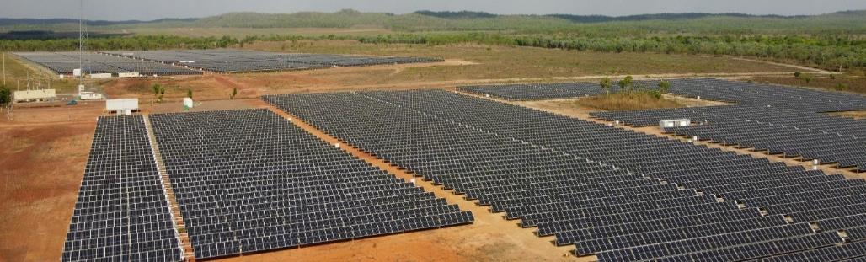
Image: Solar panels, Batchelor, NT. Credit: Jess Wright/Office of Northern Australia.

Northern Australia Infrastructure Facility
The recent amendments to NAIF’s legislative framework have provided NAIF with the finances and direction to support projects that align with Australian Government priorities and support economic growth in the north. For example, NAIF is playing a key role in supporting Australia’s emerging critical minerals sector, which will underpin many technologies required for the net zero transition, including batteries, solar panels and wind turbines.
Working in partnership with critical minerals project proponents, international investors and other government Specialist Investment Vehicles in 2024 to crowd investment into catalysing critical minerals projects in 2024 — providing $200 million apiece to Alpha HPA to develop its high-purity processing facility at Gladstone and Arafura Rare Earths Ltd to deliver its Nolan’s Rare Earth Project in the NT. Since its establishment, the NAIF has committed more than $1 billion to critical minerals projects in total.
These investments demonstrate that NAIF is playing its part to help the north seize the opportunity presented by the international move to net zero and secure its place in a changing global economic and strategic landscape. The opportunity for the north is immense, as it is home to the minerals and sources of energy the nation needs to build a Future Made in Australia and support the global transition to net zero. It is critical the government maximises the impact of its support for the north. The government will undertake a statutory review of the Northern Australia Infrastructure Facility Act 2016 (Cth) (NAIF Act) in 2024.

Table 1 Breakdown of NAIF loans by sector
NAIF investment decisions proceeding | As at 31 July 2024
Sector | NAIF loan (committed) $ | No. investment decisions | Percentage of decisions
Agriculture and water | 89,380,000 | 4 | 11%
Financing partnerships | 50,000,000 | 1 | 3%
Social infrastructure | 436,750,000 | 8 | 21%
Resources (other) | 873,500,000 | 4 | 11%
Transport and logistics | 692,800,000 | 6 | 16%
Resources (fertilisers) | 559,000,000 | 5 | 13%
Resources (critical minerals / rare earths) | 1,055,000,000 | 7 | 18%
Energy (renewables generation) | 737,000,000 | 3 | 8%
Total | 4,493,430,000 | 38
Note: Percentages are rounded to nearest whole percent.

Small loans
In response to the 2020 NAIF Statutory Review, the NAIF provided a limited recourse loan of up to $50 million to the NT Local Jobs Fund (NTLJF) for on-lending as concessional growth loans to eligible borrowers across the NT. This investment gives eligible small and medium sized businesses in the NT access to loans of up to $5 million through the NTLJF’s Territory Infrastructure Loans program, supporting local jobs and accelerating infrastructure and business growth. This project enables NAIF to support small projects across the NT.
This financing partnership broadens the reach and assistance of NAIF to a greater number of proponents, including proponents previously unable to access NAIF funding by reason of size. This will provide economic stimulus across the NT, while ensuring strong public benefit and Indigenous outcomes. The $66.7 million program ($50 million from NAIF; $16.6 million from the NT Government) is predicted to support approximately $110.1 million in Gross Territory Product and 532 full-time equivalent jobs in the NT.

Figure 6 Current NAIF project locations (mid-2024)
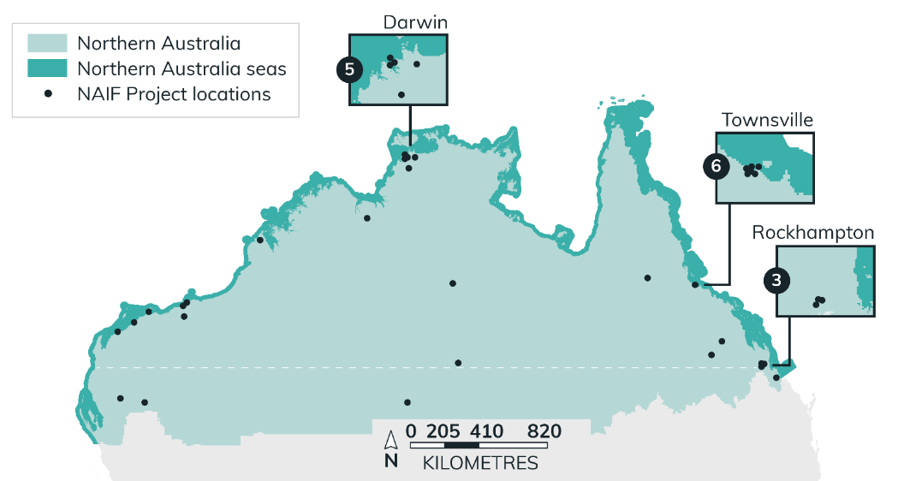
Note: “Northern Australia” as defined by the NAIF Act 2016.
Snapshot of government action
  - Undertake an independent statutory review of the NAIF Act. The review will provide advice to the Australian Government on:
    - the effectiveness of current investment in economic infrastructure development across the north, existing financial sources and government’s economic and population sustainability objectives
    - whether the time limit of 30 June 2026 for making decisions to provide financial assistance should be extended
    - the appropriate governance arrangements for the facility after that date.
  - Targeted, on-the-ground stakeholder consultations across the region to build the evidence base required to inform the review findings.
Gladstone electrolyser facility
A new green energy advanced manufacturing centre in Gladstone was opened on 8 April 2024. The facility will produce green hydrogen at an industrial scale using a fully automated production line and several cleanroom robotic assembly cells and lines. The development of the site was enabled by the Qld Government, with the Australian Government contributing $44.9 million to Fortescue Future Industries from the Collaboration Stream of the Modern Manufacturing Initiative.
The electrolyser facility is the first stage of a wider Green Energy Manufacturing Centre being developed by Fortescue on the 100 ha Gladstone site, the next phases of which will also include a hydrogen system testing facility and Fortescue’s PEM50 green hydrogen project.

Agriculture
Agriculture is a key contributor to the northern Australia economy. In 2020–21, agricultural production in northern Australia was valued at over $8 billion − around 10% of total national agricultural gross value of production. Key agricultural industries include beef, sugar cane, bananas, mangoes and melons (Table 2). The agriculture, forestry and fishing sector employed around 25,000 people in the north, of which approximately 5% are First Nations people.
Northern Australia presents significant opportunities for growth in the agricultural sector to take advantage of available land and water resources. Growth should be based on regional planning, underpinned by the best available science; aim to minimise any environmental and water resource impacts; and be informed by local community consultation.
The sector also offers opportunities for capability enhancement to support increased First Nations involvement in agribusiness, including bushfoods, and biosecurity, including on the First Nations estate where this aligns with First Nations communities’ aspirations. Despite industry opportunities, climate extremes ranging from extended tropical wet seasons and drought potential continue to pose challenges for the agricultural sector in the north.
The Government is working to support and enhance Australia’s agricultural, fisheries and forestry industries, helping to make them more productive, internationally competitive, sustainable and profitable. Priorities include efforts to build drought resilience and the provision of support, including Commonwealth-funded concessional loans to farm businesses and drought-affected small businesses in financial need to improve their long-term strength, resilience and profitability.
The Government is also focused on supporting industry to grow towards a $100 billion agriculture, fisheries and forestry industry by 2030. Key focus areas are trade and exports, biosecurity, stewardship, supply chains, water and infrastructure, innovation and research and human capital.
Figure 7 Value of agricultural commodities produced – Northern Australia vs Australia (2020–21)
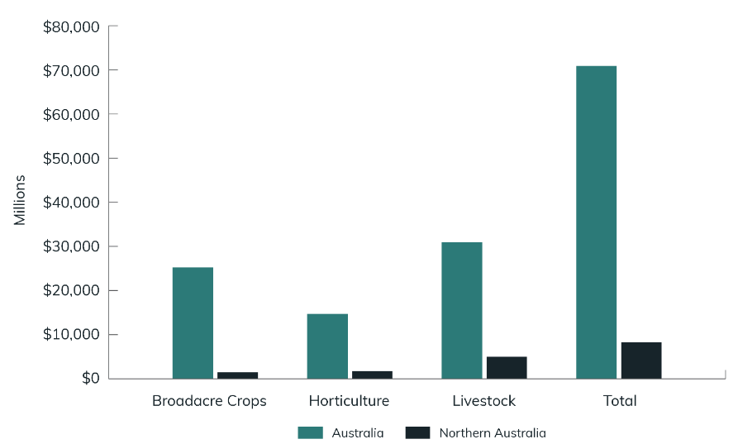
Source: Australian Bureau of Statistics (ABS), Value of Agricultural Commodities Produced, Australia, 2020−21 financial year [data set], ABS website, 2021.
Table 2 Key figures for commodity values
2020–21 $m | Northern Australia | Rest of Australia | Total Australia | Northern Australia (% of total)
Sugar cane cut for crushing | 1,095 | 189 | 1,285 | 85%
Cattle and calves | 4,810 | 8,655 | 13,465 | 36%
Fruit and nuts  (excluding grapes) — Total | 1,100 | 5,187 | 6,287 | 18%
Vegetables for human consumption | 525 | 4,254 | 4,779 | 11%
Nurseries, cut flowers or cultivated turf | 67 | 1,794 | 1,860 | 4%
Sheep and lamb | 10 | 4,322 | 4,332 | 0%
Source: BCARR analysis of ABS (2022), Value of Agricultural Commodities Produced, Australia, 2020-21 financial year based on corresponding local government areas data to northern Australia.
Snapshot of government action
  - Up to $4.075 billion in concessional loans to farm and farm-related small businesses through the Regional Investment Corporation, currently set to conclude on 30 June 2026.
  - $519.1 million over 8 years from 2024−25 in Future Drought Fund programs for initiatives to help Australian farmers and regional communities become more resilient to drought and better manage and adapt to climate change.
  - $63.8 million over 10 years from 2024–25 (and $0.9 million per year ongoing) for the Agriculture and Land Sector Plan to support initial emission reduction efforts in the agriculture and land sectors as part of Australia’s transition to net zero by 2050.
  - Co-investment with industry through Research and Development Corporations, which help to drive innovation which benefits industry and regional communities.
  - $34 million loan through NAIF to the Kimberley Cotton Company to support a new cotton processing facility in the Kimberley region of WA, creating 61 jobs and up to $248 million in public benefit.
  - Support for strategic partnerships under the Australian Trade System Support − Cultivating Australia’s Agricultural Traceability − Promoting and Protecting Agriculture measure. This includes a $1.9 million grant to the Indigenous Land and Sea Corporation to develop Australia’s first Indigenous Agricultural Product Framework to address growing demand for greater transparency across the supply chain and the importance placed on provenance and credentials.
  - Agreement by all agriculture ministers to develop a joint National Statement on First Nations in Agriculture, to be delivered in 2025. The National Statement is to be driven by the principles of self-determination as an ambitious commitment that advances First Nations perspectives, experiences and interests in the drive for greater economic inclusion in the agriculture, bushfoods, fisheries and forestry sectors.

Cooperative Research Centre for Developing Northern Australia — Cotton, Grains, Cattle program
The CRCNA is investing $8 million in Australian Government funding through the Cotton, Grains, Cattle program to support northern Australia’s critical agriculture sector through sustainable, adaptable cropping systems and cattle production improvements.
Launched in 2023, the 4-year research program seeks to inform future farming practices and investment and build new sustainable markets through 6 coordinated research projects. CRCNA analysis shows the greatest research, development and extension investment value is achieved when cropping is coordinated with other activities, such as beef production. The program will support the continued growth of the northern Australia beef industry, which is valued at over $5 billion annually, as well as tropical cotton and grains industries. The 6 projects are spread across the NT, the Ord River Irrigation Area in WA and northern Qld.
The objectives of the 6 projects are to:
- foster intensification of the northern cattle industry through cropping and cattle integration
- support the sustainable growth of the agriculture sector in the NT
- determine the viability of intensive feedlots in northern WA
- establish best practice for cotton specific to the Ord River Irrigation Area
- support the establishment and expansion of cotton and broadacre crops in Far North Qld
- co-design diversification options and drought resilience practices for northern Qld cotton, grain and cattle enterprises.
Early outcomes from the program include:
- increased agronomic skills across northern Australia supporting technical and industry workforce growth, including 3 embedded PhD scholars in the projects
- the commencement of intensive feeding studies on 10 cattle stations in the NT, including commercially operated stations, First Nations operated stations and government research stations
- increased capacity and experience amongst northern producers through knowledge sharing and collaboration
- the commencement of methane emissions and cattle forage legume feed studies at Central Queensland University
- climate resilient management of cover crops in the Ord River Irrigation Area and the NT to protect soils from intense tropical wet season storms.
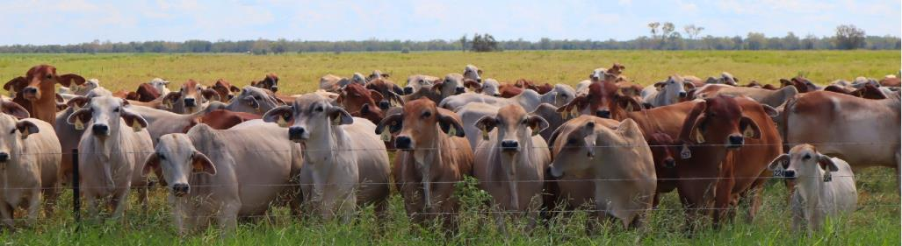Image: CRCNA.

First Nations economic opportunities
Aboriginal and Torres Strait Islander peoples currently experience poorer economic and employment outcomes than other Australians. Discrimination over generations in education, employment, housing and market access has limited Aboriginal and Torres Strait Islander peoples’ access to economic resources, opportunities and participation, perpetuating economic disparities. Consequently, significant gaps in employment and economic development remain.
Northern Australia cannot achieve its full potential unless First Nations people are empowered with economic opportunities and an enabling environment. The First Nations population is younger, growing at a faster rate than the rest of the Australian population, and is generally less likely to leave the north, with cultural and spiritual connection to Country a stabilising factor.
To build a foundation of economic empowerment, the Government is scoping a new First Nations Economic Partnership in line with the National Agreement on Closing the Gap, with the Coalition of Peaks and other stakeholders.

First Nations businesses
Around 50% of all First Nations businesses are located in the north. First Nations businesses, like all other businesses operating in northern Australia, face many challenges − including remoteness, small local markets, vast distances, poor infrastructure base and a harsh climate (including rising sea levels and extreme weather, particularly in the Torres Strait Islands). These challenges are exacerbated by additional circumstances faced by First Nations people, including complex requirements around land tenure; a lack of access to capital and the information necessary to make business decisions; limited access to culturally appropriate business support and advice; and, for many First Nations people living in the north, socio-economic disadvantage.
The IRG has noted that structural challenges for First Nations people persist in northern Australia. Some of these challenges are smaller markets; limited and ageing infrastructure; remoteness; and climate issues. The IRG has recommended working with First Nations communities and organisations to increase workforce participation and enable higher levels of entrepreneurship among the First Nations population in northern Australia.
The Australian carbon industry in northern Australia provides an economic basis for First Nations people to undertake traditional burning, which significantly reduces the risk of fires. For example, traditional fire regimes across northern Australia are among the best in the world, reducing later dry season wildfires by 115,000 km². Carbon industry projects provide not only a reduction in greenhouse gas emissions but also dramatic improvements in other aspects of land management and biodiversity values. Estimates suggest the First Nations carbon industry is valued at $53 million per year.

Unlocking the Indigenous Estate
Empowering First Nations people in the north to achieve, determine and drive their own futures and unlock the economic potential of the Indigenous estate is key to ensuring lasting prosperity, transforming communities, and ensuring they are positioned to take advantage of emerging opportunities in industry to create meaningful long-term jobs.
Making agreements with parties wishing to engage on Indigenous land has become a large part of the business of Indigenous landowners, land councils and Prescribed Bodies Corporates (PBCs). PBC funding, capacity and the ability to unlock the economic potential of the Indigenous Estate, and generate wealth from land rights and interests, has been a key focus in the development of northern Australia. PBC capacity will also be critical to realising other key priorities in the north, including clean energy and critical minerals.
Ultimately, the future growth of Australia is tied to the north and this is inextricably linked to the untapped potential of the First Nations estate and of First Nations people in the north.
Source: Northern Australia Indigenous Reference Group, Submission to the Employment White Paper, DITRDCA website, n.d., accessed 5 June 2024.
Roebuck Plain Station
The Yawuru people have managed the Roebuck Plain Station since 2022, through the incorporated organisation Nyamba Buru Yawuru, led by Yawuru woman Ninielia Mills.
The 276,000 ha station forms part of the northern Australia Indigenous Estate. It is strategically located for the export market, located on rich marine floodplain 30 km east of Broome, and has the capacity to support 20,000 head of cattle.
The station provides livelihoods for the Yawuru on their traditional lands and enables protection of important natural and cultural sites through business operations underpinned by Yawuru values. The station also runs a traineeship program to build young Indigenous people’s skills.
Snapshot of government action
  - $231.5 million over 5 years from 2023–24 to continue, improve and expand the Indigenous Protected Areas (IPA) Program, including funding for at least 10 new IPAs from 1 July 2024.
  - $77.2 million over 3 years from 2024–25 to 2026–27 to support PBCs to build capacity in recognition of the essential role PBCs play in supporting native title holders to take advantage of their Native Title rights.
  - $20.8 million over 4 years (and $3.6 million per year ongoing from 2028–29) to improve the operation of the Native Title system and solve the claim backlog.
  - Investments (at a national level) in supply-side support to build capability within the First Nations business sector: Many Rivers Microfinance Ltd for the Microenterprise Development and Community Economic Development programs ($52.1 million from 2015–16 to 2024–25), Indigenous Business Australia for the Business Solutions Program ($247.5 million from 2017–18 to 2025–26), and Indigenous Business and Employment Hubs ($49.9 million from 2022–23 to 2025–26).
  - $11.8 million over 4 years from 2024–25 to support First Nations groups to participate in up-front consent processes for Australian Carbon Credit Unit Scheme projects on Native Title lands.
  - $2.7 million over 4 years from 2024–25, as part of the Future Made in Australia — Making Australia a Renewable Energy Superpower measure, to expand the First Nations Renewable Hydrogen Engagement Fund.
  - $5.5 million to develop the First Nations Clean Energy Strategy to give First Nations people a say in renewable energy policies and programs.
  - Reviewing the Indigenous Procurement Policy, which aims to increase First Nations participation in government procurement, providing opportunities for First Nations businesses to access contracts and build economic activity.
  - Commitment to introduce new standalone legislation to protect First Nations traditional knowledge and cultural expressions, also known as Indigenous cultural and intellectual property, including to address the harm caused by fake art, merchandise and souvenirs.
Areas for continued focus
Given the importance of economic development to addressing perpetuating economic disparities for First Nations people, the Australian Government will:
- Scope a First Nations Economic Partnership to improve economic outcomes for First Nations people, including northern perspectives.
- Enhance self-determined, sustainable opportunities for First Nations people and business, including Prescribed Bodies Corporates, to leverage and protect their land, water, traditional knowledge, expertise, ingenuity and cultural heritage and other assets, including a focus on access to capital, capacity building and benefit sharing.
- Enhance participation of Aboriginal and Torres Strait Islander community-controlled organisations and First Nations business in delivering services in the north.

Visitor economy
Tourism is an important economic driver of the northern economy and a significant industry in regional and remote areas. Tourism contributed 2.4% to gross domestic product (GDP) on average across the regions in 2021–22, compared with a 1.2% contribution to GDP on average in capital cities. For some regions, such as Lasseter in the NT, tourism accounts for at least 20% of their gross regional product There were 36,641 persons directly employed in northern Australia tourism in 2020–21 and 9,323 northern Australia-based tourism businesses.
The 2 World Heritage properties in the NT (Uluru-Kata Tjuta and Kakadu National Park) are dual listed for their combined outstanding natural and cultural values. In 2021–22, these properties contributed $176.1 million and 1,100 jobs to the NT economy, noting this was during a severe decline in visitation due to COVID-19, with the sector having since recovered substantially.
In 2023, there were nearly 1 million international trips and 1.7 million domestic trips that incorporated First Nations activities:
- One in 7 international trips to Australia incorporated a First Nations experience in 2023 and generated a total of $5.9 billion in international visitor spend (when all expenditure across the trip was considered). The total number of international trips incorporating First Nations activities has increased by more than 1.4 times over the 10 years from 2013 to 2023.
- The total number of domestic trips incorporating First Nations activities has more than doubled. In 2023 alone, these domestic trips generated a total of $3.1 billion in domestic visitor spend.
The impacts of climate change and severe weather events are increasingly impacting tourism operations in the north and are a threat to the iconic natural environments and cultural sites. Investment in protecting and maintaining our precious World Heritage areas is important for confidence in the visitor economy. If managed in a responsible and sustainable way, First Nations led tourism can increase employment, reduce poverty, empower local communities, spur cultural revival and allow for a sustained relationship with Country. Events like the annual Yothu Yindi Foundation’s Garma Festival in northeast Arnhem Land — a 4-day celebration and expression of traditional art and culture — have become highlights of the international calendar.
The Australian Government has committed to co-designing the First Nations Visitor Economy Partnership — a key action under THRIVE 2030 to support greater participation of First Nations cultures, interpretation and businesses into the visitor economy. Austrade is facilitating the Partnership with First Nations industry representatives, state and territory governments, the National Indigenous Australians Agency and Tourism Australia to elevate First Nations voices across the visitor economy and to enable better engagement and advocacy on national tourism issues.
Snapshot of government action
  - $5 billion in a joint initiative with the Qld Government between 2014 and 2030 to address key threats to the Great Barrier Reef.
  - $216 million over 10 years from 2019 to grow tourism in Kakadu National Park. A further $25.9 million over 4 years from 2023–24 will be invested to improve visitor and tourism infrastructure at the park. Uluru-Kata Tjuta National Park has also received substantial funding over recent years to upgrade facilities for visitors.
  - $80 million to the development of the National Aboriginal Art Gallery in Alice Springs.
  - $8.1 million over 4 years from 2024–25 (and $2.5 million per year ongoing) to continue administration of the Approved Destination Status Scheme. The scheme is critical in supporting Chinese visitors to travel to Australia in guided tour groups.
  - $5 million in 2024–25 for the Great Barrier Reef Marine Park Authority to engage tourism operators in reef monitoring, protection and stewardship to protect the Great Barrier Reef.
  - $1 million for the Larapinta Trail Tourism Project to provide jobs and training for First Nations people.
  - Grow Australia’s visitor economy through the THRIVE 2030 strategy — investing almost $48 million to help attract visitors, upskill workers and grow visitor expenditure., THRIVE 2030 aims to achieve total visitor expenditure of $166 billion by 2024 and $230 billion by 2030, with regional target of $100 billion by 2030.
  - Identification of new areas of cooperation between First Nations communities and our international partners – including in intellectual property and exports, climate change, tourism and development - led by the Ambassador for First Nations People, the Department of Foreign Affairs and Trade’s Office for First Nations International Engagement.
  - Co-designing the First Nations Visitor Economy Partnership to elevate First Nations voices across the visitor economy and to enable better engagement and advocacy on national tourism issues.

Cost of doing business
Northern Australian stakeholders have identified the challenges of higher costs for business in the north and gaining access to capital, particularly for small to medium enterprises (SMEs). SMEs are central to driving innovation, expanding into new sectors, providing employment opportunities and fostering economic resilience across the region.
The geographically dispersed nature of SMEs in northern Australia can result in increased businesses costs and risks, and this can deter business from investing. The northern Australian business environment is characterised by:
- a smaller economic scale, which limits infrastructure and sectoral development
- higher costs and risks associated with doing business as a result of higher energy and insurance costs, greater climate variability and seasonality, vast distances and time delays to access services and support, such as specialised machinery maintenance
- greater opportunity costs as labour and resources compete with other, sometimes less dispersed, areas
- inefficiencies in transport due to underdeveloped supply chain infrastructure and weather conditions; and a stronger ‘first mover disadvantage’, where a first mover bears all of the capital costs of a new facility that reduces the risk and costs to other businesses.
A comparison of a ‘basket’ of common goods and services also demonstrates increased cost of living in the north. Analysis of data available for WA in 2023 shows the Pilbara region was on average 15% more expensive than Perth to live in, with the Kimberley region (8.9%) and Gascoyne region (5.5%) also being more expensive. In particular, housing costs in the Pilbara region were 40.6% more expensive than in Perth, 13% more expensive in the Kimberley and 10.7% more expensive in the Gascoyne region.
Higher freight costs in northern Australia
CSIRO’s TraNSIT Supply Chain dashboard demonstrates the cost of freight is higher in northern Australia.
The cost of delivering food to Darwin costs $698 per tonne. To outback WA it is $400 per tonne and, to Townsville, $292 per tonne, compared with $46 per tonne to inner city Sydney and $71 per tonne to Victoria. The cost of transporting livestock from Darwin is $90 per tonne and, from Cairns, $107 per tonne, compared with $64 per tonne from NSW and $29 per tonne from Victoria.
To a large extent these costs are driven primarily by the longer distances involved when travelling in northern Australia.
Figure 8 Key freight routes across Australia map
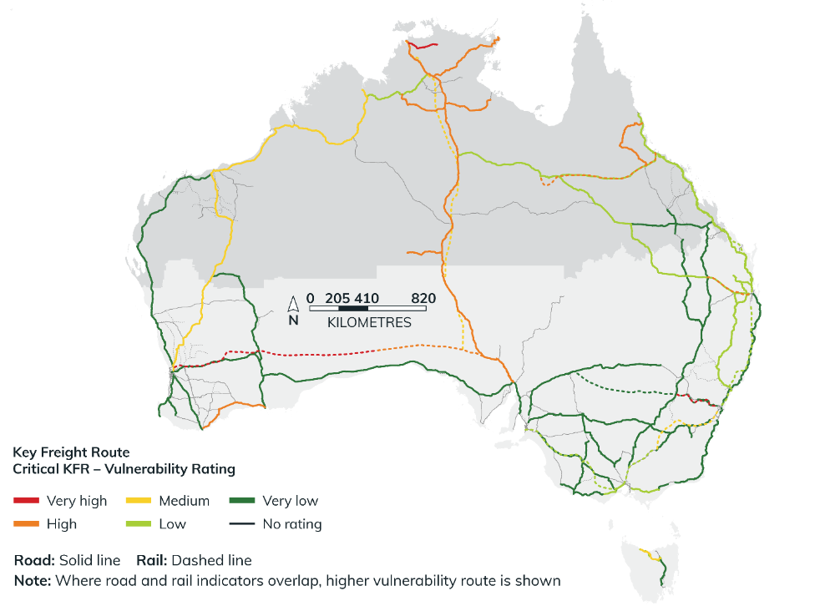
Source: Bureau of Infrastructure and Transport Research Economics, Road and Rail Supply Chain Resilience Review — Phase 1, February 2023.
Northern Australia is also more exposed to extreme weather events than other areas of Australia. Insurance affordability has been a long-running concern in northern Australia, particularly in natural disaster-prone areas. Numerous reviews have highlighted this issue in recent years, including the 2011 Natural Disaster Insurance Review, the 2015 Northern Australia Insurance Premiums Taskforce Report, the 2020 Royal Commission into National Natural Disaster Arrangements, and the Australian Competition and Consumer Commission’s (ACCC) Northern Australia Insurance Inquiry. In response, the Government has implemented a reinsurance pool for cyclone and cyclone-related flood damage.
The ACCC’s recent insurance price monitoring report for the cyclone pool shows average small business insurance premiums are more than triple in WA, and significantly higher in NT and northern Qld, than the rest of Australia. Average home and contents insurance premiums are also considerably higher in northern Australia than the rest of Australia. However, the report also acknowledged the pool is still in transition. The ACCC used data collected throughout 2022–23, when most major insurers joined the pool around or after 1 July 2023. Recent data released by the Australian Reinsurance Pool Corporation shows signs the pool is improving affordability and availability for home and SME insurance in high cyclone risk areas.
Figure 9 Insurance premiums in northern Australia and the rest of Australia, 2023
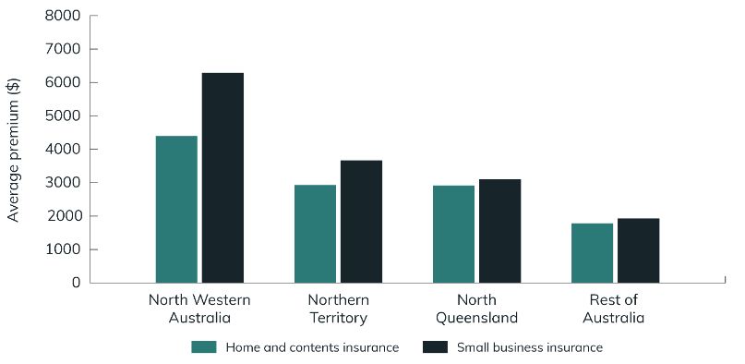
Source: Australian Competition and Consumer Commission (ACCC), Insurance monitoring: second report following the introduction of a cyclone and cyclone-related flood damage reinsurance pool, ACCC, Australian Government, 2023.
Snapshot of government action
  - $392.4 million over 4 years from 2023–24 (and $68.2 million per year ongoing) under the Industry Growth Program to support Australian SMEs and start-ups to commercialise ideas and grow their businesses.
  - $39.6 million over 4 years from 2023–24 (and $11 million per year ongoing) to continue the Single Business Service, supporting SMEs’ engagement with all levels of government.
  - $22.6 million over 4 years from 2022–23 to the National Emergency Management Agency for initiatives to improve insurance affordability and availability. These include the establishment of a new partnership forum with the insurance industry focused on risk reduction and insurance affordability; and development of a national knowledge base of mitigations for households to reduce vulnerability to natural hazards.
  - $10.9 million over 2 years from 2024–25 to expand the Go Global Toolkit — a single, simple and trusted source of practical online export support for all Australian businesses.
Area for continued focus
Given the high costs of doing business and the importance of economic development for the north, the Australian Government will:
- Investigate opportunities to address higher costs of doing business in the north.

Policy priority area 2:
Infrastructure to unlock growth
Investment in infrastructure is critical to unlocking the north’s
potential. The 2015 Northern Australia Infrastructure Audit highlighted
that ‘infrastructure must be a key element in realising this potential, particularly where a sparse population base tends to rely on transport, energy, water and communications to an even greater extent than those in the more populated south of the country’. Through the 2015 Our North, Our Future: White Paper on Developing Northern Australia and the establishment of the Northern Australia Infrastructure Facility (NAIF), there has been significant investment in infrastructure across the north. However, there is still more to be done to ensure needs are met.

Housing
Inadequate housing, from social housing through to home ownership, impacts the health, education and employment outcomes for people living in the north and makes it harder to attract workers. The lack of affordable housing is exacerbated by the higher costs of construction and maintenance in the north, particularly in remote communities, and constrains workforce attraction and retention.
Housing pressures are particularly acute in northern Australia because of:
- high input costs, based on greater distances, skill shortages and higher costs of living
- extreme weather events
- availability and affordability of insurance
- cost of construction being higher than the value of the property, impacting on finance availability
- pressures on temporary accommodation arising from large-scale projects
- subsidised housing provided to staff to attract them to the region impacting on market pricing and availability.
The Northern Australia workforce development: First Report, released by the Joint Select Committee on Northern Australia, highlights that First Nations communities living in northern Australia experience inadequate access to housing and high levels of overcrowding.
Data from the National Agreement on Closing the Gap indicates that nationally there has been improvement in housing for Aboriginal and Torres Strait Islander peoples, but the target overall to increase the proportion of Aboriginal and Torres Strait Islander peoples living in appropriately sized housing to 88% is not on track, and outcomes in the NT are substantially lower than for Australia as a whole. Only 43.4% of Aboriginal and Torres Strait Islander peoples living in the NT were living in appropriately sized housing (2021 Census), compared with 81.4% nationally. The Central Land Council estimates an additional 2,000 new houses are needed in the NT alone.
The availability of suitable housing is also a key enabler for other priorities, including transformational and complex projects, workforce skills and training development, and migration and mobility.
‘lack of appropriate housing generally means businesses cannot expand and sector growth is limited because they can't physically house their workers and communities can't support the peripheral social services (childcare, health care) needed to sustain a growing population. There is significant anecdotal evidence suggesting even the offer of high wages isn’t enough to attract workers to regional and remote areas, if there is no housing or social infrastructure to support individuals and families.’
Cooperative Research Centre for Developing Northern Australia, Submission to the Joint Select Committee on Northern Australia inquiry into northern Australia workforce development, [2023], p 6.
‘the high cost of construction due to the requirement to meet cyclone building codes, makes the cost of accommodation expensive in the region.’
NT Farmers Association, Submission to the Joint Select Committee on Northern Australia inquiry into northern Australia workforce development, [2023], p 2.
‘Inadequate and overcrowded housing presents a substantial impediment to the participation of remote community members in the workforce and is associated with poor health, lower educational and employment outcomes and increased family violence.’
Northern Land Council, Submission to the Joint Select Committee on Northern Australia inquiry into northern Australia workforce development, [2022], p 17.
The Australian Government is making substantial investments to address housing pressures across Australia. A further $6.2 billion was announced as part of the 2024–25 Budget in specific housing initiatives, taking the Government’s total new investment since 2022 to $32 billion.

Snapshot of government action
  - $10 billion investment in a Housing Australia Future Fund (HAFF), with its returns to build around 30,000 new social and affordable housing properties in its first 5 years. This includes providing funding of $200 million for repair, maintenance and improvements in remote Indigenous housing.
  - $9.3 billion for a new 5-year National Agreement on Social Housing and Homelessness with states and territories. This represents an additional $423 million over the life of the agreement compared with funding previously allocated.
  - $3 billion through the New Homes Bonus to help incentivise states and territories to build 1.2 million homes where people need them over 5 years from 2024.
  - Expanding the Affordable Housing Bond Aggregator program by increasing Housing Australia’s liability cap by $2.5 billion to $10 billion to support Housing Australia to provide more low-cost finance to community housing providers, including in regional areas.
  - $2.1 billion over 10 years from 2024–25 to improve housing in remote NT communities and develop a sustainable community-controlled housing model. Of this, $2 billion for remote housing is being matched by the NT Government.
  - $2 billion through the Social Housing Accelerator to support around 4,000 new and refurbished social homes across Australia.
  - $1.9 billion investment over 5 years to increase the maximum rates of Commonwealth Rent Assistance by 10% to assist eligible households with the costs of private rental or community housing. This builds on the 15% increase already made in September 2023, which was the largest increase in 30 years.
  - $1.9 billion in concessional loan funding for community housing providers and other charities to support delivery of social and affordable dwellings under the HAFF and the National Housing Accord.
  - A further $1 billion for the Housing Support Program (HSP) for the states and territories to deliver urgent and significant infrastructure projects to build more homes for Australians and to increase social housing supply, including in regional Australia. This is in addition to the $500 million committed to the HSP over 2023−24 and 2024−25 for the states and territories and local government authorities to deliver projects that support enabling infrastructure, provide amenities and improve planning capability for new housing development.
  - Targeting the $1 billion increase to the National Housing Infrastructure Facility towards crisis and transitional housing for women and children experiencing domestic violence and for youth.
  - $120 million over 3 years from 2024–25 to extend funding for repairs and maintenance on housing and essential infrastructure on NT homelands. This funding will continue improving housing on homelands while further work is undertaken with housing stakeholders to develop a long-term approach to housing on homelands.
Area for continued focus
Given housing is the most important issue for northern stakeholders and the impacts of inadequate housing for First Nations people and its importance for workforce development, the Australian Government will:
- Raise awareness of the specific circumstances and needs of northern Australia in policy initiatives and investments in housing.

Landmark $4 billion investment for remote housing in the NT to help close the gap
The Australian and NT Governments have announced a landmark joint $4 billion investment for housing in remote communities across the NT to help close the gap between Indigenous and non-Indigenous Australians. It is the single most comprehensive investment package for the NT’s remote housing and homelands sector. Its impact cannot be overstated.
The 10-year commitment will see up to 270 homes built each year, with the goal of halving overcrowding. The commitment to build 2,700 homes in 10 years means new homes for more than 10,000 people. Increasing housing supply will ease overcrowding, which is a major barrier to closing the gap. It also includes continued support for repairs and maintenance.
The Australian Government is investing a further $120 million over 3 years to match the NT Government’s yearly investment for housing improvements and essential infrastructure upgrades in remote homelands.
To support delivery of this landmark project, a partnership agreement has been established between the Australian and NT Governments and Aboriginal Housing NT — the NT’s peak First Nations housing body − and Aboriginal Land Councils. As well as supporting improved housing outcomes, this unprecedented investment will create local employment opportunities and support the sustainability of Aboriginal Business Enterprises.

Roads
Ensuring all-year road access to the north is essential to the north’s development. Two key roads are the Stuart Highway and Bruce Highway. The Stuart Highway runs through the centre of the NT and is the only bitumen road providing access to the road networks of Qld, WA and South Australia (SA). The Bruce Highway is Queensland’s 1,700 km north−south road corridor connecting coastal populations from Cairns to Brisbane. Cyclones and heavy rains frequently cause the closure of the Bruce and Stuart Highways, as do subsequent repair works. Closure of roads can cause supply chain issues and negatively affect regional and remote communities.
When flooding occurs across northern Australia, it generally results in community evacuations or the need to deliver goods by plane to locations that have sealed airstrips. When the flooding event is no longer declared an emergency, the roads can remain unsafe and impassable for some time, rendering community businesses responsible for flying in goods to replenish stock for customers. This comes at a significantly higher cost to the community and its businesses and increases the cost of business and the cost of living for communities.
Stakeholder engagement highlighted that roads and railways in many areas, particularly remote and rural communities, need improvement to facilitate the transport of goods and people. There was also widespread recognition that climate change driven severe weather events will worsen impacts on current infrastructure in the coming decades and that investment in weather-resistant infrastructure should be the goal. A stakeholder survey identified action to improve the quality, safety and use of key roads and action to make key roads passable in all weather as the highest ranked actions.
‘In a country as large as Australia, reliable transport infrastructure is essential. More than 1.5 billion tonnes of freight are moved around the country each year. Commodities including food and forest products, fuels, minerals, construction materials and general freight are often transported along complex routes of 1,000 km or more before reaching their markets. This can be very expensive for producers and manufacturers, and there is high risk of transport disruptions.’
Source: Commonwealth Scientific and Industrial Research Organisation (CSIRO), Solving Australia’s transport and supply chain challenges: improving costs, efficiency and resilience, CSIRO website, 2023.
Numerous industries in the NT have supply chains that operate within and beyond the region. Key to the success of these industries is the enabling infrastructure that underpins the supply chains. It provides those industries with transport linkages; export facilities; and processing and value-adding functions to increase product value, provide additional economic benefit and improve sustainability. Reliable and efficient transport links are critical for the sustainability of current industries. They will also provide leverage for growth of emerging industries and unlock geographical areas by providing east-to-west connectivity in the north.
The Australian Government is committed to focusing on delivering nationally significant land transport projects in partnership with its stakeholders and taking a strategic view of its investments and the infrastructure pipeline. The Australian Government’s Infrastructure Policy Statement defines nationally significant transport infrastructure, sets out strategic themes that will guide investment decisions, and explains how the Government will put these themes into action to deliver its policy objectives. Delivery of projects will also support Australian Government and state and territory government objectives, including promoting a competitive infrastructure market that provides opportunities for local businesses and employment in northern Australia.
The Australian Government is maintaining a strong commitment to a 10-year, more than $120 billion infrastructure pipeline, while ensuring land transport infrastructure projects delivered are nationally significant and nation-shaping projects. The Australian Government’s investment in existing and new road projects in northern Australia, guided by the strategic themes of ‘productivity and resilience’ and ‘liveability and sustainability’, is outlined in Figure 10.
Figure 10 Major road investments
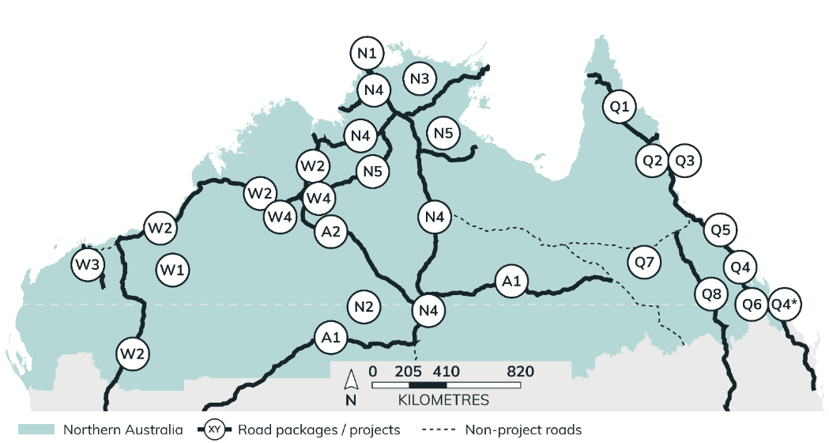
Note: Not all packages and projects are shown. Information and funding figures are correct as at Budget 2024−25

Table 3 Major road investments
Jurisdiction. | No. | Description. | Status.
National | A1 | Outback Way — WA/NT/Qld: AGC $1b | Under construction
Western Australia | W1 | Regional Road Safety Program — State Roads: AGC $54m | In planning
WA | W2 | Great Northern Highway: AGC $357.5m | Under construction
WA | W3 | Karratha to Tom Price Upgrade: AGC $304m | Under construction
WA | W4 | Duncan Road and Gordon Downs Road Upgrade: AGC $40.8m | Under construction
Northern Territory | N1 | Tiwi Islands Road Upgrades: AGC $60m | Under construction
NT | N2 | Northern Territory Strategic Roads Package: AGC $332m | Under construction
NT | N3 | Regional Roads Corridor: AGC $630.7m | Committed
NT | N4 | Stuart, Victoria and Barkly Highways Corridor: AGC $579.3m | Committed
NT | N5 | Industry Roads Corridor: AGC $518.5m | Committed
Queensland | Q1 | Cape York Corridor: AGC $480.5m | Under construction
QLD | Q2 | Kuranda Range Road Upgrade:  AGC $210m | In planning
QLD | Q3 | Cairns CBD to Smithfield: AGC $287.2m | Under construction
QLD | Q4 | Bruce Highway: AGC $10b | Under construction
QLD | Q4* | Bruce Highway, Rockhampton Ring Road: AGC $1.2b  (* included in AGC for Q4 of $10b) | Under construction
QLD | Q5 | Bowen Basin Service Link — Walkerston Bypass: AGC $181.8m | Under construction
QLD | Q6 | Queensland Beef Corridors: AGC $400.1m | Committed
QLD | Q7 | Central West: AGC $450m | Under construction
QLD | Q8 | Inland Freight Route (Mungindi to Charters Towers) Upgrade: AGC $800m | Committed
Note: AGC = Australian Government contribution

Snapshot of government action
  - Over $120 billion committed to a 10-year infrastructure pipeline, with $16.5 billion invested across Australia, through the 2024−25 Budget for new and existing projects.
  - Key land transports infrastructure projects across northern Australia, including:
    - $10 billion for the Bruce Highway in Qld
    - $1.3 billion for the Road Safety Program, with an investment of $777.7 million for Qld, $391.2 million for WA and $141 million for NT
    - $1.1 billion for the Tanami Road Upgrade across WA and NT
    - $1 billion for the Outback Way across Qld, WA and NT
    - $400 million for the Queensland Beef Corridors
    - $605.7 million to new projects in northern Australia
    - $282.6 million to existing projects that deliver critical road upgrades in northern Australia, including $237.9 million from the previous Northern Australia Roads Program being allocated to new projects in NT and WA.
  - Gradually increasing funding to $1 billion per year for the Roads to Recovery Program, through the 2024−25 budget, building on the Government’s existing commitment towards the program. Black Spot Program funding will progressively increase from the current annual commitment of $110 million to $150 million per year. The existing Bridges Renewal Program (BRP) and the Heavy Vehicle Safety and Productivity Program (HVSPP) will be merged into a single funding stream for local governments called the Safer Local Roads and Infrastructure Program. This funding will also increase gradually to $200 million per year. This funding benefits local governments and unincorporated areas responsible for local road infrastructure works, including northern Australia.
  - Working with the states and territories to refresh the National Freight and Supply Chain Strategy, which sets a national agenda for government and industry action across all freight modes to 2040 and beyond. In 2024, the Government will develop new actions to ensure the strategy remains fit for purpose and is able to improve the efficiency, effectiveness and reliability of Australian supply chains.
Area for continued focus
Given the importance of infrastructure to northern Australia’s productivity, connectivity and liveability, the Australian Government will:
- Continue to work with state and territory governments to understand and address current and future infrastructure needs and priorities in northern Australia.

Aviation
Australian communities depend on aviation. Safe, affordable, accessible and reliable air services are vital for regional and remote Australia, connecting people to family, community and essential services. Domestic and regional aviation are critical for domestic connectivity and for community access to a range of essential services. International aviation offers a vital connection between northern Australia and the rest of the world. Aviation underpins the north’s national and international supply chains and enables the northern economy. The visitor economy in the north is particularly dependent on aviation.
Australia’s aviation network serves a very large geographic area. Nearly 527 of the 561 routes across Australia involve at least one regional airport, and arrivals at regional airports represent 21.3% of total passenger arrivals and departures at airports in 2023. Regional air routes generally have fewer airlines servicing them and less competition than routes between major cities.
Regional airfares can be high, and services are infrequent and sometimes unreliable. These factors impact the transport connectivity of regional communities, reducing economic growth and activity. They can also create a disincentive to regional migration and reduce access to services, such as health care.
The Australian Government is developing an Aviation White Paper to set out the Australian Government’s policy agenda for the aviation sector to 2050. The Australian Government wants the safest aviation sector in the world − one that supports an Australia that is open to the world, provides reliable and accessible services to passengers, protects consumers and leads the transition to net zero. The Government recognises the critical role aviation plays for regional communities in northern Australia, especially to support critical services such as health care, education and freight. The Aviation Green Paper was released on 7 September 2023.
Snapshot of government action
  - Up to $155 million through a NAIF loan to North Queensland Airports to fund surface upgrades to runways, aprons and taxiways at Cairns Airport international terminal and create a mixed retail and commercial precinct at Mackay Airport.
  - $50 million over 3 years from 2024–25 to extend the Remote Airstrip Upgrade Program to improve the safety and accessibility of remote airstrips across Australia.
  - $40 million over 3 years to extend the Regional Airports Program grant funding to improve safety and connectivity of regional airports and support regional aerodromes to invest in the infrastructure required to adapt for the future.
  - Developing an Aviation White Paper to set the strategic direction for the aviation sector out to 2050.
Area for continued focus
Given the importance of aviation to northern Australia, the Australian Government will:
- Continue efforts to improve the affordability, accessibility and reliability of air services in the north.
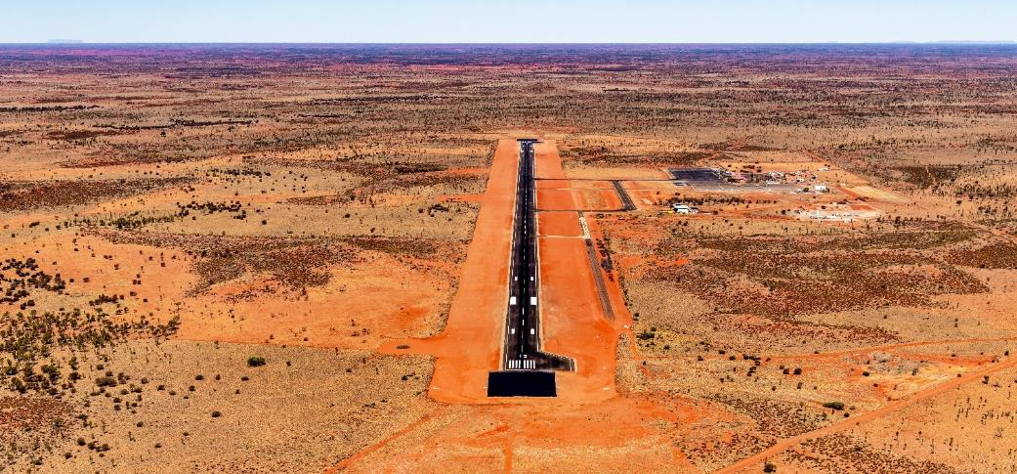
Image: Connellan Airport, NT. Source: Voyages Indigenous Tourism Australia.

Ports
Across northern Australia, significant economic developments are occurring − for example, the transition to renewable energy and green fuels and the development of critical mineral resource industry. As a result of increasing trade opportunities, requests to support international arrivals into Non-First Points of Entry Ports are increasing, and more accredited ports are needed to ensure security and biosecurity risks are managed.
Government and industry are working to align the various government approvals, budget and associated border agency processes to support the volume of infrastructure investment and development in northern Australia. This will also ensure that the infrastructure being delivered is fit for purpose so that border agencies can undertake their critical regulatory function from a national and biosecurity perspective.
Snapshot of government action
  - $180 million has been committed towards an expansion of the Cairns Marine Precinct to deliver a new marine common user facility, in partnership with the Qld Government. The new facility will expand marine maintenance, repair and overhaul services, including for Australian Defence Force and Australian Border Force vessels.
  - $160 million through a NAIF loan to the Dampier Bulk Handling Facility along with WA Government funding.
  - Approved the Kimberley Port Authority application for expanded border services at the Port of Broome in early 2024.
  - Approved Broome International Airport’s application under the Government’s new and redeveloping international port framework.

Common user infrastructure
The development of common user infrastructure in regional areas will help build northern Australia’s economic sustainability; unlock market opportunities; and de-risk new and emerging industries such as low emission fuels and advanced manufacturing and processing.
Coordination and common user infrastructure can attract more investment by reducing barriers to entry. The $10.2 million Critical Minerals National Productivity Initiative will involve working with states and territories to develop pre-feasibility proposals for critical minerals common user processing facilities. In contrast to the traditional commodities that have traditionally supported northern Australia, critical minerals are often located in small quantities at multiple mining sites and in more remote regions. Most critical minerals companies are junior miners − operators that do not have the necessary capital resources to spend on processing plants and infrastructure. Investment in new common user infrastructure will allow for increased onshore processing of critical minerals in Australia.
Middle Arm Sustainable Development Precinct
The Australian Government has committed $1.5 billion in planned equity to support the construction of common user marine infrastructure as part of the NT Government’s development of the Middle Arm Sustainable Development Precinct on the Middle Arm Peninsula of Darwin Harbour. The project is being designed to take advantage of the location’s geostrategic and natural advantages, including close proximity to international trading partners, world-class solar resources and the critical minerals required for the manufacturing of renewable energy components.
The new precinct will unlock market opportunities in the emerging industries of renewable energies and advanced manufacturing, and provide a pathway to a decarbonised economy. It will open new export opportunities in northern Australia for commodities such as green hydrogen and critical minerals, with associated downstream opportunities for onshore processing and low-emission manufacturing.
The Middle Arm Sustainable Development Precinct is a transformational project for Darwin, the NT and Australia. It will help to build the NT’s economic sustainability while creating opportunities for energy transition, exports and jobs and contributing to the Australian Government’s commitment to meet net zero outcomes.
The NT Government is carrying out further detailed planning, analysis and regulatory processes to ensure all environmental, social, cultural, economic and financial impacts are appropriately considered before the project proceeds.
Snapshot of government action
  - $1.5 billion in planned equity to build enabling common user marine infrastructure, including the construction of a wharf and modular offloading facility and dredging of the shipping channel at the Middle Arm Sustainable Development Precinct.
  - $565 million to invest in enabling infrastructure in the Pilbara to support industry diversification, boosting the region’s readiness for new green hydrogen markets and the Pilbara’s transition to renewable energy.
  - $440 million in planned equity to build new regional logistics hubs in Katherine, Alice Springs and Tennant Creek and increase capacity in the NT Rail network.
  - $22.5 million over 4 years from 2024–25 to maintain and repair essential assets in Australia’s non-self-governing territories. This will ensure these assets operate safely and effectively and will support communities in these regions to have undisrupted access to essential goods and services such as food, medicines, fresh water and electricity.
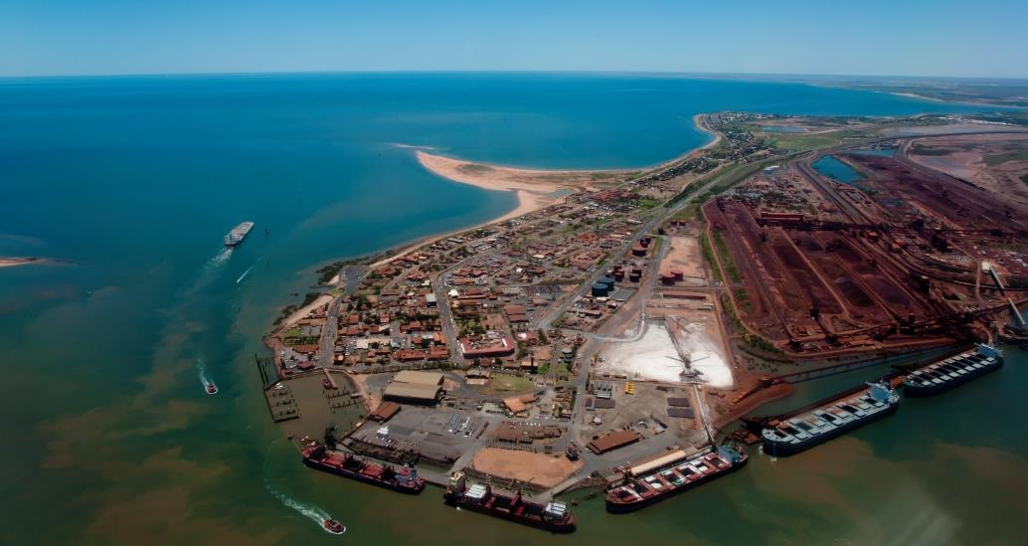
Image: Port Hedland, WA. Credit: Adrian Wojcik / Getty Images

Digital connectivity
The level of availability of digital and mobile connectivity impacts the north’s ability to conduct business and access essential education, health and emergency response services. Northern Australia faces a number of digital and mobile connectivity challenges resulting from the remoteness and isolated nature of communities, climatic conditions and challenging terrain over long distances. The higher costs and lower population density in these areas have historically discouraged commercial investment by telecommunications providers, leaving some communities under-served. Communities have regularly reported signal dropouts, blackspots, bandwidth issues and slow speeds.
In 2022, the NT ranked the lowest out of all Australian jurisdictions in the Australian Digital Inclusion Index. To avoid congested networks, businesses in remote areas often work outside of business hours and may subscribe to a range of networks to manage connection issues.
Stakeholders have highlighted the impact of mobile blackspots on safety and economic development in the north. The Australian Logistics Council noted that the lack of adequate telecommunications across regional areas is impeding the implementation of the National Freight and Supply Strategy and asked that more attention be focused on rectifying telecommunications blackspots across northern Australia − in particular, along freight routes.
Improving the quality, resilience and reliability of telecommunications services for regional Australians is one of the Government’s top priorities, and there have been significant improvements to digital connectivity and availability in recent years. The initial volume build of the National Broadband Network (NBN) was completed in 2020. Fast broadband is now available to homes and businesses across Australia. The emergence of Low Earth Orbit satellite (LEOSat) connectivity presents opportunity for new high-bandwidth, low-latency services as a complementary option for access to fast broadband nationwide.
However, broadband options are not always suitable for all homes and businesses. For example, remote Indigenous communities may consume broadband services differently and may not be able to access pre-paid options or community wi-fi. Further, some businesses may not find the NBN Co’s satellite broadband service suitable.
The Government is making significant investments in improving NBN Co’s fixed-line, fixed wireless and satellite broadband services, enabling more Australians to access higher speeds and better quality broadband. At the same time, emerging technologies such as LEOSats are offering consumers more connectivity options and increasing competition in regional markets.
There is also a considerable digital gap between First Nations and non-First Nations people. The Australian Digital Inclusion Index notes that affordability, access and digital ability are key barriers to First Nations digital inclusion, particularly in remote areas. This impacts the economic and social opportunities available to First Nations people, as well as their access to essential services, information and decision making. Data suggests that 53.3% of First Nations people ‘sometimes’, ‘often’ or ‘always’ sacrifice essentials such as food or bills to stay connected.
Snapshot of government action
  - $2.4 billion equity investment over 4 years from 2022−23 for NBN Co’s fibre upgrade program to expand full-fibre access to 1.5 million additional premises by the end of 2025. From the $1.1 billion being spent from this investment on upgrades to services in regional areas, around 236,000 premises in northern Australia will be upgraded, enabling gigabit speed services as a result of the Government’s investments.
  - $2.2 billion for regional connectivity, including in northern Australia. For example, funding under the Better Connectivity Plan for Regional and Rural Australia is providing $1.1 billion to regional and rural communities. The Plan also includes funding for place-based and mobile telecommunications infrastructure improvements, as well as $480 million to upgrade the NBN Fixed Wireless and Satellite Upgrade Program to provide improved services throughout these networks.
  - $153.3 million investment under the Regional Connectivity Program (RCP) for 108 ‘place-based’ telecommunications infrastructure projects in northern Australia to improve digital connectivity across regional, rural and remote Australia. Round 2 of the RCP dedicated $69.6 million for 34 projects in northern Australia.
  - $72 million investment under the Mobile Black Spot Program (MBSP) for approximately 248 mobile base stations located in Northern Australia to improve telecommunications infrastructure, mobile coverage and competition.
  - $68 million to support the digital inclusion of First Nations people. This includes $40 million for community Wi-Fi to enhance digital inclusion of First Nations people in remote communities.
  - $15.8 million over 3 years to 30 June 2025 to maintain and upgrade telecommunications infrastructure in approximately 457 small remote First Nations communities in the NT, Qld, WA and SA through the Remote Indigenous Communities Telecommunications program.
  - $8.7 million investment in 106 projects under the Mobile Network Hardening Program to harden mobile telecommunications infrastructure to ensure communities can continue to access services during and after disasters.
  - $2.5 million over 5 years for the First Nations Digital Advisory Group to provide strategic advice to the Minister for Communications on issues relating to digital inclusion for First Nations people.
  - Established the LEOSat Working Group, with industry, government and First Nations representation. The Group’s key focus is on how LEOSats can provide benefits to and support connectivity in remote First Nations communities.

Water
Sustainable access to water is essential to the developing northern Australia agenda. Water is critical to the growth of key northern industries, including agriculture, aquaculture, mining, energy and tourism. The delivery of safe drinking water also plays a critical role in the viability, self-determination and sustainability of First Nations and remote communities. There are still many remote communities that have limited and sometimes no access to safe and reliable drinking water. Poor water security, both quality and supply, in remote communities negatively impacts health and wellbeing.
The Australian Industry Group identified ‘inadequate energy and water supply infrastructure’ as a ‘significant impediment that impacts on economic growth’ and the Northern Land Council notes there ‘are areas with predominantly Aboriginal populations, where communities have water supplies that are subject to minimal or no regulatory oversight’.
Australian Industry Group and Northern Land Council, Submission to the Joint Select Committee on Northern Australia inquiry into northern Australia workforce development, 2022.
More than $1 billion is being invested in water infrastructure projects in northern Australia through the National Water Grid Fund (NWGF). These investments include essential town water, weirs, pipelines, water recycling and treatment plants and other water storage, distribution and scientific solutions. In addition, the National Water Grid Science Program provides an evidence base to underpin future water infrastructure investments that support regional water security in the face of climate change, population growth and increasing water demand. As part of this scientific focus, the NWGF has funded a number of projects focusing on northern Australia that aim to improve our understanding of water resources and support their management or improve access to safe, reliable drinking water.
The Australian Government remains committed to developing water infrastructure priorities across northern Australia and is working with state and territory governments to identify proposals for consideration under the NWGF. For example, it is investing in business case development and water resource assessments to identify and prioritise appropriate solutions while also supporting whole of Australian Government objectives (such as supporting new industries as we progress to net zero).
The Australian Government is also committed to having a collaborative and cohesive approach to improving water security in northern Australia, supported by best-practice water policy development and water management. To support this, the Australian Government is working with states and territories to renew the 2004 National Water Initiative through the development of a new National Water Agreement. Focus areas of the new agreement include:
- strengthening water planning to better account for the impacts of climate change and competing demands, such as from population growth and emerging industries
- recognising and elevating the interests of First Nations people in water management and increasing their involvement and influence in decision making
- providing strong guidance for government investment in water infrastructure, with a focus on increased transparency
- increasing the robust and coordinated use of science, data and cultural knowledge to inform decision making in water management
- driving water security for towns, cities, regional communities and the environment.
- The Committee on Aboriginal and Torres Strait Islander Water Interests is also participating in intergovernmental discussions, providing input and guidance on how a new National Water Agreement can best support the water reform needs and aspirations of First Nations communities, including those in northern Australia.
Water infrastructure investments in First Nations communities
The Australian Government is delivering on its $150 million commitment to support water infrastructure for First Nations communities in regional and remote Australia. The Government has allocated $74.1 million of this funding, with $53.3 million announced for 8 projects to provide improved access to water in First Nations communities across the NT, SA and NSW.
Improved water infrastructure can support economic growth and create opportunities for local employment, education and training, along with cultural tourism and opportunities for improved healthcare services on Country. This funding will be targeted at communities that currently do not have access to clean drinking water and will help progress the National Agreement on Closing the Gap Outcome 9b.
Australian Government project funding is already contributing to broader opportunities in communities. The investment in water infrastructure in Milingimbi in the NT has enabled improved wellbeing, reduced overcrowding and allowed 32 new homes to be built, with a further 32 homes to be extended through the Australian Government’s Remote Housing Investment Package.
The Government continues to work closely with state and territory partners and First Nations communities to plan and deliver water security projects.
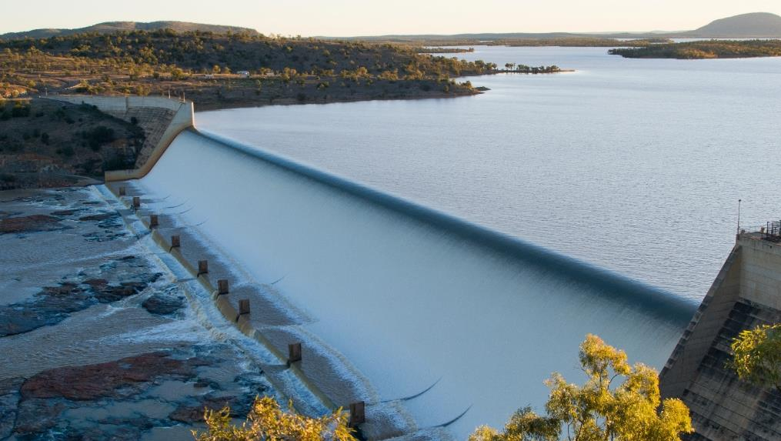
Image: Burdekin Dam, Qld. Credit: greenantphoto / Getty Images
Snapshot of government action
  - Over $1 billion in investment, through the NWGF, in water infrastructure projects in northern Australia. The NWGF is the Australian Government’s water infrastructure investment program. The NWGF is driven by 3 key priorities which are fundamental for any development in the north:
    - provide safe and reliable water for regional and remote communities — including First Nations communities
    - generate public benefit through responsible investment in water infrastructure for productive use
    - build resilient water infrastructure that is environmentally sustainable and culturally responsive.
  - Working with states and territories to renew the 2004 National Water Initiative through the development of a new National Water Agreement to support consistency across states and territories, focusing on strengthening connection between climate science and water planning, and increasing the role of First Nations people in water management.
  - $32 million over 4 years from 2024–25 to extend the Improving Great Artesian Basin Drought Resilience program to deliver water saving projects and improve water security in the region.
  - $5.5 million for the Burdekin Regional Water Assessment, funded through the NWGF, to assess long-term infrastructure and non-infrastructure solutions to meet the water resource needs of the Burdekin region in an effective and sustainable way.
Area for continued focus
Given the significant investments being made in water across Australia’s north and its importance, the Australian Government will:
- Continue to work with jurisdictions and regions to ensure there is adequate water planning and infrastructure to support a quadruple bottom line of industry, First Nations people, community and environmental sustainability objectives.

Policy priority area 3:
A safe and secure north
Northern Australia’s geo-strategic location is of critical importance
to Australia’s defence and security cooperation, providing a platform
in the Indo-Pacific region and being the frontline for biosecurity for the
nation. It is critical that we maintain a focus on preparedness and the ability
of the north to respond. Defence investments, infrastructure and workforce in the north can deliver significant benefits to local economies. Equally, a whole of government approach is needed to meet the strategic challenges Australia faces. By working together, government and stakeholders can maximise local benefits and support the sustainable growth and integration of the Defence community and industry in the north.

National Defence Strategy
In April 2024, the Australian Government released the National Defence Strategy 2024 (NDS) and the Integrated Investment Program (IIP). The NDS details the Government’s approach to addressing Australia’s most significant strategic risks based on the concept of ‘National Defence’. National Defence is a co-ordinated, whole-of-government and whole-of-nation approach to meeting the strategic challenges Australia faces. To achieve this, each agency should consider national resilience when making infrastructure investment decisions.
The NDS highlights a new strategic reality for Australia, including the strategic importance of the north to national security and the need for a re-posturing of Defence across northern Australia. There is a critical mutual relationship between Defence goals and northern Australia. The Australian Government’s ability to achieve National Defence is contingent on the continued social, economic and industrial sustainability across northern Australia. Government investment across the north should consider an integrated approach that contributes to national resilience and national security.
As a key element of National Defence, the Government is making a generational reinvestment in the Australian Defence Force’s (ADF) posture, capability and structure. A key NDS priority is for the ADF to transition from a ‘balanced’ force to a ‘focused’ force. To meet this priority, the Government has directed a range of proposed changes to force structure and posture. The shift to a more integrated ADF across operational domains will have significant implications for basing and facilities. Additional investment in facilities, training areas and ranges will be required to support the new capabilities that will be introduced into service.

Defence investments in the north
The Australian Government plans to spend between $14 billion and $18 billion over 10 years to enhance the resilience on its northern bases, across the NT, WA and North Qld. These Defence infrastructure projects, and the associated growth in the ADF community, will be transformational for northern Australia.
Targeted Defence investment in the north presents significant opportunities for northern communities and industries — including additional support in telecommunications, housing, employment, health networks, education, training, civil infrastructure and other amenities.
The Government understands the importance of working with partners to ensure the north is prepared to sustainably retain the large number of personnel expected to relocate to northern Australia, while maximising lasting local economic opportunities. The Government is committed to working to prioritise contracts with local companies. It will work with partners to ensure the investment does not put pressure on existing communities but delivers meaningful benefits for communities in the north.
Snapshot of government action
  - Between $14 billion and $18 billion over 10 years to enhance the resilience on its northern bases, across the NT, WA and North Qld.
  - $567.6 million to upgrade the Cocos (Keeling) Islands airfield to sustain Defence’s operations in the Indian Ocean.
  - $306 million Initial Support Contract with Boeing Defence Australia for the AH-64E Apache helicopter fleet, which will provide more than 150 jobs in Townsville.
  - $286.9 million investment under the Defence Fuel Resilience Program to acquire fuel storage in regional locations across northern Australia.
  - Extension of the CH-47F Chinook Integrated Support Services Contract with Boeing Defence Australia to August 2028, with direct employment opportunities for more than 70 personnel in Townsville, Oakey and Brisbane.
Area for continued focus
Given the significant investments being made by Defence in Australia’s north and the importance of working in place, the Australian Government will:
- Work with local communities, businesses, governments and other stakeholders to maximise local benefits from Defence investments in the north.

Biosecurity
Northern Australia is the frontline for exotic pests and diseases from countries to our north, making continued focus on preparedness and response critical. Biosecurity threats have significantly increased from 2015 and are disproportionately affecting northern Australia. Contributing factors include increased occurrence of illegal foreign fishing and proximity to neighbouring countries that are experiencing disease outbreaks of significance. Changing climate and weather patterns are key drivers of shifting pest and disease outbreaks of significance and distribution, including the increase of mosquito-borne diseases. Future responses to these threats may need to be more adaptive.
Biosecurity threats to northern Australia include novel tropical pests and diseases arriving at and through remote areas along the sparsely populated 10,000 km of northern coastline. Realised biosecurity threats may have significant flow-on effects to industries based in the north, including those that rely on international and domestic trade. Expectations from international trading partners are shifting, increasing our need for enhanced biosecurity surveillance, diagnostics, intelligence, analytics and data management capability.
The Government has working to provide increased, long-term funding for a strengthened biosecurity system to help safeguard against biosecurity incursions that would impact trade, jobs in regional Australia, health and our environment.
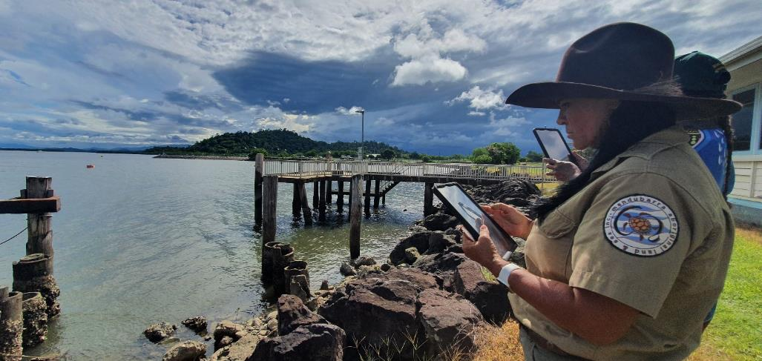
Image: Mandubarra Aboriginal Land & Sea Inc, Qld. Source: Department of Agriculture, Fisheries and Forestry.
Indigenous Ranger Biosecurity Program
The Indigenous Ranger Biosecurity Program (IRBP) has been successful in engaging and building the capability of First Nations ranger groups to undertake biosecurity assessments. Between 1 July 2019 and 31 December 2023, Indigenous rangers made over 18,800 biosecurity observations that supported effective animal, plant and aquatic health surveillance.
The essential partnership with First Nations people provides vital surveillance needed for the early detection of biosecurity threats along the northern Australian coastline. In addition to protecting us at the biosecurity frontline, the IRBP provides skills, employment and economic opportunities on Country for First Nations people in remote and regional communities.
The IRBP has invested in enhanced data collection capability through the purpose-built biosecurity application for rangers to submit biosecurity surveillance (Ranger App). This will further enhance biosecurity efforts in the north, including improving our ability to share relevant data with states and territories.
The IRBP also hosts the Northern Australia Indigenous Ranger Biosecurity Forum, which was last held in October 2023 on Mandubarra Country. The forum brought together 268 rangers and key stakeholders for a 3-day event incorporating practical biosecurity surveillance sessions, workshops, ranger group presentations that showcased their work on Country, and cultural activities.

Snapshot of government action
  - An additional $1 billion over 4 years from 2023−24 (and $268.1 million per year ongoing) to meet the Government’s election commitment to strengthen Australia’s biosecurity system.
  - $40.6 million over 4 years from 2023–24 for the Indigenous Ranger Biosecurity Program.
  - Managing the threat of lumpy skin disease and foot and mouth disease through the $4.33 million Northern Australia Coordination Network (NACN) from 2023-2025. The NACN is a collaboration between the Australian, WA, NT and Qld governments and key livestock industry stakeholders.
  - Increasing the capacity to manage the increasing biosecurity risk of an incursion in northern Australia through the Northern Australia Biosecurity Strategy (NABS) and Northern Australia People Capacity and Response Network (NAPCaRN).
  - Working to strengthen engagement and build capacity around disease prevention, preparedness, detection and response to emergency animal disease threats in northern Australia through the Office of Australia’s Chief Veterinary Office in Northern Australia.
  - Building capabilities through the interim Centre for Disease Control, launched on 1 January 2024 within the Department of Health and Aged Care an international approach recognising the connection between the health of people, animals and the environment.
Area for continued focus
Given biosecurity threats are increasing in Australia’s north and the importance of agriculture to the northern economy, the Australian Government will:
- Continue work to reduce northern Australia’s vulnerability to the impacts of biosecurity threats.

Policy priority area 4:
Growing the northern Australia workforce
For northern Australia to achieve its full potential, it is critical that a workforce is attracted to and increased in the north. The workforce in the north is affected by challenges that are unique to northern Australia, including higher costs of living and doing business, climate change, housing shortages and lack of amenity and services. A holistic approach to addressing these, as well as continued investment and interventions in education, training, migration and employment pathways to address unemployment and skills shortages, is required to attract and retain a highly skilled workforce.

Workforce skills
Across the north, there is a high demand for skilled labour, with intense competition across multiple industries and high turnover rates. Businesses face higher costs of labour and a shortage of skilled and semi-skilled personnel. Industries and sectors struggling the most to attract and retain staff in northern Australia are the health, childcare, aged care, water operations, construction and tourism sectors. Workforce development is impacted by population trends, lack of local education and training, housing, climate, distance, and poor amenities and connectivity.
Australia as a whole is facing significant skill shortages in key sectors. However, parts of northern Australia face additional disadvantages in attracting staff when competing with areas that have more amenity and are more liveable. Under current conditions, people are less willing to work and live in northern Australia. It is important that sectors outside of housing, including health and education, consider housing needs in their policy development.

As noted in the Parliamentary Joint Select Committee on Northern Australia inquiry into Northern Australia Workforce development issues paper, broader trends impacting the Australian workforce that may be especially exacerbated in northern Australia include:
- lack of skilled and semi-skilled personnel, including recognition issues
- adapting to climate change, with an increased likelihood of extreme climate events
- the rapid growth of the digital economy, with some parts of northern Australia not having access to reliable internet
- housing and accommodation shortages
- continued supply chain interruptions
- inadequate digital, physical and social infrastructure in some parts of northern Australia
- lack of availability and affordability of insurance
- increases to the cost of doing business, including those related to energy.
Credit: davidf / Getty Images
Snapshot of government action
  - Up to an additional $3.7 billion over 5 years through the new National Skills Agreement to support state and territory skills sectors, bringing total Commonwealth investment to up to $12.6 billion over 5 years.
  - $1.5 billion in partnership with states and territories to fund 500,000 Fee-Free TAFE and vocational education places across Australia from 2023 to 2026. Fee-Free TAFE supports training places in areas of high demand and skills need and students by removing financial barriers to study. As at 31 December 2023, Fee-Free TAFE has supported over 1,600 enrolments in the NT.
  - $563.8 million across 5 years to support a national network of 10 Jobs and Skills Councils (JSCs) as part of reforms to the VET sector. JSCs are empowered to develop skills and workforce solutions for their industries, bringing together employers and unions to work in partnership with governments and training providers.
  - An additional $265.1 million over 4 years from 2024–25 to the Australian Apprenticeships Incentives System which supports both apprentices and employers, focusing on priority occupations to help train the future workforce. As at 30 September 2023, there were 3,695 Australian Apprentices undertaking an Australian Apprenticeship in the NT.
  - $91 million over 5 years from 2024–25 to support vocational education and training and apprenticeships in priority clean energy occupations.
  - $88.8 million over 3 years from 2024–25 to grow Australia’s construction workforce and boost housing supply. The Government is building on Fee-Free TAFE and supporting TAFE to deliver 20,000 additional Fee-Free places, including pre-apprenticeships. Additionally, $1.8 million has been allocated to streamline assessment of migrant qualifications.
  - $38.2 million over 8 years from 2023–24 (and $1.3 million per year ongoing) to attract Australians from diverse backgrounds to science, technology, engineering and mathematics (STEM) careers and education.
  - $30.2 million over 5 years from 2023–24 to co-design and establish a network of remote training hubs in partnership with central Australian communities and the NT Government.
  - $10 million over 4 years to support the development of a national one-stop digital hub for tourism, travel and hospitality employers and workers.
  - $8 million over 4 years to enhance and improve the Australian Tourism Industry Council’s Quality Tourism Framework, supporting small and regional tourism businesses enhance their quality, accessibility and sustainability.
  - $7.5 million to State and Territory governments and tourism bodies through the Choose Tourism Grants program to fund programs to attract workers to the tourism industry.
  - $1.9 million over 3 years from 2024–25 to support the agriculture industry through foundational workforce measures that underpin ongoing productivity in the agriculture sector.
Area for continued focus
Given workforce and skill shortages are a key impediment to growth in northern Australia, and in light of possible productivity gains, the Australian Government will:
- Work with industry and state and territory governments to support northern Australia accessing the skilled workforce required for economic growth.

Employment
Unemployment rates vary across the main centres in northern Australia. In some cases, they are lower than the national average, reflecting the high demand for skilled workers. Conversely, there are high levels of unemployment in segments of the northern Australia community, including First Nations people. Better engaging and skilling First Nations people living in northern Australia has the potential to lift economic outcomes for First Nations people, address skill shortages and provide significant productivity benefits for Australia more broadly. Alongside this, strategies to attract and retain a northern workforce are also important.
First Nations people in northern Australia are more likely than non-First Nations people to be unemployed. In 2021, the unemployment rate for First Nations people in the north was 17%, compared with the approximate 5% unemployment rate across the north overall. Further, those First Nations people in the labour force are about 3 times more likely to be unable to find work and twice as likely to have disengaged from work completely. The National Agreement on Closing the Gap targets for employment, while on track nationally, are worsening in the NT, with outcomes significantly worse in very remote areas.

Table 4 Participation and rates of unemployment in northern Australia (May 2024)
Statistical Area Level 4 | Employment | Unemployment rate % | Participation rate %
National | 14,458,000 | 3.9 | 67.2
WA outback (north and south) | 126,500 | 4.0 | 70.7
Darwin | 86,100 | 3.0 | 74.9
NT outback | 53,200 | 5.5 | 69.4
Cairns | 148,600 | 4.3 | 69.7
Townsville | 129,900 | 4.7 | 68.5
Mackay − Isaac − Whitsunday | 112,300 | 2.8 | 73.3
Source: Australian Bureau of Statistics (ABS), Labour Force, Australia, Detailed. Statistics are presented from the Modelled estimates of labour force status – MRM1 (at the Statistical Area Level 4), with the direct survey estimate for Australia. Employment rounded to nearest 100.
Lower levels of First Nations employment participation are a culmination of a range of historical, cultural and geographic factors, including:
- high rates of social disadvantage and poverty
- lack of health services and social infrastructure
- access to childcare and aged care services
- disproportionate levels of incarceration
- lower educational attainment on average and lower school attendance
- limited access to transport
- limited access to private capital
- ageing infrastructure
- residence in areas where the labour markets are thin and far from centres of economic activity.
‘Low workforce participation is linked with adverse economic outcomes, higher levels of welfare dependency and social issues, all of which impact First Nations communities at a much higher rate ... A job is not only a source of income for individuals and families, it can help build skills and experience as well as self-esteem, bring about financial security and improve living standards.’
Source: Northern Australia Indigenous Reference Group, Submission to the Employment White Paper, DITRDCA website, 2022.
The Government has committed to replace the Community Development Program with a new program with real jobs, proper wages and decent conditions, developed in partnership with First Nations people. A real job with proper wages and decent conditions is at the heart of economic empowerment and a critical part of the National Agreement on Closing the Gap. Real jobs pave the way for improving social and economic participation and strengthening communities and are linked to better health and education, housing and community safety outcomes. The Government is working to design and deliver the Remote Jobs and Economic Development Program in partnership with First Nations people.
Snapshot of government action
  - $777.4 million across 5 years from 2023–24 (and $255.5 million per year ongoing) for remote employment programs, including $707.6 million for the Remote Jobs and Economic Development Program, to fund the creation of 3,000 jobs over 3 years in remote communities to help close the gap in employment outcomes in remote Australia. It will support remote communities to determine local projects and job priorities to increase economic opportunities in their areas.

  - $76.2 million over 5 years from 2023–24 (and $18.7 million per year ongoing) for a new First Nations Prison to Employment program, building on the Time to Work Employment Service, to improve the transition out of the justice system for First Nations people. Service providers will offer pre-release and post-release supports to help people re-establish themselves in the community and engage with employment, education and training.
  - $54 million over 5 years from 2023–24 for a new employment pathways package, in partnership with employers across Australia, focusing on people with barriers to work who are seeking to connect to job opportunities and achieve sustained employment. This package includes $32.1 million for the Real Jobs, Real Wages pilot and $21.9 million for the WorkFoundations program.
  - $3.7 million from 2025–26 to extend the Broome Employment Services trial until June 2027 to allow time to fully embed and evaluate the service delivery model. Australian Public Service staff are working alongside a First Nations provider to build capability and capacity and streamline the complex service system.

Education
Quality education is vital to support a dependable labour force equipped with the skills necessary for the jobs of today and for the future, including those arising from the net zero transition.
According to Jobs and Skills Australia, most new jobs are likely to require post-school qualifications. In northern Australia, 52.6% of those aged 25 to 64 had vocational or higher education qualifications in 2021, compared with the Australian rate of 63.1%. Attainment was much lower for First Nations people in the north, at 29.0%.
Lack of quality early childhood education and care options have flow-on effects for entire communities. Early childhood education and care is a key ingredient of the liveability of a region, including the workforce participation of families. Year Before Schooling early childhood education enrolments for Aboriginal and Torres Strait Islander children are showing good improvement and are on track to meet Target 3 of the National Agreement on Closing the Gap, but early childhood development is worsening and not on track. Year 12 attainment and higher education completions for First Nations children are showing improvement but are not on track.
Building a highly skilled workforce requires investment in education and training to ensure workforce needs are met now and into the future. Targeted investments in early learning, school education, training, further education and employment pathways, are needed to address this inequity of outcomes.
Through the Better and Fairer Schools Agreement (BFSA), the Australian Government is working with states and territories to fully fund public schools and to tie that funding to reforms designed to help lift student outcomes. These reforms include early identification of students who need additional support at school, evidence-based and targeted supports to help students who fall behind, greater wellbeing support for learning and engagement, and initiatives to help attract and retain teachers and school leaders.
The NT faces unique challenges in funding its public schools, given the significant concentrations of disadvantage. This means the funding needed for a public school student in the NT is almost double the national average. In recognition of this, the Australian and NT Governments have struck a landmark agreement under the BFSA to fully and fairly fund all NT public schools and invest funding in key reforms to help lift student outcomes.
Under this agreement, the Australian Government will invest at least an additional $736.7 million in NT public schools from 2025 to 2029 and the NT Government has committed to invest at least an additional $350 million over the same period. This means the Commonwealth will increase its share of funding from 20% to 40% of the Schooling Resources Standard, contingent on the NT increasing its funding share to reach 60% by 2029. This agreement follows the additional $40.4 million the Commonwealth is investing in Central Australian schools.
Snapshot of government action
  - $736.7 million in additional funding from 2025 to 2029 under the BFSA to increase the Commonwealth’s share of funding for government schools in the NT from 20% to 40% of the Schooling Resources Standard, and tying that funding to reforms to help lift student outcomes.
  - $614.7 million over 4 years from 2024-25 for the Community Child Care Fund (CCCF) to improve early childhood education and care access in regional and remote, disadvantaged, and First Nations communities. In 2023-24, the CCCF, including Connected Beginnings, supported around 900 eligible services across Australia, including the northern Australia region.
  - Community Child Care Fund Restricted (CCCFR) grants support approximately 150 services, mainly in regional, remote or very remote areas, including in northern Australia. A Closing the Gap measure is expanding this (CCCFR Expansion), with sites under contract in northern Australia including: Puuya Foundation in Lockhart River, Qld; Napranum Aboriginal Shire Council in Napranum, Qld; Kowanyama Aboriginal Shire Council in Kowanyama, Qld; Wunan Foundation in Kununurra, WA; Central Australian Aboriginal Congress in Alice Springs, NT and Central Desert Regional Council in Ti Tree, NT.
  - $74.8 million over 4 years from 2024–25 to accelerate action and deliver against the National Agreement on Closing the Gap Priority Reforms by supporting First Nations education partnership, policy development and program delivery and to improve education outcomes for First Nations students. This measure includes an ongoing partnership funding of $12.5 million to the National Aboriginal and Torres Strait Islander Education Corporation and $16.6 million to National Voice for our Children (SNAICC) — the peak body for First Nations children.
  - $66.9 million to double the number of University Study Hubs across Australia. This will include the establishment of up to 20 additional Regional University Study Hubs.
  - $40 million from 2023 to 2025 for On-Country Learning in Central Australia to support improved student enrolment, engagement, wellbeing and learning outcomes at schools in Central Australia.
  - $32.8 million over 2 years from 2024–25 to extend Commonwealth support at existing levels for services offered by the Clontarf Foundation for the 2025 school year.
  - $24.6 million over 4 years from 2024–25 (and an additional $72.7 million from 2028–29 to 2034–35) for Charles Darwin University to establish a new medical school from 1 January 2026 so that up to 40 new medical students each year will be able to train where they live and then work locally.
  - $18 million over 2 years from 2024–25 to establish a Central Australia Boarding Response Fund to improve student boarding facilities and enable them to increase the number of students they can accommodate from remote NT communities, and better support their learning needs.
  - $2.4 million to work in close partnership with First Nations stakeholders to finalise the First Nations Teacher Strategy and enable immediate investment in implementation.
  - $5.3 million over 2 years from 2024–25 to extend the Good to Great Schools Australia (GGSA) Pilot Program from 10 to 20 schools. The Pilot Program aims to support regional, remote and very remote primary schools with significant Aboriginal and Torres Strait Islander student enrolments to improve the literacy, numeracy and science outcomes of students by increasing teachers’ pedagogical skills.

Population and migration
Population and migration are inextricably linked to workforce. Following the COVID-19 pandemic, northern Australia experienced annual population growth rates of 1.2% (15,635 people) in 2021–22 and 1.5% (19,638 people) in 2022–23 − its strongest growth rate in 9 years (Figure 11). In comparison, the national population grew by 1.3% in 2021–22 and 2.4% in 2022–23.

Figure 11 Annual population change, Northern Australia
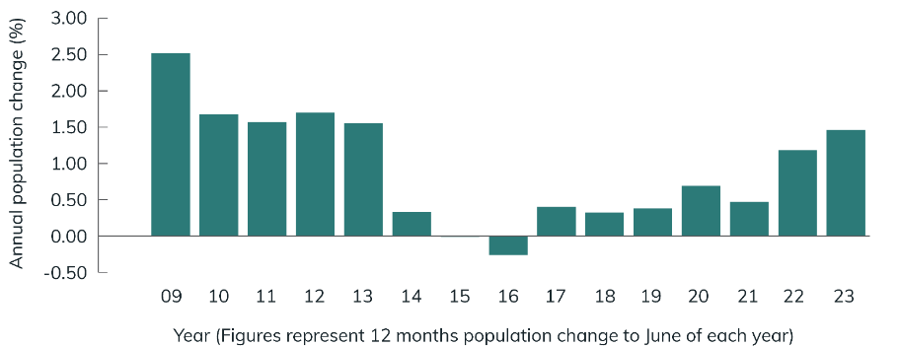
Source: BCARR analysis of Australian Bureau Statistics (ABS), Regional Population, 2022–23.
From June 2021 to 2023, the strongest driver of population growth in northern Australia was net overseas migration, with 19,721 more overseas arrivals than overseas departures. Natural increase (births minus deaths) contributed 17,502 people. Net internal migration was negative, indicating that more people left northern Australia for other parts of the country than arrived from elsewhere in Australia (a net loss of 1,950 people).
Figure 12 shows that, within northern Australia, north Qld was the strongest driver of population growth for both years, although northern WA and the NT also experienced relatively stronger population growth compared with previous years.
Figure 12 Components of population change, northern Australia, June 2021 to June 2023
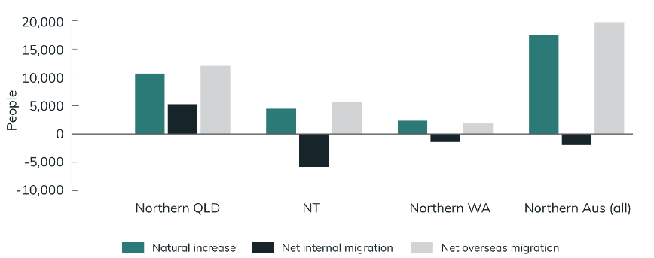
Source: BCARR analysis of Australian Bureau Statistics (ABS), Regional Population, 2022–23. Note: Based on aggregation of SA2s.
North Qld had an increase of all 3 population growth components. Its net internal migration gain was 5,280 people. In contrast, net internal migration was negative for the NT (−5,827 people) and northern WA (−1,403 people). These losses from net internal migration were more than offset by gains from net overseas arrivals and natural increase. In northern WA, natural increase was the strongest component of population growth (contributing 2,337 people).
Many stakeholders across the north have highlighted overseas migration as a mechanism to address critical workforce shortages in northern Australia, enabling skilled or other migrants to fill short-term gaps and contribute to an adaptive workforce and help build a permanent workforce. A strong and adaptive workforce in northern Australia is key to essential services provision, sustainable and resilient growth and harnessing opportunities through new industries, including the net zero economy.
‘the industry acknowledges that northern Australia will continue to require robust migration settings that allow for the flexibility required at peak seasons to supplement the domestic workforce …’
National Farmers Federation, Submission to the Joint Select Committee on Northern Australian inquiry into northern Australia workforce development, 2022, p 2.
‘The North Queensland agriculture workforce is faced with chronic labour and skill shortages … Whilst our primary focus is to attract and retain an Australian workforce … our foreseeable future will require a high dependence on a migrant workforce to bridge a gap between the labour and skills workforce shortages …’
Bowen Gumlu Growers Association, Submission to the Joint Select Committee on Northern Australian inquiry into northern Australia workforce development, 2022, p 1.
One such pathway to support workforce shortages is the Pacific Australia Labour Mobility (PALM) scheme. The PALM scheme is an important temporary migration program providing employment opportunities for workers from Fiji, Kiribati, Nauru, Papua New Guinea, Samoa, Solomon Islands, Timor-Leste, Tonga, Tuvalu and Vanuatu. It supports the Australian economy in sectors experiencing labour shortages by providing a productive, reliable workforce.
PALM scheme workers are valued members of our communities — they work in local businesses, contribute to community groups and purchase local goods and services. PALM scheme workers are located with employers in seasonal and longer term placements across northern Australia. There are significant opportunities for businesses in northern Australia to address their labour market shortages in unskilled, low-skilled and semi-skilled positions, with around 42,000 pre-screened PALM scheme workers awaiting employment opportunities in Australia. Further, there is significant interest amongst many participating countries to expand further their participation in the PALM scheme.
Snapshot of government action
  - Setting the planning level for the 2024–25 permanent Migration Program at 185,000 places, with 33,000 places each for the Regional and State and Territory Nominated visa categories. The permanent Migration Program planning level for skilled Regional visas has increased significantly from 11,200 places in 2020−21, reflecting the Government’s commitment to supporting regional development.
  - Release of the Migration Strategy on 11 December 2023. The strategy outlines an ambitious policy roadmap on regional migration. The Government has designated regional Australia as the highest processing priority for employer-sponsored skilled visas. The strategy includes an evaluation of regional migration settings in 2024, including regional visas; definitions of regional Australia for skilled migration purposes; occupation lists; Designated Area Migration Agreements; and the Working Holiday Maker program to ensure they support the development objectives of regional Australia, including northern Australia.

Policy priority area 5:
Liveable, healthy and resilient communities
The Australian Government is working to improve the liveability of northern communities. It is investing in community infrastructure and services to build healthy and resilient communities and encourage more people to live and work in the north.

Amenity
A lack of community infrastructure affects the amenity of a significant number of communities across northern Australia. It impacts quality of life and population retention in regional and remote communities. People in the north want greater access to social services and community infrastructure than they have at present.
‘social and community infrastructure is important in attracting and retaining talent in northern Australia. Sporting facilities, schools, childcare, healthcare clinics, arts spaces are all elements that prospective individuals and families seek when looking to relocate for work. There is generally a lack of these facilities in northern communities and investment is needed to improve regions’ liveability.’
Source: Northern RDA Alliance.
‘the poor state of essential infrastructure in Central Australia is a key impediment to economic development and workforce participation.’
Source: Central Land Council.
Some stakeholders have raised challenges that their organisations face in accessing government programs that support community amenity, particularly those organisations representing communities which have smaller populations and limited capacity to match government funding and deliver and fund projects; and those which experience relatively high delivery costs. The Government will continue to work to find ways to promote opportunities to access government programs.

Snapshot of government action
  - $600 million under the Growing Regions Program to provide grants of between $500,000 and $15 million to local government entities and not-for-profit organisations for capital works projects that deliver community and economic infrastructure projects across regional and rural Australia, including the north.
  - $400 million allocated to the regional Precincts and Partnerships Program (rPPP) to support transformative investment in regional, rural and remote Australia based on the principles of unifying regional places, growing economies and serving communities. Under batch 1 of the rPPP, 89% of funding went to projects in the north.
  - Election commitments delivered through the Investing in Our Communities Program and the Priority Community Infrastructure Program for community and sporting infrastructure, open space improvements and other community projects to improve liveability − $269.7 million has been allocated from these 2 programs to projects across northern Australia.
  - $50 million allocated under the Central Australia Plan for community and regional infrastructure projects in Central Australia.
  - National programs that contribute to cultural vibrancy, liveability and wellbeing, including the Regional Arts Fund, the Indigenous Visual Arts Industry Support program, the Festivals Australia program, the Indigenous Languages and Arts program and the Landcare Rangers program.
Area for continued focus
Given possible capacity and capability constraints for some northern Australian organisations, the competitive nature of many Australian Government programs and the importance of infrastructure investment in Australia’s north, the Australian Government will:
- Work to overcome challenges that northern Australians may face in equitably accessing Australian Government investment.

Climate adaptation and disaster resilience
The impacts of climate change present a significant and disproportionate risk to northern Australia. Northern Australia is more exposed to extreme weather events than other areas of Australia. Climate projections indicate temperatures will continue to increase and there will be more extreme rainfall events and flooding. Rising sea levels are threatening low-lying island and coastal communities, and there will be an increase in the number of more powerful cyclones.
While Australia has always been impacted by weather events, the severity and frequency of droughts and other natural hazards are increasingly impacting the economy, our health, livelihoods, and the wellbeing and resilience of our communities, infrastructure and ecosystems. The increase in natural hazard risk is also driving up the cost of insurance and creating a protection gap. The damage to residential and business property caused by extreme weather events is often severe and on a scale that leads to the displacement of people from their homes and disruption to business activity. Without insurance, people are more vulnerable and face longer recovery times when disaster strikes − they are reliant on their own savings or funding from governments or charities to support recovery. Longer recovery times also have knock-on effects for businesses and communities.
Potential costs of climate change and weather-related events over the next 40 years are estimated at over $400 billion for Australia. For northern Australia, the impacts of climate change are already high. For example, in relation to insurance costs, the ACCC noted in its December 2023 Insurance Monitoring report that average insurance premiums for a combined house and contents policy was most expensive in WA ($4,395), followed by the NT ($2,922) and Nth Qld ($2,918) compared with the rest of Australia which paid on average $1,779.
It is imperative to respond to the impacts of climate change, extreme weather events and disasters by reducing risk and building adaptive capacity. The Government is working with communities to strengthen their resilience and help them understand, prepare and respond.
Snapshot of government action
  - $91.8 million towards the North Queensland Recovery and Resilience Package to assist far north and north-west Qld communities, including some of the most remote disaster-prone parts of the state.
  - $28 million over 2 years to deliver the National Climate Adaptation and Risk Program, including Australia’s first National Climate Risk Assessment and National Adaptation Plan.
  - $15 million over 4 years from 2024–25 to partner with First Nations people and communities to support connection to Country through the management of drought and climate risks.
  - $13.4 million under the Coastal Estuarine Risk Mitigation Program for 5 projects in the northern regions of Qld and WA. The program aims to mitigate the impact of climate-related disasters in northern Australia through recovery, resilience and/or prevention initiatives.
  - Establishment of a Strategic Fleet to strengthen Australia’s economic sovereignty and national security, including a 5-year pilot program of 3 vessels that will be available for requisition in times of need, such as a natural disaster, to help re-establish supply chains.
Area for continued focus
Given the increasing occurrence and cost of natural hazards in the north, the Australian Government will:
- Continue efforts to ensure government funding and policy decisions consider northern Australia’s unique climate adaptation needs.

Disaster Ready Fund delivering First Nations resilience projects
The Australian Government established the Disaster Ready Fund (DRF) in 2022 to provide up to $1 billion over 5 years from 1 July 2023. The DRF helps communities better prepare for and protect themselves against the impacts of a broad range of natural hazards. On 7 June 2023, the Minister for Emergency Management announced 187 infrastructure and systemic risk reduction projects would share in $200 million of Australian Government investment under Round 1 of the DRF. Qld has received over $84 million for 50 projects, the NT has received almost $5 million for 9 projects, and WA has received almost $9 million for 23 projects.
Several Round 1 projects of the DRF are being delivered in partnership with First Nations communities. These include investments in protecting and preserving cultural sites, in-situ artefacts and objects from the impacts of natural hazards; and working in partnership with First Nations people to reduce risk.
Round 2 will provide up to $200 million for disaster risk reduction and resilience initiatives. The National Emergency Management Agency has built on the experiences and outcomes of Round 1 and taken onboard feedback from extensive stakeholder engagement to make sure the funding is used effectively, is accessible to more regions and facilitates multi-jurisdictional and national projects.

Torres Strait and Northern Peninsula Area Climate Resilience Centre
The 2022–23 Budget allocated $15.9 million over 4 years to engage with First Nations people on climate adaptation and mitigation. This includes establishing a climate centre focused on the Torres Strait and Northern Peninsula Area to:
- demonstrate contemporary and culturally appropriate approaches to climate adaptation and governance
- undertake community education, engagement and policy review
- coordinate climate research
- build local capacity in adaptation and resilience
- create links with other programs including the First Nations Community Microgrid program.
The final design was informed by extensive consultation and extended co-design processes with Torres Strait and Northern Peninsula Area leaders, and across government agencies, to ensure the centre is culturally appropriate and focused on building on-ground capability to adapt to climate impacts in the region.

Cyclone reinsurance pool
The Australian Reinsurance Pool Corporation (ARPC) has been operating a reinsurance pool for cyclone and related flood damage since 1 July 2023. Backed by an annually reinstated $10 billion government guarantee, the pool is designed to improve insurance affordability for household, strata and small business properties in cyclone-prone regions, mainly located in northern Australia.
Participation in the pool is mandatory to maximise potential premium reductions. As of January 2024, the pool includes 12 insurers and covers approximately 95% of home insurance policies. Small insurers have until 31 December 2024 to join the pool.
Expected discounts for consumers in northern Australia in the most recent ARPC modelling are, on average, 13%, 15% and 17% for home, strata and small business properties respectively.

Communities undergoing economic transition
Delivering on the potential of regional Australia requires building on each region’s unique strengths, including helping regions undergoing significant economic change to transition or adapt to specific structural challenges. While industry sectors and firms face differing economic circumstances and fortunes across Australia, the impact of closure of significant businesses on regional economies in northern Australia is often felt more acutely, given its narrower economic base and more limited opportunities for alternative employment.
Closure or downsizing of key mining operations in Australia’s north, including in the communities of Mount Isa, Weipa, Nhulunbuy, Groote Eylandt and Christmas Island, will reduce economic and employment opportunities and potentially impact the services available in these areas. In some cases, management of existing assets on traditional land is being transferred to traditional owner groups for the first time.
There are a number of processes underway across these communities, with governments working with industry and community representatives to foster economic opportunities and assist communities to transition.
Area for continued focus
Given the acute impacts of closure of significant businesses on regional economies, the Australian Government will:
- Work with industry, community representatives, First Nations people, state and territory governments and local governments to collectively assist communities undergoing significant economic transition.

Healthy communities
The north’s poor health outcomes and lower life expectancy are attributed to a range of environmental, social, cultural and economic issues, including difficult climate conditions, remoteness from basic services, high cost of living and inadequate housing. For First Nations people living in the north, the differences in health outcomes as a result of these issues are stark. The gap in life expectancy for First Nations people is 8.8 years for males and 8.1 years for females compared with the rest of Australia, with the NT having the lowest outcomes of all jurisdictions. The National Agreement on Closing the Gap health targets are showing improvement overall; however, only one of the 3 health targets is on track to be met.
In addition to a range of targeted measures to improve First Nations health outcomes, the Indigenous Australians’ Health Programme provides funding to Aboriginal Community Controlled Health Organisations (ACCHOs) to provide Aboriginal and Torres Strait Islander peoples with better access to high-quality, culturally appropriate primary health care in remote, regional and urban areas. Four-year rolling funding agreements for ACCHOs are being delivered from 1 July 2024, supported by a $300 million funding boost to help services to retain skilled staff and provide continuity of care.
More broadly, the 2020–2025 National Health Reform Agreement commits to improving health outcomes for all Australians by providing better coordinated and joined up care in the community and ensuring the future sustainability of Australia’s health system. Through this agreement, the Australian Government contributes funds to the states and territories for public hospital services, including for emergency departments, hospitals and community health settings.
The Australian Government is also focused on making Medicare stronger and medicine cheaper. Medicare provides world-class health care to every Australian. In the 2024–25 Budget, the Government announced the allocation of $227 million for a further 29 Medicare Urgent Care Clinics to take pressure off emergency departments and make it easier for Australians to access free health care; and $361 million to strengthen Australia’s mental health system.
Snapshot of government action
  - $227 million for a further 29 Medicare Urgent Care Clinics to take pressure off emergency departments and make it easier for Australians to access free health care, including 6 in the north: Broome, Palmerston, Alice Springs, Cairns, Townsville and Rockhampton.
  - $164.3 million from 2022–23 to 2025–26 to deliver 17 election commitments for First Nations health infrastructure projects. Of these, 7 projects (totalling $39 million) are in the defined Northern Australian regions. This investment complements $254.4 million over 4 years and 2 rounds of funding to address seriously deteriorating or absent health infrastructure for the Aboriginal Community Controlled Health Service sector.
  - $94.9 million over 2 years to continue and expand national strategies for First Nations vaccination uptake, sexually transmissible infection testing and culturally safe sexual health services, and communicable disease molecular point of care testing.
  - $79.4 million over 4 years from 2023−24 to primary health networks to commission multidisciplinary care, including allied health professionals, nurses, nurse practitioners and midwives, to provide services that fill an identified need in their region, as part of the Strengthening Medicare 2023 Budget package $11.1 million over 5 years from 2023–24 (and $2.8 million per year ongoing) to expand coverage of the National Agreement on Closing the Gap Pharmaceutical Benefits Scheme (PBS) Co-payment Program to all PBS medicines for eligible First Nations people. There are over 660,000 First Nations patients registered under the co-payment program, with benefits to be extended to an additional 1,315 PBS medicines.
  - $78 million from 2022–23 to 2024–25 to improve First Nations maternal and infant health outcomes in northern Australia.
  - $73.2 million for Better Renal Services for First Nations People for up to 30 4-chair dialysis units and associated workforce accommodation to provide life-saving health care to First Nations Australians with end-stage kidney disease. Dialysis units are being constructed at several locations, including in the NT at Atitjere (Harts Range), Borroloola and Ti-Tree; and in WA at Balgo and Tom Price.
  - $50.2 million over 4 years from 2023–24 to the Primary Care and Midwifery Scholarships program to support registered nurses and midwives to undertake post-graduate study to become Nurse Practitioners and Endorsed Midwives.
  - $45.4 million over 4 years from 2021–22 to 2024–25 to address rheumatic heart disease. The program supports regional and remote communities across northern WA and northern Qld as well as the NT.
  - $18.4 million from 2022–23 to 2025–26 for the expansion of Congress’ Child and Youth Assessment and Treatment Service program to expand capacity for early detection and intervention services for neurodevelopmental conditions for Aboriginal children and young people in Central Australia.
  - $18.1 million from 2021–22 to 2024–25 to support the elimination of trachoma in affected states and territories across northern Australia.
  - $10 million in 2024–25 to deliver targeted and culturally appropriate mental health supports for First Nations people.
  - $4.7 million over 5 years from 2023–24 for the NT Medical Program to increase the number of First Nations medical practitioners and address recruitment and retention challenges.
  - $4 million over 4 years from 2024–25 to the Australian Indigenous Doctors’ Association to continue to support First Nations doctors to become medical specialists.
  - Support for midwifery, nursing, teaching, social work and Aboriginal and Torres Strait Islander Health Practitioner students, under the 2024−25 budget, to undertake mandatory workplace placements required by providing eligible students with $319.50 per week during their clinical and professional placement periods.

First Nations justice outcomes
First Nations people are over-represented at every point in the criminal justice system, and youth and adult criminal justice outcomes for First Nations people are worsening. The NT has an imprisonment rate 4 times the national average. Unions NT observed that the NT’s incarceration rate only falls behind the United States of America states of Louisiana and Mississippi, with 1,026 people per 100,000 incarcerated in the NT and First Nations people over-represented in the NT’s huge prison system.
Communities with a disproportionate rate of incarceration generally experience a prevalence of issues associated with social disadvantage and increased risk of criminal activity. Limited access to information in First Nations people’s first language is also a barrier to social engagement and access to justice services.
In the words of the Larrakia Nation Aboriginal Corporation:
‘a number of Closing the Gap indicators show improvements … However, significant gaps in outcomes remain. Particularly concerning, … family and community violence outcomes have stalled, while involvement with the child protection system remains high … and youth and adult criminal justice outcomes have worsened …’
Source: Larrakia Nation Aboriginal Corporation, Submission to the Joint Select Committee on Northern Australia’s inquiry into northern Australia's workforce development, 2019, p 1.
The Australian Government is committed to working in partnership with Aboriginal and Torres Strait Islander organisations and communities to improve justice outcomes. Levels of adult incarceration are worsening and not on track, with the rate of Aboriginal and Torres Strait Islander adult prisoners in WA at 3,469.1 per 100,000 adult population, in NT at 2,947.4 per 100,000 and Qld at 2,224.1 per 100,000 compared with 2,265.8 per 100,000 nationally at 30 June 2023. Youth detention rates are not getting any better either, with the rate of Aboriginal and Torres Strait Islander young people aged 10–17 years in detention on an average day in 2022–23 at 29.8 per 10,000 young people in the population nationally.
While criminal justice, policing and corrections are primarily the responsibility of state and territory governments, the Australian Government acknowledges it has a leadership role to work in partnership with Aboriginal and Torres Strait Islander peoples, the Coalition of Peaks and states and territories to achieve justice targets.
Justice reinvestment is place based and community led. It enables First Nations communities and leaders to come together to identify local solutions to local issues, using strengths of community, cultural knowledge and stories to measure progress over time. It offers a way for communities to drive local solutions and systems change through improved collaboration and partnership with governments and service providers.
On 1 February 2024, the Acting Attorney-General and the Minister for Indigenous Australians announced 9 organisations selected to deliver justice reinvestment initiatives in the first assessment cycle of the National Justice Reinvestment Program. The following initiatives will be delivered in northern Australia:
- Nja-marleya Cultural Leaders and Justice Group Ltd (Maningrida, NT)
- Anindilyakwa Royalties Aboriginal Corporation (Groote Eylandt, NT)
- Ngurratjuta/Pmara Ntjarra Aboriginal Corporation (Central Australia, NT)
- Gindaja Treatment and Healing Indigenous Corporation (Yarrabah, Qld)
- Townsville Community Justice Group Aboriginal and Torres Strait Islander Corporation (Townsville, Qld)
- Emama Nguda Aboriginal Corporation (Derby, WA).
These 9 initiatives are in addition to early investments in Halls Creek (WA) and Alice Springs (NT), which also fall within the northern Australia boundary.
On 19 April 2024, the Attorney-General and the Minister for Indigenous Australians announced a further 10 organisations selected to deliver justice reinvestment initiatives in the second assessment cycle of the National Justice Reinvestment Program. The following 7 initiatives will be delivered in northern Australia:
- Savanna Solutions Business Services Pty Ltd (Katherine, NT)
- Minjerribah Moorgumpin Aboriginal Corporation (North Stradbroke Island, QLD)
- Gunawuna Jungai Limited (Doomadgee, QLD)
- Cape York Institute (Hope Vale, QLD)
- Jika Kangka Gununamanda Limited (Mornington Island, QLD)
- Gascoyne Development Commission (Carnarvon, WA)
- Shire of Halls Creek (Halls Creek, Mulan, Kundat Djaru and Mindibungu, WA)
These initiatives are in addition to early investments in Alice Springs (NT) and Halls Creek (WA), which also fall within the northern Australia boundary.
Snapshot of government action
  - $69 million over 4 years from 2022-2023 to establish a National Justice Reinvestment Program to support up to 30 community-led justice reinvestment initiatives. This program is ongoing with $20 million per year from 2026–27.
  - $14.2 million over 2 years from 2024–25 to deliver additional policing and other community safety support measures in Alice Springs.
  - $12.5 million over 4 years from 2022-2023 to design and establish an independent National Justice Reinvestment Unit to coordinate and support justice reinvestment initiatives at a national level, with ongoing funding of $2.6 million per year from 2026-2027.
  - $10.7 million over 4 years from 2024–25 to continue the Justice Policy Partnership.
  - $10 million over 4 years from 2023–24 for the Justice Reinvestment in Central Australia Program (Central Australia Program) as part of its $250 million plan for A Better, Safer Future for Central Australia.

Policy priority area 6:
Protecting the north’s environment and cultural heritage
The north’s natural and cultural wonders are recognised across the world. The Australian Government is focused on working with stakeholders to protect, conserve and promote the north’s unique land and waterscapes, biodiversity and significant cultural heritage.

Biodiversity
The north is home to some of the most biodiverse and unique landscapes in the world. This is internationally recognised through 8 World Heritage Sites. Kakadu National Park and Uluru-Kata Tjuta National Park in the NT, the Great Barrier Reef and Wet Tropics of Queensland in Qld, Australian Fossil Mammal Sites (Riversleigh / Naracoorte) and Purnululu National Park, Ningaloo Coast and Shark Bay in WA.
The north’s famous national parks include Kakadu, Uluru-Kata Tjuta, Christmas Island and the Daintree. In 2022, the Australian Government created the Christmas Island and Cocos (Keeling) Island Marine Parks, expanding the existing northern Australia marine parks which are essential to protecting our marine environment and sustainable fisheries.
The Government recognises the important role of the north in achieving the national target to protect and conserve 30% of Australia’s landmass and 30% of Australia’s marine areas by 2030 (the ‘30 by 30’ target). The expansion of Indigenous Protected Areas and recognition of Other Effective Area Based Conservation Measures, following environment ministers’ agreement to a national framework to guide their recognition, are some of the actions contributing to environment protection and conservation in the north.
The Government’s Nature Positive Plan: better for the environment, better for business is delivering better environmental protection, speeding up decision making to make it easier for business to do the right thing and restoring the integrity and trust in environmental laws.

The Threatened Species Action Plan 2022–2032 identifies 5 priority places in the north that are the focus for Australian Government investment to support condition improvement. These are:
- Christmas Island
- Yampi Sound, NT
- Kakadu and West Arnhem, NT
- MacDonnell Ranges, NT
- Eastern Forests of Far North Queensland.
Snapshot of government action
  - $134.2 million to strengthen and streamline environmental approval decisions on priority projects, including renewables and critical minerals projects.
  - $121 million for Australia’s first national independent Environment Protection Agency with strong new powers and penalties to better protect nature.
  - $65.1 million for extra research into threatened species so that sensitive areas can be more easily avoided and suitable projects can be more quickly approved based on robust, existing publicly available data.
  - $51.5 million for more accountability and transparency, with a new body called Environment Information Australia to give the public and businesses easier access to the latest environmental data, release State of the Environment reports every 2 years, and report on progress on national environmental goals.
  - $24.5 million for better planning — working with state and territory governments — in 7 priority regions so that it is clearer to business where complying development can more easily occur and where the ‘no go’ areas are.
  - $19.9 million to process assessments for priority renewable energy related projects.
  - $17.7 million to reduce the backlog and support administration of complex applications under the Aboriginal and Torres Strait Islander Heritage Protection Act 1984 (Cth) (ATSIHP Act) and progress the reform of Australia’s cultural heritage laws.
  - $7 million for more support for staff to assess project proposals from businesses; and more tailored support to help businesses more effectively comply with environment law.

Natural and cultural heritage
Strong First Nations cultures, languages and connection to Country are fundamental to improving life outcomes.
First Nations heritage is central in Australia’s national heritage, which all Australians should be proud of. Aboriginal and Torres Strait Islander culture is the oldest continuing culture in the world. Aboriginal and Torres Strait Islander peoples have passed down their culture to their next generations for the past 65,000 years, and they will continue to do so for future generations. First Nations heritage must be protected for generations to come. This will allow all Australians to recognise, experience and appreciate this unique and important part of Australia’s heritage identity.
The Australian Government is committed to strengthening cultural heritage protections with First Nations people. In partnership with the First Nations Heritage Protection Alliance, we are co-designing and considering improvements through policy transformation, law reform and administrative improvement.
Cultural heritage reform delivers on an election commitment to work in partnership with First Nations people to improve and streamline the Aboriginal and Torres Strait Islander Heritage Protection Act 1984 (ATSIHP Act). To improve outcomes and confidence in the cultural heritage protection system, the Government will provide $17.7 million over 3 years from 2024–25 to reduce the backlog, support administration of complex applications under the ATSIHP Act and progress the reform of Australia’s cultural heritage laws.
The cultural heritage reforms and Nature Positive Plan will support greater engagement between traditional owners, businesses and government; and support agreement making to protect cultural heritage. The Nature Positive Agenda will include a First Nations Engagement Standard to ensure that First Nations interests and cultural heritage are identified early and can be protected as projects are designed.
The Australian Government is continuing to support the aspirations of First Nations communities that are seeking international recognition, and protection, of their cultural heritage. The Australian Government has supported the Murujuga Aboriginal Corporation’s bid for Murujuga Cultural Landscape to be included on UNESCO’s World Heritage List by nominating its inclusion. If accepted, Murujuga would be the second First Nations led nomination in Australia listed exclusively for First Nations cultural heritage.
The Australia Government has also included the Cultural Landscapes of Cape York Peninsula on the World Heritage Tentative List, with the free, prior and informed consent of traditional owner groups. The protection afforded by World Heritage status would ensure that traditional owners are managing and protecting Murujuga and Cape York in partnership with the Australian, state and local governments. If accepted, the listings would expand the number of World Heritage listings in northern Australia to 10.
The conservation and revitalisation of First Nations languages is important to support the transmission of cultures, customs, inventions, innovations and history for future generations. The Government will provide $53.8 million over 4 years from 2024–25 to establish 2 new First Nations language centres, and increase funding for existing language centres and community language learning, to increase the number of First Nations language speakers.

Indigenous rangers
The Australian Government recognises that First Nations people’s participation in management of land, water and sea is crucial to positive environmental outcomes. The Indigenous Rangers Program (IRP) is funded by the Australian Government to assist Indigenous Australians to manage land, water and sea country throughout Australia in line with objectives set out by Indigenous traditional owners. The IRP is being expanded to deliver on the government’s commitment to double the number of rangers to 3,800 by 2030. The 3 priorities of the expansion are:
- expanding the IRP footprint in places without Indigenous rangers
- increasing the number of women Indigenous rangers (or women’s ranger groups)
- increasing Indigenous rangers on Indigenous Protected Areas (IPAs) currently without IRP rangers.
The Government is also working to expand the Junior Ranger program, which offers on-Country learning to Aboriginal and Torres Strait islander students across Australia.

Indigenous Protected Areas
Indigenous Protected Areas (IPAs) are areas of land, water and sea country that traditional owners have agreed to manage for biodiversity conservation. IPAs represent more than 50% of Australia’s natural reserve system and make an important contribution to environment protection in the north.

Snapshot of government action
  - $53.8 million over 4 years from 2024–25 (and $17.8 million per year ongoing from 2028–29) to establish 2 new First Nations language centres, and increase funding for existing language centres and community language learning, to grow the number of First Nations language speakers.
  - $49.93 million to support the establishment and operations of up to 50 new junior ranger sites by 2028. Projects are place based, community driven and aligned with local needs and aspirations.
  - Committed $14.7 million for 12 new IPA consultation projects and $162.8 million of continued funding for existing IPA projects.
  - $10.3 million over 4 years from 2024–25 (and $2.7 million in ongoing funding from 2028–29) to support the Australian Institute of Aboriginal and Torres Strait Islander Studies (AIATSIS) in the Return of Cultural Heritage program to facilitate the return of historic cultural materials and remains held in overseas collections to traditional owners and custodians.
  - $7.3 million in 2024–25 for AIATSIS to support and enhance its ongoing role in facilitating Aboriginal and Torres Strait Islander cultural heritage activities and for urgent capital repairs and maintenance at AIATSIS’ facilities.
  - Established an Indigenous Ranger Reference Group to support expansion of the ranger land and water management sector.

Delivering the northern agenda
Delivering the northern Australia agenda requires a new way of
working − one in which governments recognise the importance of working
in partnership with First Nations people; working in place, and the transformative impact this can deliver; a focus on resilience; and a focus on decision making supported by evidence and data.

Working in partnership with First Nations people
In 2019, governments acknowledged the need to transform how they work with Aboriginal and Torres Strait Islander peoples, placing 4 priority reforms at the heart of the new National Agreement on Closing the Gap.
The priority reforms are:
- Formal partnerships and shared decision making
- Building the community controlled sector
- Transforming government organisations
- Shared access to data and information.
In doing so, governments committed to ensuring the priority reforms are considered in everything they do when developing policies and programs that affect Aboriginal and Torres Strait Islander peoples. In the north, this means taking a partnership and place-based approach to deliver meaningful and enduring outcomes for First Nations people.
Australian governments have committed to working in new ways with Aboriginal and Torres Strait Islander peoples. Although there are pockets of good practice, overall progress against the priority reforms has been slow, uncoordinated and piecemeal.
A partnership and place-based approach to First Nations development in northern Australia requires the Australian Government to engage with Aboriginal and Torres Strait Islander communities directly, respect traditional knowledge and governance structures, and tailor development initiatives to local needs and aspirations.
Priority reform 1 under the Closing the Gap framework commits governments to empowering Aboriginal and Torres Strait Islander peoples through formal partnership and shared decision making with a focus on self-determination. A 2023 stocktake of Commonwealth partnerships identified 38 partnerships that met strong partnership elements — an increase of 19 from 2022. This includes 5 operational policy partnerships under the National Agreement on Closing the Gap − justice, early childhood care and development, social and emotional wellbeing, housing, and Aboriginal and Torres Strait Islander languages; and 6 state and territory led place-based partnerships expected to be operational by 2024, 3 of which are in northern Australia − Doomadgee (Qld), East Kimberley (WA) and Maningrida (NT).
The Government is scoping a First Nations economic partnership with the Coalition of Peaks and other stakeholders. The partnership will focus on the strengths of First Nations people and community-controlled organisations, opportunities for job creation and translating First Nations knowledge, assets, interests and rights into tangible, sustainable social and economic benefits for communities.
Actions to progress First Nations self-determination and prosperity in northern Australia are reflected throughout this Action Plan, acknowledging the need for First Nations outcomes to be considered in all government policies and programs to achieve equity, justice and prosperity. This requires a comprehensive approach that embeds First Nations people’s perspectives, values and aspirations into decision-making processes at every level, acknowledging and respecting Indigenous rights to land, self-determination and cultural autonomy. A partnership and place-based approach requires co-design with First Nations people, drawing on their expertise and lived experience to ensure relevance and effectiveness of government policies and programs across the north.

Adopting a place-based approach
Northern Australia is a unique part of Australia. It has substantial diversity across its vast area, unique opportunities, and challenges that are different from those in many other parts of the country. Untailored and one-size-fits-all approaches are unfit for the north. The Australian Government recognises the importance of working in place and the transformational impact this can deliver.
Major infrastructure investment without early engagement and planning with communities are often described as sugar hits to the northern economy. Often the speed and scale of the investment means that opportunities are taken up by larger businesses outside of the region and fly-in−fly-out workers absorb the employment opportunities, reducing the benefits flowing to local people living in the north.
Stakeholders reiterated the importance of planning at the local level. Local people have unique knowledge of their communities, needs and resources. The involvement of local people means that plans are tailored to address specific opportunities and challenges, leading to more effective and sustained outcomes and fostering greater ownership and commitment to the outcomes. Overall, involving local regions in their own planning fosters a sense of ownership, builds trust and leads to more resilient and inclusive communities.
The Regional Investment Framework is the Australian Government’s approach to delivering regional investment, coordinating across governments to make investment work better for regions and placing regions and their people at the centre of decision making. It outlines guiding principles, priorities for investment and an implementation approach that will support the delivery of smart and responsible investments that support regions to adapt and thrive, regardless of their economic circumstances. The Framework supports the Government’s commitments to valuing local voices and priorities; informed and evidence-based decision making; and delivery of investment in our regions with integrity and transparency. It puts people at the forefront of growth, with local voices influencing decision making, and is delivering targeted and place-based investment that enables communities to thrive.

Central Australia Plan
The Australian Government continues to work in partnership with local communities in Central Australia and the NT Government to deliver the plan for A Better, Safer Future for Central Australia. From establishing the Central Australia Plan Aboriginal Leadership Group for independent advice and guidance to delivering stronger health services, digital connectivity and infrastructure, the Government’s investment is backing more services and support where they are needed most. The plan has already delivered:
- increased funding for police, domestic violence services and youth services, including increased support for youth at risk
- funding for the establishment of a network of remote training hubs
- traditional owner community night patrols in Alice Springs
- improved access to preventative health services and health infrastructure for children and families
- community and regional infrastructure projects, including improved digital connectivity, working with communities
- increased funding for every school in Central Australia, aimed at supporting student enrolment, engagement, wellbeing and learning outcomes
- funding for the construction of 20 beds to provide additional safe short-term accommodation in Alice Springs
- improved lighting and safety measures at community spaces across Alice Springs
- more youth programs and activities in Town Camps with a new purpose-built Mobile Youth Hub Bus.
A $30.2 million initiative to co-design and establish a network of remote training hubs in partnership with central Australian communities and the NT government has also recently been announced. In addition to the $250 million Plan, and $48.8 million for community safety in Alice Springs, the Government is investing $18 million in boarding facilities in Central Australia for students from remote NT communities and $14.2 million in additional funding for policing and community safety support in Alice Springs.

Resilience
The Australian Disaster Resilience Index shows large areas of the north have some of the lowest resilience in the country. Similarly, the Australian Climate Service’s Heat-Health Index uses community level data to pinpoint Australian communities most vulnerable to extreme heat and demonstrates that northern Australian communities face much higher risks from heat than other communities in Australia.
If we continue to develop the north without factoring in resilience to increasingly frequent and intense climate-related hazards, we risk undermining progress. Northern Australia faces particular challenges with more frequent and intense natural hazards. We must be anticipating and addressing these challenges in the decisions we make — building back better — to build a vibrant, resilient northern Australia and be able to deliver on our priority focus areas.
To improve resilience and in response to recommendations from the 2020 Royal Commission into National Natural Disaster Arrangements, building ministers have agreed the Australian Building Codes Board will work with industry, government and community stakeholders to ensure that any future National Construction Code changes to improve climate resilience are cost-effective, practical and fit for purpose.

Working collaboratively with northern jurisdictions
Developing northern Australia is a shared endeavour. While the Australian Government has an important role, so too do the northern jurisdictions. This is why the Minister for Northern Australia restarted and reinvigorated the NAMF.
The NAMF is an important mechanism to continue to foster collaboration and knowledge sharing in order to support the development of northern Australia. While the Northern Australia Action Plan represents the Australian Government’s priorities, the Australian Government will work collaboratively with states and territories, through the NAMF, to develop a shared work program to foster northern development.

Data and evidence
Evidence is vital for government decision makers and private sector investors. It reduces risk and encourages investment by contributing to an evidence-based understanding of project and industrial prospects. Data, when shared, provides benefits to communities and helps support good decision making. To be most useful, data should be not only accessible but also accurate, robust and easily digestible, providing benefits to communities and helping to support good decision making. Stakeholder feedback highlights that it can be difficult to find data across a range of sectors specific to the north’s experience and needs.
The Australian Government is working to improve access to data including through the provision of public access to a range of data sources through the Australian Bureau of Statistics, CSIRO, Geoscience Australia, Critical Minerals Office, CRCNA, Australian Bureau of Agricultural and Resource Economics and Sciences, Bureau of Infrastructure and Transport Research Economics, and the Bureau of Communications, Arts and Regional Research (BCARR). This data supports decision making in the north.

Cooperative Research Centre for Developing Northern Australia
The CRCNA is an important contributor to the data and evidence base on northern Australia. To date, the CRCNA has invested over $154 million in research and collaborated with more than 517 project partners in the delivery of the projects that are informing the future economic development of the north, delivering research and practical recommendations for government, industry, business and the public.

CSIRO’s Transport Network Strategic Investment Tool
CSIRO’s Transport Network Strategic Investment Tool (TraNSIT) models road and rail freight routes between specific origins and destinations along a supply chain. The tool offers evidence-based information, including modelled snapshots of the current freight task, quantified inefficiencies, the impact of disruptions on logistics and transport costs, to support targeted planning and decision making. TraNSIT now covers more than 200 commodities, including the industries and sectors of importance to northern Australia.

Data hubs
Released in 2023, the Regional Data Hub brings together key data and insights on popular topics such as local government areas, people, economy, environment, infrastructure and liveability into an organised and searchable location to help users find regional data of interest. It provides a suite of data insights, dashboards and interactive maps with downloadable datasets.
The National Freight Data Hub makes freight data accessible to improve the efficiency, safety, productivity and resilience of the freight sector.
BCARR’s Progress in Australian Regions and Cities Dashboard tracks trends across regions over time across 7 themes: Labour Market, Infrastructure, Housing, Economic Activity, Environment, Demography and Wellbeing. It is updated monthly.
Data.gov.au is the central source of Australian open government data. Anyone can access the anonymised public data published by Australian Government and state and local government agencies. This data is a national resource that holds considerable value for improving service delivery and transforming policy outcomes. In addition to government data, publicly-funded research data and datasets are available from private institutions that are in the public interest. National Map is an online map-based tool that allows easy access to location-based data from Australian government agencies.

Landsat Next
Australia is partnering with the United States on the cutting-edge Landsat Next Earth observation satellite program. The Government is providing Geoscience Australia with $448.7 million to secure open and streamlined access to high-quality satellite land imaging data and deliver new data processing, data analytics and science capabilities. At the heart of this partnership will be an upgraded Australian owned and operated ground station in Alice Springs. This will produce considerable investment in local industry, people and services, supporting an upskilled workforce and Indigenous partnerships across construction, site maintenance, ground station operation and engineering, all contributing to sustainable economic growth in the region. Australia’s partnership on Landsat Next will also strengthen the NT’s position as a regional centre for satellite ground station facilities.

SouthPAN
The Southern Positioning Augmentation Network (SouthPAN) is a joint initiative of the Australian and New Zealand Governments that provides Satellite-Based Augmentation System (SBAS) services for Australia and New Zealand. The Australian Government has contributed $1.4 billion towards the SouthPAN project over 20 years. The purpose of the program is to deliver a national capability that accelerates the adoption and development of location-based technology and applications.
Geoscience Australia as the Australian Government lead agency, is working in collaboration with Toitū Te Whenua Land Information New Zealand on the development, deployment, and operation of SouthPAN, the first SBAS in the Southern Hemisphere.
Exploring for the Future program
As part of the Exploring for the Future program, Geoscience Australia undertook a detailed investigation of the energy and mineral resource potential in the region between Tennant Creek, NT and Mount Isa, Qld. Results from this study revealed new resource potential in this under-explored region of northern Australia and have stimulated exploration activity by 42 companies across approximately 200,000 sq km.
These companies, exploring for a range of commodities including critical minerals (rare earth elements, nickel, cobalt, magnesium, germanium, gallium and lithium), strategic materials (copper, zinc), precious metals (for example, gold) and petroleum, have invested approximately $36 million in the NT alone.
This exploration activity contributes to the local economy and, if economic resources are discovered, would also lead to growth in jobs and population numbers with flow-on benefits for the local economy.

Snapshot of government action
  - $566.1 million over 10 years from 1 July 2024 for Resourcing Australia’s Prosperity for Geoscience Australia to progressively map the whole of onshore Australia by 2060 to improve our understanding of Australia’s potential for mineral resources, energy and groundwater.
  - $448.7 million over 11 years from 2023–24 (and $38.2 million (indexed) ongoing) to establish Australia’s partnership with the United States on the next generation of the satellite land imaging program, Landsat Next.
  - $75 million for CRCNA which was established to support research and programs of work in the focus areas of agriculture and food, health service delivery and traditional owner led business development.
Area for continued focus
Given the importance of a strong evidence base to underpin decisions about the north, the Australian Government will:
- Partner with research organisations to develop research priorities for the north.

Conclusion

Building a prosperous north for all
The Northern Australia Action Plan 2024-2029 outlines the challenges and opportunities of the north, and commits to new ways of working to ensure the north’s prosperity, liveability and wellbeing. Informed by the Action Plan, the Australian Government will:
- be guided by the 6 policy priority areas in developing policies and programs
- take action in the short to medium to term to progress the areas for continued focus and address known barriers and issues
- improve community outcomes by working in partnership and in place
- report annually, and be accountable to meeting our commitment to the north.
The Action Plan provides the framework to capitalise on the north’s comparative advantage, of natural resources, strategic location, and resilient communities. Together we are building the communities and businesses people have told us they want and need, working in partnership to ensure future generations of the north share in the nation’s prosperity.

Artwork
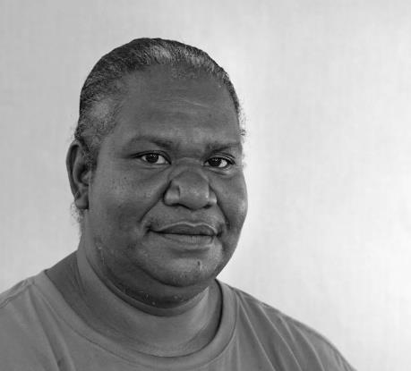
Paula Savage was born in and is a community member of Kubin Community Moa Island in the near western cluster of islands in the Torres Strait.
Paula comes from the Serganilgal clan group from the village of Dabu on Moa Island; and the Kaurareg Nation of Muralag and Kiriri.
Title: Nautilus Washed Up
All types of shells wash up on our Moa Island beaches, including the Nautilus shell.
© Paula Savage/Copyright Agency, 2024

‘Helicopter’ Joey Tjungurrayi is well recognised as one of Warlayirti Artists’ leading artists and is a great ambassador for the art centre, painting with Warlayirti Artists since the early nineties.
Title: Wangkartu

Helicopter has depicted his traditional country, located far to the south west of Balgo, in the Great Sandy Desert. This country is near Nynmi and is known as Wangkartu, named for the tjurrnu (soakwater) which was the life source for Helicopter when he was a young man travelling and hunting across the land with his family.
The many parallel lines in the painting represent the tali (sand dunes) which dominate the landscape of the area.
© Helicopter Tjungurrayi/Copyright Agency, 2024


Wangkartu by ‘Helicopter’ Joey Tjungurrayi
© Helicopter Tjungurrayi/Copyright Agency, 2024

Australian Bureau of Statistics (ABS), Local Government Areas, ABS website, 2021, accessed 24 July 2024.
Bureau of Communications, Arts and Regional Research (BCARR) analysis of Australian Bureau of Statistics (ABS), Regional population, 30 June 2023 data, ABS website, 2024.
BCARR analysis of Australian Bureau of Statistics (ABS), Estimates of Aboriginal and Torres Strait Islander Australians, 30 June 2021 data, ABS website, 2023. Analysis based on Statistical Areas Level 2 for the mainland and Local Government Areas for Christmas Island and Cocos (Keeling) Islands.
Australian Bureau of Statistics (ABS), Counts of Australian businesses, including entries and exits, July 2019 – June 2023 data, ABS website, 2023, accessed 24 July 2024.
BCARR analysis of Australian Bureau of Statistics (ABS), Census of Population and Housing 2021, Tablebuilder website, 12 July 2024, based on place of work.
Department of Defence, National Defence Strategy 2024, Department of Defence website, n.d., accessed 3 June 2024.
Department of Climate Change, Energy, the Environment and Water (DCCEEW), Australia state of the environment 2021, DCCEEW website, n.d., accessed 17 July 2024.
NAIF is also directed to notionally set aside $500 million of its appropriation to support projects which align with the Critical Minerals Strategy 2023−2030.
Department of Industry, Science and Resources (DISR), Green metals − a future made in Australia: unlocking Australia’s green iron, steel, alumina and aluminium opportunity, consultation paper, DISR, Australian Government, May 2024, accessed 24 July 2024 .
Department of Industry, Science and Resources (DISR), Major critical minerals funding unlocks Northern Territory jobs and positions Australia as renewable energy superpower [media release], 14 March 2024, DISR website, accessed 5 June 2024.
Department of Industry, Science and Resources (DISR), Critical Minerals Strategy 2023–2030, DISR website, 2023, accessed 5 May 2024.
International Energy Agency (IEA), Critical Minerals Facility, IEA website, 2023, accessed 5 June 2024.
National Reconstruction Fund Corporation (NRFC), Value-add in resources, NRFC website, 2023, accessed 5 June 2024.
Department of Industry, Science and Resources (DISR), Future Gas Strategy, DISR website, 2024, accessed 16 July 2024.
Australian Bureau of Statistics, Agricultural Commodities, Australia, reference period 2020−21, ABS website, 2022, accessed 8 May 2024.
BCARR analysis of Australian Bureau of Statistics, Census of Population and Housing 2021, accessed from Tablebuilder 12 July 2024, based on place of work. Based on northern Australia definition comprising 224 Statistical Areas Level 2.
C Chilcott, A Ash, S Lehnert, C Stokes, E Charmley, K Collins, C Pavey, A Macintosh, A Simpson, R Berglas, E White and M Amity, Northern Australia beef situational analysis, report to the Cooperative Research Centre for Developing Northern Australia, 2022, p 2, accessed 12 June 2024.
Office of the Registrar of Indigenous Corporations (ORIC), Aboriginal and Torres Strait Islander corporations, ORIC website, n.d., accessed 5 June 2024.
Establishment of businesses in the north could be stronger — for example, there are only 60 First Nations businesses registered in Greater Darwin and 408 in the rest of the NT: National Indigenous Australians Agency (NIAA), Indigenous business factsheet, NIAA website, n.d., accessed 24 July 2024.
Indigenous Land and Sea Corporation (ILSC), Discussion paper: Indigenous participation in the carbon industry, ILSC, n.d., accessed 5 June 2024.
T Janke, Z Cumpston, R Hill, E Woodward, P Harkness, S von Gavel and J Morrison, Australia state of the environment 2021: Indigenous, independent report to the Australian Government Minister for the Environment, Commonwealth of Australia, 2021, accessed 5 June 2024.
Australian Trade and Investment Commission (Austrade), Tourism Research Australia, Regional Tourism Satellite Account | Tourism Research Australia, accessed 24 July 2024
Australian Trade and Investment Commission (Austrade), Submission to the Joint Select Committee on Northern Australia inquiry into northern Australia workforce development, 2022, submission 48, p 5, accessed 19 June 2024.
Australian Trade and Investment Commission (Austrade), Submission to the Joint Standing Committee on Aboriginal and Torres Strait Islander Affairs inquiry into the economic self-determination and opportunities for First Nations Australians, Austrade submission 81 2024, accessed 24 July 2024.
2⁵ FSC Indigenous Foundation, Indigenous-led tourism benefits communities, economies, and Mother Earth, FSC Indigenous Foundation website, n.d., accessed 3 June 2024.
Department of Climate Change, Energy, the Environment and Water (DCCEEW), Protecting the Great Barrier Reef, DCCEEW website, 2024, accessed 3 June 2024.
Australian Trade and Investment Commission (Austrade), THRIVE 2030 strategy, Austrade website, n.d., accessed 5 June 2024.
Australian Trade and Investment Commission (Austrade), Budget support for the visitor economy, Austrade website, n.d., accessed 3 June 2024.
Data WA, Western Australia Regional Price Index 2023, Department of Primary Industries and Regional Development, Data WA website, n.d., accessed 3 June 2024.
Housing cost category includes rates and charges, rents, cost of utilities, credit charges and home insurance.
Data WA, Western Australia Regional Price Index 2023, Department of Primary Industries and Regional Development, Data WA website, n.d., accessed 3 June 2024.
Infrastructure Australia, Northern Australia Infrastructure Audit: infrastructure for a developing north, Infrastructure Australia, 2015, accessed 24 June 2024.
The final report of the Joint Select Committee on Northern Australia, Pivot north: inquiry into the development of northern Australia (2014) noted the costs of construction in the Pilbara region were 55–65% higher than in Perth because of distance, high labour costs, high accommodation costs and more rigorous building standards to withstand extreme weather events.
Joint Select Committee on Northern Australia, Northern Australia workforce development: First Report, (2023), accessed 24 June 2024.
Productivity Commission (PC), Closing the Gap Information Repository: dashboard, PC website, n.d., accessed 24 June 2024.
Data sourced from Productivity Commission (PC), Closing the Gap Information Repository: socio-economic outcome area 9, PC website, n.d., accessed 27 June 2024.
Department of Infrastructure, Transport, Regional Development, Communications and the Arts (DITRDCA), Infrastructure Policy Statement, DITRDCA website, 2023, accessed 5 May 2024.
Bureau of Infrastructure and Transport Research Economics (BITRE), Domestic aviation activity, BITRE, 2023.
J Thomas, A McCosker, S Parkinson, K Hegarty, D Featherstone, J Kennedy, I Holcombe-James, L Ormond-Parker and L Ganley, Measuring Australia’s digital divide: Australian Digital Inclusion Index: 2023, Australian Digital Inclusion Index website, 2024, accessed 8 May 2024.
Senate Select Committee on the effectiveness of the Australian Government’s Northern Australia agenda, Final report, Australian Government, 2021.
Thomas et al, Measuring Australia’s digital divide: Australian Digital Inclusion Index: 2023.
J Thomas, A McCosker, S Parkinson, K Hegarty, D Featherstone, J Kennedy, I Holcombe-James, L Ormond-Parker and L Ganley, Case study: mapping the digital gap — digital inclusion in remote First Nations communities, 2023, accessed 8 May 2024.
As at 14 May 2024 ($131.1 million total to projects, including state and territory contributions).
Department of Defence (Defence), National Defence Strategy 2024, Defence website, 2024, accessed 25 June 2024.
BCARR analysis of ABS Census of Population and Housing 2021, TableBuilder
PC, Closing the Gap Information Repository: dashboard].
Australian Institute of Health and Welfare (AIHW), Australia’s welfare, AIHW, 2021.
National Skills Commission, Projecting employment to 2026, Jobs and Skills Australia website, 2022, accessed 6 June 2024.
BCARR analysis of ABS Census of Population and Housing 2021, TableBuilder accessed from Tablebuilder 15/07/2024. Includes Certificate 3 and above qualifications. Denominator includes level of education inadequately described or not stated.
Regional Education Commissioner, Annual report 2022, Department of Education website, 2022, accessed 6 June 2024.
PC, Closing the Gap Information Repository: dashboard.
Department of the Treasury, Reinsurance pool for cyclones and related flood damage, consultation paper, Treasury website, 2021, accessed 15 July 2024.
Sydney Morning Herald, Intergenerational report 2023: Global warming to cost Australia more than $400b over 40 years (smh.com.au) , Shane Wright and Mike Foley, 23 August 2023, accessed 24 July 2024
Australian Competition and Consumer Commission, Insurance Monitoring report, December 2023, accessed July 2024.
Australian Bureau of Statistics (ABS), Aboriginal and Torres Strait Islander life expectancy, reference period 2020−2022, ABS website, 2023, accessed June 2024
UnionsNT Submission to Joint Select Committee on Northern Australia Inquiry into Northern Australia Workforce Development, 2023, accessed July 2024
Larrakia Nation Submission to Senate Select Committee on the effectiveness of the Northern Australia Agenda, November 2019, accessed July 2024
PC, Closing the Gap Information Repository: dashboard.
Productivity Commission (PC), Review of the National Agreement on Closing the Gap: study report, PC, Australian Government, 2024, accessed 25 June 2024.
Natural Hazards Research Australia, Disaster Resilience Index, Natural Hazards Research Australia website, n.d., accessed 5 June 2024.
Australian Climate Service (ACS), Understanding risk with the Heat-Health Index, ACS website, 2024, accessed 5 June 2024.
National Emergency Management Agency (NIAA), Building Ministers back greater climate resilience for Australian buildings [media release], 24 June 2024, National Emergency Management Agency website, accessed 27 June 2024.

