Australian Government
Department of Infrastructure, Transport, Regional Development, Communications and the Arts

Review of the National Freight and Supply Chain Strategy

Discussion Paper

August 2023

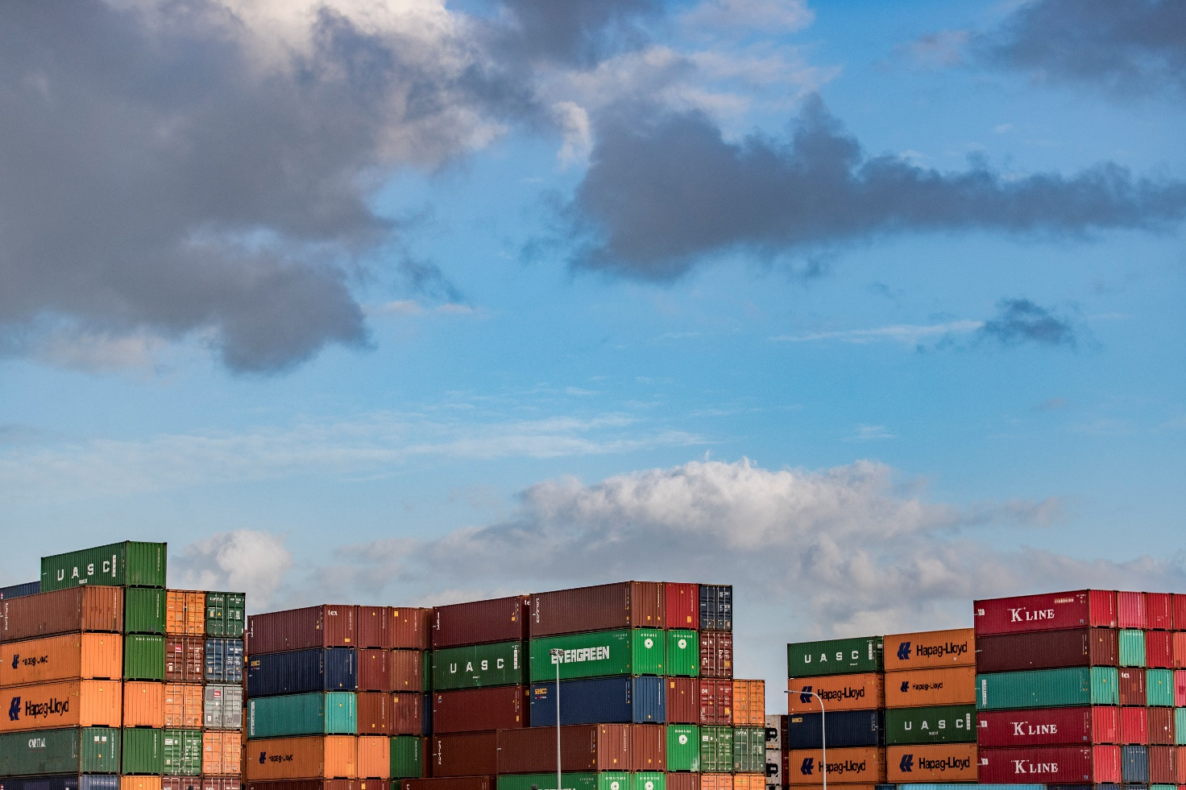

# Introduction

Australia’s supply chains are critical to our future economic success. The total domestic freight task is projected to grow 26% between 2020 and 2050, translating to an increase from around 756 billion tonne kilometres in 2020 to 964 billion tonne kilometres by 2050.[1]

The National Freight and Supply Chain Strategy (Strategy) provides the framework to meet Australia’s growing freight task, and sets an holistic, coordinated and multi-modal approach to freight and supply chains agreed by all state and territory governments.

The recent impact and increasing number of natural disasters due to climate change, the COVID-19 pandemic and geopolitical shifts have highlighted the importance of supply chains to the delivery of essential goods and services, reducing cost of living pressures and improving Australia’s prosperity. Supply chains also have an important role to play in helping Australia achieve net zero by 2050.

The Strategy and associated National Action Plan are the starting point to achieving these desired outcomes, not the end game.

The Department of Infrastructure, Transport, Regional Development, Communications and the Arts is conducting the first five-year review of the Strategy on behalf of transport ministers and in collaboration with state and territory governments. Stakeholders are encouraged to provide written submissions in response to questions in the discussion paper alongside their general feedback related to the Strategy. The department will also hold a series of stakeholder consultations. Submissions, feedback and views on the Review can be sent through the department’s [Have Your Say](https://www.infrastructure.gov.au/have-your-say) webpage by 29 September 2023.

# Is the Strategy fit for purpose?

Since 2019, the Strategy has set a national vision for freight systems and domestic and international supply chains to contribute to a strong and prosperous Australia to 2040 and beyond through achieving the following goals:

* Improved efficiency and international competitiveness
* Safe, secure and sustainable operations
* A fit for purpose regulatory environment
* Innovative solutions to meet freight demand
* A skilled and adaptable workforce
* An informed understanding and acceptance of freight operation

When the Strategy was established, it was the first time all levels of government and industry had agreed to a plan for improving the efficiency, effectiveness and reliability of Australian supply chains. However, ongoing disruptions over the last three years have had significant impacts on supply chains across Australia. We have seen disruptions of a scale never envisaged when the Strategy was written.

While the foundations of the Strategy remain strong, the review will consider whether there are areas that could be strengthened, including in relation to key Government priorities of decarbonisation and supply chain resilience.

Decarbonisation

The current Strategy and its critical action areas were informed by the 2018 *Inquiry into National Freight and Supply Chain Priorities*.[2] While decarbonisation was not identified as a priority for action in the *Inquiry*, the updated Strategy and National Action Plan will need to incorporate decarbonisation in its policy framework to ensure the Strategy remains fit for purpose in the current environment.

Australia’s transport sector is the third largest source of greenhouse gas emissions in Australia, amounting to 19 per cent of Australia’s direct greenhouse gas emissions[3]. In 2019, freight transport (rail, articulated trucks, rigid trucks and domestic marine) accounted for 26 per cent of total transport emissions[4].

Achieving Australia’s targets of reducing greenhouse gas emissions to 43 per cent below 2005 levels by 2030 and net zero by 2050 requires joined up efforts across governments and industry sectors. Climate change and the net zero transformation will affect all aspects of our economy over the coming decades, including freight and logistics, and brings enormous challenges and opportunities for the future of freight.

A key consideration of the Review will be the role of the Strategy in supporting the national vision for decarbonisation efforts through the freight and supply chain sector and what joined up government actions will get us there.

Supply Chain Resilience

All Australians depend on resilient supply chains.

The Strategy recognises that Australia’s freight and supply chains need to build resilience to meet emerging issues associated with natural disasters and climate risk, and to mitigate the impact of climate disruptions on supply chain productivity. This vision is reflected in the Strategy’s “safe, secure and sustainable operations” goal and supported by National Action 1.1 of the “Smarter and Targeted Infrastructure Investment” Critical Action Area, which outlines the need to ensure our domestic and international supply chains are serviced by resilient key freight corridors, precincts and assets.

Recent natural disasters and the growing freight task highlight the need for more effort in enhancing resilience capabilities to ensure Australian supply chains remain resilient and fit-for-purpose, now and in the future.

**Other Gaps**

There may be other gaps, in addition to decarbonisation and supply chain resilience, that the Review should consider. Examples may include, but are not limited to, land use planning considerations under the National Urban Freight Planning Principles, cybersecurity or emerging technology.

**We welcome your comments on:**

1. Do the Strategy’s current goals support the needs of the freight and supply chain sector moving forward?
2. Should other goals be included in the Strategy, and if so, what?

# Priorities for the next five-year National Action Plan

The Strategy outlines four critical action areas to help achieve the goals of the Strategy, these are:

* Smarter and targeted infrastructure investment
* Enable improved supply chain efficiency
* Better planning, coordination and regulation
* Better freight location and performance data

The 2019-24 National Action Plan (Action Plan) sits alongside the Strategy and details 13 key actions that will deliver across these critical action areas at a national level.

All state and territory governments have committed to reporting on progress in delivering the Strategy and National Action Plan annually. In the 2021-22 reporting year, over 350 initiatives were reported across these 13 actions.[5]

The scope of initiatives currently reported on range from large infrastructure projects to local road and bridge improvements. Each of these initiatives is important and will continue to be delivered.

However, there is an opportunity for Commonwealth, state and territory governments and industry to identify and work together to implement a smaller number of high priority actions where national collaboration is needed to deliver on the goals of the Strategy. This will result in a more streamlined annual report ensuring the Strategy’s performance can be monitored effectively.

If the National Action Plan focuses on a smaller number of nationally agreed actions, the current 350 initiatives will still be reported on through existing reporting frameworks.

**We welcome your comments on:**

1. Should the National Action Plan focus on a smaller number of targeted national actions, or do you want to retain the existing reporting structure?
2. If we focus on a smaller number of targeted national actions, what action areas should be included in the National Action Plan that require national coordination?

# Monitoring the Performance of the Strategy

The ability to track performance under the Strategy is key to its success.

When the Strategy was endorsed in 2019, all jurisdictions committed to report on progress in delivering the Strategy’s goals and national actions annually. This provides a qualitative way to measure freight performance and challenges for supply chains, modes or jurisdictions, and to encourage further action from governments and industry to lift freight system performance. However, there is limited quantitative monitoring of the Strategy’s performance.

Developing Key Performance Indicators (KPI) would help monitor progress of the Strategy’s goals and associated national actions. KPIs would support the annual reporting process and provide a mechanism to evaluate the Strategy’s performance quantitatively.

The Review will propose a small number of national, data-driven key performance indicators for the Strategy’s six goals. Considerations on the accessibility of data to measure proposed KPIs will be important. When it comes to data, industry, state and territory governments can and must help drive the way forward.

**We welcome your comments on:**

1. What KPIs are useful to measure the success of the Strategy?
2. What data do we need from industry, state and territory governments to measure potential KPIs?

# Reviews and Papers this Review will consider

The Review will consider the outcomes, findings or principles underpinning related work, including but not limited to:

* the reviews of Infrastructure Australia, Inland Rail and the Road and Rail Supply Chain Resilience Review
* work already underway to establish a Strategic Fleet and develop an Aviation White Paper and Infrastructure Policy Statement
* the National Reconstruction Fund’s priority investment area of Transport.

**We welcome your comments on:**

1. What outcomes, findings or principles should the Review take into consideration from related works?

# Governance arrangements to support the implementation of the Strategy

All tiers of government and industry have a role to play in helping Australia meet its future freight needs. The diagram below shows the relationship between the different parties involved in delivering and reporting on the Strategy and National Action Plan. Other entities, such as local governments and industry, are consulted throughout the Strategy’s implementation, reporting and review cycles:

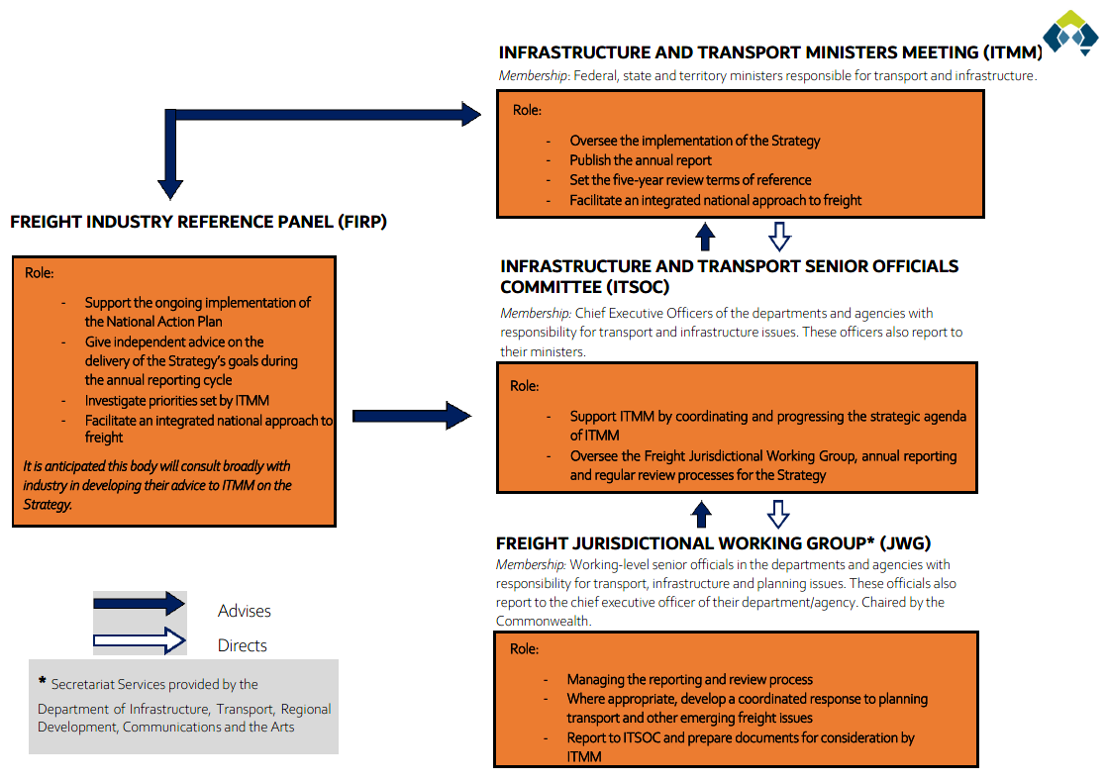

The Freight Industry Reference Panel, set up by Infrastructure, Transport and Infrastructure Ministers under the Strategy, provides industry with a clear line of sight on how the Strategy is implemented by Commonwealth, state and territory governments. The Panel provides independent feedback and advice on annual progress and leverages existing state and industry advisory groups and bodies to elicit more actions from government and industry.

The Panel works in parallel with the Strategy’s Jurisdictional Working Group, who work with the department to manage the reporting and review processes and where appropriate, develops a coordinated response to planning, transport and other emerging freight issues.

The Review will consider appropriate governance arrangements to support the implementation of the Strategy going forward.

**We welcome your comments on:**

1. Are the current governance arrangements appropriate to support the effective implementation of the Strategy going forward?
2. What role, if any, should the Freight Industry Reference Panel have to support the implementation of the Strategy?

Where to next?

We invite submissions in response to the discussion questions listed throughout the discussion paper. We invite input from all stakeholders and interested members of the public.

# Contact Us

Email: [freightstrategyreview@infrastructure.gov.au](mailto:freightstrategyreview@infrastructure.gov.au)

1. [bitre_rr154_summary_report.pdf](https://www.bitre.gov.au/sites/default/files/documents/bitre_rr154_summary_report.pdf)
2. [Inquiry_Report.pdf (infrastructure.gov.au)](https://www.infrastructure.gov.au/sites/default/files/migrated/transport/freight/freight-supply-chain-priorities/files/Inquiry_Report.pdf)
3. [Australia’s emissions projections 2022 (dcceew.gov.au)](https://www.dcceew.gov.au/sites/default/files/documents/australias-emissions-projections-2022.pdf)
4. [Australia’s emissions projections 2022 (dcceew.gov.au)](https://www.dcceew.gov.au/sites/default/files/documents/australias-emissions-projections-2022.pdf)
5. [2021-22-annual-report.pdf (freightaustralia.gov.au)](https://www.freightaustralia.gov.au/sites/default/files/documents/2021-22-annual-report.pdf)