**Model Report template**

**This is a Model Report template, developed by the Department of Infrastructure, Transport, Regional Development and Communications (the department) to assist with the development of Model Reports.**

**This template sets out a simple format for Model Reports and the minimum content expected. Use of this template may support an expedient assessment of a Model Report.**

**There is no obligation to use this template, and use of this template does not guarantee Model Report approval. Model Report authors remain responsible for ensuring their Model Report meets legislative requirements.**

**Green text in this template is for illustrative purposes only.**

**Delete this cover page before finalising the Model Report.**

**Once complete, apply for Model Report approval through** [ROVER](https://rover.infrastructure.gov.au/Produce/wizard/2023aae4-30a7-4d15-8ff7-cda459a6c0dd)**.**

**MODEL REPORT AUTHOR  
Address  
email**

**Model Report – MRE-000001  
V1.0 – [month and year]**

**Make: Make   
Model: Model (Model code)  
Variant(s): Variant 1, Variant 2, Variant 3  
Build Date Range: DD/MM/YYYY – DD/MM/YYY  
Vehicle Category: e.g. MA  
Engine: Engine code (XXXXk)  
Transmission: e.g. 6 Speed Manual, FWD  
SEVs Entry: SEV-2021-0000XXXX (e.g. SEVs vehicle under 12 tonnes, XXXXX Criteria).**

Photo 2

rear/far side

quarter view

Photo 1

front/near side

quarter view

**Unique Documents In this Model Report  
*This Model Report contains the following documents***

|  |  |  |  |
| --- | --- | --- | --- |
| **Variant** | **Scope Document ID** | **Work Instruction ID** | **Verification Checklist ID** |
| **1** | **SCP-VARI-001** | **WIN-VARI1-001** | **VCL-VARI1-001** |
| **2** | **SCP-VARI-001** | **WIN-VARI2-001** | **VCL-VARI2-001** |
| **3** | **SCP-VARI-001** | **WIN-VARI3-001** | **VCL-VARI3-001** |

**Important***This Model Report contains scope documentation, work instructions and verification checklists relevant to the modification of the* ***Make, Model (model code) variant name(s)*** *variant(s), built between* ***DD/MM/YYYY*** *and* ***DD/MM/YYYY*** *and sourced from the <<****Country>> domestic market only****.  
  
Version 1.0, approved August 2021  
Please ensure you are using the current version of the Model Report, if in doubt contact the author.*

Contents

Introduction 5

Model Report use and content 5

Contact Details 5

Pre-Modification Vehicle Scope 7

Tyre and Rim Information 8

Indicative Photographs of the SEVs Entry Vehicle 9

Post Modification Scope 10

Notes 11

Order of Implementation 13

Scope Checks 14

Component Checks 16

Recall Checks and Rectification Action 20

Identifying Outstanding Recalls 20

Sourcing Parts and Componentry 20

Procedure in the Event of Rectification Action Being Required 20

Damage and Corrosion Checks 22

Acceptable Levels of Damage and Corrosion 22

Levels of Damage Preventing Vehicle Verification 24

Body Alignment Check Procedure 25

Odometer Checks 27

Steps Required to Manufacture or Modify the Vehicle 28

EXAMPLE ONLY 28

STEP1: ADR 34/03 – Child Restraint Anchorages and Child Seat Restraint Anchorages 28

ADR 61/03 – Secure Vehicle Identification Marking 29

Manufacture or Modification Checks Required 31

EXAMPLE ONLY 31

ADR 34/03 – Post Modification Checks 31

ADR 61/03 – Post Modification Checks 31

Deterioration Checks and Rectification Action 32

Consumer Information Notice 36

Consumer Information Notice: Form and content 36

Records that must be kept 38

Performance of work instruction tasks 39

Unique Identifier 41

Scope Checks 42

Manufacture or Modification Checks 43

EXAMPLE ONLY 43

ADR 34/03 – Child Restraint Anchorages and Child Seat Restraint Anchorages 43

ADR 61/03 – Secure Vehicle Identification Marking 44

Deterioration Checks 45

Damage and Corrosion Checks 45

Acceptable Levels of Damage and Corrosion 45

Levels of Damage Preventing Vehicle Verification 47

Body Alignment Check Procedure 48

Odometer Checks 50

Recall Checks 51

# Introduction

## Model Report use and content

This Model Report contains scope documentation, work instructions and verification checklists relevant to the modification of the **Make, Model (model code) variant name(s)**, built between **DD/MM/YYYY** and **DD/MM/YYYY** and sourced from the <<**Country>> domestic market only**.This vehicle is entered on the SEVs Register as SEVs entry SEV-2021-0000XXX under the XXXX criteria only.  
  
This Model Report contains the following sections:

* **Vehicle Scope:** The vehicle scope sets out the information in respect to each model and variant to be modified in accordance with the Model Report
  + **(SPC-VARI1-001)**
  + **(SPC-VARI2-001)**
  + **(SPC-VARI3-001)**
* **Work Instructions:** Work instructions outline the steps taken to carry out all modifications to the vehicle prior to being verified.
  + **(WIN-VARI1-001)**
  + **(WIN-VARI2-001)**
  + **(WIN-VARI3-001)**
* **Verification Checklist:** A checklist for the use of an Authorised Vehicle Verifier to ensure that the vehicle has been modified in accordance with the Work Instructions and that the vehicle is consistent with the Vehicle Scope.
  + **(VCL-VARI1-001)**
  + **(VCL-VARI2-001)**
  + **(VCL-VARI3-001)**

## Contact Details

**Model Report author**

**Model Reports Pty Ltd**7 Anon Avenue, Suburb, ACT, 2666  
  
Email: [MR@anon.com.au](mailto:MR@anon.com.au)  
Tel: 04XX XXX XXX

**Regulating authority and reporting**

**Department of Infrastructure, Transport, Regional Development & Communications  
Vehicle Safety Operations Branch**GPO Box 594, CANBERRA ACT 2612

Email  
Tel: 1800 815 272

Vehicle Scope

SCP-VARI1-001

## Pre-Modification Vehicle Scope

Information below indicates the specification of a typical example of the model in original condition.

|  |  |
| --- | --- |
| **Pre-Modification Vehicle Scope** |  |
| **Vehicle Information** | Variant 1 |
| **Vehicle Make** | Make |
| **Vehicle Model** | Model |
| **Variant** | Variant 1 |
| **Model Report Type** | SEVs |
| **Build Date Range** | MM/YY-MM/YY |
| **Body Shape (NSW Body Code/Shape)** | SED |
| **Work Instruction Unique Document Identifier** | WIN-VARI1-001 |
| **SEVs Information** |  |
| **SEVs Entry Number** | SEV-2021-0000XXXX |
| **Mobility Criterion** | mobility features: none |
| **Performance Criterion (kW/t)** | XXX.X |
| **Campervan/Motorhome Criterion** | N/A |
| **Left Hand Drive Criterion** | N/A |
| **Environmental Criterion** | N/A |
| **Doors** |  |
| **Number of Side Doors** | 4 |
| **Number of Rear Doors** | 1 |
| **Vehicle Category** |  |
| **Vehicle Category** | MA |
| **Unladen Mass (kg)** | XXXX |
| **Gross Vehicle Mass (kg)**  ***Not required for MA and L Category Vehicles*** | N/A |
| **Number of Seating Positions per Row (Front Row, 2nd Row, 3rd Row etc.)** | 2,3 |
| **Motorcycle Information** |  |
| **Maximum Motorcycle Speed (km/h)**  ***Applicable to L Category Vehicles only*** | N/A |
| **Engine / Motor Information** |  |
| **Motive Power** | Petrol |
| **Model of Engine or Electric Motor** | Engine code |
| **Engine Configuration** | I4 |
| **Engine Capacity (cc)** | 1999 |
| **Engine Induction Method** | NA |
| **Drivetrain** |  |
| **Transmission Model** | Trans code |
| **Transmission Type** | Manual |
| **Drivetrain Configuration** | FWD |
| **Major Dimensions** |  |
| **Length (mm)** | XXXX |
| **Width (mm)** | XXXX |
| **Height (mm)** | XXXX |
| **Wheelbase (mm)** | XXXX |
| **Rear Overhang (mm)** | XXX |
| **Running Clearance (mm)** | XXX |

## Tyre and Rim Information

|  |  |  |
| --- | --- | --- |
|  |  |  |
| Tyre Designation | Rim Size and Profile | Rim Offset (mm) |
| XXX/XX/RXX XX Y | X.XJ x XX | XX |

Same size tyre and rim fitted as standard to both axles of the vehicle.

## Indicative Photographs of the SEVs Entry Vehicle

PHOTO 2

PHOTO 1

*Fig 1 and Fig 2. Front and rear ¾ view*

PHOTO 3

*Fig 3. Dashboard / Interior view*

PHOTO 5

PHOTO 4

*Fig 4 and Fig 5. Engine bay view and underbody view.*

## Post Modification Scope

|  |  |
| --- | --- |
| **Post-Modification Vehicle Scope** |  |
| **Vehicle Information** | Variant 1 |
| **Vehicle Make** | Make |
| **Vehicle Model** | Model |
| **Variants** | Variant |
| **Model Report Type** | SEVs |
| **Build Date Range** | MM/YY-MM/YY |
| **Body Shape (NSW Body Code/Shape)** | SED |
| **Work Instruction Unique Document Identifier** | WIN-VAR1-001 |
| **Compliance Level** | Full |
| **Areas of Non Compliance** | N/A |
| **SEVs Information** |  |
| **SEVs Entry Number** | SEV-2021-0000XXX |
| **Mobility Criterion** | mobility features: none |
| **Performance Criterion (kW/t)** | XXX.X |
| **Campervan/Motorhome Criterion** | N/A |
| **Left Hand Drive Criterion** | N/A |
| **Environmental Criterion** | N/A |
| **Doors** |  |
| **Number of Side Doors** | 4 |
| **Number of Rear Doors** | 1 |
| **Vehicle Category** |  |
| **Vehicle Category** | MA |
| **Unladen Mass (kg)** | XXXX |
| **Gross Vehicle Mass (kg)**  ***Not required for MA and L Category Vehicles*** | N/A |
| **Number of Seating Positions per Row (Front Row, 2nd Row, 3rd Row etc)** | 2,3 |
| **Motorcycle Information** |  |
| **Maximum Motorcycle Speed (km/h)**  ***Applicable to L Category Vehicles only*** | N/A |
| **Engine / Motor Information** |  |
| **Motive Power** | Petrol |
| **Model of Engine or Electric Motor** | Engine Code |
| **Engine Configuration** | I4 |
| **Engine Capacity (cc)** | XXXX |
| **Engine Induction Method** | NA |
| **Drivetrain** |  |
| **Transmission Model** | Trans Code |
| **Transmission Type** | Manual |
| **Drivetrain Configuration** | FWD |
| **Major Dimensions** |  |
| **Length (mm)** | XXXX |
| **Width (mm)** | XXXX |
| **Height (mm)** | XXXX |
| **Wheelbase (mm)** | XXXX |
| **Rear Overhang (mm)** | XXX |
| **Running Clearance (mm)** | XXX |

|  |  |  |
| --- | --- | --- |
|  |  |  |
| Tyre Designation | Rim Size and Profile | Rim Offset (mm) |
| XXX/XX/RXX XX Y | X.XJ x XX | XX |

## Notes

* In the event that information provided in vehicle scope document SCP-VARI1-001 appears incorrect or does not match that of an identical model/variant sourced for the purposes of modification, please contact the author using the contact details in the introduction section of this Model Report.
* Photos provided (Figs 1-5) are indicative of a ‘typical’ vehicle specification.

Work Instructions

WIN-VARI1-001

## Order of Implementation

In carrying out the Work Instructions contained in this Model Report, certain tasks are required to be carried out first. Please refer to the table below for the order in which these tasks are to be carried out, noting that tasks with a recommended order may be carried out in any order.

|  |  |  |  |
| --- | --- | --- | --- |
| **Work Instruction Requirement** | **S88 Section** | **Mandatory Order** | **Recommended Order** |
| Scope Checks | 16 | 1 |  |
| Recall and Rectification Checks | 19 | 2 |  |
| Component Checks | 17 | - | 3 |
| Damage and Corrosion Checks | 18 | - | 4 |
| Steps Required to Manufacture Vehicle | 20 | - | 5 |
| Manufacture or Mod Checks | 21 | - | 6 |
| Deterioration Checks and Rectification | 22 | - | 7 |
| Odometer Checks | 23 | - | 8 |
| Consumer Information Notice | 24 | - | 9 |
| Records that must be kept | 25 | - | 10 |

## Scope Checks

Use the following table to compare the vehicle to be modified against the scope of the vehicle entered on the SEVs Register.  
  
If any observations are made or discrepancies recorded, please provide a brief description in the column provided.

|  |  |  |  |  |  |
| --- | --- | --- | --- | --- | --- |
| **Vehicle Scope** | | **Vehicle Scope** | **Vehicle Scope** | | **Notes and Variation from Pre-Mod Scope** |
| **Vehicle Information** | | Typical Vehicle | As Checked | |  |
| **Vehicle Make** | | Make |  | |  |
| **Vehicle Model** | | Model |  | |  |
| **Variants** | | Variant |  | |  |
| **Model Report Type** | | SEVs |  | |  |
| **Build Date Range** | | YYYY-YYYY |  | |  |
| **Body Shape (NSW Body Code/Shape)** | | SED |  | |  |
| **Work Instruction Unique Document Identifier** | | WIN-VARI1-001 |  | |  |
| **SEVs Information** | |  |  | |  |
| **SEVs Entry Number** | | SEV-2021-0000XXX |  | |  |
| **Mobility Criterion** | | N/A |  | |  |
| **Performance Criterion (kW/t)** | | XXX.X |  | |  |
| **Campervan/Motorhome Criterion** | | N/A |  | |  |
| **Left Hand Drive Criterion** | | N/A |  | |  |
| **Environmental Criterion** | | N/A |  | |  |
| **Doors** | |  |  | |  |
| **Number of Side Doors** | | 4 |  | |  |
| **Number of Rear Doors** | | 1 |  | |  |
| **Vehicle Category** | |  |  | |  |
| **Vehicle Category** | | MA |  | |  |
| **Unladen Mass (kg)** | | XXXX |  | |  |
| **Gross Vehicle Mass (kg)**  ***Not required for MA and L Category Vehicles*** | | N/A |  | |  |
| **Number of Seating Positions per Row (Front Row, 2nd Row, 3rd Row etc)** | | 2,3 |  | |  |
| **Motorcycle Information** | |  |  | |  |
| **Maximum Motorcycle Speed (km/h)**  ***Applicable to L Category Vehicles only*** | | N/A |  | |  |
| **Engine / Motor Information** | |  |  | |  |
| **Motive Power** | | Petrol |  | |  |
| **Model of Engine or Electric Motor** | | Engine |  | |  |
| **Engine Configuration** | | I4 |  | |  |
| **Engine Capacity (cc)** | | xxxx |  | |  |
| **Engine Induction Method** | | NA |  | |  |
| **Drivetrain** | |  |  | |  |
| **Transmission Model** | | Trans |  | |  |
| **Transmission Type** | | Manual |  | |  |
| **Drivetrain Configuration** | | FWD |  | |  |
| **Major Dimensions** | |  |  | |  |
| **Length (mm)** | | XXXX |  | |  |
| **Width (mm)** | | XXXX |  | |  |
| **Height (mm)** | | XXXX |  | |  |
| **Wheelbase (mm)** | | XXXX |  | |  |
| **Rear Overhang (mm)** | | XXX |  | |  |
| **Running Clearance (mm)** | | XXX |  | |  |
| **Tyre and Rim Information** |  |  | |
| Tyre Designation | Rim Size and Profile | Rim Offset (mm) | |
| XXX/XX/RXX XX Y | X.XJ x XX | XX | |

**Vehicle Scope Checked by: ………………………………………………………………….**   
**Date: ………………………………………………………………………**

***Do not proceed with modifying the vehicle if the scope of the vehicle does not match the scope of the typical vehicle. Inform the Model Report author of any variation.***

**Notes / Observations:**

## Component Checks

The section below details the components fitted to a typical vehicle and which standards they comply to. In carrying out the work instruction a Model Report user is required to record the identifying markings of the componentry on the vehicle to be modified. If there is a discrepancy between the vehicle being modified and the typical vehicle in the Model Report, the user must inform the Model Report approval holder as a variation to that approval may be required before the modification can be completed.

|  |  |  |  |  |
| --- | --- | --- | --- | --- |
| **ADR** | **Title** | **Typical Component Identifier** | **Observed Component Identifier** | **Discrepancy recorded?** |
| 01/00 | *Reversing Lamps* | *0000-0000-0001* | *0000-0000-0001* | No |
| 02/01 | *Side Door Latches and Hinges* | *0000-0000-0001* | *0000-AAAAA* | Yes |
| 03/03 | *Seats and Seat Anchorages* | *0000-0000-0001* |  |  |
| 04/05 | *Seatbelts* | *0000-0000-0001* |  |  |
| 05/05 | *Anchorages for Seatbelts* | *0000-0000-0001* |  |  |
| 06/00 | *Direction Indicators* | *0000-0000-0001* |  |  |
| 08/01 | *Safety Glazing Materials* | *0000-0000-0001* |  |  |
| 10/02 | *Steering Column* | *0000-0000-0001* |  |  |
| 11/00 | *Internal Sun Visors* | *0000-0000-0001* |  |  |
| 13/00 | *Installation of Lighting and Light-Signalling Devices on other than L-group Vehicles* | *0000-0000-0001* |  |  |
| 14/02 | *Rear Vision Mirrors* | *0000-0000-0001* |  |  |
| 18/03 | *Instrumentation* | *0000-0000-0001* |  |  |
| 21/00 | *Instrument Panel* | *0000-0000-0001* |  |  |
| 22/00 | *Head Restraints* | *0000-0000-0001* |  |  |
| 23/02 | *Passenger Car Tyres* | *0000-0000-0001* |  |  |
| 25/02 | *Anti-Theft Lock* | *0000-0000-0001* |  |  |
| 29/00 | *Side Door Strength* | *0000-0000-0001* |  |  |
| 30/01 | *Smoke Emission Control for Diesel Vehicles* | *0000-0000-0001* |  |  |
| 31/03 | *Brake Systems for Passenger Cars* | *0000-0000-0001* |  |  |
| 34/02 | *Child Restraint Anchorages and Child Restraint Anchor Fittings* | *0000-0000-0001* |  |  |
| 42/04 | *General Safety Requirements* | *0000-0000-0001* |  |  |
| 43/04 | *Vehicle Configuration & Dimensions* | *0000-0000-0001* |  |  |
| 44/02 | *Specific Vehicle Requirements* | *0000-0000-0001* |  |  |
| 45/01 | *Lighting & Light Signalling Devices not Covered by ECE Regulations* | *0000-0000-0001* |  |  |
| 46/00 | *Headlamps* | *0000-0000-0001* |  |  |
| 47/00 | *Retroreflectors* | *0000-0000-0001* |  |  |
| 48/00 | *Devices for Illumination of Rear Registration Plates* | *0000-0000-0001* |  |  |
| 49/00 | *Front and Rear Position (Side) Lamps, Stop Lamps and End-Outline Marker Lamps* | *0000-0000-0001* |  |  |
| 50/00 | *Front Fog Lamps* | *0000-0000-0001* |  |  |
| 51/00 | *Filament Lamps* | *0000-0000-0001* |  |  |
| 52/00 | *Rear Fog Lamps* | *0000-0000-0001* |  |  |
| 60/00 | *Centre High Mounted Stop Lamp* | *0000-0000-0001* |  |  |
| 61/02 | *Vehicle Marking* | *0000-0000-0001* |  |  |
| 62/02 | *Mechanical Connections Between Vehicles* | *0000-0000-0001* |  |  |
| 69/00 | *Full Frontal Impact Occupant Protection* | *0000-0000-0001* |  |  |
| 72/00 | *Dynamic Side Impact Occupant Protection* | *0000-0000-0001* |  |  |
| 73/00 | *Offset Frontal Impact Occupant Protection* | *0000-0000-0001* |  |  |
| 74/00 | *Side Marker Lamps* | *0000-0000-0001* |  |  |
| 75/00 | *Headlamp Cleaners* | *0000-0000-0001* |  |  |
| 76/00 | *Daytime Running Lamps* | *0000-0000-0001* |  |  |
| 77/00 | *Gas Discharge Headlamps* | *0000-0000-0001* |  |  |
| 78/00 | *Gas Discharge Light Sources* | *0000-0000-0001* |  |  |
| 79/04 | *Emission Control for Light Vehicles* | *0000-0000-0001* |  |  |
| 81/02 | *Fuel Consumption Labelling for Light Vehicles* | *0000-0000-0001* |  |  |
| 82/00 | *Engine Immobilisers* | *0000-0000-0001* |  |  |
| 83/00 | *External Noise* | *0000-0000-0001* |  |  |

|  |  |  |
| --- | --- | --- |
| **Discrepancy recorded** | **Component Function** | **Action Required** |
| *Part numbers different* | *Side Door – ADR 02/01* | *Inform Model Report approval holder – new compliance info needed* |
|  |  |  |
|  |  |  |

**Vehicle Components Checked by: ………………………………………………………………….**   
**Date: ………………………………………………………………………**

## Recall Checks and Rectification Action

### Identifying Outstanding Recalls

To identify whether the vehicle is subject to ongoing recalls or a recall has been carried out in *the source* market please consult the following sources:  
  
**For UK sourced vehicles**  
**a) make.co.uk/recall  
b) car-recalls.co.uk/make**  
Alternatively contact the original manufacturer on  
***+44 115 555 5555 – Make motors (UK) - Recall and Service Hotline***, quoting the VIN of the vehicle to be modified

### Sourcing Parts and Componentry

The following is a list of known suppliers of componentry relating to the SEVs vehicle.

**Parts**

Parts and consumables for the current model can be found at:

1. OEM source market: make.co.uk/Partsorders +44 115 555 5555  
   or contact local dealership, quoting VIN number
2. Domestic OEM: make.com.au , +61 555 55555
3. UK Parts Suppliers: Autoparts.co.uk/recall-parts/make

### Procedure in the Event of Rectification Action Being Required

In the event a recall is outstanding on the vehicle to be modified:

* give a written notice to the vehicle owner/buyer stating that the recall affects the vehicle, and asking the customer to either:
* instruct the holder of the registered automotive workshop (RAW) approval to rectify the vehicle in accordance with the recall, or
* instruct the holder of the RAW approval not to proceed with the rectification, or
* advise the holder of the RAW approval of alternative arrangements for rectifying the vehicle,

and

* notify the holder of the Model Report approval and the department in writing where:
* the rectification would require the holder of the RAW approval to depart from the Work Instructions, or
* the specifications of the vehicle would vary from the final approved specification once the vehicle had been rectified and subsequently modified in accordance with the Model Report.

In carrying out or taking rectifying action the holder of the RAW approval must do the following:

* if the customer instructs the holder of the RAW approval to proceed with the rectification—rectify the vehicle to address the issues that led to the recall, or
* if the vehicle is rectified by a third party—check whether the vehicle has been rectified in a manner that addresses the issues that led to the recall.

Do not proceed to the next stage of the Work Instructions unless and until the vehicle is rectified.

**Recall and Rectification Actions Checked by: ………………………………………………………………….**  **Date: ………………………………………………………………………**

**Record all actions that have been taken in regard to identifying and rectifying recalls relevant to the vehicle being modified:**

***Note: Do not present an unrectified vehicle to the holder of an AVV approval for verification. Such a vehicle will not have been manufactured or modified in accordance with the requirements set out in this Model Report.***

## Damage and Corrosion Checks

Vehicles are to be inspected for damage and corrosion as part of carrying out the work instruction. Levels of damage and corrosion may be categorised as those that allow the verification of the vehicle by an authorised vehicle verifier (AVV) to take place and those that prevent the AVV from verifying the vehicle.

### Acceptable Levels of Damage or Corrosion

The following is a list of damage and corrosion that permits the verification of a vehicle by an AVV, records must be kept relating to any damage or corrosion that is present

1. one or more dents on the vehicle structure, or a structural component of the vehicle, of 25 millimetres or less in depth,
2. distortion of a structural component of the vehicle, or distortion of the vehicle structure, where the difference in the length of corresponding diagonal lines, as ascertained through a body alignment test, is 10 millimetres or less,
3. damage to or corrosion of a structural component of the vehicle, or of the vehicle structure, where:
   1. the damage or corrosion has been repaired by replacing damaged or corroded structural components with new components of the original specification, and
   2. the repairs did not involve the cutting or welding of a structural component, or of the vehicle structure,
4. variations in the gaps between panels greater than 5 millimetres, where:
   1. the variations are not the result of damage to the vehicle structure, and
   2. if a body alignment test has not been conducted on the vehicle—a body alignment test would not be required under the *Road Vehicle Standards (Verification of Road Vehicles) Determination 2021* by reason of the variations, and
   3. if a body alignment test has been conducted on the vehicle—the difference in the length of corresponding diagonal lines, as ascertained through the test, is 5 millimetres or less,
5. corrosion that has not resulted in flaking or pitting,
6. alterations that amount to damage to a structural component of the vehicle, where:
   1. the alterations did not involve bending, distorting, heating the metal of, or drilling or cutting holes in, the structural component, or
   2. the alterations consisted of modifications carried out in accordance with an approved Model Report that applied to the vehicle.

Using the diagram below, perform a visual vehicle Inspection marking all non-critical damage and corrosion on the vehicle;

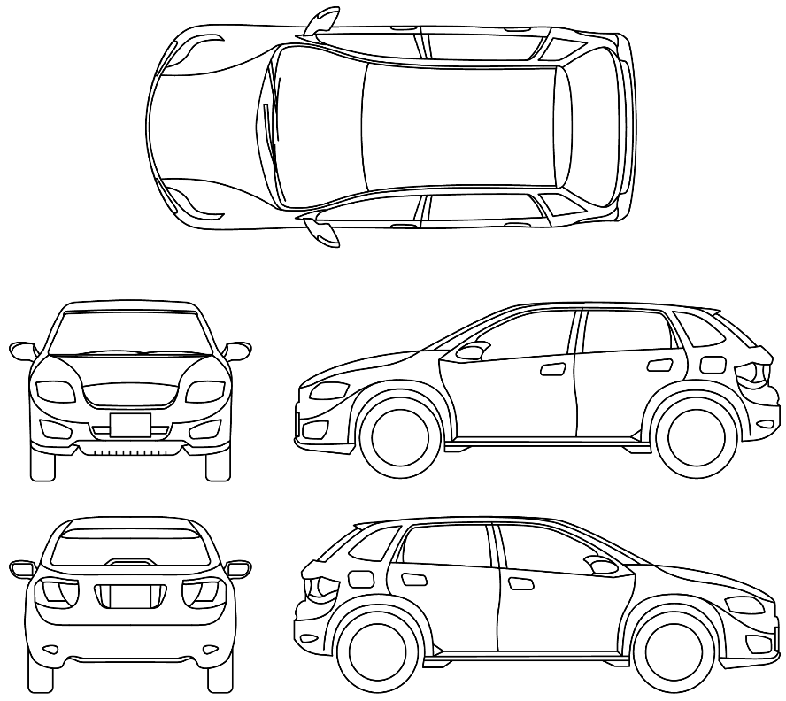

*X = Scratch/Broken, 0 = Dent, R = Rust/Surface Corrosion*

Additionally, record all damage and corrosion found in the table below;

|  |  |  |
| --- | --- | --- |
| **Damage / Corrosion Type** | **Location on Vehicle** | **Dimension of affected area** |
| *Dent* | *RHR door* | *10mm Depth, 100mm length, 100mm width* |
|  |  |  |
|  |  |  |
|  |  |  |
|  |  |  |
|  |  |  |
|  |  |  |
|  |  |  |

**Damage and Corrosion Checked by: ………………………………………………………………….**   
**Date: ………………………………………………………………………**

### Levels of Damage Preventing Vehicle Verification

Where the damage or corrosion, or repair of damage or corrosion, has resulted in:

(a) the splitting of a seam or joint between two panels, or

(b) the failure of a spot weld.

The vehicle may not be verified by an AVV, modification must not proceed and the reason for not proceeding must be documented on the diagram and in the table below;

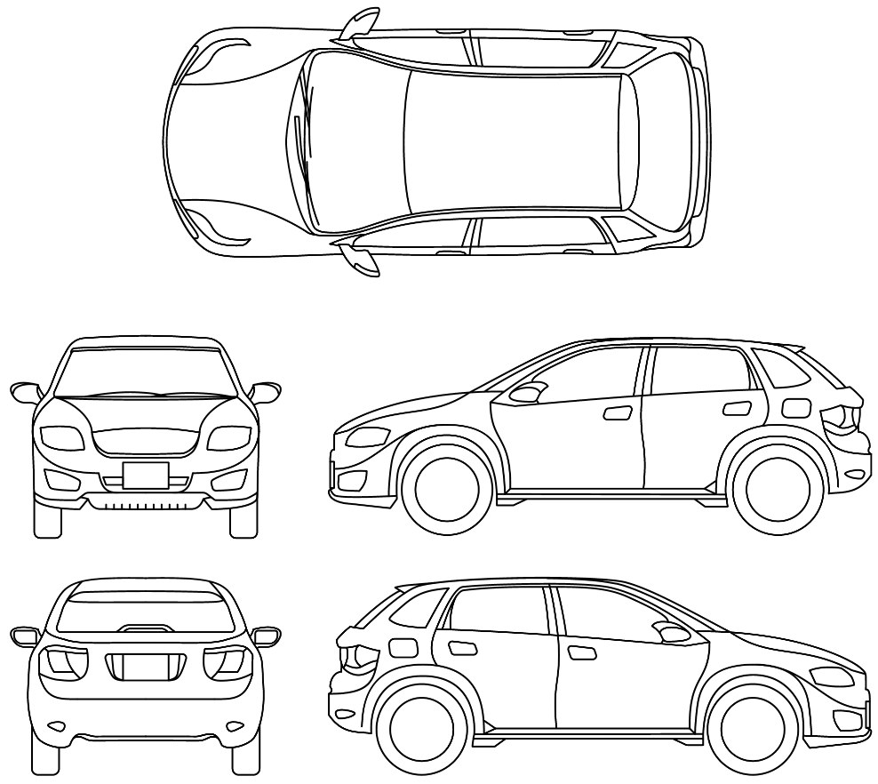

*S = Failure of Spot Weld, J = Splitting of Joint or Seam*

|  |  |  |
| --- | --- | --- |
| **Damage / Corrosion Type** | **Location on Vehicle** | **Dimension of affected area** |
| *Spot Weld Failure* | *LH Tailgate Area* | *20x20mm* |
|  |  |  |
|  |  |  |
|  |  |  |
|  |  |  |
|  |  |  |
|  |  |  |
|  |  |  |

**Damage and Corrosion Checked by: ………………………………………………………………….**   
**Date: ………………………………………………………………………**

***Note: Any damage recorded in the table above prevents a vehicle from being verified by an AVV, do not proceed with vehicle modification.***

### Body Alignment Check Procedure

If required, a body alignment check must be performed on the vehicle, following the procedure below to conduct the test.

**EXAMPLE ONLY**

**Equipment Required**

* Equipment suitable for allowing access to the underside of the vehicle
* Torch or other light source
* Measuring tape or laser measuring device
* Threaded (M10x1.25) circular dowel, 150mm length x 4.

**Method**

1. Raise the vehicle to a height, suitable for accessing the underside of the vehicle.
2. Locate the left and right hand measuring points on the front underside of the vehicle, located directly inboard of the front wheels on the axle centre line. Measuring points are female threaded and marked LFM and RFM.
3. Insert 1x threaded dowel in to each of the front measuring points.
4. Repeat steps 1-3 for the rear axle, measuring points are marked RRM and LRM.
5. Measure the distances as specified below and record results in the table below.



*Plan view of body alignment points and factory specification distances between points*

|  |  |  |  |
| --- | --- | --- | --- |
| **Measurement Dimension** | **Original Spec** | **Measured Spec** | **Variance** |
| *Point to Point* | mm | mm | Mm |
| LFM - RFM | XXXX |  |  |
| LFM - LRM | XXXX |  |  |
| RFM - RRM | XXXX |  |  |
| LFM - RRM | XXXX.X |  |  |
| RFM - LRM | XXXX.X |  |  |

**Body Alignment Checked by: ………………………………………………………………….**   
**Date: ………………………………………………………………………**

***Note: A variance of greater than 10mm, measured between points LFM – RRM and RFM – LRM renders a vehicle unverifiable by the AVV, do not proceed with vehicle modification.***

## Odometer Checks

Ensure that the odometer of the vehicle to be modified accurately reflects the how far the vehicle has travelled and has not been tampered with. This may be verified in one of the following manners.

EXAMPLE ONLY

**1)** **Check the current odometer reading against official documents:** This may include a visual inspection of the odometer and comparing the value with either a valid MOT certificate, Export notices, Deregistration documents or another verifiable document such as service books.

**2) If available, interrogate the fault memory of the vehicle:** This may be achieved by the use of a scan or diagnostic tool that has access to the engine control unit, Stability/ABS control unit or other control unit that maintains a record of vehicle distance travelled and comparing this value to the displayed value on the odometer.

If for any reason the odometer has to be changed, you must obtain supporting material that demonstrates that the new odometer accurately reflects the distance travelled by the vehicle.

**Odometer check performed by: …………………………………………………………………  
Date: ………………………………………………………………………**

**You may wish to keep a photographic record of the odometer of the vehicle as a record during the modification phase:**

## Steps Required to Manufacture or Modify the Vehicle

### EXAMPLE ONLY

### STEP1: ADR 34/03 – Child Restraint Anchorages and Child Seat Restraint Anchorages

In order to modify the vehicle in accordance with the requirements of ADR 34/03, adhere to the following method.

**This section will explain the steps required to fit Upper Seatbelt Anchorages to the vehicle in accordance with ADR 34/03.**

**Parts suppliers will be listed**

**In addition, the tools required to carry out the work and the qualifications of staff members required to carry out the work will be listed.**

**Before and after specifications will be recorded**

**Records to be kept will be listed**

**Child Restraint Anchorages Fitted by: ………………………………………………………………….**   
**Date: ………………………………………………………………………**

### ADR 61/03 – Secure Vehicle Identification Marking

All vehicles entered onto the RAV must comply with the requirements of ADR 61/03, regardless of the age or ADR applicability of the vehicle.  
  
ADR 61/03 may be found at <https://www.infrastructure.gov.au/vehicles/design/adr_online.aspx>

In modifying the vehicle, a secure vehicle identification marking in the form of a durable, self-adhesive label or metal plate must be secured to the vehicle. The following information must be captured on the secure vehicle identifier:

1. The name of the manufacturer or vehicle make
2. The VIN.

The secure vehicle identification marking must be in standard letters and numbers and attached to a conspicuous, readily accessible position on a part of the vehicle that cannot be readily replaced.

#### Ordering a Secure Vehicle Identification Marking

Secure Vehicle Identification Makings may be ordered from the following locations

**Model Reports Pty Ltd  
Anon Avenue, Suburb, ACT 2xxx  
MR@anon.com.au**

Email: [MR@anon.com.au](mailto:MR@anon.com.au)  
Tel: 04XX XXX XXX

Or

**Niddrie Nameplates** (Niddrie has indicated they are able to supply SVIs, however you may list any SVi provider in the Model Report)  
46 King Street, Airport West VIC 3042

Email: [sales@niddrienameplates.com.au](mailto:sales@niddrienameplates.com.au)  
Tel: 03 9335 2977

EXAMPLE ONLY: Niddrie has indicated they are able to supply SVIs, however you may list any SVi provider in the Model Report

It is recommended that a self-voiding, tamper resistant adhesive label be ordered for the vehicle from one of the suppliers listed above and affixed to the vehicle using the method below.

Charges apply for the provision of Secure Vehicle Identification Markings.

#### Modifying the vehicle in accordance with ADR 61/03 – Method

The following method sets out the procedure for modifying the vehicle in accordance with ADR 61/03.

EXAMPLE ONLY

No specific tools or qualifications are required for this task.

1. Upon receipt of a Secure Vehicle Identification Marking (SVI) from one of the above suppliers, ensure that the information on the marking is correct for the vehicle to be modified.
2. Clean and prepare an area on the leading edge of the passenger side B-Pillar, preferably a position no lower than 150mm below the door striker.
3. Attach the SVI to the vehicle.

Photographic evidence of SVI attached to the vehicle:

**Secure Vehicle Identification Marking affixed by: ………………………………………………………………….**   
**Date: ………………………………………………………………………**

## Manufacture or Modification Checks Required

Ensure that the modifications performed on the vehicle have been carried out correctly.

### EXAMPLE ONLY

### ADR 34/03 – Post Modification Checks

This section details the checks that are to be carried out by the vehicle modifier to ensure that any modifications that have been carried out correctly and that all systems on the vehicle affected by the modification function correctly.

### ADR 61/03 – Post Modification Checks

This section details the checks that are to be carried out by the vehicle modifier to ensure that any modifications that have been carried out correctly and that all systems on the vehicle affected by the modification function correctly.

## Deterioration Checks and Rectification Action

Compare the vehicle to be modified against the following table. If components on the vehicle exceed the deterioration limit specified in column 2, rectify the respect in which the vehicle exceeds the deterioration limit or do not proceed further with the modification.

| Deterioration limit | | |
| --- | --- | --- |
| Item | Column 1—ADR | Column 2—Deterioration limit |
| 1 | 01/00—Reversing Lamps | The vehicle’s reversing lamps must not be cracked or faded. |
| 2 | The following:  (a) ADR 04/00—Seatbelts;  (b) ADR 04/01—Seatbelts;  (c) ADR 04/02—Seatbelts;  (d) ADR 04/03—Seatbelts;  (e) ADR 04/04—Seatbelts;  (f) ADR 04/05—Seatbelts;  (g) ADR 04/06—Seatbelts. | The following:  (a) the seatbelts must not be cut, frayed or damaged;  (b) seatbelts with Emergency Locking Retractors must lock when the seatbelt is rapidly withdrawn from the retractor. |
| 3 | 06/00—Direction Indicators | The vehicle’s indicator lamps must not be cracked or faded. |
| 4 | The following:  (a) 08/00—Safety Glazing Materials;  (b) 08/01—Safety Glazing Materials. | The following:  (a) the safety glazing must not be cracked;  (b) the safety glazing must not be fitted with window tint film. |
| 5 | The following:  (a) 13/00—Installation of Lighting and Light Signalling Devices on other than L-Group Vehicles; | The location of the vehicle’s lamps must be within the following tolerances of a measurement specified by the applicant as the point at which the vehicle on which the Model Report was based was shown to comply with the ADR:  (a) 50 millimetres of the value of a vertical measurement; and  (b) 10 millimetres of the value of a horizontal measurement. |
| 6 | The following:  (a) 23/00—Passenger Car Tyres;  (b) 23/01—Passenger Car Tyres;  (c) 23/02—Passenger Car Tyres;  (d) 23/03—Passenger Car Tyres. | The following:  (a) the tyres fitted to the vehicle must be of the same specification set out in the ADR evidence;  (b) the tyres may be used, but must not:  (i) be retreaded; or  (ii) have cuts or chips on the sidewall; or  (iii) be worn beyond the tread wear indicators; or  (iv) have puncture repairs; or  (v) be more than 5 years old. |
| 7 | The following:  (a) 31/00—Brake Systems for Passenger Cars;  (b) 31/01—Brake Systems for Passenger Cars;  (c) 31/02—Brake Systems for Passenger Cars;  (d) 31/03—Brake Systems for Passenger Cars;  (e) 31/04—Brake Systems for Passenger Cars. | The following:  (a) the vehicle’s brake fluid must be replaced with new brake fluid;  (b) the vehicle’s brake pads and linings must exceed the manufacturer’s minimum recommended thickness;  (c) the brake rotors and drums must exceed the manufacturer’s minimum recommended thickness. |
| 8 | The following:  (a) 42/03—General Safety Requirements;  (b) 42/04—General Safety Requirements;  (c) 42/05—General Safety Requirements. | The vehicle’s brake hoses must not be cracked or perished. |
| 9 | The following:  (a) 43/00—Vehicle Configuration and Marking;  (b) 43/01—Vehicle Configuration and Marking;  (c) 43/02—Vehicle Configuration and Dimensions;  (d) 43/03—Vehicle Configuration and Dimensions;  (e) 43/04—Vehicle Configuration and Dimensions. | The dimensions of the vehicle:  (a) must fall within the dimensional limits set out in the ADR; and  (b) may vary from the values set out in the ADR evidence by up to:  (i) 50 millimetres for a measurement of height, and  (ii) 10 millimetres for a measurement of width or length. |
| 10 | The following:  (a) 45/00—Lighting and Light-Signalling Devices not Covered by ECE;  (b) 45/01—Lighting and Light Signalling Devices not Covered by ECE Regulations. | The vehicle’s lamps must not be cracked or faded. |
| 11 | 46/00—Headlamps | The vehicle’s lamps must not be cracked or faded. |
| 12 | 47/00—Retroreflectors | The vehicle’s lamps must not be cracked or faded. |
| 13 | 48/00—Devices for Illumination of Rear Registration Plates | The vehicle’s lamps must not be cracked or faded. |
| 14 | 49/00—Front and Rear Position (Side) Lamps, Stop lamps and End Outline Marker Lamps | The vehicle’s lamps must not be cracked or faded. |
| 15 | 50/00—Front Fog Lamps | The vehicle’s lamps must not be cracked or faded. |
| 16 | 51/00—Filament Lamps | The vehicle’s lamps must not be cracked or faded. |
| 17 | 52/00—Rear Fog Lamps | The vehicle’s lamps must not be cracked or faded. |
| 18 | 60/00—Centre High Mounted Stop Lamp | The vehicle’s lamps must not be cracked or faded. |
| 19 | 69/00—Full Frontal Impact Occupant Protection | The following:  (a) the vehicle’s airbag warning lamp:  (i) must be functioning; and  (ii) must not indicate that there are errors in the airbag system;  (b) the vehicle’s seatbelt warning lamp must be functioning. |
| 20 | 72/00—Dynamic Side Impact Occupant Protection | The following:  (a) the vehicle’s airbag warning lamp:  (i) must be functioning; and  (ii) must not indicate that there are errors in the airbag system;  (b) the airbag must not be obstructed. |
| 21 | 73/00—Offset Frontal Impact Occupant Protection | The vehicle’s airbag warning lamp:  (a) must be functioning; and  (b) must not indicate that there are errors in the airbag system. |
| 22 | 74/00—Side Marker Lamps | The vehicle’s lamps must not be cracked or faded. |
| 23 | 76/00—Daytime Running Lamps | The vehicle’s lamps must not be cracked or faded. |
| 24 | 77/00—Gas Discharge Headlamps | The vehicle’s lamps must not be cracked or faded. |
| 25 | The following:  (a) 79/00—Emission Control for Light Vehicles;  (b) 79/01—Emission Control for Light Vehicles;  (c) 79/02—Emission Control for Light Vehicles;  (d) 79/03—Emission Control for Light Vehicles;  (e) 79/04—Emission Control for Light Vehicles. | The following:  (a) the vehicle’s emission control system must be serviced and tuned in accordance with the original manufacturer’s instructions for a major service;  (b) if the vehicle is fitted with an on-board diagnostic system, the system:  (i) must be in working order; and  (ii) must not display any error codes;  (c) if the vehicle is not fitted with an on-board diagnostic system, the vehicle must not exceed the manufacturer’s specified levels for idle emissions. |
| 26 | 83/00—External Noise | The following:  (a) the results of a stationary noise test conducted on the vehicle must not exceed the noise result set out in the ADR evidence;  (b) the specification of the exhaust system must be identical to that set out in the ADR evidence. |
| 27 | 85/00—Pole Side Impact Performance | The vehicle’s airbag warning lamp:  (a) must be functioning; and  (b) must not indicate that there are errors in the airbag system. |
| 28 | 86/00—Parking Lamps | The vehicle’s lamps must not be cracked or faded. |
| 29 | 87/00—Cornering Lamps | The vehicle’s lamps must not be cracked or faded. |
| 30 | 93/00—Forward Field of View | The forward field of view of the vehicle’s windscreen area must not be discoloured, pitted, damaged or cracked. |
| 31 | 96/00—Commercial Vehicle Tyres | The tyres fitted to the vehicle:  (a) must be of the same specification as set out in the ADR evidence; and  (b) may be used, but must not:  (i) have cuts or chips on the sidewall; or  (ii) be worn beyond the tread wear indicators; or  (iii) have puncture repairs; or  (iv) be more than 5 years old. |

**Record any components that exceed the deterioration limit specified and what rectification action has been taken (if any):**

EXAMPLE ONLY

Rear tyres exceeded the 5-year age limit, replaced with new tyres of the same specification.

**Deterioration checks and rectification performed by: ………………………………………………………………….**   
**Date: ………………………………………………………………………**

***Note: If a component exceeds the deterioration limit and cannot be rectified, the vehicle cannot be verified.***

## Consumer Information Notice

In modifying the vehicle under a RAW approval, a Consumer Information Notice must be provided with the vehicle. This notice will be prepared on a durable and fade resistant material. This notice may not be removed from the vehicle.  
  
For the **Make – model – variant**, the Consumer Information Notice must be attached to the **position**.

### Consumer Information Notice: Form and content

The Consumer Information Notice demonstrated in this section is provided for indicative purposes and may not contain all of the information required by a specific vehicle type or Model Report type.  
  
Please provide the following Consumer Information Notice with the completed vehicle. All relevant information must be populated prior to vehicle delivery.

|  |  |  |  |
| --- | --- | --- | --- |
| **CONSUMER INFORMATION NOTICE** | | | |
| Make | ***Make*** | Registered Automotive Workshop | ***[RAW name and ID]*** |
| Model | ***Model*** | Model Report | ***MRE-XXXXXX*** |
| **VIN *[enter 17 digit VIN below]*** | | Model Report Variant | ***Variant code*** |
| Engine number | ***[engine number]*** | Original build date | ***[month and year the vehicle was originally completed]*** |
| Odometer reading | ***[Odometer reading at date of AVV verification]*** |  |  |

***Additionally, the Consumer Information Notice must state the following information.***

This vehicle is a concessionally approved vehicle to which section 37 of the *Road Vehicle Standards Rules 2019* applies. It has been modified by a Registered Automotive Workshop in accordance with an approved Model Report.

This vehicle was originally manufactured for the **[insert country]** market. *[For use only where the vehicle was originally manufactured for supply in another country]*

The vehicle may not comply with all of the national road vehicle standards that apply to new vehicles.

Service and replacement parts for this vehicle may not be available from a recognised franchised dealer for this make of vehicle.

This vehicle may not have been tested to show it is suitable for operation under Australian conditions.  
  
Warranty and repair of defects may not be available from the original manufacturer.

***Where a vehicle has undergone a modification to meet an applicable national road vehicle standard, please include the following notice.***

|  |  |  |
| --- | --- | --- |
| National road vehicle standard no.* | Description of modification | Part number(s) |
|  |  |  |
|  |  |  |
| *[Insert a brief description of any modifications undertaken to meet the applicable requirements of the national road vehicle standards, and any requirements applicable to the vehicle under a determination made under subsection 89(2) of the Road Vehicle Standards Rules 2019.*  *The description must be sufficient to identify the modification on inspection of the vehicle. Part numbers must be listed where these are able to be confirmed on the vehicle. May be continued on reverse.*  *\* Certain standards made under section 7 of the former Motor Vehicle Standards Act 1989, known as the Australian Design Rules, continue in force as though they are national road vehicle standards determined under section 12 of the Road Vehicle Standards Act 2018.]* | | |

## Records that must be kept

Records must be kept in relation to the carrying out the work instructions contained in the Model Report. These records are to be kept by the RAW approval holder for 7 years from the date the record is made.

The records that must be kept in modifying a vehicle include:

1. the name of each person who performed each step set out in the Work Instructions, and
2. evidence that establishes whether or not the user carried out the Work Instructions in the manner and order required by the Model Report.

Additional records that must be kept include:

1. photographs of the vehicle before and after the manufacture or modification takes place,
2. photographs of all damage or corrosion, and repair of damage or corrosion, on the vehicle,
3. photographs of part numbers,
4. the results of tests undertaken during the manufacture or modification process.

Upon completion of the vehicle modification, populate the following checklist ensuring that specific work instruction tasks are signed off and dated. Any observations or deviations from the prescribed order of implementation may also be recorded or justified.

### Performance of work instruction tasks

|  |  |  |  |  |  |
| --- | --- | --- | --- | --- | --- |
| **Work Instruction Requirement** | **Mandatory Order** | **Recommended Order** | **Order Carried Out** | **Task Completed By** | **Date of Completion** |
| Scope Checks | 1 | 1 | 1 |  |  |
| Recall and Rectification Checks | 2 | 2 | 2 |  |  |
| Component Checks | - | 3 | 4 |  |  |
| Damage and Corrosion Checks | - | 4 | 5 |  |  |
| Steps Required to Manufacture Vehicle | - | 5 | 6 |  |  |
| Manufacture or Mod Checks | - | 6 | 7 |  |  |
| Deterioration Checks and Rectification | - | 7 | 8 |  |  |
| Odometer Checks | - | 8 | 3 |  |  |
| Consumer Information Notice | - | 9 | 9 |  |  |
| Records that must be kept | - | 10 | 10 |  |  |

**Work Instruction Checklist Complete (Signed):………………………………………………………………………  
 Date:……………………………………………………………………..**

***Include any notes relating to work instruction requirements that have not be carried out in the manner or order required by the Model Report here.  
Examples may include justification for a step being carried out in a sequence not described in the work instructions e.g.  
  
1) Odometer check carried out as step 3, fault memory check was carried out as part of the ‘goods receiving’ process.***

Verification Checklist

VCL-VARI1-001

The following checklist is used by the authorised vehicle verifier to ensure the vehicle is entitled to be modified by the registered automotive workshop, and has been modified in accordance with the Work Instructions in the correct Model Report.

**Authorised Vehicle Verifier**

|  |  |
| --- | --- |
| **Business Name** |  |
| **Address** |  |
| **Email** |  |
| **Contact number** |  |

|  |  |
| --- | --- |
| **Person (s) verifying vehicle** |  |
| **Contact number** |  |
| **Location of check** |  |
| **Date of check** |  |

Has the declaration been provided by RAW? Yes / No

## Unique Identifier

This Verification Checklist is to be used to verify vehicles when modified in accordance with Work Instruction:

* **WIN-VARI1-001**

**Verification Checklist matches Work Instruction: ………………..  
Date: …………………**

***Notes***

## Scope Checks

In following the Work Instruction the modifier of the vehicle will have conducted Scope Checks to ensure the vehicle is covered by an applicable set of Work Instructions.  
  
The **AVV** is to ensure that the following checks have been completed:

* That the vehicle modifier has completed a scope check as part of carrying out the associated Work Instruction
* That any discrepancies between the Vehicle Scope and the vehicle to be modified have been recorded and appropriate notification of the Model Report approval holder has been made.
* That the vehicle has been modified to meet the ‘final specification’ identified in the Vehicle Scope.

**I am satisfied the Scope Checks have been performed by the vehicle modifier as per the Work Instruction.**

**(AVV Signed): ……………….. Date: …………………**

***Notes***

## Manufacture or Modification Checks

### EXAMPLE ONLY

### ADR 34/03 – Child Restraint Anchorages and Child Seat Restraint Anchorages

In order to verify whether the vehicle has been modified in accordance with the Work Instruction to meet the requirements of ADR 34/03, adhere to the following method.

**This section will explain the steps required to ensure that the modification has been carried out correctly.**

**Parts used will be listed**

**In addition, the tools required to carry out the work and the qualifications of staff members required to carry out the work will be listed.**

**Before and after specifications will be recorded**

**Records to be kept will be listed**

**Modification verified by (AVV): ………………………………………………………………….**   
**Date: ………………………………………………………………………**

### ADR 61/03 – Secure Vehicle Identification Marking

**This section will explain the steps required to ensure that the modification has been carried out correctly.**

**Parts used will be listed**

**In addition, the tools required to carry out the work and the qualifications of staff members required to carry out the work will be listed.**

**Before and after specifications will be recorded**

**Records to be kept will be listed**

**Modification verified by (AVV): ………………………………………………………………….**   
**Date: ………………………………………………………………………**

## Deterioration Checks

Ensure that all deterioration checks have been carried out by the vehicle modifier and where deteriorated components have been identified, rectification has been undertaken

**I am satisfied deterioration checks have been performed as per the Work Instruction.**

***Notes***

**AVV Signed: ……………….. Date: …………………**

## Damage and Corrosion Checks

Vehicles are to be inspected for damage and corrosion as part of carrying out the verification. Levels of damage and corrosion may be categorised as those that allow the verification of the vehicle to take place and those that prevent verification of the vehicle.

### Acceptable Levels of Damage and Corrosion

The following is a list of damage and corrosion that permits the verification of a vehicle by an AVV. Records must be kept relating to any damage or corrosion that is present.

1. one or more dents on the vehicle structure, or a structural component of the vehicle, of 25 millimetres or less in depth,
2. distortion of a structural component of the vehicle, or distortion of the vehicle structure, where the difference in the length of corresponding diagonal lines, as ascertained through a body alignment test, is 10 millimetres or less,
3. damage to or corrosion of a structural component of the vehicle, or of the vehicle structure, where:
4. the damage or corrosion has been repaired by replacing damaged or corroded structural components with new components of the original specification, and
5. the repairs did not involve the cutting or welding of a structural component, or of the vehicle structure,
6. variations in the gaps between panels greater than 5 millimetres, where:
7. the variations are not the result of damage to the vehicle structure, and
8. if a body alignment test has not been conducted on the vehicle—a body alignment test would not be required under the *Road Vehicle Standards (Verification of Road Vehicles) Determination 2021* by reason of the variations, and
9. if a body alignment test has been conducted on the vehicle—the difference in the length of corresponding diagonal lines, as ascertained through the test, is 5 millimetres or less;
10. corrosion that has not resulted in flaking or pitting,
11. alterations that amount to damage to a structural component of the vehicle, where:
12. the alterations did not involve bending, distorting, heating the metal of, or drilling or cutting holes in, the structural component, or
13. the alterations consisted of modifications carried out in accordance with an approved Model Report that applied to the vehicle.

Using the diagram below, perform a visual vehicle Inspection marking all non-critical damage and corrosion on the vehicle,

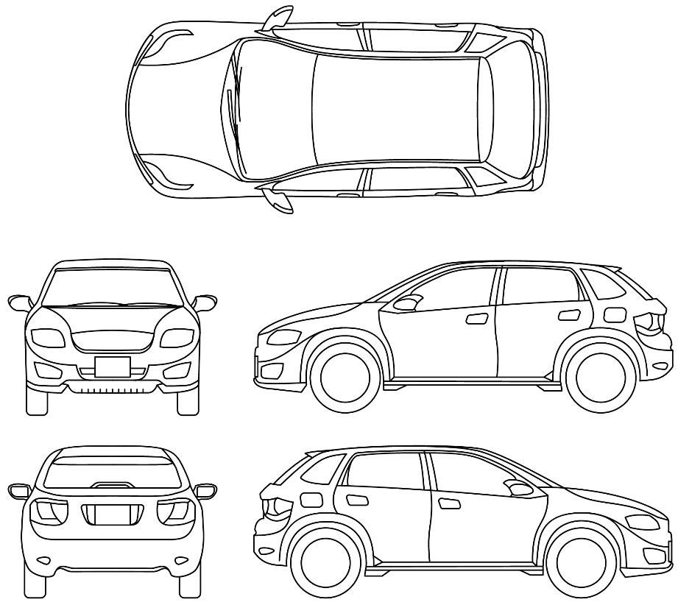

*X = Scratch/Broken, 0 = Dent, R = Rust/Surface Corrosion*

Additionally, record all damage and corrosion found in the table below:

|  |  |  |
| --- | --- | --- |
| **Damage / Corrosion Type** | **Location on Vehicle** | **Dimension of affected area** |
| *Dent* | *RHR door* | *10mm Depth, 100mm length, 100mm width* |
|  |  |  |
|  |  |  |
|  |  |  |
|  |  |  |
|  |  |  |
|  |  |  |
|  |  |  |

**Damage and Corrosion Checked by: ………………………………………………………………….**  
**Date: ………………………………………………………………………**

### Levels of Damage Preventing Vehicle Verification

Where the damage or corrosion, or repair of damage or corrosion, has resulted in:

(a) the splitting of a seam or joint between two panels, or

(b) the failure of a spot weld.

The vehicle may not be verified by an AVV, modification must not proceed and the reason for not proceeding must be documented on the diagram and in the table below:

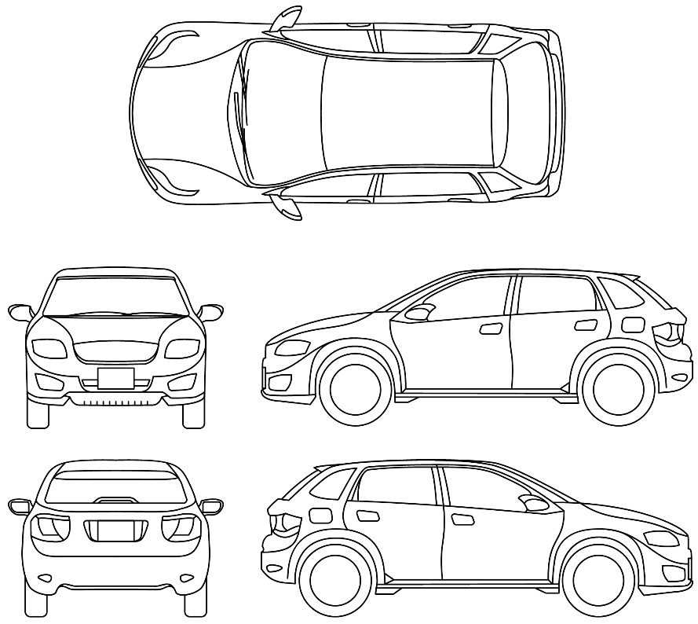

*S = Failure of Spot Weld, J = Splitting of Joint or Seam*

|  |  |  |
| --- | --- | --- |
| **Damage / Corrosion Type** | **Location on Vehicle** | **Dimension of affected area** |
| *Spot Weld Failure* | *LH Tailgate Area* | *20x20mm* |
|  |  |  |
|  |  |  |
|  |  |  |
|  |  |  |
|  |  |  |
|  |  |  |
|  |  |  |

**Damage and Corrosion Checked by: ………………………………………………………………….**   
**Date: ………………………………………………………………………**

***Note: Any damage recorded in the table above prevents a vehicle from being verified by an AVV, do not proceed with vehicle modification.***

### Body Alignment Check Procedure

If required, a body alignment check must be performed on the vehicle, following the procedure below to conduct the test.

**EXAMPLE ONLY**

**Equipment Required**

* Equipment suitable for allowing access to the underside of the vehicle
* Torch or other light source
* Measuring tape or laser measuring device
* Threaded (M10x1.25) circular dowel, 150mm length x 4.

**Method**

1. Raise the vehicle to a height, suitable for accessing the underside of the vehicle.
2. Locate the left and right hand measuring points on the front underside of the vehicle, located directly inboard of the front wheels on the axle centre line. Measuring points are female threaded and marked LFM and RFM.
3. Insert 1x threaded dowel in to each of the front measuring points.
4. Repeat steps 1-3 for the rear axle, measuring points are marked RRM and LRM.
5. Measure the distances as specified below and record results in the table below.



*Plan view of body alignment points and factory specification distances between points*

|  |  |  |  |
| --- | --- | --- | --- |
| **Measurement Dimension** | **Original Spec** | **Measured Spec** | **Variance** |
| *Point to Point* | mm | mm | Mm |
| LFM - RFM | XXXX |  |  |
| LFM - LRM | XXXX |  |  |
| RFM - RRM | XXXX |  |  |
| LFM – RRM* | XXXX.X |  |  |
| RFM – LRM* | XXXX.X |  |  |

**Body Alignment Checked by: ………………………………………………………………….**   
**Date: ………………………………………………………………………**

***Note: A variance of greater than 10mm, measured between points LFM – RRM and RFM – LRM renders a vehicle unverifiable by the AVV.***

**Damage and corrosion checks have been carried out.**

***Notes***

**AVV Signed: ……………….. Date: …………………**

## Odometer Checks

The following checks may have been performed by the vehicle modifier when checking the vehicles odometer.

**EXAMPLE ONLY**

**1) Check the current odometer reading against official documents:** This may include a visual inspection of the odometer and comparing the value with either a valid MOT certificate (UK models), Export notices, Deregistration documents or another verifiable document such as service books.

**2) If available, interrogate the fault memory of the vehicle:** This may be achieved by the use of a scan or diagnostic tool that has access to the engine control unit, Stability/ABS control unit or other control unit that maintains a record of vehicle distance travelled and comparing this value to the displayed value on the odometer.

The **AVV** is to ensure that a check has been made to ensure the vehicles odometer accurately reflects the distance the vehicle has travelled.

**I am satisfied odometer checks have been carried out**

***Notes***

**AVV Signed: ……………….. Date: …………………**

## Recall Checks

The AVV will ensure that

* the vehicle modifier has correctly identified all applicable recalls in the vehicles source market, and
* the vehicle has been rectified to address the issues that led to the recall.

**I am satisfied recall checks have been carried out and that any recalls have been addressed.**

***Notes***

**AVV Signed: ……………….. Date: …………………**