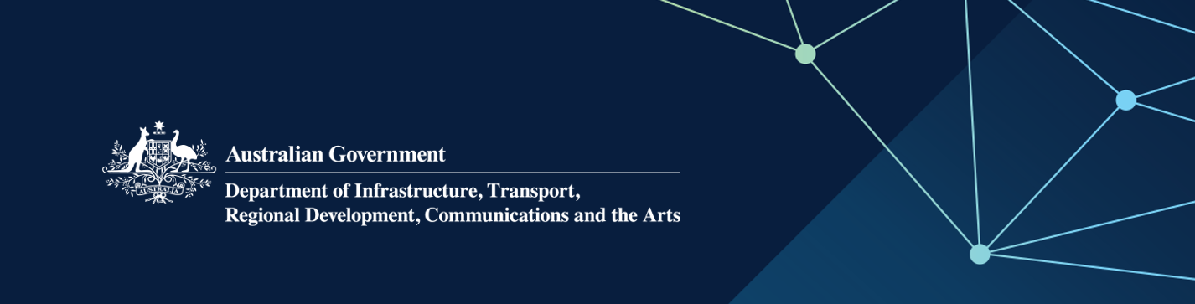

# Media Release—Exhibitions and collections to tour Australia

**6 February 2024**

More Australians will soon get to experience our cultural collections and exhibitions, with grants available to organisations through two programs to support them to tour the nation.

The **National Collecting Institutions Touring and Outreach** program aims to bring Australian and overseas cultural material to all Australians through national tours, and helps tour Australian works overseas. Each year, $1 million is available for eligible national collecting institutions such as the National Film and Sound Archive, National Library of Australia and National Museum of Australia.

The **Visions of Australia** regional exhibition touring program supports audience access to Australian arts and cultural material, with a particular focus on tours to regional and remote Australia. To be eligible for support, tours must include at least three venues outside the applicant's home state or territory, and include regional and/or remote venues. Funding of approximately $2.7 million is available each year across two funding rounds.

As well as increasing access to arts and cultural experiences for audiences outside major cities, the programs encourage partnerships between museums and galleries across the collections sector – fostering new collaborations and creating opportunities for partnerships, mentoring and skills transfer.

The programs promote the Australian Government’s National Cultural Policy, *Revive*, by providing opportunities for audiences across the country to access and engage with our vibrant arts and culture landscape.

Applications for both programs are now open. For more information and to apply, visit:

* [Visions of Australia | Office for the Arts](https://www.arts.gov.au/funding-and-support/visions-australia)
* [National Collecting Institutions Touring and Outreach Program | Office for the Arts](https://www.arts.gov.au/funding-and-support/national-collecting-institutions-touring-and-outreach-program#:~:text=The%20National%20Collecting%20Institutions%20Touring%20and%20Outreach%20(NCITO)%20Program%20aims,all%20Australians%2C%20especially%20regional%20communities.)

Media enquiries

[media@infrastructure.gov.au](mailto:media@infrastructure.gov.au) | (02) 6136 8112