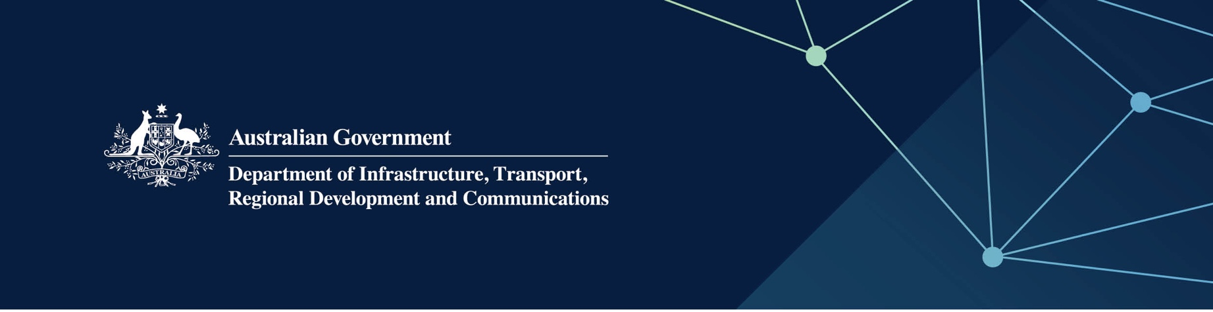

# Museum services

Delivered by the Western Australian Museum in the Indian Ocean Territories

April 2022

## Services

The WA Museum, on behalf of – and fully funded by – the Australian Government, provides the following services:

* Sustainable care and development of the Territories’ collections for the benefit of present and future generations, including:
  + collections management, research, conservation and interpretation services
  + collections effectively documented and digitised
  + advice regarding the provision of interactive multimedia and online programing
  + assist Territories community groups with making grant applications and other activities related to museum operations
  + facilitation of access by Territories community groups to sector training and mentoring programs and services.

## What does this mean for me?

The services available through the WA Museum can provide community benefit to Territories residents and businesses in helping to preserve and interpret cultural memory and interpret the Territories’ natural history.

Following an assessment of the Territories’ natural and social history, community groups can develop proposals, with the advice and support of the WA Museum, to promote the Territories to a wider audience by interpreting collections and telling stories using a range of media including multi-media. This has the potential to increase tourism and visitors to the Territories.

## For more information

|  |  |
| --- | --- |
| Area | Contact details |
| Telephone | 08 9431 8413 or 1300 134 081 |
| Email | [reception@museum.wa.gov.au](mailto:reception@museum.wa.gov.au) |
| Website | [www.museum.wa.gov.au](http://www.museum.wa.gov.au) |