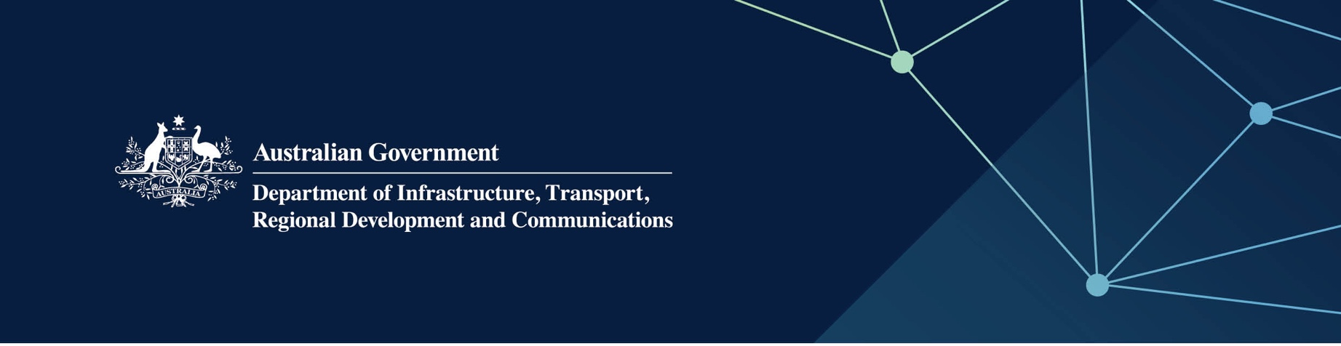

# Justice services

Delivered by the Department of Justice in the   
Indian Ocean Territories

April 2022

## Services

The Department of Justice – Attorney General, on behalf of – and fully funded by – the Australian Government, manages critical aspects of the Western Australian justice system and various State Government legal responsibilities in the Territories. The key services provided are:

* the administration of Courts, tribunals and boards
* victim support and child witness service
* the registration of births, deaths, marriages and change of name
* advocacy, guardianship and administration services
* legal, legislative drafting, policy and multi-agency co-ordination for government.

## What does this mean for me?

Court and Tribunal services alongside the judiciary, administer Court locations in the Territories. It is also responsible for managing tribunals and boards, the Sheriff’s Office (including Fines Enforcement Registry) as well as the provision of legal library and information services, and services to victims of crime and children engaged in the justice system.

Registry of Births, Deaths and Marriages creates and permanently stores birth, death, marriage and change of name records in the Territories.

The Office of the Public Advocate works to protect and promote the human rights of adults with a decision-making disability to reduce their risk of abuse, exploitation and neglect.

## For more information

|  |  |
| --- | --- |
| Area | Contact details |
| Telephone | 08 9264 1600 |
| Website | [www.wa.gov.au/organisation/department-of-justice](https://www.wa.gov.au/organisation/department-of-justice) |