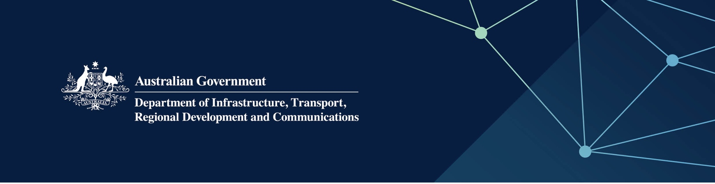

Local government services

Delivered by the Department of Local Government, Sport and Cultural Industries in the Indian Ocean Territories

April 2022

## Services

The Department of Local Government, Sport and Cultural Industries – Local Government, on behalf of – and fully funded by – the Australian Government, provides the following services:

* support services to improve local government governance processes and ensure they fulfil their statutory obligations
* capacity-building for local governments to better respond to community demands and expectations
* improved levels of accountability and legislative compliance
* executive support services to the Western Australian Local Government Grants Commission for the determination of Commonwealth general purpose financial assistance grants in accordance with the *Local Government (Financial Assistance) Act 1995* (Cth).

## What does this mean for me?

* Local governments are supported through the provision of good governance and legislative compliance so that they can deliver services that meet community needs now and into the future.

## For more information

|  |  |
| --- | --- |
| Area | Contact details |
| Telephone | 08 6552 7300 |
| Email | [info@dlgsc.wa.gov.au](mailto:info@dlgsc.wa.gov.au) |
| MyCouncil website | [www.mycouncil.wa.gov.au](http://www.mycouncil.wa.gov.au) |
| Website | [www.dlgsc.wa.gov.au/local-government](http://www.dlgsc.wa.gov.au/local-government) |