

Information about the merit-based selection process
  - Appointments to the ABC and SBS boards
September 2024

Table of contents
1. Preface 3
2. Legislative Framework 3
2.1 Membership of the ABC and SBS Boards 3
2.1.1 ABC Board 3
2.1.2 SBS Board 3
2.2 Matters for the Minister or Prime Minister 4
2.2.1 ABC Board 4
2.2.2 SBS Board 4
2.3 Merit-based selection process is mandatory 4
2.4 Membership of the Nomination Panel 4
2.5 Functions of the Nomination Panel 5
2.6 Definition of ‘merit’ 5
2.7 Categories of persons not eligible for appointment 6
2.8 Reappointments 6
2.9 Consultation requirements 6
3. Roles 6
3.1 Role of the Minister 6
3.2 Role of the Prime Minister 7
3.3 Role of the Secretary of the Department of the Prime Minister and Cabinet 7
3.4 Role of the Department of Infrastructure, Transport, Regional Development, Communications and the Arts 7
3.5 Role of the Nomination Panel 7
3.6 Role of the Governor-General 8
4. Candidate not nominated by the Nomination Panel 8
4.1 Chairperson of the ABC Board 8
4.2 Non-executive Director other than Chairperson of the ABC Board 8
5. Flowchart: The appointment process 9
5.1 The Appointment Process Flowchart in words 10

1. Preface
This document sets out information about appointments of Chairpersons and other non-executive Directors to the ABC and SBS boards, including the roles of the Department of Infrastructure, Transport, Regional Development, Communications and the Arts (the department), the Department of the Prime Minister and Cabinet (PM&C), the Nomination Panel, the Minister for Communications (the Minister), and the Prime Minister. This document does not address the election of the staff-elected Director to the ABC Board.

2. Legislative Framework
The Australian Broadcasting Corporation Act 1983 (ABC Act) and the Special Broadcasting Service Act 1991 (SBS Act) detail the arrangements for the board for each national broadcaster, including the
merit-based selection process for non-executive Directors on each board.
Selection criteria for the appointment of non-executive Directors are set out in the Australian Broadcasting Corporation (Non-executive Director—Selection criteria) Determination 2024 and the Special Broadcasting Service Corporation (Non-executive Director—Selection criteria) Determination 2024.

2.1 Membership of the ABC and SBS Boards

2.1.1 ABC Board
The ABC Board consists of:
- the Managing Director; and
- the Chairperson; and
- the staff-elected Director; and
- not fewer than 4 nor more than 6 other non-executive Directors.
The Chairperson and the other non-executive Directors (not including the staff-elected Director) are appointed by the Governor-General and hold office on a part-time basis for a period of up to 5 years. The Chairperson and non-executive Directors are eligible for reappointment. The sum of the periods for which a person holds office as either Chairperson or other non-executive Director, or both, must not exceed
10 years.

2.1.2 SBS Board
The SBS Board consists of:
- the Managing Director; and
- the Chairperson; and
- not fewer than 3 nor more than 7 other non-executive Directors.
The Chairperson and the other non-executive Directors are appointed by the Governor-General and hold office on a part-time basis for a period of up to 5 years. The Chairperson and non-executive Directors are eligible for reappointment. The sum of the periods for which a person holds office as either Chairperson or other non-executive Director, or both, must not exceed 10 years.

2.2 Matters for the Minister or Prime Minister

2.2.1 ABC Board
Before the Governor-General appoints a person as a non-executive Director on the ABC Board, the
Prime Minister (if the appointment is of the Chairperson) or the Minister (if the appointment is not of the Chairperson) must be satisfied that the person is suitable for appointment because of:
- experience in connection with the provision of broadcasting services or in communications or management; or
- expertise in financial or technical matters; or
- cultural or other interests relevant to the oversight of a public organisation engaged in the provision of broadcasting services.

2.2.2 SBS Board
Before the Governor-General appoints a person as a non-executive Director on the SBS Board (including the Chairperson), the Minister must have regard to the need to ensure that:
- the Directors collectively possess an appropriate balance of expertise in the areas required to govern the SBS effectively, including an understanding of Australia’s multicultural society and the needs and interests of the SBS’s culturally diverse audience; and
- the Directors collectively comprise persons with a diversity of cultural perspectives; and
- the Directors include a person who the Minister is satisfied, having regard to consultations between the Minister and representatives of industrial organisations representing employees, has an appropriate understanding of the interests of employees; and
- at least one of the Directors is an Indigenous person.

2.3 Merit-based selection process is mandatory
Except in the case of a reappointment (see Section 2.8), a person must not be appointed as a Chairperson or other non-executive Director to the ABC or SBS Board by the Governor-General unless a merit-based selection process in compliance with the ABC and SBS Acts is conducted (see Section 2.5). This may happen when the term of an existing Chairperson or non-executive Director expires and the person is not eligible for reappointment due to the length of earlier appointments, or when a decision is made to not reappoint that person. It may also happen after an unexpected vacancy occurs.

2.4 Membership of the Nomination Panel
The Nomination Panel is established under the ABC Act. The Nomination Panel consists of a Chair and a minimum of 2, or a maximum of 3, other members. The Nomination Panel members are appointed by the Secretary of the Department of the Prime Minister and Cabinet (PM&C). Members are appointed on a part-time basis for terms of up to 3 years and may be reappointed. The Secretary of PM&C must give notice on PM&C’s website of each person appointed to the Nomination Panel.
The current Nomination Panel is comprised of Ms Helen Williams AC (Chair), Ms Catherine Liddle, Professor Derek Wilding and Ms Daryl Karp AM.

2.5 Functions of the Nomination Panel
When the Minister notifies the Nomination Panel of a forthcoming vacancy on the ABC Board and/or the SBS Board, the Nomination Panel must conduct a merit-based selection process in accordance with the ABC and SBS Acts. The Nomination Panel must assess all applicants against the relevant selection criteria on the basis of merit (see Section 2.6).
Prior to the commencement of a selection process, the Chair of the Nomination Panel may consult with the Chair of the ABC and/or SBS board on the skills requirements for each board. The Nomination Panel is usually assisted by an external executive-search agency. The Nomination Panel may conduct a single selection process for 2 or more vacancies.
The functions of the Nomination Panel, as set out in the ABC and SBS Acts, include:
- to conduct a selection process for each appointment of a non-executive Director to the ABC Board and the SBS Board, with the exception of the staff-elected Director on the ABC Board
- to assess all applicants for an appointment against the selection criteria determined by the Minister by legislative instrument and any additional selection criteria notified in writing by the Minister to the Nomination Panel in relation to a particular appointment
- to assess all applicants for an appointment on the basis of merit, and
- to give a written report:
  - if the appointment is for the Chairperson of the ABC―to the Prime Minister and the Minister
- if the appointment is not for the Chairperson of the ABC―to the Minister
on the outcome of the selection process that contains a list of at least 3 candidates who are nominated for an appointment and a comparative assessment of those candidates.

2.6 Definition of ‘merit’
The ABC and SBS Acts provide that the assessment of applicants for appointment as non-executive Directors is based on merit if:
- an assessment is made of the comparative suitability of the applicants for the duties of that Director, using a competitive selection process; and
- the assessment is based on the relationship between the applicants’ experience, skills and competencies and the experience, skills and competencies genuinely required for the duties of that Director; and
- the assessment focuses on the capability of the applicants to achieve outcomes related to the duties of that Director; and
- the assessment is the primary consideration in nominating the candidates for that appointment.
The principle of merit will be interpreted broadly in the merit-based selection process. Formal qualifications and traditional work experience will form only one element of the Nomination Panel’s assessment of an applicant’s experience, skills and competencies. Non-traditional activities and career paths may also be recognised and valued as suitable qualifications which contribute to an applicant’s overall suitability for appointment.

2.7 Categories of persons not eligible for appointment
Current and former members of Parliament (including the Federal and State Parliaments and the Legislative Assembly of the Australian Capital Territory and Northern Territory) and senior political staff members are not eligible for appointment as a non-executive Director to the ABC Board or the SBS Board while engaged in such positions, or for a period of 12 months beginning on the day the person ceased to hold one of these positions.
The Minister has defined the term ‘senior political staff member’ by legislative instrument in the Australian Broadcasting Corporation (Definition of senior political staff member) Instrument 2024.

2.8 Reappointments
A decision to recommend to the Governor-General that a particular person be reappointed as a non-executive Director is made at the discretion of the Minister, or the Prime Minister in the case of the Chairperson of the ABC. Where an incumbent is to be recommended for reappointment, the Minister, or the Prime Minister, will follow Government policy regarding the process for appointments.
Under the ABC and SBS Acts, a merit-based selection process is not required to be conducted by the Nomination Panel for reappointments of existing non-executive Directors.

2.9 Consultation requirements
If the Nomination Panel gives the Prime Minister a report in relation to the appointment of the Chairperson of the ABC, the Prime Minister must consult the Leader of the Opposition in the House of Representatives before recommending the appointment of that person to the Governor-General.
When appointing the non-executive Director to the SBS Board who satisfies the third dot point in Section 2.2.2, the Minister must consult with representatives of industrial organisations representing employees before recommending the appointment of that person to the Governor-General.

3. Roles

3.1 Role of the Minister
The Minister’s role includes:
- deciding whether to recommend to the Governor-General that an eligible non-executive Director be reappointed (having regard to the length of earlier terms)
- notifying a non-executive Director whether they will be reappointed for another term or of the Government’s decision to request the Nomination Panel to conduct a selection process to test the field
- determining selection criteria for the appointment of non-executive Directors to each Board by legislative instrument
- giving written notice to the Nomination Panel of additional selection criteria for a particular appointment (where this is applicable)
- considering the written report of the Nomination Panel following the completion of the merit-based selection process (in the case of the Chairperson of the ABC in conjunction with the Prime Minister)
- being satisfied or having regard to the matters set out in the ABC and SBS Acts (see sections 2.2.1, 2.2.2 and 2.7), and
- recommending a person to the Governor-General for appointment (in the case of the Chairperson of the ABC in conjunction with the Prime Minister). If the person recommended by the Minister has not been nominated by the Nomination Panel, the Minister must follow the process set out in Section 4.2.

3.2 Role of the Prime Minister
The Prime Minister is responsible for:
- deciding whether to recommend to the Governor-General that an eligible Chairperson of the ABC Board be reappointed (having regard to the length of earlier terms)
- considering the written report of the Nomination Panel following the completion of a merit-based selection process for the position of Chairperson of the ABC Board
- being satisfied of the matters set out in the ABC Act (see sections 2.2.1 and 2.7), and
- recommending a person to the Governor-General for appointment as Chairperson of the ABC Board. If the person recommended by the Prime Minister has not been nominated by the Nomination Panel, the Prime Minister must follow the process set out in Section 4.1.

3.3 Role of the Secretary of the Department of the Prime Minister and Cabinet
The Secretary of PM&C is responsible for:
- appointing the members of the Nomination Panel, and
- placing a notice on PM&C’s website of each person appointed to the Nomination Panel.

3.4 Role of the Department of Infrastructure, Transport, Regional Development, Communications and the Arts
The department is responsible for:
- providing secretariat support to the Nomination Panel, including assistance with advertising the positions in print and digital media
- maintaining a record of all ABC and SBS board appointments
- seeking the Minister’s decision whether to recommend to the Governor-General that a non-executive Director (if eligible, having regard to the length of earlier terms) be reappointed or to request the Nomination Panel conduct a selection process for that position
- including a statement in the department’s annual report about each merit-based selection process that is completed, and
- if required, engaging an executive recruitment firm to assist the Nomination Panel.

3.5 Role of the Nomination Panel
The Nomination Panel is responsible for:
- conducting a merit-based selection process for each new non-executive Director appointment to the ABC and SBS Board (except for the staff-elected Director on the ABC Board) in accordance with the ABC and SBS Acts
- arranging for the publication of advertisements inviting written applications from persons seeking to be appointed to the position(s) on the department’s website and in one or more forms that are readily accessible to potential applicants, for example, on a website other than the department’s website
- following its assessment of all applicants, providing a written report to the Minister (or to the Prime Minister and the Minister if the appointment is for the Chairperson of the ABC Board) about the merit-based selection process. The report must nominate at least 3 candidates for each vacancy and must include a comparative assessment of those candidates against the applicable selection criteria determined and notified by the Minister.

3.6 Role of the Governor-General
The Governor-General is responsible for:
- the appointment or reappointment of Chairpersons and other non-executive Directors to the ABC and SBS Boards (except for the staff-elected Director on the ABC Board) based on the recommendation of the Minister for Communications (or the Prime Minister in the case of the ABC Chairperson).

4. Candidate not nominated by the Nomination Panel

4.1 Chairperson of the ABC Board
If a person not nominated by the Nomination Panel is appointed by the Governor-General as the Chairperson of the ABC Board, the Prime Minister must table the reasons for that appointment in each House of Parliament no later than 15 sittings days after the appointment is made. The reasons must include an assessment of the person against the selection criteria.
Under the ABC Act, a former politician or senior political staff member can only be appointed as a non-executive Director if it has been at least 12 months since the person ceased to be a member of a Parliament or Legislative Assembly, and they have been nominated by the Nomination Panel through the statutory merit-based selection process.

4.2 Non-executive Director other than Chairperson of the ABC Board
If the Minister wants to recommend to the Governor-General that a person who has not been nominated by the Nomination Panel be appointed as a non-executive Director on the ABC or SBS Board, the Minister must give written notice to the Prime Minister with the name of the person and the reasons for the decision. If that person is appointed by the Governor-General, the Minister must table the reasons for that appointment in each House of Parliament no later than 15 sittings days after the appointment is made. The reasons must include an assessment of the person against the selection criteria.
Under the ABC Act and SBS Acts, a former politician or senior political staff member can only be appointed as a non-executive Director if it has been at least 12 months since the person ceased to be a member of a Parliament or Legislative Assembly, and they have been nominated by the Nomination Panel through the statutory merit-based selection process.

5. Flowchart: The appointment process
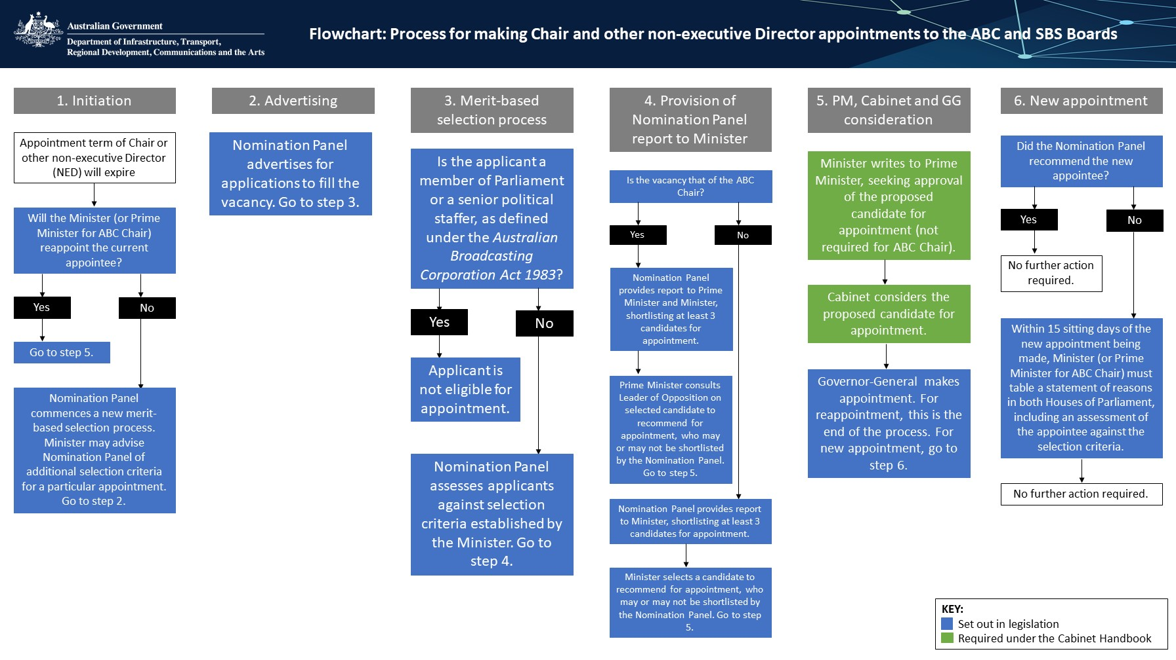

5.1 The Appointment Process Flowchart in words
- Initiation
  - Appointment term of Chair or other non-executive Director will expire.
  - Will the Minister (or the Prime Minister for the ABC Chair) reappoint the current appointee?
    - Yes―Go to step 5.
    - No―Nomination Panel commences a new merit-based selection process. The Minister may advise the Nomination Panel of additional selection criteria for a particular appointment. Go to step 2.
- Advertising
  - Nomination Panel advertises for applications to fill the vacancy. Go to step 3.
- Merit-based selection process
  - Is the applicant a member of Parliament or a senior political staffer, as defined under the Australian Broadcasting Corporation Act 1983?
    - Yes―Applicant is not eligible for appointment.
    - No―Nomination Panel assess applicants against selection criteria established by the Minister. Go to step 4.
- Provision of Nomination Panel report to Minister
  - Is the vacancy that of the ABC Chair?
    - Yes―Nomination Panel provides report to Prime Minister and Minister, shortlisting at least 3 candidates for appointment.
      - Prime Minister consults Leader of the Opposition selected candidate to recommend for appointment, who may or may not be shortlisted by the Nomination Panel. Go to step 5.
    - No―Nomination Panel provides report to Minister, shortlisting at least 3 candidates for appointment.
      - Minister selects a candidate to recommend for appointment, who may or may or may not be recommended by the Nomination Panel. Go to step 5.
- PM, Cabinet and GG consideration
  - Minister writes to Prime Minister, seeking approval of the proposed candidate for appointment (not required for the ABC Chair).
  - Cabinet considers the proposed candidate for appointment.
  - Governor-General makes the appointment. For reappointment, this is the end of the process. For a new appointment, go to step 6.
- New appointment
  - Did the Nomination Panel recommend the new appointee?
    - Yes―No further action required.
    - No―Within 15 sitting days of the new appointment being made, Minister (or Prime Minister for ABC Chair) must table a statement of reasons in both Houses of Parliament, including an assessment of the appointee against the selection criteria.
      - No further action required.

See Parts II, III and IIIA of the ABC Act, and Parts 2, 3 and 3A of the SBS Act.
National Broadcasting Legislation Amendment Act 2012, Explanatory Memorandum, page 8.

