**THE DELIVERY OF INLAND RAIL:**

AN INDEPENDENT REVIEW

Kerry Schott AO

January 2023



© Commonwealth of Australia 2023

ISBN: 978-1-925843-99-6

January 2023

Ownership of intellectual property rights in this publication

Unless otherwise noted, copyright (and any other intellectual property rights, if any) in this publication is owned by the Commonwealth of Australia (referred to below as the Commonwealth).

**Disclaimer**

The material contained in this publication is made available on the understanding that the Commonwealth is not providing professional advice, and that users exercise their own skill and care with respect to its use, and seek independent advice if necessary.

The Commonwealth makes no representations or warranties as to the contents or accuracy of the information contained in this publication.

To the extent permitted by law, the Commonwealth disclaims liability to any person or organisation in respect of anything done, or omitted to be done, in reliance upon information contained in this publication.

**Creative Commons licence**



With the exception of the Department of Infrastructure, Transport, Regional Development, Communications and the Arts photos and graphics. Copyright in this publication is licensed under a Creative Commons Attribution 4.0 Australia Licence.

Creative Commons Attribution 4.0 Australia Licence is a standard form licence agreement that allows you to copy, communicate and adapt this publication provided that you attribute the work to the Commonwealth and abide by the other licence terms.

Further information on the licence terms is available from <https://creativecommons.org/licenses/by/4.0/>

This publication should be attributed in the following way: © Commonwealth of Australia 2023

**Contact us**

This publication is available in hard copy or PDF format. All other rights are reserved, including in relation to any Departmental logos or trademarks which may exist. For enquiries regarding the licence and any use of this publication, please contact:

Director – Communications and Creative Services

Communications Branch

Department of Infrastructure, Transport, Regional Development, Communications and the Arts

GPO Box 594

Canberra ACT 2601

Australia

Email: [creativedesign@infrastructure.gov.au](mailto:creativedesign@infrastructure.gov.au)

Website: [www.infrastructure.gov.au](http://www.infrastructure.gov.au)

Glossary

|  |  |
| --- | --- |
| Abbreviation | Full Form |
| ACCC | Australian Competition and Consumer Commission |
| ARTC | Australian Rail Track Corporation Limited ABN 75 081 455 754 |
| BITRE | Bureau of Infrastructure and Transport Research Economics |
| CSIRO | Commonwealth Scientific and Industrial Research Organisation |
| GBE | Government Business Enterprise |
| IRSO | Inland Rail Service Offering |
| NSW | New South Wales |
| PPP | Public Private Partnership |
| TEU | Twenty-foot equivalent units |
| WIFT | Western Interstate Freight Terminal |

Table of contents

Glossary 3

Table of contents 4

Executive summary 5

Findings and recommendations 7

1. Purpose 15

1.1 Introduction 15

1.2 Terms of Reference 15

2. Overview of ARTC and Inland Rail 17

2.1 The ARTC business 17

2.2 The Inland Rail proposal 18

2.3 The importance of Inland Rail 19

2.4 Implementation 20

3. Governance and project delivery 22

3.1 Current governance arrangements for Inland Rail 22

3.2 Project management arrangements 24

3.3 Risk management 28

4. Inland Rail Service Offering 30

4.1 Future freight demand and the service required 30

4.2 Melbourne terminals 33

4.3 Brisbane terminals 35

4.4 Linkages to other freight operations 37

4.5 Toowoomba to Gladstone Inland Rail extension 39

5. Process to select the route 41

5.1 Initial assessments 41

5.2 Route modifications 44

6. Project scope, schedule and cost 46

6.1 Scope 46

6.2 Schedule 49

6.3 Cost 52

7. Enhancing community benefits 57

Appendix A: References 59

Appendix B: Acknowledgements 61

Appendix C: Review engagement 62

Executive summary

Inland Rail is an important project. Its outcomes are intended to move freight from roads thus easing congestion particularly between the east coast capital cities. Resilience in the national freight corridors will be enhanced, the importance of this being clear from recent floods and the COVID-19 pandemic. Emissions may reduce by an estimated 750,000 tonnes per year by 2050 as rail replaces road.[1]

The project is however late and over budget and one of the important tasks I have is to assess the extent of these problems. In this I have failed as there is insufficient certainty about the completion date and the final cost to have confidence in the current estimates.

There are a number of reasons for this regrettable situation. The first reason lies in the governance and project management arrangements for Inland Rail. The Inland Rail project is managed as a division of ARTC, a Commonwealth-owned Government Business Enterprise, and reports to the ARTC Board through a Sub-Committee set up to oversee the project, and also through the CEO of ARTC. The problem is that the Board and its Sub-Committee do not have adequate skills to oversee this project. Despite an informed request by the Chairman of ARTC to the then-Minister responsible, replacement appointments to the Board did not provide the skills required. ARTC is a large business and its management does need a capable Board with a knowledge of rail operations, project management, the freight industry and regional nous as well as legal and accounting skills. With about $900 million revenue[2] and complex operations across Australia, this business needs a capable Board.

To address this situation, I recommend that the current Shareholder Ministers appoint a new Chair and Directors with appropriate skills to replace retired positions. In addition, Inland Rail should cease being managed as a division of ARTC and be set up as a subsidiary company of ARTC established for the sole task of delivering this project. The Board of that subsidiary and ARTC should appoint a CEO to run the project as it has not had a permanent CEO for over 18 months. I understand that the previous government Minister did not approve of the Board choice for this position and indefinitely delayed taking the recommendation to Cabinet.

These new arrangements leave the current CEO of ARTC to focus on the business-as-usual matters of the company and leave the Inland Rail project to be managed by a specialist CEO with experience in project delivery. This person should report directly to the subsidiary board and also to the ARTC Board by attending that board’s meetings. This structure removes the very real risk of the ARTC business being distracted by the Inland Rail project, and should enable Inland Rail to be better organised as a project delivery task rather than part of an operational business.

State Governments and rail freight operators are keen to settle the end points of the Inland Rail route. Somewhat surprisingly the project has commenced delivery without knowing where it will start or finish. There is support for the Inland Rail service to finish at a new intermodal terminal at Ebenezer on the outer environs of Brisbane. In Melbourne there is support for two terminals to be developed. Initially Beveridge should be prepared to operate in line with Inland Rail completion serving north and north-east Melbourne areas with Truganina (WIFT) developed concurrently serving the areas to the west. This development will take longer but over time it is expected that Truganina will become the larger operation. All terminals should be developed as open access and freight operators must not be permitted to be the operator for competitive reasons.

Inland Rail must also link into other freight networks. Parkes in NSW sits at the junction of the north-south Inland Rail route and the east-west route. Development at Parkes is being supported by the local government and the State, and it too should be open access. I note that the rail link from Toowoomba to Gladstone is being examined and any future extension that may occur there should be complementary to the end point at Brisbane.

The route alignment should be accepted with any future modifications limited to changes to improve the design and constructability of the project. No material effect on the Inland Rail Service Offer should occur. The route mainly consists of existing track upgrades in Victoria and NSW (1,087 kilometres) and some new track in Queensland, and between Narromine and Narrabri in NSW (628 kilometres). Regional towns where the route, based on existing track, bisects them are understandably concerned about the disruption they may experience when Inland Rail traffic becomes significantly above their present experience. For this reason, in regional towns like Wagga Wagga and Gatton, it is recommended that the traffic disruption is reviewed from time-to-time and that an easement by-passing the town be preserved for future use.

The detailed and clearly defined scope of much of the route has not yet been settled as approval processes are not complete. There has been lengthy delays in this process, particularly in Queensland, caused in part by immature design and poor Environmental Impact Statements that need numerous changes and re-submissions. Until this scope is firmed, an assessment of schedule and cost cannot be made with confidence.

On the basis of the information available, ARTC has estimated completion of the project in 2030-31. The route from Melbourne to Parkes is expected to be finished by 2027. This latter estimate is more certain than that for the entire route. Overall when compared to the 2020 estimate the project is running four years late mainly due to approval delays which in turn delay land acquisition, when needed, and tender offers.

The ARTC estimate of the cost of the project has increased by an astonishing amount when compared to 2020. Two years ago, the estimate was $16.4 billion and now it is about $31 billion. In my view this cost estimate should not be accepted by the Shareholder as there is insufficient certainty about the scope, the related schedule, and delivery costs to have any confidence in the numbers. A full review of these matters is definitely needed by an experienced cost estimator and value engineer and several areas to be included in this work are noted. Once there is some confidence about the cost, a year-by-year budget can be established to enable management by both the Commonwealth Government and ARTC. A comparison to future benefits should also be made at this point.

The intended benefit of the Inland Rail project is to move freight from road to rail, especially on the Brisbane to Melbourne route. Rail can be competitive, lessen road congestion, lower road maintenance costs and operate with fewer emissions. In the future it is needed to meet the increasing national freight task. It is also apparent that Inland Rail can provide benefits to regional communities along its route. In the short term it has offered employment and work for local businesses. In the longer term regionally based businesses can develop. This is already occurring in NSW where local and State Governments have worked together to provide resources for business parks to form and successfully operate. Wagga Wagga and Parkes are well progressed with future plans developing for Moree and Narrabri. In Queensland similar developments could occur and possibilities are evident at Goondiwindi, Gatton and Ebenezer.

Findings and recommendations

Finding

The skills mix required by the ARTC Board for its operational business and to deliver Inland Rail was not heeded by the Shareholder Ministers of the former Government despite advice given by the ARTC Board at the time.

Recommendation 1

The Shareholder Ministers should address the skills requirements of the ARTC Board with their next appointments and continue to address these skill requirements.

Finding

The Inland Rail project has been operating without a substantive Chief Executive since mid-2021, a situation that is not viable. A first-rate Chief Executive, reporting directly to its Board is essential to the delivery of the Inland Rail project.

Recommendation 2

The position of Chief Executive of Inland Rail should be filled substantively as soon as possible.

Finding

Delivering Inland Rail as a division of ARTC has created a number of significant governance, budgetary and management risks. The size and complexity of the Inland Rail project is also such that it requires deep experience in infrastructure project management and has distracted from the day-to-day business operations of ARTC which themselves do not appear to be tightly ring-fenced.

Recommendation 3

ARTC must have governance arrangements to deliver both the Inland Rail project and the business-as-usual operations of ARTC. This can be achieved through the establishment of a subsidiary company of ARTC.

The subsidiary company should have a dedicated board, say five members, and should include the Chair of ARTC as a board member to ensure clear visibility of the Inland Rail project to the ARTC Board, with further ARTC representation limited to not more than one additional ARTC Board member.

The Chief Executive of Inland Rail should report to the subsidiary board and attend the main ARTC Board meetings to provide any information required and project updates.

The particular skills needed to oversee the Inland Rail project should be concentrated in the subsidiary (although also represented in the ARTC Board). The Chief Executive of Inland Rail should report directly to its subsidiary board and have full control over their budget, approvals, employment and other matters a major project Chief Executive would expect to control.

Recommendation 4

The position of Managing Director/Chief Executive of ARTC should:

* + focus entirely on the role of managing an operating rail company;
  + ensure that the Inland Rail project and ARTC business-as-usual operations are tightly ring-fenced; and
  + continue reporting through to the ARTC Board about the operations business.

Finding

The Statement of Expectations for ARTC was last issued in 2018 by the former Shareholder Ministers, and focussed primarily on ARTC’s delivery of Inland Rail. Statements of Expectations are an important tool for Shareholder Ministers to provide necessary and contemporary guidance and expectations for a GBE.

Recommendation 5

The Statement of Expectations issued by the Shareholder Ministers of ARTC should be reviewed and provide the necessary clarity and guidance to enable the ARTC Board to effectively deliver the Commonwealth Government’s objectives. It should then be reviewed periodically to ensure it remains fit for purpose and continues to reflect the Government’s objectives for ARTC.

Finding

ARTC’s risk mitigation and reporting processes need to improve. There should be a focus on ensuring that ARTC’s risk management and related mitigations for severe and high-level risks are escalated to the Board for full discussion. Key risks must also be flagged with Shareholder Ministers and their departments along with the mitigation strategies being pursued.

Recommendation 6

The Inland Rail project team should review its risk management systems and ensure there are appropriate triggers and metrics for the timely escalation of key risks and importantly their mitigation strategies to the Board, Shareholders Ministers and their departments. Reporting processes about risk management, including reporting processes documented in governance arrangements between Shareholder Ministers, their departments and ARTC, should also be reviewed.

Finding

To move freight from road to rail, the service offered must be competitive. The service offering proposed by Inland Rail is designed to meet these competitive criteria.

Recommendation 7

The service offering proposed by ARTC, and supported by business, that offers a reliable 24-hour transit service on double-stacked trains of 1,800 metres length should be accepted.

Finding

With the closure of the Dynon terminal and the completion of Inland Rail, the need to plan and deliver intermodal terminal operations in Melbourne is becoming urgent. There are two complementary sites that would meet immediate and near future needs and these should be progressed. Open access is desirable in line with ACCC concerns about competition in the freight industry.

Recommendation 8

Two new intermodal terminals should be developed concurrently in Melbourne. Beveridge should be available as soon as practical and the second, WIFT at Truganina, should in due course expand and become the larger operation. Both terminals should be operated by independent operators providing open access to all rail freight operators. Given that National Intermodal Corporation has an option to purchase land at Beveridge and is a Commonwealth-owned GBE that can offer open access and independence from freight operators, preference should be given to it to develop Beveridge on those conditions.

Finding

Within the city environs of Brisbane and its port there is no feasible way to operate 1,800 metre double-stacked freight trains. Smaller single-stacked train operations (as at present) are possible but there needs to be a terminal outside the city where large double-stacked trains can manage their load and have the option to single-stack beyond that point or switch to smaller vehicle road haulage for the end of trip. Considerable analysis has been done by Governments on the options to meet this requirement and the preference is to develop an intermodal and warehousing terminal at Ebenezer. A single-stack route for smaller trains to Bromelton terminal should continue and single-stacking through to Kagaru should be developed.

Recommendation 9

An intermodal terminal should be developed at Ebenezer so that its completion aligns with that of Inland Rail. The final site, lay-out and commercial model should be settled expeditiously between the Commonwealth and Queensland Governments. The terminal should be run independently by a terminal owner/operator with an open access regime. Governments should consider who that terminal operator will be, but I note that such an operator already exists in the form of Commonwealth-owned National Intermodal Corporation.

Recommendation 10

The Commonwealth and NSW Governments should investigate opportunities for intermodal facilities at Parkes, possibly to be developed by the National Intermodal Corporation.

Finding

Interoperability of different rail networks has been an ongoing problem for Australia since federation. Differences in signalling, communications, and train control systems are a particular concern because of their potential impact on safety.

Recommendation 11

ARTC should ensure that the new signalling system being acquired is interoperable with state systems, and if not what the options are to make it so, including possible replacement. Detailed discussions with other relevant Rail Infrastructure Managers must occur to address the issue.

Finding

The route alignment chosen reflects the need to meet the service required to compete with road freight and hence move freight from road to rail. This chosen route raises concerns in country towns that it bisects and once rail traffic increases are substantial, or likely to be so, consideration should be given to bypass these towns. In areas where greenfield work is on agricultural land or through areas of biodiversity the consultation process must address these matters. In Queensland, issues around approval processes appear to be improving but this must continue to halt further delays in that State.

Recommendation 12

Where the Inland Rail route bisects regional towns the disruption that additional train traffic causes should be addressed by appropriate modifications to limit noise and enable adequate cross town access if that has not already been done. As Inland Rail train traffic increases significantly the possibility to bypass the town should be investigated and easements protected for a new by-pass corridor.

Finding

The terminal recommendations for Melbourne and Brisbane, if adopted, will change the route alignment at the end points of the project. At a more detailed level, because approvals for most sections of the route are not yet granted, the detailed scope cannot be defined with certainty. This is particularly evident in Queensland where for a number of reasons the approval process has proved difficult for ARTC.

Recommendation 13

The Commonwealth should engage an independent specialist to review the design solutions developed by ARTC to define the scope of the Inland Rail project and meet associated approval requirements and, working with ARTC, define exactly what the scope of this project is on the basis of the latest evidence available through the approval processes. The cost of scope provided beyond the freight requirements for Inland Rail should be allocated elsewhere as appropriate. This work should be coordinated with further cost estimation work discussed in Section 6.3.

Where there is still uncertainty due to outstanding approvals every effort should be made to understand the nature of the matters outstanding and assist the parties to reach an expeditious conclusion. There should be particular attention paid to the Queensland sections.

Finding

While many infrastructure projects are facing delays in their schedule at present due to skills shortages and supply constraints, the Inland Rail project has two further problems causing delays. The first is the long period of time being taken to gain planning and environmental approvals across the 1,700-kilometre route. The second added difficulty is that over 70 per cent of the construction is on brownfields sites meaning that possession time to work is limited by the severe constraint of an operating railroad. Delays relating to limited possessions can be extremely costly in a project of this size and scope.

Recommendation 14

ARTC should examine the issues it has had with its approval processes and take measures to ensure they are dealt with. Delays of this kind are costly for the project and their importance must be recognised.

Recommendation 15

ARTC, the Inland Rail project team and the rail operators should examine whether the possessions regime for Inland Rail can be modified to assist in more expeditious completion of stages of the Inland Rail project.

Finding

Given the delays to this project mainly relate to approval processes and limited possessions, due to working in an operating railroad environment, ARTC should consider staging completion in optimal stages that allow ARTC to increase its revenue from added traffic, for example from Melbourne and Sydney though to Parkes, and double-stacking to Perth.

Recommendation 16

ARTC should continue to examine options for staging the completion of Inland Rail and in particular the option of completing the Melbourne/Beveridge to Parkes sections by 2027. It should also examine options for the subsequent delivery of the project through to Gowrie once it has obtained greater certainty on approvals and costs. From Gowrie to Kagaru the focus should be on the works required to gain approvals to help secure gazettal of rail corridors and completion of land acquisitions. ARTC should use this time to finalise the scope of these sections and gain greater certainty on schedule and cost.

Finding

The management of the PPP process has been difficult for ARTC and until there is a new CEO and governance and management arrangements for Inland Rail it is hard to have faith in ARTC’s capability to manage the delivery of the PPP further. Given this, consideration should be given to negotiating changes to the arrangement but these discussions need to be conducted by an experienced team.

Recommendation 17

On behalf of ARTC negotiations with Regionerate Rail should commence with a view to changing its scope to exclude double-stacking on the final section to Kagaru, and with a view to limiting costs and structuring payment arrangements in a manner that ARTC can afford. This may include a move away from a pure PPP arrangement to some other contractual arrangements.

Finding

In summary, notwithstanding that the cost estimate is better developed and more comprehensive than in 2020, it is difficult to have confidence in the updated cost estimate put forward by ARTC. Further detailed investigations would be required to validate the cost estimate.

Recommendation 18

Work to analyse the project costs of Inland Rail, and the expected timing of those expenditures over the next years of this decade, should be done carefully to ensure that the Inland Rail project team, ARTC and their Shareholder, are fully cognisant of the details. An independent value engineer/cost estimator should be appointed by the Commonwealth to conduct this work given the difficulties that ARTC have had in providing such estimates. This person should coordinate with the work being done to define the scope of the project carefully as noted in Recommendation 13. The estimates should enable both ARTC and the Commonwealth to budget with some certainty for the next 5-10 years for this project.

Recommendation 19

As Inland Rail proceeds, the local government areas that it passes through, along with the relevant State Government and ARTC, should consider where regional development might focus and what industries may be attracted to expand in those locations. To facilitate this, the Commonwealth Government should raise the issue with their State counterparts in regional development.

1. Purpose
   1. Introduction

The Minister for Infrastructure, Transport, Regional Development and Local Government, the Hon Catherine King MP, and the Minister for Finance, Senator the Hon Katy Gallagher, announced an independent review of the delivery of Inland Rail on 7 October 2022 (Review). This report is the response to that request.

In conducting this Review, I have received extraordinary assistance from many people and organisations who offered their insights and advice. The interviews I conducted, and the written submissions received, are listed in Table A.1 of **Appendix C**. Meetings with the Australian Rail Track Corporation (ARTC) management and the previous Chairman, along with the material they provided, has been especially useful. Mr David Saxelby, a Director of ARTC with extensive project management experience has made very helpful comment. The supporting work of the Secretariat based in the Department of Infrastructure, Transport, Regional Development, Communications and the Arts (the Department) has been essential and I note their contribution further in **Appendix B**. My thanks to everyone involved.

The importance of this project is widely accepted and its challenges are evident. The Review addresses these issues along the lines set out in the Terms of Reference. The sections of the Review examine the six matters in the Terms of Reference after some context provided by a brief overview of the ARTC network and the Inland Rail proposal.

* 1. Terms of Reference

The Review will:

* 1. assess the Australian Rail Track Corporation’s governance and project delivery approaches, including:
     1. the effectiveness of current governance arrangements for Inland Rail, including monitoring and reporting;
     2. project management arrangements;
     3. risk management practices; and
     4. implementation of strategy;
  2. consult with stakeholders across the freight sector to test the Inland Rail service offering and the importance of this to achieving the overall benefits of Inland Rail, including how it provides new capacity and resilience to support Australia’s national supply chain network, having regard to:
     1. urban congestion and future freight demand;
     2. potential end points for the Inland Rail Service Offering in Melbourne;
     3. potential end points for Inland Rail Service Offering in Brisbane, including Ebenezer, Kagaru, Bromelton, and/or Acacia Ridge; and
     4. efficient linkages with freight infrastructure such as other freight rail networks, ports and intermodal hubs;
  3. review the processes for selecting the Inland Rail route to confirm it is fit for purpose and has considered both impacts and potential broader economic benefits to regional economies and communities;
  4. having regard to current market constraints and regulatory environment, assess Project scope, schedule and cost, including:
     1. a broader review of the infrastructure market;
     2. review Project costs, contingencies and escalation;
     3. review schedule assumptions, including timing for planning and environmental approvals, land acquisitions and contingencies;
     4. options to optimise Project delivery to realise benefits earlier;
     5. the PPP for the Gowrie to Kagaru projects;
     6. any related port connections;
     7. potential intermodal terminals in Brisbane and Melbourne;
  5. assess opportunities for enhancing community benefits along the route;
  6. review ARTC’s engagement and consultation approach, including options to improve engagement with communities and other stakeholders along the route; and develop a pathway to consider community concerns with the alignment.

The Review will have regard to existing studies, including but not limited to:

* 1. dedicated rail freight connections to ports in Brisbane and Melbourne;
  2. the development of new intermodal terminals in Brisbane and Melbourne;
  3. the extension of Inland Rail from Toowoomba to the Port of Gladstone; and
  4. the South East Queensland Freight Demand Analysis and Modelling Study.

1. Overview of ARTC and Inland Rail
   1. The ARTC business

ARTC is a relatively new government business. After typically lengthy intergovernmental negotiations between the Commonwealth and the States, agreement was reached about the set-up of ARTC and its operations commenced in 1998. The Commonwealth Government owns ARTC and purchased rail corridors in South Australia and Western Australia and agreed long-term rail corridor leases with NSW, Victoria and Queensland. This allowed ARTC to provide access to a standard gauge national interstate rail network of about 8,500 kilometres.[3] The network connects the mainland capital cities between Brisbane and Adelaide, extending to Kalgoorlie in Western Australia, and the Hunter Valley coal rail network (see **Figure 2.1** below).

Figure 2.1: ARTC's rail network map

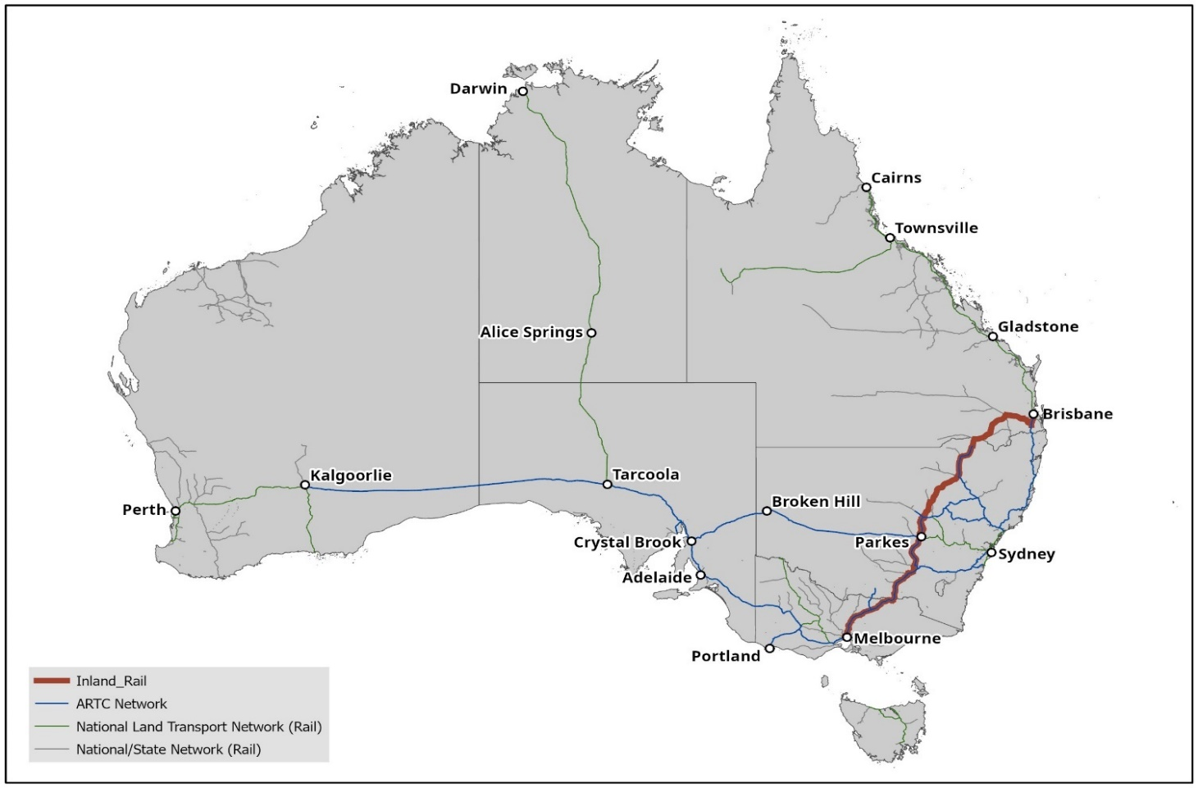

The principal users of this network are rail freight operators, although there is also some passenger traffic. ARTC revenue comes from the access charge levied on the users of its network. To maintain its business, ARTC must maintain track to a safe and reliable standard for its customers, upgrade its network as required, and assist in developing new business opportunities. Revenue is currently about $900 million per annum and notably about half of this comes from coal freight operations in the Hunter Valley.[4]

* 1. The Inland Rail proposal

The Inland Rail proposal was developed and refined through multiple studies that commenced with the North-South Rail Corridor Study in 2006. The intention was to provide a critical link in the existing national rail network to support supply chain resilience and provide additional freight capacity. When completed it would add about 1,700 kilometres of standard gauge line connecting Melbourne and Brisbane, and link the East-West interstate line from Melbourne and Sydney to Perth though the regional city of Parkes in NSW. **Figure 2.2** below provides a map of the Inland Rail project.

Major rail freight customers made a number of suggestions about the service Inland Rail needed to provide. First it should meet future freight needs. Second, they suggested that 98 per cent reliability was critical and that freight movements between Melbourne and Brisbane terminals in close to 24-hours was required for a competitive position with road freight. Finally, they noted the importance of appropriate terminal access and loading and unloading times to meet market logistic needs or availability. These early suggestions were repeated in submissions and meetings with me although, in the context of recent severe floods and bush fires, emphasis was more on resilience than on freight needs well into the future. The importance of the 24-hour time journey between Brisbane and Melbourne along with reliability remains a critical competitive requirement to move freight from road to rail.

Delivering Inland Rail to meet these types of requirements is not a particularly difficult construction along most of the route. However, there are three complexities in the project related to its extreme length. First, around 1,087 kilometres of existing track must be upgraded while existing services continue. Second, about 628 kilometres of new track must be built along with those brown field upgrades. To achieve planning and environmental approvals, and subsequent land acquisitions and access, means involving the jurisdictions of Victoria, NSW and Queensland. There are also 36 Local Government Areas, more than 11 First Nations communities and numerous local communities and property owners to be consulted. Finally, the most technically difficult parts of the project involve the steep descent down the Toowoomba Range in Queensland, and several rivers and major flood plains that must be crossed.

* 1. The importance of Inland Rail

The Inland Rail proposal is a major infrastructure project as I have just described. Its importance lies in the capacity it adds to the national freight supply chain and the provision of a cost competitive inter-capital freight service between Melbourne and Brisbane. Total domestic freight volumes are expected to grow by more than 20 per cent between 2018 and 2040 driven by both population and economic growth.[5] By 2050, it is estimated that almost 70 per cent of the freight to be carried on Inland Rail will be for domestic use. This includes household goods and groceries produced in Australia and consumed in our major cities, with over 50 per cent of this freight forecast to be carried between Melbourne and Brisbane to meet demand in South East Queensland for its rapidly growing population.

At present most rail freight on the east coast rail network does not compete favourably with road. The rail network is old and inefficient and restricts weight to single-stack trains and constrains travel times. This is particularly evident on the existing north-south corridor between Melbourne and Brisbane where passenger train preference, in and around Sydney, adds further time restrictions. The consequence is that rail freight cannot compete efficiently with road. The only route where rail does compete effectively with road is the long east-west route to Perth. On the east coast congestion on intercity highways is increasing significantly, and heavier vehicles and more congestion are increasing road maintenance costs and safety concerns. The added freight capacity that Inland Rail is intended to offer by the end of this decade is critical.

Recent disasters, including floods, fires and the COVID-19 pandemic, draw attention to the need for resilience in supply chains. Inland Rail provides additional resilience in the national freight network through an alternative north-south and east-west freight route, as well as through the provision of additional capacity.

It is also notable that the proposed route through regional areas improves access to ports and city markets and is anticipated to generate new business in the regions where freight transport links are both costly and limited. More generally, the connectivity with the National Land Transport Network should be improved and amenity for communities and their sustainability increase.

Thus, the important benefits expected from the Inland Rail proposal are increased capacity and reliability of the transport network, and notably reduced transit times between Melbourne and Brisbane with improved reliability. Industry has also noted the importance of the lower emissions trajectory that rail provides in comparison to road freight at the present time. This adds to the competitive offering and together these factors should shift freight from road to rail reducing road congestion and future highway and motorway expenditure. In addition, Inland Rail opens up country regions and their access to ports (including Newcastle and Port Kembla) and should stimulate business. This is discussed further in Section 7.

* 1. Implementation

The challenges in delivering this project do not seem to have been fully appreciated by either ARTC or its Shareholder when it was first given the go-ahead. To put the task in context, Inland Rail is the equivalent journey length of London to the Ukraine border; and while it does not pass through different foreign countries, it does, as I noted, pass through three states, the lands of at least 11 First Nations groups, 36 local government areas, numerous regional communities, and requires the establishment of a number of remote construction sites.

To get the project delivered a number of sequential tasks need to be completed. In summary these are:

* Clearly define and develop a detailed scope of work for the route. This entails dividing the route up into manageable sections and 13 sections are used for this purpose.[6] The scope must meet performance requirements as well as be prepared in detail for approval requests.
* Approval requests must be made and any amendments required must be met in some way. With a long project, through a number of approval bodies, this task is far from trivial.
* Once all approvals are gained any land acquisitions needed must be finalised with the relevant jurisdiction. While this process can be straightforward it can also be lengthy if compulsory acquisition is required.
* Following clarity of scope and project approvals, contracts for construction and related work can be tendered and finalised.
* Delivery and completion then must meet further approvals by ARTC (as the below rail operator) before commissioning can commence.

To deliver this project thus requires expertise in a range of matters. Because ARTC is fundamentally a below rail operator, it does not have all this expertise in-house. ARTC’s principal business is to sell train paths to its customers, and provide access to the network. Inland Rail, as a large infrastructure project, represents a very different business proposition. While ARTC does manage track maintenance and network delivery and upgrades, this prior work is not on the same scale as this project. Recognising this situation, ARTC set up oversight and management arrangements for Inland Rail to address the issue; but as my report makes clear later, these arrangements have not been sufficient to avoid the serious problems which this project now faces. A map of the Inland Rail route is shown in **Figure 2.2** below.

Figure 2.2: Inland Rail map[7]

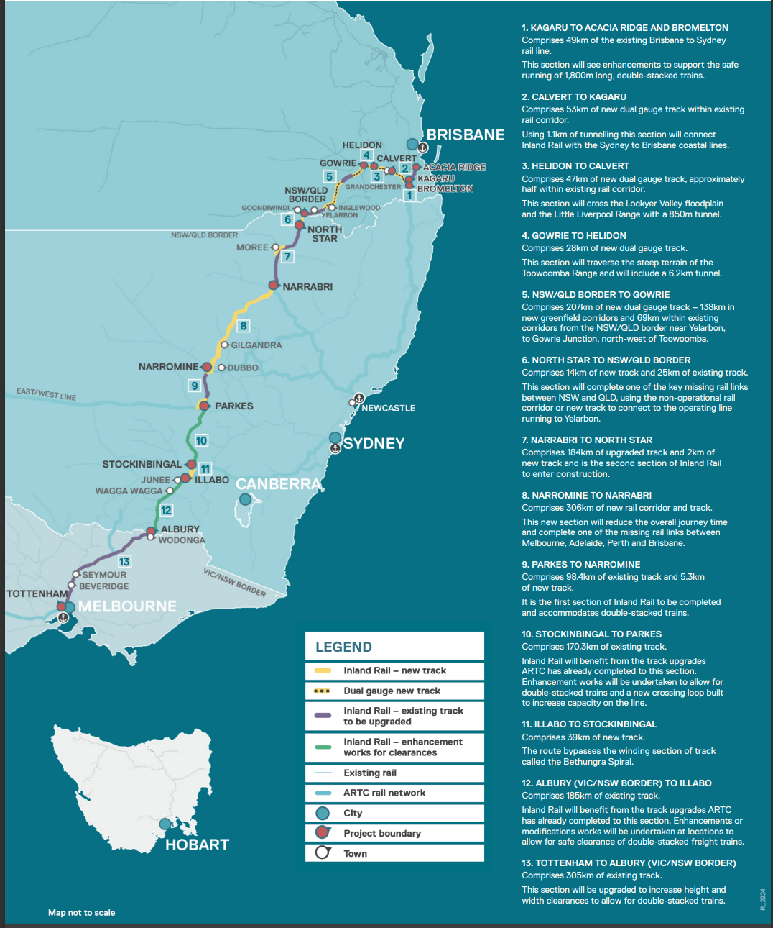

1. Governance and project delivery
   1. Current governance arrangements for Inland Rail

The governance and delivery of the Inland Rail project is the responsibility of ARTC, a Commonwealth-owned business. As well as delivering this project, ARTC is responsible for operating a large national rail freight business. Its governance arrangements are similar to any corporation. Its Board may have up to eight directors at any given time—a Chairperson, Managing Director/Chief Executive Officer and six non-executive directors. It has two Shareholder Ministers representing the Commonwealth Government as owner — the Minister for Finance and the Minister for Infrastructure, Transport, Regional Development and Local Government. Like any Australian company it has a legal foundation, and being a Commonwealth company, it is bound by the *Corporations Act 2001* (Cth) and the *Public Governance, Performance and Accountability Act 2013* (PGPA Act). It is guided by the Commonwealth Government Business Enterprises—Governance and Oversight Guidelines.[8]

It is important that the Board has the skills and expertise to conduct its business. At this level of governance, the Board’s responsibility is to develop strategy in line with the objectives set by the Government, and ensure that this is implemented by management. It must keep its Shareholder informed of progress, and any changes to the direction of the company it proposes. It should also appoint the appropriate senior managers to implement and deliver the business strategy and follow up that implementation is occurring as expected. The budget to deliver the business should be agreed with the Shareholder and appropriate reporting of the financial position of the company is essential. Various legal requirements must be met.

There is no doubt that both the Inland Rail project and the operating business of ARTC are facing present and future challenges. As noted later, in Section 6 of this report, Inland Rail is over budget and delivery is well behind schedule. The operating business of ARTC faces ongoing competitive pressures from road haulage and its reliability has been questioned by the rail freight operators consulted during this Review. It is also notable that severe flooding events are an added challenge and in future decades the profitable coal haulage business is likely to decline.

All these matters demand the attention of a capable Board to develop strategy, keep its Shareholder informed of changing circumstances, and guide management. To ensure competence of the Board the Shareholder Ministers receive a regular review of Board skills which the Board conducts. These skill reviews usually involve an individual director self-assessment against required skills conducted annually. It is common for an outside review to be added to this assessment every few years. The term of a director is typically three years; however, this can vary in length to stagger term end dates and minimise future disruptions due to Board turnover. Appointments are usually not extended beyond two terms, unless there is a strong case for doing so. For these reasons, it is important to ensure that the Board mix of skills be kept up to date and relevant. As Board vacancies arise, the Chairperson, on behalf of the Board, must indicate to the Shareholder Ministers where skills gaps may be arising.

The current skills mix of the ARTC Board has recently been assessed against 18 criteria. Omitting the Managing Director from consideration, the results suggest the Board is strong in the five areas of accounting, legal, working with government, business management, and regional and remote expertise. On the other hand, the Board is weak in five areas: technical/engineering, safety, environment and sustainability, marketing and communications, and procurement and contracting. It has rated itself as ‘average’ on rail matters, community sector, governance and risk, transport and logistics, infrastructure knowledge, and project management skills.

A Board tasked with managing a large rail freight operations company and delivering a major linear infrastructure project needs to be strong in all the matters in which this Board is weak, and preferably stronger in rail knowledge, transport and logistics, governance and risk, and project management. There is nothing astonishing about these skill requirements for ARTC and, in fact, ARTC has assured me that its desired skill mix was made known to the Shareholder Ministers of the former Government who were responsible for the latest round of Board appointments. This advice, given by the Chairperson at the time, was not heeded by Shareholder Ministers (and presumably Cabinet) at a time when these types of skills were critical for the Board. As a consequence, the ARTC Board appointments in 2022 did not reflect the skills required to govern either rail freight operations or a major infrastructure project. While the people appointed are not without skill, their expertise is not in the areas that ARTC requires.

While Ministers, as Shareholder representatives, have every right to appoint whom they choose as directors they also have an obligation to ensure that the business is governed properly and this means paying attention to the skills that are needed. Shareholder Ministers of the former Government did not meet that obligation.

The current Shareholder Ministers have three vacancies arising on the ARTC Board, including the departure of the Chairperson. This provides an opportunity to at least partly address the gaps in the Board’s skill requirements. The retirement of the most recent Chairperson adds a further gap in regional knowledge and infrastructure, which reinforces the need to address the situation.

Finding

The skills mix required by the ARTC Board for its operational business and to deliver Inland Rail was not heeded by the Shareholder Ministers of the former Government despite advice given by the ARTC Board at the time.

Recommendation 1

The Shareholder Ministers should address the skills requirements of the ARTC Board with their next appointments and continue to address these skill requirements.

While beyond my Terms of Reference for this Review (as outlined in Section 1.2 above) I note that the obligation of Shareholder Ministers to appoint directors with the skills required in a GBE is a serious matter. Many of these businesses are large and important for Australia, and too often the obligation to meet the skills mix requirement of their Boards is not met. Some Board appointments in recent years provide evidence supporting this concern.

* 1. Project management arrangements

The management of the Inland Rail project is the responsibility of ARTC who not only manage Inland Rail but also their business-as-usual rail operations. This total management task is conducted by the Chief Executive of ARTC through an organisation structure that is shown in **Figure 3.1**.

Figure 3.1: ARTC’s current organisation structure

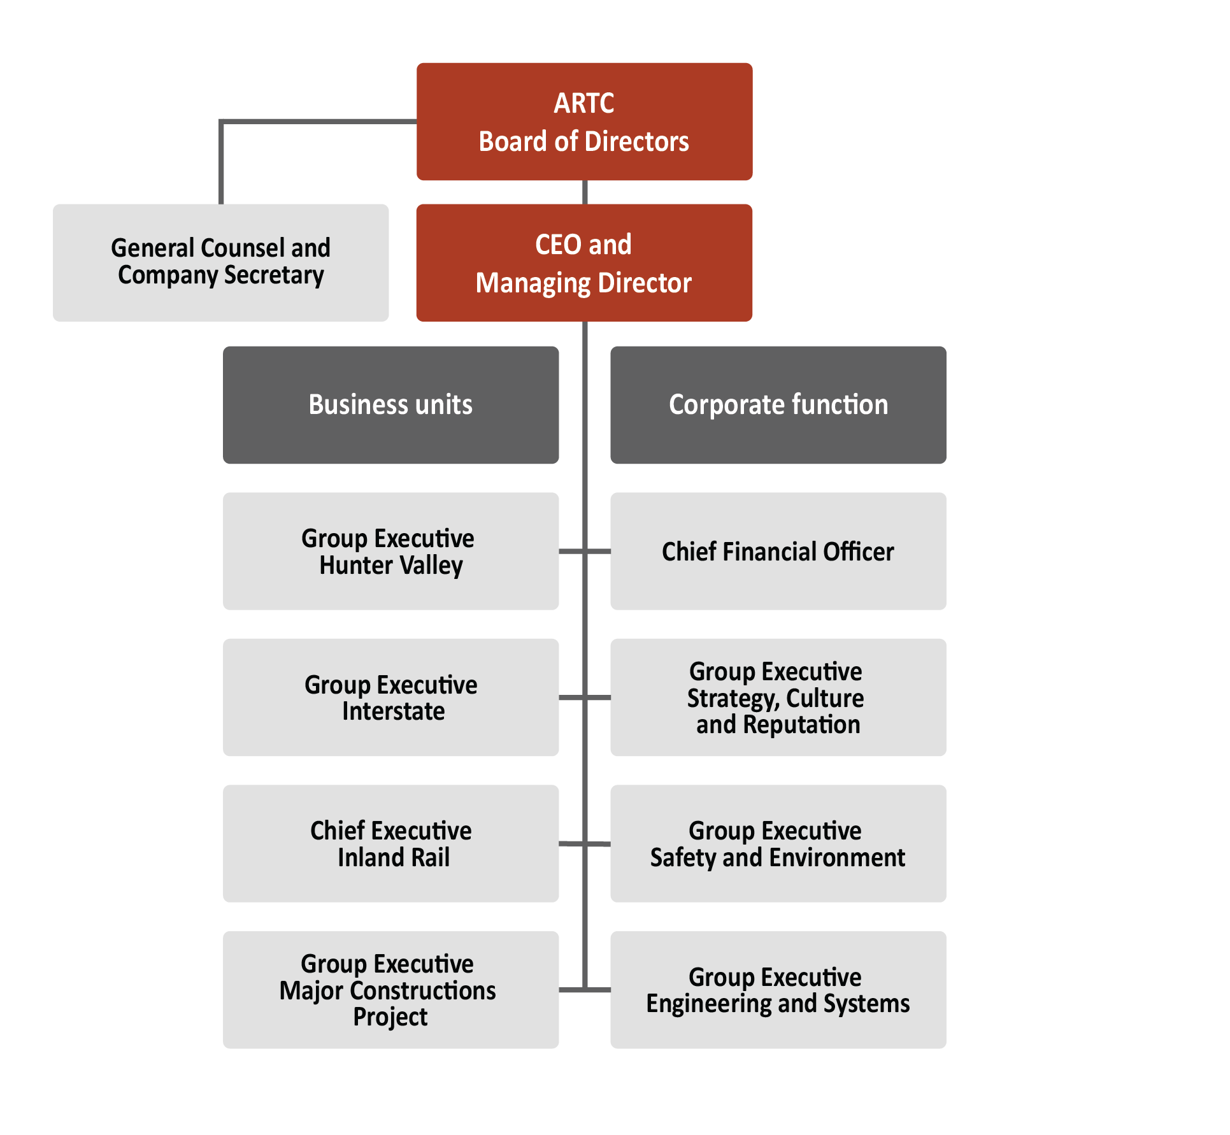

As this structure shows, the Inland Rail project is being run as a division of ARTC. The project does have a Board Sub-Committee overseeing its work but the Chief Executive of Inland Rail is in effect an Executive Divisional Manager reporting through the ARTC Chief Executive to the ARTC Board. The reasoning behind this organisation structure is to ensure that Inland Rail is delivered in line with the operational requirements of ARTC. Across Inland Rail, ARTC will own, maintain and operate the line (with the exception of the sections from Toowoomba towards Brisbane which are expected to be delivered through a PPP that is intended to maintain this part of the route for the length of the 30-year concession period). ARTC will run the rail operations along the entire route, including this section.

Given the size and complexity of the Inland Rail project, this structure has a number of risks. The first is that a first-rate Chief Executive to deliver a major infrastructure project like Inland Rail is unlikely to be prepared to take a position where they do not separately report to the Board and where they do not have full control over their project administration and approval processes including such matters as budget, planning, employment terms and conditions, and the like. The setup of these matters in an operational company like ARTC is different from that in project delivery where timely responses are critical and responses must be agile, albeit within a well audited environment.

The second risk relates to the large project taking over and dominating the operations of business-as-usual at ARTC. Managers can get distracted from their usual tasks and basic rail operations can be impacted in a way that is a threat to core ARTC business. The core business of ARTC is important for Australia and not without its own challenges.

The third risk relates to the need for ARTC to recognise that the costs and budget of Inland Rail need to be clearly ring-fenced from the rest of ARTC operations. If this does not occur an incorrect allocation of costs between ARTC and the Inland Rail project can cause the budgetary position of Inland Rail and ARTC to be inaccurate.

During the course of the Review there were signs that these risks were present. The Inland Rail project has been without a substantive Chief Executive since July 2021. This situation is not viable and is unfair to the present acting occupant. The current arrangement has also taken that occupant away from an area of responsibility where her expertise is needed on a full-time basis.

It was also evident that certain approvals are not being reached in a timely manner that befits project delivery and management. Establishing appropriate governance arrangements that are fit for purpose would improve administration and management. Agility and prompt response are not presently attributes that can be made about the Inland Rail project delivery. Present governance arrangements also showed no clear evidence of tight budgetary ring-fencing of the project.

Finding

The Inland Rail project has been operating without a substantive Chief Executive since mid-2021, a situation that is not viable. A first-rate Chief Executive, reporting directly to its Board is essential to the delivery of the Inland Rail project.

Recommendation 2

The position of Chief Executive of Inland Rail should be filled substantively as soon as possible.

The Chief Executive of Inland Rail must also have responsibility to govern and manage the project in ways that can be different from those within ARTC’s ‘business-as-usual’ where required. Process approvals, budget management, and terms and conditions of employment may need to be flexible as is typically the case on major projects. This does not lessen the need for financial controls and appropriate contracting and audits but it must allow more agility and management of timely delivery.

Improving the management of Inland Rail, and adding further Board skills, could be achieved through the establishment of a subsidiary company of ARTC to deliver the Inland Rail project. The Board of the subsidiary should be small, with membership comprising a subsidiary Chair and subsidiary directors with specific capabilities to oversee a project of this complexity. This board should also include the Chair of ARTC as an *ex officio* subsidiary board member to ensure that the delivery of Inland Rail is consistent with ARTC operating requirements and that the Board of ARTC has clear visibility of the project. Further ARTC representation on the subsidiary Board should be limited to not more than one additional ARTC Board member, and only if their skills and capability complement the composition of the subsidiary board.

The Chief Executive of Inland Rail should report to the subsidiary board and attend the main ARTC Board to provide any information required about the Inland Rail project including progress updates. The position of Managing Director/Chief Executive of ARTC should continue the role of managing an operating rail company and focus entirely on that work, reporting through to the main Board about the operations business.

The current Board has two directors whose terms are either due to end soon or have ended and the Chairman retired at the end of November 2022. In replacing or reappointing these three positions, the consideration of skills is critical. Given the major gaps in skills that have arisen, the particular skills needed to oversee the Inland Rail project should be concentrated in the subsidiary company though also represented to a lesser extent on the main ARTC Board. The main Board should gain skills particularly relevant to rail operations and the maintenance of existing track and its interoperability with other transport modes. The approach is set out in **Figure 3.2** below.

Figure 3.2: Proposed ARTC/Inland Rail subsidiary organisation structure

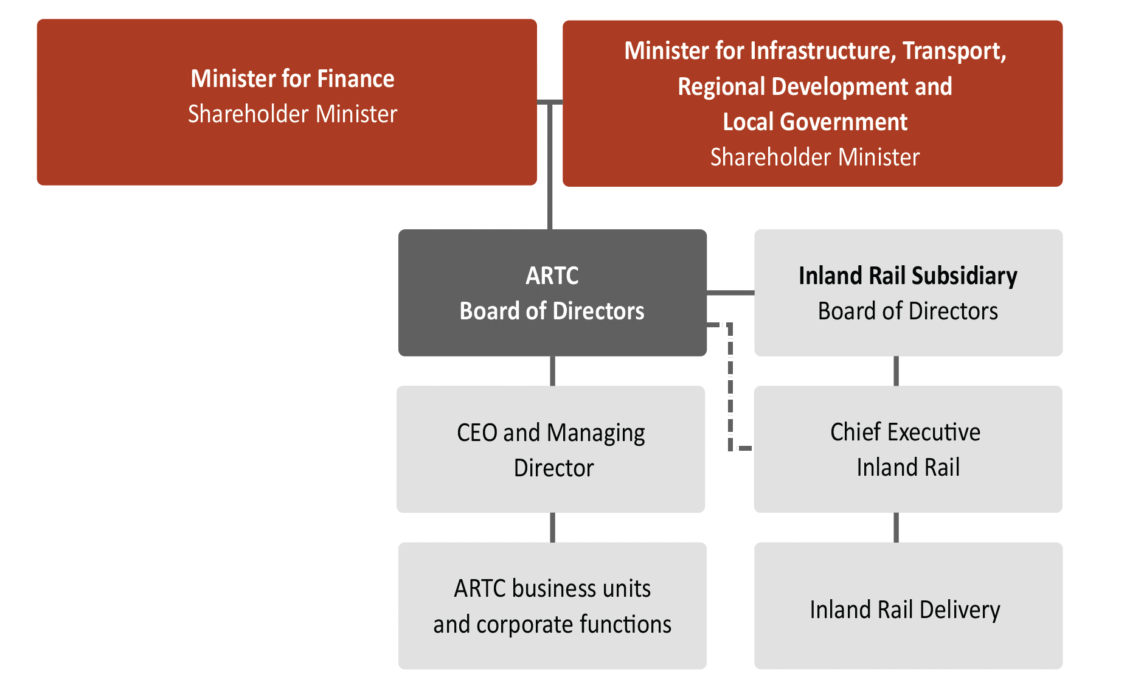

Finding

Delivering Inland Rail as a division of ARTC has created a number of significant governance, budgetary and management risks. The size and complexity of the Inland Rail project is also such that it requires deep experience in infrastructure project management and has distracted from the day-to-day business operations of ARTC which themselves do not appear to be tightly ring-fenced.

Recommendation 3

ARTC must have governance arrangements to deliver both the Inland Rail project and the business-as-usual operations of ARTC. This can be achieved through the establishment of a subsidiary company of ARTC.

The subsidiary company should have a dedicated board, say five members, and should include the Chair of ARTC as a board member to ensure clear visibility of the Inland Rail project to the ARTC Board, with further ARTC representation limited to not more than one additional ARTC Board member.

The Chief Executive of Inland Rail should report to the subsidiary board and attend the main ARTC Board meetings to provide any information required and project updates.

The particular skills needed to oversee the Inland Rail project should be concentrated in the subsidiary (although also represented in the ARTC Board). The Chief Executive of Inland Rail should report directly to its subsidiary Board and have full control over their budget, approvals, employment and other matters a major project Chief Executive would expect to control.

Recommendation 4

The position of Managing Director/Chief Executive of ARTC should:

* + focus entirely on the role of managing an operating rail company;
  + ensure that the Inland Rail project and ARTC business-as-usual operations are tightly ring-fenced; and
  + continue reporting through to the ARTC Board about the operations business.

ARTC’s Shareholder Ministers last issued a Statement of Expectations to the Company on 27 June 2018.[9] This current Statement of Expectations focusses mainly on the delivery of Inland Rail. Usually a Statement of Expectations would address wider concerns of the business, be re-issued periodically, and reviewed regularly as strategy changes to address expected business conditions and operations.

The Statement of Expectations should have particular regard to the communications between the company, the Shareholder Ministers and their departments. It should also address how risks are managed as well as reported. This Review has made clear that there was a lack of knowledge by the ARTC Executive and Board about problems with the project, and these issues were not appropriately highlighted to Shareholder Ministers and their departments. Significant deficiencies in ARTC’s monitoring and reporting processes are apparent along with inadequate Shareholder briefing.

Finding

The Statement of Expectations for ARTC was last issued in 2018 by the former Shareholder Ministers, and focussed primarily on ARTC’s delivery of Inland Rail. Statements of Expectations are an important tool for Shareholder Ministers to provide necessary and contemporary guidance and expectations for a GBE.

Recommendation 5

The Statement of Expectations issued by the Shareholder Ministers of ARTC should be reviewed and provide the necessary clarity and guidance to enable the ARTC Board to effectively deliver the Commonwealth Government’s objectives. It should then be reviewed periodically to ensure it remains fit for purpose and continues to reflect the Government’s objectives for ARTC.

* 1. Risk management

ARTC has a number of reporting obligations set out in various pieces of legislation, as well as contractual and policy instruments.[10] *Inter alia* ARTC must report and notify its Shareholder Ministers of its key risks. Most of these reporting requirements are summarised in the Commonwealth Government Business Enterprises — Governance and Oversight Guidelines and ARTC is formally required to comply with these Guidelines through its constitution. The Project Development Agreement for Inland Rail and the Equity Financing Agreement also impose risk reporting obligations.

The Corporate Plan is the higher-level document where material risks should be identified and evaluated. The matters to be noted there include the risk likelihood, the potential consequences for planning and financial projections, and the strategies for the management of those risks. ARTC also produces Quarterly Progress Reports for its Board Sub-Committee on Inland Rail, backed up by Monthly Flash Reports and these include risk identification, risk likelihood and a consequence rating. Shareholder departments have also started working with ARTC on a Shared Risk Register which has detail concerning the risk likelihood, the consequence, the steps needed to mitigate the risk, and finally the area responsible for taking those steps.

My cursory review of the more recent of these reporting documents suggests that the most severe risks at present are related to the timing of approvals and subsequent construction delays. These clearly dominate the risk registers along with serious concern that their approved budget may not be enough to cover the cost of Inland Rail including the annual payments required for the PPP project in Queensland. This project covers the technically difficult construction down the range from Toowoomba and has a 30-year concession period with annual payments. In the internal project risk reporting there are also health and safety risks identified as high risk and a risk that additional scope may be needed to address stakeholder concerns.

Risk management by the Inland Rail project team is satisfactory in that the main risks appear to be identified. There are three areas where improvements should be considered. First, whether any severe or high-level risks are being omitted from the registers. Second, whether the mitigation strategies proposed are appropriate. The mitigation for delays in planning, biodiversity and environmental approvals is obviously taking care to submit exactly what the particular jurisdiction requires under their processes. Inland Rail cannot expect any special treatment in this regard. Having submitted properly, the process can still be lengthy and further risk mitigation is usually needed. For example, providing the jurisdiction with resources is common practice amongst approval seekers. Similarly, while there is a delay it must be accepted that certain work is best held over until approvals are in place. Trying to progress too quickly can cause costs and prolongation.

There are also matters within ARTC’s control that might be managed more optimally. For example, completing continuous sections of the project, say from Melbourne to Parkes, requires possessions of brownfield sites that slows down construction progress significantly. Possessions incur a cost in lost business from the current operations and for that reason their duration is typically limited. However, a completed continuous section of the route also brings more revenue through more efficient freight haulage capacity and this benefit may outweigh possessions cost. Optimisation of possessions should be considered.

The final area for risk improvement relates to reporting. Despite the extensive reporting obligations faced by ARTC there did not appear to be a full understanding of the key severe risks and their mitigation strategies at the ARTC Board or by Shareholder Ministers or their departments. This matter can be remedied quickly.

Finding

ARTC’s risk mitigation and reporting processes need to improve. There should be a focus on ensuring that ARTC’s risk management and related mitigations for severe and high-level risks are escalated to the Board for full discussion. Key risks must also be flagged with Shareholder Ministers and their departments along with the mitigation strategies being pursued.

Recommendation 6

The Inland Rail project team should review its risk management systems and ensure there are appropriate triggers and metrics for the timely escalation of key risks and importantly their mitigation strategies to the Board, Shareholder Ministers and their departments. Reporting processes about risk management, including reporting processes documented in governance arrangements between Shareholder Ministers, their departments and ARTC, should also be reviewed.

1. Inland Rail Service Offering
   1. Future freight demand and the service required

Australia’s freight task is projected to grow by more than 20 per cent between 2018 and 2040, which is an additional 130 billion tonne kilometres of goods to be transported annually. This is depicted in **Figure 4.1** below. The projected increase is driven by population growth — expected to reach 33.1 million by 2040 — and growth in consumer demand (non-bulk freight).[11] As the figure shows, in the period 2015-20, the total freight task grew by 53 billion tonne kilometres, or 7.3 per cent. The average annual growth rate was 1.5 per cent. This growth is expected to be met by a major increase in road freight and a lesser increase in rail freight. Coastal ship and air freight remain steady.

Figure 4.1: Australia’s Freight Task[12] [13]

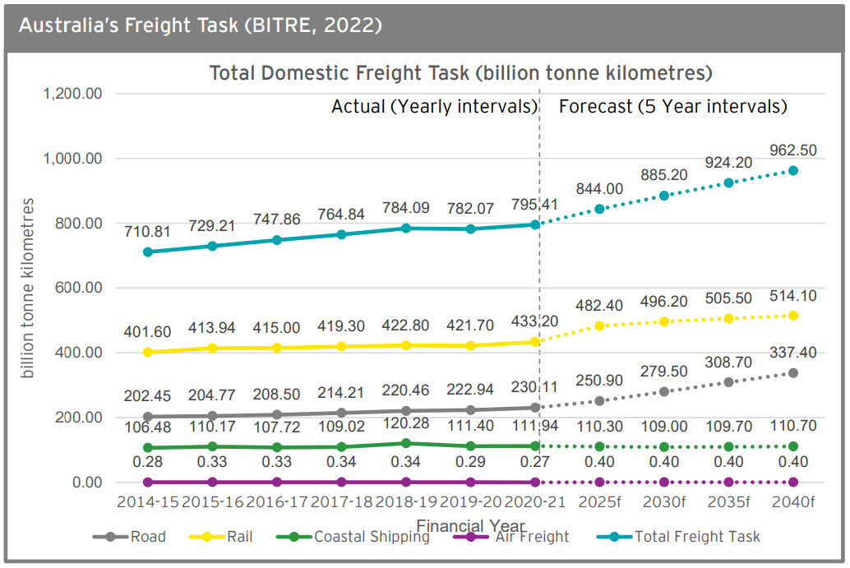

The major freight flows on land are along the east coast between Melbourne and Brisbane, and west to Perth from the eastern capital cities. North-south interstate flows are typically non-bulk freight, with demand influenced by population and economic growth. At present this north-south non-bulk freight is predominantly carried by road. Rail freight is not competitive on this route as it is slow and unreliable. Rail freight services at present follow a single slow east coast path passing through a congested Sydney rail network where passenger services have priority restricting freight operational time.

Freight volumes east-west, on the other hand, are mainly carried by rail which is competitive with road on that route. The east-west freight is typically intermediate and final consumption goods.

Most freight in Australia is bulk: mainly export iron ore and coal. Of the non-bulk freight (26 per cent of the total) only around 16 per cent is transported by rail. This is shown in **Figure 4.2** below.

Figure 4.2: Non-bulk Freight by Mode 2020-2021[14]

Interstate non-bulk rail freight is projected to grow by approximately 2.8 per cent a year between 2018 and 2040. Unless the share of that freight carried by rail is increased the congestion on roads will become severe and add to maintenance costs and road upgrade requirements. Further, BITRE estimates that Inland Rail will support the increase of north-south non-bulk rail freight by approximately 0.6 per cent a year.[15]

Freight operators told me in the Review that rail freight is becoming more competitive with road. There were four main reasons given for that assertion. First, freight operators are facing increasing pressure from customers and government to reduce emissions. Rail presents an opportunity to assist in their decarbonisation being four times more fuel efficient than road freight. On that basis Inland Rail is forecast to cut carbon emissions by 750,000 tonnes per year through and reduce truck movements by 200,000.[16]

Second, the impact of the COVID-19 pandemic on border closures and an unprecedented demand for consumer products and services, led to skills shortages for truck drivers and other skilled workers across the supply chain. In the longer term these pressures are increasing as the workforce ages and notably the transport, postal and warehousing industry has the second-oldest industry workforce in Australia.

Third, rail freight can be cost competitive if its service offering is adequate. The service offering requirements for Inland Rail are designed to meet this competitive requirement and are explained below. Modelling by the CSIRO has identified that there is a possible $213 million reduction in transport costs each year across 22 million tonnes of freight as a result of freight moving from road to Inland Rail. Cost savings per tonne for this freight shifted from road to rail could be an average of $80.77.[17]

Finally, Inland Rail supports the resilience of supply chains and the freight network. It simply provides an additional rail line along the north-south corridor and thus improves the freight network’s ability to operate through incidents and outages caused by unforeseen events like natural disasters.

A service offering for Inland Rail was developed by ARTC in 2014 in great detail after consultation with the freight and logistics industry.[18] Without getting into specific detail of that offering, its aim is to provide a cost effective and efficient freight solution that is competitive with road and can meet forecast rail freight needs over the next 50 years. At present, the transit time for freight between Melbourne and Brisbane is approximately 32 hours via the existing east coast rail line and between 18-30 hours by road if multiple drivers are used.

Freight companies all agreed in this Review that the service offering must have the following attributes:

* reliable service;
* less than 24-hour transit time between Melbourne and Brisbane; and
* an ability to transport double-stacked container freight to the intermodal terminals.

Business also noted that the positive environmental (reduced carbon emission of goods per kilometre/tonne) and safety benefits of rail over road transport are important considerations for companies when selecting a transport mode for their freight.

To meet these requirements ARTC has determined a route alignment that can provide a transit time of about 24-hours, and planned a track standard that enables double-stacking and reliable service. The length of trains at 1,800 metres is sufficient for the forecast freight task until at least 2040 and passing loops have been built to accommodate that size.

Finding

To move freight from road to rail the service offered must be competitive. The service offering proposed by Inland Rail is designed to meet these competitive criteria.

Recommendation 7

The service offering proposed by ARTC, and supported by business, that offers a reliable 24-hour transit service on double-stacked trains of 1,800 metres length should be accepted.

* 1. Melbourne terminals

About 80 per cent of Melbourne freight is currently handled at Dynon, to the south of the CBD. Dynon is split into two intermodal facilities operated by incumbent freight operators – Qube at North Dynon and Pacific National at South Dynon.

Dynon has two issues. First, as the ACCC has stated on a number of occasions, incumbent freight terminal operators are not motivated to encourage new entrants. Indeed past evidence suggests that incumbents use their terminal operations to strengthen their market position at the expense of their existing and potential competitors. Second, Dynon faces a number of short to medium term constraints – it is approaching full capacity and, in any case, cannot handle 1,800 metre double-stacked trains. For these reasons, and because of significant conflicts with the passenger network, there are plans to close Dynon in 2031 on the expiry of its lease. Remediation works must be undertaken by the lessees before the lease expires, thus necessitating withdrawals from Dynon from 2028-29.

Two suitable replacement sites for Dynon have been identified. The Western Interstate Freight Terminal (WIFT) or Truganina in Melbourne’s north west, and Beveridge in Melbourne’s north. Both sites are in Victoria’s long-term freight strategy to meet the growing freight task and rail volumes.[19] The map at **Figure 4.3** below shows the positions of WIFT in the north-west and Beveridge in the north and it is obviously desirable to have both intermodal terminals considered in the context of the Inland Rail project.

The WIFT can be developed on 990 hectares of agricultural land about 20 kilometres west of the Melbourne CBD. It is located next to an established logistics catchment area within the western State Significant Industrial Precinct and near vacant land earmarked for future warehouse development. The Department has advised that WIFT can be connected to ARTC’s Western Line through development of the southern section of the Outer Metropolitan Rail at an estimated cost of $1.8 billion.[20] The timing of this future WIFT-related development and associated land acquisition is beyond 2031 and later than the Dynon closure.

There are two complementary ways to deal with the problem. The first is to develop the smaller intermodal site at Beveridge about 40 kilometres from Melbourne. The site is 1,100 hectares and is directly adjacent to Inland Rail in the north and does not require significant rail connections. Some small-scale road upgrades are needed to facilitate truck movements and these can be done expeditiously. The Beveridge site is greenfield and able to accommodate co-location of warehouses and freight customers with further development including an Import-Export Terminal in the future. Beveridge completion is possible by 2027 with basic operations possible before then to be more aligned with that completing the Inland Rail section to Parkes and increasing freight requirements.

Industry participants commented in their meetings with me that Beveridge permits double-stacking and efficient container traffic between Melbourne and Parkes and then through to Perth on the East-West interstate line. The travel duration on this route is longer than ARTC’s existing western line from Melbourne but the economies of scale from double-stacking and longer trains add efficiencies and cost savings. Beveridge can also connect through to the Port of Melbourne with single-stacking smaller or shuttle trains, which is a sufficient requirement for connection to the port.

Figure 4.3: Melbourne Intermodal Terminals

In the immediate future the development of both Beveridge and WIFT should proceed. Beveridge can provide services in the north and east until capacity is reached, predominantly servicing Inland Rail. WIFT can develop gradually, serving the north-west and over time will become the larger intermodal terminal. Analysis by EY suggests that both terminals are commercially viable and both have potential upside from warehousing provision.[21]

The early development of Beveridge and the complementary development of WIFT, and initially the Outer Metropolitan Rail South corridor, was supported by Victorian government officials. All freight operators, the Port of Melbourne and the Australian Logistics Council also support this approach. While some stakeholders have indicated that a connection to WIFT via Outer Metropolitan Ring North should be considered, this is likely to be cost prohibitive and not needed for Inland Rail in the near or medium term.

It is important in my view that these new terminals be run as open access terminals to allow both new entrants and incumbents to operate in a fair manner. This means that no terminal should be managed by a rail freight operator though they may be permitted to lease parts of the terminal from an independent terminal operator/landlord for their particular needs. Independent warehousing should also be on offer as well as leases available to major users such as Woolworths and Coles.

National Intermodal Corporation is a Commonwealth-owned GBE set up to provide open access and warehousing in this situation. They have an option to purchase the land at Beveridge, which must be exercised by 28 February 2023. Doing so is subject to further Government decisions but would de-risk delivery timing of the precinct.

Finding

With the closure of the Dynon terminal and the completion of Inland Rail, the need to plan and deliver intermodal terminal operations in Melbourne is becoming urgent. There are two complementary sites that would meet immediate and near future needs and these should be progressed. Open access is desirable in line with ACCC concerns about competition in the freight industry.

Recommendation 8

Two new intermodal terminals should be developed concurrently in Melbourne. Beveridge should be available as soon as practical and the second, WIFT at Truganina, should in due course expand and become the larger operation. Both terminals should be operated by independent operators providing open access to all rail freight operators. Given that National Intermodal Corporation has an option to purchase land at Beveridge and is a Commonwealth-owned GBE that can offer open access and independence from freight operators, preference should be given to it to develop Beveridge on those conditions.

* 1. Brisbane terminals

At present Brisbane and South East Queensland are serviced by two terminals capable of providing interstate intermodal services — Bromelton and Acacia Ridge. Acacia Ridge is expected to reach capacity in 2025-27 and cannot accommodate the longer 1,800 metre double-stacked trains that are expected to use the Inland Rail network.

The Commonwealth and Queensland Governments have been considering the business case for intermodal terminals in South East Queensland along with warehousing and logistics requirements. This work, partly funded by a $10 million contribution from the Commonwealth Government, will be completed in mid-2023. Without seeking to pre-empt the outcome of that business case and noting that it may be subject to change, I observe at this time that Ebenezer is the preferred location for the intermodal terminal from the number of other sites that have been considered. I also note that some members of the local community do not favour an intermodal terminal development at Ebenezer at this time and the Commonwealth and Queensland Government need to provide more information about the benefits and costs of such a development. The possible locations for an intermodal terminal are shown in **Figure 4.4**.

Figure 4.4: Possible Locations for South East Queensland Inland Rail Intermodal Terminals[22]

In this study, Ebenezer is the best option when assessed against the ability to meet the Inland Rail service requirements, maximising rail freight competitiveness, proximity to end-user freight demand, and alignment and compatibility with surrounding land uses. Industry through the Review broadly supported Ebenezer, highlighting concerns with congestion at Acacia Ridge and noting the favourable road connections at Ebenezer to support the distribution of freight across Brisbane and to the Port of Brisbane. It is expected that the analysis and considerations by Government will finish in mid-2023.[23]

The proposed Ebenezer development needs to be appropriately staged and delivered to align with Inland Rail completion. The entry and exit points to the Ebenezer terminal for both road and rail must be constructed for maximum efficiency in terminal operations and further attention must be paid to the concerns of the local community who have informed me through several channels that they do not desire this terminal in their locality. Concern has also been expressed about a koala site nearby and this matter must be addressed.

Some rail operators seek to run a single-stacked service from Ebenezer to the existing terminals at Bromelton and Acacia Ridge and while Ebenezer is preferred, stopping Inland Rail at Ebenezer does not connect Inland Rail more broadly to the existing national network (unlike in Melbourne which still has the options of a single-stack operation to the port and other lines). Constructing a connection between Ebenezer and Kagaru delivers a more connected, resilient national network and provides an alternative route between Sydney and Brisbane in the event that the existing coastal route is unavailable as has been the case several times in 2022 because of flooding. This extension would also provide a route for Inland Rail through to the port in Brisbane.

The cost of extending beyond Ebenezer to Kagaru is currently estimated to be around $1.3 billion (on the basis of a double-stacked service) and an added $260 million from Kagaru to Bromelton and Acacia Ridge. Analysis suggests that rail volumes may decrease by 7.5 per cent in South East Queensland if this does not occur and this load would likely move to road with significant congestion implications. On the other hand, if double-stacking stopped at Ebenezer but a single-stack service was offered through to Kagaru there would be no decline in rail freight demand.[24] It thus seems clear that double-stacking should cease at Ebenezer with a single-stack service offered through to Kagaru. This necessitates a change to the Public Private Partnership scope where double-stacking is no longer required beyond Ebenezer to Kagaru. This should save significant cost and still deliver new network connectivity and resilience by providing a direct link between the existing Sydney to Brisbane north coast line and Inland Rail. This is discussed further in Section 6.1.

Finding

Within the city environs of Brisbane and its port there is no feasible way to operate 1,800 metre double-stacked freight trains. Smaller single-stacked train operations (as at present) are possible but there needs to be a terminal outside the city where large double-stacked trains can manage their load and have the option to single-stack beyond that point or switch to smaller vehicle road haulage for the end of trip. Considerable analysis has been done by Governments on the options to meet this requirement and the preference is to develop an intermodal and warehousing terminal at Ebenezer. A single-stack route for smaller trains to Bromelton terminal should continue and single-stacking through to Kagaru should be developed.

Recommendation 9

An intermodal terminal should be developed at Ebenezer so that its completion aligns with that of Inland Rail. The final site, lay-out and commercial model should be settled expeditiously between the Commonwealth and Queensland Governments. The terminal should be run independently by a terminal owner/operator with an open access regime. Governments should consider who that terminal operator will be but I note that such an operator already exists in the form of Commonwealth-owned National Intermodal Corporation.

* 1. Linkages to other freight operations

Parkes in NSW is at the main intersection between the Inland Rail Melbourne to Brisbane corridor, and the East-West interstate line to Adelaide and Perth. The Parkes Special Activation Precinct has taken advantage of this opportunity and focused development around Inland Rail and the Parkes Shire Council’s National Logistics Hub, where Pacific National and SCT Logistics’ terminals are already based. About 500 hectares of land has been set aside for terminal development. While some has been allocated to existing rail operators, a portion has been kept aside to establish an open access terminal operation.

Recommendation 10

The Commonwealth and NSW Governments should investigate opportunities for intermodal facilities at Parkes, possibly to be developed by the National Intermodal Corporation.

The development of a small terminal at Wagga Wagga is already underway with its first train arrival occurring recently. This development is linked to the Bowman business park and growth opportunities in the region are being actively sought. Other opportunities are being investigated at Narrabri and Narromine where regional businesses are exploring potential links through to NSW ports. While these opportunities may begin as small specialised freight links for particular products (like cotton) they can stimulate regional development and increase revenue for ARTC.

During the Review it became clear that terminals near Toowoomba are being planned for development. The Wagner group and Pacific National are proceeding with one such development and their terminal will link to domestic trade, as well as air freight for fresh produce to Asia.

As part of the work considering terminal options at Brisbane, consideration was briefly given to basing a large intermodal terminal at Toowoomba. This option was not pursued due to its significant distance from Brisbane, the low level of interest from industry generating concerns about the level of competition, and concerns about the additional road freight traffic this option would generate on the Warrego Highway.



More generally I note that Inland Rail, and the ARTC network, operate alongside other intra-state freight and passenger networks. There are about 13 separate Rail Infrastructure Managers and interoperability between them has been a problem since federation. There are multiple rail gauges, different signalling systems, rolling stock, and safe working arrangements. The differing arrangements often require costly and inefficient ‘work arounds’.

Perhaps the largest issue arising is an inconsistency of safe working rules and standards across different networks. This in turn causes problems for trains operating across different networks (including passenger trains) and planning to accommodate this reality is *ad hoc* rather than coordinated. This is particularly evident in differing signalling systems, communications, and train control systems. While not part of my Terms of Reference I note that ARTC is currently working on a new signalling system for its network, including Inland Rail in due course. Both industry and governments have raised concerns about the interoperability of this system with existing state signalling systems.[25] Given the importance of this matter for safety, this concern should be investigated further and ARTC must address the concerns raised.

Finding

Interoperability of different rail networks has been an ongoing problem for Australia since federation. Differences in signalling, communications, and train control systems are a particular concern because of their potential impact on safety.

Recommendation 11

ARTC should ensure that the new signalling system being acquired is interoperable with state systems, and if not what the options are to make it so, including possible replacement. Detailed discussions with other relevant Rail Infrastructure Managers must occur to address the issue.

* 1. Toowoomba to Gladstone Inland Rail extension

A business case is being developed for the extension of Inland Rail from Toowoomba to Gladstone. This study covers the route set out in **Figure 4.5** below and is expected to be completed in late-2023. It is not intended for this route to replace any of the existing Inland Rail route but rather to complement the service offered. The business case is being developed by the Queensland Government with oversight from the Commonwealth Government, which contributed $10 million for this work in September 2021.

The need, viability and timing of the extension is being examined, as well as how an additional rail connection to the Port of Gladstone could benefit businesses and communities in regional Queensland. The business case is also exploring commercial development and private sector funding opportunities.

The Toowoomba to Gladstone extension could provide a better-connected, more resilient and accessible rail freight network for some commodities. Increased export opportunities for the resource sector and agriculture producers may be potential benefits. However, infrastructure at the Port of Gladstone is limited and any investment in the extension must consider the further investment required at the port.

Over time, and once other ports such as Melbourne, Sydney and Brisbane become capacity constrained, Gladstone could become a fourth major port for import/export freight on the east coast. Such port constraints are not expected until beyond 2050 and my Review noted only limited support for the extension in the short to medium-term. It should not be seen as an alternative to Inland Rail linking to Brisbane as it does not cater for one of the main needs for Inland Rail, which is to service the growing population of South East Queensland.

Figure 4.5: The Toowoomba to Gladstone Extension[26]

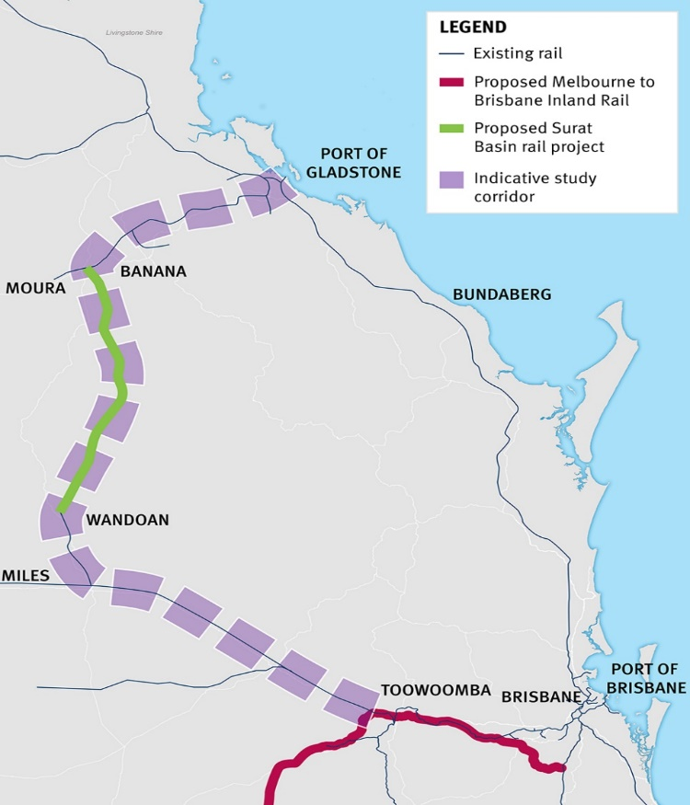

1. Process to select the route
   1. Initial assessments

The Inland Rail route was selected after numerous studies between 2006 and 2020. First, in 2006 a North-South Rail corridor was assessed for a railway between Melbourne and Brisbane. Then, in 2010, an Inland Rail Alignment Study[27] was conducted to determine a preferred route; this considered the viability of including several regional cities such as Albury, Parkes, Moree and Toowoomba. Next, in 2013, the Inland Rail Implementation Group was established to prepare the way for the delivery of the project. A freight service offering was formalised in consultation with a Stakeholder Reference Group. This led to the formalisation of the four service offerings: 24-hour transit time, 98 per cent reliability, availability, and cost competitiveness. In 2015 the Inland Rail Implementation Group report was published.[28] This report adopted the 2010 Alignment Study recommendations with some alignment variations for further consideration.

These studies iteratively refined the route to ensure that it would provide a cost competitive inter-capital freight service. This planned feature of Inland Rail is important. At present on the east coast the majority of freight, with the exception of coal, is carried on road in ever larger and heavier vehicles. As the freight task increases so does the importance of a competitive rail alternative. The freight industry stressed in their comments to this Review that rail is attractive when it is reliable and cost competitive, and it already has the advantage of significantly lower emissions per tonne carried. The selected route is thus intended to be reliable, cost competitive and more emissions reducing in its freight task than road. The selected route also provides increased connectivity across the existing national rail network adding new freight capacity and service pathways between regional and metropolitan centres and ports as far west as Perth.

The technical assessment of the route appears to have been conducted in line with industry practice. A Multi-Criteria Analysis considered the service offering, engineering and technical factors, social and community impacts, properties directly impacted, environmental and sustainability impacts, and the geotechnical, engineering and technical construction issues that arise in building a cross national rail line.

Once that analysis suggested a viable route, further assessment occurred to ensure the community and industry benefits were compelling and valuable. This then led to studies of more local regions to further refine the route. If these investigations found improvements to be viable these were included in the final rail corridor.

The route is considered in 13 sections, running south to north, between Melbourne and Brisbane. These sections allowed further consultation, detailed planning, and in due course construction. The 13 sections are listed in **Table 5.1** below, running north from Melbourne.

Table 5.1: Inland Rail sections

|  |
| --- |
| Inland Rail sections |
| Victoria |
| 1. Tottenham to Albury |
| New South Wales |
| 1. Albury to Illabo |
| 1. Illabo to Stockinbingal |
| 1. Stockinbingal to Parkes |
| 1. Parkes to Narromine |
| 1. Narromine to Narrabri |
| 1. Narrabri to North Star |
| 1. North Star to Border |
| Queensland |
| 1. Border to Gowrie |
| 1. Gowrie to Helidon |
| 1. Helidon to Calvert |
| 1. Calvert to Kagaru |
| 1. Kagaru to Acacia Ridge and Bromelton |

In Victoria, there is only one defined section from Tottenham to Albury. This passes through 13 Local Government Areas, covers 305 kilometres and intended construction is all brownfields work on existing and operational track. The recommendation in Section 4.2 to develop terminals in Melbourne at both Beveridge and Truganina (WIFT) means that part of this initial section between Tottenham and Beveridge no longer needs to be upgraded for double-stacking.

In NSW, there are seven sections between Albury and the Queensland border and 18 Local Government Areas are affected. These seven sections cover 1,029 kilometres of which 665 kilometres is brownfields work and 364 kilometres is greenfields work. The majority of the greenfields work in NSW (306 kilometres) is between Narromine and Narrabri and the Review received considerable comment on this section from the community. Concerns related to the route, the consultation process, land access, and impacts on agricultural land. The negative impact on agricultural land tied in with some parties preferring to see ongoing upgrades of the existing brownfield track as opposed to a new greenfield track being constructed on agricultural land. The new proposed track saves over five hours on the journey between Melbourne and Brisbane and this led residents to query the need for that 24-hour transit time. As noted earlier this time attribute is important for rail freight to be competitive with road.

Some residents wished to change the route to pass through Coonamble, and others wished to change the route so that it would completely avoid the Pilliga forest. The consultation undertaken by ARTC left residents feeling that the process was disingenuous. Concern was also expressed about trespassing on land by ARTC employees, and a need for greater clarity around drone use on property and the conditions of existing access arrangements. There was general displeasure with the perceived impact on the agricultural industry in the area and the disruption to their high productivity farmland. An increased flood risk that may be caused by the rail construction was noted. Several farmers requested additional fencing be provided by ARTC to add additional protections against passing trains and locomotives. Finally, residents expressed concern over the cost escalation of the project in its entirety and demonstrated a lack of trust in ARTC’s management of the project.

The other section in NSW that gave rise to significant community comment to the Review was the Albury to Illabo brownfield section which passes through Wagga Wagga. There were six specific community submissions: several residents were displeased with the route bisecting the town, the potential for noise walls to effectively ‘split’ the town in half, and suggested a bypass around Wagga Wagga. Others also requested new or upgrades to infrastructure where the rail passes through. Concerns around noise, traffic issues and the actual versus perceived benefit to the town with increasing numbers of trains running through it was understandably raised. Concern about flooding in the town, as well as impacts to flora and fauna were also noted. Comment was made about how land is acquired and the discomfort experienced in the compulsory land acquisition process as utilised by ARTC and the State Government.

In Queensland there are five sections covering 384 kilometres of which 118 kilometres is greenfield construction and 266 kilometres is brownfield work. The Queensland sections are causing the most issues at present for a number of reasons. The Intergovernmental Agreement between the Commonwealth Government and the Queensland Government about the development of Inland Rail was executed later than other state agreements.

This delay has been exacerbated by initially poor-quality Environmental Impact Statements prepared by ARTC that have not been capable of acceptance. Once these documents are accepted the next step requires gazettal of the route by the Queensland Department of Transport and Main Roads and only then can land acquisition, where necessary, occur. The poor Environmental Impact Statements at the beginning, contributed to an initial lack of confidence in the project. I am convinced that many of these problems are now overcome and I received more positive feedback from Queensland Government officials. Any steps that the Queensland Government, ARTC and the Commonwealth Government can take to progress these matters should be pursued noting that delays on infrastructure projects can be exceedingly costly and that at present the majority of Inland Rail is expected to be completed in other States about four years before Queensland completion.

There were 16 submissions received in relation to the Border to Gowrie section. Concerns expressed were similar to those expressed by many NSW communities, including concern about environmental impacts particularly on koala habitat, the erosion of farmland and the impact on productive agricultural land. The ARTC engagement process and consultation was also rated unsatisfactorily and there was added comment about the poor quality of the Environmental Impact Statements and its subsequent lack of acceptance. Some residents and the Lockyer Valley Regional Council (which represents Gatton) had similar concerns to those in Wagga Wagga about the existing train route that bisects the town having added noise and disruptions; and the potential for noise walls to exacerbate the impacts of the bisection.

Scepticism concerning the need for a 24-hour transit time from Brisbane to Melbourne was raised and some felt that ending the route at Gowrie (near Toowoomba) was adequate. There was some support for the extension of the route from Gowrie to Gladstone.

The route covering the three sections between Gowrie, Helidon, Calvert and Kagaru involves the descent from the Toowoomba range. Because of the engineering challenges with these sections a Public Private Partnership method of delivery was chosen. The designed solution is costly and this expense raised concerns. The cost issue is discussed in more depth in Section 6.3.

There were 27 submissions about the Kagaru to Bromelton and Acacia Ridge section of Inland Rail. This part of the route is largely urban and the unfavourable comments concerned environmental and social amenity impacts, particularly from noise and dust pollution. There was some preference expressed for the Gladstone-Gowrie connection and a recommendation that a terminal at Dalby be chosen to replace the Ebenezer proposal. Displeasure with the poor consultation was repeated along with concern about the cost of the PPP proposal. It was obvious from analysing the submissions, that communities were not fully across what Inland Rail was intending to provide for Queensland in particular, and by when, with many submissions using data and information that was inaccurate. Many people felt that the proposed benefits did not outweigh the negative impacts. More needs to be done by ARTC to better communicate the project and to work with those communities affected. This comment reflects similar sentiments to the Senate Inquiry into Inland Rail and ARTC should revisit the recommendations in that document.

* 1. Route modifications

In view of the extensive studies and consideration made to choose the initial route for Inland Rail there is no reason for route change in any major way. Where modifications appear to be needed are:

* In towns, like Wagga Wagga and Gatton, where the route bisects the town no immediate change should be made until there is a clear indication that train traffic is increasing. Modifications to lessen any increased disruption caused by more train traffic should be given very serious consideration and adopted. These changes may include treatment for noise, additional bridge crossings in the town and grade separation. Furthermore, once Inland Rail has been operational for some years (say 10-15 years) there should be a review of its current and expected impacts on the town. If these are significant or are expected to become significant then an alternative route avoiding the town should be planned and corridor easements preserved.
* In both Melbourne and Brisbane, the Inland Rail route should stop at terminals at Beveridge/WIFT and Ebenezer respectively. Routes for single-stacked smaller trains should be enabled beyond those points for connectivity to ports and other rail networks.
* Outside the capital cities attention should be paid to regional development opportunities so that access to the Inland Rail route is possible. Planned access, for example as is developing at Wagga Wagga, should be considered in appropriate places but not so numerous that operational efficiency is impacted.
* Intermodal terminals in the capital cities and at Parkes and Gowrie as discussed should be developed with the aim to be completed in line with Inland rail completion.

Finding

The route alignment chosen reflects the need to meet the service required to compete with road freight and hence move freight from road to rail. This chosen route raises concerns in country towns that it bisects and once rail traffic increases are substantial, or likely to be so, consideration should be given to bypass these towns. In areas where greenfield work is on agricultural land or through areas of biodiversity the consultation process must address these matters. In Queensland, issues around approval processes appear to be improving but this must continue to halt further delays in that State.

Recommendation 12

Where the Inland Rail route bisects regional towns the disruption that additional train traffic causes should be addressed by appropriate modifications to limit noise and enable adequate cross town access if that has not already been done. As Inland Rail train traffic increases significantly, the possibility to bypass the town should be investigated and easements protected for a new by-pass corridor.

1. Project scope, schedule and cost
   1. Scope

One of the main tasks of my Review was to advise the Shareholder Ministers about the likely time it would take to complete Inland Rail and its expected total cost. To enable this to be done with any confidence it is important that the scope of the work is as certain as possible, and where there are doubts about the scope these need to be fully understood and accounted for before a reasonable estimate of time and cost can be made.

At a high level the scope of this project is simply the route alignment and the specifications required for the service offering by Inland Rail to enable it to compete with road. The route alignment is settled (as set out in Section 5) but the intermodal terminals recommended earlier in Melbourne and Brisbane do cause changes to this high-level scope. In Victoria the one single section from Tottenham to Albury is now recommended to be constructed from Beveridge to Albury, with Beveridge operational in time for the completion of the Albury through to Parkes sections. The route through to WIFT (Truganina) should be developed to complement Beveridge with completion of WIFT not required for several years after Beveridge completion.

In Queensland, the recommendation is for the proposed development of an intermodal terminal at Ebenezer to proceed where the requirement for the double-stacking of trains is recommended to cease. Beyond Ebenezer a route through to Kagaru for single-stacked trains should be developed allowing smaller single-stacked trains to join the east coast rail network route and thus provide greater resilience to freight networks. The extension for single-stacking to Kagaru also opens the existing route to the small terminal at Bromelton and allows access through to Acacia Ridge on the existing network. As noted earlier in Section 4.3 it is not feasible or necessary to double-stack and use large trains beyond Ebenezer. The existing network, with the small addition from Ebenezer to Kagaru, allows smaller single-stack trains.

More detailed scope is required for the construction of each of the sections on the route and at this level of detail the scope is still not clear. While several sections are quite advanced, this is not true for most sections. In Queensland, for example, ARTC is largely still responding to submissions made on the relevant Environmental Impact Statements and planning approvals cannot be given, and any necessary land acquired, until this process is completed.

There is little doubt that the major task of delivering this project was greatly underestimated by ARTC and by the former Government as Shareholder. Rebuilding and upgrading about 1,087 kilometres of rail track where existing freight and passenger trains are operating is a major challenge; and a greenfield build of 628 kilometres of new track brings immediate change and disruption to prime farmland and regional and rural communities with resultant environmental impacts. Consultation that is both well informed and empathetic was and continues to be essential.

A summary of the progress in each of the sections in the project is summarised in the **Table 6.1** below using data up to September 2022. It shows that approvals have been given on most of the single Victorian section; in NSW the section from Stockinbingal to Parkes and Parkes to Narromine has been approved, and part of the Narromine to Narrabri section. All other sections in NSW are at different stages of their Environmental Impact Statement assessments and have not yet reached final approval; and in Queensland no sections have completed their Environmental Impact Statements and hence no approvals have been given. Construction is complete on the Parkes to Narromine section in NSW and has commenced on part of the Narrabri to North Star section.

**Table 6.1: Simplified Project Status \***

| **Inland Rail Project Status Overview (as at December 2022)** | | | | | |
| --- | --- | --- | --- | --- | --- |
| **Inland Rail Section** | **Design** | **Environmental Approval** | **Procurement** | **Construction** | **Operational** |
| **Queensland** | | | | | |
| **Kagaru to Acacia Ridge and Bromelton**  (Brownfield 49km) | Reference Design  (On hold) | Process to be confirmed | On hold | Not commenced |  |
| **Gowrie to Kagaru**  (Greenfield 128km) | Reference/  PPP bid design | Respond to submissions/ Request for Information | Preferred PPP proponent announced | Not commenced |  |
| **Border to Gowrie**  (Brownfield 69km)  (Greenfield 138km)  (Total 207km) | Reference Design | Respond to submissions/ Request for Information | Collaborative Framework Agreement announced | Not commenced |  |
| **NSW** | | | | | |
| **North Star to Border**  (Brownfield 25km)  (Greenfield 14km)  (Total 39km) | Reference/  Detailed Design | Final assessment | Collaborative Framework Agreement announced | Not commenced |  |
| **Narrabri to North Star** **Phase 1**  (Brownfield 171km) | Complete | Complete | Completed | Commenced – completion early 2023 | Partially operational |
| **Narrabri to North Star Phase 2**  (Brownfield 13km)  (Greenfield 2km)  (Total 15km) | Reference Design | Respond to submissions/ Request for Information | Collaborative Framework Agreement announced | Not commenced |  |
| **Narromine to Narrabri**  (Greenfield 306km) | Reference/ Detailed Design | Final assessment | Collaborative Framework Agreement announced | Not commenced |  |
| **Parkes to Narromine** (Brownfield 99km)  (Greenfield 5km)  (Total 104km) | Complete | Complete | Complete | Complete | Operational |
| **Stockinbingal to Parkes**  (Brownfield 170km) | Reference/ Detailed Design | Complete | Tender assessment | Not commenced |  |
| **Illabo to Stockinbingal**  (Brownfield 2km)  (Greenfield 37km)  (Total 39km) | Reference Design | Respond to submissions/ Request for Information | Tender development | Not commenced |  |
| **Albury to Illabo**  (Brownfield 185km) | Reference Design | Respond to submissions/ Request for Information | Tender assessment | Not commenced |  |
| **Victoria** | | | | | |
| **Tottenham to Albury**  (Brownfield 305km)  - **Beveridge to Albury** (Tranches 1 and 2) | Detailed Design  Reference Design | Complete | Tranche 1 - Complete  Tranche 2 - Tender | Tranche 1 – Commencing early 2023 |  |
| -**Tottenham to Beveridge** | On hold | On hold | On hold | Not commenced |  |

*\* This figure has been prepared based on data provided to the Department of Infrastructure, Transport, Regional Development, Communications and the Arts by ARTC. The Gowrie to Kagaru section of this diagram encompasses the Gowrie to Helidon, Helidon to Calvert and Calvert to Kagaru sections of the Inland Rail project.*

Where detailed design of the route has not been finalised or gained environmental approvals, contracts for tender cannot be finalised and tender outcomes including prices cannot be assessed. Construction has not commenced. It is not until a section is designed in detail and approved that a reasonably confident, though preliminary, estimate can be made. It is also not until the work is tendered that greater confidence can be placed in the estimates.

In 2020, ARTC made project time and cost estimates on the basis of an under developed scope, that have required major additions to it as reference designs have been further developed. Recent scope changes have included a design that is more mature though still not complete, changed regulations (particularly in areas of flood impact management, ecological impact and noise) and design changes to support community expectations.

ARTC has advised the Review that the additional scope falls into two broad categories:

* Scope necessary to deliver the core Inland Rail service offering that was not included in 2020, including engineering and technical requirements, and scope mandated by regulatory agencies as part of approval conditions.
* Scope added to meet the preferences and requirements of State Government agencies, local councils, and regional communities. There are numerous examples of these scope additions; some relatively minor and several quite major. An example of a major modification is a change to the route in Queensland to allow ‘future proofing’ for a possible future passenger service in the Inland Rail corridor. This has meant the addition of egress to tunnels for passenger safety and the widening of some bridges which would not be needed for a stand-alone freight corridor. More minor changes include the Burgess Road Bridge in Gatton, modifications to the Gowrie Junction Bridge to support local road access and Council future development plans, additional grade separations in Wagga Wagga, and station upgrades in Victoria.

Scope changes of this magnitude, over just a two-year period, demonstrate the immature state of the original design and planning work. Further examination shows, as I would expect, that the change is not uniform across all sections. In those few sections where designs are finalised, environmental and planning approvals have been made, and contract bids received from the market, the scope is stable. Estimates of time and cost to complete these sections in the latter case have substance and provide a level of confidence. However, this is not the case for most of the route.

An example of the problem is evident in the Albury to Illabo section of the project (in southern NSW). This is a relatively straightforward brownfield section but there is a significant change to the scope since 2020 due to basic items overlooked or omitted, including the need to improve horizontal clearances, and to upgrade pedestrian bridges to meet current accessibility standards.

Similarly, the impact of conditions attached to environmental approvals was apparently not well understood by ARTC in 2020, with enhanced scope required to be incorporated to meet approval conditions. While jurisdictional environmental requirements are now better understood there are still significant sections where design work is not finalised and environmental approvals remain outstanding. These sections thus have less scope certainty and cost and time estimates cannot be tested in the market through contract bids. As a result, I remain deeply worried about the level of scope maturity across the project as a whole and as a result the future impact on project cost and completion time estimates remains difficult to ascertain.

A detailed review of the defined scope of this project is warranted. The recommended terminals in Melbourne and Brisbane imply a defined completion point at each end of the route. This should be incorporated into the scope and I note that ending double-stacking at Ebenezer and requiring only single-stacking to Kagaru means the scope of the PPP must change.

There are also matters that impact scope which remain unclear. First, the allocation ARTC has made to balance the tension between upfront capital costs and future ongoing operational costs is not addressed transparently and indeed may not have been considered sufficiently. Second the cost of some scope items may have been improperly allocated to the Inland Rail project rather than to ARTC expenses. Third some scope costs allocated to the Inland Rail project may more properly be scope costs of a State or local government. For example, the ‘future proofing’ for passenger rail in Queensland is a State scope requirement and not technically part of the scope needed for the Inland Rail freight route. In my opinion a review of the scope of this project and underlying design solutions would be helpful to define its detail. This should examine the type of matters mentioned above along with the detailed requirements forthcoming from approval processes that are still underway. This detailed scope is needed to properly assess project cost and should be part of such assessment.

Finding

The terminal recommendations for Melbourne and Brisbane, if adopted, will change the route alignment at the end points of the project. At a more detailed level, because approvals for most sections of the route are not yet granted, the detailed scope cannot be defined with certainty. This is particularly evident in Queensland where for a number of reasons the approval process has proved difficult for ARTC.

Recommendation 13

The Commonwealth should engage an independent specialist to review the design solutions developed by ARTC to define the scope of the Inland Rail project and meet associated approval requirements and, working with ARTC, define exactly what the scope of this project is on the basis of the latest evidence available through the approval processes. The cost of scope provided beyond the freight requirements for Inland Rail should be allocated elsewhere as appropriate. This work should be coordinated with further cost estimation work discussed in Section 6.3.

Where there is still uncertainty due to outstanding approvals every effort should be made to understand the nature of the matters outstanding and assist the parties to reach an expeditious conclusion. There should be particular attention paid to the Queensland sections.

* 1. Schedule

The 2020 update estimated a completion of the full Inland Rail project by 2027. This schedule was heavily dependent on the timing of key milestones, and in particular obtaining environmental approvals and completing land acquisitions. It is now clear, on advice given to this Review, that the 2020 schedule cannot be achieved. At the date of writing ARTC expects the project to be completed in the early 2030s. In my view this estimate should be regarded with great caution, especially in the Queensland sections, until further work is done. The sections in NSW and Victoria are more advanced and their schedule appears achievable though some approvals remain outstanding. Of course, all infrastructure projects at present face challenges. Contributing to delays are skill shortages and supply chain issues for materials. The two big differences on this project are first the importance for the schedule of delays in planning and environmental approval processes. Being over 1,700 kilometres long, the need for approvals all along the route, is required. And to date, the efforts of ARTC and the various jurisdictions responsible for approvals, have typically not met the original target dates estimated by ARTC. Other approval related issues include new regulatory conditions related to flooding and climate change resilience, design changes required by Environmental Impact Statements, and modifications required to get community support in regional towns.

The second big difference on this project is that over 70 per cent of the route is brownfields construction. This means work is being conducted on an operating railroad and possessions to clear the track and allow work are necessarily limited to avoid disruption of ‘business-as-usual’. This problem is severe given the amount of work required and the high cost of delays in the schedule.

The timing of approvals has extended for virtually all project sections since 2020 and the limitations imposed by the possessions regime mean that expected completion dates have been extended as shown in **Table 6.2** below. While not reflected in the table, ARTC gave a range of possible completion dates for each section that reflect varying design maturities and the magnitude of construction for the task. Because most sections have a range of possible completion dates spanning about 12 months I have simply nominated a year as a completion time for the 2022 estimate.

Table 6.2: Inland Rail section estimated construction completion dates

|  |  |  |
| --- | --- | --- |
| Section | Estimate at 2020 | Estimate at 2022 |
| Queensland |  |  |
| Kagaru to Acacia Ridge and Bromelton | November 2024 | 2029-30* |
| Calvert to Kagaru | October 2026 | 2030-31 |
| Helidon to Calvert | October 2026 | 2030-31 |
| Gowrie to Helidon | October 2026 | 2030-31 |
| Border to Gowrie | January 2026 | 2030-31 |
| NSW |  |  |
| North Star to Border | June 2026 | 2030 |
| Narrabri to North Star | June 2026 | 2030 |
| Narromine to Narrabri | November 2025 | 2029 |
| Parkes to Narromine | September 2020 | Operational |
| Stockinbingal to Parkes | September 2023 | 2025 |
| Illabo to Stockinbingal | May 2025 | 2027 |
| Albury to Illabo | October 2024 | 2027 |
| Victoria |  |  |
| Beveridge to Albury Tranche 1 | April 2025 | 2026 |
| Beveridge to Albury Tranche 2 | December 2025 | 2025 |
| Tottenham to Beveridge | On hold | On hold* |

*\* Subject to decision regarding terminals and IRSO end points these sections may not be required.*

With delayed approvals, land acquisition and construction periods have also been extended. Project completion dates for several sections are now more than three years delayed on 2020 estimates as the table shows, with many delayed potentially by more than four years.

The critical path to complete the entire project is the Gowrie to Kagaru section down the Toowoomba range as the above table shows. This section is technically difficult and poses engineering challenges and for that reason a PPP arrangement was chosen in 2017 as the preferred delivery method. However, the reason these sections are behind schedule is the same reason all of the Queensland route is behind, namely delays in the approval processes. As noted above the delay in approvals has been largely due to ARTC’s lack of experience, especially in Queensland, with the requirements needed for Environmental Impact Statements and other approvals.

In fairness to ARTC, the lower prioritisation that State regulators place on Inland Rail planning approvals and the increasingly lower tolerance for risks relating to contamination, flooding, and safety have also contributed to these delays. It has also made progress on these issues over the last 12 months, by developing better working relationships with the regulators and holding their Environmental Impact Statement consultants to higher standards, especially in Queensland where significant reworking of submissions has been required. However, ARTC continues to maintain a positive and perhaps unrealistic bias to the delivery timeframes of the Environmental Impact Statements. ARTC should keep its Shareholder Ministers more informed about these issues and ensure that within ARTC the most senior managers and directors are aware of emerging problems early so the matters can be escalated quickly if appropriate.

Finding

While many infrastructure projects are facing delays in their schedule at present due to skills shortages and supply constraints, the Inland Rail project has two further problems causing delays. The first is the long period of time being taken to gain planning and environmental approvals across the 1,700 kilometre route. The second added difficulty is that over 70 per cent of the construction is on brownfields sites meaning that possession time to work is limited by the severe constraint of an operating railroad. Delays relating to limited possessions can be extremely costly in a project of this size and scope.

Recommendation 14

ARTC should examine the issues it has had with its approval processes and take measures to ensure they are dealt with. Delays of this kind are costly for the project and their importance must be recognised.

Recommendation 15

ARTC, the Inland Rail project team and the rail operators should examine whether the possessions regime for Inland Rail can be modified to assist in more expeditious completion of stages of the Inland Rail project.

As part of this Review, ARTC has investigated alternative options to divide the schedule for completion into parts that broadly run from south to north. This recognises that the most significant schedule delays are in Queensland and that completed parts of the route in Victoria and NSW could be realised ahead of full completion. A staged delivery schedule of this kind could also be expected to reduce overall project risk and cost.

One viable option may be to complete the Melbourne to Parkes part of the route by 2027 to allow double-stacked operations between Beveridge in Melbourne and Perth. Based on the figures provided by ARTC, this would cost about $4 billion, a portion of which has already been spent. Supply chain benefits could result through enhanced resilience and increased cost efficiency for freight customers on this route. To enable this option the intermodal terminal at Beveridge would need to be operational, at least in a basic manner, by 2027. Both the readiness of Beveridge and the completion of Inland Rail from Beveridge to Parkes by 2027 seem achievable to me.

From Parkes, ARTC should prioritise completing sections between Narromine to Gowrie as approvals are gained and greater certainty is obtained on project schedule and cost. The indicative estimate of the cost of completing Melbourne to Gowrie is around $21 billion. This figure needs to be further examined as approvals are gained and scheduling and value engineering options are considered. From Gowrie to Kagaru, ARTC should focus on the works required to gain approvals to help secure gazettal of rail corridors to enable completion of land acquisitions. ARTC should use this time to finalise the scope of these section and gain greater certainty on schedule and costs, including required connections to Ebenezer.

Finding

Given the delays to this project mainly relate to approval processes and limited possessions, due to working in an operating railroad environment, ARTC should consider staging completion in optimal stages that allow ARTC to increase its revenue from added traffic, for example from Melbourne and Sydney though to Parkes, and double-stacking to Perth.

Recommendation 16

ARTC should continue to examine options for staging the completion of Inland Rail and in particular the option of completing the Melbourne/Beveridge to Parkes sections by 2027. It should also examine options for the subsequent delivery of the project through to Gowrie once it has obtained greater certainty on approvals and costs. From Gowrie to Kagaru the focus should be on the works required to gain approvals to help secure gazettal of rail corridors and completion of land acquisitions. ARTC should use this time to finalise the scope of these section and gain greater certainty on schedule and cost.

* 1. Cost

The estimated total cost of Inland Rail in 2020 was $16.4 billion. This cost was expected to be met by the Commonwealth Government through direct contributions and indirectly through contributions by ARTC from their cashflows and funding through the PPP structure. Over the last 12 years, successive Governments committed $14.5 billion in equity, and $300 million in grant funding towards this expected cost. The remaining $1.6 billion of this 2020 expected cost is to be met by ARTC and the PPP.

At the time of writing, total expenditure on Inland Rail has been $3.1 billion. The Commonwealth Government has contributed $2.3 billion in equity and $290 million in grant funding; ARTC has contributed $500 million. Negotiations concerning the PPP contract have not finished and the capital cost of that work and the availability charges are not finalised. As noted earlier if the recommendation about the terminal at Ebenezer is accepted then the scope of this PPP needs to change due to changes between Ebenezer and Kagaru where smaller single-stack train design specifications should replace the longer double-stack train design. No additional network upgrades are required beyond Kagaru at this time.

The latest estimate of total project cost by ARTC is $31.4 billion. This is an astonishing estimated cost increase of almost double in just two years. The reasons for the cost increase are mainly an increase in scope caused by immature preliminary designs and approval requirements, delays due to the prolonged approval processes, and recent escalations.

A breakdown of the changes in costs has been provided by ARTC and is set out in **Table 6.3** below that also explains the estimated contribution to the cost increase in figures rounded to the nearest $500 million:

**Table 6.3: Estimated cost increases**

|  |  |  |
| --- | --- | --- |
| Drivers of cost increase since the 2020 Reset | Cost ($b) | |
| Base scope changes (growth) | 3.5 |  |
| New scope | 3.0 |  |
| Prolongation | 2.5 |  |
| Risk and contingency | 2.0 |  |
| Escalation | 2.0 |  |
| ARTC team costs | 2.0 |  |
| Contractor overheads and indirect costs | 1.5 |  |
| Design costs | 1.0 |  |
| Total cost increase | **17.5** |  |
| 2020 reset cost | **16.4** |  |
| Total project cost | **33.9** |  |
| Estimated likely savings opportunities | -2.5 |  |
| 2022 cost update | 31.4 |  |

ARTC has spent a lot of time analysing costs for this Review and provided further information. Nevertheless, the total cost figure should not be regarded with confidence until approvals have been finalised and detailed designs are thus more mature. There is no doubt that various cost pressures have emerged since the 2020 cost update including increased scope, delays that are prolonging delivery, increasing escalation and cost saving opportunities not being realised. Equally, there is good reason to suspect that there may be opportunities available through value engineering and a more optimised delivery approach to reduce cost.

Changes in cost are not uniform across the project. The majority of project costs have come from the Queensland sections, the Narromine to Narrabri section in NSW and the Rail Corridor work. Collectively, these make up the majority of the project’s greenfield work and about $12 billion of the total cost increase (plus a share of additional ARTC overheads). All of this cost is to the north of Narromine, with the increases to the sections to south in the vicinity of $1 billion (albeit off a far lower base).

The cost of delivery for the Gowrie to Kagaru sections has increased markedly from $5.8 billion in 2020 to an estimate now of about $9 billion. ARTC conducted a tender for this work using the PPP model and received three offers from which they chose a preferred bidder. Members of that consortium, called Regionerate Rail, include Clough, GS Engineering, WeBuild, Service Stream and the Plenary Group.[29]

Their work is challenging and the route is shown in **Figure 6.1** below. The reasons for using this delivery model were the innovative engineering solution it could offer and the greater transfer of delivery risk to the private sector that could be achieved, especially in comparison to more traditional delivery contracts.

**Figure 6.1: The Public Private Partnership sections, Gowrie to Kagaru[30]**

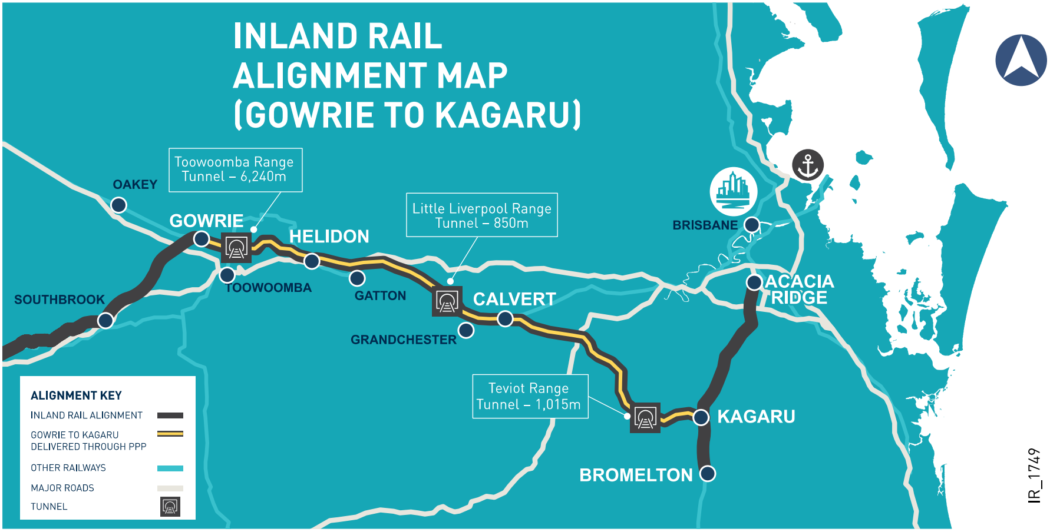

The proponent is to design, build, finance and maintain these sections for a 25-year period following construction. As an availability PPP, ARTC is to provide availability payments to the proponent after construction is completed. The availability payments are intended to cover the cost of capital expenditure, financing, operation, maintenance and lifecycle costs.

The risk of financial cost overruns during construction are intended to sit with the proponent rather than ARTC.  In addition, if the proponent is unable to complete the construction by the agreed date, it will not receive the initial availability payments (or receive reduced availability payments). This structure in theory transfers considerable financial risk away from ARTC to Regionerate Rail.

The problem for ARTC now is that the increased capital cost will lead to an increase in availability payments that present serious affordability issues for the company. Even with a restructuring between the capital charge and the availability charge, the financial challenge is extreme. ARTC revenue over future decades may decrease as coal exports decline and its revenue from the Hunter Rail haulage declines. This matter on top of these project cost increases suggests that some renegotiation of the PPP must occur. Furthermore, as noted in Section 6.1 the scope of work for the PPP may need to change to omit the Calvert to Kagaru section on the basis that the Inland Rail project could stop at Ebenezer and only smaller single-stack trains will proceed through to Kagaru, Acacia Ridge and Bromelton.

It was originally intended that the procurement for the PPP occur in parallel with environmental approval processes so that the appointed proponent could assist in the closing stages of the Environmental Impact Statement process. However, issues with the quality of Environmental Impact Statement submissions in Queensland, have significantly protracted the Environmental Impact Statement approval process. This has resulted in the early appointment of a preferred proponent, some years before environmental approvals, land acquisition, and expected financial close, and appears to have increased costs through prolongation.

Finding

The management of the PPP process has been difficult for ARTC and until there is a new CEO and governance and management arrangements for Inland Rail it is hard to have faith in ARTC’s capability to manage the delivery of the PPP further. Given this, consideration should be given to negotiating changes to the arrangement but these discussions need to be conducted by an experienced team.

Recommendation 17

On behalf of ARTC negotiations with Regionerate Rail should commence with a view to changing its scope to exclude double-stacking on the final section to Kagaru, and with a view to limiting costs and structuring payment arrangements in a manner that ARTC can afford. This may include a move away from a pure PPP arrangement to some other contractual arrangements.

The updated schedule continues to focus on delivering Inland Rail as quickly as possible, mirroring the same approach that was taken in 2020. It means that there is significant overlap, both in terms of concurrent processes on individual sections and work being undertaken simultaneously on multiple sections. This is reflected within ARTC’s internal resourcing, which is now expected to peak at over 800 instead of the 670 estimated in 2020.

In fact, generally, across the entire project, ARTC has pressed ahead trying to make a virtually impossible delivery time, possibly pressed upon them by previous Governments. It is now time for ARTC to examine the optimal delivery time across each section of this project and where delay is occurring, say because of delayed approvals, work and expenditure should cease as far as possible until work really is ready to go. The number of staff and contractors employed on this project at present who may not be fully deployed may be significant.

In examining the components of the project cost it is notable that indirect costs are running at about 50 per cent of total project costs on most sections. This is a most unusual feature as I would expect indirect costs to be around 20-30 per cent of total cost. This may indicate over-staffing related to prolongation and attempting to keep to a time target, as just suggested, or simply poor estimates of likely costs such as site accommodation for construction crews. It may also reflect the allocation of costs that are more properly allocated elsewhere.

ARTC acknowledges that only a small proportion of costs have high cost certainty. The sections with high cost certainty are those that are constructed, under construction or where major construction contracts have been awarded. About 90 per cent of the Inland Rail scope has either low or moderate cost certainty, which presents obvious risk to the total project cost.

Further work is warranted to investigate the components of the cost estimate in greater detail. Some of the significant changes to the cost need to be further ‘unpacked’ and better understood, particularly around how costs have been categorised. The structure of the estimate, whereby some sections have been estimated more conservatively than others depending on how far advanced they are, should be further tested and better aligned with standard industry practice (being P50 and P90 estimates).

Finding

In summary, notwithstanding that the cost estimate is better developed and more comprehensive than in 2020, it is difficult to have confidence in the updated cost estimate put forward by ARTC. Further detailed investigations would be required to validate the cost estimate.

Recommendation 18

Work to analyse the project costs of Inland Rail, and the expected timing of those expenditures over the next years of this decade, should be done carefully to ensure that the Inland Rail team, ARTC and their Shareholder, are fully cognisant of the details. An independent value engineer/cost estimator should be appointed by the Commonwealth to conduct this work given the difficulties that ARTC have had in providing such estimates. This person should coordinate with the work being done to define the scope of the project carefully as noted in Recommendation 13. The estimates should enable both ARTC and the Commonwealth to budget with some certainty for the next 5-10 years for this project.

Finally, the Commonwealth should note that although Inland Rail cost has increased substantially, though by how much is not clear, the challenges presented by the growing freight task remain unchanged. Once there is some confidence about the cost, a year-by-year budget can be established to enable management by both the Commonwealth and ARTC. A comparison to future benefits should also be made at this point. While the temptation arises to cancel the delivery of the project or part thereof, it is important to note that this is not a zero-cost option. As it stands, Inland Rail is expected to accommodate and drive a modal shift of 200,000 trucks a year to rail, and this will bring significant benefits in terms of supply chain efficiencies, safety, environmental and congestion reductions. Needless to say, this will not happen if Inland Rail is not delivered and this will lead to significant costs to governments in regard to upgrades to the national road network and additional maintenance.

1. Enhancing community benefits

The intention of the Inland Rail project is to shift significant amounts of freight traffic from road to rail and to improve the resilience of the national freight task. These direct benefits of the project to the populations of Queensland, NSW and Victoria have been discussed throughout the report. However, with only 15 per cent of the railway currently laid, these benefits will only become available upon completion of the whole project or at least when continuous stages of the route are complete and commissioned.

In local regional communities Inland Rail has already demonstrated that it can add significant benefits in both the short term and the longer term. In the short term during preliminary work and construction ARTC has paid attention to the benefits they can add to regional areas. This effort is commendable and can bring significant change to country towns. For example, on the Narrabri to Narromine to North Star sections around 3,782 people were employed. Of these 1,382 were local residents and 363 were local First Nations people. About 2,307 people were employed for more than six months; 437 trades people were employed; and 272 women. The Inland Rail project provided business to 236 local firms, and 21 indigenous firms. This business amounted to $290 million spent with local business and $28 million with First Nations business.

While this impact is short term the project has also planned and delivered longer term improvements to existing infrastructure. In many cases, this is necessary to bring structures up to modern standards and expectations but in others the work has been done to benefit the community and mitigate the disruption that Inland Rail could cause. For example, the number of new bridges, fences, access paths, and flood mitigation measures taken and planned are too numerous for this Review to list and are occurring all along the route.

In addition, in NSW the State Government has recognised the opportunity that Inland Rail brings to improve regional development further. Special Activation Precincts are nominated along the route and the State has provided capital for those communities with the express aim of facilitating industrial growth, job creation and the movement of industry to rural Australia. New business in these key areas has been encouraged and complementary investment upgrades in broadband and other utilities has occurred. ARTC and the NSW Government have worked together to assist these developments along with local councils and business groups.

Six ‘Special Activation Precincts’ are expected to be developed in NSW and at present Wagga Wagga, Parkes, Moree and Narrabri are progressing. At the towns of Wagga Wagga, Parkes and Moree expenditure of $200 million each has been made by the NSW Government and at Narrabri the quantum of investment has not yet been confirmed.

This capital injection has attracted agricultural waste, manufacturing, education, intermodal and other industries to these areas providing substantial economic and social benefits to the communities and towns. These impacts should increase further with Inland Rail completion.

The Bowman business park growth at Wagga Wagga is impressive and has been associated with growth in the local abattoirs, advanced manufacturing, education and a small intermodal terminal that has been completed about five kilometres off the main line and is expected to be able manage 200,000 TEUs in future. There are a number of property lots adjoining the terminal and these will be sold in the future. Visy paper operations at Tumut is a recent customer using this facility and a rail freight operator is transporting their load to Sydney from Wagga Wagga. Similarly, Riverina oils, a producer of canola oil, is using the facility to transport product.

At Parkes the development began with industrial rezoning of farm land. The principal development at this site is a major intermodal facility as discussed in Section 4.4. For the terminal 400 hectares has been allocated and the Special Activation Precinct there has a total of 2,000 hectares. Industries that are expanding include solar power generation, energy to waste facilities, recycled plastics and animal food production.

At Moree a similar is concept is developing. There are large land users nearby and grain transport to ports is enhanced by the good road connections. Horticultural industries are expanding.

What these regional developments have in common is cooperation between State and local governments and effective coordination with ARTC. It would be encouraging to see further regional growth in this manner. In Queensland this is already occurring to some extent at Toowoomba, where the local government and the private sector through the Wagner Group and Pacific National have already begun to devote resources to an intermodal terminal focussing on fresh food and Asian air freight and the local government is active in encouraging educational facilities. Other locations that would benefit from the type of approach being pursued in Toowoomba and NSW include Goondiwindi (cotton and cattle industries for a starting base), Gatton (fruit canning and processing), Ebenezer (modern open access intermodal terminal) and Whetstone (Materials Distribution Centre). All these regional developments add long term regional employment opportunities that can be highly skilled and long lasting.

Recommendation 19

As Inland Rail proceeds the local government areas that it passes through, along with the relevant State Government and ARTC, should consider where regional development might focus and what industries may be attracted to expand in those locations. To facilitate this, the Commonwealth Government should raise the issue with their State counterparts in regional development.

Appendix A: References

|  |
| --- |
| References |
| ARTC, Parsons Brinckerhoff, PricewaterhouseCoopers, Halcrow, Aurecon, ACIL Tasman, [*Melbourne-Brisbane Inland Rail Alignment Study: Final Report*](https://www.artc.com.au/library/IRAS_Final%20Report.pdf), ARTC, 2010. |
| ARTC, *Constitution: Australian Rail Track Corporation Limited ABN 75 081 455 754*, unpublished, 2012. |
| ARTC, *Inland Rail Programme Business Case*, ARTC, 2015. |
| ARTC, [*Inland Rail service offering*](https://inlandrail.artc.com.au/inland-rail-service-offering/), ARTC website, 2019, accessed 11 January 2023. |
| ARTC, [*Our network*](http://www.artc.com.au/about/network/), ARTC website, 2019, accessed 11 January 2023. |
| ARTC, *Inland Rail Gowrie to Kagaru – ‘Meet the Proponents’*, ARTC, 2021. |
| ARTC, 21/22 *Annual Report*, ARTC, Australia, 2022. |
| ARTC, [*Map of the Inland Rail route*](https://inlandrail.artc.com.au/map-of-inland-rail-route/), ARTC, 2022, accessed 11 January 2023. |
| ARTC, *Melbourne to Brisbane Inland Rail route history 2006-2021*, ARTC, 2022b. |
| Bureau of Infrastructure and Transport Research Economics, [*Australian aggregate freight forecasts – 2022 update*](https://www.bitre.gov.au/publications/2022/australian-aggregate-freight-forecasts-2022-update), Commonwealth of Australia, 2022, accessed 11 January 2023. |
| Department of Finance, [*Government Business Enterprises—Governance and Oversight Guidelines: Resource Management Guide No. 126*](https://www.finance.gov.au/sites/default/files/2019-12/commonwealth-gbe-governance-and-oversight-guidelines-rmg126.pdf), Department of Finance, 2018, accessed 11 January 2023. |
| Department of Infrastructure, Transport, Regional Development, Communications and the Arts, [*South East Queensland Inland Rail Intermodal Terminal Business Case*](https://investment.infrastructure.gov.au/projects/ProjectDetails.aspx?Project_id=111245-20QLD-MRL), DITRDCA website, 2022, accessed 11 January 2023. |
| Department of Infrastructure, Transport, Regional Development, Communications and the Arts, [*Environment*](https://www.inlandrail.gov.au/understanding-inland-rail/why-inland-rail/environment), DITRDCA website, n.d., accessed 12 January 2023. |
| Ernst and Young Australia, *Terminals Scoping Study*, EY, unpublished, 2021. |
| Ernst and Young Australia, *Inland Rail Freight Task*, report to the Australian Government Department of Infrastructure, Transport, Regional Development, Communications and the Arts, EY, unpublished, 2022. |
| Ernst and Young Australia, *National Rail Interoperability Framework: Issues Paper*, EY, unpublished, 2022. |
| Higgins AJ, McFallan S, Bruce C, Bondarenco A, McKeown A, *Inland Rail Supply Chain Mapping Pilot Project*, CSIRO, Australia, 2019. |
| Minister for Infrastructure and Transport, Minister for Finance, [*Australian Rail Track Corporation Inland Rail Statement of Expectations, Commonwealth of Australia*](https://www.inlandrail.gov.au/understanding-inland-rail/publications-and-reports/australian-rail-track-corporation-inland-rail-statement-expectations), 2018, accessed 11 January 2023. |
| Queensland Department of Transport and Main Roads, [*Toowoomba to Gladstone Inland Rail Extension Business Case*](https://www.tmr.qld.gov.au/projects/toowoomba-to-gladstone-inland-rail-extension-business-case), TMR website, n.d., accessed 11 January 2023. |
| Queensland Department of Transport and Main Roads, *Strategic Assessment of Service Requirements – SEQ Inland Rail Intermodal Terminal*, TMR, unpublished, 2021. |
| Queensland Department of Transport and Main Roads, *South East Queensland Freight Study – Updated Freight Modelling to Support Inland Rail Review*, TMR, unpublished, 2022. |
| SMEC, *Outer Metropolitan Ring (OMR) Review*, SMEC, unpublished, 2021. |
| Transport for Victoria, [*Delivering the Goods: Victorian Freight Plan*](https://transport.vic.gov.au/ports-and-freight/freight-victoria), Transport for Victoria, 2018, accessed 11 January 2023. |

Appendix B: Acknowledgements

I would like to acknowledge the contributions and assistance provided by the following people and organisations in the conduct of this review:

* The Hon Warren Truss AC, former Chairman of the Australian Rail Track Corporation
* Mr David Saxelby, Director of ARTC has been very helpful with further details.
* Mr Mark Campbell, Chief Executive Officer and Managing Director of the Australian Rail Track Corporation and the officers of the Corporation. I would particularly acknowledge the Inland Rail team led by Rebecca Pickering who has been an Acting CEO role for far too long and should be commended for keeping the project moving through this difficult period.
* Mr Jim Betts, Secretary of the Department of Infrastructure, Transport, Regional Development, Communications and the Arts and the officers of that Department. Ms Jessica Hall and her team on the secretariat have assisted me greatly with editing and fact checking. Needless to say, any errors remaining are to my account. Her team were Mr Andrew Bourne, Mr Jason Preece, Mr Drue Edwards, Mr Kerrod Giles, Mr Christopher Molesworth, Mr Tom O’Connor, Mr Craig Avery, Mr Kirk Cadiz, Ms Mary Giacca, Mr Nick MacLachlan, Ms Alyce Morgan, Ms Carolyn O’Rourke, Ms Sabina Clayton, Ms Georgia Constable, Mr Martin Laird, Ms Emily Oakes and Mr Connor Sandeman.
* Ms Jenny Wilkinson PSM, Secretary of the Department of Finance and the officers of that Department, particularly Mr Andrew Jaggers and the secretariat provided by Ms Aileen Roxburgh, and Mr Mark Bothe.
* Mr Rob Sharp, Secretary of Transport for New South Wales and the officers of that agency.
* Mr Paul Younis, Secretary, and Mr Will Tieppo, Deputy Secretary of the Victorian Department of Transport and the officers of that Department.
* Mr Neil Scales OBE, Director-General of the Queensland Department of Transport and Main Roads and the officers of that Department.
* Ms Toni Power, Coordinator-General of the Queensland Department of State Development, Infrastructure, Local Government and Planning and the officers of that Department.
* Mr Phil Davies, Chair of the Australian Logistics Council
* Aurizon
* Woolworths
* Mr Everald Compton
* National Intermodal Corporation Limited, and their Chair Erin Flaherty, CEO, James Baulderstone and Company Secretary, Jane Webster.
* Plenary Group
* Port of Melbourne
* Port of Brisbane
* Pacific National
* Qube
* The New South Wales Department of Planning and Environment
* Mr James Bolton, the NSW Office of Regional Development
* The Hon Michael McCormack MP, Federal Member for Riverina
* Mr John Fullerton, Chair of the Freight Industry Reference Panel and a past CEO of ARTC
* Sue McCarrey, Chief Executive of the National Rail Safety Regulator
* Mr Danny Broad, Chair of the Australasian Railway Association and the officers of that body.
* The Australian Logistics Council
* The Hon Mark Coulton MP, Federal Member for Parkes

Appendix C: Review engagement

Table A.1: Interviewed parties

|  |
| --- |
| Interviewed parties |
| Aurizon |
| Australian Competition and Consumer Commission |
| Australian Logistics Council |
| Australian Railway Association |
| Freight Industry Reference Panel |
| InterlinkSQ |
| LOGOS |
| Mr Everald Compton |
| Mr Mark Babister, Chair of the Independent International Panel of Experts for Flood Studies of Inland Rail in Queensland |
| National Intermodal Company |
| Office of the Coordinator General (Queensland) |
| Office of the National Rail Safety Regulator |
| Pacific National |
| Plenary |
| Port of Brisbane |
| Port of Melbourne |
| Qube Holdings |
| SCT Logistics |
| Senator the Hon Katy Gallagher, Minister for Finance |
| The Department of Finance |
| The Department of Infrastructure, Transport, Regional Development, Communications and the Arts |
| The Department of Planning and Environment (NSW) |
| The Department of Regional NSW |
| The Department of Transport (Victorian) |
| The Department of Transport and Main Roads (Queensland) |
| The Hon Catherine King MP, Minister for Infrastructure, Transport, Regional Development and Local Government |
| The Hon Mark Coulton MP, Federal Member for Parkes |
| The Hon Michael McCormack MP, Federal Member for Riverina |
| The Hon Shayne Neumann MP, Federal Member for Blair |
| The Hon Warren Truss, then Chair of the Australian Rail Track Corporation Board |
| Toowoomba Regional Council |
| Transurban |
| Wagner Corporation |
| Woolworths |

Table A.2: Submissions received

|  |  |
| --- | --- |
| # | Submission authors |
|  | Wagga Residents and Ratepayers Association on behalf of the Combined Residents, Ratepayers and Farmer’s Group of Wagga Wagga |
|  | Kevin Kennedy |
|  | Ria Reynolds |
|  | Anonymous |
|  | Caroline Salmon |
|  | Anonymous |
|  | Anonymous |
|  | Anonymous |
|  | Sandra Marsden |
|  | Anonymous |
|  | Anonymous |
|  | Anonymous |
|  | Anonymous |
|  | Anonymous |
|  | Dr Ken Davidson |
|  | Private Submission |
|  | Lionel Cunningham |
|  | Helen Hunt |
|  | Jennifer Knop |
|  | Anonymous |
|  | Kevin Loveday |
|  | Kevin Loveday |
|  | Kevin Loveday |
|  | Robyn Keenan |
|  | The NSW Farmers Association |
|  | Cameron Simpkins |
|  | Private submission |
|  | Private submission |
|  | Narrabri Billabong Pastoral Company |
|  | Darryl Piper |
|  | Gladstone Goondiwindi Railway Pty Ltd |
|  | Kris Bogdanoff |
|  | Wandong-Heathcote Junction Combined Community Groups |
|  | Andrew South |
|  | Ross Edward Gleeson |
|  | Josip Toth |
|  | Barbara Deans |
|  | Suzanne Corbett |
|  | Kevin Mann |
|  | Dr Doug Hill |
|  | Anonymous |
|  | Anonymous |
|  | Lockyer Valley Regional Council |
|  | Anonymous |
|  | Anonymous |
|  | Anonymous |
|  | Richard Shepherd |
|  | Anonymous |
|  | Toowoomba South Labor |
|  | Millmerran Rail Group |
|  | Stan Corbett |
|  | Tony Meppem |
|  | Andrew Knop |
|  | Karen McBurnie |
|  | Terri Wright |
|  | Mitch Wakeham |
|  | Geoffrey Smith |
|  | David Carter |
|  | Graeme Kelly |
|  | Marlene Moriarty |
|  | Dr Rob Loch |
|  | Mitchell Shire Council |
|  | Brett Kelly |
|  | Anonymous |
|  | Ivory’s Rock Foundation |
|  | John Henshall |
|  | Eric, Dianne and Yvette McKenzie |
|  | Better Benalla Rail |
|  | Private submission |
|  | Rail Futures Institute |
|  | Private submission |
|  | Council of Mayors (SEQ) |
|  | Michael Dibbs |
|  | Alan Channell |
|  | Anonymous |
|  | Peter Dampney |
|  | Port of Brisbane |
|  | Inner Downs Inland Rail Action Group |
|  | Carl & Nicole Baldry |
|  | Rail, Tram and Bus Union (RTBU) |
|  | Logan and Albert Conservation Association INC |
|  | Private submission |
|  | Pacific National |
|  | Logan City Council |
|  | Private submission |
|  | NSW Ports |
|  | Scenic Rim Regional Council |
|  | LOGOS Property |
|  | V Battaglia |
|  | Private submission |
|  | Strathbogie Shire Council |
|  | Lord Mayor Brisbane City Council |
|  | Wando Conservation and Cultural Centre |
|  | Peter Holt |
|  | Anonymous |
|  | Toowoomba Regional Council |
|  | Country Women’s Association of NSW |
|  | Australian Logistics Council |
|  | Goondiwindi Regional Council |
|  | Private submission |
|  | City of Ipswich |
|  | Private submission |
|  | Private submission |
|  | Narrabri Shire Council |
|  | Genrich and Noller |
|  | Private submission |
|  | Australasian Railway Association |
|  | Moree Plains Shire Council |
|  | Adrian Lyons |
|  | Private submission |
|  | Private submission |
|  | EuroaConnect |
|  | TBSE |
|  | Andrew Knop |
|  | Drinda Luckensmeyer |
|  | Private submission |
|  | Maritime Union of Australia (MUA) |
|  | Private submission |
|  | Elizabeth Kelaher |
|  | Wabtec Corporation |
|  | Glenrowan Heritage Precinct |
|  | Patricia Barnard |
|  | Kathy Faldt |
|  | Bigambul Native Title Aboriginal Corporation |
|  | Community Members of the Calvert to Kagaru section of Inland Rail |
|  | Gary Tofts |
|  | Dr Siri Gamage |
|  | Mark Rowland |
|  | Private submission |
|  | Private submission |
|  | Private submission |
|  | Private submission |
|  | Private submission |
|  | Northern Railway Defenders Forum |
|  | Private submission |
|  | Alex Worner |
|  | Victorian Chamber of Commerce and Industry |
|  | Queensland Local Government Reform Alliance |
|  | SCT Logistics |
|  | Anthony Corderoy |
|  | Lloyd Stumer |
|  | Wayne Molloy |

1. Department of Infrastructure, Transport, Regional Development, Communications and the Arts, [*Environment*](https://www.inlandrail.gov.au/understanding-inland-rail/why-inland-rail/environment), DITRDCA website, n.d., accessed 12 January 2023.
2. 2 ARTC, *21/22 Annual Report*, ARTC, Australia, 2022.
3. ARTC, [*Our network*](http://www.artc.com.au/about/network/), ARTC website, 2019, accessed 11 January 2023.
4. ARTC, *21/22* Annual *Report*, ARTC, Australia, 2022.
5. Ernst and Young Australia (EY), *Inland Rail Freight Task*, unpublished, 2022.
6. Refer to Figure 2.2 of this Report.
7. ARTC, [*Map of the Inland Rail route*](https://inlandrail.artc.com.au/map-of-inland-rail-route/), ARTC, 2022, accessed 11 January 2023.
8. Department of Finance, [*Government Business Enterprises—Governance and Oversight Guidelines: Resource Management Guide No. 126*](https://www.finance.gov.au/sites/default/files/2019-12/commonwealth-gbe-governance-and-oversight-guidelines-rmg126.pdf), Commonwealth of Australia, 2018, accessed 11 January 2023.
9. Minister for Infrastructure and Transport, Minister for Finance, [*Australian Rail Track Corporation Inland Rail Statement of Expectations, Commonwealth of Australia*](https://www.inlandrail.gov.au/understanding-inland-rail/publications-and-reports/australian-rail-track-corporation-inland-rail-statement-expectations), 2018, accessed 11 January 2023.
10. ARTC, *Constitution: Australian Rail Track Corporation Limited ABN 75 081 455 754*, unpublished, 2012.
11. EY, *Inland Rail Freight Task,* unpublished, 2022.
12. EY, *Inland Rail Freight Task,* unpublished, 2022.
13. Bureau of Infrastructure and Transport Research Economics (BITRE), [*Australian aggregate freight forecasts – 2022 update*](https://www.bitre.gov.au/publications/2022/australian-aggregate-freight-forecasts-2022-update), Commonwealth of Australia, 2022, accessed 11 January 2023.
14. EY, *Inland Rail Freight Task,* unpublished, 2022.
15. EY, *Inland Rail Freight Task,* unpublished, 2022.
16. EY, *Inland Rail Freight Task,* unpublished, 2022.
17. Higgins AJ, McFallan S, Bruce C, Bondarenco A, McKeown A, *Inland Rail Supply Chain Mapping Pilot Project*, CSIRO, Australia, 2019.
18. ARTC, [*Inland Rail service offering*](https://inlandrail.artc.com.au/inland-rail-service-offering/), ARTC, 2019, accessed 11 January 2023.
19. Transport for Victoria, [*Delivering the Goods: Victorian Freight Plan*](https://transport.vic.gov.au/ports-and-freight/freight-victoria), Transport for Victoria, 2018, accessed 11 January 2023.
20. SMEC, *Outer Metropolitan Ring (OMR) Review*, SMEC, unpublished, 2021.
21. EY, *Terminals Scoping Study*, EY, unpublished, 2021.
22. Queensland Department of Transport and Main Roads (TMR), *Strategic Assessment of Service Requirements – SEQ Inland Rail Intermodal Terminal*, TMR, unpublished, 2021.
23. Department of Infrastructure, Transport, Regional Development, Communications and the Arts (DITRDCA), [*South East Queensland Inland Rail Intermodal Terminal Business Case*](https://investment.infrastructure.gov.au/projects/ProjectDetails.aspx?Project_id=111245-20QLD-MRL), DITRDCA website, 2022, accessed 11 January 2023.
24. Queensland Department of Transport and Main Roads, *South East Queensland Freight Study – Updated Freight Modelling to Support Inland Rail Review*, TMR, unpublished, 2022.
25. Ernst and Young Australia, *National Rail Interoperability Framework: Issues Paper*, EY, unpublished, 2022.
26. Transport and Main Roads (TMR), [*Toowoomba to Gladstone Inland Rail Extension Business Case*](https://www.tmr.qld.gov.au/projects/toowoomba-to-gladstone-inland-rail-extension-business-case), TMR website, n.d., accessed 11 January 2023.
27. ARTC, Parsons Brinckerhoff, PricewaterhouseCoopers, Halcrow, Aurecon, ACIL Tasman, [*Melbourne-Brisbane Inland Rail Alignment Study: Final Report*](https://www.artc.com.au/library/IRAS_Final%20Report.pdf), ARTC, Report July 2010.
28. ARTC, *Inland Rail Programme Business Case*, ARTC, 2015.
29. The Clough entity that is a member of the Regionerate Rail consortia was placed into voluntary administration on 5 December 2022; An agreement was reached on 14 December 2022 between WeBuild and the administrators of Clough for the acquisition of the Australian organisation of Clough and certain projects. Once these arrangements are finalised, Clough’s assets relating to Inland Rail will be owned by WeBuild.
30. ARTC, *Inland Rail Gowrie to Kagaru – ‘Meet the Proponents’*, ARTC, 2021.