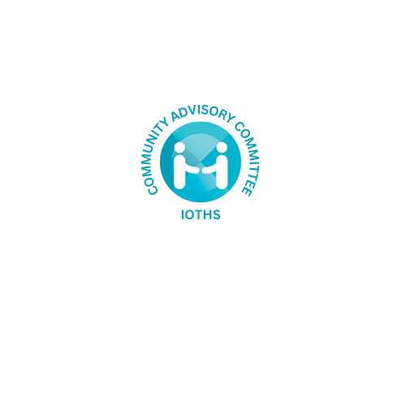

# Health matters – an update from your Community Advisory Committee

The Indian Ocean Territories Health Service (IOTHS) Community Advisory Committee (CAC) recently gathered for the first meeting of 2025. With the new year under way, the meeting provided the group the opportunity to continue discussing issues affecting the IOT, as well as raise new matters that impact our communities.

Updates were provided on previous discussions, including vermin control measures, linguistically diverse ambulance signage, specialist visits to the IOT and culturally inclusive toilet facilities.

During the meeting, new Health Services Manager Carla Rankin was welcomed to the IOT and IOTA Director Ian McKendrick provided an update on IOTHS operations. Information on health service assets was shared, as well as an update on work being done to finalise the calendar of visiting specialists.

Committee members also engaged in a discussion on health events relevant to IOT communities that can be promoted throughout the year. Working together with other community stakeholders, IOTHS will take communication materials beyond clinic waiting rooms to promote events – and the health issues they highlight.

A number of other issues were raised by committee members during the meeting, including:

* mental health services for the IOT
* allied health care visits to the islands
* the impact of limited internet access on telehealth services.

These meetings are vital for the successful design and delivery of community-driven and fit-for-purpose health services, and I am pleased to have representatives from Christmas Island and the Cocos (Keeling) Islands involved in advocating for the best outcomes for our communities. The CAC meets every three months and if you have any health-related issues you would like raised, please contact a CAC Committee member or alternatively, email my office at [iotadministrator@infrastructure.gov.au](mailto:iotadministrator@infrastructure.gov.au). The planned meeting dates can be found below.

The health services on Christmas Island and the Cocos (Keeling) Islands are delivered by the Indian Ocean Territories Health Service (IOTHS) through the Australian Government and include inpatient and emergency care, home and community health care, pathology and radiology services, oral health care, visiting specialist medical and allied health services and telehealth.

## Planned meeting dates for the IOTHS Community Advisory Committee:

* Monday 19th May 2025
* Monday 18th August 2025
* Monday 17th November 2025