

Explanatory note—Government Policy Project Notice
November 2024

This Explanatory Note sets out the process and approach that the Communications Minister would adopt in issuing, and consulting on, a Government Policy Project Notice for the purposes of NBN Co Limited’s Special Access Undertaking with the Australian Competition and Consumer Commission.

Background

Special Access Undertaking
On 13 December 2013, the Australian Competition and Consumer Commission (ACCC) gave notice pursuant to subsection 152CBC(3) of the Competition and Consumer Act 2010 (CCA) that it had accepted the Special Access Undertaking (SAU) proposal lodged by NBN Co Limited (NBN Co) on 19 November 2013.
On 14 August 2023, NBN Co lodged a proposal with the ACCC to vary the SAU.
On 17 October 2023, the ACCC gave notice in accordance with subsection 152CBG(5) that it had accepted NBN Co’s SAU variation proposal.

Government Policy Project Notice
The varied SAU established a new mechanism known as a Government Policy Project Notice (Project Notice).
A Project Notice is a formal notice given by the Communications Minister to NBN Co for the purposes of its SAU in relation to projects or programs that are reasonably required to achieve Commonwealth Government policy, taking into account the public interest served by the project or program.
This Explanatory Note sets out an explanation of the process and approach that would be taken by the Communications Minister to issuing, and consulting on, a Project Notice.
The Communications Minister will consider the need to review this Explanatory Note as necessary.

Minimum requirements
For the purposes of the SAU, the minimum requirements for a valid Project Notice are set out in the SAU’s Dictionary under the Government Policy Project Notice definition.
The table at the end of this Explanatory Note is intended to provide additional guidance regarding the information and content that would generally be provided in a Project Notice, as well as the considerations that the Communications Minister would have regard to in issuing a Project Notice.

Project Notice issuance process and relationship to business case assessment
Attachment A depicts the usual sequence of processes that would be expected to occur from the development of a business case by NBN Co through to the ACCC’s assessment under the SAU of forecast expenditure set out in a Project Notice. In certain cases, a more truncated or different process may be warranted or followed.

Draft Project Notice and consultation process
Where the Communications Minister proposes to make a Project Notice in respect of particular project or program, a draft notice will be prepared.
A copy of the draft notice and relevant information relating to the project or program will be provided to NBN Co and the ACCC for feedback on the content of the draft notice. NBN Co and the ACCC will also have the opportunity to seek additional information relevant to the notice.
The usual practice will be to give NBN Co and the ACCC a minimum of 21 calendar days to provide their feedback on the draft notice. In certain cases, a shorter consultation timeframe may apply.
Depending the scope of the particular project or program, feedback may be sought from relevant stakeholders (apart from the ACCC and NBN Co) on the content of the draft Project Notice on a case-by-case basis.
There may be a range of considerations and legal requirements impacting the use and disclosure of sensitive information or commercial information. This may limit the information that would be shared as part of the consultation process.

Finalisation, issuance and publishing of Project Notice
The Project Notice will be finalised following consideration of feedback on the draft Project Notice and will be provided to NBN Co and the ACCC.
The Project Notice would be published on the website of the Department of Infrastructure, Transport, Regional Development, Communications and the Arts (the department) (or any successor department) within 14 calendar days.

Withdrawal and replacement of Project Notices
The Communications Minister may withdraw Project Notices, and also replace a withdrawn Project Notice with a new Project Notice. The withdrawal or replacement of a Project Notice is characterised as a Government Policy Project Notice Event in the SAU.

Project Notice withdrawal
A Project Notice may be withdrawn if the project or program within its scope is being discontinued or materially changed. NBN Co and the ACCC will be notified if a Project Notice is being withdrawn, and the withdrawal notice will also be published on the department’s website.
The withdrawal notice will normally be expected to set out:
- Whether the project or program is being discontinued or materially changed.
- If it is being materially changed, the nature and extent of the change in the scope of the project or program.
- The key reason(s) why the project or program is being discontinued or materially changed. For example:
- Whether there has been a change in Government policy.
- Whether the project or program is no longer needed to achieve Government policy.
- Whether circumstances have changed such that the project or program would not be able to achieve Government policy, or the scope of the project or program needs to materially change to achieve Government policy.

Project Notice replacement
In circumstances where there is a material change in the scope of the project or program, the Minister may also issue a new Project Notice.

Legal status
This Explanatory Note is not legally binding and does not create any legally binding relationship or obligation. It does not commit the Government nor the Communications Minister to a particular course of action.
This Explanatory Note is intended to provide general guidance and it is not intended to fetter in any way the Government’s (including the Communications Minister’s) future exercise of any power, function or discretion, nor limit how the Communications Minister approaches the issuance of a Project Notice (or its withdrawal).
In the event of a conflict between any of the terms of this Explanatory Note and the terms of the SAU, the SAU will prevail to the extent of the inconsistency.

Minimum requirements for Project Notice
The SAU sets out the minimum requirements for a valid Project Notice.
The table below provides additional guidance as to the information and content that will be provided in meeting each of the minimum requirements, and as to the considerations the Communications Minister will have regard to in issuing a Project Notice and drafting its content.
Minimum requirement (as set out in the SAU) | Explanation
The notice states that it is a Government Policy Project Notice for the purposes of NBN Co’s Special Access Undertaking. | The Project Notice will confirm that it is issued for the purposes of the SAU.
The notice states that the Communications Minister has determined that NBN Co undertaking a particular project or program is reasonably required to achieve Commonwealth Government policy, taking into account the public interest served by the project or program. | The types of information that may be included in this description are as follows.  Project or program is reasonably required to achieve Government policy  In stating that the project or program is reasonably required to achieve Government policy, the Project Notice may describe (without limit):  - The relevant Government policy (or policies) that the project or program is reasonably required to achieve.  - How/why the program or project is reasonably required to achieve the relevant policies.  - If there are any considerations associated with the project or program from a long-term network investment perspective.  Project or program is serving the public interest  In stating that the public interest has been taken into account, the Project Notice may describe in high level terms the benefits expected to result from the project or program, such as:  - Long term benefits to the efficiency and operation of the network.  - Whole of economy benefits.  - Productivity and employment benefits.  - Market and competition benefits.  - Consumer benefits.  - Connectivity benefits, including in regional and remote Australia.  - Other social benefits.
Scope of the relevant project or program, including:  - the specific project or program that is the subject of the notice  - the key elements of the project or program, and the outcomes it is expected to deliver  - any restrictions or requirements the Commonwealth Government has placed on the delivery of the project or program (for example, the technology to be used or the methodology)  - the expected timeframe for delivery of the elements and outcomes of the project or program. | In describing the scope of the project or program in accordance with the requirements of the SAU, the Project Notice will seek to ensure that:  - The project or program can be distinguished from other NBN Co activities.  - The ACCC can clearly identify activities that are outside the scope of prudency review under the SAU and activities that remain within the scope of prudency review.  - The expenditure associated with the project or program can be discretely identified.  - There can be transparent reporting on the project or program.
The forecast expenditure associated with the project or program, in total and per Financial Year. | The Project Notice will set out forecast capital and operating expenditure in accordance with SAU requirements.
A description of how the project or program will be funded. | The Project Notice will include a description of the expected funding sources for the project or program, which may include:  - NBN Co’s own cashflow from its operations.  - Equity funding.  - Commercial debt funding from either the Government or a private lender.  - Concessional funding, such as a concessional loan from the Government.  - Grant funding from the Government.  - Contributions from third parties.  Under the SAU, the amount of Capital Expenditure added to NBN Co’s Regulated Asset Base (RAB) for each Financial Year will be net of third-party ‘Capital Contributions’ in that Financial Year, including Government grants which fund Capital Expenditure.
A statement regarding NBN Co’s reporting requirements under the notice in respect of the project or program that is the subject of the notice.  *Note: These may be additional to existing SAU reporting requirements. | The specific reporting requirements applying to a Project Notice will be clearly outlined, but will be tailored to the relevant project or program. It is envisaged that reporting requirements will typically include the following kinds of reporting:  - Progress on delivery of the project or program’s elements.  - Progress on achievement of the outcomes expected from the project or program.  - Actual expenditure and its comparison to forecast expenditure.  - Revenue associated with the project or program.
The notice may, at the Communication Minister’s sole discretion, state the maximum amount of Operating Expenditure and/or Capital Expenditure associated with the project or program per Financial Year, where the aggregate of those maximum amounts is no greater than the total forecast expenditure associated with the project or program.  The notice must state elements of the funding of the project or program that are associated with any such maximum amounts specified in the notice. | This Explanatory Note does not seek to prescribe when the Minister may choose to exercise this discretion. However, the Minister may consider setting a maximum forecast expenditure amount below the actual forecast expenditure in circumstances where it may be appropriate to only pass through a portion of the forecast expenditure to retailers in the revenue allowance and RAB calculation. For example, having regard to the nature of the economic, social or other benefits associated with the project or program.

Attachment A
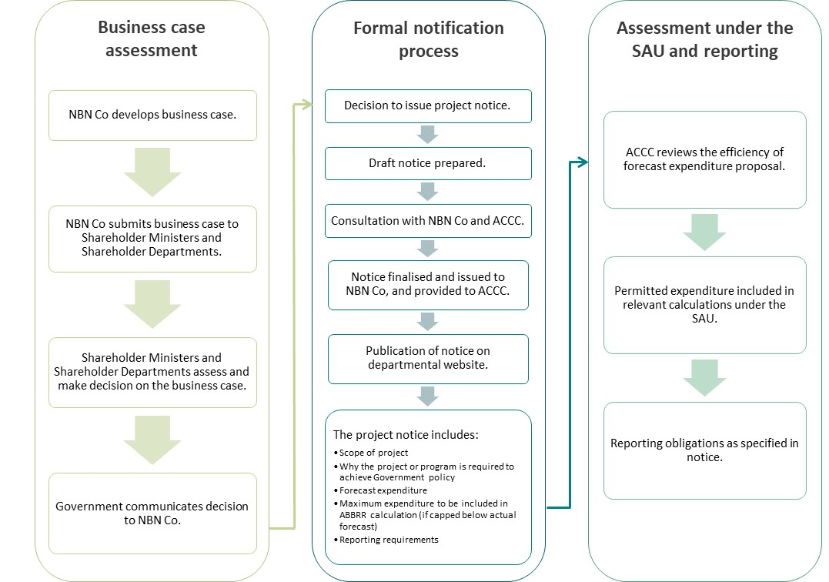
Image Description: This chart depicts the usual sequence of processes that would be expected to occur from the development of a business case by NBN Co through to the ACCC’s assessment under the SAU of forecast expenditure.

The SAU itself provides a minimum of 14 days.

