 Logo: Australian Government, Department of Communications and the Arts.

Logo: Bureau of Communications Research.

www.communications.gov.au/BCAR
#CommsAuBCAR

# Demand for fixed-line broadband in Australia, 2018–2028

July 2020

**Working paper**

© Commonwealth of Australia 2020  
July 2020 / INFRASTRUCTURE

Ownership of intellectual property rights in this publication

Unless otherwise noted, copyright (and any other intellectual property rights, if any) in this publication is owned by the Commonwealth of Australia (referred to below as the Commonwealth).

Disclaimer

The material contained in this publication is made available on the understanding that the Commonwealth is not providing professional advice, and that users exercise their own skill and care with respect to its use, and seek independent advice if necessary.

The Commonwealth makes no representations or warranties as to the contents or accuracy of the information contained in this publication. To the extent permitted by law, the Commonwealth disclaims liability to any person or organisation in respect of anything done, or omitted to be done, in reliance upon information contained in this publication.

Creative Commons licence

With the exception of (a) the Coat of Arms; (b) the Department of Infrastructure, Transport, Regional Development and Communications photos and graphics; and (c) [OTHER], copyright in this publication is licensed under a Creative Commons Attribution 4.0 Australia Licence.

Creative Commons Attribution 4.0 Australia Licence is a standard form licence agreement that allows you to copy, communicate and adapt this publication provided that you attribute the work to the Commonwealth and abide by the other licence terms.

Further information on the licence terms is available from <https://creativecommons.org/licenses/by/4.0/>.  
This publication should be attributed in the following way: © Commonwealth of Australia 2020.

Use of the Coat of Arms

The Department of the Prime Minister and Cabinet sets the terms under which the Coat of Arms is used. Please refer to the Commonwealth Coat of Arms—Information and Guidelines publication available at [www.pmc.gov.au](http://www.pmc.gov.au).

Contact us

This publication is available in hard copy or PDF format. All other rights are reserved, including in relation to any Departmental logos or trade marks which may exist. For enquiries regarding the licence and any use of this publication, please contact:

Director—Publishing and Communications  
Communication Branch  
Department of Infrastructure, Transport, Regional Development and Communications  
GPO Box 594  
Canberra ACT 2601  
Australia

Email: [publishing@communications.gov.au](mailto:publishing@communications.gov.au)

Websites: [www.infrastructure.gov.au](http://www.infrastructure.gov.au) | [www.communications.gov.au](http://www.communications.gov.au) | [www.arts.gov.au](http://www.arts.gov.au).

Contents

Glossary 7

Executive summary 9

Households 9

Small businesses 9

Methodology and approach 10

Structure of the paper 10

Caveats 10

Framework for analysis 12

Drivers of bandwidth and data demand 13

Australian households are typically small 14

Small businesses tend to employ few workers 15

Application usage varies across industries 16

People are spending more time online 16

Technological change affects bandwidth and data demand 18

Compression 18

Overlapping applications drive peak bandwidth demand 19

Households and small businesses use many different applications 20

Household applications 21

Small business applications 22

Peak household bandwidth demand 23

Bandwidth demand is driven by internet usage, household size and higher video resolution 27

Peak small business bandwidth demand 31

Bandwidth demand is driven by overlapping applications and large downloads 33

Bandwidth demand varies by industry 34

Data demand is increasing 36

Appendix A: Modelling bandwidth demand 38

Probability analysis 38

Box A1: Developments since the last BCAR working paper 39

Model validation 39

Appendix B: Busy period 41

Premises and network busy period 41

Appendix C: Household types 43

Household composition 43

Video resolution type 44

Internet usage type 44

Appendix D: Small business characteristics 45

Business counts modelling 45

Employee characteristics 46

Modelling business usage profiles 48

Appendix E: Applications 49

Forecasting applications 49

Households 50

Streamed video 50

Streamed gaming 53

Streamed virtual reality 54

Cloud storage 54

Content downloads 55

Mobile applications and software downloads 55

Peer-to-peer file sharing 56

Video calls 56

Game downloads 57

Software downloads 58

Web browsing 58

Low bandwidth applications 59

Excluded applications 60

Small businesses 60

Email 60

Web browsing 61

Cloud storage 61

Video calls 62

Streamed video 62

File transfers 62

Low bandwidth applications 63

Guest WiFi 63

Excluded applications 65

Appendix F: Caveats to the analysis 66

These estimates may overstate real-world demand 66

Considerations 67

Consumer experience 67

Willingness to pay 67

Number of devices 67

Sustained bandwidth 67

Server and application limits 68

Submissive applications 68

Traffic prioritisation 68

Multiple connections per premises or shared connections across premises 68

Mobile broadband 68

Upload analysis 69

Other internet characteristics 69

Appendix G: Sensitivity analysis 71

Household 71

Base case 71

Sensitivity analysis summary 71

Minutes excluded 72

Compression rate 74

Forecast growth rate 75

Busy period 75

Usage mix 76

Willingness to wait 77

Higher bandwidth requirements for 4K content 78

Small business 79

Base case 79

Sensitivity analysis summary 79

Minutes excluded 80

Forecast growth rate 81

Busy period 81

Usage mix 82

Appendix H: Assumptions tables 83

Households 83

Small business 85

Appendix I: Occupation list 87

References 99

Tables / images

Figure 1. Drivers of data and bandwidth demand 14

Figure 2. Household composition 14

Figure 3. Small businesses by the number of employees 16

Figure 4. Active internet use at home per adult per day 17

Figure 5. Average day download behaviour 19

Figure 6. Illustration of a household’s bandwidth requirements 20

Figure 7. Household applications 21

Figure 8. Small business applications 22

Figure 9. Distribution of household peak bandwidth demand 23

Table 1. Household peak bandwidth demand 24

Figure 10. Household peak bandwidth demand 25

Figure 11. Additional bandwidth demand by higher bandwidth usage households 25

Figure 12. Example household bandwidth demand scenarios 27

Table 2. Household types by size and internet usage 28

Figure 13. Peak bandwidth demand by household type in 2018 29

Figure 14. Peak bandwidth demand by household type in 2028 30

Figure 15. Distribution of small business peak bandwidth demand 31

Table 3. Small business peak bandwidth demand 32

Figure 16. Small business peak bandwidth demand 32

Table 4. Small business bandwidth demand including and excluding significant drivers 33

Figure 17. High bandwidth demand industries 34

Figure 18. Low bandwidth demand industries 35

Figure 19. Fixed-line data downloads per household 36

Figure 20. Annual growth in fixed-line data downloads per household 37

Figure 21. Probability analysis 38

Figure 22. Fixed-line data downloads per household 40

Figure 23. Stylised example of the difference between household and network busy periods 42

Figure 24. Household types 43

Table 5. Household composition 43

Figure 25. Business counts formulae 45

Figure 26. Internet usage mix 47

Figure 27. Internet usage mix by industries with highest and lowest share of bandwidth intensive users 48

Figure 28. Average time spent watching streamed video per day 51

Figure 29. Software downloads 58

Figure 30. Guest WiFi industries 64

Table 6. Household bandwidth demand 71

Table 7. Household sensitivity analysis summary 71

Figure 31. Household bandwidth demand distribution in 2028 by differing minutes excluded 73

Table 8. Household bandwidth demand in 2028 by differing minutes excluded 73

Table 9. Household bandwidth demand by different compression rates 74

Table 10. Household bandwidth demand by different forecast annual growth rates 75

Table 11. Household bandwidth demand by varied proportions of usage during the busy period 76

Table 12. Mix of households by user types and their application usage 76

Table 13. Low users have 25 per cent of average usage 77

Table 14. High usage individuals are 30 per cent of all users 77

Table 15. Tolerances for game downloads 78

Table 16. 4K content bandwidth requirements 79

Table 17. Small business peak bandwidth demand base case 79

Table 18. Summary of sensitivity tests 80

Figure 32. Small business demand distribution in 2028 by differing minutes excluded 80

Table 19. Small business bandwidth demand in 2028 by differing minutes excluded 80

Table 20. Small business bandwidth demand by different forecast annual growth rates 81

Table 21. Bandwidth demand by different proportions of usage occurring during the busy period 81

Table 22. Low users have 50 per cent usage relative to the medium (or average) user 82

Table 23. Household key assumptions 83

Table 24. Household usage variation 83

Table 25. Household application assumptions 83

Table 26. Households by usage type in 2018 84

Table 27. Households by usage type in 2028 85

Table 28. Small business key assumptions 85

Table 29. Small business employee application assumptions 86

Table 30. Small business non-employee application assumptions 86

Table 31. Occupation by fixed-line bandwidth requirement 87

## Glossary

This glossary provides a general guide to terms used in the paper.

**4K video**—A display with at least 8 million active pixels. For televisions, the standard resolution is 3,840 horizontal pixels by 2,160 vertical pixels.[1]

**8K video**—A display with a much higher resolution than 4K video, typically 7,680 horizontal pixels by 4,320 vertical pixels.[2]

**Application**—A program that enables end users to perform online tasks on digital devices.[3]

**‘Above the fold’**—The content that can be viewed on a webpage when the webpage is first loaded. In contrast, ‘below the fold’ refers to webpage content that is not displayed on the screen when the webpage is first loaded but can be accessed by scrolling.[4]

**Bandwidth**—A measure of the rate of data transfer, typically in megabits per second. Bandwidth can be used to describe the capacity of a connection, or the requirement of an application.[5]

**Busy period**—The period during the day when (multiple) people are more likely to be using (multiple) applications at a premises.

**Bit**—Short for binary digit, bits are the smallest form of measurement used to quantify computer data. It contains a single binary value of 0 or 1.[6]

**Byte**—A data measurement unit that contains 8 bits.[7]

**Caching**—A store of recently downloaded information kept on a local hard drive to provide faster access in the event the information is required again.[8]

**Codec**—A computer program that encodes video files, compressing the data for storage or sending, then decompresses them for playback or editing.[9]

**Data**—The collection of numbers, represented as bytes, that are in turn composed of bits.[10]

**Download**—Data from the internet that is requested by the user to be saved onto a device.[11]

**GB**—Gigabyte, a unit of data which equals 8 gigabits and 1000 megabytes (MB).

**High definition video**—High definition (HD) video displays horizontal resolutions of 720 or 1080 pixels. In 720p, the pixels are arranged 1280 by 720. In 1080p, the pixels are arranged 1920 by 1080. The higher number of pixels in 1080 results in a better picture, known as ‘Full HD’.[12]

**Household**—A private dwelling that includes 1 or more persons usually resident, at least 1 of whom is at least 15 years of age.[13]

**Internet of things**—The internet of things (IoT) refers to all devices and objects whose state can be altered via the internet, with or without active human involvement.[14]

**Kb**—Kilobit, a unit of data equal to 1,000 bits.

**Kbps**—A measure of bandwidth in kilobits (Kb) per second or 1,000 bits per second.

**MB**—Megabyte, a unit of data which equals 8 megabits (Mb), 1,000 kilobytes (KB) and 8,000 kilobits (Kb).

**Mb**—Megabit, a unit of data which is 1/8th of a megabyte (MB) or 1,000 kilobits (Kb).

**Mbps**—A measure of bandwidth in megabits (Mb) per second or 1,000 kilobits per second.

**Operating system**—The operating system (OS) is the software that communicates with the hardware and allows other programs to run. It includes fundamental files your computer needs to boot up and function. Computers, tablets and smartphones include an operating system that provides basic functionality.[15]

**Peer-to-peer**—A network where files can be shared directly between systems on the network without the need of a central server. Each computer on a peer-to-peer network can act as a file server as well as a client.[16]

**Primary applications**—Applications such as streamed video, streamed gaming and virtual reality that would not usually be used simultaneously by an individual.

**Small business**—Any businesses with fewer than 20 employees, using the definition from the Australian Bureau of Statistics.[17] In developing bandwidth estimates, the BCAR has focused only on employing small businesses (1–19 employees), which therefore excludes non‑employing businesses.

**Standard definition video**—Standard definition (SD) video displays vertical resolutions of 480 pixels. In these resolutions, the pixels are arranged 640 by 480. With this minimal number of pixels, images are less defined and can appear ‘pixelated’ (meaning that individual pixels can be seen when close to the TV).[18]

**Secondary applications**—applications such as cloud storage, peer-to-peer file sharing and software downloads that can could be generally used at the same time.

**Streamed video**—Television or video content distributed in real time over the internet (rather than broadcast networks, or video downloaded for viewing later).[19]

**Traffic**—The amount of data (downloaded and uploaded) moving across a network at any given point in time.[20] Traffic can also refer to the total amount of data transmitted over a period of time.

**Upload**—Datathat is sent from the user to the cloud or internet.[21]

**Video calling**—Video calling (VC) is a call made between 2 or more users including live pictures and sound of the participants.[22]

**Virtual reality**—Virtual reality (VR) is the digital creation of a fabricated immersive world, typically via a headset technology.[23]

**‘x’ minutes excluded**—A metric used to measure the bandwidth required to serve all but the ‘x’ busiest minutes in the month for a given household or small business, where ‘x’ is a variable that can be adjusted (e.g. if ‘x’ is 30 then it is the 30 busiest minutes per month).

## Executive summary

Most Australians access the internet daily, with almost three quarters going online 3 or more times a day.[24] An increasing number of devices and applications are being used to engage with online content, especially video.[25] The importance of video can be seen from its rise as a proportion of internet traffic from 66 per cent in 2013,[26] to 75 per cent in 2017.[27] This proportion is expected to reach 82 per cent in the world by 2022.[28]

Continued growth in demand for streamed content viewed in high screen resolutions and the emergence of virtual reality and streamed gaming will likely generate significant increases in data downloads and demand for higher bandwidth—the rate at which data is transferred.

In this paper, the Bureau of Communications and Arts Research (BCAR) seeks to estimate bandwidth demand for premises in Australia based on how people use the internet. This can help to inform how Australia’s broadband infrastructure is meeting current demand and future bandwidth requirements.

The paper provides estimates of the peak bandwidth requirements (also known as broadband speeds) for households and small businesses for 2018 and out to 2028. Peak bandwidth is the maximum speed households and businesses are likely to need for their internet-based applications and is required for only short periods. The BCAR focuses on peak bandwidth demand because if this can be met then the connection is also capable of satisfying bandwidth requirements for internet usage at all other times.

Peak fixed-line bandwidth demand for both Australian households and small businesses is forecast to increase over the next decade, although only a small share of households and businesses use a very high amount of bandwidth. This is typically for premises with more people that use multiple data‑rich applications simultaneously.

### Households

The BCAR estimates that 95 per cent of Australian households had bandwidth demand of 24 megabits per second (Mbps) or less in 2018, and this is forecast to increase to 56 Mbps or less in 2028. Average monthly household data downloads are forecast to rise from 199 gigabytes in 2018 to 767 gigabytes in 2028. This represents a compound annual growth rate of 14 per cent over the forecast period. This growth is well below the 42 per cent annual growth rate that occurred between 2010 and 2018.

This increase in bandwidth and data demand is forecast to be driven by video streaming in higher resolution formats, such as 4K and 8K television. Increased adoption of streamed gaming and virtual reality will add to this demand, while compression technology, which reduces data requirements, is expected to partially offset the growth in bandwidth demand.

### Small businesses

The BCAR estimates that 95 per cent of Australian small businesses (those with fewer than 20 employees) had bandwidth demand of 24 Mbps or less in 2018. This is forecast to rise to 37 Mbps or less in 2028. Small business bandwidth demand will also be driven by video streaming, file transfers and web browsing. Industries that provide WiFi as a service, such as education and accommodation, are forecast to have the greatest bandwidth demand due to internet usage by non-employees.

### Methodology and approach

This paper updates and extends the analysis provided in the BCAR’s 2018 publication, ‘Demand for fixed‑line broadband in Australia’.[29] The main difference is that peak fixed-line bandwidth demand is now estimated based on the likelihood that individuals are using internet‑based applications simultaneously. This means that the estimates in this paper are not directly comparable to those in 2018 because of the methodological change between the papers (see Appendix A: Modelling bandwidth demand for more information).

The analysis for this paper aggregates application usage by individuals in households and small businesses for low, medium and high internet users. The analysis considers the intensity of use of different applications as well as changes in technology, such as higher resolution video and improved compression, that could increase or decrease future bandwidth requirements. Overlapping usage of multiple applications within the day is also a significant determinant of peak bandwidth demand.

The extension of scope to small businesses recognises that they are a significant source of economic activity and employment, and they form the largest share of businesses in Australia.[30] More details on the methodology used to derive the estimates in this paper are in the appendices.

### Structure of the paper

This paper discusses the drivers of bandwidth and data demand and the analytical framework used to develop these forecasts, then provides estimates of peak fixed-line bandwidth demand for households and small businesses. This includes estimates of the distribution of bandwidth demand and the bandwidth required under different scenarios. The paper concludes with estimates of forecast average data downloads. The appendices set out the methodology, assumptions, data sources and sensitivity analysis from adjusting important assumptions in the modelling.

### Caveats

Forecasts inherently have a degree of uncertainty that could either lead to an over‑ or underestimation of actual bandwidth demand. The estimates presented in this paper may tend to overstate the bandwidth demands of broadband users to allow for the uptake and increased use of new technologies given that there is limited information available on future application usage.

The forecasts reflect the bandwidth requirements of end users based on anticipated application usage and do not take into account a consumer’s willingness to pay for that bandwidth. For example, a consumer with peak bandwidth requirements of 60 Mbps could choose a 50 Mbps plan or a higher‑priced 100 Mbps plan. As peak bandwidth demand may occur only for short periods, a consumer may prefer to pay less for a lower speed plan and either moderate their application usage or tolerate slightly slower performance during these peak times.

As the BCAR has not modelled willingness to pay, bandwidth demand was estimated at different thresholds to account for different tolerances for slightly slower application performance. The choice of how many minutes to exclude from peak bandwidth is explained in detail in Appendix G: Sensitivity analysis. The BCAR has excluded 30 and 20 minutes each month for households and small businesses respectively, because this reflects sufficient bandwidth for all but an average of 1 minute per day.

The analysis for this paper was carried out prior to the spread of COVID-19, and as such does not examine the impact of COVID-19 on bandwidth and data demand. At this stage it is unclear the extent to which COVID-19 will have an enduring effect on household peak bandwidth demand.

COVID-19 may result in some short-term impacts that are not covered in this paper. These impacts are likely to affect data downloads more than peak bandwidth requirements, although increases in data downloads will be offset as application providers lower video streaming resolutions during the pandemic.

COVID-19 has also increased peak network usage, although fixed networks around the world have been coping with these changes.[31] NBN Co observed a 25 per cent increase in network usage during the busy period from late February to late March.[32] However, an increase in peak network usage does not necessarily mean an increase in household peak bandwidth demand, which is expected to continue to occur in evening periods with increased use of multiple devices and streaming content—as was the case prior to the pandemic. Increased working from home tends to occur outside of the busy evening period, and most business applications are less bandwidth intensive than household applications.[33]

Should COVID-19 lead to lasting changes in peak bandwidth demand or data downloads for households and small businesses, these will be incorporated in future releases of this publication.

The BCAR has focused on bandwidth for downloads rather than uploads. This focus was because more data is downloaded than uploaded and there is more evidence available on downloads that could inform the analysis. More detail on the caveats are included in Appendix F: Caveats to the analysis.

## Framework for analysis

The model takes a bottom-up approach to estimate bandwidth demand profiles for households and small businesses. This broadly follows the approach developed by Communications Chambers in their studies of residential bandwidth demand in Australia[34] and the United Kingdom (UK),[35] and of UK small businesses.[36]

The analysis begins from applications—their bandwidth requirements and volume of use for different types of individuals. Application usage covers the majority of ways that the internet is used by households and small businesses. It includes bandwidth‑intensive applications such as 4K video streaming and software downloads, as well as web browsing and applications that use lower bandwidth such as streamed audio and voice calls.

Application usage is then combined to build profiles of per-individual bandwidth demand. Users are categorised into low, medium and high internet users based on the amount of time spent on these applications. These users are then combined with other users in the household or small business to build profiles of application usage by premises. Per-premises application usage considers the applications used by all individuals at the premises as well as guest and machine application usage. The overlapping usage of applications is determined by examining the probability of different combinations of applications in use at the same time within the premises—referred to as ‘application stacks’. More information on this approach is included in Appendix A: Modelling bandwidth demand.

Peak bandwidth requirements are driven by the overlap of applications which are more likely to occur in the busy period. This period is characterised by a greater likelihood of a person undertaking single or multiple online activities at the same time, and multiple people within a household or small business being online at the same time.

While these instances of high-bandwidth use may be relatively rare, it is these that set peak bandwidth demand. The BCAR has excluded 1 minute of peak bandwidth each day as this reflects a period for which the consumer may be willing to tolerate reduced speeds. More information on minutes excluded can be found in Appendix G: Sensitivity analysis.

The assumptions used in the model are informed by comprehensive research on the bandwidth used by applications, and the time and intensity with which people use these applications. Profiles of households and small businesses were developed using Australian evidence to accurately represent bandwidth demand at the premises level.

Bandwidth demand is estimated for 2018 and forecast out to 2028. The forecasts require assumptions regarding the growing intensity of application usage as well as the increasing adoption of emerging technologies, such as streamed gaming, virtual reality and internet of things (IoT) devices. Changes in technology are forecast to require greater bandwidth from higher video resolutions but will be partially offset by improved compression, which reduces the bandwidth required to send video data.[37]

The estimates aim to reflect how people use the internet in their day-to-day life. They are not designed to capture all possible uses. For example, in developing estimates assumptions were required on how long people are willing to wait for downloads. A user may be willing to wait overnight or longer to download very large files which may not require much bandwidth, while near-instantaneous downloads would require very high speeds. As peak bandwidth demand may occur only for short periods, a consumer may prefer to pay less for a lower speed plan and either moderate their application usage or tolerate slightly slower performance during these peak times.

## Drivers of bandwidth and data demand

Bandwidth is the transfer rate of data, commonly measured in megabits per second (Mbps). It measures the capacity (or ‘speed’) of an internet connection, as well as the capacity requirements of applications. The capacity of a connection determines the ability of households and small businesses to utilise bandwidth‑intensive applications, such as streaming video or downloading large files.

The increase in bandwidth-intensive application usage has driven growth in data consumption. Demand for data downloaded using a fixed-line connection grew by 42 per cent each year on average between 2010 and 2018.[38] The increase in data downloaded over time reflects the following factors; that people are spending more time online and are using more data‑rich applications. These factors are also driving increased bandwidth requirements.

Cisco has forecast that consumer fixed internet traffic (inclusive of data downloads and uploads) will grow by an average of 27 per cent each year from 2017 to 2022 in Australia. Business fixed internet traffic is expected to grow by 24 per cent each year over the same period.[39]

However, growth in data downloads is not the same as growth in bandwidth demand. Although both data and bandwidth are driven by many of the same factors, there are important differences. Data demand depends on the number of internet users within the premises, how long they spend on the internet, and the data intensity of their internet applications. Other important factors include how user preferences and technology are likely to change over time.

While these factors also drive bandwidth demand, overlapping usage of the internet is a significant additional determinant. To take a simple example, consider a household with 2 people where each occupant streams 1 hour of video. If these 2 hours of video overlap, the bandwidth required will be double that compared to if the 2 hours are sequential. However, the total data downloaded is identical in both cases.

The drivers of bandwidth and data demand—which provide input to the probability analysis to determine peak bandwidth requirements—are shown in Figure 1.

Figure 1. Drivers of data and bandwidth demand

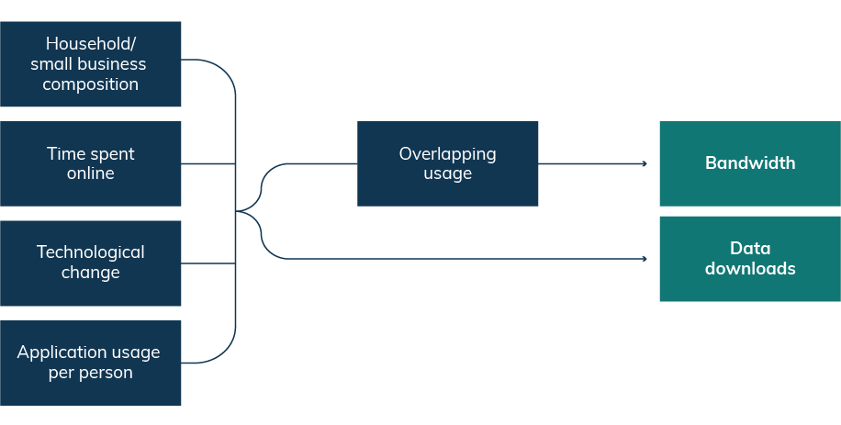

Source: BCAR

### Australian households are typically small

Household composition varies widely in Australia. Although the average household was around 2.5 people in 2016,[40] around a quarter of households had only 1 person, while another third had only 2 people (Figure 2). According to Australian Bureau of Statistics (ABS) data from the 2016 Census of Population and Housing, only 3 per cent of households had 6 or more people while 27 per cent of households had children (people aged less than 15 years).

Figure 2. Household composition

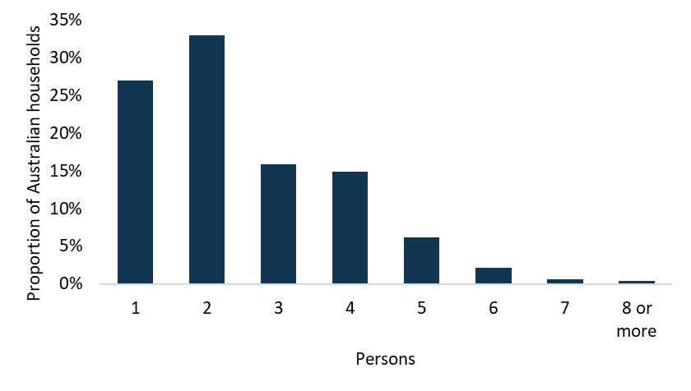

Source: BCAR estimates based on 2016 ABS Census of Population and Housing customised data

As well as household composition, an important driver of household bandwidth demand is the video content consumed by households and the devices used to stream this content within the household. For example, a household that does not have any 4K capable devices is unable to watch any content in 4K. Accordingly the BCAR has modelled households using different video formats, based on household ownership of devices by resolution. Additionally, the BCAR has developed a distribution of 4 household types to categorise different intensities of internet usage, from low to high. More information on the household types can be found in Appendix C: Household types.

### Small businesses tend to employ few workers

Small businesses, defined as fewer than 20 employees[41] are important drivers of employment and economic activity in Australia. They account for 97 per cent of all businesses, 44 per cent of total employment, and 34 per cent of total industry value added in the economy.[42]

Understanding the number of employees in each small business is fundamental to assess the small business bandwidth demand at the industry level. Bandwidth requirements depend on the number of employees in a business at the same location, with each additional employee increasing the likelihood of more bandwidth being demanded by a small business at any point in time. In the absence of data on employee location by business, employees are assumed to work from the same premises. To the extent that some small businesses have employees working across multiple premises, the estimates provided in this paper may tend to overstate bandwidth demand at a single premises.

The analysis is based on broadband use at the business premises using a fixed‑line connection. It has focused only on employing small businesses (1–19 employees) to avoid the potential for double counting, as non-employing businesses are likely to use a household connection.[43] The analysis does not include employee broadband use when outside of the premises, such as mobile broadband. More information on mobile broadband is found in Appendix F: Caveats to the analysis.

Determining how bandwidth demand varies across small businesses requires an understanding of the distribution of businesses by number of employees and industry. Data was sourced from the ABS on counts of Australian businesses by industry subdivision at the national level to identify how many businesses are non-employing, had 1–4 employees, 5–9 employees, 10–14 employees and 15−19 employees. Counts of businesses within each range were used to impute the number of employees per business. Further information is found in Appendix D: Small business characteristics.

The resulting distribution of employing small businesses is displayed in Figure 3. It shows that 34.63 per cent small businesses have only 1 employee and 0.31 per cent have 19 employees. The average (employing) small business has 3.7 employees.

Figure 3. Small businesses by the number of employees

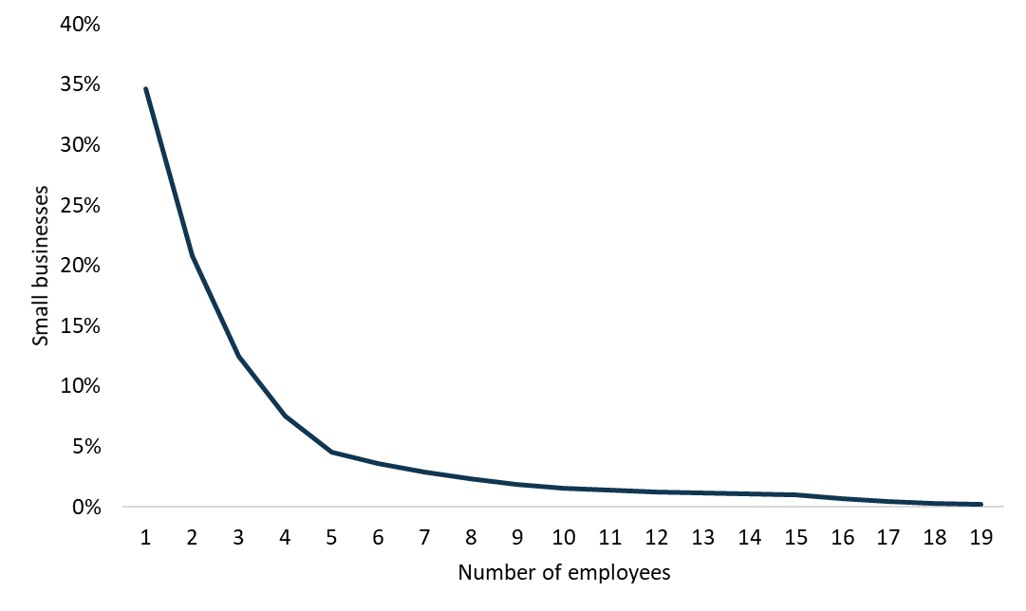

Source: BCAR estimates based on ABS customised data

#### Application usage varies across industries

Internet use varies by industry. The BCAR has categorised occupations into 4 different intensities of internet usage. Since industries have diverse occupation mixes, this drives different bandwidth requirements for different industries. Further information on usage types is found in Appendix D: Small business characteristics.

### People are spending more time online

An increase in the amount of time a person spends online makes it more likely that there will be overlapping use of applications with other people in a household or business. Overlapping use of applications leads to higher overall bandwidth demand at the premises.

Analysis of the time spent on internet applications found that:

* the average adult in a household used the internet for 3 hours per day in 2018, and is forecast to spend more than 5.5 hours online per day in 2028.
* the average employee was estimated to have spent over 1.5 hours undertaking online activities at work each day in 2018, and is forecast to spend almost 2.5 hours per day online in 2028.

There are limits to the amount of time that humans can spend online given other essential daily activities such as sleep.

Analysis of a typical day in Australia in 2017 highlighted that after excluding time spent sleeping, working, eating, commuting, exercising and personal care, Australians were left with 8.1 hours per day on average for leisure time at home that would be available to use applications on a fixed‑line network.[44] This is broadly consistent with the 9 hours per day estimate derived from the American Time Use Survey[45] (which has remained relatively constant since 2003)[46] as well as evidence from Canada (7.5 hours available).[47]

The BCAR forecast the active[48] time spent online in households and compared this to the average amount of leisure time available for internet use. In 2018, the medium user (also reflective of the average user) spent 3 hours online per day, but only 2.8 hours actively using the internet. This is forecast to reach 5.8 hours online per day in 2028, with 5.4 hours of active use.

The BCAR’s estimates also include low and high internet usage individuals. Low users are assumed to spend half the time online compared to medium users. High usage individuals are assumed to spend double the medium users’ time online.

Low and medium users’ time actively using the internet is forecast to remain under the available time threshold of 8.1 hours for leisure time to use fixed-line internet over the forecast period, while high usage individuals are forecast to break that threshold from 2023 (Figure 4). Therefore high usage individuals spend, on average, less time on other activities such as work outside of the home which provides them more time to spend at home and online. These users could also be substituting other activities such as sleep to spend more time on the internet.

Individuals are also increasingly undertaking multi-screen activities. Research highlighted that 91 per cent of Australians multi‑task while watching TV.[49] As a result, users are able to undertake more internet activity in less time and complete their online activity within the available time.

More information on the time spent on applications can be found in Appendix E: Applications and Appendix H: Assumptions tables.

Figure 4. Active internet use at home per adult per day

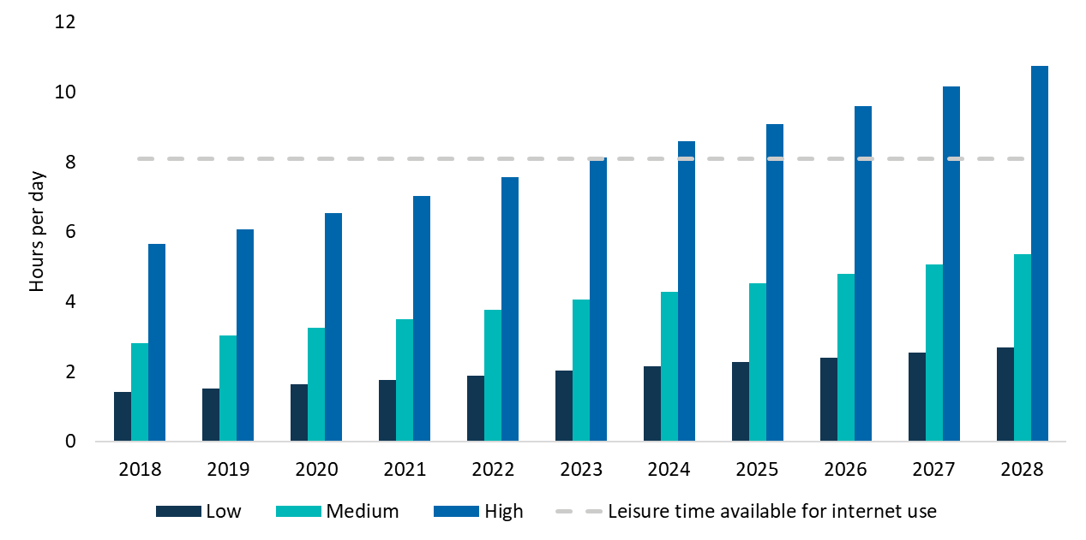

Source: BCAR estimates

### Technological change affects bandwidth and data demand

#### Compression

Bandwidth requirements of video applications have been decreasing over time due to improvements in compression technology. Compression allows information to be transmitted more efficiently, using less data. Improvements in compression technology happen every few years as a new codec is introduced or an existing codec is improved that allows content to be transferred using less bandwidth (see Box 1). The BCAR has converted future step changes to an annual rate of improvement based on how much future codecs are expected to reduce bandwidth requirements.

##### Box 1: Recent developments in compression

A codec is a computer program that encodes video files, compressing the data for storage or sending, then decompresses them for playback or editing.[50] Release of new or updated codecs provides compression improvements over time.

In 2009,[51] MPEG-4 AVC (or H.264) was widely adopted and provided bitrate savings of 50 per cent over its predecessor, MPEG-2.[52] VP9, adopted in 2015 by major platforms such as YouTube,[53] offered bitrate savings of around 30 per cent when compared to MPEG-4.[54] HEVC (or H.265), used by Netflix,[55] provides improvements of more than 50 per cent over MPEG-4.[56]

Proposed future codecs include AV1, set to be released and adopted by YouTube and Netflix,[57] offering savings of around 45 per cent over MPEG-4.[58] VVC, which is set for release from 2020, may provide savings of more than 30 per cent compared to HEVC.[59]

Bitrate savings vary widely depending upon the content being streamed. For the same perceived quality, a compressed high definition (HD) stream of ‘simple’ content may require 1.5 Mbps, whereas a compressed HD stream of ‘complex’ content may require 8 Mbps.[60]

The BCAR used the variation in average bitrate savings from historic generations of codecs to estimate the compression rate of future codecs and converted this to a trend.[61] This approach yields an estimate of a 7 per cent annual improvement in compression which is in line with Cisco forecasts.[62] The impact of different compression rate improvements on future bandwidth requirements were sensitivity tested and indicate that compression is an important driver of future bandwidth demand (see Appendix G: Sensitivity analysis).

### Overlapping applications drive peak bandwidth demand

Bandwidth requirements depend on the intensity of application use at a point in time. This intensity will vary over the course of the day. For the average household there is a busy period where online activity peaks in the evening between 4pm and 11pm, when more people are at home using internet applications (Figure 5).

Figure 5. Average day download behaviour

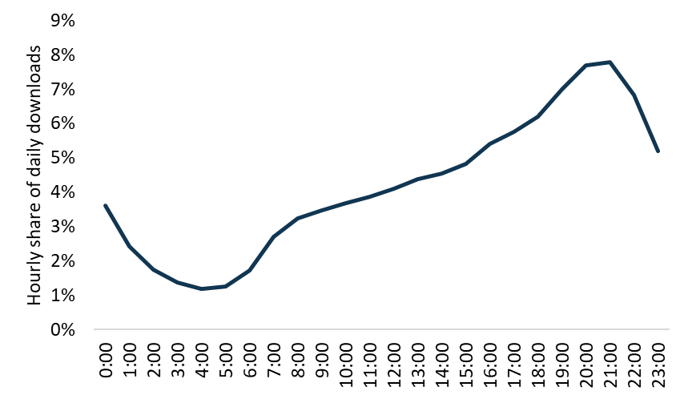

Source: BCAR calculations based on the 2020 NBN corporate plan[63]

The busy period for a premises determines its peak bandwidth requirements. This is because there is a greater likelihood that a person is undertaking single or multiple online activities, and that multiple people within a household or small business are online at the same time during this period. It is these activities happening at the same time that determines peak bandwidth demand.

An indicative household’s bandwidth requirements is shown in Figure 6 to illustrate that peak bandwidth requirements are driven by the overlap of applications, rather than the use of any particular application. In this household, peak bandwidth demand occurs when there is simultaneous usage of 4K streamed video, game downloads, web browsing and low bandwidth applications.

Figure 6. Illustration of a household’s bandwidth requirements

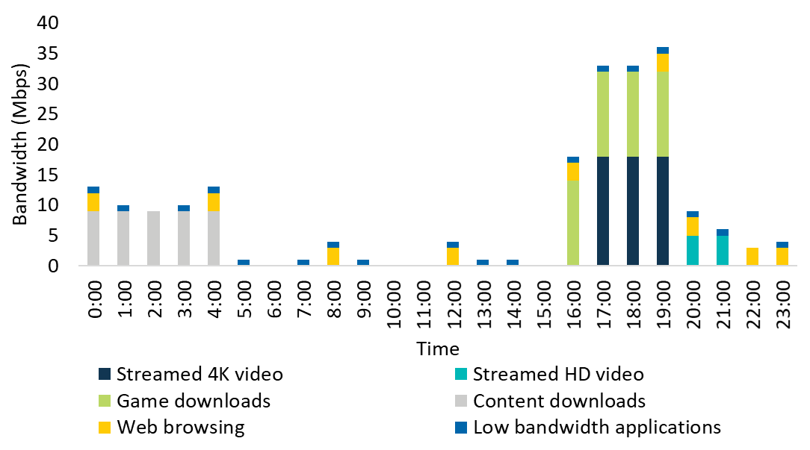

Source: BCAR, with assumptions outlined in Appendix E: Applications

Note: The bandwidth requirements shown are based on simultaneous usage of all of the applications listed.

The BCAR uses probability analysis to estimate the frequency and duration of overlapping usage of applications. Probability analysis treats the usage of different applications as independent events. In other words, the probability of using a given application at a point in time does not depend on whether other applications are in use at that moment. More information on how probability analysis was used can be found in Appendix A: Modelling bandwidth demand.

In addition to using probability analysis, the BCAR has focused on the busy period because peak bandwidth requirements are more likely to occur during this period. This focus requires an understanding of the proportion of activity that takes place during the busy period. More information on how the busy period was used in the analysis can be found in Appendix B: Busy period.

### Households and small businesses use many different applications

Applications are programs which enable users to perform tasks such as watch a movie, read an email, listen to a voice call or turn on a ‘smart’ device. Bandwidth is used by applications to transmit information or data. When this information is stored in a remote location, the data is transferred (or downloaded) to the user’s device.[64]

The BCAR has focused on bandwidth for data downloads rather than uploads (when information is sent to a remote location).[65] This is because significantly more data is downloaded than uploaded. For example, the average NBN user downloaded 190 gigabytes in April 2018, while the average upload per user was 17.5 GB for the same period.[66] There is also a greater volume of evidence available on downloads that can be used to develop the forecasts.

#### Household applications

Changes to household data usage will be mainly driven by new and improved technology. Video will become more data intensive as households switch from standard definition (SD) and high definition (HD) to 4K and 8K video. New technologies such as streamed gaming, virtual reality (VR) and internet of things (IoT) devices are also forecast to affect bandwidth requirements. Growth in the number of devices per household will also impact on bandwidth, with the average Australian household owning 6.6 screens in 2018, up from 6.1 screens in 2015.[67]

Household applications have been grouped into 4 categories to reflect their different usage and bandwidth requirements (Figure 7). The 4 categories are:

* Primary applications—such as streamed video, streamed gaming and streamed virtual reality—which are not normally used simultaneously by an individual.
* Secondary applications—such as cloud storage, content downloads, peer-to-peer file sharing, and software downloads—which could be used at the same time as other applications.
* Web browsing—which is a secondary application but is considered separately due to its ‘bursty’ nature—data use occurs in bursts as pages are loaded and then there is inactivity as the content is consumed.
* Low bandwidth applications—such as voice calling and IoT devices—which require minimal bandwidth.[68]

Figure 7. Household applications

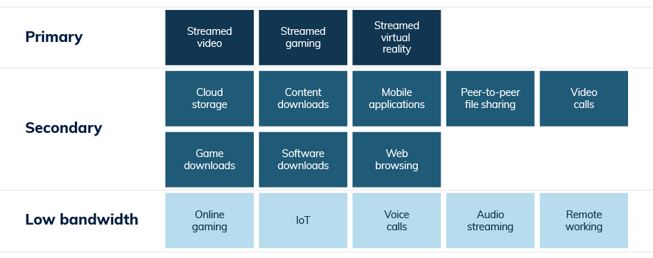

Source: BCAR

Online gaming is considered a low bandwidth application as it requires only minimal data transfer (used to transmit game state information).[69] This is distinct from streamed gaming, e-sports and streamed virtual reality, which transmit full video and audio to the user and need much higher bandwidth. The download of games is included as a secondary application. This application covers the transfer of large files so that the user can play the game after (or sometimes during) the software download.

Some applications are excluded from the analysis, such as software updates that can be scheduled to occur outside busy periods[70] or use only idle bandwidth,[71] or because they would affect upload bandwidth significantly but only require minimal download bandwidth. More information on household applications can be found in Appendix E: Applications.

#### Small business applications

Many of the applications used by small businesses are the same as those used by households. Surveys in Australia[72] and the UK[73] found that email and web browsing applications are particularly important for small businesses. There is also common usage of applications including video calling and cloud storage.

The BCAR has considered a set of applications for small businesses including email, web browsing, cloud storage, video calls, streamed video and file transfers. Low bandwidth applications are included to cover bandwidth usage by machines (such as IoT) and applications used by employees that require minimal bandwidth such as voice calls and audio streaming. Non‑employee internet usage by guests or customers is considered through the inclusion of guest WiFi bandwidth for selected industries (Figure 8).

Similar to household applications, some small business applications are excluded from the analysis, such as software updates which can be scheduled to occur outside busy periods[74] or use only idle bandwidth,[75] or because they would affect upload bandwidth significantly but require minimal download bandwidth. Additionally, special-purpose applications such as data centres, online software as a service products, online management and reporting tools and other applications used only in selected industries were not included in the analysis. More information on small business applications can be found in Appendix E: Applications.

Figure 8. Small business applications

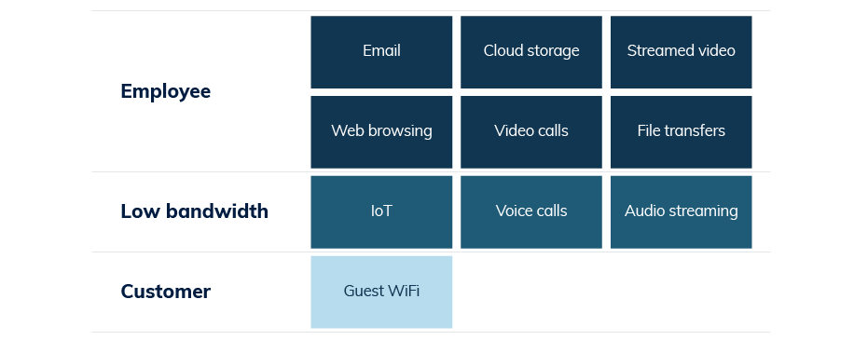

Source: BCAR

## Peak household bandwidth demand

Probability analysis of bandwidth demand drivers yields the following estimates of peak household bandwidth demand:

* half of households had peak bandwidth demand of 14 Mbps in 2018 or less and will demand 29 Mbps or less in 2028
* 90 per cent of households had peak bandwidth demand of 22 Mbps or less in 2018 and will demand 48 Mbps or less in 2028
* 95 per cent of households had peak bandwidth demand of 24 Mbps or less in 2018, and will demand 56 Mbps or less in 2028.

The distribution of demand across all households is shown in Figure 9.

Figure 9. Distribution of household peak bandwidth demand

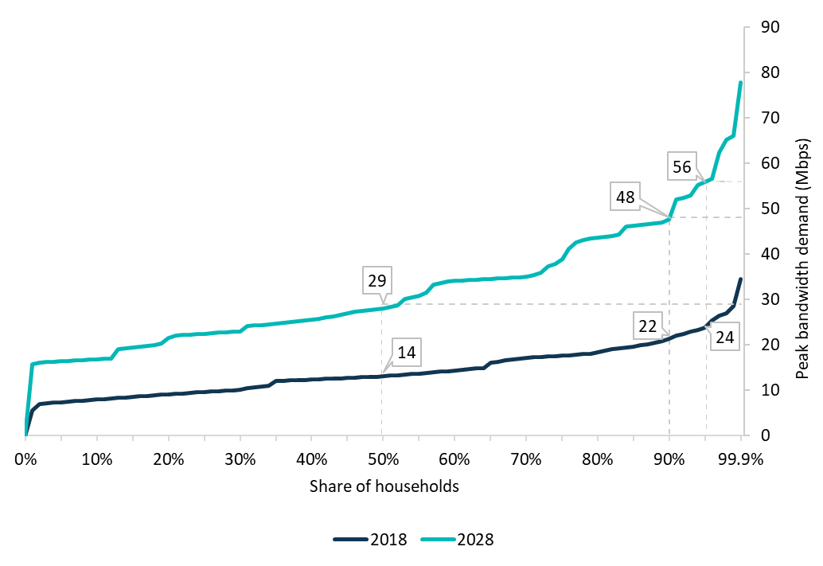

Source: BCAR estimates

The main drivers of increased broadband demand over the forecast period are higher resolution video streaming and game downloads.

The forecasts are sensitive to the uptake of higher video resolutions. The BCAR estimated that 75 per cent of streamed and downloaded video would be viewed in 4K in 2028. If the share of video viewed in 4K was significantly reduced, then bandwidth demand would be lower. For example, if only 25 per cent of video was viewed in 4K in 2028, then bandwidth requirements would be reduced from 56 Mbps to 49 Mbps for 95 per cent of households in 2028.

The BCAR has assumed that households are willing to wait 5 hours for large game downloads (approximately 40 gigabytes on average) in 2018,[76] but that this tolerance will fall to 4 hours (for an average game of 66 gigabytes) in 2028. This translates to a required bandwidth of 28 Mbps for game downloads, double the 14 Mbps required in 2018 (see Appendix E: Applications). Assuming that consumers are willing to wait for only half the time would increase bandwidth demand from 56 Mbps to 79 Mbps for 95 per cent of households in 2028, while doubling the waiting time would reduce bandwidth demand from 56 Mbps to 52 Mbps for 95 per cent of households.

More information on the BCAR’s assumed uptake of higher resolution streaming can be found in Appendix E: Applications. Bandwidth demand estimates for different download tolerances are found in Appendix G: Sensitivity analysis.

Only 2 per cent of households are estimated to require more peak bandwidth than 66 Mbps in 2028 (Table 1). This would likely represent households that stream video on multiple high resolution devices or frequently download large media and software files. For example, to meet bandwidth demand for 99.9 per cent of households, peak bandwidth was estimated to be 35 Mbps in 2018, rising to 78 Mbps in 2028. The relatively small number of households demanding these speeds may be willing to pay for higher speed broadband services.

Table 1. Household peak bandwidth demand

| **Households (percentile)** | **Bandwidth in 2018 (Mbps)** | **Bandwidth in 2028 (Mbps)** |
| --- | --- | --- |
| 50% | 14 | 29 |
| 75% | 18 | 39 |
| 90% | 22 | 48 |
| 95% | 24 | 56 |
| 98% | 28 | 66 |
| 99% | 29 | 66 |
| 99.9% | 35 | 78 |

Source: BCAR estimates

The distribution of household demand changes over the forecast period due to increased usage of data‑rich applications and more time spent using them (Figure 10). In 2018, around 87 per cent of households had peak bandwidth demand of 20 Mbps or less and 99.9 per cent required peak bandwidth of less than 35 Mbps. In 2028, around 70 per cent of peak demand is estimated to be met with 35 Mbps or less, but there is a longer tail of households that demand peak bandwidth of up to and greater than 60 Mbps.

Figure 10. Household peak bandwidth demand

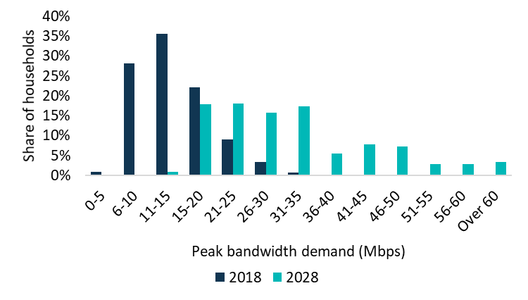

Source: BCAR estimates

While household bandwidth demands vary (see Table 1), Figure 11 shows that more bandwidth is required to meet the demands of a smaller number of additional households.

* For example, as noted previously, the median household (the 50th percentile) demands 14 Mbps in 2018 and 29 Mbps in 2028.
* In comparison, to meet peak demand for 75 per cent of the market requires another 4 Mbps in 2018, or 10 Mbps in 2028 (or 39 per cent above the median bandwidth demand).
* Extending this to meet demand for 90 per cent of households requires a further 4 Mbps in 2018, or 9 Mbps in 2028 (70 per cent above the median).
* Finally, to capture another 9.9 per cent of households (up to the 99.9th percentile) requires a further 13 Mbps in 2018, and 30 Mbps in 2028 (178 per cent above the median).

Figure 11. Additional bandwidth demand by higher bandwidth usage households

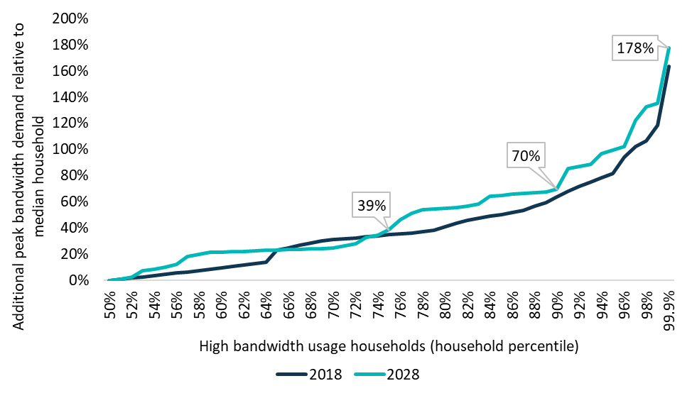

Source: BCAR estimates

Box 2: Household bandwidth demand scenarios   
The following examples of household bandwidth demand illustrate how it is the combined usage of various internet applications that affects bandwidth demand (Figure 12). Any number of combinations of applications could occur in individual households.

**Simultaneous application usage drives bandwidth**

If a household with 1 person streams HD video then the household’s bandwidth demand is 5 Mbps in 2018.[77] As technology and viewing patterns change over time, if the person streams 4K video in 2028, the household’s bandwidth demand is 9 Mbps. These scenarios are likely to occur, however they are unlikely to define a household’s peak bandwidth demand because, as discussed earlier, it is the overlap of applications that determine peak bandwidth requirements.

Considering a household with multiple applications in use at the same time, if 2 people browse the web and 1 person watches a HD video stream, the bandwidth demand would be 11 Mbps in 2018. If the same scenario occurred in 2028, but with a 4K video stream instead of HD, then the household’s bandwidth demand would be 21 Mbps.

If more applications are in use at the same time then bandwidth requirements will increase. For example, if in a household 1 person watches a SD video stream and another watches a HD video stream, bandwidth demand is 7 Mbps in 2018. If at the same time someone is on a video call and browsing the web while also downloading files from the cloud, the BCAR estimates the bandwidth requirement would be 14 Mbps in 2018. If the same scenario occurred in 2028 but both video streams were now being viewed in 4K, then the BCAR estimates that the household’s bandwidth demand would be 29 Mbps in 2028. This scenario is an example of median peak bandwidth demand as it was presented in Table 1.

For a heavier bandwidth usage household, if 3 people stream SD video, 1 person browses the web, a large game was being downloaded and there were some low bandwidth devices in use then bandwidth demand would be 24 Mbps in 2018. Considering the same scenario in 2028, if instead of the 3 SD video streams, 2 of the streams were viewed in 4K and 1 was viewed in HD then the household’s bandwidth demand would be 56 Mbps in 2028. This scenario is reflective of 95th percentile peak bandwidth demand as it was presented in Table 1.

Figure 12. Example household bandwidth demand scenarios

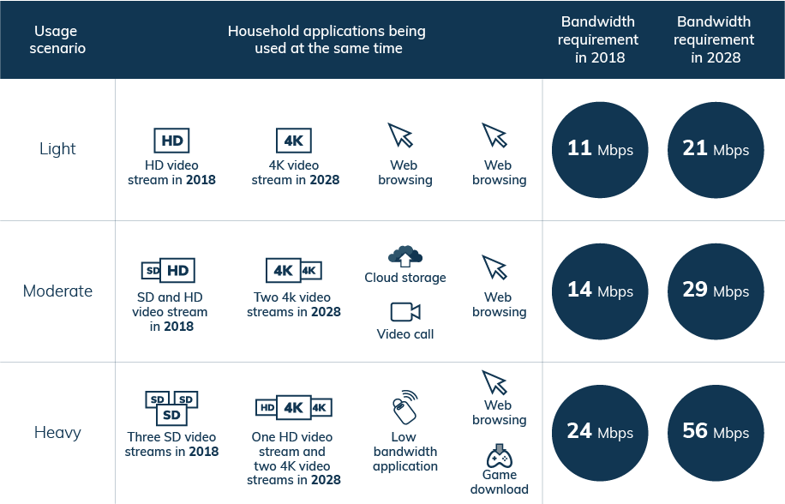

Source: BCAR estimates

Note: The bandwidth requirements shown in the figure are based on simultaneous usage of all of the applications listed. Simultaneous usage of several applications is unlikely to occur frequently for extended periods within a household. Including an additional video stream at 8K resolution in the scenarios would require an additional 37 Mbps based on 2028 bandwidth requirements (see Table 25).

### Bandwidth demand is driven by internet usage, household size and higher video resolution

The main drivers of bandwidth are household size, video resolution and internet usage. Table 2 shows the different household types that were used to develop these estimates. Around 60 per cent of households have 2 or less people and another third (32.4 per cent) have 3 or 4 people. Households were categorised into low, medium, medium with games downloads and high usage.

More information on the household types that were developed using 2016 ABS Census of Population and Housing data, by forecasting video resolution uptake and internet usage types are outlined in Appendix C: Household types.

Table 2. Household types by size and internet usage

| Number of people in household | **Internet usage types (% share of all households)**  **Low** | **Internet usage types (% share of all households)**  **Medium (2028)** | **Internet usage types (% share of all households)**  **Medium with game downloads (2028)** | **Internet usage types (% share of all households)**  **High** | **Internet usage types (% share of all households)**  **Total** |
| --- | --- | --- | --- | --- | --- |
| 2 or less | 24.0 | 18.0 (12.0) | 6.0 (12.0) | 12.0 | 59.9 |
| 3 to 4 | 13.0 | 9.7 (6.5) | 3.2 (6.5) | 6.5 | 32.4 |
| 5 to 6 | 2.9 | 2.2 (1.5) | 0.7 (1.5) | 1.5 | 7.3 |
| 7 or more | 0.2 | 0.1 (0.1) | 0.0 (0.1) | 0.1 | 0.5 |
| Total | 40.0 | 30.0 (20.0) | 10.0 (20.0) | 20.0 | 100.0 |

Source: BCAR estimates. Totals may not sum due to rounding.

Note: The table shows the share of households in 2018 and 2028. Parentheses indicate 2028 where there is a difference. These differences are driven by the BCAR’s expectation that more households are likely to download games in 2028. The analysis examined only those household types with up to 8 people; larger households of 9 or more were only 0.17 per cent of all households in Australia in 2016 according to analysis of ABS Census of Population and Housing data. Households with more than 4 adults or children were included in 4 adults or children only where required.

Figure 13 shows the distribution of peak bandwidth demand for households in 2018. The first panel shows that bandwidth demand for low usage households is estimated to range from 8 to 21 Mbps (dark blue bars) in 2018 and from 18 Mbps to 41 Mbps for high usage households (blue bars). Only high internet usage individuals who live in larger households or use high resolution devices demand bandwidth greater than 30 Mbps. The second panel shows the share of households that have these bandwidth demands. As most households contain fewer than 5 people and use SD or HD devices, peak bandwidth demand from these households was estimated to be around 30 Mbps or less in 2018.

Figure 14 shows the bandwidth demand for households in 2028. Bandwidth demand ranges from 17 Mbps to 45 Mbps for low usage households (dark blue bars) and from 40 Mbps to 93 Mbps for high internet usage households (blue bars). Only larger households or those with high resolution devices are likely to demand bandwidth greater than 55 Mbps. Households with high resolution devices demand substantially more bandwidth than households that use HD devices. The second panel shows the share of households that have these bandwidth demands. As most households have fewer than 5 people and are forecast to use HD or 4K devices, peak bandwidth demand for these households is estimated to be around 55 Mbps or less in 2028. However, there are some households with greater bandwidth demand, including 3 to 4 person households who use 4K or higher devices.

Figure 13. Peak bandwidth demand by household type in 2018

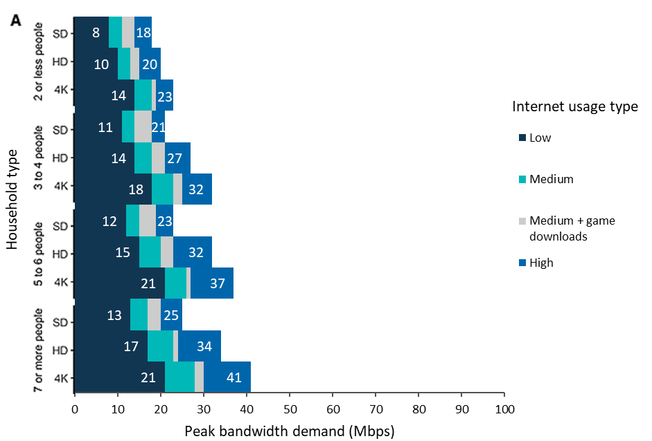

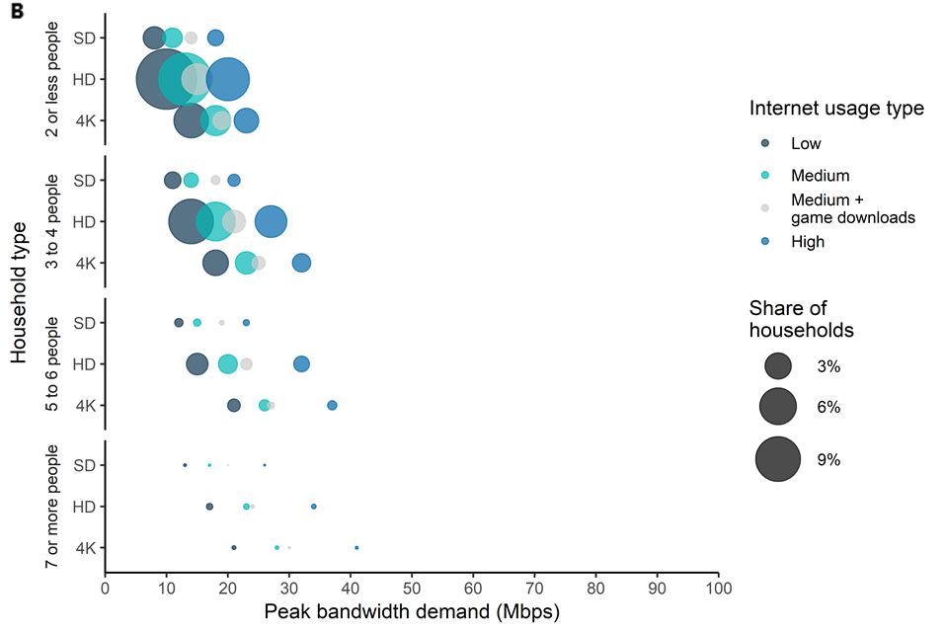

Source: BCAR estimates

Note: These figures do not imply that bandwidth demand for a low usage household of 7 or more people with 4K devices is 21 Mbps in 2018 to support 7 or more 4K video streams at the same time. Rather, the figures imply that for all but the busiest minute per day, this type of household is estimated to demand 21 Mbps to undertake their combination of applications based on the BCAR’s probability analysis. The BCAR’s analysis examined only households of up to 8 people; larger households of 9 or more were only 0.17 per cent of all households in Australia according to analysis of ABS Census data.

Figure 14. Peak bandwidth demand by household type in 2028

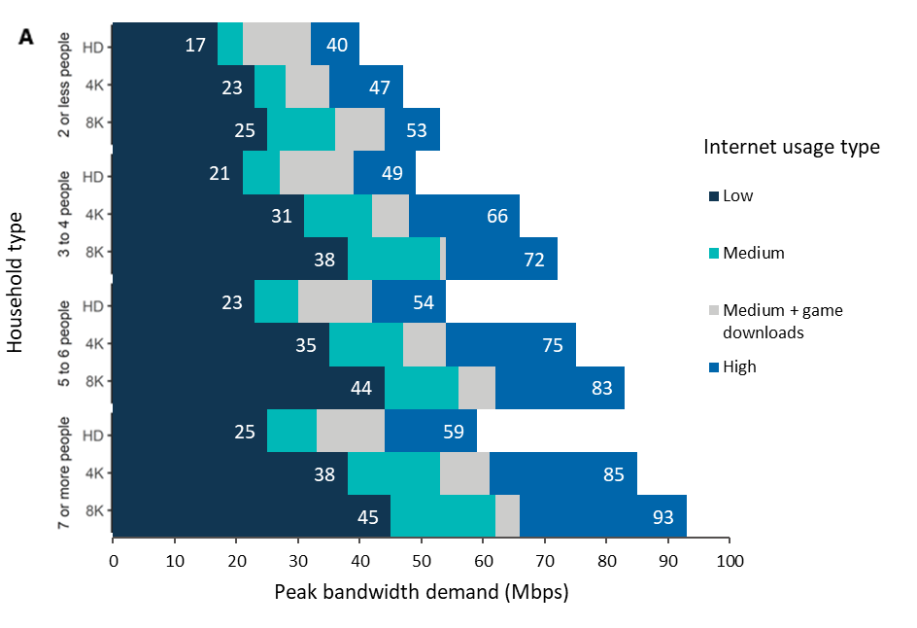

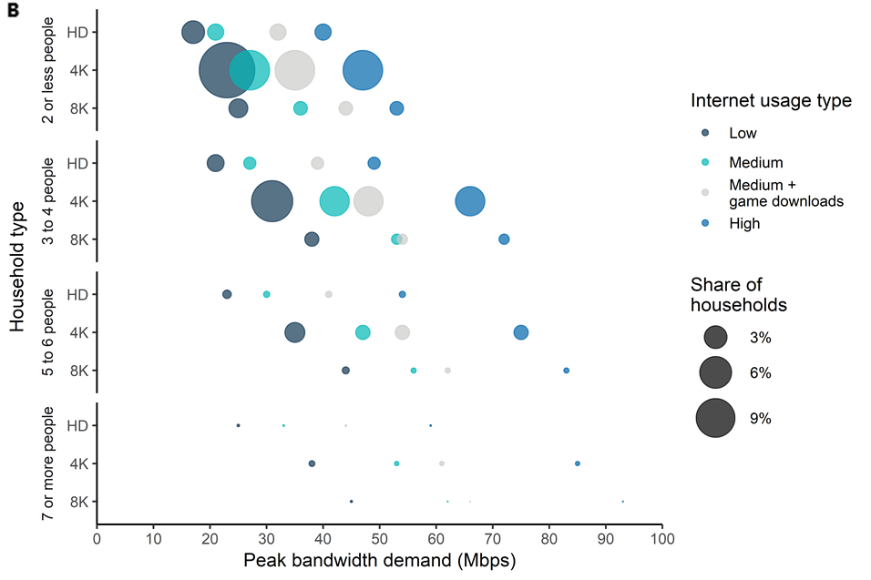

Source: BCAR estimates

Note: These figures do not imply that the bandwidth demand for a low usage household of 7 or more people with 8K devices is 45 Mbps in 2028 to support 7 or more 8K video streams at the same time. Rather, the figures imply that for all but the busiest minute per day, these households are estimated to demand 45 Mbps to undertake their combination of applications based on the BCAR’s probability analysis.

## Peak small business bandwidth demand

Probability analysis of bandwidth demand drivers yields the following estimates of bandwidth demand for small businesses:

* half of small businesses had peak bandwidth demand of 7 Mbps or less in 2018 and 9 Mbps or less in 2028
* 90 per cent of small businesses had bandwidth demand of 19 Mbps or less in 2018, increasing to 27 Mbps or less in 2028
* 95 per cent of small businesses had bandwidth demand of 24 Mbps or less in 2018, rising to 37 Mbps or less in 2028.

The BCAR’s analysis presents a distribution of peak bandwidth demand for all small businesses. Demand is forecast to rise over time due to technological developments and increases in time spent using applications. The distribution of bandwidth demand is shown in Figure 15.

Figure 15. Distribution of small business peak bandwidth demand

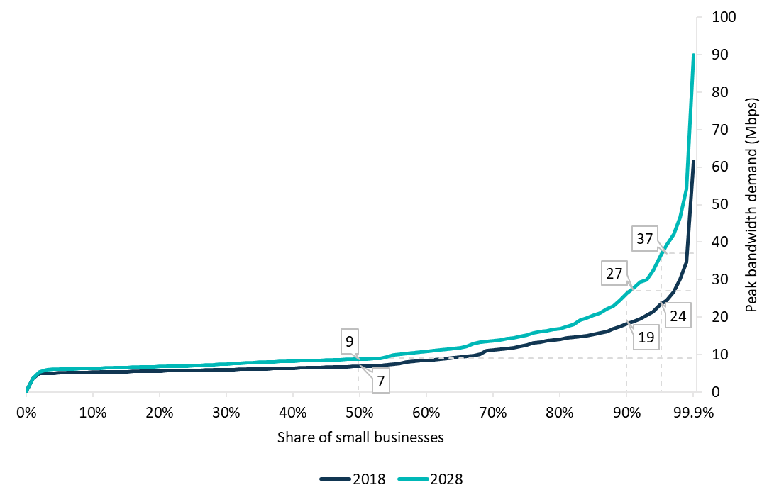

Source: BCAR estimates

As is the case for households, a very small proportion of small businesses are expected to require extremely high bandwidth. Only 0.1 per cent of small businesses require bandwidth over 62 Mbps in 2018 and 90 Mbps in 2028 (Table 3). As with households, small businesses with high demands may have additional willingness to purchase products that can provide higher bandwidth.

Table 3. Small business peak bandwidth demand

| **Small businesses (percentile)** | **Bandwidth in 2018 (Mbps)** | **Bandwidth in 2028 (Mbps)** |
| --- | --- | --- |
| 50% | 7 | 9 |
| 75% | 13 | 16 |
| 90% | 19 | 27 |
| 95% | 24 | 37 |
| 98% | 31 | 47 |
| 99% | 35 | 55 |
| 99.9% | 62 | 90 |

Source: BCAR estimates

The distribution of demand is estimated to remain relatively consistent over the forecast period (shown in Figure 16). Throughout this period, the majority of demand is expected to be met with 25 Mbps or less. However, a minority of business are estimated to require much higher bandwidth, and the highest bandwidth users (the top 1 per cent) have peak bandwidth demand greater than 35 Mbps in 2018 and over 55 Mbps in 2028.

Figure 16. Small business peak bandwidth demand

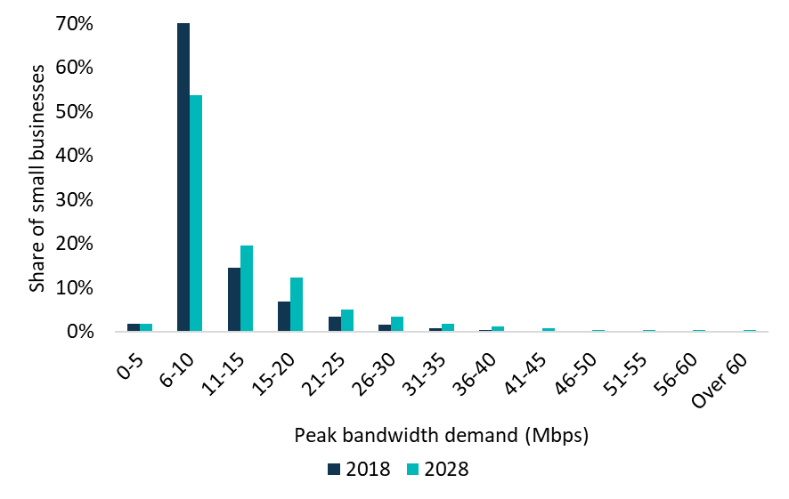

Source: BCAR estimates

### Bandwidth demand is driven by overlapping applications and large downloads

The forecasts for small business demand are driven by the overlap of applications being used by a business at the same time. Both guest WiFi and low bandwidth applications[78] are assumed to be in constant use during the busy period, which increases the likelihood of overlapping usage and therefore peak bandwidth demand. Without guest WiFi, bandwidth requirements for 95 per cent of all small businesses would fall from 24 to 21 Mbps or less in 2018, and from 37 to 30 Mbps or less in 2028 (see Table 4).

Table 4. Small business bandwidth demand including and excluding significant drivers

| **Scenario**  Small businesses (percentile) | **Bandwidth in 2018 (Mbps)**  **50%** | **Bandwidth in 2018 (Mbps)**  **90%** | **Bandwidth in 2018 (Mbps)**  **95%** | **Bandwidth in 2028 (Mbps)**  **50%** | **Bandwidth in 2028 (Mbps)**  **90%** | **Bandwidth in 2028 (Mbps)**  **95%** |
| --- | --- | --- | --- | --- | --- | --- |
| Base case | 7 | 19 | 24 | 9 | 27 | 37 |
| No guest WiFi | 7 | 17 | 21 | 9 | 23 | 30 |
| No low bandwidth applications | 5 | 13 | 17 | 8 | 18 | 31 |
| No guest WiFi or low bandwidth applications | 5 | 13 | 14 | 6 | 15 | 29 |
| File transfers are double the size | 7 | 20 | 29 | 9 | 27 | 59 |
| File transfers are half the size | 7 | 18 | 22 | 9 | 23 | 30 |

Source: BCAR estimates

Removing low bandwidth applications from the analysis found that peak bandwidth requirements fall to 17 Mbps in 2018 and 31 Mbps in 2028 for 95 per cent of small businesses. Excluding both guest WiFi and low bandwidth applications significantly reduces estimated peak bandwidth demand for small businesses. Bandwidth demand is estimated to fall to 14 Mbps in 2018, and to 29 Mbps in 2028, to meet the demands of 95 per cent of small businesses.

Another significant driver of bandwidth demand is file transfers. Testing the importance of file transfers in driving bandwidth demand by doubling the size of the file transfer to 2 gigabytes found that bandwidth demand rises to 29 Mbps in 2018, and 59 Mbps in 2028 for 95 per cent of small businesses. On the other hand, halving the size of the file transfer to 500 megabytes finds that estimated bandwidth demand is 22 Mbps in 2018 and 30 Mbps in 2028 for 95 per cent of small businesses. The outcomes that would occur from changing other important assumptions are presented in Appendix G: Sensitivity analysis.

### Bandwidth demand varies by industry

Bandwidth requirements for small businesses vary significantly by industry.[79] This is due to the different distribution of user types across industries and employment size.

Guest WiFi is a significant driver of bandwidth demand for the 3 industries with the highest bandwidth requirements for small businesses. Preschool and school education; tertiary education; and adult, community and other education all have bandwidth requirements greater than 60 Mbps in 2018, rising to over 90 Mbps in 2028, to meet the demand for 95 per cent of small businesses in these industries. The 10 highest bandwidth demand industries are shown in Figure 17.

Figure 17. High bandwidth demand industries

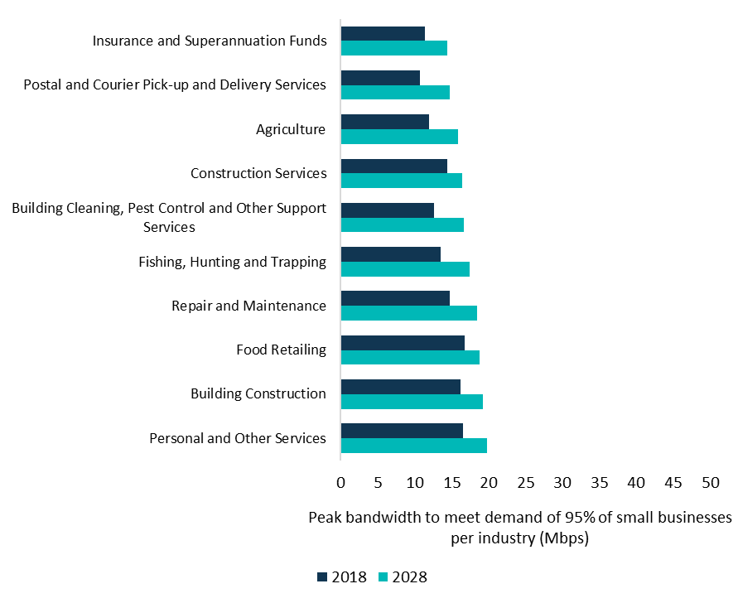

Source: BCAR estimates

Note: * denotes industries that include guest WiFi

The industry with the highest forecast bandwidth requirements for small business that does not include guest WiFi is computer system design and related services; followed by internet service providers, web search portals and data processing services; and broadcasting (except internet). The bandwidth required to meet the demands of 95 per cent of small businesses in these industries in 2028 was estimated to be 66 Mbps, 65 Mbps and 61 Mbps, respectively. Businesses in the 10 highest bandwidth demand industries comprise 12 per cent of all employing small businesses in Australia.[80]

The industries with the lowest forecast bandwidth requirements for small business in 2028 are insurance and superannuation funds; postal and courier pick-up and delivery services; and agriculture (Figure 18). The bandwidth required to meet demand for 95 per cent of small businesses in these industries in 2028 was estimated to be 15, 16 and 16 Mbps, respectively. Most of the 10 lowest bandwidth demand industries for small business were also among those industries with the lowest average employment size in Australia. However, these 10 lowest bandwidth demand industries remain significant, comprising 35 per cent of all employing small businesses in Australia.[81]

Figure 18. Low bandwidth demand industries

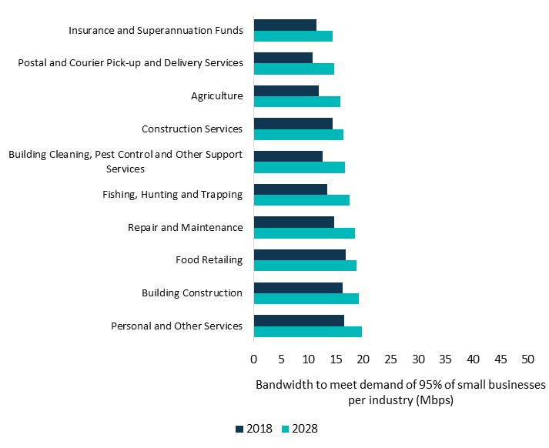

Source: BCAR estimates

## Data demand is increasing

Bandwidth is the amount of information transmitted at a point in time, while data downloads represent the volume of information that is consumed over a longer period. As discussed earlier, increases in bandwidth demand are due to increases in higher video resolution streaming and uptake of file downloads and new technologies. Data downloads are increasing over time as a result of two factors; that people are spending more time online and are using more data‑rich applications. On top of this, machine usage of data is also expected to drive increases in data downloads over the next decade.

The rapid uptake in video streaming by households has contributed to large increases in the amount of data downloaded by households, and this is expected to continue to increase over the forecast period (Figure 19). The BCAR forecasts average monthly household data downloads to increase from 199 gigabytes in 2018, to 767 gigabytes in 2028.

Figure 19. Fixed-line data downloads per household

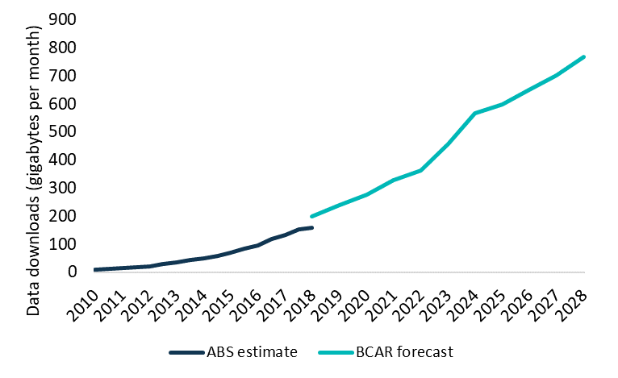

Source: BCAR estimates are based on data downloads per household, while ABS internet activity survey is by services in operation.

Note: The BCAR has not included applications that occur outside busy periods such as computer operating system patches (detailed in Appendix E: Applications) that would be additional data downloads in a month.

Although the amount of data downloaded will continue to rise, the overall rate of growth is expected to slow (Figure 20). The compound annual growth rate of 14 per cent over the forecast period is well below the 42 per cent annual growth rate that occurred between 2010 and 2018.[82] However, this represents the continuation of a long-standing trend of declining growth. Data downloads are forecast to temporarily spike between 2023 and 2024, driven by higher uptake of 4K content for streamed video.

Figure 20. Annual growth in fixed-line data downloads per household

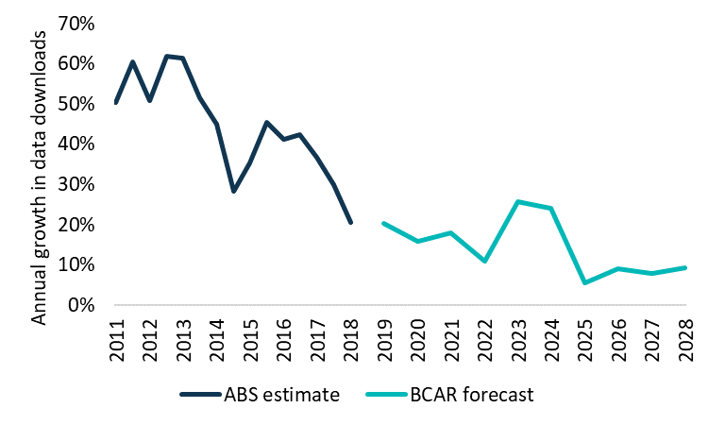

Source: BCAR analysis of ABS 8153.0, BCAR estimates

The average employee in a small business is estimated to download 9 gigabytes per month in 2018, rising to 15 gigabytes per month on fixed-line broadband in 2028. The main elements of data consumption are streamed video and web browsing which contribute over two‑thirds of data in 2028.

Data demand for each small business, on average, was estimated to be around 34 gigabytes in 2018 and 57 gigabytes in 2028 per month on fixed-line broadband. These figures exclude non-employee data from both low bandwidth applications and guest WiFi which could contribute a significant portion of data downloads in some industries. Comparing these figures to household data downloads, as discussed earlier, highlights that there is, on average, substantially less data consumption at work compared to at home.

## Appendix A: Modelling bandwidth demand

### Probability analysis

Peak bandwidth requirements are driven by the overlap of applications, rather than any single application in particular. However, there may be little time during the day when applications overlap. Considering a household of 2 people, the majority of the day may be spent out of the home with no bandwidth demanded, and there may only be a few minutes where both people happen to be streaming video at the same time as well as clicking onto a new webpage. Therefore, it is important for this analysis to consider the probability of applications overlapping.

To understand the likelihood of these overlaps, the BCAR has used a probability analysis which differs to the approach used in the BCAR’s 2018 publication, ‘Demand for fixed‑line broadband in Australia’ (see Box A1 for more information).[83] Probabilities are calculated by determining the amount of time spent using any given application in a day and then combining this with the BCAR’s assumption of the time spent on applications in the busy period. The probability of an overlap is therefore affected by the assumption about usage in the busy period (which is sensitivity tested in Appendix G: Sensitivity analysis), as well as the idea that applications are not used more or less intensively during certain parts of the busy hour period.

Considering an example in the household analysis, the average user in a HD household watches 1,495 minutes of HD streamed video per month in 2018. The BCAR assumes that 25 per cent of this viewing or 374 minutes occurs in the busy period. This equates to 10.4 per cent of the busy period in a month. The average user is assumed to spend 18 minutes per month on video calls. The likelihood of an average user undertaking a video call in the busy period is 0.1 per cent. Therefore the probability of them using both applications at the same time is approximately 0.01 per cent (Figure 21).

Figure 21. Probability analysis

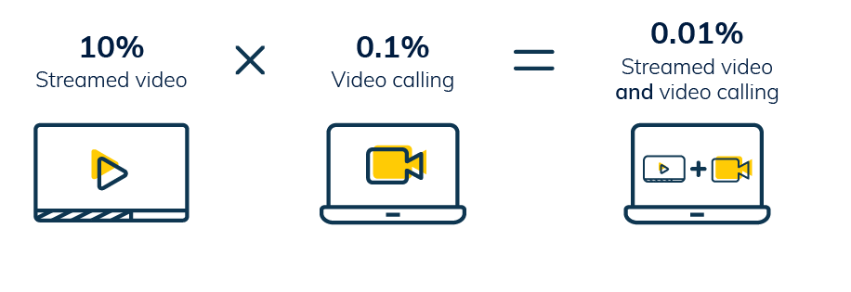

Source: BCAR estimates

This approach is used for all secondary applications and then combined with primary applications and web browsing. It is then replicated for every individual within a household and combined with low bandwidth applications at the household level. In order to reach an aggregate number for all households in Australia, these probabilities are then combined with the proportions of household types outlined in Appendix C: Household types. For the small business analysis, the probabilities are estimated for all employee applications and then aggregated using the employee counts by business in Appendix D: Small business characteristics and combined with non-employee usage in the business.

The BCAR has assumed that the probability of using an application is independent of using another application at the same time. For example, the probability that an individual is web browsing is not affected by whether or not they are downloading a large file at the same time. This assumption is made for simplicity, but in reality, certain applications may be either more or less likely to be used together. For example, software downloads may be likely to occur while web browsing, and assuming the 2 events are independent would understate bandwidth requirements. In contrast, it is unlikely that an individual would stream virtual reality while video calling at the same time, and assuming the 2 events are independent would overstate bandwidth requirements.

#### Box A1: Developments since the last BCAR working paper

The BCAR has extended and updated the approach used in the 2018 analysis of bandwidth demand, ‘Demand for fixed-line broadband in Australia’.[84]

The BCAR has taken on feedback since the publication of the previous working paper which has informed the methodologies used in this paper. An important improvement to the methodology is the use of probability analysis to develop application stacks. A probabilistic approach improves the accuracy of the forecasts by considering how often different applications are used at the same time, which has an impact on peak bandwidth demand. As the methodology in this paper is different, the estimates outlined in this paper are not directly comparable with the results published previously.

Replicating the analysis using the previous methodology would find similar bandwidth requirements for households in 2028 to what was presented in the previous working paper. The BCAR has used scenarios to present identifiable examples of bandwidth demand for typical households that align more closely with the approach taken in the BCAR’s previous paper that can be found in Figure 12.

Additional changes to the analysis since the publication of the previous paper were to:

* Examine small businesses as well as households.
* Undertake a comprehensive review of the evidence on bandwidth usage including the usage of more recent and varied data sources to estimate the real world bandwidth requirements of broadband users.
* Include additional applications such as streamed gaming and examined different types of file downloads in greater detail to more accurately estimate their impact on bandwidth demand.
* Reduce the impact of compression on lowering bandwidth demand, informed by monitoring recent technological developments.

More information on the assumptions that were used can be found in Appendix E: Applications.

### Model validation

The BCAR has undertaken comprehensive analysis of real-world internet usage to accurately reflect bandwidth requirements. The results from the analysis are consistent with similar comprehensive studies of bandwidth such as the work from Communications Chambers in their studies of residential bandwidth demand in Australia and the UK,[85] and of UK small businesses.[86] However, outside of these studies, there is limited evidence on bandwidth demand at the premises level.

There is much more evidence available on the amount of data that is downloaded at the premises level. The BCAR’s estimates are consistent with other estimates. Estimates using ABS data found that monthly data downloads in June 2018 were 159 gigabytes per subscriber,[87] while NBN Co reported an average of 201 gigabytes for the same period.[88] Estimates based on data from The Australian Competition and Consumer Commission (ACCC) for December 2018 were 213 gigabytes per subscriber.[89] In comparison, the BCAR’s estimate was 199 gigabytes per household each month in 2018 (Figure 22).

To evaluate how the BCAR’s forecasts are tracking over time, 2019 estimates can also be compared. The ACCC found that monthly downloads were 229 gigabytes per subscriber in June 2019 based on fixed-line subscribers,[90], [91] slightly below the BCAR’s forecast of 239 gigabytes for 2019, while NBN Co reported 255 gigabytes for the same period.[92] Further forward, Cisco forecasts data downloads of 335 gigabytes per household per month in 2022, below the BCAR’s average household download forecast of 363 gigabytes a month for the same year.[93]

Figure 22. Fixed-line data downloads per household

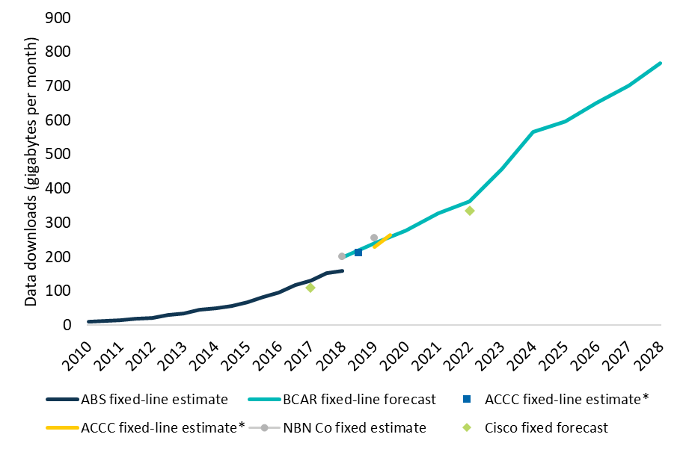  
Source: BCAR and Cisco estimates based on data downloads per household, ABS internet activity survey, ACCC internet activity report and NBN Co report are by services in operation.

*The ACCC fixed-line estimates are not comparable because of a change in methodology between June 2018 and December 2018.

Note: The ACCC internet activity report uses a different methodology to the ABS internet activity survey which is not directly comparable. The BCAR and Cisco’s forecasts relate to households, whereas the ABS and ACCC data is by subscriber. The NBN estimates are based on all fixed connections including fixed wireless whereas other estimates exclude include fixed-wireless. The BCAR has not included applications that occur outside busy periods such as computer operating system patches (detailed in Appendix E: Applications) that would be additional data downloads in a month.

## Appendix B: Busy period

The busy period is characterised by a greater likelihood of a person undertaking single or multiple online activities at the same time, and that multiple people within a household or small business are online at the same time. It is these activities happening simultaneously that determines peak bandwidth demand.

Estimating peak bandwidth demand depends on the proportion of activity that takes place during the busy period. In the absence of Australian-specific data, the BCAR’s analysis of American Time Use Survey data found that 24 per cent of the average time spent watching TV occurred between 8pm and 10pm in 2018.[94] This is important because time spent watching video is a significant driver of Australian bandwidth demand. Future studies of household bandwidth demand would benefit from further investigation of data consumption patterns at the household level.

The BCAR analysis assumes that households have a busy period of 2 hours per day and that 25 per cent of all download activity occurs in that period. In practice this means that a quarter of the time spent on each application happens in 2 hours, and the remaining usage happens throughout the rest of the day.

Business usage patterns differ from household patterns throughout the day. While there is an identifiable busy period where more activity takes place for households, business data downloads tend to be more evenly distributed throughout the day.

For small businesses, the BCAR assumed that the busy period of 2 hours in an employees’ 7 hour work day[95] and that the data downloaded in the busy period is equal to 1.5 times the average hour for small businesses. This implies that 37.5 per cent of daily activity for each application occurs in the busy period. These busy period assumptions are sensitivity tested in Appendix G: Sensitivity analysis.

### Premises and network busy period

The BCAR’s analysis is focused on household and small business premises, for which there is limited evidence of internet usage throughout the day. Accordingly, the BCAR has made assumptions about the proportion of daily internet usage occurring within the 2 busiest hours each day for households (25 per cent) and small businesses (37.5 per cent). Busy period usage at the premises level is distinct from busy period usage at the network level because the network level aggregates many more premises together. However, there is information on busy period usage at the network level as shown in Figure 5.

According to analysis of NBN Co data, approximately 15 per cent of network daily data downloads occur during the 2 busiest hours in a day (between 8pm and 10pm).[96] However, data downloads at an aggregate network level are not equivalent to download activity at an individual household or business level, as different households will have different busy periods. A household’s busy period of 2 hours could occur anytime, day or night, depending on a household’s schedule. For example, it might be from 3pm to 5pm when children return from school or from 9pm to 11pm after dinner. Similarly, for small businesses, the busy period could vary by occupation and industry.

Figure 23 demonstrates the relationship between the aggregated network busy period and household busy period for several indicative households. All these households undertake a quarter of their online activity in a 2 hour period (their household’s busy period) and the remaining activity equally throughout the rest of the day.[97] At the network level, this implies 15 per cent of activity takes place in the 2 busiest hours (between 8pm and 10pm).

Figure 23. Stylised example of the difference between household and network busy periods

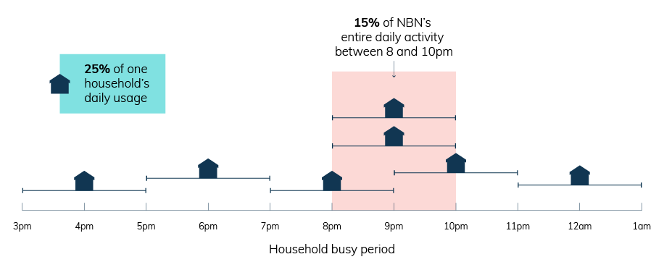

Source: BCAR

Note: This scenario shows that households undertake 25 per cent of their daily internet downloads in their 2 busiest hours and the remaining 75 per cent equally throughout the rest of the day, this would imply that, at a network level, 15 per cent of network daily data downloads occur within 2 hours. This corresponds with BCAR analysis of average day download behaviour from the NBN corporate plan which found that 15 per cent of network daily data downloads occur between 8pm and 10pm.[98]

## Appendix C: Household types

The BCAR has modelled different household types based on 3 characteristics:

1. Household composition
2. Video resolution type
3. Internet usage type.

Household composition was combined with household video resolution type (SD, HD, 4K and 8K) and whether the internet users are low, medium (excluding and including game downloads) or high internet usage individuals to create 320 different combinations of household types (Figure 24).

Figure 24. Household types

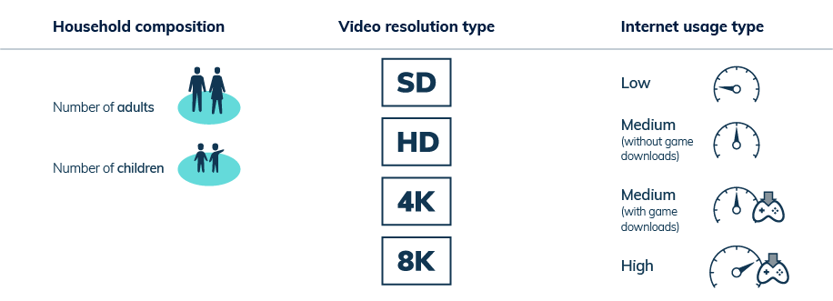

Source: BCAR

### Household composition

ABS microdata was used to construct 20 different household types based on the number of adults and children (aged less than 15) per household.[99] The household types constructed include those with 1 to 4 adults and 0 to 4 children. Due to the relative infrequency of households with greater than 4 adults, or greater than 4 children, these households were grouped into the households with 4 adults, or 4 children, respectively. The data, as it was used, is shown in Table 5.

Table 5. Household composition

| **Adults** | **Children**  **0** | **Children**  **1** | **Children**  **2** | **Children**  **3** | **Children**  **4+** | **Total** |
| --- | --- | --- | --- | --- | --- | --- |
| 1 | 26.9% | 1.6% | 1.4% | 0.5% | 0.2% | 30.6% |
| 2 | 31.3% | 6.1% | 7.6% | 2.5% | 0.7% | 48.2% |
| 3 | 8.4% | 2.5% | 1.3% | 0.4% | 0.1% | 12.7% |
| 4+ | 5.9% | 1.5% | 0.7% | 0.2% | 0.1% | 8.5% |
| Total | 72.6% | 11.7% | 11.0% | 3.6% | 1.1% | 100.0% |

Source: BCAR estimates based on customised ABS data from the 2016 Census of Population and Housing.

Note: The BCAR’s analysis only examined household types with up to 8 people, larger households of 9 or more were only 0.17 per cent of all households in Australia in 2016 according to BCAR analysis of ABS Census of Population and Housing data. Households with more than 4 adults or children were included in 4 adults or children only where required.

The BCAR has assumed that the proportion of households by composition will remain constant over the forecast period. This assumption was based on an analysis of recent household composition highlighting that the number of people per household has remained relatively stable over recent years.[100]

Children in the household are assumed to have 50 per cent of the average application usage of adults. Analysis from Nielsen found that only around 5 per cent of users who were streaming were aged between 2 and 17 in 2017.[101] Data from the Australian Consumer and Media Authority also found that children spent 10.6 hours on average each week watching screen content,[102] compared to adults who watched 18.9 hours on average per week in 2017.[103] This corresponds to children spending 56 per cent of the time of adults watching TV. This data is most applicable to streamed video, however the assumption of children having half the adult application usage is applied to all applications. While the impact of children is important to household bandwidth demand, children are in only 27 per cent of households and represent around 20 per cent of the Australian population using the ABS microdata.

### Video resolution type

Consumers are only able to stream content at the resolution that their devices are capable of delivering. For example if a consumer requests a 4K video stream on a HD device, they will receive a HD version of that stream (assuming they have access to a HD stream such as through a paid subscription delivering content at that definition). The BCAR has modelled the mixture of devices that households watch content on to accurately measure bandwidth demand.

The BCAR has assumed that HD devices were the highest resolution present in 69 per cent of households in 2018 based on UK data,[104] and have forecast this to fall to 9 per cent of households in 2028. 4K devices were assumed to be in 22 per cent of households in 2018,[105] rising to 79 per cent of households in 2028. 8K devices were assumed to not be introduced until 2019, representing only 0.1 per cent of households for that year,[106] but are forecast to be in 12 per cent of households in 2028. Finally, SD households were assumed to account for the remaining households, representing 9 per cent of households in 2018. The BCAR assumes that no household will be SD only in 2028.

Each device in a household is assumed to be capable of displaying content at the resolution of the highest resolution device in the household. For example, in a household with a 4K TV, it is assumed that the residents also have other devices such as mobile phones or laptops that are capable of delivering 4K streamed video in the event of simultaneous usage. This will not always be the case and even if it is, there are limited visual differences between HD and 4K video on smaller devices, and therefore this assumption could overstate bandwidth requirements.[107]

### Internet usage type

Individual characteristics and preferences can cause variation in internet usage. For example, the amount of time spent at home, digital literacy, availability of devices, and preferences on how to spend leisure time will all affect internet usage. Accordingly, the BCAR has modelled 4 different internet user types to capture the variation in time spent on applications. Low users are assumed to spend half the time on applications of medium users. High usage individuals are assumed to spend double the medium user’s time on applications. Additionally, medium users are split into 2 types, 1 user type that downloads games and 1 user type that does not.

The BCAR has assumed that 40 per cent of users are low, another 30 per cent are medium (with no game downloads), 10 per cent are medium (and download games) and 20 per cent are high in 2018. In 2028, the BCAR has assumed that 40 per cent of users are low, 20 per cent are low without games downloads, 20 per cent are medium with games downloads and the remaining 20 per cent are high users. These assumptions are arbitrary and are sensitivity tested in Appendix G: Sensitivity analysis.

## Appendix D: Small business characteristics

### Business counts modelling

To understand bandwidth needs of small businesses at an industry level, the total number of businesses per industry by employment size was required. The BCAR has imputed this using a geometric decay rate on customised ABS data on counts of Australian businesses.[108]

The customised ABS data was obtained to understand the number of small businesses per Australian and New Zealand industry subdivision by 5 employment size ranges: non‑employing (0 employees); 1–4 employees; 5–9 employees, 10–14 employees, and 15–19 employees. For the modelling, exact employee counts from 1 to 19 were required for each industry subdivision. The BCAR imputed these exact counts from the ranges in the customised data.

The following formula was used:

$f_{i}\left(n\right)=f_{i}\left(0\right)r^{n}$

Where $f_{i}\left(n\right)=$ the number of businesses in an industry subdivision, i = the industry subdivision, $n$ = the employment size of the business, $r$ is the calculated geometric decay rate, and $f\left(0\right)=$ the ABS count for non-employing businesses in the subdivision. To fit the decay rate against the customised ABS data, 4 different decay rates were calculated for each employment range. The function f is fully defined piecewise in Figure 25.

Figure 25. Business counts formulae

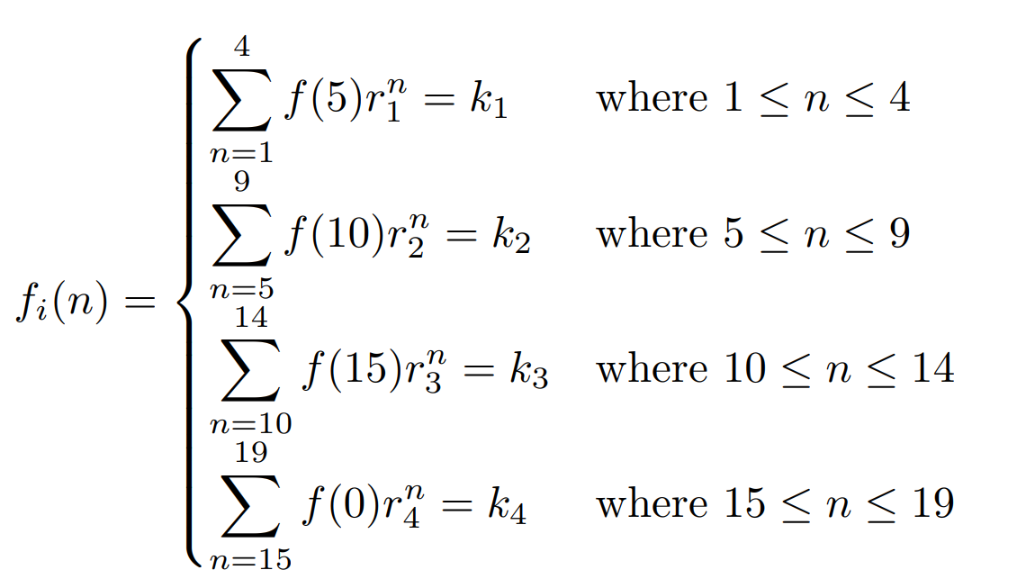

Where $k_{1}$ = the counts of businesses with 1–4 employees per subdivision, $k_{2}$ = the counts of businesses with 5–9 employees per subdivision, $k_{3}$ = the counts of businesses with 10–14 employees per subdivision, and $k_{4}$ = the counts of businesses with 15–19 employees per subdivision. Each piecewise function was solved for the respective $r_{i}$ value.

The proportion of businesses by employment size was assumed to be constant over the forecast period for simplicity and due to data limitations.

Using the geometric decay formulae finds an inverse relationship between the number of small businesses and the number of people employed in these businesses. However, if the geometric decay rate is not used, and the BCAR instead assumes that business counts are constant within the supplied data ranges (using a stepped curve), then the estimates of bandwidth requirements remain similar.

### Employee characteristics

Employees in small businesses have different levels of internet usage. To capture the variation in time spent on applications, the analysis categorises employees into four different internet usage types:

1. **Low usage employees**: defined as workers who do not use the internet as a primary input for their work. Some examples of these types of employees are mechanics, nurses and bakers. Low users comprise around half of all employees.
2. **Medium usage employees:** workers who have a desk but spend a significant amount of time away from their desk or engaged with other people. School teachers, real estate agents and barristers are examples of medium users. Almost a quarter of the workforce are medium users.
3. **High usage employees:** workers who spend most of their time at a desk with a screen, for example accountants, receptionists and telemarketers. The main distinction from medium users is the amount of time they spend at their desk. They represent 22 per cent of the workforce.
4. **High usage employees with media usage:** those who work with large files for video, statistical and other purposes. These users would be employees who tend to use software that requires high bandwidth. Some occupations that would be included are photographers, graphic designers and architects. These users represent around 4 per cent of all employees.

The BCAR undertook extensive analysis of the fixed-line internet usage of different occupations in Australia. Each occupation was categorised into the 4 usage types at the 4 digit level (see Appendix I: Occupation list for the full listing). Data from the 2016 ABS Census of Population and Housing was then used to map employees in each occupation to the industry where they are employed.[109] The classification was undertaken at the 4 digit level to provide greater accuracy and results were aggregated to the 2 digit level for use in the modelling. The BCAR’s classification was then compared with the results of the Communications Chambers analysis that was undertaken in the UK in 2015.[110] Any differences identified were investigated further.

The relative bandwidth demands of each user type are shown by the internet usage mix for Australia in Figure 26. The internet usage mix is the share of employees by each internet usage type. The BCAR considers the medium user to be reflective of the average user and compares other users to the medium usage cohort. The BCAR assumes that low users have only 20 per cent of the usage of medium users. High and high with media users are derived to have 255 per cent of the usage of medium users. Adjusting these proportions will impact the results of the analysis. Sensitivity tests with different proportions are presented in Appendix G: Sensitivity analysis.

Figure 26. Internet usage mix

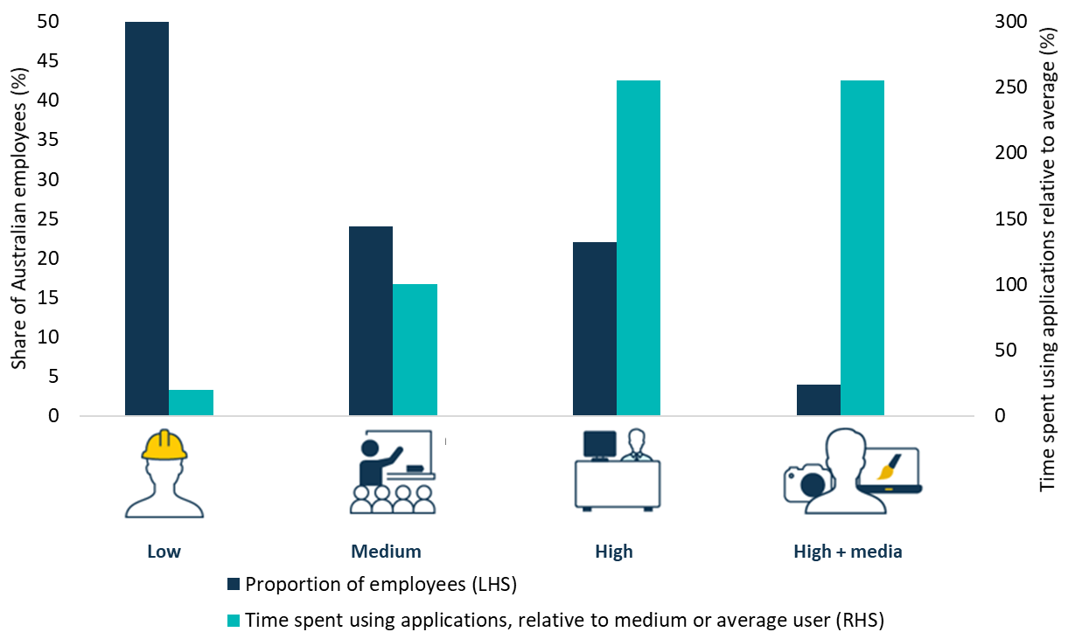

Source: BCAR estimates

In addition to the aggregate internet usage mix for Australia, the analysis includes an internet usage mix for each industry based on the share of each user type within an industry. Industries with the highest share of high and high with media users are auxiliary finance and insurance services, and computer systems design and related services, with 87 per cent of high and high with media users each. At the other end of the scale is food and beverage services, and food retailing with only 3 per cent and 5 per cent of high and high with media users, respectively. The internet usage mix for the 10 top and bottom industry subdivisions by their proportion of high and high with media users is shown in Figure 27.

Figure 27. Internet usage mix by industries with highest and lowest share of bandwidth intensive users

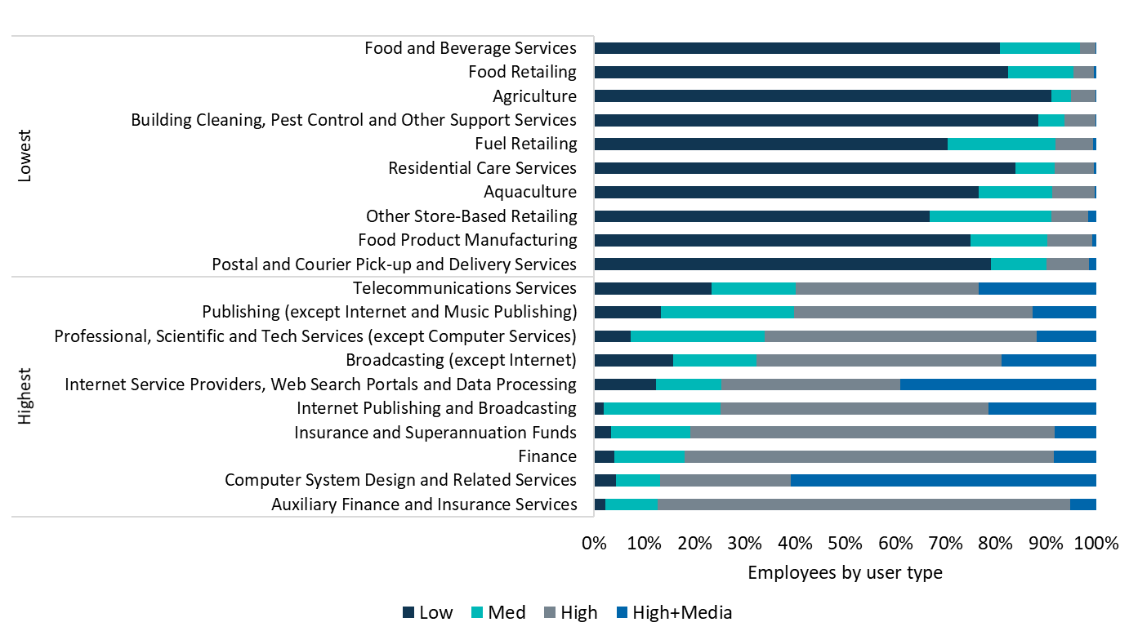

Source: BCAR estimates

#### Modelling business usage profiles

The internet usage mix for each industry is used to model internet usage profiles of businesses. The modelling develops representative businesses for each industry based on that industry’s internet usage mix. This creates profiles based on businesses with each amount of workers, from 1 to 19 employees. However, employees in very small businesses may be required to perform many functions throughout the day because there are not specialised employees to undertake different tasks. To ensure that this situation is accounted for, the BCAR assumes that the first 2 employees are blended users. These blended users are an average of the usage profiles of the 4 different user types. From the third employee onwards each subsequent employee is selected to keep the internet usage mix of the representative business closest to the internet usage mix for that industry. This information is used to develop the internet usage profiles for small businesses of different employment sizes within each industry.

## Appendix E: Applications

The BCAR has undertaken a comprehensive analysis of applications as part of its bottom-up modelling approach to estimate bandwidth demand. This section explores the bandwidth requirements and time spent using internet applications by households and small businesses, as well as addresses any necessary assumptions that have been made.

### Forecasting applications

A forecast growth rate of 5 per cent is applied to some elements of the analysis where data limitations preclude the use of real-world data to inform the assumptions.[111] This growth rate is used to capture 3 main effects that will impact future bandwidth requirements:

1. Consumers will spend more time undertaking activities online in the future
2. Consumers will likely be less tolerant to wait for content in the future
3. Consumers will expect higher quality services in the future

A forecast growth rate of 5 per cent implies that bandwidth requirements double about every 15 years. In comparison, a growth rate of 10 per cent implies requirements double every 8 years, while a 3 per cent growth rate equates to a doubling every 24 years. The choice of a 5 per cent growth rate was informed by analysis of future trends in bandwidth demand (see Box E1) and how these trends would impact the applications for which the forecast growth rate was required. The forecast growth rate is sensitivity tested in Appendix G: Sensitivity analysis.

Box E1: Future trends in bandwidth demand  
Various technological advancements have the potential to impact future bandwidth demand.

The internet of things (IoT) has the potential to increase Australian bandwidth requirements. The impact of IoT is expected to rise as the number of connected devices increases.[112] For households, examples of these connected devices include smart device voice controllers or home appliances with sensor technology.[113] Within small businesses, increasing uptake of IoT may occur through use of smart locks, interconnected security cameras or smart devices used for inventory and logistics functions.[114]

Increasing resolution for streamed online video content is expected to be a major driver of growth in bandwidth demand. Particularly for households, as users move towards devices with the capability for HD, 4K and beyond,[115] the BCAR expects a significant increase in content viewed in higher resolution formats. On the other hand, improvements in video compression technology are expected to offset some of the extra bandwidth required to stream high resolution content.[116]

Streamed gaming may play a significant role in driving future bandwidth demand.[117] Although uptake of these services is currently limited in Australia, in circumstances where streamed gaming is introduced to Australia by major platforms, there may be significant ramifications for future bandwidth demand.

Virtual reality and augmented reality have the potential to use significant amounts of bandwidth.[118] The impact of such technologies on bandwidth are dependent upon household uptake, as well as the predominant resolution of these technologies.

One significant factor that may reduce future bandwidth requirements is substitution from fixed‑line broadband. In particular, the increasing capability of mobile products, including 4G and 5G technology, may shift some usage away from fixed-line broadband and reduce the likelihood of overlapping usage on fixed-line technologies.[119] Since this is not accounted for in this analysis, these estimates may overstate the bandwidth requirements for the fixed-line network.

### Households

#### Streamed video

Video delivered through the internet is a significant portion of household traffic. The importance of video can be seen from its rise as a proportion of internet traffic from 66 per cent in 2013,[120] to 75 per cent in 2017.[121] This proportion is expected to reach 82 per cent in the world by 2022.[122]

The BCAR has assumed 60 minutes of streamed video was viewed on average per person each day at home in 2018. Determining the average time spent streaming video per day can be difficult as industry estimates can vary widely. The BCAR derived that the average person consumes 62 minutes of online video content per day using 2018 data from the Australian Consumer and Media Authority (ACMA). This data was based on adults who watched any free-to-air TV or online video content, rather than all adults.[123] Research from Deloitte found that 116 minutes per day of streamed content was watched in 2018,[124] while Screen Australia reported an average of 75 minutes per day in 2017 based only on people who used subscription video services.[125] Estimates from Nielsen data found that people watched 60 minutes on average per day in 2018, up from 52 minutes in 2017 based on annual averages.[126] These industry estimates are based on all viewing time, including streaming time using mobile broadband which should be discounted from the inputs to the analysis of fixed-line broadband.

The time spent watching streamed video is forecast to grow by 10 per cent annually until 2023 and then increase by half this rate until 2028. This reduction in the rate of growth has been applied to reflect time constraints in the day. These assumptions imply that an average user will watch 124 minutes per day in 2028. The assumed time spent watching streamed video per day for the different user types is shown in Figure 28.

Figure 28. Average time spent watching streamed video per day

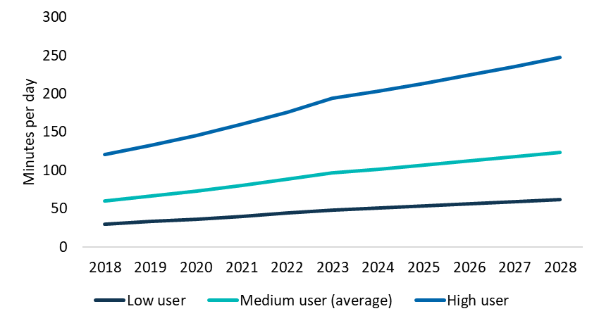

Source: BCAR estimates

The BCAR’s forecast of increased video streaming reflects a continuation of recent trends. Over the past 5 years, subscription video on demand services have experienced significant growth, from relative obscurity to widespread acceptance.[127] Using data from the ACMA, the BCAR has derived that the proportion of time spent watching professional video content online was 13 per cent in 2014–15, but increased to 30 per cent by 2017–18[128].[129] In addition, consumers are also spending time watching non‑professional content online. The rise in online content viewership has coincided with a fall in free-to-air TV viewing. Over the same period, free-to-air TV viewing fell from 59 per cent of time spent watching professional video content in 2014–15, to 46 per cent in 2017–18.[130]

The BCAR forecasts that online viewing will continue to rise, with high usage individuals assumed to watch 247 minutes (or just over 4 hours) of streamed video each day in 2028. This viewing time is above the 193 minutes of average time watching TV per day in 2018 that Ofcom found in the UK.[131] Evidence from the American Time Use Survey also found that people watching TV was the leisure activity that occupied the most time at 2.8 hours (168 minutes) per day. This accounted for just over half of all leisure time in 2018.[132] In Australia, people spent an average of around 2.5 hours (147 minutes) per day watching live or time‑shifted TV on in‑home TV sets in 2017.[133] Comparing these estimates with forecast streamed video usage shows that the time spent watching streamed video is likely to approach time spent watching free-to-air TV but that growth is likely to slow due to limits to available recreation time.

It should be emphasised that analysing time spent watching video at an individual level may overestimate household bandwidth requirements. A large proportion of TV is watched together with other household members, meaning only a single person’s bandwidth is required for the period of TV that is watched by multiple people together. Research from ThinkTV found that during the hours of 6pm to midnight, 48 per cent of linear TV viewing was co-viewing in 2018.[134] The analysis does not reflect this co‑viewing, and so may overstate bandwidth requirements.

##### TV Resolution

Bandwidth requirements of streamed video are driven by the resolution at which the content is supplied. Major content providers such as YouTube and Netflix deliver content at varied resolutions from standard definition (SD) and high definition (HD) to 4K and some provide 8K content. For paid services such as Netflix, higher resolution content generally comes at a greater cost,[135] and therefore not all users view content at the maximum available resolution. Additionally, content providers often use a method referred to as adaptive bitrate streaming to prioritise delivering content reliably rather than at the highest resolution possible (see Box E2).

###### Box E2: Adaptive bitrate streaming

Adaptive bitrates are a mechanism used by content providers to measure the bandwidth available for delivering content. The application measures the amount of bandwidth available for delivering the service and compares this with the bandwidth required to deliver the content at each resolution. The content is then provided at the best resolution possible with the available bandwidth.

While there is an increasing catalogue size of content made available at 4K, content in 8K remains very rare. The BCAR undertook a review of available content and was unable to find 8K content on most popular streaming platforms. However, as the costs of producing content at higher resolutions decrease, more content should become available in these formats. An important barrier to shifting to higher resolutions is the user requirement to have a television or monitor capable of displaying that information. These devices can be very expensive, and to realise the maximum benefits, the size of a device that delivers content at this resolution would have to be very large.[136]

The BCAR has modelled the uptake of devices by resolution (see Video resolution type). However, to map out bandwidth requirements, it is important to factor in how much content is actually viewed at each resolution. The proportion of content viewed at higher resolutions will be lower than device ownership for the following reasons:

* A household that owns a higher resolution device (e.g. 4K TV) may contain other devices that are lower resolution (e.g. HD computer) that are used to consume content while the primary device is in use.
* Pricing structures might sway some consumers to access content at a lower resolution than their device is capable of achieving. Indeed, only a third of Netflix subscribers in Australia are on the premium tier that allows 4K streaming.[137]
* The increased costs that are associated with producing higher resolution content cause less content to be made available in higher resolutions.
* Historic content may not be available at the highest resolutions.[138]

Nonetheless, by definition, the proportion of content that is viewed in higher resolutions is correlated with device ownership of higher resolutions. The BCAR assumes that 25 per cent of online content is viewed in SD in 2018, falling to no online content being viewed in SD in 2028. The majority of content is viewed in HD in 2018, at around 74 per cent, however, this is assumed to fall to 24 per cent in 2028. The remaining 1 per cent of content is viewed in 4K in 2018, rising to 75 per cent in 2028. Only 0.2 per cent of content is viewed in 8K in 2028. This is largely because of the barriers to producing content at this resolution. Despite being only 0.2 per cent of total content, this corresponds to an average of 55 minutes per month of 8K content streamed by each person in 8K households in 2028.

The bandwidth required to deliver video varies by content provider and by the nature of the content.[139] The BCAR has taken the average bandwidth requirements from the major online content providers in Australia.[140] For SD, HD and 4K content, this equates to 2 Mbps, 5 Mbps and 18 Mbps, respectively.[141] 8K video streaming however, remains less clear and is estimated to be anywhere between 50 and 100 Mbps.[142] The BCAR has assumed an initial bandwidth requirement of 70 Mbps when introduced, reducing annually by improvements in compression to be 37 Mbps in 2028.

#### Streamed gaming

Streamed gaming refers to using cloud computing to generate game video and audio, which is then streamed to the user.[143] Recent technological improvements have allowed large technology enterprises to introduce these services to the market. PlayStation,[144] Google,[145] Microsoft[146] and Electronic Arts[147] have all expressed intentions to market a streamed gaming service. However, none of these enterprises have identified that they will provide these services in Australia. Moreover, provision of these services requires large capital outlays in the target markets, mainly due to the requirements in minimising latency to ensure a quality user experience.[148]

Despite these issues, the BCAR notes that streamed gaming may be a significant driver of future bandwidth demand. Estimates from Nielsen found that adults spent 390 minutes using a game console per month.[149] The BCAR assumes that 10 per cent of time spent using a game console could be spent streamed gaming each month, deriving 39 minutes per person each month in 2018. This is forecast to rise significantly as household uptake increases, up by 20 per cent annually to reach 241 minutes in 2028. The bandwidth requirements for these services varies by resolution. However, Google Stadia and Xbox have suggested that 10 Mbps is a minimum requirement for their service.[150] The BCAR anticipates that these requirements will increase over time as a result of an increased uptake of higher resolutions. Access to higher video resolution streamed gaming may be limited by resolutions of users’ devices, the ability of game developers to produce games in higher resolutions and other internet requirements including latency. Accordingly, compression improvements are assumed to mitigate the need for higher bandwidth.

#### Streamed virtual reality

Virtual reality (VR) refers to the digital creation of a fabricated immersive world, typically delivered via a headset technology.[151] The BCAR has considered virtual reality used for streaming in this application such as live sports and virtual documentaries. Downloads of VR files are considered in the secondary applications, discussed later.

Like other video‑enabled applications, the bandwidth requirements of streamed virtual reality relies on the resolution of content provided. For simplicity, the BCAR has assumed that the bandwidth required for virtual reality does not fall over time due to compression, because the uptake of VR at higher resolution will offset this fall. The BCAR has assumed that the bandwidth requirements are 15 Mbps based on demonstrations of streamed virtual reality.[152]

Adoption of virtual reality headsets has remained relatively low,[153] with only around 5 per cent of households indicating they have a VR headset in the UK in 2019.[154] Forecasts of usage indicate that it will remain relatively low.[155] Accordingly, average time spent using this application is minimal. The BCAR has assumed that the average user streams VR for 10 minutes per month in 2018, rising to 50 minutes per month in 2028. Assuming 5 per cent of people have access to a VR headset in 2018, this would correspond to approximately 200 minutes per user, based on the UK data. In addition, further VR content may be downloaded and consumed offline (this would be captured in secondary applications such as content and game downloads, discussed later). This is an important point, because it is likely that the majority of virtual reality is downloaded rather than streamed, due to technical limitations.[156]

#### Cloud storage

Cloud storage involves storing files in remote servers accessed through the internet (or cloud). Files are uploaded from local drives to the cloud and downloaded when requested by users. Data is downloaded when the cloud file is transferred to the local drive or edited. Cloud storage applications typically download the whole file the first time then limit future downloads to the components that have changed.[157]

Data downloads from cloud storage were estimated to be 303 MB per month in 2012 per average user based on research by Drago et al.[158] Cisco also found that traffic (uploads and downloads) on cloud networks is growing by around 27 per cent each year.[159] Growing historical data downloads by this rate finds that downloads per household were 1.3 GB per month in 2018, and downloads per user were almost 0.6 GB per month. Data from the UK highlights that cloud storage usage remains relatively low, with only 24 per cent of people using cloud storage.[160] The BCAR assumes usage will increase, up to 75 per cent by 2028. There were 2 household devices, on average, that could be used to access cloud files (i.e. computer, tablet and phone) in 2017.[161] The BCAR has assumed this number for 2018, growing to 4 devices in 2028 to cater for more devices per person.

Research found that cloud storage used an average bandwidth of 1.3 Mbps in 2012 per user.[162] The BCAR has assumed that bandwidth use will continue to expand, with 2 Mbps assumed for 2018, growing to 3 Mbps in 2028. Cloud storage is used for 10 minutes on average per month in 2018, derived from the amount of data downloaded per user and the application’s bandwidth requirements. This is assumed to increase to 220 minutes per month in 2028.

#### Content downloads

Content downloads refer to users downloading media files for future consumption. This application is included to reflect bandwidth requirements for downloading media such as music, movies and TV shows. Content downloads can often occur through a subscription service such as Netflix, or through using a transactional video on demand service such as Google Play.

The BCAR has assumed that the content minutes downloaded per user is relative to the amount of streamed content they consume. This ratio was assumed to be 25 per cent in 2018 which in practice means that for every 4 minutes of streamed video, a user downloaded an additional minute of video content in 2018. As a result, the average user downloaded 451 minutes of content per month in 2018, increasing by 5 per cent annually over the forecast period to 735 minutes in 2028.

Each user is assumed to be willing to wait for half the duration of the content they watch in 2018, falling to a quarter of the content’s duration in 2028. If the user was more impatient they would likely choose to stream the content which allows the user to receive content without waiting because it is delivered in real-time. While these assumptions are made, the BCAR acknowledges that users have different willingness to wait (see Box E3: Willingness to wait).

Using these estimates, the BCAR derives an average bandwidth requirement of 9 Mbps in 2018, growing to 10 Mbps in 2028 by using HD as the default video resolution. Half of Australians are estimated to download content in 2018, growing to 75 per cent in 2028. This results in an average individual spending 98 minutes downloading content per month in 2018, growing to 363 minutes per month in 2028.

##### Box E3: Willingness to wait

A person’s willingness to wait for downloads can vary depending on the individual and the situation. For example, a user may be willing to wait an hour to download a TV episode if they have just started watching the previous 60 minute episode. However, they may only be willing to wait a matter of seconds if the current episode is about to end and they are waiting for the next episode. The bandwidth required to deliver the episode in an hour is significantly different from what is required to deliver it in under a minute.

In many cases, the user in the second scenario could stream the content if they wanted it urgently, requiring significantly less bandwidth (but over a longer period of time). However, the user may prefer not to do this, particularly if they plan to download the episode before they walk out the door to watch on their commute to work (although they could also use mobile broadband for this purpose).

Similar scenarios may shape the household’s decision to pay more for broadband in order to access content or software downloads faster. For example, households may want to download a game and play it instantly. However, games can be very large files and even an idle 100 Mbps connection would take almost an hour to download a 40 gigabyte game if nothing else was using the internet for that hour.

#### Mobile applications and software downloads

Mobile applications and software refer to the applications downloaded for smartphones, tablets and other mobile devices as well as upgrades required for device operating systems. Since the average Australian has 1.25 mobile devices[163] and 100 applications per device,[164] mobile applications and software are an important part of measuring a households’ bandwidth demands. The BCAR forecasts these numbers to increase, estimating that the average Australian will have 2.04 devices in 2028.

Combining the average amount of application downloads per device (1.5)[165] with the average amount of devices per person finds the average user downloaded 1.9 applications per month. The BCAR’s analysis also found that applications had an average size of 30 MB, based on the Australian market share of Apple and Google phones.[166] On the other hand, operating system upgrades were estimated to average an annual update of 1.6 GB (which equates to 167 MB per month per user).[167] Combining these assumptions with a smartphone penetration rate of 89 per cent,[168] 1.25 devices per person, and an assumed tolerance of 15 minutes per annual update derives a required bandwidth of 15 Mbps in 2018. Due to increases to the average application size, downloads per month and penetration rate, this number is forecast to grow to 22 Mbps in 2028. The time spent downloading mobile applications and software was estimated to be 1.9 minutes per month in 2018, growing to 3.1 minutes per month in 2028.

#### Peer-to-peer file sharing

Peer-to-peer file sharing applications, such as BitTorrent, allow the transfer of large files through internet networks. Peer-to-peer file sharing has been an important component of traffic comprising both legitimate and illegal file transfers of games, content and other media.[169] However, evidence suggests that the use of peer‑to‑peer applications has been decreasing over time.[170]

The BCAR has assumed that the average download size is double the amount of content minutes downloaded per user. This was estimated to be 903 minutes (equivalent to 26 GB) per month for each peer-to-peer user in 2018, which is expected to grow 5 per cent annually to 1471 minutes (70 GB) per month in 2028. While the volume downloaded per user is increasing, the proportion of people using these applications is expected to decline from 15 per cent in 2018[171] to 10 per cent in 2028.[172] The amount of peer-to-peer downloads will be influenced by competition in the streaming video on demand (SVOD) market. If consumers are required to pay for subscriptions to multiple platforms to access content, some might increase their use of peer-to-peer file sharing to avoid paying for subscriptions.

The BCAR estimated bandwidth requirements by assuming user tolerance levels to be equivalent to the length of content being downloaded in 2018 (that is, a user is willing to wait 1 minute to download 1 minute of content) and half this rate in 2028. Using these estimates, the implied bandwidth per user remained stable at 5 Mbps in 2018 to 2028, due to improvements in compression. This translates to the average user downloading for 903 minutes in 2018 and 735 minutes in 2028. Therefore, on average, a person spent 117 minutes per month using peer-to-peer file sharing applications in 2018, decreasing to 97 minutes per month in 2028.

#### Video calls

A video call is a call made between 2 or more users including live pictures and sound of the participants.[173] These calls are made over an internet connection using a devices’ camera.

Video calling applications such as Skype and Zoom require a minimum upload and download speed to work properly.[174] While the application may adjust its quality according to the bandwidth available, there are recommended download speeds for video calls of varying quality. The BCAR has used the recommended download speed for a HD Skype or Microsoft Teams video call of 2 Mbps (rounded up from 1.5 Mbps).[175]

To derive the time spent per user on a video call, the BCAR assumes an increasing proportion of the average time spent on phone calls, using data from the American Time Use Survey.[176] Video call minutes are estimated to be 10 per cent of total calls in 2018, growing to 50 per cent in 2028. This translates to 18 minutes of video calls per month per user in 2018, growing to 90 minutes in 2028.

#### Game downloads

Game downloads involve downloading digital installation files directly to a user’s game console without the need for a physical disk and have been increasing in Australia. Digital download sales in Australia were $887 million in 2017, an annual increase of 16 per cent, compared to physical console and portable software sales of $522 million (up 3 per cent).[177] Game downloads can be quite large and are expected to grow as users continue to demand higher video quality.[178] While some blockbuster titles can be extremely large, these titles often use methods to reduce the impact of waiting time.[179] There are also many game downloads that are much smaller in size, that are very popular, including games that are no more than a few gigabytes.[180] The BCAR’s analysis of online game downloads found that the average downloaded game size was 41 GB in 2018, which has been forecast to increase to 66 GB in 2028.

To calculate the bandwidth required, the BCAR combined the average game size with an assumed download tolerance of 5 hours per (average sized) game in 2018, shrinking to 4 hours per game in 2028.[181] This derives an implied download speed of 14 Mbps in 2018, growing to 28 Mbps in 2028. There are a portion of games which allow preloading (games downloaded before the release date that will therefore most likely be downloaded outside the busy period, or for which the user has a greater willingness to wait).[182] The BCAR has assumed preloads will reduce the average urgent game file size by 25 per cent throughout the period and has factored this into the calculations.

To determine the time spent per month downloading console games, the BCAR assumes that on average for all households, 2 average sized games are downloaded each year in 2018, rising to 4 games in 2028. However not all households download games (see Appendix C: Household types). Considering only households that download games, the average rises from 6.7 games per year in 2018 to 10 games per year in 2028. This implies that an average user in a household that downloads games would download 23 GB each month in 2018, rising to 55 GB in 2028. The amount of downloads is assumed to be inclusive of large game updates that can be required for some games.[183] This derives 29 minutes spent downloading games per month per person on average in 2018, growing to 47 minutes in 2028. Considering only users, the average time spent was 96 minutes per month in 2018, rising to 118 minutes per month in 2028.

#### Software downloads

Software downloads involve users downloading installation files directly onto their computer without needing to go in-store to order a physical copy. Most software applications can be downloaded, with some large software companies now only selling digital copies of their products.[184]

The BCAR has identified 10 major software categories to determine an average file size, shown in Figure 29. These application categories are: internet browsing, cloud storage, music streaming, home office applications, image editing, security, viewing media, editing/viewing documents, file compression and extraction, and messaging. By analysing selected products from each of these categories, the BCAR estimates that the average required software size was 240 MB in 2018, growing to 390 MB in 2028.

Figure 29. Software downloads

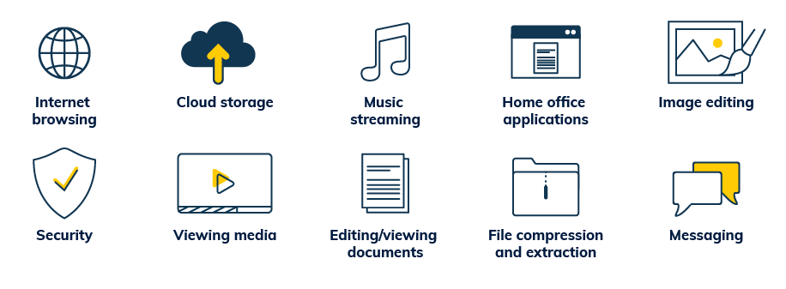

The download tolerance of these files is assumed to be around 2 minutes per file, based on the same tolerance as mobile application downloads. This derives an implied bandwidth requirement of 15 Mbps in 2018, growing to 22 Mbps in 2028. The BCAR also estimated a download frequency of 1 file per month throughout the period, which translates to 2.2 minutes spent downloading software per month per user in 2018, growing to 2.4 minutes in 2028.

#### Web browsing

Web browsing involves users locating, accessing and displaying webpages.[185] Webpages display and provide information such as links, images, video and audio. Webpages can be accessed and displayed with the help of a web browser through an internet connected device such as a laptop or smartphone.[186]

Web browsing remains one of the most important forms of internet use. The BCAR estimates that the average user spends 107 minutes per day web browsing in 2018, which is forecast to grow to 186 minutes per day in 2028.

When analysing the page weight and loading time of a webpage, the BCAR has split it up into ‘above the fold content’ and ‘below the fold content’. This divides the page into the part viewed on screen when the webpage is loaded, compared with the part loaded as the user scrolls through the rest of the page. Below the fold content typically loads slower as it is viewed later. The BCAR also includes the assumption that 50 per cent of webpages viewed have been visited before, and will therefore have a ‘caching’ effect (Box E4). Using these assumptions derives that the average user downloads 0.7 MB of data for each webpage’s ‘above the fold’ content in 2018 and 1.4 MB in 2028. Assuming a max load time of 2 seconds, the bandwidth requirements are estimated to be 3 Mbps in 2018. This is forecast to grow to 6 Mbps in 2028.

##### Box E4: Benefits of caching

Caching is the local storage of recently downloaded information, retained to provide faster future access to the same content.[187] Caching allows people to avoid downloading the same piece of content multiple times.[188] Accessing content using the cache therefore reduces the amount of time it takes to load content and the amount of traffic that flows over the network. This can also reduce the costs of delivering content that is borne by content providers.[189]

#### Low bandwidth applications

Low bandwidth applications are used as a category to capture other bandwidth usage. This category includes applications that use bandwidth less than 1 Mbps as well as applications that would not make a material difference to peak bandwidth requirements. The BCAR has included voice calls, audio streaming, IoT, online gaming and remote working as low bandwidth applications.

The BCAR splits low bandwidth applications into a ‘primary’ device and other ‘secondary’ devices. The primary device represents applications which require interaction from the user, such as online gaming and/or voice calls. The secondary applications then refer to other machine connections which may occur simultaneously in the background, such as IoT. The BCAR has assumed that the first low bandwidth application per household uses 512 kbps and that each subsequent application only uses around 50 kbps to perform less intensive activities in 2018. These bandwidth requirements are assumed to grow to 834 kbps and 83 kbps in 2028, respectively. Applications are assumed to be in use for 10 per cent of the busy period (equivalent to 48 minutes per day) in 2018, growing to 20 per cent by 2028.

##### IoT devices

Bandwidth requirements for IoT devices are very low and the transmission of data often only occurs periodically. A simple task such as a voice command requires bandwidth of only 63 kbps.[190] Considering household applications, to perform a more complex request such as music streaming, Amazon recommends 512 kbps.[191]

Telsyte has estimated the number of connected devices to be 17 per household in 2018 on average and forecasts this to increase to 37.3 connected devices per household in 2023.[192] This figure includes smartphones, computers and other devices that likely depend on human engagement to use bandwidth. The BCAR has used Cisco forecasts to assume 3.3 IoT devices per person in 2018 and 17.6 devices per person in 2028.[193]

##### Online gaming

Online gaming uses only a small amount of bandwidth to transfer information about the player’s commands, other changes in the game environment and to provide in-game audio such as voice calling where relevant.[194] Bitrates for online gaming vary, but are demonstrably small, from single megabytes transferred per hour to 300 megabytes an hour, which still only corresponds to bandwidth of 0.67 Mbps on average.[195]

The Australian Consumer and Media Authority (ACMA) found that the average time spent playing and watching games online by adults was 1.1 hours per week in 2018 or about 10 minutes per day.[196] On the other hand, survey results from the Interactive Games and Entertainment Association found that 2 out of 3 of all Australians play games, and the average daily time gamers spent playing games was 81 minutes in 2018, implying that the average Australian plays for 54 minutes each day.[197] However, these results also include time spent playing games which are not online.

##### Voice calls

Voice calls typically require low bandwidth, of around 100 kilobits per second.[198]

##### Audio streaming

The bandwidth required for audio streaming is usually between 128 to 512 kilobits per second.[199]

Survey data from the ACMA for May 2018 found that 46 per cent of Australian adults had used a music streaming service such as Spotify in the previous week.[200] Of those that had used a music streaming service, the average time spent streaming was 9.8 hours per week. Additionally, users could be listening to podcasts and audiobooks that require similar bandwidth.

It is likely that a substantial share of this activity would occur outside of the home. For example, of people who listened to radio in the previous week, the ACMA found that 7.4 hours of radio were listened to in the car each week on average, compared to 6.4 hours at home or somewhere else in 2018.[201]

##### Remote working

People may also be working from home, connecting remotely to a server to access work documents. Estimates of the bandwidth required for remote desktop applications such as Citrix are low, at around 40 to 600 kbps for most activities.[202] Research on the actual requirements from real world experiences verify these bandwidth requirements.[203]

#### Excluded applications

The BCAR has included only those applications that affect peak bandwidth demand. There are other applications that will affect overall data downloads but are less likely to drive peak bandwidth. For example, software patches for devices, such as computer operating system updates can be scheduled to occur outside busy periods.[204] Additionally, operating system downloads are designed not to impact the user and throttle how quickly the download occurs to use only idle bandwidth.[205] Other devices also require software patches such as TVs, video game consoles, tablets and IoT devices. These were also considered to be out of scope for measuring peak bandwidth due to the wide variation of devices used in households and the relatively small size and infrequency of updates.

Home security cameras are another application that could impact bandwidth as these devices may be always on and transferring more data-rich information. However, these would likely be consistently uploading data rather than downloading, other than when a resident examines this footage.

### Small businesses

The set of applications for small businesses is comprised of: applications used by employees, low bandwidth applications that capture some employee and IoT bandwidth usage, and customer use of bandwidth.

#### Email

Email is widely used in business as an important communication tool. It allows for messages and attachments to be sent from a connected device to 1 or more recipients. In the UK, Ofcom found that 95 per cent of small and medium enterprises use the internet for email applications.[206] Analysis by Radicati found that the global usage of email by business is increasing.[207] The average number of emails received by each employee per day has grown steadily over the last decade, with spam email driving this growth.

To estimate the average email downloads per user in a small business, the average amount of emails received and their average size is modelled. The average small business employee is estimated to receive 94 emails per day in 2018, with the BCAR forecasting this to grow to 141 emails received per day in 2028.[208] Evidence suggests that the share of emails with attachments is growing. Almost 1 in 4 emails (24 per cent) were estimated to contain attachments in 2013.[209] The BCAR assumes this will increase to 32 per cent in 2018 and have doubled to 48 per cent by 2028. Combining these estimates with assumptions about cloud and locally based email usage from ABS surveys,[210] derives that each user within a small business will download approximately 22.1 MB of data per working day from email applications in 2018. This is forecast to grow to 51.9 MB in 2028.

Assuming a delay tolerance of 2 seconds for an email with an attachment, the bandwidth requirement rounds up to 3 Mbps in 2018, remaining constant to 2028. Deriving usage of email applications per day from traffic and bandwidth, the time spent downloading received email is approximately 1 minute on average per user per day in 2018. This increases to 2.3 minutes per user per day in 2028.[211]

#### Web browsing

Web browsing, similarly to within households, refers to users locating, accessing and displaying webpages.[212] Web browsing is an important part of modern business needs. The BCAR estimates that the average employee spends 80 minutes per day web browsing while at work. By analysing past trends of UK data,[213] this is forecast to grow to 116 minutes per day in 2028. Bandwidth requirements are treated the same as for households, estimated at 3 Mbps in 2018 and growing to 6 Mbps in 2028.

#### Cloud storage

As for households, cloud storage involves hosting files in remote servers accessed through the internet (cloud). Estimates based on ABS data found that around 26 per cent of all businesses used cloud computing for storage capacity in 2018, up from 11 per cent in 2014.[214] A linear trend was developed to project cloud storage usage, increasing to 63 per cent in 2028.

To estimate average traffic, average file sizes on the cloud were modelled. The average file was approximately 2.4 MB in 2017,[215] which was projected to 2.5 MB in 2018 for non-media users, and 6.4 MB for media users. An employee is assumed to create 1 new file per day and edit 5 other files, a quarter of which is transferred from cloud storage. This results in data downloads from cloud storage of 28 MB for non-media users in 2018 and 71 MB for media users.

Bandwidth requirements are treated the same as for households, estimated at 2 Mbps in 2018 and growing to 3 Mbps in 2028. Media user bandwidth grows from 5 Mbps to 8 Mbps over the period, based on their larger file sizes. Deriving usage of cloud storage per day from data downloads and the required bandwidth, solves for around 0.5 minutes on average per day in 2018 for both media and non-media users. This is estimated to increase to 1.2 minutes and 1.3 minutes per day in 2028 for media and non‑media users, respectively.

#### Video calls

Video calling, similar to within households, is made between 2 or more users including live pictures and sound of the participants. The BCAR has used the recommended download speed for a HD Skype video call of 2 Mbps (rounded up from 1.5 Mbps).[216] As with households, the BCAR uses data from the American Time Use Survey[217] and estimates that 10 per cent of time spent per day on telephone calls is using video call applications to derive 0.6 minutes of video calls per day per employee in 2018. The time spent video calling is assumed to increase to 6 minutes on average per day in 2028.

#### Streamed video

Streamed video within the context of small businesses is defined as content viewed by employees during work hours. Streamed video is an essential component of the small business application set as it requires relatively high bandwidth. Estimating the time spent watching video content during work hours is a difficult task due to the limited research on this topic.

The small business set of applications includes video streaming as it is a vital tool for many businesses such as media enterprises who produce content. The application’s inclusion is also designed to reflect how it may be used for non-business purposes—for example, to stream music. Omitting this application would have a significant impact on bandwidth estimates. Even though this application may be used for non-work purposes, it is included because it is unlikely that a business would want their internet to fall over in the event that an employee was streaming video.

The BCAR has proportioned household viewing time to calculate the time spent streaming video by employees at work. As discussed earlier in the household analysis (see the Streamed video section), the amount of streamed video at home is assumed to be 60 minutes in 2018. The proportion of video streamed during work hours is estimated by using the volume of internet use at the workplace as a proxy (26 per cent).[218] Doing so yields an average of 6.8 minutes of streamed video per worker per day in 2018. The average time spent watching streamed video at work is expected to grow to 9.8 minutes in 2028.

Business bandwidth requirements are set to a household’s bandwidth requirement based on a HD stream. The BCAR has assumed that there will be limited purposes for 4K video within small businesses. Based on HD video, the bandwidth requirement is 5 Mbps in 2018, falling to 3 Mbps in 2028 as a result of improved compression.

#### File transfers

File transfers is a broad category that encompasses the transfer of large media files by small businesses such as medical images, architectural drawings, and photo/video downloads. File transfers can be an important consideration for a business’s willingness to choose a high-speed broadband plan.

The bandwidth required for file transfers depends on the size of the files received, how often they receive them, and the tolerance to wait for these files to download. Relatively little information is available on these different factors. Waiting times depend highly on user preferences. Some users may be prepared to wait 20 minutes for a large file download while other users may be willing to wait less than a minute for the download to become available. These differences in tolerance make dramatic differences to the estimated bandwidth requirements.[219] Small businesses may consider file uploads to be of more importance and may have upload bandwidth requirements due to file transfers, however upload activity is not examined in this analysis.

The BCAR modelling assumes that an average media employee within a small business downloads 1000 MB worth of files per day. To illustrate, this amounts to approximately 26 uncompressed standard heart ultrasounds,[220] 50 high resolution 20 MB photos, or 20 minutes of a HD movie download.[221] The size of file transfers are assumed to grow 5 per cent annually to be around 1.6 GB in 2028 to account for the receipt of more information. The BCAR assumes a tolerance of 10 minutes per transfer in 2018, with tolerance gradually reducing to 7.5 minutes by 2028. The choice of these times is arbitrary and decreasing the tolerance or increasing the file sizes would increase bandwidth demand, while increasing the tolerance or decreasing file sizes would lower bandwidth requirements. Using these assumptions about the file sizes and tolerance, the BCAR has derived a bandwidth requirement of 14 Mbps in 2018, growing to 29 Mbps in 2028.

#### Low bandwidth applications

Low bandwidth applications are used as a category to capture other bandwidth usage. This category is designed to capture applications that would not make a material difference to peak bandwidth requirements or generally use bandwidth of less than 1 Mbps. This includes machine usage of bandwidth, typically by IoT devices, voice calls and audio streaming.

The BCAR assumes that in a typical business, there was 1 primary low bandwidth device per employee with a bandwidth requirement of 512 kbps in 2018 based on audio streaming,[222] growing to 834 kbps in 2028. All other additional devices used by the business are assumed to use 10 per cent of the primary device’s bandwidth requirement. The BCAR has also assumed that the average business will have 3.3 devices per employee in 2018, rising to 17.6 devices in 2028.[223] This implies that bandwidth requirements for low bandwidth applications are 630 kbps in 2018, rising to 2.2 Mbps in 2028.

The BCAR has not used probabilistic analysis for low bandwidth application usage in the small business modelling which likely leads to a material overstatement of bandwidth demand for small businesses. Probabilistic analysis was not used because of data limitations relating to the lack of evidence about:

* the amount of time these devices are used in small businesses
* the number of devices used by small businesses
* the actual bandwidth requirements of these devices; and
* whether the number of devices in the business relates to the number of employees.

The bandwidth demand of small businesses without the inclusion of low bandwidth applications is presented in the section on Peak small business bandwidth demand.

#### Guest WiFi

In addition to employee and low bandwidth applications, some industries also offer WiFi internet access to customers and other guests. Supplying guest WiFi is becoming increasingly important as consumers demand access to many entertainment and recreational services that are delivered online.

The BCAR has considered guest WiFi usage for accommodation, food and beverage services (cafes and restaurants), libraries, education, hospitals, residential care services, and heritage activity industries, as shown in Figure 30. These industries were selected based on an identified need to provide non-employer internet access through fixed-line broadband. There may be other industries such as public transport that are increasingly using guest WiFi, however, these industries will more likely utilise mobile internet services.

The BCAR has not used probabilistic analysis for guest WiFi usage in the small business modelling due to data limitations which likely leads to a material overstatement of bandwidth demand for small businesses. However, to mitigate this issue the BCAR has assumed a ratio of 1:4 for guest WiFi bandwidth requirements based on the assumption that only 1 in 4 guests will be accessing the WiFi at any point in time. To capture growth in guest WiFi bandwidth demand and usage, bandwidth requirements are forecast to grow by 5 per cent each year.

Figure 30. Guest WiFi industries

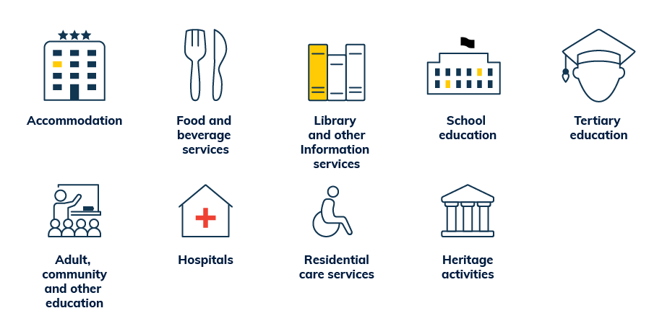

##### Accommodation

The BCAR has derived bandwidth requirements for accommodation using the average amount of rooms that an employee serves. Around 120,000 people were employed in the accommodation industry in December 2018.[224] Tourism data found that there were around 296,000 rooms in Australia and an occupancy rate of 74 per cent of rooms in 2018-19.[225] This implies that the average employee is responsible for 1.9 rooms. The BCAR then assumed that each room was allocated 1.5 Mbps in 2017 based on industry research.[226] Combining these calculations derives that bandwidth requirements are 2.9 Mbps per employee in 2018, rising to 4.7 Mbps in 2028.

##### Food and beverage services

Nestlé recommends that 14 staff are required for 50 tables, implying that each staff member serves 3.6 tables.[227] The BCAR has assumed that each table uses 1 Mbps, and so each employee would require 3.6 Mbps in 2018, rising to 5.8 Mbps in 2028.

##### Libraries

The BCAR has derived a ratio of 1 to 1 for library staff to internet connected computers using information from the Australian Library and Information Association.[228] The BCAR has also made the assumption that each library computer has a required bandwidth of 1 Mbps in 2018, growing to 1.6 Mbps in 2028.

##### Preschool and school education

The bandwidth requirements for school education were based on an average student to teacher ratio of 9.36 students per teacher in 2018 using data from the Australian Curriculum, Assessment and Reporting Authority.[229] The BCAR has assumed that 1 Mbps is the bandwidth required per student.[230] The bandwidth required per employee is therefore 9.4 Mbps in 2018, rising to 15.2 Mbps in 2028.

##### Tertiary education

Bandwidth requirements for university or tertiary education are similarly based on student‑teacher ratios using data from the Department of Education, Skills and Employment. There were 7.2 students for every staff member in 2016.[231] The BCAR has then assumed that tertiary students use more than school students, on average requiring 1.5 Mbps. The bandwidth required per employee is therefore 10.8 Mbps in 2018, rising to 17.6 Mbps in 2028.

##### Hospitals

The BCAR has made the assumption that hospitals also supply guest WiFi for patients and visitors. The bandwidth required for hospitals was assumed to be 1 Mbps per employee in 2018, rising to 1.6 Mbps in 2028.

##### Residential care activities

The BCAR has made the assumption that bandwidth required for residents and guests of residential care activities (aged care homes) is equal to 1 Mbps per employee in 2018, rising to 1.6 Mbps in 2028.

##### Heritage activities

The BCAR has made the assumption that bandwidth required for heritage activities (to include guest WiFi for museums and galleries) is equal to 1 Mbps per employee in 2018, rising to 1.6 Mbps in 2028.

#### Excluded applications

Certain applications have been excluded from the analysis because they are likely to happen outside busy periods or have a larger impact on data uploads than downloads.

##### Software updates

The BCAR has excluded software downloads because they are often scheduled to occur outside the busy period. Additionally, operating system downloads are designed to not impact the user’s internet experience and throttle how quickly the download occurs to use only idle bandwidth.[232] Alternatively, downloads can be managed to set a single computer as a server for downloads which is then shared to other devices on the network to reduce data downloads.[233] Given these characteristics, software updates are unlikely to drive peak bandwidth demand for small businesses.

##### Server backup

An additional application that is important for overall traffic is scheduled backups. However, the BCAR has excluded this application as it is likely to be scheduled to occur outside busy periods and largely affects upload activity rather than downloads. This application may also be displaced by cloud storage services such as Dropbox.[234]

##### Peer-to-peer file sharing software

This analysis excludes non-business applications that may be used on the business premises including peer-to-peer file sharing software such as BitTorrent. Although there are use cases for peer-to-peer file sharing for small businesses, particularly to transfer large files to clients, these may be more likely to impact upload activity. Evidence shows that this application is an important part of household traffic, and accordingly, it was included in the household analysis.[235]

## Appendix F: Caveats to the analysis

### These estimates may overstate real-world demand

The estimates outlined in this paper may tend to overstate the real requirements of broadband users. Forecasts have a degree of uncertainty and the BCAR has erred towards overstating bandwidth requirements. This is to allow for the uptake and increased usage of new applications given that there is limited evidence on the usage of these applications.

The BCAR’s estimates implement the following methodologies that may result in an overestimation:

* **Rounding up estimates:** To simplify the analysis, assumptions of bandwidth requirements for every household and small business application are rounded up to the nearest megabit.
* **Fixed broadband and mobile usage:** Where possible, mobile broadband usage has been excluded from household and business application requirements. However, due to data limitations some of the modelling inputs will contain a combination of fixed and mobile usage. This will result in an overestimate of fixed-line data and bandwidth requirements.
* **Inputs based on internet users:** The majority of data used as inputs in the model is collected by the ‘average internet user’ and not by the ‘average person’. The model also assumes all occupants of a household are internet users. In combination, this will also result in an overestimate of data and bandwidth requirements because not everyone is an internet user.
* **Individual streaming:** Streamed video is calculated by using the average time spent watching video for each individual. This is then applied to every member in the household. However, this assumption will overestimate the household’s bandwidth requirements, as a large proportion of video is co-viewed with others in the household. Further information on co-viewing and the time spent streaming video is included in Appendix E: Applications.
* **Categorisation of household applications:** The BCAR has categorised video calling as a secondary application and online gaming as a low bandwidth application even though they could be considered primary activities. In the model, these secondary applications can be multitasked with other primary applications, while in reality this may be unlikely for these applications. For example a person is unlikely to be video calling while streaming virtual reality.
* **Device limits:** In the analysis, the number and resolution of secondary devices in households is not limited. For example, in a household with a 4K TV it is assumed that residents also have other devices such as mobile phones or laptops that are capable of delivering 4K streamed video in the event of simultaneous usage. This will not always be the case, particularly given the limited visual differences between HD and 4K video on smaller devices.[236]
* **Human limits:** There are limits to the visual benefits from adopting higher resolution content such as 8K. The visual gains from 8K only become discernible once the screen is 65 inches (165cm) or larger.[237] It is also likely that some households that would otherwise want to realise visual benefits from 8K devices would be constrained by the size of their house. However, there are no limits on the number of high resolution devices in a household applied in the model.
* **Low bandwidth applications in small businesses are always in use:** low bandwidth devices in small businesses are assumed to always be in use during busy periods due to limited evidence on how these applications are used. More information on usage of low bandwidth applications by small businesses would assist in informing future analysis.

The BCAR has also produced estimates to examine bandwidth demand if some of these inputs were to change, which can be found in Appendix G: Sensitivity analysis.

### Considerations

This research has focused on estimating user bandwidth requirements. However, there are other aspects of bandwidth usage that the BCAR has not considered or were out of scope for the analysis.

#### Consumer experience

The focus of this paper is on user bandwidth requirements. However, other factors can affect a user’s bandwidth experience. These include WiFi capacity, in-home cabling or even application and webpage design. The bandwidth estimates presented in this paper should be considered alongside these other factors that may affect user experience.

#### Willingness to pay

Bandwidth forecasts in this paper are reflective of the requirements of end users and do not consider willingness to pay for bandwidth. Willingness to pay is a key determinant in choosing broadband plans by speed. For example, a consumer with peak bandwidth requirements of 60 Mbps could choose a 50 Mbps plan or a higher‑priced 100 Mbps plan. As peak bandwidth demand may only occur for short periods, a consumer may prefer to pay less for a lower speed plan and either moderate their application usage or tolerate slightly slower performance during these peak times.

#### Number of devices

As discussed earlier, the BCAR’s analysis is performed using methods that are unrelated to the number of devices in households and small businesses (with the exception of IoT), by examining the usage of applications. However, the usage of applications and the devices available to users are intrinsically linked. For example, streaming higher resolution video such as 4K requires a 4K or superior device. More information on video resolutions within households are included in Appendix C: Household types.

#### Sustained bandwidth

The BCAR has focused on sustained bandwidth requirements for applications. Some applications such as streamed video will use as much bandwidth as possible upon start-up (through a burst of well‑above average bandwidth) to preload content and reduce buffering but then revert to a sustained bandwidth for the remainder of the stream.[238] While this is important, the probability of multiple users starting streams at the same time is much lower than the probability of multiple users watching any part of a video at the same time. Additionally, the BCAR has considered bursting as part of its analysis of web browsing through the probability analysis of web browsing.[239]

#### Server and application limits

User experience can also be impacted by limits to other aspects of the connection between users and online content. For example, if a website receives traffic that exceeds the capacity of its server, it will take more time for the content to be transmitted to the user, causing a slower load time. If the server capacity is well below the user requested volume, then the website may even become inaccessible to consumers wishing to visit the website.[240] Server limitations can also impair the user experience of other applications, such as file downloads and video streaming.

#### Submissive applications

The BCAR has estimated bandwidth based on the requirements for each type of application. However, some applications may test the broadband connection and use all bandwidth that is available in order to optimise application performance. An example of this behaviour is the start-up of streaming, as explained earlier. File downloads also commonly exhibit this behaviour to reduce the overall wait time required before a file can be used (subject also to server and application limits). Where bandwidth demand at a premises is less than the amount of bandwidth available, any ‘left over’ bandwidth will reduce the wait times of file downloads that were assumed in the derivation of BCAR estimates. Put another way, the assumed wait times are a maximum—in reality downloads would often be quicker.

#### Traffic prioritisation

Consumer experience will also depend on the bandwidth made available to applications in use at a premises. When multiple applications are used simultaneously, bandwidth may be prioritised to a single application at the expense of another.[241] An example of this, is submissive applications (as discussed earlier) which may sacrifice bandwidth to other applications. The impact of traffic prioritisation is that applications which are prioritised lower may have impaired performance unless enough bandwidth is available to enable optimal performance.

#### Multiple connections per premises or shared connections across premises

The BCAR has examined bandwidth demand by using premises as the unit of analysis. There may be households and small businesses that have multiple fixed-line connections per premises (such as shared offices) or have only a single fixed-line connection that is shared across multiple premises (such as a house with a granny flat). As a result, these instances may have reduced or greater bandwidth demands per connection, respectively.

#### Mobile broadband

The bulk of data downloaded is through fixed networks. While recent trends highlight that mobile data downloads are growing faster than fixed downloads, it is anticipated that the majority of data will still be downloaded through fixed networks over the forecast period.[242] Accordingly, the focus of this paper is on broadband use at a premises and does not examine broadband use on-the-go. However, it is worth noting that mobile broadband is important for many households and small businesses, particularly for employees and businesses that do not work at a fixed address.

##### Household mobile broadband

Households are living increasingly mobile lives and therefore demand access to more content on‑the‑go. Improvements in mobile networks including the introduction of 5G are supporting increased mobile connectivity. Cisco forecasts identified that 9 per cent of consumer internet traffic was mobile in 2017, and 12 per cent will be mobile by 2022.[243] In Australia, Cisco estimates that the average mobile connection will download 13 gigabytes of data per month in 2022, up from 3 gigabytes in 2017.

While much of this data is delivered through mobile networks, it is important to note that some online activity that happens during time spent out of home uses data transferred using fixed‑line networks. For example, users may download content at home that they consume while commuting. Additionally, businesses in some industries offer access to WiFi networks to customers on their premises. This data has been captured and attributed to fixed-line networks in the analysis.

##### Business mobile broadband

Many businesses use mobile technologies for internet and voice services. Mobile broadband is particularly important for occupations that are required to be on the move, such as tradespeople, taxi drivers and executives who are required to travel for work. Employees that are high usage individuals on fixed-line broadband may not necessarily be high or low users of mobile broadband. Indeed, BCAR analysis of ABS data found that there is no relationship between whether businesses consider mobile internet to be of high importance and whether fixed internet is of high importance by industry.[244]

There is considerably less data about the applications used on mobile data. However, the importance of mobile internet to small businesses is expected to increase with the rollout of 5G and more widespread IoT applications. Cisco forecasts identified that 7 per cent of business internet traffic was mobile in 2017, and 11 per cent of business internet traffic will be mobile by 2022.[245]

#### Upload analysis

The BCAR has focused on data downloads rather than uploads. This focus was because more data is downloaded than uploaded and there is more evidence available on downloads that could inform the analysis. Additionally, many applications such as streamed video require only minimal upload bandwidth to send a message back to the content provider that the information is being transmitted sufficiently. This is particularly important given the dominance of video traffic online, with this traffic becoming increasingly asymmetric.[246] This is consistent with most observed network traffic, as well as asymmetric retail offerings.[247] The BCAR will continue to monitor trends that may affect the demand for faster upload speeds.

#### Other internet characteristics

This paper uses bandwidth as a measure of broadband capacity, and the ability to provide users access to services. Nonetheless, broadband is not the only requirement to adequately access online services. Some applications also have latency, jitter, packet loss and connection reliability requirements (Box F4: Internet characteristics). These characteristics can influence purchasing decisions for particular broadband plans. For example, businesses may prefer broadband plans that offer symmetrical speeds for greater upload capacity, increased resilience and security, or reliability.

##### Box F4: Internet characteristics

Latency is the time it takes for a packet of data to travel to a third party server and back.[248] This is typically more important for applications such as gaming where a user is competing to undertake an action before others, or for voice and video calling where parties are sending and waiting on information at the same time.

Packet loss occurs when 1 or more packets of data travelling across a computer network fail to reach their destination.[249] Packet loss is either caused by errors in data transmission, typically across wireless networks, or network congestion. Packet loss is measured as a percentage of packets lost in relation to the number of packets sent.

Jitter is variation in the delay of receiving information. It can be interpreted as varying latency for different packets of information. Jitter is particularly apparent in applications where the timing of information transmission is vital (e.g. video calling, where the correct ordering of audio packets is essential to correctly hear and interpret the voice component of the message).

Reliability refers to a connection which is working for a very high proportion of the time and delivers consistent quality of service.[250]

## Appendix G: Sensitivity analysis

The BCAR’s analysis is dependent on a range of assumptions that influence the bandwidth demand estimates to a varying degree. Given the uncertainty around some of the inputs that underpin the analysis, the BCAR has conducted sensitivity analysis to provide insights into the impact of important assumptions.

### Household

#### Base case

Peak bandwidth demand was forecast for households in 2018, 2023 and 2028. The distribution of demand is shown in Table 6, which highlights that there is a steady increase in bandwidth demand from 2018 to 2028. Bandwidth demand was estimated to be 24 Mbps or less in 95 per cent of households in 2018, 43 Mbps or less in 2023, and 56 Mbps or less in 2028.

Table 6. Household bandwidth demand

| **Households** | **Bandwidth in 2018 (Mbps)** | **Bandwidth in 2023 (Mbps)** | **Bandwidth in 2028 (Mbps)** |
| --- | --- | --- | --- |
| 50% | 14 | 22 | 29 |
| 75% | 18 | 29 | 39 |
| 90% | 22 | 38 | 48 |
| 95% | 24 | 43 | 56 |
| 98% | 27 | 51 | 66 |
| 99% | 29 | 54 | 66 |
| 99.9% | 35 | 63 | 78 |

Source: BCAR estimates

#### Sensitivity analysis summary

The BCAR has conducted sensitivity analysis to provide insights into the impact of adjusting important assumptions. Overall results from the analysis are presented in Table 7 which shows bandwidth demand at the 95th percentile for households.

Table 7. Household sensitivity analysis summary

| **Sensitivity test** | **Base case assumption** | **95**th **percentile bandwidth in 2018 (Mbps, change from base case)** | **95**th **percentile bandwidth in 2028 (Mbps, change from base case)** |
| --- | --- | --- | --- |
| 5% annual compression rate | 7% annual compression rate | - | 63 (+7) |
| 10% annual compression rate | 7% annual compression rate | - | 52 (-4) |
| 3% forecast annual growth* | 5% forecast annual growth | - | 52 (-4) |
| 10% forecast annual growth* | 5% forecast annual growth | - | 76 (+20) |
| 20% busy period usage | 25% busy period usage | 22 (-2) | 53 (-3) |
| 30% busy period usage | 25% busy period usage | 27 (+3) | 62 (+6) |
| 25% low user relative usage | 50% low user relative usage | 27 (+3) | 62 (+6) |
| 30% high users | 20% high users | 23 (-1) | 54 (-2) |
| Games download at half the speed | Games download at 14 Mbps (2018) and 28 Mbps (2028) | 23 (-1) | 52 (-4) |
| Games download at 1.5 times the speed | Games download at 14 and 28 Mbps, respectively | 29 (+5) | 67 (+11) |
| Games download at twice the speed | Games download at 14 and 28 Mbps, respectively | 31 (+7) | 79 (+23) |
| 4K content streams at 25 Mbps in 2018 | 4K content streams at 18 Mbps in 2018 | 28 (+4) | 66 (+10) |

Source: BCAR estimates

Note: * A forecast growth rate is applied to some elements of the analysis where data limitations preclude the use of real-world data to inform the assumptions (see Appendix E: Applications).

#### Minutes excluded

The BCAR has excluded a minute each day (equivalent to 30 minutes per month) as this reflects relatively rare scenarios for which the consumer may be willing to tolerate reduced speeds. However, revisiting this choice, raising the amount of time that is excluded will reduce the reported bandwidth requirements. The peak bandwidth demand of 95 per cent of households would be met with 22 Mbps in 2018 and 53 Mbps in 2028 if 2 minutes per day are excluded in the busy period. On the other hand, if only 1 minute per week is excluded, 95 per cent of households demand 32 Mbps or less in 2018 and 69 Mbps in 2028. The results for bandwidth demand in 2028 by different amounts of minutes excluded are shown in Figure 31 and Table 8.

Figure 31. Household bandwidth demand distribution in 2028 by differing minutes excluded

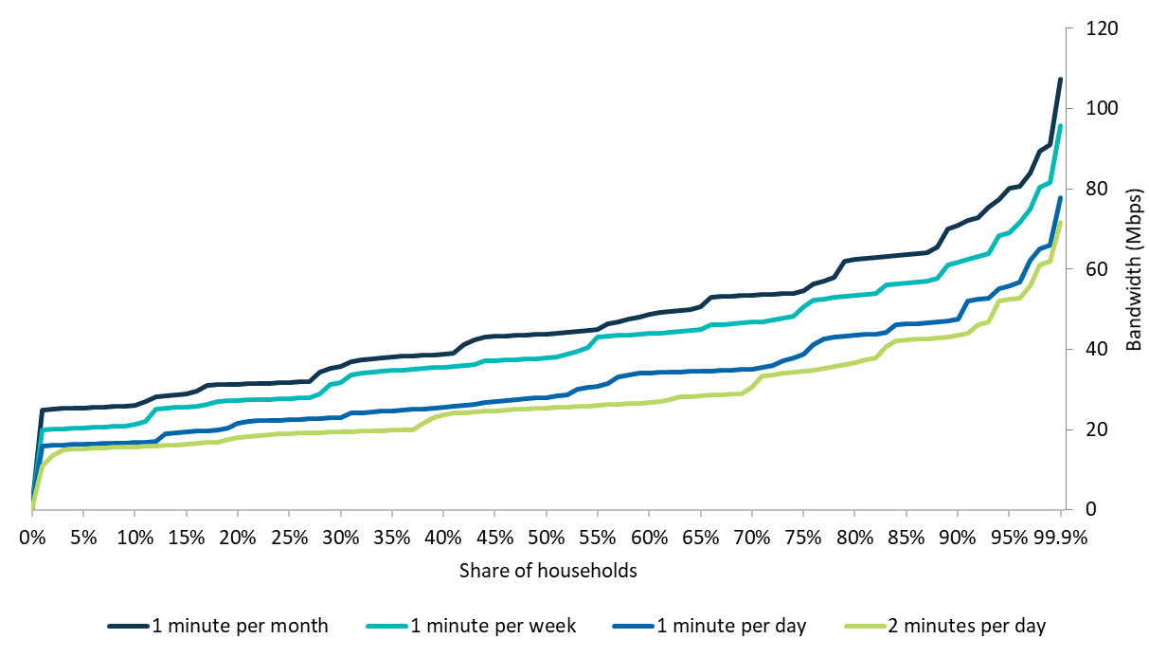

Source: BCAR estimates

Table 8. Household bandwidth demand in 2028 by differing minutes excluded

| **Households** | **1 minute per month** | **1 minute per week** | **1 minute per day (base case)** | **2 minutes per day** |
| --- | --- | --- | --- | --- |
| 50% | 44 | 38 | 29 | 26 |
| 75% | 55 | 51 | 39 | 35 |
| 90% | 71 | 62 | 48 | 44 |
| 95% | 81 | 69 | 56 | 53 |
| 98% | 90 | 81 | 66 | 62 |
| 99% | 91 | 82 | 66 | 62 |
| 99.9% | 108 | 96 | 78 | 72 |

Source: BCAR estimates

The choice of 1 minute per day was informed by an understanding of what is occurring in the period of time that is excluded. As previously discussed, some of the significant drivers of peak bandwidth requirements are software downloads and higher resolution video streaming. If insufficient bandwidth is available in the peak periods and these applications are in use, it is likely that one of two things will happen:

1. The download will be ‘throttled’ for that 1 minute and not be able to download at its peak rate which means that the user will have to wait longer for their download. This throttling will occur only for the busiest minute and the download would return to its normal speed after the busiest minute is over.
2. The streamed video application will use adaptive bitrates and the user would receive a lower resolution, such as HD instead of 4K for the 1 busiest minute. The user may not even notice the difference for this period.

However, it is worth noting that these are just 2 scenarios that could occur in the busiest minute. They are not the only possibilities. It is possible that a user may need to forego an application for this busiest minute and it is also possible that the user may make this decision on their own (perhaps pausing a buffering video). It should also be noted that the BCAR has excluded 30 minutes throughout the month. While this implies an average of 1 minute a day, it is in fact possible that these 30 minutes could all occur on the same day, particularly if someone in the household is downloading a large software file. Finally, the BCAR’s analysis does not consider willingness to pay. While 95 per cent of households are forecast to require 56 Mbps or less bandwidth in 2028, this does not mean that these households will choose to purchase plans capable of delivering this speed. Moreover, households that anticipate requiring more bandwidth may be more inclined to purchase higher speed broadband plans.

The choice of 1 minute per day equates to meeting bandwidth demand for 99.17 per cent of the busy period. It also corresponds to meeting demand for 99.93 per cent of the whole day for households (99.77 per cent for small businesses). While there is no distinct benchmark, some technology companies guarantee an uptime for 99.99 per cent of the time for their cloud services,[251] while Microsoft guarantees 99.9 per cent availability.[252] This is not directly comparable because for that period when the service is not available, the user is unable to utilise the service at all, while for the excluded period used in this analysis, it is likely that the user may still access a lesser quality or slower service.

#### Compression rate

The BCAR has assumed that the past trends of compression improvements will continue to reduce future bandwidth requirements by 7 per cent each year over the forecast period. The BCAR has also examined the impact of a reduced compression rate of 5 per cent, as well as greater improvements in compression, reducing video bandwidth requirements by 10 per cent annually.

The BCAR found that the bandwidth required to meet the demands of 95 per cent of households would rise to 63 Mbps in 2028 based on a 5 per cent annual compression rate. On the other hand, using an annual compression rate of 10 per cent finds that 95 per cent of households require 52 Mbps or less. These results are shown in Table 9.

Table 9. Household bandwidth demand by different compression rates

| **Households** | **Bandwidth in 2028 (Mbps)**  **5 per cent compression** | **Bandwidth in 2028 (Mbps)**  **7 per cent compression (base)** | **Bandwidth in 2028 (Mbps)**  **10 per cent compression** |
| --- | --- | --- | --- |
| 50% | 31 | 29 | 24 |
| 75% | 44 | 39 | 35 |
| 90% | 53 | 48 | 44 |
| 95% | 63 | 56 | 52 |
| 98% | 72 | 66 | 59 |
| 99% | 74 | 66 | 59 |
| 99.9% | 89 | 78 | 67 |

Source: BCAR estimates

#### Forecast growth rate

The BCAR has assumed a forecast growth rate of 5 per cent per year for select applications including cloud storage bandwidth and webpage weight sizes (see Appendix E: Applications). Reducing the growth rate would decrease future bandwidth requirements, while increasing the growth rate would raise future bandwidth demand significantly. If the BCAR assumed a forecast growth rate of 3 per cent per year, bandwidth demand for 95 per cent of households is 52 Mbps or less in 2028, while if the growth rate was 10 per cent, bandwidth requirements for 95 per cent of households would be met with 76 Mbps in 2028. These results are shown in Table 10.

Table 10. Household bandwidth demand by different forecast annual growth rates

| **Households** | **Bandwidth in 2028 (Mbps)**  **3 per cent growth rate** | **Bandwidth in 2028 (Mbps)**  **5 per cent growth rate (base)** | **Bandwidth in 2028 (Mbps)**  **10 per cent growth rate** |
| --- | --- | --- | --- |
| 50% | 26 | 29 | 33 |
| 75% | 37 | 39 | 52 |
| 90% | 45 | 48 | 64 |
| 95% | 52 | 56 | 76 |
| 98% | 60 | 66 | 84 |
| 99% | 61 | 66 | 86 |
| 99.9% | 74 | 78 | 97 |

Source: BCAR estimates

#### Busy period

The BCAR has assumed that a quarter of the household’s time using any application occurs in 2 hours, and the other three quarters takes place over the remaining 22 hours in the day. Increasing the amount of activity that happens in the 2 busiest hours would increase the likelihood of application overlaps and therefore raise bandwidth demand, while lowering the proportion would reduce peak bandwidth requirements. Further research on internet usage that occurs within the busy period at the household level would inform future estimates of bandwidth demand.

If 30 per cent of daily application usage is assumed to occur within the busy period, then bandwidth demand increases to 27 Mbps in 2018 and 62 Mbps in 2028 to meet the demands of 95 per cent of households, as shown in Table 11. On the other hand, if the BCAR assumes that 20 per cent of application usage happens within the busy period, then bandwidth demand decreases to 22 Mbps in 2018 and 53 Mbps in 2028 to meet the demands of 95 per cent of households.

Table 11. Household bandwidth demand by varied proportions of usage during the busy period

| **Households** | **20 per cent of daily application usage**  **Bandwidth in 2018 (Mbps)** | **20 per cent of daily application usage**  **Bandwidth in 2028 (Mbps)** | **25 per cent of daily application usage (base)**  **Bandwidth in 2018 (Mbps)** | **25 per cent of daily application usage (base)**  **Bandwidth in 2028 (Mbps)** | **30 per cent of daily application usage**  **Bandwidth in 2018 (Mbps)** | **30 per cent of daily application usage**  **Bandwidth in 2028 (Mbps)** |
| --- | --- | --- | --- | --- | --- | --- |
| 50% | 13 | 26 | 14 | 29 | 15 | 32 |
| 75% | 17 | 36 | 18 | 39 | 19 | 44 |
| 90% | 21 | 44 | 22 | 48 | 23 | 53 |
| 95% | 22 | 53 | 24 | 56 | 27 | 62 |
| 98% | 25 | 61 | 27 | 66 | 31 | 72 |
| 99% | 27 | 62 | 29 | 66 | 32 | 73 |
| 99.9% | 31 | 71 | 35 | 78 | 37 | 84 |

Source: BCAR estimates

#### Usage mix

The BCAR has assumed a mix of internet users consisting of 40 per cent low users, 40 per cent medium internet users, and 20 per cent high internet usage individuals. Low users are assumed to undertake half the activity of medium users, and high usage individuals are assumed to undertake double the activity of medium users, as shown in Table 12.

Table 12. Mix of households by user types and their application usage

| **Usage type** | **Household mix**  **2018** | **Household mix**  **2028** | **Household mix**  **Usage relative to medium user** |
| --- | --- | --- | --- |
| Low | 40% | 40% | 50% |
| Medium without game downloads | 30% | 20% | 100% |
| Medium with game downloads | 10% | 20% | 100% |
| High | 20% | 20% | 200% |

Source: BCAR estimates

The BCAR has assumed that low users have 50 per cent of the application usage of the average or medium users. However, if the assumption is changed so that low users have only a quarter of the application usage relative to the average user, high usage individuals must have 250 per cent of the application usage relative to the average user (to ensure the medium user remains at the average level). As a result, bandwidth demand rises to 62 Mbps to meet the requirements of 95 per cent of households in 2028. The growth in bandwidth demand, as shown in Table 13, is driven by the assumed increasing demands of the high internet usage individuals.

Table 13. Low users have 25 per cent of average usage

| **Households** | **Low users are 25% of average**  **Bandwidth in 2018 (Mbps)** | **Low users are 25% of average**  **Bandwidth in 2028 (Mbps)** | **Low users are 50% of average (base)**  **Bandwidth in 2018 (Mbps)** | **Low users are 50% of average (base)**  **Bandwidth in 2028 (Mbps)** |
| --- | --- | --- | --- | --- |
| 50% | 13 | 25 | 14 | 29 |
| 75% | 18 | 39 | 18 | 39 |
| 90% | 23 | 53 | 22 | 48 |
| 95% | 27 | 62 | 24 | 56 |
| 98% | 31 | 72 | 27 | 66 |
| 99% | 32 | 73 | 29 | 66 |
| 99.9% | 38 | 85 | 35 | 78 |

Source: BCAR estimates

If the BCAR adjusts the user mix (from Table 12) to instead assume that 30 per cent of users are low, 40 per cent are medium and 30 per cent are high usage individuals then bandwidth demand decreases, as shown in Table 14. This is driven by the decreased usage of applications by high internet usage individuals, who as a result of their increased proportion of the market, now undertake a lower proportion of activity (150 per cent, compared to 200 per cent), relative to the average user.

Table 14. High usage individuals are 30 per cent of all users

| **Households** | **30% of users are high internet users**  **Bandwidth in 2018 (Mbps)** | **30% of users are high internet users**  **Bandwidth in 2028 (Mbps)** | **20% of users are high internet users (base)**  **Bandwidth in 2018 (Mbps)** | **20% of users are high internet users (base)**  **Bandwidth in 2028 (Mbps)** |
| --- | --- | --- | --- | --- |
| 50% | 14 | 29 | 14 | 29 |
| 75% | 18 | 43 | 18 | 39 |
| 90% | 22 | 50 | 22 | 48 |
| 95% | 23 | 54 | 24 | 56 |
| 98% | 26 | 57 | 27 | 66 |
| 99% | 27 | 62 | 29 | 66 |
| 99.9% | 31 | 70 | 35 | 78 |

Source: BCAR estimates

#### Willingness to wait

The BCAR analysed popular game releases to derive their average file size. The average file size was estimated to be 41 GB in 2018, which was forecast to rise to 66 GB in 2028. These file sizes were used to derive bandwidth requirements for game downloads based on an assumed willingness to wait. To calculate the bandwidth requirements, the BCAR assumed a willingness to wait for at most 5 hours for an average game download in 2018, reducing to 4 hours in 2028. More information on these assumptions is included in Appendix E: Applications. The wait times assumed in this analysis do not account for the use of additional ‘left over’ bandwidth available at the premises, which in practice, would reduce wait times as discussed in Appendix F: Caveats to the analysis.

Adjusting tolerances for game downloads has an impact on bandwidth demand. If a user is willing to wait twice as long for a download, then bandwidth demand would be 23 Mbps for 95 per cent of households in 2018 and 52 Mbps in 2028, as shown in Table 15. On the other hand, if a user is willing to wait half the time, bandwidth demand would be 31 Mbps in 2018 and 79 Mbps in 2028 for 95 per cent of households.

Table 15. Tolerances for game downloads

| **Households** | **Slower game downloads (speed of half the base)**  **Bandwidth (Mbps)**  **2018** | **Slower game downloads (speed of half the base)**  **Bandwidth (Mbps)**  **2028** | **Base case**  **Bandwidth (Mbps)**  **2018** | **Base case**  **Bandwidth (Mbps)**  **2028** | **Faster game downloads (speed of 1.5 times the base)**  **Bandwidth (Mbps)**  **2018** | **Faster game downloads (speed of 1.5 times the base)**  **Bandwidth (Mbps)**  **2028** | **Very fast game downloads (speed of 2 times the base)**  **Bandwidth (Mbps)**  **2018** | **Very fast game downloads (speed of 2 times the base)**  **Bandwidth (Mbps)**  **2028** |
| --- | --- | --- | --- | --- | --- | --- | --- | --- |
| 50% | 13 | 28 | 14 | 29 | 13 | 28 | 13 | 27 |
| 75% | 18 | 37 | 18 | 39 | 18 | 44 | 18 | 42 |
| 90% | 21 | 44 | 22 | 48 | 24 | 58 | 27 | 66 |
| 95% | 23 | 52 | 24 | 56 | 29 | 67 | 31 | 79 |
| 98% | 26 | 59 | 27 | 66 | 31 | 76 | 36 | 83 |
| 99% | 28 | 62 | 29 | 66 | 32 | 77 | 36 | 87 |
| 99.9% | 33 | 74 | 35 | 78 | 36 | 86 | 40 | 96 |

Source: BCAR estimates

Note: In the base case, games are downloaded at 14 Mbps in 2018 and 28 Mbps in 2028. In the slower scenario they are downloaded at 7 and 14 Mbps, respectively. In the faster scenario they are downloaded at 21 Mbps and 42 Mbps, respectively and in the very fast scenario they are downloaded at 28 Mbps and 56 Mbps, respectively.

#### Higher bandwidth requirements for 4K content

Adjusting the bandwidth requirements for video streaming will have an impact on bandwidth demand. Bandwidth requirements vary depending on the complexity of the content.[253] If more complex content is streamed, bandwidth requirements will increase. Assuming that 4K streamed video requires 25 Mbps in 2018, bandwidth demand for 95 per cent of households increases to 28 Mbps or less in 2018. Based on the higher bandwidth in 2018, 4K would stream at 13 Mbps in 2028 (rather than the 9 Mbps assumed in the base case) once reduced by compression. This would result in bandwidth demand of 66 Mbps in 2028 for 95 per cent of households (Table 16).

Table 16. 4K content bandwidth requirements

| **Households** | **4K content requires 18 Mbps in 2018 and 9 Mbps in 2028 (base)**  **Bandwidth in 2018 (Mbps)** | **4K content requires 18 Mbps in 2018 and 9 Mbps in 2028 (base)**  **Bandwidth in 2028 (Mbps)** | **4K content requires 25 Mbps in 2018 and 13 Mbps in 2028**  **Bandwidth in 2018 (Mbps)** | **4K content requires 25 Mbps in 2018 and 13 Mbps in 2028**  **Bandwidth in 2028 (Mbps)** |
| --- | --- | --- | --- | --- |
| 50% | 14 | 29 | 14 | 34 |
| 75% | 18 | 39 | 20 | 46 |
| 90% | 22 | 48 | 25 | 58 |
| 95% | 24 | 56 | 28 | 66 |
| 98% | 27 | 66 | 32 | 78 |
| 99% | 29 | 66 | 33 | 81 |
| 99.9% | 35 | 78 | 40 | 94 |

Source: BCAR estimates

### Small business

#### Base case

The distribution of small business bandwidth demand is shown in Table 17, which shows there is an increase in bandwidth demand from 2018 to 2028. Bandwidth demand was estimated to be 24 Mbps or less in 95 per cent of small businesses in 2018, 30 Mbps or less in 2023, and 37 Mbps or less in 2028.

Table 17. Small business peak bandwidth demand base case

| **Small businesses** | **Bandwidth in 2018 (Mbps)** | **Bandwidth in 2023 (Mbps)** | **Bandwidth in 2028 (Mbps)** |
| --- | --- | --- | --- |
| 50% | 7 | 8 | 9 |
| 75% | 13 | 14 | 16 |
| 90% | 19 | 22 | 27 |
| 95% | 24 | 30 | 37 |
| 98% | 31 | 40 | 47 |
| 99% | 35 | 47 | 55 |
| 99.9% | 62 | 75 | 90 |

Source: BCAR estimates

#### Sensitivity analysis summary

The BCAR has conducted sensitivity analysis to provide insights into the impact of varying important assumptions. Overall results from the analysis are presented in Table 18 which shows bandwidth demand at the 95th percentile for small businesses.

Table 18. Summary of sensitivity tests

| **Sensitivity test** | **Base case assumption** | **95**th**percentile bandwidth in 2018 (Mbps, change from base case)** | **95**th**percentile bandwidth in 2028 (Mbps, change from base case)** |
| --- | --- | --- | --- |
| 3% forecast annual growth* | 5% forecast annual growth | - | 33 (-4) |
| 10% forecast annual growth* | 5% forecast annual growth | - | 49 (+12) |
| 30% busy period usage | 37.5% busy period usage | 22 (-2) | 35 (-2) |
| 45% busy period usage | 37.5% busy period usage | 25 (+1) | 37 (0) |
| 50% low user relative usage | 20% low user relative usage | 24 (0) | 36 (-1) |

Source: BCAR estimates

Note: * A forecast growth rate is applied to some elements of the analysis where data limitations preclude the use of real-world data to inform the assumptions (see Appendix E: Applications).

#### Minutes excluded

For small businesses, the distribution of bandwidth demand for 2028 is shown in Figure 32 below, based on the exclusion of differing minutes per month. As expected, reducing the minutes excluded each month increases bandwidth requirements.

Figure 32. Small business demand distribution in 2028 by differing minutes excluded

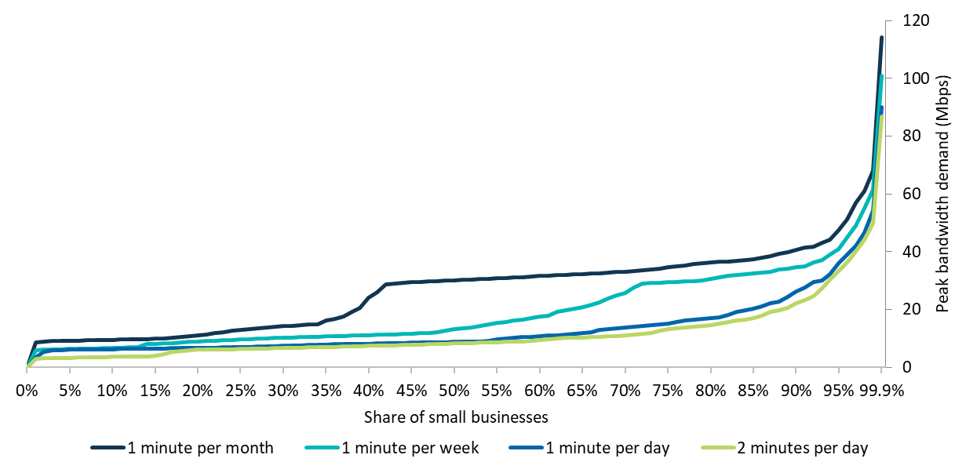

Source: BCAR estimates

Table 19. Small business bandwidth demand in 2028 by differing minutes excluded

| **Small businesses** | **1 minute per month** | **1 minute per week** | **1 minute per day (base case)** | **2 minutes per day** |
| --- | --- | --- | --- | --- |
| 50% | 31 | 14 | 9 | 9 |
| 75% | 35 | 30 | 16 | 14 |
| 90% | 41 | 35 | 27 | 23 |
| 95% | 48 | 41 | 37 | 34 |
| 98% | 61 | 56 | 47 | 45 |
| 99% | 68 | 62 | 55 | 50 |
| 99.9% | 115 | 101 | 90 | 87 |

Source: BCAR estimates

#### Forecast growth rate

The BCAR has assumed a forecast growth rate of 5 per cent each year in bandwidth requirements for select applications, including cloud storage bandwidth and webpage weight sizes (see Appendix E: Applications). Sensitivity tests reveal that the choice of forecast growth rate considerably affects the model outputs for small business bandwidth requirements, as shown in Table 20.

Assuming 3 per cent forecast growth each year, bandwidth requirements decrease when compared to the base case by 2028. Under 10 per cent forecast growth each year, bandwidth requirements increase significantly by 2028. Of the applications subject to the forecast growth assumption, file transfers is a key component in driving peak bandwidth demand.

Table 20. Small business bandwidth demand by different forecast annual growth rates

| **Small businesses** | **Bandwidth in 2028 (Mbps)**  **3 per cent forecast growth rate** | **Bandwidth in 2028 (Mbps)**  **5 per cent forecast growth rate (base)** | **Bandwidth in 2028 (Mbps)**  **10 per cent forecast growth rate** |
| --- | --- | --- | --- |
| 50% | 8 | 9 | 13 |
| 75% | 14 | 16 | 20 |
| 90% | 25 | 27 | 32 |
| 95% | 33 | 37 | 49 |
| 98% | 44 | 47 | 65 |
| 99% | 49 | 55 | 72 |
| 99.9% | 88 | 90 | 118 |

Source: BCAR estimates

#### Busy period

The number of hours in the busy period for small businesses was assumed to be 2 hours per day. The base case assumes that overall, 37.5 per cent of small business daily internet activity occurs during this 2 hour busy period.

Sensitivity tests of 30 per cent and 45 per cent of daily internet usage occurring within the busy period were undertaken, as shown in Table 21. These tests reveal that adjusting the share of online activity that happens in the busy hours varies bandwidth requirements slightly.

Table 21. Bandwidth demand by different proportions of usage occurring during the busy period

| **Small businesses** | **30% of usage in the busy period**  **Bandwidth in 2018 (Mbps)** | **30% of usage in the busy period**  **Bandwidth in 2028 (Mbps)** | **37.5% of usage in the busy period (base)**  **Bandwidth in 2018 (Mbps)** | **37.5% of usage in the busy period (base)**  **Bandwidth in 2028 (Mbps)** | **45% of usage in the busy period**  **Bandwidth in 2018 (Mbps)** | **45% of usage in the busy period**  **Bandwidth in 2028 (Mbps)** |
| --- | --- | --- | --- | --- | --- | --- |
| 50% | 7 | 9 | 7 | 9 | 7 | 10 |
| 75% | 12 | 15 | 13 | 16 | 15 | 17 |
| 90% | 17 | 24 | 19 | 27 | 19 | 28 |
| 95% | 22 | 35 | 24 | 37 | 25 | 37 |
| 98% | 29 | 45 | 31 | 47 | 32 | 50 |
| 99% | 34 | 51 | 35 | 55 | 37 | 57 |
| 99.9% | 61 | 88 | 62 | 90 | 64 | 94 |

Source: BCAR estimates

Overall, there is a positive correlation between the percentage of usage occurring during the busy period and bandwidth requirements. This aligns with the BCAR’s assumptions, as increasing usage in the busy period implies a greater likelihood of overlapping applications.

#### Usage mix

The small business assumptions regarding the mix of users are based on the usage profiles for individual occupation types developed by the BCAR (outlined in Appendix H: Assumptions tables). This means there is reasonable certainty behind the employee user type mixes (i.e. the proportion of low, medium and high usage individuals). However, there is value in testing the relative usage of low, medium and high usage individuals.

Sensitivity analysis found that the usage levels of different employees have a minimal impact on small business bandwidth requirements. The model assumes that low usage employees undertake 20 per cent of the internet usage of medium usage employees. Testing the impact on the results from varying this proportion to 50 per cent are shown in Table 22.

Bandwidth requirements remain similar if low users undertake more internet activity. This is due to the usage types being based on the medium or average user. As a result, if low users undertake proportionally more internet activity, then high internet usage individuals must undertake proportionally less internet activity, to ensure that the medium user reflects the average internet user.

Table 22. Low users have 50 per cent usage relative to the medium (or average) user

| **Small businesses** | **Low users are 20% of medium user (base)**  **Bandwidth in 2018 (Mbps)** | **Low users are 20% of medium user (base)**  **Bandwidth in 2028 (Mbps)** | **Low users are 50% of medium user**  **Bandwidth in 2018 (Mbps)** | **Low users are 50% of medium user**  **Bandwidth in 2028 (Mbps)** |
| --- | --- | --- | --- | --- |
| 50% | 7 | 9 | 7 | 9 |
| 75% | 13 | 16 | 13 | 15 |
| 90% | 19 | 27 | 19 | 27 |
| 95% | 24 | 37 | 24 | 36 |
| 98% | 31 | 47 | 30 | 48 |
| 99% | 35 | 55 | 35 | 53 |
| 99.9% | 62 | 90 | 63 | 90 |

Source: BCAR estimates

## Appendix H: Assumptions tables

### Households

The following tables present assumptions that were inputs to the household analysis. The first 2 tables refer to assumptions that pertain to households and their characteristics while the other tables outline assumptions that pertain to household applications.

Table 23. Household key assumptions

| Key assumptions | Value |
| --- | --- |
| Busy period (hours per day) | 2 |
| Busy period usage | 25% |
| Child usage relative to adult usage | 50% |
| Forecast annual growth rate* | 5% |
| Video bandwidth annual compression rate | 7% |

Note: * A forecast growth rate is applied to some elements of the analysis where data limitations preclude the use of real-world data to inform the assumptions (see Appendix E: Applications).

Table 24. Household usage variation

| **Household use variation (see Video resolution type)** | **2018** | **2028** |
| --- | --- | --- |
| **Household distribution** |  |  |
| Low | 40% | 40% |
| Medium | 30% | 20% |
| Medium with game downloads | 10% | 20% |
| High | 20% | 20% |
| **Household usage relative to average** |  |  |
| Low | 50% | 50% |
| Medium | 100% | 100% |
| Medium with game downloads | 100% | 100% |
| High | 200% | 200% |

Table 25. Household application assumptions

|  | **Minutes used per day per person**  **2018** | **Minutes used per day per person**  **2028** | **Bandwidth requirement (Mbps)**  **2018** | **Bandwidth requirement (Mbps)**  **2028** |
| --- | --- | --- | --- | --- |
| Streamed video | 60 | 124 |  |  |
| SD |  |  | 2 | 1 |
| HD |  |  | 5 | 3 |
| 4K |  |  | 18 | 9 |
| 8K |  |  | 70* | 37 |
| Streamed gaming | 1.30 | 8.05 | 10 | 10 |
| Streamed virtual reality | 0.33 | 1.67 | 15 | 15 |
| Cloud storage | 0.35 | 7.33 | 2 | 3 |
| Content downloads | 3.69 | 13.73 | 9 | 10 |
| Mobile applications and OS downloads | 0.06 | 0.10 | 15 | 22 |
| Peer-to-peer file sharing | 4.43 | 3.66 | 5 | 5 |
| Video calls | 0.60 | 3.00 | 2 | 2 |
| Game downloads | 0.96 | 1.57 | 14 | 28 |
| Software downloads | 0.07 | 0.08 | 15 | 22 |
| Web use | 107.14 | 185.55 | 3 | 6 |
| Low bandwidth application—primary device (per household) | 48.00 | 96.00 | 0.51 | 0.83 |
| Low bandwidth application—secondary devices (per household) | 48.00 | 96.00 | 0.05 | 0.08 |

Note: *8K streamed video is not introduced until 2019, when the bandwidth requirement is 70 Mbps.

The BCAR splits low bandwidth applications into a ‘primary’ device and other ‘secondary’ devices. The primary device represents applications which require interaction from the user such as online gaming, while secondary applications refer to connections which don’t require user engagement, such as IoT.

These tables present the amount of time spent using applications for the different user types as well as the associated bandwidth requirements for 2018 and 2028.

Table 26. Households by usage type in 2018

| **Applications** | **Bandwidth in 2018**  **Mbps** | **Low**  **Minutes used per day per person** | **Medium**  **Minutes used per day per person** | **High**  **Minutes used per day per person** |
| --- | --- | --- | --- | --- |
| Streamed video | SD: 2  HD: 5  4K: 18  8K: 70* | 30.10 | 60.19 | 120.38 |
| Streamed gaming | 10 | 0.65 | 1.30 | 2.60 |
| Streamed virtual reality | 15 | 0.17 | 0.33 | 0.67 |
| Cloud storage | 2 | 0.17 | 0.35 | 0.70 |
| Content downloads | 9 | 1.85 | 3.69 | 7.38 |
| Mobile applications and OS downloads | 15 | 0.03 | 0.06 | 0.12 |
| Peer-to-peer file sharing | 5 | 2.21 | 4.43 | 8.86 |
| Video calls | 2 | 0.30 | 0.60 | 1.20 |
| Game downloads | 14 | - | 0.96** | 1.92 |
| Software downloads | 15 | 0.07 | 0.07 | 0.07 |
| Web use | 3 | 53.57 | 107.14 | 214.28 |
| Total |  | **89.12** | **179.13** | **353.27** |

Notes: *8K streamed video is not introduced until 2019, when the bandwidth requirement is 70 Mbps.

**Game downloads are included only for the ‘medium with games downloads’ households who represent a quarter of medium households.

Table 27. Households by usage type in 2028

| **Applications** | **Bandwidth in 2028**  **Mbps** | **Low**  **Minutes used per day per person** | **Medium**  **Minutes used per day per person** | **High**  **Minutes used per day per person** |
| --- | --- | --- | --- | --- |
| Streamed video | SD: 1  HD: 3  4K: 9  8K: 37 | 61.86 | 123.72 | 247.44 |
| Streamed gaming | 10 | 4.02 | 8.05 | 16.10 |
| Streamed virtual reality | 15 | 0.83 | 1.67 | 3.33 |
| Cloud storage | 3 | 3.66 | 7.33 | 14.65 |
| Content downloads | 10 | 6.87 | 13.73 | 27.47 |
| Mobile applications and OS downloads | 22 | 0.05 | 0.10 | 0.20 |
| Peer-to-peer file sharing | 5 | 1.83 | 3.66 | 7.32 |
| Video calls | 2 | 1.50 | 3.00 | 6.00 |
| Game downloads | 28 | - | 1.57* | 3.14 |
| Software downloads | 22 | 0.08 | 0.08 | 0.08 |
| Web use | 6 | 92.77 | 185.55 | 371.10 |
| Total |  | **173.49** | **348.46** | **696.84** |

Note: *Game downloads are included only for the ‘medium with games downloads’ households who represent half of medium households.

### Small business

The following tables present assumptions that were inputs to the small business analysis. The first table refers to assumptions that pertain to small businesses and their characteristics while the other tables outline assumptions that pertain to small business applications.

Table 28. Small business key assumptions

| **Key assumptions** | **Value** |
| --- | --- |
| **Busy period traffic concentration** |  |
| Busy period (hours per day) | 2 |
| Busy period usage (compared to non-busy period usage per hour) | 150% |
| **Working hours** |  |
| Working hours per day | 7 |
| Working days per month | 21 |
| **Employee application usage relative to average by employee type** |  |
| Low | 20% |
| Medium | 100% |
| High | 255% |
| Blended users | 2 |
| Forecast annual growth rate* | 5% |
| Video bandwidth annual compression rate | 7% |

Note: * A forecast growth rate is applied to some elements of the analysis where data limitations preclude the use of real-world data to inform the assumptions (see Appendix E: Applications).

Table 29. Small business employee application assumptions

| Application | **Minutes used per day per employee**  **2018** | **Minutes used per day per employee**  **2028** | **Bandwidth requirement (Mbps)**  **2018** | **Bandwidth requirement (Mbps)**  **2028** |
| --- | --- | --- | --- | --- |
| Cloud storage | 0.5 | 1.3 | 2 | 3 |
| Cloud storage (media user) | 0.5 | 1.2 | 5 | 8 |
| Email | 1.0 | 2.3 | 3 | 3 |
| Streamed video | 6.8 | 9.8 | 5 | 3 |
| Video calling | 0.6 | 6.0 | 2 | 2 |
| File transfers (media users) | 10.0 | 7.5 | 14 | 29 |
| Web browsing | 80.4 | 116.1 | 3 | 6 |

Table 30. Small business non-employee application assumptions

| **Guest WiFi bandwidth per employee** | **2018 (Mbps)** | **2028 (Mbps)** |
| --- | --- | --- |
| Accommodation | 1 | 2 |
| Food and Beverage Services | 1 | 2 |
| Library and Other Information Services | 1 | 1 |
| Preschool and School Education | 3 | 4 |
| Tertiary Education | 3 | 5 |
| Adult, Community and Other Education | 3 | 5 |
| Hospitals | 1 | 1 |
| Residential Care Services | 1 | 1 |
| Heritage Activities | 1 | 1 |
| Bandwidth required for low bandwidth applications per employee | 1 | 3 |

## Appendix I: Occupation list

Table 31 outlines the occupations in the Australian and New Zealand Standard Classification of Occupations (ANZSCO) list[254] and the BCAR’s assessment of their fixed-line bandwidth requirements. This information was used to create the distributions of the 4 user types (low, medium, high and high with media users) in the small business analysis.

To derive the bandwidth requirements for occupations, the BCAR analysed the ANZSCO list at the 4‑digit level because this was the most disaggregated level of information for which there was occupation and industry employment data available using the Census of Population and Housing. An investigation of the tasks that these occupation groups undertake provided insight into the likelihood for these roles to be undertaken using digital devices that would require bandwidth from a fixed-line access point. Where not enough information was available to make an assessment at the occupation group level, further research was conducted on occupations within that group.

The BCAR’s classification was then compared with the results of the Communications Chambers analysis that was undertaken in the UK in 2015.[255] Any differences identified were investigated further.

Table 31. Occupation by fixed-line bandwidth requirement

| **Occupation code** | **Occupation name** | **Fixed-line bandwidth user type** |
| --- | --- | --- |
| 1000 | Managers, nfd | Med |
| 1110 | Chief Executives, General Managers and Legislators, nfd | Med |
| 1111 | Chief Executives and Managing Directors | Med |
| 1112 | General Managers | Med |
| 1113 | Legislators | Med |
| 1210 | Farmers and Farm Managers, nfd | Low |
| 1211 | Aquaculture Farmers | Low |
| 1212 | Crop Farmers | Low |
| 1213 | Livestock Farmers | Low |
| 1214 | Mixed Crop and Livestock Farmers | Low |
| 1300 | Specialist Managers, nfd | Med |
| 1311 | Advertising, Public Relations and Sales Managers | Med |
| 1320 | Business Administration Managers, nfd | High |
| 1321 | Corporate Services Managers | High |
| 1322 | Finance Managers | High |
| 1323 | Human Resource Managers | High |
| 1324 | Policy and Planning Managers | High |
| 1325 | Research and Development Managers | High |
| 1330 | Construction, Distribution and Production Managers, nfd | Med |
| 1331 | Construction Managers | Med |
| 1332 | Engineering Managers | Med |
| 1333 | Importers, Exporters and Wholesalers | High |
| 1334 | Manufacturers | Med |
| 1335 | Production Managers | Med |
| 1336 | Supply, Distribution and Procurement Managers | Med |
| 1340 | Education, Health and Welfare Services Managers, nfd | Med |
| 1341 | Child Care Centre Managers | Med |
| 1342 | Health and Welfare Services Managers | Med |
| 1343 | School Principals | High |
| 1344 | Other Education Managers | Med |
| 1351 | ICT Managers | High+Media |
| 1390 | Miscellaneous Specialist Managers, nfd | Med |
| 1391 | Commissioned Officers (Management) | Med |
| 1392 | Senior Non-commissioned Defence Force Members | Med |
| 1399 | Other Specialist Managers | Med |
| 1400 | Hospitality, Retail and Service Managers, nfd | Med |
| 1410 | Accommodation and Hospitality Managers, nfd | Med |
| 1411 | Cafe and Restaurant Managers | Med |
| 1412 | Caravan Park and Camping Ground Managers | Med |
| 1413 | Hotel and Motel Managers | Med |
| 1414 | Licensed Club Managers | Med |
| 1419 | Other Accommodation and Hospitality Managers | Med |
| 1421 | Retail Managers | Med |
| 1490 | Miscellaneous Hospitality, Retail and Service Managers, nfd | Med |
| 1491 | Amusement, Fitness and Sports Centre Managers | Low |
| 1492 | Call or Contact Centre and Customer Service Managers | High |
| 1493 | Conference and Event Organisers | Med |
| 1494 | Transport Services Managers | Med |
| 1499 | Other Hospitality, Retail and Service Managers | Med |
| 2000 | Professionals, nfd | High |
| 2100 | Arts and Media Professionals, nfd | High |
| 2110 | Arts Professionals, nfd | Med |
| 2111 | Actors, Dancers and Other Entertainers | Low |
| 2112 | Music Professionals | Med |
| 2113 | Photographers | High+Media |
| 2114 | Visual Arts and Crafts Professionals | Low |
| 2120 | Media Professionals, nfd | High |
| 2121 | Artistic Directors, and Media Producers and Presenters | High |
| 2122 | Authors, and Book and Script Editors | High |
| 2123 | Film, Television, Radio and Stage Directors | High+Media |
| 2124 | Journalists and Other Writers | High |
| 2200 | Business, Human Resource and Marketing Professionals, nfd | High |
| 2210 | Accountants, Auditors and Company Secretaries, nfd | High |
| 2211 | Accountants | High |
| 2212 | Auditors, Company Secretaries and Corporate Treasurers | High |
| 2220 | Financial Brokers and Dealers, and Investment Advisers, nfd | High |
| 2221 | Financial Brokers | High |
| 2222 | Financial Dealers | High |
| 2223 | Financial Investment Advisers and Managers | High |
| 2230 | Human Resource and Training Professionals, nfd | High |
| 2231 | Human Resource Professionals | High |
| 2232 | ICT Trainers | High |
| 2233 | Training and Development Professionals | High |
| 2240 | Information and Organisation Professionals, nfd | High |
| 2241 | Actuaries, Mathematicians and Statisticians | High |
| 2242 | Archivists, Curators and Records Managers | High |
| 2243 | Economists | High |
| 2244 | Intelligence and Policy Analysts | High |
| 2245 | Land Economists and Valuers | High |
| 2246 | Librarians | Med |
| 2247 | Management and Organisation Analysts | High |
| 2249 | Other Information and Organisation Professionals | High |
| 2250 | Sales, Marketing and Public Relations Professionals, nfd | High |
| 2251 | Advertising and Marketing Professionals | High |
| 2252 | ICT Sales Professionals | High |
| 2253 | Public Relations Professionals | High |
| 2254 | Technical Sales Representatives | Med |
| 2300 | Design, Engineering, Science and Transport Professionals, nfd | Med |
| 2310 | Air and Marine Transport Professionals, nfd | Med |
| 2311 | Air Transport Professionals | Med |
| 2312 | Marine Transport Professionals | Med |
| 2320 | Architects, Designers, Planners and Surveyors, nfd | High |
| 2321 | Architects and Landscape Architects | High+Media |
| 2322 | Surveyors and Spatial Scientists | High+Media |
| 2323 | Fashion, Industrial and Jewellery Designers | High+Media |
| 2324 | Graphic and Web Designers, and Illustrators | High+Media |
| 2325 | Interior Designers | High+Media |
| 2326 | Urban and Regional Planners | High |
| 2330 | Engineering Professionals, nfd | High |
| 2331 | Chemical and Materials Engineers | High |
| 2332 | Civil Engineering Professionals | High |
| 2333 | Electrical Engineers | High |
| 2334 | Electronics Engineers | High |
| 2335 | Industrial, Mechanical and Production Engineers | High |
| 2336 | Mining Engineers | High |
| 2339 | Other Engineering Professionals | High |
| 2340 | Natural and Physical Science Professionals, nfd | High |
| 2341 | Agricultural and Forestry Scientists | Med |
| 2342 | Chemists, and Food and Wine Scientists | High |
| 2343 | Environmental Scientists | High |
| 2344 | Geologists, Geophysicists and Hydrogeologists | High+Media |
| 2345 | Life Scientists | High |
| 2346 | Medical Laboratory Scientists | High |
| 2347 | Veterinarians | Med |
| 2349 | Other Natural and Physical Science Professionals | High |
| 2400 | Education Professionals, nfd | Med |
| 2410 | School Teachers, nfd | Med |
| 2411 | Early Childhood (Pre-primary School) Teachers | Low |
| 2412 | Primary School Teachers | Med |
| 2413 | Middle School Teachers (Aus) / Intermediate School Teachers (NZ) | Med |
| 2414 | Secondary School Teachers | Med |
| 2415 | Special Education Teachers | Med |
| 2420 | Tertiary Education Teachers, nfd | Med |
| 2421 | University Lecturers and Tutors | Med |
| 2422 | Vocational Education Teachers (Aus) / Polytechnic Teachers (NZ) | Med |
| 2490 | Miscellaneous Education Professionals, nfd | Med |
| 2491 | Education Advisers and Reviewers | Med |
| 2492 | Private Tutors and Teachers | Med |
| 2493 | Teachers of English to Speakers of Other Languages | Med |
| 2500 | Health Professionals, nfd | Med |
| 2510 | Health Diagnostic and Promotion Professionals, nfd | Med |
| 2511 | Nutrition Professionals | Med |
| 2512 | Medical Imaging Professionals | High+Media |
| 2513 | Occupational and Environmental Health Professionals | Med |
| 2514 | Optometrists and Orthoptists | Med |
| 2515 | Pharmacists | Med |
| 2519 | Other Health Diagnostic and Promotion Professionals | Med |
| 2520 | Health Therapy Professionals, nfd | Low |
| 2521 | Chiropractors and Osteopaths | Low |
| 2522 | Complementary Health Therapists | Low |
| 2523 | Dental Practitioners | Med |
| 2524 | Occupational Therapists | Low |
| 2525 | Physiotherapists | Med |
| 2526 | Podiatrists | Med |
| 2527 | Audiologists and Speech Pathologists \ Therapists | Med |
| 2530 | Medical Practitioners, nfd | Med |
| 2531 | General Practitioners and Resident Medical Officers | Med |
| 2532 | Anaesthetists | Low |
| 2533 | Specialist Physicians | Med |
| 2534 | Psychiatrists | Med |
| 2535 | Surgeons | Low |
| 2539 | Other Medical Practitioners | Med |
| 2540 | Midwifery and Nursing Professionals, nfd | Low |
| 2541 | Midwives | Low |
| 2542 | Nurse Educators and Researchers | Med |
| 2543 | Nurse Managers | Low |
| 2544 | Registered Nurses | Low |
| 2600 | ICT Professionals, nfd | High |
| 2610 | Business and Systems Analysts, and Programmers, nfd | High+Media |
| 2611 | ICT Business and Systems Analysts | High+Media |
| 2612 | Multimedia Specialists and Web Developers | High+Media |
| 2613 | Software and Applications Programmers | High+Media |
| 2621 | Database and Systems Administrators, and ICT Security Specialists | High+Media |
| 2630 | ICT Network and Support Professionals, nfd | High+Media |
| 2631 | Computer Network Professionals | High+Media |
| 2632 | ICT Support and Test Engineers | High+Media |
| 2633 | Telecommunications Engineering Professionals | High+Media |
| 2700 | Legal, Social and Welfare Professionals, nfd | Med |
| 2710 | Legal Professionals, nfd | Med |
| 2711 | Barristers | Med |
| 2712 | Judicial and Other Legal Professionals | Med |
| 2713 | Solicitors | Med |
| 2720 | Social and Welfare Professionals, nfd | Med |
| 2721 | Counsellors | Med |
| 2722 | Ministers of Religion | Low |
| 2723 | Psychologists | Med |
| 2724 | Social Professionals | Med |
| 2725 | Social Workers | Med |
| 2726 | Welfare, Recreation and Community Arts Workers | Med |
| 3000 | Technicians and Trades Workers, nfd | Low |
| 3100 | Engineering, ICT and Science Technicians, nfd | Med |
| 3110 | Agricultural, Medical and Science Technicians, nfd | Med |
| 3111 | Agricultural Technicians | Med |
| 3112 | Medical Technicians | Med |
| 3113 | Primary Products Inspectors | Low |
| 3114 | Science Technicians | Med |
| 3120 | Building and Engineering Technicians, nfd | Med |
| 3121 | Architectural, Building and Surveying Technicians | Med |
| 3122 | Civil Engineering Draftspersons and Technicians | High |
| 3123 | Electrical Engineering Draftspersons and Technicians | High |
| 3124 | Electronic Engineering Draftspersons and Technicians | High |
| 3125 | Mechanical Engineering Draftspersons and Technicians | High |
| 3126 | Safety Inspectors | Med |
| 3129 | Other Building and Engineering Technicians | Med |
| 3130 | ICT and Telecommunications Technicians, nfd | High |
| 3131 | ICT Support Technicians | High+Media |
| 3132 | Telecommunications Technical Specialists | Med |
| 3200 | Automotive and Engineering Trades Workers, nfd | Low |
| 3210 | Automotive Electricians and Mechanics, nfd | Low |
| 3211 | Automotive Electricians | Low |
| 3212 | Motor Mechanics | Low |
| 3220 | Fabrication Engineering Trades Workers, nfd | Low |
| 3221 | Metal Casting, Forging and Finishing Trades Workers | Low |
| 3222 | Sheetmetal Trades Workers | Low |
| 3223 | Structural Steel and Welding Trades Workers | Low |
| 3230 | Mechanical Engineering Trades Workers, nfd | Low |
| 3231 | Aircraft Maintenance Engineers | Low |
| 3232 | Metal Fitters and Machinists | Low |
| 3233 | Precision Metal Trades Workers | Low |
| 3234 | Toolmakers and Engineering Patternmakers | Low |
| 3240 | Panelbeaters, and Vehicle Body Builders, Trimmers and Painters, nfd | Low |
| 3241 | Panelbeaters | Low |
| 3242 | Vehicle Body Builders and Trimmers | Low |
| 3243 | Vehicle Painters | Low |
| 3300 | Construction Trades Workers, nfd | Low |
| 3310 | Bricklayers, and Carpenters and Joiners, nfd | Low |
| 3311 | Bricklayers and Stonemasons | Low |
| 3312 | Carpenters and Joiners | Low |
| 3320 | Floor Finishers and Painting Trades Workers, nfd | Low |
| 3321 | Floor Finishers | Low |
| 3322 | Painting Trades Workers | Low |
| 3330 | Glaziers, Plasterers and Tilers, nfd | Low |
| 3331 | Glaziers | Low |
| 3332 | Plasterers | Low |
| 3333 | Roof Tilers | Low |
| 3334 | Wall and Floor Tilers | Low |
| 3341 | Plumbers | Low |
| 3400 | Electrotechnology and Telecommunications Trades Workers, nfd | Low |
| 3411 | Electricians | Low |
| 3420 | Electronics and Telecommunications Trades Workers, nfd | Low |
| 3421 | Airconditioning and Refrigeration Mechanics | Low |
| 3422 | Electrical Distribution Trades Workers | Low |
| 3423 | Electronics Trades Workers | Low |
| 3424 | Telecommunications Trades Workers | Low |
| 3510 | Food Trades Workers, nfd | Low |
| 3511 | Bakers and Pastrycooks | Low |
| 3512 | Butchers and Smallgoods Makers | Low |
| 3513 | Chefs | Low |
| 3514 | Cooks | Low |
| 3600 | Skilled Animal and Horticultural Workers, nfd | Low |
| 3610 | Animal Attendants and Trainers, and Shearers, nfd | Low |
| 3611 | Animal Attendants and Trainers | Low |
| 3612 | Shearers | Low |
| 3613 | Veterinary Nurses | Low |
| 3620 | Horticultural Trades Workers, nfd | Low |
| 3621 | Florists | Low |
| 3622 | Gardeners | Low |
| 3623 | Greenkeepers | Low |
| 3624 | Nurserypersons | Low |
| 3900 | Other Technicians and Trades Workers, nfd | Low |
| 3911 | Hairdressers | Low |
| 3920 | Printing Trades Workers, nfd | Low |
| 3921 | Print Finishers and Screen Printers | Low |
| 3922 | Graphic Pre-press Trades Workers | High |
| 3923 | Printers | Low |
| 3930 | Textile, Clothing and Footwear Trades Workers, nfd | Low |
| 3931 | Canvas and Leather Goods Makers | Low |
| 3932 | Clothing Trades Workers | Low |
| 3933 | Upholsterers | Low |
| 3940 | Wood Trades Workers, nfd | Low |
| 3941 | Cabinetmakers | Low |
| 3942 | Wood Machinists and Other Wood Trades Workers | Low |
| 3990 | Miscellaneous Technicians and Trades Workers, nfd | Low |
| 3991 | Boat Builders and Shipwrights | Low |
| 3992 | Chemical, Gas, Petroleum and Power Generation Plant Operators | Low |
| 3993 | Gallery, Library and Museum Technicians | Low |
| 3994 | Jewellers | Low |
| 3995 | Performing Arts Technicians | Low |
| 3996 | Signwriters | Med |
| 3999 | Other Miscellaneous Technicians and Trades Workers | Low |
| 4000 | Community and Personal Service Workers, nfd | Low |
| 4110 | Health and Welfare Support Workers, nfd | Low |
| 4111 | Ambulance Officers and Paramedics | Low |
| 4112 | Dental Hygienists, Technicians and Therapists | Med |
| 4113 | Diversional Therapists | Low |
| 4114 | Enrolled and Mothercraft Nurses | Low |
| 4115 | Indigenous Health Workers | Low |
| 4116 | Massage Therapists | Low |
| 4117 | Welfare Support Workers | Low |
| 4200 | Carers and Aides, nfd | Low |
| 4211 | Child Carers | Low |
| 4221 | Education Aides | Low |
| 4230 | Personal Carers and Assistants, nfd | Low |
| 4231 | Aged and Disabled Carers | Low |
| 4232 | Dental Assistants | Med |
| 4233 | Nursing Support and Personal Care Workers | Low |
| 4234 | Special Care Workers | Low |
| 4310 | Hospitality Workers, nfd | Low |
| 4311 | Bar Attendants and Baristas | Low |
| 4312 | Cafe Workers | Low |
| 4313 | Gaming Workers | Low |
| 4314 | Hotel Service Managers | Med |
| 4315 | Waiters | Low |
| 4319 | Other Hospitality Workers | Low |
| 4400 | Protective Service Workers, nfd | Low |
| 4410 | Defence Force Members, Fire Fighters and Police, nfd | Low |
| 4411 | Defence Force Members - Other Ranks | Low |
| 4412 | Fire and Emergency Workers | Low |
| 4413 | Police | Med |
| 4420 | Prison and Security Officers, nfd | Low |
| 4421 | Prison Officers | Low |
| 4422 | Security Officers and Guards | Low |
| 4500 | Sports and Personal Service Workers, nfd | Low |
| 4510 | Personal Service and Travel Workers, nfd | Low |
| 4511 | Beauty Therapists | Low |
| 4512 | Driving Instructors | Low |
| 4513 | Funeral Workers | Low |
| 4514 | Gallery, Museum and Tour Guides | Low |
| 4515 | Personal Care Consultants | Low |
| 4516 | Tourism and Travel Advisers | High |
| 4517 | Travel Attendants | Low |
| 4518 | Other Personal Service Workers | Low |
| 4520 | Sports and Fitness Workers, nfd | Low |
| 4521 | Fitness Instructors | Low |
| 4522 | Outdoor Adventure Guides | Low |
| 4523 | Sports Coaches, Instructors and Officials | Low |
| 4524 | Sportspersons | Low |
| 5000 | Clerical and Administrative Workers, nfd | High |
| 5100 | Office Managers and Program Administrators, nfd | High |
| 5111 | Contract, Program and Project Administrators | High |
| 5120 | Office and Practice Managers, nfd | High |
| 5121 | Office Managers | High |
| 5122 | Practice Managers | High |
| 5210 | Personal Assistants and Secretaries, nfd | High |
| 5211 | Personal Assistants | High |
| 5212 | Secretaries | High |
| 5300 | General Clerical Workers, nfd | High |
| 5311 | General Clerks | High |
| 5321 | Keyboard Operators | High |
| 5400 | Inquiry Clerks and Receptionists, nfd | High |
| 5410 | Call or Contact Centre Information Clerks, nfd | High |
| 5411 | Call or Contact Centre Workers | High |
| 5412 | Information Officers | High |
| 5421 | Receptionists | High |
| 5500 | Numerical Clerks, nfd | High |
| 5510 | Accounting Clerks and Bookkeepers, nfd | High |
| 5511 | Accounting Clerks | High |
| 5512 | Bookkeepers | High |
| 5513 | Payroll Clerks | High |
| 5520 | Financial and Insurance Clerks, nfd | High |
| 5521 | Bank Workers | High |
| 5522 | Credit and Loans Officers (Aus) / Finance Clerks (NZ) | High |
| 5523 | Insurance, Money Market and Statistical Clerks | High |
| 5610 | Clerical and Office Support Workers, nfd | Med |
| 5611 | Betting Clerks | Med |
| 5612 | Couriers and Postal Deliverers | Low |
| 5613 | Filing and Registry Clerks | High |
| 5614 | Mail Sorters | Low |
| 5615 | Survey Interviewers | Med |
| 5616 | Switchboard Operators | Med |
| 5619 | Other Clerical and Office Support Workers | High |
| 5900 | Other Clerical and Administrative Workers, nfd | Med |
| 5910 | Logistics Clerks, nfd | Med |
| 5911 | Purchasing and Supply Logistics Clerks | Med |
| 5912 | Transport and Despatch Clerks | Med |
| 5990 | Miscellaneous Clerical and Administrative Workers, nfd | Med |
| 5991 | Conveyancers and Legal Executives | Med |
| 5992 | Court and Legal Clerks | High |
| 5993 | Debt Collectors | Low |
| 5994 | Human Resource Clerks | High |
| 5995 | Inspectors and Regulatory Officers | Med |
| 5996 | Insurance Investigators, Loss Adjusters and Risk Surveyors | Med |
| 5997 | Library Assistants | Med |
| 5999 | Other Miscellaneous Clerical and Administrative Workers | High |
| 6000 | Sales Workers, nfd | Low |
| 6100 | Sales Representatives and Agents, nfd | Med |
| 6110 | Insurance Agents and Sales Representatives, nfd | Med |
| 6111 | Auctioneers, and Stock and Station Agents | Med |
| 6112 | Insurance Agents | High |
| 6113 | Sales Representatives | Med |
| 6121 | Real Estate Sales Agents | Med |
| 6210 | Sales Assistants and Salespersons, nfd | Low |
| 6211 | Sales Assistants (General) | Low |
| 6212 | ICT Sales Assistants | Low |
| 6213 | Motor Vehicle and Vehicle Parts Salespersons | Low |
| 6214 | Pharmacy Sales Assistants | Low |
| 6215 | Retail Supervisors | Low |
| 6216 | Service Station Attendants | Low |
| 6217 | Street Vendors and Related Salespersons | Low |
| 6219 | Other Sales Assistants and Salespersons | Low |
| 6300 | Sales Support Workers, nfd | Low |
| 6311 | Checkout Operators and Office Cashiers | Low |
| 6390 | Miscellaneous Sales Support Workers, nfd | Low |
| 6391 | Models and Sales Demonstrators | Low |
| 6392 | Retail and Wool Buyers | Low |
| 6393 | Telemarketers | High |
| 6394 | Ticket Salespersons | Med |
| 6395 | Visual Merchandisers | Low |
| 6399 | Other Sales Support Workers | Low |
| 7000 | Machinery Operators and Drivers, nfd | Low |
| 7100 | Machine and Stationary Plant Operators, nfd | Low |
| 7110 | Machine Operators, nfd | Low |
| 7111 | Clay, Concrete, Glass and Stone Processing Machine Operators | Low |
| 7112 | Industrial Spraypainters | Low |
| 7113 | Paper and Wood Processing Machine Operators | Low |
| 7114 | Photographic Developers and Printers | High+Media |
| 7115 | Plastics and Rubber Production Machine Operators | Low |
| 7116 | Sewing Machinists | Low |
| 7117 | Textile and Footwear Production Machine Operators | Low |
| 7119 | Other Machine Operators | Low |
| 7120 | Stationary Plant Operators, nfd | Low |
| 7121 | Crane, Hoist and Lift Operators | Low |
| 7122 | Drillers, Miners and Shot Firers | Low |
| 7123 | Engineering Production Workers | Low |
| 7129 | Other Stationary Plant Operators | Low |
| 7210 | Mobile Plant Operators, nfd | Low |
| 7211 | Agricultural, Forestry and Horticultural Plant Operators | Low |
| 7212 | Earthmoving Plant Operators | Low |
| 7213 | Forklift Drivers | Low |
| 7219 | Other Mobile Plant Operators | Low |
| 7300 | Road and Rail Drivers, nfd | Low |
| 7310 | Automobile, Bus and Rail Drivers, nfd | Low |
| 7311 | Automobile Drivers | Low |
| 7312 | Bus and Coach Drivers | Low |
| 7313 | Train and Tram Drivers | Low |
| 7321 | Delivery Drivers | Low |
| 7331 | Truck Drivers | Low |
| 7411 | Storepersons | Low |
| 8000 | Labourers, nfd | Low |
| 8110 | Cleaners and Laundry Workers, nfd | Low |
| 8111 | Car Detailers | Low |
| 8112 | Commercial Cleaners | Low |
| 8113 | Domestic Cleaners | Low |
| 8114 | Housekeepers | Low |
| 8115 | Laundry Workers | Low |
| 8116 | Other Cleaners | Low |
| 8210 | Construction and Mining Labourers, nfd | Low |
| 8211 | Building and Plumbing Labourers | Low |
| 8212 | Concreters | Low |
| 8213 | Fencers | Low |
| 8214 | Insulation and Home Improvement Installers | Low |
| 8215 | Paving and Surfacing Labourers | Low |
| 8216 | Railway Track Workers | Low |
| 8217 | Structural Steel Construction Workers | Low |
| 8219 | Other Construction and Mining Labourers | Low |
| 8300 | Factory Process Workers, nfd | Low |
| 8310 | Food Process Workers, nfd | Low |
| 8311 | Food and Drink Factory Workers | Low |
| 8312 | Meat Boners and Slicers, and Slaughterers | Low |
| 8313 | Meat, Poultry and Seafood Process Workers | Low |
| 8320 | Packers and Product Assemblers, nfd | Low |
| 8321 | Packers | Low |
| 8322 | Product Assemblers | Low |
| 8390 | Miscellaneous Factory Process Workers, nfd | Low |
| 8391 | Metal Engineering Process Workers | Low |
| 8392 | Plastics and Rubber Factory Workers | Low |
| 8393 | Product Quality Controllers | Low |
| 8394 | Timber and Wood Process Workers | Low |
| 8399 | Other Factory Process Workers | Low |
| 8410 | Farm, Forestry and Garden Workers, nfd | Low |
| 8411 | Aquaculture Workers | Low |
| 8412 | Crop Farm Workers | Low |
| 8413 | Forestry and Logging Workers | Low |
| 8414 | Garden and Nursery Labourers | Low |
| 8415 | Livestock Farm Workers | Low |
| 8416 | Mixed Crop and Livestock Farm Workers | Low |
| 8419 | Other Farm, Forestry and Garden Workers | Low |
| 8510 | Food Preparation Assistants, nfd | Low |
| 8511 | Fast Food Cooks | Low |
| 8512 | Food Trades Assistants | Low |
| 8513 | Kitchenhands | Low |
| 8900 | Other Labourers, nfd | Low |
| 8910 | Freight Handlers and Shelf Fillers, nfd | Low |
| 8911 | Freight and Furniture Handlers | Low |
| 8912 | Shelf Fillers | Low |
| 8990 | Miscellaneous Labourers, nfd | Low |
| 8991 | Caretakers | Low |
| 8992 | Deck and Fishing Hands | Low |
| 8993 | Handypersons | Low |
| 8994 | Motor Vehicle Parts and Accessories Fitters | Low |
| 8995 | Printing Assistants and Table Workers | Low |
| 8996 | Recycling and Rubbish Collectors | Low |
| 8997 | Vending Machine Attendants | Low |
| 8999 | Other Miscellaneous Labourers | Low |

## References

1. Lendino, J., 2019, ‘What Is 4K (Ultra HD)?’, *PC Mag Australia*, <https://au.pcmag.com/features/23104/what-is-4k-ultra-hd>
2. Morrison, G., 2019, ‘TV resolution confusion: 1080p, 2K, UHD, 4K, 8K, and what they all mean’, *CNET*, <https://www.cnet.com/news/4k-1080p-2k-uhd-8k-tv-resolutions-explained/>
3. Toal, R., ‘Internet applications’, *Loyola Marymount University*, <https://cs.lmu.edu/~ray/notes/inetapps/>
4. Brebion, A., 2018, ‘Above the Fold vs. Below the Fold: Does it Still Matter Today?’, *AB Tasty* <https://www.abtasty.com/blog/above-the-fold/>
5. Rouse, M., 2019, ‘Bandwidth’, *Search Networking*, <https://searchnetworking.techtarget.com/definition/bandwidth>
6. Mitchell, B., 2020, ‘What Is a Bit in Computer Networking?’*, Lifewire*, <https://www.lifewire.com/definition-of-bit-816250>
7. Mitchell, B., 2020, ‘What Is a Bit in Computer Networking?’*, Lifewire*, <https://www.lifewire.com/definition-of-bit-816250>
8. Citrix, 2019, ‘What is Caching?’, <https://www.citrix.com/en-au/glossary/caching.html>
9. Fitzer, M., 2019, ‘What is a CODEC?’, *Videomaker*, <https://www.videomaker.com/article/f6/14743-what-is-a-codec>
10. Computer Hope, 2020, ‘Data’,<https://www.computerhope.com/jargon/d/data.htm>
11. Fisher, T., 2019, ‘What Does Uploading and Downloading Mean?’, *Lifewire*, <https://www.lifewire.com/uploading-and-downloading-online-3985950>
12. ATT Internet services, ‘SDTV, HDTV and 4KTV: TV resolutions explained’, <https://www.attinternetservice.com/resources/sdtv-vs-hdtv-vs-4ktv/>
13. Australian Bureau of Statistics, 2016, [*Census of Population and Housing: Census Dictionary 2016*](https://www.abs.gov.au/ausstats/abs@.nsf/Lookup/2901.0Chapter34902016), cat. no. 2901.0, ABS, Canberra
14. OECD, 2018, *IoT measurement and applications*, No. 271, <https://www.oecd-ilibrary.org/science-and-technology/iot-measurement-and-applications_35209dbf-en>, OECD Publishing, Paris
15. Christensson, P., 2016, ‘Operating System Definition’, *TechTerms*, <https://techterms.com/definition/operating_system>
16. Christensson, P., 2012, ‘P2P Definition’, *TechTerms*, <https://techterms.com/definition/p2p>
17. Gilfillan, G., 2018, *Small business sector contribution to the economy*, Research Paper Series 2018-19, Parliamentary Library, <https://www.aph.gov.au/About_Parliament/Parliamentary_Departments/Parliamentary_Library/pubs/rp/rp1819/SmallBusinessSector#_Toc527009244>
18. ATT Internet services, ‘SDTV, HDTV and 4KTV: TV resolutions explained’, <https://www.attinternetservice.com/resources/sdtv-vs-hdtv-vs-4ktv/>
19. Cloudflare, 2020, ‘What is streaming? How video streaming works?’, <https://www.cloudflare.com/learning/performance/what-is-streaming/>
20. Techopedia, 2015, ‘Network Traffic’, <https://www.techopedia.com/definition/29917/network-traffic>
21. Fisher, T., 2019, ‘What Does Uploading and Downloading Mean?’, *Lifewire*, <https://www.lifewire.com/uploading-and-downloading-online-3985950>,
22. Computer Hope, 2018,’Video call’, <https://www.computerhope.com/jargon/v/video-call.htm>
23. Cheevers, C., Bugajski, M, Luthra, A., McCarthy, S., Moroney, P. & Wirick, K., 2016, ‘Virtual and augmented reality—how do they affect the current service delivery and home and network architectures?’, *Arris*, <https://www.commscope.com/globalassets/digizuite/1733-exec-paper-virtual-and-augmented-reality-final.pdf?utm_source=arris&utm_medium=redirect>
24. Australian Consumer and Media Authority, 2020, *Communications Report 2018-19*, <https://www.acma.gov.au/sites/default/files/2020-04/Communications%20report%202018-19.pdf>
25. ThinkTV, 2018, *Fact Pack: Jan to Jun 2018 and BVOD Edition*, <https://thinktv.com.au/facts-and-stats/fact-pack-jan-to-jun-2018-and-bvod-edition/>
26. Cisco, 2014, ‘Cisco Visual Networking Index Predicts Annual Internet Traffic to Grow More Than 20 Percent (reaching 1.6 Zettabytes) by 2018’, <https://newsroom.cisco.com/press-release-content?type=webcontent&articleId=1426270>
27. Cisco, 2018, *Cisco Visual Networking Index (VNI) Complete Forecast Update, 2017–2022*, <https://www.cisco.com/c/dam/m/en_us/network-intelligence/service-provider/digital-transformation/knowledge-network-webinars/pdfs/1211_BUSINESS_SERVICES_CKN_PDF.pdf>
28. Cisco, 2019, *Cisco Visual Networking Index (VNI) Complete Forecast Update, 2017–2022*, <https://www.cisco.com/c/dam/m/en_us/network-intelligence/service-provider/digital-transformation/knowledge-network-webinars/pdfs/1211_BUSINESS_SERVICES_CKN_PDF.pdf>
29. Bureau of Communications and Arts Research, 2018, *Demand for fixed-line broadband in Australia*, <https://www.communications.gov.au/publications/demand-fixed-line-broadband-australia>
30. Australian Bureau of Statistics, 2020, [*Counts of Australian Businesses*](https://www.abs.gov.au/ausstats/abs@.nsf/mf/8165.0), cat. no. 8165.0, ABS, Canberra; Australian Bureau of Statistics, 2019, [*Australian Industry*](https://www.abs.gov.au/ausstats/abs@.nsf/mf/8155.0), Australia, 2017-18, cat. no. 8155.0, ABS, Canberra
31. Kenny, R., 2020, *The UK’s broadband network in the time of COVID-19*, Communications Chambers, [Broadband in the time of COVID-19](http://static1.1.sqspcdn.com/static/f/1321365/28280134/1585907883670/UK+Broadband+in+the+time+of+COVID.pdf?token=s5o2QNdyk8Hpjk%2BLbezKRqOxtls%3D)
32. NBN Co, 2020, ‘Australian Data Demand: new weekly report reveals growth in nbn data demand’, <https://www.nbnco.com.au/corporate-information/media-centre/media-statements/australian-data-demand>
33. Kenny, R., 2020, *The UK’s broadband network in the time of COVID-19*, Communications Chambers, [Broadband in the time of COVID-19](http://static1.1.sqspcdn.com/static/f/1321365/28280134/1585907883670/UK+Broadband+in+the+time+of+COVID.pdf?token=s5o2QNdyk8Hpjk%2BLbezKRqOxtls%3D)
34. Kenny, R. & Broughton, T., 2014, *Domestic bandwidth requirements in Australia*, Communications Chambers, [Forecasting Australian Per Household Bandwidth Demand](http://static1.1.sqspcdn.com/static/f/1321365/25381330/1409334179920/Forecasting-Australian-Per-Household-Bandwidth-Demand-Commun.pdf?token=K54uIpc4rh96rPU%2BY%2BQaLMv%2BoKk%3D)
35. Kenny, R. & Broughton, T., 2013, *Domestic bandwidth requirements in the UK,* Communications Chambers, Broadband Stakeholder Group, [Domestic demand for bandwidth](http://static1.1.sqspcdn.com/static/f/1321365/23841340/1383718319047/BSG-Domestic-demand-for-bandwidth.pdf?token=bYfkx1YHsy6JNh2HMu9FiYYXXls%3D)
36. Kenny, R., 2015, *The broadband requirements of small businesses in the UK*, Communications Chambers, [BSG SME bandwidth forecast](http://static1.1.sqspcdn.com/static/f/1321365/26509292/1441267216757/BSG+SME+bandwidth+forecast.pdf?token=%2BKl5Ow9U6qy13qkKNVayALANOu8%3D)
37. Fitzer, M., 2019, ‘What is a CODEC?’, *Videomaker*, <https://www.videomaker.com/article/f6/14743-what-is-a-codec>
38. Australian Bureau of Statistics, 2018, [*Internet Activity*](https://www.abs.gov.au/ausstats/abs@.nsf/mf/8153.0/), Australia, June 2018, cat. no. 8153.0, ABS, Canberra
39. Cisco, 2019, *VNI Forecast Highlights Tool*, [https://www.cisco.com/c/m/en_us/solutions/service-provider/vni-forecast-highlights.html#](https://www.cisco.com/c/m/en_us/solutions/service-provider/vni-forecast-highlights.html), accessed 9 February 2019
40. Australian Bureau of Statistics customised report 2019 using the ABS Census of Population and Housing 2016. This data was based on place of enumeration as it was not available by place of usual residence.
41. As noted by the [Parliamentary Library](https://www.aph.gov.au/About_Parliament/Parliamentary_Departments/Parliamentary_Library/pubs/rp/rp1819/SmallBusinessSector#_Toc527009244), the ABS defines small business as those with fewer than 20 employees, while the Australian Taxation Office defines them as those with less than $10 million turnover annually. This paper uses the ABS definition of small business.
42. Australian Bureau of Statistics, 2020, [*Counts of Australian Businesses*](https://www.abs.gov.au/ausstats/abs@.nsf/mf/8165.0), cat. no. 8165.0, ABS, Canberra; Australian Bureau of Statistics, 2019, [*Australian Industry*](https://www.abs.gov.au/ausstats/abs@.nsf/mf/8155.0), Australia, 2017-18, cat. no. 8155.0, ABS, Canberra
43. Non-employing businesses are those who have only 1 worker, not an employer and employee(s). These non‑employing businesses were not directly considered in the household estimates.
44. Lonergan Research, 2017, *Screen Time*, <https://1v1d1e1lmiki1lgcvx32p49h8fe-wpengine.netdna-ssl.com/wp-content/uploads/2017/04/1366-Screen-Time-OPSM-FINAL-Report-31-03-2017.pdf>
45. The most recent Australian Bureau of Statistics household time use survey was in 2006.
46. United States Department of Labor, 2019, [American Time Use Survey](https://www.bls.gov/webapps/legacy/tusa_1tab1.htm), *US Bureau of Labor Statistics*
47. Statistics Canada, 2019, ‘General Social Survey 2015-16’, <https://www150.statcan.gc.ca/t1/tbl1/en/tv.action?pid=4510001401>
48. Active internet use refers to bandwidth usage that requires human engagement. For example, streaming a video generally requires consistent human engagement whereas downloading a game only needs initial human engagement but uses bandwidth throughout the download.
49. Australian Consumer and Media Authority, 2019, *Communications Report 2017-18*, <https://www.acma.gov.au/publications/2019-02/report/communications-report-2017-18>
50. Fitzer, M., 2019, ‘What is a CODEC?’, *Videomaker*, <https://www.videomaker.com/article/f6/14743-what-is-a-codec>
51. Paul, R., 2009, ‘Decoding the HTML 5 video codec debate’, *Ars Technica*, <https://arstechnica.com/gadgets/2009/07/decoding-the-html-5-video-codec-debate/>
52. Ohm, J., Sullivan, G., Schwarz, H., Tan, T. & Wiegand, T., 2012, ‘Comparison of the Coding Efﬁciency of Video Coding Standards—Including High Efﬁciency Video Coding (HEVC)’, *IEEE transactions on circuits and systems for video technology*, <http://iphome.hhi.de/wiegand/assets/pdfs/2012_12_IEEE-HEVC-Performance.pdf>
53. YouTube, 2015, ‘VP9: Faster, better, buffer-free YouTube videos’, <https://youtube-eng.googleblog.com/2015/04/vp9-faster-better-buffer-free-youtube.html>
54. Rerabek, M., 2015, ‘Quality evaluation of HEVC and VP9 video compression in real-time applications’, *2015 Seventh International Workshop on Quality of Multimedia Experience*, [<https://core.ac.uk/download/pdf/148012091.pdf>](https://ieeexplore.ieee.org/document/7148088); Ozer, J., 2016, ‘Netflix Finds x265 20% More Efficient than VP9’
55. Aaron, A. & Ronca, D., 2015, ‘High Quality Video Encoding at Scale’, *Medium*, <https://medium.com/netflix-techblog/high-quality-video-encoding-at-scale-d159db052746>
56. Rerabek, M., 2015, ‘Quality evaluation of HEVC and VP9 video compression in real-time applications’, *2015 Seventh International Workshop on Quality of Multimedia Experience*, [<https://core.ac.uk/download/pdf/148012091.pdf>](https://ieeexplore.ieee.org/document/7148088); Ohm, J., Sullivan, G., Schwarz, H., Tan, T. & Wiegand, T., 2012, ‘Comparison of the Coding Efﬁciency of Video Coding Standards—Including High Efﬁciency Video Coding (HEVC)’, *IEEE transactions on circuits and systems for video technology*, <http://iphome.hhi.de/wiegand/assets/pdfs/2012_12_IEEE-HEVC-Performance.pdf>; Weerakkody R., 2014, ‘Verification testing of HEVC compression performance for UHD video’, *IEEE,* <http://publications.rwth-aachen.de/record/679143/files/07254155.pdf>
57. Li, A., 2018, ‘YouTube testing AV1 codec on Chrome, Firefox for more efficient streaming’, *9 To 5 Google*, <https://9to5google.com/2018/09/14/youtube-av1-video-beta-chrome/> ; Norkin, A., Sole, J., Swanson, K., Afonso, M., Moorthy, A. & Aaron, A., 2018, ‘Introducing SVT-AV1: a scalable open-source AV1 framework’, *Medium*, <https://medium.com/netflix-techblog/introducing-svt-av1-a-scalable-open-source-av1-framework-c726cce3103a>
58. Vatolin, D., Kulikov, D., Erofeev, M., Dolganov, S. & Zvezdakov, S., 2017, ‘MSU Codec Comparison 2017’, p. 19, <http://compression.ru/video/codec_comparison/hevc_2017/MSU_HEVC_comparison_2017_P5_HQ_encoders.pdf>; Dias, A., Saverio, B., Rivera, F., Izquierdo, E. & Mrak, M., 2018, ‘An Overview of Recent Video Coding Developments in MPEG and AOMEDIA’, *International Broadcasting Convention (IBC), Amsterdam, 2018*, <https://zenodo.org/record/1494930#.XXc67HduKUk>
59. Caballar, R., 2020, ‘Battle of the Video Codecs: Coding-Efficient VVC vs. Royalty-Free AV1’, <https://spectrum.ieee.org/tech-talk/computing/software/battle-video-codecs-hevc-coding-efficiency-vvc-royalty-free-av1>; Feldman, C., 2018, ‘VVC Video Codec—The Next Generation Codec’, *Bitmovin*, <https://bitmovin.com/vvc-video-codec/>
60. Aaron, A., Li, Z., Manohara, M., De Cock, J & Ronca, D., 2015, ‘Per-Title Encode Optimization’, *Medium*, <https://medium.com/netflix-techblog/per-title-encode-optimization-7e99442b62a2>
61. While compression test results may vary, the BCAR has based its analysis on estimates that have conducted multiple tests under various conditions.
62. Cisco, 2019, *Cisco Visual Networking Index: Forecast and Trends 2017–2022 White Paper*, <https://www.cisco.com/c/en/us/solutions/collateral/service-provider/visual-networking-index-vni/white-paper-c11-741490.html>
63. NBN Co, 2019, *Corporate Plan 2020-2023,* p.26, <https://www.nbnco.com.au/content/dam/nbnco2/2019/documents/media-centre/corporate-plan-report-2020-2023.pdf>
64. Fisher, T., 2019, ‘What Does Uploading and Downloading Mean?’, *Lifewire*, <https://www.lifewire.com/uploading-and-downloading-online-3985950>
65. Fisher, T., 2019, ‘What Does Uploading and Downloading Mean?’, *Lifewire*, <https://www.lifewire.com/uploading-and-downloading-online-3985950>
66. NBN Co, 2018, <https://www.nbnco.com.au/blog/the-nbn-project/how-are-australians-using-the-nbn-broadband-access-network>
67. OzTam, 2018, *Q4 2017 Australian video viewing report*, <https://oztam.com.au/documents/Other/AVVR-Q4-2017-Med%20Res%20Final.pdf>; ThinkTV, 2018, *Fact Pack: Jan to Jun 2018 and BVOD Edition*, <https://thinktv.com.au/facts-and-stats/fact-pack-jan-to-jun-2018-and-bvod-edition/>
68. Some IoT applications require high bandwidth but these are more likely to require upload bandwidth or use higher bandwidth outside of busy periods. For more information see Appendix E: Applications.
69. Saldana, J. & Suznjevic, M., 2014, *Online Games: Traffic Characterization and Network Support*, Consumer Communications and Networking Conference, <https://across.fer.hr/_download/repository/Mirko_Suznjevic,_Jose_Saldana_Online_Games_Traffic_Characterization_and_Network_Support.pdf>; Choros, A., 2019, ‘How much data do you need for gaming?’, *WhistleOut*, <https://www.whistleout.com.au/Broadband/Guides/how-much-data-do-I-need-for-online-gaming>; Hoad, N., 2018, ‘Fortnite or Netflix: which should NBN Co be more concerned about?’, *ABC*, <https://www.abc.net.au/news/2018-06-06/online-gamers-nbn-bandwidth/9836186>
70. Microsoft, 2019, ‘Manage updates in Windows 10, <https://support.microsoft.com/en-au/help/4028233/windows-10-manage-updates>
71. Microsoft, 2017, ‘Set bandwidth limits for background downloads’, <https://support.microsoft.com/en-in/help/4040227/windows-10-set-bandwidth-limits-for-background-downloads>
72. Australian Bureau of Statistics, 2017, [*Business Use of Information Technology*](https://www.abs.gov.au/ausstats/abs@.nsf/mf/8129.0), Australia, 2015-16, cat. no. 8129.0, ABS, Canberra
73. Ofcom, 2017, *The SME experience of communications services,* [*https://www.ofcom.org.uk/__data/assets/pdf_file/0030/96348/Ofcom-SME-consumer-experience-research-2016-Report.pdf*](https://www.ofcom.org.uk/__data/assets/pdf_file/0030/96348/Ofcom-SME-consumer-experience-research-2016-Report.pdf)
74. Microsoft, 2019, *Manage updates in Windows 10,* <https://support.microsoft.com/en-au/help/4028233/windows-10-manage-updates>
75. Microsoft, 2017, *Set bandwidth limits for background downloads,*   
    <https://support.microsoft.com/en-in/help/4040227/windows-10-set-bandwidth-limits-for-background-downloads>
76. These applications occur in the background using idle bandwidth, which means that they would take 5 hours at the longest. However, if any other application is not in use then these downloads would occur faster. The derivation of waiting times is explained in more detail in Appendix E: Applications.
77. The BCAR has focused on sustained bandwidth requirements for applications. Some applications such as streamed video will use as much bandwidth as possible upon start-up, which is not included in these estimates. More information is provided in Appendix F: Caveats to the analysis.
78. Low bandwidth applications including IoT are assumed to always be in use in the small business analysis but not in the household analysis. More information on this is included in Appendix E: Applications.
79. In interpreting these estimates, it should be noted that special-purpose applications used only in select industries were not included in the analysis.
80. Australian Bureau of Statistics, 2019, [*Counts of Australian Businesses*](https://www.abs.gov.au/ausstats/abs@.nsf/mf/8165.0), cat. no. 8165.0, ABS, Canberra
81. Australian Bureau of Statistics, 2019, [*Counts of Australian Businesses*](https://www.abs.gov.au/ausstats/abs@.nsf/mf/8165.0), cat. no. 8165.0, ABS, Canberra. The defence industry subdivision is one of the lowest bandwidth subdivisions but was excluded from this chart because there are only 22 employing businesses in the subdivision.
82. Australian Bureau of Statistics, 2018, [*Internet Activity*](https://www.abs.gov.au/ausstats/abs@.nsf/mf/8153.0/), Australia, June 2018, cat. no. 8153.0
83. Bureau of Communications and Arts Research, 2018, *Demand for fixed-line broadband in Australia*, <https://www.communications.gov.au/publications/demand-fixed-line-broadband-australia>
84. Bureau of Communications and Arts Research, 2018, *Demand for fixed-line broadband in Australia*, <https://www.communications.gov.au/publications/demand-fixed-line-broadband-australia>
85. Kenny, R., Broughton, T., 2014, *Domestic bandwidth requirements in Australia*, Communications Chambers, [Forecasting Australian Per Household Bandwidth Demand](http://static1.1.sqspcdn.com/static/f/1321365/25381330/1409334179920/Forecasting-Australian-Per-Household-Bandwidth-Demand-Commun.pdf?token=K54uIpc4rh96rPU%2BY%2BQaLMv%2BoKk%3D); Kenny, R., Broughton, T., 2013, *Domestic bandwidth requirements in the UK,* Communications Chambers, Broadband Stakeholder Group, [Domestic demand for bandwidth](http://static1.1.sqspcdn.com/static/f/1321365/23841340/1383718319047/BSG-Domestic-demand-for-bandwidth.pdf?token=bYfkx1YHsy6JNh2HMu9FiYYXXls%3D)
86. Kenny, R., 2015, *The broadband requirements of small businesses in the UK*, Communications Chambers, [BSG SME bandwidth forecast](http://static1.1.sqspcdn.com/static/f/1321365/26509292/1441267216757/BSG+SME+bandwidth+forecast.pdf?token=%2BKl5Ow9U6qy13qkKNVayALANOu8%3D)
87. Australian Bureau of Statistics, 2018, [*Internet Activity*](https://www.abs.gov.au/ausstats/abs@.nsf/mf/8153.0/), Australia, June 2018, cat. no. 8153.0, ABS, Canberra
88. NBN Co, 2019, *Corporate plan 2020-2023*, p.24, <https://www.nbnco.com.au/content/dam/nbnco2/2019/documents/media-centre/corporate-plan-report-2020-2023.pdf>
89. Australian Competition and Consumer Commission, 2019, [*Internet activity report December 2018*](https://www.accc.gov.au/system/files/Internet%20Activity%20Report%20%28December%202018%29_0.pdf)
90. The 2019 and future editions of the ACCC internet activity report do not report NBN connections by their connection type. The June 2019 estimate reflects all downloads and services on all NBN connections and fixed-line non-NBN downloads and services in operation.
91. Australian Competition and Consumer Commission, 2019, [*Internet Activity Report December 2019*](https://www.accc.gov.au/regulated-infrastructure/communications/monitoring-reporting/internet-activity-record-keeping-rule-rkr/december-2019-report)
92. NBN Co, 2019, *Corporate plan 2020-2023*, p. 24, <https://www.nbnco.com.au/content/dam/nbnco2/2019/documents/media-centre/corporate-plan-report-2020-2023.pdf>
93. Cisco, 2019, *VNI Forecast Highlights Tool*, [https://www.cisco.com/c/m/en_us/solutions/service-provider/vni-forecast-highlights.html#](https://www.cisco.com/c/m/en_us/solutions/service-provider/vni-forecast-highlights.html), accessed 9 February 2019
94. United States Department of Labor, 2019, [American Time Use Survey](https://beta.bls.gov/dataQuery/find?st=0&r=100&s=score%3AD&fq=survey:%5btu%5d&more=0), *US Bureau of Labor Statistics*
95. Australian Bureau of Statistics, 2019, [Labour Force, Australia, Detailed - Electronic Delivery](https://www.abs.gov.au/AUSSTATS/abs@.nsf/Lookup/6291.0.55.001Main+Features1Oct%202019?OpenDocument), cat. no. 6291.0.55.001. Table 9: an annual average was used to derive 7 hours per day, based on hours actually worked in all jobs by those who worked at least 1 hour a week and assuming a 5 day working week.
96. NBN Co, 2019, *Corporate plan 2020-2023*, p.26, <https://www.nbnco.com.au/content/dam/nbnco2/2019/documents/media-centre/corporate-plan-report-2020-2023.pdf>
97. These are indicative scenarios, it is neither likely that households are undertaking online activity for 24 hours a day nor are households likely to all download the same amount of data.
98. NBN Co, 2019, *Corporate plan 2020-2023*, p.26, <https://www.nbnco.com.au/content/dam/nbnco2/2019/documents/media-centre/corporate-plan-report-2020-2023.pdf>
99. Australian Bureau of Statistics customised report 2019 using the ABS Census of Population and Housing 2016. This data was based on place of enumeration, as it was not available by place of usual residence.
100. Australian Institute of Family Studies, 2018, *Population and households*, <https://aifs.gov.au/facts-and-figures/population-and-households>
101. Nielsen Australia, 2017, Digital Media Landscape, <http://digitalmeasurement.nielsen.com/digitalmedialandscape/gender_report.html>. March 2017 data was used.
102. Australian Consumer and Media Authority, 2017, *Children's television viewing and multi-screen behaviour*, <https://www.acma.gov.au/publications/2017-08/report/kids-tv-viewing-and-multi-screen-behaviour>
103. Australian Consumer and Media Authority, 2017, *Communications Report 2016-17*, <https://www.acma.gov.au/publications/2017-09/report/communications-report-2016-17>
104. Ofcom, 2019, *Ofcom Communications Market Report*, <https://www.ofcom.org.uk/research-and-data/multi-sector-research/cmr/interactive-data>
105. Ofcom, 2019, *Ofcom Communications Market Report*, <https://www.ofcom.org.uk/research-and-data/multi-sector-research/cmr/interactive-data>
106. Balderston, M., 2019, ‘2018 TV Shipments Saw Decade’s Best Growth’, *TV Technology*, <https://www.tvtechnology.com/news/2018-tv-shipments-saw-decades-best-growth>
107. Dolcourt, J. & Katzmaier, D., 2015, ‘Phones with ultra high-res 4K screens are serious overkill. Seriously’, *CNET*, <https://www.cnet.com/news/phones-with-ultra-high-resolution-4k-screens-are-serious-overkill/>
108. Australian Bureau of Statistics, customised report, 2019 using Counts of Australian Businesses, June 2018
109. Australian Bureau of Statistics, 2016 Census of Population and Housing, TableBuilder. Findings based on use of ABS TableBuilder data
110. Kenny, R., 2015, *The broadband requirements of small businesses in the UK*, Communications Chambers, [BSG SME bandwidth forecast](http://static1.1.sqspcdn.com/static/f/1321365/26509292/1441267216757/BSG+SME+bandwidth+forecast.pdf?token=%2BKl5Ow9U6qy13qkKNVayALANOu8%3D)
111. The forecast growth rate is applied when there is very limited evidence on application usage over time. For households this includes growth in cloud storage bandwidth; the volume of media content downloads and peer‑to-peer file sharing downloads; the number of mobile devices and mobile application downloads; file sizes of mobile applications, games and software, webpage weight sizes and growth in bandwidth requirements of low bandwidth devices. For small businesses this includes growth in cloud storage bandwidth, the volume of file transfer data per employee, webpage weight sizes and bandwidth requirements of low bandwidth applications.
112. World Economic Forum, 2020, *Accelerating the Impact of Industrial IoT in Small and Medium‑Sized Enterprises: A Protocol for Action*, <http://www3.weforum.org/docs/WEF_Accelerating_the_Impact_of_IIoT.pdf>
113. Software Testing Help, 2020, ‘18 Most Popular IoT Devices in 2020 (Only Noteworthy IoT Products)’ <https://www.softwaretestinghelp.com/iot-devices/>
114. Avast, 2019, ‘Best IoT Technology for Small Business’, <https://blog.avast.com/best-iot-small-business>
115. Balderston, M., 2019, ‘2018 TV Shipments Saw Decade’s Best Growth’, *TV Technology*, <https://www.tvtechnology.com/news/2018-tv-shipments-saw-decades-best-growth>
116. Fitzer, M., 2019, ‘What is a CODEC?’, *Videomaker*, <https://www.videomaker.com/article/f6/14743-what-is-a-codec>; Li, A., 2018, ‘YouTube testing AV1 codec on Chrome, Firefox for more efficient streaming’, *9 To 5 Google*, <https://9to5google.com/2018/09/14/youtube-av1-video-beta-chrome/> ;
117. Lawrence, N., 2019, ‘Google Stadia, Australia and the Impending Game-Streaming War’, *IGN*, <https://www.ign.com/articles/2019/07/29/google-stadia-australia-and-the-impending-game-streaming-war>
118. Huawei, 2016, *Whitepaper on the VR-oriented bearer network requirement*, <https://www-file.huawei.com/~/media/CORPORATE/PDF/white%20paper/whitepaper-on-the-vr-oriented-bearer-network-requirement-en.pdf>
119. Corner, S., 2018, ‘Vodafone predicts mobile substitution pain for NBN Co’, *itnews*, <https://www.itnews.com.au/news/vodafone-predicts-mobile-substitution-pain-for-nbn-co-488737>
120. Cisco, 2014, ‘Cisco Visual Networking Index Predicts Annual Internet Traffic to Grow More Than 20 Percent (reaching 1.6 Zettabytes) by 2018’, <https://newsroom.cisco.com/press-release-content?type=webcontent&articleId=1426270>
121. Cisco, 2018, *Cisco Visual Networking Index (VNI) Complete Forecast Update, 2017–2022*, <https://www.cisco.com/c/dam/m/en_us/network-intelligence/service-provider/digital-transformation/knowledge-network-webinars/pdfs/1211_BUSINESS_SERVICES_CKN_PDF.pdf>
122. Cisco, 2019, *Cisco Visual Networking Index (VNI) Complete Forecast Update, 2017–2022*, <https://www.cisco.com/c/dam/m/en_us/network-intelligence/service-provider/digital-transformation/knowledge-network-webinars/pdfs/1211_BUSINESS_SERVICES_CKN_PDF.pdf>
123. Australian Consumer and Media Authority, 2019, *Communications Report 2017-18*, p. 85, <https://www.acma.gov.au/publications/2019-02/report/communications-report-2017-18>
124. Deloitte Australia, 2018, *Media Consumer Survey 2018*, <https://www2.deloitte.com/content/dam/Deloitte/au/Documents/technology-media-telecommunications/deloitte-au-tmt-media-consumer-survey-2018-081019.pdf>
125. Screen Australia, 2017, *Online and On Demand 2017*,  
     <https://www.screenaustralia.gov.au/getmedia/f06697b8-07be-4a27-aa8b-bc3ad365238c/online-on-demand-2017>
126. Nielsen Australia, August 2019, *Streaming Video Market Line*, <https://digitallandscape.nielsendashboards.com.au/streaming-video-market-line>, December 2017 and 2018 data
127. Tarrant, N., 2018, *IBISWorld Industry Report J5700 Internet Publishing and Broadcasting in Australia*
128. The ACMA has adjusted the methodology used to collect this data as well as the question that was asked to survey respondents since 2015. As a result it cannot be determined the extent to which the increase may be due to this change.
129. Australian Consumer and Media Authority, 2015, *Communications Report 2014-15*, <https://www.acma.gov.au/publications/2015-12/report/communications-report-2014-15>

     Australian Consumer and Media Authority, 2019, *Communications Report 2017-18*, <https://www.acma.gov.au/publications/2019-02/report/communications-report-2017-18>
130. Australian Consumer and Media Authority, 2015, *Communications Report 2014-15*, <https://www.acma.gov.au/publications/2015-12/report/communications-report-2014-15>

     Australian Consumer and Media Authority, 2019, *Communications Report 2017-18*, <https://www.acma.gov.au/publications/2019-02/report/communications-report-2017-18>
131. Ofcom, 2019, Communications Market Report, <https://www.ofcom.org.uk/research-and-data/multi-sector-research/cmr/interactive-data>. Annual average of 2018 data.
132. United States Department of Labor, 2019, [American Time Use Survey](https://www.bls.gov/tus/a1-2018.pdf), *US Bureau of Labor Statistics*
133. OzTam, 2018, *Q4 2017 Australian video viewing report*, [https://oztam.com.au/documents/Other/AVVR-Q4-2017-Med%20Res%20Final.pdf](https://oztam.com.au/documents/Other/AVVR-Q4-2017-Med%20Res%20Final.pdfa)
134. ThinkTV, 2018, *Fact Pack: July to Dec 2018 Co-Viewing Edition,* <https://thinktv.com.au/facts-and-stats/fact-pack-july-to-dec-2018-and-co-viewing-edition/>
135. Donelly, T., 2020, ‘How much does Netflix cost in Australia?’, WhistleOut, <https://www.whistleout.com.au/PayTV/Guides/how-much-does-netflix-cost-in-australia>
136. Quattromani, G., 2019, ‘The big problem with Samsung’s new $9999 8K TV’, *news.com.au*, <https://www.news.com.au/technology/home-entertainment/tv/the-big-problem-with-samsungs-new-9999-8k-tv/news-story/8f1d07bc7eb854a15c97342dd5caa5e7>
137. Ma, W., 2019, ‘Netflix increases subscription prices in Australia’, *news.com.au*, <https://www.news.com.au/technology/home-entertainment/tv/netflix-increases-subscription-prices-in-australia/news-story/1d653b42c7d66a13ac94b39908c1c1a6>
138. Bates, P., 2019, What Is Upscaling? How Does It Work? Is It Worth It?, *MakeUseOf*, <https://www.makeuseof.com/tag/upscaling-how-does-it-work-and-is-it-worth-it/>
139. [Netflix](https://medium.com/netflix-techblog/per-title-encode-optimization-7e99442b62a2) explained that bandwidth requirements for different types of content vary due to the amount of information that needs to be transmitted and the speed at which this content changes. For example, cartoons generally require lower bandwidth compared to an action movie or sport for the same resolution. Sensitivity tests are performed in Appendix G: Sensitivity analysis that vary 4K bandwidth requirements, which highlight the impact of higher average bandwidth requirements from video streaming.
140. The BCAR has focused on sustained bandwidth requirements for applications. Some applications such as streamed video will use as much bandwidth as possible upon start-up, which is not included in these estimates. More information is provided in Appendix F: Caveats to the analysis.
141. Gonzalez, B., 2020, ‘Internet Speed Requirements for Video Streaming’, *Lifewire*, <https://www.lifewire.com/internet-speed-requirements-for-movie-viewing-1847401>; Netflix, 2019, ‘Internet Connection Speed Recommendations’, <https://help.netflix.com/en/node/306>; Aaron, A. & Ronca, D., 2015 ‘High Quality Video Encoding at Scale’, *Medium*, <https://medium.com/netflix-techblog/high-quality-video-encoding-at-scale-d159db052746>; While Netflix deliver 4K at 16 Mbps, Cisco also estimated that bandwidth required for 4K video is between 15 and 18 Mbps: Cisco, 2019, *Cisco Visual Networking Index: Forecast and Trends, 2017–2022 White Paper*, <https://www.cisco.com/c/en/us/solutions/collateral/service-provider/visual-networking-index-vni/white-paper-c11-741490.html>
142. Morrison, G., 2019, ‘8K TV: What you need to know’, *CNET*, <https://www.cnet.com/news/8k-tv-what-you-need-to-know/>; Kishore, A., 2017, ‘Worried About Bandwidth for 4K? Here Comes 8K!’, *Light Reading*, <https://www.lightreading.com/video/4k-8k-video/worried-about-bandwidth-for-4k-here-comes-8k!/d/d-id/737330>; Jackson, M., 2015, ‘YouTube Tests 8K Video Streams—Demands 50Mbps UK Broadband Speed’, *ISPreview*, <https://www.ispreview.co.uk/index.php/2015/06/youtube-tests-8k-video-streams-demands-50mbps-uk-broadband-speed.html>
143. Nelius, J., 2019, ‘What you need to know about the current state of cloud gaming’, *PC Gamer*, <https://www.pcgamer.com/au/what-you-need-to-know-about-the-current-state-of-cloud-gaming/>
144. Wells, A., 2019, ‘Playstation Now Will Soon Be Available In More Countries That Aren't Australia’, *Kotaku*,  
     [https://www.kotaku.com.au/2019/01/playstation-now-will-soon-be-available-in-more-countries-that-arent-  
     australia/](https://www.kotaku.com.au/2019/01/playstation-now-will-soon-be-available-in-more-countries-that-arent-australia/)
145. Lawrence, N., 2019, ‘Google Stadia, Australia and the Impending Game-Streaming War’, *IGN*, <https://www.ign.com/articles/2019/07/29/google-stadia-australia-and-the-impending-game-streaming-war>
146. Summers, N., 2019, ‘Microsoft will test xCloud game streaming in Korea next month’, *Engadget*, <https://www.engadget.com/2019/09/05/microsoft-xcloud-game-streaming-sk-telecom/>
147. Moss, K. 2018, ‘Announcing Project Atlas’, *Electronic Arts*, <https://www.ea.com/en-gb/news/announcing-project-atlas>
148. Hecht, J., 2016, ‘The Bandwidth Bottleneck That Is Throttling the Internet’, *Scientific American*, <https://www.scientificamerican.com/article/the-bandwidth-bottleneck-that-is-throttling-the-internet/>; Lawrence, N., 2019, ‘Google Stadia, Australia and the Impending Game-Streaming War’, *IGN*, <https://www.ign.com/articles/2019/07/29/google-stadia-australia-and-the-impending-game-streaming-war>
149. Nielsen, 2019, ‘The Nielsen total audience report: Q3 2018’, <https://www.nielsen.com/us/en/insights/report/2019/q3-2018-total-audience-report/>
150. Grunin, L. & Serrels, M., 2019, ‘Google Stadia streaming requirements lack some key internet-connection details’, *CNET*, [https://www.cnet.com/news/google-stadia-streaming-requirements-lack-some-key-internet-connection-details/](https://www.cnet.com/news/google-stadia-streaming-requirements-lack-some-key-internet-connection-details/G); Xbox, 2020, ‘Play your Xbox One games on phone and tablet’, <https://www.xbox.com/en-AU/xbox-game-streaming/console-streaming>
151. Cheevers, C., Bugajski, M, Luthra, A., McCarthy, S., Moroney, P. & Wirick, K., 2016, ‘Virtual and augmented reality—how do they affect the current service delivery and home and network architectures?’, *Arris*, <https://www.commscope.com/globalassets/digizuite/1733-exec-paper-virtual-and-augmented-reality-final.pdf?utm_source=arris&utm_medium=redirect>
152. Cheevers, C., Bugajski, M, Luthra, A., McCarthy, S., Moroney, P. & Wirick, K., 2016, ‘Virtual and augmented reality—how do they affect the current service delivery and home and network architectures?’, *Arris*, <https://www.commscope.com/globalassets/digizuite/1733-exec-paper-virtual-and-augmented-reality-final.pdf?utm_source=arris&utm_medium=redirect>; Paez, D., 2019, ‘Why Cloud-Based VR Gaming Could Be Here Sooner Than You Think’, *Inverse*, <https://www.inverse.com/article/56003-cloud-gaming-streaming-5g-shadow-vr>
153. Allison, J., 2019, ‘Early adopters lead in ownership of VR headsets, smartwatches and smart speakers‘, *Informa*, <https://technology.ihs.com/616819/early-adopters-lead-in-ownership-of-vr-headsets-smartwatches-and-smart-speakers>
154. Ofcom, 2019, Ofcom Nations & Regions Technology Tracker, <https://www.ofcom.org.uk/__data/assets/pdf_file/0026/143981/technology-tracker-2019-uk-data-tables.pdf>
155. Huawei, 2016, *Whitepaper on the VR-oriented bearer network requirement*, <https://www-file.huawei.com/~/media/CORPORATE/PDF/white%20paper/whitepaper-on-the-vr-oriented-bearer-network-requirement-en.pdf>
156. Cheevers, C., Bugajski, M, Luthra, A., McCarthy, S., Moroney, P. & Wirick, K., 2016, ‘Virtual and augmented reality—how do they affect the current service delivery and home and network architectures?’, *Arris*, <https://www.commscope.com/globalassets/digizuite/1733-exec-paper-virtual-and-augmented-reality-final.pdf?utm_source=arris&utm_medium=redirect>; Braud et al., 2017, ‘Future Networking Challenges: The Case of Mobile Augmented Reality’, *2017 IEEE 37th International Conference on Distributed Computing Systems (ICDCS),* <http://www.cse.ust.hk/~panhui/papers/future-networking-challenges_CameraReady.pdf>; Huawei, 2017, ‘Virtual Reality/Augmented Reality White Paper’, *China Academy of Information and Communications Technology (CAICT)*, <https://www-file.huawei.com/-/media/CORPORATE/PDF/ilab/vr-ar-en.pdf>
157. Li et al., 2014, ‘Towards Network-level Efﬁciency for Cloud Storage Services’, *Proceedings of the 2014 Conference on Internet Measurement Conference*, <http://cseweb.ucsd.edu/~tixu/papers/imc14.pdf>
158. Drago et al., 2012, ‘Inside Dropbox: Understanding Personal Cloud Storage Services’, *Proceedings of the 2012 Internet Measurement Conference*, <https://ris.utwente.nl/ws/portalfiles/portal/5498721/imc140-drago.pdf>. Table 5 was used with a sampling period of 42 days based on figure 3.
159. Cisco, 2018, ‘Global Cloud Index Projects Cloud Traffic to Represent 95 Percent of Total Data Center Traffic by 2021’, <https://newsroom.cisco.com/press-release-content?type=webcontent&articleId=1908858>
160. Ofcom, 2019, OFCOM Nations & Regions Technology Tracker, <https://www.ofcom.org.uk/__data/assets/pdf_file/0026/143981/technology-tracker-2019-uk-data-tables.pdf>
161. Australian Bureau of Statistics, 2018, [Household Use of Information Technology](https://www.abs.gov.au/AUSSTATS/abs@.nsf/DetailsPage/8146.02016-17?OpenDocument), Australia, 2016-17, cat. no. 8146.0. Table 4: computers, mobiles and tablets divided by the average household size.
162. Drago et al., 2012, ‘Inside Dropbox: Understanding Personal Cloud Storage Services’, *Proceedings of the 2012 Internet Measurement Conference*, <https://ris.utwente.nl/ws/portalfiles/portal/5498721/imc140-drago.pdf>
163. Australian Bureau of Statistics, 2018, [Household Use of Information Technology](https://www.abs.gov.au/AUSSTATS/abs@.nsf/DetailsPage/8146.02016-17?OpenDocument), Australia, 2016-17, cat. no. 8146.0, ABS, Canberra. Table 4: mobiles and tablets divided by the average household size.
164. Wave, 2017, ‘2017 app usage snapshot: Australians. We really, really love our apps’, <https://wavedigital.com.au/app-usage-in-australia-2017/>
165. Koetsier, J., 2016, ‘No, Americans Do Not Install an Average of Zero Apps Per Month’, *Branch*, <https://blog.branch.io/no-americans-do-not-install-an-average-of-zero-apps-per-month/>
166. Boshell, B., 2017, ‘Average App File Size: Data for Android and iOS Mobile Apps’, *Sweet Pricing*, <https://sweetpricing.com/blog/2017/02/average-app-file-size/>
167. Kelly, G., 2018, ‘Apple iOS 12 Release: Should You Upgrade?’, *Forbes*, <https://www.forbes.com/sites/gordonkelly/2018/09/18/apple-ios-12-should-you-upgrade/#4b23d7b571f9>
168. Deloitte, 2019, *Mobile Consumer Survey*, <https://www2.deloitte.com/au/en/pages/technology-media-and-telecommunications/articles/mobile-consumer-survey.html>
169. Hoffman, C., 2013, ‘8 Legal Uses for BitTorrent: You’d Be Surprised’, *MakeUseOf*, <https://www.makeuseof.com/tag/8-legal-uses-for-bittorrent-youd-be-surprised/>
170. Davidson J., 2019, ‘(Subscription) video killed the piracy stats’, *Australian Financial Review*, <https://www.afr.com/technology/subscription-video-killed-the-piracy-stats-20190403-p51a9m>
171. Irdeto, 2018, *All Country Results for Global Consumer Piracy Survey*, <https://resources.irdeto.com/irdeto-global-consumer-piracy-survey/all-country-results-for-global-consumer-piracy-survey>. Based on Australians who watch pirated content at least once a week
172. Davidson J., 2019, ‘(Subscription) video killed the piracy stats’, *Australian Financial Review*, <https://www.afr.com/technology/subscription-video-killed-the-piracy-stats-20190403-p51a9m>
173. Computer Hope, 2018, ‘Video call’, <https://www.computerhope.com/jargon/v/video-call.htm>
174. Skype, 2019, ‘How much bandwidth does Skype need?’, <https://support.skype.com/en/faq/FA1417/how-much-bandwidth-does-skype-need>; Zoom, ‘System Requirements for PC, Mac, and Linux’, <https://support.zoom.us/hc/en-us/articles/201362023-System-Requirements-for-PC-Mac-and-Linux>
175. Skype, 2019, ‘How much bandwidth does Skype need?’, <https://support.skype.com/en/faq/FA1417/how-much-bandwidth-does-skype-need>; Microsoft, 2020, ‘Prepare your organization's network for Microsoft Teams’, <https://docs.microsoft.com/en-us/microsoftteams/prepare-network>
176. United States Department of Labor, 2019, [American Time Use Survey](https://beta.bls.gov/dataViewer/view/timeseries/TUU10101AA01007522), *US Bureau of Labor Statistics*
177. Interactive Games and Entertainment Association, 2017, ‘Australian Video Game Industry Value’ <https://www.igea.net/wp-content/uploads/2018/02/TIV-2017-Infographic-21_02.jpg>
178. Wilde, T., 2018, ‘How game sizes got so huge, and why they'll get even bigger’, *PC Gamer*, <https://www.pcgamer.com/au/how-game-sizes-got-so-huge-and-why-theyll-get-even-bigger/>; Martindale, J., 2017, ‘Why do some games take up so much storage space? We asked developers’, *Digital Trends*, <https://www.digitaltrends.com/gaming/why-are-video-games-so-big/>
179. Franzese, T., 2020, ‘Everything you need to know about Call of Duty: Warzone’s launch’, *Inverse*, <https://www.inverse.com/gaming/call-of-duty-warzone-countdown-preload-release-time-download-size-requirements>
180. PC Gamer, 2020, ‘The best short games on PC’, <https://www.pcgamer.com/au/the-best-short-games-on-pc/#section-over-five-hours>
181. The wait times assumed in the analysis do not account for downloads using additional ‘left over’ bandwidth available at the premises, which in practice, would reduce wait times, as discussed in Appendix F: Caveats to the analysis.
182. Electronic Arts, 2019, ‘How to pre-load your games’, <https://help.ea.com/en-au/help/origin/origin/origin-pre-load-faq/>
183. There is limited evidence on the frequency and size of game updates and how these relate to average game sizes. However, as noted by [Akamai](https://blogs.akamai.com/2020/03/working-together-to-manage-global-internet-traffic-increases.html), game updates are increasingly set up to use lower bandwidth during peak periods. They are therefore less likely to be a driver of peak bandwidth demand. Despite this, due to their potentially large size, if game updates become more frequent, they may cause increases in household data downloads.
184. Callaham, J., 2013, ‘Microsoft: Office 2013 physical discs still sold in some countries’, Neowin, <https://www.neowin.net/news/microsoft-office-2013-physical-discs-still-sold-in-some-countries/>
185. Techopedia, 2019, ‘Web browser’, <https://www.techopedia.com/definition/288/web-browser>
186. Techopedia, 2019, ‘Web page’, <https://www.techopedia.com/definition/4774/web-page-page>
187. Citrix, 2019, ‘What is caching?’, <https://www.citrix.com/en-au/glossary/caching.html>
188. Amazon, 2019, ‘Caching overview’, <https://aws.amazon.com/caching/>
189. Microsoft, 2018, ‘Local caching’, <https://docs.microsoft.com/en-us/windows/win32/fileio/local-caching>
190. Cheng, J., 2011, ‘“Siri, how much data do you gobble up in a month?” Ars investigates’, *ArsTechnica*, <https://arstechnica.com/gadgets/2011/11/how-data-heavy-is-siri-on-an-iphone-4s-ars-investigates/>
191. Amazon, 2019, ‘Streaming Issues on Alexa Devices’, <https://www.amazon.com/gp/help/customer/display.html?nodeId=201973870>, accessed 7 October 2019
192. Telsyte, 2019, ‘Australian IoT@home market cracks $1bn, paving the way for IoT-commerce services’, <https://www.telsyte.com.au/announcements/2019/5/14/australian-iothome-market-cracks-1bn-paving-the-way-for-iot-commerce-services>
193. Cisco, 2019, *VNI Forecast Highlights Tool*, [https://www.cisco.com/c/m/en_us/solutions/service-provider/vni-forecast-highlights.html#](https://www.cisco.com/c/m/en_us/solutions/service-provider/vni-forecast-highlights.html), accessed 9 February 2019
194. Saldana, J. & Suznjevic, M., 2014, ‘Online Games: Traffic Characterization and Network Support’, *Consumer* *Communications and Networking Conference*, <https://across.fer.hr/_download/repository/Mirko_Suznjevic,_Jose_Saldana_Online_Games_Traffic_Characterization_and_Network_Support.pdf>
195. Choros, A., 2019, ‘How much data do you need for gaming?’, *WhistleOut*, <https://www.whistleout.com.au/Broadband/Guides/how-much-data-do-I-need-for-online-gaming>; Hoad, N., 2018, ‘Fortnite or Netflix: which should NBN Co be more concerned about?’, *ABC*, <https://www.abc.net.au/news/2018-06-06/online-gamers-nbn-bandwidth/9836186>
196. Australian Consumer and Media Authority, 2019, *Communications Report 2017-18*, <https://www.acma.gov.au/publications/2019-02/report/communications-report-2017-18>
197. Interactive Games and Entertainment Association, 2019, *Digital Australia & New Zealand 2020*, <https://igea.net/wp-content/uploads/2019/08/DA20-Report-FINAL-Aug19.pdf>
198. Skype, 2019, ‘How much bandwidth does Skype need?’, <https://support.skype.com/en/faq/FA1417/how-much-bandwidth-does-skype-need>; Zoom, ‘System Requirements for PC, Mac, and Linux’, <https://support.zoom.us/hc/en-us/articles/201362023-System-Requirements-for-PC-Mac-and-Linux>
199. NBN Co, 2018, ‘How much data does music streaming use? (2018 edition)’, <https://www.nbnco.com.au/blog/entertainment/how-much-data-does-music-streaming-use>
200. Australian Consumer and Media Authority, 2019, *Communications Report 2017-18*, p. 72, <https://www.acma.gov.au/publications/2019-02/report/communications-report-2017-18>
201. Australian Consumer and Media Authority, 2019, *Communications Report 2017-18*, p. 72, <https://www.acma.gov.au/publications/2019-02/report/communications-report-2017-18>
202. Feller, D., 2010, ‘How Much Bandwidth Do I Need for My Virtual Desktop’, *Citrix*, <https://www.citrix.com/blogs/2010/05/20/how-much-bandwidth-do-i-need-for-my-virtual-desktop/>
203. Feller, D., 2018, ‘Windows 10 Bandwidth Estimates for XenDesktop’, <https://virtualfeller.com/2018/03/26/windows-10-bandwidth-requirements-for-xendesktop/>
204. Microsoft, 2019, ‘Manage updates in Windows 10’, <https://support.microsoft.com/en-au/help/4028233/windows-10-manage-updates>
205. Microsoft, 2017, ‘Set bandwidth limits for background downloads’, <https://support.microsoft.com/en-in/help/4040227/windows-10-set-bandwidth-limits-for-background-downloads>
206. Ofcom, 2017, *The SME experience of communications services: research report*, <https://www.ofcom.org.uk/__data/assets/pdf_file/0030/96348/Ofcom-SME-consumer-experience-research-2016-Report.pdf>
207. The Radicati Group, 2015, *Email Statistics Report, 2015-2019*, <https://www.radicati.com/wp/wp-content/uploads/2015/02/Email-Statistics-Report-2015-2019-Executive-Summary.pdf>
208. The Radicati Group, 2015, *Email Statistics Report, 2015-2019*, <https://www.radicati.com/wp/wp-content/uploads/2015/02/Email-Statistics-Report-2015-2019-Executive-Summary.pdf>
209. The Radicati Group, 2009, *Email Statistics Report, 2009-2013*, <https://www.radicati.com/wp/wp-content/uploads/2009/05/email-stats-report-exec-summary.pdf>
210. Australian Bureau of Statistics, 2017, [*Business Use of Information Technology*](https://www.abs.gov.au/ausstats/abs@.nsf/mf/8129.0), Australia, 2015-16, cat. no. 8129.0 Table 8, ABS, Canberra
211. This is time spent actively downloading emails. Employees may spend significantly more time reading emails or using email clients, but the downstream bandwidth required for these activities are much lower.
212. Techopedia, 2019, ‘Web browser’, <https://www.techopedia.com/definition/288/web-browser>
213. Ofcom, 2019, *Adults’ Media Use and Attitudes Report 2019*, <https://www.ofcom.org.uk/__data/assets/pdf_file/0031/149872/Adults-media-use-and-attitudes-report-2019-chart-pack.pdf>
214. Australian Bureau of Statistics, 2015, [*Business Use of Information Technology*](https://www.abs.gov.au/AUSSTATS/abs@.nsf/Lookup/8129.0Main+Features12013-14?OpenDocument), Australia, 2013-14, cat. no. 8129.0 Table 15, ABS, Canberra; Australian Bureau of Statistics, 2017, [*Characteristics of Australian Business*](https://www.abs.gov.au/ausstats/abs@.nsf/mf/8167.0), Australia, 2017-18, cat. no. 8167.0 Table 3, ABS, Canberra
215. Mover, 2019, ‘How to Migrate from Dropbox to another Dropbox team’, <https://mover.io/guides/migrating-dropbox-to-dropbox/>
216. Skype, 2019, ‘How much bandwidth does Skype need?’, <https://support.skype.com/en/faq/FA1417/how-much-bandwidth-does-skype-need>
217. United States Department of Labor, 2019, [American Time Use Survey](https://beta.bls.gov/dataViewer/view/timeseries/TUU10101AA01007522), *US Bureau of Labor Statistics*
218. Ofcom, 2020, Adults’ Media Use and Attitudes Report, https://www.ofcom.org.uk/__data/assets/pdf_file/0033/196458/adults-media-use-and-attitudes-2020-full-chart-pack.pdf
219. Kenny, R., 2015, *The broadband requirements of small businesses in the UK*, Communications Chambers, [BSG SME bandwidth forecast](http://static1.1.sqspcdn.com/static/f/1321365/26509292/1441267216757/BSG+SME+bandwidth+forecast.pdf?token=%2BKl5Ow9U6qy13qkKNVayALANOu8%3D)
220. Liu, F., Hernandez-Cabronero, M., Sanchez, V., W. Marcellin, M. & Bilgin, A., 2017, ‘The Current Role of Image Compression Standards in Medical Imaging’, *Information (Switzerland)*, vol. 8, no. 4, <https://www.mdpi.com/2078-2489/8/4/131/htm>
221. Netflix, 2019, ‘How can I control how much data Netflix uses?’ <https://help.netflix.com/en/node/87>
222. Amazon, 2019, ‘Streaming Issues on Alexa Devices’, <https://www.amazon.com/gp/help/customer/display.html?nodeId=201973870>, accessed 7 October 2019
223. Cisco, 2019, *VNI Forecast Highlights Tool*, [https://www.cisco.com/c/m/en_us/solutions/service-provider/vni-forecast-highlights.html#](https://www.cisco.com/c/m/en_us/solutions/service-provider/vni-forecast-highlights.html), accessed 9 February 2019
224. Australian Bureau of Statistics, 2019, [*Labour Force, Detailed, Quarterly*](https://www.abs.gov.au/AUSSTATS/abs@.nsf/allprimarymainfeatures/5F60A449AE6DE5F6CA258090000ED52A?opendocument)*,* Australia, November 2019, cat. no. 6291.0.0.55.003 Table 6, ABS, Canberra
225. Austrade, 2019, *Australian Accommodation Monitor*, <https://www.tra.gov.au/Economic-analysis/Australian-Accommodation-Monitor/aam-2018>
226. Hertzfeld, E., 2017, ‘Hotels struggle with how much bandwidth is enough’, *Hotel Management*, <https://www.hotelmanagement.net/tech/how-much-bandwidth-enough>; Miller, D., 2018, ‘Hoteliers adapt to guests' in-room streaming needs’, *Hotel News Now*, <http://hotelnewsnow.com/Articles/290752/Hoteliers-adapt-to-guests-in-room-streaming-needs>
227. Nestlé Professional, 2018, ‘How many people do you need to run your restaurant?’, <https://www.nestleprofessional.com/news/how-many-people-do-you-need-run-your-restaurant>
228. Australian Library and Information Association, 2012, *Standards and Guidelines for Australian Public Libraries*, <https://www.alia.org.au/sites/default/files/documents/advocacy/PLSG_ALIA_2012.pdf>
229. Australian Curriculum, Assessment and Reporting Authority, 2019, *Student numbers*, <https://www.acara.edu.au/reporting/national-report-on-schooling-in-australia-data-portal/student-numbers#dataset>; Australian Curriculum, Assessment and Reporting Authority, 2019, *Staff numbers* <https://www.acara.edu.au/reporting/national-report-on-schooling-in-australia-data-portal/staff-numbers>
230. Shih, B., 2017, ‘6 Bandwidth Best Practices for Schools To Consider This Year’, *Education Superhighway*, <https://www.educationsuperhighway.org/blog/6-bandwidth-best-practices-schools-consider/>; Burns, M., 2004, ‘The Bandwidth Schools Have and the Bandwidth They Need’, *eLearning Industry*, <https://elearningindustry.com/bandwidth-schools-bandwidth-need>
231. Department of Education, Skills and Employment, 2017, *Higher Education Statistics: Appendix 2—Student-Staff Ratios*, <https://docs.education.gov.au/documents/appendix-2-student-staff-ratios>
232. Microsoft, 2017, ‘Set bandwidth limits for background downloads’, <https://support.microsoft.com/en-in/help/4040227/windows-10-set-bandwidth-limits-for-background-downloads>
233. Evans, J., 2018, ‘How enterprises can control iOS update bandwidth demands’, *Computer World*, <https://www.computerworld.com/article/3305748/how-enterprises-can-control-ios-update-bandwidth-demands.html>
234. Withers, S., 2018, ‘How Dropbox can replace your file server’, *Business IT,* <https://www.bit.com.au/guide/how-dropbox-can-replace-your-file-server-477991>
235. Sandvine, 2019, *Global internet phenomena report*, <https://www.sandvine.com/global-internet-phenomena-report-2019>
236. Dolcourt, J. & Katzmaier, D., 2015, ‘Phones with ultra high-res 4K screens are serious overkill. Seriously’, *CNET*, <https://www.cnet.com/news/phones-with-ultra-high-resolution-4k-screens-are-serious-overkill/>
237. Quattromani, G., 2019, ‘The big problem with Samsung’s new $9999 8K TV’, *news.com.au*, <https://www.news.com.au/technology/home-entertainment/tv/the-big-problem-with-samsungs-new-9999-8k-tv/news-story/8f1d07bc7eb854a15c97342dd5caa5e7>
238. Ramachandran et al., 2019, ‘The Truth About Faster Internet: It’s Not Worth It’, *Wall Street Journal*, <https://www.wsj.com/graphics/faster-internet-not-worth-it/>
239. The time spent variable used as an input in the web browsing probability analysis for the first instance of web browsing was different to the time spent variable in the web browsing probability analysis for subsequent instances of web browsing. The input for the first browsing instance was the amount of time spent browsing the web (i.e. including passive time reading the content on the webpage). This was performed to ensure sufficient bandwidth for loading ‘below the fold’ webpage content at all times. The input for other web browsing instances in the same household was based on the amount of time spent loading new webpages to reflect ‘above the fold’ bandwidth usage.
240. Dataplugs, 2019, ‘How Bandwidth Affects Website Performance’, <https://www.dataplugs.com/en/how-bandwidth-affects-website-performance/>
241. Fitzpatrick, J., 2017, ‘How to Use Quality of Service (QoS) to Get Faster Internet When You Really Need It’, *How‑toGeek*, <https://www.howtogeek.com/75660/the-beginners-guide-to-qos-on-your-router/>
242. Australian Bureau of Statistics, 2018, [*Internet Activity*](https://www.abs.gov.au/ausstats/abs@.nsf/mf/8153.0/), Australia, June 2018, cat. no. 8153.0, ABS, Canberra
243. Cisco, 2019, *VNI Forecast Highlights Tool*, [https://www.cisco.com/c/m/en_us/solutions/service-provider/vni-forecast-highlights.html#](https://www.cisco.com/c/m/en_us/solutions/service-provider/vni-forecast-highlights.html), accessed 9 February 2019
244. Australian Bureau of Statistics, 2017, [*Business Use of Information Technology*](https://www.abs.gov.au/ausstats/abs@.nsf/mf/8129.0), Australia, 2015-16, cat. no. 8129.0, ABS, Canberra
245. Cisco, 2019, *VNI Forecast Highlights Tool*, [https://www.cisco.com/c/m/en_us/solutions/service-provider/vni-forecast-highlights.html#](https://www.cisco.com/c/m/en_us/solutions/service-provider/vni-forecast-highlights.html), accessed 9 February 2019
246. Cisco, 2019, *Visual Networking Index complete traffic forecast (2017-2022) Q & A*, <https://www.cisco.com/c/en/us/solutions/collateral/service-provider/visual-networking-index-vni/qa_c67-482177.html>, accessed 9 February 2019
247. Federal Communications Commission, 2015, *2015 Broadband progress report and notice of inquiry on immediate action to accelerate deployment*, <https://docs.fcc.gov/public/attachments/FCC-15-10A1.pdf>
248. Ofcom, 2017, *UK Home Broadband Performance: The performance of fixed-line broadband delivered to UK residential consumers*, <https://www.ofcom.org.uk/__data/assets/pdf_file/0027/113796/home-broadband-2017.pdf>
249. Wilson, M., 2019, ‘Packet Loss—What is it, How to Diagnose and Fix It in your Network’, <https://www.pcwdld.com/packet-loss>
250. Yardley, M., Bokun, S., Afonso, N. & Rusby, P., 2015, *Understanding the demand for communications services by SMEs*, Ofcom, <https://www.ofcom.org.uk/__data/assets/pdf_file/0025/74482/annex_3_analysys_mason_ofcom_sme_study.pdf>
251. Thorne, B., 2018, ‘Four nines and beyond: A guide to high availability infrastructure’, *Atlassian*, <https://www.atlassian.com/blog/statuspage/high-availability>
252. Microsoft, 2019, ‘SLA summary for Azure services’, <https://azure.microsoft.com/en-gb/support/legal/sla/summary/>
253. Aaron, A., Li, Z., Manohara, M., De Cock, J & Ronca, D., 2015, ‘Per-Title Encode Optimization’, *Medium*, <https://medium.com/netflix-techblog/per-title-encode-optimization-7e99442b62a2>
254. Australian Bureau of Statistics, 2006, [Australian and New Zealand Standard Classification of Occupations](https://www.ausstats.abs.gov.au/Ausstats/subscriber.nsf/0/69651C2DD21FE15BCA2575DF001CB1CC/$File/12200_2006.pdf), cat. no. 1220.0, ABS, Canberra
255. Kenny, R., 2015, *The broadband requirements of small businesses in the UK*, Communications Chambers, [BSG SME bandwidth forecast](http://static1.1.sqspcdn.com/static/f/1321365/26509292/1441267216757/BSG+SME+bandwidth+forecast.pdf?token=%2BKl5Ow9U6qy13qkKNVayALANOu8%3D)