Australian Government,
Department of Infrastructure, Transport, Regional Development, Communications and the Arts

BUREAU OF COMMUNICATIONS, ARTS AND REGIONAL RESEARCH

# Cultural and Creative Activity in Australia, 2008–09 to 2022–23 (Methodology Refresh)

Statistical Working Paper

**December 2024**

The Department of Infrastructure, Transport, Regional Development, Communications and the Arts acknowledges the Traditional Custodians of Country throughout Australia and their continuing connection to land, sea and community. We pay our respects to them, their cultures and to their Elders, past, present and emerging.

© Commonwealth of Australia 2024

ISBN 978-1-922879-71-4 BCARR reference: 2024-1219

Ownership of intellectual property rights in this publication

Unless otherwise noted, copyright (and any other intellectual property rights, if any) in this publication is owned by the Commonwealth of Australia (referred to below as the Commonwealth).

Disclaimer

The material contained in this publication is made available on the understanding that the Commonwealth is not providing professional advice, and that users exercise their own skill and care with respect to its use, and seek independent advice if necessary.

The Commonwealth makes no representations or warranties as to the contents or accuracy of the information contained in this publication. To the extent permitted by law, the Commonwealth disclaims liability to any person or organisation in respect of anything done, or omitted to be done, in reliance upon information contained in this publication.

Creative Commons licence



With the exception of (a) the Coat of Arms; (b) the Department of Infrastructure, Transport, Regional Development, Communications and the Arts photos and graphics; (c) content supplied by third parties; (d) content otherwise labelled; copyright in this publication is licensed under a Creative Commons BY Attribution 4.0 International Licence.

Use of the Coat of Arms

The Department of the Prime Minister and Cabinet sets the terms under which the Coat of Arms is used. Please refer to the [Commonwealth Coat of Arms - Information and Guidelines](https://www.pmc.gov.au/resources/commonwealth-coat-arms-information-and-guidelines) publication available at [http://www.pmc.gov.au](http://www.pmc.gov.au/).

Contact us

This publication is available in PDF format. All other rights are reserved, including in relation to any departmental logos or trademarks which may exist. For enquiries regarding the licence and any use of this publication, please contact:

Email: [publishing@infrastructure.gov.au](mailto:publishing@infrastructure.gov.au)

Website: [www.infrastructure.gov.au](http://www.infrastructure.gov.au/)

Table of contents

About this document 5

Background 6

Key findings 6

Cultural and creative activity in Australia is significant 6

Cultural and creative activity is growing, but not as much as some other parts of the economy 6

Cultural and creative activity contributes more than economic growth alone 7

Next steps 7

Introduction 8

Key changes from the previous report 9

Consistent production boundary 9

Updated estimation process 10

Narrowed scope 10

Production-focused measures 11

Economic estimates 11

Cultural and Creative Activity, 2008–09 to 2022–23 12

Comparing estimates to previous reporting (2008–09 to 2019–20) 14

Relative to nominal Gross Domestic Product (GDP) 15

Comparison with Australian industries 16

Cultural and creative activity by domain 18

1. Literature, creative and performing arts 20

2. Visual arts and crafts 22

3. Music production and distribution 23

4. Museums and galleries 24

5. Film and television activities 26

6. Radio broadcasting 27

7. Internet publishing and broadcasting 28

8. Libraries and archives 29

9. Print media and publishing (excl. internet) 30

10. Architecture services 32

11. Design and fashion 33

12. Advertising and promotion 34

13. Events (arts) 35

14. Arts education 36

15. Digital games development 37

Cultural and creative activity GVA by industry 38

Specialised activity 40

Support activity 42

In-scope cultural and creative subdivisions 43

Embedded activity 45

Conclusion and next steps 47

Appendix A—Stakeholder feedback 48

A.1 Consultation process for the Cultural and Creative Methodology Refresh 48

A.2 General feedback 49

A.3 Detailed discussion on stakeholder feedback 51

Definition adopted in the methodology refresh 51

Applying the Concentric Circles Model to the satellite account framework 51

Scope of cultural and creative activity 54

Tracking digital activities 59

Non-market activities and wellbeing 59

Further detail and improving data usability 59

Appendix B – Modifications to the domains 61

Appendix C – Product coverage and classifications 66

Appendix D – Industry coverage and classifications 70

Appendix E – Scope determination of cultural and creative industries and products based on the decision-making framework 71

Appendix F – Glossary 80

References 82

## About this document

This statistical working paper provides new estimates for the economic contribution of cultural and creative activity in Australia.

The new estimates reflect important changes to the measurement of cultural and creative activity. The methodology used to measure this activity has been improved, and the scope of activities considered to be cultural and creative is now underpinned by a clear decision making framework. The Bureau of Communications, Arts and Regional Research (BCARR) undertook extensive consultation with stakeholders to develop and refine the estimates of cultural and creative activity. This paper also sets out details of this consultation process.

The new estimates cover the period from 2008–09 to 2022–23, which includes the economic impact of COVID-19 on cultural and creative activity from March 2020 to June 2023. Results from previous estimates developed by the Australian Bureau of Statistics (ABS) using older methodology are also compared for the period 2008–09 to 2019–20.

Several of the main sources of ‘creative only’ activity in the previous estimates, such as computer system design and clothing and footwear manufacturing, wholesaling and retailing, have now been removed from the industry scope.

For this reason, this publication does not separately report activity as ‘cultural’, ‘creative’ or ‘both cultural and creative’ as most industries with their underpinned products now relate to both cultural and creative activity in the refined list.

Figures in this paper are in current prices (nominal terms) and measure activity on a national accounts basis only – that is, it excludes volunteering and non-market production which are not captured in the calculation of Gross Domestic Product (GDP). Figures are presented in a format that can be updated each year.

## Background

The Australian Bureau of Statistics first measured cultural and creative activity in Australia in 2014, and the Bureau of Communications, Arts and Regional Research (BCARR) has been producing annual updates since 2018. The original scope of the sector was broad, including not only the production and creation of cultural and creative services, but also activities related to their manufacture and distribution.

This report sets out the most recent update to the approach for measuring the economic contribution of cultural and creative activity, including a revision to the scope of activities considered to be cultural and creative. The revised scope is narrower than previous versions, and better represents the sector. It also reflects accepted best practice in economic measurement and allows estimates to be updated by incorporating newly-available datasets with more granular data.

## Key findings

### Cultural and creative activity in Australia is significant

* Cultural and creative activity contributed $63.7 billion to the Australian economy in 2022–23, up from $39.4 billion in 2008–09. To put this into context, cultural and creative activity is comparable in size to Australia’s Agriculture, Forestry and Fishing industry, and the Accommodation and Food Services industry.
* Some cultural and creative activities were particularly hard hit by COVID-19 and the associated lockdowns, closures and disruptions. Domains vulnerable to COVID-19 included literature, creative and performing arts; visual arts and crafts; film and television activities; and museums and galleries. However, there are signs of improvement, with these domains rebounding strongly from COVID-19, and cultural and creative activity’s share of the economy has been stabilising in recent years. Improved digital connectivity has also made some of the domains more accessible to consumers, such as internet publishing and broadcasting, elevating demand.

### Cultural and creative activity is growing, but not as much as some other parts of the economy

* 14 of the 15 cultural and creative domains grew in nominal terms from 2008–09 to 2022–23. A substantial share of this growth occurred in domains which have large amounts of commercial activity, such as:

• Advertising and promotion which grew strongly over the period (↑$9.1 billion).

• Print media and publishing (excl. internet) grew over the period but now makes up a smaller share of GDP (↑$1.7 billion). The increase was mainly driven by software publishing activities that have experienced strong growth in recent years, but was offset by the decrease in newspaper, magazine and other periodic publishing activities.

• Film and television (↑$1.0 billion), and architecture services (↑$2.5 billion) both increased in nominal terms from 2008–09 to 2022–23.

• Only radio broadcasting decreased over the period (↓$24 million) driven by rising competition from online and cloud-based media platforms and falling demand from advertisers.

* Cultural and creative activity has grown in absolute terms, but growth has been slower than the pace of growth for the Australian economy overall. This largely reflects the continued strength in the Mining industry (buoyed by high commodity prices), and the Health Care and Social Assistance industry (supported by an ageing population). These industries fall almost entirely outside of the scope of cultural and creative activity.

• As a share of total Australian GDP, cultural and creative activity declined from 3.1% in 2008–09 to 2.5% in 2022–23, despite expanding by more than 60% in size (in nominal terms) over this time.

### Cultural and creative activity contributes more than economic growth alone

* The measure of cultural and creative activity used in this analysis relates to its contribution to the market economy. However, the cultural and creative sector clearly extends well beyond economic measurements, from its cultural significance to its health benefits, and its contributions to personal and societal wellbeing. These non-market and broader social benefits are outside of the traditional scope of measurement and are difficult to quantify in monetary terms.

## Next steps

* The main purpose of this methodology refresh is to estimate the economic contribution of cultural and creative activity. Further research is proposed, such as measuring cultural and creative employment and a geographic disaggregation of estimates at the state and territory level.

## Introduction

Cultural and creative activity refers to the economic activity generated from the production and support of goods and services created by cultural and artistic means. This activity is much larger than ‘the arts’ sector alone. It takes place across the economy and spans activities from architecture services to digital games development, from museums and galleries to design and fashion.

Cultural and creative activity is recognised as an important part of knowledge-based economies. In Australia, this activity makes a valuable contribution to our economic and social wellbeing. No universal definition of cultural and creative activity exists. Each country has different views on what they see as being cultural and creative, and each has a different way of measuring this activity.

‘Cultural and Creative Activity in Australia’ quantifies this economic contribution and tracks how it changes over time. This method of analysing a particular aspect of an economy is known as a ‘satellite account’. A satellite account for cultural and creative activity was established by the Australian Bureau of Statistics (ABS) in 2014 and has been updated annually by the Bureau of Communications, Arts and Regional Research (BCARR) at the Department of Infrastructure, Transport, Regional Development, Communications and the Arts (the department) since 2018. Estimates from the publication are used by industry, academia, and policymakers within government to better understand the cultural and creative sectors of the economy and monitor changes in activity over time.

A refresh to how to measure cultural and creative activity was an action listed in [*Revive: a place for every story, a story for every place—Australia's cultural policy for the next five years*](https://www.arts.gov.au/what-we-do/new-national-cultural-policy).[1] The purpose of this refresh was to ensure that estimates of the cultural and creative sector remain fit-for-purpose in our changing economy. In February 2023, BCARR published a consultation paper[2] on a proposed methodological refresh (the consultation paper). Subsequent consultation with stakeholders helped to refine the methodology refresh. Details of the stakeholder consultation are provided in Appendix A.

The main purpose of the methodology refresh is to estimate the economic contribution of cultural and creative activity. Further research is proposed for the refresh, such as estimating cultural and creative employment and a geographic disaggregation of estimates. The subsequent phases of this research are listed at the end of this paper.

This paper is set out as follows:

* **Section 1** highlights the main changes of this new publication (shown as ‘new estimates’) relative to the previous method developed by the ABS and continued by BCARR (shown as ‘previous estimates’).
* **Section 2** provides key findings of cultural and creative activity from 2008–09 to 2022–23, including comparisons with previous estimates.
* **Section 3** details cultural and creative activity for each of the 15 domains.
* **Section 4** provides cultural and creative activity gross value added estimates by industry.
* **Section 5** concludes and proposes next steps for this research.

## Key changes from the previous report

This paper contains important changes from BCARR’s previous cultural and creative activity estimates.

All data tables presented in this paper are also available as excel datasheets and can be downloaded from the publication page. Further information on these updates can be found in the document *Frequently Asked Questions: Cultural and Creative Activity in Australia, 2008–09 to 2022–23 (Methodology Refresh)*.

### Consistent production boundary

The methodology has been updated to capture cultural and creative activity within the national accounts production boundary through a new framework (Figure 1). The new framework identifies cultural and creative activity as three categories: specialised activity, embedded activity, and support activity.

Figure 1. Updated framework and boundary

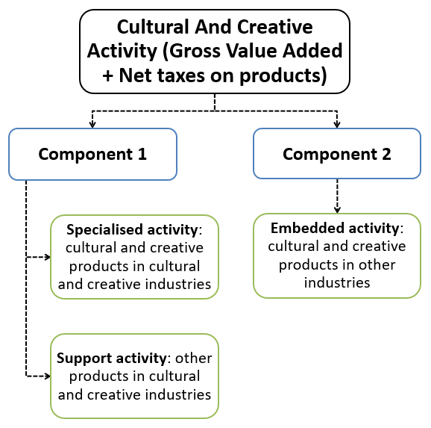

Source: BCARR.

This update allows the economic value of all three types of cultural and creative activity to be captured wholly through the production-side of the economy – by products and industries. All components within the production boundary[3] of the national accounts are now measured using a consistent approach. This differs from the previous framework which estimated the activity through both the production and income sides. The updated framework allows components 1 and 2 to be directly comparable and also avoids the risk of double‑counting that was possible in the previous framework.

### Updated estimation process

The new methodology moves to a best-practice approach to produce estimates by quantifying the economic value of cultural and creative activities through a 4-step approach (Figure 2). The updated approach draws on additional sources of information that were not provided in the previous estimation method, such as events activity. It is an important step to improve the detailed cultural and creative weights and benchmarking process, and ensure that future estimates of the cultural and creative activity remain relevant.

Figure 2. Updated estimation process to quantify the economic value of cultural and creative activity

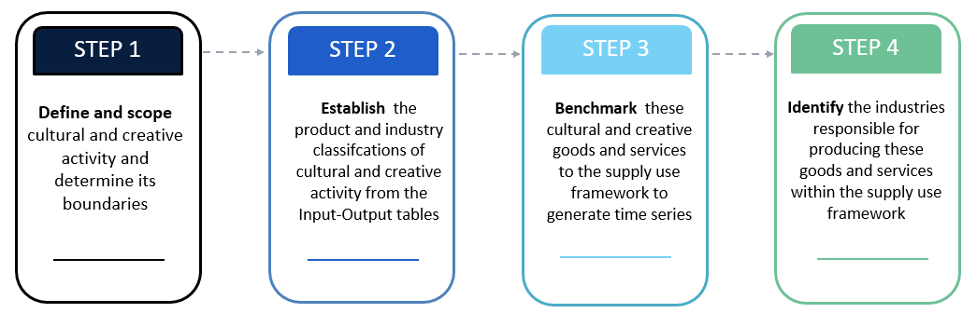

Source: BCARR.

### Narrowed scope

The new scope was supported by a decision-making framework developed by the department and used to determine which industry and product lists were included as cultural and creative activity. This was a pragmatic approach created to make the scope consistent and transparent.

A key aim of the methodology refresh was for the cultural and creative sector to see itself in the new measure. The Concentric Circles Model was the principal framework used in this decision-making framework to determine the activities in scope for cultural and creative activity. The cultural and creative areas in which the Australian Government makes substantial investments are considered by many to be the ‘core’ creative arts and cultural industries. The Concentric Circles Model articulates this concept by examining the structure of the sector, which also includes wider cultural industries and related products.[4]

The decision-making framework contains a criterion of industry engagement with domestic cultural policy over the previous decade (including the recent national cultural policy, parliamentary inquiries, and with older cultural policies such as the 2013 *Creative Australia* policy). Engagement with domestic cultural policy was one of two further criteria used in the decision-making framework. The other criterion was whether the industry or product exploits intellectual property. Activities which exploit intellectual property are broadly in line with the creative industry models developed by the UK Department of Culture, Media and Sport (DCMS) and Queensland University of Technology (QUT) and capture some creative activity not captured by the domestic cultural policy criterion.

Most activities continue to be in the new scope, particularly if the activity was considered both cultural *and* creative. However, several main sources of ‘creative only’ activity from the previous industry scope have been removed. These include computer system design and related services; clothing and footwear manufacturing, wholesaling and retailing. For this reason, the new publication does not separately report activity as ‘cultural’, ‘creative’ or ‘both cultural and creative’ as most products and industries now relate to both cultural *and* creative activity in the refined list. The coverage of activities captured in the new scope is also similar to other Australian official publications, such as the ABS’s *Cultural and creative activities,* which provides statistics about participation in and attendance at selected cultural and creative activities.[5]

Stakeholders involved in the consultation held a range of views on what activities should be in or out of scope as cultural and creative. In the absence of a consistent framework, we consider the new scope to be a more realistic and transparent list of industries and products from which cultural and creative activity is based. The new scope also regroups cultural and creative activity into 15 domains so that it is more relevant for industry reporting. Further details on the stakeholder consultation, as well as the scope and labelling changes of the domains, product lists and industry codes, are provided in the appendix.

### Production-focused measures

The updated cultural and creative statistics are examined from the production‑side, which includes domestic output, gross value added (GVA) and gross domestic product (GDP). Domestic output represents total Australian production, which refers to the value at basic prices[6] of goods and services produced in Australia.[7] GVA is a measure of the contribution to domestic production made by an individual producer, industry or sector. This is the value of output less the value of the goods and services used up in the process of production. By excluding net taxes (taxes less government subsidies), GVA provides a more accurate measure of economic activity by industry than does GDP.

The cultural and creative workforce has not been examined in this paper. Estimates of compensation of employees for the cultural and creative workforce – which includes wages and salaries – are expected to be developed and released together with employment estimates in the next phase of this research.

Estimates of cultural and creative activity in this paper are based solely on the production boundary of the national accounts. This boundary excludes volunteering and non‑market based production – as this activity is not captured in calculations of GDP. This emphasis on the direct economic contribution broadly aligns with cultural/creative accounts developed in other countries. While this initial methodology refresh does not prioritise potential or intangible values from cultural and creative activity, BCARR will consider exploring these topics in future research.

## Economic estimates

New estimates of the economic contribution from cultural and creative activity to GDP was $39.4 billion in 2008–09. Between 2008–09 and 2022–23, cultural and creative activity in Australia grew to $63.7 billion, an increase of $24.4 billion (or 61.9%).

Table 1. Cultural and Creative Activity 2008–09 and 2022–23

|  |  |  |  |  |
| --- | --- | --- | --- | --- |
| **Cultural and Creative Activity** | **2008–09** | **2022–23** | **Change** | **Movement (%)** |
| Gross Value Added ($m) | 37,102 | 60,724 | 23,621 | 63.7 |
| *plus* Net taxes on products ($m) | 2,248 | 2,987 | 739 | 32.9 |
| *equals* Total Cultural and Creative GDP ($m) | **39,350** | **63,711** | **24,361** | **61.9** |
| As a proportion of GDP (%) | **3.1** | **2.5** | **-0.6** |  |

Source: ABS Australian System of National Accounts, Australian National Accounts: Input-Output Tables (Product Details); Australian National Accounts: Supply Use Tables; BCARR calculations.

Comparing the new estimates of cultural and creative activity with previous estimates – which were last reported for the 2019–20 financial year – shows a substantial decrease in the size of cultural and creative activity (Table 2). In 2008–09, activity was revised down from $86 billion using the previous estimates to $39.4 billion using the new estimates (a difference of $46.6 billion). In 2019–20, activity was revised down from $122.3 billion using the previous estimates to $50.0 billion using the new estimates (a difference of $72.3 billion).

Table 2. Revisions to key aggregates, 2008–09 and 2019–20

|  |  |  |  |
| --- | --- | --- | --- |
| **Cultural and Creative Activity** | **2008–09**  **$m** | **2019–20**  **$m** | **Average annual growth rate**  **%** |
| New estimates | 39,350 | 49,976 | 2.2 |
| Previous estimates | 85,956 | 122,267 | 3.3 |
| Revisions | **-46,606** | **-72,291** | **-1.1** |

Source: ABS Australian System of National Accounts, Australian National Accounts: Input-Output Tables (Product Details); Australian National Accounts: Supply Use Tables; BCARR calculations.

The reduced size of the cultural and creative activity estimates is mainly the result of narrowing the scope. The new estimates of cultural and creative activity now exclude industries such as computer system design and related services, clothing and footwear manufacturing, wholesaling and retailing.Removal of these industries from the new scope is also the main driver for the average annual growth rate of cultural and creative activity being revised downwards from 3.3% to 2.2% between 2008–09 and 2019–20.

Figure 3 compares the growth index relative to GDP between the new and previous estimates. The chart shows that the growth rate of the new estimates is slower than the growth rate of previous estimates during the period, and is also slower than the pace of growth in the Australian economy overall.

Figure 3. Cultural and creative activity, growth relative to the total GDP, BCARR’s new estimates and previous estimates

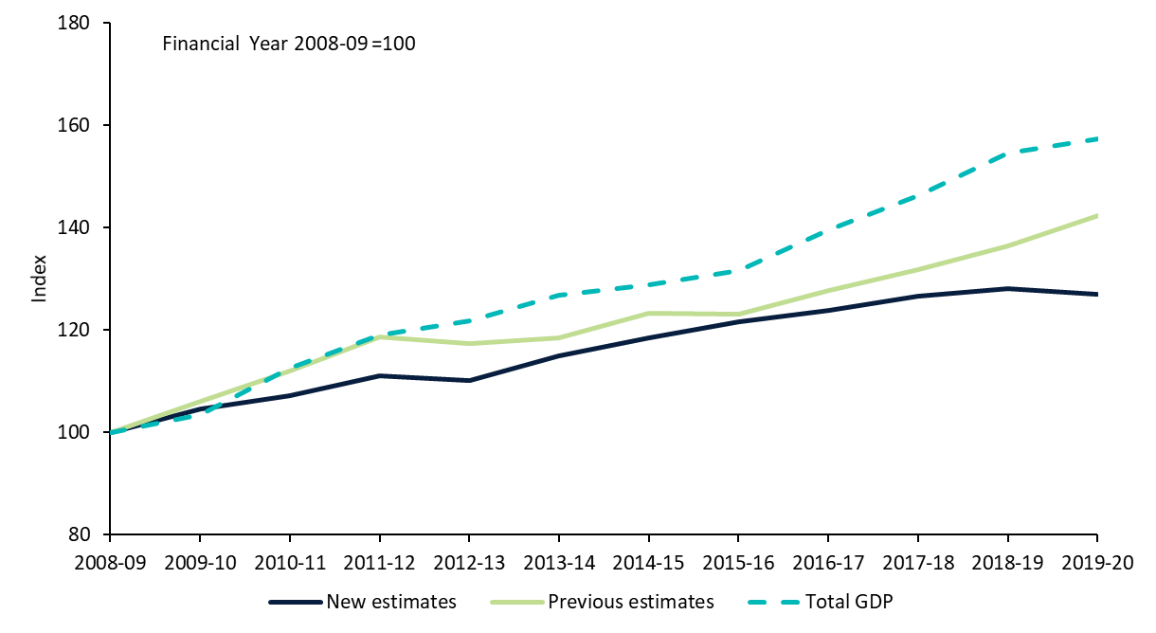

Source: ABS Australian System of National Accounts, Australian National Accounts: Input-Output Tables (Product Details); Australian National Accounts: Supply Use Tables; BCARR calculations.

### Cultural and Creative Activity, 2008–09 to 2022–23

Cultural and creative activity in Australia grew to $63.7 billion in nominal terms in 2022–23, an increase of $24.4 billion or 61.9% since 2008–09.

Figure 4. Cultural and creative activity, 2008–09 to 2022–23, current prices

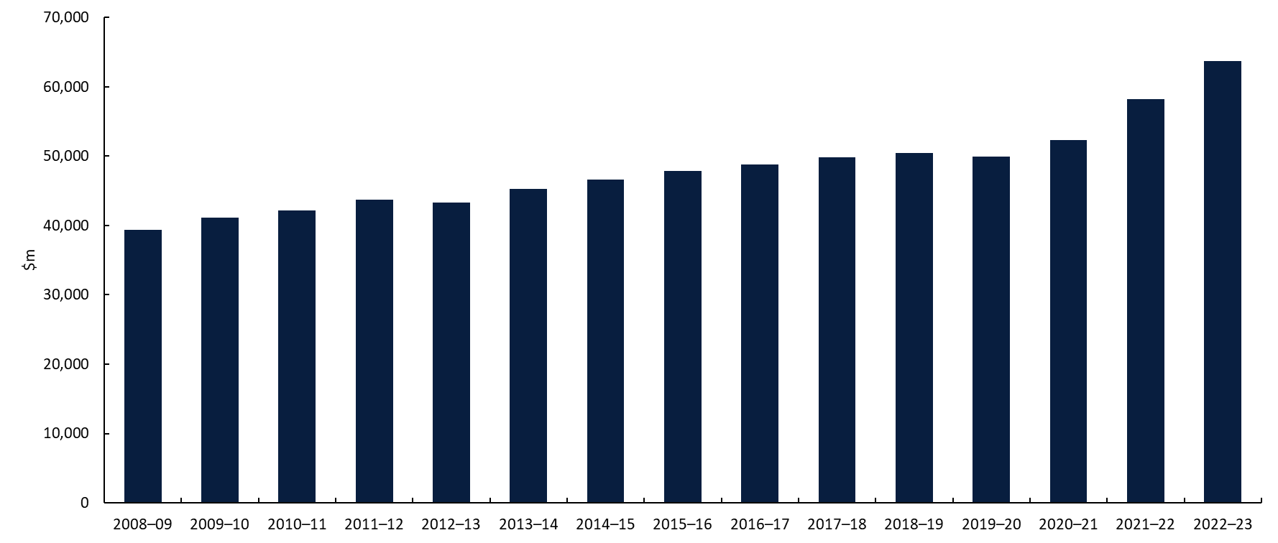

Source: ABS Australian System of National Accounts, Australian National Accounts: Input-Output Tables (Product Details); Australian National Accounts: Supply Use Tables; BCARR calculations.

This growth included an increase of $23.6 billion in cultural and creative gross value added from 2008–09 to 2022–23, which was primarily from the Professional, Scientific and Technical Services industry with an increase of $14.2 billion over the period. This industry division includes activities that mainly provide professional, scientific and technical services that generally require a high level of expertise and training and formal (usually tertiary level) qualifications. Cultural and creative activities captured within this division primarily include advertising, architecture, management services for artists, and professional photography.

Net taxes on products of cultural and creative activity have increased by $739 million or 32.9%, from $2.2 billion in 2008–09 to $3.0 billion in 2022–23.

Table 3. Cultural and creative activity components and share of GDP, 2008–09 to 2022–23

|  |  |  |  |  |
| --- | --- | --- | --- | --- |
| **Period** | **Cultural and creative activity gross value added (GVA)**  **$m** | **Net taxes on products of cultural and creative activity**  **$m** | **Cultural and creative activity GDP**  **$m** | **Cultural and creative activity as a share of GDP**  **%** |
| 2008–09 | 37,102 | 2,248 | **39,350** | **3.1** |
| 2009–10 | 38,759 | 2,413 | **41,172** | **3.2** |
| 2010–11 | 39,855 | 2,309 | **42,165** | **3.0** |
| 2011–12 | 41,315 | 2,425 | **43,740** | **2.9** |
| 2012–13 | 41,035 | 2,275 | **43,310** | **2.8** |
| 2013–14 | 42,963 | 2,278 | **45,240** | **2.8** |
| 2014–15 | 44,087 | 2,514 | **46,601** | **2.9** |
| 2015–16 | 45,390 | 2,444 | **47,833** | **2.9** |
| 2016–17 | 46,540 | 2,223 | **48,762** | **2.8** |
| 2017–18 | 47,537 | 2,272 | **49,809** | **2.7** |
| 2018–19 | 48,145 | 2,259 | **50,404** | **2.6** |
| 2019–20 | 47,737 | 2,239 | **49,976** | **2.5** |
| 2020–21 | 49,807 | 2,459 | **52,266** | **2.5** |
| 2021–22 | 55,354 | 2,918 | **58,271** | **2.5** |
| 2022–23 | 60,724 | 2,987 | **63,711** | **2.5** |

Source: ABS Australian System of National Accounts, Australian National Accounts: Input-Output Tables (Product Details); Australian National Accounts: Supply Use Tables; BCARR calculations.

### Comparing estimates to previous reporting (2008–09 to 2019–20)

Comparing the new estimates of cultural and creative activity to BCARR’s previous estimates shown in *Cultural and creative activity in Australia 2010–11 to 2019–20*,[8] the revision shows a widening of the gap in activity in current prices (nominal values). However, as a share of GDP, the gap (as percentage point difference between 2008–09 and 2019–20) has remained largely unchanged.

Figure 5. Results of revisions from the previous estimates, 2008–09 to 2019–20

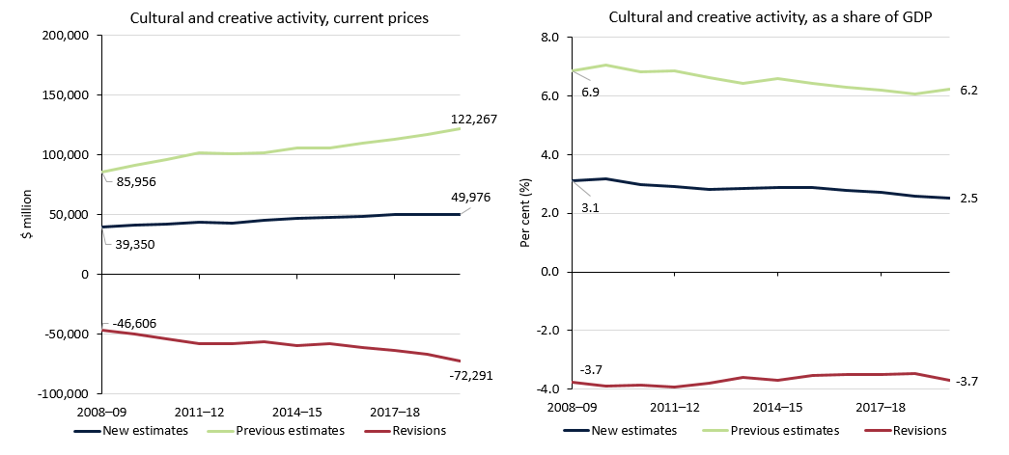

Source: ABS Australian System of National Accounts, Australian National Accounts: Input-Output Tables (Product Details); Australian National Accounts: Supply Use Tables; BCARR calculations.

The new scope’s exclusion of computer system design and related services, and clothing and footwear manufacturing, wholesaling and retailing industries is the main reason why the new estimates are much lower than the figures reported previously (Table 4). Gross value added for these (now-excluded) industries was estimated at over $50 billion in 2019–20, and represented 41.4% of total cultural and creative GDP previously.

Table 4. Revisions from 2008–09 to 2019–20

|  |  |  |  |  |
| --- | --- | --- | --- | --- |
| **Period** | **Cultural and creative activity gross value added (GVA)**  **$m** | **Net taxes on products of cultural and creative activity**  **$m** | **Cultural and creative activity GDP**  **$m** | **Cultural and creative activity as a share of GDP**  **%** |
| 2008–09 | -43,887 | -2,719 | **-46,606** | **-3.7** |
| 2009–10 | -47,985 | -1,995 | **-49,980** | **-3.9** |
| 2010–11 | -51,882 | -2,187 | **-54,069** | **-3.9** |
| 2011–12 | -56,261 | -2,061 | **-58,322** | **-3.9** |
| 2012–13 | -55,878 | -1,649 | **-57,528** | **-3.8** |
| 2013–14 | -53,940 | -2,610 | **-56,550** | **-3.6** |
| 2014–15 | -55,679 | -3,680 | **-59,360** | **-3.7** |
| 2015–16 | -55,545 | -2,446 | **-57,992** | **-3.5** |
| 2016–17 | -57,447 | -3,503 | **-60,951** | **-3.5** |
| 2017–18 | -60,602 | -2,804 | **-63,406** | **-3.5** |
| 2018–19 | -64,040 | -2,743 | **-66,783** | **-3.5** |
| 2019–20 | -69,782 | -2,509 | **-72,291** | **-3.7** |

Source: ABS Australian System of National Accounts; Australian National Accounts: Input-Output Tables (Product Details); Australian National Accounts: Supply Use Tables; BCARR calculations.

The average annual growth rate has been revised from 3.3% to 2.2% during the period. Figure 6 shows the overall impact of the revisions to annual percentage change in cultural and creative GDP from 2009–10 to 2019–20.

Figure 6. Revisions to annual growth rate of cultural and creative activity, 2009–10 to 2019–20

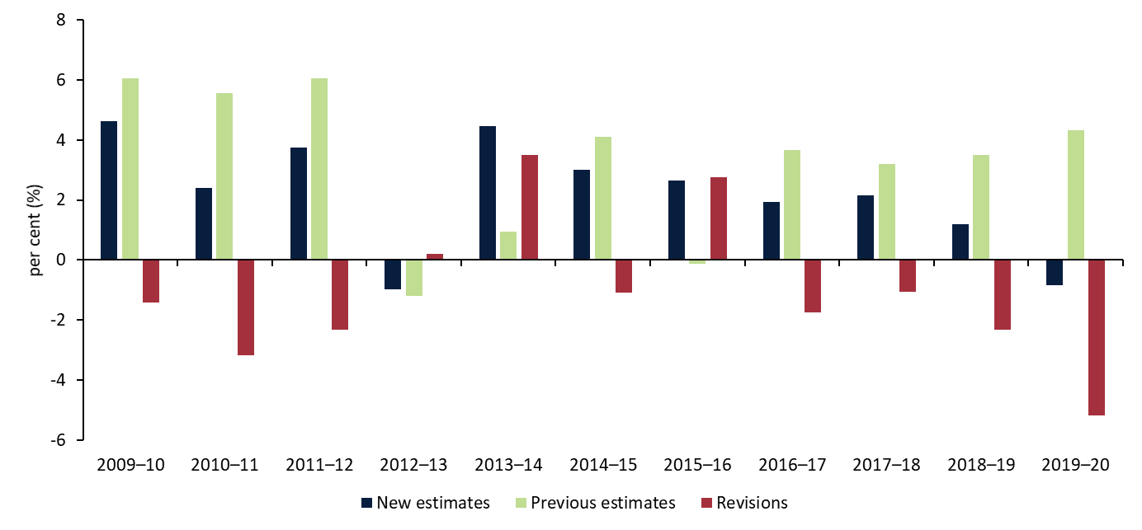

Source: ABS Australian System of National Accounts; Australian National Accounts: Input-Output Tables (Product Details); Australian National Accounts: Supply Use Tables; BCARR calculations.

### Relative to nominal Gross Domestic Product (GDP)

While cultural and creative activity is growing in nominal terms, as a share of GDP it declined by 0.6 percentage points over the period – from 3.1% in 2008–09 to 2.5% in 2022–23 (Figure 7). As shown in Figure 8, the increase in cultural and creative activity is slower than the pace of the Australian economy overall.

Figure 7. Cultural and creative activity, share of GDP, 2008–09 to 2022–23

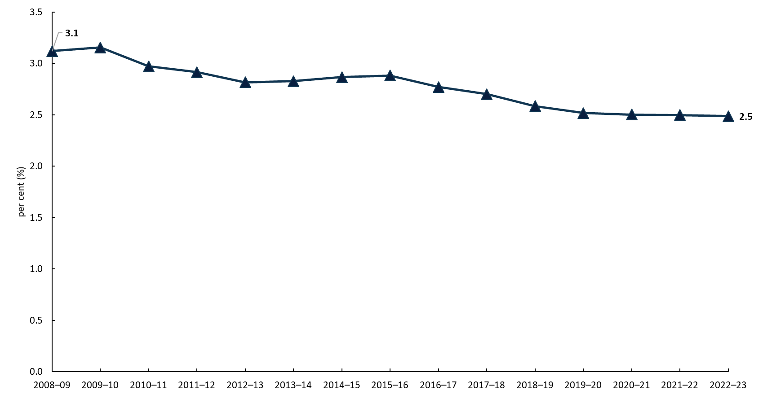

Source: ABS Australian System of National Accounts; Australian National Accounts: Input-Output Tables (Product Details); Australian National Accounts: Supply Use Tables; BCARR calculations.

Figure 8. Cultural and creative activity relative to nominal GDP

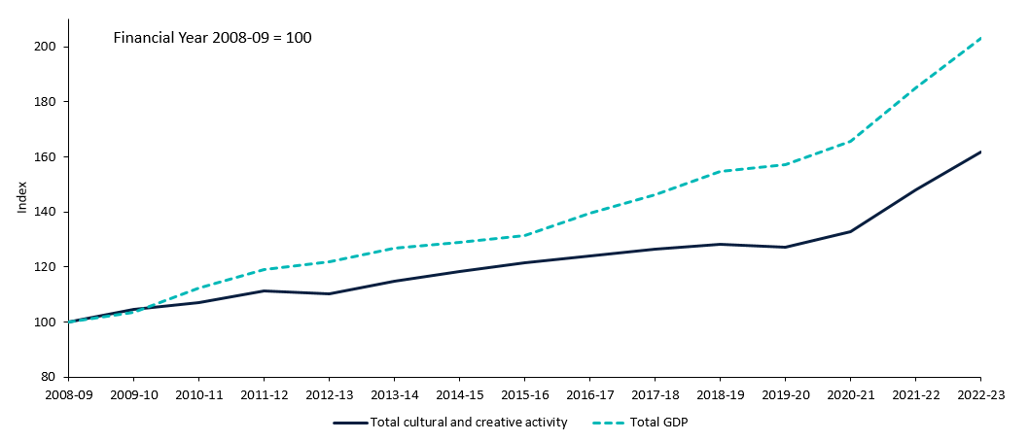

Source: ABS Australian System of National Accounts; Australian National Accounts: Input-Output Tables (Product Details); Australian National Accounts: Supply Use Tables; BCARR calculations.

In Figure 8, the index at 100 represents the base year of 2008–09. The dashed line represents GDP growth for the entire Australian economy relative to the base year. Cultural and creative activity grew slower than the overall economy since 2009–10.

The slower growth of cultural and creative activity during this period relative to the Australian economy overall reflects the expansion of activities such as mining, and healthcare that are almost entirely outside cultural and creative activity (explained further in the next section).

### Comparison with Australian industries

The Australian System of National Accounts lists 19 industries in the Australian economy. When added together with ownership of dwellings, the activity in these industries equals the total amount of final goods and services produced in the economy in a given period.

Cultural and creative activity is not an industry division, but rather includes output produced by many industries across the economy. Cultural and creative activity is therefore not additional to the industry shares shown in Figure 9, but is provided here to indicate its size relative to other industry divisions. Figure 9 shows that cultural and creative activity accounted for 2.5% of GVA in the economy in 2022–23. This is comparable to the size of the Agriculture, Forestry and Fishing industry, also at 2.5%.

Figure 9. Cultural and creative GVA and industry share of total economy, 2022–23

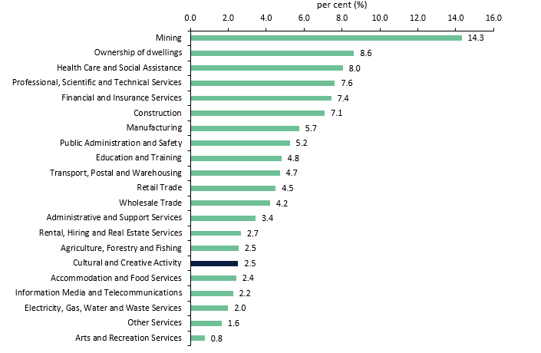

Source: ABS Australian System of National Accounts; Australian National Accounts: Input-Output Tables (Product Details); Australian National Accounts: Supply Use Tables; BCARR calculations.

The Australian economy has been supported by strong growth in Mining (buoyed by high commodity prices) and the Health Care and Social Assistance industry (supported by an ageing population). During the period from 2008–09 to 2022–23, the average annual growth rate in GVA for Mining was 9.9%, and for Health Care and Social Assistance was 7.3% (Figure 10). The average annual growth rate for the overall economy was 5.3%, while GVA for cultural and creative activity increased by an average of 3.6% during the period.

Figure 10. GVA average annual growth rate by industry division, 2008–09 to 2022–23

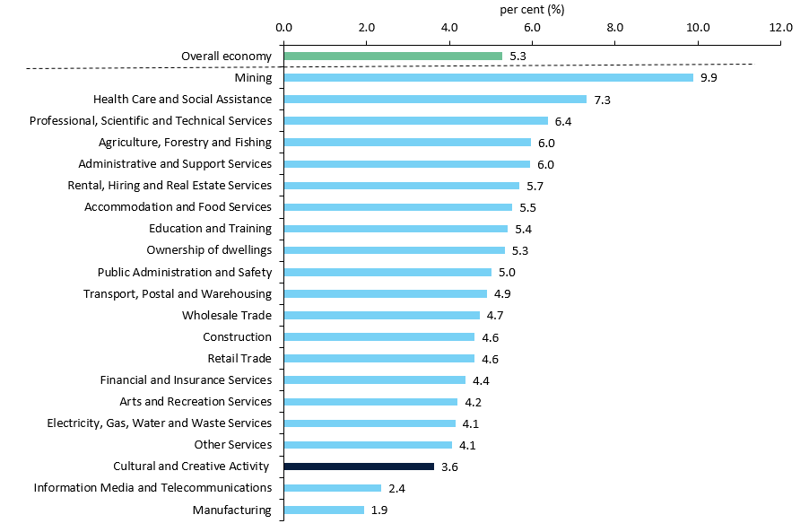

Source: ABS Australian System of National Accounts; Australian National Accounts: Input-Output Tables (Product Details); Australian National Accounts: Supply Use Tables; BCARR calculations.

The Arts and Recreation Services industry also experienced a faster growth rate than cultural and creative activity over this period, at 4.2%. Activities relating to sports and recreation, as well as gambling activities, were the main drivers for the stronger growth of this industry division. These activities were out of scope for cultural and creative activity, however, they have accounted for over 70% of Arts and Recreation Services GVA since 2008–09, with an average annual growth rate of 4.4% during the period.

## Cultural and creative activity by domain

In the new scope, cultural and creative activities are grouped by 15 domains, as shown in Figure 11. The activities within the domains are grouped in terms of the input-output product classification (IOPC) codes, and the Australian and New Zealand Standard Industrial Classification 2006 (ANZSIC 06) class codes.

Figure 11. Cultural and creative activity, GDP by domain, 2022–23

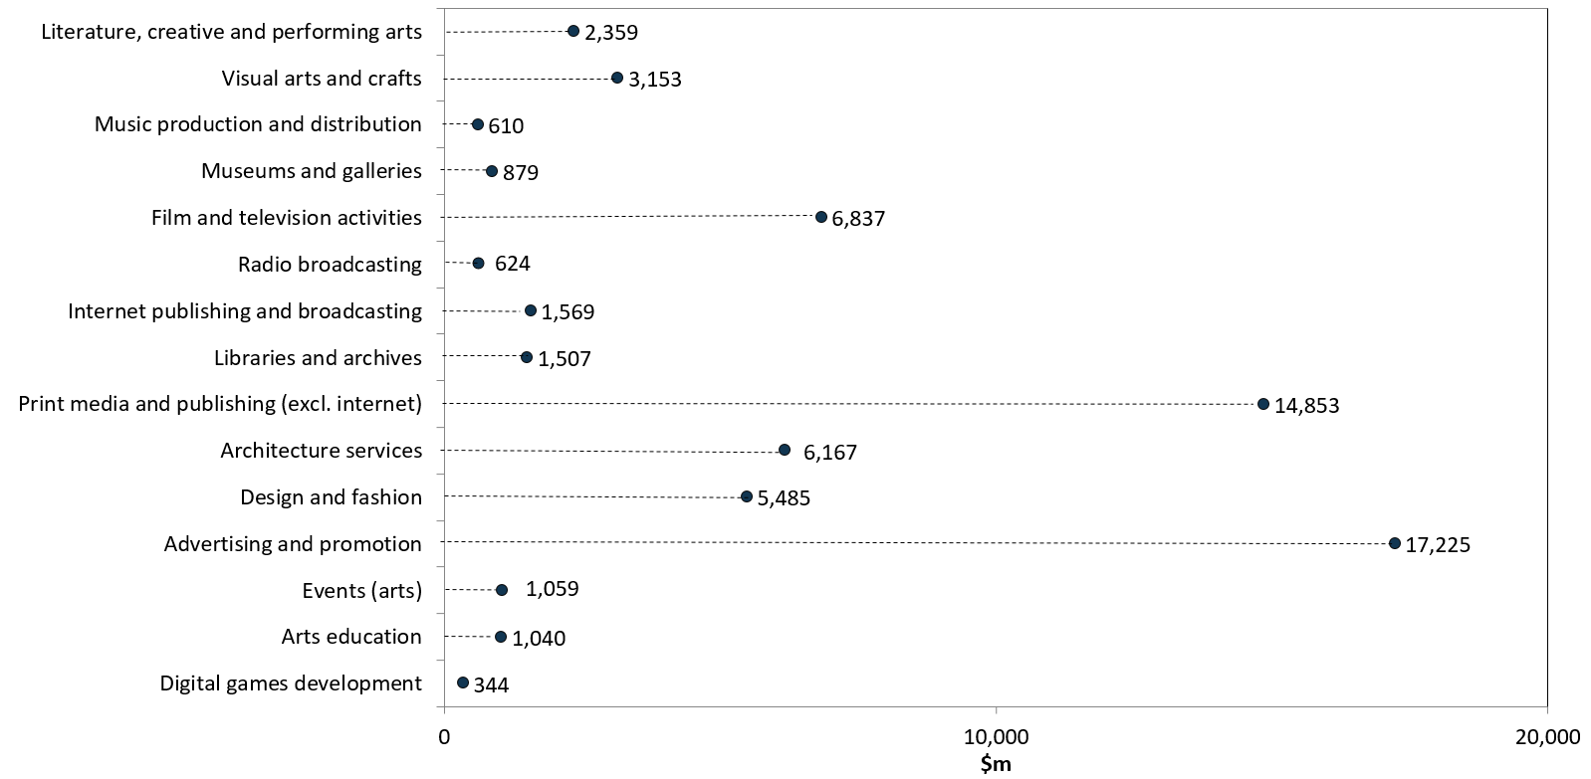

Source: ABS Australian System of National Accounts; Australian National Accounts: Input-Output Tables (Product Details); Australian National Accounts: Supply Use Tables; BCARR calculations.

The largest contribution to cultural and creative activity in 2022–23 was advertising and promotion. This domain increased by 6.3 percentage points as a proportion of total activity, from 20.8% in 2008–09 to 27.0% in 2022–23.

Figure 12. Contribution to cultural and creative activity, GDP by domain, 2008–09 and 2022–23

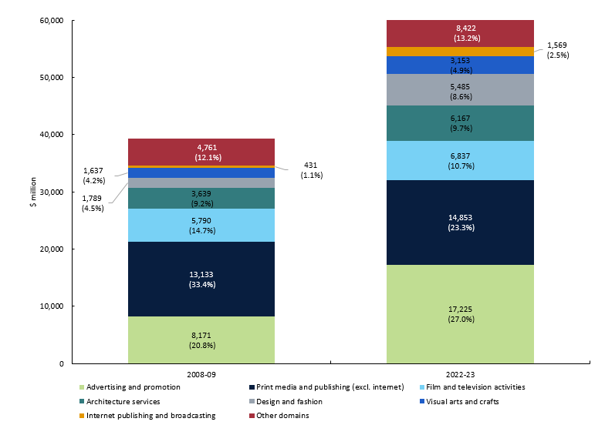

Source: ABS Australian System of National Accounts, Australian National Accounts: Input-Output Tables (Product Details); Australian National Accounts: Supply Use Tables; BCARR calculations.

Print media and publishing (excl. internet) – after being the largest domain in 2008–09 – became the second largest domain in 2022–23, representing 23.3% of cultural and creative activity. Film and television activities, the third largest domain, also declined as a share of cultural and creative activity to 10.7% in 2022–23. Architecture services, the fourth largest domain, increased to 9.7% in 2022–23. Combined activity from these 4 domains contributed over 70% of cultural and creative activity in 2022–23.

Fourteen of the 15 domains experienced growth in nominal terms from 2008–09 to 2022–23. Advertising and promotion had the strongest growth of $9.1 billion.

Figure 13. Nominal GDP growth by domain, between 2008–09 and 2022–23

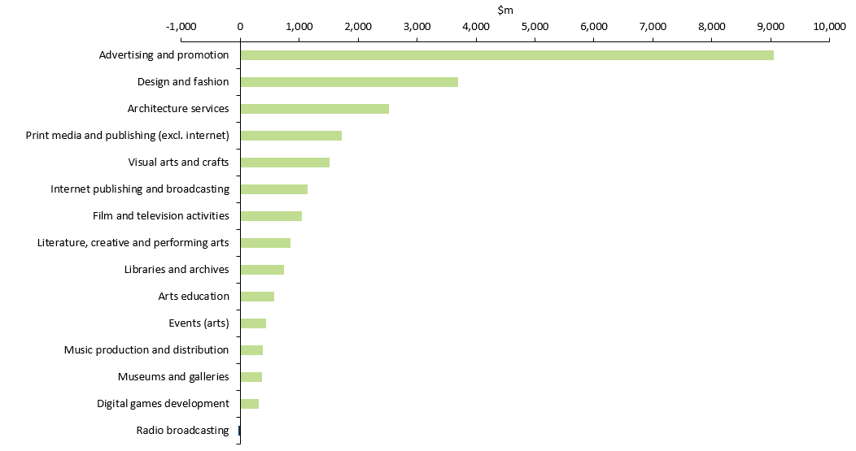

Source: ABS Australian System of National Accounts, Australian National Accounts: Input-Output Tables (Product Details); Australian National Accounts: Supply Use Tables; BCARR calculations.

The only domain that declined was radio broadcasting which decreased by $24 million or 3.8%, driven by rising competition from online and cloud-based media platforms and falling demand from advertisers. Many radio stations now broadcast over the internet and these online-only radio stations fall into the internet publishing and broadcasting industry.[9]

Although the overall cultural and creative activity grew in nominal terms, the growth rates for many of the above domains did not keep pace with the economy as a whole during the period from 2008–09 to 2022–23. Digital games development has experienced the strongest growth over the period. From its small base of initial activity, digital games development increased by an average annual growth rate of 21.6% from 2008–09 to 2022–23. Detailed analysis of each domain is provided in the following sections.

## 1. Literature, creative and performing arts

Literature, creative and performing arts consists of:

* *Performing arts operations* which provide or produce live theatrical or musical presentations or performances.[10]
* *Creative artists, musicians, writers and performers* who are independent individuals or groups mainly engaged in the regular creation of original artistic or cultural works who may or may not produce and perform their works. Also includes activities providing independent technical expertise necessary for these productions, and celebrities mainly engaged in endorsing products or making speeches or public appearances for which they receive a fee;8 and
* *Performing arts venue operations* that operates venues for the presentation and rehearsal of performing arts.[11]

Visual arts creation activities are *excluded* from this domain**.**

Many businesses in the performing arts industries rely on government funding in addition to other sources of revenue. This support allows them to produce a diversity of works and to provide some services to users free of charge. However, other businesses, such as contemporary music producers, can achieve higher profit margins by providing services to large audiences.[12]

Cultural and creative activity GDP in literature, creative and performing arts increased by $859 million or 57.2% from $1.5 billion in 2008–09 to $2.4 billion in 2022–23.

Figure 14. Literature, creative and performing arts, GDP and as a share of overall economy

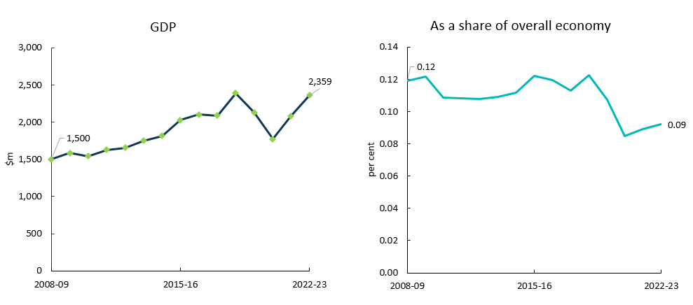

Source: ABS Australian System of National Accounts, Australian National Accounts: Input-Output Tables (Product Details); Australian National Accounts: Supply Use Tables; BCARR calculations.

Declines in activity occurred in 2019–20 and 2020–21 due to COVID-19 and the inability to hold performances.[13] This domain recovered strongly between 2021–22 and 2022–23. As borders reopened, there was a significant increase in demand for international artists in the contemporary music segment, and ticket sales for the sector have improved.[14]

As a share of the overall economy, this domain has fallen slightly over the period, from 0.12% in 2008–09 to 0.09% in 2022–23.

Table 5. Literature, creative and performing arts, 2008–09 to 2022–23

|  |  |  |  |  |  |
| --- | --- | --- | --- | --- | --- |
| **Literature, creative and performing arts**  **Period** | **Output**  **$m** | **GVA**  **$m** | **Net taxes on products**  **$m** | **GDP**  **$m** | **As a share of overall economy**  **%** |
| 2008–09 | 2,982 | 1,434 | 66 | **1,500** | **0.12** |
| 2009–10 | 3,215 | 1,492 | 92 | **1,584** | **0.12** |
| 2010–11 | 3,283 | 1,454 | 89 | **1,543** | **0.11** |
| 2011–12 | 3,471 | 1,540 | 84 | **1,624** | **0.11** |
| 2012–13 | 3,487 | 1,574 | 83 | **1,657** | **0.11** |
| 2013–14 | 3,651 | 1,664 | 84 | **1,748** | **0.11** |
| 2014–15 | 3,750 | 1,732 | 84 | **1,816** | **0.11** |
| 2015–16 | 4,042 | 1,950 | 75 | **2,025** | **0.12** |
| 2016–17 | 4,203 | 2,024 | 76 | **2,100** | **0.12** |
| 2017–18 | 4,313 | 2,014 | 72 | **2,087** | **0.11** |
| 2018–19 | 4,914 | 2,311 | 77 | **2,388** | **0.12** |
| 2019–20 | 4,266 | 2,070 | 57 | **2,127** | **0.11** |
| 2020–21 | 3,367 | 1,732 | 37 | **1,770** | **0.08** |
| 2021–22 | 4,227 | 2,026 | 55 | **2,081** | **0.09** |
| 2022–23 | 4,804 | 2,302 | 56 | **2,359** | **0.09** |

Source: ABS Australian System of National Accounts, Australian National Accounts: Input-Output Tables (Product Details); Australian National Accounts: Supply Use Tables; BCARR calculations.

## 2. Visual arts and crafts

Visual arts and crafts consist of:

* *Activities of independent artists*, e.g. sculptors, painters, etc.
* *Manufacturing products of crafts* including tableware, ornamental pottery and domestic ware not elsewhere classified; glass containers, bottles or jars; glass stoppers; glass inners for vacuum vessels; jewellery and silverware; and imitation jewellery (excl incorporating precious metal except as plating or as minor constituents) (excl watch straps); bags of leather or leather substitute.
* *Professional photographic services* that are mainly engaged in providing still, video or computer photography services, including the recording of special events such as weddings.[15]
* *Photographic film processing* activity such as developing film and/or making photographic slides, prints and enlargements.[16]

Cultural and creative activity GDP in visual arts and crafts increased by $1.5 billion, from $1.6 billion in 2008–09 to $3.2 billion in 2022–23 (Figure 15). COVID-19 has negatively affected visual arts and crafts in 2019–20, and this domain decreased by $149 million or 5.9% in that year. The decline was mainly driven by professional photographic services and photographic film processing services. During lockdowns, households and businesses had to increasingly use in-house software and printers to process and print photographs, reducing demand for industry services.[17]

Figure 15. Visual arts and crafts, GDP and as a share of overall economy

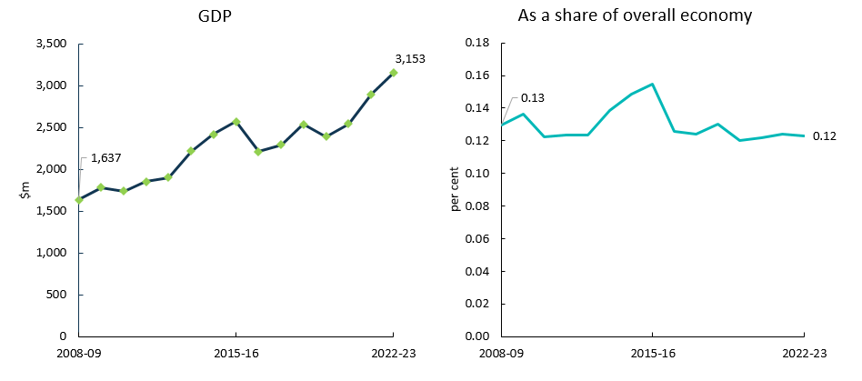

Source: ABS Australian System of National Accounts, Australian National Accounts: Input-Output Tables (Product Details); Australian National Accounts: Supply Use Tables; BCARR calculations.

As a share of the overall economy, visual arts and crafts has remained relatively flat over the period (Table 6). The growing popularity of smartphones and digital camera technology by consumers and amateur photographers has weakened demand for photography in recent years. However, professional photographers still play a vital role in certain markets, such as school, wedding, real estate and commercial photography, despite facing the difficulties mentioned above.[18]

Table 6. Visual arts and crafts, 2008–09 to 2022–23

|  |  |  |  |  |  |
| --- | --- | --- | --- | --- | --- |
| **Visual arts and crafts**  **Period** | **Output**  **$m** | **GVA**  **$m** | **Net taxes on products**  **$m** | **GDP**  **$m** | **As a share of overall economy**  **%** |
| 2008–09 | 2,885 | 1,180 | 457 | **1,637** | **0.13** |
| 2009–10 | 2,919 | 1,316 | 463 | **1,779** | **0.14** |
| 2010–11 | 3,049 | 1,262 | 476 | **1,738** | **0.12** |
| 2011–12 | 3,320 | 1,357 | 495 | **1,852** | **0.12** |
| 2012–13 | 3,390 | 1,387 | 513 | **1,900** | **0.12** |
| 2013–14 | 3,623 | 1,633 | 585 | **2,219** | **0.14** |
| 2014–15 | 3,839 | 1,755 | 663 | **2,418** | **0.15** |
| 2015–16 | 4,333 | 1,938 | 631 | **2,569** | **0.15** |
| 2016–17 | 3,528 | 1,660 | 553 | **2,213** | **0.13** |
| 2017–18 | 3,897 | 1,726 | 566 | **2,292** | **0.12** |
| 2018–19 | 4,245 | 1,946 | 593 | **2,539** | **0.13** |
| 2019–20 | 3,949 | 1,820 | 570 | **2,390** | **0.12** |
| 2020–21 | 4,051 | 1,865 | 678 | **2,543** | **0.12** |
| 2021–22 | 4,565 | 2,039 | 855 | **2,894** | **0.12** |
| 2022–23 | 5,099 | 2,278 | 875 | **3,153** | **0.12** |

Source: ABS Australian System of National Accounts; Australian National Accounts: Input-Output Tables (Product Details); Australian National Accounts: Supply Use Tables; BCARR calculations.

## 3. Music production and distribution

Music production and distribution consists of:

* *Musical instruments* (including parts and accessories).
* *Music publishing* which is the acquisition and registration of copyright for musical compositions and the promotion and authorisation of the use of these compositions in recordings, radio, television, motion pictures, live performances, print, or other media.[19]
* *Music and other sound recording* activities which is the production of original (sound) master recordings and the release and distribution of them to wholesalers, retailers or directly to the public. This also includes the operation of sound recording studios and in the production of pre-recorded radio programs.[20]

Cultural and creative activity GDP in this domain increased by $382 million, from $228 million in 2008–09 to $610 million 2022–23 (Figure 16). This includes an annual decline of $68 million in 2020–21. COVID-19 caused disruptions that restricted various forms of activity in the industries relating to music publishing and sound recording, such as in-person sound recording services and licensing for live performances.[21]

Figure 16. Music production and distribution, GDP and as a share of overall economy

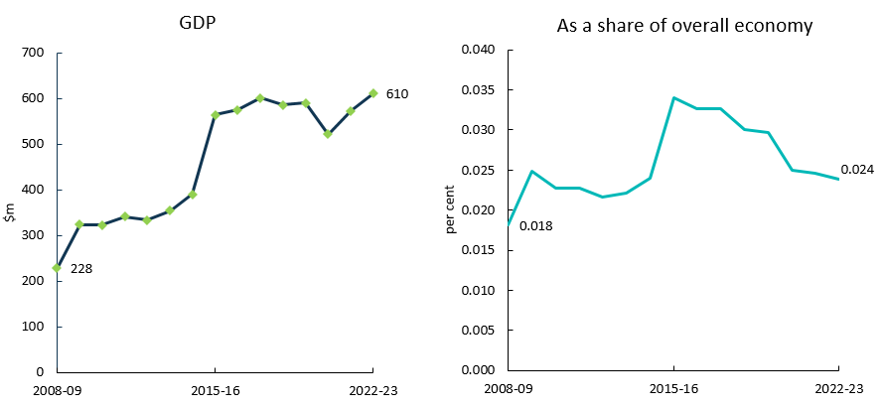

Source: ABS Australian System of National Accounts, Australian National Accounts: Input-Output Tables (Product Details); Australian National Accounts: Supply Use Tables; BCARR calculations.

Music production and distribution is a small domain comprising around 0.02% of the overall economy. Changes in technology have affected how music publishing industry operates as consumers have adopted new ways of obtaining and streaming music content online. This shift is evident as businesses are transitioning to online distribution and reducing the production of physical music content.[22]

Table 7. Music production and distribution, 2008–09 to 2022–23

|  |  |  |  |  |  |
| --- | --- | --- | --- | --- | --- |
| **Music production and distribution**  **Period** | **Output**  **$m** | **GVA**  **$m** | **Net taxes on products**  **$m** | **GDP**  **$m** | **As a share of overall economy**  **%** |
| 2008–09 | 417 | 135 | 93 | **228** | **0.018** |
| 2009–10 | 723 | 247 | 77 | **324** | **0.025** |
| 2010–11 | 749 | 246 | 76 | **322** | **0.023** |
| 2011–12 | 798 | 266 | 76 | **342** | **0.023** |
| 2012–13 | 766 | 258 | 75 | **333** | **0.022** |
| 2013–14 | 745 | 266 | 88 | **354** | **0.022** |
| 2014–15 | 970 | 321 | 69 | **390** | **0.024** |
| 2015–16 | 1,258 | 454 | 109 | **564** | **0.034** |
| 2016–17 | 1,298 | 467 | 107 | **574** | **0.033** |
| 2017–18 | 1,344 | 488 | 113 | **601** | **0.033** |
| 2018–19 | 1,311 | 475 | 112 | **586** | **0.030** |
| 2019–20 | 1,339 | 477 | 113 | **590** | **0.030** |
| 2020–21 | 1,327 | 393 | 128 | **521** | **0.025** |
| 2021–22 | 1,363 | 437 | 136 | **573** | **0.025** |
| 2022–23 | 1,470 | 471 | 139 | **610** | **0.024** |

Source: ABS Australian System of National Accounts; Australian National Accounts: Input-Output Tables (Product Details); Australian National Accounts: Supply Use Tables; BCARR calculations.

## 4. Museums and galleries

Museums and galleries consist of museum operations such as the preservation and exhibition of heritage objects and artefacts as well as visual arts and crafts with aesthetic, historical, cultural, and educational value. This also includes activities related to entities operating in historical places, sites or houses.[23]

Museums and galleries operate in a highly competitive environment. This domain competes with other leisure, sporting and entertainment organisations for a share of consumer spending and government funding. Similar to the Libraries and archives domain, this domain is highly sensitive to changes in funding arrangements. Cultural and creative activity GDP in this domain increased by $374 million, from $504 million in 2008–09 to $879 million 2022–23. As a share of the overall economy, it has declined slightly over the period.

Figure 17. Museums and galleries, GDP and as a share of overall economy

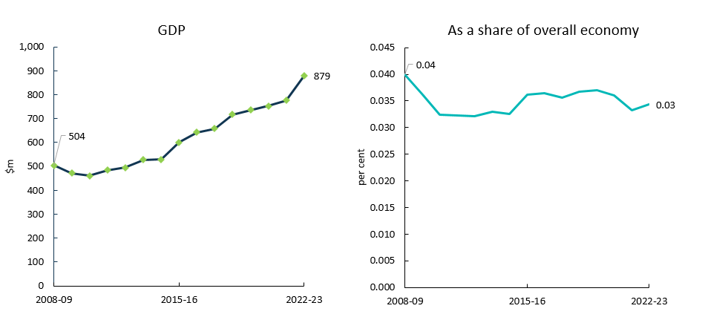

Source: ABS Australian System of National Accounts, Australian National Accounts: Input-Output Tables (Product Details); Australian National Accounts: Supply Use Tables; BCARR calculations.

The output of cultural and creative activity in museums and galleries declined in 2019–20 and 2020–21 (Table 8). Lockdowns during the pandemic forced art galleries and museums to close their doors to visitors in March 2020, and the closures significantly reduced visitor numbers.[24] Total intermediate use of museum and galleries also decreased in 2019–20 and 2020–21, with the declines outpacing its output. This resulted in a slight increase in gross value added during this period.

Table 8. Museums and galleries, 2008–09 to 2022–23

|  |  |  |  |  |  |
| --- | --- | --- | --- | --- | --- |
| **Museums and galleries**  **Period** | **Output**  **$m** | **GVA**  **$m** | **Net taxes on products**  **$m** | **GDP**  **$m** | **As a share of overall economy**  **%** |
| 2008–09 | 998 | 480 | 24 | **504** | **0.04** |
| 2009–10 | 963 | 447 | 26 | **472** | **0.04** |
| 2010–11 | 983 | 435 | 25 | **460** | **0.03** |
| 2011–12 | 1,039 | 461 | 23 | **484** | **0.03** |
| 2012–13 | 1,044 | 471 | 23 | **494** | **0.03** |
| 2013–14 | 1,101 | 502 | 26 | **527** | **0.03** |
| 2014–15 | 1,098 | 507 | 23 | **530** | **0.03** |
| 2015–16 | 1,189 | 573 | 28 | **601** | **0.04** |
| 2016–17 | 1,277 | 615 | 27 | **642** | **0.04** |
| 2017–18 | 1,341 | 625 | 33 | **658** | **0.04** |
| 2018–19 | 1,464 | 686 | 31 | **717** | **0.04** |
| 2019–20 | 1,460 | 707 | 28 | **735** | **0.04** |
| 2020–21 | 1,422 | 730 | 23 | **753** | **0.04** |
| 2021–22 | 1,559 | 747 | 29 | **776** | **0.03** |
| 2022–23 | 1,772 | 849 | 30 | **879** | **0.03** |

Source: ABS Australian System of National Accounts; Australian National Accounts: Input-Output Tables (Product Details); Australian National Accounts: Supply Use Tables; BCARR calculations.

## 5. Film and television activities

Film and television activities consists of:

* *Motion picture and video production* activities that mainly engaged in producing motion pictures, videos and television programs or commercials.[25]
* *Motion picture and video distribution* activities that mainly engaged in acquiring distribution rights and distributing motion pictures and videos.23
* *Motion picture exhibition* activities that mainly engaged in screening motion pictures using a variety of visual media.[26]
* *Post-production services and other motion picture and video activities* that mainly engaged in providing post-production services and other motion picture and video activities such as editing, film/tape transfers, titling, subtitling, credits, closed captioning and computer-produced graphics, animation and special effects, as well as developing and processing motion picture film.24
* *Free-to-air television broadcasting* of visual content, in the form of electronic images together with sound, through broadcasting studios and facilities.[27]
* *Cable and other subscription broadcasting* of broadcasting television programs on a subscription or fee basis to viewers.25

Cultural and creative GDP in film and television activities experienced a continual decline from 2016–17 to 2020–21 (Figure 18). This decline was mainly driven by decreases in free-to-air television broadcasting, and cable and other subscription broadcasting. These broadcasting activities have faced several challenges over the period as more Australians have turned to online content. COVID-19 worsened this situation as economic disruption led to a decline in television advertising.[28]

Figure 18. Film and television activities, GDP and as a share of overall economy

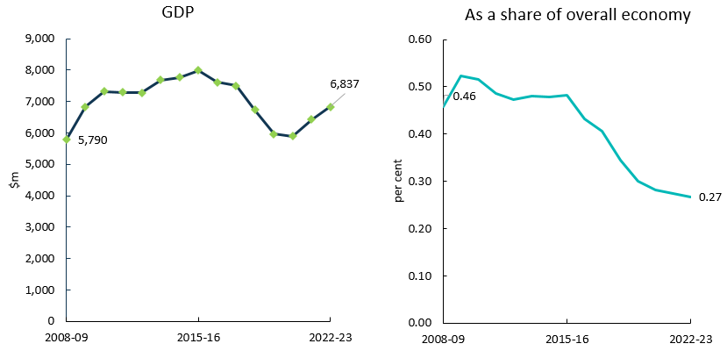

Source: ABS Australian System of National Accounts, Australian National Accounts: Input-Output Tables (Product Details); Australian National Accounts: Supply Use Tables; BCARR calculations.

COVID-19 also significantly affected other activities in this domain. Motion picture and video production has been disrupted, and public health measures forced cinemas to close temporarily or operate at reduced capacity in most states and territories.[29]

Film and television activities increased by $1.0 billion or 18.1% from 2008–09 to 2022–23. As a share of GDP, it has declined from 0.46% to 0.27% during the period.

Table 9. Film and television activities, 2008–09 to 2022–23

|  |  |  |  |  |  |
| --- | --- | --- | --- | --- | --- |
| Film and television activities  **Period** | **Output**  **$m** | **GVA**  **$m** | **Net taxes on products**  **$m** | **GDP**  **$m** | **As a share of overall economy**  **%** |
| 2008–09 | 14,562 | 5,420 | 369 | **5,790** | **0.46** |
| 2009–10 | 15,355 | 6,443 | 387 | **6,830** | **0.52** |
| 2010–11 | 16,424 | 6,990 | 327 | **7,317** | **0.52** |
| 2011–12 | 16,878 | 6,889 | 406 | **7,295** | **0.49** |
| 2012–13 | 16,804 | 6,933 | 342 | **7,275** | **0.47** |
| 2013–14 | 16,745 | 7,345 | 342 | **7,687** | **0.48** |
| 2014–15 | 17,259 | 7,364 | 410 | **7,774** | **0.48** |
| 2015–16 | 17,456 | 7,535 | 458 | **7,994** | **0.48** |
| 2016–17 | 17,069 | 7,271 | 343 | **7,613** | **0.43** |
| 2017–18 | 16,678 | 7,119 | 381 | **7,499** | **0.41** |
| 2018–19 | 16,503 | 6,430 | 302 | **6,732** | **0.35** |
| 2019–20 | 15,139 | 5,688 | 276 | **5,964** | **0.30** |
| 2020–21 | 14,842 | 5,585 | 307 | **5,892** | **0.28** |
| 2021–22 | 16,426 | 6,030 | 390 | **6,420** | **0.28** |
| 2022–23 | 17,535 | 6,438 | 399 | **6,837** | **0.27** |

Source: ABS Australian System of National Accounts; Australian National Accounts: Input-Output Tables (Product Details); Australian National Accounts: Supply Use Tables; BCARR calculations.

## 6. Radio broadcasting

Radio broadcasting is mainly engaged in broadcasting audio signals, using radio broadcasting studios and facilities to transmit aerial programming.[30]

Activity for this domain decreased by $24 million or 3.8% from 2008–09 to 2022–23, with significant declines in 2018–19 and 2019–20 (Figure 19). COVID-19 led to volatile consumer sentiment and weak economic conditions which muted demand from advertisers, the industry’s primary source of revenue. However, many Australians still listen to radio programs while driving, which has somewhat insulated radio broadcasters from the technological disruptions which have affected other forms of traditional media.[31]

Figure 19. Radio broadcasting, GDP and as a share of overall economy

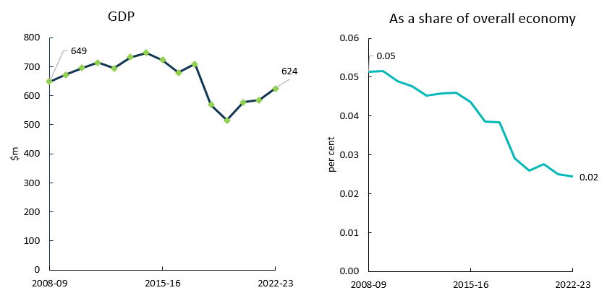

Source: ABS Australian System of National Accounts, Australian National Accounts: Input-Output Tables (Product Details); Australian National Accounts: Supply Use Tables; BCARR calculations.

As a share of overall economy, radio broadcasting has fallen from 0.05% to 0.02% over the period.

Table 10. Radio broadcasting, 2008–09 to 2022–23

|  |  |  |  |  |  |
| --- | --- | --- | --- | --- | --- |
| Radio broadcasting  **Period** | **Output**  **$m** | **GVA**  **$m** | **Net taxes on products**  **$m** | **GDP**  **$m** | **As a share of overall economy**  **%** |
| **2008–09** | 1,093 | 471 | 178 | **649** | **0.05** |
| **2009–10** | 1,028 | 505 | 166 | **672** | **0.05** |
| **2010–11** | 1,115 | 565 | 131 | **695** | **0.05** |
| **2011–12** | 1,113 | 533 | 181 | **715** | **0.05** |
| **2012–13** | 1,149 | 553 | 142 | **694** | **0.05** |
| **2013–14** | 1,180 | 594 | 139 | **733** | **0.05** |
| **2014–15** | 1,181 | 600 | 147 | **747** | **0.05** |
| **2015–16** | 1,438 | 713 | 9 | **722** | **0.04** |
| **2016–17** | 1,382 | 671 | 8 | **679** | **0.04** |
| **2017–18** | 1,448 | 699 | 10 | **709** | **0.04** |
| **2018–19** | 1,331 | 564 | 5 | **569** | **0.03** |
| **2019–20** | 1,265 | 511 | 5 | **516** | **0.03** |
| **2020–21** | 1,306 | 589 | -12 | **577** | **0.03** |
| **2021–22** | 1,373 | 583 | 2 | **585** | **0.03** |
| **2022–23** | 1,466 | 622 | 2 | **624** | **0.02** |

Source: ABS Australian System of National Accounts; Australian National Accounts: Input-Output Tables (Product Details); Australian National Accounts: Supply Use Tables; BCARR calculations.

## 7. Internet publishing and broadcasting

Internet publishing and broadcasting consists of activities engaged in publishing and/or broadcasting content on the internet.[32]

Cultural and creative activity in this domain increased by $1.1 billion from 2008–09 to 2022–23 (Figure 20). This domain has grown strongly. Improved digital connectivity has made internet publishing and broadcasting services more accessible to consumers, elevating demand.[33] During COVID-19 lockdowns, consumers also sought entertainment which accelerated the demand for streaming services and online content.

Figure 20. Internet publishing and broadcasting, 2008–09 to 2022–23

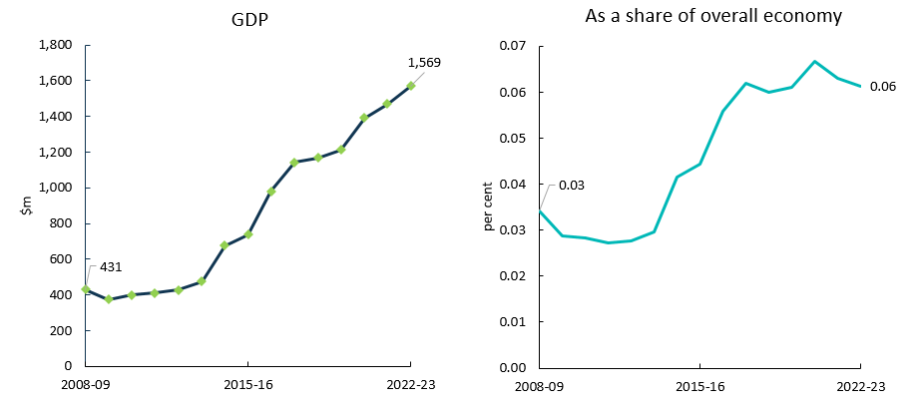

Source: ABS Australian System of National Accounts, Australian National Accounts: Input-Output Tables (Product Details); Australian National Accounts: Supply Use Tables; BCARR calculations.

As a share of overall economy, this domain increased from 0.03% to 0.06% over the period.

Table 11. Internet publishing and broadcasting, 2008–09 to 2022–23

|  |  |  |  |  |  |
| --- | --- | --- | --- | --- | --- |
| Internet publishing and broadcasting  **Period** | **Output**  **$m** | **GVA**  **$m** | **Net taxes on products**  **$m** | **GDP**  **$m** | **As a share of overall economy**  **%** |
| **2008–09** | 820 | 420 | 11 | **431** | **0.03** |
| **2009–10** | 685 | 365 | 9 | **374** | **0.03** |
| **2010–11** | 754 | 390 | 10 | **400** | **0.03** |
| **2011–12** | 819 | 400 | 10 | **410** | **0.03** |
| **2012–13** | 816 | 414 | 11 | **426** | **0.03** |
| **2013–14** | 959 | 462 | 11 | **473** | **0.03** |
| **2014–15** | 1,478 | 666 | 9 | **675** | **0.04** |
| **2015–16** | 1,641 | 737 | 0 | **737** | **0.04** |
| **2016–17** | 2,046 | 974 | 7 | **981** | **0.06** |
| **2017–18** | 2,356 | 1,135 | 7 | **1,142** | **0.06** |
| **2018–19** | 2,345 | 1,159 | 8 | **1,167** | **0.06** |
| **2019–20** | 2,536 | 1,203 | 9 | **1,212** | **0.06** |
| **2020–21** | 2,415 | 1,381 | 10 | **1,391** | **0.07** |
| **2021–22** | 2,673 | 1,460 | 11 | **1,471** | **0.06** |
| **2022–23** | 2,853 | 1,558 | 11 | **1,569** | **0.06** |

Source: ABS Australian System of National Accounts; Australian National Accounts: Input-Output Tables (Product Details); Australian National Accounts: Supply Use Tables; BCARR calculations.

## 8. Libraries and archives

Libraries and archives include activities such as maintaining the collections of documents and facilitating the use of such documents.[34]

This domain is funded primarily by governments with most industry services provided to users free of charge. Government funding accounts for more than 90% of revenue and the domain is therefore highly sensitive to changes in these funding arrangements. The remaining share of industry revenue is typically derived from fees and charges, as well as from private funding and donations.[35]

Cultural and creative activity GDP in libraries and archives increased by $735 million from 2008–09 to 2022–23.

Figure 21. Libraries and archives, GDP and as a share of overall economy

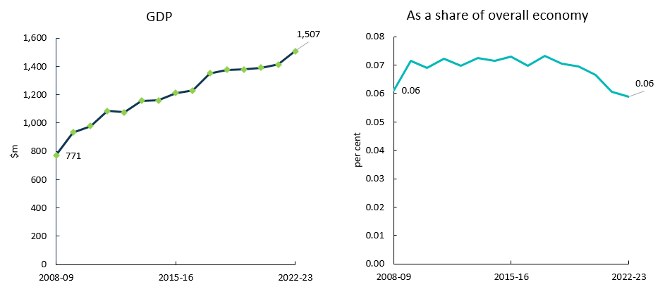

Source: ABS Australian System of National Accounts, Australian National Accounts: Input-Output Tables (Product Details); Australian National Accounts: Supply Use Tables; BCARR calculations.

The output of libraries and archives declined in 2019–20 and 2020–21. The initial COVID-19 outbreak inhibited libraries and archives’ operations, with all establishments forced to close during lockdowns and later reopening to a restricted number of patrons.[36] Total intermediate use in this domain also decreased, with the decline outpacing the output decline in 2019–20 and 2020–21. This resulted in a slight increase in GVA in both years.

As a share of overall economy, this domain has remained relatively flat over the period.

Table 12. Libraries and archives, 2008–09 to 2022–23

|  |  |  |  |  |  |
| --- | --- | --- | --- | --- | --- |
| Libraries and archives  **Period** | **Output**  **$m** | **GVA**  **$m** | **Net taxes on products**  **$m** | **GDP**  **$m** | **As a share of overall economy**  **%** |
| **2008–09** | 1,203 | 752 | 19 | **771** | **0.06** |
| **2009–10** | 1,282 | 909 | 25 | **934** | **0.07** |
| **2010–11** | 1,277 | 953 | 25 | **978** | **0.07** |
| **2011–12** | 1,348 | 1,059 | 25 | **1,084** | **0.07** |
| **2012–13** | 1,382 | 1,048 | 26 | **1,074** | **0.07** |
| **2013–14** | 1,464 | 1,130 | 28 | **1,158** | **0.07** |
| **2014–15** | 1,475 | 1,115 | 45 | **1,160** | **0.07** |
| **2015–16** | 1,539 | 1,181 | 30 | **1,211** | **0.07** |
| **2016–17** | 1,624 | 1,196 | 32 | **1,228** | **0.07** |
| **2017–18** | 1,806 | 1,319 | 33 | **1,352** | **0.07** |
| **2018–19** | 1,809 | 1,339 | 37 | **1,376** | **0.07** |
| **2019–20** | 1,783 | 1,345 | 34 | **1,379** | **0.07** |
| **2020–21** | 1,735 | 1,349 | 42 | **1,391** | **0.07** |
| **2021–22** | 1,781 | 1,366 | 48 | **1,414** | **0.06** |
| **2022–23** | 1,901 | 1,458 | 49 | **1,507** | **0.06** |

Source: ABS Australian System of National Accounts; Australian National Accounts: Input-Output Tables (Product Details); Australian National Accounts: Supply Use Tables; BCARR calculations.

## 9. Print media and publishing (excl. internet)

Print media and publishing (excl. internet) consists of:

* *Printing products* such as books, newspapers, journals and periodicals printed but not published by the business.
* *Printing Support Services* such as pre‑press (e.g. typesetting, colour separation or platemaking), post-press or finishing (e.g. laminating, embossing or book binding) services.[37]
* *Newspaper Publishing* activities creating and disseminating newspapers.[38]
* *Magazine and Other Periodical Publishing* activities creating and disseminating magazines, journals and other periodicals.36
* *Book Publishing* activities creating and disseminating books including atlases, textbooks and travel guides.[39]
* *Other Publishing* (except software, music and internet) activities such as greeting card, postcard and art print publishing.37
* *Software Publishing* activities mainly engaged in creating and disseminating ready-made (non-customised) computer software.[40]
* *Other information services* (including radio and television news collection and telephone based recorded information services).[41]

Cultural and creative activity GDP in print media and publishing (excl. internet) has increased by $1.7 billion or 13.1% from 2008–09 to 2022–23 (Figure 22). The increase was mainly driven by software publishing activities that have experienced strong growth in recent years. Despite the challenges posed by COVID-19, growth in software publishing has remained steady, buoyed by the increased demand for software supporting remote work and other business technologies.[42]

Figure 22. Print media and publishing (excl. internet), GDP and as a share of overall economy

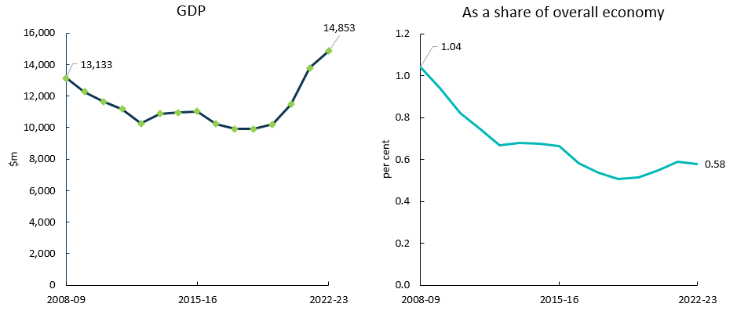

Source: ABS Australian System of National Accounts, Australian National Accounts: Input-Output Tables (Product Details); Australian National Accounts: Supply Use Tables; BCARR calculations.

However, as a share of GDP, print media and publishing (excl. internet) has declined from 1.04% to 0.58% during this period (Table 13). This was mainly driven by the decrease in newspaper, magazine and other periodic publishing activity, as consumers purchase fewer printed publications and use digital media to access content.[43]

Table 13. Print media and publishing (excl. internet), 2008–09 to 2022–23

|  |  |  |  |  |  |
| --- | --- | --- | --- | --- | --- |
| Print media and publishing (excl. internet)  **Period** | **Output**  **$m** | **GVA**  **$m** | **Net taxes on products**  **$m** | **GDP**  **$m** | **As a share of overall economy**  **%** |
| **2008–09** | 19,659 | 12,258 | 875 | **13,133** | **1.04** |
| **2009–10** | 18,847 | 11,320 | 937 | **12,257** | **0.94** |
| **2010–11** | 18,968 | 10,696 | 942 | **11,638** | **0.82** |
| **2011–12** | 19,020 | 10,277 | 906 | **11,183** | **0.75** |
| **2012–13** | 17,804 | 9,420 | 836 | **10,256** | **0.67** |
| **2013–14** | 18,529 | 10,005 | 862 | **10,867** | **0.68** |
| **2014–15** | 18,703 | 10,049 | 909 | **10,958** | **0.67** |
| **2015–16** | 18,837 | 10,107 | 919 | **11,026** | **0.66** |
| **2016–17** | 18,446 | 9,344 | 885 | **10,230** | **0.58** |
| **2017–18** | 17,146 | 9,032 | 879 | **9,912** | **0.54** |
| **2018–19** | 18,951 | 9,007 | 899 | **9,906** | **0.51** |
| **2019–20** | 20,821 | 9,262 | 935 | **10,197** | **0.51** |
| **2020–21** | 22,797 | 10,468 | 1,016 | **11,484** | **0.55** |
| **2021–22** | 28,173 | 12,644 | 1,144 | **13,788** | **0.59** |
| **2022–23** | 30,484 | 13,681 | 1,171 | **14,853** | **0.58** |

Source: ABS Australian System of National Accounts; Australian National Accounts: Input-Output Tables (Product Details); Australian National Accounts: Supply Use Tables; BCARR calculations.

## 10. Architecture services

Architecture services consists of activity in providing services such as planning and designing buildings and structures; or planning and designing the development of land.[44]

Cultural and creative activity GDP in architecture services increased by $2.5 billion or 69.5%, from 2008–09 to 2022–23.

Figure 23. Architecture services, GDP and as a share of overall economy

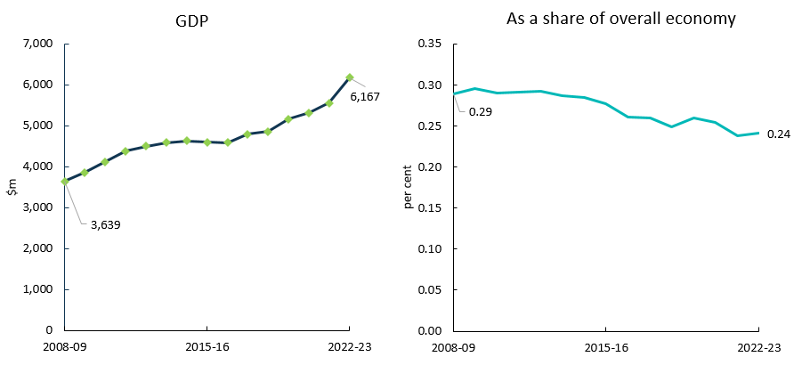

Source: ABS Australian System of National Accounts, Australian National Accounts: Input-Output Tables (Product Details); Australian National Accounts: Supply Use Tables; BCARR calculations.

Architecture firms have benefitted from a period of low interest rates and high population growth which has also increased property prices. These trends have provided a significant source of industry demand, particularly for small-scale architects.[45]

However, as a share of overall economy, this domain has declined from 0.29% to 0.24% over the period.

Table 14. Architecture services, 2008–09 to 2022–23

|  |  |  |  |  |  |
| --- | --- | --- | --- | --- | --- |
| Architecture services  **Period** | **Output**  **$m** | **GVA**  **$m** | **Net taxes on products**  **$m** | **GDP**  **$m** | **As a share of overall economy**  **%** |
| **2008–09** | 8,574 | 3,639 | 0 | **3,639** | **0.29** |
| **2009–10** | 8,613 | 3,859 | 0 | **3,859** | **0.30** |
| **2010–11** | 9,103 | 4,119 | 0 | **4,119** | **0.29** |
| **2011–12** | 9,401 | 4,376 | 0 | **4,376** | **0.29** |
| **2012–13** | 9,591 | 4,499 | 0 | **4,499** | **0.29** |
| **2013–14** | 10,186 | 4,574 | 7 | **4,581** | **0.29** |
| **2014–15** | 10,187 | 4,626 | 0 | **4,626** | **0.28** |
| **2015–16** | 10,300 | 4,592 | 6 | **4,598** | **0.28** |
| **2016–17** | 10,056 | 4,579 | 4 | **4,583** | **0.26** |
| **2017–18** | 11,023 | 4,781 | 5 | **4,786** | **0.26** |
| **2018–19** | 11,295 | 4,856 | 5 | **4,861** | **0.25** |
| **2019–20** | 11,704 | 5,153 | 5 | **5,158** | **0.26** |
| **2020–21** | 11,924 | 5,308 | 5 | **5,313** | **0.25** |
| **2021–22** | 12,693 | 5,551 | 6 | **5,557** | **0.24** |
| **2022–23** | 14,087 | 6,160 | 6 | **6,167** | **0.24** |

Source: ABS Australian System of National Accounts; Australian National Accounts: Input-Output Tables (Product Details); Australian National Accounts: Supply Use Tables; BCARR calculations.

## 11. Design and fashion

Design and fashion consists of *other specialised design services*, including commercial art and display services; and specialised design service not elsewhere classified (such as fashion, interior and jewellery design). The key difference between the new scope for this domain from the previous domain for design is that the updated scope ***excludes*** computer system and related services[46] which has considerably reduced the size of design activity compared with the previous domain.

Cultural and creative activity GDP in design and fashion has experienced significant growth of $3.7 billion from 2008–09 to 2022–23.

Figure 24. Design and fashion, GDP and as a share of overall economy

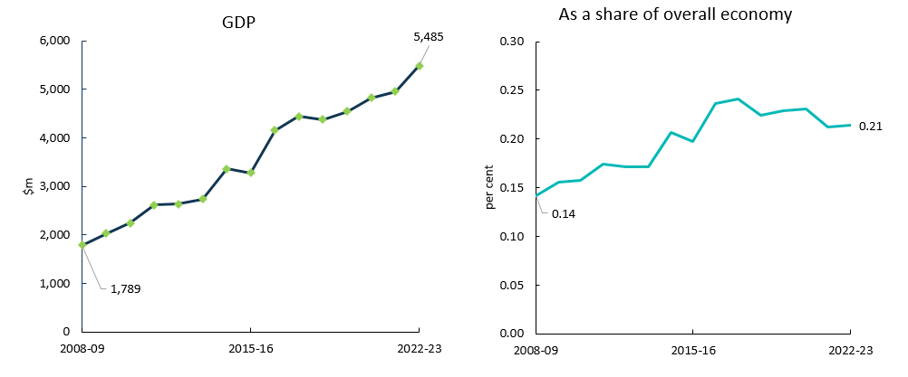

Source: ABS Australian System of National Accounts, Australian National Accounts: Input-Output Tables (Product Details); Australian National Accounts: Supply Use Tables; BCARR calculations.

Specialised design service providers that have integrated new design innovations have capitalised on the widespread adoption of digital technology. More businesses have taken their operations online and onto social media platforms, lifting demand for website design services.[47] As a share of overall economy, this domain increased from 0.14% to 0.21% over the period.

Table 15. Design and fashion, 2008–09 to 2022–23

|  |  |  |  |  |  |
| --- | --- | --- | --- | --- | --- |
| Design and fashion  **Period** | **Output**  **$m** | **GVA**  **$m** | **Net taxes on products**  **$m** | **GDP**  **$m** | **As a share of overall economy**  **%** |
| **2008–09** | 3,912 | 1,787 | 1 | **1,789** | **0.14** |
| **2009–10** | 4,156 | 2,026 | 6 | **2,032** | **0.16** |
| **2010–11** | 4,507 | 2,235 | 4 | **2,240** | **0.16** |
| **2011–12** | 5,231 | 2,607 | 5 | **2,612** | **0.17** |
| **2012–13** | 5,326 | 2,633 | 5 | **2,638** | **0.17** |
| **2013–14** | 5,779 | 2,733 | 5 | **2,738** | **0.17** |
| **2014–15** | 6,942 | 3,354 | 7 | **3,361** | **0.21** |
| **2015–16** | 6,931 | 3,276 | 4 | **3,280** | **0.20** |
| **2016–17** | 8,624 | 4,151 | 7 | **4,158** | **0.24** |
| **2017–18** | 9,163 | 4,436 | 6 | **4,442** | **0.24** |
| **2018–19** | 9,226 | 4,376 | 6 | **4,382** | **0.22** |
| **2019–20** | 9,353 | 4,535 | 7 | **4,542** | **0.23** |
| **2020–21** | 9,720 | 4,815 | 7 | **4,822** | **0.23** |
| **2021–22** | 9,975 | 4,945 | 6 | **4,951** | **0.21** |
| **2022–23** | 11,052 | 5,479 | 6 | **5,485** | **0.21** |

Source: ABS Australian System of National Accounts; Australian National Accounts: Input-Output Tables (Product Details); Australian National Accounts: Supply Use Tables; BCARR calculations.

## 12. Advertising and promotion

Advertising and promotion consists of:

* *Advertising services* such as the creation of advertising campaigns and materials; and media planning and buying (i.e. placing advertisements);
* *Management services* (including business, artists, entertainers and sporting professionals).

Advertising and promotion is the largest domain, accounting for 27.0% of cultural and creative activity in 2022–23. Cultural and creative activity GDP in this domain increased by $9.1 billion, from $8.2 billion in 2008–09 to $17.2 billion in 2022–23.

Figure 25. Advertising and promotion, GDP and as a share of overall economy

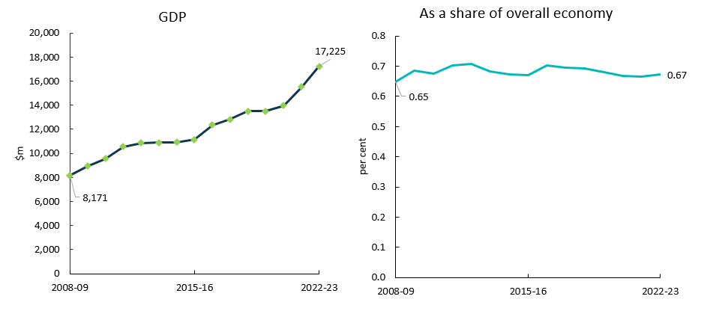

Source: ABS Australian System of National Accounts, Australian National Accounts: Input-Output Tables (Product Details); Australian National Accounts: Supply Use Tables; BCARR calculations.

As a share of the overall economy, this domain increased slightly from 0.65% to 0.67% over the period (Table 16). Increased content consumption on internet-based platforms is bolstering demand for online advertising.[48]

Table 16. Advertising and promotion, 2008–09 to 2022–23

|  |  |  |  |  |  |
| --- | --- | --- | --- | --- | --- |
| Advertising and promotion  **Period** | **Output**  **$m** | **GVA**  **$m** | **Net taxes on products**  **$m** | **GDP**  **$m** | **As a share of overall economy**  **%** |
| **2008–09** | 17,840 | 8,133 | 39 | **8,171** | **0.65** |
| **2009–10** | 18,203 | 8,855 | 81 | **8,935** | **0.69** |
| **2010–11** | 19,211 | 9,515 | 59 | **9,573** | **0.67** |
| **2011–12** | 20,625 | 10,502 | 61 | **10,563** | **0.70** |
| **2012–13** | 21,065 | 10,804 | 64 | **10,868** | **0.71** |
| **2013–14** | 22,122 | 10,835 | 68 | **10,902** | **0.68** |
| **2014–15** | 21,759 | 10,797 | 117 | **10,914** | **0.67** |
| **2015–16** | 22,736 | 11,037 | 101 | **11,137** | **0.67** |
| **2016–17** | 24,829 | 12,262 | 91 | **12,352** | **0.70** |
| **2017–18** | 25,950 | 12,737 | 94 | **12,831** | **0.70** |
| **2018–19** | 27,728 | 13,416 | 102 | **13,517** | **0.69** |
| **2019–20** | 26,999 | 13,389 | 100 | **13,489** | **0.68** |
| **2020–21** | 27,590 | 13,863 | 103 | **13,966** | **0.67** |
| **2021–22** | 30,528 | 15,426 | 103 | **15,529** | **0.67** |
| **2022–23** | 33,880 | 17,120 | 105 | **17,225** | **0.67** |

Source: ABS Australian System of National Accounts; Australian National Accounts: Input-Output Tables (Product Details); Australian National Accounts: Supply Use Tables; BCARR calculations.

## 13. Events (arts)

Events (arts) consists of:

* *Theatre, concert ticketing and booking* services; and
* *Event management or promotion* (including art or similar); fund raising services (fee based) or administration services not elsewhere classified.

Cultural and creative activity GDP in arts-related events increased by $437 million or 70.3% from 2008–09 to 2022–23.

Figure 26. Events (arts), GDP and as a share of overall economy

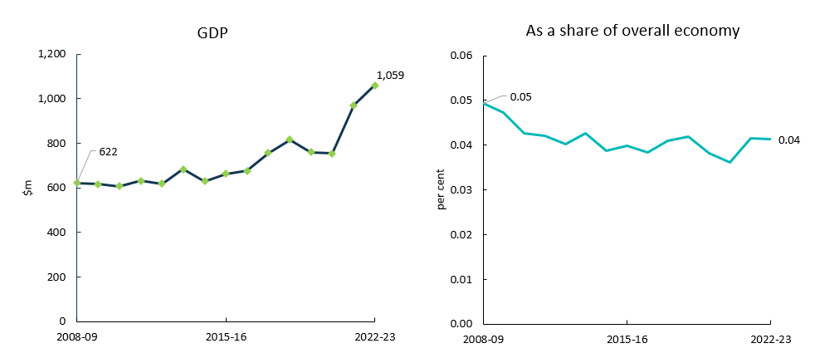

Source: ABS Australian System of National Accounts, Australian National Accounts: Input-Output Tables (Product Details); Australian National Accounts: Supply Use Tables; BCARR calculations.

Event promotion and management activities performed poorly during COVID-19. Pandemic-induced lockdowns led to major restrictions on a range of conferences, events and other industry services over this period. As a result, the GVA of events declined before rebounding in 2021–22 when restrictions eased.[49] As a share of overall economy, events declined from 0.05% to 0.04% during the period.

Table 17. Events (arts), 2008–09 to 2022–23

|  |  |  |  |  |  |
| --- | --- | --- | --- | --- | --- |
| Events (arts)  **Period** | **Output**  **$m** | **GVA**  **$m** | **Net taxes on products**  **$m** | **GDP**  **$m** | **As a share of overall economy**  **%** |
| **2008–09** | 992 | 600 | 22 | **622** | **0.05** |
| **2009–10** | 972 | 602 | 14 | **616** | **0.05** |
| **2010–11** | 904 | 592 | 15 | **606** | **0.04** |
| **2011–12** | 978 | 615 | 17 | **631** | **0.04** |
| **2012–13** | 982 | 603 | 16 | **619** | **0.04** |
| **2013–14** | 1,037 | 663 | 20 | **684** | **0.04** |
| **2014–15** | 953 | 608 | 21 | **629** | **0.04** |
| **2015–16** | 1,017 | 637 | 25 | **663** | **0.04** |
| **2016–17** | 1,064 | 662 | 14 | **676** | **0.04** |
| **2017–18** | 1,144 | 744 | 12 | **756** | **0.04** |
| **2018–19** | 1,215 | 804 | 12 | **816** | **0.04** |
| **2019–20** | 1,105 | 751 | 9 | **760** | **0.04** |
| **2020–21** | 1,095 | 744 | 11 | **754** | **0.04** |
| **2021–22** | 1,422 | 959 | 11 | **970** | **0.04** |
| **2022–23** | 1,553 | 1,048 | 12 | **1,059** | **0.04** |

Source: ABS Australian System of National Accounts; Australian National Accounts: Input-Output Tables (Product Details); Australian National Accounts: Supply Use Tables; BCARR calculations.

There has been a marked improvement in activity for this domain since 2021–22 as restrictions have eased, and major events like music concerts have resumed.[50]

## 14. Arts education

Arts education provides non-vocational instruction in the arts, including art, dance, drama and music. This activity is highly fragmented as many providers are owner-operators who provide activities such as music and performing arts lessons.[51] Increased savings and discretionary income has improved household willingness-to-pay for instruction in extracurricular activities, supporting industry performance for this domain.[52]

Cultural and creative activity GDP in arts education has increased by $578 million from 2008–09 to 2022–23.

Figure 27. Arts education, GDP and as a share of overall economy

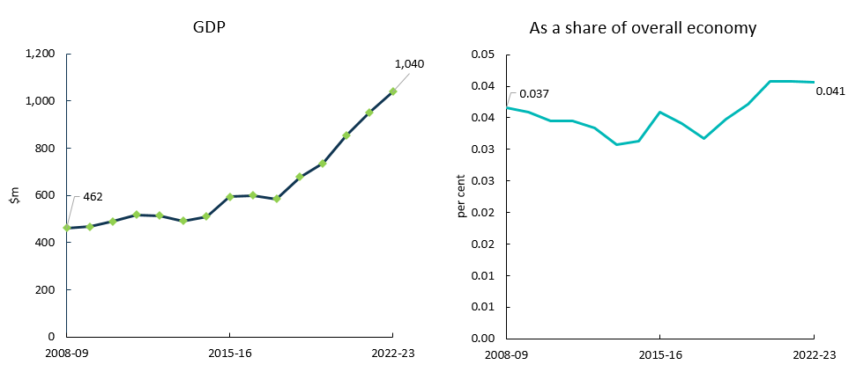

Source: ABS Australian System of National Accounts, Australian National Accounts: Input-Output Tables (Product Details); Australian National Accounts: Supply Use Tables; BCARR calculations.

As a share of overall economy, arts education has remained relatively flat over the period.

Table 18. Arts education, 2008–09 to 2022–23

|  |  |  |  |  |  |
| --- | --- | --- | --- | --- | --- |
| Arts education  **Period** | **Output**  **$m** | **GVA**  **$m** | **Net taxes on products**  **$m** | **GDP**  **$m** | **As a share of overall economy**  **%** |
| **2008–09** | 513 | 369 | 93 | **462** | **0.04** |
| **2009–10** | 527 | 338 | 130 | **468** | **0.04** |
| **2010–11** | 551 | 358 | 130 | **489** | **0.03** |
| **2011–12** | 578 | 382 | 135 | **517** | **0.03** |
| **2012–13** | 605 | 375 | 138 | **513** | **0.03** |
| **2013–14** | 816 | 480 | 12 | **491** | **0.03** |
| **2014–15** | 857 | 500 | 9 | **510** | **0.03** |
| **2015–16** | 955 | 550 | 45 | **595** | **0.04** |
| **2016–17** | 965 | 536 | 63 | **599** | **0.03** |
| **2017–18** | 961 | 531 | 54 | **585** | **0.03** |
| **2018–19** | 1,090 | 615 | 63 | **678** | **0.03** |
| **2019–20** | 1,088 | 658 | 79 | **737** | **0.04** |
| **2020–21** | 1,198 | 765 | 88 | **852** | **0.04** |
| **2021–22** | 1,314 | 848 | 103 | **951** | **0.04** |
| **2022–23** | 1,449 | 935 | 105 | **1,040** | **0.04** |

Source: ABS Australian System of National Accounts; Australian National Accounts: Input-Output Tables (Product Details); Australian National Accounts: Supply Use Tables; BCARR calculations.

## 15. Digital games development

Digital games development consists of *computer systems, hardware and software design and development* services relating to *digital games*. There is no specific IOPC or ANZSIC class for digital games development, and the in‑scope units have been found to be predominantly coded to ANZSIC class *7000 Computer system design and related services* based on the latest ABS’s publication of *Film, Television and Digital Games*.[53] This publication has also been used as an additional data source to estimate this activity, by separating digital games development out from the product IOPC *70000010 Computer systems, hardware and software design and development services*.

Australia is home to a growing games industry and digital games development has been cited as ‘a crucial pillar of a modern, digital, and creative Australia.’[54] From its small base of initial activity, cultural and creative GDP in digital games development has increased significantly – from $24 million in 2008–09 to $344 million in 2022–23.

Figure 28. Digital games development, GDP and as a share of overall economy

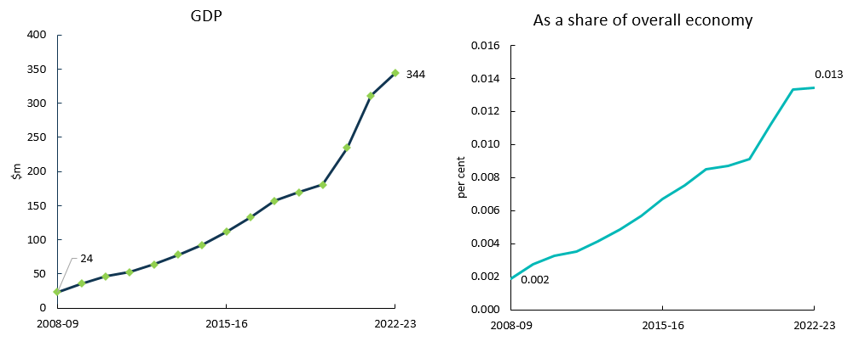

Source: ABS Australian System of National Accounts, Australian National Accounts: Input-Output Tables (Product Details); Australian National Accounts: Supply Use Tables; BCARR calculations.

Consumer uptake of video games has been strong over the past decade. As a share of overall economy, this domain has increased from 0.002% to 0.013% over the period.

Table 19. Digital games development, 2008–09 to 2022–23

|  |  |  |  |  |  |
| --- | --- | --- | --- | --- | --- |
| Digital games development  **Period** | **Output**  **$m** | **GVA**  **$m** | **Net taxes on products**  **$m** | **GDP**  **$m** | **As a share of overall economy**  **%** |
| **2008–09** | 57 | 23 | 1 | **24** | **0.002** |
| **2009–10** | 78 | 35 | 1 | **36** | **0.003** |
| **2010–11** | 99 | 45 | 1 | **46** | **0.003** |
| **2011–12** | 118 | 51 | 2 | **53** | **0.004** |
| **2012–13** | 141 | 61 | 2 | **64** | **0.004** |
| **2013–14** | 166 | 76 | 1 | **78** | **0.005** |
| **2014–15** | 199 | 90 | 2 | **92** | **0.006** |
| **2015–16** | 239 | 108 | 3 | **111** | **0.007** |
| **2016–17** | 285 | 127 | 6 | **133** | **0.008** |
| **2017–18** | 335 | 150 | 7 | **157** | **0.009** |
| **2018–19** | 400 | 160 | 9 | **169** | **0.009** |
| **2019–20** | 441 | 169 | 12 | **181** | **0.009** |
| **2020–21** | 557 | 220 | 15 | **235** | **0.011** |
| **2021–22** | 771 | 293 | 19 | **311** | **0.013** |
| **2022–23** | 856 | 325 | 19 | **344** | **0.013** |

Source: ABS Australian System of National Accounts; Australian National Accounts: Input-Output Tables (Product Details); Australian National Accounts: Supply Use Tables; BCARR calculations.

## Cultural and creative activity GVA by industry

Cultural and creative activity occurs across several industry divisions, including: Manufacturing; Construction; Wholesale Trade; Retail Trade; Information Media and Telecommunications; Professional, Scientific and Technical Services; Administrative and Support Services; Education and Training; Arts and Recreation Services; and Other Services.

Table 20. Cultural and creative activity, GVA by industry division, 2008–09 to 2022–23

|  |  |  |  |  |  |  |  |  |  |  |  |
| --- | --- | --- | --- | --- | --- | --- | --- | --- | --- | --- | --- |
| **Period** | **Manufacturing**  **$m** | **Construction**  **$m** | **Wholesale Trade**  **$m** | **Retail Trade**  **$m** | **Information Media and Telecommunications**  **$m** | **Professional, Scientific and Technical Services**  **$m** | **Administrative and Support Services**  **$m** | **Education and Training**  **$m** | **Arts and Recreation Services**  **$m** | **Other Services**  **$m** | **Total**  **$m** |
| 2008–09 | 1,420 | 976 | 1,161 | 220 | 17,540 | 12,603 | 600 | 369 | 2,031 | 184 | **37,102** |
| 2009–10 | 1,879 | 1,021 | 1,042 | 270 | 17,831 | 13,529 | 602 | 338 | 2,072 | 174 | **38,759** |
| 2010–11 | 2,027 | 1,075 | 1,238 | 228 | 17,642 | 14,486 | 592 | 358 | 2,023 | 186 | **39,855** |
| 2011–12 | 2,354 | 1,027 | 1,497 | 275 | 17,047 | 15,785 | 615 | 382 | 2,143 | 191 | **41,315** |
| 2012–13 | 2,101 | 1,007 | 1,612 | 312 | 16,276 | 16,374 | 603 | 375 | 2,190 | 186 | **41,035** |
| 2013–14 | 2,571 | 1,124 | 1,600 | 269 | 17,403 | 16,319 | 663 | 480 | 2,315 | 220 | **42,963** |
| 2014–15 | 3,089 | 1,095 | 1,575 | 296 | 17,674 | 16,598 | 608 | 500 | 2,371 | 282 | **44,087** |
| 2015–16 | 3,042 | 1,021 | 1,627 | 338 | 18,291 | 16,917 | 637 | 550 | 2,720 | 247 | **45,390** |
| 2016–17 | 2,822 | 1,033 | 1,709 | 298 | 17,364 | 18,968 | 662 | 536 | 2,889 | 260 | **46,540** |
| 2017–18 | 2,726 | 1,332 | 1,362 | 299 | 17,644 | 19,786 | 744 | 531 | 2,866 | 246 | **47,537** |
| 2018–19 | 2,935 | 1,308 | 1,266 | 251 | 16,915 | 20,515 | 804 | 615 | 3,268 | 267 | **48,145** |
| 2019–20 | 2,626 | 1,331 | 1,191 | 222 | 16,682 | 21,046 | 751 | 658 | 3,018 | 213 | **47,737** |
| 2020–21 | 2,759 | 1,364 | 1,230 | 251 | 17,850 | 21,975 | 744 | 765 | 2,668 | 200 | **49,807** |
| 2021–22 | 2,715 | 1,426 | 1,268 | 249 | 20,543 | 24,120 | 959 | 848 | 3,005 | 221 | **55,354** |
| 2022–23 | 2,978 | 1,581 | 1,525 | 286 | 21,926 | 26,774 | 1,048 | 935 | 3,415 | 256 | **60,724** |

Source: ABS Australian System of National Accounts; Australian National Accounts: Input-Output Tables (Product Details); Australian National Accounts: Supply Use Tables; BCARR calculations.

Professional, Scientific and Technical Services was the largest contributor to cultural and creative activity GVA growth over the period (Figure 29).

GVA in this industry experienced significant growth of $14.2 billion or 112.4% from 2008–09 to 2022–23. The increase was driven primarily by advertising services, up by $6.7 billion or 114% during the period, largely reflecting positive economic conditions and business confidence.[55]

Figure 29. Cultural and creative GVA change by division, 2008–09 to 2022–23

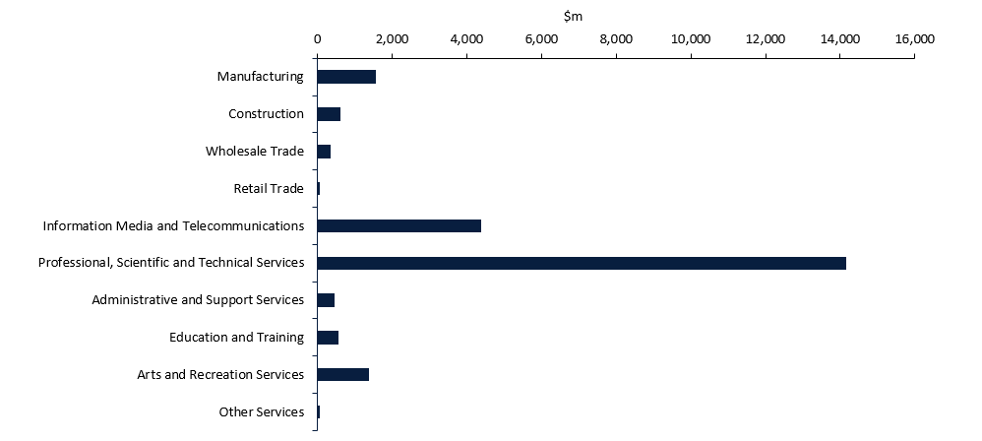

Source: ABS Australian System of National Accounts; Australian National Accounts: Input-Output Tables (Product Details); Australian National Accounts: Supply Use Tables; BCARR calculations.

After Professional, Scientific and Technical Services, Information Media and Telecommunications was the second largest contributor to the increase in cultural and creative activity. GVA in Information Media and Telecommunications rose by $4.4 billion or 25.0% from 2008–09 to 2022–23, mainly driven by software publishing, which has experienced significant growth in recent years due to increased internet access and adoption of new technology.

In the refreshed framework, cultural and creative activity can also be re-identified by 3 categories: specialised activity, support activity and embedded activity. In the following sections, these categories are examined by different industry divisions.

### Specialised activity

Specialised activity refers to cultural and creative products being produced within cultural and creative industries. This activity increased by $19.4 billion or 80.9%, from $23.9 billion in 2008–09 to $43.3 billion in 2022–23.

Table 21. Specialised activity, 2008–09 to 2022–23

|  |  |  |  |  |  |  |  |
| --- | --- | --- | --- | --- | --- | --- | --- |
| **Period** | **Manufacturing**  **$m** | Information Media and Telecommunications  **$m** | **Professional, Scientific and Technical Services**  $m | **Education and Training**  **$m** | **Arts and Recreation Services**  $m | **Other Services**  **$m** | Total Specialised Activity  **$m** |
| **2008–09** | 301 | 11,435 | 9,966 | 265 | 1,785 | 160 | **23,912** |
| **2009–10** | 334 | 13,431 | 10,723 | 252 | 1,809 | 151 | **26,701** |
| **2010–11** | 368 | 13,488 | 11,468 | 268 | 1,762 | 162 | **27,516** |
| **2011–12** | 369 | 13,060 | 12,513 | 284 | 1,879 | 166 | **28,272** |
| **2012–13** | 313 | 12,572 | 12,964 | 280 | 1,921 | 161 | **28,211** |
| **2013–14** | 348 | 12,973 | 12,840 | 462 | 2,031 | 190 | **28,844** |
| **2014–15** | 125 | 13,701 | 13,032 | 484 | 2,051 | 238 | **29,631** |
| **2015–16** | 112 | 14,148 | 13,213 | 515 | 2,272 | 214 | **30,473** |
| **2016–17** | 130 | 13,107 | 14,640 | 503 | 2,409 | 225 | **31,014** |
| **2017–18** | 131 | 13,371 | 15,350 | 501 | 2,433 | 211 | **31,997** |
| **2018–19** | 141 | 12,694 | 15,897 | 581 | 2,719 | 230 | **32,263** |
| **2019–20** | 91 | 12,658 | 16,439 | 617 | 2,500 | 182 | **32,487** |
| **2020–21** | 114 | 13,966 | 17,199 | 722 | 2,171 | 174 | **34,345** |
| **2021–22** | 125 | 17,253 | 18,786 | 800 | 2,423 | 192 | **39,578** |
| **2022–23** | 137 | 18,415 | 20,853 | 881 | 2,754 | 223 | **43,263** |

Source: ABS Australian System of National Accounts; Australian National Accounts: Input-Output Tables (Product Details); Australian National Accounts: Supply Use Tables; BCARR calculations.

Specialised activity accounted for 71.2% of total cultural and creative activity GVA in 2022–23, which indicates that most cultural and creative products were produced primarily within cultural and creative industries. Professional, Scientific and Technical Services and Information Media and Telecommunications combined represented around 90% of this specialised activity in 2022–23.

Figure 30. Industry contributors to specialised activity, 2008–09 and 2022–23

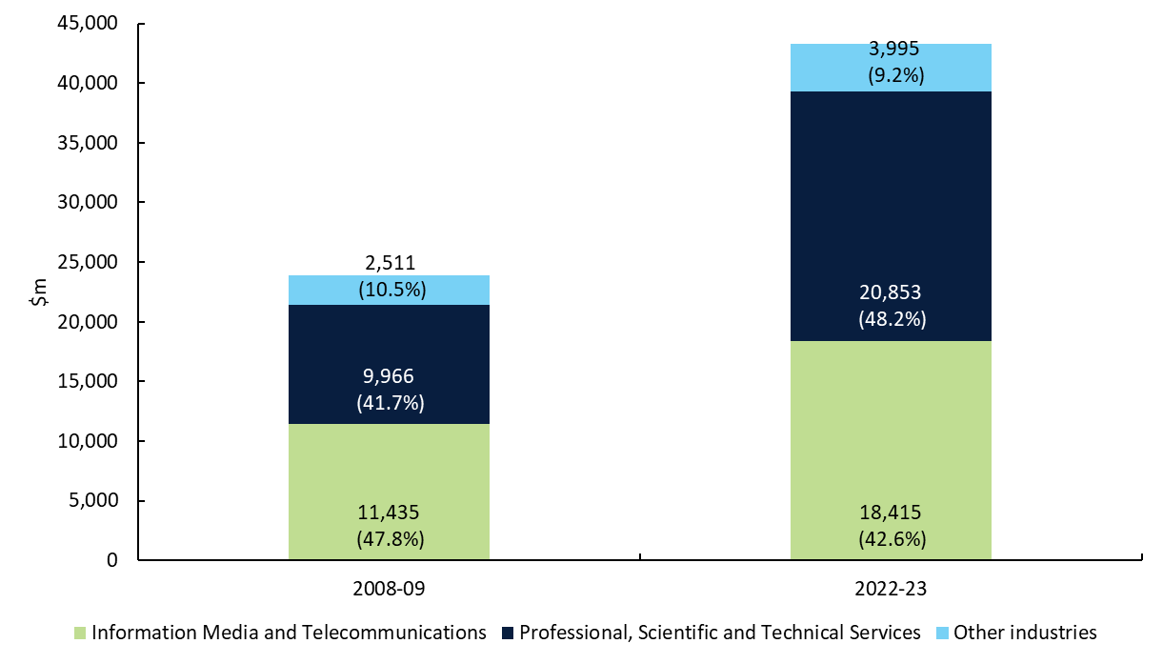

Source: ABS Australian System of National Accounts; Australian National Accounts: Input-Output Tables (Product Details); Australian National Accounts: Supply Use Tables; BCARR calculations.

### Support activity

Support activity refers to any other products outside the scope of cultural and creative products within cultural and creative industries. This activity accounted for $5.7 billion or 9.4% of cultural and creative activity GVA in 2022–23.

Table 22. Support activity, 2008–09 to 2022–23

|  |  |  |  |  |  |  |  |
| --- | --- | --- | --- | --- | --- | --- | --- |
| Period | Manufacturing  $m | Information Media and Telecommunications  $m | Professional, Scientific and Technical Services  $m | Education and Training  $m | Arts and Recreation Services  $m | Other Services  $m | Total Support Activity  $m |
| **2008–09** | 49 | 6,092 | 629 | 104 | 240 | 24 | **7,139** |
| **2009–10** | 169 | 4,374 | 636 | 86 | 255 | 23 | **5,542** |
| **2010–11** | 189 | 4,131 | 689 | 91 | 249 | 25 | **5,374** |
| **2011–12** | 249 | 3,942 | 728 | 98 | 251 | 25 | **5,292** |
| **2012–13** | 202 | 3,646 | 766 | 95 | 256 | 25 | **4,990** |
| **2013–14** | 246 | 4,337 | 846 | 17 | 273 | 29 | **5,748** |
| **2014–15** | 45 | 3,882 | 880 | 16 | 304 | 43 | **5,171** |
| **2015–16** | 35 | 4,070 | 964 | 35 | 398 | 33 | **5,535** |
| **2016–17** | 34 | 4,176 | 1,103 | 33 | 411 | 35 | **5,791** |
| **2017–18** | 34 | 4,188 | 1,174 | 30 | 385 | 34 | **5,844** |
| **2018–19** | 37 | 4,135 | 1,179 | 34 | 492 | 37 | **5,914** |
| **2019–20** | 24 | 3,958 | 1,275 | 40 | 462 | 30 | **5,790** |
| **2020–21** | 32 | 3,824 | 1,299 | 43 | 443 | 26 | **5,666** |
| **2021–22** | 41 | 3,224 | 1,387 | 49 | 525 | 29 | **5,254** |
| 2022–23 | 44 | 3,441 | 1,539 | 54 | 597 | 33 | 5,709 |

Source: ABS Australian System of National Accounts; Australian National Accounts: Input-Output Tables (Product Details); Australian National Accounts: Supply Use Tables; BCARR calculations.

Support activity decreased by $1.4 billion or 20%, from $7.1 billion to $5.7 billion from 2008–09 to 2022–23. The main contributors of support activity were from various non-cultural-or-creative products relating to advertising services (advertising space) on newspapers, magazines and other periodicals, books, and internet publishing. Most support activity was therefore found in the information media and telecommunications industry (Figure 31). The significant decline in support activity was mainly driven by the reduced advertising services on newspaper publishing, due to the shifting consumer preferences towards digital media.[56]

Figure 31. Industry contributors to support activity, 2008–09 and 2022–23

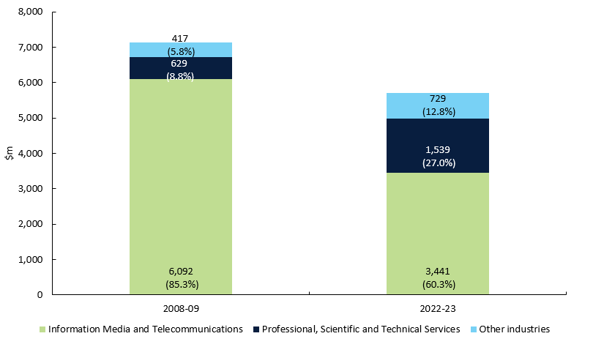

Source: ABS Australian System of National Accounts; Australian National Accounts: Input-Output Tables (Product Details); Australian National Accounts: Supply Use Tables; BCARR calculations.

### In-scope cultural and creative subdivisions

Both specialised and support activities are captured by the cultural and creative industries, and Table 23 provides a further breakdown of the in-scope cultural and creative industries by 11 subdivisions (2-digit ANZSIC).

Table 23. In-scope cultural and creative industry subdivisions

|  |  |  |  |  |  |  |  |  |  |  |  |  |
| --- | --- | --- | --- | --- | --- | --- | --- | --- | --- | --- | --- | --- |
| **Period** | **Printing (including Reproduction of Recorded Media)**  **$m** | **Publishing (except Internet and Music Publishing)**  **$m** | **Motion Picture and Sound Recording Activities**  **$m** | **Broadcasting (except Internet)**  **$m** | **Internet Publishing and Broadcasting**  **$m** | **Library and Other Information Services**  **$m** | **Professional, Scientific and Technical Services (except Computer System Design and Related Services)**  **$m** | **Adult, Community and Other Education**  **$m** | **Heritage Activities**  **$m** | **Creative and Performing Arts Activities**  **$m** | **Personal and Other Services**  **$m** | **Total**  **$m** |
| 2008–09 | 350 | 10,098 | 1,923 | 4,077 | 420 | 1,010 | 10,595 | 369 | 480 | 1,545 | 184 | **31,051** |
| 2009–10 | 503 | 9,131 | 2,268 | 4,889 | 365 | 1,152 | 11,359 | 338 | 447 | 1,617 | 174 | **32,243** |
| 2010–11 | 557 | 8,258 | 2,300 | 5,464 | 390 | 1,207 | 12,157 | 358 | 435 | 1,576 | 186 | **32,889** |
| 2011–12 | 618 | 7,609 | 2,491 | 5,162 | 400 | 1,340 | 13,241 | 382 | 461 | 1,669 | 191 | **33,564** |
| 2012–13 | 515 | 6,774 | 2,355 | 5,349 | 414 | 1,326 | 13,730 | 375 | 471 | 1,706 | 186 | **33,202** |
| 2013–14 | 593 | 7,336 | 2,416 | 5,753 | 440 | 1,365 | 13,685 | 480 | 502 | 1,802 | 220 | **34,592** |
| 2014–15 | 171 | 7,369 | 2,496 | 5,746 | 646 | 1,326 | 13,912 | 500 | 507 | 1,848 | 282 | **34,802** |
| 2015–16 | 147 | 7,494 | 2,881 | 5,744 | 735 | 1,364 | 14,177 | 550 | 570 | 2,100 | 247 | **36,009** |
| 2016–17 | 163 | 6,631 | 2,932 | 5,404 | 972 | 1,344 | 15,743 | 536 | 615 | 2,204 | 260 | **36,805** |
| 2017–18 | 165 | 6,753 | 2,856 | 5,376 | 1,134 | 1,439 | 16,523 | 531 | 623 | 2,195 | 246 | **37,841** |
| 2018–19 | 179 | 6,828 | 2,974 | 4,420 | 1,153 | 1,454 | 17,076 | 615 | 683 | 2,528 | 267 | **38,177** |
| 2019–20 | 115 | 7,354 | 2,717 | 3,877 | 1,199 | 1,470 | 17,714 | 658 | 704 | 2,257 | 213 | **38,277** |
| 2020–21 | 146 | 8,467 | 1,984 | 4,494 | 1,377 | 1,467 | 18,498 | 765 | 729 | 1,885 | 200 | **40,012** |
| 2021–22 | 165 | 10,559 | 2,583 | 4,373 | 1,456 | 1,507 | 20,173 | 848 | 746 | 2,202 | 221 | **44,833** |
| 2022–23 | 181 | 11,270 | 2,757 | 4,667 | 1,554 | 1,608 | 22,393 | 935 | 848 | 2,503 | 256 | **48,972** |

Source: ABS Australian System of National Accounts; Australian National Accounts: Input-Output Tables (Product Details); Australian National Accounts: Supply Use Tables; BCARR calculations.

### Embedded activity

Embedded activity refers to cultural and creative products in other industries that are outside of the scope of cultural and creative activity. Some activities such as events (arts) or digital games development were only identified as cultural and creative activity at the product level. However, these cultural and creative products were produced in other industries that are outside the scope of cultural and creative industries, such as administrative services industries or computer system design and related services.

Arts and Recreation Services could also produce embedded activities as most of this division – including parks and gardens operations, gambling, sports and recreation – remains out of scope for cultural and creative industries. Some of these industries could still produce cultural and creative products, such as publishing-related products.

Embedded activity contributed $11.8 billion of cultural and creative activity GVA in 2022–23 (Table 24), which accounted for 19.4% of total cultural and creative activity.

Table 24. Embedded activity, 2008–09 to 2022–23

|  |  |  |  |  |  |  |  |  |  |
| --- | --- | --- | --- | --- | --- | --- | --- | --- | --- |
| Period | Manufacturing | Construction | Wholesale Trade | Retail Trade | Information Media and Telecommunications | Professional, Scientific and Technical Services | Administrative and Support Services | Arts and Recreation Services | Total |
|  | **$m** | **$m** | **$m** | **$m** | **$m** | **$m** | **$m** | **$m** | **$m** |
| 2008–09 | 1,070 | 976 | 1,161 | 220 | 12 | 2,008 | 600 | 5 | **6,051** |
| 2009–10 | 1,376 | 1,021 | 1,042 | 270 | 26 | 2,171 | 602 | 8 | **6,516** |
| 2010–11 | 1,470 | 1,075 | 1,238 | 228 | 23 | 2,329 | 592 | 12 | **6,966** |
| 2011–12 | 1,735 | 1,027 | 1,497 | 275 | 45 | 2,544 | 615 | 13 | **7,751** |
| 2012–13 | 1,586 | 1,007 | 1,612 | 312 | 58 | 2,644 | 603 | 13 | **7,833** |
| 2013–14 | 1,977 | 1,124 | 1,600 | 269 | 92 | 2,634 | 663 | 11 | **8,371** |
| 2014–15 | 2,918 | 1,095 | 1,575 | 296 | 91 | 2,686 | 608 | 16 | **9,286** |
| 2015–16 | 2,894 | 1,021 | 1,627 | 338 | 73 | 2,740 | 637 | 51 | **9,381** |
| 2016–17 | 2,659 | 1,033 | 1,709 | 298 | 80 | 3,224 | 662 | 70 | **9,734** |
| 2017–18 | 2,561 | 1,332 | 1,362 | 299 | 86 | 3,263 | 744 | 48 | **9,695** |
| 2018–19 | 2,757 | 1,308 | 1,266 | 251 | 86 | 3,438 | 804 | 58 | **9,968** |
| 2019–20 | 2,511 | 1,331 | 1,191 | 222 | 65 | 3,333 | 751 | 57 | **9,460** |
| 2020–21 | 2,614 | 1,364 | 1,230 | 251 | 60 | 3,477 | 744 | 54 | **9,795** |
| 2021–22 | 2,550 | 1,426 | 1,268 | 249 | 66 | 3,947 | 959 | 56 | **10,521** |
| 2022–23 | 2,797 | 1,581 | 1,525 | 286 | 70 | 4,381 | 1,048 | 64 | **11,752** |

Source: ABS Australian System of National Accounts; Australian National Accounts: Input-Output Tables (Product Details); Australian National Accounts: Supply Use Tables; BCARR calculations.

Most embedded activity was produced from Professional, Scientific and Technical Services and Manufacturing industries (Figure 32). This was because some cultural and creative activities – such as management services (including business, artists, entertainers and sporting professionals), manufacturing products of printing materials and crafts – have only been identified as in-scope activities through their product levels rather than industry levels. As a result, the economic value produced by these activities was only estimated as embedded activity.

Figure 32. Industry contributors to embedded activity, 2008–09 and 2022–23

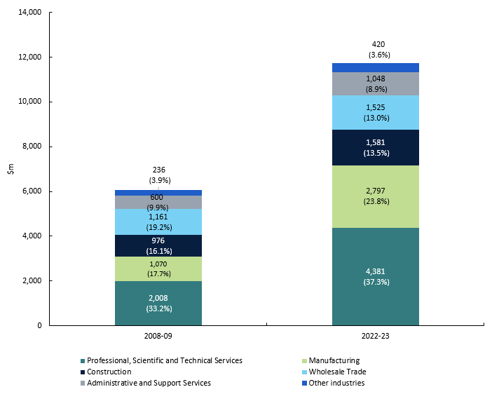

Source: ABS Australian System of National Accounts; Australian National Accounts: Input-Output Tables (Product Details); Australian National Accounts: Supply Use Tables; BCARR calculations.

## Conclusion and next steps

This paper provides new estimates of Australian cultural and creative activity based on a refreshed methodology and a revised scope. The paper provides detailed estimates of cultural and creative activity by domain and industry and also compares the new estimates with estimates from previous publications. Details of the consultation process and feedback received from stakeholder submissions is provided in the appendix.

Following on from this measure of economic activity for cultural and creative activity, the department will engage with the ABS and other stakeholders to develop methodologies to measure other types of cultural and creative statistics as part of subsequent phases of this research. Figure 33 details the intended phases of research for the refresh.

Figure 33. Topics proposed to be covered in the initial refresh and subsequent phases of the refresh

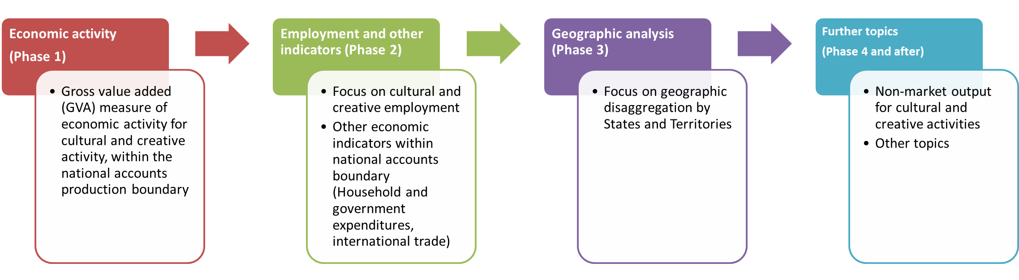

Source: BCARR.

Thank you to everyone who has been engaged in this consultation process. Your contributions have offered a wealth of knowledge and perspectives which will improve estimates to measuring cultural and creative activity. For any further feedback or inquiries, contact: [bcarr@infrastructure.gov.au](mailto:bcarr@infrastructure.gov.au).

## Appendix A—Stakeholder feedback

### A.1 Consultation process for the Cultural and Creative Methodology Refresh

Consultation for the refresh of measuring cultural and creative activity involved two rounds of stakeholder engagement. The first round of consultation was from February to June 2023, which invited stakeholders to submit their feedback on BCARR’s proposed methodology through a ‘Have your say’ webpage. The second round of consultation was from July 2023 to March 2024, with targeted stakeholder workshops in February and March 2024.

Figure 34. Consultation timeline for initial methodology refresh

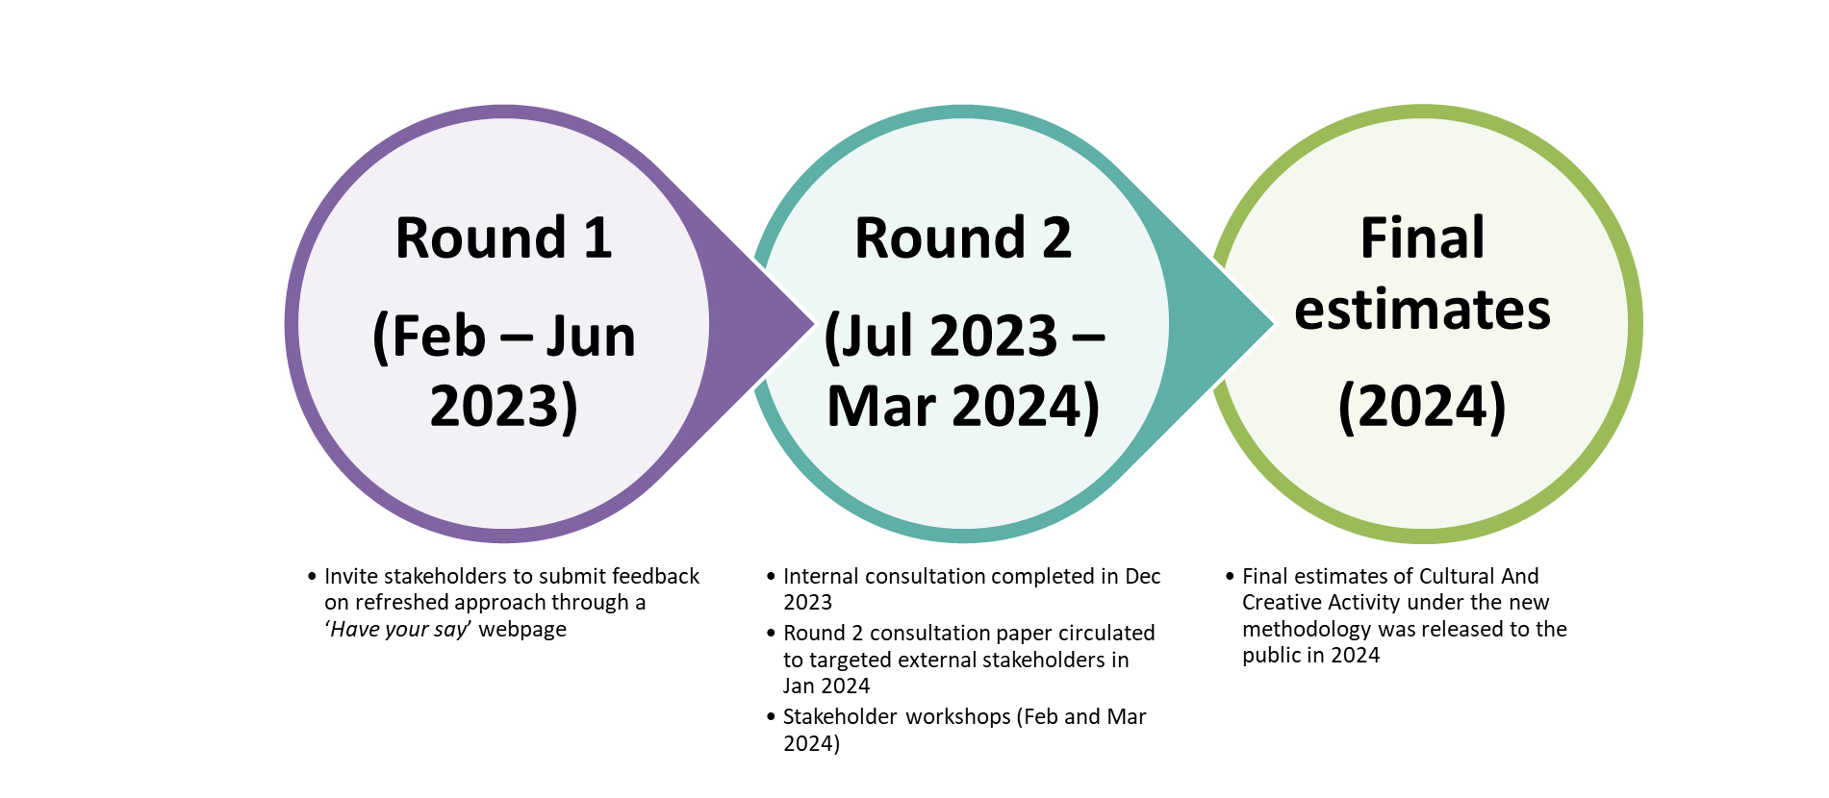

Source: BCARR.

The initial consultation paper published in February 2023 shared BCARR’s proposed approach to refresh methodology on measuring cultural and creative activity in Australia, and also invited stakeholders to provide feedback on this approach. BCARR received 14 submissions[57] from academia, industry bodies, individuals, and government. These submissions were in addition to the feedback already provided by the Australian Bureau of Statistics (ABS) who peer reviewed this work prior to the release of the consultation paper.

Feedback received from the first round of consultation included support for a refresh to the satellite account, views on the definition as well as what cultural and creative activity should be considered in scope, and the theoretical models that should underpin this framework. Stakeholders also provided feedback on related issues, such as: social and other non-market benefits of cultural and creative activity; whether digital activity can be identified; and measures of cultural and creative employment in the future cultural and creative publications.

The department engaged with internal and external stakeholders for the second round of consultation including stakeholder workshops to discuss feedback from the submissions. Following these consultations, the department progressed the essence of the proposed methodology put forward in the initial consultation paper.[58] This methodology reflects accepted best practice in economic measurement and allowed estimates to be updated by incorporating newly-available datasets with more granular data.

Further changes to the scope of cultural and creative industries and products were considered based on stakeholder feedback, and further determined by a decision‑making framework developed by the department. The framework is underpinned by existing theoretical models of cultural and creative industries, combined with criteria on whether industries have engaged with domestic cultural policy. The amended scope has been discussed with stakeholders through the workshops as part of the second round of consultation.

Details of the stakeholder feedback received and the department’s response can be found in the following sections.

### A.2 General feedback

Feedback received from the first round of consultation included support for a refresh to the methodology being used to measure cultural and creative activity, views on cultural and creative activity and what should be considered in scope, and the theoretical models that should underpin this framework. Feedback also included other issues such as the potential role of cultural and creative activity for non-market activities and wellbeing, digital activities, and cultural and creative workers. A summary of the submissions[59] to the consultation paper is shown in Box 1.

**Box 1: Feedback from selected submissions**

**Proposed refresh:**

* *The process for the refresh exercise as set in place by BCARR staff makes a lot of sense, with a clear recognition of where the problems lie that need attention ... the linking of the concentric circles model of the industrial structure of the cultural sector with the trident model of occupational classification provides a sound basis for jointly specifying products, industries and labour use which will accord with both the expectations of users and the capacities of the statistical sources to provide the data to quantify the accounts.* (Throsby, sub. 3, pp. 1–2)
* *We welcome the consultation paper ... The reasons given in the paper for the need to refresh their methodology are well taken.* (Cunningham, Brook and McCutcheon, sub. 6, p. 1)
* *The addition of the Input-Output Product Classifications (IOPCs) as an additional data source, will address existing gaps in data and offer more granular data.* (A New Approach, sub. 9, p. 7)

**Definition:**

* *The problem of defining cultural and creative sector is lack, or looseness of definition* (O’Connor, sub. 2, p.6).
* *A focus on the Creative Arts sector would under-rate creativity that happens elsewhere in Australia, such as in the following examples from Finance and Business.* (Rothberg, sub. 4, p. 8)
* *We further recommend a re-focus on what is creative and cultural using UK DCMS definition - those industries and occupations that have potential for wealth and job creation through the exploitation of intellectual property* (Cunningham, Brook and McCutcheon, sub. 6, p. 3)
* *How can definitions of cultural and creativity accommodate generative AI?* (A New Approach, sub. 9, p. 8)
* *Providing a foundational definition for cultural and creative activity in Australia through the satellite accounts, recognising that other pieces of work will meet particular needs of specific sectors or types of analysis.* (Creative Australia, sub. 10, p. 5)
* *With advances in Artificial Intelligence, there are creative activities and industries that now rely on more than just “human” creativity.* (sub. 12, p. 5)

**Digital activities:**

* *Development of the satellite accounts should explore how to track activities in the digital sphere, including alignment with ABS development of digital satellite accounts …* *The Australia council understands that the data source and methodology in BCARR’s proposed refreshed cultural and creative satellite accounts is consistent with the Australian digital activity satellite accounts, which will provide further opportunities to better measure the Australian digitalisation in the future.* (Creative Australia, sub. 10, p. 2 & p. 7)
* *How might AI (or other future technological advancements) impact workforce participation trends for specialised workers, support workers, or embedded workers?* (A New Approach, sub. 9, p. 8)

**Non-market activities and wellbeing:**

* *The satellite account is a case of statistics in search of an industry ... GVA (or similar) is a poor proxy for the value of art and culture … There needs to be an explicit acknowledgement that the value of cultural sector is far more than economic.* (O’Connor, sub. 2, pp. 2–3)
* *Cultural and Creative activities have intrinsic value, which cannot be captured in these Accounts, but they also have a range of instrumental values beyond creating economic activity that the Accounts might endeavour to capture.* (sub. 12, p. 4)

**Events:**

* *Ensuring events and festivals management activity is captured is important. The proposed model appears to do this.* (sub. 5, p. 1)
* *The inclusion of events in the methodology review is strongly supported. It could be expanded on to add festivals and events, as those cross over between the various domains.* (Council of Capital City Lord Mayors, sub. 11, p. 5)

**Employment and other indicators:**

* *It would be useful to include employment data, cross-industry comparisons, geographic breakdowns, and data on events and international trade* (Creative Australia, sub. 10, p. 3)
* *A more accurate data reference through changes to the Cultural and Creative Activity Satellite Accounts and collection of ABS employment data relating to the visual arts with reference to the Indigenous Data Sovereignty network to ensure appropriate protocols, will achieve a more comprehensive understanding of the contribution and value of the First Nations art economy* (National Association for the Visual Arts, sub. 14, p. 4)
* *Considering how the long-term development of the satellite accounts may complement and interest with measures identified in other studies, such as indirect/ flow-on value and non-market value.* (Creative Australia, sub. 10, p. 5)
* *In order to understand the impact of COVID-19 on creative workers, we need to move beyond the inflated data categories that typically include many elements of the sector that do not necessarily include creative work.* (sub. 8, p. 4)
* *An ideal outcome for this methodology review would be to further disaggregate information by State and Local Government areas. This could be further explored using State and Local Government data.* (Council of Capital City Lord Mayors, sub. 11, p. 5)
* *The ABS framework for defining the cultural sector’s industry and occupation classifications was developed well before the emergence of the concept of the creative industries.* (Blackburn, sub. 1, p. 1)

Submissions also provided feedback on the methodology. Some stakeholders queried whether the Concentric Circles Model should be used to construct the Cultural and Creative Activity Satellite Account. Suggestions were also made on the scope of cultural and creative domains, products, and industries. The following sections detail the feedback received from submissions alongside the department’s responses to them.

### A.3 Detailed discussion on stakeholder feedback

#### Definition adopted in the methodology refresh

As stated in the consultation paper, the department continued to uphold the broad definitions for cultural and creative activity that were used by the ABS:

human creativity is a vital input to cultural and creative activity. Cultural activity requires human creativity as an input and may contain intellectual property to communicate symbolic meaning; while creative activity also requires human creativity as a significant and identifiable input.[60]

Some of the submissions questioned whether these definitions which centre on human creativity require an update, or a more fundamental change. For example, whether such definitions are too loose to provide a framework for classifying economic activity. Further, with rapid advances in artificial intelligence (AI), how can existing definitions accommodate generative AI? Or are there creative activities and industries that now rely on more than just ‘human’ creativity?

In the initial consultation paper, BCARR reviewed existing approaches to defining cultural and creative activities, both in Australia and abroad. We noted that economic analysis of cultural and creative activity remains limited. No universally-accepted definition exists for the scope of this activity and there is no international standard used to construct a satellite account framework. The department considered that the broad definitions of cultural and creative activity developed by the ABS remained suitable for constructing a satellite account framework in practice – while applying these definitions to the new framework, cultural and creative activity would encompass productive activities being classified under the umbrella of ‘cultural and creative’ through the input-output and supply-use frameworks. This practical process was also supported by a decision-making framework that clarifies scope for what constitutes cultural and creative activity.

##### AI technology

It is clear that AI technology is a growing part of the economy, and this has the ability to act as both a substitute and complement to labour. In some ways, AI is similar to how previous innovations in computing and automation have been incorporated into the production process. However, we note that AI is evolving rapidly and is already showing decision-making capabilities. AI is expected to expand in creative sectors as it is expanding in other parts of the economy. As stated by the OECD, AI is changing the automation landscape, with more tasks which were typically carried out by higher-skilled workers now being automated.[61]

In November 2023, the OECD further updated the definition of an AI system as:

… a machine-based system that, for explicit or implicit objectives, infers, from the input it receives, how to generate outputs such as predictions, content, recommendations, or decisions that can influence physical or virtual environments. Different AI systems vary in their levels of autonomy and adaptiveness after deployment.[62]

Based on this definition, the inputs that an AI system receives include ‘*rules and data, which may be provided by humans or machines, in operating AI systems*.’56 We therefore considered that human creativity should still be treated as the base and inputs for AI. However, we noted that the role of AI will need to be reviewed, particularly if there are changes to the national accounts which more explicitly capture AI and other digital activities.

#### Applying the Concentric Circles Model to the satellite account framework

Some submissions queried whether the Concentric Circles Model should be the approach used to construct the Cultural and Creative Activity Satellite Account. Some of these submissions also raised concerns about whether the layers of the Concentric Circles Model could spur debate about which industries are considered ‘core’ or more important than others.

The department does not consider the different layers of the concentric circles to reflect any differences in hierarchy or importance between domains of cultural and creative activity. The Concentric Circles Model provides a way to understand (rather than set up hierarchies on) the value and importance of cultural goods and services by suggesting that these goods and services have two kinds of value – economic value and cultural value. This model helps to define what cultural goods and services are and how they relate to each other. In Australia, the Concentric Circles Model was initially used as the base to group the cultural and creative industries into 12 domains[63] in the ABS’s *Cultural and Creative Activity Satellite Account*. As explained by the author of the concentric circles model, David Throsby, the model assumes that the cultural content comes from creative artistic (distinct from scientific) ideas and that these ideas come mainly from primary artistic fields such as music, drama, dance, visual arts, and literature. This is why these activities lie at the centre of the model, with successive layers of the concentric circles defined as the ideas and influences of these creative activities which diffuse outwards.[64]

The Concentric Circles Model has also been considered in other countries – for example, the US Bureau of Economic Analysis used it to help view the structure and relationship between cultural industries to construct their Arts and Cultural Production Satellite Account (ACPSA). In their statistical working paper, the US Bureau of Economic Analysis explained the linkage between this model and the conceptual framework for setting up a satellite account:

If you place yourself inside the inner-most circle at a live performance and then think about the myriad goods and services provided by dozens of other industries necessary to place you in your seat – you will be on your way to developing a set of industries for a creative arts account. Without a set of backward links to acknowledging the role of supporting industries necessary for the core to function, the ACPSA would not reflect the true impact of arts and culture on employment, income, output and value added within the economy.[65]

In the department’s methodology refresh, we have continued to follow this practical approach to update the domain categories, while identifying the cultural and creative activities from both the product and industry perspectives of the Australian input-output tables. This approach interprets the Concentric Circles Model which is suited to an input-output framework:

… the processes depicted in the Concentric Circles Model are not one-way, but all involve potentially reciprocal relationships between industries, making the model ideally suited to use with input-output methods, where industry interactions are of course an essential feature (Throsby, sub. 3, p. 2).

##### How would this model be applied to the input-output table?

As explained in the initial consultation paper, the input-output tables provide the most disaggregated product classification level within the Australian System of National Accounts. These tables also provide a rich information source on the supply and use of products in the Australian economy, and the structure of, and inter-relationships between Australian industries.[66] For this reason, input-output tables have always been treated as the base for constructing a satellite account framework – particularly when the starting point for these accounts is from the production‑side of the national accounts.

As noted in the initial consultation paper, the refresh aims to improve the methodology by setting up a ‘matrix framework’ based on the input-output tables (Figure 35). Cultural and creative activities could then be defined and identified using a two-way approach, which resolves many of the data gap issues, and allows for the updating of cultural and creative weights on a continual basis.[67]

Figure 35. Matrix to capture cultural and creative activity

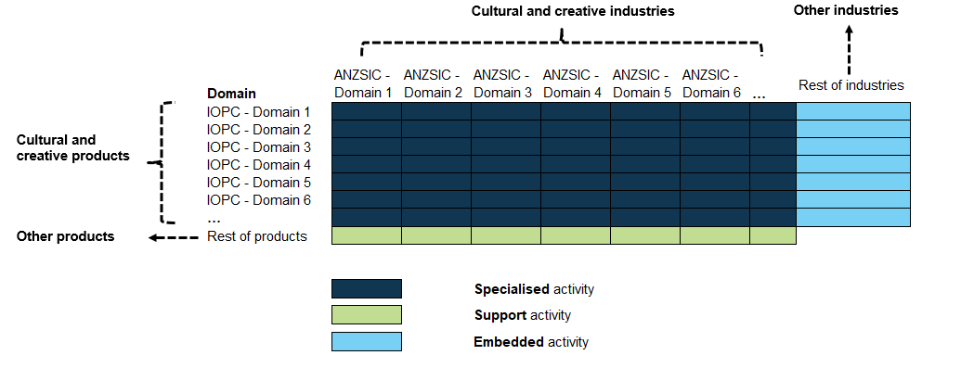

Source: BCARR.

This matrix framework in the refreshed methodology was set up based on the ‘creative trident’ model structure but the activities captured within each component could be quite different. As discussed in the initial consultation paper, the trident model from the previous satellite account framework referred to the 3 locations of **employment** within the creative occupations and industries – specialist, embedded and support workers;[68] while in the department’s new method, the 3 components within the matrix framework refer to **economic activity** and represent relationships between the products and industries being identified as in or out of scope for cultural and creative activity, and the occupational list is not required for estimating gross value added (GVA).

As these two models look at different relationships, there are differences in how activity is categorised and treated. The new framework follows the national accounts production approach and measures only the final goods and services of cultural and creative activity, which can be seen in the examples below.

Under the creative trident model, embedded workers – who are in cultural and creative occupations but are not working in cultural and creative industries – could include the more than 500 ‘Arts and media professionals’[69] employed in the residential care services industry. However, the cultural and creative activity being produced by these workers might be treated only as ‘intermediate use’ rather than as a ‘final good or service’. Within the system of national accounts, if an activity is treated as ‘intermediate use’ only, it should be excluded from the GVA calculation since it does not represent a ‘final good or service’. This is because GVA is derived by subtracting intermediate use from output. The refreshed methodology aligns with the national accounts system to consistently measure cultural and creative activity which avoids potential double-counting by excluding intermediate activities from the GVA calculation.

This example could be further validated from the input-output tables. Based on the latest input-output table,[70] it shows that the primary products being produced by the ‘Residential care and social assistance services’ industry group (IOIG 8601)[71] relate to residential care services for the elderly, disabled, mental health illnesses or substance abuse, child care services, and other social assistance services. However, cultural or artistic-related services (which are assumed to be directly produced by arts and media professionals) have been treated as ‘intermediate use’ rather than ‘final output’ for this industry group. In this situation, by calculating GVA for the residential care and social assistance services industry, these activities would need to be removed from total domestic output, and would therefore not be treated as an ‘embedded activity’ in the matrix framework of the refreshed methodology.

Support workers – who are not in cultural and creative occupations but work in cultural and creative industries – could include a cleaner who works at a museum. However, the cleaning activity[72] that is directly produced by this worker within the museum industry (ANZSIC 8910 Museum operation) might be captured only as intermediate use rather than as a final good or service. If this cleaning service relates only to intermediate use then it would not be identified as ‘support activity’ in the matrix framework of the refreshed methodology.

#### Scope of cultural and creative activity

Estimation of the economic value of cultural and creative activity is determined by how this activity is scoped and identified within the system of national accounts. Many of the submissions the department received for the consultation paper provided valuable feedback on how the scope of cultural and creative activity could be improved – in particular, by identifying cultural and creative activity from the product and industry group details lists in the input-output tables.

##### Using a decision-making framework to determine the scope

The department reviewed these recommendations in detail and made further changes to the cultural and creative domains, with the underpinning products and industries adjusted accordingly. The refreshed list was further determined based on a decision-making framework developed by the department (Figure 36).

The framework is underpinned by existing theoretical models[73] of cultural and creative industries, combined with criteria on whether industries have engaged with domestic cultural policy through various mechanisms, including through submissions to various arts and cultural policy consultation activities and parliamentary inquiries in the period 2013 to 2023.

Figure 36. Decision-making framework to determine the scope of cultural and creative industry and products

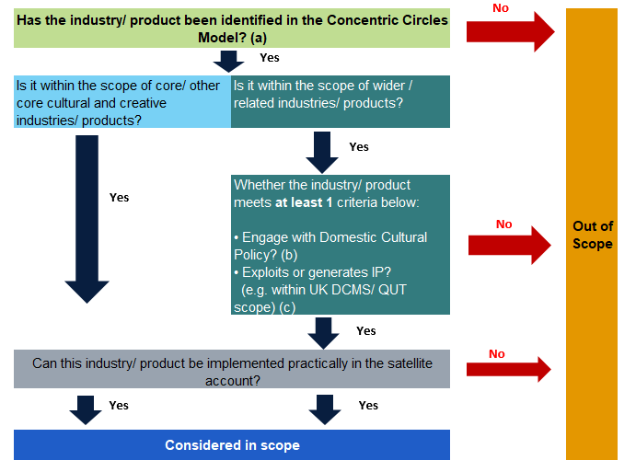

Source: Department of Infrastructure, Transport, Regional Development, Communications and the Arts.

Notes:

* + - * 1. The Concentric Circles Model of cultural industries developed by Professor David Throsby includes 4 layers: Core creative arts (incl. Literature, Music, Performing arts, and Visual arts); Other core creative industries (incl. Film, Museums, Galleries, Photography, and Libraries); Wider cultural industries (incl. Sound recording, Television and radio, Video and computer games, Heritage services, and Publishing and print media); and Related industries (incl. Design, Fashion, Advertising, and Architecture).
        2. This criterion refers to the engagement with domestic cultural policy from the period 2013 to 2023.
        3. The UK Department of Culture, Media and Sport (DCMS)/ Queensland University of Technology (QUT) model defines creative industries as ‘those industries which have their origin in individual creativity, skill and talent and which have a potential for wealth and job creation through the generation and exploitation of intellectual property.’

The framework was created to ensure a consistent and transparent approach for determining what is within the scope of the methodology refresh. Details on the scope determination of cultural and creative industries and products are provided in Appendix E. The following sections also detail further modifications to the scope and labelling of cultural and creative domains.

##### Modifications to the labelling and scope for the domains

Some of the feedback provided in submissions related to the scope of the domains and how they have been named. The department has made further adjustments to ensure the domain names better reflect the activities being captured, and are aligned with the needs of policy and industry stakeholders.

For example, some stakeholders wanted to separate the existing category of ‘Broadcasting, electronic or digital media, and film’ and create a new domain as ‘Screen’ activities. A new ‘Film and television activities’ domain was set up which re-categorised activities such as motion picture and video production, exhibition, distribution, copyright leasing, and post-production services, as well as free-to-air television and cable (Pay TV) and other subscription broadcasting services under this domain; while leaving radio broadcasting and internet publishing and broadcasting in their own domains. These modifications are broadly consistent with the scope identified in the [ABS’s *Film, Television and Digital Games, Australia*](https://www.abs.gov.au/statistics/industry/technology-and-innovation/film-television-and-digital-games-australia/latest-release)and the Screen Australia’s [*Drama Report*](https://www.screenaustralia.gov.au/fact-finders/reports-and-key-issues/reports-and-discussion-papers/drama-report).

Another further modification was to the domain of ‘Visual crafts’, where some visual arts creation activities were actually captured under the industry ANZSIC 9002 *Creative Artists, Musicians, Writers and Performers* which includes the services of artists and sculpting, as well as services that may be indirectly related to fine art. This industry also captures literature activities such as writing**.** The domain name has been relabelled from ‘Creative and performing arts’ to ‘Literature, creative and performing arts’ and separates out visual arts creation‑related activities to the domain of ‘Visual arts and crafts’. Visual arts and crafts also comprises several manufacturing products of crafts, as well as professional photographic services and photographic film processing activities.

Details on the main changes to the domains are in Appendix B.

##### Further removing cultural and creative enabling products within the manufacturing sector

In the initial consultation paper, the proposed list to identify cultural and creative activity included some enabling products within the manufacturing sector, such as print machinery and parts, as well as various clothing, footwear and accessories categories. While some stakeholders indicated that such products are part of the cultural and creative activity supply chain, the department acknowledges that the products themselves do not strongly relate to activity that is either cultural or creative.

These enabling products have been removed from the cultural and creative product list. Within the manufacturing sector, the only products retained as in-scope for cultural and creative activity are:

* products of crafts such as bags of leather or leather substitute, glass containers or jars, tableware and ornamental pottery, jewellery and silverware, and imitation jewellery;
* printing products such as books, newspapers, journals and periodicals printed but not published by the business;
* printing support services products; and
* musical instruments (including parts and accessories).

Details of the cultural and creative products and industries can be found in Appendix C and Appendix D.

##### Reasons for removing wholesaling and retailing activities

Some submissions raised concerns about removing wholesaling and retailing industries from the industry classification list, and suggested that, rather than excluding these activities, to consider collecting data grouped by parts of a value (supply) chain.

As explained in the initial consultation paper, the methodology refreshed aims to more accurately reflect the scope of cultural and creative activity. Some activities in the existing satellite account may not clearly relate to either cultural or creative activity, such as clothing retailing and wholesaling. These activities are included as creative output despite these industries being dominated by large companies not typically associated with the arts.[74]

Also, the new estimates activity at both product and industry levels through a new matrix framework (refer to Figure 1).[75] Although these wholesaling and retailing activities were removed from the cultural and creative industry list, some cultural and creative products could still be captured within such industries as embedded activity. For example, for some manufacturing and publishing products, such as manufacturing of musical instruments and software publishing services, part of their final goods or services are actually produced and supplied from the wholesaling and retailing industries (as secondary production[76] produced by these industries). In these instances, retailing and wholesaling industries in the refreshed Cultural and Creative Activity Satellite Account would still be considered parts of a value chain and have not been completely removed from cultural and creative activity.

Some comments also queried the logic of removing wholesaling and retailing activities while retaining some distribution activities, such as motion picture and video distribution. These activities are retained because motion picture and video distribution consist of activities mainly engaged in acquiring distribution rights and distributing motion pictures and videos. These products are distributed (through leasing and wholesale channels) to a range of exhibitors such as motion picture theatres and television stations using a variety of visual media.[77] These activities happen prior to wholesaling and retailing. After a company acquires the distribution rights for a motion picture, the on-selling of this motion picture would be classed as wholesale and retail to cinemas for exhibition, to TV and pay TV broadcasters for public viewing, to subscription video on demand providers, and to retailers and wholesalers for sale or rent on physical media (i.e. DVDs and Blu-ray discs). This activity also includes agents that lease and wholesale films and videos to organisations, and distribute video products using digital formats.[78] In addition, from an industry perspective, the main products of the motion picture and video distribution are movies and TV shows, which are strongly related to cultural and creative goods and services.

##### Limitations for products identified as ‘partially in-scope’ to cultural and creative activity

Feedback from some submissions raised issues about products that are partially in-scope and queried whether these could be further disaggregated. For example, in the list, digital games development was included in the category of IOPC 70000010 *Computer systems, hardware and software design and development services*. Another issue was raised for product IOPC 72990020 *Theatre, concert and sport ticketing and booking services*, where concern was raised about including services for sports that should not be identified as cultural or creative.

As shown in the estimation process to quantify cultural and creative activity in Figure 2, if a product from the input-output table is considered partially in-scope but is primarily related to cultural and creative activity, it will be included in the total.[79] As a result, for any product that is identified as partially in-scope, the treatment for estimating its cultural and creative output value will be either ‘100%’ or ‘0%’.

This all-or-nothing approach is due to the input-output product classification (IOPC) being the most granular product classification level within the Australian System of National Accounts. This is a known issue for many satellite account frameworks, such as the digital economy satellite account, that uses the same approach. Further splitting of the output of these partially in-scope products would require estimation to be based on additional data sources – and these data sources may be outside of the national accounts’ publications; while calibrating any proxy weights back to the input-output tables properly would bring about further challenges.

For this methodology refresh, the treatment of products as ‘100%’ or ‘0%’ is retained, but with the following **exceptions**:

* ***Events***. Events activity is apportioned to include arts-related events but not sports-related event services. This weighting is derived from the ratio between ‘Heritage, creative and performing arts (IOIG 8901)’ activities and ‘Sports and recreation (IOIG 9101)’ activities within the total intermediate use (TIU) matrix of the input-output tables. After applying the weights, the sports and recreation component is excluded from the estimates.
* ***Digital games development***. No specific ANZSIC industry or IOPC product class exists for digital games development. The ABS’s *Film, Television and Digital Games* is used as the additional data source to estimate this activity. Digital games development was predominantly coded to computer design and related services, however the gross value added of this activity only accounts for a small ratio of the total industry.
* ***Visual arts and crafts***. Some visual arts creation activities have been captured under ‘Services of independent creative artists, writers and performers’, together with *literature, creative and performing arts*. Similar to events, the TIU matrix of the input-output tables is used to separate out this activity from other activities within the IOPC *90020010 Services of independent creative artists, writers and performers* and the relative ANZSIC industry classification *9002 Creative Artists, Musicians, Writers and Performers*.

The department will further investigate these ‘partially in-scope’ issues in future research, to ensure the cultural and creative components of these products and industries are more accurately identified and captured, and meet stakeholder requirements.

##### Cultural and creative occupations and opportunities for future research

In the initial consultation paper, it stated that a refresh in the approach may help to unlock additional sources of information and statistics, including employment, and other types of cultural and creative statistics in subsequent research.

The department acknowledges that many stakeholders view cultural and creative activity from a worker/occupation context. While an occupation-focused analysis makes intuitive sense to understand the composition of workers in the cultural and creative economy, it is not well-aligned to measuring the economic contribution in terms of gross value added (GVA). This initial refresh focuses only on economic contribution (GVA). The occupations list is not used in the first phase of this review, but will be examined closely during phase 2, when cultural and creative employment will be considered.

Many of the submissions provided valuable feedback on the proposed cultural and creative occupation list, and highlighted that some existing occupations are outdated – for example:

The description for Multimedia Specialist refers to using CD-ROMs. CD-ROMs have been obsolete for many years, even in domestic personal computers, and this is the description in which many people in occupations using the highest and most advanced technologies are placed… Also screen industry specific roles are not well covered by the ANZSCO codes. For example, visual effect is not captured in the codes so visual effects technicians and artists are classified as Graphic and Web Designers, and Illustrators (2324). As a starting position for inclusion of these industries in the ANZSCO codes, broad titles such as "Digital Artist" and "Digital Producer" might be considered. (sub. 12, p. 6)

Some stakeholders also queried how AI (or other future technological advancements) might impact the workforce participation trends for specialised, embedded and support workers.

Most of the issues raised are the result of emerging occupations which have not been well‑identified in the current Australian and New Zealand Standard Classification of Occupations (ANZSCO). While ANZSCO has previously made some minor updates, it largely describes occupations from the original 2006 version, which was based on the 2001 labour market.[80]

The ABS has been undertaking a comprehensive review of ANZSCO since February 2023. The purpose of this review is to reflect the contemporary labour market and better meet stakeholders’ needs. The department has been engaged in this review of the occupation lists in these consultations.

The department expects to consult with stakeholders to modify and finalise the cultural and creative occupation list after consulting with the ABS on the new occupation classification. The department will also engage with the ABS on the methodology for estimating the employment of cultural and creative sector.

#### Tracking digital activities

Some of the submissions commented that the refresh should explore how to track digital activities and other emerging advanced technologies, including an alignment with the ABS’s digital satellite account.

Economic analysis of the value of digital technologies has been limited in both national and international contexts. Digital activities are already captured in the system of national accounts; however, they are incorporated in industry aggregates which do not explicitly identify digital drivers.

Digital activity has not been explicitly identified or separated out in this methodology refresh. However, the data source and methodology for the refresh is consistent with the digital economy satellite account, which has been broadly adopted by many countries including Australia.

For example, the refreshed methodology has estimated the cultural and creative GVA through an ‘output‑associated’ approach[81] – this approach was used by the US Bureau of Economic Analysis to measure the digital economy in 2018, and was further adopted in the ABS’s Australian *Digital Activity Satellite Account*[82] and the BCARR’s *Digitalisation Satellite Account* for measuring the Internet of Things, Information and Communications Technology, and Digital Activities.[83] In addition, using the input‑output tables and supply-use tables as the main data sources in the methodology refresh is also consistent with the Australian and international digital activity satellite accounts. The department expects these consistencies will provide further opportunities to measure these emerging technologies within the cultural and creative sector in the future.

#### Non-market activities and wellbeing

Some of the submissions commented that it is important to recognise the value of the cultural and creative sector, which extends beyond the economic value. For example:

GVA (or similar) is a poor proxy for the value of art and culture… There needs to be an explicit acknowledgement that the value of cultural sector is far more than economic.  
(O’Connor, sub.2, pp.2–3)

The department agrees that cultural and creative activity benefits society beyond the market value of this activity alone. However, these broader social benefits are outside of the traditional scope of a satellite account framework. It is also difficult to measure these activities in monetary terms, as would be required for a satellite account.

The focus for both the ABS Cultural and Creative Activity Satellite Account and the department’s refresh is on the direct economic contribution from this activity within the national accounts production boundary, through the estimation of gross value added. This framework is broadly consistent with the cultural and creative satellite accounts set up in other countries.

The potential or intangible value was not the focus for this methodological refresh. However, the department has been working with other areas and agencies in providing the inputs to the Treasury’s *Measuring What Matters Statement*[84], which outlines the Australian Government’s first national framework on wellbeing.

#### Further detail and improving data usability

Some of the submissions stated that the refresh should also explore additional data sources, such as multiple jobs and the First Nations visual arts and crafts market. Other feedback was to consider cross-industry and cross-country comparisons; further disaggregation of cultural and creative industries by 2 or 3-digit ANZSIC industry level; providing employment statistics, geographic breakdowns of states and territories (or other locations), and international trade.

A further recommendation was that the visibility, accessibility and usability of the estimates could be improved. For example, estimates could be made available as Excel datasheets in addition to current reporting. This would improve the capacity to access and manage the data for a variety of purposes.

The department has made all data tables presented in this new release available in a datasheet format. Some of the other suggestions made above, such as cross-industry comparisons and further disaggregation of cultural and creative industries by subdivisional level (2-digit ANZSIC) have also been considered for the release of new estimates.

In the department’s initial consultation paper, it was mentioned that state and territory estimates of cultural and creative activity would be examined. The department proposes to develop a methodology on state and territory disaggregation after the release of new estimates at the national level. We propose to examine this disaggregation during phase 3 of the research, after estimates of cultural and creative employment are developed. Due to less availability of the state-level input data, such estimates, if possible at all, would have less detail than at the national level.

## Appendix B – Modifications to the domains

Modifications to the domains

|  |  |  |  |  |  |
| --- | --- | --- | --- | --- | --- |
| No. | Modified domain name | New scope | Previous domain name and scope in the initial consultation paper | Issues raised for previous domain | Modification from the initial consultation paper |
| 1 | **Literature, creative and performing arts** | This domain includes:   * Performing arts operations. * Creative artists, musicians, writers and performers. Visual arts creation activities are excluded from this domain. * Performing arts venue operations. | In the consultation paper, this domain was labelled as ‘Creative and performing arts’, and included Performing arts operation; Creative Artists, Musicians, Writers and Performers; and Performing Arts Venue Operation. | The previous domain also covered some visual arts activities, such as activities being captured under ANZSIC 9002 Creative Artists, Musicians, Writers and Performers which includes the services of artists and sculpting, as well as services that may be indirectly related to fine art.  This domain also consists of literature activities such as writing. | * **Modify** the domain name as ‘**Literature, creative and performing arts**’ to better reflect the activities being captured within this domain; and * **separate out** visual arts-related activities such as services of artists and sculpting, as well as services that may be indirectly related to fine art from ‘Services of independent creative artists, writers and performers’ and **move to a new domain as ‘Visual arts and crafts**’. The estimation of the visual arts component of this industry (and underpinned product) is based on the TIU matrix of the input-output tables. |
| 2 | **Visual arts and crafts** | This domain includes:   * Tableware, ornamental pottery and domestic ware no elsewhere classified * Jewellery and silverware; * Imitation jewellery (excl incorporating precious metal except as plating or as minor constituents) (excl watch straps); * Activities of independent artists, e.g. sculptors, painters, etc.; * Professional photographic services; and * Photographic film processing activity; * Glass containers, bottles or jars; glass stoppers; glass inners for vacuum vessels; * Handbags, bags of leather or leather substitute (including toiletry bags, purses, wallets, excluding bags for packaging). | In the consultation paper, the domain was labelled as ‘Visual crafts’ and covered:   * Paper festival, carnival or other entertainment articles (incl conjuring tricks, novelties, Christmas decorations); * Tableware, ornamental pottery and domestic ware not elsewhere classified; * Jewellery and silverware manufacturing; and * Imitation jewellery (excl incorporating precious metal except as plating or as minor constituents) (excl watch straps)   ‘Photography’ was also considered as a separate domain in the consultation paper previously, included:   * photographic goods not elsewhere classified (excl sensitised photographic film, paper, plates & chemicals); * professional photographic services that are mainly engaged in providing still, video or computer photography services, including the video taping of special events such as weddings * photographic film processing (IOPC 95320010). | Some feedback received on the domain name – the term ‘visual crafts’ should be reconsidered as it is not a term that is known or recognised in the sector. The current domain name, ‘Visual arts and crafts’ is preferable.  Also, some visual arts creation activities are captured under Creative Artists, Musicians, Writers and Performers.  Feedback received on whether to remove manufacturing goods as they are not related to cultural or creative activity. | * **Add** glass containers, bottles or jars; glass stoppers; glass inners for vacuum vessels. * **keep** tableware, ornamental pottery and domestic ware not elsewhere classified in this domain, and further group manufacturing products: handbags, suitcases (incl canvas), bags (of leather or leather substitute) (incl toiletry bags, purses, wallets) (excl bags for packaging); * **keep** jewellery and silverware; Imitation jewellery (excl incorporating precious metal except as plating or as minor constituents) (excl watch straps). However, ANZSIC 2591 Jewellery and Silverware Manufacturing is considered out of scope as this industry also consists of activities such as coin minting and goldsmithing that are not related to cultural and creative activity. * **remove** all of other manufacturing products from the previous domain as they do not clearly relate to visual arts; * **partially capture the visual arts creation activities** from ANZSIC 9002 Creative Artists, Musicians, Writers and Performers and IOPC 90020010 Services of independent creative artists, writers and performers in this domain; * further **group** ‘Professional Photographic Services’ and ‘Photographic Film Processing’ (Also add ANZSIC 9532 Photographic Film Processing in) to this domain.; and * **relabel** this domain as ‘Visual arts and crafts’. |
| 3 | **Music production and distribution** | This domain includes:   * Musical instruments (incl parts and accessories) * Music publishing; and * Music and other sound recording activities. | In the consultation paper, the domain was labelled as ‘*Music*’ and covers music publishing; and music and other sound recording activities.  The manufacture of musical instruments was not covered in the previous domain. | Some feedback received that the domain name might not properly reflect the activities captured in this domain. | * **Modify** the domain name as **‘Music production and distribution’** to better reflect the activities being captured within this domain; and * **further group ‘Musical instruments (incl parts and accessories)’** to this domain. |
| 4 | **Museums and galleries** | This domain includes museum operation activities | Same domain name and scope in the consultation paper. | No issues raised on this domain. | No change. |
| 5 | **Film and television activities** | This domain consists of:   * Motion picture and video production; * Motion picture and video distribution; * Motion picture exhibition; * Post-production services and other motion picture and video activities; * Free-to-air television broadcasting; and * Cable and other subscription broadcasting. | In the consultation paper motion picture exhibition was labelled as ‘*Film*’, while motion picture and video production, distribution, copyright leasing, post-production services were labelled under domain of ‘*Video and computer games*’ previously. | Some feedback highlighted that Film Exhibition should not solely represent the film industry. Moving Motion picture and video production, distribution, copyright leasing, post-production services to the new domain. | **Re-categorise** these motion picture activities, as well as FTA broadcasting and cable and other subscription broadcasting **under a new domain ‘Film and television activities’.** |
| 6 | **Radio broadcasting** | This domain includes radio broadcasting activities. | In the consultation paper, this domain was labelled as ‘*Television and radio*’ and included:   * various manufacturing products relating to TV and radio, such as radio and television equipment, parts, receiving sets, etc. * radio, free-to-air television and cable (Pay TV) and other subscription broadcasting services; and * other information services (incl radio and television news collection and telephone based recorded information services). | Feedback received on whether to remove all of the manufacturing products if they are not considered either cultural or creative.  Some stakeholders also suggested to separate this domain from the screen activities. | * **Remove** all of the **manufacturing products**; * **separate** radio broadcasting activity in its own domain and **re-name** the domain as ‘**Radio broadcasting’**; and * **move** **other information services** to the domain of ‘**Print media and publishing**’. |
| 7 | **Internet publishing and broadcasting** | This domain includes activities engaged in publishing and/or broadcasting content on the internet. | In the consultation paper, this domain was grouped under ‘Publishing and print media’ with other publishing (excl. internet) and printing activities. | Some stakeholders suggested to separate this domain by its own. | **Separate** this activity in its own domain and **re-name** the domain as ‘**Internet publishing and broadcasting’.** |
| 8 | **Libraries and archives** | This domain consists of library and archive activities. | In the consultation paper, this domain was with the same scope but was labelled as ‘*Libraries*’. | No issues raised on this domain. | No issues raised for this domain but **relabel the domain name as ‘Libraries and archives’** to better reflect the activities being captured under this domain. |
| 9 | **Print media and publishing (excl. internet)** | This domain includes:   * Printing products such as books, newspapers, journals and periodicals printed but not published by the business; * Printing Support Services; * Newspaper Publishing; * Magazine and Other Periodical Publishing; * Book Publishing; * Other Publishing (except Software, Music and Internet); * Software Publishing; and * Other information services (incl radio and television news collection and telephone based recorded information services). | In the consultation paper, this domain was labelled as ‘*Publishing and print media*’ and included:   * Printing which includes the operation of printing and providing reprographic services. * Printing support services including services such as pre-press, post press or finishing services. * Newspaper publishing; magazine and other periodical publishing; book publishing; * Other publishing not elsewhere classified such as art print, greeting cards, postcards and calendars; * Software publishing mainly engaged in creating and disseminating ready-made (non-customised) computer software * Internet Publishing and Broadcasting mainly engaged in publishing and/or broadcasting content on the internet. * Various manufacturing products (enablers) relating to printing such as Newsprint; Printing and photocopying machinery and parts; Machinery and parts for paper or book-binding, etc. | * Feedback received that manufacturing products such as print machinery and parts, are part of the cultural and creative activity supply chain. However, for those products themselves, they do not clearly relate to cultural or creative activity. * Some stakeholder also suggested that 5420 Software publishing is removed as these industries has no reported employment for a significant number of years. * Some stakeholder suggested grouping internet publishing and broadcasting services with TV and radio broadcasting, and re-label the domain as ‘Broadcasting and Platform Publishing’. | * **Remove the printing enabling products** such as newsprint, printing machinery and parts; * **remove** ANZSIC 1611 Printing**,** but **keep** various **printing products such as books, newspapers, journals and periodicals** printed but not published by this business * **move out ‘Internet Publishing and Broadcasting’** product and industry classifications and set up its own domain; * **keep including Software publishing in this domain** – based on 2019–20 Input Output table, these publishing activities accounted for over 50% of Australian production of total publishing activities; * **add** ANZSIC 5419 Other Publishing (except Software, Music and Internet). This industry consists of primary activities such as arts print publishing, greeting card and postcard publishing; * **further move** IOPC 60200010 Other information services (incl radio and television news collection and telephone based recorded information services)and **add** ANZSIC 6020 Other Information Services to this domain; and * **relabel** this domain as ‘**Print media and publishing (excl. internet)**’. |
| 10 | **Architecture Services** | This domain includes architecture services activities. | In the consultation paper, this domain was labelled as ‘Architecture’ and included:   * Architectural services; and * Engineering design and consulting services (IOPC 69000050). | * No feedback received for this domain. However, engineering design and consulting services is removed from this domain – while the only activity related to cultural and creative within this product is industrial design services, most other activities relate to consulting services which are neither cultural or creative. | **Remove** Engineering design and consulting services**,** and **re-label** the domain name as ‘**Architecture Services**’to better reflect the activities being captured within this domain. |
| 11 | **Design and fashion** | This domain includes Other specialised design services, including commercial art and display services; specialised design service not elsewhere classified (including fashion, interior and jewellery design). | In the consultation paper, the domain name was the same but except for other specialised design services, also included Computer systems, hardware and software design and development services (only being identified through product IOPC 70000010 level). | Some stakeholder suggested significant consideration to remove or include ANZSIC 7000 Computer System Design and Related Services in this domain. Analysis shows most of the jobs under this ANZSIC code are not highly creative. Also suggested a further review of this industry to identify specific occupations and create a new code to represent Digital Games (to sit under the domain Screen Activities). | **Remove** ‘Computer systems, hardware and software design and development services’from this domain.  Computer systems, hardware and software design and development services **is partially captured** under a new domain of ‘Digital games development’. This domain is **re-labelled** as ‘**Design and fashion**’. |
| 12 | **Advertising and promotion** | This domain includes:   * Advertising; and * Management services (incl business, artists, entertainers and sporting professionals). | In the consultation paper, this domain was labelled as ‘*Advertising*’ and included:   * trade advertising material or commercial catalogues printed but not published by this business; other printed matter not elsewhere classified; * advertising signs, name-plates and sign-plates (excl electric and metal); * advertising services (space) on newspapers, magazines and other periodicals, books, directory, mailing list, collection or compilations, other publishing, and internet publishing; and * advertising services such as the creation of advertising campaigns and materials, and media planning and buying (i.e. placing advertisements). | Some stakeholder recommended that while some of the products includes ‘advertising’ in their title, they do not relate to creative advertising and marketing services (such as Directory, mailing list, collection or compilation - advertising services) and are not part of a cultural and creative supply chain. | * **Only keep** IOPC 69000110 and ANZSIC 6940 Advertising Servicesin this domain**;** * **further group** 69000150 Management services (incl business, artists, entertainers and sporting professionals); and * **re-label** the domain name as ‘**Advertising and promotion**’ to better reflect the activities being captured within this domain. |
| 13 | **Events (arts)** | This domain includes:   * Theatre, concert ticketing and booking services; * Event management or promotion (including art or similar); fund raising services (fee based) or administration services not elsewhere classified. | In the consultation paper, this domain was labelled as ‘Events’ but included ticketing and booking services, as well as events management or promotion for both arts and sports. | Concerns raised on this activity that also includes sport activity for ticketing and booking services, event management or promotion, etc.  Some stakeholder also recommended to rename this an ‘events and festivals’. | * **Remove** the estimates of sports ticketing and booking services, as well as sports-related event management or promotion when quantifying this activity; and * **relabel** this domain as ‘Events (arts)’   Further, economic activity from festivals is normally captured across multiple domains because it depends on the type of festival. E.g., it could be captured from screening motion pictures using a variety of visual media (such as screening productions at festivals and other similar events); or Performing arts: includes operations engaged in providing or producing live theatrical or musical presentations and performances. Renaming this domain as ‘Events and Festivals’ would therefore not reflect the activities being captured within this domain properly. |
| 14 | **Arts education** | This domain consists of arts education activities. | Arts education was previously classified under domain of ‘*Other support activities*’ in the consultation paper. | Feedback received on recommending that Arts Education sits alone due to this industry has a high creative occupation share and has significant employment figures. | **Create** a new domain as ‘**Arts education**’. |
| 15 | **Digital games development** | This domain consists of computer systems, hardware and software design and development services relating to digital games. | In the consultation paper, computer systems, hardware and software design and development services were labelled under the domain of ‘*Design*’.  There was also a domain of ‘*Video and computer games*’, including:  • Video games, poker machines and other coin or disc operated games • Other audio and video equipment and accessories (excl parts) • Motion picture and video production, distribution, copyright leasing, post-production services • Video and other electronic media rental or hire. | Some stakeholder suggested moving Motion picture and video production, distribution, copyright leasing, post-production services to the new domain ‘Screen’.  Some feedback raised concern that video games are included in the same category as poker machines and coin/disc operated games, and strongly emphasised that any future data collection or categorisation of video games should be entirely separate from poker machines. | A **new domain** on ‘Digital games development’ has been **created**, and the ABS’s *Film, Television and Digital Games* is used as additional data source to estimate this activity. As noted in this publication*, "there is no specific ANZSIC class for digital game development. In scope units have been found to be predominantly coded to ANZSIC class 7000 (Computer system design and related services)*”.[85]  **IOPC 24290060 Video games, poker machines and other coin or disc operated games** relates to the manufacturing industry and is not related to digital games development. This activity is therefore not considered in-scope for cultural and creative activity. An equivalent issue exists for **24290080 Other audio and video equipment and accessories (excl parts)**. **These two products are removed.**  In addition, **Video and other electronic media rental or hire has been removed**. As a result, **the entire domain for ‘Video and computer games’ is removed.** |

## Appendix C – Product coverage and classifications

Products retained and added

|  |  |  |  |  |
| --- | --- | --- | --- | --- |
| IOPC | IOPC description | Previous domain name in the initial consultation paper | New domain name | Action |
| 13200051 | Handbags, suitcases (incl canvas), bags (of leather or leather substitute) (incl toiletry bags, purses, wallets) (excl bags for packaging) | Fashion | Visual arts and crafts | Retain |
| 16110010 | Books (incl atlases & touring guides), maps, charts, plans, sheet music printed but not published by this business | Publishing and print media | Print media and publishing (excl. internet) | Retain |
| 16110020 | Newspapers, journals and periodicals printed but not published by this business once a week or more | Publishing and print media | Print media and publishing (excl. internet) | Retain |
| 16110030 | Newspapers, journals and periodicals printed but not published by this business less than weekly | Publishing and print media | Print media and publishing (excl. internet) | Retain |
| 16110060 | Letter and correspondence cards (printed but not published), postcards | Publishing and print media | Print media and publishing (excl. internet) | Retain |
| 16120010 | Typesetting and prepared printing plates/cylinders, or other media for use in printing | Publishing and print media | Print media and publishing (excl. internet) | Retain |
| 16120020 | Printing trade services nec (excluding desktop publishing) | Publishing and print media | Print media and publishing (excl. internet) | Retain |
| 20100030 | Glass containers, bottles or jars; glass stoppers; glass inners for vacuum vessels | Add | Visual arts and crafts | Add |
| 20290040 | Tableware, ornamental pottery and domestic ware not elsewhere classified | Visual crafts | Visual arts and crafts | Retain |
| 25910020 | Jewellery and silverware | Visual crafts | Visual arts and crafts | Retain |
| 25910030 | Imitation jewellery (excl incorporating precious metal except as plating or as minor constituents) (excl watch straps) | Visual crafts | Visual arts and crafts | Retain |
| 25990070 | Musical instruments (incl parts and accessories) | Other support activities | Music production and distribution | Retain |
| 54110010 | Newspaper publishing (incl printed and published by the same business) published once a week or more | Publishing and print media | Print media and publishing (excl. internet) | Retain |
| 54110020 | Newspaper publishing (incl printed and published by the same business) published less than weekly | Publishing and print media | Print media and publishing (excl. internet) | Retain |
| 54110040 | Copyright leasing - newspapers | Publishing and print media | Print media and publishing (excl. internet) | Retain |
| 54120010 | Magazine and other periodical publishing (incl printed and published by the same business) | Publishing and print media | Print media and publishing (excl. internet) | Retain |
| 54120040 | Copyright leasing - magazines and other periodicals | Publishing and print media | Print media and publishing (excl. internet) | Retain |
| 54130010 | Book publishing (incl textbooks, encyclopedias, travel guides and atlases) (incl printed and published by the same business) | Publishing and print media | Print media and publishing (excl. internet) | Retain |
| 54130040 | Copyright leasing - books | Publishing and print media | Print media and publishing (excl. internet) | Retain |
| 54190010 | Other publishing not elsewhere classified (incl maps, greeting cards, postcards and calendars) (incl printed and published by the same business) | Publishing and print media | Print media and publishing (excl. internet) | Retain |
| 54190040 | Copyright leasing - other | Publishing and print media | Print media and publishing (excl. internet) | Retain |
| 54200010 | Software publishing services (non-customised) | Publishing and print media | Print media and publishing (excl. internet) | Retain |
| 54200020 | Copyright leasing - software (non-customised) | Publishing and print media | Print media and publishing (excl. internet) | Retain |
| 55110010 | Motion picture and video production | Video and computer games | Film and television activities | Retain |
| 55120010 | Motion picture and video distribution services | Video and computer games | Film and television activities | Retain |
| 55120020 | Copyright leasing - motion pictures and videos | Video and computer games | Film and television activities | Retain |
| 55130010 | Motion picture theatre services | Film | Film and television activities | Retain |
| 55140010 | Post-production services and other motion picture and video activities | Video and computer games | Film and television activities | Retain |
| 55210010 | Music publishing not elsewhere classified (incl sheet music) | Music | Music production and distribution | Retain |
| 55210030 | Music copyrights (Acquiring, registering and selling) | Music | Music production and distribution | Retain |
| 55220010 | Music and other sound recording studios operation (incl pre-recorded radio programming services) | Music | Music production and distribution | Retain |
| 56100010 | Radio broadcasting services | Television and radio | Radio broadcasting | Retain |
| 56210010 | Free-to-air television broadcasting services | Television and radio | Film and television activities | Retain |
| 56220010 | Cable (Pay TV) and other subscription broadcasting services | Television and radio | Film and television activities | Retain |
| 57000010 | Internet publishing and broadcasting services (incl radio, television, books, newspapers and magazines) | Publishing and print media | Internet publishing and broadcasting | Retain |
| 60100010 | Library and archive services | Libraries | Libraries and archives | Retain |
| 60200010 | Other information services (incl radio and television new collection and telephone based recorded information services) | Television and radio | Print media and publishing (excl. internet) | Retain |
| 69000020 | Architectural services | Architecture | Architecture Services | Retain |
| 69000060 | Commercial art and display services | Design | Design and fashion | Retain |
| 69000070 | Specialised design services not elsewhere classified (incl fashion, interior and jewellery design) | Design | Design and fashion | Retain |
| 69000110 | Advertising services | Advertising | Advertising and promotion | Retain |
| 69000150 | Management services (incl business, artists, entertainers and sporting professionals) | Other support activities | Advertising and promotion | Retain |
| 69000180 | Photography services not elsewhere classified (incl Video filming of Weddings etc) | Photography | Visual arts and crafts | Retain |
| 70000010 | Computer systems, hardware and software design and development services | Design | [86]Digital games development[87] | Retain (but partially captured) |
| 72990020 | Theatre, concert and sport ticketing and booking services | Events | Events (arts) | Retain (but partially captured for arts related activity only) |
| 72990030 | Event management or promotion (incl sport, art or similar); fund raising services (fee based) or administration services not elsewhere classified | Events | Events (arts) | Retain (but partially captured for arts related activity only) |
| 82120010 | Arts education services (excl vocational) | Other support activities | Arts education | Retain |
| 89100010 | Museum and art gallery services | Museums and galleries | Museums and galleries | Retain |
| 90010010 | Performing arts operation not elsewhere classified (incl theatre restaurants and circuses) | Performing arts | Literature, creative and performing arts | Retain |
| 90020010 | Services of independent creative artists, writers and performers | Literature and/ or creative arts | Literature, creative and performing arts; Visual arts and crafts | Retain. Visual arts separated out from other activities. |
| 90020020 | Theatre lighting, costume design and set design services | Literature and/ or creative arts | Literature, creative and performing arts | Retain |
| 90030010 | Performing arts venue operation | Performing arts | Literature, creative and performing arts | Retain |
| 95320010 | Photographic film processing | Photography | Visual arts and crafts | Retain |

Products removed

|  |  |  |  |
| --- | --- | --- | --- |
| IOPC | IOPC description | Previous domain name in the initial consultation paper | Action |
| 13510011 | Men's and boys' clothing (excl shirts, blouses, T-shirts) | Fashion | Remove |
| 13510030 | Women's and girls' clothing (excl shirts, blouses, T-shirts) | Fashion | Remove |
| 13510040 | Shirts and blouses (with collars) | Fashion | Remove |
| 13510050 | T-shirts and tank tops | Fashion | Remove |
| 13510061 | Swimwear and wetsuits | Fashion | Remove |
| 13510071 | Underwear and foundation garments (incl brassieres, corsets, girdles) | Fashion | Remove |
| 13510090 | Outer nightwear (incl dressing gowns and robes) and sleepwear | Fashion | Remove |
| 13510101 | Plastic clothing and clothing accessories not elsewhere classified (incl waterproof, headwear) (excl footwear, handbags, rubber clothing accessories) | Fashion | Remove |
| 13510130 | Fur and sheepskin clothing and clothing accessories (excl headwear, footwear, handbags, toys) | Fashion | Remove |
| 13510140 | Hats and other headgear (excl safety, rubber or plastic) | Fashion | Remove |
| 13510151 | Safety headgear and eyewear (industrial or sporting) (incl goggles) | Fashion | Remove |
| 13510170 | Clothing and clothing accessories not elsewhere classified (incl textile or leather belts, gloves) (excl headwear, footwear, handbags, rubber clothing accessories) | Fashion | Remove |
| 13520010 | Footwear with plastic or rubber uppers (incl waterproof footwear, thongs) (excl sports footwear) | Fashion | Remove |
| 13520030 | Sports footwear | Fashion | Remove |
| 13520041 | Footwear with leather uppers (incl leather footwear with outer soles of rubber or plastic) (excl sports footwear) | Fashion | Remove |
| 13520050 | Footwear not elsewhere classified (incl steel capped footwear) | Fashion | Remove |
| 13520060 | Footwear parts not elsewhere classified (incl plastic heels) | Fashion | Remove |
| 15100020 | Newsprint | Publishing and print media | Remove |
| 15290020 | Paper festival, carnival or other entertainment articles (incl conjuring tricks, novelties, Christmas decorations) | Visual crafts | Remove |
| 16110070 | Trade advertising material or commercial catalogues printed but not published by this business; other printed matter not elsewhere classified | Advertising | Remove |
| 16200011 | Pre-recorded Audio media, manufactured but not published by this business | Other support activities | Remove |
| 16200020 | Reproduced computer software, manufactured but not published by this business | Other support activities | Remove |
| 16200040 | Other pre-recorded media (including records), manufactured but not published by this business | Other support activities | Remove |
| 24110020 | Photographic goods not elsewhere classified (excl sensitised photographic film, paper, plates & chemicals) | Photography | Remove |
| 24190080 | Radio and radar equipment, navigational aids, and radio remote control equipment | Television and radio | Remove |
| 24210061 | Printing and photocopying machinery and parts | Publishing and print media | Remove |
| 24220022 | Radio and television studio equipment (incl cameras, transmitters and transceivers) | Television and radio | Remove |
| 24220060 | Parts for radio and television studio equipment, transmitters and radio transceivers | Television and radio | Remove |
| 24220070 | Television antennae parts | Television and radio | Remove |
| 24290010 | Television receiving sets (excl parts) | Television and radio | Remove |
| 24290020 | Radio receiving sets (incl car radios and clock radios) (excl parts) | Television and radio | Remove |
| 24290030 | Sound and video recording and reproducing equipment (incl CD players, record players) (excl parts) | Sound recording | Remove |
| 24290060 | Video games, poker machines and other coin or disc operated games | Video and computer games | Remove |
| 24290070 | Prepared unrecorded media for sound or video recording (incl blank CDs, magnetic tapes) | Sound recording | Remove |
| 24290080 | Other audio and video equipment and accessories (excl parts) | Video and computer games | Remove |
| 24290090 | Parts for television and radio receiving sets, sound and video recording and reproducing equipment, other audio and video equipment | Television and radio | Remove |
| 24690100 | Printing machinery and parts | Publishing and print media | Remove |
| 24690120 | Machinery and parts for paper or book-binding | Publishing and print media | Remove |
| 25990030 | Advertising signs, name-plates and sign-plates (excl electric and metal) | Advertising | Remove |
| 54110030 | Newspapers - advertising services | Advertising | Remove |
| 54120030 | Magazines and other periodicals - advertising services | Advertising | Remove |
| 54130030 | Books - advertising services | Advertising | Remove |
| 54140030 | Directory, mailing list, collection or compilation - advertising services | Advertising | Remove |
| 54190030 | Other publishing - advertising services | Advertising | Remove |
| 57000020 | Internet publishing - advertising services | Advertising | Remove |
| 66320010 | Video and other electronic media rental or hire | Video and computer games | Remove |
| 66390010 | Other goods and equipment rental hire nec (incl art works, household goods and office machinery) | Other support activities | Remove |
| 69000050 | Engineering design and consulting services | Architecture | Remove |
| 69000200 | Interpreting and translating services | Other support activities | Remove |
| 89210010 | Zoological and botanical services | Heritage services | Remove |
| 89220010 | Nature reserve and conservation park services | Heritage services | Remove |

## Appendix D – Industry coverage and classifications

Industries retained and added

|  |  |  |  |  |
| --- | --- | --- | --- | --- |
| ANZSIC | ANZSIC description | Domain name in the consultation paper | New domain name | Action |
| 1612 | Printing Support Services | Publishing and print media | Print media and publishing (excl. internet) | Retain |
| 5411 | Newspaper Publishing | Publishing and print media | Print media and publishing (excl. internet) | Retain |
| 5412 | Magazine and Other Periodical Publishing | Publishing and print media | Print media and publishing (excl. internet) | Retain |
| 5413 | Book Publishing | Publishing and print media | Print media and publishing (excl. internet) | Retain |
| 5419 | Other Publishing (except Software, Music and Internet) | Add | Print media and publishing (excl. internet) | Add |
| 5420 | Software Publishing | Publishing and print media | Print media and publishing (excl. internet) | Retain |
| 5511 | Motion Picture and Video Production | Video and computer games | Film and television activities | Retain |
| 5512 | Motion Picture and Video Distribution | Video and computer games | Film and television activities | Retain |
| 5513 | Motion Picture Exhibition | Film | Film and television activities | Retain |
| 5514 | Post-production Services and Other Motion Picture and Video Activities | Video and computer games | Film and television activities | Retain |
| 5521 | Music Publishing | Music | Music production and distribution | Retain |
| 5522 | Music and Other Sound Recording Activities | Music | Music production and distribution | Retain |
| 5610 | Radio Broadcasting | Television and radio | Radio Broadcasting | Retain |
| 5621 | Free-to-Air Television Broadcasting | Television and radio | Film and television activities | Retain |
| 5622 | Cable and Other Subscription Broadcasting | Television and radio | Film and television activities | Retain |
| 5700 | Internet Publishing and Broadcasting | Publishing and print media | Internet publishing and broadcasting | Retain |
| 6010 | Libraries and Archives | Libraries | Libraries and archives | Retain |
| 6020 | Other Information Services | Add | Print media and publishing (excl. internet) | Add |
| 6921 | Architectural Services | Architecture | Architecture services | Retain |
| 6924 | Other Specialised Design Services | Design | Design and fashion | Retain |
| 6940 | Advertising Services | Advertising | Advertising and promotion | Retain |
| 6991 | Professional Photographic Services | Photography | Visual arts and crafts | Retain |
| 8212 | Arts Education | Other support activities | Arts education | Retain |
| 8910 | Museum Operation | Museums and galleries | Museums and galleries | Retain |
| 9001 | Performing Arts Operation | Creative and performing arts | Literature, creative and performing arts | Retain |
| 9002 | Creative Artists, Musicians, Writers and Performers | Creative and performing arts | Literature, creative and performing arts; Visual arts and crafts | Retain. Visual arts separated out from other activities. |
| 9003 | Performing Arts Venue Operation | Creative and performing arts | Literature, creative and performing arts | Retain |
| 9532 | Photographic Film Processing | Add | Visual arts and crafts | Add |

Industries removed

|  |  |  |  |
| --- | --- | --- | --- |
| ANZSIC | ANZSIC description | Domain name in the consultation paper | Action |
| 1351 | Clothing Manufacturing | Fashion | Remove |
| 1352 | Footwear Manufacturing | Fashion | Remove |
| 1611 | Printing | Publishing and print media | Remove |
| 1620 | Reproduction of Recorded Media | Other support activities | Remove |
| 2591 | Jewellery and Silverware Manufacturing | Visual crafts | Remove |
| 6632 | Video and Other Electronic Media Rental and Hiring | Video and computer games | Remove |
| 8921 | Zoological and Botanical Gardens Operation | Heritage services | Remove |
| 8922 | Nature Reserves and Conservation Parks Operation | Heritage services | Remove |

## Appendix E – Scope determination of cultural and creative industries and products based on the decision-making framework

Scope determination on industries

**Note:** This table also includes the scope assessment for all of the 43 ANZSIC industries in the previous satellite account

|  |  |  |  |  |  |  |  |
| --- | --- | --- | --- | --- | --- | --- | --- |
| ANZSIC | ANZSIC description | Is it in the Concentric Circles Model?[88] | If yes, which layer? | Criteria 1: Engage with Domestic Cultural Policy? | Criteria 2: Exploits or generates IP?[89] | Can be implemented practically? | Scope Determination |
| 1351 | Clothing Manufacturing | **Yes** | Related Industries – Fashion | **No** | **No** |  | Out of Scope |
| 1352 | Footwear Manufacturing | **Yes** | Related Industries – Fashion | **No** | **No** |  | Out of Scope |
| 1611 | Printing | **Yes** | Wider Cultural Industries – Publishing and Print Media | **No** | **No** |  | Out of Scope |
| 1612 | Printing Support Services | **Yes** | Wider Cultural Industries – Publishing and Print Media | **Yes** | **Yes** | **Yes** | In Scope |
| 1620 | Reproduction of Recorded Media | **No** |  | **No** | **No** |  | Out of Scope |
| 2591 | Jewellery and Silverware Manufacturing | **No** |  | **No** | **Yes** |  | Out of Scope. This industry also includes activities such as coin minting that is not related to cultural or creative. |
| 3712 | Clothing and Footwear Wholesaling | **No** |  | **No** | **No** |  | Out of Scope |
| 3732 | Jewellery and Watch Wholesaling | **No** |  | **No** | **No** |  | Out of Scope |
| 3735 | Book and Magazine Wholesaling | **No** |  | **No** | **No** |  | Out of Scope |
| 4242 | Entertainment Media Retailing | **No** |  | **No** | **No** |  | Out of Scope |
| 4244 | Newspaper and Book Retailing | **No** |  | **No** | **No** |  | Out of Scope |
| 4251 | Clothing Retailing | **No** |  | **No** | **No** |  | Out of Scope |
| 4252 | Footwear Retailing | **No** |  | **No** | **No** |  | Out of Scope |
| 4253 | Watch and Jewellery Retailing | **No** |  | **No** | **No** |  | Out of Scope |
| 5411 | Newspaper Publishing | **Yes** | Wider Cultural Industries – Publishing and Print Media | **No** | **Yes** | **Yes** | In Scope |
| 5412 | Magazine and Other Periodical Publishing | **Yes** | Wider Cultural Industries – Publishing and Print Media | **Yes** | **Yes** | **Yes** | In Scope |
| 5413 | Book Publishing | **Yes** | Wider Cultural Industries – Publishing and Print Media | **Yes** | **Yes** | **Yes** | In Scope |
| 5419 | Other Publishing (except Software, Music and Internet) | **Yes** | Wider Cultural Industries – Publishing and Print Media | **No** | **Yes** | **Yes** | In Scope |
| 5420 | Software Publishing | **Yes** | Wider Cultural Industries – Publishing and Print Media | **No** | **Yes** | **Yes** | In Scope |
| 5511 | Motion Picture and Video Production | **Yes** | Other Core Creative Industries | **Yes** | **Yes** | **Yes** | In Scope |
| 5512 | Motion Picture and Video Distribution | **Yes** | Wider Cultural Industries | **Yes** | **No** | **Yes** | In Scope |
| 5513 | Motion Picture Exhibition | **Yes** | Wider Cultural Industries | **Yes** | **No** | **Yes** | In Scope |
| 5514 | Post-production Services and Other Motion Picture and Video Activities | **Yes** | Wider Cultural Industries | **Yes** | **Yes** | **Yes** | In Scope |
| 5521 | Music Publishing | **Yes** | Core Creative Arts – Music | **Yes** | **Yes** | **Yes** | In Scope |
| 5522 | Music and Other Sound Recording Activities | **Yes** | Core Creative Arts – Music/ Wider Cultural Industries – Sound Recording | **Yes** | **Yes** | **Yes** | In Scope |
| 5610 | Radio Broadcasting | **Yes** | Wider Cultural Industries – Television and Radio | **Yes** | **Yes** | **Yes** | In Scope |
| 5621 | Free-to-Air Television Broadcasting | **Yes** | Wider Cultural Industries – Television and Radio | **Yes** | **Yes** | **Yes** | In Scope |
| 5622 | Cable and Other Subscription Broadcasting | **Yes** | Wider Cultural Industries – Television and Radio | **Yes** | **Yes** | **Yes** | In Scope |
| 5700 | Internet Publishing and Broadcasting | **Yes** | Wider Cultural Industries – Publishing and Print Media | **Yes** | **Yes** | **Yes** | In Scope |
| 6010 | Libraries and Archives | **Yes** | Other Core Cultural Industries – Libraries | **Yes** | **Yes** | **Yes** | In Scope |
| 6020 | Other Information Services | **Yes** | Wider Cultural Industries – Publishing and Print Media | **No** | **Yes** | **Yes** | In Scope |
| 6632 | Video and Other Electronic Media Rental and Hiring | **No** |  | **No** | **No** |  | Out of Scope |
| 6921 | Architectural Services | **Yes** | Related Industries – Architecture | **Yes** | **Yes** | **Yes** | In Scope |
| 6924 | Other Specialised Design Services | **Yes** | Related Industries – Design/ Fashion | **No** | **Yes** | **Yes** | In Scope |
| 6940 | Advertising Services | **Yes** | Related Industries – Advertising | **No** | **Yes** | **Yes** | In Scope |
| 6991 | Professional Photographic Services | **Yes** | Other Core Cultural Industries – Photography | **Yes** | **Yes** | **Yes** | In Scope |
| 7000 | Computer Systems Design and Related Services | **No** |  | **No** | **Yes** |  | Out of Scope |
| 8212 | Arts Education | **Yes** | Related Industries | **Yes** | **No** | **Yes** | In Scope |
| 8910 | Museum Operation | **Yes** | Other Core Cultural Industries – Museums/ Galleries | **Yes** | **Yes** | **Yes** | In Scope |
| 8921 | Zoological and Botanical Gardens Operation | **Yes** | Related Industries | **No** | **No** |  | Out of Scope |
| 8922 | Nature Reserves and Conservation Parks Operation | **Yes** | Related Industries | **No** | **No** |  | Out of Scope |
| 9001 | Performing Arts Operation | **Yes** | Core Creative Arts – Performing Arts | **Yes** | **Yes** | **Yes** | In Scope |
| 9002 | Creative Artists, Musicians, Writers and Performers | **Yes** | Core Creative Arts – Performing Arts/ Music/ Literature/ Visual Arts | **Yes** | **Yes** | **Yes** | In Scope |
| 9003 | Performing Arts Venue Operation | **Yes** | Core Creative Arts – Performing Arts | **Yes** | **Yes** | **Yes** | In Scope |
| 9532 | Photographic Film Processing | **Yes** | Other Core Cultural Industries – Photography | **No** | **No** | **Yes** | In Scope |

Scope determination on products

|  |  |  |  |  |  |  |  |
| --- | --- | --- | --- | --- | --- | --- | --- |
| IOPC | IOPC description | Is it in the Concentric Circles Model? | If yes, which layer? | Criteria1: Engage with Domestic Cultural Policy? | Criteria 2: Exploits or generates IP? | Can be implemented practically?? | Scope Determination |
| 13200051 | Handbags, suitcases (incl canvas), bags (of leather or leather substitute) (incl toiletry bags, purses, wallets) (excl bags for packaging) | **Yes** | Core Creative Arts – Visual arts (and crafts)/ Related Products – Fashion | **No** | **Yes** | **Yes** | In Scope |
| 13510011 | Men's and boys' clothing (excl shirts, blouses, T-shirts) | **Yes** | Related Products – Fashion | **No** | **No** |  | Out of Scope |
| 13510030 | Women's and girls' clothing (excl shirts, blouses, T-shirts) | **Yes** | Related Products – Fashion | **No** | **No** |  | Out of Scope |
| 13510040 | Shirts and blouses (with collars) | **Yes** | Related Products – Fashion | **No** | **No** |  | Out of Scope |
| 13510050 | T-shirts and tank tops | **Yes** | Related Products – Fashion | **No** | **No** |  | Out of Scope |
| 13510061 | Swimwear and wetsuits | **Yes** | Related Products – Fashion | **No** | **No** |  | Out of Scope |
| 13510071 | Underwear and foundation garments (incl brassieres, corsets, girdles) | **Yes** | Related Products – Fashion | **No** | **No** |  | Out of Scope |
| 13510090 | Outer nightwear (incl dressing gowns and robes) and sleepwear | **Yes** | Related Products – Fashion | **No** | **No** |  | Out of Scope |
| 13510101 | Plastic clothing and clothing accessories not elsewhere classified (incl waterproof, headwear) (excl footwear, handbags, rubber clothing accessories) | **Yes** | Related Products – Fashion | **No** | **No** |  | Out of Scope |
| 13510130 | Fur and sheepskin clothing and clothing accessories (excl headwear, footwear, handbags, toys) | **Yes** | Related Products – Fashion | **No** | **No** |  | Out of Scope |
| 13510140 | Hats and other headgear (excl safety, rubber or plastic) | **Yes** | Related Products – Fashion | **No** | **No** |  | Out of Scope |
| 13510151 | Safety headgear and eyewear (industrial or sporting) (incl goggles) | **Yes** | Related Products – Fashion | **No** | **No** |  | Out of Scope |
| 13510170 | Clothing and clothing accessories not elsewhere classified (incl textile or leather belts, gloves) (excl headwear, footwear, handbags, rubber clothing accessories) | **Yes** | Related Products – Fashion | **No** | **No** |  | Out of Scope |
| 13520010 | Footwear with plastic or rubber uppers (incl waterproof footwear, thongs) (excl sports footwear) | **Yes** | Related Products – Fashion | **No** | **No** |  | Out of Scope |
| 13520030 | Sports footwear | **Yes** | Related Products – Fashion | **No** | **No** |  | Out of Scope |
| 13520041 | Footwear with leather uppers (incl leather footwear with outer soles of rubber or plastic) (excl sports footwear) | **Yes** | Related Products – Fashion | **No** | **No** |  | Out of Scope |
| 13520050 | Footwear not elsewhere classified (incl steel capped footwear) | **Yes** | Related Products – Fashion | **No** | **No** |  | Out of Scope |
| 13520060 | Footwear parts not elsewhere classified (incl plastic heels) | **Yes** | Related Products – Fashion | **No** | **No** |  | Out of Scope |
| 15100020 | Newsprint | **No** |  | **No** | **No** |  | Out of Scope |
| 15290020 | Paper festival, carnival or other entertainment articles (incl conjuring tricks, novelties, Christmas decorations) | **No** |  | **No** | **No** |  | Out of Scope |
| 16110010 | Books (incl atlases & touring guides), maps, charts, plans, sheet music printed but not published by this business | **Yes** | Wider Cultural Products – Publishing and Print Media | **Yes** | **No** | **Yes** | In Scope |
| 16110020 | Newspapers, journals and periodicals printed but not published by this business once a week or more | **Yes** | Wider Cultural Products – Publishing and Print Media | **Yes** | **No** | **Yes** | In Scope |
| 16110030 | Newspapers, journals and periodicals printed but not published by this business less than weekly | **Yes** | Wider Cultural Products – Publishing and Print Media | **Yes** | **No** | **Yes** | In Scope |
| 16110060 | Letter and correspondence cards (printed but not published), postcards | **Yes** | Wider Cultural Products – Publishing and Print Media | **Yes** | **No** | **Yes** | In Scope |
| 16110070 | Trade advertising material or commercial catalogues printed but not published by this business; other printed matter not elsewhere classified | **No** |  | **No** | **No** |  | Out of Scope |
| 16120010 | Typesetting and prepared printing plates/cylinders, or other media for use in printing | **Yes** | Wider Cultural Products – Publishing and Print Media | **Yes** | **Yes** | **Yes** | In Scope |
| 16120020 | Printing trade services nec (excluding desktop publishing) | **Yes** | Wider Cultural Products – Publishing and Print Media | **Yes** | **Yes** | **Yes** | In Scope |
| 16200011 | Pre-recorded Audio media, manufactured but not published by this business | **No** |  | **No** | **No** |  | Out of Scope |
| 16200020 | Reproduced computer software, manufactured but not published by this business | **No** |  | **No** | **No** |  | Out of Scope |
| 16200040 | Other pre-recorded media (including records), manufactured but not published by this business | **No** |  | **No** | **No** |  | Out of Scope |
| 20100030 | Glass containers, bottles or jars; glass stoppers; glass inners for vacuum vessels | **Yes** | Core Creative Arts – Visual arts (and crafts) | **No** | **Yes** | **Yes** | In Scope |
| 20290040 | Tableware, ornamental pottery and domestic ware not elsewhere classified | **Yes** | Core Creative Arts – Visual arts (and crafts) | **No** | **Yes** | **Yes** | In Scope |
| 24110020 | Photographic goods not elsewhere classified (excl sensitised photographic film, paper, plates & chemicals) | **No** |  | **No** | **No** |  | Out of Scope |
| 24190080 | Radio and radar equipment, navigational aids, and radio remote control equipment | **No** |  | **No** | **No** |  | Out of Scope |
| 24210061 | Printing and photocopying machinery and parts | **No** |  | **No** | **No** |  | Out of Scope |
| 24220022 | Radio and television studio equipment (incl cameras, transmitters and transceivers) | **No** |  | **No** | **No** |  | Out of Scope |
| 24220060 | Parts for radio and television studio equipment, transmitters and radio transceivers | **No** |  | **No** | **No** |  | Out of Scope |
| 24220070 | Television antennae parts | **No** |  | **No** | **No** |  | Out of Scope |
| 24290010 | Television receiving sets (excl parts) | **No** |  | **No** | **No** |  | Out of Scope |
| 24290020 | Radio receiving sets (incl car radios and clock radios) (excl parts) | **No** |  | **No** | **No** |  | Out of Scope |
| 24290030 | Sound and video recording and reproducing equipment (incl CD players, record players) (excl parts) | **No** |  | **No** | **No** |  | Out of Scope |
| 24290060 | Video games, poker machines and other coin or disc operated games | **No** |  | **No** | **No** |  | Out of Scope |
| 24290070 | Prepared unrecorded media for sound or video recording (incl blank CDs, magnetic tapes) | **No** |  | **No** | **No** |  | Out of Scope |
| 24290080 | Other audio and video equipment and accessories (excl parts) | **No** |  | **No** | **No** |  | Out of Scope |
| 24290090 | Parts for television and radio receiving sets, sound and video recording and reproducing equipment, other audio and video equipment | **No** |  | **No** | **No** |  | Out of Scope |
| 24690100 | Printing machinery and parts | **No** |  | **No** | **No** |  | Out of Scope |
| 24690120 | Machinery and parts for paper or book-binding | **No** |  | **No** | **No** |  | Out of Scope |
| 25910020 | Jewellery and silverware | **Yes** | Core Creative Arts – Visual arts (and crafts) | **No** | **Yes** | **Yes** | In Scope |
| 25910030 | Imitation jewellery (excl incorporating precious metal except as plating or as minor constituents) (excl watch straps) | **Yes** | Core Creative Arts – Visual arts (and crafts) | **No** | **Yes** | **Yes** | In Scope |
| 25990030 | Advertising signs, name-plates and sign-plates (excl electric and metal) | **No** |  | **No** | **No** |  | Out of Scope |
| 25990070 | Musical instruments (incl parts and accessories) | **Yes** | Core/ Other Core Creative Products – Music | **No** | **No** | **Yes** | In Scope |
| 54110010 | Newspaper publishing (incl printed and published by the same business) published once a week or more | **Yes** | Wider Cultural Products – Publishing and Print Media | **No** | **Yes** | **Yes** | In Scope |
| 54110020 | Newspaper publishing (incl printed and published by the same business) published less than weekly | **Yes** | Wider Cultural Products – Publishing and Print Media | **No** | **Yes** | **Yes** | In Scope |
| 54110030 | Newspapers - advertising services | **No** |  | **No** | **Yes** |  | Out of Scope |
| 54110040 | Copyright leasing - newspapers | **Yes** | Wider Cultural Products – Publishing and Print Media | **No** | **Yes** | **Yes** | In Scope |
| 54120010 | Magazine and other periodical publishing (incl printed and published by the same business) | **Yes** | Wider Cultural Products – Publishing and Print Media | **Yes** | **Yes** | **Yes** | In Scope |
| 54120030 | Magazines and other periodicals - advertising services | **No** |  | **No** | **Yes** |  | Out of Scope |
| 54120040 | Copyright leasing - magazines and other periodicals | **Yes** | Wider Cultural Products – Publishing and Print Media | **Yes** | **Yes** | **Yes** | In Scope |
| 54130010 | Book publishing (incl textbooks, encyclopedias, travel guides and atlases) (incl printed and published by the same business) | **Yes** | Wider Cultural Products – Publishing and Print Media | **Yes** | **Yes** | **Yes** | In Scope |
| 54130030 | Books - advertising services | **No** |  | **No** | **Yes** |  | Out of Scope |
| 54130040 | Copyright leasing - books | **Yes** | Wider Cultural Products – Publishing and Print Media | **Yes** | **Yes** | **Yes** | In Scope |
| 54140030 | Directory, mailing list, collection or compilation - advertising services | **No** |  | **No** | **No** |  | Out of Scope |
| 54190010 | Other publishing not elsewhere classified (incl maps, greeting cards, postcards and calendars) (incl printed and published by the same business) | **Yes** | Wider Cultural Products – Publishing and Print Media | **No** | **Yes** | **Yes** | In Scope |
| 54190030 | Other publishing - advertising services | **No** |  | **No** | **Yes** |  | Out of Scope |
| 54190040 | Copyright leasing - other | **Yes** | Wider Cultural Products – Publishing and Print Media | **No** | **Yes** | **Yes** | In Scope |
| 54200010 | Software publishing services (non-customised) | **Yes** | Wider Cultural Products – Publishing and Print Media | **No** | **Yes** | **Yes** | In Scope |
| 54200020 | Copyright leasing - software (non-customised) | **Yes** | Wider Cultural Products – Publishing and Print Media | **No** | **Yes** | **Yes** | In Scope |
| 55110010 | Motion picture and video production | **Yes** | Other Core Creative Products | **Yes** | **Yes** | **Yes** | In Scope |
| 55120010 | Motion picture and video distribution services | **Yes** | Wider Cultural Products | **Yes** | **No** | **Yes** | In Scope |
| 55120020 | Copyright leasing - motion pictures and videos | **Yes** | Wider Cultural Products | **Yes** | **Yes** | **Yes** | In Scope |
| 55130010 | Motion picture theatre services | **Yes** | Wider Cultural Products | **Yes** | **Yes** | **Yes** | In Scope |
| 55140010 | Post-production services and other motion picture and video activities | **Yes** | Wider Cultural Products | **Yes** | **Yes** | **Yes** | In Scope |
| 55210010 | Music publishing not elsewhere classified (incl sheet music) | **Yes** | Core Creative Arts – Music | **Yes** | **Yes** | **Yes** | In Scope |
| 55210030 | Music copyrights (Acquiring, registering and selling) | **Yes** | Core Creative Arts – Music | **Yes** | **Yes** | **Yes** | In Scope |
| 55220010 | Music and other sound recording studios operation (incl pre-recorded radio programming services) | **Yes** | Core Creative Arts – Music/ Wider Cultural Products – Sound Recording | **Yes** | **Yes** | **Yes** | In Scope |
| 56100010 | Radio broadcasting services | **Yes** | Wider Cultural Products – Television and Radio | **Yes** | **Yes** | **Yes** | In Scope |
| 56210010 | Free-to-air television broadcasting services | **Yes** | Wider Cultural Products – Television and Radio | **Yes** | **Yes** | **Yes** | In Scope |
| 56220010 | Cable (Pay TV) and other subscription broadcasting services | **Yes** | Wider Cultural Products – Television and Radio | **Yes** | **Yes** | **Yes** | In Scope |
| 57000010 | Internet publishing and broadcasting services (incl radio, television, books, newspapers and magazines) | **Yes** | Wider Cultural Products – Publishing and Print Media | **Yes** | **Yes** | **Yes** | In Scope |
| 57000020 | Internet publishing - advertising services | **No** |  | **No** | **Yes** |  | Out of Scope |
| 60100010 | Library and archive services | **Yes** | Other Core Cultural Industries – Libraries | **Yes** | **Yes** | **Yes** | In Scope |
| 60200010 | Other information services (incl radio and television new collection and telephone based recorded information services) | **Yes** | Wider Cultural Products – Publishing and Print Media | **No** | **Yes** | **Yes** | In Scope |
| 66320010 | Video and other electronic media rental or hire | **No** |  | **No** | **Yes** |  | Out of Scope |
| 66390010 | Other goods and equipment rental hire nec (incl art works, household goods and office machinery) | **No** |  | **No** | **No** |  | Out of Scope |
| 69000020 | Architectural services | **Yes** | Related Products – Architecture | **Yes** | **Yes** | **Yes** | In Scope |
| 69000050 | Engineering design and consulting services | **Yes** | Related Products – Architecture and engineering activities and related technical consultancy | **No** | **No** |  | Out of Scope |
| 69000060 | Commercial art and display services | **Yes** | Related Products – Design/ Fashion | **No** | **No** | **Yes** | In Scope |
| 69000070 | Specialised design services not elsewhere classified (incl fashion, interior and jewellery design) | **Yes** | Related Products – Design/ Fashion | **No** | **Yes** | **Yes** | In Scope |
| 69000110 | Advertising services | **Yes** | Related Products – Advertising | **No** | **Yes** | **Yes** | In Scope |
| 69000150 | Management services (incl business, artists, entertainers and sporting professionals) | **Yes** | Related Products | **Yes** | **Yes** | **Yes** | In Scope |
| 69000180 | Photography services not elsewhere classified (incl Video filming of Weddings etc) | **Yes** | Other Core Cultural Products – Photography | **Yes** | **Yes** | **Yes** | In Scope |
| 69000200 | Interpreting and translating services | **No** |  | **No** | **No** |  | Out of Scope |
| 70000010 | Computer systems, hardware and software design and development services | **No** |  | **No** | **Yes** | **Yes** | Only digital games development component in scope. |
| 72990020 | Theatre, concert and sport ticketing and booking services | **Yes** | Related Products | **Yes** | **No** | **Yes** | Only arts related component in scope. |
| 72990030 | Event management or promotion (incl sport, art or similar); fund raising services (fee based) or administration services not elsewhere classified | **Yes** | Related Products | **Yes** | **No** | **Yes** | Only arts related component in scope. |
| 82120010 | Arts education services (excl vocational) | **Yes** | Related Products | **Yes** | **No** | **Yes** | In Scope |
| 89100010 | Museum and art gallery services | **Yes** | Other Core Cultural Products – Museums/ Galleries | **Yes** | **Yes** | **Yes** | In Scope |
| 89210010 | Zoological and botanical services | **Yes** | Related Products | **No** | **No** |  | Out of Scope |
| 89220010 | Nature reserve and conservation park services | **Yes** | Related Products | **No** | **No** |  | Out of Scope |
| 90010010 | Performing arts operation not elsewhere classified (incl theatre restaurants and circuses) | **Yes** | Core Creative Arts – Performing Arts | **Yes** | **Yes** | **Yes** | In Scope |
| 90020010 | Services of independent creative artists, writers and performers | **Yes** | Core Creative Arts – Performing Arts/ Music/ Literature/ Visual Arts | **Yes** | **Yes** | **Yes** | In Scope |
| 90020020 | Theatre lighting, costume design and set design services | **Yes** | Core Creative Arts – Performing Arts | **Yes** | **Yes** | **Yes** | In Scope |
| 90030010 | Performing arts venue operation | **Yes** | Core Creative Arts – Performing Arts | **Yes** | **Yes** | **Yes** | In Scope |
| 95320010 | Photographic film processing | **Yes** | Other Core Cultural Products – Photography | **No** | **No** |  | In Scope |

## Appendix F – Glossary

**ANZSIC:** the Australian and New Zealand Standard Industrial Classification (ANZSIC) was developed for the compilation and analysis of industry statistics in Australia and New Zealand.

**ANZSCO:** the Australian and New Zealand Standard Classification of Occupations (ANZSCO) was developed for the standardised collection, analysis and dissemination of occupation data for Australia and New Zealand.

**Australian System of National Accounts (ANSA)**: the ASNA forms a body of statistics that incorporates a wide range of information about the Australian economy and its components. In addition to the long-standing statistics of national income, expenditure and product, the accounts include the financial accounts, Input-Output tables, balance sheet statistics (including capital stock statistics), multifactor productivity statistics, state accounts, and satellite accounts.

**Basic price:** is the amount receivable by the producer from the purchaser for a unit of a good or service produced as output, minus any tax payable plus any subsidy receivable, on that unit as a consequence of its production or sale; it excludes any transport charges invoiced separately by the producer.

**Current prices:** estimates are valued at the prices of the period to which the observation relates. For example, estimates for this financial year are valued using this financial year’s prices. This contrasts to chain volume measures where the prices used in valuation refer to the prices of the previous year.

**Domain**: a group of cultural and creative activities. In the refreshed methodology, cultural and creative activity has been re-grouped by 15 domains.

**Gross domestic product (GDP):** is the total market value of goods and services produced in Australia within a given period after deducting the cost of goods and services used up in the process of production but before deducting allowances for the consumption of fixed capital. Gross domestic product is ‘at market prices’. It is equivalent to gross national expenditure plus exports of goods and services less imports of goods and services.

**Gross value added (GVA):** the value of output at basic prices minus the value of intermediate consumption at purchasers’ prices. The term is used to describe gross product by industry and by sector. Basic prices valuation of output removes the distortion caused by variations in the incidence of commodity taxes and subsidies across the output of individual industries.

**Input-Output (I-O) tables:** are a means of presenting a detailed analysis of the process of production and the use of goods and services (products) and the income generated in the production process. These tables can be either in the form of (a) supply and use tables or (b) symmetric input and output tables.

**IOPC**: Input output product classification (IOPC) is the detailed level product classification, organised according to the industry to which each product is primary. I-O tables are compiled at this level of product classification.

**Market prices**: prices that are economically significant or otherwise disposed of on the market, or intended for sale or disposal on the market.

**National accounts:** system of measuring the economic activity of a nation by representing all output, expenditure, and income activities of the economy.

**National accounts basis:** the activity measured by a satellite account framework that falls within the national accounts production boundary. In the new estimates this comprises activity of cultural and creative gross value added (GVA) plus net taxes on their products.

**Net taxes on products:** equals to taxes on products less subsidies on products. Taxes on products refers to a tax that is payable per unit of a good or service. The tax may be a specific amount of money per unit of quantity of a good or service (quantity being measured either in terms of discrete units or continuous physical variables such as volume, weight, strength, distance, time, etc.), or it may be calculated ad valorem as a specified percentage of the price per unit or value of the goods or services transacted. A tax on a product usually becomes payable when it is produced, sold or imported, but it may also become payable in other circumstances, such as when a good is exported, leased, transferred, delivered, or used for own consumption or own capital formation.

Subsidies on products refers to a subsidy payable per unit of a good or service. The subsidy may be a specific amount of money per unit of quantity of a good or service, or it may be calculated ad valorem as a specified percentage of the price per unit. A subsidy may also be calculated as the difference between a specified target price and the market price actually paid by a purchaser. A subsidy on a product usually becomes payable when the product is produced, sold or imported, but it may also become payable in other circumstances, such as when a product is exported, leased, transferred, delivered or used for own consumption or own capital formation.

**Output:** goods and services that are produced by an establishment for use or consumption both within and outside that establishment.

**Production boundary**: the national accounts production boundary includes:

* the production of all individual or collective goods and services that are supplied to units other than the producers, or intended to be supplied, including the production of goods and services used up in the process of producing such goods and services;
* the own-account production of all goods that are retained by their producers for their own final consumption or gross capital formation; and
* the own-account production of housing services by owner-occupiers.

**Purchasers’ price:** is the amount paid by the purchaser, excluding any deductible tax, in order to take delivery of a unit of a good or service at the time and place required by the purchaser. The purchasers' price of a good includes any transport charges paid separately by the purchaser to take delivery at the required time and place.

**Satellite account:** a framework linked to the national accounts, which enables focused attention on a particular aspect of economic or social life (e.g. cultural and creative activity) by combining national accounts estimates with the findings of other surveys and statistics.

## References

1. Australian Government (2023), [Revive: a place for every story, a story for every place—Australia's cultural policy for the next five years](https://www.arts.gov.au/what-we-do/new-national-cultural-policy), January 2023, p.72
2. Bureau of Communications, Arts and Regional Research (2023), Cultural and Creative Activity Satellite Accounts Methodology Refresh, Australia
3. The ABS defines the production boundary of the national accounts as: 1) the production of all individual or collective goods and services that are supplied to units other than the producers, or intended to be supplied, including the production of goods and services used up in the process of producing such goods and services; 2) the own-account production of all goods that are retained by their producers for their own final consumption or gross capital formation; and 3) the own-account production of housing services by owner-occupiers.
4. Department of Infrastructure, Transport, Regional Development and Communications (2020), Submission to the House of Representatives Standing Committee on Communications and the Arts: Inquiry into Australia’s creative and cultural industries and institutions (sub. 293), Australia, October 2020, p. 6.
5. Australian Bureau of Statistics (2023), [Cultural and creative activities 2021-22](https://www.abs.gov.au/statistics/people/people-and-communities/cultural-and-creative-activities/latest-release#methodology), Australia, April 2023.
6. The basic price is the amount received by the producer from the purchaser for a unit of good or service (minus any taxes paid and plus any subsidy received), as the result of production or sale of the unit.
7. Australian Bureau of Statistics (2024), [Australian National Accounts: Input-Output Tables methodology](https://www.abs.gov.au/methodologies/australian-national-accounts-input-output-tables-methodology/2021-22#glossary), Australia, March 2024
8. Bureau of Communications, Arts and Regional Research (2022), Cultural and Creative Activity in Australia, 2010–11 to 2019–20, Australia
9. IBISWorld industry report (2023), J5610 Radio Broadcasting in Australia, July 2023, p. 35.
10. Australian Bureau of Statistics (2006), Australian and New Zealand Standard Industrial Classification 2006, cat. No. 1292.0, February 2006, p. 354.
11. Australian Bureau of Statistics (2006), Australian and New Zealand Standard Industrial Classification 2006, cat. No. 1292.0, February 2006, p. 355.
12. IBISWorld industry report (2023), R9001 Music and theatre production in Australia, September 2023, p. 12.
13. IBISWorld industry report (2021), R9001 Music and Theatre Production in Australia, June 2021, p. 3
14. IBISWorld industry report (2023), R9001 Music and theatre production in Australia, September 2023, p. 8.
15. Australian Bureau of Statistics (2006), Australian and New Zealand Standard Industrial Classification 2006, cat. No. 1292.0, February 2006, p. 318.
16. Australian Bureau of Statistics (2006), Australian and New Zealand Standard Industrial Classification 2006, cat. No. 1292.0, February 2006, p. 368.
17. IBISWorld industry report (2023), S9532 Photographic Film Processing in Australia, May 2023, p. 8
18. IBISWorld industry report (2023), M6991 Professional Photographic Services in Australia, June 2023, p. 9
19. Australian Bureau of Statistics (2006), Australian and New Zealand Standard Industrial Classification 2006, cat. No. 1292.0, February 2006, pp. 286-287.
20. Australian Bureau of Statistics (2006), Australian and New Zealand Standard Industrial Classification 2006, cat. No. 1292.0, February 2006, p. 287.
21. IBISWorld industry report (2023), J5520 Music publishing and sound recording in Australia, May 2023, p. 20
22. IBISWorld industry report (2018), J5520 Music publishing and sound recording in Australia, January 2018, p. 5.
23. Australian Bureau of Statistics (2006), Australian and New Zealand Standard Industrial Classification 2006, cat. No. 1292.0, February 2006, p. 352.
24. IBISWorld industry report (2021), R8910 Art Galleries and Museums in Australia, September 2021, p. 11
25. Australian Bureau of Statistics (2006), Australian and New Zealand Standard Industrial Classification 2006, cat. No. 1292.0, February 2006, p. 285.
26. Australian Bureau of Statistics (2006), Australian and New Zealand Standard Industrial Classification 2006, cat. No. 1292.0, February 2006, p. 286.
27. Australian Bureau of Statistics (2006), Australian and New Zealand Standard Industrial Classification 2006, cat. No. 1292.0, February 2006, p. 288.
28. IBISWorld industry report (2023), J5621 Free-to-Air Television Broadcasting in Australia, August 2023, p. 8
29. IBISWorld industry report (2022), J5513 Cinemas in Australia, February 2022, p. 9
30. Australian Bureau of Statistics (2006), Australian and New Zealand Standard Industrial Classification 2006, cat. No. 1292.0, February 2006, p. 288.
31. IBISWorld industry report (2023), J5610 Radio Broadcasting in Australia, July 2023, p. 9
32. Australian Bureau of Statistics (2006), Australian and New Zealand Standard Industrial Classification 2006, cat. No. 1292.0, February 2006, p. 290.
33. IBISWorld industry report (2023), J5700 Internet Publishing and Broadcasting in Australia, August 2023, p. 9
34. Australian Bureau of Statistics (2006), Australian and New Zealand Standard Industrial Classification 2006, cat. No. 1292.0, February 2006, p. 295.
35. IBISWorld industry report (2018), J6010 Libraries and archives in Australia, May 2018, p. 4.
36. IBISWorld industry report (2018), J6010 Libraries and archives in Australia, May 2018, p. 11.
37. Australian Bureau of Statistics (2006), Australian and New Zealand Standard Industrial Classification 2006, cat. No. 1292.0, February 2006, p. 136.
38. Australian Bureau of Statistics (2006), Australian and New Zealand Standard Industrial Classification 2006, cat. No. 1292.0, February 2006, p. 282.
39. Australian Bureau of Statistics (2006), Australian and New Zealand Standard Industrial Classification 2006, cat. No. 1292.0, February 2006, p. 283.
40. Australian Bureau of Statistics (2006), Australian and New Zealand Standard Industrial Classification 2006, cat. No. 1292.0, February 2006, p. 284.
41. Australian Bureau of Statistics (2006), Australian and New Zealand Standard Industrial Classification 2006, cat. No. 1292.0, February 2006, p. 295.
42. IBISWorld industry report (2023), J5420 Software Publishing in Australia, January 2023, p. 9.
43. IBISWorld industry report (2023), J5412 Magazine and Directory Publishing in Australia, May 2023, p. 7.
44. Australian Bureau of Statistics (2006), Australian and New Zealand Standard Industrial Classification 2006, cat. No. 1292.0, February 2006, p. 312.
45. IBISWorld industry report (2023), M6921 Architectural Services in Australia, August 2023, p. 14
46. The ABS defines computer system design and related services as activities ‘*mainly engaged in providing expertise in the field of information technologies such as writing, modifying, testing or supporting software to meet the needs of a particular consumer; or planning and designing computer systems that integrate computer hardware, software and communication technologies*’. The key difference between *computer system design and related services* and *software publishing* is computer system design and related services provides customised software design consulting services, while software publishing does not. Software publishing consists of activities ‘mainly engaged in creating and disseminating ready-made (non-customised) computer software’.
47. IBISWorld industry report (2023), M6924 Specialised Design Services in Australia, August 2023, p. 9
48. IBISWorld industry report (2023), M6941 Advertising Agencies in Australia, March 2023, p. 11
49. IBISWorld industry report (2022), R7299 Event Promotion and Management Services in Australia, August 2022, p. 9.
50. IBISWorld industry report (2023), R7299 Event Promotion and Management Services in Australia, August 2023, p. 15.
51. IBISWorld industry report (2023), P8210 Arts and Non-Vocational Education in Australia, June 2023, p. 9.
52. IBISWorld industry report (2023), P8210 Arts and Non-Vocational Education in Australia, June 2023, p. 30.
53. Australian Bureau of Statistics (2023), [Film, Television and Digital Games, Australia methodology](https://www.abs.gov.au/methodologies/film-television-and-digital-games-australia-methodology/2021-22-financial-year#scope), 2021-22 financial year, June 2023.
54. Department of Foreign Affairs and Trade (2022), [The booming Australian digital games industry,](https://www.dfat.gov.au/about-us/publications/trade-investment/business-envoy/business-envoy-february-2022/booming-australian-digital-games-industry) Australia, February 2022
55. IBISWorld industry report (2023), M6941 Advertising Agencies in Australia, March 2023, p. 9
56. IBISWorld industry report (2023), J5411 Newspaper Publishing in Australia, June 2023, p. 7.
57. Ten of these 14 submissions were published on the [*department’s website*](https://www.infrastructure.gov.au/have-your-say/cultural-and-creative-activity-satellite-accounts-methodology-refresh) after receiving consent from the author(s).
58. Bureau of Communications, Arts and Regional Research (2023), Cultural and Creative Activity Satellite Accounts Methodology Refresh Consultation Paper, p.13
59. Submissions that did not consent to public release have been anonymised in this paper.
60. Australian Bureau of Statistics (2014), Australian National Accounts, Cultural and Creative Activity Satellite Accounts, Experimental, ABS Cat. no. 5271.0, p. 29.
61. OECD (2022), OECD Framework for the Classification of AI Systems, p. 28, February 2022
62. OECD (2023), [Updates to the OECD’s definition of an AI system explained](https://oecd.ai/en/wonk/ai-system-definition-update), November 2023.
63. Australian Bureau of Statistics (2013), Discussion Paper: Cultural and Creative Activity Satellite Accounts, Australia, ABS Cat. no. 5271.0.55.001, p.8
64. Throsby, D. (2008), [The Concentric Circles Model of the Cultural Industries](https://www.researchgate.net/publication/248952696_The_concentric_circles_model_of_the_cultural_industries), Cultural Trends, Australia, September 2008, p. 149
65. Bureau of Economic Analysis (2014), The Arts and Cultural Production Satellite Account (ACPSA), United States, July 2014, p.4
66. Bureau of Communications, Arts and Regional Research (2023), Cultural and Creative Activity Satellite Accounts Methodology Refresh, Australia, P.16
67. Bureau of Communications, Arts and Regional Research (2023), Cultural and Creative Activity Satellite Accounts Methodology Refresh, Australia, P.16
68. P. Higgs and S. Cunningham (2008), [Creative Industries Mapping: Where have we come from and where are we going](https://eprints.qut.edu.au/18129/1/c18129.pdf)?, Creative Industries Journal, vol.1, no.1, p7-30.
69. According to the 2021 Census of Population and Housing. Occupations refer to those under Sub-Major Group 21 Arts and Media Professionals of Australian and New Zealand Standard Classification of Occupations (ANZSCO). Arts and Media Professionals communicate ideas, impressions and factual information through printed, electronic, visual and performance media, and produce, direct and present film, television, radio and stage productions.
70. Australian National Accounts: Input-Output Tables, 2021-22 financial year.
71. IOIG 8601 Residential care and social assistance services industry group is a more aggregated input-output industry group (IOIG) that covers multiple ANZSIC classifications including: ANZSIC 8601 Aged Care Residential Services, 8609 Other Residential Care Services, 8710 Child Care Services, and 8790 Other Social Assistance Services.
72. In this example, it is assumed the cleaning activity being produced by the cleaner is relating to the Input-Output Product Classification (IOPC) 73110010 Building and industrial cleaning services nec (incl gutters, drains, roads, beaches, swimming pools and toilets). From the Input-Output table, this IOPC product is the only product originated from ANZSIC 7311 Building and Other Industrial Cleaning Services.
73. Throsby, D. (2008), [The Concentric Circles Model of the Cultural Industries](https://www.researchgate.net/publication/248952696_The_concentric_circles_model_of_the_cultural_industries), Cultural Trends, Australia, September 2008, p. 150; Queensland University of Technology, [Defining the Creative Economy](https://research.qut.edu.au/creativehotspots/defining-the-creative-economy/), Australia
74. Bureau of Communications, Arts and Regional Research (2023), Cultural and Creative Activity Satellite Accounts Methodology Refresh, Australia, P.7
75. Bureau of Communications, Arts and Regional Research (2023), Cultural and Creative Activity Satellite Accounts Methodology Refresh, Australia, P.16
76. As defined by the ABS: “when a unit engages in more than one type of production, the primary production is the activity for which gross value added is the greatest for that unit. The production reported by a unit may include both primary and secondary production. The output of an industry may be a number of products that are jointly produced (e.g. natural gas linked to crude oil). In this case primary products may be distinguished by the principal product with the smaller output treated as secondary production.”
77. Australian Bureau of Statistics (2006), Australian and New Zealand Standard Industrial Classification 2006, cat. No. 1292.0, February 2006, p. 285.
78. IBISWorld industry report (2022), J5512 Motion Picture and Video Distribution in Australia, August 2022, p. 4.
79. Bureau of Communications, Arts and Regional Research (2023), Cultural and Creative Activity Satellite Accounts Methodology Refresh Consultation Paper, p.13
80. Australian Bureau of Statistics (2022), [Learn more about ANZSCO and the comprehensive review](https://www.abs.gov.au/about/consultation-and-conferences/updating-anzsco/about-anzsco), Australia, 2022
81. During the output-associated approach, GVA was quantified by the industry output of activities relating to cultural and creative which comprised the same ratio to total industry output. Intermediate use was assumed to have the same ratio as output.
82. Australian Bureau of Statistics (2019), Measuring Digital Activities in the Australian Economy, Australia, February 2019
83. Bureau of Communications, Arts and Regional Research (2020), [Measuring the digitalisation of Australia’s economy 2012–13 to 2016–17—Statistical working paper—experimental estimates, Australia](https://www.infrastructure.gov.au/department/media/publications/measuring-digitalisation-australias-economy-2012-13-2016-17-statistical-working-paper-experimental), September 2020
84. Australian Government (2023), [Measuring What Matters Statement](https://treasury.gov.au/publication/p2023-mwm), Australia, July 2023
85. However, the gross value added of digital game development only accounts for a very small ratio of the total computer system design and related services industry.
86.
87. No specific ANZSIC industry or IOPC product class exists for digital game development. The ABS’s *Film, Television and Digital Games* was used as an additional data source to estimate this activity. Digital game development was predominantly coded to computer design and related services, however the gross value added of this activity only accounts for a small ratio of the total industry.
88. Throsby, D. (2008), The Concentric Circles model of the Cultural Industries, Cultural Trends, p.154
89. The detailed assessment for this criteria is broadly based on [*Defining the Creative Economy*](https://research.qut.edu.au/creativehotspots/defining-the-creative-economy/), and [*IP Australia’s database*](https://search.ipaustralia.gov.au/trademarks/search/quick).