

BUREAU OF COMMUNICATIONS, ARTS AND REGIONAL RESEARCH

# **Frequently Asked Questions: Cultural and Creative Activity in Australia, 2008–09 to 2022–23 (Methodology Refresh)**

**December 2024**

## Overview

### What is the purpose of this publication?

This publication provides new estimates for the economic contribution of cultural and creative activity in Australia. Major revisions were made to the methodology, and to the scope of activities considered to be cultural and creative based on a decision-making framework developed by the Department of Infrastructure, Transport, Regional Development, Communications, and the Arts (the department). BCARR undertook consultation with stakeholders to develop and refine the approach for estimating cultural and creative activity. This publication also sets out the details of this consultation process.

In February 2023, BCARR published a [consultation paper](https://www.infrastructure.gov.au/department/media/publications/cultural-and-creative-activity-satellite-accounts-methodology-refresh-consultation-paper) on a proposed methodological refresh to measure cultural and creative activity (the consultation paper). This refresh was an action listed in [*Revive: a place for every story, a story for every place—Australia's cultural policy for the next five years*](https://www.arts.gov.au/what-we-do/new-national-cultural-policy). The purpose of this refresh was to ensure that estimates of the cultural and creative sector remain fit-for-purpose in our changing economy. Subsequent consultation with stakeholders helped to refine the methodology refresh.

### What is a ‘satellite account’?

A satellite account, also known as a thematic account, is used to measure the size of economic sectors that are not explicitly defined as industries in national accounts. A satellite account allows for an expansion of the national accounts for a selected area of interest while maintaining the concepts and structures of the core national accounts.[1]

### What are the key changes from the BCARR’s previous report?

This publication contains four important changes from BCARR’s previous cultural and creative activity estimates.

#### A new framework

The methodology has been updated through a new framework to capture cultural and creative activity within the production boundary of the national accounts (comprising activity of cultural and creative gross value added plus net taxes on their products), by re-identifying cultural and creative activity as three categories: specialised activity, embedded activity, and support activity.

Figure . Updated framework of cultural and creative activity, national accounts production boundary

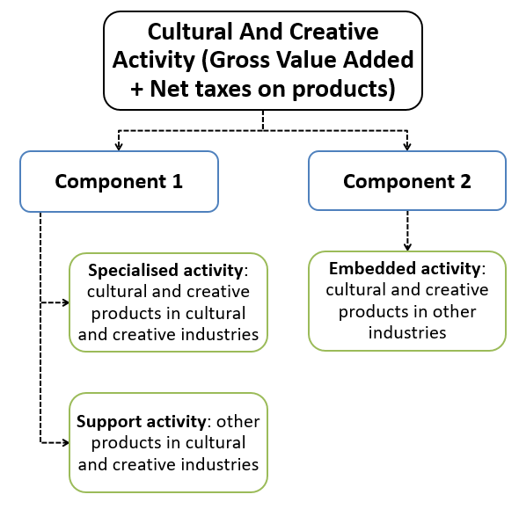

Source: BCARR.

This update allows the economic value of all three types of cultural and creative activity to be captured wholly through the production side of the economy – by products and industries – and is now measured using a consistent approach. This differs from the previous framework that estimated cultural and creative activity through both the production and income sides of the economy.

#### Updated estimation process

The new methodology moves to a best-practice approach to produce estimates by quantifying the economic value of cultural and creative activities through a four-step approach.

Figure . Updated estimation process to quantify the economic value of cultural and creative activity

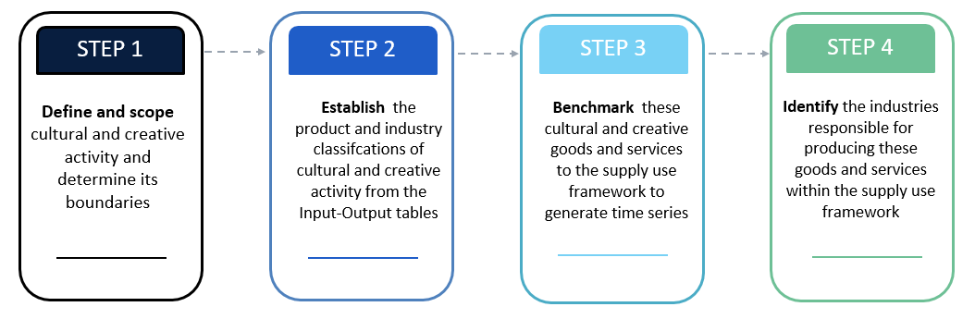

Source: BCARR.

#### Refined scope

The new scope of 28 cultural and creative industries – defined by the Australian and New Zealand Standard Industrial Classification (ANZSIC) – is narrower than the scope of the previous publication (with 43 ANZSIC industries). The estimated size of cultural and creative activity is therefore also smaller than in the previous report. Several of the main sources of ‘creative only’ activity in the previous scope, such as computer system design and clothing and footwear manufacturing, wholesaling and retailing have now been removed from the cultural and creative industry list.

#### Production-focused measures

The updated cultural and creative statistics are examined from the production side, which includes domestic output, gross value added (GVA) and gross domestic product (GDP). Estimates of compensation of employees for the cultural and creative workforce – which includes wages and salaries – are expected to be developed and released together with employment estimates in the next phase of this research.

Estimates of cultural and creative activity in this report are based solely on the national accounts production boundary, which excludes volunteering and non‑market based production. This exclusion is due to their activity not being captured in the GDP calculations. The emphasis on the direct economic contribution broadly aligns with cultural/creative satellite accounts developed in other countries. While this initial methodology refresh does not examine potential or intangible values from cultural and creative activity, BCARR will consider exploring these topics in future research.

### How was the impact of COVID-19 captured in this publication?

The new estimates cover the period from 2008–09 to 2022–23, including COVID-19’s impact on cultural and creative activity from March 2020 to June 2023.

COVID-19 and associated lockdowns negatively impacted many cultural and creative domains, such as: literature, creative and performing arts; visual arts and crafts; film and television activities; music production and distribution; and events (arts). However, some digital-related activities remained steady, such as software publishing, and internet publishing and broadcasting, which were buoyed by increased demand for software and internet-supported remote work and other business technologies.

## More information on the new scope

### How has the new scope of cultural and creative activity been decided?

The new scope was supported by a transparent decision-making framework developed by the department and used to determine which industry and product lists were included in the previous cultural and creative activity publications. This was a pragmatic approach created to make the scope consistent and transparent.

The framework is underpinned by existing theoretical models of cultural and creative industries, combined with criteria on whether industries have engaged with domestic cultural policy through various mechanisms, including through submissions to various arts and cultural policy consultation activities and parliamentary inquiries in the period 2013 to 2023.

Figure . Decision-making framework to determine the scope of cultural and creative industry and products

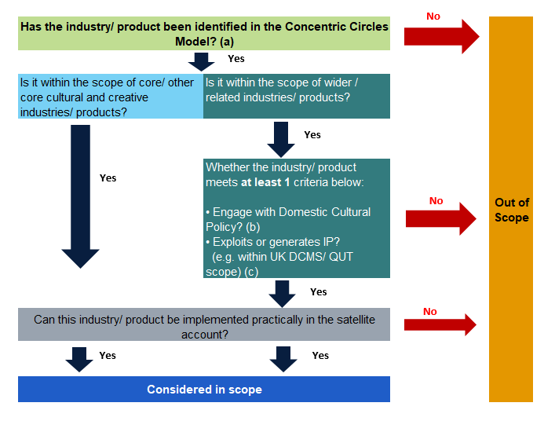

Source: Department of Infrastructure, Transport, Regional Development, Communications, and the Arts.

Notes:

* + - * 1. The Concentric Circles Model of cultural industries developed by Professor David Throsby includes four layers: *Core creative arts* (incl. Literature, Music, Performing arts, and Visual arts); *Other core creative industries* (incl. Film, Museums, Galleries, Photography, and Libraries); *Wider cultural industries* (incl. Sound recording, Television and radio, Video and computer games, Heritage services, and Publishing and print media); and *Related industries* (incl. Design, Fashion, Advertising, and Architecture).
        2. This criterion refers to the engagement with domestic cultural policy from the period 2013 to 2023.
        3. The UK Department of Culture, Media and Sport (DCMS)/ Queensland University of Technology (QUT) model defines creative industries as ‘those industries which have their origin in individual creativity, skill and talent and which have a potential for wealth and job creation through the generation and exploitation of intellectual property.’

### Why is the new scope of cultural and creative activity narrower than it was previously?

A key aim of the methodology refresh was for the cultural and creative sector to see itself in the new measure.

Most activities continue to be included in the new scope, particularly if the activity was considered both cultural *and* creative. However, several of the main sources of ‘creative only’ activity from the previous industry scope have been removed. These include computer system design and related services; clothing and footwear manufacturing, wholesaling and retailing.

For this reason, this report does not separately report activity as ‘cultural’, creative’ or ‘both cultural and creative’ as most products and industries now relate to both cultural *and* creative in the refined list.

### Why do we use a decision-making framework?

There is no universally-accepted definition for cultural and creative activity to guide scope. As such a decision-making framework was developed to make the scope consistent and transparent. The Concentric Circles Model was the principal framework used in this decision-making framework to determine the activities in scope for cultural and creative activity. The cultural and creative areas in which the Australian Government makes substantial investments are considered by many to be the ‘core’ creative arts and cultural industries. This concept has been articulated by the Concentric Circles Model in examining the structure of the sector, while these core parts of the sector also enable broader cultural and creative production that reaches into the more commercial realms of the economy.

The decision-making framework contains a criterion of industry engagement with domestic cultural policy over the previous decade (including the recent national cultural policy, parliamentary inquiries, and with older cultural policies such as the 2013 *Creative Australia* policy). Engagement with domestic cultural policy was one of two further criteria used in the decision-making framework. The other criterion was whether the industry or product exploits intellectual property. Activities which exploit intellectual property is in line with the creative industry models developed by the UK Department of Culture, Media and Sport (DCMS) and Queensland University of Technology (QUT), and captures some creative activity that is not captured by the domestic cultural policy criterion.

### Why are the new cultural and creative estimates smaller than previous BCARR releases?

The new scope’s exclusion of computer system design and related services, and clothing and footwear manufacturing, wholesaling and retailing industries is the main reason why the new estimates are much lower than the figures reported previously. Gross value added for these (now-excluded) industries was estimated at over $50 billion in 2019–20, and represented 41.4% of total cultural and creative GDP in the previous estimates.

## More information about the methodology

### What are the key differences between the methodology used in this publication and the approach used by the BCARR in 2018?

The new methodology for measuring the cultural and creative activity involves two elements that address issues highlighted in the previous methodology: an update to the framework used to scope and identify cultural and creative activity; and an update to the methodology used to produce estimates.

The framework update captures cultural and creative activity through a new ‘trident’ framework, by re‑identifying cultural and creative activity as specialised activity (cultural and creative products in cultural and creative industries), embedded activity (cultural and creative products in other industries outside the cultural and creative scope) and support activity (any other products outside the scope of cultural and creative products within cultural and creative industries).

To implement this new framework, a four-step approach has been applied. First, cultural and creative activity was defined conceptually. Second, lists of product and industry classifications of cultural and creative activity were established from the input-output tables. Third, the input-output outcomes were benchmarked to the supply‑use framework to generate the time series. Fourth, the industries responsible for producing these goods and services within the supply-use framework were then identified to estimate output, intermediate use and gross value added.

BCARR’s updated approach draws on additional sources of information that are not provided by the previous estimates, such as events activity. This proposed refresh is an important step to improve and ensure the relevance of future estimates of cultural and creative activity.

### How does this methodology compare to other nations, and across states and territories?

There is no universally agreed definition of cultural and creative activity. Several government and non‑government organisations have reported on the economic impact of cultural and/or creative industries. However, a range of statistical definitions and approaches have been used. Due to the variety of definitions used to classify cultural and creative activity, international comparisons are difficult to make.

However, the data source and methodology for the refresh is consistent with other satellite accounts frameworks such as the digital economy satellite account, which has been broadly adopted by many countries including Australia. For example, the refreshed methodology has estimated the cultural and creative activity GVA through an ‘output-associated’ approach – this approach was used by the US Bureau of Economic Analysis to measure the digital economy in 2018, and was further adopted in the Australian Bureau of Statistics’ *Australian digital activity satellite account* and the BCARR’s *digitalisation satellite account for measuring the Internet of Things, Information and Communications Technology, and digital activities*. In addition, using the input‑output tables and supply-use tables as the main data sources in the refreshed cultural and creative activity methodology is also consistent with the Australian and international digital activity satellite accounts. The department expects these consistencies will provide further opportunities to measure these emerging technologies within the cultural and creative sector in the future.

The cultural and creative economic contributions of states and territories have not been covered in either the new or previous estimates. In the department’s initial consultation paper, it was mentioned that state and territory estimates of cultural and creative activity would be examined. The department proposes to develop a methodology on state and territory disaggregation after the release of new estimates at the national level. This would need to be examined after estimates of cultural and creative employment are developed.

## Key findings in this report

Cultural and creative activity contributed $63.7 billion to the Australian economy in 2022–23, up from $39.4 billion in 2008–09. To put this into context, cultural and creative activity is comparable in size to Australia’s Agriculture, Forestry and Fishing industry, or the Accommodation and Food Services industry.

Some cultural and creative activities were particularly hard hit by COVID-19 and the associated lockdowns, closures and disruptions. Domains vulnerable to COVID-19 included Literature, creative and performing arts, Visual arts and crafts, Film and television activities, and Museums and galleries. However, there are signs of improvement, with these domains rebounding strongly from COVID-19, and cultural and creative activity’s share of the economy has been stabilising in recent years. Improved digital connectivity has also made some of the domains more accessible to consumers, such as internet publishing and broadcasting, to elevate the demand.

Cultural and creative activity has grown in absolute terms, but growth has been slower than the pace of growth for the Australian economy overall. This largely reflects the continued strength in the Mining industry (buoyed by high commodity prices), and the Health Care and Social Assistance industry (supported by an ageing population). These industries fall almost entirely outside of the scope of cultural and creative activity.

As a share of total Australian GDP, cultural and creative activity declined from 3.1% in 2008–09 to 2.5% in 2022–23, despite expanding by more than 60% in size (in nominal terms) over this time.

### Questions relating to domains

In the new scope, cultural and creative activities are grouped by 15 domains. The activities within the domains are grouped in terms of the input-output product classification (IOPC) codes, and the Australian and New Zealand Standard Industrial Classification 2006 (ANZSIC 06) class codes.

Fourteen of the 15 cultural and creative domains grew in nominal terms from 2008–09 to 2022–23. A substantial share of this growth occurred in domains which have large amounts of commercial activity, such as:

* Advertising and promotion which grew strongly over the period (↑$9.1 billion).
* Print media and publishing (excl. internet) grew over the period but now makes up a smaller share of GDP (↑$1.7 billion). The increase was mainly driven by software publishing activities that have experienced strong growth in recent years, but was offset by the decrease in newspaper, magazine and other periodic publishing activities.
* Film and television (↑$1.0 billion), and architecture services (↑$2.5 billion) both increased in nominal terms from 2008–09 to 2022–23.
* Only radio broadcasting decreased over the period (↓$24 million) driven by rising competition from online and cloud-based media platforms and falling demand from advertisers.

#### Which domain of cultural and creative activity experienced the largest increase?

Advertising and promotion experienced the largest increase from 2008–09 to 2022–23. This is the largest domain accounting for 27.0% of cultural and creative activity in 2022–23. Cultural and creative activity GDP in this domain increased by $9.1 billion, from $8.2 billion in 2008–09 to $17.2 billion in 2022–23.

The growth was mainly driven by advertising services, with an increase of $6.9 billion over the period. As a share of overall economy, this domain increased slightly, from 0.65% to 0.67% over the period. Increased content on internet-based platforms is bolstering demand for online advertising.

#### Which domain of cultural and creative activity experienced the strongest growth?

Digital games development has experienced the strongest growth from 2008–09 to 2022–23, with an average annual growth rate of 21.6% during the period. From its small base of initial activity, cultural and creative GDP in digital games development has increased significantly – from $24 million in 2008–09 to $344 million in 2022–23**.**

#### How is ‘events’ captured in the new publication?

The updated methodology provides opportunity to better capture other activities such as events activity. This activity was out of scope for the previous estimates because it could not be identified directly from the latest ANZSIC classification. The refreshed methodology resolved this issue by identifying events activity through the product details level.

In the new methodology, the definition of events activity refers to activities that provide event management, promotion and ticketing services, as well as other events-related administration services. It also includes theatre and concert booking services. Events activity is apportioned to include arts-related events but not sports-related event services.

#### How can I find out more about the activity captured in each domain?

More information on the size of cultural and creative activity in Australia by industry division and by each domain is provided in the BCARR’s statistical working paper *Cultural and Creative Activity from 2008–09 to 2022–23 (Methodology Refresh)*.

## More information about the consultation

### What was the consultation process for this methodology refresh?

The department undertook a stakeholder consultation process to inform the refresh of the methodological framework and the new scope for cultural and creative activity. Consultation involved two rounds of stakeholder engagement with industry, government and academic groups. The first round of consultation was from February to June 2023, which invited stakeholders to submit their feedback on BCARR’s proposed methodology through a ‘[*Have your say*](https://www.infrastructure.gov.au/have-your-say/cultural-and-creative-activity-satellite-accounts-methodology-refresh)’ webpage. The second round of consultation was from July 2023 to March 2024, with targeted stakeholder workshops in February and March 2024.

### How can I find stakeholder submissions to this consultation?

BCARR received 14 submissions from academia, business and industry bodies, individuals, and government for the first round of consultation. Ten of these submissions were published on the [*department’s website*](https://www.infrastructure.gov.au/have-your-say/cultural-and-creative-activity-satellite-accounts-methodology-refresh) after receiving consent from the author(s). These submissions were in addition to the feedback already provided by the Australian Bureau of Statistics who peer reviewed this work prior to the release of the consultation paper.

### What are the next steps for this consultation?

Following on from this measure of economic activity for cultural and creative activity, the department will engage with the Australian Bureau of Statistics and other stakeholders to develop methodologies to measure other types of cultural and creative statistics as part of subsequent phases of this research.

Figure . Topics proposed to be covered in the initial refresh and subsequent phases of the refresh

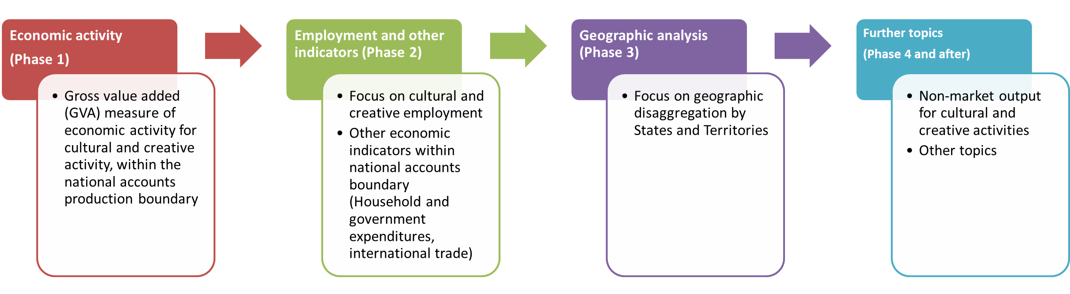

Source: BCARR.

1. Australian Bureau of Statistics (2021), Australian System of National Accounts: Concepts Sources and Methods, ABS Cat. no. 5216.0, p. 664.