Australian Government
Department of Infrastructure, Transport, Regional Development, Communications and the Arts

Proposed Amendments to the Powers and Immunities Framework - Consultation Paper

*Telecommunications (Low-Impact Facilities) Determination 2018* and T*elecommunications Code of Practice 2021*

November 2024



© Commonwealth of Australia 2024

Ownership of intellectual property rights in this publication

Unless otherwise noted, copyright (and any other intellectual property rights, if any) in this publication is owned by the Commonwealth of Australia (referred to below as the Commonwealth).

Disclaimer

The material contained in this publication is made available on the understanding that the Commonwealth is not providing professional advice, and that users exercise their own skill and care with respect to its use, and seek independent advice if necessary.

The Commonwealth makes no representations or warranties as to the contents or accuracy of the information contained in this publication. To the extent permitted by law, the Commonwealth disclaims liability to any person or organisation in respect of anything done, or omitted to be done, in reliance upon information contained in this publication.

Creative Commons licence



With the exception of (a) the Coat of Arms; (b) the Department of Infrastructure, Transport, Regional Development, Communications and the Arts photos and graphics; (c) content supplied by third parties; (d) content otherwise labelled; copyright in this publication is licensed under a Creative Commons BY Attribution 4.0 International Licence.

All images have been sourced externally with the written permission of the owner, and are intended to be for illustrative purposes.

Use of the Coat of Arms

The Department of the Prime Minister and Cabinet sets the terms under which the Coat of Arms is used. Please refer to the Commonwealth Coat of Arms - Information and Guidelines publication available at [http://www.pmc.gov.au](http://www.pmc.gov.au/).

Contact us

This publication is available in PDF format. All other rights are reserved, including in relation to any departmental logos or trademarks which may exist. For enquiries regarding the licence and any use of this publication, please contact:

The Director - Telecommunications Deployment Policy

Digital Inclusion and Deployment Branch

Email: [powersandimmunities@communications.gov.au](mailto:powersandimmunities@communications.gov.au)

Table of Contents

Purpose of the paper 4

Key questions 4

Background 5

Why are changes needed now? 6

The carriers’ powers and immunities framework 7

Part A – Proposed amendments in the draft LIFD 9

Increasing maximum dimensions of certain low-impact facilities 9

Radio and satellite terminal antenna or dishes – all areas 10

Omnidirectional antennas – all areas 10

Radiocommunications dishes – rural areas 11

Deploying radiocommunications facilities without a cabinet 12

Solar panel arrays – rural areas 12

Larger equipment shelters in rural areas 13

Increasing the volume on co-located facilities in residential areas 14

Determining cabling on bridges as a low-impact facility 15

Other amendments to the LIFD 17

Part B – Proposed amendments to the Code 18

Clarifying the requirement to provide Installation Certificates to Landowners and Occupiers 18

Part C: Other reforms to the Powers and Immunities Framework 19

Next Steps 20

Australian Privacy Principle 5 Notice 20

# Purpose of the paper

The Department of Infrastructure, Transport, Regional Development, Communications and the Arts (the department) is seeking views on proposed amendments to the *Telecommunications (Low-impact Facilities) Determination 2018* (the LIFD) and the *Telecommunications Code of Practice 2021* (the Code)*.*

The proposed changes for the LIFD include increases in the dimensions of some existing low-impact facilities, and the introduction of the installation of cabling on bridges. The changes for the Code clarify elements of the installation certificate provision and how it applies to land occupiers.

The proposed changes will help to enhance connectivity for all Australians by improving the efficiency with which telecommunications networks can be deployed, whilst enhancing the resiliency and energy usage of telecommunications infrastructure.

The discussion in this paper is set out in three sections:

* **Background**: This section provides an overview of Australians’ expectations for greater connectivity, the carriers’ powers and immunities framework, and the safeguards intended to balance the carriers’ need for an efficient and economic deployment framework against the interests and concerns of landowners;
* **Part A**: This section discusses each of the proposed amendments to the LIFD, which are outlined in the exposure draft of the Telecommunications (Low-impact Facilities) Amendment Determination 2024 (the draft LIFD);
* **Part B**: This section discusses the proposed amendments to the Code, which are outlined in the exposure draft of the Telecommunications Code of Practice (Installation Certificate Waivers) Amendment Instrument 2024 (the draft Code); and
* **Part C**: Other reforms to the powers and immunities framework.

Images used in this paper are for illustrative purposes, and where they are the intellectual property of a third party, the department has received written permission to use them.

## Key questions

The department is seeking views on the proposals outlined in this discussion paper and the draft LIFD and draft Code and have provided a series of key questions below to help guide responses. The department would also appreciate quantitative and/or qualitative supporting information to be provided to explain or demonstrate the particular positions set out in submissions.

Submissions received by the department as part of this consultation process will be used to inform the Australian Government’s decision about the content of the final legislative instruments. The consultation period will close on Monday, 2 December 2024.

Key questions

* + - What benefits or difficulties (financial or non-financial) would be incurred as a result of implementing the proposed LIFD and Code changes?
    - In what ways would these amendments improve connectivity, energy consumption and resiliency of telecommunications facilities?
    - Do these changes raise any concerns for landowners and occupiers? Can these issues be quantified and how could they be addressed?
    - What other factors should be taken into account when considering the proposed amendments to the LIFD and the Code? Are there alternative arrangements that could deliver the same outcome?

# Background

We live in an increasingly digital world, and our reliance on connectivity is an essential part of everyday life. Homes across Australia rely on connectivity on a daily basis enabling us to work from home, and to access remote learning, personal administration and telehealth support, as well as entertainment and other applications. Schools, hospitals, businesses and emergency services also rely on new technologies and connectivity to undertake daily operations in our community.

Earlier this year, the department undertook a national survey to learn more about wireless connectivity usage in Australia[1]. The survey found nine in ten Australians want better connectivity than what they currently experience and almost one in three Australians experience limited or no network coverage. A large portion of the Australian population indicated that poor wireless connectivity has a big impact on their personal (44%) and professional (35%) lives. A significant majority of Australians (92%) agree it is important for networks to expand to support growing communities[2].

The results from the national survey reinforce the findings and recommendations from a number of reviews, inquiries and reports which demonstrate coverage, capacity and reliability of telecommunications services as being of crucial importance, especially for Australians living in peri-urban, regional, rural and remote areas of Australia.

Summary of findings and recommendations from inquiries, reports and reviews

**A.** Findings 1 and 2 of the Australian Competition and Consumer Commission (ACCC’s) ***Regional Mobile Infrastructure Inquiry*** identified reliable and resilient mobile services as being vitally important to regional and remote Australians, and that the need for these services is heightened in emergencies and natural disasters. Regional and rural residents have concerns about coverage and congestion issues, especially when there appears to be less commercial incentive to invest in capacity upgrades in these areas[3].

**B.** The House of Representatives Standing Committee on Communications and the Arts ‘*Connecting the Country: Mission Critical’* report from its **Inquiry into co-investment in multi-carrier regional mobile infrastructure**, recommended the Government reform the carriers’ powers and immunities framework to enable mobile infrastructure to be deployed in regional, rural and peri-urban areas more swiftly, and encourage investment in ‘smart’ mobile infrastructure that incorporates renewable and decarbonised energy solutions[4].

**C.** The **Final Report of the Mobile Telecommunications Working Group** outlined a suite of agreed national principles to support streamlined planning approvals for telecommunications infrastructure.[5] The proposed changes to the LIFD and Code support the following national principles:

* + *There is a need for reliable mobile telecommunications connectivity:* recognising mobile telecommunications as an essential utility in all established and future growth areas, including the community expectation they will have access to a mobile service that has adequate coverage and capacity; and
  + *Responding to shifting demands on mobile telecommunications networks:* accepting and recognising demand on telecommunications networks and infrastructure will increase in new developments and growth areas which will need to be met with the deployment of additional telecommunications equipment and infrastructure to provide sufficient coverage and capacity to serve the area.

**D. The Australian Communications and Media Authority’s (ACMA’s)** reports assessing the resilience of telecommunications networks, such as the ‘*Impacts of the 2019-20 bushfires on the telecommunications network[6]’*, *‘Telecommunications outages – Sydney Storms, February 2020[7]’* andvarious other jurisdictional inquiries, found the primary cause of telecommunications outages in natural disasters is the failure of main power supply. The reports also found renewable energy solutions, such as solar panels, help mitigate the risk.

## Why are changes needed now?

Australians expect to have access to a reliable telecommunications service much in the same way as they expect they will have access to water and electricity. Connectivity is essential for driving national productivity growth and provides opportunities for all Australians regardless of where they live or work. To meet these connectivity needs, it is often necessary for carriers to deploy new infrastructure.

The Australian Government’s last substantial updates to the LIFD and the Code occurred in 2018 and 2021 respectively, which included changes to the dimensions of low-impact facilities and introduction of new conditions. Since these changes were implemented, there has been greater demand on both fixed line and mobile telecommunications services by Australians and carriers continue to upgrade existing networks and deploy new infrastructure to meet this demand. These deployments are balanced with the interests of landowners and occupiers through notification and objection processes, conditions carriers must comply with in the Code, and for certain low-impact facilities, consultation with local councils and communities in the *Mobile Phone Base Station Deployment Code* (C564:2020).[8]

The post-COVID environment has seen the continued decentralisation of Australia’s workforce from city and commercial centres to working from home, and for some, home has shifted to regional and rural areas. The Australian Bureau of Statistics notes 37 per cent of Australians work from home on a regular basis[9], and the National Library of Medicine notes approximately 70 per cent of Australians had used a telehealth appointment in the previous twelve months[10].

Additionally, Australians downloaded approximately 12.2 million terabytes of data across retail wired and wireless broadband services in the 3 months to 31 December 2022. This was 1.5 million terabytes more than the same period in 2021[11]. The sharp increase in data usage could be attributed to more Australians attending virtual meetings, accessing streaming platforms for entertainment, and utilising data intensive games and apps. In their *‘Trends and developments in telecommunications 2022-23 report’*, the ACMA acknowledged that ‘as data consumption grows, so does the need for more communications infrastructure.’[12]

For people to be able to realise the benefits of these services, telecommunications infrastructure is needed in their communities to help meet expectations and demand. The proposed amendments would enable more streamlined deployments for certain telecommunications facilities. This is balanced by appropriate safeguards, which can enable telecommunications equipment and infrastructure to be deployed and reduce the resource burden experienced by local councils.

The Australian Local Government Association’s (ALGA) submission to the House of Representatives Standing Committee on Regional Development, Infrastructure and Transport’s *Inquiry into Local Government Sustainability* notes “the local government sector faces significant skills shortages across a range of professions which leads to reduced productivity, service delivery and increased costs for local government” and “hinders progress on critical issues like housing and infrastructure development.”[13] Jobs and Skills Australia, established to provide advice to the Minister for Employment and Workplace Relations and Minister for Skills and Training on Australia’s current, emerging and future skills and training needs and priorities, noted in its submission there is a national shortage of urban and regional planners in all jurisdictions, except for the ACT.[14]

The proposed amendments to the LIFD and Code acknowledge these resourcing concerns from the local government sector and would enable deployments of telecommunications equipment to occur in a cost efficient and timely manner, while at the same time, ensuring appropriate safeguards are in place to protect the interests of landowners and communities.

More importantly, the proposed changes will improve connectivity, particularly in rural and regional areas, to help to provide real world economic, social and safety outcomes for everyday Australians. The 2022, ‘*Realising the potential of the next generation of mobile technology report’,* economic modelling estimates 5G will increase Australia’s GDP by $67 billion by 2030 based on the current trajectory for adoption[15]. However, an additional $27 billion could be realised by maintaining Australia’s global leadership position through accelerated adoption through various levers, such as improvements to legislation and policy[16].

## The carriers’ powers and immunities framework

Telecommunications companies have powers under Schedule 3 of the *Telecommunications Act 1997* (the Act) to inspect land, install ‘low-impact’ facilities, and to maintain any kind of telecommunications facility. They also have immunity from some state and territory laws when carrying out these activities, such as planning laws. This is referred to as the carriers’ powers and immunities (P&I) framework. This framework has been in place for over 20 years, and is essential in enabling the efficient construction and maintenance of telecommunications networks in a nationally consistent way.

Under subsection 6(3) of the Act, the Minister for Communications may, by legislative instrument, determine that a specified facility is a low-impact facility. The LIFD currently allows for carriers to install antennas, dishes, fibre optic cables and other infrastructure used to deliver broadband, landline and mobile communications services to the local community.

When exercising carrier powers, the Act imposes a range of conditions on carriers including a requirement to comply with the conditions set out in the Code. These obligations and conditions are intended to balance the carriers’ need for an efficient and nationally consistent deployment framework against the interests and concerns of landowners. For example:

* Telecommunications carriers are required to notify landowners and occupiers if they are planning to undertake upcoming works. This includes telling landowners and occupiers about plans to install telecommunications infrastructure, as well as the grounds and process for making an objection about the proposed work. A notice should be received by a landowner at least 10 business days before the carrier starts any activity on the land.
* Land owners and occupiers of land may object to proposed activity within certain timeframes. When a land owner or occupier objects, a carrier must make reasonable efforts to consult with the land owner or occupier about the activities. If the land owner or occupier and carrier are unable to resolve the objections, the land owner or occupier can ask the carrier to refer the objection to the TIO. If the land owner or occupier asks the carrier to refer the objection to the TIO, the carrier must do so.
* Telecommunications carriers are expected to engage with communities in a meaningful and sensitive way about proposed deployments of mobile phone base stations. The *Industry Code for Mobile Phone Base Station Deployment C564:2020* (Industry Code) sets out notification processes that telecommunications carriers should follow when installing certain low-impact facilities supporting mobile phone networks. The Industry Code is designed to ensure stakeholders are advised before a mobile phone base station is constructed, and that council and community views are taken into account.
* When carrying out activities using the P&I framework, telecommunications carriers must comply with a number of conditions within the Code, such as:
  + act in accordance with good engineering practices and interfere as little as possible with the landowner's use of the land,
  + comply with industry standards and codes registered by the ACMA,
  + give an engineering certificate to a landowner within 60 days of installing specific classes of facilities,
  + restore the land to a state similar to its condition before the activity began, and
  + keep and maintain records of certain types of facilities.

Complaints about a carrier’s compliance with its obligations under the Act or Code can be made to the ACMA on 1300 850 115 or by email to [info@acma.gov.au](mailto:info@acma.gov.au).

Further information about telecommunication deployments is available at the following pages on the department’s website:

* [Need for wireless connectivity](https://www.infrastructure.gov.au/media-communications-arts/spectrum/5g-and-eme/need-wireless-connectivity)
* [Improving mobile connectivity](http://www.infrastructure.gov.au/improving-mobile-connectivity)
* [Carriers' powers and immunities framework](http://www.infrastructure.gov.au/powers-and-immunities)

Part A – Proposed amendments in the draft LIFD

Part A of this paper outlines a series of proposed changes to the LIFD including:

* Increases in dimensions or sizes of some existing low-impact facilities;
* Removing a requirement for a cabinet to be installed on the same structure as a telecommunications facility (e.g. small cell);
* Introducing the installation of cabling on bridges as a low-impact facility; and
* Amending provisions to fix a drafting error or to provide greater clarity.

The existing safeguards and conditions specified in the Code will apply to these proposals, which includes the availability of objection grounds for landowners and occupiers to the TIO, and complaints to the ACMA about compliance with conditions and other obligations. Schedule 3 of the Act also provides for compensation to be payable should a landowner or occupier suffer financial or other damage from a carrier undertaking an activity using the P&I framework.

# Increasing maximum dimensions of certain low-impact facilities

There are a number of proposed changes to increase the maximum allowable dimensions for certain existing low-impact facilities. The increased dimensions are expected to enable better connectivity, while at the same time improve resilience and reduce the energy consumption of facilities.

Table 1: Summary of Proposed Changes to Existing Low-Impact Facilities Items

|  |  |  |
| --- | --- | --- |
| Provision in the LIFD | Proposed Amendment | Applicable Areas |
| Item 1, Part 1 of the Schedule | Increase satellite dish provisions from a maximum of 1.2m to 1.8m in diameter | Residential and Commercial |
| Item 2, Part 1 of the Schedule | Increase satellite dish provisions from a maximum of 1.8m to 2.4m in diameter | Industrial and Rural |
| Item 5, Part 1 of the Schedule | Increase maximum allowable height of an omnidirectional antenna or array of omnidirectional antennas from 4.5m to 6m | Residential, Commercial, Industrial and Rural |
| Item 7A, Part 1 of the Schedule | New provision increasing the maximum radiocommunications dish diameter from 2.4m to 3.8m | Rural |
| Item 8, Part 1 of the Schedule | Remove the existing requirement that a radiocommunications facility must be deployed with a cabinet | Residential, Commercial, Industrial and Rural |
| Item 4A, Part 3 of the Schedule | Increase maximum dimensions for equipment shelters | Industrial, Rural. |
| Item 7, Part 3 of the Schedule | Increase dimensions of solar panel arrays from 12.5m2 to 50m2 | Rural |
| Item 2, Part 8 of the Schedule | Increase the total co-location volume of facilities. | Residential and Commercial |

## Radio and satellite terminal antenna or dishes – all areas

Radio and satellite terminal antennas or dishes are generally used to support access to telecommunications services in extremely remote locations, including mainland Australia and the external territories. The proposed changes for residential and commercial areas also align with existing planning frameworks in some jurisdictions for such facilities, providing a nationally consistent approach.

The department is proposing amendments to Items 1 and 2 of Part 1 to the Schedule in the LIFD to increase the maximum diameter of a radio or satellite terminal antenna or dish that may be used to provide a subscriber connection in the following ways:

* For residential and commercial areas, it is proposed to increase the existing diameter size of 1.2m to 1.8m; and
* For industrial and rural areas, it is proposed to increase the existing diameter size of 1.8m to 2.4m.

The proposed amendments would help to provide more efficient use of satellite backhaul and access to higher speeds. It also provides better redundancy and energy use outcomes by providing greater resilience in inclement weather, and enabling the site to be powered by a lower power transmitter. the proposed changes can also improve connectivity in extremely remote locations, such as Norfolk Island.

## Omnidirectional antennas – all areas

The department is proposing an amendment to Item 5 of Part 1 to the Schedule of the LIFD to increase the maximum size of an omnidirectional antenna, or an array of omnidirectional antennas, by 1.5 metres in length. This would increase the current length from 4.5m to 6m, with no changes proposed to the distance between antenna (5m), or the protrusion height from a structure (2m).

An omnidirectional antenna is a type of antenna that can simultaneously transmit and receive radio waves equally in all directions. Omnidirectional antennas are used in various ways – from large, broadcasting antennas to smaller antennas used in mobile devices including mobile phones, FM radios and wireless computer networks. The proposed changes would enable the deployment of omnidirectional antennas intended to support point-to-multipoint base stations for communications via mobile radio, such as by police and other emergency services, including rural fire services. These types of antennas are typically deployed in central locations, such as the centre of a building rooftop or on top of an existing tower or pole, to maximise the coverage area.

An example of the type of omnidirectional antenna the proposed changes would support is provided in the Figure below.

Image One: An example of an Omnidirectional antenna

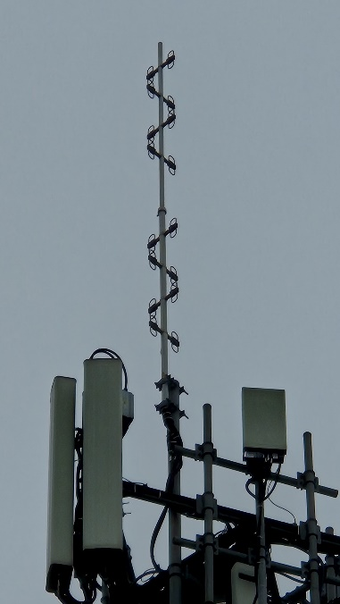

|  |
| --- |
|  |
|  |

The department understands that carriers, to support emergency services organisations, are experiencing delays in rolling out these longer antennas because they are not included as low-impact facilities and consequently, need to obtain approval under planning arrangements. The proposed change would assist emergency service organisations by enabling these longer antennas to be deployed faster than under current arrangements, ensuring additional and improved coverage is provided for the areas they are intended to serve. Emergency service organisations also expect to co-locate these antennas on existing, well-established telecommunications and broadcasting sites, which further minimises the need for additional planning approval as the deployments would be undertaken with the agreement of the infrastructure owner.

## Radiocommunications dishes – rural areas

The department is proposing an amendment to include a new Item 7A of Part 1 of the Schedule to the LIFD to increase the maximum size of radiocommunications dishes in rural areas.

The department understands that carriers will typically deploy large format microwave dishes on existing and built-up telecommunications towers including broadcasting sites. The LIFD currently allows for radio communications dishes of no more than 2.4 metres in diameter to be deployed as low-impact facilities in rural and industrial areas. The proposal would see the maximum diameter of the radiocommunication dish increase to 3.8 metres, and if attached to a structure, for the protrusion to be no greater than 2 metres.

Image Two: Image of various sized radiocommunications dishes with their approximate sizes

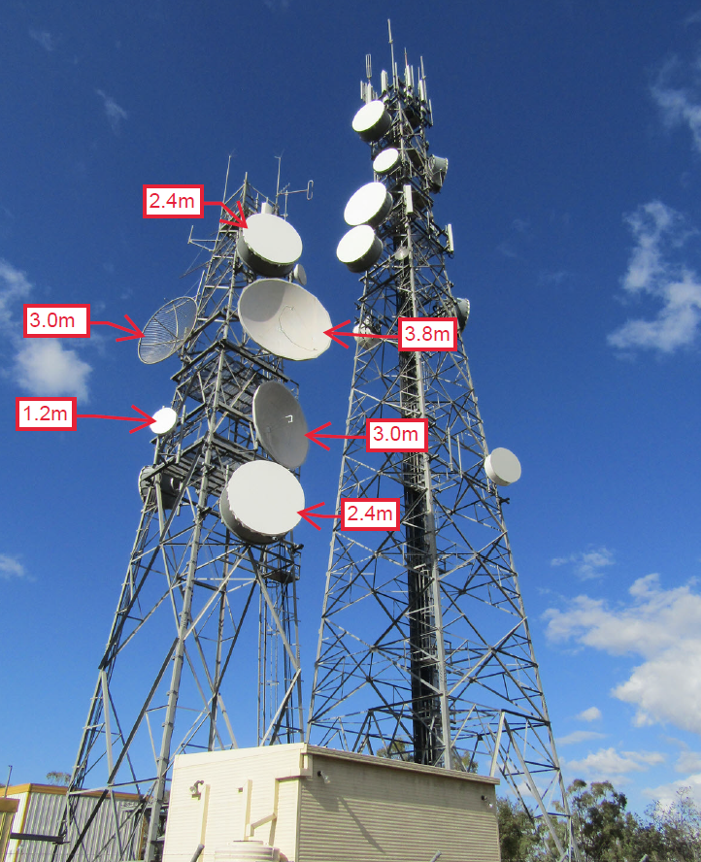

These types of microwave dishes are typically used to facilitate backhaul communications for mobile voice and data traffic and, depending on the location, facilitate Universal Service Obligation connectivity. Radiocommunications dishes of 3.8 metres provide high capacity throughout for transmission links that are beyond 60km. The larger microwave dishes will help support existing mobile connectivity while ensuring that carriers can meet expectations of customers in increasing data demand in rural and remote locations.

## Deploying radiocommunications facilities without a cabinet

The department is proposing to amend Item 8 of Part 1 of the Schedule to the LIFD to allow carriers the option to deploy certain radiocommunications facilities without a cabinet. These facilities are also commonly referred to as ‘small cells’.

Contemporary small cell designs used by some carriers in their networks no longer require an external/separate cabinet or adjacent equipment shelter to provide mobile telecommunications services to customers. This has resulted in better visual and deployment outcomes as small cells can be deployed more discreetly and in other settings (like mounted on the side of a building), while still delivering on coverage and quality objectives.

Where a carrier does require a cabinet, the cabinet can be deployed as a low-impact facility with the carrier including the relevant Item from a different Part of the Schedule to the LIFD on the notice to be provided to the landowner and/or occupier.

The proposed change to the radiocommunications facility provision in the LIFD will not impact a carriers’ requirement to consult with local councils and communities under section 5 of the *Mobile Phone Base Station Deployment Industry Code (C564:2020).*

## Solar panel arrays – rural areas

The department proposes to increase the maximum size of solar panels in Item 7 of Part 3 of the Schedule to the LIFD from 12.5m2 to 50m2 in areas defined as rural. A rural area is defined in the LIFD as:

* an area where ‘its principle designated use is for rural purposes’; and
* an ‘area that is not part of a built‑up area is a rural area if it cannot otherwise be described as a commercial, industrial or residential area’.

This means a carrier would not be able to build a solar array in a ‘residential’, ‘industrial’ or ‘commercial’ area in a regional township. The proposed change would allow a solar array on available rural land on the roads leading in or away from the township, for example.

The change would enable carriers to deploy approximately 24 individual solar panels accommodating an area of up to 50m2, and generate a peak power output of approximately 12kW used to power a telecommunications facility. An example of a solar array of this approximate size is in the Figure below.

Image Three: An example of an approx. 50m2 solar array.

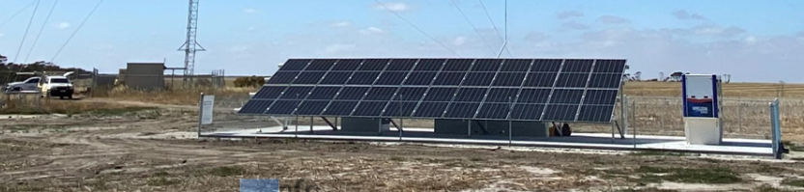

Enabling the deployment of solar panels in rural areas as a low-impact facility can improve the resiliency of telecommunications facilities in these areas, especially in reducing reliance on mains power as the single energy supply to operate the facility. The main cause of telecommunications outages in rural and remote areas is from impacts to main power supply, including during natural disasters. Once power supply to a telecommunications facility is impacted, connectivity can be lost if there is no back up or alternative power solution to power the site. Solar panels are a cost-effective solution that can add an additional layer of redundancy to help keep telecommunications facilities operating and importantly, keep communities connected.

In some remote rural areas, solar panels are becoming the main source of power for telecommunications facilities, supported by back up batteries and diesel generators. Along with solar being a sustainable energy source, constructing a solar panel array can be quicker than waiting to connect a remote site to a more traditional main power supply (i.e. poles and wires).

The proposed amendment enables the deployment of solar panel arrays as the main power source for a telecommunications facility. These types of deployments are referred to as standalone power systems or SAPs.

Case study

In Western Australia, Telstra and Horizon Power partnered to deploy a standalone power system (SAP) at a telecommunications site at Mount Ney, Western Australia. The area had previously been impacted by bushfires in 2015, which resulted in widespread telecommunications and power outages.

The SAP enables the telecommunications site to operate completely ‘off grid’ from the electricity network, reducing the sites’ carbon footprint while, at the same time, improving resiliency of the site from future natural disasters.

The department understands that Horizon Power were able to use statutory powers available to it under Western Australian legislation to deploy the SAP without the need for planning approval.

The proposed amendment to the LIFD would enable carriers to undertake similar installations of SAPs to support telecommunications facilities in rural and remote areas without the need to partner with another entity and reduce the costs and delays associated with obtaining planning approval.

## Larger equipment shelters in rural areas

The department is proposing to insert Item 4A in Part 3 of the LIFD that would enable large equipment shelters to be constructed in industrial and rural areas to provide sufficient space and storage for additional equipment to help improve redundancy and resilience in these areas. The requirement to seek planning approvals will be required for all other areas. While there are existing provisions in the LIFD for equipment shelters that apply in all areas defined in the LIFD, the size of these shelters will not suit the types of equipment expected to be stored.

The proposed maximum dimensions for equipment shelters in rural areas is proposed to increase from 12.5m2 to a maximum of 52m2, which equates to 13.0 metres (L) x 4 metres (W) x 5.0 metres (H). The department is interested in views on the proposed height dimension of 5.0m.

The typical use case of these larger format equipment shelters will be used to house telecommunications equipment, batteries for power redundancy and resiliency, and air conditioning equipment to enable a carrier to connect customers and business to a telecommunications network.

Case Study: Telstra’s Intercity Fibre Network

Telstra has committed $1.6 billion to build a new, national, sovereign fibre backbone, the intercity fibre network. The intercity fibre network aims to future-proof Australia’s connectivity needs for the next 20+ years and support Australia’s digitalisation needs and ambitions to be more productive and provide a secure economic future for everyone, wherever they are located.

Much of Telstra’s current long-haul fibre in the ground was installed in the 1980’s and 90’s, before the current digital age, and is at or nearing capacity in many areas. Australia’s data demands are expected to grow at rates of 24-33% compound annual growth rate (2032) which the existing fibre infrastructure cannot support.

The intercity fibre network aims to allow for future access to areas of Australia currently underserviced or not served at all by fibre connectivity, allowing for an increase in digital inclusion and opportunity in these areas. The new network will also provide important connectivity to Australia’s subsea cable landing stations to help support and enable global connectivity.

The intercity fibre network will deliver transmission rates of up to 650 Gbps and will also deliver express connectivity between capital cities of up to 55 terabits per second (Tbps) per fibre pair capacity compared to today’s 8.8 Tbps per fibre pair.

To interconnect this new national network, larger format equipment shelters will need to be installed along the fibre paths to regenerate optical fibre signals, spur fibre pairs to customers, power optical, routing and switching equipment, cool active network elements and have the necessary room to accommodate battery backup systems in the case of power failure, and possibly accommodate other third-party vendor equipment.

For some equipment shelters located in very remote regions of Australia, equipment will be powered exclusively by solar with battery backup systems powering network elements when there is no solar generation.

Other potential use case examples of the types of equipment that could be stored in the proposed shelters include temporary facilities, such as Cells on Wheels or NBN Road Muster trucks. These types of temporary facilities can be installed under the LIFD in certain circumstances to provide additional coverage and capacity during seasonal events or tourism, to support maintenance activities, and to be deployed in response to emergencies, such as natural disasters. Additionally, larger equipment shelters could be used to store ancillary facilities, such as generators for larger telecommunications facilities, batteries and bundles of cabling for maintenance purposes. Having this equipment available in rural areas can help reduce delays associated with upgrading or repairing equipment when necessary.

There are safeguards provided in the P&I framework that can protect the interests of landowners and occupiers when carriers propose to install larger equipment shelters in rural areas. For example:

* existing notification and objection processes for landowners and occupiers;
* compensation is available for acquisition of property and if a person suffers financial loss or damage because of an inspection, installation or maintenance activity undertaken by a carrier;
* carriers must comply with various safety and operational requirements set out in the Code, such as:
  + act in accordance with good engineering practices,
  + interfere as little as possible with the landowner's use of the land,
  + restore the land to a state similar to its condition before the activity began.

## Increasing the volume on co-located facilities in residential areas

This proposed change amends item 2 of Part 8 of the Schedule to the LIFD to increase the volume to co-located facilities in residential areas from 25 percent to 50 percent. Currently, when installing certain low-impact facilities in a residential area the total co-location volume of those facilities cannot be more than 25 percent greater than the volume of the original facility or original infrastructure. It is important to note the 50 percent for co-location already applies in commercial areas under the LIFD.

This amendment builds on specific findings and recommendations made in various reports and inquiries regarding co-location:

Summary of co-location findings and recommendations from inquiries and reports

**A.** The **House of Representatives Standing Committee on Communications and the Arts** ‘The Next Gen Future’ report from its ‘**Inquiry into deployment, adoption and application of 5G’**, which recommended the Australian Government commence a review of the low-impact facilities framework to ensure that its powers encourage co-location of facilities and equipment in a 5G environment.

**B.** The **Final Report of the Mobile Telecommunications Working Group** outlined a suite of agreed national principles to support streamlined planning approvals for telecommunications infrastructure.[17] The proposed changes to the co-location provisions would support the following national principles:

* + *Responding to shifting demands on mobile telecommunications networks:* accepting and recognising demand on telecommunications networks and infrastructure will increase in new developments and growth areas which will need to be met with the deployment of additional telecommunications equipment and infrastructure to provide sufficient coverage and capacity to serve the area.
  + Promoting infrastructure sharing, and its benefits, in deployments: Acknowledging the benefits of co-location of telecommunications equipment such as reduced deployment and operation costs, network reliability, improved competition, and reduced environmental impacts.

Improving connectivity to increase greater consumer demands means that more telecommunications infrastructure will be required. The proposed increase in co-location volumes means that carriers can install facilities on existing telecommunications and public infrastructure. The proposed change would result in less large telecommunications infrastructure having to be installed in residential areas, reducing concerns about overall visual amenity from the community.

## Determining cabling on bridges as a low-impact facility

This proposed change would require new Items 11, 12 and 13 in Part 3 of the Schedule to the LIFD to be included determining the installation of cabling on a bridge, either in new or existing conduit, to be a low-impact facility. The changes would allow for cabling and conduit to be installed on a bridge for both fixed line and mobile connectivity purposes.

Summarised, the changes would allow for:

* Cabling that is attached to, on, under, or within a bridge;
* Cabling within existing conduit deployed by a carrier that is attached to, on, under or within a bridge; and
* Cabling or conduit within existing ducts of a bridge.

It is noted that the use of ‘within’ is intended to enable a carrier to install cabling within existing ducts of a bridge. If the proposed items are ultimately agreed to by the Minister for Communications, the supporting explanatory statement for the instrument would outline this policy intent.

The department understands that the deployment of cabling and conduit on bridges using either the installation or maintenance powers under the P&I framework has been a long-standing industry practice. However, two separate legal proceedings in 2023 regarding the deployment of cabling and conduit on a bridge utilising the P&I framework found that it is not permitted, either using the carrier’s installation[18] or maintenance powers[19].

In the first case, the High Court of Australia dismissed an appeal from the appellant Court. The effect of this High Court’s decision means the installation of fibre optic cabling through existing conduit owned by another carrier utilising ‘maintenance’ powers is not currently permitted. Similarly, in the second case, the Federal Court found that installation of cabling and conduit on a bridge did not constitute an ‘ancillary facility’ under the LIFD, and therefore could not be permitted as a ‘low-impact facility’.

As a result of the legal proceedings, carriers are now required to obtain development approvals to install cabling and conduit on bridges. This has resulted in carriers being required to negotiate separate tenure agreements for every installation, and often having to submit a development application. This has also resulted in timeframes being significantly lengthened and increased costs for carriers, resulting in deployments either being delayed or not being commercially viable. This not only results in poorer connectivity for communities, but can result in perverse outcomes, such as carriers having to trench under riverbeds to install cabling and conduit.

Case study 2: Alternative deployment option – underwater cable

Following the recent legal proceedings, a carrier had to find an alternative means to deploy cabling and conduit across Lane Cove River in New South Wales.

The carrier identified the only solution was to undertake trenching in the riverbed of Lane Cove River. The carrier had to seek multiple development approvals to undertake the works, which included a full environmental impact analysis. The overall process of finding a suitable location, submitting and receiving a response on the development application and finalising the works took 16 months. Of this time period, the installation of the cabling and conduit took five days.

Not only were there considerable delays due to the activity not being considered a ‘low-impact’ facility, it resulted in significant increases in deployment costs for the carrier. More importantly, however, is that the work caused significant ecological disturbance to the riverbed, impacted riparian zones and surrounding parkland access by the community.

There are also existing conditions in the Code that will apply to the installation of cabling and conduit on bridges, including:

Table: Conditions in the Code applicable to the proposed cabling on bridges item.

|  |  |
| --- | --- |
| Section of the Code | Explanation |
| Section 1A.3 | A carrier must, in connection with carrying out a prescribed activity take all reasonable steps to:   * act in accordance with good engineering practice; and * protect the safety of persons and property; and * ensure that the activity interferes as little as practicable with:   + the operations of a public utility; and   + public roads and paths; and   + the movement of traffic; and   + the use of land; and * protect the environment. |
| Section 1A.8 | In engaging in a prescribed activity or a temporary defence facility activity, a carrier must take all reasonable steps to ensure that the carrier causes as little detriment and inconvenience, and does as little damage, as is practicable. |
| Section 1A.9 | A carrier must take all reasonable steps to ensure that the land is restored to a condition similar to its condition before an activity began. |
| Section 1A.11 | If an installation is likely to affect the operations of a public utility, the carrier must make reasonable efforts to enter into an agreement with the utility that makes provision for the manner in which the carrier will engage in the activity. |
| Section 1A.12 | A carrier must give written notice of its intention to:   * close, divert or narrow a road or bridge; * install a facility on, over or under a road or bridge; * alter the position of a water, sewerage or gas main or pipe; and * alter the position of an electricity cable or wire   to the person or authority responsible for the care and management of the thing affected by the activity. |

## Other amendments to the LIFD

There are other minor proposed changes to the LIFD, either to correct drafting errors or help to clarify existing provisions. These amendments are summarised in the table below:

Table: A summary of other amendments to the LIFD

|  |  |  |
| --- | --- | --- |
| Provision in the LIFD | Proposed Amendment | Reason for Proposed Amendment |
| Items 1, 3, 4 of Part 1 of the Schedule, and Items 4, 4A and 5 of Part 3 | Amendment the reference from ‘local authority’ to ‘local government authority’. | Under section 1.5 of the LIFD, local government authority is defined. However, there has been a long-standing drafting error in certain provision that refers to ‘local authority’. The proposed amendment is to correct the existing drafting error. |
| Heading of Part 3 | Amend the title of Part 3 from ‘Part 3 – Above Ground Housing’ to ‘Part 3 – Above ground housing and facilities’ | The proposed amendment better reflects the existing facilities in Part 3. |

# Part B – Proposed amendments to the Code

## Clarifying the requirement to provide Installation Certificates to Landowners and Occupiers

The department is considering a proposal to amend section 1A.7 of the Code to allow landowners and occupiers the power to waive the requirement for an installation certificate separately. Additionally, the department is proposing to allow either a landowner or occupier to waive the requirement if they have an agreement between themselves that allows them to do so.

Currently under subsection 1A.7(1) of Code, the carrier must provide the landowners and any occupier of the land with installation certifications within 60 days of completing the installation of a facility on the land. Subsection 1A.7(3) gives the landowner the ability to waive the requirement, but not the occupier.

The proposed changes to allow for the following:

* A landowner to waive the requirement for an installation certificate on their own behalf;
* An occupier to waive the requirement for an installation certificate on their own behalf;
* A landowner to waive the requirement for an installation certificate on their own behalf, and the behalf of the occupier, where an agreement is in place between the parties; or
* An occupier to waive the requirement for an installation certificate on their own behalf, and the behalf of the landowner, where an agreement is in place between the parties.

The proposed changes do not diminish a carrier’s requirement to provide an installation certificate to a landowner or occupier – rather, it empowers either party to waive the requirement if they elect to do so, or if either party is empowered to do so under an existing agreement.

Since the 2021 amendments to the Code, the three mobile network operators have divested their tower assets. This has resulted in separate Mobile Network Infrastructure Providers (MNIPs) being established, that now own and manage tower infrastructure. The department understands that often MNIPs can have agreements in place with landowners that include provisions around installation certificates. The proposed changes would allow either the landowner or the occupier to waive the installation requirement, or either party to waive it on the other’s behalf if an agreement is in place between them.

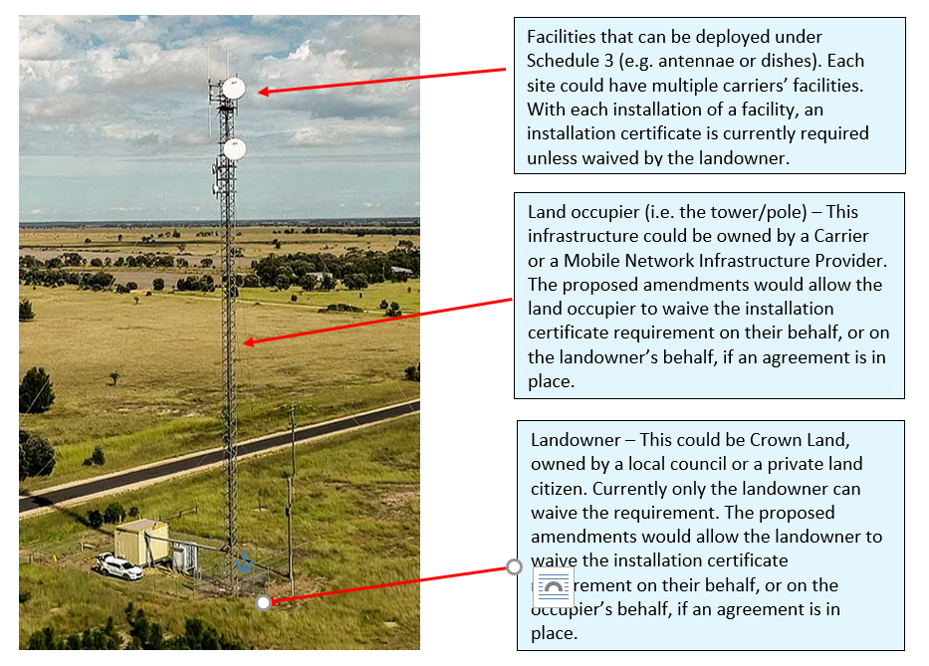

# Part C: Other reforms to the Powers and Immunities Framework

The Powers and Immunities Reference Group (P&I Reference Group), comprising peak bodies from the telecommunications and landowner sectors, considered a number of policy issues across 2022 including:

* streamlined arrangements for the deployment of Multi-Functional poles, such as the possibility for poles to be specified as a low-impact facility,
* the management of redundant telecommunications facilities, and
* the development of an industry code to improve consultation before carriers’ access commercial high-rise buildings to undertake P&I activities.

The P&I Reference Group reached consensus on proposed measures to manage redundant telecommunications facilities and recommendations to consider in the development of an industry code on accessing commercial high-rise buildings. The P&I Reference Group did not reach consensus on streamlined arrangements for the deployment of poles.

The department notes the following regarding these matters:

* ***Multi-Functional Poles:*** The department is considering this matter in the broader context, given the delivery of the Mobile Telecommunications Working Group’s Final Report. Discussions are continuing with some stakeholders including in relation to developing guidelines and agreements, as appropriate.
* ***Redundant Facilities:*** Changes to the *Telecommunications Act 1997* would likely be required to establish a redundant facilities framework, as well as changes to other existing Commonwealth legislation. Given this, establishing a framework for the removal of redundant facilities is subject to an opportunity to enact these reforms through changes to primary legislation.
* ***Industry Code for high rise buildings:*** In November 2023, Minister Rowland wrote to Communications Alliance, seeking for this body of work to be put on their 2024 Work Plan. Communications Alliance agreed to undertake a review of the Guideline and, consequently, in February 2024 sought stakeholder representation for participation in a working committee. This work is awaiting agreement from interested landowner stakeholders to establish a working group to address these matters.

# Next Steps

The department welcomes views from interested members of the public on whether the proposed amendments to the LIFD and Code of Practice as drafted, achieves its intended purpose of modernising and removing unnecessary barriers.

Please include:

* contact name
* organisation name, if applicable
* contact details, including telephone number, postal and email addresses
* confirmation whether or not your submission can be made public—published—or kept confidential.

All submissions to be made public need to meet the [Digital Service Standard](https://www.digital.gov.au/policy/digital-experience/digital-service-standard) for accessibility.

Any submission that does not meet this standard may be modified before being made public.

If your submission can be made public, please ensure you do not include any personal information that you do not want to be published.

If your submission is confidential, please ensure each page of the submission is marked as confidential.

**Please click on the 'Have your say' link below to either upload your submission or provide short comments.**

Have your say – Amending the Powers and Immunities Framework

Comments can also be made:

* By email to: [powersandimmunties@communications.gov.au](mailto:powersandimmunties@communications.gov.au)
* By mail to:  
  Director, Telecommunications Deployment Policy

Digital Inclusion & Deployment Branch

Department of Infrastructure, Transport, Regional Development, Communications and the Arts

GPO Box 594

CANBERRA ACT 2601

Comments must be received by **5:00pm Australian Eastern Standard Time, 2 December 2024**

# Australian Privacy Principle 5 Notice

The department is collecting information for the purposes of amending the Telecommunications Code of Practice 2021 in accordance with the *Privacy Act 1988*.

The department will use this information to inform consideration of issues associated with amending the Regulations and will store this information securely. It may be used by the department to make further contact with you about the review.

The department will not disclose information to third parties, except in the circumstances outlined below.

Submissions, in part or full, including the name of the author may be published on the department's website unless the submission is confidential. Confidential submissions or short comments (including the author's name) will not be published. Private addresses and contact details will not be published or disclosed to any third parties unless required by law.

Submissions will only be treated as confidential if they are expressly stated to be confidential. Automatically generated confidentiality statements or disclaimers appended to an email do not suffice for this purpose. If you wish you make a confidential submission, you should indicate this by ensuring your submission is marked confidential.

Confidential submissions will be kept securely and will only be disclosed in the following circumstances:

* in response to a request by a Commonwealth Minister
* where required by a House or a Committee of the Parliament of the Commonwealth of Australia
* where required by law.

The department may also disclose confidential submissions within the Commonwealth of Australia, including with other Commonwealth agencies, where necessary in the public interest.

Please note that in order to protect the personal privacy of individuals in accordance with the Privacy Act any submissions containing sensitive information, personal information or information which may reasonably be used to identify a person or group of people may not be published, even if not marked as confidential.

The department's privacy policy contains information regarding complaint handling processes and how to access and/or seek correction of personal information held by the department. The Privacy Officer can be contacted on 02 6274 6495 or by email: [privacy@infrastructure.gov.au](mailto:privacy@infrastructure.gov.au).

1. A copy of the Telecommunications Usage Survey Report and fact sheet is available at [www.infrastructure.gov.au/media-communications-arts/spectrum/5g-and-eme/need-wireless-connectivity](https://www.infrastructure.gov.au/media-communications-arts/spectrum/5g-and-eme/need-wireless-connectivity)
2. Telecommunications Usage Survey Report - <https://www.infrastructure.gov.au/sites/default/files/documents/telecommunications-usage-survey-report.pdf>
3. ACCC’s Regional Mobile Infrastructure Inquiry – Final Report – Recommendation Nine
4. House of Representatives ‘Connecting the country: Mission Critical’ Report, Recommendation 12
5. The Final Report of the Mobile Telecommunications Working Group is available at [www.infrastructure.gov.au/improving-mobile-connectivity](http://www.infrastructure.gov.au/improving-mobile-connectivity)
6. ACMA’s ‘Impacts of the 2019-20 bushfires on the telecommunications network’, dated April 2020
7. ACMA’s ‘Telecommunications outages – Sydney storms report’, dated February 2020
8. Communications Alliance has undertaken a review of the Code and are proposing to submit to the ACMA shortly.
9. Australian Bureau of Statistics, Media Release, 13 December 2023.
10. National Library of Medicine, ‘Patient Use, Experience, and Satisfaction With Telehealth in an Australian Population (Reimagining Health Care): Web-Based Survey Study’, < https://www.ncbi.nlm.nih.gov/pmc/articles/PMC10472164/>
11. ACMA, ‘Trends and developments in telecommunications 2022–23 Report’, page 2 < [Trends and develo https://www.acma.gov.au/sites/default/files/2023-12/Trends%20and%20developments%20in%20telecommunications%202022-23_0.pdfpments in telecommunications 2022-23 (acma.gov.au)](https://www.acma.gov.au/sites/default/files/2023-12/Trends%20and%20developments%20in%20telecommunications%202022-23_0.pdf)>
12. As above, page 2
13. ALGA submission number 181, page 5. Available at <https://www.aph.gov.au/Parliamentary_Business/Committees/House/Regional_Development_Infrastructure_and_Transport/Localgovernmentsustaina/Submissions>
14. Jobs and Skills Australia submission number 64, page 4.
15. ‘*Realising the potential of the next generation of mobile technology report’,* dated 2022, page 14
16. ‘*Realising the potential of the next generation of mobile technology report’,* dated 2022, page 14
17. The Final Report of the Mobile Telecommunications Working Group is available at [www.infrastructure.gov.au/improving-mobile-connectivity](http://www.infrastructure.gov.au/improving-mobile-connectivity)
18. Optus Fixed Infrastructure Pty Limited v State of Queensland & Anor [2023] HCATrans 86 (16 June 2023)
19. Optus Fixed Infrastructure Pty Ltd v Telecommunications Industry Ombudsman [2023] FCA 928