|  |  |
| --- | --- |
| To | Bureau of Communications, Arts and Regional Research, [bcarr@infrastructure.gov.au](mailto:bcar@infrastructure.gov.au) |
| From | Glenn Rothberg (Dr) |
| Subject | **Feedback to**  **“Cultural and Creative Activity Satellite Accounts Methodology Refresh Consultation paper, February 2023”** |

**Feedback to Creative Satellite Account Consultation Paper**

**Contents**

Outline 2

Views about Creativity: Five Problems 2

Public Sector Sources 2

Problem 1: Recognising the Wider Roles of Culture and Creativity 3

Problem 2: Overstated National Creative Impact of The Arts 5

Problem 3: Arts Sector Under-Rates Creativity of Industry Sectors 7

Problem 4: Creative ‘Occupation’ is Unrealistic Indicator of Creative Value 9

Problem 5: Unclear Whether ‘Creative Australia’ is Fit for Purpose 11

Suggested Solutions: The Creativity Canvas 11

References 11

# Outline

There is a very important role for creativity in Australia. Currently, it is undervalued.

Creativity contributes to adding value across twenty [ANZSIC](https://www.abs.gov.au/statistics/classifications/australian-and-new-zealand-standard-industrial-classification-anzsic/2006-revision-2-0/division-definitions) designated (public and private) industry sectors in Australia. The evidence (and reality) is that, while creativity contributes to national value, the source of creativity is far broader than (an advocated focus on) The Creative Arts sector. In fact, **most** measured value added in Australia (and creativity) appears to be provided by the non-Arts sectors of Industry.

However, if public policy is based on a limited, special, or unrepresentative public sector narrative or canvas about creativity – rather than what actually happens – then the consequential national outcomes, including the value that creativity adds, may be compromised. I think that there are shortcomings – and special cases – in the current public sector views and announcements about creativity. So, for the Bureau of Communications, Arts and Regional Research (BCARR) I provide feedback[1] based on a composite of public sector views and announcements about creativity.

I suggest that there are at least five problems with BCARR’s vision, concept, and methodology in its benchmark approach to The Arts addressing creativity. These problems include: role recognition, overstatement and understatement of creativity impacts, measurement relevancy, and sector over-reach.

So, I argue that, as special cases – because they are not reflecting what actually happens with creativity – some BCARR approaches (including ‘Satellite’ methodology) may contribute to a dysfunctional national perspective.

They also raise an issue as to whether some of the currently espoused public sector policy approaches to creativity - and Ministerial announcements - are fit for purpose. I suggest that, as part of a national perspective, BCARR’s approach to creativity requires a fundamental revision.

# Views about Creativity: Five Problems

## Public Sector Sources

I refer to the following views about creativity:

* 21st April 2023, Office for the Arts, National Cultural Policy Taskforce, BCARR letter (Ref MC23-060280) in email, in response to my email 24th March 2023 to Minister Tony Burke;
* [BCARR, February 2023](https://www.infrastructure.gov.au/have-your-say/cultural-and-creative-activity-satellite-accounts-methodology-refresh), Cultural and Creative Activity Satellite Accounts Methodology Refresh: Consultation paper;
* January 30th 2023, ‘Revive’ and ‘Creative Australia’[*Prime Minister’s announcement*](https://www.pm.gov.au/media/revive-australias-new-national-cultural-policy) *(jointly with Minister for Employment, Workplace Relations and the Arts), and* [*The Australia Council for the Arts*](https://australiacouncil.gov.au/news/media-releases/towards-creative-australia-a-bold-new-era-for-australian-arts-and-creativity/)*.*;
* [Throsby, D. (2008)](https://www.tandfonline.com/doi/abs/10.1080/09548960802361951) The Concentric Circles Model of the Cultural Industries, *Cultural Trends.*

## Problem 1: Recognising the Wider Roles of Culture and Creativity

There are wider and more relevant roles for “culture” and “creativity” than accommodated by BCARR. That is, what is assumed and defined, appears to have (mistakenly) influenced BCARR views about the roles of culture and creativity: what they are, and what they do, and what might be measured.

Thus, for understanding and addressing culture and creativity, BCARR meanders among describing them as: industries, sectors, commodities, products, economies, and occupations.

I argue that culture may be understood in any and every organisation through values and activities, reflected in the way in which colleagues engage, behave, and interact. These relationships, although invisible, reflect the culture - positive, negative, friendly, unfriendly, toxic, motivating – and so on - that may impact creativity.

However, contrary to appreciating culture as invisible relationships, it is claimed (supported by BCARR) that there is a cultural industry. I think this is inaccurate and misleading.

First, it is misleading (of BCARR) to portray culture and creativity as merely residing within the Arts, as the following suggests: **“**While there is no universally‑accepted definition, the terms ‘cultural’ and ‘creative’ are used to describe activities connected with the arts, media, heritage, design, fashion, and information technology.[2] “, (BCARR, p.6).

Second, the BCARR notion of “the cultural industries” – is based on their apparent cultural content – and is derived from a Concentric Circles Model (Throsby, 2008). According to The Concentric Circles Model, the industries that produce cultural goods and services, and the main industries they contain, are illustrated in diagrammatic form in Figure 1, (from Throsby, 2008, p.149).

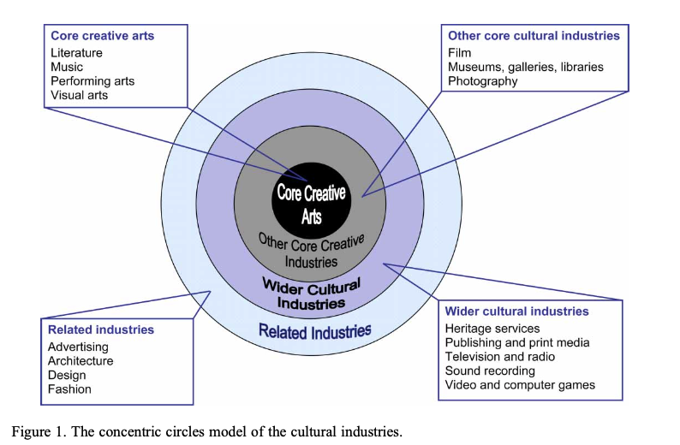

Here, it is assumed that there is “emphasis on primary **creative ideas** as the driving force that propels the cultural industries and that distinguishes them from other industries in the economy”, (Throsby, 2008, p.156). The problem is that this incorrectly suggests that the role of ideas is largely present in some (cultural) industries, and largely absent from others. I disagree: and so too, does the evidence. Further, and in contradiction, there is advocacy for defining “cultural goods and services as a distinct **commodity** class, and indeed is a distinction that is common to a variety of fields, concerned with the value of cultural phenomena”, (Throsby, 2008, p.148).

Clearly, relationships, including creative ones that matter, are not restricted to particular **industries**, sectors, occupations, or individuals. For example, it is claimed that UNESCO Cultural Ministers agree upon culture and creativity in terms of “industries which have their origin in individual creativity- DCMS”; and “engaged in a creative occupation – NESTA”, (BCARR, p.9). However, what “Cultural” Ministers say, or do, may have no relevance for relationships among colleagues in their organisations, and whether and how they add value, from time to time.

As a sample dataset, illustrated below, also evident elsewhere, and across civilization, what happens with creativity is not necessarily based on particular industries, or notional “creative’ occupations. For example, despite the observed creativity of medical science, BCARR does not include it as a creative industry. So, here are some Australian examples of Creative Medical Science.

| **Creative Medical Science** | |
| --- | --- |
| Spray-on Skin | In 1999, Perth-based plastic surgeon Professor Fiona Wood patented the spray-on skin technique. The innovation involves taking a small patch of the victim’s healthy skin and using it to grow new skin cells in a laboratory.  The new skin cells, sprayed on the victim’s damaged skin, significantly reduces recovery time and scarring. |
| Medical Application of Penicillin | In 1939, Australian scientist Howard Florey purified penicillin from a special strain of mould. The team demonstrated penicillin’s ability to fight bacterial infection in mice and, later, humans. The antibiotic was mass produced and used to save lives by combating infection from common bacteria. |
| Cochlear Implant (bionic ear) | Professor Graeme Clark invented the first bionic ear at Melbourne University in the 1970s. These devices - Cochlear implants – are implanted into the head to electronically stimulate the auditory nerve, bringing hearing to those whose hearing is impaired. |
| Ultrasound Scanner | In 1976 Ausonics commercialised the ultrasound scanner. Studying ultrasound from 1959 onwards, the Ultrasonics Research Section of the Commonwealth Acoustics Laboratories Branch (later to become the Ultrasonic Institute) discovered a way to differentiate ultrasound echoes bouncing off soft tissue in the body and converting them to TV images. The discovery gave expectant parents a window to the foetus without x-ray exposure, and the technology is also used in the diagnoses of medical problems of the breast, abdomen, and reproductive organs. |
| Gardasil and Cervarix Cancer Vaccines | In 2006, Brisbane-based medical researchers Professor Ian Frazer and Dr Jian Zhou developed the world’s first anti-cancer vaccine – Gardasil.  The vaccine protects women against four strains of a virus called human papillomavirus (HPV) – the cause of many cervical cancers. |

## Problem 2: Overstated National Creative Impact of The Arts

In my view, advocacy and support by BCARR for the Concentric Circles Model (Throsby 2008) cannot be justified. That is because, I think that the key assumptions for the (defined) structure of the concentric circles model are unrealistic. For example, it is assumed, but not evidenced, that the creative arts (literature, music, drama, dance, visual art) are placed at the centre (of the Concentric Circles Model) and other industries are grouped around them, (Throsby, 2008, p.148).

The problem is that, while this assumption “accords primacy to the processes of artistic (as distinct from scientific) creativity”, (Throsby, 2008, p.149), the primacy of artistic creativity over scientific creativity is not consistent with historical fact. Creativity is evident, possible and desirable for individual industry sectors, along the lines of: Creative Science, Creative Finance, Creative Information, Creative Manufacturing, and so on. That is, the (BCARR) presumed centrality of the creative arts is not witnessed among many value-adding industry sector outcomes, such as the following recent examples from the Transport sector, in Australia.

| **Creative Transport** | |
| --- | --- |
| Black box flight recorder | The black box flight recorder, which records the final moments of a crashed plane’s last flight has contributed to the safety of commercial air travel. Now installed on every commercial plane, it was invented by Australian scientist Dr David Warren, whose father died in a Bass Strait aircraft tragedy in 1934. The device helps investigators fix what was wrong by listening to a recording of the last conversations between crew and other sounds inside the plane before it crashed. |
| Winged Keel | Ben Lexcen, an Australian yachtsman and marine architect, invented the winged keel – a nearly horizontal foil, or wing, at the base of a sailing boat keel.  They are typically found on high-performance sail boats. The winged keel made its debut in 1983 in America’s Cup on *Australia II* |
| Inflatable Escape Slide and Raft | In 1965 Jack Grant, an employee of Qantas, invented the inflatable aircraft escape slide, which is now mandatory safety equipment on all major airlines.  The slides can also be used as a flotation device if the aircraft lands on water. |

## Problem 3: Arts Sector Under-Rates Creativity of Industry Sectors

While creativity is difficult to measure, value added, by Industry sector, is not. In the National Accounts, across Industry sectors, value added is measured – by [Australian Bureau of Statistics](https://www.abs.gov.au/). So, among Industry sectors, value added is an outcome that can be used as a rough proxy for indicating the presence, absence, contribution, or impact of creativity.

Indeed, we can rank industry sectors according to their contribution to national added value: this can provide some indication of the spread, availability, and impact of creativity across the nation.

Provided below is some evidence of where value-added activity occurs in Australia, across twenty industry sectors, across five decades. This 47-year average (1975 to 2022) is derived from ABS 5204.0 Australian System of National Accounts, [Table 5, Gross Value Added (GVA) by Industry](https://www.abs.gov.au/statistics/economy/national-accounts/australian-system-national-accounts/latest-release#data-downloads).

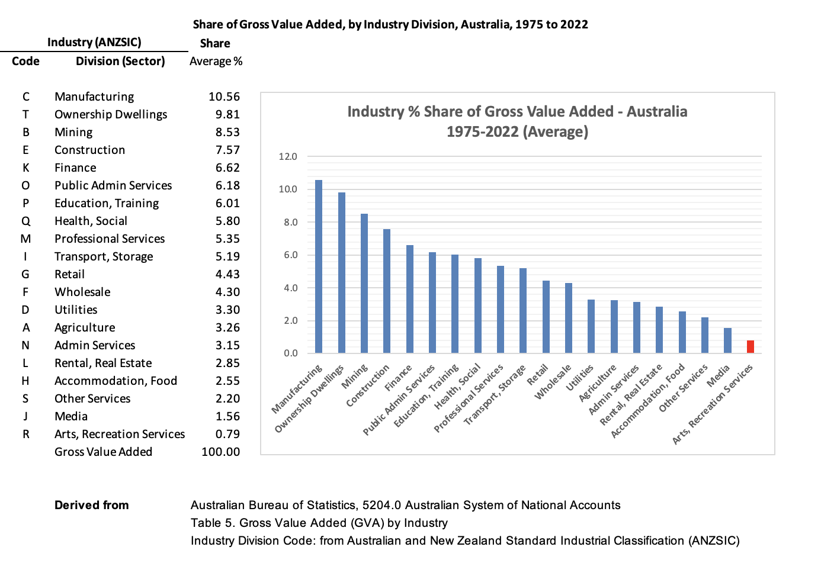



The above chart, which embodies creativity, ranks industry sectors according to their contribution to national added value.

* + The five largest value-adding sectors in Australia are: Manufacturing (10.6%), Dwelling ownership (9.8%), Mining (8.5%), Construction (7.6%), and Finance (6.6%).
  + The five smallest value-adding sectors in Australia are: **Arts and Recreation Services (0.8%)**, Media (1.6%), Other Services (2.2%), Accommodation and Food (2.6%), and Rental and Real Estate (2.9%).

Clearly, given that its value-adding contribution is measured as minor, it would appear to be a problem of overstatement to refer to The Arts sector (and its ancillaries) as “The Creative Sector” or “The Creative Economy”.

As the above Chart shows, a focus on the Creative Arts sector would under-rate creativity that happens elsewhere in Australia, such as in the following examples from Finance and Business.

| **Creative Finance and Business** | |
| --- | --- |
| Polymer Bank Notes | Plastic bank notes were developed in a combined effort by the Reserve Bank of Australia and CSIRO in the 1980s. Made from a special polymer - instead of the traditional bank notes made from paper, cloth fibres or a combination of both – and including a series of in-built security devices, plastic bank notes are almost impossible to counterfeit and last about ten times longer than traditional bank notes. |
| Plastic Spectacle Lenses | In 1960 Sola Optical released the first scratch-resistant plastic lens for glasses. The technology was further developed to create the first plastic bifocal, trifocal, and progressive-focus lenses.  Plastic lenses are used throughout the world due to their many benefits including safety, their light weight, and durability. |
| Permanent-Crease Clothing | In 1957, CSIRO developed a process called Si-Ro-Set. The technique uses chemicals to permanently alter the structure of wool fibres so they can be set with heat. This technology allowed for fashion innovations such as permanently pleated skirts. |
| Frazier Lens | In 1993, Australian inventor Jim Frazier’s deep-focus lens was patented in the United States. His innovative lens allowed for both the subject and background to be in focus at the same time. It also has the ability to rotate without the movement of the camera. Commonly used in movies and film throughout the world, the inventor of the lens received an Academy Award in 1998 for this contribution. |

## 

## Problem 4: Creative ‘Occupation’ is Unrealistic Indicator of Creative Value

As noted, the concept of the Concentric Circle Model is of doubtful validity, or a special case, and is effectively based on an assumption about the existence of (very limited) cultural industries. Consistent with the (largely irrelevant) BCARR notion that occupations are on a spectrum between creative and non-creative, irrespective of whether value is produced by them, the BCARR methodology then proceeds to find, and support, a proxy for “cultural content”, - “empirical evidence to illustrate the [concentric circle] model’s application”.

Apparently, according to some research, empirical data on “creative occupations” is used to illustrate the model’s key characteristic: that the cultural content of the output of the cultural industries declines as one moves outwards from the core, (Throsby, 2008, p.147). However, if “cultural content declines beyond the core”, so what?

This seems to be about the employment of apparently ‘creative’ specialists. What’s the point? There are specialists in every industry! That is, as Creative Artists tend to be employed in the Creative Arts, so: Scientists tend to populate Science; Engineers tend to populate Engineering and Construction; Medical Practitioners tend to populate Medicine; Architects tend to populate Architecture; Actors tend to populate Theatre, Drama and Entertainment; Farmers tend to populate Farming and Agriculture; Miners tend to populate Mining; Teachers tend to populate Education.

It is not surprising that the employment of sector specialists declines as one moves outwards from the core of the sector. So, the empirical data – creative occupations data - laboriously collected, across continents, appears to reveal very little of any relevance or significance.

The problem is: creative occupations in a self-referencing creative arts sector, is hardly an argument for demonstrating much that is useful, including a ‘creative Trident’[3] (Throsby, 2008, p.152).

Specifically - and contrary to BCARR advocacy, and satellite methodology upgrading - occupation is an unlikely and unrealistic indicator of creative value. The problem is that within a given occupation, a person may be creative, at any time, depending on the circumstances. It is not the occupation that is creative, but the person in conjunction with a range of attributes – none of which are subject to so-called Satellite methodology.

As a further example, I doubt that The Concentric Circle Model, with its apparent emphasis on so-called creative occupations, could explain how its core features account for the following cases within Creative Electronics.

| **Creative Electronics** | |
| --- | --- |
| Electronic Pacemaker | Australian doctor Mark Lidwill and physicist Edgar Booth developed the first artificial pacemaker in the 1920s.  Artificial pacemakers, implanted inside the body, send small electric charges into the heart to help it maintain a regular beat to keep the heart beating properly. |
| Google Maps | Danish brothers Lars and Jens Rasmussen developed the platform for Google Maps in Sydney in the early 2000s. Along with Australians Neil Gordon and Stephen Ma, they founded a small start-up company called Where 2 Technologies in 2003. The following year it was bought by internet giant Google, which also hired the four men, and the technology was turned into what we now know as Google Maps. |
| Electric Drill | In 1889, Australian electrical engineer Arthur James Arnot patented the world’s first electric drill with his colleague William Brain.  It was subsequently developed as the portable hand-drill. |
| Wi-Fi Technology | In 1992 John O’ Sullivan and the CSIRO developed Wi-Fi technology, used by more than a billion people around the world today.  The core parts of the technology came out of research in the mid-1970s in the field of radio astronomy. |

## Problem 5: Unclear Whether ‘Creative Australia’ is Fit for Purpose

Recently there has been a welcome upgrading of The Australian Council for the Arts. This occurred within the *30th January 2023,* [*Prime Minister’s announcement*](https://www.pm.gov.au/media/revive-australias-new-national-cultural-policy) *(jointly with Minister for Employment, Workplace Relations and the Arts), and* [*The Australia Council for the Arts*](https://australiacouncil.gov.au/news/media-releases/towards-creative-australia-a-bold-new-era-for-australian-arts-and-creativity/)*.*

However, for its inclusion of the term “Creative Australia”, this announcement about the Creative Arts introduces some ambiguity. That is because the term “Creative Australia” implies creativity across the nation – among all 20 Industry[4] sectors.

Clearly, addressing the role of creativity across Australia remains a larger canvas than the several special cases of creativity offered and embedded in The Arts/The Creative Arts sector’s notion of ‘Revive’, including music, writing, histories, stories and art education. In this way, a (national) notion of “Creative Australia” appears to be unsupported by the upgrading of The Australian Council for the Arts.

# Suggested Solutions: The Creativity Canvas

Here are two suggestions for BCARR consideration to improve the national creativity canvas.

First, revise the descriptive accuracy of The Arts sector’s current title to reflect its role, as Creative Arts Australia. Changing the title to Creative **Arts** Australia avoids misleading Industry, and Parliament, about an overstated role for The Arts in national creative tasks.

Second, revise the focus of Creative Arts Australia to partnering national value adding and Industry Breakthrough. Creativity is an important intermediary for the potential value it can add. I suggest that the current Arts-based concepts of creativity could be meaningfully and more appropriately enhanced through a broader canvas that themes the role of Breakthrough in adding value across Industry sectors. Involved – with creativity and beyond – Breakthrough witnesses a range of interaction and progression activities including: ideas, vision, people, processes, technology, skills and competencies; origin, acceptance, implementation and value capture. In consideration, I have developed “*The General Theory of Breakthrough: Achieving Game-Changer Value*” which: is published as a [print book](https://www.amazon.com/General-Theory-Breakthrough-Achieving-Game-Changer/dp/B0BJH7MJ1Y/ref=sr_1) on Amazon; is also available [online](https://www.amazon.com/General-Theory-Breakthrough-Achieving-Game-Changer/dp/B0BJH7MJ1Y/ref=sr_1) as an Apple Book; is outlined in a recent [Journal of Creativity](https://doi.org/10.1016/j.yjoc.2022.100033) article; and is introduced in a brief [video](https://youtu.be/LzXkCDM8t5o).

# References

Australian Bureau of Statistics (2014), Information Paper: Cultural and Creative Activity Satellite Accounts, Australia, ABS Cat. no. 5271.0.55.002

[BCARR 2023](https://www.infrastructure.gov.au/sites/default/files/documents/cultural-and-creative-activity-satellite-accounts-methodology-refresh-consultation-paper-february2023_0.pdf), “Cultural and Creative Activity Satellite Accounts Methodology Refresh: Consultation paper”, February 2023

Rothberg, Glenn (2022), [“The General Theory of Breakthrough: Achieving Game-Changer Value”, Kindle/Amazon, USA, 185 pages](https://www.amazon.com/General-Theory-Breakthrough-Achieving-Game-Changer/dp/B0BJH7MJ1Y/ref=sr_1)

Throsby, D. (2008), The Concentric Circles model of the Cultural Industries, Cultural Trends, 17:3, 147-164, <http://dx.doi.org/10.1080/09548960802361951>p. 151.

1. This arises from a request for feedback from Cultural and Creative Activity Satellite Accounts Methodology Refresh: Consultation paper, February 2023, and its invitation to provide feedback ([BCARR, February 2023](https://www.infrastructure.gov.au/have-your-say/cultural-and-creative-activity-satellite-accounts-methodology-refresh))
2.
3. While the Trident is about “non-market activity, such as volunteer services and the non‑market output of cultural and creative industries”, (BCARR, p.5): this seems to be largely an irrelevant issue to understanding and capturing what creativity is, what it does, and the outcomes of value it produces.
4. ANZSIC basis