

Stage 2 Reforms of the Disability Standards for Accessible Public Transport 2002

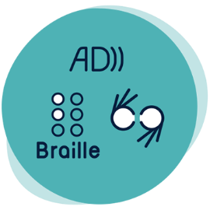

Signs, symbols, braille: Braille and tactile lettering for signage

The Transport Standards contain inconsistent braille requirements and this presents challenges to braille readers. If information is not presented in proper format, some braille users may be unable to access key journey information. There is an opportunity to clearly define the braille and tactile signage requirements and design standards to reflect braille best practice and align these with related requirements under the Premises Standards.

## Reform options

### Maintain current requirements in the Transport Standards

Transport Standards Section 17.6 *Raised lettering or symbols or use of braille*, would remain unchanged and no new guidance would be issued.

### Non-regulatory option

Guidance would be provided to include best practice advice on braille and tactile signage, including:

* Definition of tactile signage
* How to translate text to braille
* Location of signage
* How braille and tactile signage should align with the Premises Standards
* Advice to consult with the disability community if stated requirements cannot be met

### Regulatory option

Transport Standards Section 17.6 would be removed and replaced with new requirements for braille and tactile design.

New requirements would be included in the Transport Standards for:

* Braille and tactile labels
* Braille and tactile signs
* Braille design requirements
* Tactile design requirements

These requirements would apply to conveyances, infrastructure and premises (except premises to which the Premises Standards apply).

The Transport Standards Guidelines would be updated to reflect new requirements.

## Have your say

Public consultation on the Stage 2 reform of the Transport Standards will open from 15 March to 9 August 2022.

For further information:

* **Website:** [https://www.infrastructure.gov.au](https://www.infrastructure.gov.au/infrastructure-transport-vehicles/transport-accessibility)
* **Call:** 1800 621 372
* **Email:** [DisabilityTransport@infrastructure.gov.au](mailto:DisabilityTransport@infrastructure.gov.au)
* **Survey:** <https://edm.infrastructure.gov.au/survey.php?sid=28663&name=braille-and-tactile-lettering-for-signage>