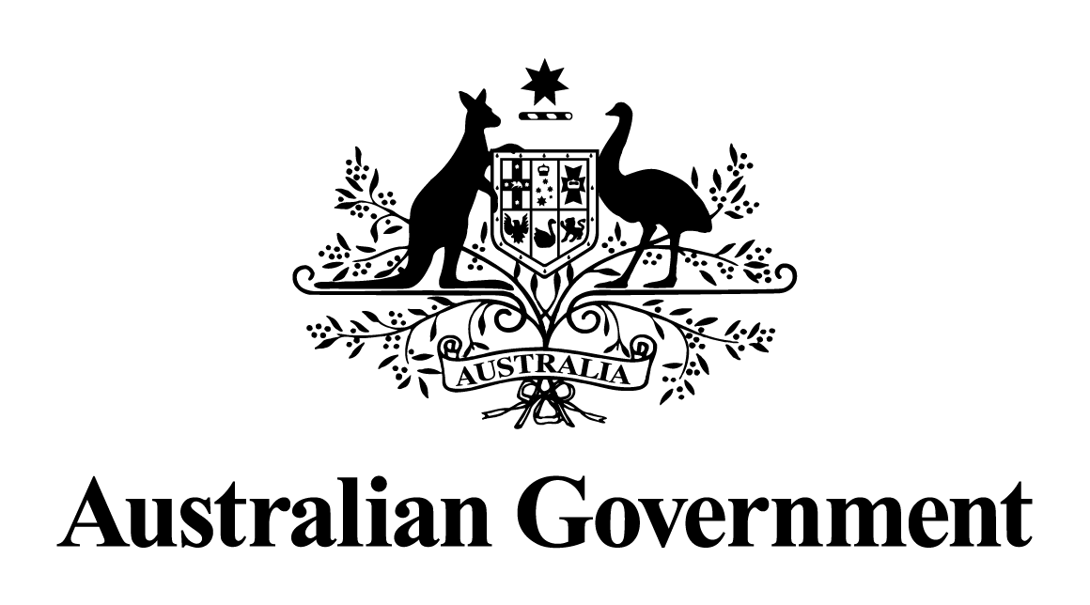

# Australian Government response to the Senate Standing Committees on Environment and Communications Legislation Committee report:

Interactive Gambling Amendment (Credit and Other Measures) Bill 2023 [Provisions]

February 2025

## Overview

The Australian Government is committed to online gambling taking place under a robust legislative framework with strong consumer protections.

The Australian Government welcomes the report by the Senate Standing Committees on Environment and Communications Legislation Committee (the committee) into the Interactive Gambling Amendment (Credit and Other Measures) Bill 2023 [provisions], which was tabled on 12 October 2023.

The *Interactive Gambling Amendment (Credit and Other Measures) Act 2023* passed the Parliament on 6 December 2023, and commenced in full on 11 June 2024. The legislation amends the *Interactive Gambling Act 2001* (the IGA) to prohibit the use of credit cards, credit-related products and digital currency as payment methods for interactive wagering services. The ban does not capture lottery services, which, together with keno-type lotteries, are not included in the definition of ‘wagering services’ (betting on racing and sports) under the IGA.

The Government also legislated to provide the Australian Communications and Media Authority with enforceable undertakings and remedial directions powers to enforce the credit card prohibition and other online gambling offences.

The ban is consistent with the Government’s online gambling harm reduction initiatives, including:

* Implementing monthly activity statements so Australians who gamble online can clearly see their wins and losses each month;
* Requiring all staff who work in online gambling companies to have appropriate training to create a culture of safer gambling;
* Introducing new evidence-based taglines with stronger messages about the risks and harms of online gambling;
* Strengthening classification of gambling-like features in video games to better protect children;
* Establishing mandatory pre-verification to prevent children and people who have self-excluded to place an online bet; and
* Launching the National Self-Exclusion Register (BetStop), which has been used by more than 37,000 Australians (as at January 2025), with 40% of those opting for self-imposed lifetime bans.

## Australian Government response

The Australian Government’s response to the committee’s report is set out in detail below.

### Recommendation 2:

2.64 The committee recommends that the Minister for Communications undertake a review over the next 12 months into the regulation of keno-type lotteries under the Interactive Gambling Act 2001. The review should consider the potential for how credit and digital payment bans and other harm reduction policies may be applied to keno-type lotteries.

The Government **supports** this recommendation.

The Australian Government, through the Department of Infrastructure, Transport, Regional Development, Communications and the Arts (the department) commenced a review into the regulation of online keno under the IGA on 15 July 2024*.*

Online keno is a game of chance, drawn every 3 minutes that offers players the opportunity to win prizes by selecting numbers and matching them with the drawn numbers. It is considered to be a type of lottery under the IGA.

The department also used the opportunity to seek feedback from stakeholders on the regulation of another emerging online lottery service under the IGA – foreign matched lotteries – which allows Australians to access international lottery draws, when they would otherwise be ineligible to do so. These overseas lotteries offer large jackpots, sometimes worth hundreds of millions of dollars.

Foreign matched lotteries, along with some online keno products are currently promoted to Australians via a variety of mediums including direct marketing (e.g. emails), out of home (e.g. billboards), television, radio, social media, sporting ground advertising and sports sponsorship.

The review included targeted consultation with stakeholders from the wagering, lottery and harm minimisation advocates, community and charity peak bodies, academics, states and territories and Commonwealth agencies.

Stakeholders were asked to provide feedback to a series of questions, including whether the current definition of an ‘excluded lottery service’ under the IGA is fit for purpose, and whether harm reduction policy options, including credit and digital payment bans, or other restrictions, should be applied to these types of online lottery products.

The review has been completed, and the Government will consider the final recommendations.