This document comprises questions sent by AAB community members to be addressed at or prior to the AAB meeting on 20 November 2024, with responses.

|  | **Questions** | **Response** | **Further action** | **Deadline** |
| --- | --- | --- | --- | --- |
| **1** | **Runway closure Saturday 2 November 2024**  On Saturday 2 November, Legacy Runway was shut without any notice to residents for an entire day. This meant that NPR took all arrivals and departures for the entire day.  There was no notice on Webtrak, and 4 hours or more after the closure had already started Brisbane Airport Corporation put up a notice on Facebook to say that it would be shut until 6pm. | | | |
| 1.1 | Why was notice not given to Brisbane residents by either BAC or ASA? | **BAC**  The closure was unplanned and occurred due to a pavement failure. It was not possible to provide advance notification. |  |  |
| 1.2 | When notice was ﬁnally given via a post on Facebook why was it so delayed? | **BAC**  For planned maintenance related runway closures BAC takes a proactive approach to providing advance notification. However, on this occasion the runway closure was caused by a pavement failure at the juncture of bitumen and concrete surfaces. This appeared to be caused by recent periods of heavy rain that resulted in some sub-surface movement. The runway was closed at around 6am for repairs, with the intention of a rapid repair and a quick restoration of normal operations. Some services are not readily available on weekend days (contracting staff, asphalt plant) and so the repairs took significantly longer than anticipated. The Facebook post was published when it became apparent the closure would be for an extended period of time. |  |  |
|  |  | **Airservices**  Airservices is able to provide advance notification via WebTrak and on the NCIS rolling banner of planned operational changes. This particular event was an unplanned issue that resulted in changes to operations. It also occurred on a weekend when our website managers are not available. |  |  |
| 1.3 | What other methods did BAC or ASA use to notify residents of this event? | **BAC**  BAC normally uses social media channels and posts on the BNE website to inform residents of significant events. This has been in place for a number of years and feedback has been positive about this approach. | BAC would consider the use of other channels of communication, and would appreciate any suggestions from AAB members. |  |
| 1.4 | What suggestions do BAC and ASA have for improving the system of notifying Brisbane residents in a timely manner and when can these improvements be implemented? |  | BAC would consider the use of other channels of communication, and would appreciate any suggestions from AAB members. |  |
|  |  | **Airservices**  Airservices does not currently have any other tools that it could use on weekends to provide notification of unplanned changes. | We are in the process of adding mode information to WebTrak so communities can see what mode is being used. | First half of 2025. |
| **2** | **Increasing ﬂight numbers**  It seems that currently the public only get notice of new airline services for Brisbane Airport through social media announcements from Brisbane Airport Corporation. | | | |
| 2.1 | Is it correct that there is no process for notifying residents of an increase in ﬂights from an airline, either an increase in frequency of a current service, or the start of a brand new service, even though each additional plane has a direct impact on residents overﬂown by it? | **BAC**  In general, high profile new services (e.g. Brisbane – Dallas) are announced jointly by BAC and the associated airline through both mainstream media and social media channels. Other new services (e.g. an additional Brisbane-Sydney flight) are normally not announced by BAC, although the operating airline often publishes notifications through their usual channels. In both cases, the announcements are public and residents would receive the same notification as the wider public audience. |  |  |
| 2.2 | Why are directly impacted Brisbane residents not given any notice of these changes but a lot of effort goes into social media posts and media releases, photo opportunities etc? | **BAC**  Details of upcoming additional services and growth forecasts are provided at the quarterly BACACG meetings, for representatives of Brisbane communities. |  |  |
| 2.3 | Can BAC and ASA please advise when do they consider the increased and cumulative noise impact on residents as a result of the ongoing increase in Brisbane Airport related ﬂights? | **BAC**  BAC considers the impact of noise on communities as part of their Master Plan process. This consideration is a regulated requirement of the Master Plan process, and prescribes the assessment and information (e.g ANEF, N70, N60 contours) that must be published. |  |  |
| 2.4 | Can residents be given notice of these new services and a period for consultation, including details of the times at which these new ﬂights are anticipated to be during the 24 hour operations of the Brisbane Airport eg during 6am to 10pm and from 10pm to 6 am. | **BAC**  As per global industry norm Brisbane Airport does not consult with the public on requests from airlines for new services. | Feedback on growth is invited through the Master Plan process, and through the community representatives that attend BACACG. |  |
|  |  | **Airservices**  Brisbane Airport Corporation’s approval for the new runway included a future forecast for growth in aircraft movements. This future forecast was part of the project approval, as was 24 hour operation of the airport.  Airservices Australia does not provide advance notice of increasing aircraft movements, however through the BACACG regular updates on growth are provided by BAC and Aircraft In Your Neighbourhood reports on movement numbers from previous months. |  |  |
| **3** | **Use of RNP-AR** New Farm/Teneriffe residents are caught in the V between the ILS path and the RNP-AR path as shown in the map below. There are often 15 hours continuous arrivals using these two ﬂight paths, which are low altitude with no noise relief. It also impacts residents across the river at Bulimba. *See attached map in Appendix 1*  In the last phase of engagement by Trax on behalf of Airservices, Set 2 concept 3 had a proposal for arrivals over land from the north and west via the new runway*:*  *3.1(p): Introduce advanced Required Navigation Performance-Approval Required (RNP- AR) approaches for certiﬁed non-jet aircraft. RNP-AR refers to a high-precision arrival path that joins the ﬁnal approach closer to the runway, using satellite navigation, onboard avionics and specialist pilot training* | | | |
| 3.1 | Can ASA please provide the data of the number of planes using RNP-AR arrival over the period 2020 to 2024, broken down by jet and non-jet? | **Airservices**  Data for this full time period will need to be sourced.  For the period 1 July 2023 to 30 June 2024, RNP-AR use to the new runway over land (runway 01L) was approximately 1340 movements. This compares to around 21,000 movements on other approaches to this runway. The RNP-AR operates at approximately 6 percent of arrival operations to the new runway.  These were all jet aircraft; while suitably equipped and authorised non-jet aircraft are permitted to use the RNP-AR procedures, they have commenced doing so more recently. | Data has been requested | 30 November 2024 |
| 3.2 | Does this data show an increase of the use of this 'short cut' by airlines, and if so why? | **Airservices**  The use of RNP-AR procedures is likely to increase over time as more aircraft and crew are endorsed to use it. During peak traffic periods however, it is more likely that the ILS will be used as this is simpler for air traffic control from an aircraft sequencing perspective. |  |  |
| 3.3 | How is the choice to allocate this route made? | **Airservices**  Aircraft must be equipped and certified to fly this procedure, so this is the main decision factor, but the volume of aircraft arriving is also a factor per d above |  |  |
| 3.4 | Is noise a factor that is considered when choosing the route? | **Airservices**  No. Air traffic controllers are trained to operate airspace according to the required rules. They will apply noise abatement procedures as published but do not consider noise more generally when directing aircraft. |  |  |
| 3.5 | Is the cumulative impact of residents receiving RNP-AR paths followed by ILS paths a few minutes later considered? | **Airservices**  This is not considered from an operational decision-making perspective. |  |  |
| 3.6 | Has the impact on residents of the increasing use of the RNP-AR been studied? | **Airservices**  BAC’s Environmental Impact Statement (EIS) assessed the impact of increasing traffic volumes over time across Greater Brisbane. It did not cover the RNP-AR, as this technology was not available at the time of the EIS.  Airservices Environmental Impact Assessment (EIA) noted the introduction of the RNP-AR but did not specifically address growth in its use over time. |  |  |
| 3.7 | How is noise on the RNP-AR path measured? | **Airservices**  We have conducted temporary noise monitoring to capture noise data for this and a number of other flight paths. |  |  |
|  | The noise monitor at Brisbane Powerhouse does not capture this as evidenced by the below extract from the Brisbane Airport New Parallel Runway Post Implementation Review - Draft PIR Report - Response to Feedback effective 21 December 2022 produced by Airservices Australia. | | | |
| 3.8 | Has ASA done any work done to address this noise monitor issue to properly capture the noise metrics at New Farm, particularly as the aircraft go around the curve of the RNP-AR path? | **Airservices**  We have an ongoing temporary noise monitoring program. A temporary noise monitor was located at Hawthorne, which is subject to the RNP-AR flight path operations, from May to October 2024.  Once we have confirmed the final operations post delivery of all Noise Action Plan elements, the location of noise monitors will be reviewed and updated in consultation with the community. |  |  |
| 3.9 | Why are non-jet already using this path when this was a concept only and another round of consultation is still to go? There are numerous Qantas Dash 8 planes using this route daily. | **Airservices**  The RNP-AR procedure is available to any suitably equipped and authorised aircraft. The QantasLink Dash 8s have been equipped and CASA-authorised for some time and have recently started using RNP-ARs into Brisbane Airport. They made a total of 60 arrivals in October across all RNP-ARs into Brisbane Airport. |  |  |
| 3.10 | Are more planes having equipment installed and pilots now being trained to use the RNP-AR path? | **Airservices**  Yes. Qantas is fitting out their Dash-8 fleet to be RNP-AR capable. |  |  |
| 3.11 | If there has been an increase in the use of RNP-AR why have impacted residents not been notiﬁed of the change, given that the consultation period still has another phase. Will residents be consulted as the RNP-AR ﬂight numbers continue to grow? | **Airservices**  There has been no change in the RNP-AR flight path design. Consultation through the Noise Action Plan for Brisbane is about changing flight path design to connect additional arrival paths from the north and west to RNP-AR approaches.  The BAC EIS accounted for the growth of air traffic over time and this growth is part of the project approval.  Airservices has spoken often to the forecast for increased aircraft movement numbers over time. This is a trend across the country and most airports. |  |  |
| **4** | Set 2 concept 3 covered the following: *3.1z) Investigate moving the RNP-AR join point to the new runway further north (similar to the old river track).*  The factsheet for set 2 concept 3 said the use of an RNP-AR similar to the River Track was dismissed due to safety, but there was no information given on this and no commentary on the noise relief which would be provided through it. | | | |
| 4.1 | Understanding that safe operation is a priority, why is this ﬂight path currently in use, but the Trax plan says it can't be used? | **Airservices**  The safety risk was described in the information sheet addressing this recommendation. It noted that shifting the join point for the RNP-AR would result in aircraft flying head to head if joining the new runway and legacy runway by RNP-AR at the same time, which is not compliant with safety standards. |  |  |
| 4.2 | Was this option dismissed too early? | **Airservices**  No. Safety is Airservices highest priority and this option did not meet the required safety standards. |  |  |
| 4.3 | Is this something that Think Research can consider? | **Airservices**  We can ask Think Research to review this and provide further detail if the AAB desires. | Request Think Research review if desired by AAB | TBA |
| **5** | **Noise monitor issues at New Farm** In 2022 Airservices provided the following data of the Modelled vs Actual aircraft noise from a number of suburbs. Table 11 below (*See Appendix 1)* shows the data for New Farm. The conclusion reached by AirServices was:  *This review has identiﬁed that New Farm has a notable difference between the modelled and actual noise results, while other locations are largely consistent with forecast noise levels.* | | | |
| 5.1 | Can ASA update this table to include updated columns for the period:   * 01/08/2021 to 31/07/2022 * 01/08/2022 to 31/07/2023 * 01/08/2023 to 31/07/2024 | **Airservices**  Will need to request this data. | Data requested for three full years. | 30 November 2024 |
|  | The noise monitor reports for New Farm over the last 12 months available on ‘Aircraft in my Neighbourhood’ [Brisbane noise monitoring report – AsA National](https://aircraftnoise.airservicesaustralia.com/2020/01/29/brisbane-noise-monitoring-report/) [Insightfull](https://aircraftnoise.airservicesaustralia.com/2020/01/29/brisbane-noise-monitoring-report/) show an increasing number of planes going over the monitor above 70db through to 105db | | | |
| 5.2 | If this information is recorded and reported on, what actions are taken by ASA and BAC in response to these reports? | **Airservices**  105dB does not appear to be an accurate figure. The vast majority of reported noise events are at a 65 and 70 decibel level, noting a much smaller number at 75 and sometimes 80 which would likely be the heavier international aircraft. Events above these levels would likely be caused by other noise sources such as birds or a loud machine nearby.  Noise monitoring is conducted to provide information on noise levels that we can use to compare to proposed improvements to determine the net benefit. We are implementing the Noise Action Plan for Brisbane in response to noise information and community concerns across Greater Brisbane. |  |  |
| 5.3 | Does someone within ASA monitor these reports, and investigate and recommend actions to be taken by airlines or ATC to reduce the noise to below 70db? | **Airservices**  We regularly review noise monitoring data, both as part of options development and assessment and also to maintain awareness of aircraft operations over Greater Brisbane. Where observe higher than expected noise levels, we will ask our consultants to review the audio of these to determine the cause. We are implementing the Noise Action Plan for Brisbane which is seeking to improve noise outcomes. |  |  |
| 5.4 | Is there a system for example to investigate airlines that are repeat offenders of going over this noise limit or a certain plane type? | **Airservices**  There is no maximum allowable level for aircraft noise against which to investigate airline operators. |  |  |
| 5.5 | Several ASA and Trax reports have identiﬁed issues at the Brisbane Powerhouse noise monitor at New Farm. This included issues with the contours and also that it did not pick up RNP-AR. Given this report was in 2022, what steps have been taken to rectify the noise monitor issues at this location before changes to ﬂight path design are implemented? | **Airservices**  We have conducted temporary noise monitoring in Hawthorne and will review noise monitor locations toward the end of the Noise Action Plan for Brisbane. The noise monitor is operating as expected in monitoring ILS flight path movements and as noted, some aircraft are producing higher noise levels than forecast. This is not an issue with the noise monitor but rather identifies that the operations are not consistent with what was forecast when the studies were done. We noted in the PIR report that the EIS and later final design EIA forecasts were based on the best available information at the time. |  |  |
| **6** | **Letter to the Minister** The minutes of meeting of 6 March 2024 refer to the previous Chair writing to the Minister on behalf of the AAB with a request for the Minister to raise the introduction of noise based levies. | | | |
| 6.1 | Has this letter been done and has the Minister responded? | KJ will have a draft on or before 20 Nov | AAB to review | 1/12/24 |
| **7** | **Planes ﬂying versus published**  Planes are clearly directly above my house, but when I view them on these systems they show them over the river. I would estimate they are out by at least 1km. | | | |
| 7.1 | Why do the planes in reality versus what shows on Webtrak and Flight Radar 24 differ? | **Airservices**  WebTrak is based on radar data feeds and is accurate.  Flight Radar 24’s website says they use aircraft data, which does not use a localised measure of altitude above mean sea level. It states *‘This is why altitude values near the ground can sometimes appear unrealistic.’*  Depending on the altitude of an aircraft, its perceived position relative to someone on the ground will change. A lower aircraft will more obviously appear off to the side of a location. A higher aircraft will appear to be directly over a location when it is actually a kilometre or more to the side. Lateral distance is extremely difficult to gage from the ground when an aircraft is at a higher altitude. |  |  |
| 7.2 | Is it an accuracy issue with the tracking system or is this some other reason? | As above. |  |  |
| 7.3 | Can this be reviewed before the next phase of consultation to ensure the correct data is being used? | As above. |  |  |
| **8** | **Ability to email NCIS**  In recent changes, NCIS only allow complaints to be submitted via an online form or via Webtrak which links to the same form.  There is therefore no ability to email in screenshots or photographs of issues. It is often difficult to explain an issue without these visual aids to refer to.  It also means that we are unable to provide crucial evidence relevant to investigations. | | | |
| 8.1 | How can ASA justify this change and can they update their system to allow for this material to be submitted so as to properly consider the issues which affected Brisbane residents have? | **Airservices**  NCIS has not accepted email submissions since 2015 when a new complaints system was introduced. The system has automated functions that support processing of enquiries to the correct airport location and to an existing complainant if relevant. Emails require manual processing which extends response time and may introduce errors in cumulative data collection. Under our IT and Cyber Security Policy, opening of links and files from outside the organisation is also not allowed due to the risk of malware and other cyber security attacks. Thus review of any email attachments is not allowed unless the source is verified. | We can investigate if the Webform can be upgraded to allow images to be included. AAB feedback on this option would be welcomed. |  |
| **9** | **Process and timeline for Brisbane Terminal 3 and Brisbane Airport Masterplan** | | | |
| 9.1 | At the last AAB meeting I asked what the timeline and process was for the above. The Department agreed to provide this information but it has not been received. | KJ has discussed this with the Dept and asked for a plain language document with statutory timeframes. |  |  |
| 9.2 | Many Brisbane residents did not receive any notice or consultation regarding NPR despite being in the same house for 20 years. What processes are in place to rectify it this time, and will an extended period be allowed for responses given the numerous issues that remain unaddressed following the completion of the NPR? | **BAC**  The consultation summary undertaken for the NPR is available at [Brisbane-Airport-Community-Engagement-Communications-Report-New Runway.pdf](https://www.bne.com.au/sites/default/files/no-index/2023-08/Brisbane-Airport-Community-Engagement-Communications-Report-New%20Runway.pdf)  The timeline for the 2026 Master Plan timeline and process was presented to the community representatives at the BACACG meeting in September. The summary is:   * 2024-mid 25: planning, writing & documentation * July 2025: Public comment period (60 business days, which generally amounts to around three calendar months) and finalisation. * March 2026: Draft plan submitted for Ministerial approval. Community submissions are included as part of the draft plan. | An update on the communication and consultation process can be provided to the AAB in early 2025. |  |
| 9.3 | Will noise impacts be considered and data provided to residents during the consultation process for each of these items? | **BAC**  Noise impacts will be considered and BAC will provide updated noise forecasts as required by the relevant regulations. |  |  |
| 9.4 | Has the Department given BAC and ASA a list of what information it requires to be produced on noise impacts for these processes? If so, can or will this be shared with residents? | **BAC**  The information required is contained in the National Airports Safeguarding Framework (Guideline A) and requires the following minimum areas must be notified:   * within the 20 ANEF * 20 or more daily events greater than 70 dB(A) * 50 or more daily events of greater than 65 dB(A) * 100 events or more daily events of greater than 60 dB(A) **or**   6 or more events of greater than 60 dB(A) between the hours of 11pm and 6 am |  |  |
| **10** | **Community Engagement Standard**  In September 2023, Airservices Australia implemented a new community engagement standard. Stakeholders of other airports seem to be receiving much more detailed information than Brisbane residents. | | | |
| 10.1 | Is the standard being applied to Brisbane Airport engagement? | **Airservices**  The CES does not apply to programs that were already in progress ahead of its introduction. The Noise Action Plan Communications Approach was finalised in August 2023 after engagement with the Brisbane community. It contains some of the principles and processes reflected in the CES which was in draft at the time, but it was developed as the bespoke engagement commitment for the Noise Action Plan based on what the community said they expected. |  |  |
| 10.2 | Where can we ﬁnd the Community Engagement Plan for the Brisbane Airport changes. | **Airservices**  On the Noise Action Plan for Brisbane Engage Airservices page [here](https://ehq-production-australia.s3.ap-southeast-2.amazonaws.com/4e64f636447e5ef7dd896ba730e3f7e9c2139952/original/1698800733/cc2f87cfe574870a7021e6e404d6d3b8_Noise_Action_Plan_for_Brisbane_Communications_Approach_FINAL.pdf) |  |  |
| 10.3 | Why does Engage show that other airports receive Community Engagement Plans (for example Gladstone, from October 2024) but Brisbane does not? | **Airservices**  The Communications Approach is this plan and is in the list of documents on the right side of the Engage page. |  |  |
| **11** | **Noise Action Plan**  The AAB terms of reference provide that: *The Noise Action Plan will be a living document to be maintained by BAC and Airservices.* | | | |
| 11.1 | When was this plan last updated, and where can the 'living document' be found? | **Airservices**  There have been no updates, as we have not found any additional actions that need to be added to it at this stage. |  |  |
| 11.2 | What are the governance procedures around changes to the Noise Action Plan and is there a document that tracks these changes for ease of reference? | **Airservices**  Any changes to the Noise Action Plan for Brisbane would be subject to community engagement and approval through the Noise Action Plan for Brisbane Program Management Office and then the Department who maintain an oversight role per recommendation 1.1aa. |  |  |
| 11.3 | Is there a scorecard that shows progress on the action items ie what is complete, when completed, target dates etc. | **Airservices**  We have not produced a scorecard. Quarterly progress updates are shared with the community on the Engage Airservices page. |  |  |
| **12** | I**mplementation of the recommendations identiﬁed in the PIR**  The terms of reference of the AAB provide that one of the purposes of the AAB is: *to provide advice to and from the community on the recommendations identiﬁed in the Post Implementation Review.* | | | |
| 12.1 | Where does the community ﬁnd updates on the status of the implementation process? | **Airservices**  Quarterly progress updates are shared with the community on the Engage Airservices page. |  |  |
| 12.2 | Is there a scorecard that shows progress on the action items ie what is complete, when completed, target dates etc. | **Airservices**  We have not produced a scorecard. |  |  |
| **13** | **In 2023 ASA has engaged Think Research Ltd as a consultant for the independent assurance in response to the Noise Action Plan for Brisbane**  Per the factsheet produced by AirServices Australia and available on Engage, Think Research are required to: *participate in quarterly community engagement activities and provide information on the independent review of the proposals, options, or assessments associated with each recommendation.* | | | |
| 13.1 | What has Think Research participated in since their appointment so far as it relates to Brisbane Airport? | **Airservices**  Think Research have participated in a number of actions since their appointment. This includes:   * Review of preferred designs to confirm if any further refinement opportunity exists * Discussions with AAB members in mid 2024 on any matters of interest * Offer to AAB members to identify any specific matters they would like Think Research to provide advice on (current AAB open action) * Advice on international flight path change decision-making models and their potential application in Australia. | Investigate reports provided by Think Research and what can be made available to the AAB. | 30 November 2024 |
| 13.2 | What information has it provided and to who? | As above |  |  |
| 13.3 | Can a copy of their reports be made available to the AAB members and to the general public? | As above |  |  |
| 13.4 | What is done with the information in these reports? | The information is considered prior to finalising design decisions and to inform other related activity. We look at their role as not only providing advice, but ensuring we have not missed an opportunity for a greater noise improvement outcome. |  |  |
| 13.5 | Is an action list generated to work on the items they raise? | No it is not. The reviews are of current work that is under deliberation, so any findings are immediately actioned. |  |  |
| **14** | **Daytime relief**  While the Ministerial directive to use more SODPROPS will help noise abatement at night and over bayside suburbs, the majority of ﬂights are during the day over land, with southern approach ﬂightpaths to Brisbane Airport carrying increasing aircraft numbers, often continuous up to 15 hours a day for both NPR and Legacy residents. This affects schools, houses, workplaces (including those working from home) and hospitals etc  With day ﬂight numbers greater than night, and given the NPR was approved on the basis that most ﬂights would be going over Moreton Bay (and in the case of New Farm as per the table above, we would not be experiencing many ﬂights) | | | |
| 14.1 | What steps will ASA be taking to mitigate the impact of aircraft noise created by these heavily used southern approach ﬂightpaths over land, particularly during the day? | **Airservices**  The recently announced flight path changes that were part of the Ministerial Directive enable the use of SODPROPS mode during daytime hours when conditions suit. This was confirmed as part of the announcement.  The BAC EIS, which was subject to the approval by government, stated that in 2015 only around 10 to 17% of daytime flights would be in SODPROPS mode and that the remainder would be in parallel runway modes. The EIS also shows this reducing to no daytime use by 2035. We are now into 2024 so almost half way between these forecast periods.  The Noise Action Plan for Brisbane is seeking to identify opportunities to minimise noise impacts across Greater Brisbane, including in daytime hours. |  |  |
| **15** | **Reporting on aircraft not remaining on SIDs**  A lot of work has been done and is being done on aircraft flight paths. This is all for nought if aircraft do not follow SIDS when they can.  There are dozens of examples of radar plots of departures to the south for northbound aircraft which do not follow the appropriate SID. The examples are on clear days, unaffected by weather, and other traffic. The paths appear to be “shortcuts”. The radar plots can be provided before the meeting if requested or I can have them with me on the day. | | | |
| 15.1 | What percentage of aircraft do not follow SIDs, or are taken off SIDs by ATC? | **Airservices**  Will need to request this data. | Data request for remaining on SIDs from runway end to waypoint | 30 November 2024 |
| 15.2 | Can ASA make available to residents/public, the reason for deviation from SIDs for each instance? | There are a range of reasons aircraft will be taken off a SID, including to manage a conflicting operation (eg. Emergency services aircraft transiting through the area), to avoid bad weather (i.e. a storm cell along the trajectory of the SID), to better sequence departures (eg. to get a slower aircraft out of the path of a faster one). Vectoring aircraft off a published SID is an approved and frequently used action to keep aircraft safely separated from each other. It also provides a degree of natural noise sharing, rather than concentrating aircraft over the same communities.  The reasons aircraft are taken off SIDs are not recorded in a manner that would enable public reporting. |  |  |
| **16** | **Airservices testimony at Senate Inquiry**  Mr Peter Curran’s testimony at the recent Senate Inquiry has brought into question Airservices intent and transparency for the NAP4B. | | | |
| 16.1 | If the purpose of the NAP4B was to create redesign that would enable relief from concentrated and convergence of flight paths, how is Airservices and TRAX going to be able to achieve this if using the same or similar airspace over the same communities? | **Airservices**  Package 4 is looking at options outside the constraints of the existing airspace design, with the aim of determining if there are lower impact ways to design and manage Brisbane aircraft operations. |  |  |
| **17** | **Clarification of TRAX response to a question**  The following is a question posed to TRAX during the last round of engagement as a question on notice from a meeting.  *10. The committee queried the Set 4 Design Concepts included in the Phase 5 engagement exercise that are proposed to enable Independent Parallel Runway Operations.*  Response:  The new parallel runway was designed to operate independently from the existing runway. This means aircraft landing on one runway do not need to be coordinated with those landing on the other. The flight path changes proposed in Set 4 are necessary to ensure the safe operation of both runways independently. These changes involve adjusting the arrival flight paths for both runways.   * For the new runway (01L), arrival paths would shift slightly south by about 1-2 km, to overcome some flyability issues experienced during adverse weather conditions. * For the legacy runway (01R), the arrival paths would move 4-5 km further south to maintain safe horizontal and vertical separation from aircraft landing on the new runway whilst allowing aircraft enough time to align with the Instrument Landing System before starting their final approach. * To keep aircraft safely separated, those landing on the legacy runway fly 1,000 feet lower than those landing on the new runway. Aircraft arriving to the legacy runway level off at 3,000 feet and fly level for a period before descending for final approach. * Moving the 3,000 feet point further south will not make aircraft fly lower over land during final approach. However, shifting the position of those arrival flight paths at higher altitudes as they descend to the 3,000 feet point would change where noise is distributed, making some areas noisier and others quieter. | | | |
| 17.1 | Can Airservices please clarify TRAX’s response? | **Airservices**  We will need to seek clarification from Trax as this was their response. | Forward to Trax for response | 15 Nov 2024 |
| **18** | **Jetstar aircraft flying lower than others** | | | |
| 18.1 | Why are Jetstar Airline coming into Brisbane overflying the Samford area are always the lowest jet aircraft in the sky around 4,000 plus feet, when their counterparts are flying around 6,000 plus feet? | **BAC**  An initial review of two months data has identified a slight difference between JetStar and other jet aircraft. This does not appear to be at the same extent as reported, however we will forward this information on to JetStar for further advice. | Forward to Jetstar for response | TBA |
| **19** | **Health impacts from aircraft fuel**  Communities like Samford rely on the capture of rainwater for drinking, bathing, cooking etc. Prior to the opening of the NPR, general aviation would track at a higher altitude of 6,000 plus feet and were of no consequence.  Since the NPR opened, general aviation mainly from Archerfield are tracking directly under the NPR flight paths from 1,000 feet. A lot of these aircraft are aged and using lead based Avgas. See enclosed screen captures.  My tank water contamination report as enclosed is showing a raft of heavy metals including lead. My home is ten years old, situated on five acres not near any road. We experience eight levels of aircraft activity daily including living under the WACKO and SMOKA paths. The scientist conducting the test commented:  External lab results show traces of lead and other heavy metals not seen in rain water, (Lead, Molybdenum, Titanium and Vanadium) Some of these metals are used in lubrication and as additives in fuel and lubricants.  Costs of the NPR Flight Path design have been socialised on to me and my family. We have spent two thousand dollars recently to protect our three resident grandchildren and ourselves from the cumulative impacts. We will also incur extra ongoing maintenance costs. I am therefore requesting that AAB address this matter. | | | |
| 19.1 | This is a health impact not covered in the AAB’s terms of reference. But Airservices flight path design for the NPR has brought about this consequence and risk to families on tank water. Therefore, it’s prudent this matter is dealt with at AAB. | **CHAIR**  As noted, this is outside the AAB’s ToR. However, it can be noted:   * In the issues Register being established by the Department * Through BACACG | Dept to add to issues register and advised on progress in finding/establishing an appropriate authority to investigate and regulate. |  |
| 19.2 | Can ASA provide information on altitudes of low flying GA aircraft in relevant areas? | **BAC**  BAC have offered to seek data on this. | Data to be requested | 20 Nov 2024 |

***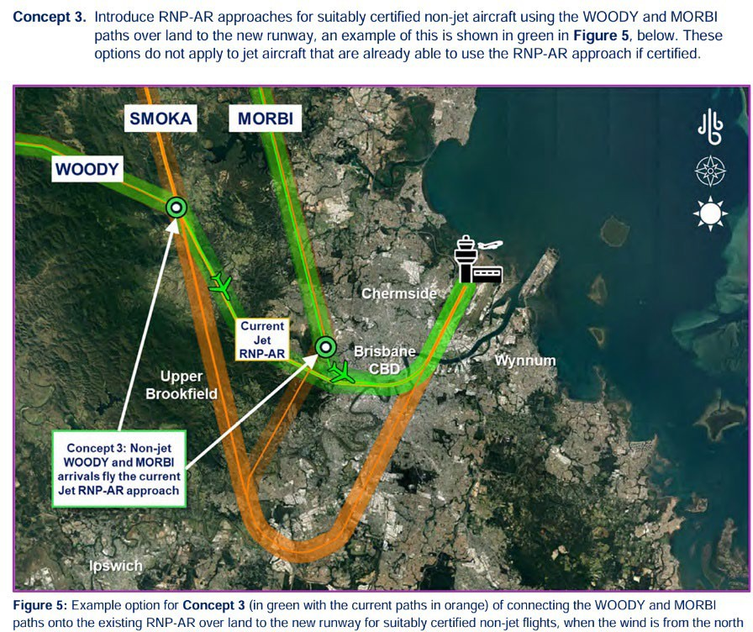******See Section 3***

***See Section 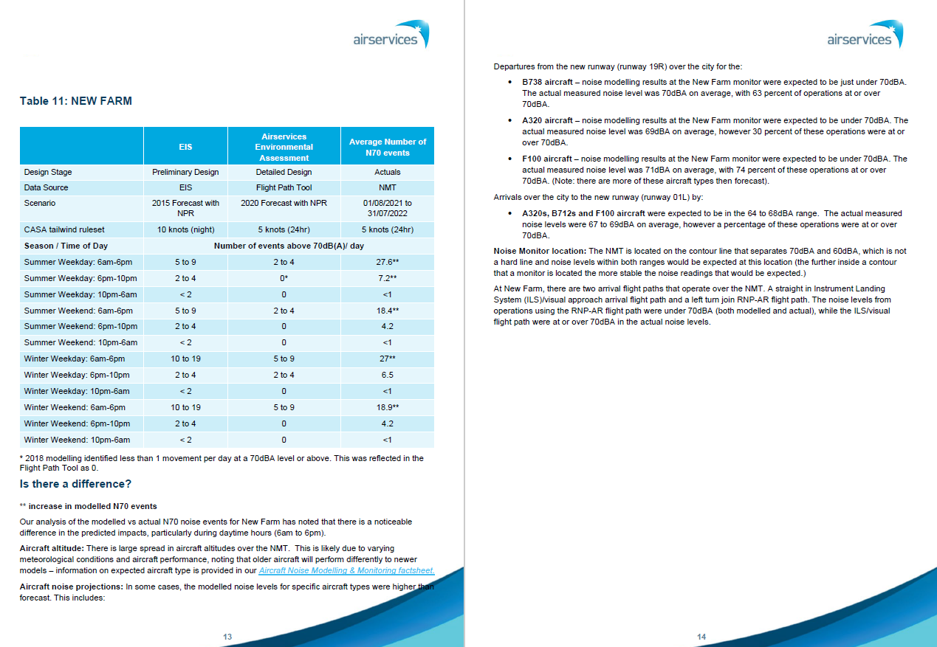5***