Australian Government
Department of Infrastructure, Transport, Regional Development and Communications

Airport Building Control

Operations Manual v3.0

February 2022



© Commonwealth of Australia 2021

ISBN 978-1-922205-38-4

February 2022

Ownership of intellectual property rights in this publication

Unless otherwise noted, copyright (and any other intellectual property rights, if any) in this publication is owned by the Commonwealth of Australia (referred to below as the Commonwealth).

Disclaimer

The material contained in this publication is made available on the understanding that the Commonwealth is not providing professional advice, and that users exercise their own skill and care with respect to its use, and seek independent advice if necessary.

The Commonwealth makes no representations or warranties as to the contents or accuracy of the information contained in this publication. To the extent permitted by law, the Commonwealth disclaims liability to any person or organisation in respect of anything done, or omitted to be done, in reliance upon information contained in this publication.

Creative Commons licence

With the exception of (a) the Coat of Arms; (b) the Department of Infrastructure, Transport, Regional Development and Communications photos and graphics; and (c) [OTHER], copyright in this publication is licensed under a Creative Commons Attribution 4.0 Australia Licence.

Creative Commons Attribution 4.0 Australia Licence is a standard form licence agreement that allows you to copy, communicate and adapt this publication provided that you attribute the work to the Commonwealth and abide by the other licence terms.

Further information on the licence terms is available from <https://creativecommons.org/licenses/by/4.0/>

This publication should be attributed in the following way: © Commonwealth of Australia 2022

Use of the Coat of Arms

The Department of the Prime Minister and Cabinet sets the terms under which the Coat of Arms is used. Please refer to the Commonwealth Coat of Arms - Information and Guidelines publication available at [http://www.pmc.gov.au](http://www.pmc.gov.au/).

Contact us

This publication is available in hard copy or PDF format. All other rights are reserved, including in relation to any departmental logos or trademarks which may exist. For enquiries regarding the licence and any use of this publication, please contact:

Director – Creative Services

Communication Branch

Department of Infrastructure, Transport, Regional Development and Communications

GPO Box 594

Canberra ACT 2601

Australia

Email: [creative.design@infrastructure.gov.au](mailto:creative.design@infrastructure.gov.au)

Website: [www.infrastructure.gov.au](http://www.infrastructure.gov.au/)

## **Version control**

|  |  |  |  |
| --- | --- | --- | --- |
| Version | Date | Description of amendment(s) | Approved by |
| 1.0 | September 2011 | Initial release |  |
| 1.1 | February 2013 | Incorporate recommendations from internal audit in September 2012 | Not released as Compliance Framework in development |
| 2.0 | June 2013 | Full revision and alignment with Compliance Framework | Romy Collier, Section Head (released 16 October 2013) |
| 3.0 | February 2022 | Full revision; amalgamation of ABC Operations Manual and ABC Compliance Framework | Megan Thomas, Director (released 23 February 2022) |

## **Document review**

The Airport Building Control Operations Manual (the Manual) will be reviewed periodically. Additional amendments may be made on an ad-hoc basis.

Suggestions for revisions of the Manual may originate from the Department, any Airport Building Controller (ABC), or other stakeholder. All changes to the Manual must be authorised by the Department. The procedure for revisions is as follows:

* ABCs can suggest revisions to the Department by email to [ABCMailbox@infrastructure.gov.au](mailto:ABCMailbox@infrastructure.gov.au);
* Where revisions are initiated by the Department, the draft updates will be provided to the ABC Network and a reasonable period allowed for the ABC Network to comment;
* Following consideration of all comments, the Manual will be updated and published to GovTEAMS, and the ABC Network advised accordingly.

## **Dictionary**

|  |  |  |  |
| --- | --- | --- | --- |
| Term | Definition | Term | Definition |
| (the) Act | The Airports Act 1996 | **ALC** | Airport Lessee Company |
| (the) Department | The Department of Infrastructure, Transport, Regional Development and Communications | **BCA** | Building Code of Australia |
| (the) Manual | This document | **CASA** | Civil Aviation Safety Authority |
| (the) Minister | The Minister with responsibility, at a given time, for the Act | **Division** | Domestic Aviation and Reform Division |
| ABC | Airport Building Control(ler) | **EPBC Act** | Environment Protection and Biodiversity Conservation Act 1999 |
| ABCO | Airport Building Control Online | **MDP** | Major Development Plan |
| ABCR | Airports (Building Control) Regulations 1996 | **NCC** | National Construction Code |
| AEO | Airport Environment Officer | **OLS** | Obstacle Limitation Surface |
| AEPR | Airports (Environment Protection) Regulations 1997 | **PANS-OPS** | Procedures for Air Navigation Services – Operations |
| AES | Airport Environment Strategy | **PERCOW** | Permit to Commence Works |
| Airservices | Airservices Australia | **RFI** | Request for Information |

Table of Contents

**Version control** 3

**Document review** 3

**Dictionary** 3

1. Introduction 9

**Context** 9

**Purpose** 9

**Principles** 10

2. Airport Building Control Framework 11

***Airports Act 1996*** 11

**Airports (Building Control) Regulations 1996** 11

**Building standards** 11

National Construction Code / Australian Standards 11

Other building standards 12

Authorities, referral bodies and links with other legislation 12

**Services agreements** 13

**Airports (Environment Protection) Regulations 1997** 14

3. Roles and Responsibilities 15

**The Department (Domestic Aviation and Reform Division)** 15

Airport master plans and major development plans 15

**Airport Lessee Companies (ALCs)** 16

**Airport Building Controllers (ABCs)** 17

Appointment of ABCs 18

**Airports Environment Officers (AEOs)** 18

4. Risk-based Management Framework 20

**What is risk?** 20

**Risk assessment tools** 20

Risk triggers 21

Evidence 21

Decision 21

Risk-based escalation 21

**Airport Building Control risk management policy** 22

5. Building Activity Approvals 24

**Overview** 24

**Submitting an application – Airport Building Control Online** 25

Information to be submitted 25

Building activity application fees 26

**ALC Consent** 26

General 26

ALC considerations 26

Decision 27

**ABC assessment and approval** 28

General 28

Assessment process and considerations 28

Referral to AEO 30

Decision 30

Changes to applications 31

**Other matters** 31

Exemptions 31

Land clearing 32

Staged approvals 32

Permit to Commence Works (PERCOW) 33

6. Building Activity Completion Process 34

**During construction** 34

Duration of approval 34

Inspections 34

**Certificate of Compliance** 35

**Ongoing monitoring** 37

7. Appeals, Enforcement and Penalties 38

**Review by Administrative Appeals Tribunal** 38

**Enforcement** 38

8. Administration, Information and Governance 41

**Work Health and Safety** 41

**Insurance** 41

**Records management** 41

**Confidentiality and privacy** 42

**Reporting requirements** 42

**Freedom of Information** 42

**Security** 43

9. Compliance Management Toolkit 44

**Tool 1: ABC Process Map (Detailed)** 45

**Tool 2: ABCO Application Lifecycle** 46

46

**Tool 3: Non-compliance Management Process Map** 47

**Tool 4: Risk Management Framework** 48

**Tool 5: Land Clearing Guidelines** 55

**Tool 6: ABC Quarterly Report Template** 57

**Tool 7: Standard Templates** 67

**Tool 8: ABCO User Rights Matrix** 69

**Tool 9: Schedule of Application Fees** 70

1. **Introduction**

## **Context**

1.01 The Airport Building Control Operations Manual (the Manual) outlines the building activity process at federally leased airports, and provides ABC service providers with information on procedures, conditions and standards at those airports.

1.02 The Department of Infrastructure, Transport, Regional Development and Communications (the Department) is responsible for the administration of the *Airports Act 1996* (the Act) and the  
Airports (Building Control) Regulations 1996 (the ABCR) which establishes the building control regime at federally leased airports.

1.03 This Manual sets out the relevant requirements of the ABC framework, and how it interacts with other legislation, codes and standards to drive consistent, effective and comprehensive compliance management. It is intended to assist ABC service providers, as well as Departmental staff and other interested parties, to fulfil their legislative obligations efficiently and effectively, and to provide timely and effective support to the ABC Network.

1.04 The ABC framework applies a risk-based approach to compliance and assessment, driven by a desire to ensure that the regulatory framework allows technical experts to make the necessary professional judgements regarding compliance with the ABCR. A risk-based approach also provides guidance on the level of risk posed to the Commonwealth, as well as tools and templates to ensure the Department remains informed of matters of high risk to the Commonwealth.

1.05 A risk-based approach focuses on identifying and assessing risk based on objective and agreed criteria, which allows for the prioritisation of activity and effort to the highest risk matters. Such an approach also reflects the long-term airport infrastructure regulatory environment where responsibility for compliance is shared appropriately between the Department, Airport Lessee Companies (ALCs), Airport Building Controllers (ABCs), Airport Environment Officers (AEOs) and other stakeholders.

1.06 While the Manual may assist in understanding the scope of the legislation, it is intended **only as a guide**. All parties who are subject to legislative obligations in relation to airport building control should always refer to the relevant legislation to inform decision-making. The Department’s ABC Helpdesk team can also be contacted to discuss or clarify specific circumstances.

## **Purpose**

1.07 The purpose of the Manual is to facilitate risk-based compliance management of building and development works at federally leased airports in order to:

* support national consistency in the application of risk-based airport building control;
* ensure compliance with relevant legislation and standards across all federally leased airports;
* identify roles and regulatory responsibilities;
* promote evidence and risk-based judgement;
* achieve best-practice in delivering safe and sustainable building and development outcomes.

1.08 The Manual provides a single source of the Department’s expectations of all parties involved in the airport building control process, including ABCs, applicants, ALCs, AEOs and others, and should be a first point of reference to inform each party’s decision-making process.

## **Principles**

1.09 The ABC framework is founded on the following principles:

1. **Objectives-focused**: maintaining focus on the Department’s key objective of maximising regulatory compliance.
2. **Risk-based**: actively prioritising and taking a scaled approach to the delivery of compliance activities, allowing time and resources to be directed to the areas of greatest need.
3. **Proportionate**: treatments proposed for non-compliance are commensurate with relevant compliance obligations, and the allocation of time and resources to compliance activities reflects the criticality of each situation.
4. **Culturally and behaviourally led**: compliance is supported by Departmental leadership and the Manual encourages behaviours consistent with compliance outcomes.
5. **Evidence-based judgement**: parties apply sound professional judgement supported by evidence that demonstrates why the action taken was necessary and appropriate.
6. **Airport Building Control Framework**

## ***Airports Act 1996***

2.01 The Act is the primary legislation governing activities at federally leased airports.

2.02 Part 5 of the Act deals with on-airport land use, planning and building controls, and establishes that building works carried out at a federally leased airport must be consistent with the master plan (or airport plan, in the case of Sydney West Airport) and any approved major development plans for the airport.

2.03 Specifically, Division 5 of Part 5 deals with building controls including mandatory pre-approval of all building and works activities, and certification of the resulting buildings and structures. Notably, s 100 of the Act provides for the establishment of regulations made in relation to building approvals and the application of appropriate standards and state laws.

## **Airports (Building Control) Regulations 1996**

2.04 The ABCR were established to expand on Division 5 of Part 5 of the Act. Specifically, the ABCR provides greater detail in regard to the information which must be included in a building activity application, the processes by which these applications are to be assessed and decided, and the responsibilities of all parties involved.

2.05 Approvals must be sought for all building and construction works, including earthworks, land clearing, utilities installation, geotechnical assessments, etc.

2.06 What constitutes building and works, works which qualify for an exemption, and the process and criteria for approvals are set out in Part 2 of the ABCR.

2.07 The Regulations call upon existing national and international standards against which building activity applications are to be assessed and decided by ABCs.

2.08 The Regulations also sets out the building control process through which all building activity applications pass, including receiving and assessment of applications, payment of application fees, issuing requests for information, issuing permits and certificates of compliance for occupancy or use (whether or not subject to conditions).

2.09 Further, the ABCR also establishes a compliance assurance process, which is supported by penalty provisions contained in the Act.

## **Building standards**

### National Construction Code / Australian Standards

2.10 The ABCR sets building standards at airports with reference to relevant Australian and international building standards.

2.11 The National Construction Code (NCC) incorporates all on-site construction requirements into a single code, including the Building Code of Australia (BCA). The BCA adopts and references numerous standards as suitable methods of achieving compliance with nominated parts of the BCA.

2.12 The NCC and BCA adopt and refer to numerous standards as suitable methods of achieving compliance with nominated parts of the NCC.

2.13 The NCC incorporates variations to take account of special requirements appropriate in each state or territory jurisdiction. ABCs assess applications under the NCC, taking account of jurisdictional variations.

2.14 Provisions of the BCA may be overridden by, or subject to, state or territory legislation. The BCA must therefore be read in conjunction with that legislation where the BCA lacks adequate coverage. Any queries on such matters should be referred to the relevant State or Territory authority.

### Other building standards

2.15 The NCC does not cover all building activities, in which case the ABC must determine the standards that are appropriate to the proposed works. The ABC must take these appropriate standards into consideration when assessing applications.

2.16 In some cases, the NCC does not specifically address certain types of buildings, such as aircraft hangars, aircraft boarding concourses, etc. In such cases, ABCs must ensure applications meet other Australian or international standards.

2.17 Where the NCC does not apply, sub-regulation 1.04(4)(a)(ii) of the ABCR permits the ABC to determine an appropriate standard to be applied to the proposed works. In doing so, the ABC must have regard to customary standards for the kind of activity being carried out. Any standard so adopted must result in a building activity which is fit for occupancy or use when completed.

2.18 Other standards or practices that may be deemed suitable by an ABC include:

* Australian, New Zealand or international standards;
* publications by recognised industry associations;
* current airport practices (e.g. Part 139 (Aerodromes) Manual of Standards);
* State/Territory regulations; and
* local regulations.

2.19 Where a proposed development does not comply with nominated standards, ABCs may rely on a report or certificate prepared and issued by an appropriate technical expert or regulatory authority in order to satisfy the relevant building, works or demolition criteria.

### Authorities, referral bodies and links with other legislation

Fire authorities

2.20 Applications for permits and certificates of compliance may be referred to the Aviation Rescue and Fire Fighting Service and/or the state or territory fire authority (collectively ‘fire authorities’).

2.21 Where appropriate, the ABC may include, whether as a condition or otherwise, recommendations from fire authorities in permits and certificates of compliance.

2.22 Sub-regulation 1.03(d) of the ABCR provides that the operation of state and territory law regarding the protection of persons against fire is not affected by the operation of the ABCR.

Health and safety

2.23 Section F of the BCA[1] contains the health requirements and standards which ABCs enforce, including:

* damp and weatherproofing;
* sanitary and other facilities;
* room heights;
* light and ventilation;
* sound transmission and insulation; and
* condensation management.

2.24 Food hygiene health requirements are enforced by state, territory and local governments and, as a result, there will be differences between jurisdictions. The control and administration may be performed by either the ALC or state/local government, whichever the ABC deems appropriate.

2.25 In issuing any approvals, the ABC must ensure that any health conditions of approval are included in the documentation. Where required, the ABC may refer the application to the relevant local health authority. Examples where this may be required include food premises, hairdressers, skin penetration premises, boarding houses, mortuaries, hospitals etc.

2.26 There is no formal requirement for ABCs to liaise with or inform state, territory or local government authorities that deal with work health and safety (WHS) matters. However, the *Commonwealth Places (Application of Laws) Act 1970* provides for relevant state and territory WHS laws to apply at federally leased airports.

2.27 Sub-regulation 1.03(c) of the ABCR provides that the operation of state and territory law relating to WHS matters is not affected by the operation of the ABCR.

2.28 Where an unsafe practice in relation to any health and safety matter is observed, this must be referred to the ALC and any relevant state, territory or local authority immediately.

Civil Aviation Safety Authority (CASA) and Airservices Australia (Airservices)

2.29 All works involving penetration of protected airspace require either the Secretary’s or the ALC’s approval under the Airports (Protection of Airspace) Regulations 1996 (APOA Regulations). Such works are known as ‘controlled activities’.

2.30 An application for a controlled activity under the APOA Regulations 1996 must be given to the ALC at least 28 days before the applicant’s intended commencement of the controlled activity.

2.31 In deciding whether or not to approve a controlled activity, the Secretary or ALC will consider the effect of the controlled activity on the safety, efficiency and regularity of existing and future aviation operations at the airport, and will take account of the views of CASA, Airservices, the ALC and relevant aircraft operators.

2.32 If an applicant or ABC is in doubt as to whether a proposed building activity might involve a controlled activity, the matter should be referred to [Flysafe@infrastructure.gov.au](mailto:Flysafe@infrastructure.gov.au) (ABCs please cc [ABCMailbox@infrastructure.gov.au](mailto:ABCMailbox@infrastructure.gov.au)).

2.33 Other CASA and Airservices requirements, including compliance with the Manual of Standards Part 139, should be resolved with those agencies separately to the building activity application process, however the building activity application should provide sufficient detail for the ABC to be satisfied the proposed works have been appropriately considered against aviation safety and operational requirements.

Other authorities

2.34 An ABC may advise that an applicant refer a proposed development to other authorities, such as those responsible for urban utilities (electricity, gas, water and sewerage).

2.35 In some instances, the supply authority for utilities and services will be the ALC, e.g. where there is an on-site solar power generation facility servicing tenancies.

## **Services agreements**

2.36 ABCs are contracted service providers and are engaged as such under contract to the Department. The contracts, known as Services Agreements, establish the ABCs’ working arrangements including weekly hours, service charges, accommodation, recordkeeping and the like.

2.37 The Services Agreements also specify quarterly reporting and invoicing requirements as well as the keeping of timesheets by the ABCs. These requirements are discussed at Section 8 of the Manual, and the template is included as Tool 6 of the Compliance Management Toolkit at Section 9 of the Manual.

## **Airports (Environment Protection) Regulations 1997**

2.38 Part 6 of the Act deals with environmental management of federally leased airport sites.

2.39 The Airports (Environment Protection) Regulations 1997 (AEPR) is made under s 132 of the Act to:

* establish, in conjunction with national environment protection measures, a system for regulating, managing and ensuring accountability for activities at federally leased airports which generate, or have potential to generate, pollution or excessive noise; and
* promote continuing improvement of environmental management practices for activities carried out at federally leased airports.

2.40 It is important to note the AEPR does not apply to pollution or noise generated by an aircraft.

2.41 Whilst the AEPR deals specifically with the environmental impacts of activities carried out on an airport site, the impacts or potential impacts of those activities may be experienced outside the airport site. Applicants should be prepared to undertake additional approval and/or notification processes outside of the ABCR in relation to those off-airport impacts.

2.42 Whilst the AEPR is the primary legislation in this space, federally leased airport sites are also subject to the requirements of the *Environment Protection and Biodiversity Conservation Act 1999* (EPBC Act) and its associated regulations.

1. **Roles and Responsibilities**

## **The Department (Domestic Aviation and Reform Division)**

3.01 The Department advises the Australian Government on the policy and regulatory framework for Australian airports and the aviation industry, manages the administration of the Government's interests in the federally leased airports under the Act, and provides policy advice to the Minister on the efficient management of Australian airspace and on aircraft noise and emissions.

3.02 Based on the success of airport privatisation to date in facilitating significant development of the federally leased airports, there is an expectation that the Department will continue to drive consistent, effective and comprehensive compliance with the regulatory regime and become a recognised leader in developing and administering appropriate regulatory frameworks that maximise safety, public value and amenity.

3.03 The Domestic Aviation and Reform Division (the Division) within the Department is primarily responsible for administering the Act and its associated regulations in relation to 21[2] of the 22[3] federally leased airports. The Division provides ongoing assessment and oversight of major airport developments, including developments likely to have a significant community impact, and advises the Minister on a broad range of regulatory oversight matters. The Division is achieves its oversight of ALC compliance with the ABCR and AEPR through the ABCs and AEOs.

3.04 The Division maintains the currency and accuracy of airport, environment, building control and industry regulatory authorisations, appointments and other legal instruments and ensures automatic and effective review and update mechanisms are in place.

3.05 The Division administers the Services Agreements with ABCs, including oversight of the reporting requirements, Service Agreement payments and ad hoc requests for advice. The Division is also responsible for reviewing the regulatory settings associated with building control at airport sites.

3.06 Separate line areas of the Department are responsible for applying the ABCR and AEPR at Sydney West Airport during its pre-opening construction phase.

### Airport master plans and major development plans

3.07 A master plan is the key strategic development for the airport site. It has a 20 year planning horizon and is updated every five or eight years[4].

3.08 Master plans utilise aviation traffic data (passenger, freight and aircraft movements) and forecasts to predict the likely future development needs for both aviation and non-aviation land uses at the airport. Permitted land uses are established for precincts within the airport site.

3.09 In order to minimise, where possible, potential conflicts between the operation of the airport site and surrounding land uses, an airport’s master plan is required to be broadly consistent with neighbouring land use strategies.

3.10 Master plans are also required to contain both an airport environment strategy and a ground transport plan, both of which are also expected to take into consideration, and be broadly consistent with, similar planning tools in place off-airport.

3.11 Major development plans (MDPs) are also required for any ‘major airport development’, being a development which is significant enough to warrant the approval of the Minister. What constitutes a ‘major airport development’ is defined in s 89 of the Act, and broadly includes the creation or significant alteration of aeronautical facilities (including passenger terminals and aircraft movement areas), certain developments with an estimated cost of construction of $25 million or more, or developments that are likely to significantly impact either the environment or the local or regional community.

3.12 As with master plans, MDPs are required to demonstrate broad consistency with off-airport land uses. Likewise, subsequent applications for building or works permits must demonstrate their consistency with the relevant approved MDP.

3.13 Master plans and MDPs both carry requirements for public consultation prior to submission to the Minister for his or her approval.

3.14 Table 1 below provides a concise overview of the federally leased airport planning framework.

Table 1 - Federally leased airport planning framework overview

|  |  |  |  |
| --- | --- | --- | --- |
|  | Master Plans | Major Development Plans | Building activity approvals |
| Purpose | 20-year strategic vision for the airport site, renewed every five or eight years, including future land uses, types of permitted developments, ground transport planning and environmental and noise impacts. | Approval process for ‘major airport developments’ as defined by s 89 of the Act. | Approval process for building activities at an airport, including construction, demolition and other works. |
| Decision-maker | The Minister | The Minister | ABCs |
| Public consultation | 60 business days. | 60 business days[5]. | None, but application details are published on ALCs’ websites. |
| Assessment timeframe | 50 business days (10 business day extension available to Minister). | 50 business days (10 business day extension available to Minister). | 28 calendar days. |
| If no decision is made | Deemed approved at the end of 50 business days. | Deemed approved at the end of 50 business days. | Deemed refused at the end of 28 calendar days. |

3.15 Section 89A of the Act requires the proponent of a ‘sensitive development’[6] to seek the prior approval of the Minister before bringing forward a draft MDP for the Minister’s consideration.

3.16 The Airport Plan for Sydney West Airport serves broadly the same purpose as the master plans for other federally leased airports.

## **Airport Lessee Companies (ALCs)**

3.17 Airport Lessee Companies (ALCs) have the primary responsibility for managing the broad duties and obligations, as set out in the Act and its subordinate legislation, relating to maintaining, developing and improving the airport precinct.

3.18 As such, the ultimate responsibility for ensuring positive construction, development and environmental outcomes falls to the ALC and, to a lesser extent, airport tenants and operators of undertakings. ALC building activity consents must be issued (see Section 5, and Tools 1 and 2 in Section 9, of the Manual) before an ABC can issue a building or works permit.

3.19 As part of their role, ALCs are responsible for preparing, maintaining and ensuring compliance with airport master plans, MDPs and environment strategies. They are also ultimately responsible for ensuring building works do not occur without, or in contravention of, ABC approval.

## **Airport Building Controllers (ABCs)**

3.20 ABCs are appointed and authorised by the Department to implement Part 5, Division 5 of the Act and the ABCR at the federally leased airports. They are responsible for appropriate regulatory oversight and support for investment in airport infrastructure, while ensuring the safety of airport development and operations is promoted and maintained.

3.21 Each ABC administers and advises airport operators on building control issues outlined in the ABCR, and implements the building approval system for ongoing building activity at the airport. The ABC must also ensure that an appropriate standard of building work is achieved at the airport.

3.22 Advice from the ABC does not and cannot extend to design advice on any specific building activity.

3.23 The ABC consults with, and advises, ALCs and other operators of undertakings at federally leased airports, about their activities and regulatory obligations in the context of the Act, the ABCR, the airport master plan and relevant MDPs.

3.24 ABCs also consult with and advise the Department on applications for building approvals and variations, and applications for certificates of compliance.

3.25 ABCs are the Department’s primary source of information about compliance with the building control regulatory regime. ABCs have the authority and the responsibility to make decisions regarding the compliance with regulations and standards and, where necessary, to take compliance action against parties found to be in breach of their obligations under the regulatory framework. Whilst ABCs may rely on technical advice from certain other professionals, e.g. architects, engineers, etc., it is ultimately the ABC’s decision whether to issue a permit or certificate of compliance

3.26 The ABC’s role has two aspects: the technical aspect and the compliance monitoring aspect.

3.27 As part of the ABCs’ technical role, the ABC must:

* assess applications against the NCC and/or other technical requirements consistent with the BCA;
* assess applications for compliance with relevant commitments and conditions in approved MDPs;
* inspect building works;
* impose conditions;
* certify works as meeting appropriate standards;
* maintain records;
* provide information to the ALC and applicants;
* process exemption applications;
* ensure ALCs and applicants have adequately demonstrated consistency with the airport’s final Master Plan and Airport Environment Strategy; and
* monitor compliance and, where necessary, initiate enforcement action.

3.28 As part of the compliance-monitoring aspect of an ABC’s role, the ABC must:

* monitor and enforce compliance with land use, planning, building control and environmental management elements of the Act;
* liaise with the AEO on environmental issues and may provide approval to building and works subject to the appropriate environmental conditions being met.

3.29 Some of the activities that the ABC must undertake to discharge their role include the following:

* advice to ALCs and applicants as to the building approval processes;
* advice and assistance to the airport operators so as to achieve regulatory compliance for any proposed building activity – however, ABCs do not provide design advice;
* an efficient and transparent assessment process for applications and variations, ensuring that:
  + all required information specified in the ABCR has been provided,
  + ALC building activity consent has been obtained and any consent requirements of the ALC,
  + the criteria listed in regulations that the ABC must have regard to are addressed,
  + applicants are notified of decisions within prescribed timeframes and documents issued as approvals or certificates contain all required information referred to in the regulations, and
  + any conditions of approval are clearly communicated.
* inspection of building activities, and consultation with appropriately qualified persons, to ensure that:
  + public protection and access issues are adhered to during building activities and demolition;
  + building activities are carried out in accordance with the approved documentation, such works are supervised by appropriately qualified persons, all necessary safety precautions are taken and that sites are cleaned up on completion of the building activity; and
  + suitable conditions are imposed on approvals and certificates;
* issue Certificates of Compliance for both buildings and works (see Section 6 of the Manual);
* determine whether there is a need for a Remedial Direction Stop Work Order or to revoke an approval where there is concern that the performance of a building activity is inconsistent with the original approval;
* consult with and advise the Secretary, or another authorised person, on applications for building approvals and variations, and applications for certificates of compliance; and
* report to the Department on the ABC’s workload as required under contract, including advice on how the position could evolve and develop.

### Appointment of ABCs

3.30 Part 4 of the ABCR sets out the requirements and process for appointing ABCs.

3.31 In particular, sub-regulation 4.01(1) states the Secretary may appoint any of the following as an ABC:

* an authority of the Commonwealth or of the state/territory in which the airport is located, including a local government body; or
* a person or entity:
  + which is qualified under the law of the state/territory in which the airport is located to approve building activity or certify the fitness of buildings;
  + which does not hold more than five percent of the shares in the ALC for the airport; and
  + in which the ALC does not hold more than five percent of the shares.

3.32 At this time, only the Secretary holds legal authority to appoint an ABC. Where an additional ABC needs to be appointed, the relevant ABC office should email the details of the requirement and the proposed appointee’s qualifications to the ABCMailbox; the ABC Network team will then progress the matter through the Secretary.

3.33 Before appointing an ABC, the Secretary is first required to give the relevant ALC(s) written notice of their intention to do so. The ALC has 14 days from the date of the notice to make a submission on the proposed appointment, which the Secretary must then consider in making their final decision.

## **Airports Environment Officers (AEOs)**

3.34 AEOs are the Department’s primary source of information about compliance with the environmental regulatory regime. AEOs have the authority and the responsibility to make decisions regarding compliance with regulations and standards and, where necessary, take compliance action against parties found to be in breach of their obligations under the regulatory framework.

3.35 The Department has appointed AEOs to support and guide the achievement of airport environmental standards at the federally leased airport, and to administer compliance with the AEPR and Part 6 the Act. The intent is to promote awareness of environmental issues and to ensure that management systems are in place to deal with the pollution, noise and other environmental impacts that are produced by, and on, airports, with a view to reducing those environmental impacts and increasing public amenity over time.

3.36 AEOs are authorised to make decisions regarding compliance with environmental regulations and standards, and are the Department’s primary source of information about the same. Where necessary, AEOs are also authorised to take compliance action against parties found to be in breach of their obligations under the Act and the Airports (Environmental Protection) Regulations 1997.

3.37 While an AEO does not have an explicit role in the building assessment process, the AEO may:

* consult with and assist the ALC to manage environmental issues at the airport in accordance with their AES including, where appropriate, providing advice to inform the ALC consent for building activities;
* assist the ABC in their assessment of building activities in accordance with the relevant criteria established under the ABCR (i.e. sub-regulations 2.13, 2.14 and 2.15) and s 101 of the Act. It remains at the discretion of the ABC in determining whether referral to an AEO is required to assist the ABC’s assessment of the building application; and
* in providing the AEO’s response to the ABC, suggest ‘advisory notes’ be included in any future approval, noting obligations and/or expectations of development in accordance with the AEPR.

1. **Risk-based Management Framework**

4.01 The decision to follow a risk-based approach to compliance is driven by the Department’s desire to allow the allocation of time and resources to be directed proportionately based on the professional judgement of technical experts. A risk-based approach also provides a level of visibility to the Department about its exposure to risk in a given situation.

4.02 This reflects the Department’s broader approach which seeks to appropriately weight the compliance responsibilities and risk shares of the Department, ALCs, ABCs, AEOs and other stakeholders.

4.03 Compliance management is the responsibility of the Department in conjunction with the ABCs and AEOs who are physically deployed at or to each of the airport sites.

4.04 This risk assessment framework draws upon the Department’s risk management guidelines and policies. The process outlined below can be applied in all circumstances. The process can be applied by both compliance officers and other staff. The evidentiary standards required to justify actions are variable depending upon the severity and scale of the action.

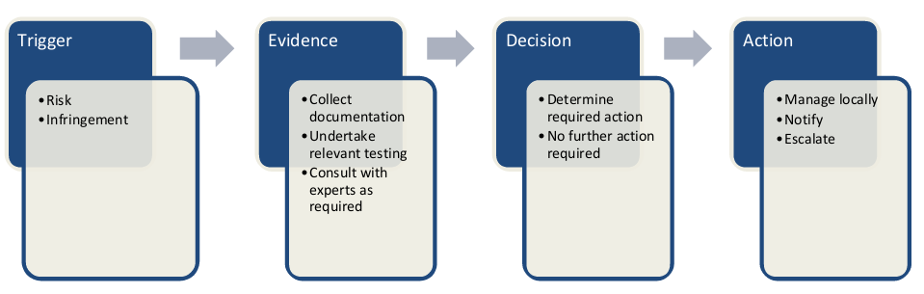

Figure 1 - Risk management process overview

## **What is risk?**

4.05 Risk is defined as “the effect of uncertainty on objectives.”[7] Risk can be either present, potential or perceived, and is generally expressed as a function of the likelihood of an event occurring and the probable consequences that will arise if it eventuates.

4.06 ABCs will inevitably identify potential risks as part of their day-to-day monitoring activities. Whilst some risks will be able to be managed immediately, others will require more extensive management including gathering evidence, briefing the Department and managing formal remediation and other compliance processes set out in the Regulations.

## **Risk assessment tools**

4.07 The Department’s Risk Management Policy and Framework contains several tools for considering likelihood and consequences, conducting a risk assessment, identifying appropriate controls and determining when to escalate a matter to the Department for management.

4.08 The Risk Management Policy and Framework is consistent with the requirements of overarching federal legislation and policy, including the *Public Governance, Performance and Accountability Act 2013*, the Public Governance and Accountability Rule 2014 and the Commonwealth Risk Management Policy.

4.09 Relevant sections of the Risk Management Policy and Framework are replicated for reference in Tool 4 in Section 9 of the Manual. These are to be used by ABCs to inform their own management of each situation, as well as to brief the Department where necessary.

### Risk triggers

4.10 ‘Triggers’ for potential risk will often be identified by ABCs during the course of scheduled and routine inspections. These might include indications of activity occurring in contravention of the ABCR, observations of unsafe practices or the potential for avoidable detrimental effects on public safety or development outcomes.

4.11 Potential risk triggers may also be brought to the ABC’s attention by other parties, such as the ALC.

4.12 Once a trigger has been identified, the compliance officer should gather evidence in accordance with their regulatory powers and responsibilities.

### Evidence

4.13 The initial purpose of gathering evidence is to determine if an event constitutes a risk or an infringement. Once that has been determined, ABCs will establish which section(s) of the Regulations have been, or are at risk of being, contravened.

4.14 ABCs and others involved in the compliance and enforcement process should follow the principle of documenting and recording all necessary evidence (i.e. all inspections, conversations, correspondence and other forms of communication need to be documented).

4.15 Evidence must be:

* **documented** – including conversations, meetings and other non-text communications;
* **factual** – free of value judgement, bias and personal preference;
* **relevant** – related to the regulatory / compliance matter; and
* **defensible** – able to withstand scrutiny.

4.16 All evidence gathered during the course of a compliance or enforcement process is to be uploaded to the relevant application file in ABCO with appropriate permissions to allow both the ABC office and the Department to access the information at any time.

### Decision

4.17 Based on the evidence gathered during the ABC’s investigations, a decision will ultimately need to be taken as to how the matter should be handled.

4.18 The option is always available for the ABC to escalate the matter to the Department for advice on the appropriate course of action.

4.19 Where there is insufficient evidence to pursue a risk or infringement through official channels, it may be open to the ABC to consider options such as applicant education, increased inspection frequencies or the like. It is also open to ABCs to determine that no further action should be taken.

### Risk-based escalation

4.20 A risk-based escalation approach also supports the Department to more effectively manage compliance of the ALCs and others with the relevant legislation and airport head lease provisions. This is achieved by enabling prioritisation and resourcing to the matters of greatest need.

4.21 The responsibility to remediate any breaches and proactively treat emerging issues rests with the ALCs and proponents, however ABCs are charged with overseeing these processes and briefing the Department where appropriate.

4.22 The Department’s risk management matrix provides the foundation for the management of risks to compliance with the regulatory regime.

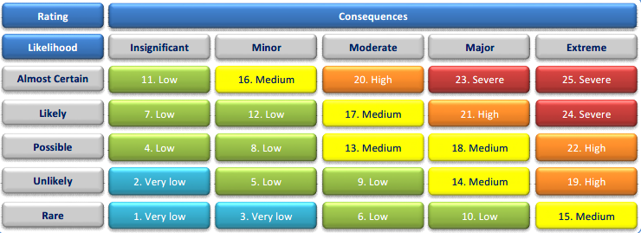

Figure 2 - Department's risk management matrix

4.23 In the event of a **risk,** compliance officers should make a professional judgement as to the likelihood of the risk materialising. The Department provides the following guidance regarding the assessment of likelihood within its Risk Management Guidelines.

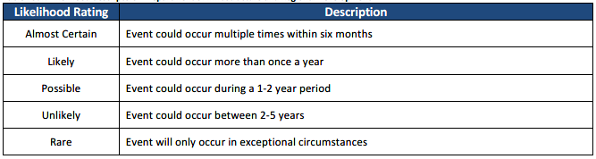

Figure 3 - Likelihood ratings

4.24 The corresponding risk rating provides compliance officers with the minimum required next steps regarding notifying the Department.

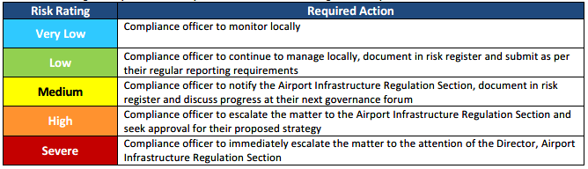

Figure 4 - Risk and required action matrix

## **Airport Building Control risk management policy**

4.25 The Risk Management Policy and Framework also contains the Secretary’s overarching policy statement on the Department’s overarching risk appetite.

4.26 The Department has a relatively high appetite (i.e. is relatively more likely to accept considered risks with appropriate and effective controls) for innovative approaches to achieving transport and infrastructure outcomes, including ongoing development at the federally leased airports.

4.27 Conversely, the Department has no appetite for actions which include or lead to death, serious injury, fraud and corruption, or deliberate or purposeful violations of legislative or regulatory requirements. The Department also has a very low appetite for actions which result in reputational damage, system control failures, unexplained financial variances, information security breaches, and non-delivery of the Department’s services.

4.28 It is important to note that, while the Risk Management Policy and Framework most clearly applies to Departmental employees, ABCs as contracted service providers are also bound to manage risk on behalf of the Department. This is especially true where ABCs have specialist technical knowledge not otherwise available.

1. **Building Activity Approvals**

## **Overview**

5.01 Tool**s** 1 and 2 in Section 9 of the Manual depicts the application stages in the ABC assessment process.

5.02 Figure 5 below depicts, at a high level, the building activity assessment process from submitting the application through to the ABC issuing, or refusing to issue, a building or works permit.

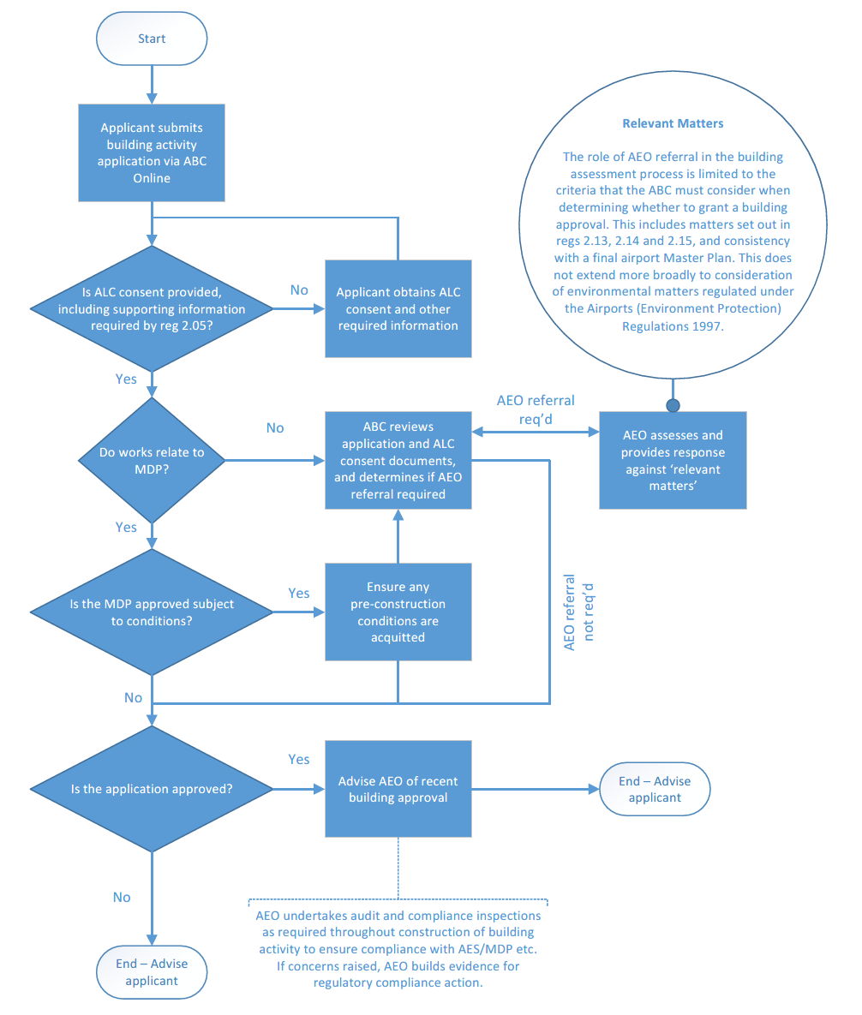

Figure 5 - Airport Building Activity Application Process

## **Submitting an application – Airport Building Control Online**

5.03 Airport Building Control Online, referred to as ABC Online or simply ABCO, is the Department’s bespoke web-based portal for submitting and progressing building activity applications.

5.04 ABCO is available at abco.infrastructure.gov.au. Anyone who needs to register for ABCO, including prospective applicants, can do so from the homepage. The ABCO User Rights Matrix is at Tool 8 in Section 9 of the Manual shows the actions certain groups of users can perform in ABCO and is a useful guide for users as to where they can get help in using ABCO.

5.05 ABCO handles, in a largely automated way, applications throughout the entire lifecycle and automatically places application, permit, certificate of compliance and supporting documentation in the Department’s electronic document management system.

5.06 Registering for a user account and submitting an application in ABCO are both relatively straightforward processes. Assistance is available by contacting the ABC office for the state in which the airport in question is located, or by contacting the Department’s ABC Network team on 02 6274 7977 or [by email](mailto:ABCMailbox@infrastructure.gov.au) to ABCMailbox@infrastructure.gov.au.

5.07 Sub-regulation 2.02(1A) provides that only the following may apply for a building approval:

* the ALC for the airport in question, or an agent of the ALC;
* a sub-lessee of the ALC holding an interest in the building or land in or on which the work is to be carried out, or an agent of a sub-lessee;
* a person holding another interest at the airport site (e.g. a licence, easement, etc.), or their agent.

Publication of details of applications

5.08 Regulation 2.04A of the ABCR requires that an ALC must publish on their website certain information about each building activity application submitted.

5.09 This must occur within five business days after the ALC submits an application to the ABC (where the ALC is the applicant/proponent) or five business days after receiving an application for ALC consent (where the ALC is not the applicant/proponent).

### Information to be submitted

5.10 Regulations 2.05 to 2.09 specify the documentation that must be included in a valid application– though references to providing two copies of certain documents are outdated with ABCO’s introduction.

5.11 When applying for consent from the ALC, the applicant must provide the following information in accordance with sub-regulation 2.03(1) of the ABCR:

* a description of the proposed building activity and its location on the airport site;
* where a final master plan (incorporating an AES) for the airport is in place, a statement describing how the proposed building activity is consistent with that plan;
* site plans for the proposed building activity including building footprints, setbacks, site dimensions, site coverage, existing vegetation, proposed landscape areas, location of access and parking, security, and/or depiction of the proposed development resulting from the building activity;
* architectural drawings including floor plans and building elevations; and
* if the proposed building activity is, or compromises part of, a major airport development (within the meaning of s 89 of the Act), a statement describing how the proposed building activity is consistent with:
  + the approved MDP for the airport; or
  + any exemption declared by regulations made under s 90(1) of the Act.

5.12 It must be noted that the type, scale and intensity of the proposal will dictate the degree of detail and type of supporting information required.

### Building activity application fees

5.13 Fees for building activity applications are set out in Schedule 1 of the ABCR, which is replicated at Tool 9 in Section 9 of the Manual. All fees must be paid upon submission of an application and ABCO will not permit an ABC to commence their assessment of an application until payment is made and appropriately recorded.

5.14 ABCO automatically generates a Payment Request when the applicant submits their application. The Payment Request serves as a tax invoice for the applicant.

5.15 Fees up to $5,000 may be paid either by credit card or electronic funds transfer (EFT); fees of more than $5,000 may be paid only via EFT.

5.16 Credit card payments may be made directly through the payment portal on ABCO at the time of submitting the relevant application.

5.17 EFT payments must include the Payment Request Number in order for the payment to be correctly allocated to the relevant application. A remittance advice must also be provided to the relevant ABC office and uploaded to ABCO. Where an applicant has not included the Payment Request Number and/or provided a remittance advice, delays in assessing the building activity application may result.

5.18 Fees are not payable for the submission of an exemption notification.

## **ALC Consent**

### General

5.19 An application for building activity on an airport site must be lodged to the ALC and ABC for assessment. In accordance with sub-regulation 2.12(1)(a) of the ABCR, the ABC may not approve an application unless the ALC has first consented to the building activity.

5.20 The ALC, together with the ABC, will encourage and facilitate preliminary discussions with potential applicants in order to ensure that no major difficulties occur at later stages in the consent process and the application can be dealt with expeditiously.

5.21 Details of the application must be published by the ALC on the airport’s website within five days of the receipt (sub-regulation 2.04A(3)).

5.22 In providing its consent, the ALC warrants that the proposed works are consistent with the airport’s final master plan and environment strategy, and with any approved MDP for the project. The ALC is also taken to be certifying that the content requirements of the ABCR are met by the application.

5.23 It is the Department’s expectation that, in providing ALC consent under reg 2.04, ALCs will include a statement that includes standard language in substantially the form shown at Appendix C. This is to ensure that all applications arriving with the ABC contain the required information and documentation.

5.24 Nothing in the Act or the ABCR prevents an ALC charging a fee, separate to the building activity application fees discussed above, for the ALC consent process.

### ALC considerations

5.25 The ALC must review all applications to ensure that a proposed building activity will be consistent with the following:

* the final Master Plan (incorporating the Environment Strategy) for the airport (when in place);
* an approved Major Development Plan for a major project or suite of projects (when in place); and
* the ALC’s planning objectives for the airport.

5.26 In determining whether to refuse or consent, the ALC must consider the significance of any inconsistencies. An ALC must not refuse consent if doing so is inconsistent with an obligation of the company as a lessor under a sublease, or under an interest to which the Act applies (sub-reg 2.04(2)).

5.27 Other issues the ALC must consider in determining whether to grant consent are (see sub-reg 2.04(4)):

* the type, location, shape, size, height, density, design and external appearance of the development that will result from the proposed building activity;
* if a building is intended to be constructed, the siting of the building in relation to the size and shape of the site it will occupy;
* the relationship the results of the activity will have to existing buildings and other structures on adjoining land or to other approved development on adjoining land at the airport;
* if appropriate, the proposed means of entrance to, and exit from, the resulting development and in particular, whether adequate provision has been made for loading, unloading, manoeuvring and parking of vehicles;
* if appropriate, the management of vehicles and pedestrians travelling to and from the resulting development; and
* the impact the building activity, or resulting development, is likely to have on the environment and if an adverse impact is likely, whether it is reasonably possible to protect the environment.

5.28 Additionally, the ALC will consider airport specific issues such as the use of cranes, airport security, and the effect of building work on airport operations and public safety. The ALC will also assess and determine the effect on existing and proposed underground and overhead services such as electricity, gas, fuel, etc.

5.29 To ensure the amenity, operation, safety and security of the airport are not compromised, the ALC may impose conditions prescribing how the building activity is to be carried out (sub-reg 2.04(5)). Any such conditions may also be imposed on the approval issued by the ABC if the ABC deems this is necessary.

5.30 If a proposed building activity is refused consent due to inconsistency with planning objectives for the airport, the ALC must consider the significance of the inconsistency. In particular, attention should be paid to the type, location, shape, size, height, density, design and external appearance of the development that will result from the proposed building activity. (sub-reg 2.04(4)(a)).

5.31 Guidelines for obtaining building activity consent provisions are available from the ALC. These provide potential or existing airport operators, architects and developers with general information on the site, services and the standard of development required for all facilities constructed on the airport.

5.32 If there is a final master plan or approved major development plan for the airport, the ALC, as part of its consent, must issue a declaration to the effect that the proposal is consistent with the Plan(s)  
(sub-reg 2.05(2)-(3)). This requirement also applies to the airport plan for Sydney West Airport.

5.33 If approval is necessary pursuant to the Airports (Protection of Airspace) Regulations, the ALC or the Secretary must grant approval prior to any approval by the ABC (sub-reg 2.12(1)(b)).

### Decision

5.34 The ALC must give written notice of its decision to the applicant and to the ABC within 28 days of receiving and reviewing the application. The applicant can agree to a longer period (sub-reg 2.03(4)).

5.35 By the end of the 28 days, or any longer agreed period, the ALC must:

* grant consent; or
* grant consent subject to any condition that it considers appropriate; or
* refuse consent.

5.36 If at the end of 28 days (or agreed longer period), the ALC has not given written notice to the applicant and the ABC, consent is taken to have been refused (sub-reg 2.03(5)).

5.37 If consent is refused, or granted subject to one or more conditions, the notice must include the reasons for that decision.

5.38 Once the ALC provides consent for the building activity, a documented list of ALC consent plans and drawings must be provided to the ABC.

Publication of decision

5.39 Regulation 2.04B of the ABCR requires the ALC to publish its decision on ALC consent on its website within five business days of making that decision. This also applies where ALC consent is taken to have been refused.

5.40 The details published must include the decision itself (to the extent of whether ALC consent was granted or not) as well as the date on which the decision occurred.

## **ABC assessment and approval**

### General

5.41 Building activities on an airport site require building approval from the ABC, unless exempted under  
reg 2.24. However, the ABC must be notified in writing of any building activity exempt from Subdivision C of Division 5 of Part 5 of the Act.

5.42 Activities which require building approval fall into three categories shown in Table 2 below.

Table 2 - Permit types and relevant activities

|  |  |
| --- | --- |
| Permit type | Relevant activities |
| Building permit | Construction or alteration of a building or other structure, including the alteration or installation of services. |
| Works permit | Construction or alteration of works including civil works such as roads, pavements, footpaths, services such as electrical, water, sewerage, gas, telecommunications which may or may not be directly associated with one or more buildings. |
| Demolition authorisation | Demolition, destruction, dismantling or removal or a building or works. |

5.43 Refer to reg 2.24 and the discussion of land clearing (see later in Section 5, and in Tool 5 in Section 9, of the Manual) for the list of exempt building activities.

5.44 ABCs have 28 calendar days in which to make a decision on each application. The 28-day period starts only when the ABC considers they have all the information they reasonably require to competently determine an application. The ABC’s decision-making period also does not commence until any relevant MDP has been approved by the Minister.

5.45 The most effective way to achieve a prompt decision is to ensure the application, as submitted, meets all the requirements of the ABCR—all applicants are encouraged to consult with the relevant airport building control office before submitting an application through ABCO.

5.46 Approvals are valid for three years from the date of issue, unless a condition of the approval specifies a shorter period (see reg 2.19).

### Assessment process and considerations

5.47 The ABC will assess the application for compliance with the Regulations. Typically, an assessment for a building permit involves reviewing the proposal for compliance with the relevant provisions of the BCA.

5.48 Applications for a building activity approval may include certificates being submitted for:

* building permit – sub-reg 2.07(1)(c)(d):
  + all certificates required, under any applicable law, approving arrangements for health and comfort of persons (including heating, insulation, cooling, sanitation, disposal of refuse, sewerage, drainage, lighting and ventilation), fire resistance, fire protection, telecommunications services,
  + any certificate given by an appropriate building expert, approving the structural elements of the building plan,
  + any certificate or report as required for performance based designs under the Building Code of Australia (BCA) or other building standards;
* works permit – sub-reg 2.08(c)(d):
  + all certificates required, under any applicable law, approving arrangements for sewerage, drainage, lighting, ventilation, fire resistance and fire protection,
  + any certificate given by an appropriate works expert, approving any structural elements of the works;
* demolition authorisation – sub-reg 2.09(c):
  + any certificate given by an expert in demolition procedures, approving any structural elements of the demolition plan.

5.49 Before accepting any plan, specification, certificate or other document signed by a professional engineer, or an appropriately qualified person, it is essential the ABC is satisfied that the signatory has appropriate qualifications, skills and experience to an acceptable level in the relevant field of work.

5.50 The ABC may require:

* evidence of registration or license to practice in the relevant discipline in the state; and / or
* proof of experience in similar projects; and / or
* certificates of currency of insurance for professional indemnity and public liability.

5.51 In each case, the ABC will determine an application on its merit and if doubt should arise, further detailed checking or other independent certification may be considered necessary.

5.52 For a works permit, the ABC will ensure that the proposal satisfies the requirements of the applicable Australian or international standards as determined by the ABC.

5.53 The ABC may request additional information from the applicant and/or the ALC in order to satisfy themselves as to any aspect of the application. This is known as a request for information (RFI).

5.54 Where the ABC issues an RFI to either the applicant or the ALC, the 28-day ABC decision period recommences when the ABC receives all of the requested information.

5.55 ABCs must act reasonably in issuing RFIs so as not to unnecessarily or inappropriately delay works.

5.56 In order to streamline the building approval process, the ABC should be involved in the early stages of the project to assist the building designers in resolving regulatory issues. This may take the form of pre-application meetings.

5.57 The ABC must also consider public safety and amenity of buildings and services during building construction (sub-regs 2.13(4), 2.14(4) and 2.15(3)).

5.58 The ABC will endeavour to review applications and advise the applicant as soon as is reasonably practicable of any compliance or regulatory issues.

5.59 Applicants can facilitate the assessment process by ensuring that:

* the ABC is involved at the early design documentation phase to provide advice on regulatory requirements; and
* the application includes all the relevant documents, correct numbers of drawings etc.

### Referral to AEO

5.60 ABCs are empowered to take a risk-based approach in determining whether the advice of the AEO is required. It remains the discretion of the ABC to determine whether to refer an application to the AEO for consideration.

5.61 The role of AEOs in the building activity assessment process is limited—it is restricted to the criteria that the ABC must consider when determining whether to issue a building approval and does not extend more broadly to consideration of environmental matters regulated under the AEPR.

5.62 The scope of advice sought and received from the AEO must be limited to only the following matters:

* confirming, where the ABC is not able to determine unilaterally, that the application in question is consistent with the AES and, by extension, the airport’s final master plan; or
* where the proposed works pose environmental risks which may amount to concerns about public safety during the conduct of the building activity.

5.63 The decision whether to issue a building activity approval is one for the ABC alone to make under the ABCR. The ABC must make a decision that complies with all relevant criteria under the ABCR, with proper consideration given to all specified matter, and any other relevant matters. If the ABC requests advice from the AEO, or any other party, the ABC must determine for themselves how much weight to give to that advice.

5.64 An approval issued under the ABCR does not mean an applicant is exempted from other regulatory duties, such as under the AEPR and the Act. Therefore, where the AEO determines that environmental deficiencies exist in an application, it is open to the AEO to address this through their normal mechanisms under the AEPR.

### Decision

5.65 The ABC must give written notice of their decision to the applicant and to the ALC within 28 calendar days of receiving application (reg 2.11). This 28-day period does not commence until any relevant MDP is approved and, if the ABC has issued an RFI, the 28-day period recommences when all requirements of that RFI have been satisfied.

5.66 Before the end of this 28-day period, the ABC must (sub-reg 2.11(1))

* approve the building activity; or
* approve the building activity subject to any condition the ABC deems appropriate;
* undertake to the applicant that the building activity will be approved if the applicant complies with a direction in the undertaking; or
* refuse to approve the building activity.

5.67 If, at the end of 28 days, the ABC has not given written notice to the applicant and the ALC, the ABC is taken to have refused to approve the building activity.

5.68 If the ABC approves the building activity, the permit must specify any inspection stages.

5.69 If the application is refused, or is granted approval subject to a condition, the ABC’s written notice must set out the reasons for that decision.

Publication of decision

5.70 Regulation 2.04B of the ABCR requires the ALC to publish the ABC’s decision on building activity approval on its website within five business days of the decision being made. This also applies where ABC approval is taken to have been refused.

5.71 The details published must include the decision itself (to the extent of whether or not the building activity was approved) as well as the date on which the decision occurred.

### Changes to applications

5.72 Applications may be retracted, withdrawn or cancelled, depending upon the current status of the application.

5.73 A submitted application may be retracted at no cost if the application fee has not yet been paid.

5.74 At any time before the ABC has made a decision on an application for building approval, the applicant may vary or withdraw the application, subject to the relevant fees (reg 2.10).

5.75 In the case of withdrawal of an application, if the ABC has not yet made a decision on the application, The applicant will be entitled to a refund of the application fee minus a $250 refund application fee (payable separately, not to be deducted from the refund amount).

5.76 Applications may not be varied in a way that would significantly alter the character, size or impact on the building activity, or the resulting development (sub-reg 2.10(2)).

5.77 If the estimated cost of amended works is greater than that of the original works, then a corresponding increase in the application fee is payable as well as the $250 variation fee (regs 2.10 and 2.16).

5.78 The ABC must refer any refunds to the Department for payment (refer to Chapter 6 of the Manual for information on refunds).

5.79 A template for notifying the ABC of the intention to withdraw an application and requesting a refund is at Tool 7 in Section 9 of the Manual.

5.80 An application for which the ABC has already issued a permit may be cancelled or amended. There is no refund available for a cancelled application.

5.81 Amending an application for which a permit has already been issued attracts a fee of $250; if the amendment results in an increase in the estimated cost of works, there may be an additional amount payable in respect of this.

## **Other matters**

### Exemptions

5.82 Regulation 2.24 of the ABCR provides that certain types of building and works are exempt from Division 5 of Part 5 of the Act and with the remaining provisions of the ABCR.

5.83 These works are considered relatively minor in nature and do not require building approval by the ABC.

5.84 Sub-regulation 2.24(2) requires that the proponent of exempt works must notify the ABC that exempt works have been or will be carried out. It is expected that notification will occur prior to the commencement of the works, with the exception of emergency repairs under sub-reg 2.24(1)(d)(v). Exemption notifications are lodged in ABCO by selecting ‘Exemption’ as the application type.

5.85 Sub-regulation 2.24(4) requires the proponent to maintain a record of all plans and details of works undertaken for a period of one year following completion of the exempt works.

5.86 Whilst not required by the ABCR, it is standard practice for ABCs to issue an Exemption Determination for exempt works which have been notified to them. This serves the dual purposes of confirming the works are indeed exempt, and of completing the ABCO record.

5.87 The person carrying out the exempt work must retain records of all plans for the building activity and may be required to provide the ABC with a certificate attesting to the structural safety of a repaired or altered building (sub-regs 2.24(3)-(5)).

### Land clearing

5.88 Amongst the amendments to the Act in 2007 was the addition of land clearing as a building activity  
(s 98(1)(f)) for which a building activity application must be made.

5.89 The term ‘land clearing’ remains undefined in the Act, the ABCR and the AEPR. For this reason, Land Clearing Guidelines have been included in this sub-section, and at Tool 5 in Section 9, of the Manual to both provide a definition for the purposes of s 98(1)(f) as well as guidance on activities which are considered to be exempt from the requirement for a works permit.

5.90 Where land needs to be cleared of vegetation as part of a building activity or similar, the application to undertake land clearing will form part of the broader building/works application. However, it is not uncommon for ALCs to clear land in anticipation of undertaking building works at some time in the future, or for the purposes of preparing for the development of a new aviation or non-aviation precinct.

5.91 These Land Clearing Guidelines are for guidance only and do not constitute advice for the purposes of the EPBC Act. In particular, they do not remove the obligation under the EPBC Act to notify of a proposal to undertake an action which will have, or is likely to have a significant impact on a matter of national environmental significance.

5.92 Applicants and ALCs are reminded that, under s 89(1)(m) of the Act, any development that is likely to have a significant environmental or ecological impact triggers a requirement for an MDP.

5.93 ALC consent occurs in substantially the same manner as with other categories of works, noting that the ALC would be required to address whether, in their opinion, the proposed clearing constitutes a significant environmental impact and therefore an MDP.

5.94 The building activity application assessment also follows substantially the same process as with other categories of works. This includes referring the application to the AEO for advice.

5.95 Where removal of a nationally listed species, ecological community or heritage-listed vegetation type is contemplated, the ALC will need to apply for a ‘Permit to Take’ under the EPBC Act; this is required in addition to and separately from any approval by the ABC or Ministerial approval of an MDP.

5.96 The applicant or ALC may also need to apply to the relevant state or territory government authority for a relevant permit under local legislation and arrangements.

5.97 Activities noted as ‘exempt’ in the Land Clearing Guidelines still require notification to the ABC under  
Sub-regulation 2.24(2) of the ABCR and an exemption determination to be made.

### Staged approvals

5.98 It is recognised that in many instances it is not possible for an applicant to provide, at the time of submitting a building activity application, all the required documentation for all elements of a development. For this reason, and to facilitate situations where one element depends upon the completion of another element, ABCO and the assessment process have been set up to permit staged approvals.

5.99 ABCs and applicants are both able to recommend a staged approach however stages cannot be split without the applicant’s consent.

5.100 The maximum number of stages permissible within ABCO is 99. It should be noted that, unless the development can be condensed into 99 or less stages, such a development would require multiple building activity applications. Where a development is anticipated to require more than 99 stages, this will need to be discussed with the ABC (and potentially the Department).

### Permit to Commence Works (PERCOW)

5.101 ALCs may require the applicant to submit to them a request for a Permit to Commence Works (PERCOW) following the ABC issuing a permit.

5.102 A PERCOW is a non-regulatory approval that effectively acknowledges the ABC-issued permit, including any conditions, and allows the building activity to commence on-site.

5.103 As with ALC consent, nothing in the Act or the ABCR prevents an ALC charging a fee, separate to the building activity application fees discussed above, associated with an application for a PERCOW. This is true irrespective of whether the ALC provides, or refuses to provide, a PERCOW.

5.104 Likewise, and given the PERCOW is a non-regulatory approval issued by the ALC, the Act and the ABCR do not compel an ALC to follow any particular assessment or decision-making process, or to provide their decision within any timeframe. The ABC is also not in a position to control or substantially influence the ALC’s decision-making process.

1. **Building Activity Completion Process**

## **During construction**

6.01 An ABC may issue a permit subject to conditions and, where this is the case, the works must be undertaken in accordance with those conditions.

6.02 Irrespective of whether or not an ABC has attached conditions to a permit, the building activity must always be undertaken by appropriately qualified professionals, and the use of materials must be in accordance with the appropriate building standards.

6.03 An applicant must not commence the building activity until they have received both the ABC permit and, where required, a PERCOW from the ALC.

### Duration of approval

6.04 Permits issued by ABCs are valid for a period of three years (five years for certain works at Sydney West Airport) from the date on which the permit is issued, unless the permit specifies a shorter period.

6.05 An applicant may apply to the ABC for an extension of one year, provided such application is made prior to the original permit ceasing to be in force. An applicant may also apply for a second extension of one year, provided that application is made prior to the end of the first extension period. No more than two extensions of time may be granted for an approval (see reg 2.19(4)).

6.06 An ABC may revoke a permit under reg 2.20 if:

1. two years after the permit is issued works have not commenced and the ABC is of the opinion the works will not commence before the permit expires; or
2. works have ceased and the ABC is of the opinion works are unlikely to resume;
3. the works are not, or can no longer be, carried out in accordance the permit (including any conditions imposed by the ABC), any of the plans, specifications or standards upon which the ABC relied in the issue of the permit, or any applicable Australian Standard.

6.07 Permits may also be revoked on the request of the person to whom the permit was issued, where the ABC finds the application to have been substantially false or misleading, or where works have continued in contravention of a stop work direction.

### Inspections

6.08 A building permit may (and will in most cases) specify one or more inspections which must occur during the period of the works. Where the application was made for a staged approval process, these inspections will most often line up with those stages.

6.09 The ABC must be notified at least seven days prior to the expected date on which an inspection stage will be achieved. Upon attending for an inspection, the ABC will advise whether they have found that the building activity is occurring in accordance with the permit, and further work on the relevant part of the building activity must not continue until the ABC has so advised.

6.10 Sub-regulations 2.17(j) to (o) set out the things that an applicant must do and provide before, during and after each inspection stage.

Inspections by private certifiers

6.11 There may be times where a private certifier is required to assess a building or works to ensure compliance with a relevant technical standard. A private certifier is a person that certifies an aspect of the building or works e.g. structural, fire, civil, services or other engineers, electrical or plumbing contractors, architects, builders etc.

6.12 Inspections to be performed by certifiers must be performed during certain critical stages of construction or works to ensure that the work when completed will comply with relevant legislation and the general law relating to standards of safety.

6.13 The ABC must ensure, as far as practicable, that the private certifier inspects those areas of work that in the event of failure would constitute a risk to health and safety or may cause damage to property.

6.14 It must be noted that inspections by private certifiers are not to be taken in any way as relieving the builder of any legal responsibility. Accordingly, and despite the duty on persons carrying out the building activity at sub-regs 2.17 (1)(e) and (f), the ABC should ensure that works are carried out only by licensed and registered contractors / practitioners who have experience in the type of work being performed.

6.15 In regard to building materials, the BCA stipulates the extent of documentary evidence necessary to support a claim that a particular material, design or form of construction will gain compliance.

6.16 The responsibility for accepting or rejecting this evidence lies with the ABC who has the discretion to require any further information.

6.17 Each ALC may have preferences, conditions and practices for certain types of materials to be used for works and construction. However, these still need to meet the necessary regulatory requirements.

6.18 In approving building activities (reg 2.13) and issuing certificates of compliance (reg 3.04), the ABC may rely on a relevant certificate issued, or report prepared by a building expert (reg 1.04) or regulatory authority, certifying designs, inspections, materials and construction methods as evidence of suitability.

6.19 While various Acts, Regulations and Codes may provide parameters for the ABC to make judgement, it is difficult to achieve consistency in decisions due to the variation in state and territory regulatory requirements. Although the methodology and forms used for certification between states may vary, identifying suitable certifiers should remain consistent within each jurisdiction.

## **Certificate of Compliance**

6.20 Upon completion of the works or, where a staged approval process is followed, a stage of the works, the applicant is to apply (via ABCO) for a certificate of compliance.

6.21 A certificate of compliance evidences the ABC’s determination that, having completed an inspection of the finished works (or stage) and considered that inspection in the context of the application, design drawings and certifications, ABC-issued permit and relevant legislation and standards, the building or works are satisfactory to be occupied or used.

6.22 An ABC must not issue a certificate of compliance unless they are satisfied the building activity was carried out and completed satisfactorily and in accordance with the approved documentation, specifications and any conditions of approval contained in the building or works permit.

6.23 Matters considered in assessing the application and determining suitability include (regs 3.04 to 3.06):

* any inspections specified on the approval to be carried out by the ABC are to have been satisfactorily completed;
* submission of certificates from certifiers, contractors, relevant authorities, experts, etc. as required by the ABC;
* the qualifications of the certifiers are suitable for the work concerned;
* the purpose or use of the building or works is consistent with the building or works permit;
* provisions for health, safety and comfort of occupants or users are not compromised; and
* the duties specified and the content of all certificates are to the ABC’s satisfaction.

6.24 Additional criteria to be considered in the issue of a certificate of compliance are set out at reg 3.05.

6.25 The ABC may, having considered the items discussed above, refuse to issue a certificate of compliance.

6.26 A certificate of compliance for occupancy will be issued for buildings (including fit-outs of existing buildings), while a certificate of compliance for use will be issued for works that do not result in the construction of a building.

6.27 Where a staged approval process has been undertaken, and certificates of compliance issued for individual stages, reg 3.09 provides that the ABC may issue:

* one certificate of compliance for the building or works as completed;
* one certificate of compliance for all parts of the building or works, as completed, which are of the same building class or are completed in accordance with the same standard or standards; or
* several amalgamated certificates of compliance for the different parts of the building or works.

6.28 Certificates referred to in paragraph 6.27 are generally referred to as ‘final certificates of compliance’.

6.29 ABCs may issue a certificate of compliance subject to reasonable conditions. A conditional certificate of compliance may be issued where, upon receipt of an application for a certificate of compliance and having carried out the appropriate inspections, the ABC has identified minor non-compliances (i.e. there is no threat to health or safety).

6.30 Where a conditional certificate of compliance has been issued, the ABC will follow up with the ALC and applicant to satisfactorily address those issues with a view to ultimately issue an unconditional certificate of compliance.

Varying a certificate of compliance

6.31 An applicant may apply in writing to vary a certificate of compliance. In considering whether to vary, the ABC must take into account the same matters as for issuing a certificate of compliance (see reg 3.10) and whether the variation is in the public interest so that the building or works is safe for occupancy or use (see sub-regs 3.10(1)(b) and 3.10(2)).

6.32 If an application for a certificate of compliance is in relation to a building approval not given by the ABC, then the ABC will review the application for compliance and advise the applicant accordingly. A fee will be incurred for this type of application pursuant to regs 3.02 and 3.10.

6.33 In preparing an application for a certificate of compliance, the applicant will need to obtain all relevant certificates and documents as specified in the building approval and as deemed necessary by the ABC.

6.34 To streamline this process, a pre-final site inspection with the ABC is encouraged, to highlight any outstanding matters required to be resolved prior to the nominated completion date.

Validity of certificates of compliance

6.35 Certificates of compliance are valid until the building or works cease to exist, or undergo alterations that require the issue of a replacement certificate of compliance, unless the certificate is revoked.

6.36 A certificate of compliance is taken to be revoked if another certificate of compliance issued for the same location of the building or works.

6.37 Certificates of compliance are attached to the building, works or land, not to the person to whom the certificate is issued. This means all relevant certificates of compliance remain valid and in force even where building, works or land have been sold, re-leased or otherwise transferred.

Duties of the certificate holder

6.38 Sub-regulation 2.17(1)(n) requires that detailed as-built drawings of the resulting building or works must be provided to the ABC within six months of reaching practical completion.

6.39 The duties attached to a certificate of compliance for occupancy (sub-reg 3.07(1)) which must be followed by the holder of the certificate are that:

* the building must be used for a purpose that is consistent with the classification of the building under the BCA;
* the building must be maintained in a condition that is consistent with its classification; and
* the essential services associated with the building must be maintained in accordance with the relevant requirements of the BCA and relevant standards.

6.40 The duties attached to a certificate of compliance for use (sub-reg 3.07(2)) which must be followed by the holder of the certificate are that:

* the works must not be used for a purpose which is inconsistent with the standards to which they were constructed; and
* the works must be maintained in a condition that is consistent with its use.

## **Ongoing monitoring**

6.41 The ABC’s compliance monitoring role continues beyond the issue of a certificate of compliance for the effective life of the resulting building or works.

6.42 Specifically, ABCs are charged with ensuring no unauthorised alterations or additions are made to buildings on-airport. ABCs are also tasked with ensuring that buildings, structures, etc. are used in accordance with their respective certificate of compliance and relevant building standards and the like.

6.43 As noted in Section 7 of the Manual, there are provisions in the Act and ABCR for ABCs to take compliance action where a building or works are occupied or used in a way which is inconsistent with a certificate of compliance, or a condition imposed on a certificate of compliance.

6.44 It is not the case, however, that ABCs are expected to undertake routine or scheduled inspections of such premises. Rather, they are expected to be passively aware of potential risks and issues as they move around the airport site.

1. **Appeals, Enforcement and Penalties**

## **Review by Administrative Appeals Tribunal**

7.01 A person who disagrees with a decision made under the ABCR should first seek to resolve the matter informally with the decision-maker.

7.02 However, where that is not possible, reg 6.01 provides that certain decisions of an ABC or ALC are subject to review by the Administrative Appeals Tribunal (AAT), upon application by a person listed in that regulation.

7.03 The decisions of an ABC or ALC which may be appealed to the AAT can be broadly categorised as those involving ALC consent, granting permits, issuing certificates of compliance, and dealing with infringement notices.

7.04 Upon receipt of a valid application accompanied by the appropriate filing fee, the AAT will forward a request to the relevant decision-maker.

7.05 Requests received directly by an ABC are to be referred immediately to the Department.

7.06 Following appropriate hearings, etc., the AAT will make a decision on the application to either:

* affirm the decision under review;
* vary the decision under review;
* set aside the decision under review; and
* substitute an alternative decision; or
* refer a decision back to the original decision-maker for reconsideration.

7.07 Decisions of the AAT, while themselves subject to appeal, are binding on the relevant decision-makers.

7.08 It is critical that ABCs and ALCs retain appropriate documentation relating to their decision-making and keep records regarding the submission of all relevant paperwork from ALCs and applicants when administering the regulations.

7.09 ABCs and ALCs are also expected to consider the likelihood of a matter progressing to the AAT and to ensure any decision regarding compliance is assessed as to whether the decision would withstand independent legal scrutiny.

7.10 Collection and recording of evidence is discussed in Section 4 of the Manual.

## **Enforcement**

7.11 The options available to ABCs to manage instances of non-compliance are set out in the Act and the ABCR. Broadly, these are captured in Table 3 below.

Table 3 - Enforcement options available to ABCs

|  |  |
| --- | --- |
| Enforcement option | Details |
| Remedial direction (s 103 of the Act) | A direction to stop work, or to carry out remedial works, or to demolish, dismantle or remove the works where works have occurred, or are occurring, without a permit or in contravention of a condition imposed on a permit. |
| Remedial direction  (s 109 of the Act) | A direction to cease to occupy or use, a direction to carry out remedial works, or a direction to demolish, dismantle or remove the works, where a building, structure or thing is being occupied or used without a certificate of compliance or in contravention of a condition imposed on a certificate of compliance. |
| Infringement notice  (Part 5 of the ABCR) | An infringement notice, with an associated monetary penalty, issued in relation to any of the offence provisions contained in the Act. |

7.12 Remedial directions can only be issued where a building activity has been or is being carried out without ABC approval, or in contravention of a condition of the ABC’s approval.

7.13 Table 4 below details the application of remedial directions under s 103 and s 109 of the Act.

Table 4 - Application of remedial directions

|  |  |
| --- | --- |
| Type of remedial direction | Application |
| Direction to stop work | Requires that no further works be undertaken on the development (or the relevant section of the development) in question until the ABC has completed their investigation of the matter and either has issued a permit or is satisfied the conditions of the permit are being met. |
| Direction to cease to occupy or use | Requires that the building, structure or thing not be occupied or used until the ABC has completed their investigation of the matter and either has issued a certificate of compliance or is satisfied the relevant conditions are being met. |
| Direction to carry out remedial works | Requires that the person carrying out the non-compliant building activity do a particular thing, as set out in the direction, to bring the works into compliance with the permit and any conditions. |
| Direction to demolish, dismantle or remove the works | Requires that the building, structure or thing which results from the non-compliant works be removed. This may require, for example, the demolition of a building or structure, or the removal of utility cables/pipes/conduits. |

7.14 ABCs are required to inform or escalate to the Department based on the reasonably expected consequences of a non-compliance event – refer to Figure 4 in Section 4 of the Manual.

7.15 The Act and the ABCR provide for the issue of infringement notices for:

* carrying out works without a permit (s 99(2) and s 99(4) of the Act), or occupying or using a building, structure or thing without a certificate of compliance;
* contravening the conditions of a permit or certificate of compliance (s 108 of the Act); and
* contravening a direction given under s. 103 or s. 109 of the Act (s 103(3) and 109(3) of the Act, respectively).

7.16 The Department’s expectation is that ABCs will attempt to resolve non-compliances through genuine good-faith discussions and, if necessary, issuing remedial directions before resorting to the issue of an infringement notice. This is consistent with the overall approach of facilitating safe and high quality development outcomes but is, of course, dependent on the nature and severity of the non-compliance.

7.17 The selection of an appropriate enforcement option, where necessary, is to be informed by the completion of a risk assessment. Prior to taking any enforcement action, the ABC must gather and record all available evidence pertaining to the matter.

7.18 ABCs should note that any matter for which the ABC issues an infringement notice may be referred to be dealt with by a court. Evidence prepared by the ABC in taking enforcement action, as described in Section 4 of the Manual, regardless of the type of enforcement action to be taken, must be prepared as though the matter could be referred to a court.

7.19 ABCs should monitor the implementation of solutions identified through compliance and enforcement processes to ensure effective return to, and maintenance of, compliance.

Infringement notices

7.20 Part 5 of the Regulations sets up an infringement notice penalty regime for all building activities at federally leased airports. This system is intended to act as an incentive for sound building control practices where it is apparent that such practices are not being followed.

7.21 The infringement regime allows the ABC to issue infringement notices against persons who the ABC believes has committed an offence against Part 5 of the Act as an alternative to prosecution.

7.22 Examples of offences include undertaking building activities at federally leased airports without approval and occupying or using buildings or works that have not been certified as compliant.

7.23 An ABC may serve, or cause to be served, an infringement notice on the relevant party (reg 5.03).

7.24 The infringement notice must specify, amongst other things, details of the alleged offence and how and when the penalty can be paid. The penalties for infringement notices are set as one-fifth of the maximum fine that may be imposed for an offence by a court, as set out under ‘Penalties’ below.

7.25 Under the ABCR, the ABC, or the Secretary, may extend the period for payment of the infringement notice penalty and may allow payment by instalments (regs 5.04 and 5.05).

7.26 If the Secretary decides to withdraw an infringement notice which has already been paid, the ABC will arrange to refund the person who paid the penalty (reg 5.11).

Penalties

7.27 Penalties are expressed in penalty units. As at 1 July 2020, one penalty unit is equal to $222.00.

7.28 Penalties specified in the Act are set out in Table 5 below.

Table 5 - Infringement notice penalties

|  |  |
| --- | --- |
| Offence (section of Act) | Penalty |
| Carry out building work without approval (s 99) | 250 penalty units for an ALC (s 99(2))  50 penalty units for a person other than an ALC (s 99(4)) |
| Contravene a condition of approval (s 102) | 50 penalty units |
| Contravene a remedial direction (s 103) | 50 penalty units |
| Occupy or use without a certificate of compliance (s 106) | 250 penalty units for an ALC (s 106(3))  50 penalty units for a sub-lessee of an airport lease (s 106(6)) |
| Contravene a condition of a certificate of compliance (s 108) | 50 penalty units |
| Contravene a remedial direction  (s 109) | 50 penalty units |
| Make a false or misleading statement to a Regulatory Official (s 227) | Imprisonment not exceeding six (6) months |

Prosecution

7.29 The Commonwealth Director of Public Prosecutions may initiate prosecutions for matters where the Department recommends this as the appropriate response.

7.30 Payment of an infringement notice penalty excuses a person from the possibility of prosecution.

7.31 Part 5 of the ABCR provides that a person may be prosecuted for an offence without an infringement notice first being issued, or following the withdrawal of an infringement notice. This should only be considered in the most serious of circumstances, including but not limited to situations where there has been a death, or a real and imminent threat to life.

7.32 ABCs must liaise closely with the Department when a situation appears to be heading towards litigation. It should be remembered that prosecution is the last resort.

7.33 Detailed evidence must be documented at the time the alleged offence is identified by the ABC. If it cannot be documented immediately, it should be documented as soon as possible thereafter.

1. **Administration, Information and Governance**

## **Work Health and Safety**

8.01 When using the Department’s premises or facilities, ABCs and their personnel must comply with all Departmental policies and procedures in effect at those premises or relating to those facilities. These may relate to:

* work health and safety (including the smoke free workplace policy);
* the Australian Public Service and Departmental Codes of Conduct;
* safety and security; and
* workplace harassment and bullying.

## **Insurance**

8.02 Certifiers and contractors have certain professional obligations under state and territory law, and under federal law administered by other agencies. Having the appropriate professional indemnity and public liability policies is the responsibility of individual entities.

8.03 Currently, each state and territory has its own methods and requirements for professional indemnity and public liability insurances. In determining acceptable criteria, the ABC should adopt the current practice in the relevant state or territory.

8.04 ABCs may request evidence of professional indemnity insurance or public liability insurance in order to qualify its suitability.

8.05 Relevantly, nothing in the ABCR affects the operation of any state or territory laws relating to builder’s insurance (see sub-reg 1.03(b)).

8.06 Additionally, an ALC will typically not issue a PERCOW until it is satisfied that the ALC, and its employees and agents, are appropriately indemnified against damage, suits and claims for personal injuries and property damage by the relevant construction contractor(s).

## **Records management**

8.07 All relevant information relating to building control activities must be captured and retained in the Department’s electronic document and records management system (EDRMS). All documents uploaded to ABCO, including those generated by ABCO itself, are automatically deposited in the EDRMS without any manual input by any party.

8.08 ABCs are required to document decisions and outcomes, including records of meetings and discussions, which are not otherwise uploaded to or automatically captured by ABCO. This can be achieved using ABCO’s ‘Assessment notes’ function or by uploading a separate file note (or similar) to ABCO as a reference document. In many instances, this will include discussions or email exchanges with the Department relating to a specific application.

8.09 ABC functions may be subject to the Department’s internal audit process as well as reviews by the Australian National Audit Office. Such processes may include desktop reviews of any and all documents and records relating to one or more building activity application(s).

8.10 Recordkeeping, and the gathering of evidence, are critical elements of the regulatory process.

8.11 Whilst ABCO is intended as the primary application and document handling mechanism for all on-airport building activity, it is recognised that some documentation will be provided to ABCs in hard copy form. These hard copies are to be scanned and uploaded to ABCO as soon as possible to ensure a complete record is held for each application.

8.12 At the completion of a project, both ABC and applicant are to ensure all relevant documents are uploaded to ABCO prior to the ABCO application being set to ‘closed’. The complete ABCO record for each project is automatically archived in the Department’s EDRMS for future reference by the ABC and the Department if required.

## **Confidentiality and privacy**

8.13 ABCs and Departmental staff must not disclose any information obtained in the performance of the airport building control function or the exercise of any powers under the Act and the ABCR (the ABC function) to any person who does not have a lawful and proper need to access the information.

8.14 In relation to the Protection of Personal Information, ABCs and Department staff must:

* only use or disclose information obtained through the performance of the ABC function in accordance with legislative and contractual obligations;
* not engage in any practice which would breach an Information Privacy Principle contained in section 14 of the *Privacy Act 1988*;
* comply, as far as possible, with any policy or guidelines issued by the Privacy Commissioner or the Department; and
* ensure any other party who may be required to deal with Personal Information is made aware of the obligations in relation to the Protection of Personal Information.

## **Reporting requirements**

8.15 The Services Agreements between the Commonwealth and the ABC service providers include various periodic reporting requirements.

8.16 ABC service providers are required to provide quarterly reports detailing:

* the hours spent on technical and compliance roles;
* progress with developments of interest;
* instances of non-compliance;
* known issues and emerging trends (of a nature which might affect ABC service delivery);
* stakeholder engagement;
* development prospects; and
* forward compliance monitoring program.

8.17 The ABC Quarterly Report template is included at Tool 6 in Section 9 of the Manual.

8.18 In addition to their quarterly reports, each member of an ABC service provider’s staff is required, on a fortnightly basis, to submit a timesheet detailing the activities on which they have spent their time.

## **Freedom of Information**

8.19 Documentation relating to the decisions and functions of ABCs are discoverable under the *Freedom of Information Act 1982* (the FOI Act). As such, all relevant documentation (as discussed under ‘Records management’ above) must be recorded formally with due regard for the public trust invested in ABCs and in the Department.

8.20 If an ABC receives a request for information, they should contact the ABC Network Coordinator without delay so that the Department’s Freedom of Information Officer can be promptly notified and coordinate the request.

8.21 No information held by an ABC or ABC office is to be released to any person who does not, by virtue of their direct involvement in a development, have a lawful and proper need to access the information.

## **Security**

8.22 All ABCs and their support staff are required to hold an Australian Government Baseline security clearance. The Department can assist in commencing this process.

8.23 An Australian Security Identification Card (ASIC) is required for ABCs and other staff to obtain unescorted access to the secure areas of security controlled airports that have regular public transport services. ABCs can apply for an ASIC through the ALC (refer *Aviation Transport Security Regulations 2005*, Subdivision 6.5.2). The ALC will then arrange the necessary security clearance(s) that are required before an ASIC can be issued.

8.24 While using the Department’s premises, ABCs (and their personnel) must clearly display their Departmental Access Pass at all times. ABCs must comply with all relevant security requirements specified in the Protective Security Policy Framework.

8.25 Where work is to be undertaken at the Department’s premises, ABCs and their personnel must protect and secure departmental assets and information including information technology systems under their control, in accordance with the Protective Security Policy Framework, the Department’s Protective Security Manual, Protective Security Policy, Secure IT Information Technology and Electronic Information Security Policy.

1. **Compliance Management Toolkit**

**Tool 1** – ABC Process Map

**Tool 2** – ABCO Application Lifecycle

**Tool 3** – Non-Compliance Management Process Map

**Tool 4** – Department’s Risk Management Framework

**Tool 5** – Land Clearing Guidelines

**Tool 6** – ABC Quarterly Report Template

**Tool 7** – Standard templates

**Tool 8** – ABCO User Rights Matrix

**Tool 9** – Schedule of Application Fees

## **Tool 1: ABC Process Map (Detailed)**

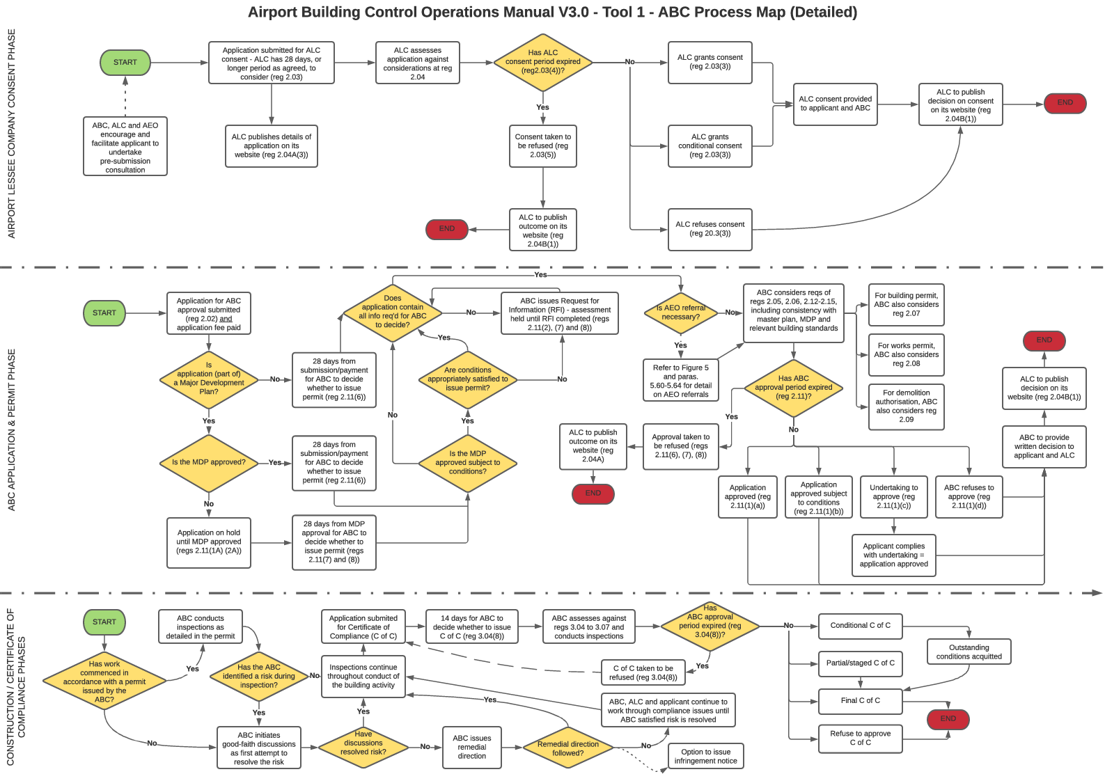

## **Tool 2: ABCO Application Lifecycle**

## 

## **Tool 3: Non-compliance Management Process Map**

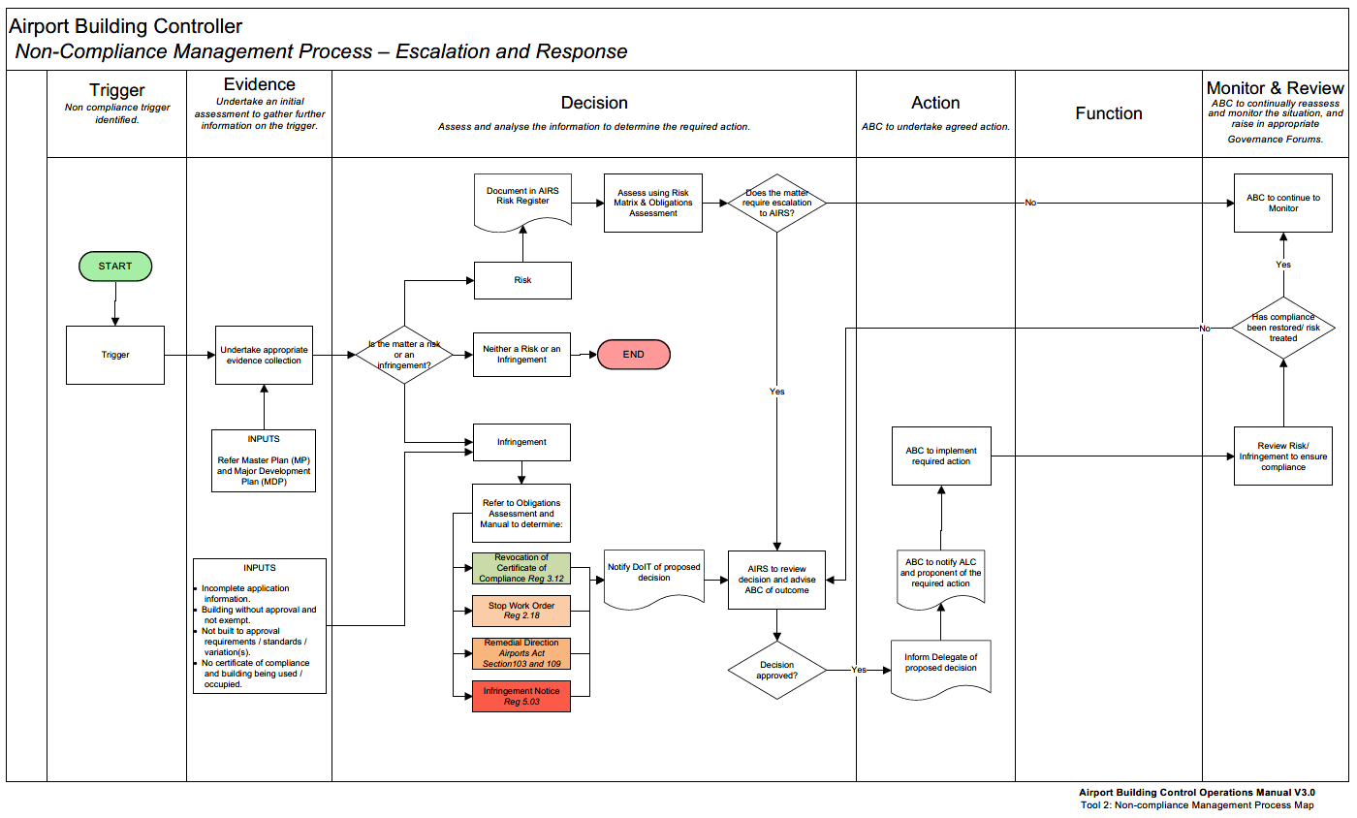

## **Tool 4: Risk Management Framework**

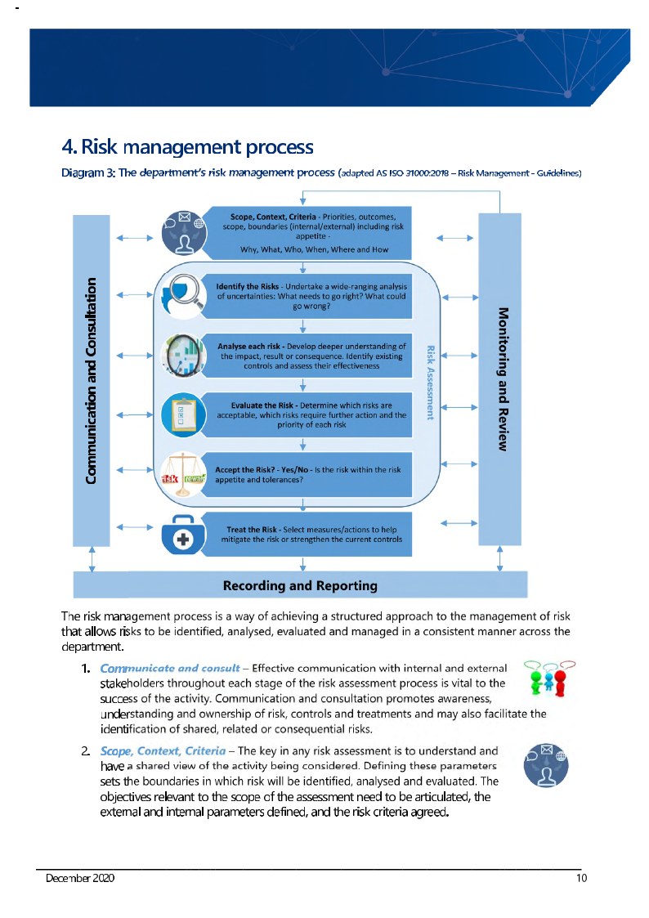

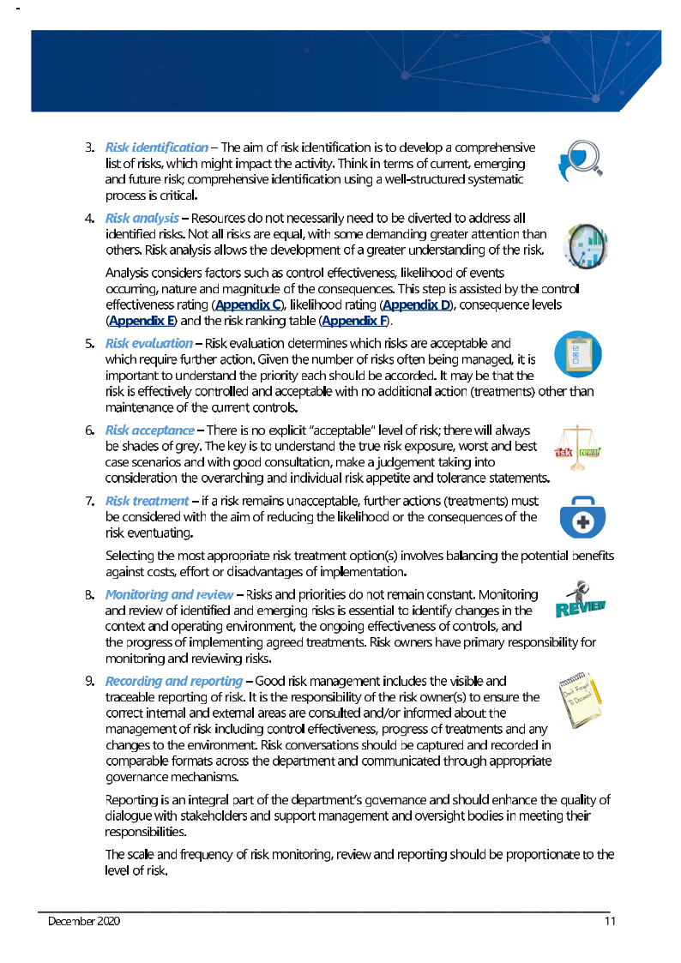

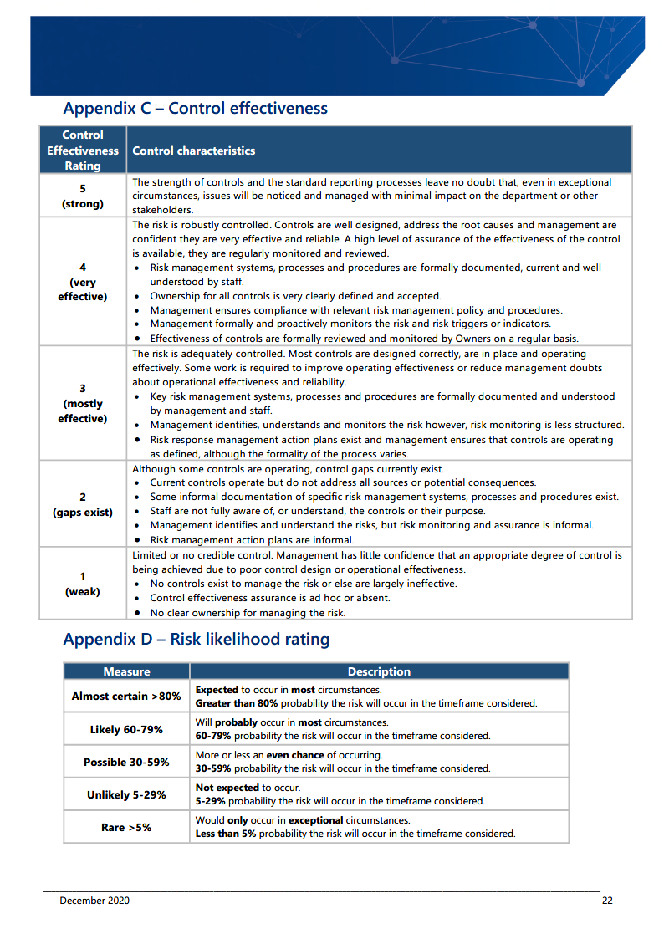

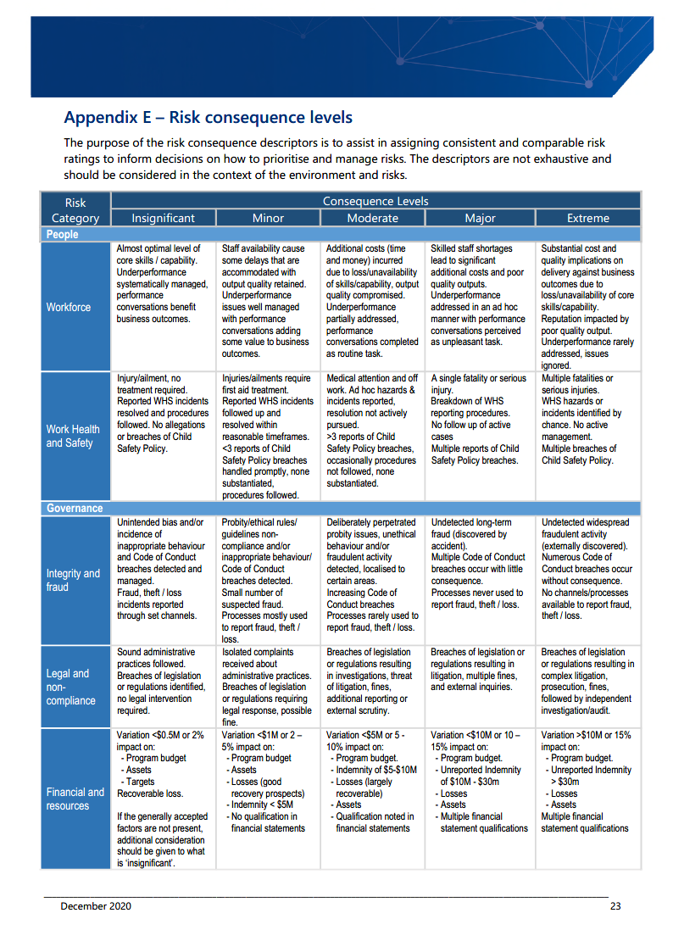

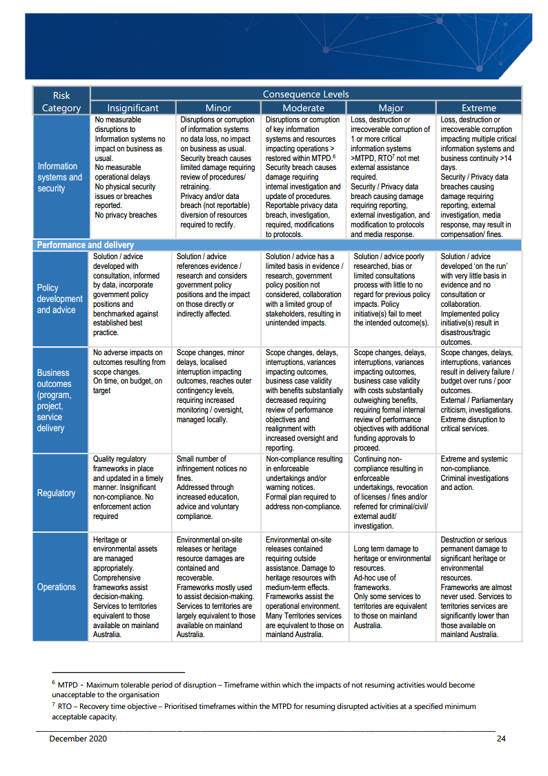

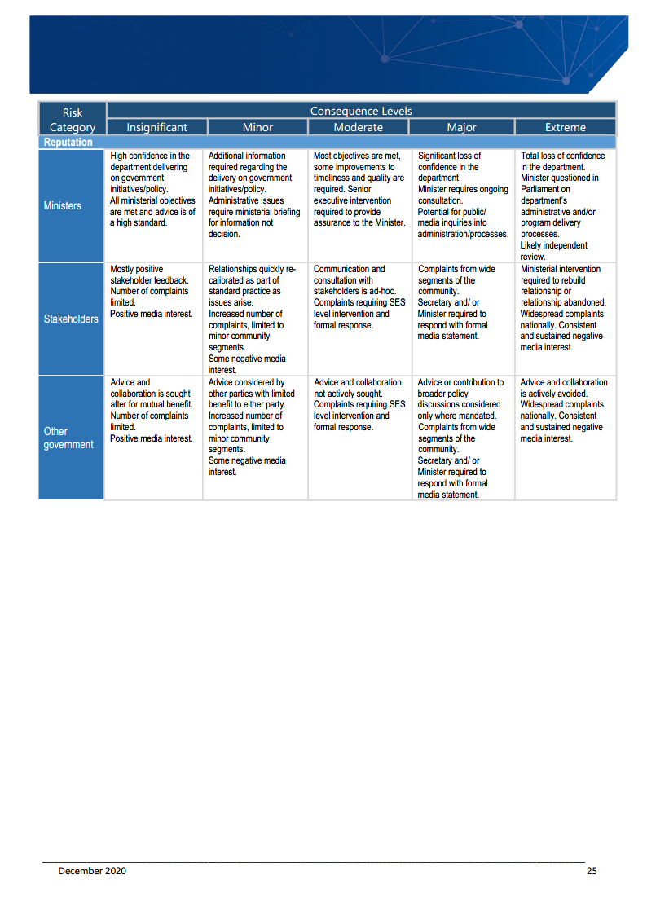

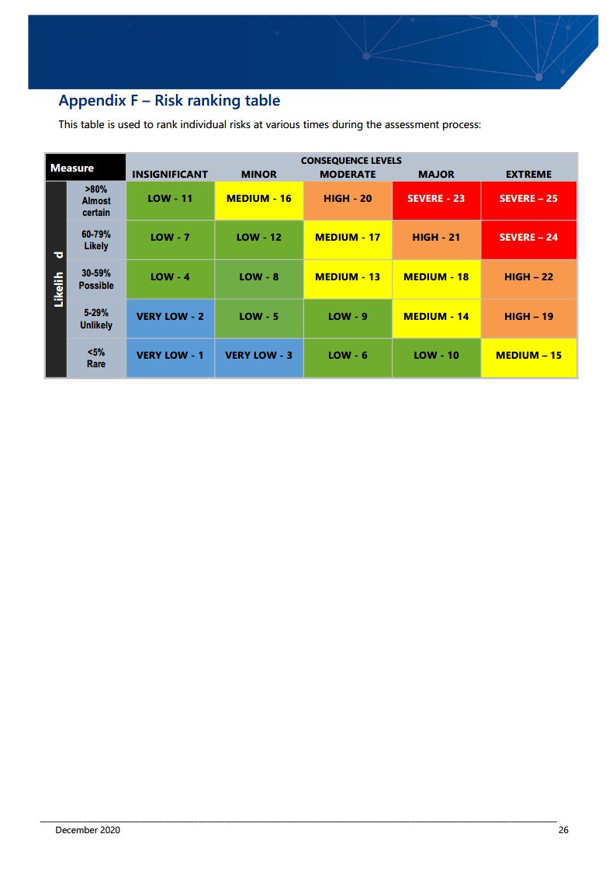

## **Tool 5: Land Clearing Guidelines**

The following guidelines are intended to clarify the term ‘land clearing’ and supersede the previous *Land Clearing – leased Federal airports Guidelines for ABCs and AEOs* issued on 3 April 2013.

In 2007, land clearing was added to the Airports Act 1996 at s. 98(1)(f) as a category of building activity and therefore as an activity for which a works permit is required.

**Definition**

For the purposes of s. 98(1)(f) of the Act, and where other relevant references are made to land clearing on federally leased airport sites, ‘land clearing’ is defined as:

*Land clearing is the removal of vegetation from any site, parcel or lot on a federally leased airport.*

*Land clearing includes:*

* + *cutting down, felling, thinning, logging or removal of vegetation;*
  + *killing, destroying, poisoning, ringbarking, uprooting or burning vegetation;*
  + *infilling of wetlands or dumping material on dry land vegetation;*
  + *drowning of vegetation through the construction of impoundments; and*
  + *substantially damaging or injuring vegetation in any other way.*

**Exemption**

For the purposes of s. 99 of the Act and Regulation 2.24 of the ABCR, the following land clearing activities are considered exempt from Subdivision C of Division 5 of Part 5 of the Act:

* + mowing and pruning so as to maintain vegetation in a healthy, viable condition;
  + weed control;
  + works for the purpose of maintaining landscaping, garden beds and streetscapes;
  + maintenance of on-airport drains, existing easements and roads;
  + maintaining clearance around air navigation and communication equipment, aprons, taxiways and runways as stipulated in the Manual of Standards Part 139;
  + ensuring that Obstacle Limitation Surface is not infringed;
  + clearing undertaken solely for the purposes of fire control where the requirements of fire control are specified in an airport master plan or environment strategy, and/or where a state, territory or local fire legislation is in force which mandates the undertaking of fire risk prevention measures such as clearing around assets;
  + the trimming or removal of vegetation that poses a security risk;
  + clearing of vegetation for the purpose of implementing feral pest control measures as identified in an approved management plan; and
  + clearing of vegetation due to an obvious safety risk affecting airport operators and/or users that requires immediate action to prevent serious injury.

In consultation with the ABC and AEO prior to lodging a building activity application or exemption notification, the following activities may be exempt from Subdivision C of Division 5 of Part 5 of the Act:

* + burning of vegetation where it is an accepted management regime as part of an approved management plan; and
  + disturbance of exotic grasses or exotic pastures.

**ABC and AEO considerations**

The ABC (and AEO where such referral is indicated) needs to be satisfied, via the documentation accompanying the application and the ALC consent that the proposed land clearing does not constitute a significant environmental or ecological impact, or that the proposal is consistent with an approved MDP which addresses any potentially significant environmental or ecological impact.

Depending on the scale of clearing proposed, the ABC and AEO may also consider:

* + the nature of the vegetation to be cleared, i.e. whether there are any listed, rare, endangered or threatened flora or fauna species present – although areas containing such species are typically zoned as environmentally significant in the master plan and environment strategy for the airport, this should not be assumed;
  + whether the area proposed for clearing constitutes habitat (permanent or transient) for native fauna;
  + whether the area proposed for clearing contains any sites of (potential) heritage value;
  + the measures proposed by the ALC and/or the applicant to minimise the adverse impacts of the proposed clearing – even where species present are not listed, rare, endangered or threatened, relocation or other management strategies may be appropriate to lessen the environmental and ecological impacts of the clearing;
  + the effect of land clearing on the environment on and around the airport site;
  + the level of interest in environmental matters from groups or individuals off the airport, and the extent and appropriateness of any consultation undertaken with those groups or individuals;
  + the effect on local area hydrology;
  + any dust, sediment and erosion control measures proposed; and
  + the presence of unexploded ordnance or soil or groundwater contamination which might be disturbed by the proposed clearing.

ABCs can impose conditions on building, works and demolition permits. Such conditions must be reasonable, specific and measurable.

*These Guidelines do not constitute advice on land clearing for the purposes of the Environment Protection and Biodiversity Conservation Act 1999. In particular, it does not remove the obligation for ALCs to notify the relevant Department or agency responsible for administering the EPBC Act if they propose to undertake an action which will have, or is likely to have, a significant impact on a matter of national environmental significance.*

## **Tool 6: ABC Quarterly Report Template**

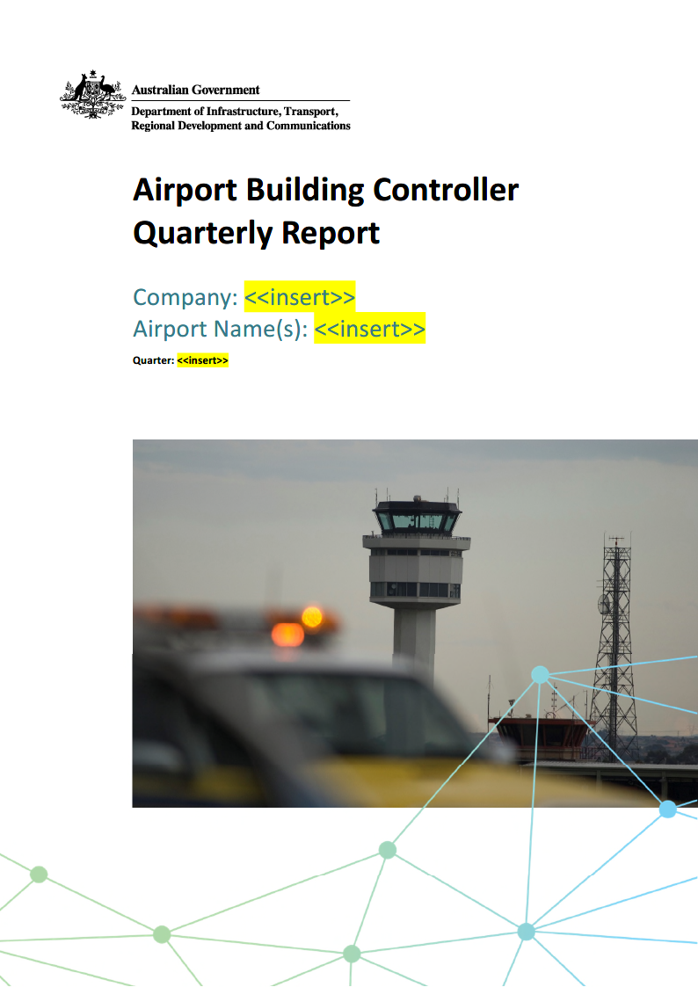

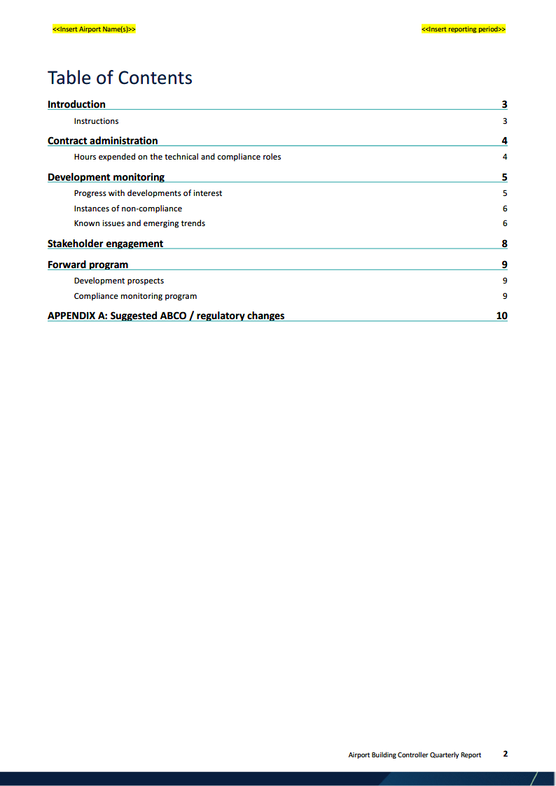

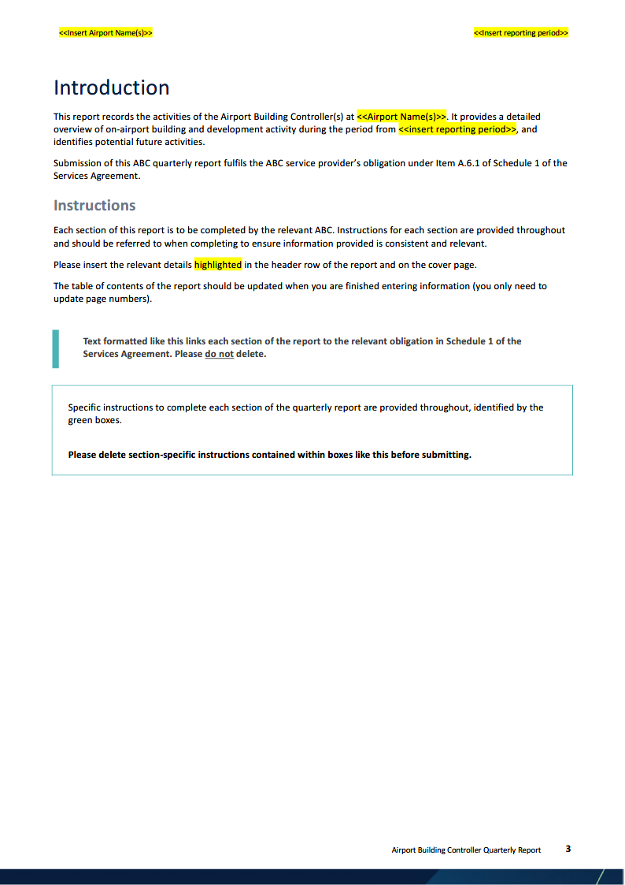

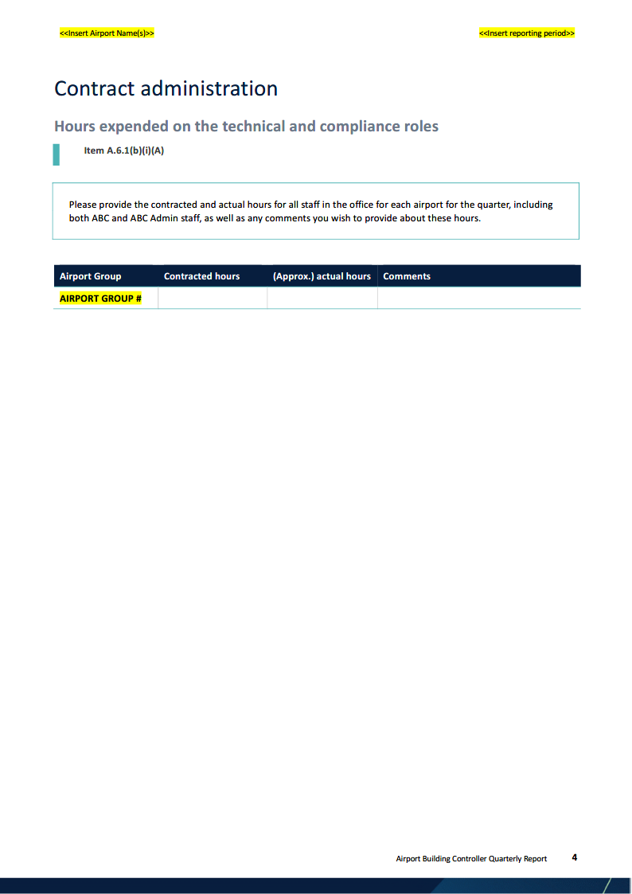

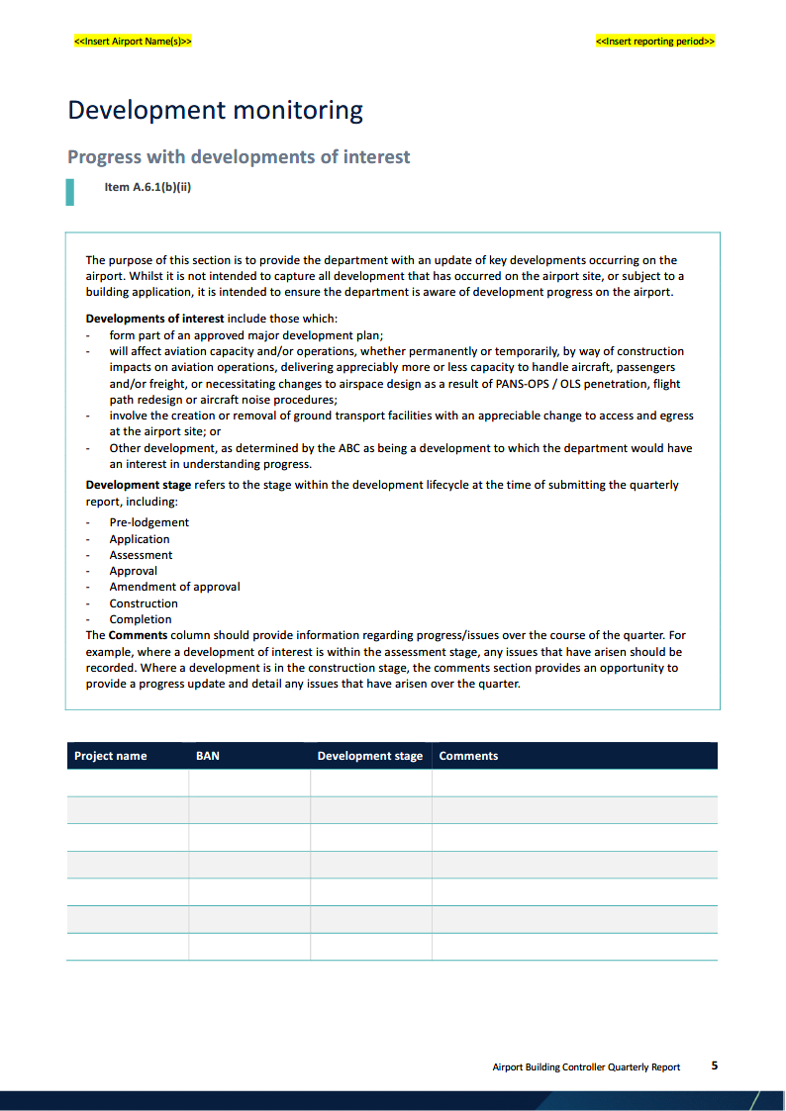

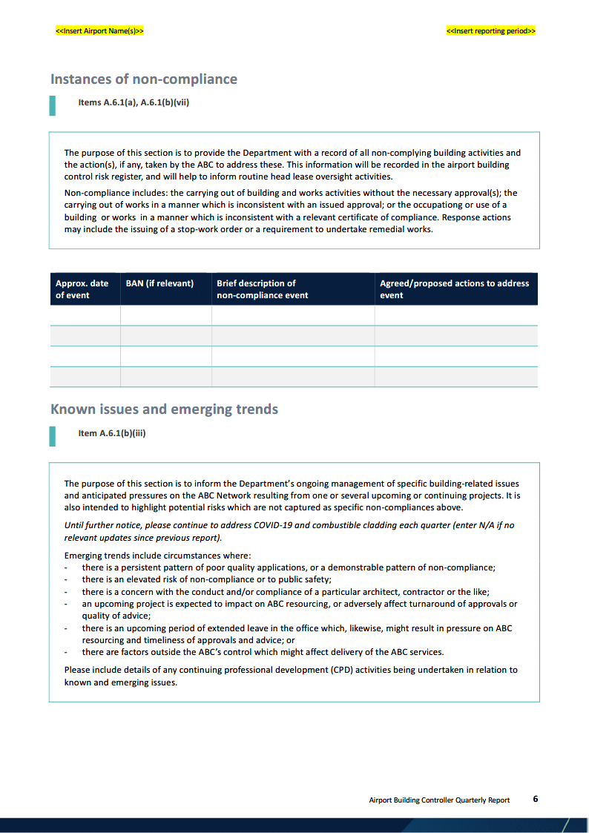

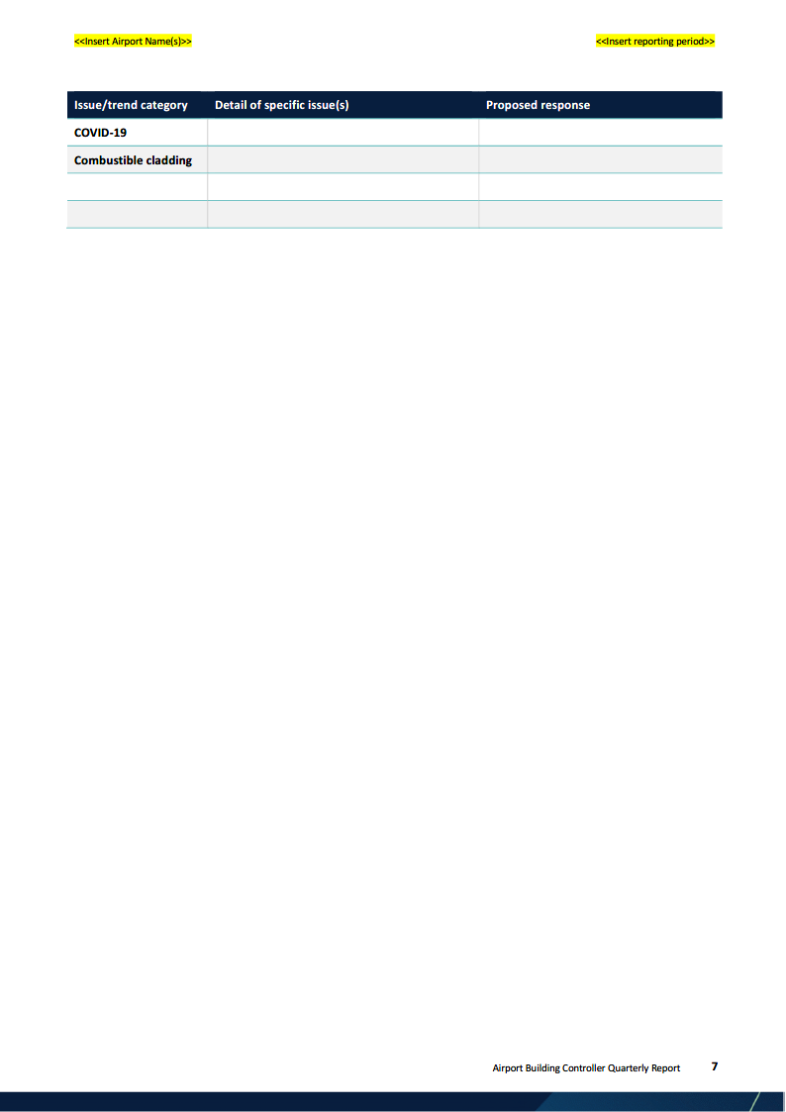

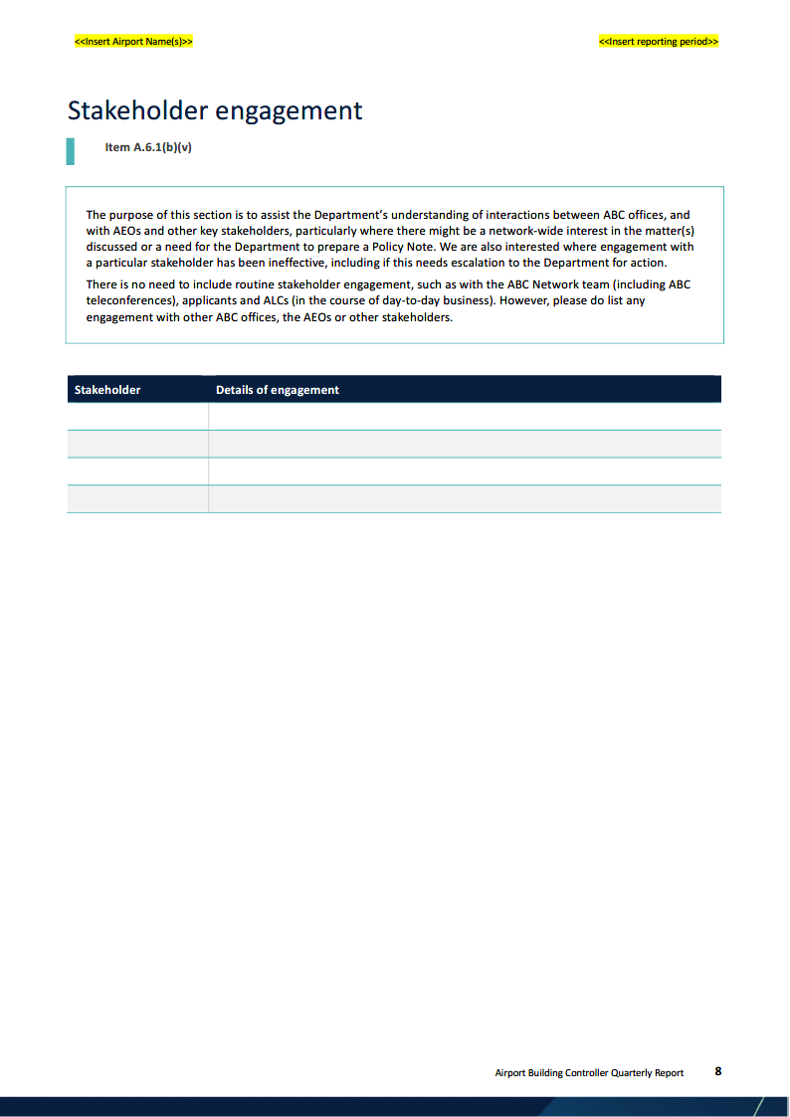

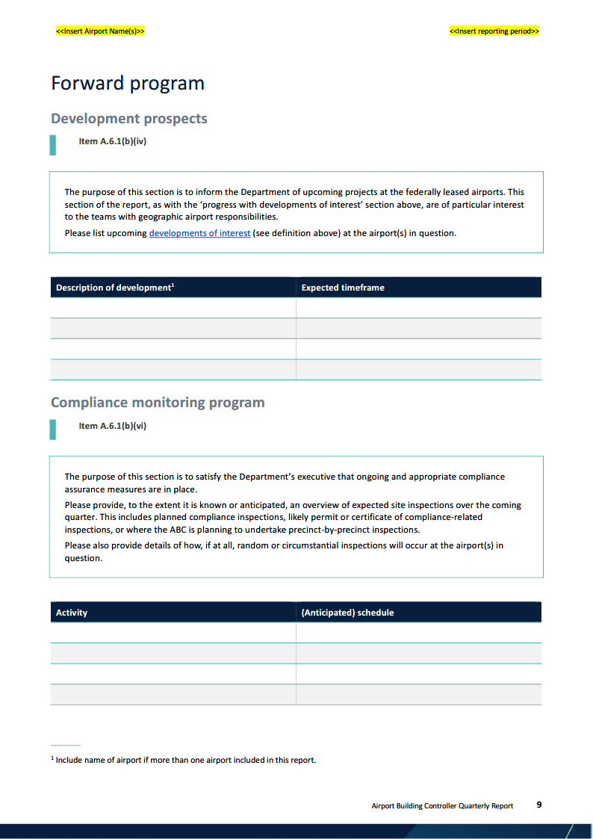

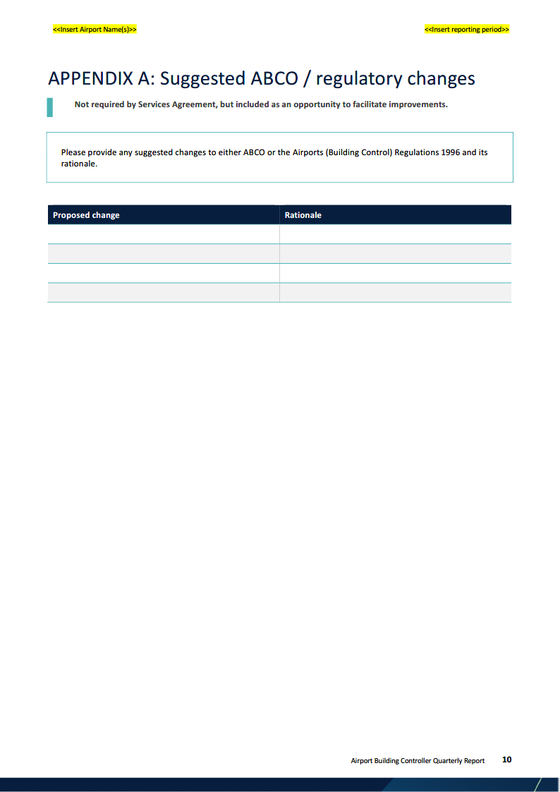

## **Tool 7: Standard Templates**

**Standard Language for ALC Consent**

*The following standard language is expected to appear (and may be appropriately adapted in consultation with the relevant ABC to suit various ALCs’ requirements) in all ALC consent documents included in applications made on or after DD Month 2021.*

In providing this consent on behalf of <<insert ALC name>> I declare that I have reviewed and assessed the application against each of the following criteria and requirements.

**Building activity application content requirements**

I confirm, to the extent possible within my role and qualifications, that the application as presented to <<ALC>> contains all the information and documentation, including suitably prepared design drawings and design and engineering certificates, required for the purposes of regulations 2.05 to 2.09 of the ABCR.

**Final Master Plan for the airport**

The proposed development is consistent with the final master plan for the airport in that it <<insert details about precincts/zoning, protected airspace, neighbouring land uses, ground transport impacts/connections, aviation capacity, etc.>>.

**Major Development Plan**

The proposed development does/does not form part of an approved Major Development Plan (MDP).

Where the proposal does form part of an approved MDP, the application is consistent with that MDP on the basis that it a within the footprint of the development as described in the MDP, it does not create impacts which have not been addressed in the MDP and it adequately addresses all commitments and conditions made during the approval process for the MDP.

Where the proposed development does not form part of an approved MDP, I declare it is <<ALC’s>> view that an MDP is not required for this proposed development because <<insert details>>.

**ALC’s planning objectives for the airport**

The proposed development is consistent with <<ALC’s>> planning objectives for the airport in that it <<insert details>>. <<ALC>> has had regard to the matters set out at sub-regulation 2.04(4) in addition to <<other matters relevant to the application>>.

**Final Environment Strategy for the airport**

The proposed development is consistent with the final environment strategy for the airport.

The application adequately addresses all environmental impacts which might reasonably be expected to occur on the site, including <<add as appropriate>>. The application contains a suitable Construction Environment Management Plan (if required) and Operational Environment Management Plan (if required) for the development. Management plans are also included in the application for <<PFAS, acid sulphate soils, construction noise, dust suppression, etc. as appropriate>>.

**Aviation considerations**

I confirm that <<ALC>> has considered the potential for aviation impacts (such as penetration of protected airspace, lighting, aircraft noise, aviation security and public safety, and the efficiency of aviation operations at the airport).

**Publication**

I confirm that the details of the application and <<ALC’s decision on consent>> have been duly published to <<ALC’s>> website for the purposes of regulations 2.04A and 2.04B of the ABCR.

**Template for Notification of Withdrawal and Request for Refund**

Dear ABC

I am writing to advise that I/we wish to withdraw building activity application BAN-YY-APT-NNNN. I/we also wish to request a refund of the application fee on the basis that no decision has yet been made to issue a building, works or demolition permit.

Please see below the required information for the Department to process the requested refund.

Payer name (Legal Entity name):

Date of initial (electronic fund transfer or credit card payment) payment:

Receipt #:

<ABC>Will withdrawal fee ($250) apply:

<ABC>If yes, has withdrawal fee been paid:

Requested refund amount (full application fee):

BAN #:

Payment request number (building application fee):

Reason for refund:

Bank account details (acc name, BSB, account number):

Kind regards

Applicant

## **Tool 8: ABCO User Rights Matrix**

| Function/Rule | App. | ABC | Admin | ALC | AEO | AIRS |
| --- | --- | --- | --- | --- | --- | --- |
| **SUBMITTING AN APPLICATION** | | | | | | |
| Can lodge new application | Y | Y | Y | N | N | N |
| Can be an applicant contact | Y | N | N | N | N | N |
| Can preview an application | Y | Y | Y | N | N | N |
| Can save a draft application | Y | Y | Y | N | N | N |
| Can view draft application | Y | Y | Y | N | N | N |
| Can view submitted application | Y | Y | Y | Y | Y | Y |
| Send/receive correspondence | Y | Y | Y | Y | Y | Y |
| **MAKE A PAYMENT (CC AND EFT)** | | | | | | |
| Update/invalidate payment request | N | Y | Y | N | N | N |
| Make a payment from the ABCO system | Y | Y | N | N | N | N |
| **MANAGE LOGIN DETAILS AND PROFILE** | | | | | | |
| Reset/update own password | Y | Y | Y | Y | Y | Y |
| Update own account details | Y | Y | Y | Y | Y | Y |
| **REQUEST FURTHER INFORMATION** | | | | | | |
| Issue RFI | N | Y | Y | N | N | N |
| **DOCUMENTS** | | | | | | |
| Document(s) upload | Y | Y | Y | Y | Y | N |
| View/search documents | Y | Y | Y | Y | Y | Y |
| Add stage to a document attributes | N | Y | Y | N | N | N |
| Add document type | N | Y | Y | N | N | N |
| Update review status | N | Y | Y | N | N | N |
| Delete documents (prior to submission) | Y | N | N | N | N | N |
| Determine document availability | N | Y | Y | N | N | N |
| Export search results | Y | Y | Y | Y | Y | Y |
| **APPROVE APPLICATION** | | | | | | |
| Issue approval | N | Y | N | N | N | N |
| Save a draft approval | N | Y | Y | N | N | N |
| **CERTIFICATES OF COMPLIANCE** | | | | | | |
| Request issue of a certificate | Y | Y | Y | N | N | N |
| Issue certificate | N | Y | N | N | N | N |
| Save draft certificate | N | Y | Y | N | N | N |
| **ABCO HOME SCREEN** | | | | | | |
| View all applications for all airports | N | N | N | N | N | Y |
| Search/view application – assigned airport | N | Y | Y | Y | Y | Y |
| View applications related to user | Y | Y | Y | Y | Y | N |
| View applications submitted by user | Y | Y | Y | N | N | N |
| **AIRS FUNCTIONALITY** | | | | | | |
| Assign User Role / Allowed Airport | N | N | N | N | N | Y |
| **ABC FUNCTIONALITY** | | | | | | |
| Create payment request | N | Y | Y | N | N | N |
| Manual (EFT) payment | N | Y | Y | N | N | N |
| Assessment notes | N | Y | Y | N | N | N |
| Update/revoke approval | N | Y | Y | N | N | N |
| Revoke certificate | N | Y | Y | N | N | N |

## **Tool 9: Schedule of Application Fees**

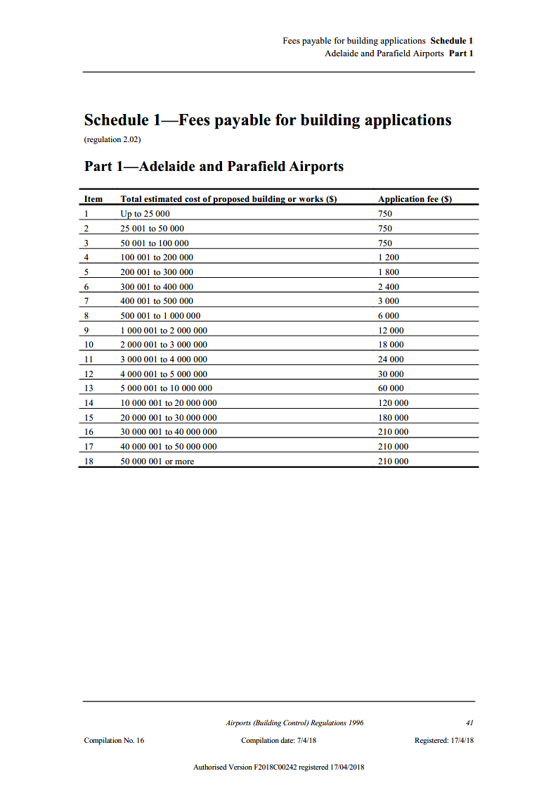

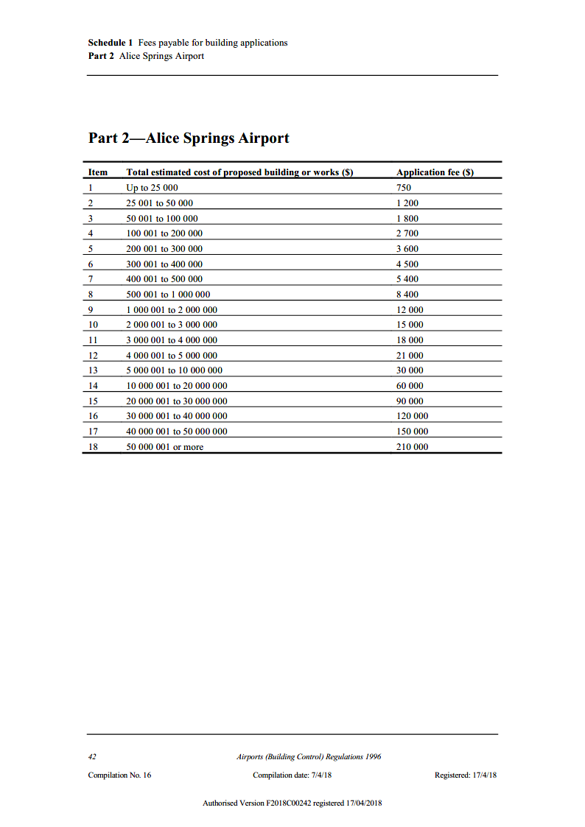

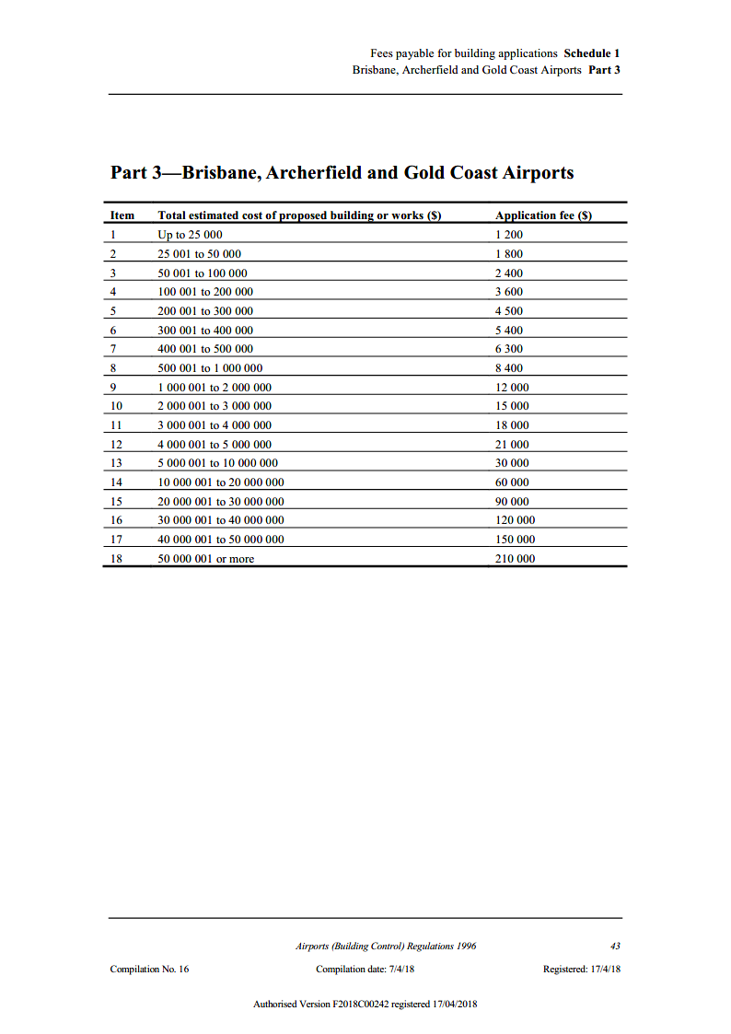

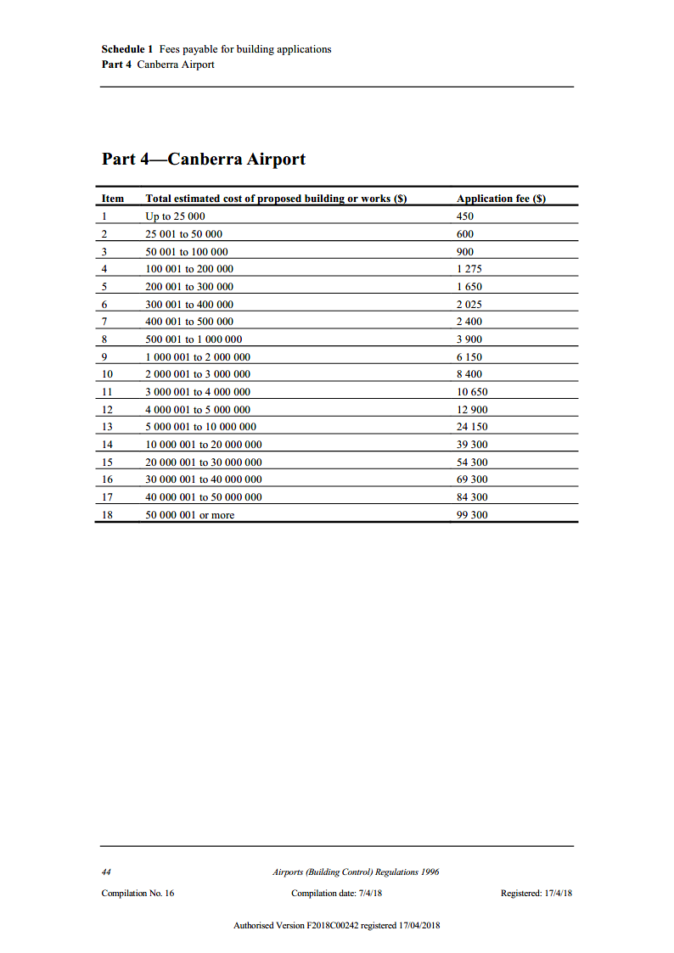

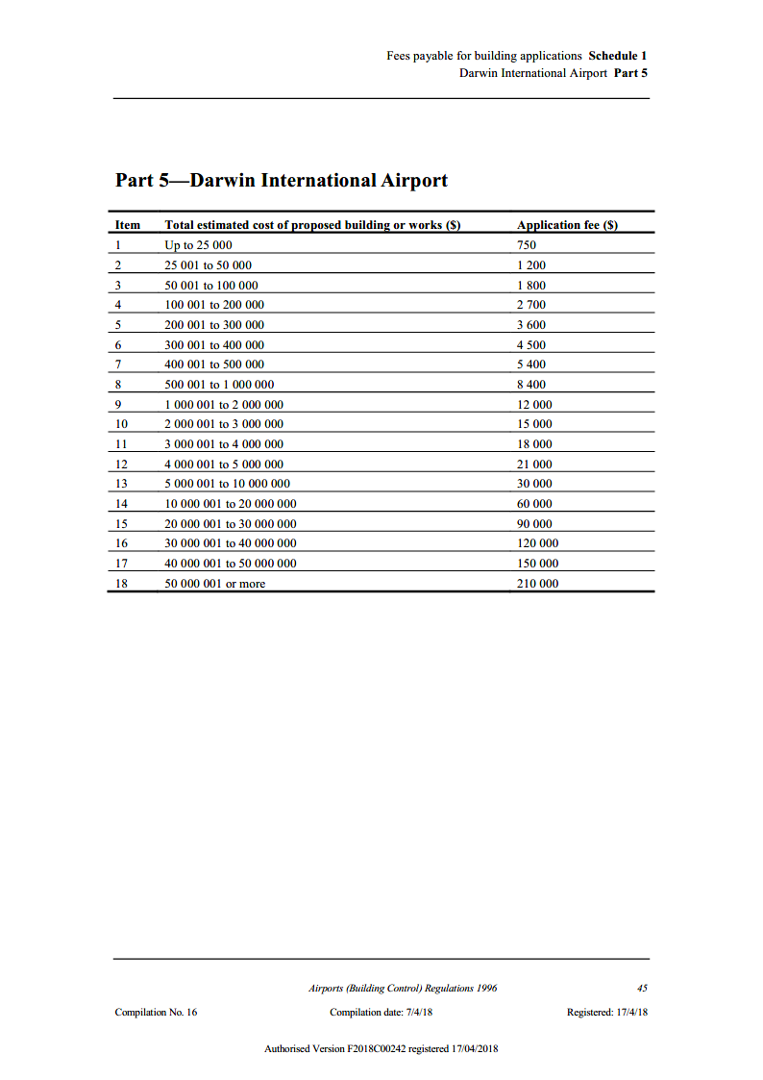

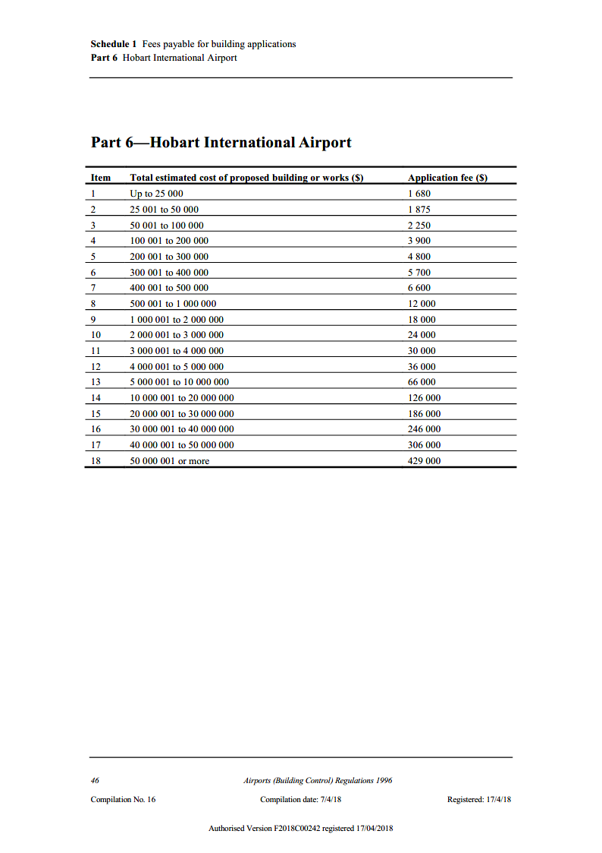

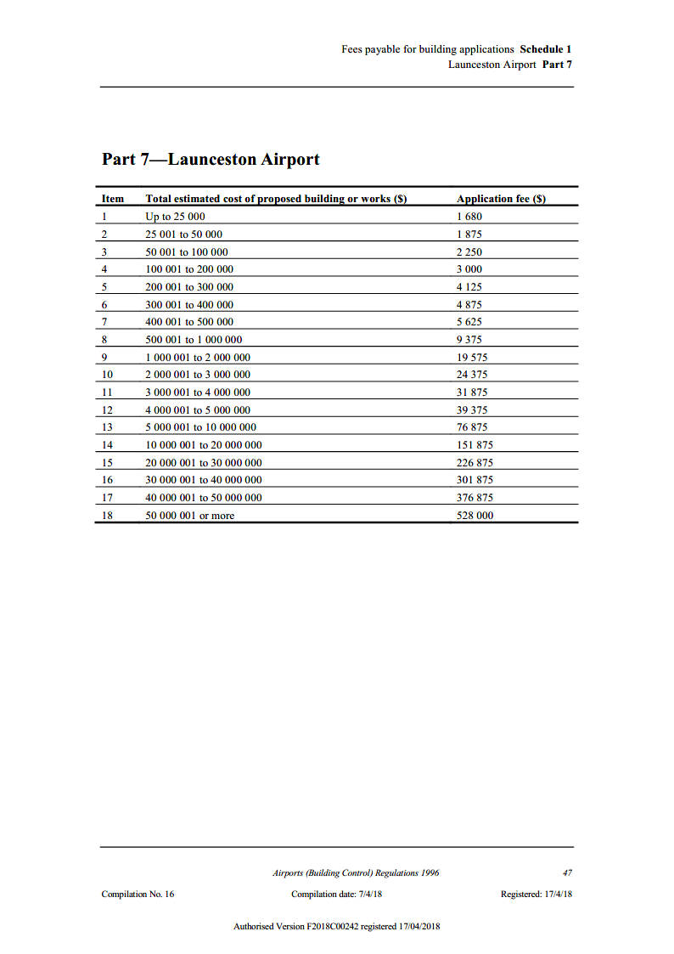

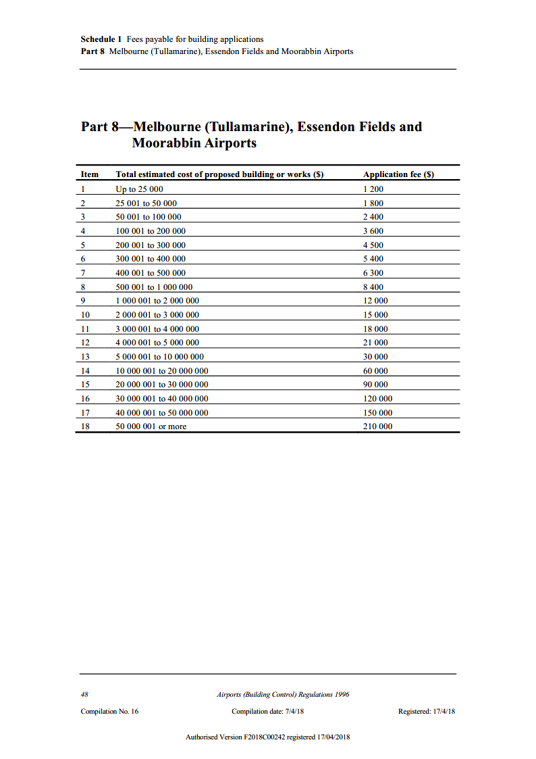

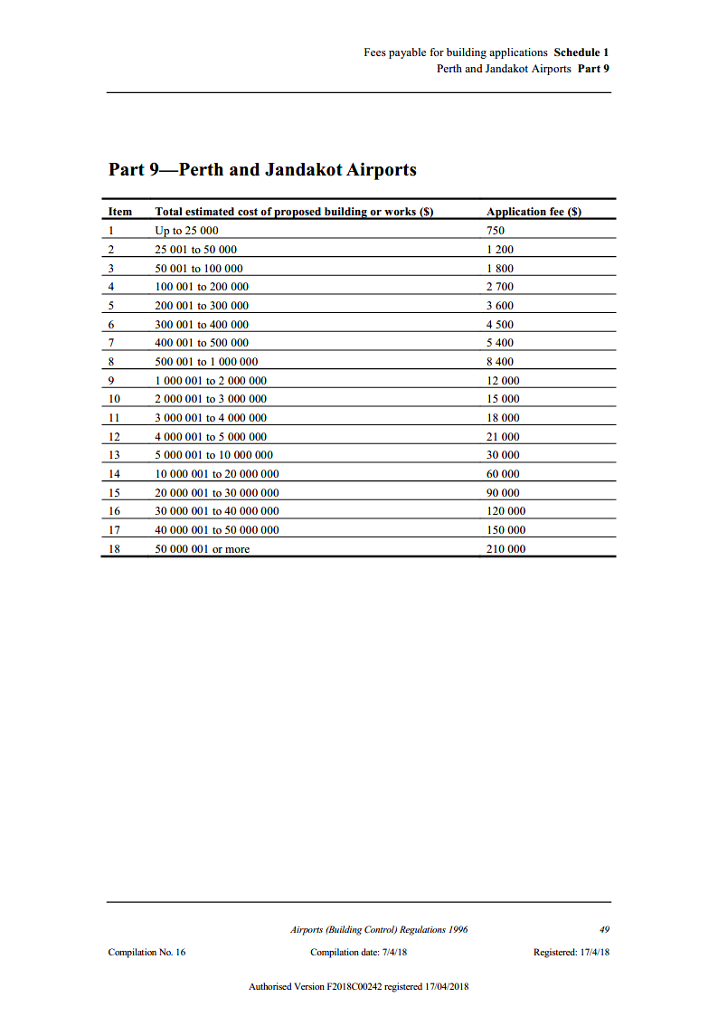

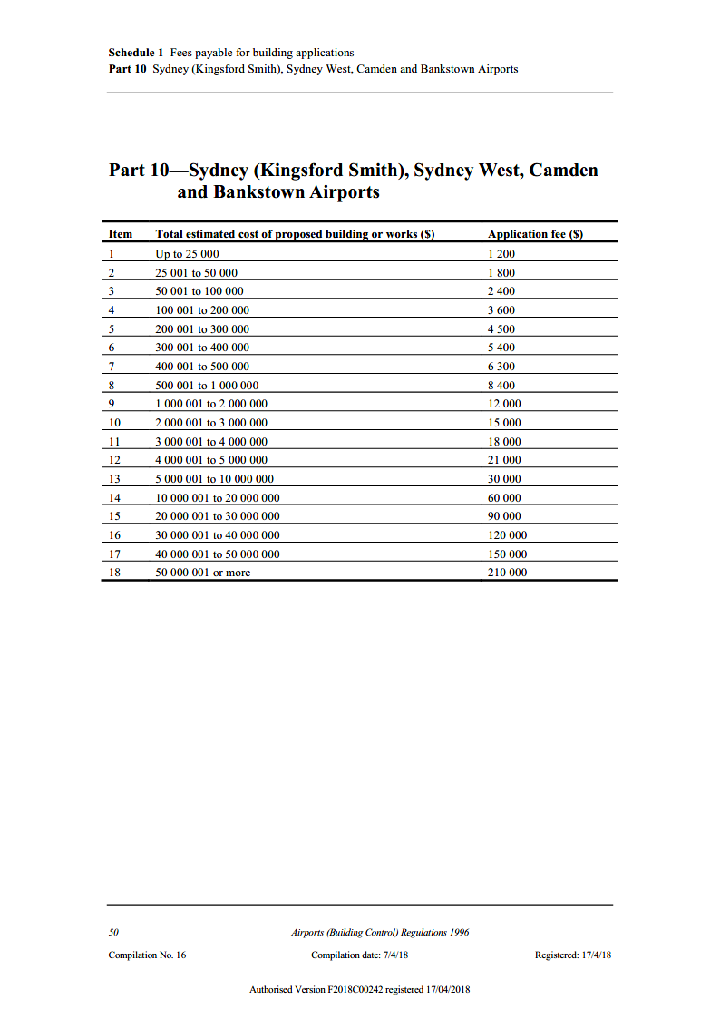

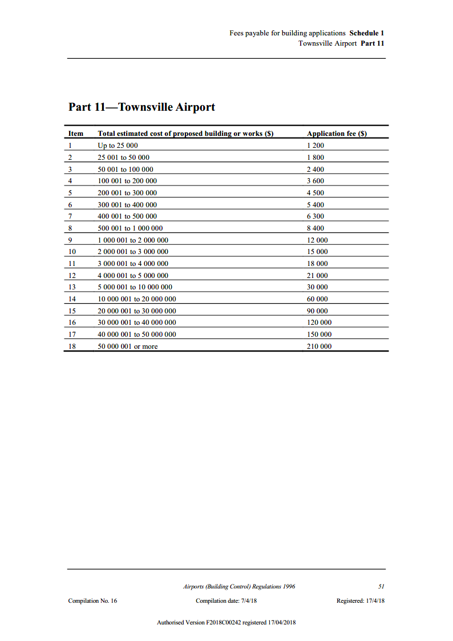

1. National Construction Code 2019 Amendment 1, published by the Australian Building Codes Board.
2. Land use planning, building control and environmental management provisions (i.e. Part 5) of the Act do not apply at Mount Isa or Tennant Creek Airports.
3. The 22nd federally leased airport referenced here is Sydney West Airport; see later paragraphs.
4. Replacement master plans re required on a five year cycle for Sydney (Kingsford-Smith), Melbourne (Tullamarine), Brisbane and Perth Airports. The eight year cycle applies to all other federally leased airports, except Sydney West Airport at this stage.
5. Section 92 of the Act provides that the Minister may approve a shorter public consultation period of not less than 15 business days on applicant by the proponent.
6. ‘Sensitive developments’ are defined at s 71A of the Act.
7. Definition from the International Standard for Risk Management (AS/NZS ISA31000).