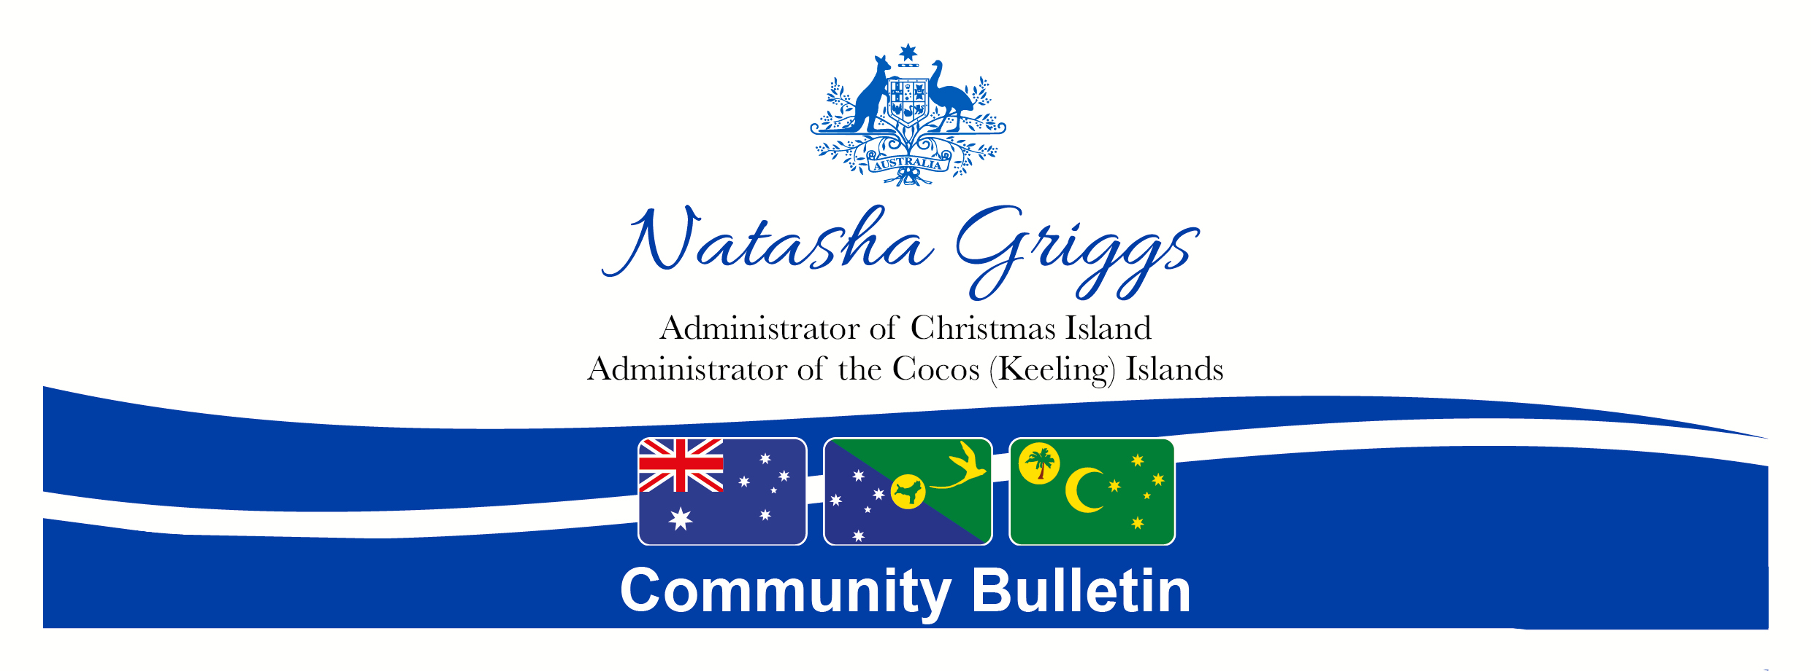
Number: | A12/2022 | Date: | 9 September 2022

Vale Queen Elizabeth II
It is with great sadness that I pay my respects to the Queen of Australia, Her Royal Majesty, Queen Elizabeth II, who passed away overnight at the age of 96. Her Royal Majesty was the longest-reigning monarch in British history and epitomised duty and service to her people.
On behalf of the communities of Australia’s Indian Ocean Territories, I send our deepest condolences to the Royal Family, who are today not only mourning their Queen, but a beloved mother, grandmother and great-grandmother.
We here in the Indian Ocean Territories have a special connection to Her Majesty, who visited the Cocos (Keeling) Islands on her first royal tour in 1954 – a visit which held a special place in her heart.
I was fortunate enough to have the honour of meeting Her Majesty at Parliament House during her final tour of Australia in 2011.
She was an exemplar and role model of service throughout her reign and her life and in particular to women in leadership.
In honour of Her Majesty, flags will be lowered to half-mast across the Indian Ocean Territories. I will be writing a formal letter of condolence to the Royal Family and Buckingham Palace from the residents of Christmas Island and the Cocos (Keeling) Islands. Residents are invited to leave a message of condolence on the Australian Governor General’s website https://www.gg.gov.au.
I invite community members to lay flowers, wreaths and memoriums at the base of the flag pole at Government House (the Administrator’s official residence) on Christmas Island and West Island, Cocos (Keeling) Islands, to acknowledge and pay respect to the passing of Queen Elizabeth II.
While today marks the end of era, the memories of, and deep respect for, Her Majesty will never fade.
May she rest in peace, and Long Live the King.
Natasha Griggs
Administrator of Christmas Island and the Cocos (Keeling) Islands

