

2024 Regional Telecommunications Review
  - Connecting communities, reaching every region
December 2024
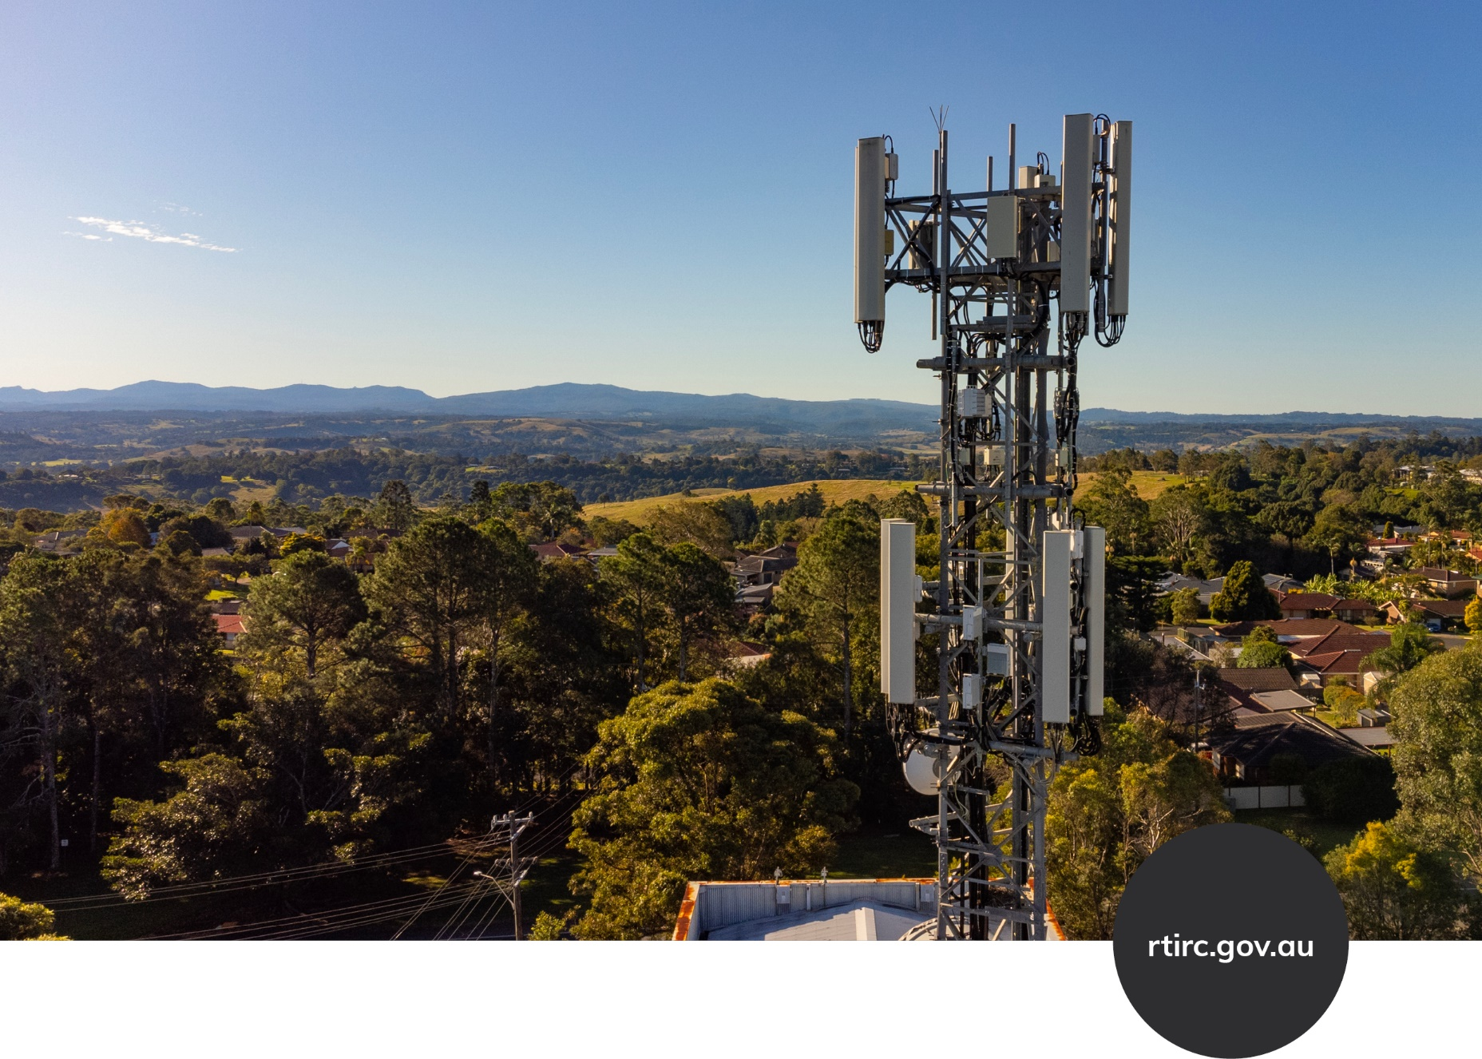

2024 Regional Telecommunications Review
  - Connecting communities, reaching every region

© Commonwealth of Australia 2024
Digital 978-1-922879-67-7
Print 978-1-922879-68-4

Ownership of intellectual property rights in this publication
Unless otherwise noted, copyright (and any other intellectual property rights, if any) in this publication is owned by the Commonwealth of Australia (referred to below as the Commonwealth).

Disclaimer
The material contained in this publication is made available on the understanding that the Commonwealth is not providing professional advice, and that users exercise their own skill and care with respect to its use, and seek independent advice if necessary.
The Commonwealth makes no representations or warranties as to the contents or accuracy of the information contained in this publication. To the extent permitted by law, the Commonwealth disclaims liability to any person or organisation in respect of anything done, or omitted to be done, in reliance upon information contained in this publication.
This report has been prepared for consultation purposes only and does not indicate the Commonwealth's commitment to a particular course of action. Additionally, any third party reviews or recommendations included in this report do not reflect the views of the Commonwealth, or indicate its commitment to a particular course of action.

Creative Commons licence


With the exception of (a) the Coat of Arms; (b) the Department of Infrastructure, Transport, Regional Development, Communications and the Arts logos, photos and graphics; (c) content supplied by third parties; (d) content otherwise labelled; material in this publication is licensed under a Creative Commons BY Attribution 4.0 International Licence.
Creative Commons BY Attribution 4.0 International Licence is a standard form licence agreement that allows you to copy, communicate and adapt this publication provided that you attribute the work to the Commonwealth and abide by the other licence terms.
This publication (and any material sourced from it) should be attributed in the following way:
2024 Regional Telecommunications Review © Commonwealth of Australia 2024 licensed under CC BY 4.0. To view a copy of this licence, visit https://creativecommons.org/licenses/by/4.0/.

Third party copyright
The Department has made all reasonable efforts to clearly identify material where the copyright is owned by a third party. Permission may need to be obtained from third parties to re-use their material.

Use of the Coat of Arms
The Department of the Prime Minister and Cabinet sets the terms under which the Coat of Arms is used. Please refer to the Commonwealth Coat of Arms - Information and Guidelines publication available at http://www.pmc.gov.au.

Contact us
This publication is available in print and digital formats. All other rights are reserved, including in relation to any departmental logos or trademarks which may exist. For enquiries regarding the licence and any use of this publication, please contact: rtirc@infrastructure.gov.au


Satellite Dish, Kununurra WA – Getty Images, John Clutterbuck

Contents
I. Letter of transmittal 8
II. Executive summary 10
III. Recommendations 14
IV. Introduction 18
Terms of reference 18
The importance of telecommunications services 19
What’s happened since the 2021 Review? 22
Approach to the 2024 Review 23
V. Telecommunications services in regional, rural and remote Australia 26
Australian telecommunications market 26
Mobile 29
Broadband 35
Fixed voice services 41
Network resilience 42
1. Upscaling connectivity literacy 44
Training modules 48
2. Improving the mobile experience 50
More focus on funding capacity building 50
Regulatory options to improve choice of mobile provider 51
Wi-Fi calling for fixed locations 52
Mandatory emergency mobile roaming 53
Illegal mobile phone boosters 53
Coverage maps and funding priorities 54
3. Expedite universal service modernisation 55
2023 Universal Service Obligation Review 56
Phasing out the Copper Continuity Obligation 56
Backup services for all consumers 58
Modernising the Universal Service Obligation 58
The continued relevance of payphones 59
Customer Service Guarantee enhancements 61
4. Consumer protection 64
Telecommunications Consumer Protection Code 65
5. Affordability 68
Pre-paid low-cost plans 69
Unmetered data for essential services 69
School Student Broadband Initiative 70
6. Develop a national telecommunications data platform 71
For consumers and businesses 71
For governments 73
Measuring Broadband Australia program 74
7. Regional telecommunications strategy 76
8. Government programs 78
Evaluate existing programs 78
Modernising government programs 78
Awareness of government programs and investment 81
9. Support for First Nations Digital Inclusion Advisory Group 83
10. Embedding community Wi-Fi 85
Community connectivity hubs 85
Expanding free Wi-Fi in remote First Nations communities 86
Invest in public Wi-Fi for key regional and remote locations 87
11. Transition oversight 89
12. Expedite planning approvals 92
13. Powering connectivity 95
Minimum backup power periods for critical telecommunications infrastructure 95
Priority for power restorations to critical infrastructure 96
Prioritising energy connections for new telecommunications installations 96
14. Evolution of the Regional Telecommunications Independent Review Committee 98
Appendix A – 2024 RTIRC survey 100
Appendix B – List of public submissions 103
Appendix C – Public consultation 109
Appendix D – Glossary 112
Appendix E – Committee biographies 117



I. Letter of transmittal
The Hon Michelle Rowland MP
Minister for Communications
Minister.rowland@mo.communications.gov.au
Parliament House
CANBERRA ACT 2600
Dear Minister
On behalf of the 2024 Regional Telecommunications Independent Review Committee, I am pleased to present our report to you.
The Committee travelled across the nation listening to communities in regional cities, small country towns and remote First Nations communities. Our consultations included townhall meetings, community leadership events and virtual forums. We invited written submissions and introduced an online survey that drew unprecedented participation.
We heard loud and clear that telecommunications are essential for regional communities and that many experience inadequate service. We heard that while there has been improved broadband in many areas, the mobile experience has become more challenging for many. It is clear significant disparities in connectivity remain, particularly in remote locations and among First Nations communities.
The Committee recognises the investment that is being made across the country. The impact of this could be significantly enhanced with investment in connectivity literacy in regional areas. We also advocate for giving priority to modernising universal service arrangements and consumer protections. Our Report proposes ways to strengthen resilience in infrastructure and expedite planning processes. We also highlight emerging technologies like modern LEO satellite options and direct to handset technology, which, if thoughtfully integrated, could offer promising connectivity alternatives in hard-to-reach areas. We promote stronger oversight of future technology transitions and a new path forward for the Review task.
Telecommunications services touch every aspect of life in regional, rural and remote Australia, and it is more critical than ever to ensure equitable access. The Committee believes our recommendations outline practical and strategic pathways to bridge the digital divide and support regional Australia's full participation in the 21st century economy.
I join Committee members Mr Ian Kelly, the Hon Fiona Nash, Dr Jessa Rogers and Ms Kristy Sparrow in commending this report to you.
Yours sincerely

Alannah MacTiernan
Chair
2024 Regional Telecommunications Independent Review Committee
13 December 2024

II. Executive summary
Access to dependable telecommunications is not a luxury but a necessity. Reliable connectivity is critical as it links people who live and work in regional, rural and remote Australia to essential services, including healthcare, education, emergency response and business operations. However, despite considerable investments and technological advancements, significant disparities and a lack of awareness of available options remain, leaving some communities at a disadvantage.
In today’s world, telecommunications drive the economic and social well-being of regional, rural, and remote communities across Australia. It enhances quality of life, supports community resilience, and ensures that regional Australians can fully participate in the digital economy.
Yet, the 2024 Regional Telecommunications Independent Review Committee (the Committee) has found that while many regional centres now enjoy urban-level connectivity, smaller and more remote communities still face ongoing struggles with service quality, reliability and affordability.
In summary:
- Broadband connectivity in regional Australia has greatly improved, it is now ubiquitous, but awareness and understanding of available options, especially regarding National Broadband Network (NBN) services, remains limited.
- It is clear to the Committee that existing mobile networks in many regional areas are under pressure and facing congestion and capacity issues that require urgent attention to ensure reliable service.
- Terrestrial mobile networks have reached a stage in which extending coverage any further is increasingly unviable, due to sparse populations and high cost of infrastructure and maintenance. In coming years, Low Earth Orbit (LEO) satellites with Direct to Handset (DTH) mobile services may provide basic connectivity options for the most remote areas without existing terrestrial mobile coverage.
- Remote First Nations communities continue to face significant challenges in accessing quality, affordable telecommunications services. Community Wi-Fi schemes are emerging as a promising solution to help improve connectivity in these communities.
- Affordability remains a significant concern across regional, rural, and remote Australia, where maintaining service redundancy and adopting emerging technologies like LEO satellites are currently costly. Many people can only afford a single service, highlighting the need for cost-effective connectivity solutions.
- Maintaining public ownership of the NBN will heighten consumer confidence and is essential for ensuring that rural and remote communities have access to affordable, high-quality broadband services.
- New emerging technologies, such as LEO satellite services, are providing improved broadband solutions, but also present challenges, particularly in terms of affordability, community concerns around sovereignty and national security, and consumer protections.
- In many parts of regional, rural, and remote Australia, residents value their landline phone services delivered over copper and other legacy technologies. These networks are ageing and increasingly expensive to operate. The Committee recognises these legacy networks cannot be supported indefinitely, and funding provided could be better deployed to build a broadband connected future. It is important that the people who rely on these legacy connections are properly supported and protected in their transition to newer technologies.

Upgrading broadband infrastructure and improving connectivity literacy
The NBN has been transformative, bringing high-speed internet to many people in regional, rural and remote Australia. Ongoing upgrades, including the extension of fibre networks and improvements to fixed wireless and satellite services, have made broadband more accessible. However, connectivity literacy – the knowledge of available options, of how to get connected, stay connected and improve connectivity – remains a significant barrier. Many residents are unaware of the services and technologies they could access, limiting the potential of existing infrastructure.
To address this, the Committee highlights the importance of developing training modules and a network of ‘Connectivity Champions’ to provide on-the-ground support. Embedding these resources in trusted local organisations could significantly improve awareness and uptake of advanced connectivity solutions.

Bridging connectivity gaps and expanding mobile coverage
Mobile networks have improved significantly over the years, but gaps persist, particularly in remote areas where extending terrestrial mobile coverage remains prohibitively expensive. Telstra continues to dominate mobile infrastructure in rural and remote regions, but even with its extensive footprint, achieving complete terrestrial mobile coverage across Australia’s vast landscape is not possible. Optus and TPG are steadily expanding their presence in regional Australia although their respective network coverage is less extensive compared with Telstra.
Beyond coverage, mobile capacity issues were a recurring concern including network congestion, particularly during peak periods such as tourist seasons or major local events. The Committee found numerous instances where slow internet speeds, dropped calls, and service interruptions are a daily reality for residents and businesses. The increased use of data-intensive applications and technologies further strains network capacity. These challenges require targeted investments to enhance mobile infrastructure where demand has outstripped capacity. Improved connectivity literacy will also support an understanding of alternative connectivity options to alleviate these capacity impacts.
Emerging technologies such as LEO satellite networks and DTH capabilities offer promising solutions. LEO satellite services provide high-speed internet in remote areas, but their affordability and reliability remains a concern. DTH services, expected to launch in 2025, will enable direct communication between satellites and standard smartphones, improving connectivity in areas beyond the reach of traditional terrestrial mobile networks. However, these services must be integrated thoughtfully, with careful management of consumer expectations and clear communication about their limitations.

Modernising the Universal Service Obligation
The longstanding Universal Service Obligation (USO), which guarantees access to basic telephone services, must be modernised to reflect today’s digital realities. The Committee recommends a unified service obligation that is technology-neutral and mandates voice-capable broadband services be available to all. NBN Co Limited (NBN Co), as the default provider, should ensure these services meet minimum quality and speed standards, particularly in remote areas. The transition from copper and other legacy networks must be carefully managed, ensuring reliable alternatives are in place before any legacy infrastructure is retired. The Committee also advocates for maintaining public payphones as a free service for domestic calls within Australia, especially in areas where mobile coverage is limited.

Addressing affordability and strengthening consumer protections
Affordability is a persistent challenge in rural, regional, and remote Australia. The relatively high costs currently associated with services like LEO satellite internet are a barrier for many households. The Committee supports initiatives for low-cost broadband plans, particularly for First Nations communities, and calls for government subsidies where necessary. Additionally, unmetered access to critical government websites should be introduced to ensure equitable access to essential online services.
Consumer protections must be strengthened and consolidated to address issues such as unconscionable and misleading sales practices, and inadequate service standards. The ongoing review of the Telecommunications Consumer Protection (TCP) Code should emphasise safeguarding vulnerable populations, particularly in areas where competition is limited. Transparent billing practices and effective dispute resolution mechanisms are essential for consumer confidence and trust.

Building resilience for emergencies
Natural disasters such as bushfires and floods have underscored the importance of resilient telecommunications infrastructure. Reliable communication during emergencies is lifesaving. The Committee supports efforts to improve the resiliency of networks, especially during disasters, including expanding community connectivity hubs and mandating minimum backup power duration for critical infrastructure. Collaboration between energy providers and telecommunications companies is crucial to prioritise power restoration for network assets.

Ensuring strategic government oversight and investment
The rapid pace of technological change and the complexity of telecommunications markets necessitate strong, adaptive government oversight. A long-term regional connectivity strategy is vital to coordinate investments, promote innovation, and ensure that all Australians have access to quality services. The Committee recommends the Australian Government develop a Regional Telecommunications Strategy and transition from the current three-year Regional Telecommunications Independent Review Committee (RTIRC) review cycle to a permanent Regional Telecommunications Commissioner or Advisory Panel. This entity would continuously monitor service adequacy, advocate for rural communities, and respond to emerging issues in real-time.
Australian Government funding programs must be regularly evaluated and updated to remain effective. Investments should prioritise capacity enhancements in existing coverage areas, support innovative technologies, and ensure meaningful engagement with First Nations communities. Transparency is key. A public platform tracking the progress of funded projects would help build community trust and ensure accountability.
Technology migrations have proven to be very challenging in regional, rural and remote Australia. From the Committee’s perspective, the 3G transition process has been fraught and is a clear demonstration of the need for greater oversight.

Improving data collection and market transparency
Access to reliable data on network performance and service availability is essential for both consumers and policymakers. The Committee calls for the creation of a national telecommunications data platform, managed by the Australian Communications and Media Authority (ACMA) or the Australian Competition and Consumer Commission (ACCC), to centralise information and guide future investments. Accurate, standardised data will enable better planning, inform consumer choices, and highlight areas needing urgent attention.
The Committee also stresses the importance of sharing detailed network infrastructure information with government agencies to improve emergency response and investment strategies. Greater transparency will also help address market inefficiencies and drive competition, particularly in areas where there is limited competition.

The future
One role of the Australian Government is to monitor and rectify the performance of inefficient markets to ensure they deliver beneficial outcomes for their consumers. To this end, the Committee’s recommendations speak to a range of policy levers available to government for enhancing the regional telecommunications market. Those levers include:
- providing accurate and transparent market information (Recommendations 1, 2, 6)
- encouraging market innovation (Recommendations 2, 5, 8, 10)
- increasing market monitoring, enforcement and regulation (Recommendations 4, 3, 5, 6, 11, 14)
- refining government programs for greater supplier certainty (Recommendations 7, 8)
- improving regional linkages to create a ‘thicker’ market (Recommendations 1, 5, 6)
- subsidising supply or demand (Recommendations 2, 5, 8)
- mandating universal service arrangements (Recommendation 3)
- direct provision of goods and services by government (Recommendations 1, 5, 8, 10)
- understanding how the telecommunications needs of First Nations communities, as well as regional, rural, and remote consumers and businesses, are met and how they are engaged (Recommendations 1, 2, 3, 5, 7, 8, 9, 10, 14).
Telecommunications are thought of as an essential service for regional, rural, and remote Australians, supporting their livelihoods, safety, and well-being. While significant advancements have been made, ongoing challenges in coverage, capacity, and affordability must be addressed through strategic government action, robust consumer protections, and a commitment to digital inclusion. Implementing the Committee’s recommendations can help bridge the digital divide and provide greater equity for regional, rural and remote Australians.

III. Recommendations
- Upscaling connectivity literacy
The Committee recommends a significant increase in the focus and resources for connectivity literacy in regional, rural and remote Australia. Limited knowledge and awareness hinder many users from navigating telecommunications options, selecting suitable services and maintaining reliable connections. Without addressing this issue, digital inequality will persist, and both government and private sector infrastructure investment will not be delivering its full potential.
The Australian Government should:
- develop a program to create Connectivity Champions to provide consumer support through existing regional networks, such as Australia Post, community resource centres and libraries. Connectivity Champions would complement First Nations Digital Mentors, developed with, and by, First Nations communities
- develop high-quality connectivity literacy training programs to train Connectivity Champions, communities, businesses and other stakeholders
- refocus the Regional Tech Hub and increase funding to expand its capacity, boost awareness of its services, and improve its performance in providing existing core services
- review the Regional Tech Hub’s scope, strategy and governance at the end of its current contract period.
- Improving the mobile experience
The Committee recommends actions to improve mobile services, including addressing diminishing mobile experience in existing regional, rural and remote coverage areas.
The Australian Government should:
- prioritise funding to improve existing terrestrial mobile network capacity, service quality, and resilience, rather than further extending terrestrial coverage
- continue funding new terrestrial mobile coverage for critical areas like roads, and leverage strategically located Wi-Fi hotspots where needed
- request the ACCC to conduct a new inquiry into mandatory domestic mobile roaming, considering emerging DTH satellite technologies and its effect on competition
- mandate, at the earliest opportunity, emergency mobile roaming during disasters and expedite the regulatory and operational framework for its use
- increase consumer and business awareness of terrestrial mobile network alternatives like Wi-Fi calling and Voice over Internet Protocol (VoIP) services for fixed locations
- enhance the ACMA's resources to enforce compliance against the sale and use of illegal mobile phone boosters and other unauthorised equipment and installation practices.
- Expedite universal service modernisation
The Committee recommends the Australian Government expedite modernising the USO and the Statutory Infrastructure Provider (SIP) regime by merging them into a unified service obligation. NBN Co, as the provider of last resort, and other SIP operators would be required to provide voice-capable broadband services with minimum speeds and standards for all premises.
The Committee also notes that continued public ownership of NBN Co will be crucial to ensure that service standards are met under a modernised USO in regional, rural and remote Australia.
The contractual Copper Continuity Obligation (CCO) should be phased out where and when proven and effective voice-capable broadband services are available.
The Committee further recommends:
- NBN Co be tasked and funded to implement, in consultation with industry stakeholders, a plan to manage the needs of different cohorts of regional, rural and remote users
- the modernised USO be technology-neutral
- the modernised USO be flexible, ensuring that minimum speeds, quality and other standards are readily adaptable so they remain relevant to changing needs
- premises without terrestrial mobile coverage have access to an affordable secondary redundant broadband service including optional battery backup, with government contributions as necessary
- when a modernised USO is introduced, the Customer Service Guarantee (CSG) is updated and strengthened to provide appropriate protections for regional, rural, and remote consumers
- public phones (payphones) be embedded as a free service for domestic calls. Once current contractual obligations expire, the Australian Government should consider tendering for a provider to operate public phone services.
- Consumer protection
The Committee:
- recommends a full review of consumer protections and service standards to consolidate and strengthen protections contained in a multitude of legislative instruments
- supports the ongoing TCP Code review with a focus on strengthening enforceable consumer protections, in particular, ensuring commission-based sales incentives do not undermine the fair treatment of vulnerable consumers.
- Affordability
The Committee recommends:
- the introduction of pre-paid, low-cost broadband plans in remote First Nations communities, as proposed by the First Nations Digital Inclusion Advisory Group
- the Australian Government facilitate extending these options, promoting affordability and access for all regional, rural and remote Australians
- developing an initiative for unmetered access to critical government websites for users on limited data plans
- ongoing availability and funding for the School Student Broadband Initiative (SSBI) to ensure all school-aged children have access to broadband internet, along with initiatives to increase awareness of the program in regional, rural and remote Australia.
- Develop a national telecommunications data platform
The Committee recommends the Australian Government establish a national telecommunications data platform. Managed by the ACMA or the ACCC, the national platform should include:
- For consumers: an interactive online tool that allows consumers to easily access detailed information on broadband and mobile service availability in their area, helping them make informed decisions about their connectivity options across Australia.
- For the restricted use of Australian and state and territory governments: information about the location of telecommunications infrastructure assets for the purpose of investment and emergency planning and response.
Telecommunications providers should be required to supply data to governments in standardised formats to enable comparisons between locations and providers. This will enhance transparency in broadband and mobile coverage and help guide infrastructure investments, especially in underserved rural and remote areas.
The Committee further recommends that the Measuring Broadband Australia (MBA) program is continued beyond its current contract enabling the ACCC to monitor service performance.
- Regional telecommunications strategy
The Committee recommends that the Australian Government develop a regional, rural and remote connectivity strategy. The strategy should be a vision for regional telecommunications and guide future investment and the regulatory environment for the future.
- Modernising government programs
The Committee recommends that rigorous evaluations of the Australian Government’s current rounds of telecommunications investment programs be conducted to ensure public investment is well targeted and delivered effectively. Further, the Government should ensure that future rounds of existing and new programs, are fit for purpose by:
- considering technology developments, such as LEO satellites and DTH capabilities
- mandating meaningful community engagement throughout each project phase, with special emphasis on First Nations communities both as title holders and consumers
- prioritising competitive retail and infrastructure options where viable
- addressing connectivity literacy and affordability
- enhancing resilience and capacity
- recognising the value of cross-government collaboration and planning.
To increase transparency, the Government should create a public website to track milestones for all funded telecommunications projects. This platform would keep regional, rural and remote communities informed about infrastructure rollouts by providing regular updates on timelines, potential delays, and their causes, thereby building trust and awareness of government efforts to improve connectivity.
- Support for the First Nations Digital Inclusion Advisory Group
Recognising the value of the work of the First Nations Digital Inclusion Advisory Group, the Committee recommends that it be continued as a standing initiative. Consideration should be given to adopting relevant First Nations Digital Inclusion Advisory Group recommendations across regional, rural and remote communities to address the digital divide.
- Embedding community Wi-Fi
The Committee recommends that the Australian Government:
- continue funding contributions for existing Strengthening Telecommunications Against Natural Disasters (STAND) facilities
- invest in new community connectivity hubs to provide community Wi-Fi services during emergencies and natural disasters
- expand investment in mesh Wi-Fi networks in remote First Nations Communities allowing a choice from a tailored menu of connectivity options that best meet local needs and noting that communities without mobile coverage should be prioritised
- invest in and promote free public Wi-Fi initiatives in key locations across regional, rural and remote Australia.

- Transition oversight
The Committee recommends comprehensive independent monitoring and public reporting during large-scale telecommunications transitions, such as mobile technology switch offs and the migrations required for modernising the USO. The ACMA could be well-placed to perform this role.
- Expedite planning approvals
The Committee recommends that the Australian Government should exercise its power to expedite planning approvals for large telecommunications infrastructure projects, such as tower installations in regional, rural and remote Australia and in instances where Australian Government funding has contributed to projects.
- Powering connectivity
The Committee recommends that regulation be introduced to require:
- minimum backup power periods for new critical telecommunications infrastructure installations in regional, rural and remote Australia, with existing assets to be captured over time. The backup period would be regularly reviewed to take account of changes in storage and network technology
- energy providers to give high priority to restorations of power for critical telecommunications infrastructure in regional, rural and remote Australia
- energy providers to prioritise energy connections for new telecommunications installations.
- Evolution of Regional Telecommunications Independent Review Committees
The Committee recommends replacing the current appointment of Regional Telecommunications Independent Review Committees every three years with a permanent Regional Telecommunications Commissioner or Regional Telecommunications Advisory Panel. Given the rapid pace of technology change, increasing complexity of the market and the need to modernise the USO, continuous oversight is required.

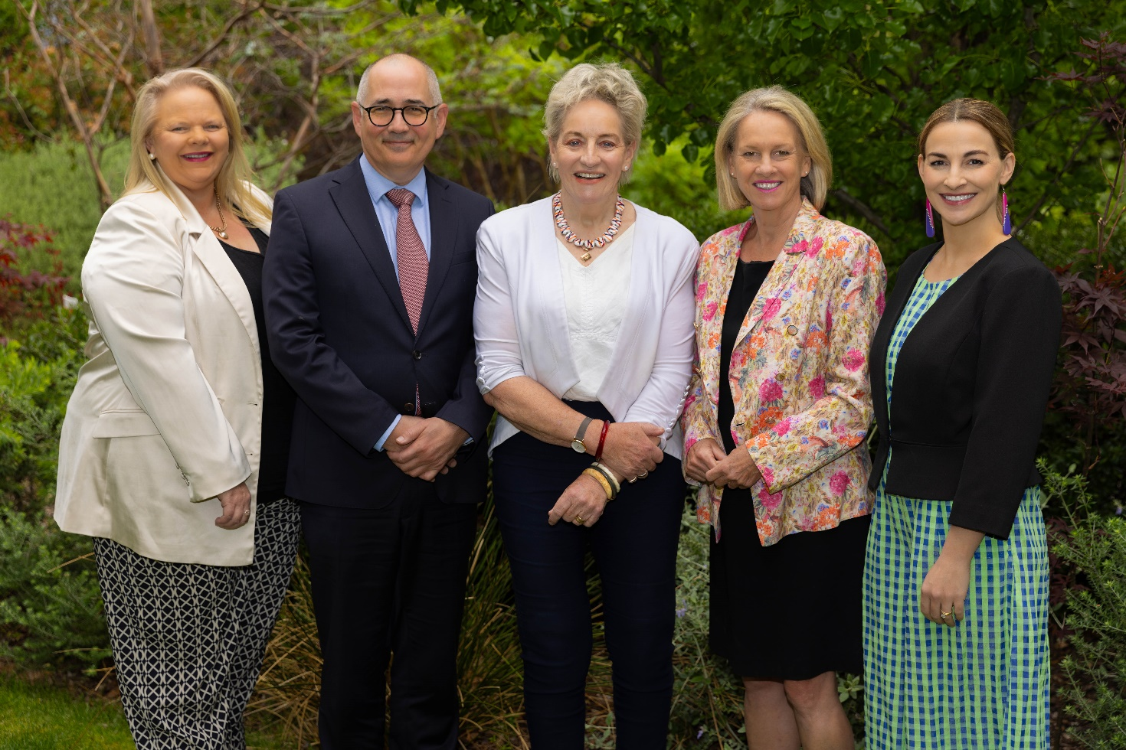
2024 Committee Members – provided by the Department of Infrastructure, Transport, Regional Development, Communications and the Arts

IV. Introduction
A Regional Telecommunications Independent Review Committee (RTIRC) is established every three years in accordance with Part 9B of the Telecommunications (Consumer Protection and Service Standards) Act 1999 (the Act).
The role of the independent committee is to examine the adequacy of telecommunications services in regional, rural and remote parts of Australia with reference to the services available in urban areas. The Regional Telecommunications Review (the Review) report and recommendations are based on its findings through public consultation, written submissions and survey responses.
The 2024 RTIRC (the Committee) members are the Hon Alannah MacTiernan, Mr Ian Kelly, the Hon Fiona Nash, Dr Jessa Rogers and Ms Kristy Sparrow. See Appendix A – Committee biographies.
This is the sixth legislated Regional Telecommunications Review, and it follows the 2021 Review chaired by the Hon Luke Hartsuyker. The Committee was asked to provide its report to the Hon Michelle Rowland MP, Minister for Communications, by 31 December 2024.

Terms of reference
Sections 158P and 158Q of the Act set out the terms under which reviews of regional telecommunications are to be conducted. In conducting the Review, the Committee must have regard to any policies of the Australian Government notified to the Committee by the Minister and any other matters as the Committee considers relevant. The full Terms of Reference for the 2024 Review include:
- The Regional Telecommunications Independent Review Committee must conduct a review of the adequacy of telecommunications services in regional, rural, and remote parts of Australia.
- In determining the adequacy of those services, the Committee must have regard to whether people in regional, rural and remote parts of Australia have equitable access to telecommunications services that are significant to people in those parts of Australia, and currently available in one or more parts of urban Australia.
- In conducting the Review, the Committee must make provision for public consultation and consultation with people in regional, rural and remote parts of Australia.
- In conducting the Review, the Committee is to have regard to any policies of the Australian Government notified to it by the Minister for Communications, and such other matters as the Committee considers relevant. The Minister requests that you have regard to the following:
  - awareness and the impact of the Government’s $1.1 billion investment in improving regional communications, including the $656 million Better Connectivity Plan for Regional and Rural Australia; extent to which this investment is addressing identified needs; and flexibility to address emerging needs and challenges
  - the implications of, and opportunities presented by, changing and emerging technologies and broader market developments for regional communications policy settings and the design and delivery of regional communications programs
  - attitudes of regional households, communities and businesses to; community awareness of; access to supporting technologies to support take-up of; and public sentiment on changing and emerging technologies
  - needs in First Nations communities, and the extent to which those needs are being met, taking into account initiatives across the Government
  - potential to fast track some USO modernisation outcomes, particularly within NBN Co’s fixed wireless network footprint, which would build momentum for broader change
  - the suitability of regional communications during emergencies and natural disasters, including reliability, resilience, speed and coverage.
- Taking into account Terms of Reference Section 4, the Committee is to consider and provide advice on:
  - telecommunications needs in regional Australia, gaps in services, and barriers to addressing needs, gaps and improvements in telecommunications outcomes
  - changes or adjustments needed to existing Government policies and design and delivery of programs to ensure they continue to be effective; remain fit for purpose; maximise the social and economic potential of regional Australia, and existing and emerging technologies; and deliver improved telecommunications outcomes
  - policy settings that might be needed to support more rapid rollout of, and investment in, new and emerging telecommunications technologies in regional, rural and remote Australia, or to address emerging issues
  - constraints and capacity of the telecommunications providers to deliver investment and improved services to meet the needs of regional Australia
  - the need for targeted place-based solutions, which may differ by region and remoteness.
- The report may set out recommendations to the Australian Government.
- In formulating a recommendation that the Australian Government should take a particular action, the Committee must assess the costs and benefits of that action.
- The Committee must prepare a report of the Review by 31 December 2024 or earlier and present it to the Minister for Communications.

The importance of telecommunications services
The Committee heard that adequate and accessible telecommunications services are now viewed as an essential service for everyday life, an enabler of human rights as well as a human right by people living in regional, rural and remote Australia as part of a broad social contract with the Australian Government. Regional, rural and remote Australians expect robust, resilient and reliable services that are proven in the Australian landscape. Telecommunications serve as a vital lifeline enabling residents to stay connected with family and friends, access online communities and participate in social activities, including First Nations community-based cultural activities on Country. These services also play a crucial role in supporting mental health and well-being, especially in remote areas where face-to-face interactions may be limited.
Telecommunications services are essential for accessing services, such as healthcare, education, and government services. Telehealth services allow rural residents to consult with specialists without the need for long-distance travel. Online education platforms provide opportunities for continuous learning and skill development and allow students the choice to remain in their communities while completing their education.
Access to reliable telecommunications services is critical for businesses across all sectors to connect with global markets, access essential online resources, streamline their operations and expand customer bases. The use of digital technology has transformed industries, with sectors such as agriculture benefiting from innovative tools to monitor crop and livestock conditions, access real-time market data, and sell products directly to consumers. By embracing these technologies, businesses of all sizes can enhance productivity and improve decision-making competitiveness in an increasingly dynamic economy. The advancement of telecommunications infrastructure remains crucial to sustaining and growing these economic benefits, especially in rural and regional areas, as well as an enabler of economic participation by First Nations people and communities.
The Committee found regional, rural and remote areas continue to face challenges in terms of access, awareness, affordability and reliability. Geographic isolation, harsh weather conditions and the high cost of infrastructure can make it difficult to provide adequate coverage. While there has been marked improvements in telecommunications services for these areas, there remains a digital divide. This is most stark in remote and very remote First Nations communities, and in the availability and reliability of mobile services. The Committee also identified that many individuals, businesses and communities are unaware of recent advancements or alternative solutions, limiting their ability to fully benefit from available telecommunications infrastructure.
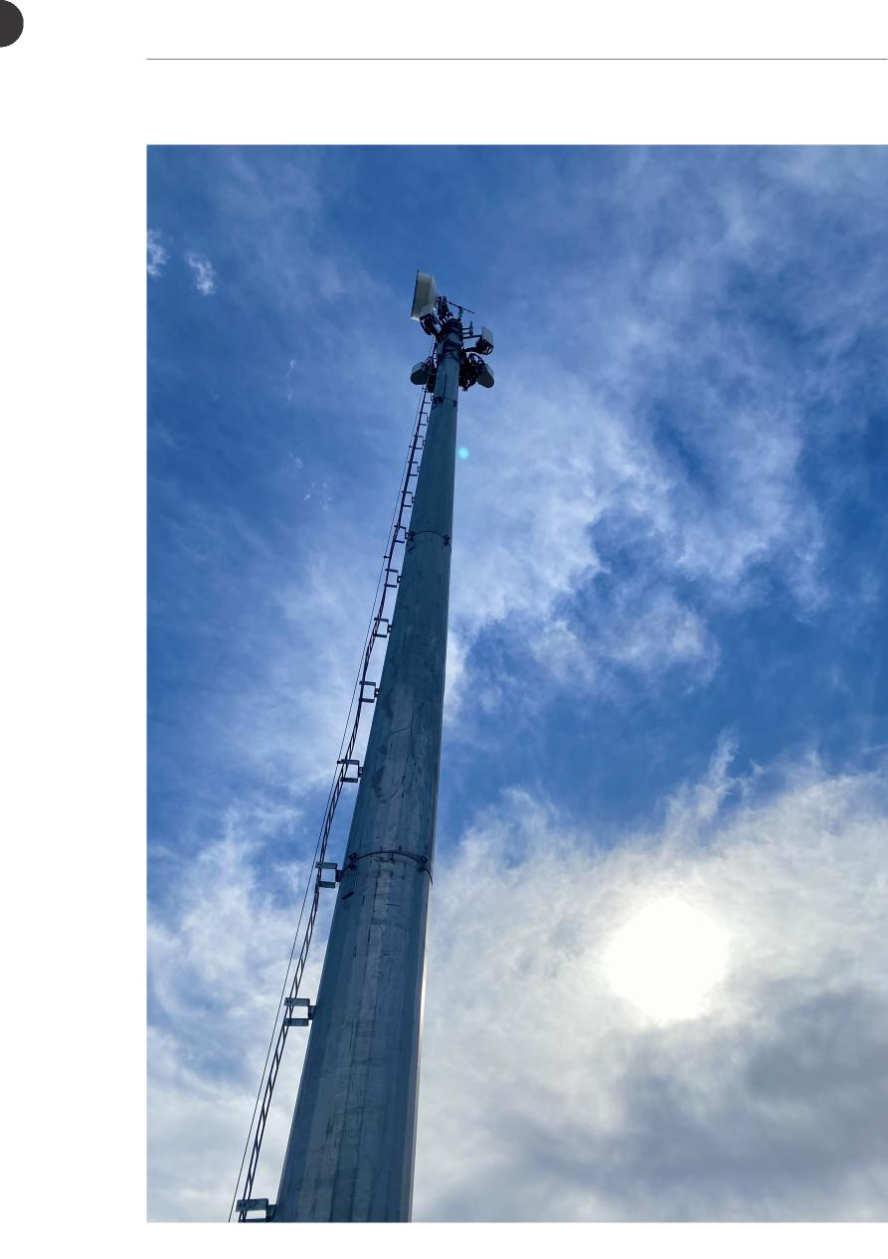
Telecommunications tower site visit, Victoria.

What’s happened since the 2021 Review?
In response to the 2021 RTIRC recommendations, the Australian Government is:
- investing in improving regional connectivity
- enhancing network resilience
- conducting trials of emerging technologies
- building connectivity literacy
- enforcing network standards
- focusing on First Nations communities
- addressing affordability for vulnerable and marginalised groups in regional areas.
The Australian Government has made a $2.4 billion equity investment to increase full fibre across the country, allowing more homes and businesses to realise the benefits of Fibre to the Premises (FTTP) broadband connections. This investment includes a regional component of around $1.1 billion for FTTP upgrades for at least 660,000 regional premises currently connected to Fibre to the Node (FTTN) technology.
The Better Connectivity Plan for Regional and Rural Australia allocates more than $1.1 billion to enhance communications in regional, rural and remote areas over five years. Investments include boosting multi-carrier mobile coverage, funding digital infrastructure projects, supporting on-farm connectivity and conducting a mobile coverage audit. Upgrades to the NBN fixed wireless network and satellite services have been prioritised. Programs like the Regional Connectivity Program (RCP) and Mobile Black Spot Program (MBSP) have delivered capacity upgrades, expanded coverage and infrastructure improvements to broadband services and mobile coverage in regional locations.
The Telecommunications Disaster Resilience Innovation program (TDRI) and Mobile Network Hardening Program (MNHP) have focused on developing technologies and funding upgrades to enhance resilience in regional and remote areas during natural disasters.
Pilot programs are being funded with states and territories to test innovative solutions for multi-carrier mobile coverage. The Australian Government is also supporting resilience upgrades in remote and First Nations communities, and on-farm connectivity by providing rebates for the uptake of ag-tech. Trials of LEO satellite services and alternative technologies are underway to consider suitability to support voice connectivity in regional and remote areas.
Efforts are being made to build digital and connectivity literacy through initiatives like the Regional Tech Hub, which provides connectivity assistance, information and support for regional consumers. The First Nations Digital Inclusion Advisory Group is working to provide advice to the Australian Government on supporting digital inclusion, including in remote communities, and its initial report informed the First Nations digital inclusion measures announced in the 2024–25 Budget.
The Australian Government has consulted on universal services modernisation to ensure future service provision and associated funding arrangements align with changing consumer preferences, market developments and evolving technological landscapes.
Recent changes in mobile tower infrastructure ownership and regulation have seen major carriers divest their assets to third-party companies, but regional, rural and remote Australia is not yet seeing any significant change from a consumer perspective.
The rollout of LEO satellite services, initially through Starlink, has rapidly expanded broadband options, providing competition. This development has been very successful and future developments are promising, but among other concerns, there remain questions around weather implications, affordability, security and long-term viability.
Finally, the 3G network switch off marks a transition towards newer, more efficient 4G and 5G technologies. However, the switch off was not without its challenges and anxieties, especially for those customers in regional, rural and remote areas with limited mobile coverage.

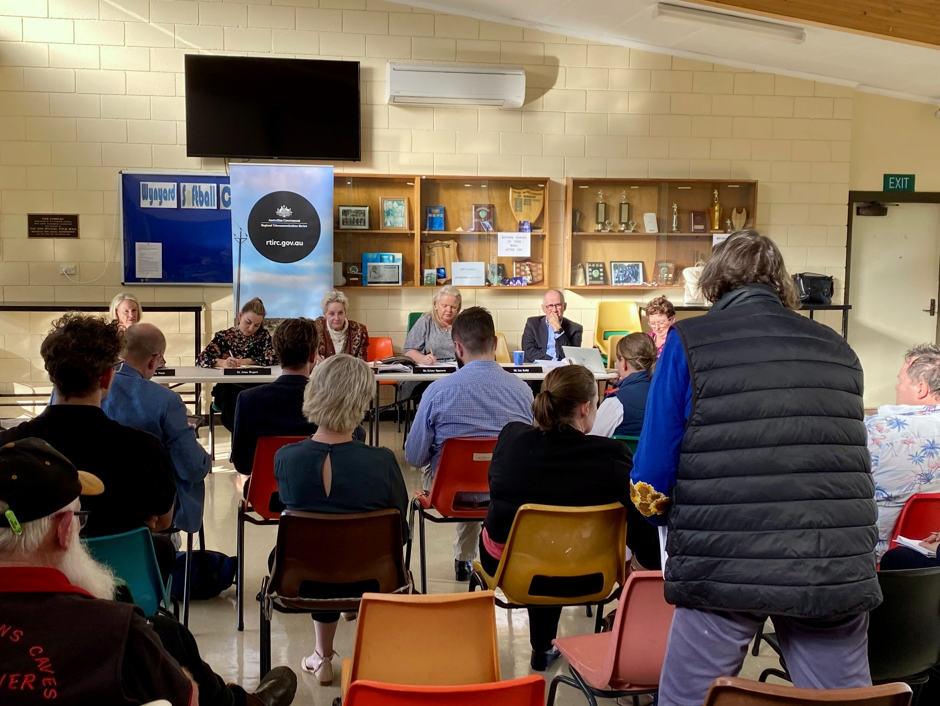
Public consultation in Wynyard, Tasmania

Approach to the 2024 Review
The 2024 Regional Telecommunications Review (the Review) conducted a comprehensive public consultation process to gather insights and experiences from individuals, businesses and government entities operating in regional, rural, and remote Australia.
Throughout 2024, the Committee consulted extensively across Australia, holding public town hall style consultations from Thursday Island and Mt Isa in Queensland to Longford in Tasmania, across to Northampton and up to Kununurra in Western Australia. Forums were also held in these centres with community and business leaders. Virtual consultations were held to enable consumers and businesses that could not attend town halls to contribute. NBN Co and Telstra representatives attended all consultations and engaged with consumers on specific issues. The Regional Tech Hub was represented at most consultations.
Figure 1 – Public consultation locations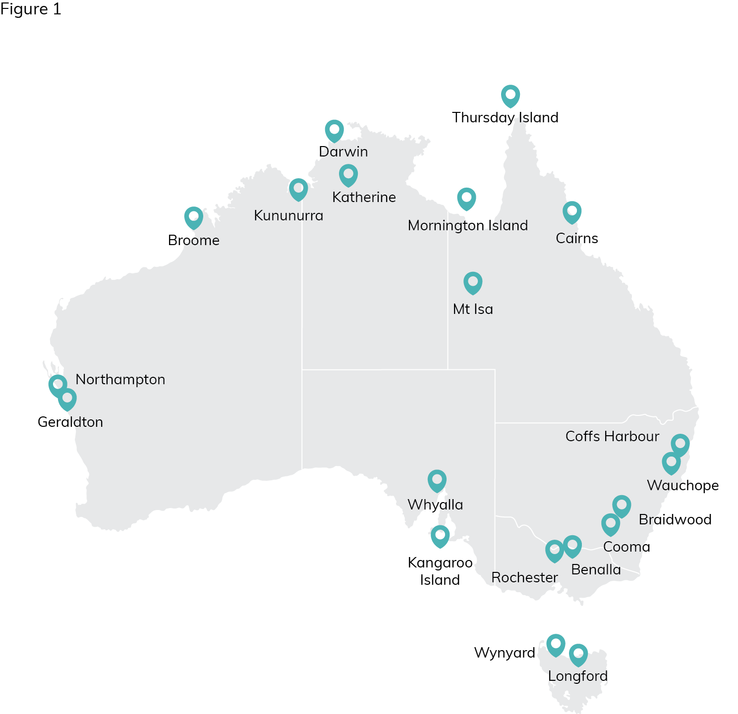
* In addition, 2 online public consultations were held.
The Committee had the privilege of visiting remote First Nations communities on Mornington Island and Thursday Island, First Nations organisations in Broome, and places such as Katherine with significant First Nations populations. Such consultation was a requirement of the Review under its establishing legislation and Terms of Reference.
The consultation process was structured around the release of an Issues Paper on 23 April 2024, which outlined the key areas of focus for the Review and provided a series of questions to guide written submissions. Interested parties were invited to submit written submissions to the Committee by 31 July 2024.
The Committee received a substantial number of written submissions, totalling 306, from a diverse range of stakeholders. These included 180 short comments – predominantly from individuals and small businesses – received directly through the Department of Infrastructure, Transport, Regional Development, Communications and the Arts' Have Your Say web page. The Committee also received 126 longer written submissions representing the views of individuals, businesses, community organisations, state and territory and local governments, the telecommunications industry, members of Parliament, peak industry bodies, regulators and consumer and business advocacy groups. Non-confidential longer written submissions were subsequently published on the department’s Have Your Say web page on 25 October 2024.
In addition to the call for written submissions, the Committee released a structured online survey as a quick and easy way for Australians to provide feedback on their telecommunications experiences and issues. The Committee received 3,098 survey responses, providing valuable feedback on the telecommunications experiences of individuals living and working in regional, rural and remote areas.
The survey was conducted online and open to voluntary participation from residents nationwide. Participants were invited to subjectively rate the quality, availability, and reliability of their telecommunications services on a 1–10 Likert scale. These ratings were averaged to produce an overall satisfaction score for each technology type. The self-selected nature of the survey and allowance for multiple responses from the same household ensured a broad range of input but it also introduced potential bias (see Appendix A for a detailed discussion of the methodology and limitations). The data was grouped using Remoteness Areas as defined by the Australian Statistical Geography Standard – Remoteness Area classification.
The number of survey responses is unparalleled in the Review’s history, reflecting the strong demand by Australians for accessible, equitable and reliable telecommunications services, products and infrastructure as well as a genuine thirst for connectivity knowledge and enhanced consumer protections for all.
A total of 22 public consultations were held.
In addition to public consultations, the Committee held targeted meetings with telecommunications businesses, state and territory government agencies, community organisations and business groups across the continent. These meetings allowed the Committee to gather specific insights from key stakeholders and address their unique concerns and priorities. Committee members also participated in various forums across Australia in 2024, including the Australasia Satellite Forum and the Developing Northern Australia Conference.
The Committee was pleased to work closely with the First Nations Digital Inclusion Advisory Group throughout the Review. The Committee fully supports its mission and is encouraged by the development of a roadmap for digital inclusion that will shortly be presented to the Australian Government.
Views expressed via all these communication channels helped form the Committee’s understanding of the adequacy of telecommunications services in regional, rural and remote Australia and shape its recommendations to the Australian Government. Public consultations, submissions and survey results are referenced throughout the report.
A list of non-confidential public submissions can be found at Appendix B.
The Committee also consulted broadly with industry, receiving expert advice from key stakeholders and departmental briefings on key issues.
To view a full list of industry consultations please see Appendix C.
A glossary, which provides definitions for key terms used throughout this report, can be found in Appendix D.
Taken together, the public consultations, written submissions, survey responses, industry consultations, expert advice and departmental briefings have informed the recommendations of this report.
The Committee sincerely thanks all participants in the consultation process, acknowledging everyone who took the time to provide expert advice, briefings, presentations and information.
The Committee would also like to thank all members of the 2024 Review Secretariat for their unfailing energy, professionalism and commitment.

V. Telecommunications services in regional, rural and remote Australia
By drawing on information from community consultations, the submissions process, and targeted meetings with key industry, community and government stakeholders, the Committee has been able to develop a comprehensive understanding of contemporary telecommunications services in regional, rural and remote Australia.

Australian telecommunications market
The Committee learned that telecommunications companies are finding it increasingly difficult to achieve a return on their infrastructure investments, particularly in regional, rural, and remote Australia. Compared with other industries, the rate of return for operators is modest. Due to factors including low and uneconomic customer numbers, higher fixed operating costs, and a history of price increases that have remained well below inflation. Several submissions spoke to industry concerns about a decline over time in returns on invested capital that is making it difficult to tackle larger infrastructure investments, like mobile towers, in regional Australia. Additionally, rapid technological advancements enable non-telecom companies to provide services over-the-top of existing networks, further impacting profitability and the ability to generate revenue needed to support ongoing network investment.

Women looking at smart phone – Getty Images, WANDER WOMEN COLLECTIVE
The telecommunications landscape is changing. Major technology companies, known as hyperscalers – such as Microsoft, Amazon and Google are increasingly integrated into telecommunications networks and the services delivered over them. Cloud services and data centres, including those provided by telecommunications companies, hyperscalers and other types of data centre and technology companies, play a critical role in connecting different parts of the digital ecosystem. These services are expanding to the edges of networks, including into some regional areas, where they offer significant potential to drive regional digitalisation and enhance connectivity.
In addition to mobile network investment, significant investment in intercity fibre and sub-sea cable is occurring, driven in part by the needs and commercial support of hyperscalers. Ongoing increases in data usage and the anticipated demand for network capacity, particularly from emerging technologies such as artificial intelligence, are also fuelling this investment.
The availability of these transit links may encourage investment further into regional and remote areas. These fibre connections can be used as a backbone by local internet service providers and smaller telecommunications companies to extend their services into underserved regions. With high-speed, high-capacity fibre infrastructure in place, businesses in regional and remote areas may have access to more reliable and scalable internet services, encouraging further digital investment and economic opportunities in these regions. Additionally, it can enable new services such as edge computing and support the deployment of advanced technologies like the Internet of Things, making these areas more attractive for businesses and investors.
Unlike our capital cities, parts of regional Australia are thin markets for telecommunications services due to their small, dispersed populations and low levels of demand and supply. Thin markets lack enough scale to function effectively and tend to exhibit volatility and other weaknesses that disadvantage their customers and investors. These weaknesses can include monopolies, limited choice in goods and services, higher prices, and supply gaps, as some types of businesses are not commercially viable at smaller scales, despite consumer willingness to pay.
In 2024, competition for mobile services in much of regional Australia appears to be poor to non existent, while competition in broadband services is faring better due to emerging LEO satellite technology and the NBN retail/wholesale operating model. Weaknesses are apparent in the mobile sector as Telstra maintains its solid competitive advantage in mobile coverage, thus reducing incentives for other mobile network operators (MNOs) to expand their networks.
Infrastructure sharing arrangements between telecommunications companies is one way to improve the commercial viability of regional connectivity investment and expand services available in regional areas. However, despite the restructuring of the tower sector in 2021 – which should have promoted sharing – and increasing Australian Government incentives to encourage passive sharing, the extent of this hoped-for improvement has been disappointing.
On 5 September 2024, the ACCC announced it would not oppose the Optus and TPG regional mobile network and spectrum sharing arrangement. The ACCC concluded that the agreement would enhance TPG’s competitive position, improving choice for regional consumers. It would also support Optus’ regional 5G rollout. The Committee believes that once deployed, this active sharing development along with DTH services could lead to significant and positive changes to mobile service competition and availability for regional, rural and remote Australia.
Other submissions, such as that from Connected Farms noted that ‘spectrum access is a key enabler of digital inclusion’, arguing a lack of spectrum access is a key barrier to local competition and innovation. The Communications Alliance (CA) submission suggested a cause of decline in returns on invested capital was the existing regulatory environment, which is compromising industry sustainability. Numerous submissions similarly blamed complex and costly planning processes for causing project delays and lengthy implementation timeframes for new mobile infrastructure. The Internet Association of Australia’s submission argued for a more competitive landscape through regulatory reform as well as more funding for shared infrastructure projects to increase regional coverage across multiple providers.
Tellingly, the ACCC observed in its submission that, since the last review in 2021, it is still receiving more complaints proportionally from consumers in regional, rural and remote areas than from those in urban areas. It noted that ‘network operators and retailers hold the primary responsibility for making adequate and accurate information available to consumers, and to avoid incentivising or engaging in mis-selling’. The ACCC supports efforts by the Regional Tech Hub and Better Internet for Rural, Regional & Remote Australia (BIRRR) to improve connectivity literacy through provision of reliable, independent consumer advice and trouble-shooting support but adds that ‘consumer outcomes will improve if relevant information is more accessible for First Nations consumers’ as the ‘challenges in improving digital inclusion for First Nations groups are ongoing and complex, and encompass access to infrastructure and services, as well as digital literacy’. The commitment to establish a First Nations Digital Support Hub and network of digital mentors will help address this issue.
During the Review, the Committee heard from Australian Private Networks (APN) about positive connectivity outcomes for some First Nations communities. These included Community Wi-Fi projects, supported by the RCP, that will deliver broadband internet and telephone connectivity to remote areas such as Guda Guda in the Wyndham-East Kimberley region and Mornington Island in the Gulf of Carpentaria. APN also described similar projects delivered under the first round of the RCP with co-contribution from the Western Australian Government, aimed at providing essential community Wi-Fi and VoIP phone services to the remote towns of Kalumburu and Jigalong.
The Wireless Internet Service Providers Association of Australia’s (WISPAU) submission strongly advocated for the role of fixed wireless internet service providers (WISPs) in regional areas. WISPs offer ‘a unique opportunity to not only provide backhaul connectivity but also lead in community education and investment in an area and continue to improve services for the benefit of those in the community’. In terms of the regional user experience, WISPAU convincingly highlights ‘the value of local support’ and the advantage of having ‘a local WISP provider that can respond quickly’ to determine and resolve onsite performance issues within a customer’s home or local Wi-Fi network setup. WISPs provide internet access in regional areas by transmitting data via radio signals from a base station to a fixed antenna, as an alternative to traditional wired technology. The submission further suggests improving access to fibre backhaul at competitive pricing and funding job incentive payments and training to help WISP operators address regional telecommunications capacity and skill shortage issues.

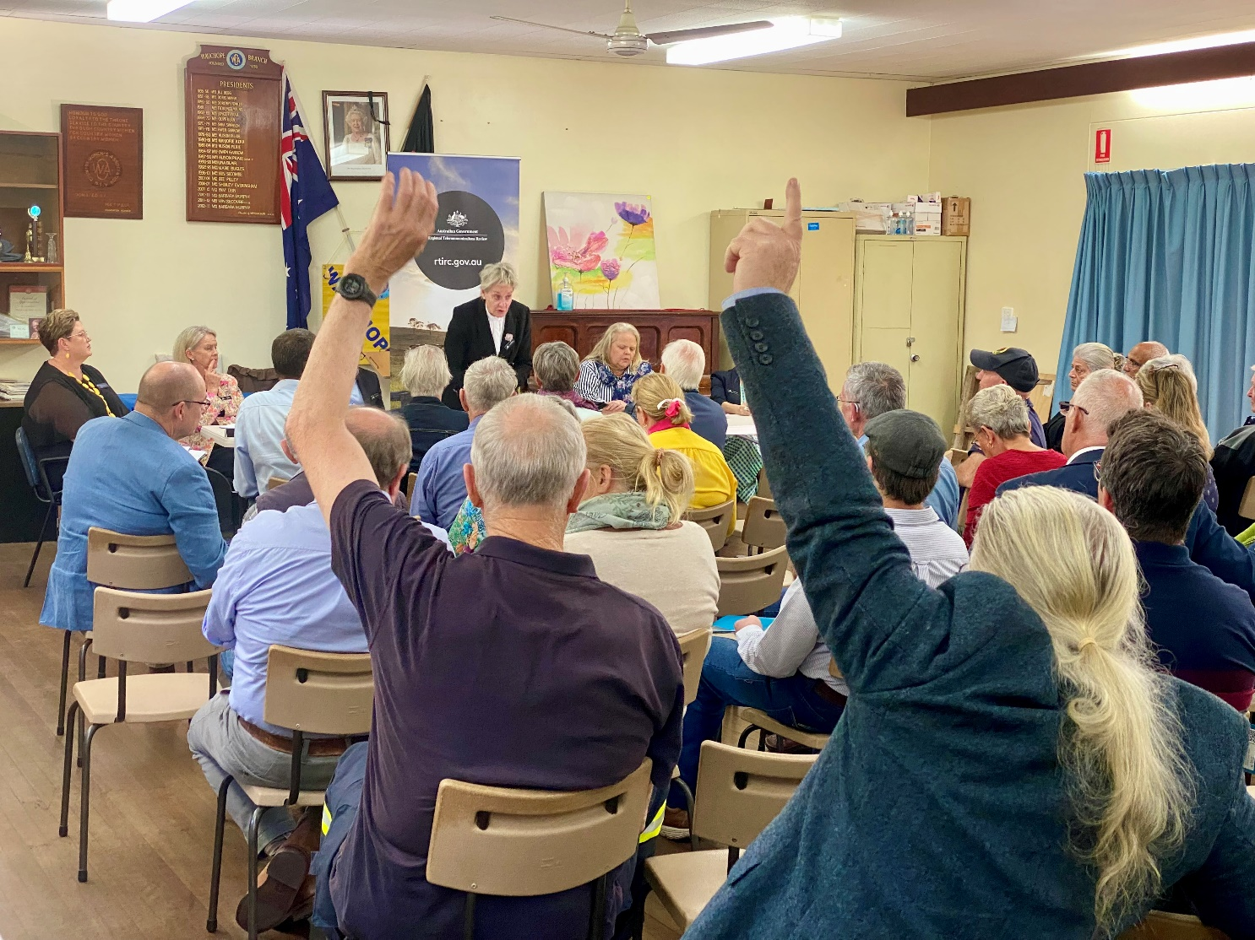
Public consultation in Wauchope, New South Wales

Mobile
Throughout the 2024 Review, more participants engaged on issues relating to mobile services than any other topic. This is not surprising given that mobile phones are the most common way Australians communicate and go online. According to the ACMA’s most recent report on trends and developments in telecommunications, 95% of adults who access the internet do so with a mobile phone. The use of applications for messaging, video calls, and voice calls is also significantly increasing with Facebook Messenger and WhatsApp being the preferred platforms. Younger Australians aged 18–44 were more likely to adopt these applications compared with older generations.
There have been ongoing investments into mobile networks in regional, rural and remote Australia since the 2021 review. The Australian Government committed more than $656 million through the October 2022 Budget to improve mobile and broadband connectivity and resilience in rural and regional Australia. The availability of 4G and, in some areas, 5G networks has enabled faster internet speeds and more reliable mobile connectivity in some places. Telstra, for example, has added 500 new regional and remote mobile sites and upgraded 2,700 regional and remote mobile sites since the beginning of the 2021 financial year. Telstra reports that these investments have added 240,000 km2 of new coverage and 700,000 km2 of new 4G coverage.
Committee members conducted their own informal mobile network speed testing while consulting in locations around the country. They experienced better speed test results in Whyalla, South Australia than any other location, including capital cities, with download speeds more than 500 Mbps. However, in other places like Broome (in the height of tourist season) and Karumba, the Committee could not even load a basic web page at times using a mobile network. When queried about very poor speeds, industry responses were generally non-specific and often lacking detailed explanations or referenced future infrastructure projects that have experienced substantial delays in implementation.
The 2024 Review survey highlights significant dissatisfaction with mobile services among respondents from regional, rural, and remote areas of Australia.
Out of 3,098 survey participants, 3,011 respondents reported using a mobile service. There was an overall average satisfaction rating of 3.6 out of 10 for mobile services. Satisfaction was highest among those living in major cities, with a gradual decline observed in outer regional and remote areas. However, in very remote Australia, the average satisfaction rating was higher than any region other than major cities (see Figure 2).
Figure 2 – Average satisfaction rating by remoteness area, Mobile
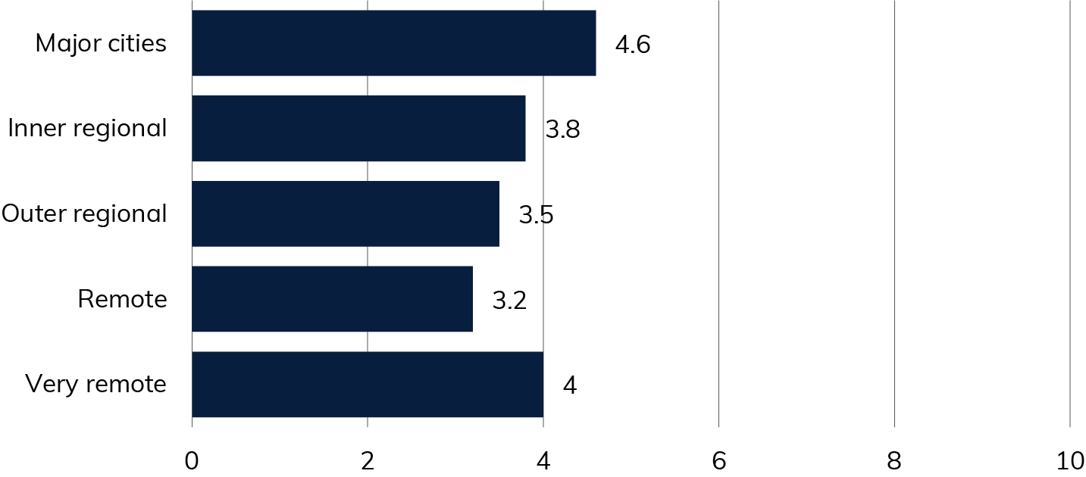
Source: 2024 RTIRC Survey
At every public consultation, concerns were raised about mobile services. Survey responses and short-form submissions also overwhelmingly indicate dissatisfaction with mobile services in regional, rural and remote Australia.
The Committee recognises that despite significant public and private investment in new and improved mobile infrastructure, services in regional, rural and remote Australia are at times failing to meet consumer demands and expectations. Managing these expectations is crucial, particularly in challenging environments where many factors can affect service quality. Achieving 100% terrestrial mobile network coverage is unlikely to ever be economically feasible given Australia’s varied and vast terrain. Therefore, transparency about coverage limitations and realistic network capabilities is essential, alongside a commitment to prioritise investments in the most underserved areas.

Coverage
The three MNOs – Telstra, Optus and TPG – offer different levels of coverage in regional, rural, and remote areas. Increased coverage is driven by a combination of co investment with the Australian Government, such as the MBSP, and MNO-led infrastructure investments.
Australia’s most extensive mobile network coverage, particularly in regional, rural and remote areas, is provided by Telstra. Telstra claims to cover 99.7% of the Australian population, with more than 2.7 million square kilometres of the landmass covered (it is understood this includes its external antenna coverage). Telstra states its mobile network covers 1 million square kilometres more than any other Australian mobile network, but its claimed coverage is still only 35% of Australia’s landmass. For some regional, remote, and rural users, Telstra is the only option, especially in sparsely populated areas where it has established the most comprehensive 4G and expanding 5G services. Even where there is competitive coverage, Telstra remains the dominant provider.
While Optus has a significant presence in some parts of regional Australia, it lags Telstra in many areas. Optus has increased its investment in regional mobile infrastructure in recent years, including through its involvement in the MBSP. Optus claims to cover 98.5% of the population. Telstra's mobile site advantage over Optus has slightly narrowed. In regional areas, Telstra’s lead decreased from 43% in 2020 to 39% in 2024. Similarly, in remote areas, Telstra’s dominance decreased from 297% to 271% over the same period.
In relative terms, TPG has the least coverage in rural and remote areas. While it performs well in metropolitan and suburban regions, its regional and remote presence is limited. Following the ACCC’s denial on anti-competitive grounds, in June 2023, of a regional network sharing deal between Telstra and TPG, in April 2024 Optus and TPG announced a similar significant regional mobile network and spectrum-sharing agreement.
Under this agreement, TPG will be able to use around 3,700 of Optus’ mobile towers in regional and rural areas, allowing it to expand its coverage without the need to build its own infrastructure. This is especially important for TPG, which has traditionally had the weakest presence in regional Australia. The deal also includes spectrum sharing in these areas, giving both networks greater capacity to deliver mobile services, including 4G and 5G, to more Australians in less densely populated regions. TPG’s presence in rural and regional markets will expand through this new network-sharing agreement with Optus, improving retail competition in these markets.
One of the key issues highlighted to the Committee is the disconnect between the predictive coverage maps published by mobile operators and the actual user experience on the ground. Many users reported being in situations where the promised coverage did not align with reality, leading to frustration and dissatisfaction. This discrepancy raised questions about the transparency and accuracy of telecommunications companies’ claims, emphasising the importance of reliable empirical data to validate coverage assertions. The ACCC addressed this issue in its submission to the 2024 RTIRC, stating that:
Mobile coverage maps – and associated coverage claims based on those maps – present predicted coverage. The methodologies used by mobile network operators to predict their coverage are not transparent, and there is no standardised methodology with agreed input parameters being used for this purpose. Given this lack of industry standards, mobile network operators are free to use differing methodologies or assumptions in predicting coverage.
ACCC submission
For example, the ACCC noted in its Mobile Infrastructure Report 2023 that the accessibility of each MNO’s coverage varies significantly based on handheld device or external antenna coverage estimates. For instance, Optus claims approximately 83% of its 4G coverage area is accessible with a handheld device, while the remaining 17% requires an external antenna. TPG’s 4G outdoor coverage is around 74% of its 4G coverage with an antenna. Telstra claims 4G outdoor coverage via handheld devices for approximately 52% of its external antenna coverage area.
The Committee also notes that consumer expectations will always need to consider factors such as building materials, topography, distance from towers, number of users and physical obstructions which can affect service quality and experiences.

Direct to Handset services
In coming years, near 100% outdoor coverage for Short Message Service (SMS), voice and basic data services may be achievable with the rollout of satellite DTH technology, a non-terrestrial mobile network. Global satellite phone services (such as Iridium, Inmarsat, Globalstar and Thuraya) have been available for decades but require specific handsets and come at a high service cost, making them unaffordable for most users. However, DTH technology, using new generation LEO satellite systems, has emerged as a promising future complementary service to existing terrestrial mobile services.
This new technology enables direct communication between satellites and smartphones, bypassing traditional terrestrial mobile networks. Unlike conventional satellite phones DTH technology is being designed to work with standard modern smartphones.
Apple announced a $1.5 billion investment in satellite communications company, Globalstar, to fund the expansion of DTH services for iPhones. Apple iPhone users with the latest handsets and software can already access Emergency SOS messaging via satellite. Users in the United States and Canada can also access Apple Messages via satellite. These services allow users to send messages in areas without terrestrial mobile coverage. Apple’s satellite messaging services utilise the Globalstar’s LEO satellite network.
Google has partnered with Skylo to launch a similar emergency messaging service with the Pixel 9 product line. This service currently is available in the United States; however, Google has outlined plans to expand the service to other regions in coming years.
In July 2023, Optus announced a partnership with Starlink to deliver outdoor DTH mobile connectivity in areas without existing mobile coverage: that is, near 100% coverage of the Australian continent where the user has line of sight to the sky. Optus has indicated it plans to initially roll out SMS capability. Voice and limited data capabilities will be available about a year after the initial deployment, once more Starlink DTH capable satellites are launched.
In 2024, Telstra and TPG both announced partnerships with Lynk Global to trial DTH mobile connectivity in Australia utilising their respective spectrum. Lynk Global is planning to launch 76 DTH capable LEO satellites by the end of 2025 to provide an initial text message service. Both companies have indicated that trials are due to commence in 2025. AST SpaceMobile launched its first DTH satellites in September 2024 and plans to partner with mobile operators globally to trial its DTH capability in coming years.


Starlink – Kristy Sparrow
The Committee is of the view that Australia is an ideal candidate for the adoption of DTH satellite technology to complement terrestrial networks for out of coverage requirements. In addition, the ability to provide communication services to remote areas, particularly during emergencies and natural disasters, could have a significant impact on the lives of Australians. In time, DTH is expected to provide an effective, universal, basic mobile service capability.
The ability to make voice calls via DTH satellite technology is still under development, but it is expected to become available, along with limited data applications once more satellites are launched into orbit and subject to international approvals. Managing consumer expectations will be crucial, as this technology is still in development. For instance, current generation DTH services will not be able to offer the high-speed, high bandwidth services available on terrestrial mobile networks, may have capacity limits and will need line of sight to the sky.
A LEO Satellite Working Group was established in 2022 by the Australian Government, to help inform the Australian Government about how emerging LEO satellite capabilities might play a role in future telecommunications policy. While the Working Group views DTH as beneficial for improving access and supporting remote and emergency communication, it identifies several limitations. DTH technology is still evolving, and issues like potential network congestion (particularly during emergencies) and high operational costs could limit its effectiveness.
While DTH services may not be a direct substitute for terrestrial mobile services, this technology has the potential to disrupt traditional mobile markets, particularly in regions with limited terrestrial coverage. Telstra, the dominant carrier in remote Australia, may face increased competition from MNOs and Mobile Virtual Network Operators offering DTH services.
Pricing for DTH services is yet to be confirmed and affordability could be an issue for some consumers, as is the case for a range of other telecommunication services. Apple services are available only on the latest handsets, which are out of reach for many users due to their high cost. Optus is yet to announce a pricing structure for its proposed Starlink DTH service, pricing will likely include a premium such as applied in the past for International Roaming services or a specific package fee.
While DTH may offer a valuable service to people who live and work and travel in areas that do not have existing terrestrial mobile coverage, it will not replace the need for terrestrial mobile services. Based on current operator roadmaps, it appears DTH services will focus on introduction of messaging and then voice capability, and will not extend to (basic) broadband for several years. Capacity of the DTH service is expected to be low, and full-time use of DTH services could be very expensive depending on how pricing models evolve.

Capacity
A significant issue raised during the consultations is mobile network capacity. In many rural and remote areas, mobile networks do not provide sufficient capacity to handle high volumes of traffic, particularly during peak times such as tourist seasons, events or natural disasters. This results in slow internet speeds, dropped calls and service outages, leaving residents and visitors frustrated. Some remote communities spoke of frequent extended outages affecting all communications for a week or longer.
The increasing demand for data in Australia has posed significant challenges for MNOs who are struggling to keep pace with consumers’ evolving needs. Monthly data consumption per mobile subscriber increased by 17% in 2023 while customer numbers remain comparable.

In just the last three years since RTIRC 2021, demand in regional areas has nearly doubled. In FY24, more than 41% of the total data downloaded on Telstra’s mobile network was downloaded in regional and remote parts of Australia. The volumes involved are enormous – 1313 petabytes, which is 1,313 million gigabytes – the equivalent of around 1,313 million hours of Netflix streaming.
Telstra submission
With only 27% of Australia’s population living in regional and remote Australia, and 41% of data on Telstra’s network downloaded in this area, it is little wonder that networks are struggling to keep pace. Increased data demands are coming from multiple sources.
Case study: Shire of Pingelly – poor and deteriorating mobile experience
The Shire of Pingelly in Western Australia reports significant frustration over what it describes as deteriorating mobile coverage. In its 2024 Regional Telecommunications Review submission, the Shire expressed concern about the impact of unreliable mobile service on daily life, commerce and public safety. Across Pingelly, including the town centre, mobile service is often so poor that residents struggle to make or receive calls indoors. Businesses face similar challenges, with some having to ask customers to step outside to complete card payments. This issue affects older residents who rely on mobile phones for safety alarms. Resident testimonials highlight these frustrations:
  - Bendigo Bank: ‘It’s both inconvenient and embarrassing to ask customers to step outside for e-banking.’
  - Rural resident: ‘Coverage has reduced by at least a third over the past two years.’
  - Mobile mechanic: ‘I use both Telstra and Optus SIMs for Wi-Fi calling as Telstra’s network worsens daily.’
This is not an isolated example. Participants at multiple consultation locations nationwide reported poor or diminishing mobile experiences. A common comment at community consultations was that during peak tourist seasons or local events, mobile networks become overwhelmed by the influx of visitors, resulting in service degradation. Local businesses, some of which rely heavily on mobile networks for processing payments and communicating with customers, reported suffering financially as a result.
Agricultural producers reported to the Committee that mobile networks in regional, rural, and remote Australia often struggle to meet the data demands of modern farming equipment. Some precision agriculture equipment and field applications, for example, depend on real-time data collection and analysis, and are built reliant on mobile network connectivity to operate.
Simultaneously, there is an underutilisation of many AgTech products that do not rely solely on mobile connectivity. Many businesses are unaware that these products exist, further demonstrating the need for improved connectivity literacy. Similarly, payment systems can be effectively supported via Wi-Fi, yet many consumers and businesses remain unaware of these alternatives.
Some participants highlighted the impact of low mobile capacity on emergency services. During natural disasters, mobile networks are often overwhelmed by the surge in traffic, making it difficult for residents to contact emergency services or receive important alerts. The need for more resilient networks with greater capacity was a key theme in these consultations, with many participants calling for increased investment in mobile infrastructure to improve network performance.

In Hepburn Shire Council, tourism plays a crucial role in the local economy. On the weekends the population surges dramatically as tourists come to the region to enjoy the natural assets and attractions. This influx of people places immense pressure on telecommunication providers, leading to frequent instances of slow internet connections and strained network capacities. During large-scale events like the Chill Out Festival in Daylesford, the surge in attendees often overwhelms local mobile phone services. At the 2024 festival, the high number of patrons led to significant strain on provider towers, making it nearly impossible for attendees to access phone services or send SMS messages reliably.
Greater Ballarat Alliance of Councils submission
The design and initial capacity of mobile networks were not always sufficient to support growth in data usage. Despite efforts on the part of Mobile Network Infrastructure Providers (MNIPs) and MNOs to make upgrades, congestion issues and service disruptions persist. Network capacity upgrades are often not commercially viable in smaller communities and MNOs may be hesitant to invest in additional capacity where there is not a strong business case for a sufficient return on investment. As the thirst for data via the mobile network continues to grow, the Committee recognises the pressing need for innovative solutions to address this escalating demand and ensure a reliable mobile experience for all users.
Some companies promote mobile phone repeaters and antennas to consumers as solutions for improving mobile signal strength in areas with weak coverage. While these devices can help overcome some coverage and signal strength issues, they do not address the performance challenges caused by network congestion. Many submissions to the Committee advocated for rebates or grants to assist consumers with the cost of mobile enhancing equipment, arguing they are essential for maintaining connectivity in rural and remote areas. However, the Committee is cautious about supporting these subsidies, as adding more devices to a network already operating at or near capacity could exacerbate congestion issues and reduce service quality.
Concerns were also raised with the Committee about the use of illegal mobile phone boosters, and other unauthorised equipment and non-compliant installation practises, which can interfere with networks and degrade service quality for other users.
The Australian Government has invested heavily in infrastructure projects, such as the MBSP, to add new mobile coverage in underserved areas, but there has been less of a focus on investing in capacity to keep pace with growing demand in areas of existing coverage.

3G switch off
The Committee considers the 3G switch off has been chaotic for regional, rural and remote communities. Concerns with the 3G mobile network switch off in 2024 were raised repeatedly during Committee consultations. While the decision of when to transition from one mobile technology to another is ultimately a commercial one, the Committee notes that the Australian Government must enhance its oversight of these significant technology transitions.
The Committee strongly supported the extension of the switch off date as it was clear that migration planning and communication was inadequate for rural, remote and regional areas.
As was the case with 2G being shut down and now 3G, technology migrations will continue. A key concern for the Committee is the need for careful management of the migration of USO voice services. The Committee notes Telstra has already started moving customers away from copper connections and other legacy technologies. This transition requires immediate oversight, irrespective of any forthcoming updates to the USO modernisation framework.

Broadband
In 2008, the Glasson Review acknowledged the transformative potential of the NBN in reshaping service provision across regional Australia. The NBN is the largest infrastructure project ever undertaken by the Australian Government. The completion of the initial build of the NBN in 2020 marked a significant milestone in Australia’s telecommunications infrastructure. Since then, upgrades and advancements have continued to enhance connectivity, particularly in regional, rural, and remote areas, including in response to 2021 Review recommendations.
The NBN has brought high-speed internet to millions of people living in regional rural and areas, beginning to bridge the digital divide and providing access to online services, education, healthcare, and business opportunities. Ongoing upgrades have meant the NBN network continues to improve, delivering better services to more people in regional rural and remote areas.
NBN Co continues to upgrade its fixed line network. Under the Fibre Connect Program, 3.5 million homes initially connected with FTTN and 1.5 million homes with Fibre to the Curb (FTTC) are eligible to upgrade to FTTP on demand. This program includes regional Australia and supports NBN Co’s goal of enabling 10 million homes (up to 90% of the fixed line network) to access plans based on the NBN Home Ultrafast wholesale speed tier, with peak download speeds ranging from 500 Mbps to close to 1 Gbps by the end of 2025.
NBN Co is also upgrading its fixed wireless and satellite services. Fixed wireless towers are undergoing new technology and software enhancements to boost network speeds and coverage in regional Australia. A $750 million investment program supports these upgrades, with $480 million provided by the Australian Government and $270 million from NBN Co. As a result, over 700,000 homes and businesses will gain access to faster speeds on the NBN fixed wireless network. These upgrades, which are nearing completion, will expand the range of the NBN fixed wireless towers, allowing approximately 120,000 additional premises to access faster fixed wireless. The fixed wireless uplift will allow NBN Co to shift many customers from Sky Muster services to NBN fixed wireless services. This has, in turn, reduced demand on the Sky Muster network, which is delivering benefits for customers who remain in satellite areas.
NBN Co has introduced new Sky Muster Plus Premium satellite plans, offering uncapped data usage (with fair use policies) for all internet activities and faster speeds. Additionally, new features like dedicated static IP addresses are available for Sky Muster Plus and Premium users who require remote network access. This upgraded service has been welcomed by many regional consumers, for example, the Isolated Children’s Parents’ Association of Australia.
The development of Sky Muster Plus Premium, providing unlimited data allowances, has been a most welcome advancement to Sky Muster Plus for many students in geographically isolated Australia who rely on satellite internet to access educational programs and resources. The ongoing enhancement of this service has continued to improve the experiences and opportunities for users. Other developments such as Wi-Fi calling and SMS over Wi-Fi have further enhanced the communications experience of Sky Muster and Sky Muster Plus users.
Isolated Children’s Parents’ Association of Australia submission
Despite this long-term investment program, during community consultations and in submissions, it became clear that there is a persistent lack of awareness about the availability of NBN services. Many residents and businesses in regional and rural areas are still unaware of NBN options. The Committee heard cases of this in relation to NBN fixed wireless and satellite availability at their locations. Many of the submissions and consumers at consultations stated they could not access the NBN or the NBN was not available in their area.
Improving consumer confidence and understanding of connectivity options can help support the uptake of the NBN. In Queensland alone, up to 31% of premises where NBN is available have not connected to the network. Awareness campaigns of services available will only go so far to address this issue, and a multi-faceted approach should be developed that includes uplift of connectivity literacy across the nation.
Queensland Government submission
Likewise, the Committee heard from many consumers and businesses who were unaware of NBN upgrade programs such as FTTP upgrades (in Rochester, Morven, Augathella, Bendigo and several retirement villages in regional locations).
NBN FTTP in Morven and Augathella, Queensland, what a fantastic opportunity that these communities have been given ... however the uptake has been very slow. I think education and on the ground information is key.
Louise (Queensland) submission
As a result, many community members continue to rely on outdated technologies and face digital exclusion despite the presence of improved infrastructure. The Committee also heard examples of local government being unaware of the Government’s Telecommunications in New Developments policy. The policy sets out that fixed voice, broadband and mobile services should be made available to residents in new developments.
The Committee also heard that procurement barriers also restrict access to optimal telecommunications infrastructure, particularly for some state agencies, retirement villages and new estates. For instance, some regional education, health and emergency services have struggled to access necessary connectivity upgrades due to rigid procurement requirements, which prevent them from adopting innovative, high-speed options like NBN fixed wireless or FTTP.
Across all NBN technologies, submissions revealed that consumers can sometimes face slow speeds, degraded services, difficulties contacting providers for assistance, extended wait times for repairs, and service outages. NBN’s brand reputation has been negatively impacted by these issues, with consumers expressing frustration over the difficulty of upgrading services or resolving degraded connections. Frustrations were also expressed about frequent outages, especially on the NBN fixed wireless network due to the NBN Fixed Wireless and Satellite Upgrade Program, and the impact of power outages on broadband infrastructure.
NBN Co has begun assessing the viability of LEO satellite services as a potential replacement for Sky Muster, given the satellites anticipated end-of-life. LEO satellites could provide faster speeds and lower latency, though questions remain about affordability and network resilience. Besides enhancing NBN’s service portfolio, this could also help address reputational issues associated with Sky Muster, which has faced notable consumer dissatisfaction. The Committee notes that LEO satellites alone may not have capacity to provide high-speed broadband for all users outside the existing NBN fixed line footprint.
Fixed line broadband services are also provided by infrastructure providers other than NBN, including over Telstra’s Asymmetric Digital Subscriber Line (ADSL) copper network and alternate fibre networks in apartment complexes, regional cities and towns and new housing estates. The Committee notes that fixed broadband services that are currently provided by Telstra’s copper network will be an important cohort, given the number and locations, to be managed through USO modernisation.
There are also many smaller WISPs in regional, rural and remote areas, offering alternative connectivity options outside of the NBN and major telecommunication companies. These fixed wireless networks deliver broadband services to a specific number of users within a coverage area, using towers that transmit signals to antennas on buildings. WISPs typically serve specific regions where traditional services are limited. The Committee met with several WISPs and in some cases were impressed by their strategic focus and operations, particularly their ability to quickly restore services after severe weather events.
The Committee heard that these fixed broadband providers may offer specialised services for residential and sector specific business needs, support local economic activities, provide competition and fill critical connectivity gaps in underserved regions.
Fixed wireless, fibre and satellite services are becoming widespread, but they depend on power at the premises. As discussed, the Committee supports the need for USO modernisation. But, as the telecommunications landscape evolves through this modernisation process, it will be important to ensure that alternative services are resilient and that there is a clear plan to provide the reliability that legacy voice services have historically provided to rural and remote Australians.
Survey responses from 1,943 individuals with broadband connections offered insights into perceptions of broadband service quality in regional, rural, and remote Australia. The overall average satisfaction rating for broadband services was 5.9 out of 10, suggesting mixed but generally moderate satisfaction levels.
Respondents in major cities reported the highest average satisfaction (6.77), while very remote areas followed closely with an average rating of 6.4, as shown in Figure 3. Inner regional areas had an average satisfaction rating of 6.04. In outer regional and remote areas, ratings were slightly lower, averaging 5.74 and 5.78, respectively.
Figure 3 – Average satisfaction rating by remoteness area, Broadband
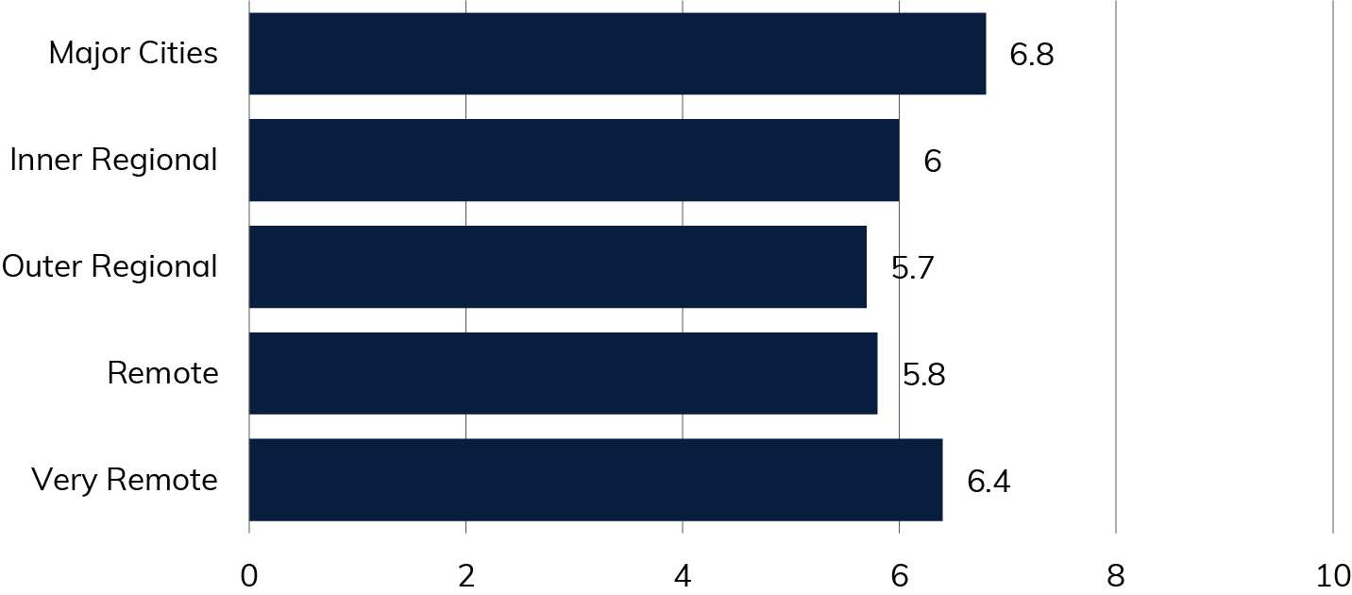
Source: 2024 RTIRC Survey

LEO satellites
Current investments in new constellations of LEO satellites are one of the most transformative technology developments of our generation.
Starlink is already a well-established broadband provider both globally and in Australia and is available across the country. The Committee heard overwhelmingly positive feedback about Starlink services during its public consultations.
Currently, Starlink equipment and monthly plans are considerably more expensive than other available broadband options and SpaceX (Starlink’s provider) does not offer face-to-face consumer support for installation or fault rectification. OneWeb provides satellite services to enterprise and government clients. Other LEO satellite platforms are also being rolled out globally and expected to be available in Australia soon, including Amazon which intends to provide such a service in the future via its Kuiper network. The emergence of new LEO satellite broadband providers is expected to bring increased competition to the Australian market and likely drive down prices and foster ongoing innovation.
Despite the many challenges faced by rural and remote communities, the Committee’s consultations revealed a sense of optimism about the improvements in existing services and the potential of emerging technologies to help continue to bridge the digital divide. Satellite services, especially Starlink, were frequently mentioned as a solution in areas where fixed telecommunications infrastructure is difficult or costly to provide and support.
In places like Broome, Northampton, and the Torres Strait, residents praised Starlink for its reliability compared with other satellite networks. In Wauchope and Benalla, the Committee heard how effective LEO satellite services were in overcoming topographical challenges faced by line-of-sight terrestrial services. On Thursday Island, the Committee heard from an early adopter about Starlink providing a solid connection for gaming, even through the wet season.
The Committee also heard some reports of limitations, including seasonal congestion in Kununurra during tourist season, service disruptions due to rain in Mt Isa and Katherine, and issues with early versions of Telstra’s Satellite Voice service (Powered by Starlink) during virtual consultations. For businesses, there is concern the lack of static IP capability reduces both wide area network efficiency and security. Additionally, the absence of Australian-based support means troubleshooting and repairs need a working broadband service and must be done without human interaction, which can complicate and delay issue resolution.
Affordability was a widespread concern raised about Starlink across various regions. Many submissions pointed out that while Starlink offers faster speeds and lower latency, the high upfront equipment costs, ongoing subscription fees and self-install model make it inaccessible for some households and businesses, especially in rural and remote areas.
The survey results reveal a high level of satisfaction among users of Starlink’s LEO satellite services. Based on 299 survey responses, the overall average satisfaction rating for LEO satellite services in regional, rural, and remote Australia was 8.4 out of 10. Respondents in major cities recorded an average rating of 8.86, while those in very remote areas reported the highest satisfaction levels, with an average rating of 9.09.
Figure 4 – Average satisfaction rating by remoteness area, LEO satellites
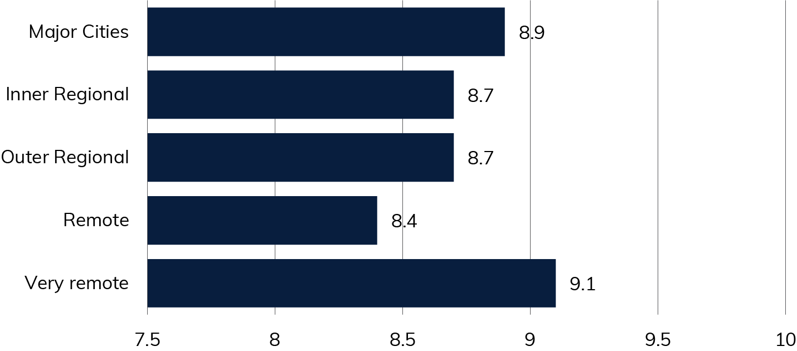
Source: 2024 RTIRC Survey
These high satisfaction scores for Starlink highlight the positive potential of LEO satellite services for regional, rural, and remote communities. However, the high cost of LEO satellite services remains a barrier for some consumers. As pointed out by the ARC Centre of Excellence for Automated Decision-Making:

Emerging technologies, such as 5G and LEO satellites have been put forward as potential opportunities for those in regional and remote Australia to gain quality and reliable connectivity. However, those taking up these options (where they are available) are not likely to be on the lowest incomes. For example, Starlink requires the installation of a $599 terminal and a monthly fee of $139 for a residential service. This is out of reach for lowest income households. Meanwhile, people on low incomes continue to rely on intermittent access via prepaid mobile, Wi-Fi services where available, and ageing digital devices. Unless affordable options are available, developments in high-speed communications will remain unevenly distributed along existing lines of inequality.
ARC Centre of Excellence for Automated Decision-Making submission
Cost is not the only current limitation with LEO satellite technology. LEO satellite services require a clear line of sight to the constellation of satellites, which may not be achievable in certain areas that are heavily timbered or have other obstructions. This can limit accessibility and coverage reliability for users in some challenging environments. LEO satellites also experience periodic handoffs between satellites as they orbit, which can result in connection dropouts. These interruptions, and those due to earth station and network outages, can affect the quality and reliability of services. This is particularly problematic for real-time applications like VoIP, which may be prone to signal loss and reduced call quality.
Starlink – currently the primary provider of LEOSat services in Australia – has not yet reached a point of being sustainably profitable, and until this is the case, it should not be considered that the market can sustain services for rural and remote areas, However, this may change as providers are able to increase their return on investment. Expected increases in LEOSat competition also have the potential to reduce the future burden on public telecommunications funding in regional and remote Australia.
ACCC submission
Until LEO satellite providers have demonstrated long-term financial viability, there is a risk they may not be able to support affordable, long-term service options for remote and vulnerable communities.
As noted in written submissions and during community consultations, rain fade and adverse weather conditions, including smoke, are issues that can impact all satellite services to some degree, including LEO satellites. Rain fade refers to the signal degradation or loss caused by rain or atmospheric moisture, which absorbs or scatters the satellite signal, leading to reduced connectivity and potential service interruptions.
The Australian Government has launched trials to assess the performance and reliability of fixed voice services, particularly focusing on the potential of LEO satellite technology to provide quality voice services in regional and remote areas. These trials are being rolled out across 50 locations nationwide. The trials will evaluate the reliability and quality of voice calls and examine how weather conditions affect service performance. This data will also help the Australian Government understand how well LEO satellite services can support voice communications across varied Australian landscapes, including during the northern wet season.
In addition to LEO satellite services, existing NBN Co fixed wireless and satellite services will be tested to provide a basis for comparison. The trial data will be collected independently and made publicly available, providing transparency and insight into how these technologies perform in diverse Australian conditions.
The Committee heard that, like all technologies, congestion can be an issue for LEO satellites, particularly during large-scale events. Previously, Space X CEO, Elon Musk, has noted that Starlink was ‘... really meant for sparsely populated regions’, highlighting one of the limitations of LEO satellite networks. Due to their capacity being configured around geographic cells, the performance of these networks, can be impacted if there are large number of users in a given location trying to access the service. There have been some areas in Australia where Starlink has become temporarily unavailable due to oversubscription of specific cells. As more customers join the network, continued investment will be required to ensure continued quality services.
LEO satellite constellations are owned and operated by foreign companies, raising questions about data security and control over sovereign risks. These risks can be mitigated by the need for LEO constellations to have Australian-based gateways providing an element of physical control. Most LEO Satellite owners and providers will, however, be captured by Australia’s regulatory framework through carrier and spectrum licensing. Submissions also noted that Australian regulators have little to no control over data limits, speed reductions and pricing increases.
The Committee also received evidence of the need to better understand the cumulative environmental impact of the rapidly increasing number of LEO satellites which generally have a lifespan of 5 to 7 years. The emissions from launch vehicles and atmospheric re-entry disintegration of these satellites are potentially a new threat to the Earth’s vital ozone layer. This could well limit growth in the number of satellites approved.
In the past decade, more satellites have been launched than in the entire history of space activity. By 2035, large constellations orbiting Earth are expected to include over 54,000 satellites – more than five times the current number. This underscores the need for worldwide considerations of the number of constellations that should be launched and reinforces the ongoing importance of terrestrial networks. Relevant Australian agencies should continue to monitor issues associated with LEO satellite solutions to ensure Australia’s interests with respect to data sovereignty and environmental impacts are understood and where possible, protected against.
It is not just LEO satellite technology that will be important in future.
As a leading satellite service provider in Australia, Optus understands the increasing role that satellite can play in addressing Australia’s connectivity needs and in helping to ‘Close the Gap’. While LEOSat solutions such as Optus and SpaceX collaboration have captured the public attention, satellite systems of all configurations (GEO, MEO and LEO) have a role to play in ‘plugging gaps’ in terrestrial connectivity.
Optus submission

Fixed voice services
In many parts of regional, rural and remote Australia, legacy landline voice services continue to be highly valued. Unlike mobile and broadband services, which rely on power at the premises, legacy landline services may continue to work when there is a power outage at the premises, making them more resilient. In regions where telecommunications infrastructure can be affected by extreme weather or power failures, these voice services can often be the last communication service to go down, providing a critical lifeline during emergencies.
The Committee heard that some regional, rural, and remote Australians still rely on landlines for reliable communication, especially in areas with no mobile coverage. The use of landlines has significantly reduced, with the number of services delivered over Telstra’s legacy networks in regional and rural areas decreasing from approximately 600,000 fixed voice services in September 2018 to around 300,000 in September 2023. This includes roughly 100,000 bundled voice and ADSL services outside the NBN fixed line footprint. The number of services delivered over legacy networks continues to decline. Despite this decline, landlines continue to play a key role in ensuring access to telecommunications redundancy, emergency services, and maintaining communication. As Australia transitions to more modern telecommunications technologies, there is concern that the phase-out of copper networks and other legacy technologies could leave some consumers more vulnerable, especially during power outages and emergencies.
During consultations and in submissions, it was repeatedly reported that consumers in rural and remote areas often face significant issues with legacy voice services, including voice quality issues, long repair times, recurring faults, or being told they cannot access a landline service, despite Telstra’s USO obligations.
The Committee notes that in September 2024, the ACMA decided not to remake the Telecommunications (Backup Power and Informed Decisions) Service Provider Determination 2014 which expired on 1 October 2024 under sunsetting arrangements. It required that before entering into certain agreements with a customer, service providers were required to inform the customer that a FTTP phone service would not operate during a power failure unless a backup power service was supplied. The Committee suggests that as part of any USO modernisation that leads to voice services being migrated from copper to fibre, fixed wireless or satellite technology, a similar determination may need to be revisited.

Network resilience
The urgent need to continue the hardening of regional telecommunications networks to withstand regular power outages, natural disasters and emergencies was exemplified by feedback the Committee received from residents in several areas including remote towns in the Mid-West region of Western Australia, Gippsland region in Victoria and coastal regions of North Queensland.
In April 2021, Severe Tropical Cyclone (STC) Seroja impacted towns and communities across Western Australia’s Mid West. Making landfall in Kalbarri (in the Mid West), in 10 hours STC Seroja moved through approximately 600km of land and became a tropical low near Merredin (in the Wheatbelt). After the extreme weather event, the Western Australia Department of Fire and Emergency Services reported 6,000 properties were without power and there was a loss of 186 mobile base stations. More recently, in January 2024 a severe storm caused power outages throughout the Goldfields and Wheatbelt regions resulting in 34,000 outages in homes and businesses.
Small Business Development Corporation Western Australia submission
This feedback highlights the crucial importance of telecommunications network resilience, especially during widespread power outages, as it ensures continuous communication for emergency response, public safety, and community connectivity when other services are disrupted.
The Committee heard concerns about the reliability of mobile networks during natural disasters, particularly in regional and remote areas. Several submissions highlighted the importance of robust, alternative communication systems, such as UHF radio, to ensure community connectivity in times of crisis. These submissions emphasised the need for innovative solutions that complement existing telecommunications infrastructure and enhance resilience in emergency situations.
On a positive note, the Committee also heard that satellite technologies, such as Starlink and NBN Sky Muster, can provide connectivity during power outages and emergencies, provided a backup power source is available. Initiatives like the STAND program provided approximately 130 portable telecommunications facilities such as cells on wheels and portable satellite fly away kits, and 1,068 NBN Disaster Satellite services at evacuation centres and emergency services depots nationally. Standalone satellite services equipped with power resilience, can ensure continued access to essential services during natural disasters and emergencies. Community and local government feedback on the STAND program was overwhelmingly positive, though concerns remain about the program’s conclusion, future maintenance of installed systems, and the need for continual operational funding. The Committee listened to the concerns of residents from these communities and suggests that solutions be found for them and other vulnerable, disaster-prone communities in regional Australia.
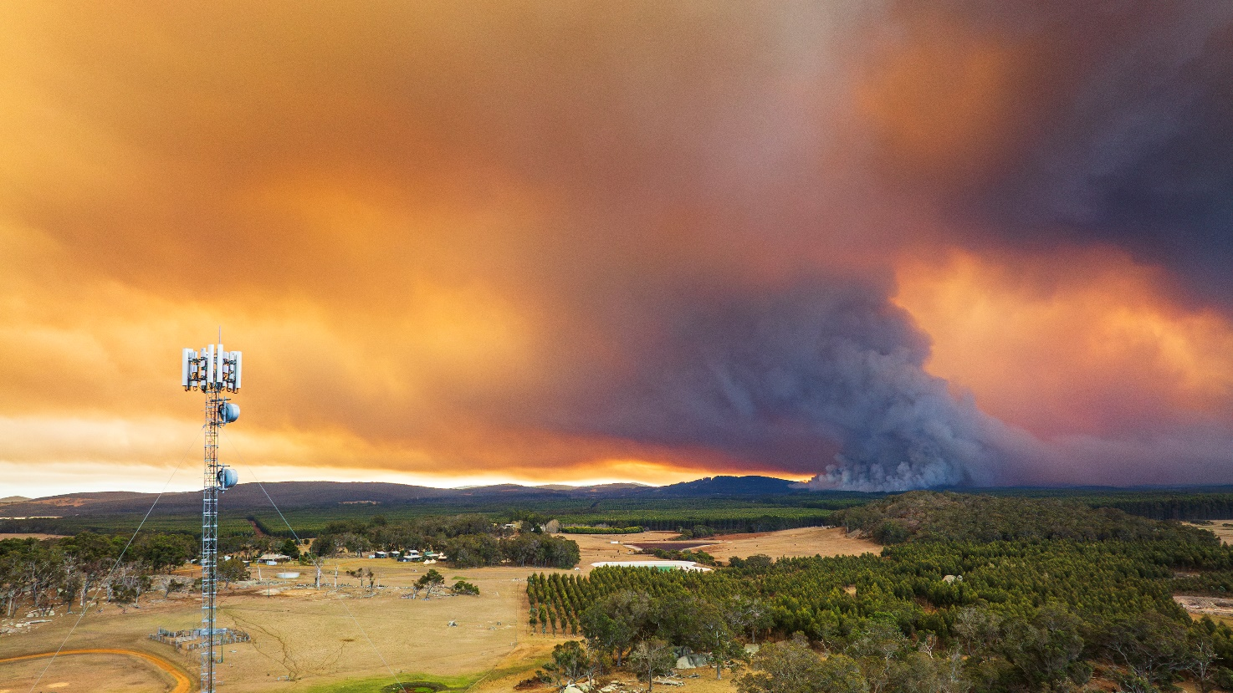
South Western Australia bushfires – Getty Images, Philip Thurston
Resilience solutions should include investments in longer-lasting (days, not hours) power backups, third-party access to fuel-powered generators for towers and other off-grid power solutions. Automatic Transfer Units (see Glossary at Appendix D) will help to address the third-party mobile tower access issues and their roll-out should be encouraged in power hardening programs. Regularly scheduled tower maintenance to resolve existing infrastructure issues, such as water-damaged roofs and misaligned antennas, is also essential. Improved communication from network operators about outages, including user-friendly systems for logging mobile network faults, is recommended.
The Committee also emphasises the importance of ensuring that vulnerable communities, individuals, and their local councils and state governments are ‘disaster ready’ and aware of how to stay connected in an emergency or power outage. Utilising the assistance of the Regional Tech Hub and the National Emergency Management Agency, through Australian Government initiatives such as the Disaster Ready Fund (DRF) and others, to increase awareness is suggested. The DRF is designed to fund projects that help build disaster resilience and ensure the long-term sustainability of communities at risk of future disasters.
The Committee notes the welcome development that NBN Co has secured funding from the Australian Government’s TDRI program which will enable it to develop a digital power outage notification application programming interface. This will help NBN Co better prepare for and respond to power outages, improving network management during natural disasters.

1. Upscaling connectivity literacy

Key findings
- A lack of connectivity literacy is a major barrier for many people in regional, rural, and remote Australia and prevents them from obtaining the best available telecommunication services in their local area. Improving connectivity literacy levels for regional Australians is also key to maximising the intended outcomes of government investments in telecommunications.
- The Regional Tech Hub provides a valuable resource for growing and supporting connectivity literacy but additional strategies, resources and outreach activities are needed to ensure all regional Australians can access the guidance needed to get and stay connected.
‘Connectivity literacy’, a term developed by Better Internet for Rural, Regional and Remote Australia (BIRRR), has become essential for people living in rural and remote areas. Connectivity literacy describes a person’s ability to navigate the increasingly complex landscape of telecommunications technologies, service providers, customer plans and necessary hardware to obtain and manage services that best meet their needs and budgets. Connectivity literacy is distinct from ‘digital literacy’, which focuses on the ability to operate devices, manage software, navigate digital tools and engage with digital content. Being digitally literate does not necessarily mean consumers have the skills to get and stay connected. Connectivity literacy, unlike digital literacy, does not appear to directly correlate to demographic factors such as age, gender, location, income or education levels.
The Australian Digital Inclusion Index uses survey data to measure digital inclusion across the dimensions of ‘Access’, ‘Affordability’ and ‘Digital Ability’, exploring how these vary across the country and different social groups. The Index has not previously considered the barrier of connectivity literacy and there is also a significant lack of research and data specifically focused on connectivity literacy as an obstacle to digital inclusion.
Connectivity literacy impacts people of all ages, backgrounds and locations although it is more pronounced in rural and remote areas where many factors can impact consumers’ understanding and awareness. As telecommunications options grow increasingly complex, especially in remote regions, the ability to make informed connectivity decisions is more crucial than ever.
Improving Connectivity Literacy is crucial for enhancing digital inclusion and ensuring that consumers can access and maintain reliable and affordable telecommunications services. However, this should not be a role for the consumer alone, Government and industry must also address Connectivity Literacy and support the consumer to be aware and understand connectivity, to ensure improved digital inclusion in RRR areas.
Better Internet for Regional, Rural and Remote Australia submission
Getting connected in regional, rural and remote Australia is no longer as simple as choosing an internet provider or mobile plan. The range of options has expanded significantly, making it difficult to navigate the telecommunications landscape. This challenge is particularly pronounced in regional, rural and remote Australia where the availability of infrastructure – which can at times be limited – necessitates careful consideration of satellite, fibre, fixed wireless, or mobile networks. Even when multiple options are available, they vary greatly in terms of performance, coverage, choice of customer premises equipment, and cost which can make the decision-making process overwhelming for those without technical expertise.
Other factors also add complexity to the search for the best connection for regional and remote consumers. Misinformation and sales bias can influence consumers to make choices that may not fully meet their needs as providers and installers may prioritise certain products or plans. Terminology used for services and in contracts can be inconsistent and complex, making it difficult for consumers to compare options effectively. This challenge is compounded by confusing contractual conditions, (including Critical Information Summaries or CIS), that can obscure key details and confuse customers. Rural, regional, and remote areas often lack technical support, which means consumers have limited assistance for troubleshooting locally. Finally, communicating with service providers can be challenging in terms of time and the channel required to access support.
Further complexities arise with the differences between available technologies. For example, NBN Sky Muster’s geostationary earth orbit (GEO) satellite offers reliable coverage over vast areas but with higher latency, while LEO satellite constellations like Starlink provide lower latency and faster speeds but at a higher cost. Likewise, fixed wireless provides a stable connection to a specific location, using a fixed antenna, while mobile wireless offers portable connectivity through cellular networks for use on the move. Despite such differences, the telecommunications industry often refers to these services interchangeably. Without sufficient knowledge of the distinctions, consumers may find it difficult to choose the most suitable option for their needs and budget.
Another frequently reported issue is poor residential mobile coverage. Many people living in rural and remote areas experience weak or non-existent mobile signals inside their homes yet are unaware technologies like Wi-Fi calling and SMS over Wi-Fi allow them to use their home broadband connection and Wi-Fi network for mobile calls and texts.
There is a clear need for greater support to help telecommunications consumers – particularly in regional, rural and remote areas – understand how to get and stay connected. This support should extend beyond providing basic information – it should actively help guide individuals to make informed choices. The Committee believes the enhancement of Regional Tech Hub operations, development of connectivity literacy training modules, and a widespread network of Connectivity Champions can together play a transformative role.
Refining the role of the Regional Tech Hub
The Regional Tech Hub helps rural, regional, and remote Australians navigate connectivity options, choose appropriate service providers and plans and troubleshoot issues with their broadband and mobile services. It offers guidance on technologies, supports transitions during network changes (for example, the 3G switch off), and informs consumers of their rights and available financial assistance. Currently receiving $2 million per annum from the Australian Government, the Regional Tech Hub is a key regional resource for empowering consumers to make informed decisions and stay connected.
In its current form, the Regional Tech Hub assists regional Australians through a website, online helpdesk, hotline and through social media and community events. Despite its successes, overall awareness of the Regional Tech Hub remains low, and it was virtually unknown among participants in public consultations across the country, although greater awareness was expressed in written submissions.

The Local Government Association of Queensland (LGAQ) recommends the Federal Government commits to improving public awareness and understanding of telecommunications services and undertakes a review of the Regional Tech Hub’s purpose, scope, accessibility and resourcing to ensure it is equipped to support local communities, especially in regional, rural and remote locations.
The LGAQ recommends the Federal Government consider expanding the remit of the Regional Tech Hub to support regulators in advising communities of their consumer protection rights and avenues for resolving disputes.
Local Government Association of Queensland submission
The Committee recommends reviewing the role and governance arrangements of the Regional Tech Hub as well as boosting its resources to better support its core business aim of improving connectivity literacy in regional Australia. While the Regional Tech Hub has been generally well-received by those who have used its services, public consultations also revealed general awareness remains low in many regions.
To start to bridge this awareness gap in the short term, the Committee recommends an increase in funding to enhance the Regional Tech Hub’s operational capacity and outreach, and ideally that this increase commence in the 2025–26 financial year. To help broaden its community reach, the Regional Tech Hub needs increased staffing and targeted marketing. Increased visibility, especially in remote areas, could also be improved through strategic partnerships with local organisations and government agencies.
Concerns were also raised with the Committee about confusing advice provided by the Regional Tech Hub. The current reliance on lengthy and complex email responses has made it challenging for consumers to understand clear, actionable advice. The website also needs improvements. Users reported to the Committee that it is difficult to navigate, and this highlights the need for a more intuitive and accessible digital presence.
As the Regional Tech Hub’s current contract ends in 2026, the Committee recommends conducting an audit and review of its operations and performance (in line with the Committee’s recommendations for other government programs) with a view to clarifying its scope, improving its performance, outreach strategy and governance. This step is especially important considering other recommendations for improving connectivity literacy and customer information.

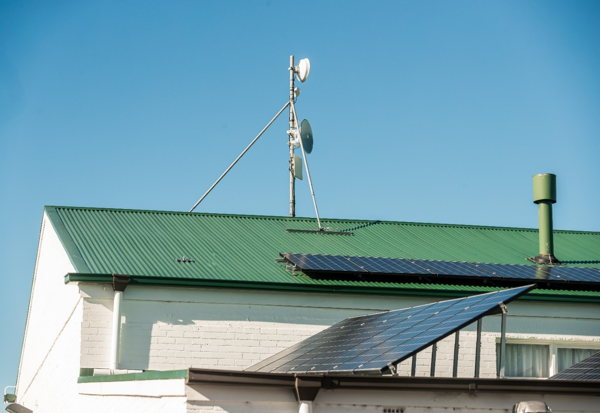
Telecommunications satellite dish on roof, Hobart – Department of Infrastructure, Transport, Regional Development, Communications and the Arts
Connectivity Champions
Australia is a vast country and, beyond the important work of the Regional Tech Hub, the Committee also sees the need for ‘Connectivity Champions’ – an initiative designed to identify and use trusted local sources of connectivity knowledge in rural and remote communities. These champions could be embedded within existing communities in facilities such as the Australia Post network, community resource centres and libraries, providing in-person advice to individuals in the regions where they live and work.
Connectivity Champions would be trained in telecommunications options, connectivity tools and consumer protections, enabling them to act as local advisors. They could provide hands-on support, guiding consumers through the complexities of connectivity, such as choosing the right broadband provider, understanding the nuances of different technologies, or troubleshooting common issues like poor in-home mobile or Wi-Fi coverage. Community Connectivity Champions should be able to work with the Regional Tech Hub on complex matters. By leveraging the existing footprint of Australia Post or other centres in regional and remote areas, these champions would have day-to-day access to hard-to-reach communities.
Written submissions addressing the issue of connectivity literacy highlighted how many consumers do not understand the options available to them or may be unaware the options even exist.

Connectivity literacy is another barrier impacting digital engagement. For some regional households, lack of awareness of best value for money connectivity options and how to access them (that is, connectivity literacy) may be the barrier that prevents their needs being met.
Lack of understanding about the most fit-for-purpose services available can result in poor user experiences. Improving connectivity awareness and literacy is a major step needed to improve public perceptions about the quality of the regional digital connectivity landscape, which is becoming significantly better for most households and communities.
In the past, regional telecommunications infrastructure coverage was the major barrier excluding regional people from participating in the online world. This is becoming less relevant with progressive investment and new technology developments, resulting in affordability and connectivity literacy becoming more significant issues.
Victorian Government submission
Many submissions and consultations agreed that upscaling connectivity literacy was needed to increase consumer awareness and help people to make the ‘right’ choice whether for their business, educational or agricultural purposes or simply while performing day-to-day tasks. The submissions uniformly called for increased, sustained resourcing and targeted additional investment as necessary requirements for upscaling connectivity literacy with the Shire of Victoria Plains submission suggesting the development of a ‘connectivity toolkit’ to help address misleading information about telecommunications services. Some submissions suggested:
- redefining the scope of the Regional Tech Hub and the expansion of its staffing and funding
- the funded promotion of knowledgeable persons strategically placed across existing community networks such as libraries
- the development and local delivery of bespoke training modules for those representatives
- continued investment in connectivity literacy and support for First Nations communities.
The role of these proposed Connectivity Champions aligns closely with the aims of the First Nations Digital Inclusion Advisory Group roadmap, which seeks to extend the funding for a First Nations Digital Support Hub and network of digital mentors.

Case study: Kimberley Aboriginal Medical Services — Broome, Western Australia
During its visit to the Kimberley Aboriginal Medical Services (KAMS) in Broome, the Committee observed a remarkable integration of advanced telecommunications infrastructure tailored to the unique needs of remote healthcare delivery. KAMS is a fine example of how strategic investment in connectivity enhances service delivery outcomes for Aboriginal communities across remote regions. This example should inspire others to recognise what is possible when adequate resourcing and technological expertise are applied to remote connectivity challenges.
The Committee noted how KAMS’s leadership team has effectively aligned their connectivity strategy with the organisation’s overarching mission to deliver comprehensive primary healthcare to remote Aboriginal communities. This strong alignment ensures that information sharing and access are optimised, enabling seamless communication between the various clinics and the central office in Broome. This integration supports well-informed decision-making and enhances patient care.
Recognising the vital role of reliable connectivity in healthcare provision, KAMS has prioritised its connectivity needs. Their hybrid network architecture, which employs a combination of fibre optics, wireless and satellite technologies, is designed to ensure robustness and scalability. This strategic choice of technologies and providers addresses the diverse and challenging geography of the Kimberley, ensuring consistent and reliable communication across the entire network.
To safeguard against service disruptions, KAMS has implemented a sophisticated system of dual technology solutions that provide multiple layers of redundancy. This includes real-time fault monitoring and load balancing capabilities via a dashboard which helps maintain network performance and ensure continuous availability. A resilient system like this is crucial for sustaining the delivery of essential healthcare services in remote and often unpredictable environments.
The Committee also noted KAMS’s forward-thinking approach. It has a vision to incorporate its own mobile network infrastructure in very remote areas to support a more agile and responsive workforce. By equipping healthcare professionals with mobile tools, KAMS aims to enable staff to access patient information and critical resources in real time, regardless of their location. This investment could also open opportunities for providing some mobile connectivity to residents.
KAMS’s technical leadership has played a pivotal role in shaping the organisation’s sophisticated telecommunications infrastructure. The Chief Technology Officer’s knowledge and leadership have been instrumental in designing and managing a network that effectively meets the complex demands of remote healthcare.
This is a great example of what business can achieve with strategic investment and technical expertise. However, the challenge remains of how best to encourage consumers to set up reliable connections for themselves, even if not at the same level of complexity.
The Committee recommends additional funding be allocated in the 2025–26 Budget to pilot a Connectivity Champions program in partnership with regional community facilities and networks. This initiative would establish Connectivity Champions who would offer on-the-ground support to local consumers, working through existing networks such as Australia Post, community resource centres, and libraries. The Connectivity Champions would complement First Nations Digital Mentors developed with, and by, First Nations communities as recommended by the First Nations Digital Inclusion Advisory Group.

Training modules
Submissions to the Committee highlighted the need for dedicated connectivity literacy training programs to help regional Australians better understand and navigate the complexities of telecommunications technologies. Several submissions emphasised that these programs would provide a ‘single source of truth,’ offering consistent and accurate information about connectivity options, troubleshooting, and available resources. For example, Warren Shire Council suggested utilising online platforms and distance learning tools to deliver training modules directly to remote locations and developing joint capacity-building programs for local government staff on the latest telecommunications technologies.
The Committee recommends the development of high-quality connectivity literacy training programs for community organisations, connectivity champions, businesses, and other stakeholders. These training modules, distinct from the Regional Tech Hub, would cover essential topics such as identifying connectivity needs, providing basic troubleshooting support, and navigating available connectivity options tailored to local areas. Modules would also focus on tailored content for addressing common connectivity challenges in remote regions and be developed in collaboration with regional stakeholders to ensure they are fit for purpose.
Recommendation 1: Upscaling connectivity literacy
The Committee recommends a significant increase in the focus and resources for connectivity literacy in regional, rural and remote Australia. Limited knowledge and awareness hinder many users from navigating telecommunications options, selecting suitable services and maintaining reliable connections. Without addressing this issue, digital inequality will persist, and both government and private sector infrastructure investment will not be delivering to their full potential.
The Australian Government should:
- develop a program to create Connectivity Champions to provide consumer support through existing regional networks, such as Australia Post, community resource centres and libraries. Connectivity Champions would complement First Nations Digital Mentors, developed with, and by, First Nations communities
- develop high-quality connectivity literacy training programs to train Connectivity Champions, communities, businesses and other stakeholders
- refocus the Regional Tech Hub and increase funding to expand its capacity, boost awareness of its services, and improve its performance in providing existing core services
- review the Regional Tech Hub’s scope, strategy and governance at the end of its current contract period.

2. Improving the mobile experience

Key findings
- Many Australians in regional, rural, and remote areas rely heavily on mobile technology as their primary means of connectivity, despite its limitations compared to fixed broadband options.
- Existing mobile networks in many regional areas are under pressure, facing congestion and capacity issues that require urgent attention to ensure reliable service.
- Terrestrial mobile networks have reached a stage where further extending coverage is increasingly economically challenging, due to sparse populations and the high costs of infrastructure and maintenance.
- In the coming years, LEO satellites with DTH mobile services may provide a solution for the most remote areas that remain without terrestrial mobile coverage.
The Committee heard that many people living in regional, rural, and remote Australia remain dissatisfied with their mobile experience, citing issues such as unreliability, frequent call dropouts, and slow data speeds. While some continued investment in expanding terrestrial mobile networks is necessary, there should be a greater focus on improving the capacity and quality of existing services. With the advent of DTH technology promising widespread coverage beyond terrestrial networks through LEO satellites, a move to investing in capacity becomes compelling. Innovative solutions, such as strategically placed Wi-Fi hotspots, can also alleviate pressure on mobile networks. Increasing connectivity literacy as well as setting and communicating reasonable consumer expectations are also crucial to ensure people understand their options and can make informed choices about their connectivity needs.
In response to ongoing concerns about mobile coverage in regional, rural, and remote areas, the Australian Government committed $20 million to fund an independent National Audit of Mobile Coverage (the Audit). The Audit is underway and will run until mid-2027. It includes a combination of drive-by testing, fixed location testing utilising Australia Post assets (post offices and vehicles), and other crowdsourced data, focusing on the availability and performance of mobile coverage. Data collected from the Audit is being made available to the public via the Mobile Audit Visualisation Tool. The program will help the Government better identify mobile coverage black spots, target future investment and assess the accuracy of carrier coverage maps.
The Committee strongly supports this initiative, recognising its potential to drive meaningful improvements in mobile coverage and service reliability.

More focus on funding capacity building
Expanding terrestrial mobile network coverage further into rural and remote areas is expensive and complex and, with the development of DTH technology, will reduce the need for terrestrial solutions to provide general coverage. Yet, as the ACCC points out: ‘With one of the lowest population densities globally and an expansive landmass, addressing the connectivity needs of regional, rural and remote Australians presents an exceptional challenge.’
While expanding coverage will remain important in some circumstances, ensuring the capacity and reliability of existing terrestrial mobile networks in areas that already have coverage is crucial. In many regional centres, the existing infrastructure struggles to cope with demand, particularly during peak usage periods or times of crisis.
Traditionally, the MBSP has provided funding only for projects that deliver new coverage in areas where it did not previously exist. In time, DTH technology will offer national coverage to standard mobile handsets, with an initial focus on basic messaging and voice service.
Considering this, and the evidence the Committee has received (and experienced) concerning significant mobile network congestion in many rural and remote areas, attention must turn to improving the quality of services in areas with existing terrestrial mobile coverage. While the RCP funds some upgrades to existing mobile base stations, more needs to be done.
Investment in the capacity and quality of existing mobile networks is crucial, but there is also a critical need for new coverage in underserved areas, particularly in First Nations communities that currently have no mobile service. As stated elsewhere in this report, the First Nations Digital Inclusion Advisory Group’s 2023 Initial Report notes that ‘... 670 First Nations communities do not fall within areas of mobile coverage.’
Continued investment in new mobile coverage along major roads and highways is essential for safety. Reliable mobile services on key routes are crucial to ensure that drivers and travellers can access emergency or repair services in case of accidents or breakdowns, especially in remote regions where assistance may be hours away. The Committee heard positive feedback about the Regional Roads Australia Mobile Program, particularly about how cross-government collaboration will help identify priority locations.
Engagement and collaboration across government, such as through the recently launched $50m Regional Roads Australia Mobile Program, can ensure funding meets local needs and priorities, delivers value-for-money and long-term sustainability.
New South Wales Government submission
Alternative solutions to capacity building should also be considered. The Committee sees a place for strategically positioned free Wi-Fi hotspots, which may present a cheaper alternative, for example, at road stops, electric vehicle charging stations or other locations for improved safety and to support tourism in very remote areas (including camp sites where all bookings are online). These hotspots could be connected by satellite or existing infrastructure and provide access to travellers and residents.

Regulatory options to improve choice of mobile provider
Tower infrastructure management in regional Australia has undergone significant changes in recent years. Historically, the bulk of mobile towers were owned and operated by major carriers (or MNOs). Recently, these companies have divested thousands of tower sites to other companies (or MNIPs) for operation. This divestment was largely motivated by balance sheet considerations.
The Committee supports the Australian Government continuing to drive infrastructure sharing for remote black spot areas. This includes active sharing, access to neutral hosts, emergency roaming during natural disasters and domestic roaming.
In 2016 and 2017, the ACCC conducted an inquiry into declaring a domestic mobile roaming service. Such a declaration is a regulatory mechanism designed to compel an MNO to provide network access on request. If commercial arrangements are not working, the ACCC can set the prices and terms through retail price controls or by regulating wholesale prices. In 2018, the ACCC decided against this move, citing concerns that it would negatively affect market dynamics and reduce incentives for carriers to invest in regional areas.
The inquiry concluded that declaring mobile roaming would not enhance coverage in regional Australia. While the ACCC found that it could offer benefits by increasing provider options in areas with limited infrastructure competition, the evidence at the time suggested it would weaken commercial incentives for operators to invest in expanding and improving coverage. Without the competitive advantage of exclusive coverage, providers would have less motivation to invest in new infrastructure in these areas.
However, this inquiry was conducted before DTH technology became a realistic prospect. DTH technology could disrupt the mobile market by providing outdoor mobile coverage to close to 100% of Australia’s landmass through LEO satellites, which may influence an assessment of the relative pros and cons of declaring a domestic mobile roaming service.
In its submission to the 2024 Review, the ACCC notes that:
It is not possible to determine whether declared mobile roaming would promote the long-term interests of end-users at a given point in time without conducting an inquiry and having regard to evidence. However, it is clear that any such inquiry would need to have regard to the development of the LEOSat direct-to-device services and its likely impact on the market.
ACCC submission
Domestic mobile roaming has the potential for more efficient, shared use of existing and new neutral host mobile network equipment. The Australian Government should request the ACCC to reconsider direct mobile roaming in the context of emerging satellite technologies. This technology will alter current market dynamics and may change the case for declaring a mobile roaming service.
In the context of infrastructure sharing for better economies of scale, the Committee also supports the First Nations Digital Inclusion Advisory Group Roadmap recommendation that the Australian Government encourage industry to share mobile network coverage in regional, rural and remote locations, and at the very least ensure emergency roaming capabilities for safety reasons.

Wi-Fi calling for fixed locations
The Committee heard from many people across regional Australia – in public consultations and submissions – who have unreliable or no mobile service. The Committee discovered a lack of awareness in many areas about using fixed broadband services to enable use of Wi-Fi calling and SMS over Wi-Fi – or over-the-top applications such as WhatsApp and Messenger calling – and that such services could help mobile-related quality and accessibility.
Wi-Fi calling and SMS over Wi-Fi are technologies that allow users to make voice calls and send SMS messages using a fixed broadband Wi-Fi network, which can be particularly useful in areas with no or poor mobile reception, such as inside buildings, underground or in remote locations.
By raising awareness of alternative methods for communications through channels like the Regional Tech Hub and Connectivity Champions (see Recommendation 1), consumers and businesses could help move load off the mobile network while at a fixed location easing network congestion and improving their user experience. The Committee suggests an advertising campaign in rural and remote areas would also help promote this as part of broader connectivity initiatives.

Mandatory emergency mobile roaming
There was strong support at consultations and in submissions for the Australian Government to establish emergency roaming, particularly for rural and remote regions that are frequently affected by disasters, to ensure essential communications remain operational during emergencies.
Temporary Disaster Roaming (TDR) was raised in the 2020 Royal Commission into Natural Disasters, prompting the 2021 RTIRC to recommend a feasibility study on mobile roaming in emergency situations. This recommendation led to ACCC’s 2022–23 Regional Mobile Infrastructure Inquiry, which found that while temporary emergency roaming (or TDR) was technically feasible, further work was required to design and develop the capability. In response, Telstra – whose role in TDR is fundamental given its superior network coverage – announced it was working with all network providers to develop a TDR solution that would enable mobile roaming between networks within a localised area during natural disasters for a short and specified duration of time.
While the Committee was assured progress has been made, the lack of tangible progress as another disaster season approaches is frustrating. The Committee heard that while there is broad support for TDR, concerns remain regarding the proposed solution and the slow pace of development.
While delighted to see a commitment from Telstra and the Australian Government to scope Temporary Disaster Roaming (TDR) capability, we have concerns with the process of TDR development and the mechanics of its usage. To date, this process appears to have been captured, driven, and led by the mobile network operators, where decisions are guided by commercial operations, and not necessarily having the safety of rural and regional people at the forefront of this process.
RDA Grampians submission
The Committee recommends the Australian Government mandate TDR during emergencies and natural disasters to ensure public safety and make significant efforts to expedite the implementation of this critical measure. The Committee also noted that the future of any implemented TDR will need to consider DTH.

Illegal mobile phone boosters
The Committee was particularly concerned to learn, during its consultations, of instances across Australia where individuals or technicians had installed illegal mobile phone boosters that do not have necessary licenses. These illegal boosters can cause interference on terrestrial mobile networks, which leads to degraded service quality, dropped calls, slower data speeds and in some cases, an inability for users in the area to access the mobile network altogether. Additionally, some installers and technicians operate without adhering to Australian cabling and license standards, as mandated by the Telecommunications (Types of Cabling Work) Declaration 2024.
The Committee heard of multiple instances of consumers having few protections when it came to poor installers or equipment purchased offshore, not just illegal mobile phone boosters but also point-to-point equipment, non-compliant cabling and installation practices. The Committee encourages all consumers, where they are aware of such issues, to make a complaint directly to the ACMA as these practices and equipment may pose immediate health and safety risks and compromise the integrity of existing telecommunications networks. The ACMA reported that illegal boosters are investigated as part of its compliance program.
The ACMA also informed the Committee that mobile phone repeaters supplied in line with the provisions of the Radiocommunications Equipment (General) Rules 2021 are allowed.
The Committee is of the view that the Australian Government should ensure the ACMA is appropriately funded to enhance its resources to enforce compliance against illegal equipment and non-compliant installation practices.

Coverage maps and funding priorities
Dissatisfaction with telco-provided mobile coverage maps was also widespread, with submissions urging the Australian Government to mandate a standardised national mobile network coverage map and perform regular audits.
Many submissions endorsed greater government involvement in monitoring capacity and prioritising peak demands in areas with fluctuating populations. Enhanced funding for the MBSP and RCP received broad support, with recommendations for program refinements to incentivise place-based solutions tailored to specific local needs.
Overall, submissions reflected an expectation that the Australian Government should take a proactive role in improving the mobile experience in regional, rural, and remote areas. There was also a clear call for the Australian Government to ensure mobile services are not compromised during the transition from 3G to newer technologies like 4G and 5G.
Recommendation 2: Improving the mobile experience
The Committee recommends actions to improve mobile services, including addressing diminishing mobile experience in existing regional, rural and remote coverage areas.
The Australian Government should:
- prioritise funding to improve existing terrestrial mobile network capacity, service quality, and resilience, rather than further extending terrestrial coverage
- continue funding new terrestrial mobile coverage for critical areas like roads, and leverage strategically located Wi-Fi hotspots where needed
- request the ACCC to conduct a new inquiry into mandatory domestic mobile roaming, considering emerging DTH satellite technologies and its effect on competition
- mandate, at the earliest opportunity, emergency mobile roaming during disasters and expedite the regulatory and operational framework for its use
- increase consumer and business awareness of terrestrial mobile network alternatives like Wi-Fi calling and Voice over Internet Protocol (VoIP) services for fixed locations
- enhance the ACMA's resources to enforce compliance against the sale and use of illegal mobile phone boosters and other unauthorised equipment and installation practices.

3. Expedite universal service modernisation

Key findings
- Many rural and remote residents, especially those who live where there is no mobile coverage, value their landline phone services delivered over copper and other legacy technologies.
- Legacy voice services are ageing and becoming increasingly expensive to maintain and operate as the technology is phased out globally.
- Australians without mobile coverage and other vulnerable groups will need additional support when legacy voice networks are decommissioned.
The USO requires Telstra, as the statutory universal service provider, to supply standard telephone services and payphones to people in Australia on reasonable request. Telstra now delivers most of its USO services over NBN Co’s fixed line networks while continuing to provide USO voice services over copper and other legacy networks in areas outside the NBN fixed line and fixed wireless footprints.
The USO was originally introduced in the late 1980s during a period of microeconomic reform, as the Australian Government sought to introduce competition into network industries that were previously government owned. To prevent a scenario where regional consumers were left unserved or underserved, the USO was established to ensure that Telstra would continue to provide affordable, standard telephone services in these areas. Initially introduced as the Community Service Obligation in 1989, it was renamed the Universal Service Obligation in 1991, followed by the introduction of a telecommunications industry levy in 2012 intended to recognise the net costs of delivery of services in loss making areas. Over time, however, multiple reviews, including a 2017 Productivity Commission review, have recommended reform, arguing that the current USO arrangements are outdated.
Since 2012, Telstra has received a fixed payment, funded through a mix of government and levy funding of $230m p.a. for delivery of USO voice services and $40 million p.a. for payphones subject to meeting relevant regulatory and contractual requirements.
In 2017, the Productivity Commission found that the USO was ‘…no longer serving the best interests of the Australian community’. The report called for negotiations with Telstra to terminate the payphone component of the Telstra Universal Service Obligation Performance Agreement (TUSOPA) ‘as soon as practical,’ followed by the eventual termination of the USO’s standard telephone services component once the NBN rollout was complete.
In response, the Australian Government acknowledged that the USO, while an essential safeguard, was becoming increasingly outdated due to changing consumer preferences and technological advancements. This sentiment has been echoed repeatedly during the Committee’s consultations with operators and other stakeholders, highlighting the need to modernise the USO to meet contemporary needs.

2023 Universal Service Obligation Review
On 27 October 2023, the Hon Michelle Rowland MP, Minister for Communications committed that the Australian Government would consider stakeholder views on future universal telecommunications services as part of a broader USO review. The Minister noted this would be undertaken in the context of significant technological advancements and shifting consumer preferences, particularly with the introduction of LEO satellite services and the growth of mobile services.
The Committee understands that the primary aim of the review is to develop a modern, fit-for-purpose USO. Public consultation on both the delivery and funding of universal telecommunications services took place from late 2023 to mid-2024. At the time of writing, the Australian Government is considering the input received.
Stakeholders, including Optus, have argued that the current USO model stifles competition and continues to subsidise legacy services, even as more advanced, unsubsidised options like LEO satellites are becoming widely available:
USO reform should also help promote competition in regional and rural Australia. A market will not function as effectively where subsidies, particularly flowing from industry to the incumbent, continue to sustain legacy market structures for no real consumer benefit.
Optus submission to the USO Review

Phasing out the Copper Continuity Obligation
Many people who have relied on legacy landline services in rural and remote Australia are understandably anxious about transitioning to new technologies, as these older systems have historically been reliable and resilient.
Long-term fixed line customers have expressed scepticism whether any replacement wireless technology could provide sufficient confidence to allow removal of the existing traditional underground copper lines or dedicated High Capacity Radio Concentrator (HCRC) wireless services which have been delivering terrestrial voice services since the mid to late 1980s throughout RRR Australia.
Western Australian Government submission
However, the reality is that these legacy networks cannot be maintained indefinitely due to the costs of upkeep and the limitations of outdated infrastructure. Many of the components are no longer being manufactured and the ageing systems are becoming more expensive to maintain, creating a significant opportunity cost for investment. As new technologies emerge, it is important to modernise these systems to ensure continued service and reliability. It is the Committee’s view that the community understands that. For example:
The copper network has provided a historically reliable mode of USO delivery for many Australians in regional areas. However, user experience indicates that a cohort of customers on legacy networks, including the copper network and high-capacity radio connectors, experience ongoing issues with service reliability, down time and repair waits. These issues, most often associated with the ageing of the networks, have been stated publicly by telecommunications companies and affirmed by independent reviews. On this basis, the NFF supports efforts to consider sensible USF reform.
National Farmers’ Federation submission
A primary driver for USO change is the evolving nature of consumer demand. In 1991, voice services were the foundation of communications infrastructure. Today, it is the view of the Committee, that access to the internet and the wide range of services it enables is the critical driver, with voice services increasingly also relying on this underlying internet infrastructure. The modernisation of the USO must align with this shift in consumer needs as much as it needs to align with the need to replace the ageing infrastructure.
The TUSOPA currently requires Telstra to continue using the copper network until 2032 to deliver standard telephone services to premises outside of the NBN fixed line footprint that were connected by copper as of 1 July 2012. Telstra has – for several years – publicly expressed its desire to withdraw from the CCO.
The Australian Government should negotiate with Telstra to phase out the CCO in areas outside the NBN fixed line footprint where proven and effective voice-capable broadband services exist, such as NBN Co’s fixed wireless network.
Throughout public consultations, the Committee heard views that high latency associated with NBN Sky Muster satellite services can make these services inadequate to carry a primary fixed voice service. The Australian Government is conducting independent trials to help inform whether LEO satellite broadband connections can deliver high-quality and reliable voice services.
NBN Co fixed wireless and satellite services will also be trialled in parallel to provide a comparison. Data will be collected on the reliability and quality of voice services, as well as information about weather and climate conditions to test performance across different conditions. Results will be progressively published by the Department of Infrastructure, Transport, Regional Development, Communications and the Arts.
Trials such as these are strongly supported by submissions from multiple regional stakeholders.
All new technologies which will replace major communication sources (i.e. landline replacement, internet type replacement) should be required to go through processes that ensure robust trialing and reporting before being implemented. AgForce calls for a set standard of procedural guidelines outlining the targets to be shown by trials before implementation should be put in place. These trials need to be done in adequate numbers and varying situations to show true performance before being adopted. To determine what is ‘adequate’, a clear definition should be agreed upon.
AgForce submission
The Committee recommends that existing USO arrangements remain in place in the NBN satellite footprint until satellite services are demonstrated to deliver quality voice services. Additionally, the Australian Government will need to consider whether baseline broadband speeds can be delivered in all locations, including FTTN areas, after the closure of the copper network.
The Committee is concerned about ‘copper towns’. A copper town is one where fixed line internet services can be provided by ADSL and mapped for NBN Satellite. A large number of copper towns will require substantial infrastructure investments to upgrade primary connectivity options. Without this investment, the existing satellite networks, including future LEO satellite options, risk becoming congested, as more users are forced to rely on them. Ensuring that these larger copper towns have access to suitable, high-capacity broadband infrastructure will be crucial to prevent congestion and ensure equitable service delivery.
The Committee notes some customers are already being moved from legacy voice services to mobile or satellite alternatives, without fully understanding the transition implications or their rights as a consumer. The need to transition often arises because repairs to the ageing infrastructure are no longer feasible due to a lack of available parts or other logistical constraints. The experience for some consumers has been challenging, marked by limited support, inadequate communication, connection issues and widespread uncertainty. The Committee highlights the need for greater oversight to ensure that customers are well-informed about such transitions and receive adequate support throughout the process.

Backup services for all consumers
The Committee considers a key principle in modernising the USO should be ensuring that all consumers have the option to access a reliable secondary ‘backup’ telecommunications service in their premises. This is essential to ensure that communities have access to essential services, such as emergency communications, healthcare and education – particularly during service disruptions or natural disasters when primary connections may fail. In urban areas, where most people have access to both fixed broadband and mobile networks, access to multiple networks is available. If the fixed broadband connection goes down, people can use mobile services as a backup. However, this is not always an option in regional and remote areas, where mobile coverage can be poor or non-existent.
Due to the current operation of USO and SIP regime, rural and remote consumers can choose to access baseline services from two distinct networks supporting fixed voice and broadband services. Throughout consultations and submissions, there was strong advocacy for maintaining the option to access two separate and distinct services provided over separate networks to ensure redundancy. The Committee heard that affordable backup broadband services must be made available – particularly for consumers in areas without mobile coverage.
We support the modernisation of the USO, particularly within NBN’s fixed wireless network footprint, but emphasise the need to consider rural consumers’ unique challenges. Recommendations: Ensure USO changes prioritise service reliability and affordability in rural areas. Maintain a focus on the specific needs of rural consumers throughout the modernisation process. Ensure RRR consumers, particularly those without adequate mobile coverage, have affordable access to telecommunications redundancy. Protect RRR consumers with improved Customer Service Guarantees and in particular, strengthened installation and repair timeframes.
Regional, Rural and Remote Communications Coalition submission
The Committee believes that subsidised access to a secondary, redundant broadband service is essential to ensure continuous access to vital communications and services. It considers this approach will support the development of a connected regional, remote, and rural Australia that is broadband-based rather than voice service-focused. Where satellite redundancy is the only option, the backup service should be on a separate network from the primary service to guard against network outages.
The Committee notes that back up services may need to vary by location as set out below. In some locations, the primary and backup service will both be satellite, but provided over different networks.

 |  | Primary | Back up/ redundancy
Outdoor Mobile Coverage | Yes | Fixed line, fixed wireless, satellite | Mobile
 | No | Fixed line, fixed wireless, satellite | Secondary satellite (subsidised and/or tailored plan for infrequent use)

Modernising the Universal Service Obligation
Written submissions overwhelmingly support expediting the modernisation of universal service arrangements, although there is varied opinion on some components of a new framework. A common view is that changes should be implemented in an orderly manner, with particular focus on transitioning current users smoothly from legacy networks, including the copper network, to more modern and efficient solutions such as satellite, fixed wireless, and mobile broadband.
Submissions advocate consolidating two current schemes that support access to voice and broadband – the USO and SIP regime – into a unified regulatory framework, with NBN Co as the default SIP. This approach would address remaining consumer protection concerns by imposing obligations on NBN Co.
Most submissions favour a technology-neutral approach, suggesting the inclusion of newer telecommunications technologies like LEO satellites and advocate for improved installation and repair standards across all services. As discussed further below, public payphones received very broad support for retention, at least until alternative solutions emerge.
Many submissions called for USO reform to establish clearly defined minimum standards for telecommunications services in rural and remote areas. However, views on how to define these minimum standards – such as speeds, data allowances, latency, reliability, and affordability – were more divided. The Committee acknowledges that defining telecommunications service standards in regional and remote Australia is challenging, as it involves a range of factors and varies depending on the diverse needs, expectations, and preferences of consumers.
Defining and measuring service standards is further complicated by the lack of universally agreed data. Nevertheless, submissions highlighted the need for measurable benchmarks, such as speeds, reliability, voice quality, accessibility, and user experience. For example, Pivotel advocated for clear service standards to ensure reliability and redundancy, while other submissions called for broader measures that establish baseline connectivity standards and ensure transparency in service standards reporting.
To address the evolving needs of telecommunications consumers in Australia, the Committee recommends consolidating the USO and SIP regime into a unified service obligation. This unified obligation should be technology-neutral, allowing providers like NBN Co and other SIPs to deliver voice-capable broadband services with minimum speed requirements for all premises.
Additionally, the Committee recommends the new service obligation be flexible so that minimum speeds, quality and other standards are readily adaptable, so they remain relevant to changing needs. Premises in areas without mobile coverage should have access to affordable backup broadband services, and provisions should be made to support in-home battery backups for network equipment to maintain connectivity during power outages. These changes should be implemented only after a comprehensive plan is developed by NBN Co to manage the needs of different cohorts of regional, rural and remote Australians that currently rely on legacy fixed line voice services.
To support a smooth transition, careful management will be needed for specific consumer groups who may face additional challenges. For instance, individuals with medical conditions relying on telecommunications for emergency monitoring, those using standalone power systems, and those in locations with limited line-of-sight to satellite constellations, may require tailored solutions.
Transition planning should ensure these consumers have dependable connectivity and dedicated support to address their unique needs as they shift to alternative technologies. Reflecting the unique market requirements and failure risks, continued public ownership of NBN Co will be crucial to ensuring that service standards are met under a new unified service obligation for regional, rural and remote Australia.

The continued relevance of payphones
There are around 14,300 Telstra payphones in operation across Australia, which are subsidised under the USO. About 25.8 million free phone calls were made from these payphones in the last year.
The National Indigenous Australians Agency separately manages and funds a network that includes up to 229 community payphones, 301 Wi-Fi satellite phones, and 24 Wi-Fi hubs across around 450 small, remote First Nations communities. These services, which cater to communities with adult populations under 50, are not covered by the payphone USO but play a crucial role in providing essential communication access in these remote areas.
The Committee heard during consultations and in submissions that payphones play an increasingly crucial role in emergencies and for vulnerable members of the community, especially in areas with no, or limited, mobile coverage. Additionally, issues were raised about the lack of community consultation when payphones are being removed from communities.
Stakeholder feedback has revealed that a significant proportion of payphones available in First Nations communities are not covered by the current USO. Community phones and payphones continue to play an important role in First Nations communities. Therefore, ACCAN recommends that all services of this nature should be covered under the universal services framework irrespective of provider.
Australian Communications Consumer Action Network (ACCAN) submission
Across public consultations and written submissions, the Committee heard strong support for national calls from payphones being retained as a free service. With over two million payphone calls nationally made monthly, and many payphones in remote First Nations communities being highly used and valued in those communities, the importance of these services cannot be overstated.
While Telstra is to be commended for its work and has taken steps to modernise payphones – such as enabling free Wi-Fi and installing battery backups at some payphones in disaster prone areas – the Committee recommends that the Australian Government continues to review how these services are delivered and continues to ensure adequate notice and consultation about any payphone removal processes – in particular when and how a specific payphone is removed.
The Committee considers access to free national calls to be essential, particularly for those in areas with no mobile coverage. Ensuring the ongoing availability of free public phones, as well as exploring further enhancements to their functionality, will be crucial to maintaining connectivity for Australia’s most isolated and vulnerable populations.
Telstra receives significant funding from industry and the Australian Government to support payphone services, and the company uses payphones to promote its brand. As the Australian Government continues to evaluate the future of payphones and their funding, the Committee notes the concerns of competitors who argue this funding gives Telstra an unfair marketing advantage. These concerns should be considered in any future policy decisions.
The Committee recommends retaining payphones, including access to free national calls, particularly in rural and remote regions. Once current contractual obligations end, the Australian Government should consider tendering for a provider to operate and maintain public phone services to ensure ongoing public access, provide options for continuing innovation and encourage competitive infrastructure opportunities.
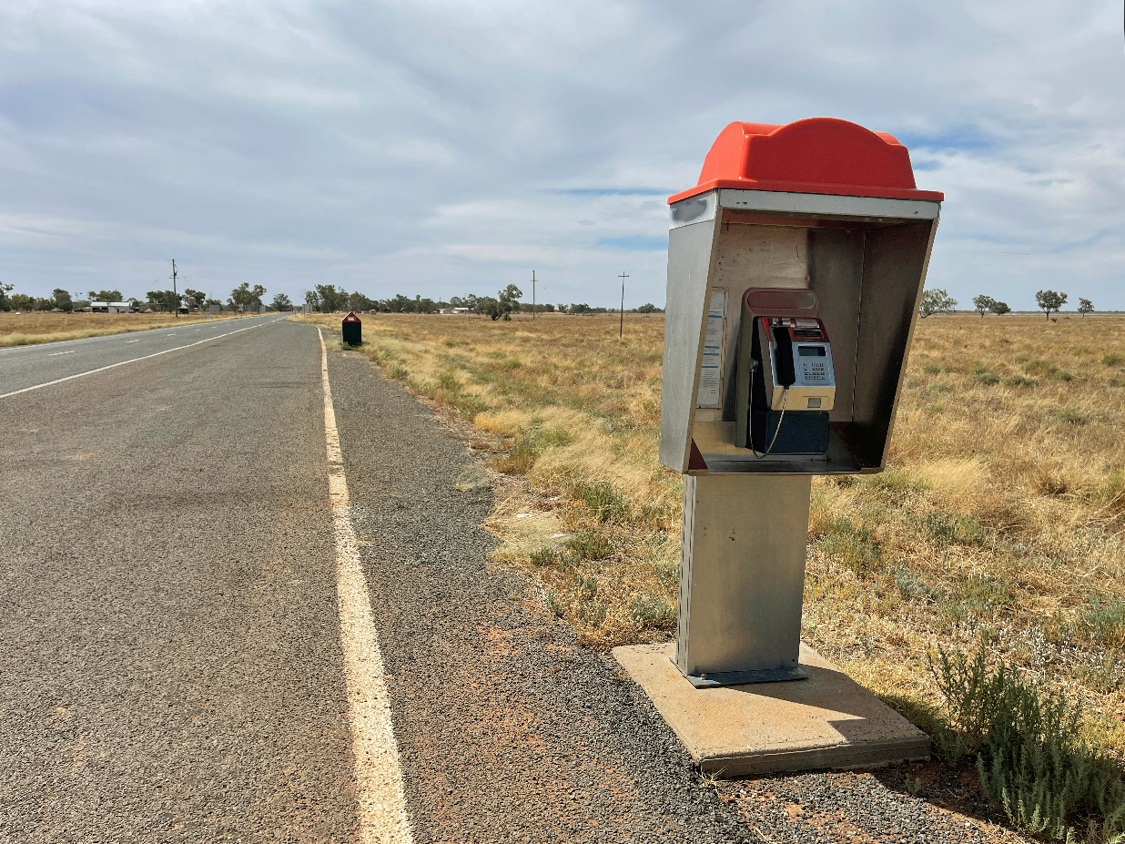
Public telephone roadside, News South Wales – Getty Images, Andrew Merry

Customer Service Guarantee enhancements
The Customer Service Guarantee (CSG) standard is designed to ensure reliable landline telecommunications services by mandating minimum standards for service delivery, repair times, and customer support from providers. It establishes specific timelines for connecting and repairing standard telephone services. The CSG also requires telecommunications companies to compensate customers if they fail to meet these timelines, with automatic credits for residential and business customers. However, CSG compensation does not apply where the provider offers an interim or alternative service while a connection or repair is being made.
Under its USO obligations, Telstra must offer CSG services, while other providers generally ask new voice customers to waive these rights. Providers with more than 100,000 CSG-eligible services, such as Telstra and Optus, are required to achieve at least 90% compliance with CSG timeframes and submit annual performance reports to the ACMA.
The CSG Standard applies exclusively to landline services, covering fault repair, service installation, and certain feature activations (like call waiting). It does not include mobile, internet or fax services. Exemptions (including to compensation arrangements) exist for specific disruptions, such as natural disasters, maintenance, or third-party network damage, where telecommunications companies are not liable for meeting the standard.
In its submission, NBN Co advocates for a reformed consumer protection model that focuses on ensuring individual consumers can access alternative networks to provide redundancy rather than maintaining strict response timelines, which it views as more practical given the range of networks now available across Australia. Under this model, the emphasis would be on maximising connectivity uptime and minimising disruptions for consumers by supporting access to multiple redundant networks, particularly for those with unique needs, such as individuals in remote areas or those with medical requirements.
During consultations consumers reported they often can face lengthy delays in both the installation and repair of telecommunications services, leaving them without reliable communication for extended periods. Submissions highlighted that faults are frequently not resolved in a timely manner, with recurring issues and multiple technician visits, further exacerbated by appointment cancellations and unresolved problems.
The long fault resolution process for NBN services, involving multiple parties from the customer to providers, NBN Co, and subcontractors, can result in significant delays and poor outcomes for consumers. Service Level Agreements for operators permit delays in repair and installation times, as performance targets only need to be met 90% of the time. This leaves up to 10% of customers needing connection or fault repair facing long waits, often without adequate recourse. The Committee received submissions highlighting that some providers evade accountability by meeting service benchmarks that average out over large regional populations, which leaves a cohort of consumers consistently experiencing poor service. Alarmingly, these are often the same consumers who already suffer from recurring telecommunications issues. This underscores the pressing need for stronger consumer protections under a modernised USO.
Another issue raised was the availability and reliability of interim services. The Committee heard that consumers often face lengthy delays in receiving interim solutions, which in many cases requires them to self-install equipment. Furthermore, these interim services frequently fail to work properly, leaving them without essential communication during critical times.
Case study: Sharon’s ongoing telecommunications issues in rural Tasmania
Sharon, a resident in rural Tasmania and a medical priority customer, has faced persistent telecommunications issues with her Telstra landline for 15 years. Living in a mobile blackspot, Sharon was migrated from a copper line to a 3G Next G Wireless Link connection and then to a 4G fixed wireless landline when 3G was shut down. The migration process involved long delays, number porting problems, billing issues, and the removal of her Priority Assist service. While her landline now works over 4G, it cuts out during tower outages, leaving her without communication when she needs it most.
The Committee believe that should a unified service obligation be introduced, the CSG must be updated and strengthened to ensure coordinated consumer protections across all telecommunications services.
Obligations that are updated as result of a modernised USO should establish clear performance standards, mandate reasonable redundancy measures, develop updated installation and fault repair timelines and outline compensation in cases of service failure. Penalties for non-compliance, particularly in remote areas where service disruptions have a greater impact, should be re-evaluated to ensure that wholesalers and providers are held accountable for delays that disproportionately affect vulnerable consumers in these regions. Ensuring these updated CSG standards are robust and enforceable would create more equitable service outcomes for regional and remote Australians.

Recommendation 3: Expedite universal service modernisation
The Committee recommends the Australian Government expedite modernising the USO and the Statutory Infrastructure Provider (SIP) regime by merging them into a unified service obligation. NBN Co, as the provider of last resort, and other SIP operators would be required to provide voice-capable broadband services with minimum speeds and standards for all premises.
The Committee also notes that continued public ownership of NBN Co will be crucial to ensure that service standards are met under a modernised USO in regional, rural and remote Australia.
The contractual Copper Continuity Obligation (CCO) should be phased out where and when proven and effective voice-capable broadband services are available.
The Committee further recommends:
- NBN Co be tasked and funded to implement, in consultation with industry stakeholders, a plan to manage the needs of different cohorts of regional, rural and remote users
- the modernised USO be technology-neutral
- the modernised USO be flexible, ensuring that minimum speeds, quality and other standards are readily adaptable so they remain relevant to changing needs
- premises without terrestrial mobile coverage have access to an affordable secondary redundant broadband service including optional battery backup, with government contributions as necessary
- when a modernised USO is introduced, the Customer Service Guarantee (CSG) is updated and strengthened to provide appropriate protections for regional, rural, and remote consumers
- public phones (payphones) be embedded as a free service for domestic calls. Once current contractual obligations expire, the Australian Government should consider tendering for a provider to operate public phone services.

4. Consumer protection
Key findings
- The regulatory and consumer protection framework for telecommunications is extremely complex.
- Consumers’ expectations of consumer protections and telco providers’ service standards are not being met.
- People in rural and remote areas experience faults and outages more frequently, and repair times are often extended compared to urban areas.
- Further reform of the TCP Code is supported.

The Committee heard from a wide range of stakeholders, including government representatives, industry groups, and consumers, about the pressing need for a review of telecommunications consumer protections and service standards.
The Committee is deeply concerned about recent revelations that unconscionable sales practices are continuing in some of the most vulnerable regional communities. This highlights the need for constant vigilance of business practices in regional, rural and remote Australia and the imposition of significant penalties for breaches.
The telecommunications consumer protection framework is highly complex, comprising an intricate mix of legislative, regulatory, and industry-based safeguards. This fragmented structure often falls short of delivering the clear, robust consumer protections needed in today’s rapidly evolving telecommunications environment especially in rural and remote areas and First Nations communities.
The Australian Consumer Law, administered by the ACCC, provides general protections for all consumers, but telecommunications-specific safeguards are contained in the Telecommunications Act 1997 and the Telecommunications Consumer Protection and Service Standards Act 1999 and instruments made or registered under those acts. These safeguards outline baseline standards such as itemised billing, number portability, and standard terms and conditions. The ACMA enforces these standards, with powers to issue formal warnings, impose remedial directions, cancel licences or seek civil penalties in the Federal Court. Despite this robust regulatory environment, the lack of coordination between various instruments and the reliance on industry codes, such as the TCP Code, often complicates enforcement and compliance efforts.
In its submission, NBN Co highlighted the necessity of modernising consumer protections to align with advances in technology and service delivery models. It stated that a ‘modern universal service framework needs to be supported by an equally modern consumer protection regime,’ which acknowledges the diverse technology options now available via fixed line, wireless and satellite networks. This highlights the inadequacy of outdated consumer protection measures, which fail to adequately address the complexities of modern telecommunications offerings and consumer needs.
The regulatory landscape, as described by Telstra, is marked by ‘exceptional complexity’ including consumer protection, privacy regulations, wholesale pricing and access, service standards, complaints procedures, advertising rules, spectrum access, planning requirements, the USO, and national security considerations. This complex system presents significant challenges not only for service providers but also for consumers, who struggle to navigate their rights and protections. The multiplicity of overlapping rules creates confusion, and even well-intentioned regulatory provisions can become burdensome and inefficient in practice. A consolidated and simplified framework would benefit consumers and the industry by streamlining compliance and enforcement, reducing regulatory duplication, and enhancing the overall effectiveness of consumer protections.
During consultations and in submissions, consumers highlighted a critical gap in awareness regarding their rights under the various protection frameworks. Many expressed concerns that providers often do not adequately inform them of their rights, leaving consumers unaware of the protections available to them, which further exacerbates their vulnerability to service issues and poor customer experiences. The Committee also heard that many consumers are unaware of options to find information about outages, and that there is a lack of timely, detailed outage notifications.
Between 1 July 2021 and 30 June 2024, the Telecommunications Industry Ombudsman (TIO) received over 51,000 complaints from consumers in regional and remote areas, with complaints from these regions consistently making up about a quarter of all complaints each year. While the overall number of complaints has decreased in recent years, the TIO’s submission notes that regional complaints are declining at a slower rate compared to urban areas. Telecommunications companies failed to resolve 30% of complaints referred to them from the TIO between July and September of 2024.
The TIO, alongside research commissioned by the Consumer Policy Research Centre, highlights a growing loss of trust in the telecommunications sector, with many consumers feeling frustrated by the complaint process. The Centre’s findings indicate that a significant number of Australians face ongoing challenges with their telco services, but many do not lodge complaints due to a belief that it will not lead to meaningful change. This loss of trust is also highlighted by Roy Morgan research from 2023, which found that the telecommunications industry is now the most distrusted sector in the Australian economy.
The call for targeted and effective consumer protections that reflect the diversity of modern telecommunications networks underscores the need for a more flexible yet unified regulatory approach. Similarly, the regulatory regime’s complexity highlights the inefficiencies inherent in the current system. Consumer concerns further illustrate the gaps in the existing framework. These insights collectively make a strong case for reviewing and consolidating consumer protections and related regulations to ensure they are enforceable, clear, accessible and fit for purpose in today’s environment.
The Committee recommends a full review of consumer protections and service standards to consolidate and strengthen the provisions currently contained in multiple legislative instruments. A comprehensive review of all consumer protection frameworks should also consider the evolving technological landscape and the services being demanded. In parallel, the regulatory framework must adapt to these changes, ensuring that protections remain relevant and robust. Simplifying consumer protections and creating a more cohesive structure would allow for greater flexibility and responsiveness to future technological advancements. Clearly, modernising the USO provides the ideal timing for such a review.

Telecommunications Consumer Protection Code
The TCP Code sets out arrangements designed to safeguard telecommunications consumers in Australia, specifically covering areas like sales practices, customer service, contract transparency and billing. Developed by Communications Alliance (CA) and registered by the ACMA, the TCP Code is intended to ensure fair treatment of residential and small business users.
Currently, the TCP Code is undergoing a comprehensive review. The CA which oversees the review, has engaged in multiple consultation rounds with stakeholders to gather input on necessary improvements.
The ACCC has raised concerns about the proposed TCP Code updates, emphasising that they still fall short of adequate consumer protection. The ACCC’s feedback on draft changes points to several critical issues, including the need to eliminate commission-based sales incentives which can encourage aggressive sales tactics that lead consumers into unsuitable contracts. It also advocates for stronger, enforceable obligations to ensure telecommunications providers deliver fair outcomes, especially for vulnerable groups. The ACCC stresses that the current TCP Code’s reliance on vague guidance, rather than strict requirements, does not adequately protect consumers and that more stringent monitoring and dispute resolution mechanisms are needed.
ACCAN has a similar view:
ACCAN holds the view that the existing TCP Code falls short as a protective measure for consumers of communication services. This is attributed to the voluntary adherence to the TCP Code, delayed enforcement, and its inability to cater to the requirements of Australian consumers. ACCAN members and stakeholders expressed a lack of confidence in the TCP Code’s effectiveness in providing appropriate community safeguards against issues such as domestic and family violence and irresponsible sales practices, which are especially prominent in RRR Australia.
ACCAN submission
First Nations Digital Inclusion Advisory Group has also raised concerns about the TCP Code and other consumer protections:
We further suggest that the Telecommunications Consumer Protection Code and other consumer protections should be strengthened (including enforcement provisions) to prevent mis-selling of telecommunications products to First Nations consumers. Consumer rights and awareness activities should be addressed with urgency.
First Nations Digital Inclusion Advisory Group submission
The Committee acknowledges that some specific consumer protections have recently been established as enforceable standards. This includes the Telecommunications (Financial Hardship) Industry Standard 2024 and the Minister for Communications’ current direction to the ACMA to establish an enforceable industry standard for telecommunications customers experiencing domestic and family violence. These protections were previously part of the TCP Code but will now be formalised as binding standards, ensuring greater accountability and consistency in their implementation.
Despite these recent changes, the Committee supports the positions of ACCAN, the ACCC and First Nations Digital Inclusion Advisory Group, agreeing that the TCP Code requires substantial improvements to protect consumers effectively, with a specific focus on rural and remote and First Nations consumers. The Committee shares the ACCC’s view that if the TCP Code cannot achieve these higher standards, direct regulation by the ACMA should be considered to enforce these protections, recognising telecommunications as an essential service and ensuring fair treatment for all consumers.

Recommendation 4: Consumer protection
The Committee:
- recommends a full review of consumer protections and service standards to consolidate and strengthen protections contained in a multitude of legislative instruments
- supports the ongoing TCP Code review with a focus on strengthening enforceable consumer protections, in particular, ensuring commission-based sales incentives do not undermine the fair treatment of vulnerable consumers.

5. Affordability
Key findings
- Affordability remains a significant barrier to accessing appropriate telecommunications services throughout regional, rural and remote Australia and particularly in remote First Nations communities.
- Technological transitions, such as the shift from 3G to 4G, may impose significant financial burdens on rural and remote residents.
- The affordability challenge extends beyond monthly service fees to include essential equipment costs, such as routers, antennas, and mobile phone repeaters.
As noted throughout this report, affordability remains a significant barrier to telecommunications access for regional and remote Australians. This issue is prevalent across rural, regional, and remote areas, but it is particularly acute in remote First Nations communities. The high cost of broadband services and equipment, combined with the limited availability of pre-paid and low-cost plans, exacerbates the financial burden on these communities.
The people in regional and rural communities that are impacted by digital exclusion are often also battling financial insecurity. Analysis of income support data published by the Department of Social Services shows that people in regional and rural Australia are disproportionately represented in receiving income support payments. Just over one in four Australians live in regional or rural communities. Yet, 42 percent of those on the JobSeeker payment, 43 percent of Age Pension recipients and 47 percent of people receiving the Parenting Payment live in regional or rural Australia.
Anglicare Australia submission
The Committee heard that low-income consumers, who often prioritise having a mobile phone due to necessity, find fixed broadband plans unaffordable. For First Nations people, this is compounded by other issues such as negative experiences with contracts previously or a lack of identification documentation. For those without mobile coverage, the combined cost of home broadband and a mobile service adds even more financial strain. In both submissions and consultations, the Committee also received feedback that consumers in regional and remote areas face the additional burden of frequently migrating between technologies. These migrations are often costlier and more disruptive compared to those experienced by consumers in metropolitan areas.

People living in rural and remote areas often go to great lengths and private expense to try to bridge the gap in order to access digital services, whether this is internet, telephony or television. These extra costs, covered by the consumers themselves should be taken into consideration. Each time technology changes, families living in rural and remote areas have additional costs, which are often significant, in order to update equipment and resources to try to remain connected in the quickly changing digital world. An example is the imminent change from 3G to 4G mobile service.
Isolated Children’s Parents’ Association of Australia (ICPA) submission
Affordability of telecommunications services extends beyond monthly service costs to include the additional expenses for equipment such as routers, mobile phone repeaters, and antennas, and other signal-extending equipment. These are often essential in regional, rural and remote areas to improve coverage.

Pre-paid low-cost plans
The Committee recognises the efforts of the First Nations Digital Inclusion Advisory Group in working with providers and advocating to the Australian Government for the potential of pre-paid broadband services and innovative low-cost broadband plan options to address affordability concerns. Pre-paid plans offer flexibility and control over expenses, which is crucial for individuals with fluctuating or limited incomes. Additionally, pre-paid options can mitigate the financial risk of entering long-term contracts, which may not be feasible for residents in areas with uncertain service reliability or for those who frequently relocate.
The Committee commends Telstra for its efforts to address affordability in remote Australian communities through the launch of its new pre-paid Community Plan. Developed in collaboration with First Nations stakeholders, this bespoke $25 plan provides 25GB of data with a 14-day expiry and is tailored to the specific needs of remote customers who often face challenges accessing affordable connectivity. The plan is available in 97 remote stores across Australia, with customer support provided through Telstra’s First Nations Contact Centre.
Supporting pre-paid and other low-cost plan models tailored to remote First Nations communities could be transformative in increasing digital participation. These plans, designed to be affordable and accessible without credit checks or rigid contracts, would offer residents a more inclusive and adaptable connectivity model. The Committee believes the Government should support First Nations Digital Inclusion Advisory Group’s recommendation to encourage internet service providers to offer pre-paid broadband services to First Nations communities and help facilitate this plan type in those areas. Furthermore, the Australian Government should work to extend these low-cost, pre-paid, and flexible broadband plans nationwide to other vulnerable regional, rural, and remote populations, beyond First Nations communities. Addressing affordability through innovative plan structures would help bridge the connectivity gap for those most at risk of digital exclusion.

Unmetered data for essential services
Unmetered data refers to internet usage that does not count against a customer’s data allowance, making it free to access essential online services without incurring additional charges. For users on limited data plans, unmetered access to government and health services – such as Centrelink, Medicare, MyGov, and Services Australia – would improve affordability and facilitate access to critical resources. Multiple submissions, including those from First Nations Digital Inclusion Advisory Group, the Central Land Council, BIRRR, and ACCAN, advocated for unmetered access to essential government websites. New Zealand has already implemented such a policy.

Eliminating the data cost through unmetered access to online government services would therefore be of significant assistance to many of Australia’s most vulnerable people and support the objectives of a modern universal service framework of enhancing their connectivity. ACCAN recommends that the USO include the provision to adopt a zero rating for government websites, meaning that no data charges are incurred, to ensure that vulnerable and low-income groups have access to government and other essential services that are becoming increasingly digitised.
ACCAN submission to the USO Review

School Student Broadband Initiative
To boost education opportunities and narrow the digital divide, the Australian Government has invested $8.8 million in the School Student Broadband Initiative (SSBI). The program aims to provide up to 30,000 qualifying families and carers with school-age children who do not have an active NBN connection at home with a free NBN connection until 31 December 2025. The initiative is designed to ensure these students have reliable internet access to support their education and help bridge the connectivity gap.
To identify eligible families, NBN Co has partnered with a range of organisations across Australia, including education authorities, national charities, not-for-profits, local community groups, and schools. These partners leverage their existing programs and networks to reach eligible families, and the National Referral Centre also offers a self-nomination option for those who meet the criteria.
From submissions and consultations, it is evident that awareness of the SSBI was very low among eligible families and carers across regional Australia. The Committee believes the SSBI to be an important initiative to connect more low-income households and reduce the digital divide. It also recognises that access to the internet is an essential tool for educational participation.
The Committee understands NBN Co’s Low-Income Digital Inclusion Forum has provided advice to the Australian Government to consider extending support to other cohorts.
Currently new applications will not be accepted after the end of 2024. The Committee recommends a continued funding commitment for the SSBI to ensure more school-aged children have access to broadband internet. The Committee also proposes targeted initiatives to increase awareness of the program in rural, regional, and remote areas.

Recommendation 5: Affordability
The Committee recommends:
- the introduction of pre-paid, low-cost broadband plans in remote First Nations communities, as proposed by the First Nations Digital Inclusion Advisory Group
- the Australian Government facilitate extending these options, promoting affordability and access for all regional, rural and remote Australians
- developing an initiative for unmetered access to critical government websites for users on limited data plans
- ongoing availability and funding for the School Student Broadband Initiative (SSBI) to ensure all school-aged children have access to broadband internet, along with initiatives to increase awareness of the program in regional, rural and remote Australia.

6. Develop a national telecommunications data platform

Key findings
- People in regional, rural and remote Australia find it very difficult to know what services are available to them where they live and work.
- Governments need better information about existing telecommunications infrastructure for the purposes of investment planning and emergency response.
- It is impossible to objectively assess the adequacy and availability of telecommunications services in regional, rural and remote Australia, with reference to services available in metro areas given the absence of standardised data.
A key gap in the current telecommunications landscape is the lack of comprehensive data about the mobile and broadband services offered across regional, rural, and remote Australia. While coverage maps and service provider advertisements suggest broad availability, the reality on the ground can often be very different. This has made an objective assessment of the availability of regional telecommunications services impossible.
In the Committee’s view, mobile and broadband providers should be required to provide detailed data – in a standardised format – to the Australian Government, describing services offered at any address in Australia. This dataset would be compiled from information submitted by SIPs, MNOs, non-NBN WISPs, and alternative fixed line and satellite network providers, and would be managed by the ACMA or the ACCC.
The public data tool should allow consumers to view detailed information, including the availability of:
- broadband services at specific locations, with the ability to identify retail service providers, technology types (for example, fibre, fixed wireless, satellite), and service speeds
- mobile services and services providers at specific locations.
- By mapping this information onto a detailed geographic grid, the tool would provide a dynamic and interactive visualisation of broadband availability.
The Committee is particularly concerned that place-based data and information (such as community Wi-Fi case studies) continue to be gathered and used to ensure First Nations people attain equal levels of digital inclusion as other Australians. Data reported to the Australian Government should be made available to First Nations Digital Inclusion Advisory Group to support activities under its forthcoming digital inclusion roadmap. This will assist First Nations Digital Inclusion Advisory Group’s efforts to pinpoint any unique connectivity barriers faced by remote communities and explore possible remedies by examining data by location, service quality, reliance on prepaid mobile services, access to Triple Zero calls, connectivity on regional and remote roads, connection types, device use, and other important data points for closing the digital divide in remote First Nations communities and homelands.

For consumers and businesses
Through the committee consultations, it became clear that one of the key challenges for consumers is the lack of a single, comprehensive resource outlining their connectivity options. While comparison sites exist, they do not display all available connection options and are often operated by private companies promoting offerings from paid partners. This can lead consumers to overlook other services that may better suit their needs. In the absence of a neutral, centralised platform, individuals must piece together information from multiple sources, which can be time-consuming and confusing.
This problem is exacerbated in rural and remote areas, where connectivity options are often delivered by technologies with inherent limitations. NBN broadband is available across Australia through fixed line, fixed wireless, and satellite technologies. However, the Committee learned through consultations that significant numbers of people mistakenly believe they cannot access an NBN service. Often, this misconception arises because they have been informed by their retailer that satellite services are unavailable. Not all NBN providers offer the full range of NBN technologies, speed tiers, or plan options, creating potential biases in the services presented to consumers. Additionally, NBN satellite services are primarily sold by smaller, lesser-known providers, which are often unfamiliar to many regional Australians. Issues with mapping and address databases further add to the confusion, as third-party tools sometimes fail to accurately reflect NBN service eligibility.
Beyond NBN, there are various other broadband options in regional, rural and remote areas, including WISPs, LEO satellite services, and alternative fibre networks. These options can make it difficult for consumers to determine which services are accessible to them. While some options offer broader coverage, others are restricted to specific regions, adding to the complexity of choosing the right service.
Consumers, local and state governments, and advocacy groups also expressed concerns about mobile coverage maps and the lack of standardisation across carriers. Mobile coverage maps from different carriers use varying metrics to define coverage, leading to discrepancies in the data and often failing to accurately reflect real-world experiences or on-the-ground coverage.
The Western Australia Government also understands the limitations inherent in coverage maps generated by computer-modelled prediction algorithms and software. Notwithstanding this, the mobile coverage maps available to the public do not accurately reflect actual coverage experienced by customers, nor are these maps the best representations of the coverage maps available to the carriers. There is often a significant disconnect between what is claimed and what is experienced, with the carrier maps often overestimating actual coverage.
Western Australian Government submission
The Committee found strong support in submissions for establishing a national telecommunications data platform to provide consumers, especially those in regional areas, with up-to-date, unbiased information on mobile and broadband service availability and providers. The ACCC’s submission referenced the Australian Energy Regulator’s ‘Energy Made Easy’ website, established as a retail price comparison site in 2012, and suggested that Australian consumers and small businesses need comparable information to make informed decisions about their telecommunications needs.
However, some telecommunications provider submissions raised concerns, noting that creating universal coverage maps could oversimplify data and lead to inaccuracies. Some operators pointed to data already submitted to the ACCC, arguing that it could be leveraged for coverage comparisons without imposing additional regulation.
The Committee notes that several countries have implemented comprehensive broadband and mobile availability maps to improve transparency and support better decision-making for consumers. For example, the United States Federal Communications Commission’s (US FCC) National Broadband Map provides detailed information on the availability of fixed and mobile broadband services, including technology types and service providers in specific areas (see Figure 5). New Zealand’s Commerce Commission is piloting a Telecommunications Connectivity Map, which allows users to explore broadband and mobile coverage by region, technology, and urban or rural classification, helping to identify coverage gaps and areas with overlapping service options. These tools provide valuable insights that could be leveraged to improve broadband mapping and service availability in Australia.
Figure 5 – Screenshot of US FCC National Broadband Map
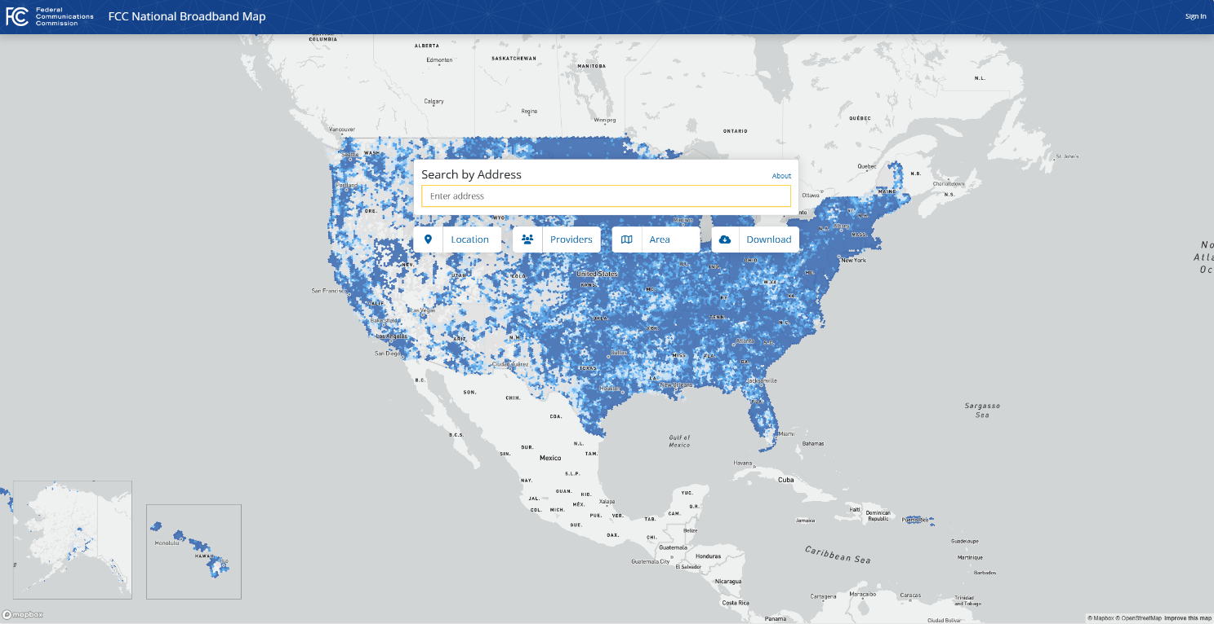
Federal Communications Commission National Broadband Map
The Committee has considered the positive steps taken in 2024 by the New Zealand Commerce Commission to improve consumer protection. The Commission sought cooperation from all New Zealand mobile operators to make it easier for consumers to compare mobile coverage and ensure an ‘exit right’ for customers who sign up for services but find that the coverage does not match what was claimed. The mobile operators have also reportedly agreed to develop standard coverage descriptors (e.g., Excellent, Good, Fair, and No Coverage) and signal strength thresholds, providing a more consistent view across networks. The Commission has requested that operators ensure consumers can easily locate coverage maps on their websites and that links to these maps be included in any consumer materials relating to coverage or plans. Adopting a similar approach in Australia – using policy, legislation and consultation standards appropriate to the country – should be encouraged.
The Committee recommends the Australian Government establish a national telecommunications data platform. Managed by the ACMA or the ACCC as appropriate, the national platform should feature an interactive online tool that allows consumers to easily access detailed information on broadband and mobile service availability in their area, helping them make informed decisions about their connectivity options across Australia.

For governments
In addition to consumer-focused data, the proposed national telecommunications data platform should include critical information about telecommunications infrastructure for restricted use by the Australian Government, as well as state, territory and local governments. This information would be invaluable for investment, emergency response and disaster planning purposes.
We are now at a critical juncture where more accurate data is needed to enable policy and programs that precisely target very specific unmet regional telecommunications needs.
Victorian Government submission
During natural disasters, telecommunications infrastructure is often the first casualty, and its restoration is critical to ensuring effective communication between emergency services and the public. By making this infrastructure data available to government agencies, situational awareness would be improved. Having real-time access to the operational status of mobile towers in affected areas would enable emergency management agencies to better coordinate responses, allocate resources, and prioritise restoration efforts in areas where telecommunications services are essential for public safety.
Beyond the public benefit of contributing to connectivity literacy, some submissions suggested that the Australian Government use this type of visual presentation to inform stakeholders about the regional areas of greatest need. This could include overlaying additional demographic or other data to identify gaps and better target specific policy objectives. Additionally, governments could use this data to plan future investment and infrastructure needs, ensuring that vulnerable areas are prioritised for network upgrades or the installation of backup systems, such as satellite-enabled community connectivity hubs referred to in Recommendation 11.
To improve data reliability, some submissions proposed requiring operators to provide consistent, standardised data to the government, possibly using international standards where applicable. By ensuring telecommunications providers supply data in standardised formats, the platform would enhance transparency, allowing for more effective comparisons between locations and providers.
The proposed RTIRC Commissioner or Advisory Group (see final chapter, Evolution of RTIRC) could use a tool like this to assess the availability and adequacy of telecommunications services in regional, rural, and remote Australia compared to those in metropolitan areas. Of course, what is considered ‘adequate’ now will change over time, and the map can (and should) be updated as speed expectations and service delivery evolve.

Measuring Broadband Australia program
Administered by the ACCC, the MBA program is designed to provide Australian consumers with accurate and independent information on broadband performance. Funding for the program is cost recovered in full from industry via the Annual Carrier Licence Charge and is set to expire on 30 June 2025.
The Committee received positive feedback on the program through submissions and consultations; however, it was noted that the program’s scope is limited, especially for regional, rural and remote areas, and it does not report on all telecommunications technologies.
The ACCC Measuring Broadband Australia program is a good example of a successful data crowdsourcing program. Utilising the devices, platform and technology of a third-party service provider, as at June 2024 the MBA has 58,1744 remote testing devices across the nation, providing detailed tests of performance across a range of metrics across multiple time-periods. However, there are some limitations with the MBA program. For example, of the national 1,744 testing sites, only 260 are from rural and remote locations across Australia.
Queensland Government submission
More granular regional independent data collection is needed to ensure policymakers, service providers and communities can obtain an accurate understanding of telecommunications services across the country.
The Committee recommends that the MBA program be continued beyond its current contract to allow the ACCC to independently monitor and report on broadband performance.
Recommendation 6: Develop a national telecommunications data platform
The Committee recommends the Australian Government establish a national telecommunications data platform. Managed by the ACMA or the ACCC, the national platform should include:
- For consumers: an interactive online tool that allows consumers to easily access detailed information on broadband and mobile service availability in their area, helping them make informed decisions about their connectivity options across Australia.
- For the restricted use of Australian and state and territory governments: information about the location of telecommunications infrastructure assets for the purpose of investment and emergency planning and response.
Telecommunications providers should be required to supply data to governments in standardised formats to enable comparisons between locations and providers. This will enhance transparency in broadband and mobile coverage and help guide infrastructure investments, especially in underserved rural and remote areas.
The Committee further recommends that the Measuring Broadband Australia (MBA) program is continued beyond its current contract enabling the ACCC to monitor service performance.

7. Regional telecommunications strategy
Key findings
- A more coordinated approach to telecommunications planning in regional, rural and remote Australia would improve the effectiveness of decision making and the productivity of investment.
- Stakeholders stressed the need for a clear, unified national strategy to guide policy and investment, and align efforts across all levels of government.
- There is strong support for Australian Government leadership to drive a long-term, well-resourced strategy, ensuring sustained infrastructure development and responsiveness to emerging technologies.
The Committee heard from a wide range of stakeholders ¬– including local and state government representatives, industry players and some consumers – about the pressing need for a cohesive, strategic approach to telecommunications investment in regional, rural and remote Australia.
Throughout the Review, stakeholders expressed frustration with the fragmented nature of current efforts which lack a unified vision and are hindered by inconsistent investment and ad hoc decision-making. This fragmented approach, they argued, leaves communities without the connectivity they need and limits the potential for sustained infrastructure improvements. Considering this, the Committee recognises the importance of a regional telecommunications strategy that would provide a clear, coordinated framework for connectivity across these areas.
The Committee appreciated the opportunity to consult members of the Australian Local Government Association during the Review. It noted the strong views held by some representatives that councils do not possess the necessary resources, skills or funding to carry out strategic planning around telecommunications including assessments of service adequacy, and thus councils should not be held generally responsible for outcomes in this area.
Multiple written submissions called for improved alignment between local, state and federal planning processes, and for better coordination of government funding cycles with these planning processes.
A national strategy would serve as an essential reference point for all stakeholders, setting a cohesive vision that informs and aligns future initiatives. State and territory governments, local councils and service providers could use this strategy as a guide, ensuring their projects and funding requests align with a unified objective rather than conflicting or isolated aims. For example, the Northern Territory Government’s submission underscored the need for a ‘national connectivity strategy to set a consistent direction, guide policy and priorities for investment, and adapt to new and emerging technologies and consumer needs.’ Such a strategy would not only provide direction but also establish shared goals that are accessible and easily understood by both public and private entities.
Stakeholders also noted that a clear, accessible strategy would bring transparency and inclusivity to the process. By setting out its vision and goals in straightforward language, the strategy would empower consumers, local businesses and government agencies to understand and support regional telecommunications initiatives. The accessibility of the strategy would foster public engagement, increase trust, and enable all stakeholders to make decisions based on a widely understood national purpose. The Committee agrees that clarity and accessibility are key and that the strategy should be crafted with language and goals that resonate across diverse audiences.
Throughout the Review, there was strong support for Australian Government leadership in driving this strategy. Submissions from the Victorian Government and others emphasised that the Commonwealth has primary responsibility for national telecommunications policy, including legislative and regulatory frameworks and broader connectivity outcomes for Australians. While local governments have an essential role in responding to specific community needs, they often lack the funding, resources and authority needed to address the broad, systemic challenges of connectivity. Federal leadership is therefore critical to ensure the strategy is properly resourced and consistently applied across regions.
The Committee also heard that a long-term approach to telecommunications investment is essential for addressing the needs of regional, rural and remote communities. Currently, upgrades and expansions are often treated as one-off projects, with funding tied to short-term objectives. This limits the capacity for ongoing investment and leaves communities in a cycle of dependency on ad hoc funding, rather than creating a sustained, reliable framework for connectivity. Stakeholders stressed that a regional telecommunications strategy should commit to consistent, long-term funding to ensure infrastructure development is planned with foresight and community resilience in mind.
The Regional Connectivity Ministers’ Roundtable (RCMR) was established in 2024 to enhance collaboration between the Commonwealth and state and territory governments on regional connectivity issues and improve communications outcomes for regional, rural, remote and First Nations communities. The RCMR plays a key role in fostering intergovernmental cooperation on connectivity challenges impacting regional Australians. Chaired by the Minister for Communications, the RCMR includes participation from state and territory ministers responsible for regional communications and connectivity. Meetings are held biannually to address national priorities, including telecommunications resilience, data sharing and investment.
The Committee held a productive roundtable with state and territory regional telecommunications policy representatives, which provided valuable insights. The Committee believes these discussions, along with ongoing engagement with regional, rural and remote communities, are essential and should continue to ensure alignment between federal and state government priorities and strategies.
Recommendation 7: Regional telecommunications strategy
The Committee recommends that the Australian Government develop a regional, rural and remote connectivity strategy. The strategy should be a vision for regional telecommunications and guide future investment and the regulatory environment for the future.

8. Government programs
Key findings
- Rigorous evaluation of Australian Government telecommunications programs is required.
- The evolution of DTH technology is likely to have a significant impact on mobile markets in regional, rural and remote Australia in the coming years which will shape mobile network investment decisions.

Evaluate existing programs
Federal, state and territory governments have each made substantial investments in telecommunications infrastructure and services over the last decade to meet massive growth in demand for connectivity. Australians have also become profoundly reliant on telecommunications and our insatiable hunger for data and digital tools – described as a ‘step change in demand’ by the 2021 Review – shows no sign of abating.
More than $1.1 billion is being invested under the Australian Government’s Better Connectivity Plan for Regional and Rural Australia – the largest public communications investment since the introduction of the National Broadband Network. This includes $480 million invested through the NBN Fixed Wireless and Satellite Upgrade Program and $656 million for funding programs, including new rounds of long-standing programs like the MBSP and RCP, and newer initiatives such as the On Farm Connectivity Program.
While Australian Government investment is crucial to bridging the digital divide and supporting emergency preparedness, the Committee finds rigorous assessments of the economic and social benefits have not been conducted, even for large-scale initiatives. The Committee recommends program evaluations be funded and prioritised to inform future investments, accelerate outcomes, and improve communication of benefits to communities.

Modernising government programs
Considering the forecast entry into the Australian market of DTH satellite technology services in 2025–26, the Australian Government should also undertake a review of existing programs which includes an analysis of the impacts and options presented by new and emerging technologies and current priorities. Future investments should prioritise needs, particularly in remote First Nations communities, and focus on local engagement, connectivity literacy, consumer choice, network capacity and resilience.
Written submissions to the Review frequently discussed Australian Government funded programs, most commonly citing the MBSP, MNHP, RCP and Regional Tech Hub.
Design considerations for Australian Government programs was the central issue raised across these submissions, including calls to revise the scope of funding programs, make them easier to engage with and to better align investment with local and state government planning and funding processes.

New South Wales Farmers supports the Government continuing regional connectivity programs such as the blackspot program and the Better Connectivity Plan for Regional and Rural Australia. These public investment programs are critical to ensure connectivity service expansion and quality improvements. The program design must consider the ongoing advancement of technological solutions, such as satellite-delivered connectivity and in-field connectivity solutions.
NSW Farmers submission
New programs must also be appropriately funded to undertake a regular evaluation of investment outcomes and community impacts. Evaluations should be undertaken independently for accountability.
The Committee notes that existing programs typically disallow funding for any projects that already form part of an organisation’s forward work plan. In practice, this means grantees design projects using desktop and predictive mapping tools to support applications for funding, and conduct only limited engagement for initial community, state and local government support. The Committee understands this leads to situations in which successful applications take an average of four years from contract start to completion. Sometimes, telecommunications companies terminate projects for various reasons and the community is not informed in a timely way.
The Committee acknowledges how confusing and disappointing this is for residents with reasonable expectations of improved connectivity after public announcements of new or upgraded telecommunications services in their local area. Australian Government programs must be sufficiently flexible to accommodate delivery challenges and yet still ensure outcomes can be achieved within reasonable timeframes and represent value for money.
New programs must ensure recipient communities are kept informed throughout the project lifecycle, including when projects are facing termination. Transparent communication about project progress and potential delays is essential to maintain public trust, especially in regions where community expectations are heightened following public announcements of improved connectivity.
Additionally, programs should mandate robust power redundancy requirements and require community engagement at all project stages. The Committee received feedback in submissions and consultations indicating a decline in engagement and communication between the telecommunications industry and local stakeholders and communities.
Pre- and post-build engagement would better ensure infrastructure is designed and maintained to meet local needs and budgets, while power redundancy would increase network resilience. Together, these measures would support reliable and meaningful improvements to regional telecommunications.
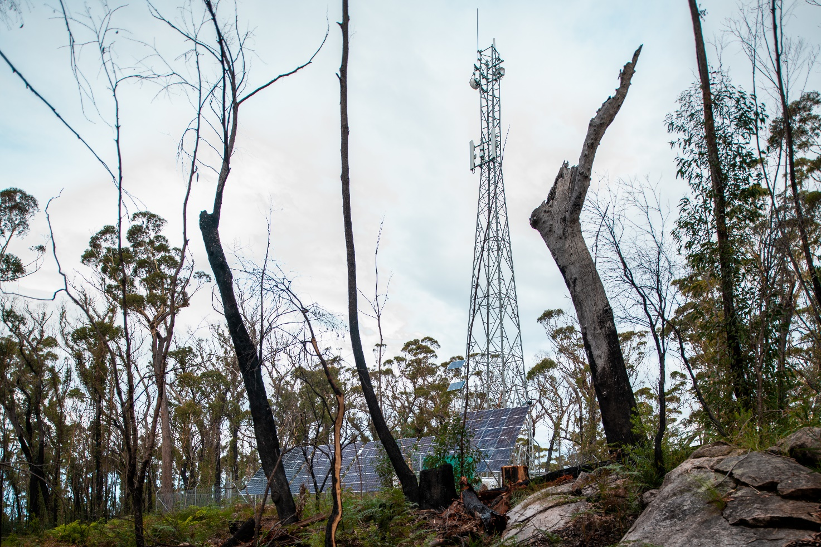
Telecommunications Mobile Black Spot Tower and solar panels in the bush – Department of Infrastructure, Transport, Regional Development, Communications and the Arts
Programs should also continue to accommodate reasonable adjustments to contracted dates for the completion of capital works. After a flood for example, it can take weeks for surrounding land to dry out so that heavy vehicles, equipment and materials can enter a site. Sudden events like this can also mean an otherwise available workforce must be deployed to repair and restore existing services, and new connections are inevitably delayed. In regions with significant environmental challenges such as seasonal flooding or cyclonic activity, funded infrastructure must also be resilient enough to withstand severe climate conditions.
In this context, the Committee provides a range of options below for modernising programs:
- Program eligibility criteria could be revised to permit applications for projects that bring forward planned investments (that is, planned projects with all required approvals in place). This could help ensure that future investments lead to earlier outcomes, with fewer terminations and lower costs.
- Program design could involve a two-step process in which initial grant funding is provided for project scoping and approvals. After a grantee completes this step, assessment of the final design against objectives can be assessed and, if all requirements are met, full project funding can then be provided. This may create a more transparent funding process and lead to full funding being withheld unless the project is confirmed as able to commence construction. This two-step approval process would also provide different public messaging which, in turn, would help manage community expectations.
- Funding could support terrestrial infrastructure where there is community need but no commercial interest proponent. While this is available to projects in remote First Nations communities, it could be considered in other locations not currently targeted for funding by telecommunications companies due to high forecast costs and commercial constraints. This would require a different funding model.
- Other adjustments to program design could include, as appropriate, changes to the standard Australian Government co-contribution funding percentage and/or an increase in operational expenditure funding.
Finally, while a ‘technology neutral’ policy underlies the current design of regional connectivity programs (and should continue to so), for even greater flexibility the programs could feature distinct ‘technology streams’ to support a grantee’s ability to split and manage their delivery activities by stream.
Through written submissions and community consultations, the Committee also heard that the large number of programs aimed at improving regional connectivity often confuses local government areas and communities. This in turn complicates efforts to address local digital needs and reduces the effectiveness of individual programs. Submissions highlighted that infrastructure projects in regional areas – such as roads, airports and ports – should include mandated connectivity as part of their development, ensuring projects align with modern digital demand. Concerns were raised about a lack of performance reviews for government-funded connectivity projects in regional areas, as well as the potential for commercial biases favouring certain technologies over others.

Awareness of government programs and investment
Since the 2021 Review, the Australian Government has made significant investments in telecommunications to enhance connectivity in regional, rural and remote areas. These efforts are now driven by the Better Connectivity Plan for Regional and Rural Australia, which allocates over $1.1 billion to improve regional telecommunications. Despite the Australian Government’s investment and the development of various programs aimed at improving connectivity, awareness of these initiatives remains low, limiting their potential impact.
Among the programs aimed at improving connectivity, two stand out for their potential impact but have suffered from low public awareness: the Regional Tech Hub and the SSBI. These programs, if widely known and used, would play a critical role in getting people connected and helping them stay connected. However, during consultations with communities, it became clear to the Committee that few people were aware of these programs or understood their potential benefits. The Committee also noted funding constraints may be impacting the Regional Tech Hub’s efforts to raise awareness and effectively reach more communities.
At consultations around the country, the Committee often noted communities were unaware that funding has been allocated to improve mobile and broadband infrastructure in their areas under the MBSP, the RCP or state government investment programs. Even if they were aware, they have little information about when these projects will be completed, when they can expect to see the promised improvements in connectivity and how to access the new infrastructure. Representatives from Telstra and NBN Co attended all the community consultations, and representatives from those providers were able to give updates on-the-spot. However, communities should have better information early on and not have to wait for periodic reviews to get information about the status of government funded projects that affect their communities. The Committee noted a great deal of frustration among residents regarding the status of these projects.
The frustration surrounding the progress on infrastructure projects highlights a broader issue: communication and transparency. The Committee acknowledges that while the government has made significant investments in regional telecommunications, there remains a clear need for better public communication and transparency about the status of these projects and more realistic timelines for their completion. Communities are eager for improved connectivity, but they need to be kept informed about when and how these improvements will be delivered. Without regular updates and clear information, the gap between government action and community expectations will continue to grow.
To address this, the Committee recommends the creation of a public platform that tracks funded telecommunications projects, like the US FCC Broadband Funding Map (see Figure 6). This tool would provide regular updates on project timelines, potential delays, and their causes, helping to keep regional, rural and remote communities informed and fostering greater trust in the government’s efforts to improve connectivity.
Figure 6 – US FCC Broadband Funding Map
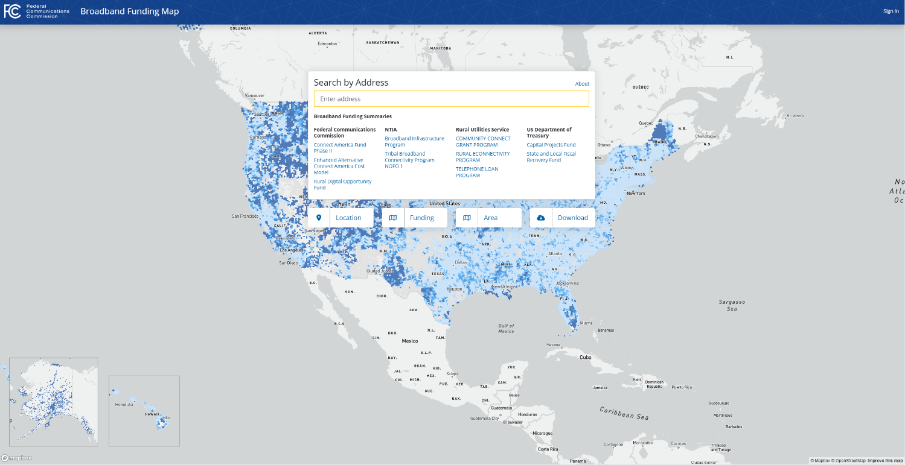
Federal Communications Commission National Broadband Map
NBN Co’s submission supports a similar idea, suggesting the Australian Government develop a public dashboard of all investment programs to provide federal, state and local governments with consistent clarity for strategic decision-making. NBN Co noted that greater visibility of federally and state-funded projects, including network boundaries, could reduce the time spent investigating and developing opportunities only to discover that they are excluded by overbuild provisions. These provisions can be subject to different interpretations, making it challenging to assess whether a project overbuilds another, whether it provides a superior experience for customers, or whether an area is adequately served. The lack of coordination can lead to situations where overlapping projects compete unnecessarily, impacting the strategic use of resources. NBN Co emphasised the importance of assessing whether projects deliver a demonstrable improvement over existing telecommunications solutions in the relevant area.
Recommendation 8: Modernising government programs
The Committee recommends that rigorous evaluations of the Australian Government’s current rounds of telecommunications investment programs be conducted to ensure public investment is well targeted and delivered effectively. Further, the Government should ensure that future rounds of existing and new programs, are fit for purpose by:
- considering technology developments, such as LEO satellites and DTH capabilities
- mandating meaningful community engagement throughout each project phase, with special emphasis on First Nations communities both as title holders and consumers
- prioritising competitive retail and infrastructure options where viable
- addressing connectivity literacy and affordability
- enhancing resilience and capacity
- recognising the value of cross-government collaboration and planning.
To increase transparency, the Government should create a public website to track milestones for all funded telecommunications projects. This platform would keep regional, rural and remote communities informed about infrastructure rollouts by providing regular updates on timelines, potential delays, and their causes, thereby building trust and awareness of government efforts to improve connectivity.

9. Support for First Nations Digital Inclusion Advisory Group
Key findings
- The First Nations Digital Inclusion Advisory Group’s work is crucial for addressing digital inclusion challenges in First Nations communities and should continue as a funded initiative.
- Many First Nations communities remain without any mobile coverage, highlighting the urgent need for tailored infrastructure solutions.
- Applying the Group’s recommendations more widely could help bridge the digital divide in regional, rural and remote areas.
As noted in the introduction, the Committee had the privilege of working closely with First Nations Digital Inclusion Advisory Group during the 2024 Review. The insights provided by First Nations Digital Inclusion Advisory Group were invaluable for gaining a better understanding of the unique challenges and opportunities facing First Nations communities today with respect to closing the digital gap.
A strong alignment exists between the Committee’s positions on connectivity and the aims of First Nations Digital Inclusion Advisory Group, with both groups sharing a commitment to improving digital inclusion throughout Australia, including its most remote and island territories. The Committee was also impressed with the rigour with which First Nations Digital Inclusion Advisory Group approaches its work, and the following comments, findings and recommendations reflect our shared perspectives and close collaboration.
The Committee fully supports First Nations Digital Inclusion Advisory Group’s mission and notes the importance of the First Nations digital inclusion roadmap. This comprehensive roadmap has been drafted by First Nations Digital Inclusion Advisory Group based on its extensive engagement with First Nations people and communities, as well as the First Nations Digital Inclusion Plan and the National Agreement on Closing the Gap.
The roadmap represents a significant strategic step towards ensuring First Nations Australians have equitable access to telecommunications and reliable, affordable services that enhance their economic and cultural well-being. Many principles and recommendations in this report align strongly with the roadmap, reinforcing the value of a coordinated and consultative approach to ensuring digital inclusion for all Australians.
The Committee’s Terms of Reference require a review of the adequacy of telecommunications services in regional, rural and remote parts of Australia. However, the Committee is also required to consider, among other factors, equitable access, new technologies, awareness of government programs, and the extent to which the needs of First Nations communities are being met.
The Committee learned that 43% of First Nations communities are outside any mobile coverage. To close this digital gap, the Committee emphasises the importance of consulting with these communities to ensure they fully understand available infrastructure and services, and that communications options meet their specific needs. These needs include resilient infrastructure, wider choices (such as Community Wi-Fi systems with satellite backhaul and retaining public payphones), better affordability (pre-paid broadband and low-cost mobile plans), greater consumer protection through streamlined regulation and greater data transparency.
Overall, the Committee strongly supports the roadmap, including recommendations to enhance funding for the First Nations Digital Support Hub and digital mentorship programs, which aligns with our recommendations for connectivity champions and connectivity hubs. Similarly, the Committee recommends regular data sharing arrangements between governments and operators, with the goal of providing clearer and more accurate customer advice and more transparent telecommunications information. The Committee further supports Australian Government funding of co-located and shared infrastructure in places not considered commercially viable and supports, in principle, the roadmap’s inclusion of broadcasting infrastructure as a fundamental aspect of digital inclusion that is enjoyed by other parts of regional and urban Australia.
While broadcasting is outside the scope of the Committee’s review, the Committee is supportive of the First Nations Digital Inclusion Advisory Group’s broadcasting recommendations. Ensuring that traffic is directed to the most appropriate network is crucial to maintaining the performance and reliability of telecommunications services. The Committee recognises that well-maintained broadcasting infrastructure can help relieve demand on broadband and mobile networks, contributing to a more efficient and effective overall connectivity ecosystem. Broadcasting through First Nations media can provide a culturally appropriate channel for uplifting connectivity literacy.
Recognising the value of the work underway by the First Nations Digital Inclusion Advisory Group, the Committee recommends the Australian Government enable its efforts to continue as a standing funded initiative. Consideration should also be given to supporting relevant roadmap recommendations that seek to target critical aspects of the regional, rural and remote digital divide beyond First Nations.
Recommendation 9: Support for the First Nations Digital Inclusion Advisory Group
Recognising the value of the work of the First Nations Digital Inclusion Advisory Group, the Committee recommends that it be continued as a standing initiative. Consideration should be given to adopting relevant First Nations Digital Inclusion Advisory Group recommendations across regional, rural and remote communities to address the digital divide.

10. Embedding community Wi-Fi
Key findings
- The loss of telecommunications services during natural disasters leaves communities isolated and unable to contact emergency services.
- Community Wi-Fi networks in remote First Nations communities and tourism regions provide reliable, culturally appropriate connectivity.
- In tourist-heavy areas and during large-scale events, network congestion due to visitor influx disrupts local businesses and safety.
- More businesses could invest in providing Wi-Fi to deliver broadband to their customers.

Community connectivity hubs
One of the most pressing issues raised during the Committee’s consultations was the complete loss of telecommunications services in communities following natural disasters. The Committee heard that some communities were left without telecommunications for weeks after a natural hazard event. In these circumstances, it is essential for people to have access to a reliable communication point to reach emergency services, contact family and charge their devices.
When bushfires, floods or cyclones strike, residents are often left without the ability to contact emergency services, check weather updates, or communicate with family and friends. In these critical moments, maintaining connectivity is not just a matter of convenience, it is essential for public safety. The lack of communications infrastructure can leave people isolated, unable to receive vital information or request help. Power outages often accompany such disasters, further compounding the problem as people struggle to charge their phones and stay connected.
The Australian Government has made significant strides in improving telecommunications resilience in disaster-prone areas including through the STAND program. However, the Committee believes more can be done to ensure all communities are adequately supported, particularly those in remote regions. Given the increasing frequency and unpredictability of natural disasters, it is critical to ensure that all Australians, regardless of location, have access to reliable communication services in emergencies.
Mansfield Shire Council urges that Government funding be continued to support Strengthening Telecommunications Against Natural Disasters (STAND) services at the Neighbourhood Safer Places and Bushfire Places of Last Resort within the Shire. These services are critical to both communications services are impacted by disasters such as fire, floods, landslides and earthquakes – all of which are experienced within Mansfield Shire. Focus should be placed on providing STAND services and wireless network infrastructure with Uninterrupted Power Supply, solar and/or generator backup.
Mansfield Shire Council submission
In response, the Committee recommends a continuance of the current STAND program to ensure that existing facilities remain usable. The Committee further recommends establishing more Community connectivity hubs in key locations across disaster-prone areas nationwide. Building on the successes of the STAND program, these hubs would be equipped with satellite-enabled Wi-Fi and independent power sources, providing critical communication links when traditional telecommunications services are disrupted. Strategically placed at evacuation centres or community spaces, these hubs would offer a practical solution for maintaining connectivity during emergencies and outages, ensuring communities are not left disconnected when they need it most.
The proposed hubs should cover both capital and operational costs to ensure the continuity of services. Community engagement should guide site selection, with priority given to areas with limited or no fixed line access or mobile coverage, particularly in remote First Nations communities.
Beyond their use in emergencies, community connectivity hubs could provide additional value to communities by supporting connectivity during local events. These hubs could offer public internet access or be reserved for community organisations and businesses to ensure critical services, such as payment systems, remain operational or made open to relieve pressure on mobile networks.
By funding and supporting these hubs, the Australian Government would be taking an important step toward ensuring that Australians, regardless of their location, have access to essential telecommunications services during emergencies and beyond.

Expanding free Wi-Fi in remote First Nations communities
The Committee saw that community Wi-Fi projects in remote First Nations communities are particularly impactful, offering culturally appropriate, no-cost internet services.
When the Committee visited Mornington Island in Queensland, the community Wi-Fi installation by Australian Private Networks was near completion. This solution includes a mesh Wi-Fi network that covers the populated areas of the community, along with a free phone and broadband access point in each home. The project aims to provide widespread and reliable connectivity, ensuring residents have access to essential digital services throughout the community.
The Committee also heard from residents and health workers from Bidyadanga in Western Australia, where a similar Wi-Fi solution has already been implemented. The feedback from the community was overwhelmingly positive. Residents expressed satisfaction with reliable internet access across the area. The system has not only improved connectivity but has also been well integrated into daily life, supporting various needs, from healthcare to social connection.
A noteworthy aspect of the Wi-Fi initiative in Bidyadanga is the role that younger generations play in supporting digital literacy. Younger community members often guide older people on how to use the new system, creating an environment where intergenerational learning fosters greater inclusion and tech proficiency. This approach has enhanced digital engagement for the entire community, allowing everyone to benefit from the resources made accessible through the network.
Remote First Nations communities are seeing tangible benefits from these Wi-Fi solutions, which support social, health, and economic participation. The Committee recognises their value to these communities and strongly supports the recommendation of the First Nations Digital Inclusion Advisory Group to expand community Wi-Fi to underserved communities to ensure other communities can experience similar improvements in connectivity and access to digital services.
While the program has been highly beneficial, consultation participants expressed concerns about the lack of clarity surrounding ongoing funding. Many residents worry that once the initial funding period ends, they may lose access to these vital services.
The implementation of community Wi-Fi projects plays a key role in achieving Target 17 of the Closing the Gap initiative, which seeks to close the gap in internet access and digital skills for First Nations people. By providing affordable and reliable connectivity in remote and regional areas, these projects enhance digital inclusion and empower First Nations communities to access education, health services and economic opportunities.
The Committee also emphasises the importance of involving First Nations and rural and remote communities in the planning, implementation and management of community Wi-Fi projects to ensure they meet local needs. Communities should have options to select the most suitable connectivity solution from a standardised list of options, rather than fully bespoke systems, ensuring each project aligns with local needs while remaining scalable and sustainable.
Furthermore, the Committee recommends that Wi-Fi access in remote First Nations communities be kept free of charge, with ongoing government funding to cover operational and maintenance costs. This ensures that all community members can access essential digital services without affordability barriers.

Invest in public Wi-Fi for key regional and remote locations
Community-wide mesh Wi-Fi initiatives have emerged as a viable solution to bridging the digital divide in regional, rural and remote areas. By providing free or low-cost Wi-Fi in community spaces, residents, small businesses, event attendees, the disaster impacted and tourists can access an alternative to congested mobile networks and expensive services. This ensures broader access to the internet, which is increasingly essential for participation in modern life.
The Committee also heard that during peak seasons and major events, local mobile networks often become strained by the influx of visitors. Increased demand for data services – such as streaming, social media and navigation applications – leads to congestion, slower speeds and dropped calls.
Written submissions from various regions underscored the economic and social impact of persistent connectivity issues in regional areas, particularly along tourism routes. Areas such as Eden, New South Wales; Cobram, Victoria; Rainbow Beach, Queensland; and Denham, Western Australia, reported frequent network congestion during peak tourist seasons. Limited connectivity along remote road corridors, like the 2,700km Outback Way, poses safety concerns, delaying emergency response and leaving tourists, locals and workers without reliable access to navigation and booking resources.
Submissions noted that slow, unreliable networks adversely affect tourism, with reduced bookings and customer service issues impacting the hospitality sector. Examples from Tasmania highlighted that poor coverage directly affects business performance and community safety. Stakeholders advocated for free community Wi-Fi to address gaps in areas where commercial services are not viable.
To bolster connectivity, some submissions proposed business and community-led infrastructure initiatives to prevent congestion during peak times. Tourism NT’s submission reinforced that improved connectivity would boost its Aboriginal tourism sector. In consultations across Australia, the Committee heard innovative suggestions for extending the benefits of community Wi-Fi networks to support local economic activity and tourism. In Tasmania, a local council suggested reserving portions of a public Wi-Fi network specifically for small businesses operating at outdoor markets, festivals and concerts. By doing so, councils could ensure that vendors can make reliable transactions even when mobile networks become congested. Tourism operators in the Northern Territory also voiced the need for strategically placed Wi-Fi hotspots in remote areas where mobile coverage is limited. Such hotspots would enable travellers to book campsites, accommodation or learn about nearby attractions, supporting the tourism industry while meeting the practical needs of visitors. By helping tourists navigate and enjoy remote areas, Wi-Fi networks not only support local businesses but also enhance the overall visitor experience.
In smaller tourist towns, Wi-Fi networks also play an essential role in alleviating mobile network congestion, which has become a recurring issue. By diverting traffic to public Wi-Fi networks, mobile experiences can improve, offering faster speeds and more reliable connections for residents and tourists alike. These combined benefits underscore the potential for community Wi-Fi initiatives to enhance local economies, improve mobile network performance and foster greater digital inclusion across regional, rural and remote Australia.
To address these challenges and leverage opportunities, the Committee recommends investing in and promoting free public Wi-Fi initiatives in key locations across regional, rural, and remote Australia. The Committee notes that more businesses need to invest in Wi-Fi solutions to better support their operations and customers. Such initiatives would alleviate the pressure on mobile networks, especially during high-demand periods like community events and peak tourist seasons. By offering reliable and accessible connectivity, these Wi-Fi networks would not only support tourism but also enhance safety and ensure that both visitors and locals have the necessary digital access to participate fully in social, economic and emergency activities.
Recommendation 10: Embedding community Wi-Fi
- The Committee recommends that the Australian Government:
- continue funding contributions for existing Strengthening Telecommunications Against Natural Disasters (STAND) facilities
- invest in new community connectivity hubs to provide community Wi-Fi services during emergencies and natural disasters
- expand investment in mesh Wi-Fi networks in remote First Nations Communities allowing a choice from a tailored menu of connectivity options that best meet local needs and noting that communities without mobile coverage should be prioritised
- invest in and promote free public Wi-Fi initiatives in key locations across regional, rural and remote Australia.

Lisa Alexander Photography

11. Transition oversight

Key findings
- The 3G switch off is causing significant anxiety in some regional, rural and remote communities which provides valuable learnings for the management of impacts of future technology transitions.
- People who live in regional, rural and remote Australia deal with technology transitions more often and need additional and tailored support during these transitions.
- Greater government oversight, reporting and support are needed to ensure technology transitions are well-managed and do not leave regional, rural and remote communities feeling exposed.
The transition from older telecommunications technologies to newer ones, such as the migration from 3G highlights a recurring challenge in ensuring that regional, rural and remote Australians are not left behind. Any switch off or phasing out of established technologies has potential to create anxiety, especially in areas where infrastructure upgrades are incomplete. Whether it is the decommissioning of legacy mobile networks or the gradual shift from copper-based and other legacy landline services, communities in regional Australia often bear a disproportionate brunt of these transitions. The concern is not just about adopting new technology but about maintaining access to reliable services that meet their unique needs.
The 3G mobile network switch off was repeatedly raised as a concern in the Committee’s consultations. Across regional, rural and remote Australia, people expressed anxiety over how the switch off would affect them and their businesses. Many observed that while 4G and 5G networks are available in urban areas, infrastructure in some rural areas has not been upgraded to support newer services. Their concern was that once 3G was turned off, there would be more gaps in mobile coverage, especially for those with ‘fortuitous’ coverage, where consumers experience service in areas that carrier maps show as lacking coverage. The Committee finds the technology transition is leaving some people confused, concerned and under-prepared. It should be acknowledged that similar concerns were widespread years ago when 2G and CDMA services were phased out.
The Committee is sympathetic to community complaints about coverage gaps, fears about personal safety or a lack of affordability if new handsets or other equipment are needed. Some businesses naturally fear being disconnected if their premises cannot currently achieve 4G coverage or they use business equipment or farming applications dependent on that generation of mobile technology.
Further, official communications with vulnerable and isolated communities, including seafaring communities such as the Torres Strait, should have been carefully crafted in consultation with relevant community leaders.
Written submissions also demonstrate the need for greater oversight of technology transitions. Some highlighted uncertainty around whether newer 4G or 5G networks would provide comparable coverage. The Isolated Children’s Parents’ Association (ICPA) noted that students could experience disrupted educational access if coverage worsens, emphasising the need for well-communicated transition plans and thorough testing of new technologies. NSW Farmers stressed that the Australian Government must ensure 4G coverage at least matches 3G before the shutdown, advocating for clear communication strategies and strategic investments to guarantee service continuity. The National Farmers’ Federation (NFF) further highlighted the necessity for government oversight, suggesting a comprehensive audit of mobile coverage and proactive intervention to manage the transition and prevent service gaps. These stakeholders make it clear that government involvement is crucial to facilitate a smoother, better-understood shift from 3G.
There was overwhelming and strong support for the Australian Government holding service providers to account during large-scale telecommunications transitions. Crucially, there was a strong expectation that future transitions must be informed by learnings from the shutdown of the 3G network to ensure that regional, rural and remote communities, vulnerable people and businesses have certainty of quality access and reliability and are not adversely impacted.
The Committee recognises that MNOs, the Australian Mobile Telecommunications Association (AMTA) and the Australian Government worked together to support the planned network switchover. This included efforts by the department through an industry working group to manage issues and amplify preparedness messaging to mobile customers, as well as engage with federal and state agencies, peak bodies and non-government organisations to mitigate transition risks and ensure public safety.
Despite carriers preparing to switch off their 3G networks since 2019, many communities only recently received increased support from MNOs at the urging of the Minister for Communications. Despite these efforts, there is not sufficient dedicated support from carriers to assist consumers post-switch-off, leaving some at risk if they lose coverage or find their device incompatible after the shutdown. The Committee notes extending the Emergency Call Determination is an important safeguard but remains concerned about the need for comprehensive, accessible support for communities navigating this transition.
Technologies such as HCRC and Next G Wireless Link are not known to most in the city. But these technologies and others are well known to many in rural and remote areas. There is a greater burden of transitions for people in rural and remote areas, so they should be met with an adequate degree of support when telecommunications companies choose to transition technologies.
Those in remote locations tend to be migrated through different technologies more often than their urban counterparts. These continual changes and transitions are confusing and stressful. There are not sufficient protections in place for these consumers and there is a lack of support and safety for these migrations. Migration processes need to be strengthened, enhanced and enforced to reflect the critical nature of telecommunications in today’s world.
AgForce submission
The Committee notes that other important platforms (e.g. 4G to 5G, NBN’s Sky Muster or Telstra’s copper network) will in time be superseded and urges the Australian Government to sharpen its transition oversight of significant technology changes. It is crucial to ensure consumer rights are not only protected through clear communication and information during technology migration processes, but also that operators take responsibility for maintaining service standards, providing appropriate support through dedicated support channels, and addressing any disruptions that may arise. Technology and service migrations require improved communications and documentation to assist consumers and businesses in understanding what will happen and when it will happen. Clear and consistent documentation using identical language, diagrams and descriptions shared by installers and contractors would improve connectivity literacy, expedite migrations and improve operator efficiency.
The Committee believes that every future telecommunications migration – whether it involves voice, mobile or broadband services – should be accompanied by comprehensive government oversight and planning. This includes a coordinated effort to monitor coverage, assess gaps and work with providers to ensure that upgrades are rolled out effectively across all regions alongside targeted and timely communications with consumers and businesses.

Recommendation 11: Transition oversight
The Committee recommends comprehensive independent monitoring and public reporting during large-scale telecommunications transitions, such as mobile technology switch offs and the migrations required for modernising the USO. The ACMA could be well-placed to perform this role.

12. Expedite planning approvals
Key findings
- Planning approvals timeframes are creating unacceptable delays in the delivery of telecommunications infrastructure in regional, rural and remote Australia.
- The Australian and state and territory governments could use their powers to reduce approval delays.
- Delays in building mobile infrastructure in regional Australia are often due to challenges such as securing power connections, overcoming local community objections, identifying suitable sites, managing high costs and navigating complex regulatory requirements.
In Australia, planning laws and approval processes vary from jurisdiction to jurisdiction and from council to council, particularly for larger telecommunications infrastructure such as towers. MNOs and MNIPs operating at the national level or across multiple jurisdictions and local government areas to improve connectivity face complex and costly approval processes, which impose an unnecessarily high regulatory burden and cause delays to project implementation.
Carriers currently have powers under Schedule 3 of the Telecommunications Act 1997 to inspect land, install ‘low-impact’ facilities and maintain any kind of telecommunications facility. They also have immunity from some state and territory laws when carrying out these activities, such as planning laws. This is referred to as the carriers’ powers and immunities framework. This framework has been in place for over 20 years and is essential for enabling the efficient construction of certain aspects of telecommunications networks in a nationally consistent way.
While some of Australia’s mobile network infrastructure is exempt from local government planning requirements, much of it still needs development approval. This involves navigating complex state, territory and local planning regulations.
The Committee observed that infrastructure delivery timeframes can be protracted in regional, rural and remote Australia, particularly for new mobile base stations. The delivery process is understandably complicated, involving site acquisition and access, supply chains, power and backhaul connections, weather contingencies and a complex range of required approvals.
Planning approvals, land access and energy supply are directly impeding the delivery of new telecommunications infrastructure across regional Australia. Other obstacles typically include events such as cyclones or bushfires, wet season conditions including flooding, supply chain delays, workforce shortages and local community disapproval. The Committee endorses the stakeholder view that all levels of government can help speed up infrastructure supply by streamlining approvals processes, minimising fees and charges for public land and ensuring flexibility in government funding programs. The Committee also urges governments to continue working together, especially through bodies such as the Federal and State Planning Ministers’ Meeting and the Regional Connectivity Ministers’ Roundtable, to streamline processes and improve data capture.
These cooperative efforts currently include the work of the Mobile Telecommunications Working Group, established following the 2023 Planning Ministers’ Meeting. This working group, comprising federal, state and territory communications and planning officials, provided advice in its final report on a national framework for prioritising and accelerating planning and approvals for larger mobile infrastructure, especially in new developments and growth areas. Feedback received by the Committee about the working group’s Final Report was positive, including that it had already created the ‘foundation of a coherent, national framework to prioritise [and] accelerate approvals of larger telecommunications infrastructure, which could significantly benefit rural, regional, and remote areas.’
Industry criticism that it is self-defeating for governments to seek significant rents from occupants of Crown land while co-funding their infrastructure projects with public monies is acknowledged. The Committee considers this a ‘vicious circle’ that makes little investment sense and suggests eliminating rents and fees on public land identified for large telecommunications infrastructure where program funding is attached to the site. Projects could also be required to meet specific standards for installation, performance, resilience, restoration and maintenance unique to each site and reflective of community expectations. This can be achieved through new program settings and contractual arrangements, with the assistance of state and local governments and utility companies.
Today, the mobile network operators do not generally build or own their tower or rooftop sites. They have essentially operationalised this cost: MNIPs finance, build and operate sites and seek to sell access to this new infrastructure to all interested parties. It is the MNIPs that face the challenges of finding locations to build sites, negotiating with land owners, councils and communities.
Indara submission
Councils typically act as decision-makers on development applications for larger infrastructure and are responsible for some planning policies. Indara’s submission noted that Schedule 3 of the Telecommunications Act 1997 allows for the installation of certain facilities (such as antennas on existing structures) without development consent but not for larger infrastructure such as towers. This contrasts with other critical infrastructure such as power and water utilities.
The Committee understands that, on occasion, telecommunications infrastructure development applications are denied based on complaints from a small minority in the community. It was also informed that councils can often advocate strongly for connectivity as a priority, yet their planning schemes do not permit the industry to submit development applications for larger infrastructure in zones feasible for these much-needed facilities.
The Commonwealth has observed an increasing trend of local councils writing to the Minister for Communications and passing motions attempting to limit deployments of telecommunications infrastructure as a result of community pressure. Unfortunately, this delays carriers from providing communities with improved mobile connectivity in their local areas.
Final Report of the Mobile Telecommunications Working Group, National principles to support streamlined telecommunications planning arrangements, February 2024.
The House of Representatives Standing Committee on Communications and the Arts ‘Connecting the Country: Mission Critical’ report from its Inquiry into co-investment in multi-carrier regional mobile infrastructure, recommended the Government reform the carriers’ powers and immunities framework to enable mobile infrastructure to be deployed in regional, rural and peri-urban areas more swiftly, and encourage investment in ‘smart’ mobile infrastructure that incorporates renewable and decarbonised energy solutions. This Committee agrees.

Recommendation 12: Expedite planning approvals
The Committee recommends that the Australian Government should exercise its power to expedite planning approvals for large telecommunications infrastructure projects, such as tower installations in regional, rural and remote Australia and in instances where Australian Government funding has contributed to projects.

13. Powering connectivity
Key findings
- Connecting power is often one of the major delays in building new telecommunications infrastructure.
- Telecommunications services fail too quickly during power outages due to insufficient backup power and network design.
- Power restoration to telecommunications services is not adequately prioritised after disaster events.
- The interdependence of telecommunications and energy infrastructure requires better coordination.
The Committee’s visit to the Mid-West region of Western Australia and Far North Queensland underscored the critical need for investment in both telecommunications and power infrastructure. Experiences shared by locals in these places and others painted a clear picture of the challenges they face and the urgent need for solutions. Addressing these issues is not only vital for the day-to-day lives of the residents but also for their safety and well-being during extreme weather events.
The Committee is in full agreement with the First Nations Digital Inclusion Advisory Group’s Roadmap recommendation to ensure the resilience of communications and broadcasting infrastructure, including power supplies.

Minimum backup power periods for critical telecommunications infrastructure
Stakeholders consistently highlighted the critical need for long-duration power backup, especially in areas susceptible to frequent outages. Murrindindi Shire Council, for instance, advocated for a minimum of 24-hour battery backup for mobile towers, extending to 72 hours in more remote regions to safeguard against the risks posed by natural disasters. Warren Shire Council suggests introducing specific ‘reliability standards for critical services that require uninterrupted connectivity.’
The experiences from regions such as the Mid-West of Western Australia and Far North Queensland were particularly revealing. Residents in these areas often face frequent power outages, not just during extreme weather events but also under normal conditions. Communities located on radial feeders – essentially the ‘end of the line’ for electricity – experience disproportionate disruptions. As the Shire of Chapman Valley illustrated, a series of pole-top fires on February 22, 2024, led to widespread power and mobile network outages, affecting neighbouring areas due to a lack of built-in resilience.

Unfortunately, power supply in the Midwest is substandard and in particular the Shire of Chapman Valley relies on ‘one line in-one line out’ configuration so any power interruption in between will affect all power supply to the east. To illustrate the reliability issues threat areas such as Chapman Valley face, as recently as Thursday February 22, 2024 a number of pole top fires occurred from the outskirts of Geraldton to the Nanson area (20km from Geraldton). This caused power outages in the whole Chapman valley area as well as neighbouring Northampton and subsequent mobile tower outages as there was no resilience built into the tower infrastructure.
Shire of Chapman Valley submission
The Committee strongly supports the view that backup power infrastructure needs to be designed with the local context in mind. Days, rather than hours, of backup capability should be the target, especially as advancements in renewable and battery technologies make this increasingly feasible.

Priority for power restorations to critical infrastructure
Several stakeholders also called for protocols to ensure energy providers give precedence to telecommunications infrastructure when restoring power, recognising the sector’s vital role in disaster recovery. Telstra emphasised the necessity of prioritising energy restoration to telecommunication sites to support public safety and emergency response efforts. The Regional, Rural and Remote Communications Coalition also stressed the significant challenges regional communities face when prolonged power outages disrupt essential communication services, particularly during natural disasters.
The Northern Territory Government’s submission raised concerns about the allocation of resilience funding, emphasising the need for a more targeted approach to address the most urgent needs:
Programs such as the Mobile Network Hardening Program (MNHP) have targeted MNOs, enabling them to determine priority areas that are not necessarily based on highest needs. While this funding is appreciated, the Australian Government should evaluate whether telecommunications companies could independently fund resilience upgrades as part of their regular operations. Government funding should prioritise areas where network hardening is most urgently required (based on outage data analysis) and look for solutions that support resilience across all telecommunications services in a location or region.
Northern Territory Government submission
Additionally, the Queensland Government recommended that energy providers develop more holistic approaches to network planning in tandem with the energy sector. The Committee recognises energy resilience is closely linked to telecommunications reliability, and prioritising power restorations is essential for community safety and disaster readiness.
To mitigate delays, industry players, such as Telstra, are investing in standalone systems, including solar, diesel and hydrogen power solutions. However, stakeholders expressed concern that even beyond initial connections, power outages – frequent in regions with unreliable supplies – periodically disrupt telecommunications services, affecting connectivity in both emergency and everyday situations. The Committee recognises that without reliable power solutions, these ongoing issues hinder effective and consistent telecommunications access, especially in remote areas.

Prioritising energy connections for new telecommunications installations
The Committee heard repeated complaints from the telecommunications industry about lengthy delays in obtaining mains power connections for new tower sites, with the issue especially pronounced in Western Australia. This challenge impacts priority sites in the MBSP, undermining efforts to enhance connectivity. Carriers noted that power supply to mobile tower infrastructure is essential, as services cannot be delivered without it.
The Committee heard that delays, sometimes extending beyond 24 months from application to completion, present a critical barrier to delivering reliable telecommunications services in regional, rural and remote Australia. AMTA highlighted that the delivery of telecommunications services fundamentally depends on timely power connections, and without them, carriers cannot fulfil public expectations for accessible and dependable telecommunications. These delays are especially concerning when they affect sites that have already received government funding, such as those in blackspot areas, where improved connectivity is urgently needed.
Amplitel also shared experiences of protracted delays, noting power connection times can exceed 20 months, significantly hindering the initial rollout of telecommunications services. These delays not only disrupt service delivery but also exacerbate the impact of natural disasters. For example, even when tower structures remain intact following events like bushfires or floods, telecommunications services are often rendered inoperable due to power loss. Amplitel stressed the need for a collaborative framework that enhances engagement among telecommunications providers, developers, local councils and energy companies to expedite power connections and improve service resilience.
A closer and more streamlined engagement between telecommunications providers and energy companies is required, including an engagement framework with mandated service levels for power connections to telecommunications sites.
Amplitel submission
Despite the urgency of this issue, the Committee acknowledges the complexity of the regulatory environment. While the Australian Government regulates telecommunications, it does not have direct authority over energy regulation, which falls under the jurisdiction of state and territory governments. Addressing this challenge will therefore require careful coordination and collaboration between sectors and levels of government. Stakeholders, such as AMTA, have called for the establishment of a framework by power authorities that prioritises and streamlines engagement with telecommunications providers. This proposed framework should include mandated service level agreements to ensure power connections are completed safely and efficiently.
The Committee believes that improving the timeliness of power connections to telecommunications infrastructure is critical for enhancing connectivity, particularly in disaster-prone and underserved areas.
Recommendation 13: Powering connectivity
The Committee recommends that regulation be introduced to require:
- minimum backup power periods for new critical telecommunications infrastructure installations in regional, rural and remote Australia, with existing assets to be captured over time. The backup period would be regularly reviewed to take account of changes in storage and network technology
- energy providers to give high priority to restorations of power for critical telecommunications infrastructure in regional, rural and remote Australia
- energy providers to prioritise energy connections for new telecommunications installations.

14. Evolution of the Regional Telecommunications Independent Review Committee
Key findings
- Technology and related policy imperatives are moving too quickly to be addressed by a review conducted at three yearly intervals. Standing up an RTIRC also comes with significant cost and results in crucial institutional knowledge and momentum loss every three years.
- Establishing a permanent Regional Telecommunications Commissioner or Advisory Panel would provide consistent monitoring, improve stakeholder engagement and ensure timely responses to technological advancements.
Every three years since 2008, a Regional Telecommunications Independent Review Committee (RTIRC) has been appointed under the Telecommunications (Consumer Protection and Service Standards) Act 1999 and charged with reviewing the adequacy of telecommunications services in regional, rural and remote areas of Australia on behalf of the Australian Government.
Successive governments have committed significant funding and resources to each of these reviews, yet the long interval between them means there is an inability to consult on important issues as they occur while other matters are missed altogether. The connectivity environment is fluid and changing so rapidly the Committee believes the rigid three-year cadence of these legislated reviews is no longer relevant in 2024 and needs to evolve.
The Committee believes that a permanent Regional Telecommunications Commissioner or Regional Telecommunications Advisory Panel would offer a more effective approach than the current three-yearly review process. While the three-year interval between reviews was initially designed to allow for adequate time to implement recommendations and assess changes in the telecommunications landscape, it has become clear that this model is no longer suitable in today’s rapidly evolving technological environment.
The Committee acknowledges the existing efforts by various government bodies focused on regional, rural and remote areas, including the ACCC and the ACMA. These organisations play crucial roles in ensuring fair competition, consumer protection, and regulatory compliance in telecommunications and other sectors. However, these efforts are not always specific to the unique and evolving challenges faced by telecommunications in RRR areas. Other agencies such as Infrastructure Australia and Regional Development Australia contribute to broader infrastructure planning and investment but their focus often lacks the telecommunications-specific emphasis. A permanent Regional Telecommunications Commissioner or Regional Telecommunications Advisory Panel would:
- provide ongoing oversight of the state of telecommunications services in regional, rural, and remote areas
- represent regional, rural and remote stakeholders in policy and program development, ensuring the interests of each of these unique cohorts are protected
- be better able to respond to technological changes as issues emerge
- foster stronger, more sustained relationships with stakeholders, including telecommunications providers, local governments and community organisations
- be tasked with developing, refining and regularly reviewing ‘Regional Telecommunications Service Benchmarks’
- publish regular benchmarking reports and performance assessments to provide the public with clear and accessible information about the state of telecommunications in regional areas
- have the authority to adapt these benchmarks over time
- develop and implement long-term strategic goals for regional telecommunications
- communicate priorities and give advice to the Minister for Communications, and other Ministers as required, on key priorities and sectoral issues.
The Committee has increasing concerns that the broad categorisation of ‘regional’ often fails to account for the specific challenges and priorities of distinct areas. The permanent Regional Telecommunications Commissioner or Regional Telecommunications Advisory Panel would provide an annual report to the Minister for Communications on the state of regional telecommunications, including benchmark reporting on the quality and accessibility of services in regional, rural and remote Australia.
Recommendation 14: Evolution of RTIRC
The Committee recommends replacing the current appointment of Regional Telecommunications Independent Review Committees every three years with a permanent Regional Telecommunications Commissioner or Regional Telecommunications Advisory Panel. Given the rapid pace of technology change, increasing complexity of the market and the need to modernise the USO, continuous oversight is required.

- 2024 RTIRC survey
This appendix provides a short overview of the survey conducted by the Committee to assess the experiences of people living in regional, rural and remote Australia with telecommunications services. The survey was part of the broader 2024 Review and served as a tool to capture views of individuals regarding the quality, availability and reliability of telecommunication services.

Methodology
The survey was distributed online and was open to all individuals and business representatives in Australia. Respondents were self-selected voluntary participants rather than a random sample of the population. More than one response per address was permitted, allowing multiple household members or business representatives to participate in the survey.
Respondents were asked to rate various aspects of their mobile and broadband services using a Likert scale from 1 to 10. These ratings focused on three key dimensions: quality, availability and reliability of services. Satisfaction was calculated as the average score across these three metrics.
Additional questions covered topics including the use of mobile coverage extenders, the impact of power outages on communications and the types of telecommunications connections in use.

Response and demographics
A total of 3,098 responses were received representing 2,505 individual submissions, 524 business submissions and 69 other submission types.
The responses were geocoded into the Australian Statistical Geography Standard Remoteness Structure which defines 5 classes of relative geographic remoteness across Australia:
- Major cities of Australia (4%)
- Inner regional Australia (32.29%)
- Outer regional Australia (45.96%)
- Remote Australia (12.83%)
- Very remote Australia (4.88%).
A small number of responses could not be geocoded (4%).
The 2,505 individual submissions were also asked additional demographic information including age, gender and if the respondent identifies as an Aboriginal or Torres Strait Islander.
- Age: Of the 2,505 individual respondents, the largest count by age category was aged 60+ which represents 44.87% of the survey population, followed by the age category 45¬–60 which represents 30% of the survey population. These results provide a significant overrepresentation of older Australians in the survey.
- Gender: Of the 2,505 individual respondents, 1,386 respondents (around 55%) were female, while 1,047 (around 42%) were male with 3% identifying as non-binary or preferred not to answer. The female representation is most prevalent in the 45–60 age group where 62.77% of respondents were female and the 31-45 age group where 64.38% were female.
- First Nations Respondents: There were 106 individuals identifying as an Aboriginal or Torres Strait Islander. This equates to about 4.5% of survey respondents which is slightly higher than the national figure which is 3.8% of the total Australian population.
However, because the proportion of the total population of First Nations people is higher in regional and remote areas, First Nations responses were under-represented in the survey responses across each remoteness area per the table below.

Remoteness area | Proportion (%) of total population of each area | Proportion (%) of survey responses for each area
Major cities | 2.2 | 1.7
Inner regional | 5.3 | 3.3
Outer regional | 9 | 3.3

Limitations
The survey has several limitations and caution should be taken when interpreting the results. Some key limitations include:
Sample: the self-selection of respondents combined with a very small sample size means that those with particularly strong opinions or specific experiences may have been more likely to participate, potentially skewing the results. Responses by Technology Type and Remoteness Area are listed below.

Technology Type | Inner Regional | Major Cities | Outer Regional | Remote | Very Remote | Total
Mobile | 939 | 117 | 1349 | 369 | 134 | 2908
LEO Satellite | 73 | 7 | 148 | 43 | 19 | 290
Landline | 293 | 30 | 413 | 122 | 66 | 924
Broadband | 661 | 99 | 819 | 193 | 94 | 1866
Collection method: the online distribution of the survey may have limited participation from individuals in areas with poor or no internet access. This is particularly significant for people in remote and very remote Australia.
Overrepresentation of respondents aged 60 and older: this group has distinct telecommunications needs and expectations, which may not be fully reflective of the broader population.
Multiple responses from the same address: this may have led to certain households or businesses being overrepresented, particularly in areas with multiple service issues.
Connectivity literacy: The accuracy of survey responses may be limited by consumer misunderstandings about technology differences. For example, some consumers may use mobile services for broadband needs, leading to inaccurate data.
Likert scale shortcomings: these include central tendency bias, where respondents choose neutral or middle options rather than expressing a strong opinion, potentially hiding their true feelings; acquiescence bias, where some respondents tend to agree with statements regardless of their genuine views; and limited depth, as Likert scales may not fully capture the complexity of respondents’ attitudes.

- List of public submissions
The Committee received a total of 306 written submissions, comprising 180 short comments made through the Department of Infrastructure, Transport, Regional Development, Communications and the Arts Have Your Say webpage and 126 longer written submissions submitted through the webpage or via email. Submissions came from members of the public, community organisations, advocacy and industry groups, businesses, and local, state and territory governments. A total of 202 submissions, approximately 66%, were made by individuals.
Longer submissions not marked as confidential or private were published on the Department of Infrastructure, Transport, Regional Development, Communications and the Arts’ website on 25 October 2024. Submissions were not published if they were identified as private or confidential by those making the submissions.
The list of public submissions is available below:
Submission | State
ACT Government | ACT
Adjunct Professor Robin Eckermann AM | ACT
AgForce | Queensland
Amanda | New South Wales
Amplitel Pty Ltd | Queensland
Anderson, P | Western Australia
Anglicare Australia | ACT
Anonymous | New South Wales – 11 anonymous submitters
Anonymous | Victoria – four anonymous submitters
Anonymous | Queensland – six anonymous submitters
Anonymous | Western Australia – five anonymous submitters
Anonymous | South Australia – three anonymous submitters
Anonymous | Northern Territory – one anonymous submitter
Anonymous | Tasmania – three anonymous submitters
Anonymous | Four anonymous submitters gave no location
ARC Centre of Excellence For Automated Decision-Making and Society | Victoria
Australian College of Nurse Practitioners | National
Australian Communications Consumer Action Network | National
Australian Competition and Consumer Commission | National
Australian Mobile Telecommunications Association | National
Baker, C | Queensland
Baker, R | Tasmania
Barron Flood Plain Action Group | Queensland
Bent, R | New South Wales
Berry, R | Victoria
Better Internet for Rural, Regional and Remote Australia | National
Blackburne, B | Victoria
Borg, L & M | Queensland
Broad Agri Contracting | Queensland
Bulga Plateau Rural Fire Brigade | New South Wales
Calder, K | Victoria
Canning, D | Queensland
Cass, B | New South Wales
Cass, R | New South Wales
Central Land Council | Northern Territory
Chalmers, P | Queensland
City of Moreton Bay | Queensland
Clark, J | Queensland
Colin Boyce MP, Member for Flynn | Queensland
Communications Alliance | National
Connected Farms | National
Council of Yankalilla | New South Wales
Country Education Partnership Victoria | Victoria
Couper, B | Western Australia
Cruikshank, A | Victoria
Danckert, L P | New South Wales
Dawson, G | New South Wales
Denise | Queensland
Destination Sydney Surrounds North | New South Wales
Di Salvo, M | Western Australia
Doherty, M | Queensland
Donoghue, S | New South Wales
Dowling Pastoral | New South Wales
Fahey, C | New South Wales
First Nations Digital Inclusion Advisory Group | National
Fletcher, S | Queensland
Foott, B | New South Wales
Fotheringham, S. C. | Tasmania
Fraser Coast Regional Council | Queensland
Free TV Australia | New South Wales
French, J | New South Wales
Garside, J | N/A
Garth Hamilton MP, Member for Groom | Queensland
Gee, R | Queensland
Goondiwindi Regional Council | Queensland
Gray, D | New South Wales
Greater Ballarat Alliance of Councils | Victoria
Hamilton, L | New South Wales
Hancock, C | N/A
Hans G | New South Wales
Harrington and Surrounds Business and Community Association | New South Wales
Harris, P | Tasmania
Helen Haines MP, Member for Indi | Victoria
Hewitt, W F | Queensland
Hogan, A | Western Australia
Hogg, N | Queensland
Hunold, P | New South Wales
Ibis Court Retirement Village | Queensland
Indara Digital Infrastructure | New South Wales
Indigo Shire | Victoria
Internet Association of Australia Ltd | National
Isolated Children’s Parents’ Association Australia | National
Jackson, A | Queensland
Jacobs, G | South Australia
Jessica | Queensland
Johnson, J | Tasmania
Kane, G | Queensland
Kate J | Queensland
Kelly, M | New South Wales
Kiehne, G | New South Wales
Kitchener, J | New South Wales
Lack, D | Tasmania
Little, L | Queensland
Local Government Association of Northern Territory | Northern Territory
Local Government Association of Queensland | Queensland
Macleod, P | Queensland
Mansfield Shire Council | Victoria
Marcus B | Tasmania
Marshall, B | Tasmania
Martin, V | New South Wales
Mitchell, R | New South Wales
Motion-Wise, M | New South Wales
Mountford, M | New South Wales
Murrindindi Shire Council | Victoria
Narrabri Shire Council | New South Wales
National Farmers’ Federation | ACT
National Rural Health Alliance | ACT
Natural Resource Link Pty Ltd | Victoria
NBN Co | National
Neil, A | Victoria
New South Wales Government | New South Wales
Northern Territory Government | Northren Territory
New South Wales Farmers | New South Wales
O’Bryen, A | Queensland
Office of the National Rural Health Commissioner | National
One Gippsland | Victoria
Optus | National
Outback Highway Development Council Inc | Queensland
Paterson, D | Queensland
Pawson, R & M | New South Wales
Payne, M | Victoria
Pens, M | Western Australia
Peter | Victoria
Pivotel Group | Queensland
Pracy, K | New South Wales
Pyrenees Shire Council | Victoria
Queensland Capacity Network | Queensland
Queensland Government | Queensland
Ramsay, Y | New South Wales
Reaburn, K | South Australia
Regional Development Australia (RDA) Barwon South West | Victoria
Regional Development Australia (RDA) Grampians | Victoria
Regional Development Australia (RDA) Tasmania | Tasmania
Regional Development Australia (RDA) Wheatbelt Inc | Western Australia
Regional Development Australia (RDA) Yorke and Mid North | South Australia
Regional Tech Hub | National
Regional, Rural and Remote Communications Coalition | National
Reid, R | New South Wales
Rex Glass Fenwick Farm | Western Australia
Rielly, S | Queensland
Rugby Area | New South Wales
S Durrani | ACT
Sachse, S | Western Australia
Salisbury, A | Queensland
Sanders, E | South Australia
SBS and NITV | National
Selleck, S | South Australia
Shannon, E | New South Wales
Sharpe, T | Victoria
Shire of Bridgetown-Greenbushes | Western Australia
Shire of Chapman Valley | Western Australia
Shire of Corrigin | Western Australia
Shire of Cunderdin | Western Australia
Shire of Esperance | Western Australia
Shire of Lake Grace | Western Australia
Shire of Pingelly | Western Australia
Shire of Victoria Plains | Western Australia
Shire of Waroona | Western Australia
Shire of Yilgarn | Western Australia
Sinclair, B | Queensland
Small Business and Family Enterprise Ombudsman | National
Small Business Development Corporation | Western Australia
Smith, G | New South Wales
Snow, W | New South Wales
South Gippsland Shire Council | Victoria
Stewart, R | Victoria
Stopp, L | South Australia
Strathbogie Shire | Victoria
Swane, R | New South Wales
Szymanski, A | Queensland
Tasmanian Government | Tasmania
Tasmanian Hospitality Association | Tasmania
Telecommunications Industry Ombudsman | National
Telstra | National
Thornton, G | Victoria
Torres Shire Council | Queensland
Tourism NT (Northern Territory Gov) | Northern Territory
Turner, I | New South Wales
Uniti Group Limited | Queensland
Valleyfield | Victoria
Victoria Government | Victoria
Vocus | New South Wales
Western Australia Farmers | Western Australia
Walker, M | Queensland
Wallace, V | New South Wales
Warren Shire Council | New South Wales
Weddin Shire Council | New South Wales
Western Australia Government | Western Australia
Western Australian Local Government Association | Western Australia
Western Downs Regional Council | Queensland
Western Queensland Alliance of Councils | Queensland
Western Queensland Alliance of Councils | Queensland
Williams, J | Queensland
Williams, R | New South Wales
Wireless Internet Service Providers Australia | Queensland
Young, K | Victoria
Zammit, J | Queensland
Zanardi, S | New South Wales

- Public consultation
The Regional Telecommunications Independent Review Committee conducted 20 face-to-face consultation sessions across each state and the Northern Territory, two online consultation sessions, and meetings with communities, business and governments across regional, rural and remote Australia.
The locations and stakeholders are listed below.

State/Territory | Date | Location
Western Australia | 22 March 2024 | Geraldton
 | 22 March 2024 | Northampton
 | 21 August 2024 | Broome
 | 22 August 2024 | Kununurra
Tasmania | 12 April 2024 | Longford
 | 12 April 2024 | Wynyard
Victoria | 3 May 2024 | Benalla
 | 3 May 2024 | Rochester
New South Wales | 24 May 2024 | Coffs Harbour
 | 24 May 2024 | Wauchope
 | 9 August 2024 | Braidwood
 | 10 August 2024 | Cooma
Queensland | 17 June 2024 | Mount Isa
 | 18 June 2024 | Mornington Island
 | 19 June 2024 | Thursday Island
 | 19 June 2024 | Cairns
South Australia | 26 July 2024 | Kangaroo Island
 | 26 July 2024 | Whyalla
Northern Territory | 12 September 2024 | Katherine
 | 12 September 2024 | Darwin
Eastern & Central | 1 October 2024 | Virtual
Western | 1 October 2024 | Virtual

Consultation with stakeholders
ACT Government
Active8me (Australian Private Networks Pty Ltd)
Amplitel
Annual Regional Organisation of Councils Assembly
Australian Communications and Media Authority
Australian Communications Consumer Action Network
Australian Competition and Consumer Commission
Australian Local Government Association
Connected Farms
East Kimberley Chamber of Commerce and Industry
Field Solutions Group
First Nations Digital Inclusion Advisory Group
Fitzroy Valley Flood Recovery Working Group
Indara
Intelsat
Indi Telecommunications Advisory Group
Kimberley Aboriginal Medical Services
Launtel
Logic IT solutions
Lynk Global
Mornington Island Hospital
NBN Co
Northern Territory Government
New South Wales Government
OneWifi
Optus Limited
Queensland Capacity Network
Queensland Government
Regional Development Australia
Regional Tech Hub
Shire of Broome
South Australian Government
Starlink
Tasmanian Government
Telecommunications Industry Ombudsman
Telstra Limited
Torres Strait Regional Authority
Telecommunications Industry Ombudsman
Telstra Limited
TPG Telecom
Viasat
Victorian Government
Vocus
Western Australian Government
Western Australian Local Government Association

- Glossary
Term | Definition
3G, 4G, 5G mobile service | Successive generations of mobile technology.
ACCAN | Australian Communications Consumer Action Network.
ACCC | Australian Competition and Consumer Commission.
ACMA | Australian Communications and Media Authority.
ADSL | Asymmetric Digital Subscriber Line (ADSL) is a technology for data transmission over a copper phone line using a signal splitter.
AMTA | Australian Mobile Telecommunications Association.
ANAO | Australian National Audit Office.
APN | Australian Private Networks.
Backhaul | The connection between an access node and a core network. For instance, a fibre cable running from a neighbourhood exchange to the core network.
Better Connectivity Plan for Regional and Rural Australia | The Better Connectivity Plan for Regional and Rural Australia is a key funding initiative and part of the Australian Government’s telecommunications agenda.
BIRRR | Better Internet for Regional, Rural and Remote Australia
Broadband | Broadband allows users to access information via the Internet using one of several high-speed transmission technologies. Transmission is digital, meaning that text, images, and sound are all transmitted as ‘bits’ of data. The transmission technologies that make broadband possible move these bits much more quickly than traditional telephone or wireless connections, including traditional dial-up Internet access connections.
CA | Communications Alliance
CCO | The Copper Continuity Obligation (CCO) requires Telstra to maintain services on the legacy copper network to customers outside the NBN fixed line footprint.
Closing the Gap | The objective of the National Agreement on Closing the Gap (the National Agreement) is to enable Aboriginal and Torres Strait Islander people and governments to work together to overcome the inequality experienced by Aboriginal and Torres Strait Islander people and achieve life outcomes equal to all Australians.
Community connectivity hubs | Community connectivity hubs are shared spaces such as community halls or schools, where people can access free connectivity, including during emergencies or natural disasters when other telecommunications services are unavailable.
Community Wi-Fi | Community Wi-Fi provides the ability for any member of the public to be connected to the internet in a particular location. Also referred to as Public Wi-Fi.
Connectivity literacy | Connectivity literacy describes the knowledge needed to understand how to get connected and stay connected to equitable, affordable and reliable voice and broadband services.
Copper network | A legacy customer access network using copper wire to deliver standard voice telephony and ADSL services.
CSG | Customer Service Guarantee
Digital literacy | Digital literacy describes a user’s ability to navigate digital tools and online environments in a safe and effective way.
DRF | Disaster Ready Fund
DTH | Direct to Handset (DTH) are SMS services provided via satellite, allowing users to send mobile text messages in areas where there is no cellular coverage.
FTTC | Fibre to the Curb (FTTC) is used where fibre is extended close to the premises, connecting to a small distribution point unit, generally located inside a pit on the street. The existing copper network is connected to the fibre to form the final connection to the NBN access network.
FTTN | Fibre to the Node (FTTN) connection is used where the existing copper phone and internet network from a nearby fibre node is used to form the final connection to the NBN access network.
FTTP | A Fibre to the Premises (FTTP) connection is used in circumstances where a fibre optic line is run from the nearest available fibre node, directly to a premises.
Fixed line | A network in which voice, data or broadband services are delivered through a physical wire.
Fixed wireless | A network in which connections are provided through radio signals between fixed antennas.
First Nations Digital Inclusion Advisory Group | First Nations Digital Inclusion Advisory Group.
Gbps | Gigabits per second.
Gigabyte | A gigabyte is a unit of information used to quantify computer memory or storage capacity, equivalent to one billion bytes.
GEO satellites | Geostationary/geosynchronous earth orbit (GEO) satellites circle the Earth above the equator from west to east following Earth’s rotation. Travelling at exactly the same rate as Earth makes them appear to be ‘stationary’ over a fixed position.
HCRC | A High Capacity Radio Concentrator (HCRC) is a point-to-point radio network that provides voice services to some rural and remote premises.
Hyperscaler | A hyperscale company, hyperscale provider or hyperscaler refer to an organisation that operates massive-scale data centres and cloud infrastructure to support their business operations. The term ‘hyperscale’ refers to the ability of such companies to rapidly scale their infrastructure to accommodate the growing demands of their customers. Key characteristics of hyperscalers include vast infrastructure, cloud services, scalability redundancy, resilience and heavy reliance on power.
Landline | A telephone service that uses copper or fibre cable for voice communications.
Latency | The time it takes a data packet to be transmitted from one point in a network to another, expressed in milliseconds (ms).
LEO satellites | Low Earth Orbit (LEO) satellites are used for telecommunications. These orbit the earth in constellations at low altitudes of 200 to 2000 kms but do not appear fixed above a position on the earth’s surface like geostationary or geosynchronous satellites.
LGAQ | Local Government Association of Queensland.
MBA | Measuring Broadband Australia.
Mbps | Megabits per second.
MBSP | The Mobile Black Spot Program (MBSP) is an Australian Government initiative that invests in telecommunications infrastructure projects to improve mobile coverage and competition across Australia.
MEO | Medium Earth Orbit (MEO) satellites refer to a range of orbits between LEO and GEO is used by a variety of satellites with different applications.
Mesh Wi-Fi networks | Mesh Wi-Fi networks usually consist of one main router that connects directly to a modem, and multiple network nodes placed throughout an area, each generally requiring only an electrical hook-up. Together these make a larger, single Wi-Fi network.
MNHP | The Mobile Network Hardening Program (MNHP) is an Australian Government program funding upgrades to improve the resilience of Australia’s mobile network telecommunications infrastructure in regional and peri-urban Australia.
MNIP | Mobile Network Infrastructure Provider.
MNO | A mobile network operator (MNO), such as Telstra, Optus, TPG Telecom and others.
Mobile phone boosters | A mobile phone booster is equipment that boosts the signal of a mobile phone. A mobile phone booster can interfere with mobile networks signals and weaken network performance for other users.
Mobile phone repeaters | Cellular mobile repeaters are radiocommunications devices that retransmit a mobile signal. They are also known as mobile phone repeaters and are used to improve the reliability of mobile services.
Mobile roaming | The ability for a mobile phone to connect to base stations not owned or operated by their MNO.
Mobile Virtual Network Operator | A mobile provider who offers phone plans to customers but who does not own the mobile network technology used to deliver those services
NBN | National Broadband Network.
NBN Co | NBN Co Limited (NBN Co) is a Government Business Enterprise established by the Australian Government to build and operate the NBN.
Network congestion | When a network unit has more data throughput than it can handle, and service quality is impacted as a result. Congestion can result in longer data transfer times, data packet loss and the blocking of new connections.
Petabytes | There are 1,000 terabytes in a petabyte and 1,000 gigabytes in a terabyte.
RCMR | Regional Connectivity Ministers’ Roundtable.
RCP | Regional Connectivity Program.
Regional Roads Australia Mobile Program | An Australian Government initiative to improve multi-carrier mobile coverage on highways and major roads in regional and remote Australia.
Regional Tech Hub | An Australian Government program, delivered by the National Farmers’ Federation, to provide independent and free advice to consumers about their phone and internet options and troubleshoot their technical issues.
RRR | Regional, rural and remote.
Sky Muster | A satellite internet service provided by NBN Co using two geosynchronous satellites. Delivers broadband internet outside the fibre and fixed wireless networks footprint.
SMS | Short Message Services (SMS) are also known as text messages.
SSBI | The School Student Broadband Initiative (SSBI) is an Australian Government program that offers free home internet until the end of 2025 for up to 30,000 families and carers who look after school age children and do not have an active NBN connection.
STAND | The Strengthening Telecommunications Against Natural Disasters (STAND) program ran for over two years from 2020–21 to 2021–22. The intended outcomes were to improve the resilience of regional and remote mobile phone base stations, fund additional portable communications facilities to allow quicker service restoration, deliver improved communications to communities about their telecommunications options in disasters, and enhance telecommunications for rural fire authorities and evacuation centres.
Starlink | Starlink is a satellite internet constellation operated by Starlink Services, LLC. Since launching in Australia in 2021, Starlink’s satellite internet service has offered broadband connectivity across Australia.
SIP | A Statutory Infrastructure Provider (SIP) is a carrier required to provide basic wholesale broadband services in the areas it services. This includes voice services if it operates fixed line or fixed wireless networks.
SIP regime | The SIP regime is set out in Part 19 of the Telecommunications Act 1997 and commenced on 1 July 2020. It aims to ensure that all people in Australia can access high speed broadband services.
TCP | Telecommunications Consumer Protection.
Technology-neutral | Delivering telecommunications services through a range of technologies, without requiring that particular technologies be used to reach adequate solutions.
Telecommunications industry levy | Levy set up by the Telecommunication Industry Levy Act 2012 and administered under the Telecommunications (Consumer Protection and Service Standards) Act 1999.  The levy supports the provision of public interest telecommunications services by funding the payment of contractors, grant recipients and eligible administrative costs to ensure continuity of key safeguards.  This provides for reasonably accessible standard telephone services and payphone services to all Australians on an equitable basis, regardless of where they live or carry on business; a national telephone service to enable people with a hearing or speech impediment to make and receive telephone calls; delivery of emergency call services; delivery of other public policy telecommunications outcomes.
TIO | The Telecommunications Industry Ombudsman (TIO) is a non-government organisation providing free and independent dispute resolution services for small businesses and residential consumers with unresolved complaints about their telephone or internet service.
TUSOPA | The Telstra Universal Service Obligation Performance Agreement (TUSOPA) is an agreement with the Australian Government which sets out the scope of services to be performed by Telstra in delivering standard telephone services and payphone services under the USO.
USO | The Universal Service Obligation (USO) is a longstanding consumer safeguard that ensures all people in Australia can access fixed phone services and payphones regardless of where they live or work. Telstra is required to supply fixed voice services and payphones across Australia on reasonable request.
US FCC | United States Federal Communications Commission.
VoIP | Voice over Internet Protocol.
Wi-Fi | A wireless local network protocol that operates using unlicensed spectrum in the 2.4 gigahertz and 5 gigahertz bands.
Wi-Fi calling | Wi-Fi calling allows you to make and receive phone calls over a home Wi-Fi connection.
Wi-Fi hotspot | A Wi-Fi hotspot is an internet access point that allows you to connect to a Wi-Fi network using your computer, smartphone or another compatible digital device.
WISP | Wireless Internet Service Provider.
WISPAU | Wireless Internet Service Providers Association of Australia.

- Committee biographies


The Hon Alannah MacTiernan (Western Australia) – Chair
The Hon Alannah MacTiernan served in state, federal and local government for 30 years. Prior to entering Parliament in 1993, she was a partner in a commercial law practice. Ms MacTiernan was a Minister in the Western Australia Government for 13 years. From 2001–08 she served as Minister for Transport, Planning and Lands, and from 2017–2022 she held the portfolios of Regional Development, Agriculture and Hydrogen Industry. During her time at the helm, Ms MacTiernan was responsible for many signiﬁcant infrastructure projects throughout Western Australia. As Minister for Regional Development for 6 years she was responsible for Western Australia regional telecommunications investments – including pioneering the very successful Digital Farms programs that made commercial grade internet available to thousands of agribusinesses. Western Australia’s vast size and relatively regional small population nodes provided Ms MacTiernan with a very real understanding of the challenges faced by regional and remote communities in accessing 21st century telecommunications. Ms MacTiernan’s time as a federal member expanded her knowledge of the national extent of these challenges. She is currently working for Liberty Primary Metals / GFG Alliance on Green Steel Projects.



Mr Ian Kelly (Victoria)
Mr Ian Kelly is a consultant and Advisor. His three-decade career across the information, communications, technology sectors, and more recently in health services, has been as a Non-Executive Director, CEO, executive, consultant, and in investment management. Having lived and worked internationally for most of his career, Mr Kelly has had leadership roles in mergers and acquisitions, strategy, operations, start-ups and business transformations. Following leading M&A transactions and managing corporate strategy projects in the Middle East, Southeast Asia, India and Europe, he returned to Australia, leaving his role as Group Chief Executive at Sure Group based in Guernsey, where he led a full-service telco operating in 7 island countries with unique service delivery, geopolitical, and, in some locations, defence challenges. Mr Kelly has extensive experience with telecoms and adjacent technologies and services, including subsea and terrestrial cables, satellites, data centres, cyber security, critical network infrastructure, mobile, and fixed and wireless broadband. Mr Kelly lives in regional Victoria, has an MBA, a Bachelor of Arts, Bachelor of Business, and is a Graduate of the AICD. He volunteers with Bicycles for Humanity, where he leads the Finance and Governance Committee and is a Non-Executive Director at Retina Australia.



The Hon Fiona Nash (New South Wales)
In 2021, the Hon Fiona Nash was appointed as the first Regional Education Commissioner. Her broad remit to improve regional education from early childhood education to tertiary education means she can provide a national focus and direction for regional education.
Ms Nash is a champion for regional Australia – ensuring improved and equitable access to education for all Australians living in regional, rural and remote communities. Ms Nash previously represented New South Wales in the Senate from 2005 to 2017, holding several ministerial roles including Minister for Regional Development, Minister for Regional Communications and Shadow Parliamentary Secretary for Regional Education.



Dr Jessa Rogers (Victoria)
Dr Jessa Rogers CF GAICD MAIATSIS (Wiradjuri) is a senior First Nations researcher and educator at QUT, and Managing Director of Baayi Consulting. Dr Rogers serves on several boards including the Nursing and Midwifery Board of Australia, the ACECQA Board, and the Board of St Phillip’s College in Alice Springs. She is also a member of the Editorial Board of the Australian Aboriginal Studies Journal and the Feminist Anthropology Journal. Dr Rogers is a member of the ACCAN Indigenous Steering Committee. An internationally recognised scholar, she has been both a Fulbright Scholar at Harvard University, and a Churchill Fellow. Her current research focuses on Indigenous people’s experiences of education in regional and remote areas including at boarding school and digital inclusion/online learning which she undertakes as a member of QUT’s Digital Media Research Centre and a recipient of an Australian Research Council award.



Ms Kristy Sparrow (Queensland)
Ms Kristy Sparrow is a grazier and co-founder of Better Internet for Regional, Rural and Remote Australia, an advocacy group established in 2014 to address telecommunication issues faced by people who live and work in rural and remote areas. Ms Sparrow grew up on a property in the New South Wales Riverina before attending university in Melbourne and then teaching in a small dairy community in regional Victoria. This was followed by a long stint as a Remote Area Families Services officer in regional Queensland. Mother of twins, ex-distance education home tutor and preschool teacher and strong regional advocate, Ms Sparrow also volunteers tirelessly in her community in various roles. Ms Sparrow has a wealth of experience and a deep understanding of the intricacies of regional telecommunications and issues faced by consumers and businesses. With a passion for ensuring equitable access to telecommunications services, Ms Sparrow has been a tireless voice in advocating for improved connectivity, addressing the unique challenges faced by regional communities. She is a member of the AgForce Telecommunications Working Group, Low Income Digital Inclusion Forum, Regional Tech Hub Advisory Panel and the Rural, Regional and Remote Communication Coalition. Ms Sparrow also served as Deputy Chair of the 2021 Regional Telecommunications Independent Review Committee and has been nominated by the National Farmers’ Federation, a body representing regional, rural and remote Australia, as a member of the Committee.

Throughout this document, references to RTIRC relate more broadly to the process of reviews of regional telecommunications conducted each three years. References to ‘the Committee’ relate specifically to the 2024 Regional Telecommunications Independent Review Committee.
AMCA, ‘Expectations for telcos dealing with vulnerable consumers’, July 2021, accessed November 2024.
Central Land Council, 2024 RTIRC submission.
First Nations Digital Inclusion Advisory Group, 2024 RTIRC submission.
Department of Health, ‘Australian Statistical Geography Standard – Remoteness Area’, 14 December 2021, accessed November 2024.
Telstra, ‘Our big build to connect Australia’s future’, August 2024, accessed November 2024.
ACCC, ‘Regional mobile infrastructure inquiry final report’, July 2023, accessed November 2024.
Telstra, ‘Telstra sells 49 per cent of Towers business for $2.8 billion and announces returns for shareholders’, 30 June 2021, accessed November 2024; Optus, ‘Optus announces sale of towers to AustralianSuper for AU$1.9 billion’, 1 October 2021, accessed November 2024.
ACCC, ‘ACCC will not oppose Optus and TPG regional mobile network and spectrum sharing’, 5 September 2024, accessed 17 September 2024.
ACCC 2024, RTIRC submission.
WISPAU 2024 RTIRC submission.
ACMA, ‘Trends and developments in telecommunications 2022–23’, December 2023, accessed November 2024.
Telstra, 2024 RITRC submission, p 21. This includes Telstra investments in its own right and through Telstra contributions to co-investment initiatives.
ACCC, Regional mobile infrastructure inquiry 2022-23, final report ‘Regional mobile infrastructure inquiry 2022-23‘, July 2024, accessed November 2024.
ACCC, ‘Mobile Infrastructure report‘, November 2023, accessed November 2024.
Apple, ‘Emergency SOS via satellite on iPhone 14 and iPhone 14 Pro lineups made possible by $450 million Apple investment in US infrastructure’, 10 November 2022, accessed November 2024; Apple, ‘Send a text message via satellite on iPhone’, iPhone User Guide, accessed November 2024.
Optus, ‘Together Optus and SpaceX Plan to Cover 100% of Australia’, 12 July 2023, accessed November 2024.
ACCC, ACCC Internet Activity Report December 2023. The Committee noted the drop from the reported figure of 32% in 2021 is due to a reporting change to the data in late 2021.
Australian Bureau of Statistics, ‘Regional population estimates by Remoteness Area (2022–23 financial year)’, accessed November 2024.
NBN Co, 2024 RTIRC submission.
NBN Co, 2024 RTIRC submission.
NBN Co, 2024 RTIRC submission.
Patel, N.V., ‘Who is Starlink really for?’, MIT Review, 6 September 2021, accessed November 2024..
US Federal Aviation Administration, ‘Risks Associated with Reentry Disposal of Satellites from Large Constellations in Low Earth Orbit’, September 2022, accessed November 2024.
Department of Infrastructure, Transport, Regional Development, Communications and the Arts, ‘Better delivery of universal services – Discussion paper‘, October 2023, accessed November 2024.
The Australian Digital Inclusion Index can be found at https://www.digitalinclusionindex.org.au
Shire of Victoria Plains. 2024 RTIRC submission
Warren Shire Council, 2024 RTIRC submission
National Audit of Mobile Coverage, At the time of writing, the Mobile Audit Visualisation Tool was accessible at: https://d1zckiwudrcznp.cloudfront.net/.
ACCC, 2024 RTIRC submission.
ANAO, Productivity Commission, Telecommunications Universal Service Obligation: Inquiry Report (June 2017)—as quoted in ANAO Report No. 12 (2017–18), p. 18.
Australian Government response to the Productivity Commission’s Inquiry into the Telecommunications Universal Service Obligation’ (December 2017)—as quoted in DCA, Submission 3, p. 3.
ABC News, ‘Helpline calls from public phones rise as service reaches third year of free use‘, 20 September 2024, accessed November 2024.
National Indigenous Australians Agency, ‘First Nations Digital Inclusion Plan 2023–26’, July 2023, accessed November 2024.
See for example BIRRR, 2024 RTIRC submission.
Telstra, 2024 RTIRC submission
Telecommunications Industry Ombudsman, ‘Latest telco data reveals 30 percent of referred complaints remain unresolved‘, 14 November 2024, accessed November 2024.
Telecommunications Industry Ombudsman, ‘Barriers to effective dispute resolution in the telecommunications industry: key insights report’, July 2024, accessed November 2024.
Roy Morgan Research, ‘Telecommunications industry overtakes Social Media as the most distrusted industry’, 4 April 2024, accessed November 2024.
ACCC, ‘Telecommunications Consumer Protections Code Review ACCC Response to 20 May 2024 draft‘, June 2024, accessed November 2024.
First Nations Digital Inclusion Advisory Group, ‘Initial Report’, October 2023, accessed November 2024.
US Federal Communications Commission, ‘National Broadband Map‘, 2024, accessed November 2024.
Commerce Commission New Zealand, ‘Commerce Commission - Telecommunications Connectivity Map‘, October 2024, accessed November 2024.
Closing the Gap, ‘Closing the Gap Targets and Outcomes‘, n.d., accessed November 2024.
ACMA, ‘New telco rules to support continued access to Triple Zero’, 25 October 2024, accessed November 2024.
Mobile Telecommunications Working Group, National Principles to support streamlined telecommunications planning arrangements, Final Report of the Mobile Telecommunications Group, February 2024, accessed 25 November 2024
Parliament of Australia, ‘Connecting the country: Mission critical’, November 2023, accessed November 2024.
Warren Shire Council, 2024 RTIRC submission.
Australian Bureau of Statistics, ‘Estimates of Aboriginal and Torres Strait Islander Australians‘, August 2023, accessed November 2024.
Department of Health, ‘Australian Statistical Geography Standard – Remoteness Area‘, 14 December 2021, accessed November 2024.
2024 RTIRC Survey.

