## 

| **Number:** | 2024/15 | **Date:** | 30 September 2024 |
| --- | --- | --- | --- |
| **Relevant:** | Jervis Bay Territory residents | | |
| **Topic:** | JBT’s new rural fire rules | | |

## New Fire Rules for the JBT

Just a reminder, the JBT’s new rural fire rules will be coming into effect from 1 October 2024.

Following extensive opportunities for JBT community feedback and stakeholder consultation, the *Jervis Bay Territory Rural Fire Rules 2024* reflect the distinct needs and requirements of the JBT. The remade rules support ongoing, effective bushfire prevention and management for the territory following the sunsetting of the current *Jervis Bay Territory Rural Fires Rule 2014* on 1 October.

The new *Jervis Bay Territory Rural Fire Rules 2024* are modelled on the New South Wales rural fire laws, to support consistency and clarity for emergency services, whether they are operating in the JBT or in NSW.

The Rulesset out the requirements for membership, conduct and discipline of JBT Rural Fire Service Members – including the territory’s rural fire brigades – while supporting the legislation underpinning the Bush Fire Management Committee and the preparation of Fire Management Plans and the issuing of fire permits and notices.

The bushfire season has commenced and runs until 31 March, however bush and grass fires can occur throughout the year. It’s important to be prepared and to ‘Live Bush Fire Ready’. Understanding the fire risk in your area is a great first step and the RFS is there to help. You can visit [www.rfs.nsw.gov.au](http://www.rfs.nsw.gov.au/) for information on bush fire preparedness.

Understanding the bush fire danger ratings and what to do if a bush or grass fire threatens your family or home will help you make safe decisions. You can learn more by scanning the links below.

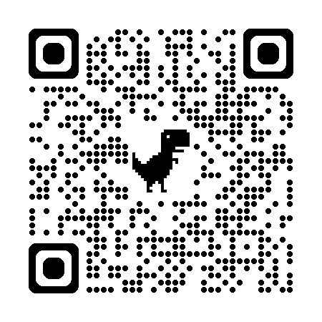                                         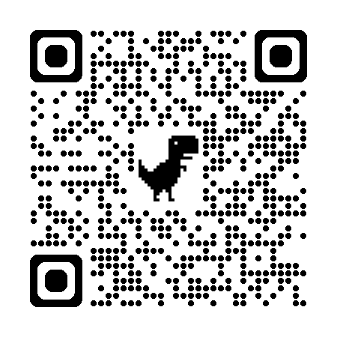

BUSH FIRE DANGER RATINGS                                     PREPARING FOR BUSH AND GRASS FIRES

We thank the local community for continuing to support bushfire prevention and management in the JBT.