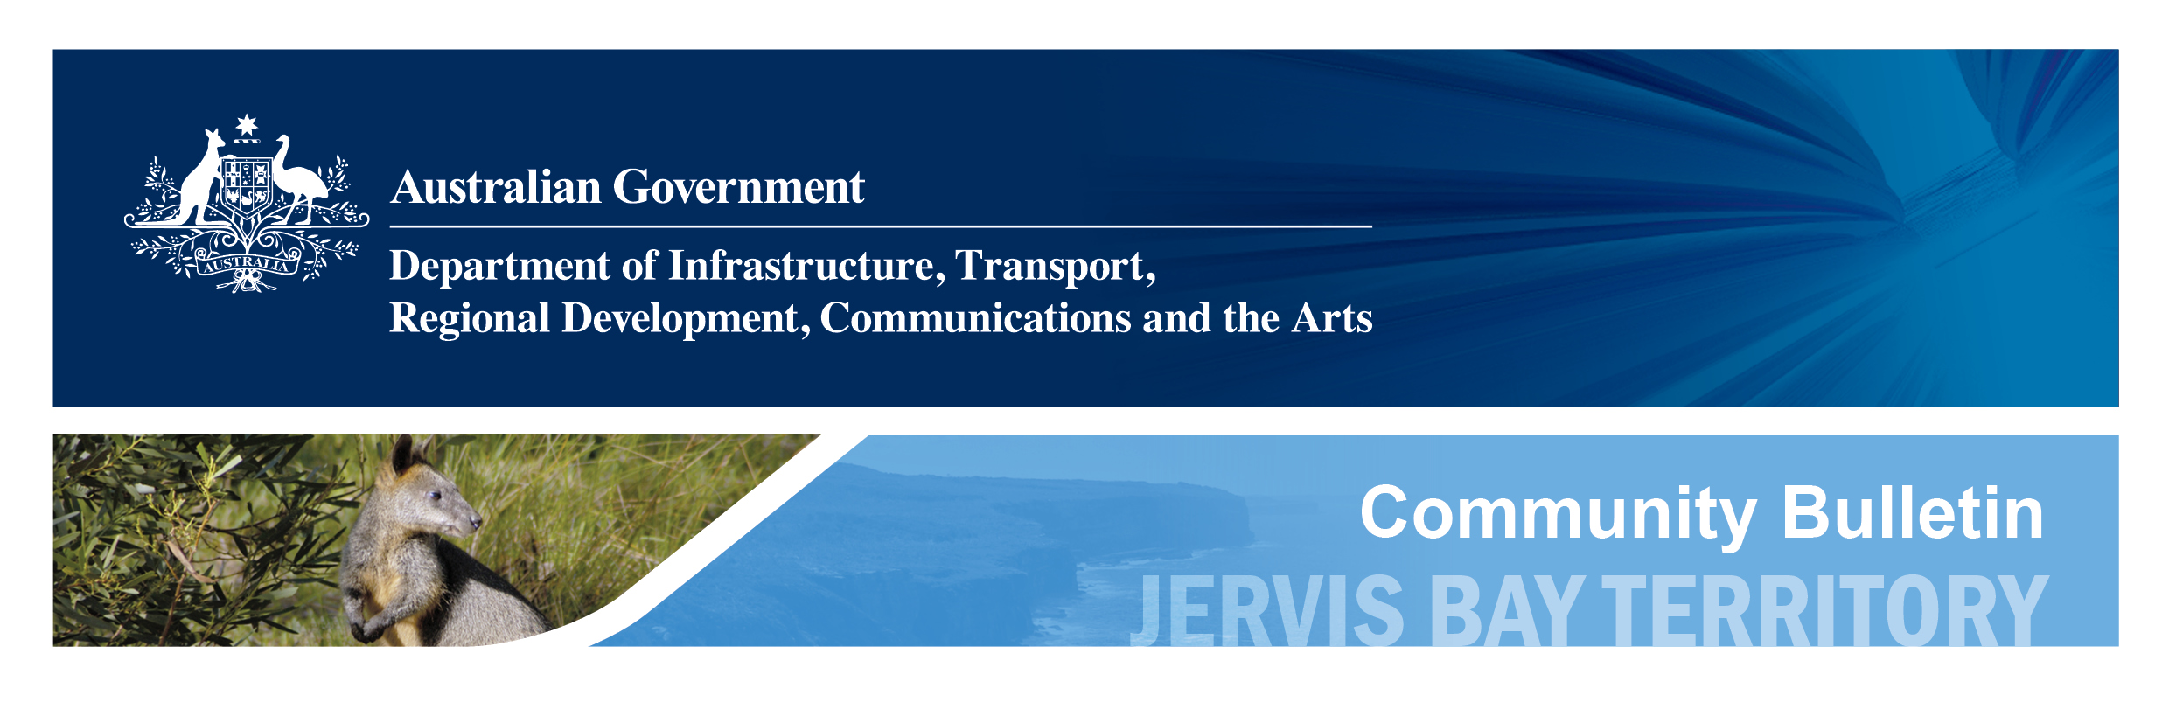

| **Number:** | 2024/14 | **Date:** | 20 September 2024 |
| --- | --- | --- | --- |
| **Relevant:** | Jervis Bay Territory, Village Road residents | | |
| **Topic:** | Village Road Housing Remediation Project | | |

# Vital remediation works for Village Road properties

Important works to improve existing housing conditions in the Jervis Bay Territory will soon be under way, with remediation works planned to 23 houses and 4 flats along Village Road, which are currently the responsibility of the Australian Government.

The safety and wellbeing of the Jervis Bay community is a key priority for Australian Government, which is why we are prioritising these essential works to reduce the risks of mould and asbestos, as well as ensuring that all properties are adhering to the National Construction Code and Safety Standards.

While acknowledging that these works are vital to the ongoing welfare of residents, we also understand that there will be necessary short-term disruption to the properties’ current tenants.

We have appointed BY Group to undertake this project and will ensure that all tenants have full understanding of the project works for their individual properties, including the contractor’s requirements for access.

We will work with the contractor to minimise disruptions during the works, and thank you for working with us to make sure that these vital improvements and safety measures can be successfully rolled-out along Village Road.

To ensure clear lines of communication between the community and the project coordinators, Jervis Bay Territory Office staff will be the point of contact for all proposed works, and will be available to answer questions or listen to concerns about this important project.

We will continue to engage with the community throughout the remediation process, and will provide tenants and the community with the necessary information as it becomes available.

Works are anticipated to commence in October 2024 and conclude by December 2025.

For more information, or for any initial questions, contact the JBT Office on 02 4442 2200 or [jbt@infrastructure.gov.au](mailto:jbt@infrastructure.gov.au).