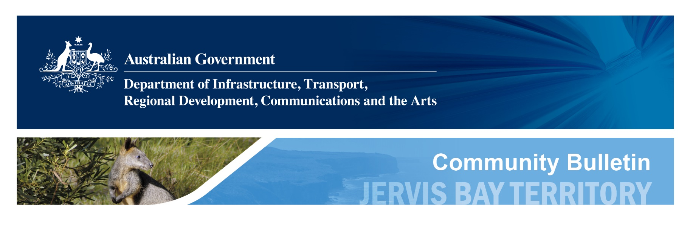

| **Number:** | 18/2024 | **Date:** | 14 October 2024 |
| --- | --- | --- | --- |
| **Relevant:** | Jervis Bay Territory residents and visitors | | |
| **Topic:** | Jervis Bay Territory drinking water | | |

# JBT drinking water—PFAS testing results

Testing for October 2024 shows that Per- and Polyfluoroalkyl Substances (PFAS) levels in JBT drinking water remain many times lower than levels recommended by the [Australian Drinking Water Guidelines](https://www.nhmrc.gov.au/about-us/publications/australian-drinking-water-guidelines).

The Guidelines are set by the National Health and Medical Research Council. They are regularly updated to make sure they are based on the latest scientific evidence. On behalf of the Department of Infrastructure, Transport, Regional Development, Communications and the Arts, Shoalhaven Water undertakes routine monthly testing for PFAS in JBT’s drinking water and engages an independent laboratory, accredited by the National Association of Testing Authorities, to do this work.

The drinking water at Wreck Bay and the rest of JBT is sourced from Lake Windemere. The drinking water from Lake Windemere is tested for PFAS at the treatment plant before and after treatment. This water is then supplied by pipeline to the various locations within JBT including Wreck Bay. This monthly testing continues to show drinking water is well within the national guidelines. The health and safety of JBT residents and visitors remains our first priority. We will continue to keep the local community informed on testing results.

|  | **Sum of PFOS & PFHxS** | **PFOA** |
| --- | --- | --- |
| JBT drinking water  October 2024 test results | 0.0005 micrograms/litre | <0.0005 micrograms/litre |
| Australian Drinking Water Guidelines  Health values for PFAS | 0.07 micrograms/litre | 0.56 micrograms/litre |

*PFOS=Perfluorooctane Sulfonate, PFHxS=Perfluorohexane Sulfonate, PFOA=Perfluorooctanoic Acid

For general information on PFAS health effects and exposure pathways, contact the Department of Health on 1800 941 180, or see the fact sheet: <https://www1.health.gov.au/internet/main/publishing.nsf/Content/ohp-pfas.htm#pfas>.