Logo: Australian Government, Department of Communications and the Arts.

Logo: Bureau of Communications Research.

www.communications.gov.au/BCAR
#CommsAuBCAR

# Cultural and creative activity in Australia

# 2008-09 to 2016-17

October 2018

**Working paper**

Disclaimer

The material in this report is of a general nature and should not be regarded as legal advice or relied on for assistance in any particular circumstance or emergency situation. In any important matter, you should seek appropriate independent professional advice in relation to your own circumstances. The Commonwealth accepts no responsibility or liability for any damage, loss or expense incurred as a result of the reliance on information contained in this report.

This report has been prepared for consultation purposes only and does not indicate the Commonwealth’s commitment to a particular course of action. Additionally, any third party views or recommendations included in this report do not reflect the views of the Commonwealth, or indicate its commitment to a particular course of action.

Copyright

© Commonwealth of Australia 2018

The material in this report is licensed under a Creative Commons Attribution—4.0 International license, with the exception of:

* the Commonwealth Coat of Arms
* this Department’s logo
* any third party material
* any material protected by a trademark, and
* any images and/or photographs.

More information on this CC BY license is set out as follows:

* Creative Commons website—[www.creativecommons.org](http://www.creativecommons.org)
* Attribution 4.0 international (CC by 4.0)—[www.creativecommons.org/licenses/by/4.0](http://www.creativecommons.org/licenses/by/4.0).

Enquiries about this license and any use of this discussion paper can be sent to: [copyright@communications.gov.au](mailto:copyright@communications.gov.au).

Third party copyright

The Department has made all reasonable efforts to clearly identify material where the copyright is owned by a third party. Permission may need to be obtained from third parties to re-use their material.

Attribution

The CC BY licence is a standard form licence agreement that allows you to copy and redistribute the material in any medium or format, as well as remix, transform, and build upon the material, on the condition that you provide a link to the licence, you indicate if changes were made, and you attribute the material as follows:

Licensed from the Commonwealth of Australia under a Creative Commons Attribution 4.0 International licence.

Enquiries about the use of any material in this publication can be sent to: [copyright@communications.gov.au](mailto:copyright@communications.gov.au).

Using the Commonwealth Coat of Arms

Guidelines for using the Commonwealth Coat of Arms are available from the Department of Prime Minister and Cabinet website at [www.pmc.gov.au/government/its-honour](https://www.pmc.gov.au/government/its-honour).

Contents

Cultural and creative activity in 2016-17 7

Cultural and creative activity from 2008-09 to 2016-17 9

Cultural activity 2008-09 to 2016-17 15

Creative activity 2008-09 to 2016-17 17

Cultural and creative activity by domain, 2008-09 to 2016-17 19

Museums 22

Environmental heritage 23

Libraries and archives 24

Literature and print media 25

Performing arts 27

Design 29

Broadcasting, electronic or digital media, and film 31

Music composition and publishing 33

Visual arts and crafts 35

Fashion 36

Other culture goods manufacturing and sales 37

Supporting activities 38

Appendix A: Methodology 39

Appendix B: Data gaps 45

Appendix C: ANZSIC (2006) industry classes 46

Appendix D: Structure for cultural and creative activity of the domain tables 49

Appendix E: Glossary 50

List of tables 53

List of figures 54

Executive Summary

There is growing interest in quantifying the economic contribution of cultural and creative industries both in Australia and internationally. Measurement of this activity can inform policy makers about how such industries contribute to economic outcomes relative to other industries.

Cultural and creative activity is increasingly recognised as an important component of economic growth. Its contribution has the potential to grow as the economy transforms in parallel with the use of advanced technologies and the rise of automation. The economic response to a digital and technology‑based transition is already evident in services such as internet publishing and computer system design which are also linked to creative activity.

The economic value of cultural and creative activity is determined by how it is defined and identified for each activity, or for both. In addition, some cultural and creative activity may not be captured fully, owing to how volunteering and non‑market based production are reflected in the measurements.

While there is no universally accepted definition, the terms ‘cultural’ and ‘creative’ are often used to describe activities connected with the arts, media, heritage, design, fashion, and information technology.[1] As defined by the Australian Bureau of Statistics (ABS), human creativity is a vital input to cultural and creative activity. Cultural activity requires human creativity as an input and may contain intellectual property to communicate symbolic meaning.[2] Creative activity requires human creativity as a significant and identifiable input.2

This paper reports a times series on the economic contribution of cultural and creative activity in Australia from 2008‑09 to 2016-17. The definition is based on the ABS’s *Australian National Accounts: Cultural and Creative Activity Satellite Accounts* (Satellite Accounts).[3]

The Satellite Accounts estimated the economic contribution from cultural and creative activity to Gross Domestic Product (GDP) at $86.0 billion in 2008-09. The main components of this activity include activity from cultural and creative industries as well as the wages and salaries, and employers’ social contributions received from cultural and creative occupations that are performed outside of these cultural and creative industries.[4]

Between 2008-09 and 2016-17, cultural and creative activity in Australia grew to $111.7 billion, an increase of $25.8 billion or 30.0 per cent. While this activity is growing in absolute terms, the increase is slightly slower than the pace of the Australian economy overall. As a share of GDP, cultural and creative activity declined by 0.5 percentage points, from 6.9 per cent in 2008‑09 to 6.4 per cent in 2016-17.

Over that period, the Australian economy has been supported by activities relating to the mining sector, which is almost entirely outside cultural and creative activity. At the same time, some cultural and creative industries have faced increased global competition and have needed to adjust to the transition towards digital content. This has led to a decline in areas such as onshore printing and clothing manufacturing.

While parts of cultural and creative activity are shrinking as a share of GDP, other activities are outpacing the overall economy. Cultural and creative activity within professional, scientific and technical services, and education and training has increased its share within the economy over the period. These activities utilise highly skilled labour which will be increasingly important to Australia’s economic growth.

Examining the breakdown of cultural and creative activity, cultural activity grew from $51.4 billion in 2008-09 to $63.5 billion in 2016-17 while its share of GDP declined from 4.1 per cent to 3.6 per cent over this period. Creative activity increased from $75.2 billion in 2008-09 to $99.7 billion in 2016-17 while its share of GDP declined from 6.0 per cent to 5.7 per cent over this period (Table 1).

**Table 1.** Cultural and creative activity 2008-09 and 2016-17

| **Gross Domestic Product - National Accounts Basis ($m)** (a) | **2008-09** | **2016-17** |
| --- | --- | --- |
| Cultural activity | 51,395 | 63,476 |
| As a proportion of GDP (%) | 4.1 | 3.6 |
| Creative activity | 75,210 | 99,728 |
| As a proportion of GDP (%) | 6.0 | 5.7 |
| Total for cultural and creative activity (b) | 85,956 | 111,713 |
| As a proportion of GDP (%) | 6.9 | 6.4 |

1. Activity considered both cultural *and* creative activity is counted only once in the total.

Source: ABS cat. 5204, 5209; BCAR calculations

The majority of cultural and creative activity in 2016-17 came from cultural and creative industries, comprising 76.7 per cent or $85.7 billion. The related industries (also known as ‘domains’) that contributed most to this activity were design at $42.8 billion, fashion at $14.2 billion, and broadcasting, electronic or digital media, and film at $9.7 billion.

Cultural and creative activity in design experienced significant growth of $16.2 billion or 60.7 per cent from 2008-09 to 2016-17. Design is the largest domain and has increased as a share of GDP by 0.3 percentage points. This growth is driven mainly by computer system design and related services. Workplaces have increased their use of information technology in their processes which have then required regular upgrades and enhancements over the past decade.[5]

Cultural and creative activity in fashion increased by $2.4 billion or 20.3 per cent from 2008-09 to 2016‑17. However, as a share of GDP, this domain fell by 0.1 percentage points over this period. Clothing and footwear wholesaling and retailing have driven the increase in absolute terms; but these industries have faced a challenging operating environment with greater competition and higher shopfront rental costs.[6]

Cultural and creative activity in broadcasting, electronic or digital media, and film increased by $2.4 billion or 32.2 per cent from 2008-09 to 2016-17; although this domain remained relatively flat as a share of GDP over this period. Free-to-air television broadcasting, and cable and other subscription broadcasting were the two main contributors to this domain. While these components have grown over the period, future challenges may be on the horizon as Australians consume content on a wider variety of platforms.[7]

The figures presented in this report, unless otherwise stated, are in current prices and on a national accounts basis. This basis excludes volunteering and non-market based production due to its activity not being captured in the calculation of GDP. The figures are presented in a format that enable them to be updated each year.

Caution should be used when comparing the measurement of cultural and creative activity with activity that occurs in a particular industry of the Australian economy. The contribution of cultural and creative activity to the economy measures the contribution of that activity across multiple industry sectors as defined in the Australian and New Zealand Standard Industrial Classification 2006 (ANZSIC 06). This includes manufacturing, education, information media and telecommunications and arts and recreation services). The contribution of a particular industry (such as manufacturing) measures the contribution to the economy of activity from only that industry.

The remainder of this paper is structured as follows: the first section provides an overview of the size of cultural and creative activity in 2016-17 and its largest components; the second section shows how this activity has changed over time, and the main drivers of this change; the third and fourth sections report separately on cultural activity and creative activity, respectively; the final section details how each domain has contributed to cultural and creative activity; the methodology and supporting information including a glossary of terms used in the paper, can be found in the appendix.

## Cultural and creative activity in 2016-17

Cultural and creative activity contributed $111.7 billion, or 6.4 per cent to GDP in 2016-17. Cultural and creative activity can be measured separately or as both cultural and creative activity.

Cultural activity contributed $63.5 billion or 3.6 per cent to GDP in 2016-17, while creative activity contributed $99.7 billion or 5.7 per cent to GDP in 2016-17. There is considerable overlap of industries and occupations common with these segments. Activity that has identified as both cultural and creative accounted for $51.5 billion or 3.0 per cent to GDP. This common activity is counted only once in the total for cultural and creative activity, as shown in Figure 1.

**Figure 1.** Cultural and creative activity, 2016-17

This is a Venn diagram showing the values and overlap of cultural and creative activity. Cultural activity is valued at $63.5 billion and creative activity is valued at $99.7 billion, with an overlap between the two of $51.5 billion.

Source: ABS cat. 5204, 5209; BCAR calculations

The value of cultural and creative activity in industries considered to be cultural or creative was $85.7 billion in 2016‑17. The largest components were design at $42.8 billion, fashion at $14.2 billion, and broadcasting, electronic or digital media, and film at $9.7 billion, as shown in Figure 2.

**Figure 2.** Cultural and creative industries, Gross Value Added (GVA) by domain 2016-17

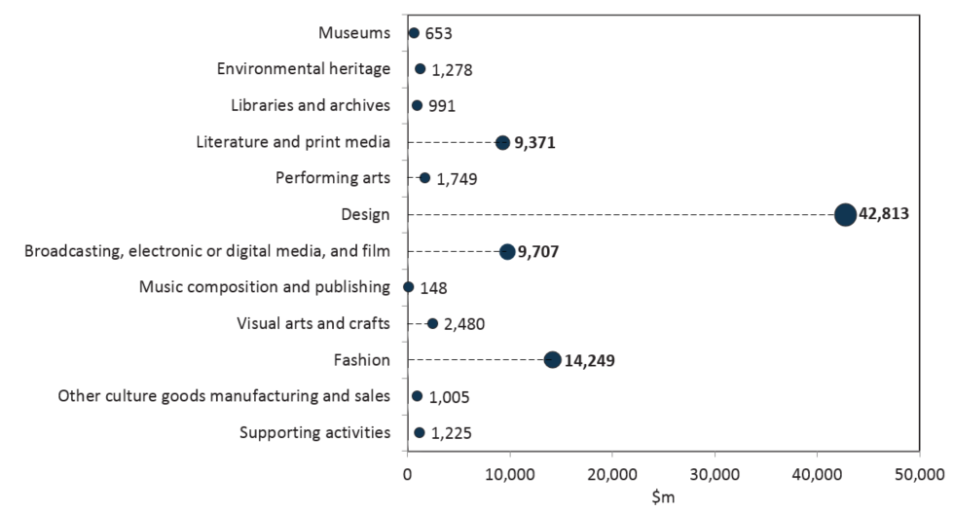Source: ABS cat. 5204, 5209; BCAR calculations

## Cultural and creative activity from 2008-09 to 2016-17

Cultural and creative activity increased by $25.8 billion or 30.0 per cent, from $86.0 billion in 2008-09 to $111.7 billion in 2016-17. This growth was driven mainly by an increase of $19.9 billion in gross value added (GVA) from cultural and creative industries—primarily from professional, scientific and technical services with an increase of $16.4 billion over the period, as shown in Figure 3. [8]

**Figure 3.** Cultural and creative activity, 2008-09 to 2016-17

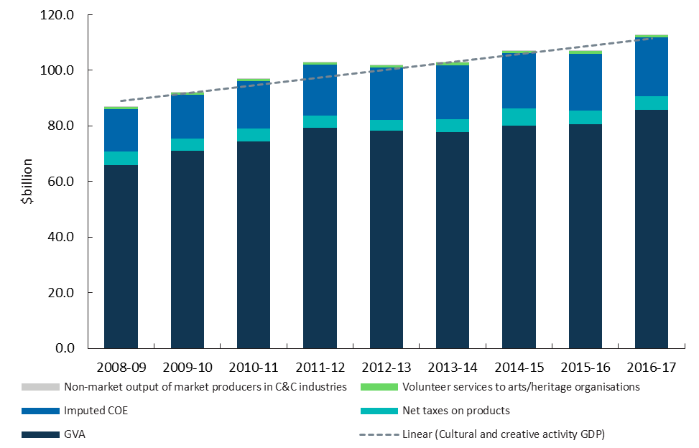Source: ABS cat. 5204, 5209; BCAR calculations

Cultural and creative activity, on a Satellite Accounts basis, consists of four components (see Appendix A: Methodology and Table 2):

* GVA from cultural and creative industries increased by $19.9 billion or 30.3 per cent, from $65.8 billion in 2008-09 to $85.7 billion in 2016-17. Net taxes on products attributable to cultural and creative industries increased over the period by 0.6 per cent or $32 million.
* Compensation of Employees (COE) received by individuals working in cultural and creative occupations that are outside industries identified as cultural and creative was $21.0 billion in 2016-17. This grew by $5.8 billion or 38.3 per cent over the period.
* The value of volunteer services to arts and heritage organisations was $983 million in 2016-17, $227 million more than in 2008-09.
* Non-market output of market producers in cultural and creative industries was $88 million in 2016-17, an increase of $20 million compared to 2008-09.

**Table 2.** Cultural and creative activity, share of GDP, 2008-09 to 2016-17

This is a table showing the value of cultural and creative activity on a national accounts and satellite accounts basis from 2008-09 to 2016-17. Volunteer services and non-market output of market producers grew by $227 million and $20 million respectively over the time period.

While cultural and creative activity is growing in absolute terms, the increase is slightly slower than the pace of the Australian economy overall (Figure 4). The Australian economy has been supported by activities that are almost entirely outside cultural and creative activity, such as mining related activity over the period.

In Figure 4, the dotted line at 100, represents the base year index of 2008‑09. The area above the line represents growth whereas the area below the line represents a contraction since 2008-09. Similarly, the dash line represents GDP growth for the entire Australian economy relative to the base year. Cultural and creative activity grew faster than the overall economy in 2009-10 but then slowed after 2011-12. This slowdown reflects the contraction in manufacturing which is explored further in the industry division decomposition of the paper.

**Figure 4.** Cultural and creative activity relative to nominal GDP

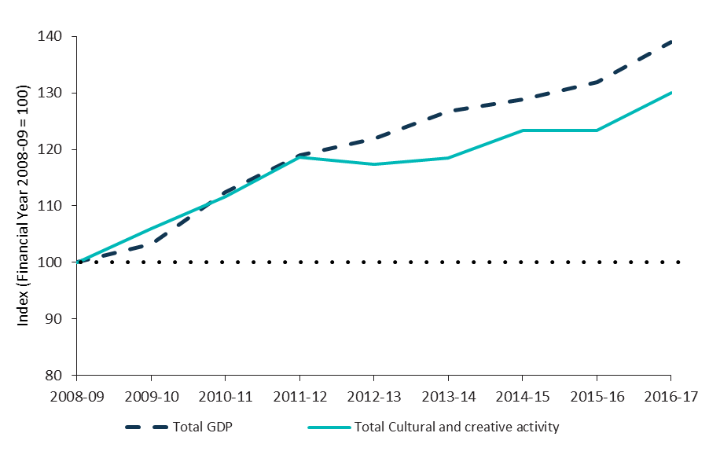

Cultural and creative activity as a share of GDP declined slightly by 0.5 per cent over the period, from 6.9 per cent in 2008-09 to 6.4 per cent in 2016-17 (Figure 5).

**Figure 5.** Cultural and creative activity, share of GDP, 2008-09 to 2016-17

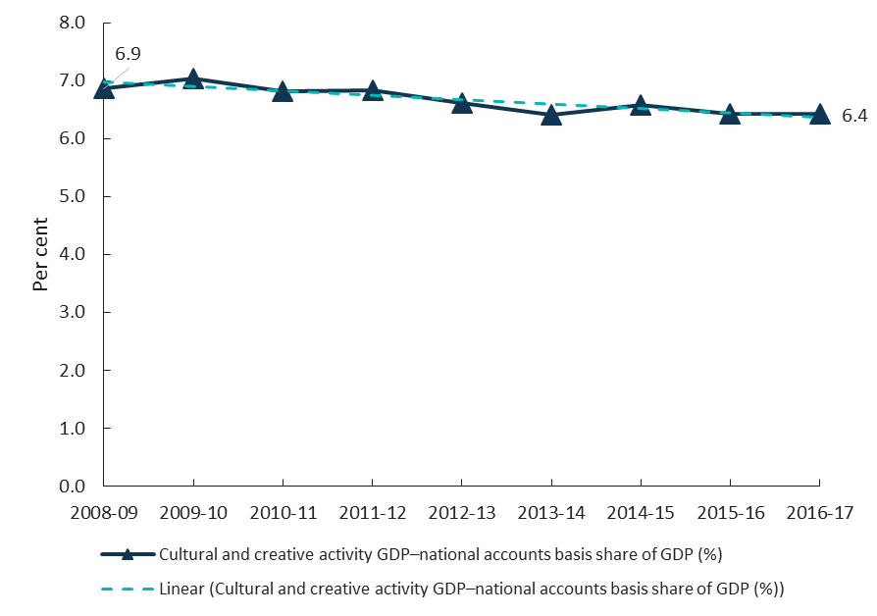

Source: ABS cat. 5204, 5209; BCAR calculations

The decline was driven by the reduction of cultural and creative activity in manufacturing, from $6.2 billion in 2008-09 to $3.9 billion in 2016-17. Cultural and creative activity within manufacturing was the only industry division to record an absolute decline, as shown in Table 3 and Figure 6. This decline in manufacturing accelerated in 2012-13. However, cultural and creative activity increased significantly in absolute terms within the industry division of professional, scientific and technical services with an increase of $16.4 billion or 60.7 per cent over the period; followed by retail trade at $3.3 billion or 33.9 per cent.

**Table 3**. Cultural and creative activity, GVA by industry division, 2008-09 to 2016-17

This is a table showing the cultural and creative activity by industry division from 2008-09 to 2016-17. Cultural and creative activity in manufacturing was the only industry division to contract over the period, declining from $6.2 billion in 2008-09 to $3.9 billion in 2016-17. Cultural and creative activity increased significantly in absolute terms within the industry division of professional, scientific and technical services with an increase of $16.4 billion over the period.

The industry divisions presented in this report are consistent with the ABS’ Australian System of National Accounts, cat. 5204.

Professional, scientific and technical services was the largest contributor to cultural and creative activity by GVA over the period, increasing from 41.1 per cent in 2008-09 to 50.7 per cent in 2016-17. The increase in this industry division was driven primarily by computer system design services, up by $10.9 billion or 59.2 per cent over the period. The increase was due to the greater investment and adoption of information technology to create greater efficiency in business operations.

After computer system design services, architectural services was the second largest contributor to the increase in professional, scientific and technical services. GVA in architectural services rose by $2.4 billion from 2008-09 to 2016-17. Additionally, advertising services increased by $1.7 billion and other specialised design services grew by $1.2 billion over the same period.

**Figure 6.** GVA change by division, cultural and creative industries, 2008-09 to 2016-17

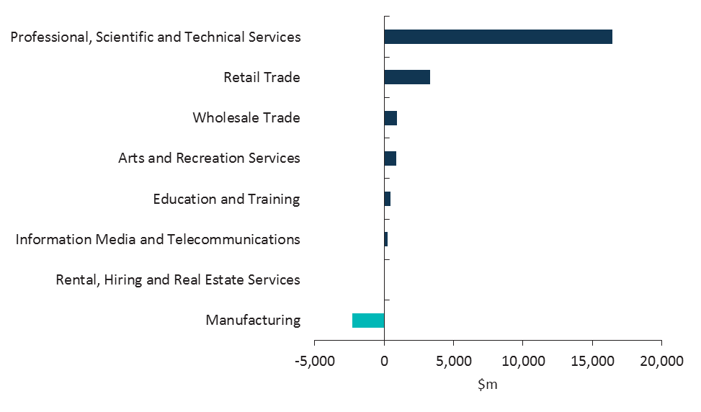

Source: ABS cat. 5204, 5209; BCAR calculations

Five out of six cultural and creative industries within the manufacturing industry division experienced a decline from 2008-09 to 2016-17, as shown in Figure 7. Printing fell the most by $1.3 billion or 34.2 per cent.

The printing industry in Australia has declined significantly over the past decade. Increased competition from overseas has created strong price pressures that have led to falling demand and excess capacity.[9] Another contributing factor has been consumers moving to online platforms. These online platforms provide information quicker to customers than traditional print materials and are more cost effective in distributing information.8 As a result, online platforms are increasingly being used by businesses to interact and engage with their customers with traditional printing services being phased out.8

**Figure 7.** GVA change of cultural and creative industries in manufacturing, 2008-09 to 2016-17

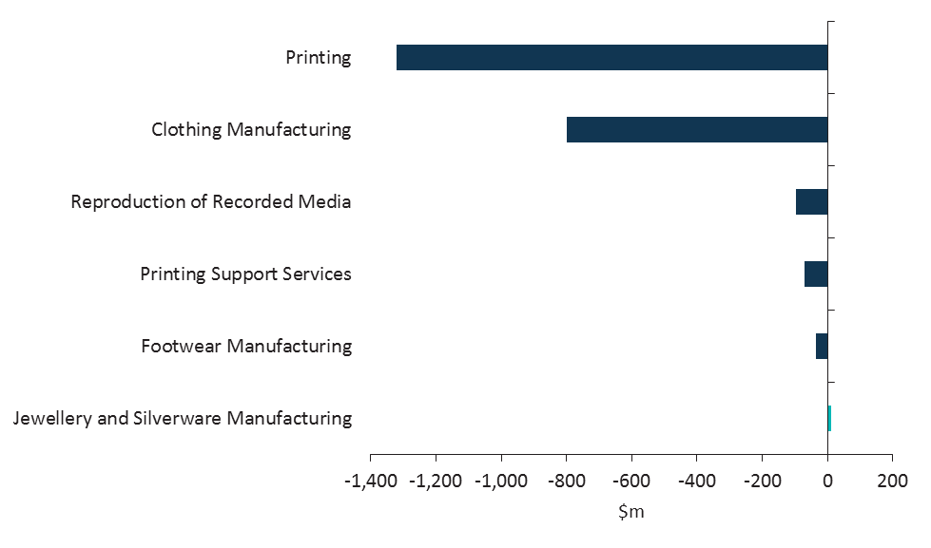

Source: ABS cat. 5204, 5209; BCAR calculations

After printing, clothing manufacturing, fell by $799 million or 54.3 per cent over the period. This decline in clothing manufacturing in Australia is largely attributed to manufacturers facing increased competition from cheaper imports particularly from China.[10] Businesses have also continued to move their operations overseas to benefit from lower operating costs.9

In absolute terms, only cultural and creative activity in manufacturing declined. However, when each industry division’s growth is compared with the pace of the economy as a whole, only two industry divisions outpaced the rest of the economy by the end of the period. Cultural and creative activity in professional, scientific and technical services outpaced the economy by 21.8 percentage points and cultural and creative activity in education and training outpaced the economy by 18.2 percentage points in 2016-17, as shown in Figure 8. These industry divisions tend to require more specialised skills than other industry divisions.

In Figure 8, the dotted line at 100, represents the base year index of 2008-09. As noted earlier, the area above the line represents growth whereas the area below the line represents a contraction since 2008‑09. Also, if an industry division grew but did not outpace the economy as a whole, as did five out of the eight industry divisions (see Figure 8 – right hand panel), then their growth would be between the base year line and the dashed nominal GDP line.

**Figure 8.** Industry division’s GVA relative to GDP

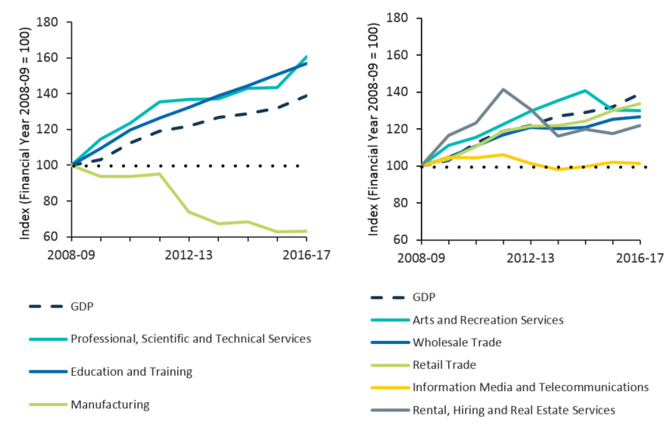

Source: ABS cat. 5204, 5209; BCAR calculations

## Cultural activity 2008-09 to 2016-17

Cultural activity requires human activity as an input and may contain intellectual property to communicate symbolic meaning, such as in beliefs, values, and traditions.10

Cultural activity increased by $12.1 billion or 23.5 per cent from $51.4 billion in 2008-09 to $63.5 billion in 2016-17 as shown in Table 4.

GVA for cultural industries increased by $6.6 billion or 18.8 per cent from $35.2 billion in 2008-09 to $41.9 billion in 2016-17.

Net taxes on products attributable to cultural industries increased by $506 million or 11.2 per cent from 2008-09 to 2016-17.

COE received by individuals working in cultural occupations that are outside industries identified as cultural was $16.6 billion in 2016-17. This has grown by $4.9 billion over the period.[11]

The value of volunteer services to arts and heritage organisations was $983 million in 2016-17, $227 million more than in 2008-09. This value is identical to the total cultural and creative value of volunteer services due to the cultural and creative overlap of arts and heritage organisations.

Non-market output of market producers in cultural industries was $68 million in 2016‑17, with an increase of $13 million compared to 2008-09.

**Table 4.** Cultural activity, share of GDP, 2008-09 to 2016-17

This is a table showing the value of cultural activity on a national accounts and satellite accounts basis from 2008-09 to 2016-17. Cultural activity increased on a national accounts basis by $12.1 billion from $51.4 billion in 2008-09 to $63.5 billion in 2016-17.

The industry divisions presented in this report are consistent with the ABS’s Australian System of National Accounts, cat. 5204.

Cultural activity represents a smaller share of total GVA compared to creative activity and primarily consists of design at $13.4 billion, broadcasting, electronic or digital media, and film at $9.7 billion, and literature and print media at $9.2 billion in 2016-17 (Figure 9). Cultural activity in design includes architecture, advertising and other specialised design services; cultural activity in broadcasting, electronic, or digital media and film includes free-to-air television broadcasting, and cable and other subscription broadcasting; and cultural activity in literature and print media includes activities like newspaper publishing, printing, and newspaper and book retailing.

**Figure 9.** GVA by domain, cultural industries, 2016-17 ($m)

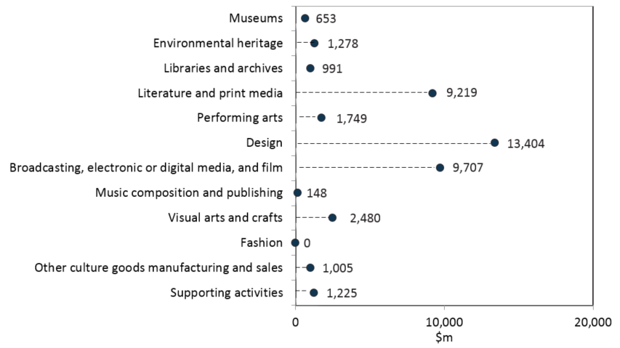

Source: ABS cat. 5204, 5209; BCAR calculations

Cultural activity, as a per cent of GDP, declined slightly by 0.5 per cent, from 4.1 per cent in 2008-09 to 3.6 per cent in 2016-17 (Figure 10).

**Figure 10**. Cultural activity, share of GDP, 2008-09 to 2016-17

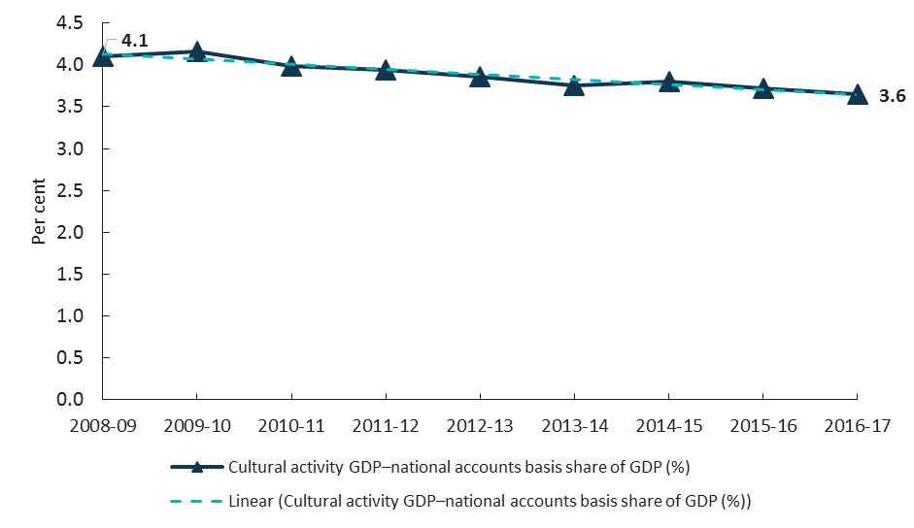

Source: ABS cat. 5204, 5209; BCAR calculations

## Creative activity 2008-09 to 2016-17

Creative activity requires human creativity as a significant and identifiable input.[12]

Creative activity increased by $24.5 billion or 32.6 per cent from $75.2 billion in 2008-09 to $99.7 billion in 2016-17, as shown in Table 5.

GVA for creative industries increased by $19.9 billion or 34.5 per cent from $57.9 billion in 2008-09 to $77.8 billion in 2016-17.

Net taxes on products attributable to creative industries decreased by $40 million or 0.9 per cent from 2008-09 to 2016-17.

COE received by individuals working in creative occupations that are outside industries identified as creative was $17.5 billion in 2016-17. This has grown by 35.9 per cent during the period.[13]

The value of volunteer services to arts and heritage organisations was $983 million in 2016-17, $227 million more than $756 million in 2008-09. This value is identical to the total cultural and creative value of volunteer services due to the cultural and creative overlap of arts and heritage organisations.

Non-market output of market producers in the creative industries was $73 million in 2016-17, with an increase of $18 million compared to 2008-09.

**Table 5.** Creative activity, share of GDP, 2008-09 to 2016-17

This is a table showing the value of creative activity on a national accounts and satellite accounts basis from 2008-09 to 2016-17. Creative activity increased by $24.5 from $75.2 billion in 2008-09 to $99.7 billion in 2016-17.

The industry divisions presented in this report are consistent with the ABS’s Australian System of National Accounts, cat. 5204.

Creative activity represents a larger share of total GVA compared to cultural activity and displays a very similar structure to the overall combination of creative and cultural activity, being dominated by design at $42.8 billion, fashion at $14.2 billion, and broadcasting, electronic or digital media, and film at $9.6 billion in 2016-17 (Figure11). Creative activity in design includes computer systems design and related services, architecture, advertising and other specialised design services; creative activity in fashion includes clothing retailing, and clothing and footwear wholesaling; creative activity in broadcasting, electronic, or digital media and film includes free-to-air television broadcasting, and cable and other subscription broadcasting.

**Figure 11.** GVA by domain, creative industries, 2016-17 ($m)

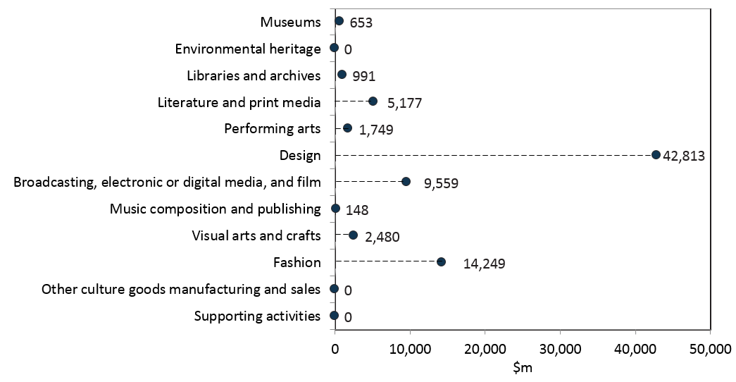Source: ABS cat. 5204, 5209; BCAR calculations

Creative activity as a per cent of GDP declined slightly by 0.3 per cent, from 6.0 percent in 2008-09 to 5.7 per cent in 2016-17 (Figure 12).

**Figure 12**. Creative activity, share of GDP, 2008-09 to 2016-17

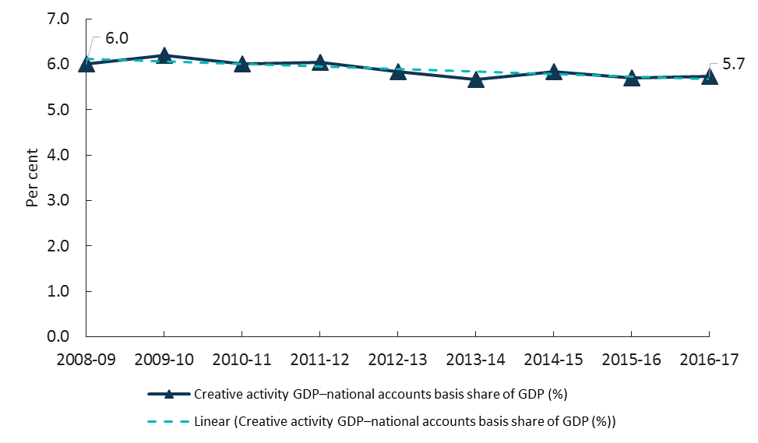Source: ABS cat. 5204, 5209; BCAR calculations

## Cultural and creative activity by domain, 2008-09 to 2016-17

Cultural and creative activity can be also analysed by domains which are grouped in terms of related industries. The Satellite Accounts listed twelve such domains which are museums; environmental heritage; libraries and print media; performing arts; design; broadcasting, electronic or digital media, and film; music composition and publishing; visual arts and crafts; fashion; other culture goods manufacturing and sales; and supporting activities and are shown in Figure 13 and Figure 14. The activity within the domains is grouped in terms of Australian and New Zealand Standard Industrial Classification 2006 (ANZSIC 06) class codes. The class codes by domain can be found at Appendix C.

The largest contribution to cultural and creative activity was design. This domain increased by 7.3 percentage points as a proportion of total activity, from 31.0 per cent in 2008-09 to 38.3 per cent in 2016-17. Fashion, the second largest domain as a proportion of cultural and creative activity declined by 1.0 percentage point, from 13.8 per cent in 2008-09 to 12.8 per cent in 2016-17. The proportion of broadcasting, electronic or digital media, and film has remained relatively flat, moving from 8.5 per cent in 2008-09 to 8.7 per cent in 2016-17. Literature and print media*,* the second largest domain in 2008-09 at 14.9 per cent dropped to 8.4 per cent and became the fourth largest domain of cultural and creative activity in 2016-17.

These four domains, in total, contributed 68.2 per cent of cultural and creative activity with all other domains having had a much smaller impact at 8.5 per cent in 2016-17. The remaining 23.3 per cent was made up of income received from creative and cultural workers in other industries (Imputed COE) and net taxes on products.

**Figure 13**. Contribution to cultural and creative activity, GVA (by domain), net taxes on products, and COE in other industries, 2008-09 and 2016-17

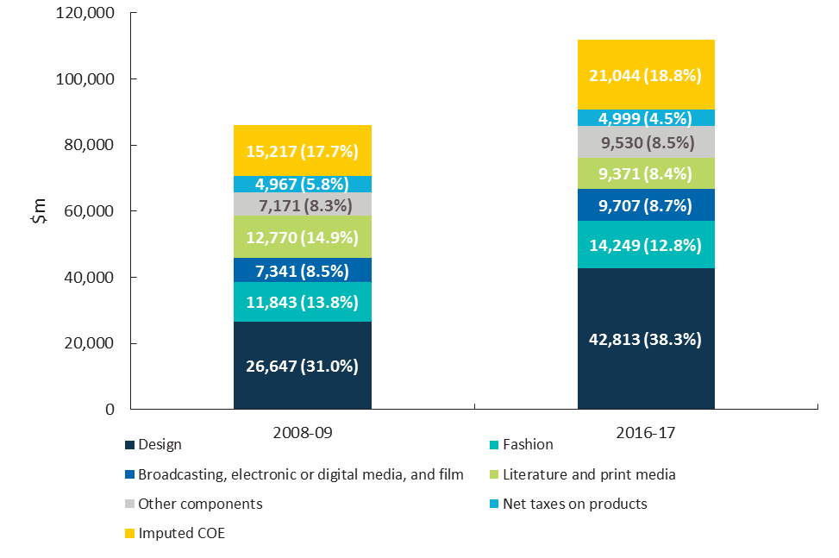

Source: ABS cat. 5204, 5209; BCAR calculations

Eleven of the twelve domains experienced growth from 2008-09 to 2016-17. Design had the strongest growth of 60.7 per cent or $16.2 billion (Figure 14). The only domain to decline in absolute terms was literature and print media which decreased by 26.6 per cent or $3.4 billion. This was driven by falling demand due to consumers moving towards online platforms.

**Figure 14.** Nominal GVA growth by domain, cultural and creative industries, 2008-09 to 2016-17

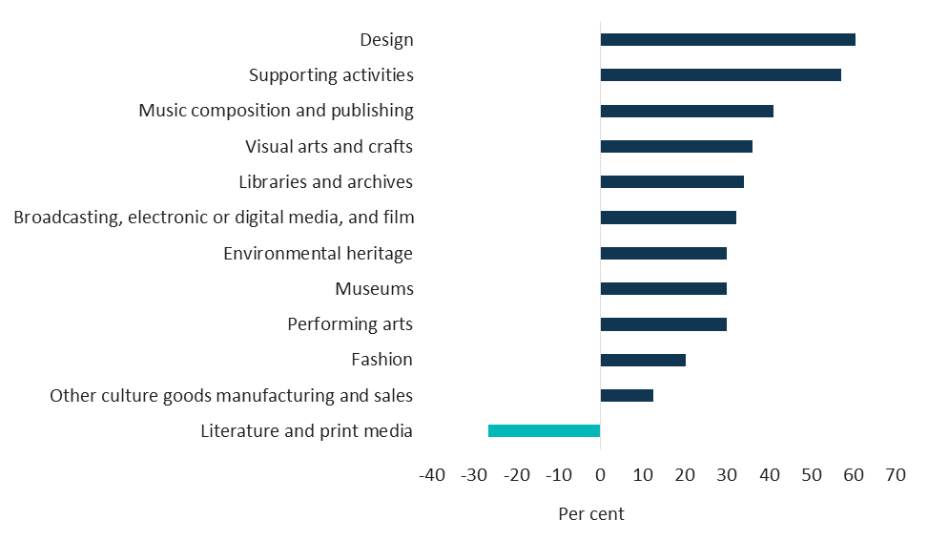Source: ABS cat. 5204, 5209; BCAR calculations

The information presented by domain is consistent with the information presented by industry division (as shown in Figure 8). Literature and print media contracted over the period; most cultural and creative domains grew, but did not keep pace with the economy as a whole; and design, which consists of services like architecture, computer system design and advertising services, as well as supporting activities, and music composition and publishing, outpaced the economy (Figure 15).

**Figure 15.** Domains’ GVA relative to GDP

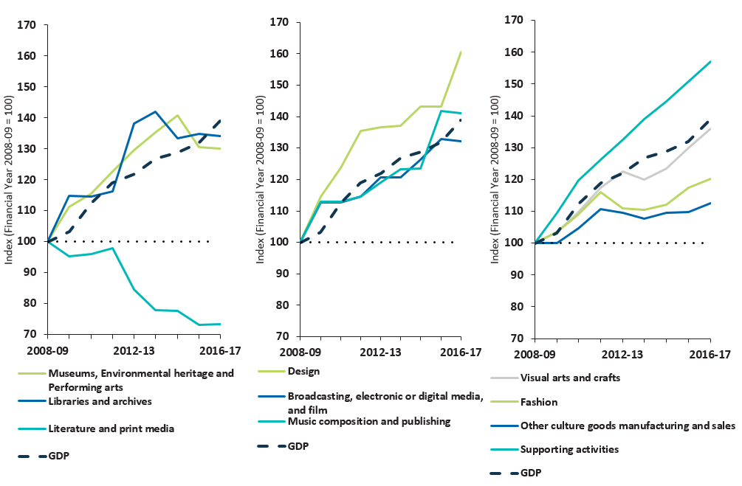Source: ABS cat. 5204, 5209; BCAR calculations

### Museums

The museums domain includes museum operations such as the preservation and exhibition of heritage objects and artefacts as well as visual arts and crafts with aesthetic, historical, cultural, and educational value. This also includes activities related to entities operating in historical places, sites or houses.[14]

GVA of cultural and creative activity in museums achieved modest growth from 2008-09 to 2014-15, followed by a decline more recently (Table 6). Museums operate in a highly competitive environment. They contend with other leisure, sporting and entertainment organisations for a share of consumer expenditure and government funding. Museums are also providing some services to users free‑of‑charge but are diversifying income streams through increased earnings from cafes, gift shops and larger private donations.[15]

GVA of cultural and creative activity in museums increased by $151 million or 30.0 per cent from 2008‑09 to 2016-17. However, as a per cent of GDP, it has remained relatively flat over the period (Table 6 and Figure 16).

**Table 6.** Cultural and creative activity in museums, 2008-09 to 2016-17[16]

| **Museums** | **2008-09** | **2009-10** | **2010-11** | **2011-12** | **2012-13** | **2013-14** | **2014-15** | **2015-16** | **2016-17** |
| --- | --- | --- | --- | --- | --- | --- | --- | --- | --- |
| Output ($m) | 1,145 | 1,317 | 1,434 | 1,517 | 1,271 | 1,340 | 1,354 | 1,412 | 1,488 |
| COE ($m) | 337 | 362 | 395 | 422 | 347 | 355 | 341 | 360 | 368 |
| GOS and GMI ($m) | 188 | 219 | 209 | 219 | 340 | 364 | 396 | 337 | 329 |
| Taxes less subsidies on production ($m) | -23 | -21 | -23 | -25 | -36 | -38 | -29 | -42 | -44 |
| **GVA ($m)** | **503** | **559** | **580** | **616** | **652** | **681** | **708** | **656** | **653** |
| **As a per cent of GDP** | **0.04** | **0.04** | **0.04** | **0.04** | **0.04** | **0.04** | **0.04** | **0.04** | **0.04** |

Components of GDP are presented nominally. Further detail is provided at *Appendix D: Structure for cultural and creative activity of the domain tables*.

**Figure 16.** GVA, Cultural and creative activity in museums, 2008-09 to 2016-17

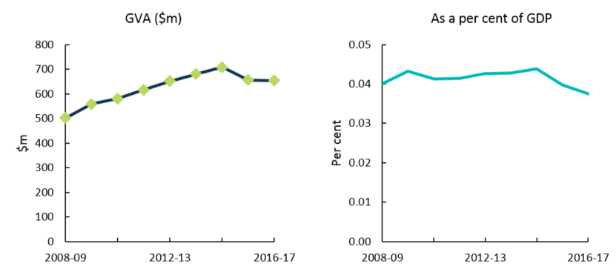Source: ABS cat. 5204, 5209; BCAR calculations

### Environmental heritage

Environmental heritage consists of:

* Zoological and botanical gardens operation which includes the active management, breeding, preservation, and study and exhibition of live plants and animals in a controlled environment such as zoological or botanical gardens;[17] and
* Nature reserves and conservation parks operation which is the preservation of flora and fauna in their natural environment such as in nature reserves and conservation parks.13

Government funding drives this domain’s performance and it is highly sensitive to changes in funding arrangements.[18] GVA of cultural and creative activity in environmental heritage increased by $295 million or 30.0 per cent from 2008-09 to 2016-17 while as a per cent of GDP, it has fallen slightly by the end of the period (Table 7 and Figure 17).

**Table 7.** Cultural and creative activity in environmental heritage, 2008-09 to 2016-17[19]

| **Environmental heritage** | **2008-09** | **2009-10** | **2010-11** | **2011-12** | **2012-13** | **2013-14** | **2014-15** | **2015-16** | **2016-17** |
| --- | --- | --- | --- | --- | --- | --- | --- | --- | --- |
| Output ($m) | 2,194 | 2,523 | 2,747 | 2,907 | 2,436 | 2,568 | 2,593 | 2,705 | 2,850 |
| COE ($m) | 421 | 452 | 493 | 526 | 433 | 442 | 426 | 450 | 459 |
| GOS and GMI ($m) | 604 | 682 | 685 | 724 | 907 | 960 | 1,012 | 910 | 900 |
| Taxes less subsidies on production ($m) | -42 | -39 | -43 | -45 | -65 | -70 | -53 | -77 | -81 |
| **GVA ($m)** | **983** | **1,094** | **1,135** | **1,206** | **1,275** | **1,331** | **1,385** | **1,283** | **1,278** |
| **As a per cent of GDP** | **0.08** | **0.08** | **0.08** | **0.08** | **0.08** | **0.08** | **0.09** | **0.08** | **0.07** |

Components of GDP are presented nominally. Further detail is provided at *Appendix D: Structure for cultural and creative activity of the domain tables*.

**Figure 17**. GVA, Cultural and creative activity in environmental heritage, 2008-09 to 2016-17

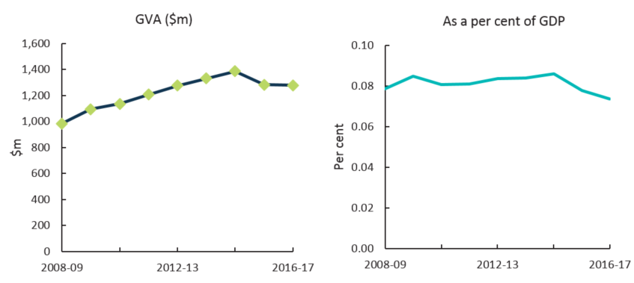Source: ABS cat. 5204, 5209; BCAR calculations

### Libraries and archives

The libraries and archives domain is engaged primarily in providing library or archive services. This includes maintaining the collections of documents (e.g. books, journals, newspapers and music) and facilitating the use of such documents (recorded information regardless of its physical form and characteristics).[20]

This domain is funded primarily by governments with most industry services provided to users free of charge. Government funding accounts for more than 90 per cent of revenue and the domain is therefore highly sensitive to changes in these funding arrangements.[21] The remaining share of industry revenue is typically derived from fees and charges, as well as from private funding and donations.16

GVA of cultural and creative activity in libraries and archives has increased by $252 million or 34.1 per cent from 2008-09 to 2016-17. However, as a share of GDP, it has remained relatively flat over the period (Table 8 and Figure 18).

**Table 8**. Cultural and creative activity in libraries and archives, 2008-09 to 2016-17[22]

| **Libraries and archives** | **2008-09** | **2009-10** | **2010-11** | **2011-12** | **2012-13** | **2013-14** | **2014-15** | **2015-16** | **2016-17** |
| --- | --- | --- | --- | --- | --- | --- | --- | --- | --- |
| Output ($m) | 1,303 | 1,308 | 1,424 | 1,507 | 1,428 | 1,447 | 1,449 | 1,521 | 1,603 |
| COE ($m) | 442 | 425 | 464 | 496 | 494 | 504 | 457 | 483 | 494 |
| GOS and GMI ($m) | 283 | 412 | 371 | 351 | 516 | 535 | 516 | 500 | 485 |
| Taxes less subsidies on production ($m) | 14 | 12 | 13 | 14 | 11 | 11 | 13 | 13 | 13 |
| **GVA ($m)** | **739** | **849** | **848** | **860** | **1,021** | **1,050** | **986** | **996** | **991** |
| **As a per cent of GDP** | **0.06** | **0.07** | **0.06** | **0.06** | **0.07** | **0.07** | **0.06** | **0.06** | **0.06** |

Components of GDP are presented nominally. Further detail is provided at *Appendix D: Structure for cultural and creative activity of the domain tables*.

**Figure 18.**GVA, Cultural and creative activity in libraries and archives, 2008-09 to 2016-17

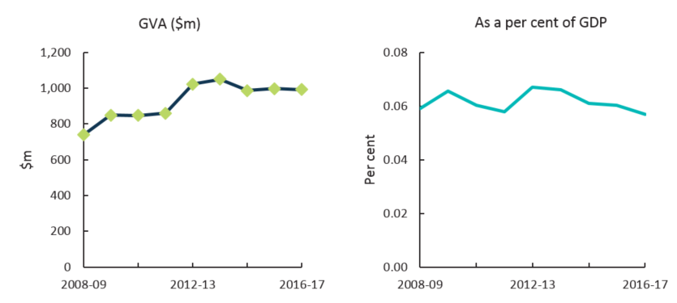Source: ABS cat. 5204, 5209; BCAR calculations

### Literature and print media

Literature and print media consists of:

* Printing which includes the operation of printing and providing reprographic services.[23]
* Printing support services which includes services such as pre-press, post‑press or finishing services.17
* Book and magazine wholesaling of books, periodicals and magazines.[24]
* Newspaper and book retailing of books, periodicals and newspapers.[25]
* Newspaper publishing which is the creating and disseminating of newspapers.[26]
* Magazine and other periodical publishing which is the creating and disseminating of magazines, journals and other periodicals.20
* Book publishing which is the creating and disseminating of books including atlases, textbooks and travel guides.[27]
* Other publishing (except software, music and internet) which includes the operation of other forms of creating and disseminating activities (except software, music and internet publishing) such as greeting card, postcard and art print publishing.21

Literature and print media has declined significantly over the period with increased overseas competition creating strong price pressures that have led to falling demand for domestically produced materials.[28] Another contributing factor has been consumers moving to online platforms to obtain their information. Online platforms provide information quicker to customers than traditional print materials and are more cost effective in distributing information.[29] As a result, online platforms are increasingly being used by businesses to interact and engage with their customers while traditional printing services being phased out.[30]

GVA of cultural and creative activity in literature and print media has declined by $3.4 billion or 26.6 per cent from 2008-09 to 2016-17. As a share of GDP, literature and print media has approximately halved during this period, from 1.0 per cent in 2008-09 to 0.5 per cent in 2016-17 (Table 9 and Figure 19).

**Table 9**. Cultural and creative activity in literature and print media, 2008-09 to 2016-17

| **Literature and print media** | **2008-09** | **2009-10** | **2010-11** | **2011-12** | **2012-13** | **2013-14** | **2014-15** | **2015-16** | **2016-17** |
| --- | --- | --- | --- | --- | --- | --- | --- | --- | --- |
| Output ($m) | 22,971 | 23,127 | 25,176 | 26,645 | 20,329 | 19,975 | 17,771 | 18,068 | 19,036 |
| COE ($m) | 6,361 | 6,008 | 6,552 | 7,001 | 6,007 | 5,836 | 5,881 | 5,757 | 5,878 |
| GOS and GMI ($m) | 6,158 | 5,931 | 5,443 | 5,225 | 4,561 | 3,869 | 3,770 | 3,365 | 3,247 |
| Taxes less subsidies on production ($m) | 250 | 231 | 251 | 266 | 225 | 238 | 263 | 234 | 246 |
| **GVA ($m)** | **12,770** | **12,170** | **12,247** | **12,492** | **10,793** | **9,942** | **9,915** | **9,356** | **9,371** |
| **As a per cent of GDP** | **1.02** | **0.94** | **0.87** | **0.84** | **0.71** | **0.63** | **0.61** | **0.57** | **0.54** |

Components of GDP are presented nominally. Further detail is provided at *Appendix D: Structure for cultural and creative activity of the domain tables*.

**Figure 19**. GVA, Cultural and creative activity in literature and print media, 2008-09 to 2016-17

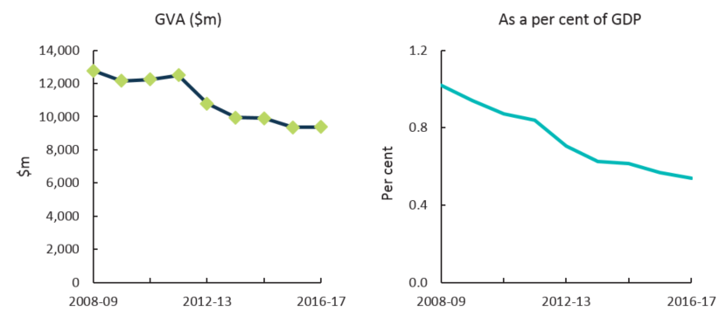Source: ABS cat. 5204, 5209; BCAR calculations

Literature and print media is a domain that has different outcomes for the segments of cultural activity and creative activity. Each segment is showing a similar decline to cultural and creative activity in literature and print media. The outcomes for cultural activity during the period from 2008‑09 to 2016-17 are presented in Table 10 and creative activity in Table 11.

**Table 10**. Cultural activity in literature and print media, 2008-09 to 2016-17

| **Literature and print media** | **2008-09** | **2009-10** | **2010-11** | **2011-12** | **2012-13** | **2013-14** | **2014-15** | **2015-16** | **2016-17** |
| --- | --- | --- | --- | --- | --- | --- | --- | --- | --- |
| Output ($m) | 22,547 | 22,720 | 24,733 | 26,176 | 19,961 | 19,595 | 17,486 | 17,763 | 18,714 |
| COE ($m) | 6,206 | 5,860 | 6,391 | 6,828 | 5,872 | 5,703 | 5,745 | 5,628 | 5,746 |
| GOS and GMI ($m) | 6,087 | 5,853 | 5,387 | 5,183 | 4,490 | 3,817 | 3,732 | 3,321 | 3,211 |
| Taxes less subsidies on production ($m) | 246 | 245 | 256 | 265 | 241 | 247 | 263 | 254 | 261 |
| **GVA ($m)** | **12,539** | **11,957** | **12,034** | **12,276** | **10,603** | **9,768** | **9,740** | **9,203** | **9,219** |
| **As a per cent of GDP** | **1.00** | **0.92** | **0.86** | **0.82** | **0.69** | **0.62** | **0.60** | **0.56** | **0.53** |

**Table 11.** Creative activity in literature and print media, 2008-09 to 2016-17

| **Literature and print media** | **2008-09** | **2009-10** | **2010-11** | **2011-12** | **2012-13** | **2013-14** | **2014-15** | **2015-16** | **2016-17** |
| --- | --- | --- | --- | --- | --- | --- | --- | --- | --- |
| Output ($m) | 12,202 | 12,567 | 13,680 | 14,478 | 9,772 | 9,100 | 8,874 | 8,508 | 8,964 |
| COE ($m) | 2,930 | 2,644 | 2,883 | 3,080 | 2,693 | 2,538 | 2,504 | 2,432 | 2,483 |
| GOS and GMI ($m) | 4,601 | 4,561 | 4,311 | 4,220 | 3,258 | 2,811 | 2,780 | 2,655 | 2,579 |
| Taxes less subsidies on production ($m) | 115 | 115 | 115 | 116 | 115 | 115 | 115 | 115 | 115 |
| **GVA ($m)** | **7,646** | **7,319** | **7,309** | **7,416** | **6,066** | **5,464** | **5,400** | **5,202** | **5,177** |
| **As a per cent of GDP** | **0.61** | **0.57** | **0.52** | **0.50** | **0.40** | **0.34** | **0.33** | **0.31** | **0.30** |

### Performing arts

Performing arts consists of:

* Performing arts operations which provide or produce live theatrical or musical presentations or performances.[31]
* Creative artists, musicians, writers and performers who are independent (freelance) individuals or groups mainly engaged in the regular creation of original artistic or cultural works who may or may not also produce and perform their works. This includes providing independent technical expertise necessary for these productions, and celebrities mainly engaged in endorsing products or making speeches or public appearances for which they receive a fee.25
* Performing arts venue operations of venues for the presentation and rehearsal of performing arts.[32]

Many business entities that engage in performing arts operations rely on government funding in addition to other sources of revenue.[33] This enables them to produce a diversity of works and to provide some services to users free of charge. However, other business entities, such as contemporary music producers, achieve higher profit margins by providing services to large audiences.27

GVA of cultural and creative activity in performing arts has experienced growth of $403 million or 30.0 per cent from 2008-09 to 2016-17. However, as a share of GDP, it has fallen slightly over the period (Table 12 and Figure 20).

**Table 12.** Cultural and creative activity in performing arts, 2008-09 to 2016-17[34]

| **Performing arts** | **2008-09** | **2009-10** | **2010-11** | **2011-12** | **2012-13** | **2013-14** | **2014-15** | **2015-16** | **2016-17** |
| --- | --- | --- | --- | --- | --- | --- | --- | --- | --- |
| Output ($m) | 3,140 | 3,612 | 3,931 | 4,161 | 3,486 | 3,676 | 3,712 | 3,872 | 4,080 |
| COE ($m) | 692 | 742 | 809 | 865 | 711 | 727 | 699 | 739 | 754 |
| GOS and GMI ($m) | 713 | 810 | 805 | 849 | 1,126 | 1,195 | 1,271 | 1,125 | 1,109 |
| Taxes less subsidies on production ($m) | -59 | -55 | -60 | -64 | -92 | -99 | -75 | -108 | -114 |
| **GVA ($m)** | **1,346** | **1,497** | **1,554** | **1,650** | **1,744** | **1,822** | **1,895** | **1,756** | **1,749** |
| **As a per cent of GDP** | **0.11** | **0.12** | **0.11** | **0.11** | **0.11** | **0.11** | **0.12** | **0.11** | **0.10** |

Components of GDP are presented nominally. Further detail is provided at *Appendix D: Structure for cultural and creative activity of the domain tables*.

**Figure 20**. GVA, Cultural and creative activity in performing arts, 2008-09 to 2016-17

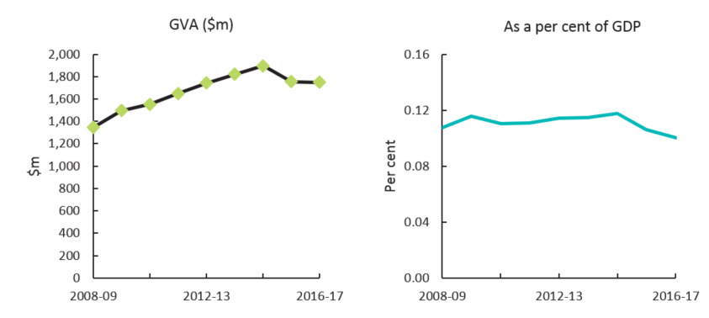Source: ABS cat. 5204, 5209; BCAR calculations

### Design

Design consists of:

* Architectural services such as planning and designing buildings and structures; or planning and designing the development of land.[35]
* Other specialised design services that are not elsewhere classified.[36]
* Advertising services such as the creation of advertising campaigns and materials; and media planning and buying (i.e. placing advertisements).[37]
* Computer systems design and related services which is providing expertise in the field of information technologies such as writing, modifying, testing or supporting software to meet the needs of a particular consumer; or planning and designing computer systems that integrate computer hardware, software and communication technologies.[38]

Design is the largest domain of cultural and creative activity. It has increased as a share of GDP by over 0.3 percentage points over the period. The growth is driven mainly by computer systems design and related services. Workplaces have increased their use of information technology in their processes which have then required regular upgrades and enhancements. Furthermore, financial services providers such as banks and insurers, have increased their use of online platforms to engage with their clients.[39]

GVA of cultural and creative activity in design has experienced significant growth of $16.2 billion or 60.7 per cent from 2008-09 to 2016-17 (Table 13 and Figure 21).

**Table 13**. Cultural and creative activity in design, 2008-09 to 2016-17[40]

| **Design** | **2008-09** | **2009-10** | **2010-11** | **2011-12** | **2012-13** | **2013-14** | **2014-15** | **2015-16** | **2016-17** |
| --- | --- | --- | --- | --- | --- | --- | --- | --- | --- |
| Output ($m) | 55,027 | 59,193 | 64,437 | 68,196 | 72,782 | 74,024 | 75,733 | 80,371 | 84,677 |
| COE ($m) | 19,194 | 19,500 | 21,267 | 22,723 | 25,775 | 26,018 | 26,938 | 29,608 | 30,230 |
| GOS and GMI ($m) | 6,662 | 10,286 | 10,861 | 12,485 | 9,794 | 9,599 | 10,227 | 7,524 | 11,493 |
| Taxes less subsidies on production ($m) | 791 | 757 | 824 | 872 | 855 | 895 | 980 | 1,034 | 1,090 |
| **GVA ($m)** | **26,647** | **30,543** | **32,952** | **36,080** | **36,425** | **36,512** | **38,146** | **38,167** | **42,813** |
| **As a per cent of GDP** | **2.13** | **2.36** | **2.34** | **2.42** | **2.39** | **2.30** | **2.36** | **2.31** | **2.46** |

Components of GDP are presented nominally. Further detail is provided at *Appendix D: Structure for cultural and creative activity of the domain tables*.

**Figure 21**. GVA, Cultural and creative activity in design, 2008-09 to 2016-17

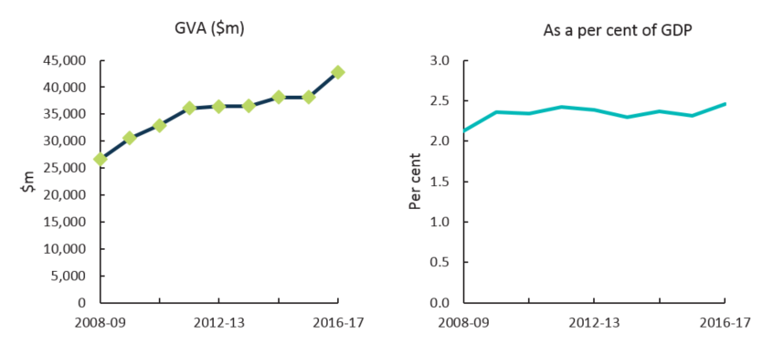Source: ABS cat. 5204, 5209; BCAR calculations

Cultural activity in design, increased from $8.2 billion in 2008-09 to $13.4 billion in 2016-17 (Table 14).

**Table 14.** Cultural activity in design, 2008-09 to 2016-17viii

| **Design** | **2008-09** | **2009-10** | **2010-11** | **2011-12** | **2012-13** | **2013-14** | **2014-15** | **2015-16** | **2016-17** |
| --- | --- | --- | --- | --- | --- | --- | --- | --- | --- |
| Output ($m) | 22,471 | 22,910 | 24,939 | 26,394 | 26,548 | 27,805 | 28,148 | 29,283 | 30,852 |
| COE ($m) | 5,866 | 5,939 | 6,477 | 6,921 | 8,073 | 8,452 | 8,449 | 9,700 | 9,904 |
| GOS and GMI ($m) | 1,998 | 2,751 | 2,923 | 3,401 | 3,160 | 2,735 | 2,918 | 1,942 | 3,193 |
| Taxes less subsidies on production ($m) | 307 | 307 | 307 | 307 | 307 | 307 | 307 | 307 | 307 |
| **GVA ($m)** | **8,171** | **8,998** | **9,707** | **10,629** | **11,540** | **11,494** | **11,674** | **11,949** | **13,404** |
| **As a per cent of GDP** | **0.65** | **0.70** | **0.69** | **0.71** | **0.76** | **0.72** | **0.72** | **0.72** | **0.77** |

### Broadcasting, electronic or digital media, and film

Broadcasting, electronic or digital media, and film consists of:

* Software publishing which is the creation and dissemination of ready-made (non-customised) computer software.[41]
* Motion picture and video production which is the production of motion pictures, videos and television programs or commercials.[42]
* Motion picture and video distribution which is the acquiring of distribution rights and distribution of motion pictures and videos.34
* Motion picture exhibition which is the screening of motion pictures using a variety of visual media.[43]
* Post-production services and other motion picture and video activities including specialised motion picture or video post-production services such as editing, film/tape transfers, titling, subtitling, credits, closed captioning and computer-produced graphics, animation and special effects, as well as developing and processing motion picture film.35
* Radio broadcasting which is the broadcasting of audio signals, using radio broadcasting studios and facilities, to transmit aerial programming.[44]
* Free-to-air television broadcasting which is engaged in free-to-air television broadcast of visual content, in the form of electronic images together with sound, through broadcast studios and facilities.36
* Cable and other subscription broadcasting which is the broadcast of television programs on a subscription or fee basis to viewers.36
* Internet publishing and broadcasting which is the publishing and broadcast of content on the internet.[45]
* Video and other electronic media rental and hiring which is the rental or hire of pre‑recorded video tapes, discs and other electronic media.[46]

Free-to-air television broadcasting, and cable and other subscription broadcasting are the two main contributors to this domain. While these two components have grown over the period, they may face future challenges as Australians consume content on a range of different platforms.[47]

GVA of cultural and creative activity in this domain has increased by $2.4 billion or 32.2 per cent from 2008-09 to 2016-17. While broadcasting, electronic or digital media, and film has increased in absolute terms, it has remained relatively flat as a share of GDP over the period (Table 15 and Figure 22).

**Table 15.** Cultural and creative activity in broadcasting, electronic or digital media, and film, 2008-09 to 2016-17[48]

| **Broadcasting, electronic or digital media, and film** | **2008-09** | **2009-10** | **2010-11** | **2011-12** | **2012-13** | **2013-14** | **2014-15** | **2015-16** | **2016-17** |
| --- | --- | --- | --- | --- | --- | --- | --- | --- | --- |
| Output ($m) | 18,235 | 19,328 | 21,040 | 22,267 | 22,076 | 21,703 | 22,996 | 23,970 | 25,254 |
| COE ($m) | 3,659 | 3,891 | 4,244 | 4,534 | 4,444 | 4,434 | 4,671 | 4,998 | 5,103 |
| GOS and GMI ($m) | 3,503 | 4,195 | 3,823 | 3,662 | 4,213 | 4,219 | 4,373 | 4,517 | 4,357 |
| Taxes less subsidies on production ($m) | 179 | 188 | 205 | 217 | 197 | 209 | 232 | 235 | 247 |
| **GVA ($m)** | **7,341** | **8,275** | **8,271** | **8,413** | **8,853** | **8,862** | **9,276** | **9,750** | **9,707** |
| **As a per cent of GDP** | **0.59** | **0.64** | **0.59** | **0.56** | **0.58** | **0.56** | **0.57** | **0.59** | **0.56** |

Components of GDP are presented nominally. Further detail is provided at *Appendix D: Structure for cultural and creative activity of the domain tables*.

**Figure 22**. GVA, Cultural and creative activity in broadcasting, electronic or digital media, and film, 2008‑09 to 2016-17

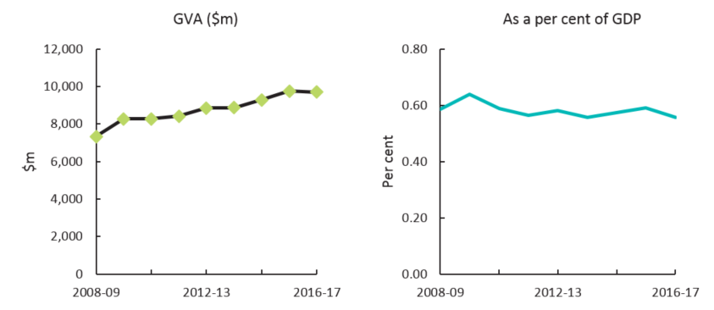Source: ABS cat. 5204, 5209; BCAR calculations

Creative activity in broadcasting, electronic or digital media, and film, increased from $7.2 billion in 2008-09 to $9.6 billion in 2016-17 (Table 14).

**Table 16**. Creative activity in broadcasting, electronic or digital media, and film, 2008-09 to 2016-17ix

| **Broadcasting, electronic or digital media, and film** | **2008-09** | **2009-10** | **2010-11** | **2011-12** | **2012-13** | **2013-14** | **2014-15** | **2015-16** | **2016-17** |
| --- | --- | --- | --- | --- | --- | --- | --- | --- | --- |
| Output ($m) | 17,702 | 18,784 | 20,448 | 21,641 | 21,393 | 21,025 | 22,336 | 23,325 | 24,575 |
| COE ($m) | 3,455 | 3,693 | 4,027 | 4,303 | 4,168 | 4,154 | 4,395 | 4,718 | 4,817 |
| GOS and GMI ($m) | 3,591 | 4,266 | 3,919 | 3,763 | 4,352 | 4,391 | 4,561 | 4,715 | 4,568 |
| Taxes less subsidies on production ($m) | 175 | 175 | 175 | 175 | 175 | 175 | 175 | 175 | 175 |
| **GVA ($m)** | **7,220** | **8,133** | **8,121** | **8,241** | **8,695** | **8,720** | **9,131** | **9,607** | **9,559** |
| **As a per cent of GDP** | **0.58** | **0.63** | **0.58** | **0.55** | **0.57** | **0.55** | **0.57** | **0.58** | **0.55** |

### Music composition and publishing

Music composition and publishing consists of:

* Music publishing which is the acquisition and registration of copyright for musical compositions and the promotion and authorisation of the use of these compositions in recordings, radio, television, motion pictures, live performances, print, or other media.[49]
* Music and other sound recording activities which is the production of original (sound) master recordings such as tapes and CDs and the release and distribution of them to wholesalers, retailers or directly to the public. This also includes the operation of sound recording studios and in the production of pre-recorded radio programs.[50]

Music composition and publishing is a relatively small domain comprising less than 0.01 per cent of GDP. Technological changes have affected this domain’s performance as consumers have adopted new ways of obtaining and streaming music content through online formats.[51] This is evident as business entities have moved towards an online distribution model and reduced the production of physical music content.42

New online copyright infringement legislation, lower pricing and increased online availability have decreased the amount of music consumed unlawfully over the past few years.[52] The move towards publishing music online has created challenges for musicians in obtaining royalties from their work. This concern has seen a rise in membership of copyright collecting societies with around 74 per cent of musicians currently members in Australia.[53] Alongside these changes, music composition and publishing has outpaced the economy since 2014-15 (see Figure 15).

GVA of cultural and creative activity in this domain increased by $43 million or 41.1 per cent from 2008‑09 to 2016-17 (Table 17 and Figure 23).

**Table 17**. Cultural and creative activity in music composition and publishing, 2008-09 to 2016-17[54]

| **Music composition and publishing** | **2008-09** | **2009-10** | **2010-11** | **2011-12** | **2012-13** | **2013-14** | **2014-15** | **2015-16** | **2016-17** |
| --- | --- | --- | --- | --- | --- | --- | --- | --- | --- |
| Output ($m) | 323 | 346 | 377 | 399 | 433 | 418 | 467 | 494 | 521 |
| COE ($m) | 73 | 84 | 92 | 98 | 96 | 98 | 102 | 113 | 116 |
| GOS and GMI ($m) | 28 | 29 | 21 | 16 | 24 | 26 | 21 | 29 | 26 |
| Taxes less subsidies on production ($m) | 4 | 5 | 5 | 6 | 5 | 6 | 6 | 6 | 7 |
| **GVA ($m)** | **105** | **119** | **118** | **120** | **125** | **129** | **130** | **149** | **148** |
| **As a per cent of GDP** | **0.01** | **0.01** | **0.01** | **0.01** | **0.01** | **0.01** | **0.01** | **0.01** | **0.01** |

Components of GDP are presented nominally. Further detail is provided at *Appendix D: Structure for cultural and creative activity of the domain tables*.

**Figure 23.** GVA, Cultural and creative activity in music composition and publishing,2008-09 to 2016-17

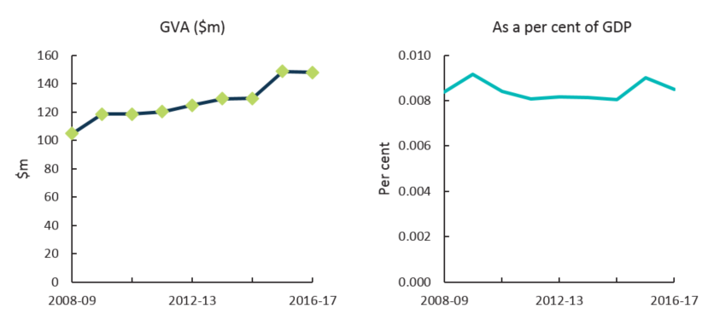Source: ABS cat. 5204, 5209; BCAR calculations

### Visual arts and crafts

Visual arts and crafts consists of:

* Jewellery and silverware manufacturing using precious or semi‑precious metal and stones, and the cutting of such stones. This includes manufacturing custom-made or costume jewellery, trophies, badges or medals, or minting coins.[55]
* Jewellery and watch wholesaling of watches or clocks (including parts), jewellery, precious stones or precious metals.[56]
* Watch and jewellery retailing of new watches and jewellery (except clocks and silverware).[57]
* Professional photographic services of providing still, video or computer photography services, and includes the video taping of special events such as weddings.[58]

GVA of cultural and creative activity in this domain has experienced growth of $657 million or 36.1 per cent from 2008-09 to 2016-17. Watch and jewellery retailing is the largest contributor to this growth, followed by professional photographic services. While visual arts and crafts have increased in absolute terms, it has remained relatively flat as a share of GDP over the period (Table 18 and Figure 24).

**Table 18.** Cultural and creative activity in visual arts and crafts, 2008-09 to 2016-17[59]

| **Visual arts and crafts** | **2008-09** | **2009-10** | **2010-11** | **2011-12** | **2012-13** | **2013-14** | **2014-15** | **2015-16** | **2016-17** |
| --- | --- | --- | --- | --- | --- | --- | --- | --- | --- |
| Output ($m) | 3,834 | 3,962 | 4,313 | 4,565 | 4,391 | 4,354 | 4,403 | 4,697 | 4,949 |
| COE ($m) | 1,227 | 1,246 | 1,359 | 1,452 | 1,491 | 1,520 | 1,552 | 1,690 | 1,726 |
| GOS and GMI ($m) | 537 | 582 | 578 | 623 | 683 | 605 | 626 | 608 | 681 |
| Taxes less subsidies on production ($m) | 58 | 57 | 62 | 66 | 59 | 63 | 69 | 70 | 74 |
| **GVA ($m)** | **1,823** | **1,885** | **1,999** | **2,141** | **2,234** | **2,188** | **2,248** | **2,368** | **2,480** |
| **As a per cent of GDP** | **0.15** | **0.15** | **0.14** | **0.14** | **0.15** | **0.14** | **0.14** | **0.14** | **0.14** |

Components of GDP are presented nominally. Further detail is provided at *Appendix D: Structure for cultural and creative activity of the domain tables*.

**Figure 24**. GVA, Cultural and creative activity in visual arts and crafts, 2008-09 to 2016-17

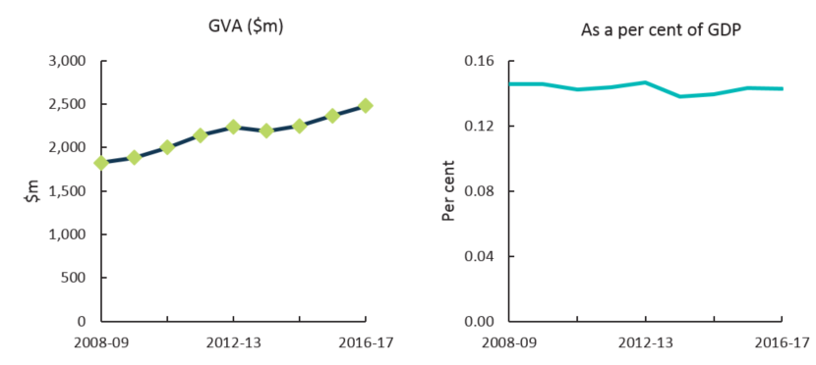Source: ABS cat. 5204, 5209; BCAR calculations

### Fashion

Fashion consists of:

* Clothing manufacturing (except knitted clothing) which includes clothing trade services such as hem stitching, basque knitting or buttonholing.[60]
* Footwear manufacturing of footwear or footwear components such as uppers and upper parts, and outer and inner soles and heels.[61]
* Clothing and footwear wholesaling.[62]
* Clothing retailing of clothing or clothing accessories.[63]
* Footwear retailing of boots, shoes or other footwear.51

Cultural and creative activity in fashion has increased in absolute terms, due to growth in clothing and footwear wholesaling and retailing. However, these industries have faced a challenging operating environment with greater overseas competition and higher onshore rental costs.[64]

GVA of cultural and creative activity in fashion has increased by $2.4 billion or 20.3 per cent from 2008‑09 to 2016-17. However, as a per cent of GDP, this domain has fallen by 0.13 percentage points from 0.95 per cent in 2008-09 to 0.82 per cent in 2016-17 (Table 19 and Figure 25).

**Table 19**. Cultural and creative activity in fashion, 2008-09 to 2016-17[65]

| **Fashion** | **2008-09** | **2009-10** | **2010-11** | **2011-12** | **2012-13** | **2013-14** | **2014-15** | **2015-16** | **2016-17** |
| --- | --- | --- | --- | --- | --- | --- | --- | --- | --- |
| Output ($m) | 20,164 | 21,205 | 23,084 | 24,430 | 22,001 | 21,313 | 21,430 | 22,502 | 23,708 |
| COE ($m) | 6,627 | 6,613 | 7,212 | 7,706 | 7,606 | 7,516 | 7,712 | 8,028 | 8,197 |
| GOS and GMI ($m) | 4,887 | 5,323 | 5,363 | 5,656 | 5,205 | 5,211 | 5,182 | 5,501 | 5,643 |
| Taxes less subsidies on production ($m) | 329 | 325 | 354 | 374 | 331 | 350 | 389 | 388 | 408 |
| **GVA ($m)** | **11,843** | **12,261** | **12,928** | **13,736** | **13,143** | **13,076** | **13,282** | **13,917** | **14,249** |
| **As a per cent of GDP** | **0.95** | **0.95** | **0.92** | **0.92** | **0.86** | **0.82** | **0.82** | **0.84** | **0.82** |

Components of GDP are presented nominally. Further detail is provided at *Appendix D: Structure for cultural and creative activity of the domain tables*.

**Figure 25**. GVA, Cultural and creative activity in fashion, 2008-09 to 2016-17

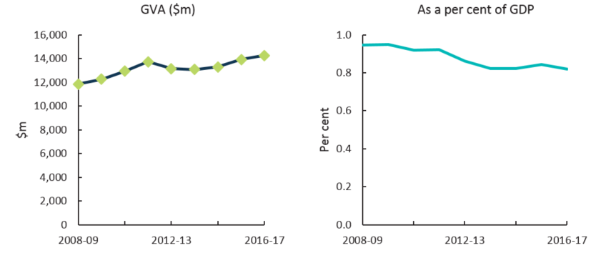Source: ABS cat. 5204, 5209; BCAR calculations

### Other culture goods manufacturing and sales

Other culture goods manufacturing and sales consists of:

* Reproduction of recorded media which is mainly the reproduction of pre-recorded audio, video, software and other data on electronic, optical and magnetic media.[66]
* Entertainment media retailing which includes audio tapes, compact discs, computer games, digital versatile discs or video cassettes.[67]

Other culture goods manufacturing and sales is primarily driven by the entertainment media retailing industry. This industry is affected by the increased use of digital formats as consumers adopt new ways of obtaining and streaming media content and the increased popularity of online shopping.[68]

GVA of cultural and creative activity in this domain has increased by $112 million or 12.6 per cent from 2008-09 to 2016-17. However, as a share of GDP, it has remained relatively flat over the period (Table 20 and Figure 26).

**Table 20**. Cultural and creative activity in other culture goods manufacturing and sales, 2008-09 to 2016-17[69]

| **Other culture goods manufacturing and sales** | **2008-09** | **2009-10** | **2010-11** | **2011-12** | **2012-13** | **2013-14** | **2014-15** | **2015-16** | **2016-17** |
| --- | --- | --- | --- | --- | --- | --- | --- | --- | --- |
| Output ($m) | 2,540 | 2,523 | 2,747 | 2,907 | 2,583 | 2,629 | 2,225 | 2,405 | 2,534 |
| COE ($m) | 508 | 511 | 557 | 595 | 560 | 560 | 574 | 593 | 605 |
| GOS and GMI ($m) | 350 | 347 | 339 | 353 | 382 | 365 | 362 | 349 | 359 |
| Taxes less subsidies on production ($m) | 36 | 35 | 39 | 41 | 35 | 37 | 41 | 39 | 41 |
| **GVA ($m)** | **893** | **893** | **934** | **989** | **977** | **962** | **977** | **981** | **1,005** |
| **As a per cent of GDP** | **0.07** | **0.07** | **0.07** | **0.07** | **0.06** | **0.06** | **0.06** | **0.06** | **0.06** |

Components of GDP are presented nominally. Further detail is provided at *Appendix D: Structure for cultural and creative activity of the domain tables*.

**Figure 26**. GVA, Cultural and creative activity in other culture goods manufacturing and sales, 2008-09 to 2016-17

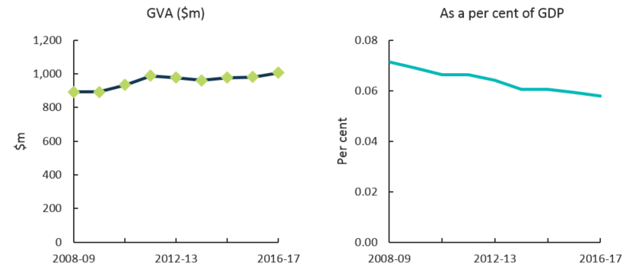Source: ABS cat. 5204, 5209; BCAR calculations

### Supporting activities

Supporting activities consists of providing arts education which is engaged mainly in providing non‑vocational instruction in the arts, including art, dance, drama and music.[70]

Operators within arts education are typically independent small enterprises and may be attached to schools.[71] GVA for supporting activities increased by $445 million or 57.2 per cent from 2008-09 to 2016-17 while as a share of GDP, it has remained relatively flat over the period (Table 21 and Figure 27).

**Table 21.** Cultural and creative activity in supporting activities, 2008-09 to 2016-17[72]

| **Supporting activities** | **2008-09** | **2009-10** | **2010-11** | **2011-12** | **2012-13** | **2013-14** | **2014-15** | **2015-16** | **2016-17** |
| --- | --- | --- | --- | --- | --- | --- | --- | --- | --- |
| Output ($m) | 1,057 | 1,142 | 1,243 | 1,316 | 1,418 | 1,494 | 1,564 | 1,763 | 1,857 |
| COE ($m) | 666 | 726 | 792 | 846 | 917 | 955 | 995 | 1,044 | 1,066 |
| GOS and GMI ($m) | 105 | 116 | 129 | 124 | 104 | 116 | 121 | 120 | 146 |
| Taxes less subsidies on production ($m) | 9 | 12 | 13 | 13 | 11 | 12 | 10 | 12 | 13 |
| **GVA ($m)** | **779** | **853** | **933** | **984** | **1,032** | **1,082** | **1,126** | **1,176** | **1,225** |
| **As a per cent of GDP** | **0.06** | **0.07** | **0.07** | **0.07** | **0.07** | **0.07** | **0.07** | **0.07** | **0.07** |

Components of GDP are presented nominally. Further detail is provided at *Appendix D: Structure for cultural and creative activity of the domain tables*.

**Figure 27**. GVA, Cultural and creative activity in supporting activities, 2008-09 to 2016-17

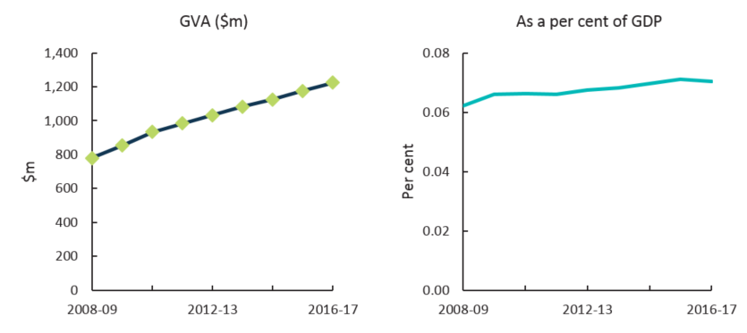Source: ABS cat. 5204, 5209; BCAR calculations

## Appendix A: Methodology

Components of cultural and creative activity

The ABS published *Australian National Accounts: Cultural and creative activity Satellite Accounts, Experiment* (cat. no. 5271.0) in 2014. This publication measured the economic contribution of cultural and creative activity on a satellite accounts basis in Australia. The satellite accounts consists of two boundaries: the national accounts basis and an extension beyond the national accounts production (as shown in Figure A1).[73] National accounts basis refers to those activities that fall within the national accounts production boundary, while the extension beyond the national accounts production boundary provides a more complete picture of the value of cultural and creative activity to society.58

Within the national accounts production boundary, the economic contribution of this activity is split into two components (as specified in the Satellite Accounts 5271.0):

* **Component 1** is activity in industries which form the supply chains for cultural and creative goods and services. This component comprises gross value added and net taxes on products of cultural and creative industries.
* **Component 2** is activity in other industries performed by workers in cultural and creative occupations. This component comprises cultural and creative activity being carried out by people employed in industries outside the supply chains defined in component 1.

Outside national accounts, cultural and creative activity is measured by (also consistent with the Satellite Accounts 5271.0):

* **Component 3** is volunteer services to arts and heritage organisations. The ABS has measured this component by using the ‘replacement cost’ method, whereby each hour of a volunteer’s time is valued at what it would cost to replace with a paid hour.
* **Component 4** is non-market output of market producers in the cultural and/or creative industries. The ABS has measured this component by valuing the production of market non-profit institutions in cultural and creative industries.

**Figure A 1**. Boundary for cultural and creative activity satellite accounts

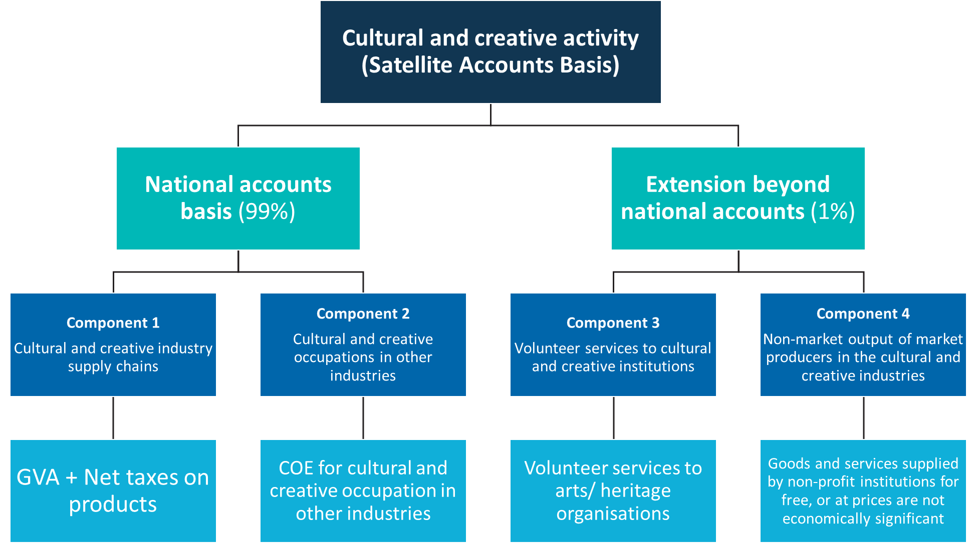

Methodology used by Bureau of Communication and Arts Research (BCAR) in 2018

**Component 1: Cultural and creative industry supply chains**

| **Indicator** | **BCAR 2018 Methodology** |
| --- | --- |
| GVA of cultural and creative industries | 1. Replicate Satellite Accounts (5271.0) cultural and creative proportions within individual Input-Output Industry Groups (IOIG) for the 2008-09 year. This sets up 2008-09 as the base year, and aligns the GVA with 5271.0. 2. Apply the current price movement from the 2016-17 publication of *Australian System of National Accounts* (5204.0) to step 1. This will generate the time series from 2008-09 to 2016-17 as well as incorporate any revisions during the period. 3. Split total GVA into IOIGs by using the proportions from each corresponding Input-Output table (5209.0). 4. Apply cultural and creative ratios to every financial year to derive each cultural and creative industry GVA. 5. Aggregate all cultural and creative industry GVAs. |
| Net taxes on products of cultural and creative industries | 1. Replicate Satellite Accounts (5271.0) cultural and creative proportions within individual IOIG for the 2008-09 year. This sets up 2008-09 as the base year, and aligns the net taxes on products with 5271.0. 2. Apply the current price movement from the 2016-17 publication of *Australian System of National Accounts* (5204.0) to step 1. This will generate the time series from 2008-09 to 2016-17 as well as incorporate any revisions during the period. 3. Split total net taxes on products into IOIGs by using the proportions from Input-Output tables (5209.0). 4. Apply cultural and creative ratio to every financial year, to derive cultural and creative activity net taxes on products for each industry. 5. Aggregate the net taxes on products for all cultural and creative industries. 6. Apply the below ratio to Gross Fixed Capital Formation (Private) and Exports 7. Add figures from Step 5 and Step 6 to generate the total of net taxes on products for cultural and creative activity |

**Component 2: Cultural and creative occupations in other industries**

| **Indicator** | **BCAR 2018 Methodology** |
| --- | --- |
| COE for cultural and creative occupations in other industries | 1. Replicate 2008-09 Satellite Accounts (5271.0) cultural and creative proportions of COE[74] for cultural and creative occupations in other industries by industry division. This sets up 2008-09 as the base year, and aligns the COE for cultural and creative occupations in other industries with 5271.0. 2. Apply the proportions from step 1 to the COE data for financial years after 2008-09. |

**Component 3: Volunteer services to cultural and creative institutions**

| **Indicator** | **BCAR 2018 Methodology** |
| --- | --- |
| Volunteer services to arts/ heritage organisations | The current approach assumes that the volunteer services to arts/heritage organisations retains a constant share of total cultural and creative activity on a national accounts basis over the period. |

**Component 4: Non-market output of market producers in the cultural and creative industries**

| **Indicator** | **BCAR 2018 Methodology** |
| --- | --- |
| Non-market output of market producers in the cultural and creative industries | The current approach assumes that non-market output of market producers in the cultural and creative industries retains a constant share of total cultural and creative activity on a national accounts basis over the period. |

Differences from ABS methodology

**Net taxes on products for cultural and creative industries**

The BCAR used a different methodology from the ABS to calculate net taxes on products when the segments of cultural and creative activity are measured separately due to the unavailability of data. Net taxes on products for cultural and creative activity, in total, is consistent with what was published in the Satellite Accounts, as shown in Table A2.

**Table A1**. BCAR’s approach to calculating net taxes on products, 2008‑09.

| **Net taxes on products of cultural and creative industries in 2008-09** | **BCAR calculations ($m)** |
| --- | --- |
| Net taxes on products of C&C activity - Total industries (a) | **518** |
| Total net taxes on products for C&C related IOIGs (b) | 1,995 |
| *(c ) = % of (a)/(b)* | 26% |
| Net taxes on products - Total GFCF-Private (d) | 17,714 |
| Net taxes on products - C&C activity GFCF- Private (e) *(e ) = (c ) x (d)* | **4,603** |
| Net taxes on products - Total Export (f) | -592 |
| Net taxes on products - C&C activity Export  *(g) = (c ) x (f)* | **-154** |
| Total net taxes on products of cultural and creative industries (h) **(h) = (a) + (e )+ (g)** | **4,967** |

**Table A2.** Comparison of ABS andBCAR calculations, net taxes on products of cultural and creative industries, 2008-09.

| **By segment** | **ABS calculations ($m)** | **BCAR calculations ($m)** |
| --- | --- | --- |
| **Cultural (a)** | -2,615 | 469 |
| **Creative (b)** | 2,618 | 437 |
| **Both(c)** | 4,964 | 4,062 |
| **Total cultural and creative activity *(a)+(b)+(c )*** | **4,967** | 4,967 |

| **By activity** | **ABS calculations ($m)** | **BCAR calculations ($m)** |
| --- | --- | --- |
| **Cultural activity (a)+(c )** | 2,349 | 4,531 |
| **Creative activity (b)+(c )** | 7,582 | 4,499 |
| **Total cultural and creative activity *(a)+(b)+(c )*** | **4,967** | 4,967 |

**Imputed COE for cultural and creative occupations in other industries**

The BCAR used a different methodology from the ABS to calculate COE of cultural or creative occupations in non-cultural or non-creative industries in two industry divisions. These divisions were Division G: Retail Trade and Division M: Professional, Scientific and Technical Services (as shown in Table A3). The BCAR deviated from the ABS figures in these industry divisions because either cultural occupations or creative occupations exceeded 100 per cent of the total. The BCAR was also unable to replicate the ABS figures because of unavailability of data.

**Table A3.** Comparison of ABS andBCAR calculations, cultural and creative activity, imputed COE, Division G and Division M, 2008-09.

| **Division G Retail Trade** | **ABS calculations ($m)** | **BCAR calculations ($m)** |
| --- | --- | --- |
| **Cultural** occupations in non-cultural industries | 697 | 595 |
| **Creative** occupations in non-creative industries | 587 | 676 |
| **Cultural and creative** occupations in non-cultural and creative industries | 693 | 693 |

| **Division M Professional, Scientific and Technical Services** | **ABS calculations ($m)** | **BCAR calculations ($m)** |
| --- | --- | --- |
| **Cultural** occupations in non-cultural industries | 1,787 | 1,050 |
| **Creative** occupations in non-creative industries | 1,077 | 949 |
| **Cultural and creative** occupations in non-cultural and creative industries | 1,184 | 1,184 |

To derive the figures for Division G and Division M, the BCAR analysed the listing of which industries were in or out of scope. This can be found at Table 17 in the ABS Satellite Accounts (5271.0).

The COE received by individuals working in cultural occupations outside of cultural industries is derived from:

* Cultural occupations in creative industries;
* Cultural occupations in non-cultural and creative industries. The ABS Satellite Accounts identified these industries as “out of scope”; and
* Occupations identified as both cultural and creative in non-cultural and creative industries (also identified as “out of scope”).

Similarly, the COE received by individuals working in creative occupations outside the creative industries comprises of:

* Creative occupations in cultural industries
* Creative occupations in non-cultural and creative industries (“out of scope”); and
* Occupations identified as both cultural and creative in non-cultural and creative industries (also identified as “out of scope”).

**Figure A 2**. BCAR calculations, cultural and creative activity, imputed COE for Division G and M.

This is a hierarchy graph showing BCAR’s methodology for calculating COE of cultural or creative occupations in non-cultural or non-creative industries in Division G and M. 
The COE received by individuals working in cultural occupations outside of cultural industries is derived from:
• Cultural occupations in creative industries; 
• Cultural occupations in non-cultural and creative industries. The ABS Satellite Accounts identified these industries as “out of scope”; and
• Occupations identified as both cultural and creative in non-cultural and creative industries (also identified as “out of scope”).
Similarly, the COE received by individuals working in creative occupations outside the creative industries comprises of:
• Creative occupations in cultural industries
• Creative occupations in non-cultural and creative industries (“out of scope”); and
• Occupations identified as both cultural and creative in non-cultural and creative industries (also identified as “out of scope”).

## Appendix B: Data gaps

Consistent with the Satellite Accounts 5271.0, some industries that are identified as in-scope have significant amounts of activity that stakeholders do not view as cultural or creative. An example used in the Satellite Accounts is higher education (a supporting industry) that covers entities engaged mainly in undergraduate or postgraduate teaching, of which only a small part is considered cultural or creative. In these cases, out-of-scope activities are removed from the Satellite Accounts through an apportioning process where possible, otherwise the industries are excluded to prevent the accounts being overstated. The industries excluded for this reason, as presented in the Satellite Accounts, are listed below. Cultural and creative activity in these industries is, however, captured partly by the second component of the Satellite Accounts (compensation of employees in cultural and creative occupations in other industries).[75]

This is a list showing the industries excluded from cultural and creative activity as presented in the ABS Satellite Accounts.

## Appendix C: ANZSIC (2006) industry classes

| **Domain** | **Code** | **ANZSIC class name** | **Segment** | **Comments** |
| --- | --- | --- | --- | --- |
| **Broadcasting, electronic or digital media, and film** | **5420** | Software Publishing | **Both** | Wholly in-scope. |
| **5511** | Motion Picture and Video Production | **Both** | Wholly in-scope. |
| **5512** | Motion Picture and Video Distribution | **Both** | Wholly in-scope. |
| **5513** | Motion Picture Exhibition | **Both** | Wholly in-scope. |
| **5514** | Post-production Services and Other Motion Picture and Video Activities | **Both** | Wholly in-scope. |
| **5610** | Radio Broadcasting | **Both** | Wholly in-scope. |
| **5621** | Free-to-Air Television Broadcasting | **Both** | Wholly in-scope. |
| **5622** | Cable and Other Subscription Broadcasting | **Both** | Wholly in-scope. |
| **5700** | Internet Publishing and Broadcasting | **Both** | Wholly in-scope. |
| **6632** | Video and Other Electronic Media Rental and Hiring | **Cultural** | Wholly in-scope. |
| **Design** | **6921** | Architectural Services | **Both** | Wholly in-scope. |
| **6924** | Other Specialised Design Services | **Both** | Wholly in-scope. |
| **6940** | Advertising Services | **Both** | Wholly in-scope. |
| **7000** | Computer System Design and Related Services | **Creative** | Wholly in-scope. |
| **Environmental heritage** | **8921** | Zoological and Botanical Gardens Operation | **Cultural** | Wholly in-scope. |
| **8922** | Nature Reserves and Conservation Parks Operation | **Cultural** | Wholly in-scope. |
| **Fashion** | **1351** | Clothing Manufacturing | **Creative** | Wholly in-scope. |
| **1352** | Footwear Manufacturing | **Creative** | Wholly in-scope. |
| **3712** | Clothing and Footwear Wholesaling | **Creative** | Wholly in-scope. |
| **4251** | Clothing Retailing | **Creative** | Wholly in-scope. |
| **4252** | Footwear Retailing | **Creative** | Wholly in-scope. |
| **4259** | Other Personal Accessory Retailing | **Creative** | Partially in-scope. Briefcase and luggage retailing are out-of-scope. |
| **Libraries and archives** | **6010** | Libraries and Archives | **Both** | Wholly in-scope. |
| **Literature and print media** | **1611** | Printing | **Cultural** | Partially in-scope. Photocopying is out-of-scope. |
| **1612** | Printing Support Services | **Creative** | Wholly in-scope. |
| **3735** | Book and Magazine Wholesaling | **Cultural** | Wholly in-scope. |
| **4244** | Newspaper and Book Retailing | **Cultural** | Wholly in-scope. |
| **5411** | Newspaper Publishing | **Both** | Wholly in-scope. |
| **5412** | Magazine and Other Periodical Publishing | **Both** | Partially in-scope. Racing forms publishing is out-of-scope. |
| **5413** | Book Publishing | **Both** | Wholly in-scope. |
| **5419** | Other Publishing (except Software, Music and Internet) | **Creative** | Partially in-scope. Calendar and diary publishing is out-of-scope. |
| **Museums** | **8910** | Museum Operation | **Both** | Wholly in-scope. |
| **Music composition and publishing** | **5521** | Music Publishing | **Both** | Wholly in-scope. |
| **5522** | Music and Other Sound Recording Activities | **Both** | Wholly in-scope. |
| **Other culture goods manufacturing and sales** | **1620** | Reproduction of Recorded Media | **Cultural** | Wholly in-scope. |
| **2599** | Other Manufacturing nec | **Cultural** | Partially in-scope. Included for musical instrument manufacturing. |
| **3739** | Other Goods Wholesaling nec | **Cultural** | Partially in-scope. Included for musical instrument and recorded media wholesaling. |
| **3800** | Commission-Based Wholesaling | **Cultural** | Partially in-scope. Included for its role in reselling cultural and creative goods. |
| **4242** | Entertainment Media Retailing | **Cultural** | Wholly in-scope. |
| **4273** | Antique and Used Goods Retailing | **Cultural** | Partially in-scope. Coin and stamp dealing are out-of-scope. |
| **4279** | Other Store-Based Retailing nec | **Cultural** | Partially in-scope. Included for retail art gallery operation and musical instrument retailing. |
| **4310** | Non-Store Retailing | **Cultural** | Partially in-scope. Included for direct selling of books. |
| **4320** | Retail Commission-Based Buying and/or Selling | **Cultural** | Partially in-scope. Included for selling and buying of books. |
| **6639** | Other Goods and Equipment Rental and Hiring nec | **Both** | Partially in-scope. Included for art work, video recorder and sound equipment rental. |
| **Performing arts** | **4520** | Pubs, Taverns and Bars | **Both** | Partially in-scope. Included for the activity generated at venues during live entertainment performances. |
| **4530** | Clubs (Hospitality) | **Both** | Partially in-scope. Included for the activity generated at venues during live entertainment performances. |
| **9001** | Performing Arts Operation | **Both** | Wholly in-scope. |
| **9002** | Creative Artists, Musicians, Writers and Performers | **Both** | Wholly in-scope. |
| **9003** | Performing Arts Venue Operation | **Both** | Wholly in-scope. |
| **Supporting activities** | **3020** | Non-Residential Building Construction | **Cultural** | Partially in-scope. Included for construction of cultural facilities. |
| **3109** | Other Heavy and Civil Engineering Construction | **Cultural** | Partially in-scope. Included for construction of cultural facilities. |
| **6962** | Management Advice and Related Consulting Services | **Cultural** | Partially in-scope. Included for artist / entertainer management services. |
| **7211** | Employment Placement and Recruitment Services | **Cultural** | Partially in-scope. Included for casting agency operation. |
| **7212** | Labour Supply Services | **Cultural** | Partially in-scope. |
| **7299** | Other Administrative Services nec | **Cultural** | Partially in-scope. Included for cultural event management, arts promotion and theatre and concert booking services. |
| **7510** | Central Government Administration | **Cultural** | Partially in-scope. |
| **7520** | State Government Administration | **Cultural** | Partially in-scope. |
| **7530** | Local Government Administration | **Cultural** | Partially in-scope. |
| **8101** | Technical and Vocational Education and Training | **Cultural** | Partially in-scope. |
| **8102** | Higher Education | **Cultural** | Partially in-scope. |
| **8212** | Arts Education | **Cultural** | Wholly in-scope. |
| **9499** | Other Repair and Maintenance nec | **Cultural** | Partially in-scope. Included for jewellery and musical instrument repair. |
| **9551** | Business and Professional Association Services | **Cultural** | Partially in-scope. |
| **9552** | Labour Association Services | **Cultural** | Partially in-scope. |
| **9559** | Other Interest Group Services nec | **Cultural** | Partially in-scope. |
| **Visual arts and crafts** | **1320** | Leather Tanning, Fur Dressing and Leather Product Manufacturing | **Both** | Partially in-scope. Associated with crafts. |
| **2029** | Other Ceramic Product Manufacturing | **Both** | Partially in-scope. Associated with crafts. |
| **2591** | Jewellery and Silverware Manufacturing | **Both** | Partially in-scope. Coin minting is out-of-scope. |
| **3732** | Jewellery and Watch Wholesaling | **Both** | Partially in-scope. Watch and clock wholesaling are out-of- scope. |
| **4253** | Watch and Jewellery Retailing | **Both** | Partially in-scope. Watch retailing is out-of-scope. |
| **6991** | Professional Photographic Services | **Both** | Wholly in-scope. |

## Appendix D: Structure for cultural and creative activity of the domain tables

The table for cultural and creative activity in domains includes the following indicators:

**Output:** consists of those goods and services that are produced within, and become available for use outside an establishment, plus any goods and services produced for own final use.[76]

**GVA**: is defined as the value of output at basic prices minus the value of intermediate consumption at purchasers’ prices. The term is used to describe gross product by industry and by sector. Basic prices valuation of output removes the distortion caused by variations in the incidence of commodity taxes and subsidies across the output of individual industries.[77]

GVA for each Australian industry in the cultural and creative satellite accounts has been decomposed into their primary inputs[78]:

* **Compensation of Employees** **(COE)**, which is the total remuneration payable by enterprises to employees in cash or in kind;
* **Gross Operating Surplus (GOS) and Gross Mixed Income (GMI)**, which are the incomes from production received by the owners of corporate enterprises (attributed to GOS) and unincorporated enterprises (attributed to GMI);
* **Other taxes less subsidies on production**, which includes employers’ payroll tax, motor vehicle taxes, land taxes, municipal and improvement rates, and a number of other items.

## Appendix E: Glossary

The glossary provides a general guide to terms defined by the ABS and used in this report.

**Compensation of employees (COE):** Total remuneration received by an employee from their employer, either in cash or in kind. It excludes unpaid voluntary work and taxes payable by the employer on their wage and salary bill (e.g. payroll tax).

**Domain:** A set of categories that define cultural and creative activity by combining data for related industry classes. Domains are based on, but do not necessarily align with, the 2006 Australian and New Zealand Standard Industrial Classification (ANZSIC).

**Gross domestic product (GDP):** Is the total market value of goods and services produced in Australia within a given period after deducting the cost of goods and services used up in the process of production but before deducting allowances for the consumption of fixed capital. Thus gross domestic product, as here defined, is 'at market prices'. It is equivalent to gross national expenditure plus exports of goods and services less imports of goods and services.

**Gross mixed income of unincorporated enterprises (GMI):** Is the surplus accruing to owners of unincorporated enterprises from processes of production (as defined for gross operating surplus) before deducting any explicit or implicit interest, rents or other property income payable on the financial assets, non-produced non-financial natural resource assets (such as land) required to carry on the production and before deducting consumption of fixed capital. However, GMI is measured after the deduction of financial intermediation services indirectly measured (FISIM) and the insurance serving charge. The owners, or other members of their households, may work without receiving any wage or salary. Mixed income therefore includes both gross operating surplus for unincorporated enterprises and returns for the proprietors’ own labour (akin to wages and salaries). In practice, all unincorporated enterprises owned by households that are not quasi-corporations are deemed to fall into this category, except owner-occupiers in their capacity as producers of housing services for own final consumption, and households employing paid domestic staff (an activity which is deemed to generate zero surplus).

**Gross operating surplus (GOS):** Is the surplus accruing to owners from processes of production before deducting any explicit or implicit interest charges, rents or other property incomes payable on the financial assets, non-produced non-financial natural resource assets (such as land) required to carry on the production and before deducting consumption of fixed capital. However, GOS is measured after the deduction of FISIM and the insurance service charge. It excludes gross mixed income which is the surplus accruing to owners of unincorporated enterprises. Gross operating surplus is also calculated for general government, where it equals general government’s consumption of fixed capital.

**Gross value added (GVA):** The value of output at basic prices minus the value of intermediate consumption at purchasers' prices. The term is used to describe gross product by industry and by sector. Basic prices valuation of output removes the distortion caused by variations in the incidence of commodity taxes and subsidies across the output of individual industries.

**Input-Output Industry Group (IOIG):** IOIGs are based on the Australian and New Zealand Standard Industrial Classification (ANZSIC) and the I-O tables are published at this level of industry.

**Input-Output tables:** Input and output tables are a means of presenting a detailed analysis of the process of production and the use of goods and services (products) and the income generated in the production process. These tables can be either in the form of (a) supply and use tables or (b) symmetric input and output tables.

**National accounts:** The complete and consistent accounting approach for measuring the economic activity of a nation.

**National accounts basis:** The activity measured by the satellite accounts that falls within the national accounts production boundary. In the satellite accounts this comprises activity of cultural and creative industries, net taxes on their products, and activity in other industries performed by workers in cultural and creative occupations.

**Non-market output:** Goods and services produced by any institutional units that are supplied free or at prices that are not economically significant.

**Non-market output for market producers:** Is an imputation to measure the output of non-profit institutions engaged in market production that is not measured when output is valued through sales. It is calculated as the difference between output for market units when calculated by the prescribed valuation method for non-market units of cost summation, and output as calculated by the prescribed method for market units of valuation by sales. Where output on a cost valuation basis exceeds output on a sales valuation basis, the difference is taken to be the non-market output of market producers. Where output on a sales basis exceeds output on a cost basis, non-market output of market producers is assumed to equal zero.

**Other subsidies on production:** All subsidies, except subsidies on products, which resident enterprises may receive as a consequence of engaging in production. Other subsidies on production include: subsidies related to the payroll or workforce numbers (including subsidies payable on the total wage or salary bill), on numbers employed, or on the employment of particular types of persons, e.g. persons with disabilities or persons who have been unemployed for a long period.

**Other taxes on production:** All taxes that enterprises incur as a result of engaging in production, except taxes on products. Other taxes on production include: taxes related to the payroll or workforce numbers excluding compulsory social security contributions paid by employers and any taxes paid by the employees themselves out of their wages or salaries; recurrent taxes on land, buildings or other structures; some business and professional licences where no service is provided by the Government in return; taxes on the use of fixed assets or other activities; stamp duties; taxes on pollution; and taxes on international transactions.

**Output:** Goods and services that are produced by an establishment for use or consumption both within and outside that establishment.

**Production boundary**: The national accounts production boundary includes:

* the production of all individual or collective goods and services that are supplied to units other than the producers, or intended to be supplied, including the production of goods and services used up in the process of producing such goods and services;
* the own-account production of all goods that are retained by their producers for their own final consumption or gross capital formation; and
* the own-account production of housing services by owner-occupiers.

**Satellite account:** A framework linked to the national accounts, which enables focused attention on a particular aspect of economic or social life (e.g. cultural and creative activity) by combining national accounts estimates with the findings of other surveys and statistics.

**Satellite accounts basis**: Satellite accounts basis - in the example of cultural and creative activity - refers to the activity included on a national accounts basis, plus volunteer services and non-market output of market producers in the cultural and creative industries. Data presented on a satellite accounts basis are not directly comparable with national accounts aggregates.

**Subsidies on products:** Is a subsidy payable per unit of a good or service. The subsidy may be a specific amount of money per unit of quantity of a good or service, or it may be calculated ad valorem as a specified percentage of the price per unit. A subsidy may also be calculated as the difference between a specified target price and the market price actually paid by a purchaser. A subsidy on a product usually becomes payable when the product is produced, sold or imported, but it may also become payable in other circumstances, such as when a product is exported, leased, transferred, delivered or used for own consumption or own capital formation.

**Taxes on products:** Is a tax that is payable per unit of a good or service. The tax may be a specific amount of money per unit of quantity of a good or service (quantity being measured either in terms of discrete units or continuous physical variables such as volume, weight, strength, distance, time, etc.), or it may be calculated ad valorem as a specified percentage of the price per unit or value of the goods or services transacted. A tax on a product usually becomes payable when it is produced, sold or imported, but it may also become payable in other circumstances, such as when a good is exported, leased, transferred, delivered, or used for own consumption or own capital formation.

## List of tables

**Table 1.** Cultural and creative activity 2008-09 and 2016-17 5

**Table 2.** Cultural and creative activity, share of GDP, 2008-09 to 2016-17 10

**Table 3**. Cultural and creative activity, GVA by industry division, 2008-09 to 2016-17 11

**Table 4.** Cultural activity, share of GDP, 2008-09 to 2016-17 15

**Table 5.** Creative activity, share of GDP, 2008-09 to 2016-17 17

**Table 6.** Cultural and creative activity in museums, 2008-09 to 2016-17 22

**Table 7.** Cultural and creative activity in environmental heritage, 2008-09 to 2016-17 23

**Table 8**. Cultural and creative activity in libraries and archives, 2008-09 to 2016-17 24

**Table 9**. Cultural and creative activity in literature and print media, 2008-09 to 2016-17 25

**Table 10**. Cultural activity in literature and print media, 2008-09 to 2016-17 26

**Table 11.** Creative activity in literature and print media, 2008-09 to 2016-17 26

**Table 12.** Cultural and creative activity in performing arts, 2008-09 to 2016-17 27

**Table 13**. Cultural and creative activity in design, 2008-09 to 2016-17 29

**Table 14.** Cultural activity in design, 2008-09 to 2016-17 30

**Table 15.** Cultural and creative activity in broadcasting, electronic or digital media, and film, 2008-09 to 2016-17 31

**Table 16**. Creative activity in broadcasting, electronic or digital media, and film, 2008-09 to 2016-17 32

**Table 17**. Cultural and creative activity in music composition and publishing, 2008-09 to 2016-17 33

**Table 18.** Cultural and creative activity in visual arts and crafts, 2008-09 to 2016-17 35

**Table 19**. Cultural and creative activity in fashion, 2008-09 to 2016-17 36

**Table 20**. Cultural and creative activity in other culture goods manufacturing and sales, 2008-09 to 2016-17 37

**Table 21.** Cultural and creative activity in supporting activities, 2008-09 to 2016-17 38

## List of figures

**Figure 1.** Cultural and creative activity, 2016-17 7

**Figure 2.** Cultural and creative industries, Gross Value Added (GVA) by domain 2016-17 8

**Figure 3.** Cultural and creative activity, 2008-09 to 2016-17 9

**Figure 4.** Cultural and creative activity relative to nominal GDP 10

**Figure 5.** Cultural and creative activity, share of GDP, 2008-09 to 2016-17 11

**Figure 6.** GVA change by division, cultural and creative industries, 2008-09 to 2016-17 12

**Figure 7.** GVA change of cultural and creative industries in manufacturing, 2008-09 to 2016-17 13

**Figure 8.** Industry division’s GVA relative to GDP 14

**Figure 9.** GVA by domain, cultural industries, 2016-17 ($m) 16

**Figure 10**. Cultural activity, share of GDP, 2008-09 to 2016-17 16

**Figure 11.** GVA by domain, creative industries, 2016-17 ($m) 18

**Figure 12**. Creative activity, share of GDP, 2008-09 to 2016-17 18

**Figure 13**. Contribution to cultural and creative activity, GVA (by domain), net taxes on products, and COE in other industries, 2008-09 and 2016-17 19

**Figure 14.** Nominal GVA growth by domain, cultural and creative industries, 2008-09 to 2016-17 20

**Figure 15.** Domains’ GVA relative to GDP 21

**Figure 16.** GVA, Cultural and creative activity in museums, 2008-09 to 2016-17 22

**Figure 17**. GVA, Cultural and creative activity in environmental heritage, 2008-09 to 2016-17 23

**Figure 18.**GVA, Cultural and creative activity in libraries and archives, 2008-09 to 2016-17 24

**Figure 19**. GVA, Cultural and creative activity in literature and print media, 2008-09 to 2016-17 26

**Figure 20**. GVA, Cultural and creative activity in performing arts, 2008-09 to 2016-17 28

**Figure 21**. GVA, Cultural and creative activity in design, 2008-09 to 2016-17 30

**Figure 22**. GVA, Cultural and creative activity in broadcasting, electronic or digital media, and film, 2008‑09 to 2016-17 32

**Figure 23.** GVA, Cultural and creative activity in music composition and publishing,2008-09 to 2016-17 34

**Figure 24**. GVA, Cultural and creative activity in visual arts and crafts, 2008-09 to 2016-17 35

**Figure 25**. GVA, Cultural and creative activity in fashion, 2008-09 to 2016-17 36

**Figure 26**. GVA, Cultural and creative activity in other culture goods manufacturing and sales, 2008-09 to 2016-17 37

**Figure 27**. GVA, Cultural and creative activity in supporting activities, 2008-09 to 2016-17 38

References

1. Australian Bureau of Statistics (2014), [Discussion Paper: Cultural and Creative Activity Satellite Accounts](http://www.ausstats.abs.gov.au/Ausstats/subscriber.nsf/0/FA89869065846371CA257B890013D307/$File/5271055001_2013.pdf), Australia, 2013, cat. no. 5271.0.55.001, June 2013, p. 2
2. Australian Bureau of Statistics (2014), [Discussion Paper: Cultural and Creative Activity Satellite Accounts](http://www.ausstats.abs.gov.au/Ausstats/subscriber.nsf/0/FA89869065846371CA257B890013D307/$File/5271055001_2013.pdf), Australia, 2013, cat. no. 5271.0.55.001, June 2013, p. 8
3. Australian Bureau of Statistics (2014), Australian national accounts: cultural and creative activity satellite accounts, experimental, 2008-09, cat. no. 5271.0
4. Wages and salaries, and employers’ social contributions, is also known as Compensation of Employees.
5. IBISWorld industry report (2018), M7000 Computer system design services in Australia, April 2018, p. 5.
6. IBISWorld industry report (2017), G4251 Clothing Retailing in Australia, November 2017, p. 5.
7. IBISWorld industry report (2017), J5621 Free-to-Air Television Broadcasting in Australia, November 2017, p. 4.
8. The difference between GVA and GDP is explained in the glossary and can be found at Appendix E.
9. IBISWorld industry report (2018), C1611 Printing in Australia, January 2018, p. 5.
10. IBISWorld industry report (2018), C1351B Women’s and Girls Wear Manufacturing in Australia, March 2018, p. 4.
11. There are some departures from the Satellite Accounts in the calculations of cultural activity for net taxes on products and COE for occupations in other industries. Further explanation can be found in *Appendix A: Methodology*.
12. Australian Bureau of Statistics (2014), [Discussion Paper: Cultural and Creative Activity Satellite Accounts](http://www.ausstats.abs.gov.au/Ausstats/subscriber.nsf/0/FA89869065846371CA257B890013D307/$File/5271055001_2013.pdf), Australia, 2013, cat. no. 5271.0.55.001, June 2013, p. 8
13. There are some departures from the Satellite Accounts in the calculations of creative activity for net taxes on products and COE for occupations in other industries. Further explanation can be found in *Appendix A: Methodology*.
14. Australian Bureau of Statistics (2006), Australian and New Zealand Standard Industrial Classification 2006,   
    cat. No. 1292.0, February 2006, p. 352.
15. IBISWorld industry report (2017), R8910 Art Galleries and Museums in Australia, October 2017, p. 4
16. The table of cultural activity in the domain of *museums*, and the table of creative activity in this domain are identical with Table 6 over the same period since all activity in this domain is both cultural and creative.
17. Australian Bureau of Statistics (2006), Australian and New Zealand Standard Industrial Classification 2006,   
    cat. No. 1292.0, February 2006, p. 352.
18. IBISWorld industry report (2017), R8922 Nature Reserves and Conservation Parks in Australia, October 2017, p. 5.
19. The table of cultural activity in the domain of *environmental heritage* is identical with Table 7 over the same period. There is no creative activity in the domain of *environmental heritage.*
20. Australian Bureau of Statistics (2006), Australian and New Zealand Standard Industrial Classification 2006,   
    cat. No. 1292.0, February 2006, p. 295.
21. IBISWorld industry report (2018), J6010 Libraries and archives in Australia, May 2018, p. 4.
22. The table of cultural activity in the domain of *libraries and archives*, and the table of creative activity in this domain are identical with Table 8 over the same period since all activity in this domain is both cultural and creative.
23. Australian Bureau of Statistics (2006), Australian and New Zealand Standard Industrial Classification 2006,   
    cat. No. 1292.0, February 2006, p. 136.
24. Australian Bureau of Statistics (2006), Australian and New Zealand Standard Industrial Classification 2006,   
    cat. No. 1292.0, February 2006, p. 241.
25. Australian Bureau of Statistics (2006), Australian and New Zealand Standard Industrial Classification 2006,   
    cat. No. 1292.0, February 2006, p. 255.
26. Australian Bureau of Statistics (2006), Australian and New Zealand Standard Industrial Classification 2006,   
    cat. No. 1292.0, February 2006, p. 282.
27. Australian Bureau of Statistics (2006), Australian and New Zealand Standard Industrial Classification 2006,   
    cat. No. 1292.0, February 2006, p. 283.
28. IBISWorld industry report (2018), C1611 Printing in Australia, January 2018, p. 5.
29. IBISWorld industry report (2018), M7000 Computer system design services in Australia, April 2018, p.5.
30. IBISWorld industry report (2018), C1611 Printing in Australia, January 2018, p. 5.
31. Australian Bureau of Statistics (2006), Australian and New Zealand Standard Industrial Classification 2006,   
    cat. No. 1292.0, February 2006, p. 354.
32. Australian Bureau of Statistics (2006), Australian and New Zealand Standard Industrial Classification 2006,   
    cat. No. 1292.0, February 2006, p. 355.
33. IBISWorld industry report (2017), R9001 Music and theatre production in Australia, April 2017, p. 5.
34. The table of cultural activity in the domain of *performing arts*, and the table of creative activity in this domain are identical with Table 12 over the same period since all activity in this domain is both cultural and creative.
35. Australian Bureau of Statistics (2006), Australian and New Zealand Standard Industrial Classification 2006,   
    cat. No. 1292.0, February 2006, p. 312.
36. Australian Bureau of Statistics (2006), Australian and New Zealand Standard Industrial Classification 2006,   
    cat. No. 1292.0, February 2006, p. 314.
37. Australian Bureau of Statistics (2006), Australian and New Zealand Standard Industrial Classification 2006,   
    cat. No. 1292.0, February 2006, p. 316.
38. Australian Bureau of Statistics (2006), Australian and New Zealand Standard Industrial Classification 2006,   
    cat. No. 1292.0, February 2006, p. 320.
39. IBISWorld industry report (2018), M7000 Computer system design services in Australia, April 2018, p. 5.
40. The table of creative activity indomain of *design* is identical with Table 13 over the same period since all of this domain is creative.
41. Australian Bureau of Statistics (2006), Australian and New Zealand Standard Industrial Classification 2006,   
    cat. No. 1292.0, February 2006, p. 284.
42. Australian Bureau of Statistics (2006), Australian and New Zealand Standard Industrial Classification 2006,   
    cat. No. 1292.0, February 2006, p. 285.
43. Australian Bureau of Statistics (2006), Australian and New Zealand Standard Industrial Classification 2006,   
    cat. No. 1292.0, February 2006, p. 286.
44. Australian Bureau of Statistics (2006), Australian and New Zealand Standard Industrial Classification 2006,   
    cat. No. 1292.0, February 2006, p. 288.
45. Australian Bureau of Statistics (2006), Australian and New Zealand Standard Industrial Classification 2006,   
    cat. No. 1292.0, February 2006, p. 290.
46. Australian Bureau of Statistics (2006), Australian and New Zealand Standard Industrial Classification 2006,   
    cat. No. 1292.0, February 2006, p. 306.
47. IBISWorld industry report (2017), J5621 Free-to-Air Television Broadcasting in Australia, November 2017, p. 4
48. The table of cultural activity in *Broadcasting, electronic or digital media, and film* is identical with Table 15 over the same period since all of this domain is cultural.
49. Australian Bureau of Statistics (2006), Australian and New Zealand Standard Industrial Classification 2006,   
    cat. No. 1292.0, February 2006, pp. 286-287.
50. Australian Bureau of Statistics (2006), Australian and New Zealand Standard Industrial Classification 2006,   
    cat. No. 1292.0, February 2006, p. 287.
51. IBISWorld industry report (2018), J5520 Music publishing and sound recording in Australia, January 2018, p. 5.
52. For more information on copyright infringement, please refer to the Department of Communications and the Arts Consumer Survey on Online Copyright Infringement 2017 – A marketing research report, June 2017.
53. Australia Council for the arts (2017), [Making art work: An economic study of professional artist in Australia](http://www.australiacouncil.gov.au/workspace/uploads/files/making-art-work-throsby-report-5a05106d0bb69.pdf), September 2017, p. 103.
54. The table of cultural activity in *music composition and publishing,* and table of creative activityin this domain are identical with Table 17 over the same period since all activity in this domain is both cultural and creative.
55. Australian Bureau of Statistics (2006), Australian and New Zealand Standard Industrial Classification 2006,   
    cat. No. 1292.0, February 2006, p. 197.
56. Australian Bureau of Statistics (2006), Australian and New Zealand Standard Industrial Classification 2006,   
    cat. No. 1292.0, February 2006, p. 239.
57. Australian Bureau of Statistics (2006), Australian and New Zealand Standard Industrial Classification 2006,   
    cat. No. 1292.0, February 2006, p. 256.
58. Australian Bureau of Statistics (2006), Australian and New Zealand Standard Industrial Classification 2006,   
    cat. No. 1292.0, February 2006, p. 318.
59. The table of cultural activity in *visual arts and crafts,* and table of creative activity in this domainare identical with Table 18 over the same period since all activity in this domain is both cultural and creative.
60. Australian Bureau of Statistics (2006), Australian and New Zealand Standard Industrial Classification 2006,   
    cat. No. 1292.0, February 2006, p. 128.
61. Australian Bureau of Statistics (2006), Australian and New Zealand Standard Industrial Classification 2006,   
    cat. No. 1292.0, February 2006, p. 129.
62. Australian Bureau of Statistics (2006), Australian and New Zealand Standard Industrial Classification 2006,   
    cat. No. 1292.0, February 2006, p. 238.
63. Australian Bureau of Statistics (2006), Australian and New Zealand Standard Industrial Classification 2006,   
    cat. No. 1292.0, February 2006, p. 256.
64. IBISWorld industry report (2017), G4251 Clothing Retailing in Australia, November 2017, p. 5.
65. The table of creative activity in *fashion* is identical with Table 19 over the same period since all activity in this domain is creative. There is no cultural activity in this domain.
66. Australian Bureau of Statistics (2006), Australian and New Zealand Standard Industrial Classification 2006,   
    cat. No. 1292.0, February 2006, p. 136.
67. Australian Bureau of Statistics (2006), Australian and New Zealand Standard Industrial Classification 2006,   
    cat. No. 1292.0, February 2006, p. 254.
68. IBISWorld industry report (2018), G4242 Video game, DVD and recorded music retailing in Australia, January 2018, p. 4.
69. The table of cultural activity in *other culture goods manufacturing and sales* is identical with Table 20 over the same period since all activity in this domain is cultural. There is no creative activity in this domain*.*
70. Australian Bureau of Statistics (2006), Australian and New Zealand Standard Industrial Classification 2006,   
    cat. No. 1292.0, February 2006, p. 341.
71. IBISWorld industry report (2017), P8210 Art and non-vocational education in Australia, September 2017, p. 13.
72. The table of cultural activity in *supporting activities* is identical with Table 21 over the same period since all activity in this domain is cultural. There is no creative activity in this domain*.*
73. Australian Bureau of Statistics (2014), Australian national accounts: cultural and creative activity satellite accounts, experimental, cat. no. 5271.0, p. 4
74. The approach to derive cultural and creative COE is the same as methodology outlined in Component 1 GVA of cultural and creative industries.
75. Australian Bureau of Statistics (2014), 5271.0 - Australian National Accounts: Cultural and Creative Activity Satellite Accounts, Experimental, 2008-09, [Explanatory notes](http://www.abs.gov.au/AUSSTATS/abs@.nsf/Lookup/5271.0Explanatory%20Notes12008-09?OpenDocument) 13.
76. Australian Bureau of Statistics (2014), [Discussion Paper: Cultural and Creative Activity Satellite Accounts](http://www.ausstats.abs.gov.au/Ausstats/subscriber.nsf/0/FA89869065846371CA257B890013D307/$File/5271055001_2013.pdf), Australia, 2013, cat. no. 5271.0.55.001, June 2013, p. 43.
77. Australian Bureau of Statistics (2014), [Discussion Paper: Cultural and Creative Activity Satellite Accounts](http://www.ausstats.abs.gov.au/Ausstats/subscriber.nsf/0/FA89869065846371CA257B890013D307/$File/5271055001_2013.pdf), Australia, 2013, cat. no. 5271.0.55.001, June 2013, p. 42.
78. Australian Bureau of Statistics (2014), [Discussion Paper: Cultural and Creative Activity Satellite Accounts](http://www.ausstats.abs.gov.au/Ausstats/subscriber.nsf/0/FA89869065846371CA257B890013D307/$File/5271055001_2013.pdf), Australia, 2013, cat. no. 5271.0.55.001, June 2013, pp. 14-15.