6 April 2016 |  |   JOHN STANHOPE  Chairman  GPO Box 1777  MELBOURNE VIC 3001  111 BOURKE STREET  MELBOURNE VICTORIA 3000  Telephone 61 3 9106 7114  Facsimile +61 3 9206 4139  www.auspost.com.au
 | Senator The Hon Mitch Fifield  Minister for Communications  Parliament House  CANBERRA ACT 2600 |  | Senator The Hon Mathias  Cormann Minister for Finance  Parliament House  CANBERRA ACT 2600
Dear Ministers
I refer to your letter dated 15 March 2016, regarding the Government's Statement of Expectations for Australia Post ("the Statement "). This letter serves as Australia Post's response to the Statement.

As indicated in the Statement , Australia Post made a number of commitments as part of securing postal regulatory reform.We will continue to meet these commitments , including no involuntary redundancies for those directly affected by reform and who are actively looking for work, maintaining concession and seasonal greeting stamps at 60 cents and 65 cents respectively and ongoing consultation with key stakeholders.

Additionally, we commit to provide the relevant reporting against the implementation of postal reforms to Shareholder Ministers on a quarterly basis as part of our Quarterly Progress Reports- the first to be included as part of the March 2016 report due to be submitted by 11May 2016.

We note the other requests made by Shareholder Ministers in the Statement and confirm our commitment to comply with these.

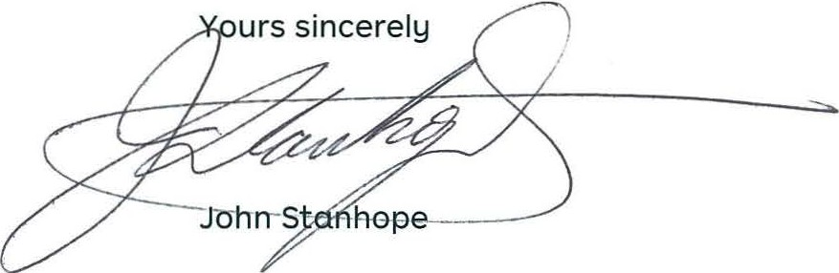

CC : Ahmed Fahour, Managing Director & Group CEO

