Logo: Australian Government, Regional Telecommunication Review.
www.rtirc.gov.au

# 2018 Regional Telecommunications Review—Getting it right out there

2018 Regional Telecommunications Review—getting it right out there.
rtirc.go.au

Farmer and two children in a field with livestock

Disclaimer

The material in this report is of a general nature and should not be regarded as legal advice or relied on for assistance in any particular circumstance or emergency situation. In any important matter, you should seek appropriate independent professional advice in relation to your own circumstances. The Commonwealth accepts no responsibility or liability for any damage, loss or expense incurred as a result of the reliance on information contained in this report.

This report does not indicate the Commonwealth’s commitment to a particular course of action. Additionally, any third party views or recommendations included in this report do not reflect the views of the Commonwealth, or indicate its commitment to a particular course of action.

Copyright

© Commonwealth of Australia 2018

Logo:  Creative Commons.  The material in this report is licensed under a Creative Commons Attribution—4.0 International licence, with the exception of:

* the Commonwealth Coat of Arms
* this Department’s logo
* any third party material
* any material protected by a trademark, and
* any images and/or photographs.

More information on this CC BY licence is set out as follows:

* Creative Commons website—[www.creativecommons.org](http://www.creativecommons.org/)
* Attribution 4.0 international (CC by 4.0)—[www.creativecommons.org/licenses/by/4.0](http://www.creativecommons.org/licenses/by/4.0).

Enquiries about this licence and any use of this discussion paper can be sent to: [copyright@communications.gov.au.](mailto:copyright@communications.gov.au)

Third party copyright

The Department has made all reasonable efforts to clearly identify material where the copyright is owned by a third party. Permission may need to be obtained from third parties to re-use their material.

Attribution

The CC BY licence is a standard form licence agreement that allows you to copy and redistribute the material in any medium or format, as well as remix, transform, and build upon the material, on the condition that you provide a link to the licence, you indicate if changes were made, and you attribute the material as follows:

Licensed from the Commonwealth of Australia under a Creative Commons Attribution 4.0 International licence.

Enquiries about the use of any material in this publication can be sent to: [copyright@communications.gov.au](mailto:copyright@communications.gov.au).

Using the Commonwealth Coat of Arms

Guidelines for using the Commonwealth Coat of Arms are available from the Department of Prime Minister and Cabinet website at [www.pmc.gov.au/government/its-honour](https://www.pmc.gov.au/government/its-honour).

## Letter of Transmittal

  
Senator the Hon Bridget McKenzie  
Minister for Regional Services, Sport, Local Government and Decentralisation  
Parliament House  
CANBERRA ACT 2600

Dear Minister

Together with my colleagues, Ms Wendy Duncan, Ms Johanna Plante, Ms Robbie Sefton, Ms Kylie Stretton and Mr Paul Weller, I am pleased to present the 2018 Report of the Regional Telecommunications Independent Review Committee.

Over the course of the review, the committee heard a range of views on regional telecommunications services. In addition to the public consultations, we received hundreds of submissions from individuals, businesses and organisations.

There are great opportunities to maximise the economic benefits for regional communities through the use of digital technologies. However, where you live and work matters. If regional Australia is to be the prosperous and innovative economic powerhouse that it can be, more infrastructure investment is needed.

The committee supports the Universal Service Guarantee, however, it needs to meet the legitimate needs of regional, rural and remote Australians. We support a measured and cautious approach to any changes to the current arrangements.

Participation in the digital world is no longer a luxury but an integral part of daily life. However, digital inclusion in the regions lags far behind the major cities. There is a crisis of confidence when it comes to using and understanding digital technology in regional Australia. More needs to be done to help people engage and participate in the digital world.

It is important to acknowledge that telecommunications touches every aspect of life for those living in regional, rural and remote Australia. It is more critical than ever to get it right out in the regions.

I commend this report to you.

Yours sincerely,

Sean Edwards
Chair, Regional Telecommunications Independent Review Committee
30 September 2018


Sean Edwards  
Chair, Regional Telecommunications Independent Review Committee  
30 September 2018



Contents

Letter of Transmittal iii

Executive Summary 1

Maximising economic benefits 2

Consumer Protections 3

Social benefits and digital inclusion 4

Digital Literacy 6

1. Introduction 8

1.1 Approach taken to the Review 8

1.2 Terms of Reference 10

1.3 Complementary reviews 11

1.4 Summary of Recommendations 11

Access to Infrastructure 11

Consumer Protections 11

Digital Inclusion 12

2. Maximising Economic Benefits 16

The opportunities for regional, rural and remote Australia 18

2.1 National Broadband Network 19

Regional Rollout 19

Data demands on the network 20

Sky Muster 20

A new approach is needed 21

2.2 Mobile 22

2.3 Place-based Planning 23

2.4 Maximising economic opportunities in regional Australia 24

3. Consumer Protections 27

New protections and standards 27

3.1 Universal Service Obligations and Guarantees 28

3.2 High capacity radio concentrator (HCRC) 30

3.3 Vital Consumer Protections—faults and repairs 30

National Broadband Network Quality of Service 32

4. Social benefits and digital inclusion 35

4.1 Attracting and retaining people in the regions 36

4.2 Health 37

Case study: Victorian Stroke Telemedicine Program 37

4.3 Education 39

4.4 Delivering the data 41

NBN Sky Muster satellite activation profile 42

4.5 Indigenous 42

4.6 Affordability 45

5. Digital literacy 48

5.1 Infrastructure vs education 48

5.2 The Internet of Things—realising the benefits 49

5.3 Solutions 49

A central tech hub 49

Independent tech advisers 50

Case study: South West NBN Advisor—Western Australia 51

Appendix 1—List of Submissions 52

Appendix 2—Public consultations 56

Northern Territory 56

Western Australia 56

Tasmania 56

South Australia 56

Victoria 56

New South Wales 57

Queensland 57

Australian Capital Territory 57

Appendix 3—Committee Membership Bios 58

Appendix 4—Glossary and abbreviations 62

## Executive Summary

On 30 April 2018, the Minister for Regional Services, Senator the Hon Bridget McKenzie, announced the 2018 Regional Telecommunication Review. The Minister asked that we have regard to the regional rollout of the National Broadband Network, the Mobile Black Spot Program and the Government’s commitments to a review of consumer safeguards and the Universal Service Guarantee. The committee was also asked to consider how to maximise the economic benefits for regional communities through the use of digital technologies.

During the course of the review, the committee met with hundreds of regional, rural and remote people to conduct a health check of existing telecommunications services and better understand the barriers people in regional communities face when it comes to using digital technologies and services.

Public consultations were held in 22 regional locations and we received over 380 submissions from a range of individuals and organisations. We appreciate the time and effort that everyone put into attending meetings and preparing submissions.

Much has happened since the 2015 review—more than 96% of premises in regional Australia can now access the NBN or have construction underway. Over 600 Mobile Black Spot Program towers have been deployed, with the fourth round of this program commencing shortly.

Looking forward, the pace of technological change continues to increase. The deployment of 5G networks and Low Earth Orbit satellite networks is imminent, and both are expected to be competing with existing networks.



Trying to get mobile coverage near Charters Towers, QLD



Telecommunications tower in Mildura, VIC

### Maximising economic benefits

Where you live and work matters. Those regional businesses that have a fixed-line broadband service as well as reliable mobile coverage from one or more mobile network operators are in a strong position to take advantage of new digital applications and economic opportunities. From an infrastructure perspective, there are few barriers to taking up new and innovative digital applications for businesses of this nature.

For other regional, rural and remote businesses, however, the situation is not as conducive to maximising economic opportunities. Sky Muster satellite service data limitations, congestion on the fixed wireless network, and poor mobile coverage are creating significant disparities for these Australians.

The NBN Sky Muster satellite service has been available to consumers since April 2016 and has been a significant improvement over previous satellite services that have been available in this country. For example, NBN Co’s Interim Satellite Service and Satellite Support Scheme were temporary arrangements while the Sky Muster satellites were under construction. The Interim Satellite Service aimed to offer a wholesale broadband service with peak access speeds of 6mbps downlink and 1mbps uplink. However, the Interim Satellite Service had limited capacity and many users experienced poor quality of service as a result of heavy use by other customers.

However, the lived experiences of many users of the satellite service falls well short of their needs and expectations, particularly as demand for data increases and the use of digital technologies increases.

The pace of change in technology and digital applications is rapid. These world class satellites that began offering services only a little over two years ago are in need of further supplementation, if the economic opportunities that are available for many regional, rural and remote communities are to be fully realised. In our view, some Australians using the Sky Muster service are being held back economically and socially by the constraints of the satellite network.

Sky Muster will remain a necessary technology to service Australians in some rural and remote areas, but steps should be taken to make alternate technologies available where feasible. This will give NBN Co more options for those that will remain on the satellite service, such as further increasing data limits.

NBN Co can be part of providing these alternate solutions but there needs to be some important changes in approach. There is currently little information available about the company’s intended approach to future network upgrades in regional areas. There is also no transparency about which locations might be part of NBN Co’s future network upgrade plans or the indicative timing of these upgrades. This is creating uncertainty about future investment in the broader regional economy and the telecommunications industry.

We make a number of recommendations to give effect to NBN Co’s stated commitments to upgrading its regional networks.

If we truly aspire to regional Australia being the prosperous and innovative economic powerhouse it has the potential to be, more needs to be done. There are innovative digital applications available right now that will have an immediate and positive impact if they can be used. These applications could unleash a new wave of productivity improvements in multiple sectors, creating new economic opportunities across regional Australia and underpinning prosperity, decentralisation and better social outcomes.

The committee is strongly of the view that there are compelling factors for significant additional capital investment in telecommunications infrastructure to maximise the economic opportunities and economy-wide benefits that are available for the people in regional, rural and remote Australia.

The timing for this new investment is right now, we shouldn’t just wait for the next technology ‘silver bullet’ to come along. If we do nothing in the short-term then the current inequities faced by many regional, rural and remote Australians will simply get worse. The committee is of the view that there is little to no free market drivers to stimulate the change required in the telecommunications industry’s capital focus.

With so many potential technology solutions within grasp, there is a critical need to adopt a strategic place-based approach to guide future telecommunications investments. A place-based approach will give effect to local and national goals, through targeted investment in telecommunications infrastructure that is specifically suited and tailored to the particular requirements of each region. With the regional rollout of the NBN so advanced, the development of regional digital plans is a logical next step.

### Consumer Protections

Consumer safeguards are an important protection for rural and remote people, particularly as they may have limited or no alternative services available to them. We welcome the Government’s Consumer Safeguards Review, which is preparing the consumer safeguards framework for the post 2020 environment.

The committee sees benefit in the Universal Service Guarantee concept in that it would modernise the long-standing Universal Service Obligation by guaranteeing ongoing access to broadband as well as voice. It is clear, however, that the services covered by the Universal Service Guarantee need to meet the legitimate needs of regional, rural and remote Australians.

Throughout our consultations, many people expressed concerns about the potential for changes to their fixed voice services. Voice services are inevitably benchmarked against what consumers are familiar with and reasonably expect.

For many living in rural, and particularly remote Australia, Telstra’s fixed voice service is the only connection to the outside world if their internet service is not working. This is particularly the case for Sky Muster customers that do not have mobile coverage. These people want to retain their landline services as they cannot rely on the Sky Muster satellites for voice services, which they were not designed to deliver. The committee supports a measured and cautious approach to any changes to the Universal Service Obligation arrangements.

We acknowledge that for the vast majority of regional people, their landlines are repaired within the timeframes set out in the Customer Service Guarantee benchmarks. However, for those that did not fall into this category, the committee was appalled at some of the excessive repair times reported by the community for landline services, which extended through weeks and even months in some cases. The committee is at a loss as to why a 10% non-supply of services is deemed acceptable in rural areas for example, given it represents on average over the last 5 years around 10,000 premises annually, which could equate to 30,000 people impacted each year.

There needs to be far greater emphasis on landline services repair times for those living in regional and remote areas.

The issue is so serious that the committee recommends an audit should be undertaken on the repair times for landline services for those living in regional and remote areas that are not fixed within the specified Customer Service Guarantee timeframes. This audit should also take account of the criteria and processes for claiming an exemption under the Customer Service Guarantee standard and the impacts these exemptions have on repair times.

In relation to broadband services, we have found that the actual quality and reliability of the service are far more important factors for users than the theoretical maximum speed of the package being sold.

There is a significant disconnect between what NBN Co is saying about the performance of the Sky Muster service at the network level, compared to the lived experience of many users. NBN Co acknowledges early teething problems with the Sky Muster service, but states that it has now stabilised and is working to international best practice benchmarks (NBN Co submission, p. 4). For some people, the service falls well short of their current needs and expectations. We believe that this is largely because many problems at the retail service provider level or at the individual premises are not logged as faults and therefore fall outside of NBN Co’s reporting about the stability of the broader satellite network.

Consumers on the fixed-wireless network experience similar issues. The committee has heard from a number of people that the speeds consumers are receiving on the fixed-wireless network are not the speeds they were promised and are paying for.

From 2017 these issues are being addressed for fixed-line broadband services. The ACCC released guidelines to industry on how to comply with the Australian Consumer Law when making broadband speed claims, and commenced its consumer Measuring Broadband Australia program. The ACCC to date has published two rounds of findings for the Measuring Broadband Australia program, helping Australians with fixed-line NBN services to get what they pay for under their internet plan.

We understand that perhaps not all the diagnostics of the fixed-line network testing are available over the fixed wireless or satellite technologies. However, we strongly support independent measuring of the performance of fixed-wireless and satellite NBN services in regional areas to better understand where problems may lie in the supply chain that negatively impact on end-users.

### Social benefits and digital inclusion

Participation in the digital world is no longer a luxury, it is an integral part of everyday life. Essential services including government services, health and education are increasingly moving to a digital-first model.

The benefits of digital inclusion are significant. However, the experiences heard by this committee demonstrate that digital inclusion in the regions lags far behind the major cities. The Australian Digital Inclusion Index reveals substantial differences between rural and urban areas. This index measures digital access, affordability, and digital ability to give a score out of 100.

Significantly, all of Australia’s least digitally included regions are outside the major cities: Eyre (45.0), South East SA (48.6), North Victoria (50.8), and Murray and Murrumbidgee (51.0).

To ensure regional Australia is best positioned to retain people and grow in the long term, a strong base of essential infrastructure, social networks, employment opportunities, education and health services are required. Access to good quality telecommunications underpins all these areas.

Education in regional, rural and remote communities is one of the most data-intensive activities. Whether students are being educated via distance or at local schools, education is increasingly digital. Particularly for distance education, video is a key component of lessons. Broadband access and fast upload and download speeds are essential for this service.

The NBN Sky Muster Education Port, offered as part of NBN Co’s Public Interest Premises policy, has been game changing for distance education students. There have been calls to extend the Education Port to all students undertaking education and training across regional and remote Australia. There is certainly merit to this argument.

However, there is a range of important services that require high amounts of data. The creation of more bespoke programs, such as the Education Port, requires value judgements to be made about what activities and individuals are deserving of more data. This does not fix the problem.

Given the lower than anticipated take-up of the Sky Muster service, many of the individual spot beams are underutilised. This means that there should be additional capacity to allocate to users, rather than restricting them through the current Fair Use Policy.

Our recommendation is that existing data limits for Sky Muster services should be reviewed with the aim of increasing data limits across the board. As a minimum the spot beams that are underutilised should have data limits increased. Spot beams that are reaching capacity should be prioritised for upgrades.

It is time to address the structural and skills issues that are holding back many Indigenous Australians living in remote communities from getting the economic and social benefits of digital technologies and services. The significance of digital inclusion for Indigenous Australians is recognised across a number of government and industry players.

However, we consider that there should be a more coherent and holistic policy approach to telecommunications services in Indigenous communities.

A number of stakeholders have called for the development of an Indigenous Digital Inclusion Strategy and we support this approach. This strategy should have a focus on access, affordability and digital ability and be developed in partnership with Indigenous communities. It is important that there is local ownership of the strategy, and that it builds upon the capacity of existing organisations, infrastructure and programs to avoid duplication.

Those who cannot afford to keep pace with new communications technologies risk being excluded from the opportunities afforded by the new digital future. The higher proportion of low income households in regional and remote Australia makes digital affordability a key barrier to digital inclusion.

Government, business, and everyday users are increasingly expecting to use the internet on a daily basis. If everyone is expected to engage digitally, then the needs of everyone should be considered. Governments and industry must reduce barriers to people engaging with essential services online, including unmetering data for access to government sites.



### Digital Literacy

There is a crisis of confidence when it comes to using and understanding digital technology in regional and remote Australia. One of the main messages from our public consultations was that people often lack the knowledge or experience of how to use different technology, what it can be used for, and how to troubleshoot issues.

To date, public and private investment in mobile and broadband technology has largely been focused on building infrastructure. With the regional NBN rollout reaching completion, now is the time to focus on ensuring people are getting the most out of their improved connectivity.

There is a significant market for an easy to understand platform that regional Australians turn to for help on digital technologies. The popularity of the Better Internet for Regional Rural and Remote Australia (BIRRR) website shows that people are hungry for independent information about digital technologies. However, many stakeholders have raised concerns about the sustainability of this volunteer model.

In addition, when it comes to getting the full use out of broadband and mobile technologies, many people need an initial helping hand. People need the motivation and confidence to connect. An independent digital adviser for regional, rural and remote areas would focus on helping people get connected, and stay connected.

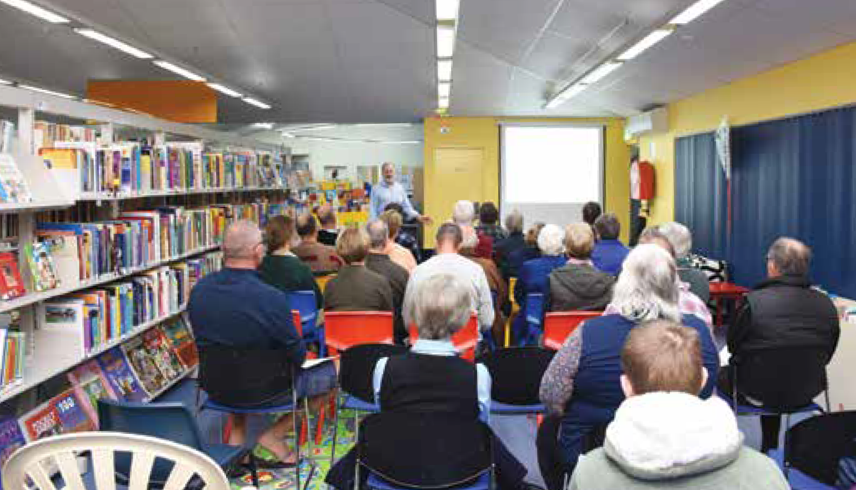

Mike Hendry delivering advice as South West NBN Advisor

## 1. Introduction

The 2018 Regional Telecommunications Independent Review Committee has examined how people use telecommunications services in regional, rural and remote parts of Australia. The committee is comprised of Mr Sean Edwards (Chair), Ms Wendy Duncan, Ms Johanna Plante, Ms Robbie Sefton, Ms Kylie Stretton and Mr Paul Weller.

A Regional Telecommunications Independent Review Committee (RTIRC) is established every three years by Part 9B of the *Telecommunications (Consumer Protection and Service Standards) Act 1999* (the Act). This is the fourth legislative Regional Telecommunications Review and follows on from the 2015 review chaired by Ms Deena Shiff.

The committee was asked to provide its report to the Minister for Regional Services, Sport, Local Government and Decentralisation, Senator the Hon Bridget McKenzie, by 30 September 2018.

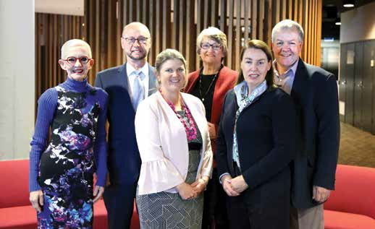

*The committee: Ms Johanna Plante, Mr Sean Edwards (Chair), Ms Kylie Stretton, Ms Wendy Duncan, Ms Robbie Sefton, Mr Paul Weller*

### 1.1 Approach taken to the Review

The committee released an issues paper on 7 June 2018 seeking to gain a better understanding of the ways regional Australians use telecommunications services. In particular, the paper focussed on better understanding the barriers people in regional communities face when it comes to using digital technologies, and how these can be overcome.

The committee received more than 380 submissions to the issues paper.

The non-confidential submissions can be found at: rtirc.gov.au.

The committee consulted extensively, holding 22 public face-to-face consultations across Australia, from Devonport in Tasmania to Kununurra in Western Australia. The committee met with members of the public and key groups representing regional Australians. For a full list of the consultations program see Appendix 2.

We appreciate the time and effort that hundreds of people put in to attend meetings and make their views known. People drove for hours, gave freely of their time and openly shared their experiences about regional telecommunications issues.

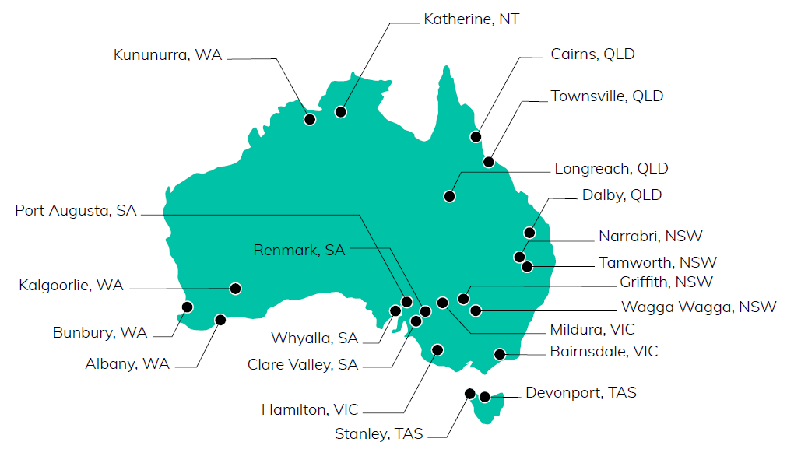

*Map of consultations*

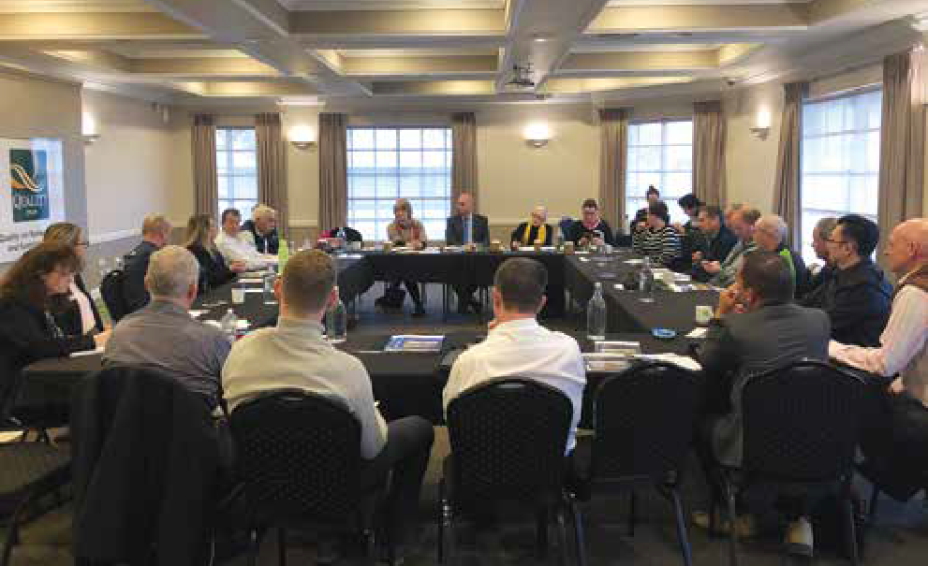

*Public consultation in Kalgoorlie, WA*

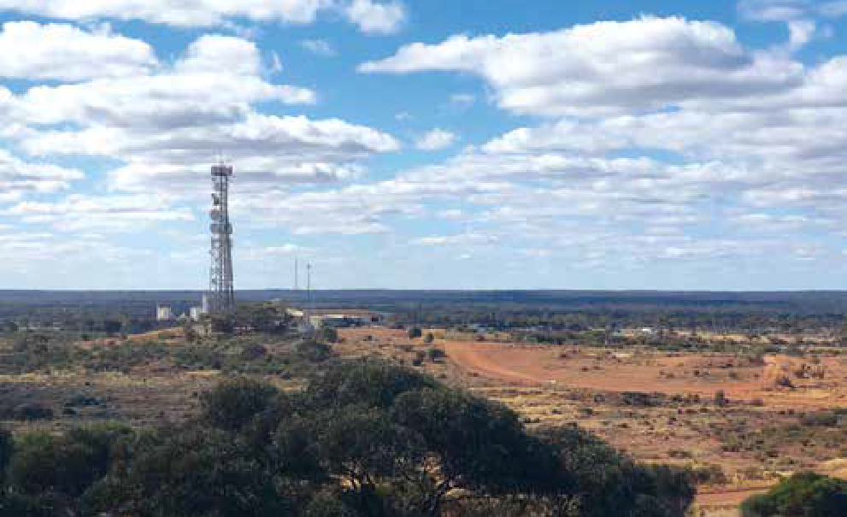

*Telecommunications tower at Kalgoorlie, WA*

### 1.2 Terms of Reference

Sections 158P and 158Q of the *Telecommunications (Consumer Protection and Service Standards) Act 1999* contain the terms of reference for the Regional Telecommunications Independent Review Committee and the conduct of regional telecommunications reviews. Minister McKenzie asked the committee to have particular regard to the National Broadband Network, the Mobile Black Spot Program, and the Government’s commitments to a consumer safeguards review and the Universal Service Guarantee.

1. The committee must conduct a review of the adequacy of telecommunications services in regional, rural and remote parts of Australia.
2. In determining the adequacy of those services, the committee must have regard to whether people in regional, rural and remote parts of Australia have equitable access to telecommunications services that are significant to people in those parts of Australia, and currently available in one or more parts of urban Australia.
3. In conducting the review, the committee must make provision for public consultation and consultation with people in regional, rural and remote parts of Australia.
4. In conducting the review, the committee is to have regard to:
5. The Government’s policy for the rollout of, and investment in, the National Broadband Network; and
6. The commitments to a consumer safeguards review and the Universal Service Guarantee; and
7. The Government’s policy for the rollout of, and investment in, the Mobile Black Spot Program.
8. Taking into account Term of Reference 4, the committee is to:
9. Consider how to maximise the economic benefits for regional communities through the use of digital technologies; and
10. Consider how regional consumers use their broadband service and how they might derive more benefit from it; and
11. Undertake an analysis of the coverage achieved under the Mobile Black Spot Program and examine the extent of the existing gaps in mobile coverage in regional Australia.
12. The committee must prepare a report of the review and give it to the Minister for Regional Communications. The report may set out recommendations to the Australian Government.
13. In formulating a recommendation that the Australian Government should take a particular action, the committee must assess the costs and benefits of that action.

### 1.3 Complementary reviews

There are a number of relevant reviews underway. The Government’s Consumer Safeguards Review, launched by the Minister for Communications in April 2018, is due to report by the end of the year. There is also the Joint Standing Committee on the National Broadband Network and ongoing work to develop options for the Universal Service Guarantee for voice and broadband services. The Regional Telecommunications Review will complement this work and share relevant findings where appropriate.

### 1.4 Summary of recommendations

#### Access to Infrastructure

**Recommendation 1**: To give effect to NBN Co’s stated commitments to upgrading its network, we recommend that:

1. The company establish clear criteria to provide transparency about planned future technology upgrades and indicative timings of these upgrades in regional, rural and remote areas. We suggest that future technology upgrades initially focus on high value agricultural areas, business precincts, public interest premises, and the regional tourism sector.
2. The Government require NBN Co to adjust the area switch element of its Technology Choice Program so that it can be a financial co-contributor with other interested parties.
3. NBN Co should assign responsibility for improving and upgrading the fixed-wireless and satellite networks to an experienced member of the company’s senior executive management team. In addition, at least one member of the Board of Directors should have relevant skills and experience in regional, rural and remote issues.

**Recommendation 2**: The Government commits to a large scale, multi-year Stronger Regional Connectivity Package to improve broadband and mobile services in areas of high economic, social and public safety significance, particularly in areas served predominantly by the Sky Muster satellite service. Investment to be guided by a strategic place-based approach.

#### Consumer Protections

**Recommendation 3**: The committee recommends no changes to the current Universal Service Obligation arrangements until there are fit-for-purpose alternative voice options for those consumers served by the Sky Muster satellite service.

**Recommendation 4**: The committee recommends that industry be asked to bring forward new and innovative solutions for providing voice services in rural and remote Australia, particularly for areas served by the High Capacity Radio Concentrator (HCRC) network.

**Recommendation 5**: The committee recommends that the Government undertake an audit that focuses on:

1. Repair times for landline services for those living in regional, rural and remote areas that are not fixed within the specified Customer Service Guarantee timeframes.
2. Measures the impact of Customer Service Guarantee exemptions such as mass disruption events on repair times in regional, rural and remote areas.

Penalties should be considered for excessive repair timeframes.

**Recommendation 6**: The committee recommends:

1. Independent measuring of the performance of fixed-wireless and satellite NBN services in regional areas to better understand where problems may lie in the supply chain that negatively impact on end-users.
2. Truth in advertising and reporting about the quality of services consumers will receive during peak times.

#### Digital Inclusion

**Recommendation 7**: The existing data limits for Sky Muster services be reviewed with the aim of increasing data limits across the board. As a minimum, the spot beams that are underutilised should have data limits increased.

**Recommendation 8**: A targeted Indigenous Digital Inclusion program with a focus on access, affordability and digital ability be developed in partnership with Indigenous communities.

**Recommendation 9**: Governments and industry should reduce barriers to people engaging with essential services online, including unmetering data for access to government sites.

**Recommendation 10**: The Government commit to improving digital literacy in regional, rural and remote Australia by:

1. Developing an online technology ‘hub’ to provide independent and factual information to help support people to build up the skills to solve telecommunications issues.
2. Deploying technical advisers on a short-term basis across regional, rural and remote Australia to provide on-the-ground support to help people get connected and stay connected, using technologies that are suitable to their individual needs.
3. Encouraging the agriculture sector to provide industry-specific advice about the Internet of Things and other digital applications that will drive productivity gains in the sector.

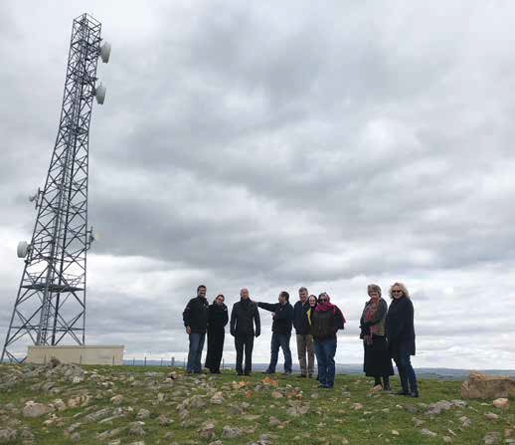

*Members of the committee and secretariat with Rob Mader in Clare, SA*

Snapshot image of what's happened since the 2015 Regional Telecommunications Review 

OCTOBER 2015, First NBN Co Sky Muster satellite launched.

FEBRUARY 2016, Minister for Communications announces Round 2 of the Mobile Black Spot Program.

APRIL 2016, NBN Co Sky Muster satellite commences delivering services.

OCTOBER 2017, ACCC decides not to declare mobile roaming.

FEBRUARY 2018, NBN Co commits to upgrading the most congested fixed wireless towers.

APRIL 2018, The Minister for Communications releases the Terms of Reference for the Consumer Safeguards Review.

MAY 2018, The Government commits to developing a Universal Service Guarantee.







Continuation of the Snapshot image of what's happened since the 2015 Regional Telecommunications Review.

APRIL 2017, overnment announces funding for the ACCC to implement 
a broadband performance monitoring program for NBN  fixed-line services.

AUGUST 2017, ACMA uses statutory powers to obtain information from industry about the pain points for consumers migrating to the NBN.

DECEMBER 2017, ACMA reports volume of data downloaded increased by 43% between the June 2016 and June 2017 quarters to over  3.1 million terabytes.

Mobile phone operators report 4G network coverage in the range of 96% to 99% of the Australian population.

The Minister for Communications announces the ACMA will develop and implement new consumer protections for NBN customers.

AUGUST 2018, The 600th Mobile Black Spot Program tower deployed.

SEPTEMBER 2018, 96% and over of premises in regional Australia able to access the NBN or have construction underway.

## 2. Maximising economic benefits

As part of the review’s Terms of Reference we have been asked to consider how to maximise the economic benefits for regional communities through the use of digital technologies. We have primarily considered this issue through the prisms of:

* access to the necessary telecommunications infrastructure
* consumer protections
* the digital inclusion of regional Australians

This section of the committee’s report will primarily focus on access to telecommunications infrastructure.

Where you live and work matters.

Most regional, rural and remote Australians now have access to some level of broadband service through one or more networks, including the NBN, the mobile networks, ADSL services, or alternate providers such as commercial fixed-wireless and satellite networks. In addition, a growing number of regional businesses are using machine to machine applications through narrowband networks and low bandwidth satellite technologies.

Looking forward, the pace of technological change continues to increase. The deployment of 5G networks and Low Earth Orbit satellite networks is imminent, and both are expected to be competing with existing networks.

We are now faced with the situation where some regional businesses, particularly those near more densely populated areas, can access broadband services through many different networks. In comparison, those businesses situated in the less populated areas in rural and remote Australia have access to just one satellite broadband network.

The examples below clearly show that where you live is the main indicator of the level of telecommunications services you can expect to receive. Even those on the periphery of significant regional centres may need to invest significantly in order to access vital telecommunications services.

These examples are not unique, they are representative of many Australians’ stories, challenges and aspirations.

* Regional businesses that have a fixed-line broadband service as well as mobile coverage from one or more mobile network operators are in a strong position to take advantage of new digital applications and economic opportunities. From an infrastructure perspective, there are few barriers to taking up new and innovative digital applications for businesses of this nature.

_____________________________________________________________________________________

Stu Nankivell, a senior content producer for Blue Goanna Digital, a creative digital agency based in Clare, South Australia has seen remarkable progress in the past few years. After connecting to the NBN fibre to the node service in Clare in January 2017, Stu now has a 100/40mbps service.

‘Going from an upload speed of 1mbps to 40mbps has taken so much stress out of my work and means I can meet deadlines. I went from day-long failed uploads and road trips with hard drives, to the transfer of significantly large files within minutes.

Regional areas like Clare are such a great place for creative businesses like Blue Goanna to thrive. Having access to a reliable and good quality broadband service gives us more time to get on with our core business of producing engaging content.’

Stu Nankivell, Blue Goanna Digital, Clare, SA Blue Goanna Digital logo.

_____________________________________________________________________________________

* For other regional businesses, the situation is not as conducive to maximising economic opportunities. Sky Muster satellite service data limitations, fixed wireless network congestion and poor mobile coverage are creating significant disparities. In addition, the continued focus on theoretical peak upload and download network speeds is proving to be unhelpful for many consumers, if for example, that speed can only be attained in the middle of the night.

_____________________________________________________________________________________

‘With four school aged children and a farming business it is not a surprise that we exceed our peak data allowance almost monthly. Whilst we have a higher amount which can be accessed ‘off peak’, I am reluctant to allow the children to access the internet at this time for a number of reasons. Firstly, I believe internet use during the hours of 1–7am could potentially increase the risk of exposure with unsavoury people, secondly I do not allow my children to have unsupervised internet access and let’s face it with four children, a family farming business, afterschool activities etc I need some sleep at some stage!’

Katie Zagami, AvaGrow Farms, Wairewa Valley, Victoria submission AvaGrow Farms logo.

_____________________________________________________________________________________

* The additional costs of running a business in regional Australia can be significant. Although there is national pricing for mobile plans, for those people in areas of marginal mobile coverage, the additional costs of equipment that can legally help to improve mobile signal strength can be a significant burden or, for many, is simply unaffordable.

_____________________________________________________________________________________

‘Our mobile service is unreliable and sporadic. We rely on legal Telstra approved repeaters which when working are adequate for homestead use only. These units are expensive (installation cost + unit $2000+) and not very robust. Average life span is approximately 3-4 years with replacement costs of $1200. We are now on our 3rd unit.

‘It has become evident now that all vehicles will have to have repeaters installed to give us a reliable service outside the homesteads. These devices would need to be fitted to utes, tractors, trucks and harvesters as they cannot be transferred between vehicles. This is a further cost of approximately $1000+ per vehicle. There are up to 20 farm businesses in this area that experience these same problems.’

Ian, Anne, Stephen and Felicity Dolton, Bruce Rock, WA submission

_____________________________________________________________________________________

* Small regional towns and industrial estates are engine rooms of growth, innovation and economic opportunities. Regional service centres rely heavily on the businesses in the surrounding areas being successful and generating economic wealth. Work undertaken by PricewaterhouseCoopers Australia (PwC), cited in the NSW Business Chamber’s submission (p. 3), indicates that small businesses could potentially unlock an additional $49.2 billion of private sector output over the next ten years by making better use of digital technologies. The PwC modelling suggests that 53% of the potential economic benefit could be made by small businesses located outside Australia’s inner metropolitan centres.

_____________________________________________________________________________________

‘Griffith wants to be taken seriously as a regional centre and there are lots of opportunities for the region. We have world class producers, such as De Bortoli Wines, Casella Family Wines and Baiada in our region. We also see opportunities in walnut production/processing, aquaculture, cotton, citrus, rice and numerous other primary industries. As a community, we have the skills and the passion to succeed, but we need good communications infrastructure.’

Brett Stonestreet, General Manager, Griffith City Council Griffith City Council logo.

_____________________________________________________________________________________

### The opportunities for regional, rural and remote Australia

Most regional businesses appreciate the benefits that digital technologies bring to their businesses and personal lives. They are keen to use technology and, if the necessary telecommunications infrastructure is in place, the opportunities to maximise the economic benefits are enormous.

Economic modelling from the Accelerating Precision Agriculture to Decision Agriculture project (P2D) indicates that digital agriculture could increase the gross value of Australian agricultural production by $20.3 billion, a 25% increase over 2014–15 levels. The greatest gains are expected to come from automation, better tailoring of inputs such as fertiliser and seed, and environmental benefits such as water savings.

Tourism in regional Australia is showing great potential, with visitors increasing on average by 4.1% per annum over the past five years. Research from Tourism Australia shows that 289 million visitor nights were spent in regional Australia in 2017, up from 234 million in 2012.

Remote working creates opportunities for regional Australians that have good digital connectivity. It can for example, enable a farming family to diversify their income sources or established professionals to continue to be part of a metropolitan-based or global business, while enjoying the benefits of living in a regional area.

Good connectivity is also a key factor in attracting and retaining people to rural and remote areas. Younger people and professional workers in particular are profoundly influenced by the availability of technology when they are considering where to work and live.

The ability to make these, or a multitude of other economic opportunities, a reality is entirely dependent on the level of digital connectivity available.

### 2.1 National Broadband Network

#### Regional Rollout

The committee acknowledges that the regional NBN rollout is very advanced, with more than 96% of premises in regional Australia able to access the network or have construction underway. Almost all of the remaining premises are in design. Around 70% of premises outside urban areas will have access to a fixed-line service.

The prioritisation of regional, rural and remote areas that have historically been poorly served with telecommunications services is a major commitment by both Government and NBN Co.

As a national program, NBN Co’s cost per premises calculations, which have underpinned decisions about the type of technology deployed in different areas, is consistent with a network rollout of such scale. This is also in line with the company’s objectives to roll out the network cost-effectively and as quickly as possible, using a multi-technology mix.

However, in our view this approach has resulted in some anomalies that should be addressed as a priority as part of the company’s commitments to upgrading the network. Examples include: small towns being served by the Sky Muster satellite service rather than fixed-wireless or fixed-line technologies; and industrial estates and intensive horticulture enterprises on the periphery of some regional towns being served by Sky Muster, while the nearby township has fixed-line services.

_____________________________________________________________________________________

‘High quality telecommunication services are essential for business today, for the take up of technology and simply for productivity. The Carnarvon Horticultural district is now in a data desert thanks to the decision by NBN Co to provide only satellite service. This puts Carnarvon at a competitive disadvantage to other horticultural regions such as Darwin where the horticultural district was one of the first areas to get NBN. As we move into smart farming, and the potential for drone based/satellite technology to provide real data, enabling farmers to make better decisions, we may find Carnarvon is left behind as other areas move ahead.’

Sweeter Banana Co-operative submission Sweeter Banana Co-operative logo.

_____________________________________________________________________________________

#### Data demands on the network

In some respects, NBN Co is a victim of its own success. Providing under-served regional Australians with good quality fixed-line and fixed-wireless broadband services has enabled people to take up innovative digital applications and technologies at a rapid rate. Regional Australians are happily contributing to the unprecedented year-on-year growth in demand for data and this is placing pressure on all regional telecommunications networks, including the NBN.

Estimates of the growth in consumer demand for data vary significantly, with NBN Co noting a year-on-year increase of 30% in its latest Corporate Plan (p. 40) and estimating that demand for data is expected to grow 20% to 30% annually through to 2025.

In its 2016–17 Communications report, the ACMA noted that the volume of data downloaded increased by 43% between the June 2016 and June 2017 quarters. Telstra’s submission to the review noted that its fixed-line customers’ data usage is growing by around 80% per annum (p.21).

The Bureau of Communications and Arts Research (BCAR) released a working paper in February 2018 on Demand for fixed-line broadband in Australia, forecasting an increase in data demand from 95 gigabytes (GB) in 2016 to 420GB in 2026 (p.4).

Our concern with such differing estimates of demand is that future network planning and upgrades that are based on lower than actual demand increases will quickly lead to degraded network performance. Using the above examples, if the usage patterns currently being experienced by Telstra are being experienced across the sector, then NBN Co’s estimates of demand will prove to be too low when it comes to pre-empting and prioritising network upgrades.

To some extent, degraded network performance is already evident in parts of the fixed- wireless network, with NBN Co currently taking steps to upgrade the most congested fixed-wireless cells. The company has also indicated that it expects to incur additional capital expenditure on the fixed-wireless network through to 2022 (p.62). NBN Co has attributed this to three issues that all impact on network performance—a higher-than- expected number of concurrent users, data consumption, and a faster take-up rate than expected (p.7).

With the ongoing increases in data usage, it is not clear to the committee whether these three issues will be permanently addressed by the current network upgrades. Having said that, at least there are upgrade pathways for the fixed-wireless network. We are not confident that the same can be said for the Sky Muster satellite service.

#### Sky Muster

The NBN Sky Muster satellite service has been available to consumers since April 2016 and has been a significant improvement on previous satellite services available in Australia. At the time of its launch, the NBN Co satellites were among the most advanced to have been deployed.

Following some well-publicised performance and installation challenges with the satellite service, NBN Co deployed a multitude of software fixes and made changes to installation scheduling and practices. NBN Co is now confident that the Sky Muster satellite service has stabilised and is working to international best practice benchmarks. An important and well-received decision taken by the company was to double the data allowances for Sky Muster users in late 2017.

The committee acknowledges the work the company has done on the satellite service. However, we must say that the lived experiences of many Sky Muster users falls well short of their needs and expectations.

The pace of change in technology and digital applications is so rapid that these world class satellites that began offering services only a little over two years ago are already in need of further supplementation, if the economic opportunities that are available for many regional, rural and remote communities are to be realised.

Average monthly downloads over the NBN network are exceeding 200GB per premises across most of the fixed-line technologies and fixed-wireless users are rapidly approaching these figures. In contrast, the average monthly downloads per Sky Muster user is managed at 40GB, through a combination of the company’s Fair Use Policy and higher pricing for larger Sky Muster plans. We have heard from a number of Sky Muster users that they are extremely frugal with their data and actively self-manage their usage to avoid it being ‘shaped’ (slowed down significantly). Once they are shaped, basic necessities such as emails, banking, payroll and checking weather/fire forecasts are impossible, so the ability to continue to use these services is protected at all costs.

As the fixed-wireless statistics show, all things being relatively equal, there is no fundamental difference in data needs between regional and metropolitan consumers. In our view, some Australians using the Sky Muster service are being held back economically and socially by the constraints of the satellite network, particularly as demand for data and the use of digital technology increases.

In practice this is reflected by the number of people choosing to use technologies other than the Sky Muster service. Although Sky Muster is available to around 400,000 premises, NBN Co has recently revised its estimated take-up rates down to around 100,000, which is approximately the number of people that have already taken up the service.

In addition to the decisions that individuals are making about the Sky Muster service, or perhaps reflecting them, a number of governments are flagging strong interest in co-contributing to secure alternate technology solutions in rural and remote areas. Examples include the NSW Regional Digital Connectivity Program, the Victorian Connecting Regional Communities Program, the Western Australian Grainbelt Digital Enhancement Program, and the Northern Territory Government’s Remote Telecommunications Co-Investment Program.

#### A new approach is needed

Sky Muster will remain a necessary technology to service Australians in some rural and remote areas but steps should be taken to make alternate technologies available where feasible. This will give NBN Co more options for those who will remain on the satellite service, such as further increasing data limits.

NBN Co can be part of providing these solutions but there needs to be some changes in approach by the company. There is currently little information available about the company’s intended approach to future network upgrades in regional areas. There is also no transparency about which locations might be part of NBN Co’s future network upgrade plans or the indicative timing of these upgrades. This is creating uncertainty about future investment in the broader regional economy and the telecommunications industry.

NBN Co’s Technology Choice Program provides interested parties with the option to pay for a switch to an alternate technology. The area switch component of the program provides the option to change an eligible group of premises to an alternative NBN broadband technology.

The cost to change technology infrastructure is dependent upon the size and complexity of the project. Each area switch will vary depending on the location and the existing NBN broadband infrastructure in the area. It can range from a few thousand dollars to millions of dollars for large complex areas.

However, NBN Co’s Technology Choice model is not an attractive option for governments or businesses that are considering co-investment. As we have noted, a number of state and local governments are interested in co-contributing to technology upgrades in rural and remote areas.

Under NBN Co’s current Technology Choice model, the company appears to charge the applicant the full incremental costs of the technology upgrade where an existing NBN service, such as satellite, is already available in the area. Given NBN Co’s commitments to upgrading its regional networks, it makes sense to move to a co-investment model that could harness other sources of funding to bring forward scheduled upgrades or to enable unscheduled upgrades in areas that are a priority for the co-investors. Co-investment is a well-established feature of many programs that are designed to improve digital connectivity, whether at the Commonwealth or state level.

In addition, as NBN Co transitions from a network builder to a network operator in regional Australia, the company should take steps to ensure these vitally important regional networks remain a priority for the company. NBN Co should appoint specific members of the senior executive management team and the Board of Directors to take responsibility for upgrading and improving the fixed-wireless and satellite networks, as well as acting as regional advocates at the most senior levels of the company.

**Recommendation 1**—To give effect to NBN Co’s stated commitments to upgrading its network, we recommend that:

1. The company establish clear criteria to provide transparency about planned future technology upgrades and indicative timings of these upgrades in regional, rural and remote areas. We suggest that future technology upgrades initially focus on high value agricultural areas, business precincts, public interest premises, and the regional tourism sector.
2. The Government require NBN Co to adjust the area switch element of its Technology Choice Program so that it can be a financial co-contributor with other interested parties.
3. NBN Co should assign responsibility for improving and upgrading the fixed-wireless and satellite networks to an experienced member of the company’s senior executive management team. In addition, at least one member of the Board of Directors should have relevant skills and experience in regional, rural and remote issues.

### 2.2 Mobile

The benefits of modern mobile devices are pervasive, cutting across almost every facet of society. The ability to access data and applications while on the move has fundamentally changed how people live and work.

As noted in the ACMA’s 2016–17 Communications Report, the mobile phone is the most popular and most frequently used device to go online, both in terms of the proportion of people using and frequency of use. Eighty-four per cent of online Australians use a mobile to access the internet at least once a day, well ahead of laptop computers (69%) and desktop computers (54%).

The popularity of communications apps on mobile phones is growing, with eight in 10 internet users having used an app to communicate via either messages or voice or video calls. Additionally, the shift to mobile phone-only households continues, with 6.67 million Australian adults having a mobile phone and no fixed-line telephone at home.

All of these trends have been in evidence for some time but there are also some new trends emerging. In recognition of the increasing reliance upon the mobile network to support Internet of Things (IoT) devices on farm, mobile network operators are developing network capabilities and services specifically aimed at supporting multitudes of small data packet devices.[1] Industry forecasts indicate that 29 billion devices will be connected worldwide by 2022, of which 18 billion will relate to IoT.

Consistent with previous regional telecommunications reviews, further improvements to mobile coverage continue to be a major priority for regional, rural and remote communities. Many people have been highly supportive of the outcomes that have been achieved through the Mobile Black Spot Program and there were many personal examples given to the committee of the positive changes that have occurred.

As has been noted elsewhere, the Mobile Black Spot Program represents the largest and most successful public investment in improving mobile coverage that has ever been undertaken in Australia. All three mobile network operators, every state government, and many local governments and businesses have participated in the program.

Under the first three rounds of the program, the Government’s commitment has leveraged a total investment of more than $680 million, which is delivering a total of 867 new base stations across Australia. The first three rounds of the program will deliver new handheld phone coverage to more than 88,000 square kilometres, including almost 33,000 premises; over 200,000 square kilometres of new external antenna coverage; and new mobile coverage to almost 8,000 kilometres of major transport routes.

The Mobile Black Spot Program co-investment model has worked particularly well and clearly demonstrates that state governments and other co-contributors recognise the economic, social and public safety benefits that can be achieved by improving connectivity in regional areas. Co-investment should continue to feature in future regional telecommunications initiatives.

However, with a focus only on mobile coverage, governments and local communities could be missing opportunities to achieve positive outcomes on the ground through the use of alternative technologies, based on identified local needs.

Going forward, the telecommunications needs of many local communities will be best met through a mix of technologies and solutions. To encourage the most innovative and fit-for-purpose technology solutions, we consider that future regional telecommunications investment programs should be designed to allow a broader range of solutions and infrastructure providers to be eligible for funding.

We discuss our suggested approach and recommendations for a broader Stronger Regional Connectivity funding package below. We would expect that improving mobile coverage would continue to be a priority for many regional communities and will be a key component of any future telecommunications investment programs.

### 2.3 Place-based planning

With so many potential technology solutions within grasp, there is a critical need to adopt a strategic place-based approach to guide future telecommunications investments. A place-based approach would give effect to local and national goals, through targeted investment in telecommunications infrastructure that is specifically suited and tailored to the particular requirements of each region. A number of state and territory agencies have already begun this journey. With the regional rollout of the NBN so advanced, the development of regional digital plans is a logical next step.

The Victorian Government, through its Connecting Regional Communities Program, has committed to the development of detailed, place-based Digital Plans for each of nine Regional Partnerships. Similarly the Northern Territory Government is developing a Digital Strategy that includes a focus on rural and remote communities.

The NSW Government has determined that the digital connectivity needed to support demand will require bandwidth beyond that provided under the NBN rollout, particularly in areas served exclusively by satellite connectivity. The NSW Government is proposing to address this through the $50 million Connecting Country Communities Fund and the $500 million Growing Local Communities Fund.

_____________________________________________________________________________________

Communities across the Central Highlands region are currently contributing to the development of localised digital plans that will define digital success and provide a road map for realising the social and economic potential of regional communities. The plans will address local priorities and needs in terms of telecommunications and broadband infrastructure, recognising that each area is unique in its key industries, population, geography and existing digital infrastructure.’

Central Highlands Councils Victoria submission Central Highlands Councils Victoria logo.

_____________________________________________________________________________________

### 2.4 Maximising economic opportunities in regional Australia

If we truly aspire to regional Australia being the prosperous and innovative economic powerhouse it has the potential to be, then more needs to be done.

The committee is strongly of the view that there are compelling factors for additional capital investment in telecommunications infrastructure to maximise the economic opportunities and economy-wide benefits that are available for people in regional, rural and remote Australia.

Our recommendation for significant additional telecommunications investment is based on the premise that there are innovative digital applications that are available right now that will have an immediate and positive impact if they can be used. These applications could unleash a new wave of productivity improvements in multiple sectors, creating new economic opportunities across regional Australia, and underpinning prosperity, decentralisation and better social outcomes.

The next generation of agricultural productivity is coming from innovative digital applications that increase production and/or reduce input costs. Many Australian farmers want to adopt more automation and robotics, as well as the collection and analysis of paddock scale data. All these activities require good connectivity in the paddock as well as the homestead.

If we want our farmers to achieve the productivity increases that the latest research indicates is possible, we need more investment.

_____________________________________________________________________________________

‘Farmers want to access the new technologies reliant on broadband connectivity, including precision agriculture, irrigation automation, remote sensing technology, farm biosecurity and livestock monitoring. However, poor connectivity is reducing agriculture’s ability to make greater productivity gains.’

Tasmanian Farmers & Graziers Association submission 

_____________________________________________________________________________________

Telehealth videoconferencing technology is widely available, both in Australia and overseas. However, if we want telehealth videoconferencing to be a reality in rural and remote areas, those communities need to have the telecommunications infrastructure in place that will enable it. Researchers from the CSIRO have estimated that using telehealth technology to help the chronically ill to monitor and manage their condition at home could almost halve mortality rates and save the health budget up to $3 billion a year.[2]

If we want to better support people, including our vital community workers and emergency services personnel, we need to have reliable mobile coverage in rural and remote areas. We can’t mitigate all the risks of travelling in rural and remote areas, but we can make it possible for people who do get into difficulties to get help. As the Mobile Black Spot Program has shown, widespread coverage improvements are possible but it takes co- investment to make this happen.

If we want our regional, rural and remote businesses to continue to increase the economic contribution they make to their local community, we need to ensure the telecommunications infrastructure is fit-for-purpose.

The Caravan Parks Association of Queensland indicates there are more than 10 million visitor nights per year in the caravan and camping sector in Queensland. The industry is a significant economic contributor to regional Queensland and it is estimated that for every dollar received by a caravan park there is $1.38 of economic activity generated in their local community.

_____________________________________________________________________________________

‘Over the past three years over 20% of respondents to our survey, regardless of their region, indicated that mobile and internet has created challenges for them in the running of their business. When looking at regional businesses this increased to 37% and for remote businesses to over 50%. While there have been positive impacts for some businesses, including the opening of new markets, the negative feedback was far more significant with negative feedback from guests and significant challenges noted by many businesses.’

Caravan Parks Association of Queensland submission Caravanning Queensland logo.

_____________________________________________________________________________________

The timing for this new investment is right now, we shouldn’t just wait for the next technology ‘silver bullet’ to come along. If we do nothing in the short-term then the current inequities faced by many regional, rural and remote Australians will simply get worse. The committee is of the view that there is little to no free market drivers to stimulate the change required in the telecommunications industry’s capital focus.

We appreciate that not all of regional, rural and remote Australia’s telecommunications needs can be met immediately and that new technologies will continue to emerge. These include the widespread deployment of 5G networks, Low Earth Orbit satellites, and potentially low-cost solutions such as AT&T’s AirGig wireless technologies. Any of these solutions could, in time, be accommodated within our proposed Stronger Regional Connectivity program.

In practice, given the rapid way in which technology evolves, we will in all likelihood never be able to say the job is complete when it comes to telecommunications services in regional Australia. New technologies and new applications are part of business as usual now, and into the future. We can however take steps now that will give regional communities the opportunity to succeed.

Some states are well advanced in the development of place-based analysis of local telecommunications needs. We welcome this approach and do not see a strong case for replicating this work. If investment decisions can be guided by local priorities and the gains that can be achieved, we are confident that we will see meaningful improvements in many communities.

For those jurisdictions that are yet to undertake any detailed analysis of local telecommunications needs, there is a risk of missing out on Commonwealth co-investment opportunities. This should create an incentive to begin that journey as soon as practicable. To provide some rigour around regional digital planning, the cost-benefit analysis should take into account economic, social and public safety benefits. Projects that are assessed at having a cost benefit that is greater than one-to-one should be prioritised for funding.

The quantum of funding required to maximise the economic opportunities for regional, rural and remote communities should not be underestimated. Making a measurable impact will almost certainly cost hundreds of millions of dollars. However, the economy-wide benefits will run into the billions of dollars if the estimates we have quoted elsewhere in this report can be realised. The benefits accrue at Commonwealth, state and local levels, and touch almost every area, whether it be trade, health, education, agriculture, tourism or social services.

As the benefits of improving telecommunication infrastructure are economy wide, much of the revenue that is generated is not captured by the infrastructure providers. Much of the work that needs to be done will not be commercially viable in its own right and providers will not be able to justify the full costs to their investors.

In our view, co-investment is the only way that these infrastructure improvements will be possible at the scale that is required. Co-investment with industry, interested state, territory and local governments, as well as businesses, will be critical for this project to succeed and should be a key feature of the program design.

**Recommendation 2**—The Government commits to a large scale, multi-year Stronger Regional Connectivity Package to improve broadband and mobile services in areas of high economic, social and public safety significance, particularly in areas served predominantly by the Sky Muster satellite service. Investment to be guided by a strategic place-based approach.

## 3. Consumer protections

There is significant uncertainty about what the transition to the Universal Service Guarantee and the new consumer safeguards framework will mean for regional, rural and remote people.

While development of the Universal Service Guarantee and the current Consumer Safeguards Review are separate processes to the 2018 Regional Telecommunications Review, this work is of inherent interest to people in regional, rural and remote areas. Throughout our consultations, many people expressed concerns about the potential for changes to their fixed voice services. Voice services are inevitably benchmarked against what consumers are familiar with and reasonably expect.

The committee sees benefit in the Universal Service Guarantee concept in that it would modernise the long-standing Universal Service Obligation by guaranteeing ongoing access to broadband as well as voice. It is clear, however, that the services covered by the Universal Service Guarantee need to meet the legitimate needs of regional, rural and remote Australians.

Consumer safeguards are an important protection for rural and remote people, particularly as they may have limited or no alternative services available to them. We welcome the government’s Consumer Safeguards Review, which is preparing the consumer safeguards framework for the post 2020 environment. The Consumer Safeguards Review is being undertaken in a number of parts: redress and complaints handling; reliability of telecommunications services; and choice and fairness in the retail relationship between the customer and their provider.

When consumers transition and use services provided via the NBN or other broadband providers they expect to get easily connected and stay connected. When this does not occur, they expect there will be an effective process in place to protect them.

There is a strong view in regional Australia that some telecommunications providers are abrogating their responsibilities in handling customer issues to the Telecommunications Industry Ombudsman and community organisations such as BIRRR.

If the modern consumer safeguards are to be effective and fit for purpose, this approach needs to change. Evidence heard in the 22 public consultations and the submissions show the current consumer safeguards do not adequately protect people in rural and regional areas.

### New protections and standards

The committee notes that during the course of its review new standards have been introduced to help consumers. The new rules introduced by the ACMA are designed to give consumers confidence that their complaints will be effectively managed if problems arise with their telecommunications service. This puts pressure on carriage service providers whereby they must:

* have and follow a written complaints handling process that meets minimum standards;
* acknowledge all consumer complaints within two working days;
* use their best efforts to resolve complaints on first contact; and
* otherwise resolve complaints within 15 working days.

ACMA research found that almost one-in-six households moving to an NBN service was left without a working connection for more than a week. For almost one-in-10 households, the interruption was for more than two weeks.[3] These new rules intend to give consumers greater confidence that their service provider will make sure their new NBN service will work as expected and provide options if their connection doesn’t work.

Likewise, the NBN Co announced it had reached an agreement with the ACCC to introduce new service standards on 12 September 2018 to improve customer experience. Under these standards, NBN Co will pay rebates to retailers for poor connections, fault rectifications and missed appointments. These new standards are important, but will only help if retail service providers pass on service levels and pass on rebates. We hope that these standards will help create a reduction in many of the issues that the committee heard about during consultations.

### 3.1 Universal Service Obligations and Guarantees

Voice services are vital for those living in regional, rural and remote Australia. The current Universal Service Obligation provides people across Australia with reasonable access to fixed voice and payphone services wherever they reside or conduct business.

Their provision is underpinned by a contract between the Commonwealth and Telstra. Under this contract, Telstra receives $230 million per annum (excluding GST) to provide fixed telephone services, and $40 million per annum (excluding GST) to provide payphone services.

Under the contract Telstra is generally required to maintain copper voice services in place outside NBN Co’s fixed-line footprint.

For many living in rural and particularly remote Australia, Telstra’s fixed voice service is their only connection to the outside world if their internet service is not working. This is particularly the case for Sky Muster customers who do not have mobile coverage. These people want to retain their landline services as they cannot rely on the satellite service for voice calls, given the issues with reliability and quality of service. These challenges include Sky Muster’s susceptibility to weather events and the latency issues associated with voice.

During wet and overcast weather in northern Australia, consumers have reported being without satellite services for extended periods. If consumers had to rely on a satellite service to meet their voice service needs, the service would be non-existent at a time when it is most needed. Safety concerns for those on isolated properties is extremely important, reinforcing the need for an alternative technology.

Latency issues associated with satellite voice technology are also problematic. The Sky Muster satellite service was not designed to provide voice services, only broadband services. The delay when using Voice over Internet Protocol (VoIP) on Sky Muster can be significant.

Further, in areas vulnerable to flooding and bush fires, the need for reliable communications is obvious. This is exacerbated in areas with no mobile phone services or terrestrial radio or television services. This is an ongoing issue for people living in a number of areas across regional, rural and remote Australia. For example, this is the reality for people living in the Yarramalong Valley in NSW who rely heavily on the copper network in times of emergency (Alan and Judith Smedley submission, p. 2).

Following the 2015 Regional Telecommunications Review, many called into question the effectiveness of the current Universal Service Obligation arrangements. As a result, the Productivity Commission was tasked to review the future of the Universal Service Obligation.

Many people raised significant concerns with the committee about the Productivity Commission’s recommendation[4] that the Universal Service Obligation arrangements be wound up by 2020, and consider that the commission does not fully appreciate the importance of landline networks in rural and remote areas.

Standard telephone services must be maintained until such a time that baseline services needs are exceeded using alternative technology (BIRRR submission, p. 36). In their submission, ICPA Australia advocates for rural and remote families to have a minimum of two communications services (voice and data) that are independent of each other (ICPA Australia, p. 3). When communications services are down, it affects business and education for these families as well as being a safety issue.

There was little comment from submitters about payphones, although some noted that they continue to play an important role in some regional and remote communities. Specific groups of people rely on payphones to make emergency calls; for example people living in areas with unreliable mobile phone coverage, and people on low incomes. Payphones remain important in remote Indigenous communities, which is discussed later in the report.

There is a question as to whether the Commonwealth funding to Telstra to provide fixed telephone services and payphone services could be reallocated. For example, by moving some of the payphone allocation to the fixed telephone services, more resources could be put into resolving more complex copper maintenance issues. The Australian Local Government Association (ALGA) submitted that there must be consultation with the local community before removing payphones (ALGA submission, p. 4).

In December 2017, in response to the Productivity Commission’s review, the Government indicated it would develop options for a new Universal Service Guarantee that would modernise the existing arrangements by ensuring consumers have access to broadband as well as voice services. The Universal Service Guarantee would leverage the National Broadband Network, along with other commercial networks, such as mobile.

Importantly, the Government has taken a more measured approach to the Universal Service Guarantee than was suggested by the Productivity Commission, stipulating a number of requirements that must be met before changes are made to the existing Universal Service Obligation arrangements. These include:

* broadband services are available to 100% of Australian premises, on request, at the completion of the NBN rollout in 2020;
* voice services are available to 100% of Australian premises on request;
* any proposed new service delivery arrangements are more cost effective than the existing Universal Service Obligation contract (including any transitional costs); and
* a new consumer safeguards framework is in place following a review and associated public consultation process.

The committee found that people living in rural and remote Australia believe the current Universal Service Obligation should continue to ensure that consumers and businesses have baseline voice services that are at least equivalent to that standard currently offered.

The committee supports a measured and cautious approach to any changes to the Universal Service Obligation arrangements.

**Recommendation 3**—The committee recommends no changes to the current Universal Service Obligation arrangements until there are fit-for-purpose alternative voice options for those consumers served by the Sky Muster satellite service.

### 3.2 High capacity radio concentrator (HCRC)

Telstra fulfils its universal service obligations to many people living in rural and remote areas with high capacity radio concentrator (HCRC) technology. However, throughout the consultation process many expressed concerns about the HCRC system reaching the end of its serviceable life. The HCRC network currently provides approximately 14,000 individual services to around 6,400 premises in remote areas.

The HCRC network is ageing and there is little information available about what alternative services have been planned or prepared to ensure landline services continue to be available in the event that the HCRC network fails.

Two of the largest representative groups in regional Australia, ICPA and BIRRR have reported that members have experienced lengthy outages and repair times. We have heard that suitable trained technicians and replacement parts for the network have not been available, resulting in outages, sometimes lasting months.

Consumers are concerned with the state of the HCRC network and that there is no clear strategy for the network. Consumers would like to see alternative voice technologies trialed to test their availability, quality, reliability, cost-effectiveness and whether they would be accepted by communities.

**Recommendation 4**—The committee recommends that industry be asked to bring forward new and innovative solutions for providing voice services in rural and remote Australia, particularly for areas served by the High Capacity Radio Concentrator (HCRC) network.

### 3.3 Vital Consumer Protections—faults and repairs

The committee is deeply concerned about the extended periods that some people endure while waiting to have their landlines repaired.

We acknowledge the vast majority of regional people have their landlines repaired within the timeframes set out in the Customer Service Guarantee. However, the committee was appalled to hear some of the excessive repair times for landline services, which extended through weeks and even months in some cases.

The Customer Service Guarantee Standard establishes performance standards that telephone service providers must meet or exceed for repair of standard telephone services, including appointment timeframes. The maximum current repair times are:

| Community | Community size (people) | Repair time (after customer reports the fault) |
| --- | --- | --- |
| Urban | Equal to or greater than 10,000 people | End of next working day |
| Rural | Between 201 and 9,999 people | End of second working day# |
| Remote | Up to 200 people | End of third working day# |

# In certain circumstances, for example, where the fault can be rectified by the phone company without attending the customer’s premises, the fault rectification period is the end of the next working day after report.

Source: [https://www.acma.gov.au/Citizen/Phones/Landlines/Phone-connection-and-repair/customer-](http://www.acma.gov.au/Citizen/Phones/Landlines/Phone-connection-and-repair/customer-) service-guarantee-for-phone-users-faqs.

In 2017–18 there were 99,935 fault repair requests by people living in rural areas and in 91,595 of these requests Telstra was compliant (91.7%). In remote areas there were 2,603 fault repair requests and in 2,396 of these requests Telstra was compliant (92%).

In both cases Telstra complied with the Customer Service Guarantee benchmark, however, this means there were more than 8,500 businesses and families with a service that wasn’t repaired in the required timeframe. While it is proportionately a small number, these people have faced significant disruptions. The impacts are exacerbated for those that are not in mobile phone coverage areas.

Being without landlines and mobile phones makes a number of things incredibly difficult, including education, maintaining healthcare, keeping people safe, and running a business.

_____________________________________________________________________________________

‘We rely on the landline service for business. However, this service is becoming increasingly unreliable because of frequent exchange breakdowns and copper networks often failing, especially after rain. Repairs to these networks are only a patch up job with cable left lying exposed on top of the ground.’

Ian, Anne, Stephen and Felicity Dolton, Bruce Rock, WA submission

_____________________________________________________________________________________

‘Landline can be scratchy and go off when it rains. Constant landline failures through lack of maintenance and an out dated exchange needs replacing.’

Livestock SA submission Livestock SA logo.

_____________________________________________________________________________________

Members of the Northern Territory Cattlemen’s Association told the committee that the time to repair their landlines can take weeks, during which time they have to rely on limited satellite internet communications. In the instance that both services go down they are left with only UHF radio communications. Members said they contacted Telstra to report their faults and were advised to use their mobile phones until the fault was repaired—an impossibility as they do not have mobile coverage.

We hope that Telstra’s decision to provide a dedicated call centre team with specialised knowledge to manage calls from customers located more than 100 kilometres from a Telstra branded store will improve these peoples’ experiences.

A common theme throughout the submissions and consultations for those living in rural and remote areas is the time it takes for landlines to be repaired and then the frustration that is caused through temporary repairs. When this happens, customers face the same problem they reported later that day or for weeks to come. This leads to more faults being reported as a permanent repair is not being completed when the initial fault is reported.

_____________________________________________________________________________________

Landline is totally inefficient, constantly breaking down. Difficulty in organising quick repairs, usually 4-7 days leaving us without communications. For example phone was unusable on 9 July, line was crackling and it was impossible to hear or understand what was being said. Reported the fault and were told it could not be repaired until 18 July. Left with no reliable communication until that date. The phone was repaired the morning of 18 July, by that afternoon it was back to what it was when reported.

Brian and Beverly Keating, Bindi, VIC submission

_____________________________________________________________________________________

Farmers in the Shire of Yilgarn, in the eastern wheatbelt of Western Australia, have reported considerable landline outages, severely restricting communications by any means as mobile phone coverage is not available or intermittent. In the summer months of 2017–18, residents did not have landline coverage over regular intervals, causing significant implications in times of emergency. Telstra was continually informed of these outages, however rectification still has not been achieved to the satisfaction of the residents affected (Shire of Yilgarn submission, p. 2).

The issue is so serious that the committee recommends an audit be undertaken on the repair times for landline services for those living in regional and remote areas that are not fixed within the specified Customer Service Guarantee timeframes. This audit must also take account of the criteria and processes for claiming an exemption under the Customer Service Guarantee Standard. A provider may be exempt for a number of reasons, including for mass service disruptions (where mass outages have occurred due to extreme weather conditions or other factors beyond the provider’s control). Without consideration of these exemptions, the number of extended timeframes may be much higher than the Customer Service Guarantee Standard statistics suggest.

There needs to be greater emphasis on landline services repair times for those living in regional and remote areas.

**Recommendation 5**—The committee recommends the Government undertake an audit that focuses on:

1. Repair times for landline services for those living in regional, rural and remote areas that are not fixed within the specified Customer Service Guarantee timeframes.
2. Measures the impact Customer Service Guarantee exemptions such as mass service disruption events on repair times in regional, rural and remote areas.

Penalties should be considered for excessive repair timeframes.

#### National Broadband Network Quality of Service

We have found that the actual quality of the broadband service is a far more important indicator than the theoretical maximum speed of the package being sold. We are concerned that plans are being sold on the basis of a maximum plan speed (for example 25/5mbps or 50/10mbps) when the reality is this speed is not attainable or only available when most people are asleep.

For example, at peak times on the Sky Muster service, such as in the middle of the day or mid evening, consumers are reporting speed reduction to such an extent that connection is impossible and/or service dropout is frequent (ICPA Queensland, p. 9).

There is a significant disconnect between what NBN Co is saying about the performance of the NBN Sky Muster service at the network level, compared with the lived experience of many users. NBN Co acknowledges early teething problems with the Sky Muster service, but states that it has now stabilised and is working to international best practice benchmarks (NBN Co submission, p. 4). Many Sky Muster customers have told the committee that the service falls well short of their needs and expectations. We believe this is largely because problems at the retail service provider level or at the individual premises are not picked up when NBN Co reports about the stability of the broader network.

There have been numerous reports of poor service provided by the Sky Muster service, both in terms of coverage and aftersales support (Shire of Merredin, p. 3). Some people are terminating their Sky Muster satellite service when a mobile phone tower is built in the area as the mobile broadband is perceived as being more user friendly and reliable, particularly in terms of latency (Steve Boak, p. 1).

It is also reported that many internet service providers have sold contracts promising data speeds that have not been consistently or reliability achieved. ICPA Queensland is concerned about the lack of regulation of the industry to ensure service providers deliver their end of the contractual arrangement. This means consumers are expected to pay for a level of service they are not receiving.

Consumers on the fixed-wireless network experience similar issues. The committee has heard from a number of people that the speeds consumers are receiving on the fixed- wireless network are not the speeds they were promised (ICPA, p. 2).

In their submission, Aussie Broadband (p. 3) details some analysis undertaken in February 2018, in which the company conducted 29,000 speed tests on the fixed-wireless connections of 1,600 Aussie Broadband customers. The analysis showed that customers on both 50/20mbps and 25/5mbps plans averaged less than half their ordered speed for half the day. The only time they were likely to experience close to full speeds was between 2am and 5am.

From 2017 these issues are being addressed for fixed-line broadband plans. The ACCC released guidelines to industry on how to comply with the Australian Consumer Law when making broadband speed claims, and commenced its consumer Measuring Broadband Australia program. To date the ACCC has published two rounds of findings from the Measuring Broadband Australia program, helping Australians with fixed-line NBN services receive what they are paying for under their internet plan.

The Measuring Broadband Australia program was set up to address the high levels of consumer complaints and dissatisfaction about perceived slow data speeds and a desire among consumers for easily comparable speed and performance information[5]. The program also addresses the issues around retail service providers selling unrealistic speed plans.

A number of major retail service providers have already been called out, having to offer compensation to customers who have paid more for higher speeds they were not capable of receiving. The ACCC guidelines also informs retailers on how to advertise broadband speeds to customers, including clearly identifying typical minimum speeds during peak periods.

We understand that perhaps not all the diagnostics of the fixed-line network testing are available on the fixed-wireless or satellite technologies. However, we strongly support independent measuring of the performance of fixed-wireless and satellite NBN services in regional areas to better understand where problems may lie in the supply chain that negatively impact on end-users. At the moment it appears to us that people are being sold services with advertised speeds that do not match their lived experience.

**Recommendation 6**—The committee recommends:

1. Independent measuring of the performance of fixed-wireless and satellite NBN services in regional areas to better understand where problems may lie in the supply chain that negatively impact on end-users.
2. Truth in advertising and reporting about the quality of services consumers will receive during peak times.



## 4. Social benefits and digital inclusion

Participation in the digital world is no longer a luxury, it is an integral part of everyday life. Essential services such as health, education and government services are increasingly moving to a digital-first model.

_____________________________________________________________________________________

‘Connectivity is the silver bullet which will serve to provide the type of essential services such as education in rural and remote locations which families expect and deserve.’

ICPA Australia submission 

_____________________________________________________________________________________

The rollout of the NBN has meant many people living in regional, rural and remote Australia have been able to access broadband, and the services that come with it, for the first time. People with access to fixed-line or fixed-wireless NBN are largely able to participate in the digital world. For those with no option other than satellite internet, data limits can restrict them from realising the full benefits of digital inclusion.

Digital inclusion is social inclusion for the 21st Century. It is the premise that everyone has access to and the skills to use digital technologies to participate in and benefit from modern society. This includes: accessing government services (such as MyGov); managing their health; accessing education; entertainment; organising finances; and connecting with friends and family.

The Australian Digital Inclusion Alliance (ADIA) emphasises the need for digital technology to be accessible not only in terms of connectivity, but it must also be inclusive. People with disability must also be able to readily access the digital world (ADIA submission, p. 2). It is essential that quality telecommunications services are made available and accessible to all Australians (Northern Territory Government submission, p.6).

_____________________________________________________________________________________

‘The Telstra Foundation funded the MJD Foundation to trial how people with Machado-Joesph Disease (MJD), a family of neuro-degenerative diseases which impacts Indigenous people, can use digital tablets to improve access to medical and therapeutic treatment and social inclusion. A keyboard prototype was developed to enable clients to communicate in both English and their native Yolnu language, enabling them to touch type to communicate with family and friends, as well as medical and disability support staff and carers.’

Telstra submission

_____________________________________________________________________________________

The benefits of digital inclusion are significant. However, the experiences heard by this committee demonstrate that digital inclusion in the regions lags far behind the major cities. The Australian Digital Inclusion Index reveals substantial differences between rural and urban areas. This index measures digital access, affordability, and digital ability to give a score out of 100. The measurement of digital inclusion across geographical regions is shown in the figure below.

Figure 1  
Australian Digital inclusion index 2018 data by geography

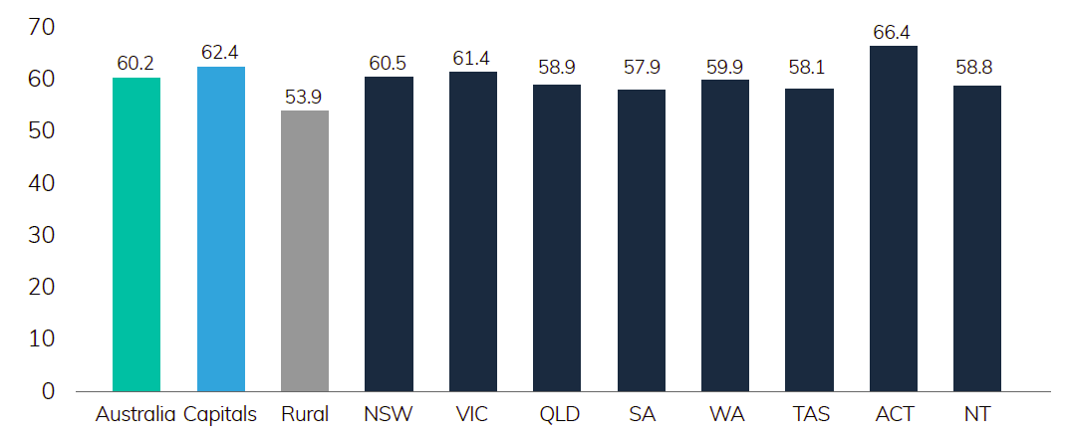

Source: Australian Digital Inclusion Index 2018 (based on data from Roy Morgan Single Source, April 2017—March 2018).

In 2018, digital inclusion is 8.5 points higher in capital cities (62.4) than in country areas (53.9) (ADII 2018, p. 7). The index illuminates the link between geography and digital inclusion—and while the ‘Capital–Country gap’ has narrowed slightly over the past three years, from 9.5 (2015) to 8.5 (2018), there is still a divide. Significantly, all of the regions with the lowest levels of digital inclusion are outside the major cities: Eyre (45.0), South East SA (48.6), North Victoria (50.8), and Murray and Murrumbidgee (51.0) (ADII 2018, p. 16).

### 4.1 Attracting and retaining people in the regions

Connectivity has the power to attract and retain residents and workers in regional, rural and remote Australia. The committee heard evidence that young people were reluctant to work in places without mobile coverage because they wanted to be able to stay in touch with their families and friends.

_____________________________________________________________________________________

‘Availability of satellite and mobile technologies are dependent upon access to the equipment and hardware required for a connection. In rural and remote areas, separated by expansive distances, this means that often accessibility is limited, leaving much of the area without access to the required technology. This also makes it difficult to retain people in these areas where mobile and internet coverage is limited.’

ICPA Australia submission Isolated Children's and Parents' Association logo.

_____________________________________________________________________________________

To ensure regional Australia is best positioned to retain people in the long term, a strong base of essential infrastructure, social networks, employment opportunities, education and health services are required. Access to good quality telecommunications underpins all the aforementioned areas. This is supported by the Productivity Commission’s Transitioning Regions Report, which cited OECD research that found infrastructure and connectivity were critical enablers for regional economies (p.74).

The employment and study opportunities that come with connectivity have the ability to keep people in the regions. The benefit of keeping young people ‘in and on country’ has a clear social benefit, with positive impacts on local economies. This is reinforced by a 2016 Regional Capitals Australia survey, which found 80% of the capitals surveyed cited communications and technology as a ‘top 3’ policy priority for their city.[6]

The committee’s view is that strongly-connected regions are essential to improving their attractiveness to workers.

### 4.2 Health

Telehealth is one of the great social benefits of telecommunications. Telehealth removes geographical barriers to important medical services and advice, ensuring all Australians, no matter where they live, can access quality health care.

Many Australians, particularly those in remote or very remote Australia, are hundreds of kilometres away from hospitals and specialists. At the same time, regional Australians are 20% more likely to experience chronic disease, with higher rates of diabetes, cardiovascular disease and stroke than those in major cities (National Rural Health Alliance submission). Innovative telecommunications technologies provide an opportunity to ensure regional and rural Australians have the same access to high-quality treatment and care as those living in the city.

The potential social and economic benefits of increasing access and take up of telehealth are well documented. A trial by CSIRO showed savings of 24% over year to the healthcare system made through reductions in the number and cost of GP visits, specialist visits and procedures carried out (CSIRO, 2018).[7] Importantly, the research showed that return on investment of a telemonitoring initiative on a national scale would be in the order of five to one. This takes into account the reduced hospital inpatient and outpatient services, reduced visits to GPs, reduced visits from community nurses and an overall reduced demand on increasingly scarce clinical resources.

There are already some fantastic initiatives taking place in telehealth in Australia, having a positive impact on the health and wellbeing of patients. For example, in its submission to this review, the Stroke Foundation highlights a number of ‘telestroke’ programs taking place at the state level.

#### Case study: Victorian Stroke Telemedicine Program

The first of its kind in Australia, the Victorian Stroke Telemedicine (VST) Program has demonstrated the ability to facilitate rapid clinical decision-making and treatment of stroke by seamlessly connecting regional emergency departments to a roster of metropolitan-based neurologists all day, every day.

* Major achievements of the VST Program to date include:
* More than 3,500 initial consultations performed.
* More than 600 patients identified as meeting the criteria to receive thrombolysis.
* More than 180 patients referred for endovascular clot retrieval.
* A 30-minute reduction in door-to-needle time (the crucial delay from emergency department arrival to thrombolysis that is directly linked to patient outcomes).
* A 2.5 fold percent increase (to 33 percent) in patients with acute stroke treated with thrombolysis within 4.5 hours of symptom onset, equivalent to metro hospitals.
* 1 in 3 calls results in a diagnosis other than a stroke; i.e. the VST program provides both telestroke and teleneurology consultations.

Despite the obvious benefits of telehealth, it has been slow to take off in Australia. The committee has heard that restrictive telehealth consultation guidelines for Medicare rebates (distance criteria and restrictions on which health professionals can participate in the scheme) accounts for a large part of this slow take-off (Pearcey Institute submission, p. 3). Additionally, there needs to be sufficient bandwidth available for healthcare for telehealth services to work. The quality of broadband access and data available is still not sufficient to fully implement the opportunities that telehealth present.

_____________________________________________________________________________________

‘Data limitations are problematic for users of rural health and telehealth. A North Queensland family had four children doing Specific Needs sessions with professionals but could only do limited sessions due to data limits.

ICPA (Aust) would like to see Telstra initiate unmetered sites for health and specific education needs, similar to the unmetered education sites. Also, for NBN Sky Muster families need to be able to access extra data packs or a Medical Port similar to the Education Port for those with Medical or Specific Education Needs.’

ICPA Australia submission Isoated Children's and Parents' Association logo.

_____________________________________________________________________________________

The Royal Flying Doctors Service (RFDS) delivers some of its services to rural and remote communities via video conferencing. When the technology works, this is cost effective for patients, with reduced travel time to easy access care. This method of working also is valuable for rurally-isolated health professionals, and provides opportunities for coordinated care between patients, rural clinicians and specialists, who are often located at major metropolitan hospitals (RFDS submission, p. 2).

_____________________________________________________________________________________

‘Whilst access to videoconferencing services is slowly increasing, there are still several barriers to accessing services for rural and particularly remote RFDS communities. These include, for example, insufficient bandwidth allocated for healthcare. This often results in frozen screens, lagging, and dropouts. These issues are magnified during peak usage times. As a result, both clinicians and patients may become frustrated and revert back to telephone calls, or clinicians may, on an ad-hoc basis, resort to less optimum platforms (such as Facetime or Skype) to gain valuable visual information.

Unmetered access to online health services and higher peak period data limits for Sky Muster would greatly improve access to these much needed services.’

Royal Flying Doctors Service submission Royal Flying Doctors Service logo.

_____________________________________________________________________________________

Mental health is another area that stands to benefit significantly from telehealth. The committee acknowledges that the federal government has recently announced $11.4 million of funding to help the mental health of drought-affected farmers and their families. This initiative will allow people in drought-affected areas to access counselling sessions on Skype, recognising the long distances and the cost of travel in money and time of rural people[8]. In order to receive these services, people need a reliable internet connection.

The NBN is a vital first step to addressing these challenges. To ensure all Australians benefit from this innovation we must first ensure we have the right enablers in place: adequate bandwidth and coverage for regional and rural communities, affordable equipment, digital ability and literacy.

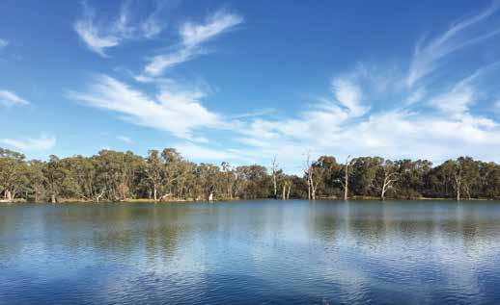

*Darling and Murray River junction in Wentworth, NSW*

### 4.3 Education

Education in regional, rural and remote communities is one of the most data-intensive activities. Whether students are being educated via distance or at local schools, education is increasingly digital. Particularly for distance education, video is a key component of lessons. Broadband access and fast upload and download speeds are essential in order to facilitate this service.

The committee’s visit to the School of the Air in Katherine, Northern Territory revealed first- hand the impact the internet has had on students studying in remote areas. The committee observed lessons being delivered online, where students could interact with each other and teachers by live messaging or over the phone.

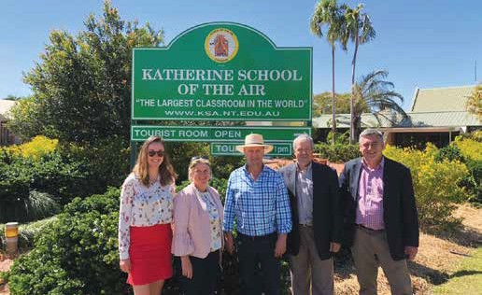

*Members of the committee and secretariat at School of the Air in Katherine, NT*

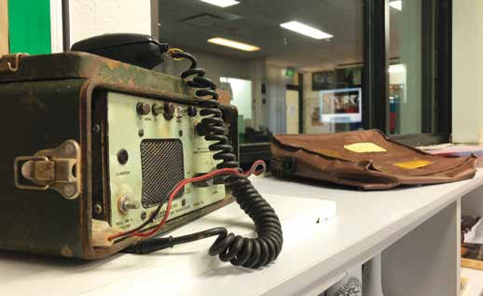

*Old technology originally used for delivering lessons at School of the Air, Katherine, NT*

While the internet has been a game changer for School of the Air, the landline is still important. For distance education students in the satellite footprint, the landline service is essential in ensuring daily access to students and teachers, even when the internet fails.

Feedback indicates there are still significant issues with the reliability and quality of service of the NBN Sky Muster satellite service. In particular, two of these challenges are its susceptibility to weather events and the latency issues associated with voice over satellite technology (ICPA Queensland submission, p. 2). Importantly, when the internet goes down, the availability of landline phones ensures that distance education students still have connectivity and are able to continue participating in their lessons (ICPA Australia submission, p. 8).

As discussed earlier in this report, we recommend no changes to the current Universal Service Obligation until there are fit-for-purpose alternative voice options for those consumers served by the Sky Muster satellite service.

The modern curriculum assumes fast and reliable internet connectivity, which many rural and remote schools lack. Furthermore, online NAPLAN, anticipated to be rolled out across the country, is reliant on the availability of adequate bandwidth for students to complete the assessment online. Without reliable internet, students risk being left behind their city counterparts.

There have been significant strides in enabling education through connectivity. Importantly, the NBN Sky Muster Education Port, offered as part of NBN Co’s Public Interest Premises policy has been game changing for distance education students. Additionally, Telstra’s unmetering of educational sites for their customers on ADSL, cable or mobile broadband plans has helped ensure educational activities are available and accessible for students studying by distance education.

Unfortunately, the Education Port has not improved the situation for people who do not qualify to access it. There are many educational needs for people not studying via distance, for example; students at rural schools, tertiary and vocational students and people undertaking remote work placements. All of these groups need access to the internet and large amounts of data to complete their studies.

### 4.4 Delivering the data

There is a data divide in Australia. Higher data limits for Sky Muster users are needed so that families don’t need to choose between using data for essential education purposes or for critical health advice.

People on fixed-line and fixed-wireless broadband can typically receive unlimited data for about $70 a month, while similarly priced Sky Muster plans only deliver about 210GB per month (with a maximum of 70GB during peak times).

NBN’s Fair Use Policy for Sky Muster customers limits the amount of data people use. This policy is important as there is limited capacity on the satellites, and the policy ensures no one overuses their share to the disadvantage of others. However, the Fair Use Policy is applied equally across all Sky Muster spot beams, without consideration of whether particular spot beams are at risk of congestion.

The Fair Use Policy means the following rules apply for data usage:

* Individual services may not exceed 150GB of peak period (7am–1am) usage over any 4 week rolling period.
* Individual services may not exceed 300GB of off-peak period (1am–7am) usage over any 4 week rolling period.

Failure to comply with the Fair Use Policy means that the users’ data will be shaped.

The doubling of data for NBN Sky Muster customers in 2017 has been warmly welcomed, but it is not enough to keep up with the increasing high data demands of necessary activities. Families on Sky Muster struggle to remain under their data limit when they are trying to balance education, entertainment, telehealth, home, business, staff and visitors’ needs all on one plan.

_____________________________________________________________________________________

‘Telehealth services are being rolled out but require fast connections with audio and visual technologies. The quality of broadband access is still not sufficient to fully implement the opportunities that telehealth present. I have heard of one example where a student did his online studies very late in the evenings so that his sibling could use the internet during the day for telehealth purposes. With much of our region being classified remote or very remote, with a trip to hospital and specialists being hundreds or kilometers away, access to high speed broadband and telehealth services should now be considered a right and not a luxury.’

Regional Development Australia Townsville and North West Queensland submission  
 Regional Development Australia Townsville and North West Queensland logo.

_____________________________________________________________________________________

There have been calls to extend the Education Port to all students undertaking education and training across regional and remote Australia. There is certainly merit to this argument, the number of people engaged in some sort of formal education or training in Australia is enormous, and these people would also benefit from have more data available.

More than 3 million (19%) of Australians aged 15 to 64 are engaged in some kind of formal study.[9] A survey conducted by the Regional Development Australia Wheatbelt Inc. found that 76% of 18 to 34-year-olds in the region use the internet for professional networking and education/training (p. 10). The same trends can be seen across other parts in regional and remote Australia.

However, there is a range of important services that require high amounts of data. The creation of more bespoke programs, such as the Education Port, requires value judgements to be made about what activities are deserving of more data. This does not fix the problem.

The take-up of the Sky Muster satellite service is lower than was expected (100,000 premises activated, compared to 400,000 ready to connect), and the take-up is expected to stay flat over the next four years (NBN Co 2018–19 Corporate Plan, p. 59).

#### NBN Sky Muster satellite activation profile

| Premises ready to connect—cumulative (millions) | FY17 | FY18 | FY19 | FY20 | FY21 | FY22 |
| --- | --- | --- | --- | --- | --- | --- |
| 2017 report forecast | 0.1 | 0.1 | 0.2 | 0.2 | N/A | N/A |
| 2018 report forecast | N/A | 0.1 | 0.1 | 0.1 | 0.1 | 0.1 |

Source: NBN Co Corporate Plan 2018–19, p.59, and NBN Co Corporate Plan 2017–18, p. 50.

Given the lower than anticipated take-up, many of the 101 spot beams are underutilised. This means there should be additional capacity to allocate to users, rather than restricting them through the Fair Use Policy.

Through our proposed Stronger Regional Connectivity Package, areas with higher take-up of Sky Muster services could be moved to alternative technologies as a priority, freeing up finite satellite capacity. It is our view that the data packages should be reviewed to provide the largest data allowances possible to all users with no option other than the satellite service.

**Recommendation 7**—The existing data limits for Sky Muster services be reviewed with the aim of increasing data limits across the board. As a minimum, the spot beams that are underutilised should have data limits increased.

### 4.5 Indigenous

It is time to address the structural and skills issues that are holding back many Indigenous Australians living in remote communities from accessing the economic and social benefits of digital technologies and services. Better access to phone and internet services would mean that Aboriginal and Torres Strait Islander people living in remote communities could continue to learn, work, and engage with essential government services while living in their cultural homelands.

Remote Indigenous communities are some of the most disadvantaged in the nation often with different needs, socio-economic conditions, environmental challenges, and usage patterns to other households in Australia (Northern Territory Government submission, p. 6).

_____________________________________________________________________________________

’There are about 130,000 Aboriginal and Torres Strait Islander people living in over 1,100 discrete communities across remote Australia, with the employment to population ratio averaging about 45%. Half of this population is under 24 years old. Over 30% of remote and very remote Indigenous households still have no access to Internet, with the majority of these still without basic telephony services. Remote Indigenous people have most to gain from being connected to address the widening digital divide.’

Indigenous Remote Communications Association submission Indigenous Remote Communications Association logo.

_____________________________________________________________________________________

Access to communications services can improve the wellbeing of those living in remote Indigenous communities. Like all Australians, the benefits include access to telehealth services and specialist care, education opportunities, and in reaching a wider audience for their businesses.

Additionally, specific opportunities for remote Indigenous communities include sharing language and stories, digital archiving and genealogy mapping technology, conducting research and enabling communities to share their stories through digital technology such as video storytelling (Communications Alliance Ltd submission).

Improved connectivity also presents great opportunities for Indigenous businesses. Work by PricewaterhouseCoopers (PwC) estimates that Indigenous businesses added between $2.2 billion and $6.6 billion to the Australian economy in 2016 (PwC 2017, piii).[10]

In particular, the Indigenous visual arts sector is a major contributor to the arts economy and responsible for some of Australia’s most valuable works of art (Australia Council for the Arts, 2015, p. 4).[11] In the last six months of 2017, 67 remote Indigenous-owned art centres funded through the Australian Government’s Indigenous Visual Arts Industry Support Program generated approximately $15 million in art sales and employed more than 300 Indigenous arts workers.

In addition to their economic contribution, Indigenous businesses can provide significant social contributions as they are more likely to employ Indigenous people which in turn reduces the employment gap (PwC 2017, p. iii).



_____________________________________________________________________________________

‘Digital inclusion will promote improvements in most other Closing the Gap (CTG) measures, including education, health, social inclusion, governance, compliance with government regulations and ability to participate in employment and economic improvements. Chapter five of the Closing the Gap policy relates to economic development and Chapter seven relates to social inclusion. Both of these key outcomes will be improved by addressing Digital Inclusion. The importance of Telecommunications and Infrastructure underpins the Department of Prime Minister and Cabinet’s Indigenous Advancement Strategy.’

Broadband for the Bush submission Broadband for the Bush logo.

_____________________________________________________________________________________

The social and economic benefits of connectivity for remote Indigenous communities are clear, but there are a range of particular issues in improving digital access and inclusion. In addition to the physical challenges of delivering infrastructure to remote locations, there are also language barriers, affordability issues and limited awareness of what is available.

Digital inclusion is comparatively low for Indigenous Australians. The Australian Digital Inclusion Index 2018 shows that Indigenous Australians living in urban and regional areas have low levels of digital inclusion, scoring below the national average on access, affordability and digital ability. The largest gap is in affordability, where the score for Indigenous Australians (49.7) is 7.9 points below the national average (57.6). This data does not include remote Indigenous Australians, where the gap is much greater due to geographic isolation, cost of infrastructure rollouts and socioeconomic disadvantage (IRCA submission, p. 6).

Mobile-only connectivity is high among the Indigenous Australian population. Mobile internet access carries a higher cost per gigabyte than fixed connections, contributing to the low affordability result (ADII 2018 submission, p. 7). Many Indigenous Australians opt for pre-paid mobile phones often as a way of controlling expenditure.[12] This payment option means they are not locked into a contract, but are incrementally more expensive than alternative services. As a consequence Indigenous Australians often use some of the most expensive services on offer.

In many remote Indigenous communities there are limited telecommunications options. Tangentyere Council Aboriginal Corporation, a service delivery agency for the 18 housing associations known as ‘town camps’ in Alice Springs, says telecommunications options are few and far between for their members.

_____________________________________________________________________________________

‘While mainstream Australia may experience public phone boxes and fixed land line services as redundant, Tangentyere considers that access and availability of fixed-line phone services and public phone boxes in remote and regional urban and Town Camp localities as essential to making contact with essential services, maintaining social connectedness including cultural and family ties and to ensure safety and wellbeing, especially in the case of an emergency.’

Tangentyere Council Aboriginal Corporation submission Tangentyere Council Aboriginal Corporation logo.

_____________________________________________________________________________________

The significance of digital inclusion for Indigenous Australians is recognised across a number of government and industry players. In terms of infrastructure, the Department of the Prime Minister and Cabinet maintains and monitors around 300 Wi-Fi Telephones and 245 Community Payphones in remote Indigenous communities.

NBN Co’s Public Interest Premises policy is designed to deliver more capacity where it can make the most difference. There are 93 Indigenous community organisations registered as Public Interest Premises, 45 of which are in the Northern Territory. Many of these organisations use the Public Interest Premises product to offer Wi-Fi in remote Indigenous communities. The Broadband for the Bush Alliance and IRCA noted in their submissions that isolated Indigenous communities, many of which are within the satellite footprint, may be better suited to infrastructure that supports mobile connectivity or Wi-Fi than individual household connections.

Additionally, the Northern Territory government and Telstra have committed $28 million over 2019–2022 to prioritise infrastructure investment in remote communities, major transport corridors and remote tourism sites (Northern Territory government submission, p. 3). This builds on their remote telecommunications infrastructure co-investment program, which has delivered mobile telephone and broadband services to about 23,000 residents in 45 remote communities since 2007.

There are also initiatives in place to improve the digital literacy of Indigenous Australians. The program inDigiMOB (run by Telstra and the Indigenous Remote Communications Association) provides technical, training and infrastructure support resources to communities and organisations, according to their diverse needs and contexts for Aboriginal and Torres Strait Islander peoples in remote areas of the Northern Territory.

A coherent and holistic policy approach to telecommunications services is needed for remote Indigenous communities. A number of stakeholders have called for the development of an Indigenous Digital Inclusion Strategy. It is important that there is local ownership in all aspects of the strategy, and that it builds upon the capacity of existing organisations, infrastructure and programs to avoid duplication.

The strategy should include data collection to measure whether remote Aboriginal and Torres Strait Islander community members have broadband available to them with the minimum requirements in terms of access, availability, affordability and digital literacy. The strategy should consider affordability and suitability of services for Indigenous communities, such as community Wi-Fi. It is important that a digital literacy program is included as part of any such strategy, and is developed to be culturally and linguistically appropriate for remote community members.

**Recommendation 8**—A targeted Indigenous Digital Inclusion program with a focus on access, affordability and digital ability be developed in partnership with Indigenous communities.

### 4.6 Affordability

Those who cannot afford to keep pace with new communications technologies are at risk of being excluded from the opportunities afforded by the new digital future. Regional and remote Australians are more likely to have lower incomes than their city counterparts. Median equivalised household incomes in Australia’s greater capital city areas are 18% higher than incomes outside the capital cities.[13]

The concentration of low income households in regional, rural and remote Australia makes digital affordability a key barrier to digital inclusion and a major cause for concern (Australian Digital Inclusion Alliance submission, p. 4). Research from the Bureau of Communications and Arts Research (BCAR), shows the amount rural households spend on key communications services as a share of disposable income has usually been above that of the average household in Australia (figure below).

Figure 2  
Average share of household disposable income spent on mobile and fixed-line telephone rent, calls and internet charges

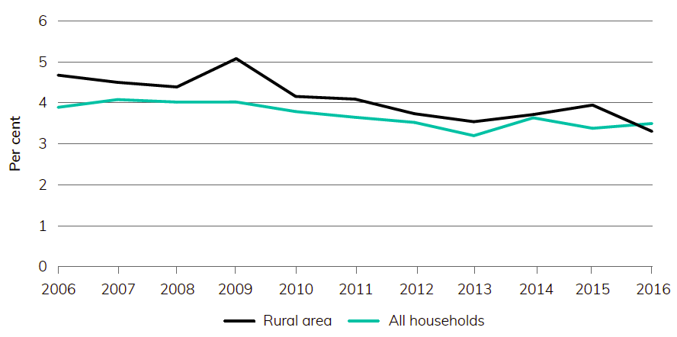

Source: Estimates based on the Household, Income and Labour Dynamics in Australia survey, wave 16.[14]

While the NBN rollout is increasing the range of products for some consumers in regional areas, there are still concerns that the current NBN Co pricing structure will disadvantage regional customers. Customers do not choose the technology that NBN Co uses to service their home or business and customers should not be disadvantaged because of the technology available in their area.

We have heard that potential customers who are vulnerable or in low-income households struggle to afford the NBN. We hope that NBN Co’s recently announced entry-level bundle, aimed at voice-only and basic broadband consumers, will lower barriers for people trying to connect at the lowest possible cost. We do acknowledge though that this new bundle does not extend to fixed-wireless or satellite customers at this stage.

We believe the pricing approach adopted by NBN Co must support the objective of reducing the digital divide between regional and metro Australia.

If everyone is expected to engage digitally, then the needs of everyone should be considered. People with disabilities, from a non-English speaking background, with mobile- only data access, or no mobile coverage have different needs in accessing online services.

Government and the private sector need to take into account the diverse circumstances of people using their services in their design and pricing decisions. For example, the committee has heard concerns about two-step verification (for example with many banking apps) in areas where there is no mobile coverage. We understand that many organisations have overcome this by providing other options to verify identity, such as with another app. Whether the issue is no infrastructure to access, affordability or digital literacy barriers, organisations, including government, need to design their services to be as accessible as possible.

**Recommendation 9**—Governments and industry should reduce barriers to people engaging with essential services online, including unmetering data for access to government sites.

## 5. Digital literacy

There is a crisis of confidence when it comes to using and understanding digital technology in regional and remote Australia. One of the main messages across the 22 public consultations was that people in these communities often lack the knowledge or experience of how to use different technology, what it can be used for, and how to troubleshoot issues.

More and more essential services are moving to a digital-first model. From accessing education, online banking and business software, people are expected to have internet access and the essential skills to navigate websites to perform these important tasks.

Digital literacy is a double-edged sword in regional Australia. Not only are people expected to know more about the numerous available technologies, but it is often more difficult to obtain this knowledge. Satellite dishes, external antennas, and repeaters may be necessary to get connected in regional Australia. At the same time, there are limited resources in regional, rural and remote areas to develop the necessary technical and digital skills.

### 5.1 Infrastructure vs education

To date, public and private investment in mobile and broadband technology has been largely focused on building infrastructure. We have formed the view that it is equally important for resources to be directed to building digital literacy and technical capabilities. With the NBN rollout reaching completion, now is the time to focus on ensuring people are getting the most out of their improved connectivity.

Government, industry, and volunteer groups are currently trying to reduce the vast gap of digital literacy services in Australia. The Government’s ‘Be Connected—Every Australian Online’ initiative is aimed at empowering all Australians to thrive in a digital world. This is essential given the expectations that Australians will be able to access and successfully navigate a range of online services in order to engage with government, for example Medicare, Centrelink and the Australian Tax Office. The combination of online learning resources along with a network of community partners help disadvantaged community members communicate online, but this needs to go further.

Industry has recognised that regional communities need access to reliable information to ensure residents understand what services are available to them, and what mix of services will best suit their needs. Across many of the public consultations, there was a notable number of people who expressed concerns with the lack of local face-to-face support available for telecommunications issues. Telstra has stated it is making efforts to make changes and dedicate more resources to its engagement strategies for regional Australia (Telstra submission, p.5). One such example is the establishment of a dedicated call centre team with a specialised knowledge to manage calls from customers located more than 100 kilometres from a Telstra branded store to ensure more remote customers’ needs are properly understood and catered for (Telstra submission, p.6).

NBN Co launched its NBN local initiative in October 2017, and a number of NBN local representatives attended public consultations with the committee for the review. These NBN staff were able to provide helpful and practical advice to people experiencing difficulties with the NBN. The work of the NBN local team could be well supported by the rollout of independent advisers.

The volunteer run group BIRRR performs an important role in advocating for and developing digital literacy in regional rural and remote Australia. While BIRRR does excellent work helping people get connected and stay connected, a volunteer organisation cannot be expected to solve the vast problems across Australia.

### 5.2 The Internet of Things—realising the benefits

Investment in and adoption of new IoT technologies can have massive potential productivity gains in the agricultural industry. As we’ve noted earlier, the Precision 2 Decision (P2D) project estimates IoT technologies can unlock $20.3 billion in gross value of agricultural production. In order to realise these benefits, the right settings to facilitate this adoption must be in place.

The P2D survey reported knowledge of on-farm communication options was low across all industries, yet when producers have greater knowledge of telecommunications options and data appreciation, their investment in technology increases. This demonstrates that in a rapidly evolving on-farm IoT industry, education is one of the biggest challenges faced by those looking for and offering solutions (AgTech Centric submission p.18).

The recently announced partnership between NBN and the National Farmers Federation (NFF) is aiming to better inform farmers of their connectivity options.[15] The work being done by these groups is helping the people accessing them, and should be commended. The resources developing in this space should continue to be championed in digital literacy programs and industry forums.

### 5.3 Solutions

A three-pronged approach is needed to improve digital literacy:

* A central point needs to be established to deliver trustworthy, independent information
* On the ground advice and support must be provided, and
* Specialised advice is needed for the agriculture industry.

In developing such programs, we suggest the Government look to engage with regional communities in partnership with regional representative groups, retail service providers, mobile network operators, NBN Co and government agencies.

#### A central tech hub

There is a significant market for a simple platform aimed towards regional Australians to help them navigate digital technologies. The popularity of the BIRRR website shows people are hungry for independent information about digital technologies. However many stakeholders have raised concerns about the sustainability of this volunteer model, and BIRRR itself has called for the establishment of a technology hub.

A number of submissions to the review called for the installation of a ‘tech hub’ or communications help centre that targets regional, rural and remote customers. This would alleviate some of the barriers customers encounter when diagnosing faults and navigating the complaints processes of the different retail service providers.

We also heard feedback in the public consultations regarding supply chain confusion. It is not always clear whether a particular fault is the responsibility of the retail service provider (for example Optus, Telstra or Vodafone) or the infrastructure provider (for example NBN Co). A central point with information about the supply chain, and who to contact to report a particular issue, would help solve these problems.

The tech hub could be modelled on the services and techniques already used with success by BIRRR. It should include: a help centre, online forum, chat or online support and a website.

#### Independent tech advisers

When it comes to getting the full use out of broadband and mobile technologies, many people need an initial helping hand. People need the motivation and confidence to connect. An independent digital adviser for regional and remote areas would focus on helping people connect and stay connected.

Many businesses and community members are confused about the NBN network rollout and the different options for speeds and data packages on offer. An independent adviser could provide impartial information about the speeds available and broadband data limits to help people work out what service is right for them.

**Recommendation 10**—The Government commit to improving digital literacy in regional, rural and remote Australia:

1. Developing an online technology ‘hub’ to provide independent and factual information to help support people to build up the skills to solve telecommunications issues.
2. Deploying technical advisers on a short-term basis across regional, rural and remote Australia to provide on-the-ground support to help people get connected and stay connected, using technologies that are suitable to their individual needs.
3. Encouraging the agricultural sector to provide industry-specific advice about Internet of Things and other digital applications that will drive productivity gains in the sector.

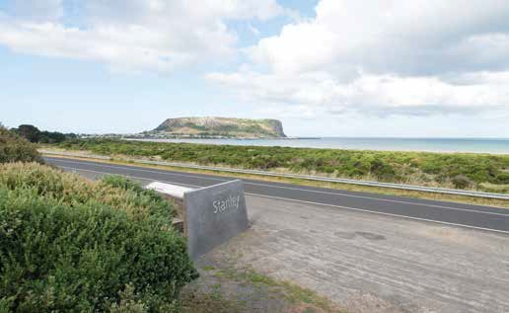

*Stanley, Tasmania*

### Case study: South West NBN Advisor—Western Australia

The South West NBN Advisor Program initiative was developed during 2016 by the South West Development Commission (SWDC) to provide free, accurate and impartial advice to the South West regional community, small business sector and the not-for-profit sector on what needs to be considered when transitioning to the NBN.

The NBN Advisor position was created in partnership with the SWDC, Regional Development Australia—South West, NBN Co, Business South West and the South West Chambers of Commerce and Industry. To undertake this work, Mr Mike Hendry was employed on a part-time basis for 18 months. During this time, Mr Hendry engaged with the South West community business sector by delivering the following outcomes:

* Presented 150 public seminars to more than 3,300 attendees.
* Provided specialised advice and assistance to over 350 clients (including 180 business and 171 consumers).
* Cold called over 300 small business proprietors.
* Developed an interactive and informative one-hour visual presentation.
* Undertook regular talkback sessions on ABC radio.
* Developed a four-page brochure and distributed over 6,000 copies.
* Distributed over 6,000 NBN Small Business brochures.
* Drove over 10,000km visiting all towns in the South West region.
* Created and mailed more than 40,000 items.
* Engaged and shared information with retail service providers, lobby groups and NBN Co.

The value in the delivery of the program is demonstrated by the fact that businesses and consumers with a greater understanding of these questions were more likely to connect early, and they had higher levels of satisfaction with the migration experience and their NBN services once connected.

The key to the success of the program was that the South West NBN Advisor role focused on providing ‘impartial advice’ in terms of options, business considerations and opportunities for business and the community on the benefits of high speed broadband rollout.

## Appendix 1—List of submissions

Non-confidential submissions are listed below. The committee received additional submissions that the authors requested not be published, and 164 survey responses.

| Submissions | State |
| --- | --- |
| Aerostats All Australia | NSW |
| AgForce Queensland | QLD |
| AgTechCentric | ACT |
| Armidale Regional Council | NSW |
| Aussie Broadband | VIC |
| Australia’s Academic and Research Network | National |
| Australian Communications and Media Authority | National |
| Australian Communications Consumer Action Network | National |
| Australian Competition and Consumer Commission | National |
| Australian Digital Inclusion Alliance | National |
| Australian Library and Information Association | National |
| Australian Local Government Association | National |
| Australian Small Business and Family Enterprise Ombudsman | National |
| AvaGrow Farms | VIC |
| Better Internet for Rural, Regional and Remote Australia | National |
| Betts Transport | NSW |
| Blunden, R | QLD |
| Broadband for the Bush Alliance | National |
| Burke Shire Council | QLD |
| Burns, J | NSW |
| Caravan Parks Association of Queensland | QLD |
| Carr, P | QLD |
| Central Australian Youth Link-Up Service | NT |
| Central Highlands Councils Victoria | VIC |
| Centre for Appropriate Technology | NT |
| City of Ballarat | VIC |
| Clarke, M | NSW |
| Communications Alliance and Australian Mobile Telecommunications Association Joint submission | National |
| Connect Technology | National |
| Cotton Australia | National |
| Cottrell, M | VIC |
| Cunningham, R | SA |
| Department of Primary Industries and Regions South Australia | SA |
| Dolton, I | WA |
| Downham, G | QLD |
| East Arnhem Land Regional Economic Development Committee | NT |
| Gillespie, K | NSW |
| Golden Plains Shire Council | VIC |
| Goldfields Settlements | WA |
| GrainGrowers | NSW |
| Indigenous Remote Communications Association | National |
| Infoquest Pty Ltd | SA |
| Isolated Children’s Parents’ Association of Australia | National |
| Isolated Children’s Parents’ Association of NSW | NSW |
| Isolated Children’s Parents’ Association of QLD | QLD |
| Johnston, R | NSW |
| Jones, M | WA |
| Kenny, N | NSW |
| Lamb, C and G | NSW |
| Liverpool Plains Shire Council | NSW |
| Livestock SA | SA |
| Local Government Association of Queensland | QLD |
| Local Government Association of the Northern Territory | NT |
| Mason, P | NSW |
| McArdle, D | NSW |
| McKenzie, K and Rowe, B | NSW |
| McMurtrie, A | NSW |
| Merriwa District Progress Association | NSW |
| Mid Murray Council | SA |
| Modrich, E | VIC |
| Moules, P | NSW |
| National Farmers Federation | National |
| National Narrowband Network Co. | National |
| NBN Co Limited | National |
| Neilson, C | QLD |
| NiftyCAD Support Centre | WA |
| Noosa Pengari Steiner School Association | QLD |
| Northern Areas Council | SA |
| Northern Territory Cattlemen’s Association | NT |
| Northern Territory Government | NT |
| NSW Business Chamber | NSW |
| NSW Farmers | NSW |
| Office of Rowan Ramsey MP | SA |
| Office of the Leader of the Opposition, NT | NT |
| Optus | National |
| Pilbara Regional Council | WA |
| Queensland Tourism Industry Council | QLD |
| Regional Development Australia, Murraylands and Riverland | SA |
| Regional Development Australia, Northern Territory | NT |
| Regional Development Australia, Townsville and North West Queensland | QLD |
| Regional Development Australia, Wheatbelt | WA |
| Regional Development Australia, Whyalla and Eyre Peninsula | SA |
| Rippin, K and Barbieri, M | NSW |
| Riverview Farming Pty Ltd | NSW |
| Royal Flying Doctor Service of Australia | National |
| SBS | National |
| Shire of Mt Marshall | WA |
| Shire of Westonia | WA |
| Shire of Yilgram | WA |
| Simm, R | QLD |
| Southern Downs Regional Council | WA |
| Stroke Foundation | National |
| Swanson, J | NSW |
| Sweeter Banana Co-operative | WA |
| Tangentyere Council Aboriginal Corporation | NT |
| Tasmania Farmers and Graziers Association | TAS |
| Telecommunications Industry Ombudsman | National |
| Telstra | National |
| Thallon Progress Association Inc. | NSW |
| The Country Women’s Association of Australia (CWAA) | National |
| The Country Women’s Australia, Nundle | NSW |
| The Kentish Council | TAS |
| The Kimberley Pilbara Cattlemen’s Association of WA | WA |
| The Pearcey Institute Ltd | VIC |
| Thorn, H | WA |
| Tumbulgum Community Association | NSW |
| Victorian Automobile Chamber of Commerce | VIC |
| Victorian Farmers Federation | VIC |
| Vodafone | National |
| W Tree Promotion and Progress Association | VIC |
| Wells, S | QLD |
| West Coast Council | TAS |
| Western Downs Regional Council | QLD |
| Wheatbelt Business Network | WA |
| Wheatbelt East Regional Organisation of Councils—multiple submissions | WA |
| White, M | QLD |
| Wudinna District Council in South Australia | SA |

## Appendix 2—Public consultations

The Regional Telecommunications Independent Review Committee conducted 22 face-to- face public consultations with communities, business and governments across regional, rural and remote Australia. The committee also attended three national conferences and an Indigenous Focus day organised by the Broadband for the Bush Alliance. The locations are listed below:

### Northern Territory

6 June 2018—Katherine—Godinymayin Yijard Rivers Arts and Culture Centre

6 June 2018—Darwin—Indigenous Focus Day

7 June 2018—Darwin—Broadband for the Bush Forum

### Western Australia

8 June 2018—Kununurra—KGT Employment

17 July 2018—Bunbury—Koombana Bay Sailing Club

18 July 2018—Albany—Albany Bowling Club

19 July 2018—Kalgoorlie—Quality Inn, Railway Hotel

### Tasmania

19 June 2018—Stanley—Stanley Town Hall

19 June 2018—Devonport—Mersey Yacht Club

### South Australia

25 June 2018—Whyalla—Mt Laura Homestead

25 June 2018—Port Augusta—Central Oval

26 June 2018—Clare Valley—Clare Country Club

3 July 2018—Renmark—Renmark Hotel

### Victoria

3 July 2018—Mildura—Quality Hotel Mildura Grand

31 July 2018—Bairnsdale—Bairnsdale RSL

31 July 2018—Hamilton—Hamilton Performing Arts Centre

### New South Wales

5 July 2018—Wagga Wagga—Commercial Club

6 July 2018—Griffith—Griffith Ex-Servicemen’s Club

24 July 2018—Narrabri—Crossing Theatre

25 July 2018—Tamworth—Ibis Styles

12 & 13 September 2018—Sydney—Australian Communications Consumer Action Network (ACCAN) 2018 Conference

### Queensland

9 July 2018—Dalby—Dalby Leagues Club

9 July 2018—Longreach—Qantas Founders Museum

10 July 2018—Townsville—Mercure Townsville

11 July 2018—Cairns—Pullman Cairns International

### Australian Capital Territory

1 August 2018—Australian Capital Territory—Isolated Children’s Parents’ Association (ICPA) Federal Conference

## Appendix 3—Committee membership bios

 Mr Sean Edwards (Chair)

Following a successful business career building up and leading private and public property and wine companies, Mr Edwards was elected as a Senator to the Australian Parliament. Mr Edwards served as a member of the Australian Senate from 2011 to 2016 representing South Australia. He subsequently worked extensively on the Economics, Foreign Affairs Defence and Trade and Rural Affairs and Transport Standing Committees and chaired the Standing Committee of Economics between 2014 and 2016. Mr Edwards was active in community affairs from a young age and for many years has presided over and driven many public organisations, clubs and industry advocacy bodies. Before entering Parliament, Mr Edwards was an auctioneer, land and estate agent. Mr Edwards is a vigneron and winemaker in the Clare Valley, South Australia.

 Ms Wendy Duncan

Ms Duncan is a former Western Australian Parliamentarian from 2008–2017, initially in the Legislative Council before representing the Assembly seat of Kalgoorlie. Ms Duncan was raised on her parents’ sheep station and she and her siblings received their early education from the School of the Air. Ms Duncan worked for the National Farmers’ Federation in Canberra from 1977–1979 while completing tertiary education.

Before being elected to Parliament Ms Duncan had a career in agriculture, small business and local government. Following the 2008 election, she was Parliamentary Secretary to the Minister for Regional Development and Minister for Lands. Ms Duncan was Deputy Speaker of the Legislative Assembly from 2013–2017 and was also the first female Western Australian Nationals State President. Ms Duncan retired from parliament at the 2017 state election.

 Ms Johanna Plante

Ms Plante is well-known in the telecommunications industry having held leadership positions across industry for several decades with service providers, regulatory agencies, peak bodies and consumer organisations. Ms Plante has worked at the Australian Communications and Media Authority, AUSTEL and the Australian Communications Industry Forum on consumer and disability issues, as well as working at Telstra, AUSTEL and Networking the Nation on regional telecommunications issues. Ms Plante has gained an in- depth understanding of the telecommunications needs and challenges faced by both industry providers and less ‘mainstream’ consumers including rural and regional residents and businesses, Indigenous communities, seniors, people with disability and those living in remote areas of Australia. She is the immediate past Chairperson of the Australian Communications Consumer Action Network, a role she held for five years. As a founding member in 2016, Ms Plante has also been a regular contributor and adviser to the Regional, Rural and Remote Communications Coalition.

 Ms Robbie Sefton

Ms Sefton is a wool, meat and grain farmer and also the managing director of Seftons, a rural and regional strategic marketing company based in Tamworth, New South Wales.

Ms Sefton has lived, worked and travelled all over regional, rural and remote Australia as a rural leader and advocate. Ms Sefton is a graduate of the Australian Rural Leadership Program, the 2002 RIRDC NSW Rural Woman of the Year and a member of many boards and advisory groups for governments, businesses and not-for-profits. Robbie has been a board member of the Grazier’s Investment Company, a panel member on the Reserve Bank of Australia Small Business Finance Panel, and is currently the Deputy Chair of the National Australia Day Council. Ms Sefton has represented Australian rural women in international forums, such as the International Rural Women’s Conference, and in high level forums in Australia, including the Rural Women’s Summit in Canberra.

 Ms Kylie Stretton

Ms Stretton is a rural advocate with experience in public relations, communications, telecommunications, rural mental health, education, regenerative agriculture and advancing rural communities. Ms Stretton is a co-founder/administrator for Better Internet for Rural Regional and Remote Australia.

Her work involves administering, researching, sourcing and delivering technical support and information about internet and mobile communications in regional, rural and remote areas to approximately 12 000 followers on Facebook and Twitter. Ms Stretton has also been a member of AgForce Queensland’s Telecommunications Policy Committee since April 2017. Ms Stretton is a strong advocate for rural families and agriculture, especially the northern beef industry, and was named 2017 NAB Agribusiness Cattle Council of Australia Beef Rising Champion in November 2017. Ms Stretton is also the co-founder of the ‘Ask An Aussie Farmer’ Facebook community. Ms Stretton and her husband Shane are the owners and managers of a Charters Towers livestock agency, Northern Livestock Services, as well as operating Clancella Downs, where they produce beef and free-range eggs, and operate education programs.

 Mr Paul Weller

Mr Weller is a dairy farmer and a known and trusted community leader who has provided a strong voice for rural Victoria for more than 20 years. Mr Weller is a former president of the Victorian Farmers’ Federation and a board member of the National Farmers’ Federation. Mr Weller was a Director of Murray Goulburn Co-operative during 2005 to 2006, before being elected to the Victorian Parliament. During his time as a Member of the Victorian Parliament, Mr Weller held the role of the Deputy Speaker of the House, and Chairman of the Rural and Regional Committee of the Victorian Parliament from 2011 to 2014. In 2016 Mr Weller was appointed Director on the Board of Agersens, a technology company developing equipment to help beef and dairy farmers automate the movement and control of their livestock.

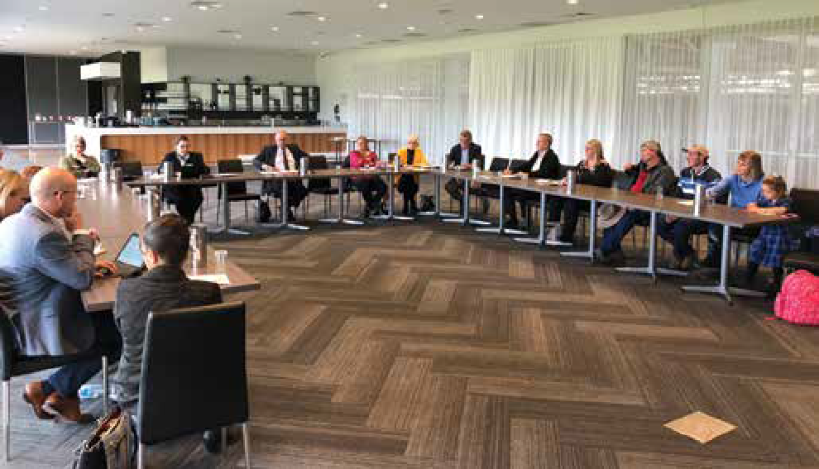

Public consultation in Port Augusta, SA

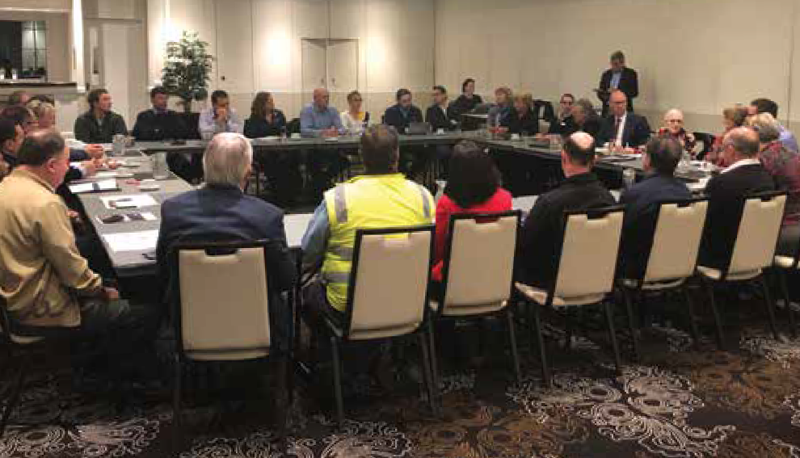

Public consultation in Griffith, NSW

## Appendix 4—Glossary and abbreviations

|  |  |
| --- | --- |
| Australian Competition and Consumer Commission (ACCC) | Australia’s competition regulator, ensuring that individuals and businesses comply with Australian competition, fair trading, and consumer protection laws. |
| Australian Communications and Media Authority (ACMA) | Australia’s regulator for broadcasting, the internet, radiocommunications and telecommunications. |
| Asymmetric Digital Subscriber Line (ADSL) | A technology for delivering high-speed data transmission over a copper phone line. |
| Bureau of Communications and Arts Research (BCAR) | A research body within the Department of Communications and the Arts. |
| Better Internet for Regional, Rural and Remote Australia (BIRRR) | A volunteer-based group that offers support, independent advice and advocacy regarding bush broadband options and issues. |
| Commonwealth Scientific and Industrial Research Organisation (CSIRO) | An independent government agency responsible for scientific research. |
| Customer Service Guarantee (CSG) | A standard designed to encourage service improvement and guard against poor service. |
| Copper network | A copper-based customer access network used to deliver standard voice telephony and broadband services. |
| Australian Digital Inclusion Index | This index provides a baseline for digital inclusion in Australia by measuring digital access, affordability, and digital ability to give a score out of 100. |
| Fair Use Policy | An NBN Co policy which is intended to avoid adverse network impacts on the quality or reliability of the NBN-Related Networks and the products and services supplied by NBN Co. |
| Fixed-line | Network design in which voice, data or broadband services are delivered over a physical line. |
| Fixed-wireless | Network design in which network connections are provided through radio signals. |
| High Capacity Radio Concentrator (HCRC) | A point to point radio network that provides voice services to some rural and remote premises. |
| Internet of Things (IoT) | A concept that refers to devices such as sensors, machines and other digital instruments which are connected to each other and the internet so that they are able to collect and exchange data. |
| Isolated Children’s Parents’ Association (ICPA) | A voluntary, non-profit, apolitical parent body dedicated to ensuring all geographically isolated children’s educational needs and aspirations are not disadvantaged because of where they live. There is a federal and a number of state councils of the ICPA. |
| Measuring Broadband Australia program | An ACCC program that helps provide consumers with accurate, independent and comparable information about NBN fixed-line broadband speeds and performance. |
| Low Earth Orbit (LEO) | Satellite systems used in telecommunications, which orbit between 400 and 1,000 miles above the earth’s surface. |
| Megabits Per Second (mbps) | A unit of measurement of transmission speeds. |
| Mobile Black Spot Program | An Australian Government initiative improving mobile phone coverage and competition across Australia. |
| NBN Co Limited (NBN Co) | An Australian Government owned corporation established to build and operate Australia’s wholesale broadband access network. |
| National Broadband Network (NBN) | A national project giving Australians access to fast internet services. |
| Productivity Commission (PC) | The Australian Government’s independent research and advisory body on a range of economic, social and environmental issues affecting the welfare of Australians. |
| Public Interest Premises | Places NBN Co considers are used on an on-going basis for a public interest purpose. These may include an indigenous community organisation, not-for-profit organisation, educational facility, health facility or local government facility. |
| Retail Service Provider (RSP) | A provider of retail broadband services to end users. |
| Sky Muster | NBN Co’s satellite service that delivers broadband access to homes and businesses in regional and remote Australia. |
| Universal Service Obligation (USO) | A consumer protection that ensures everyone has reasonable access to landline telephones and payphones regardless of where they live or work. |
| Voice over Internet Protocol (VoIP) | A method for delivering voice communications over the internet. |

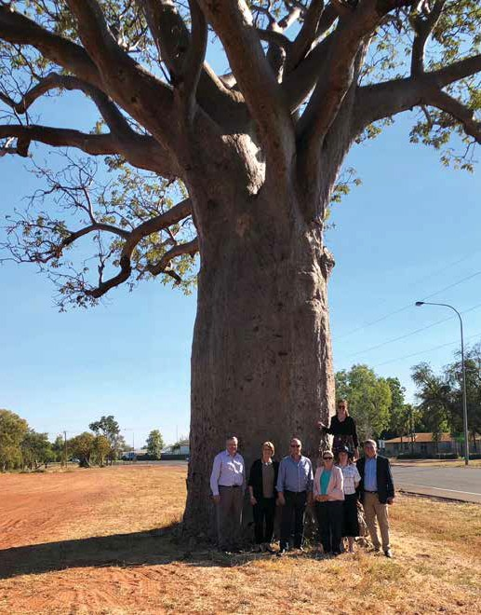

Members of the committee and secretariat with boab tree in Kununurra, WA84 2018 Regional Telecommunications Review

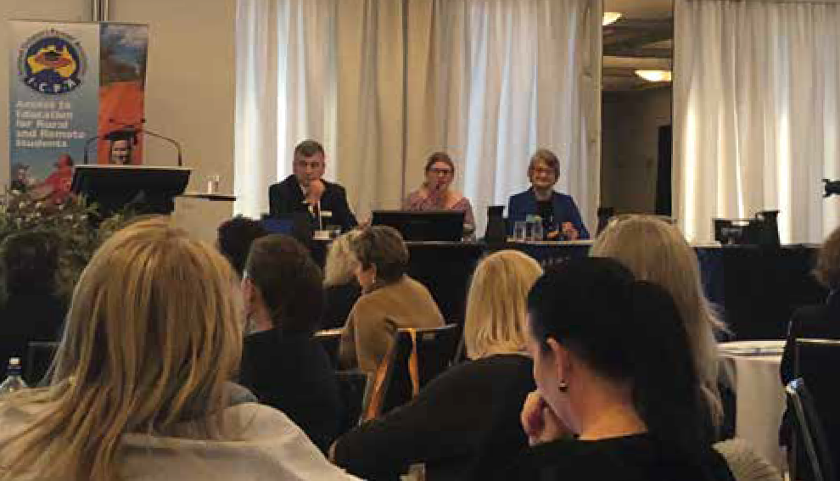

Kylie Stretton and Wendy Duncan, and Phil Smurthwaite from the Department of Communications and the Arts at the Isolated Children’s Parents’ Association Federal Conference in Canberra

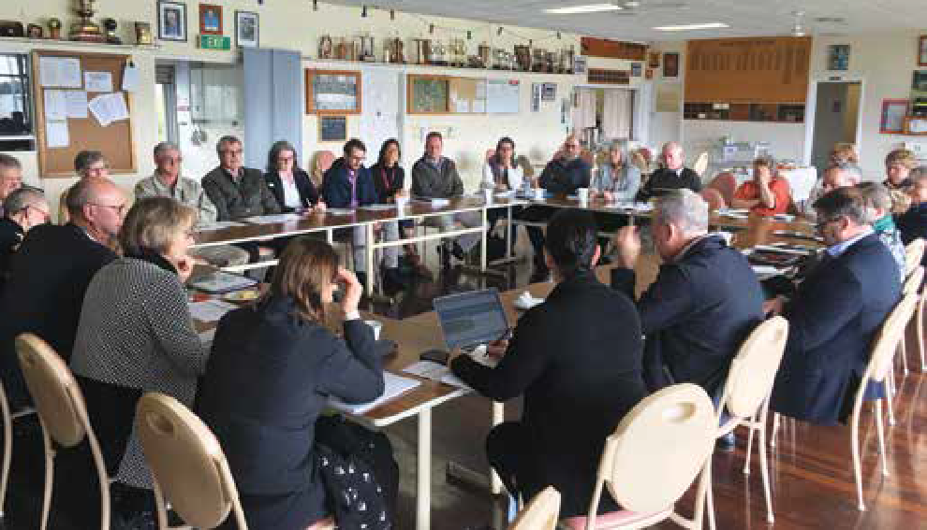

Public consultation in Albany, WA

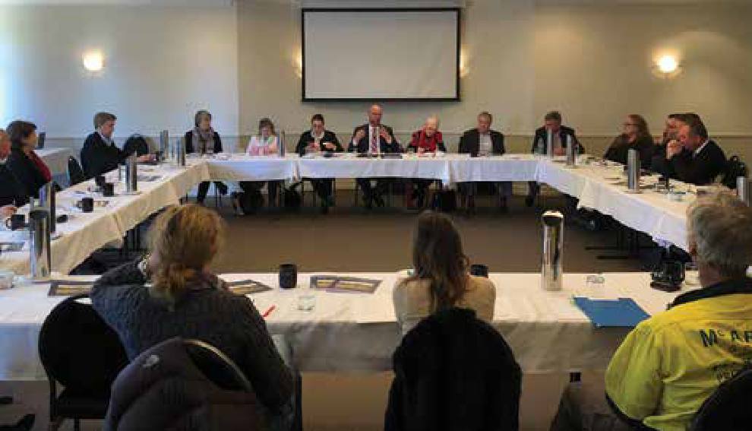

Public consultation in Tamworth, NSW

Regional Telecommunications Independent Review Committee
PO Box 2154
Canberra ACT 2601 secretariat@rtirc.gov.au rtirc.gov.au


1. Lamb, D 2017, ‘Accelerating precision agriculture to decision agriculture: A review of on-farm telecommunications challenges and opportunities in supporting a digital agriculture future for Australia’, University of New England and Cotton Research and Development Corporation, Australia.
2. Australian Medical Association, ‘Telehealth could deliver massive savings: CSIRO’, 30 Aug 2016, <https://ama.com.au/ausmed/telehealth-could-deliver-massive-savings-csiro>.
3. ACMA Research, ‘NBN consumer experience: Households and businesses—the end-to-end journey’, August 2018, <https://www.acma.gov.au/theACMA/nbn-consumer-experience-households-and-businesses-the-end-to-end-journey>.
4. ACCC, 2017, ‘Broadband speed claims: industry guidance’, <http://www.accc.gov.au/system/files/CCS%20-%20Broadband%20Speed%20Claims%20-%20Industry%20guidance%20-%20FINAL%20ex%20%20SCB%2018%20Aug%202....pdf>.
5. ACCC, 2017, ‘Broadband speed claims: industry guidance’, [www.accc.gov.au/system/files/CCS%20-%20Broadband%20Speed%20Claims%20-%20Industry%20guidance%20-%20FINAL%20ex%20 SCB%2018%20Aug%202....pdf](http://www.accc.gov.au/system/files/CCS%20-%20Broadband%20Speed%20Claims%20-%20Industry%20guidance%20-%20FINAL%20ex%20%20SCB%2018%20Aug%202....pdf).
6. Regional Capitals Australia submission to PC—Inquiry into Transitioning Regional Economies, p. 9.
7. CSIRO, 2018 ‘Home monitoring of chronic diseases’, [https://www.csiro.au/en/Research/BF/Areas/Digital-health/Improving-access/Home-monitoring](http://www.csiro.au/en/Research/BF/Areas/Digital-health/Improving-access/Home-monitoring).
8. Prime Minister, Deputy Prime Minister and Minister for Agriculture and Water Resources, ‘Immediate Relief for Farming Families takes Drought Relief to $576 million’, 5 August 2018, media release.
9. ABS, 6227.0—Education and Work, Australia, May 2017, [http://www.abs.gov.au/ausstats/abs@.nsf/mf/6227.0](http://www.abs.gov.au/ausstats/abs%40.nsf/mf/6227.0).
10. PwC, 2018, ‘The contribution of the Indigenous business sector to Australia’s economy’, <https://www.pwc.com.au/indigenous-consulting/assets/the-contribution-of-the-indigenous-business-sector-apr18.pdf>.
11. Australia Council for the Arts, 2015, ‘Arts Nation: An Overview of Australian Arts’, <http://www.australiacouncil.gov.au/workspace/uploads/files/arts-nation-final-27-feb-54f5f492882da.pdf>.
12. BCAR, 2017, ‘Trends and drivers in the affordability of communications services for Australian households’, working paper, p.23.
13. ABS, 2017, 6523.0—Household Income and Wealth, Australia, 2015–16, [http://www.abs.gov.au/AUSSTATS/abs@.nsf/Lookup/6523.0Main+Features12015-16](http://www.abs.gov.au/AUSSTATS/abs%40.nsf/Lookup/6523.0Main%2BFeatures12015-16).
14. This paper uses unit record data from the Household, Income and Labour Dynamics in Australia (HILDA) Survey. The HILDA Project was initiated and is funded by the Australian Government Department of Social Services (DSS) and is managed by the Melbourne Institute of Applied Economic and Social Research (Melbourne Institute). The findings and views reported in this paper, however, are those of the author and should not be attributed to either DSS or the Melbourne Institute.
15. Australian Farmers, 2018, ‘New partnership to unlock ‘connected farm’ potential’, <https://farmers.org.au/news/new-partnership-to-unlock-connected-farm-potential/>.